Effect Of Exposures On The Mechanical Properties Of Polymers .1. Poly(Methylmethacrylate)

Muyiwa Turoti*¹, C.E. Gimba²

¹Department of Chemistry, Obafemi Awolowo University, Ile-Ife, Nigeria
²Department of Chemistry, Ahmadu Bello University, Zaria, Nigeria
*Corresponding author: Tel: +2348033766099, Fax 036-231245
*E-mail address: muyiwaturoti@yahoo.co.uk

Abstract: The degradation of PMMA films exposed to outdoor environment, ultraviolet irradiation at 254nm and oven aging at 300K was monitored by IR spectroscopy to determine the carbonyl and hydroxyl indices, determination of viscosity average molecular weight, tensile strength, Young’s modulus, elongation at break and time to embrittlement. The results generally showed that there was correlation between the mechanical properties and the accumulation of oxidation products. The ultraviolet irradiation was most effective in decreasing most of the properties of PMMA film shortening its longevity to 179h only. The results also indicated that the some of the properties of PMMA films were indeed improved at the early stage of exposure to oven followed by the outdoor environment hence these two environments would be where PMMA films could be better utilized.
[Muyiwa Turoti, C.E. Gimba. Effect Of Exposures On The Mechanical Properties Of Polymers .1. Poly(Methylmethacrylate). World Rural Observ 2015;7(4):87-95]. ISSN: 1944-6543 (Print); ISSN: 1944-6551 (Online). http://www.sciencepub.net/rural. 13. doi:10.7537/marswro070415.13.

Key words: oxidation, Young’s modulus, tensile strength, elongation at break, embrittlement time

Introduction
The first logical study for appropriate end uses of polymeric materials is to know their behavior under different exposures which will ultimately constitute the service environment. The degradation characteristics under such conditions will also predict the type of stabilization process that will be required if such is desired. Moreover, the degradation by-products could be isolated as chemical reagents. Poly(methylmethacrrylate) (PMMA) is known to be a useful commercial polymerdue to its film transparency attributed to the presence of the bulky substituents,CH₃ and COOCH₃, include a wide variety of fields and applications in the area of optics as dust covers for hi-fi equipment, sunglasses, watch glasses, lenses, magnifying glasses., in vehicles as rear lights, indicators, tachometer covers, warning triangles, electrical engineering as lamp covers, switch parts, dials, control buttons., medicine as packaging for tablets, pills, capsules, urine containers, sterilizable equipment and others (Polymethyl methacrylate (PMMA)- from CAEDS-Technical University of Gabrovo). It also serve as reducing materials for peak heat reduction release (Costache et al., 2006).
Thermal degradation of PMMA at relatively high temperatures has been reported probably due to the kinetic consideration (shorter time) of producing the desired low molecular weight organic compounds of industrial importance from the polymer. Such products that have been obtained, at relatively high temperatures such as 673K, include ethane, propane, acetone, acetic acid, benzene and its derivatives (Takashi et al., 1989). However, it has been realized that there are transitional morphological changes during heating of polymers particularly at about the transition temperatures(…). The Tg of isotactic PMMA is 378K. The durability of commercial polymers could be periodically assessed during their utility conditions particularly under the outdoor environment that is presently witnessing global climatic changes due to increasing industrial emissions. For instance, paint polymers, including PMMA, should be studied with the view of assessing its degradation characteristics for appropriate utilization in the environment where its properties would be found most useful. Estimation of the time and level of deterioration of mechanical properties of such polymer could be made by subjecting the polymer samples to aging and determine their properties at different periods of exposure.
This study, therefore, was set to assess the relative effects of outdoor, UV and oven aging on the properties of PMMA.

Materials And Methods
PMMA (Mw=8.9x10⁵, Mv=5.8x10⁵) was supplied by Aldrich.
Benzene was of reagent grade from BDH, Ltd used as solvent for PMMA.
Experimental
Preparation of PMMA films
1.0g of PMMA was placed in between folded aluminum foils and inserted within the steel platens of a Hot Press machine at 170-180⁰C for 90 seconds without pressure. Then a pressure of about 9.0x10³ Kgxm⁻² was applied for another 90secs. The hot films were then rapidly cooled in water. Films of different thickness of the polymer sample were selected for each of the three exposure conditions.
Outdoor aging
Holes (4cm diameter each) were carved out from previously constructed cardboard papers of 6cm x 6cm. Films of PMMA of about 5cm diameter was overlaid on the hole and stapled to the paper. Many of such were then mounted on specially prepared plywood containing rounded hole each of diameter 4½cm to allow penetration of sunlight through the films. The plywood was then suspended on a flat roof top at an angle of 450^{O}C to the horizontal (Schmidt, 1988).
Oven Aging
Films of polymer samples were prepared on cardboard papers as described under outdoor aging. With the aid of pieces of strong copper wires, the cardboard papers were suspended on the shelves of an air-circulated oven at 100⁰C. Long strips of polymer films were also hanged in the oven for the determination of mechanical properties.
UV aging
Ultraviolet radiation at 254nm in a UV cabinet was used as described earlier (Turoti et al, The polymer films were prepared as described under outdoor aging and then exposed directly at the same distance under the UV light source. Strips of polymer films of 0.16-0.24mm thickness were similarly placed.
Mechanical Properties
The tensile strength (TS), Young’s modulus (YM) and elongation at break. % (EB) were determined prior to and periodically during exposure as detailed earlier (Turoti et al., 1999). Each reported value was the average of values determined for five strips from the same film of PMMA
Viscosity-average molecular weight, Mv
Benzene was used as solvent for the PMMA samples and at a temperature of 30$±$0.2⁰C in an Ubellohde viscometer the procedure for viscosity measurement of a polymer as described elsewhere (Turoti et al., 1999) was followed. M_{v} for each PMMA sample was calculated using the Mark-Houwink-Sakurada equation and the $∝$=0.70 and K=4.0x10⁻³ values at 30⁰C as obtained from tables (Bandrupt and Immergut., 1975).

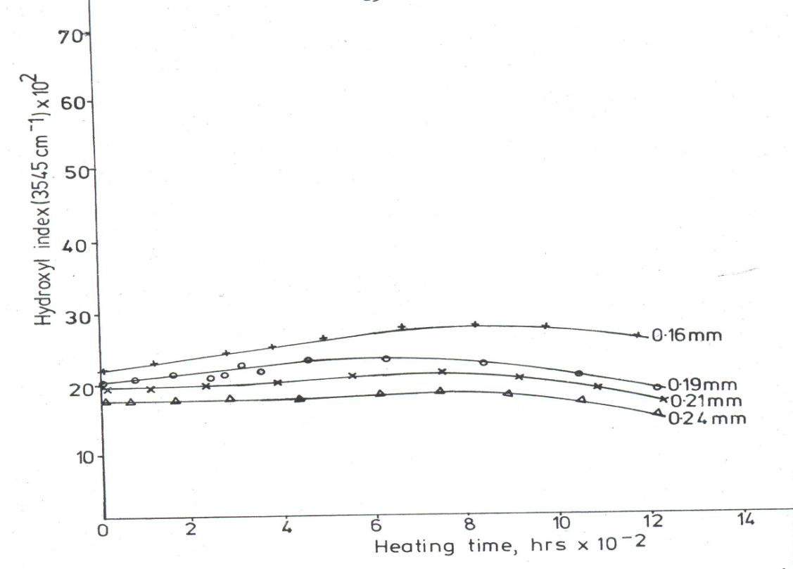

Fig.1 Thermoxidation of PMMA. Effect of heating time and film thickness on hydroxyl index

Hydroxyl and Carbonyl indices
The IR spectrophotometer, model 710B, was used for the determination of the hydroxyl index (HOI) and carbonyl index (COI).They were obtained as the ratio of area of each of the–OH and >CO absorption band at 3450 and 1725 cm⁻¹ respectively to that of the area of reference absorption, C-H stretch at 2915 cm⁻¹ as described previously (Peters et al., 1995). The cardboards containing films, as described under aging, were cut to size up with the dimensions of the window for the spectrophotometer.
Embrittlement time (ET)
The ET of the films were determined according to the procedure described elsewhere (Turoti et al., 2010). Prior to and during exposure, films were monitored for embrittlement daily by bending the two ends of each strip towards and angle of 180⁰ until the date/h that cracking occurred.

Results And Discussion
Oxidation of polymers
Figure 1 shows that PMMA film has increasing HOI values within the initial 800h of oven aging followed by decreasing indices. There is decreasing –OH indices with increasing film thickness and at i0.24mm there is hydroxyl induction period(HOIP) of about 500hr before the increasing followed by decreasing values, like in other films.
Figure 2 shows that all the text films have thickness dependent carbonyl induction periods (COIP) of about 430, 600, 800 and 980 hours for the 0.16, 0.19, 0.21 and 0.24mm films respectively during thermoxidative exposure. Oxidative induction periods are evidences of stabilization (Peters et al, 1995).

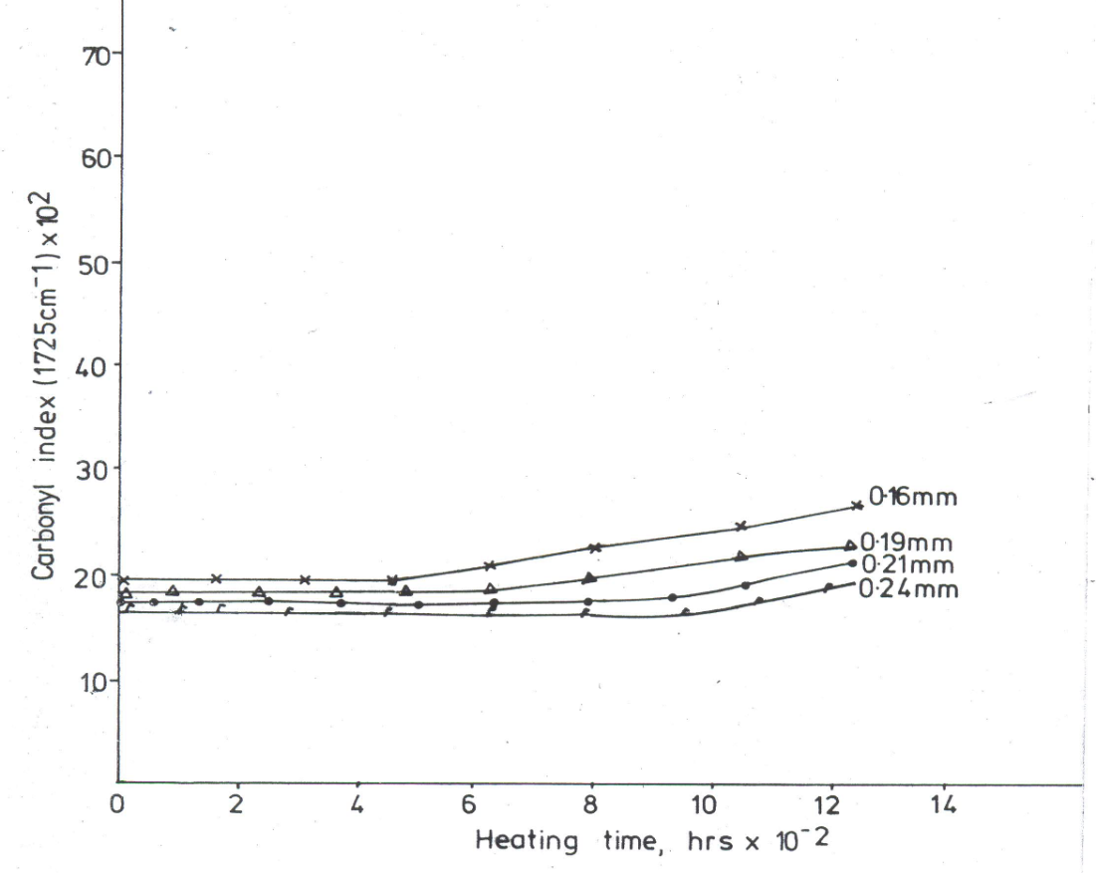
Figure 2 Thermooxidation of PMMA. Effect of heating time and film thickness on carbonyl index.

These periods are followed by slight increases in carbonyl indices which decreases with increasing film thickness.
The photo-oxidation at 254mm and room temperature (299K) is not a model but one of our studies on accelerated exposure on plastic materials as done in earlier work (Turoti et al, 1998). Exposure of the PMMA film samples generated a high level of HOI but for a shorter aging time (Fig 3). The COI values during this exposure condition are relatively low compared to the HOI but experienced similar increase in values for the period of irradiation (Fig 4). Both indices did not indicate any same period of exposure of 600hr. and UVB (295-380nm) could be i.
Fig.3. Photoxidation of PMMA. Effect of UV irradiation time and film thickness on hydroxyl index.
Early chain fragmentation and reaction with atmospheric oxygen hinders induction period during the photoxidation. .The early oxidation did not probably allow de-polymerization in line with the previous observation (Reiner, 1966).
Scheme to show decomposition of PMMA chain to non-cross linked conjugated products
Also cross-linking might be unlikely as gel was not found by the dissolution of samples in benzene.

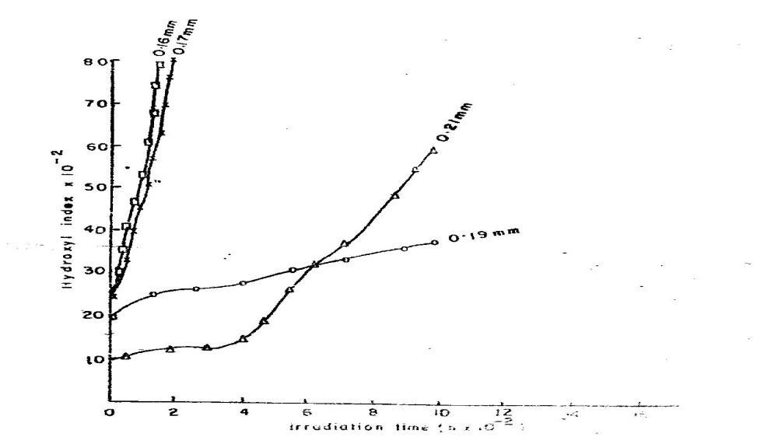
Figure 3. Photo-oxidation of PMMA. Effect of UV irradiation time and film

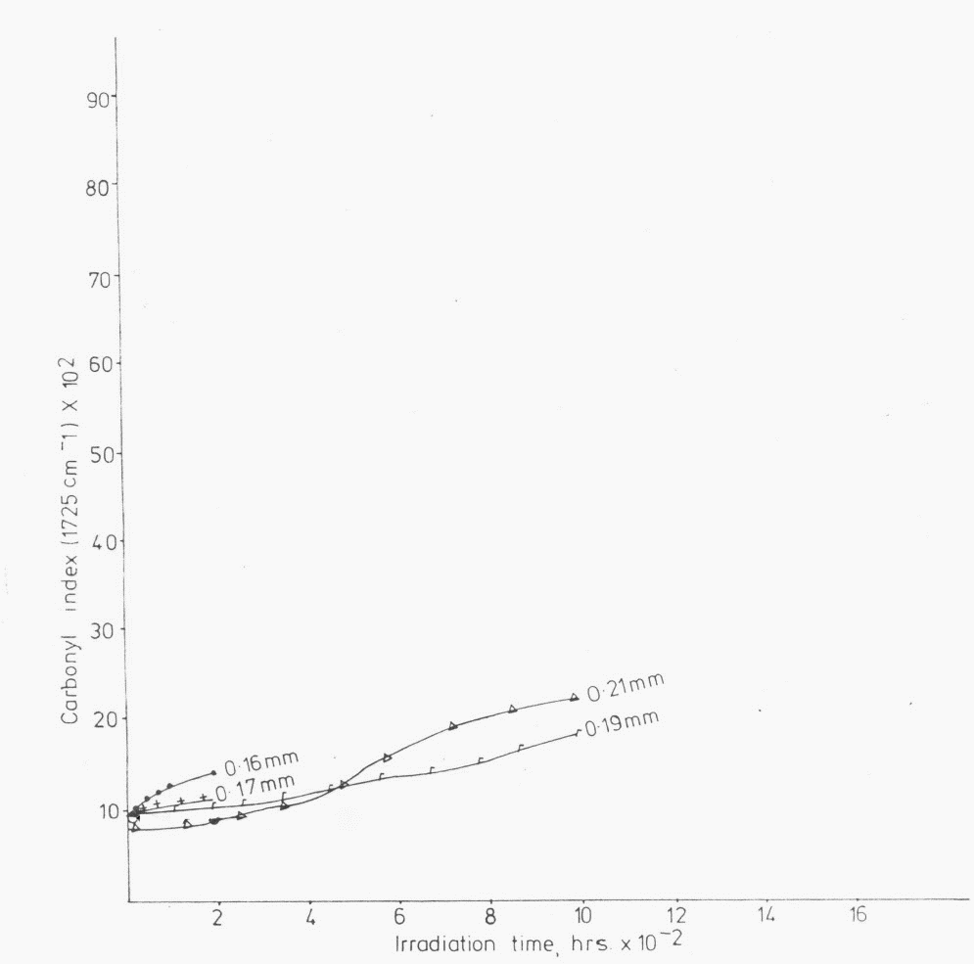
Figure 4. Photo-oxidation of PMMA. Effect of irradiation time and film thickness on carbonyl index.

Fig. 4. Photoxidation of PMMA. Effect of exposure time and film thickness on carbonyl index. The results from exposure to UV show that the 0.19mm film is most resistant to oxidation after about 450hr.
This shows direct relationship between the production of carbonyl compounds as secondary compounds from hydroxyl compounds as irradiation progresses. The photoxidation of PMMA films shows that the oxidation indices generally decrease with increasing film thickness. The similarity in the two oxidation indices with the exposure of the 0.19mm film that has lower indices than the 0.24mm film at about the longer solar UV wavelength, with smaller energy incise less chain scission of the PMMA film samples than obtained during the UV earlier observed elsewhere (Turoti, 1995).

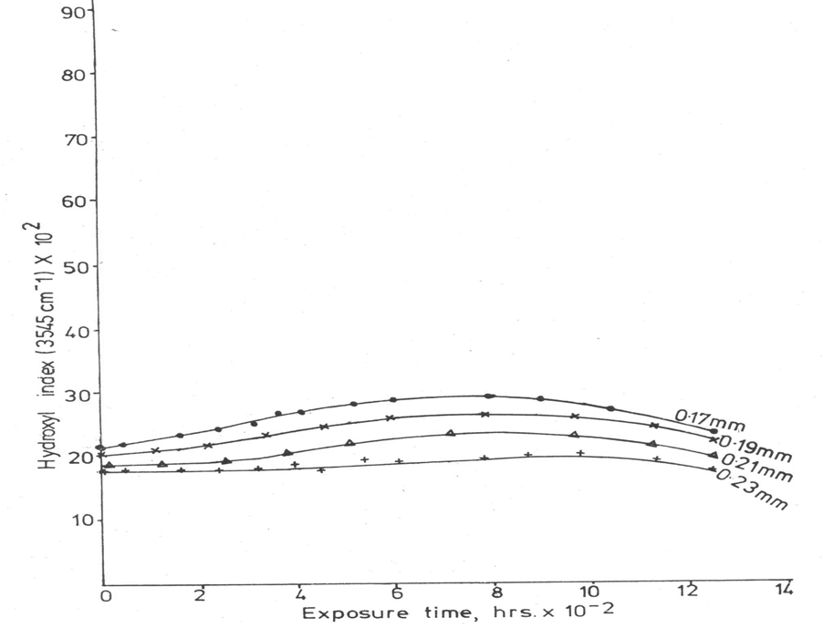
Fig. 5. Outdoor exposure of PMMA. Effect of exposure time and film thickness on hydroxyl index.

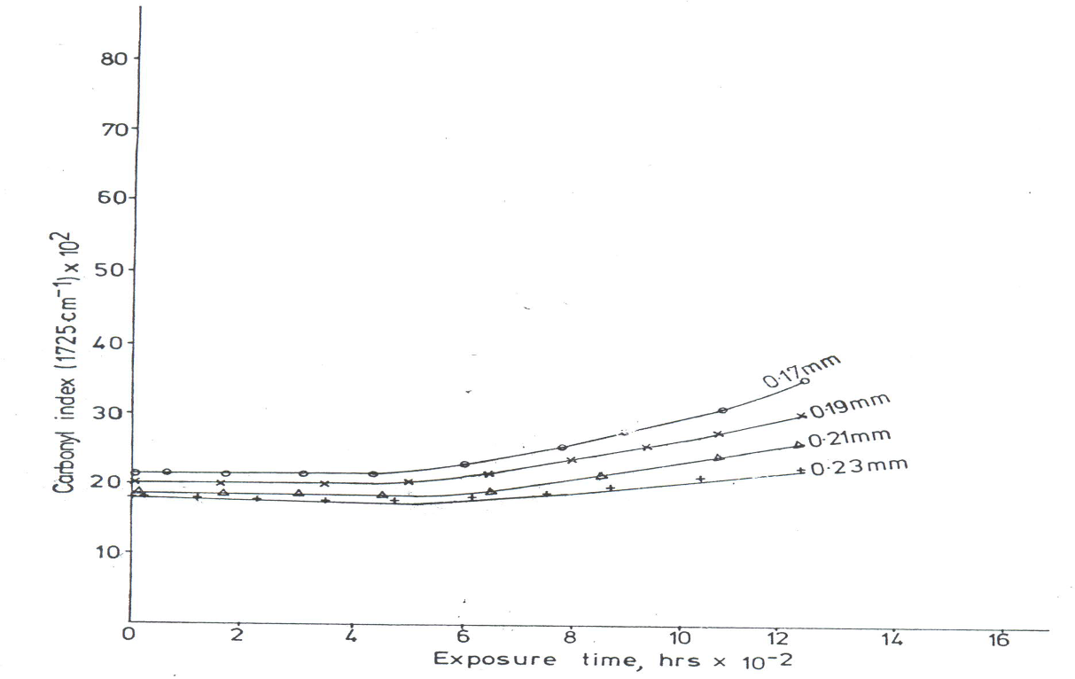
Figure 6. Outdoor exposure of PMMA. Effect of outdoor exposure and film thickness on carbonyl index

The present results on oxidation showed that the same aging condition produced HOI and COI at different rates for the polymer. Using the same film thickness and maximum values of oxidation indices for comparative analysis, it can be seen that PMMA film had HOI values in the order, UV > outdoor = oven and for COI values: UV >outdoor.>oven.
As it can be seen the relative values of the HOIP or COIP generally affect the levels of oxidation of the PMMA samples used in this study. For instance there were neither HOIP nor COIP during UV aging where the greatest HOI and COI values were obtained. Each of the outdoor and oven aging registered the same values of induction period of 400h so were their HOI values the same and lower levels of oxidation indices were obtained under these two exposure conditions. Generally the greater the level of oxidation induction period the less the accumulation of oxidation products during the exposure of the PMMA samples to the three environments. As such relationship was in line with a previous work on a similar polymer system (Turoti et al., 1999).
Figure 7 shows the order of decreasing average viscosity molecular weight is UV > outdoor > oven for the PMMA films. The trend is generally in agreement with the trend of HOI or COI presented in the previous section. The initial chain scission was attested by the rapid decrease in the viscosity average molecular weight within the early hours of aging.

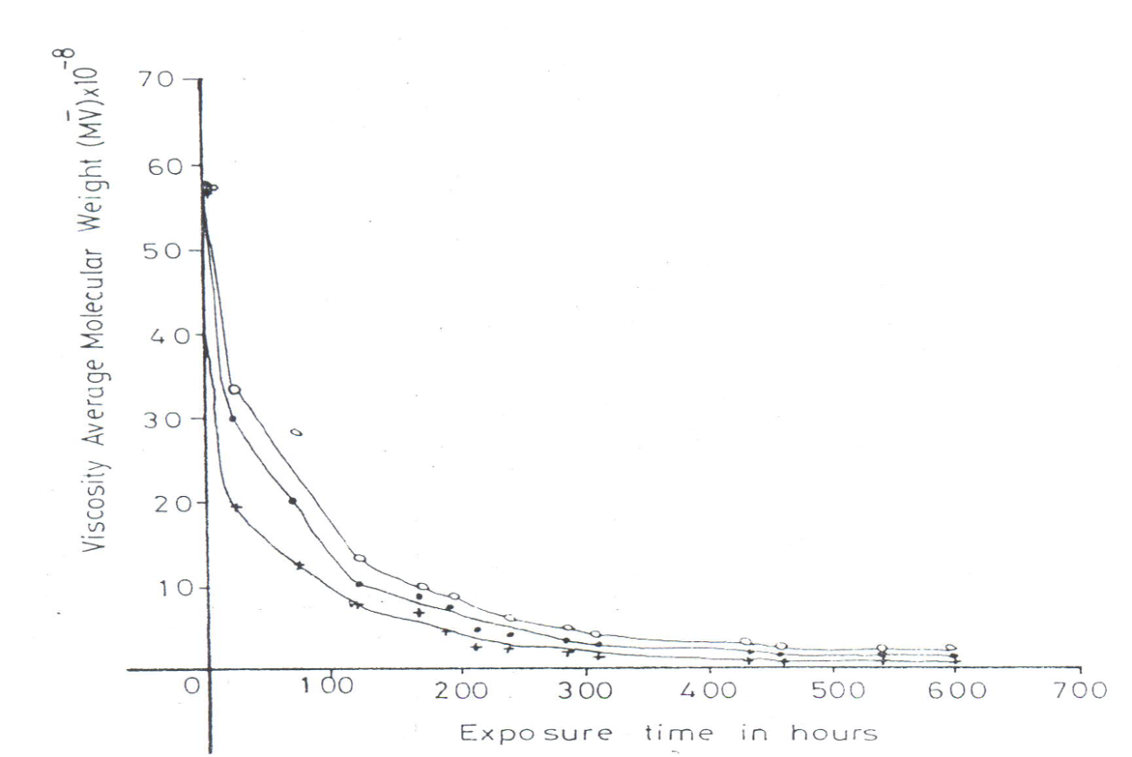
Figure 7. Viscosity average molecular weight (Mv) of PMMA..
Effect of outdoor weathering ( ), UV irradiation ( ) and oven aging ( ) time on(M_{v}).

3.2. Mechanical properties of PMMA films
The three mechanical properties in this study include tensile strength (TS) Young’s modulus (YM) and elongation at break (EB) using 0.19mm PMMA film for each property within 5-7 hr from the onset of exposure.
Fig. 8 shows that the TS has rapid initial increase up to 5x10⁷Nm⁻² within 50h and thereafter remains virtually constant. The values under the three exposures indicate an order of TS: oven>UV> outdoor throughout the period of investigation. It is clear from fig.8 that there is about 267% increase in TS when PMMA film is subjected to thermoxidative oven aging at 373K.This may be quite remarkable as it has recently been found that the TS of PMMA could only be increased by 32.9% using 0.25w% MWNCT nanotechnology (Arum and Kanagaraj, 2015). The YM values show initial decreases up to 100h and thereafter appreciated with the net values order of oven>UV> outdoor (Fig 9). This suggests that after 100h of exposure to both oven and UV as well as after 250h under outdoor environment, PMMA films can be used or recycled with enhanced YM. These evidences show that PMMA film is stable to these aging conditions. As expected, the EB values (Fig.10) were of the converse order, outdoor>UV> oven, since a neat polymer film with high values of TS and/or YM generally possesses low EB (McCaffery, 1970).

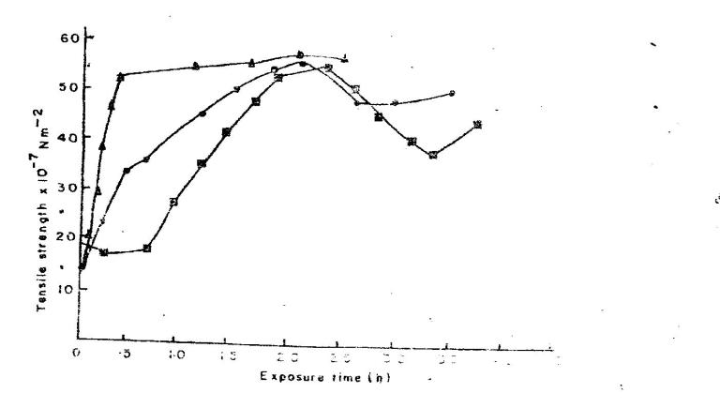
Figure 8 Tensile strength (TS) of PMMA. Effect of outdoor weathering ( ), UV irradiation ( ) and oven aging ( ) time on TS.

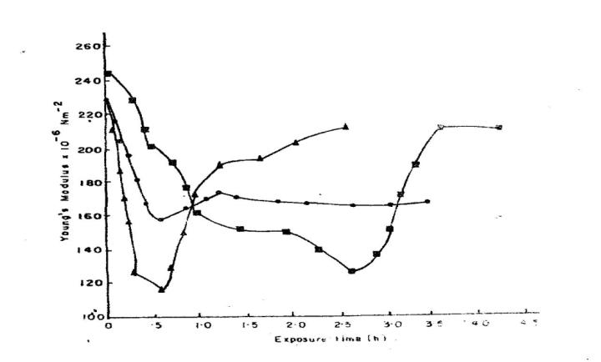
Figure 9. Young’s modulus (YM) of PMMA. Effect of outdoor weathering ( ), UV irradiation ( ) and oven aging ( ) time on YM.

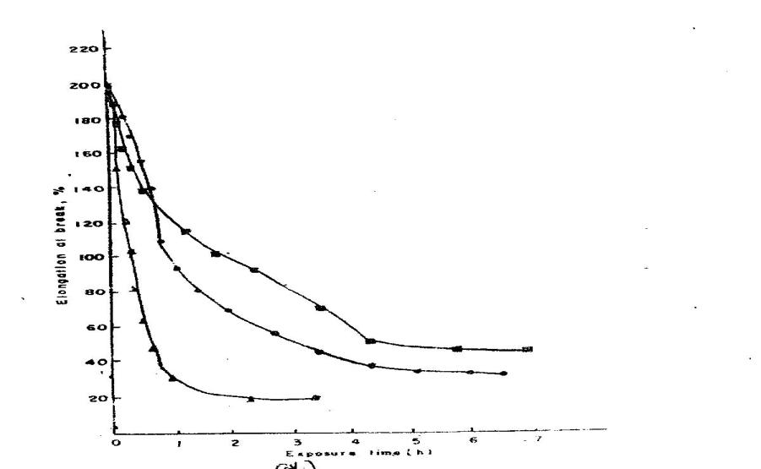

Figure 10. Elongation at break of PMMA. Effect of outdoor weathering ( ), UV irradiation ( ) and oven aging ( ) time on EB.

Table 1 showed the time to embrittlement (ET) of PMMA films used in this study.

Table 1. Hydroxyl Induction Period (HOIP), Carbonyl Induction Period (COIP) and Embrittlement time (ET) of PMMA films under Outdoor, UV and Oven Exposure.

Outdoor Ultraviolet Oven
HOIP 600 45 650
COP 550 82 620
ET (h) 409 179 705

Table 1 shows that the life span (ET) of the same PMMA film (0.19mm) stands at 409h (about 17days) for outdoor aging, 179h (< 8 days) for UV aging and 705h (about 30 days) for oven aging. The ET values show dependence on the relative values of the HOIP and COIP under the three exposure conditions, that is, the longer the oxidation induction periods the greater the longevity of the film. Also, the ET values show dependence on the relative values of the mechanical properties, that is, the greater the TS or YM and the smaller the elongation at break (EB) the longer the life span of the film. For instance, the same film exposed under oven aging that has the greatest TS or YM and smallest EB values (Figs 8-10) also has the longest life span in line with some previous works (Turoti et al, 2010, 1999). The same trend goes for the relative values of the viscosity average molecular weights, M_{v} (Fig. 7). The exposure to oven that has the longer oxidation induction periods has the longest life span and least reduction in M_{v.} These observations most probably demonstrate a high degree of consistency within the results obtained in this study and indicate their reproducibility.

Conclusion
The degradation of PMMA was most effective by ultraviolet irradiation at 254nm when rapid main chain scission occurred as evident from the relatively high levels of accumulation of oxidation products and very low viscosity average molecular weights at the early stage of exposure. The tendency towards degradation was relatively low during outdoor and oven aging decreasing in that order. Thicker films sustained less oxidation under thermooxidative and outdoor environment. It was clear that 0.2mm thickness would be most appropriate for coatings based on PMMA meant for outdoor decorative paints where durability is a major objective. It was also generally conclusive that accumulation of oxidation products correlated substantially with oxidation induction periods and that low oxidation indices were concomitant with enhanced mechanical properties and longevity. The recycling of used-films of this polymer would require subjecting PMMA films to thermo-oxidation at 373K so as to have better mechanical properties during and after the recycling processing.

Acknowledgement
The authors are indeed grateful to Mr. Chinedu Oti presently in the Industrial Chemistry, Polymer Science and Technology laboratory Section, of Obafemi Awolowo University, Ile-Ife, Nigeria for perfecting the graphics used in this paper.

References
- Arum and kanagaraj (2015) Mechanical characterization and validation of polymethylmethacrylate/multiwalled carbon nanotube composite fer polycentric knee joint. Journ of Mechanical behavior of biomedical materials, 50,33-42.
- Bandrupt J, Immergut, E.M. (1975). Polymer Handbook, Wiley Interscience, New York.
- Costache, MC., Wang, D., Heidecker, M.J., Manias, E., Wilkie, C.A. (2006). The thermal degradation of polymethylmethacrylatenano composites with montmorillonite, layered double hydroxides and carbon nanotubes. Polymer for Advanced Technology Polym. Adv. Technol. 17,272-290.
- Reiner, R. (1966). Encyclopedia of Polymer Science and Technology. Wiley Interscience, Now York.
- Schmidt, E.V. (1988). Degradation of organic coatings by weathering FMJ International Publishers, New York.
- Takashi, K., Atsushi I., Anthony, H. 1989. Behavior of Primary radicals during Thermal degradation of Poly (methylmethacrylate). Polym. Deg. Stab. 25,61-184.
- Peters, O.A, Turoti, M. J.B. Adeniyi Olayemi J.Y. (1995). The thermooxidative degradation of Poly(vinylchloride). Part I. The stabilizing actionfdibutyltin Maleate and Trisnitro (1,3 -dobydroxy-2 - nitropropane) on PVC I. inair. Polym. Deg. and Stab. 50 175-182, 1995. (UK).
- Turoti, M, J.Y. Olayemi J.B Adeniyi Olufemi Peters (I999) The photooxidative degradation of poly (vinylchloride). Part 3.The stabilizing action of Dibutyltinmalteate and Trisnitro (l,3-dihydroxymethyl-2-nitropropane) PVC from ultraviolet light radiation. Poly. Deg. and Stab. 63, 341-347, (UK).
- Turoti, M, Gimba & S.S. Achi (2010). Environmental degradation of surface coatings.1. Stabilization of green poly(glycerol-phthalate) based alkyd coatings with some dibutyltindicarboxylates during outdoor exposure. Toxicological and Environmental Chemistry, 92(5):895-892(UK).
- Turoti, M., Olayemi, J. Y., Adeniyi, J.B., Peters, O.A. (1998). The photo oxidation degradation of poly(vinyl chloride).2: The stabilizing action of dibutyltin maleate and Trisnitro (1,3-dihydroxymethy1-2-nitropropane) on PVC from ultraviolet light irradiation. Polym. Deg. Stab. 61291-302.
- Turoti, M., Gimba, C.E. Achi, S.S. (2010). Environmental degradation of surface coatings.1. Stabilization of green poly (glycerol-phthalate) based alkyd coatings with some dibutylin carboxylates during outdoor exposure. Toxicology and environmental Chemistry. 92(5),885-892.

1/6/2016

