FAO Contribution to food and income security in Sudan: An Assessment

Abdel Raouf Suleiman Bello* and Eiman Musa Ahmed Fadul**

*Department of Agricultural Extension and Rural Society, College of Food and Agriculture Sciences, King Saud University, and Department of Agricultural Extension and Rural Development, University of Khartoum, Sudan.
** Eiman Musa Ahmed Fadul, Training Administration, Ministry of Agriculture, and Irrigation, Sudan.
Corresponding Author’s Email: raoufbello@yahoo.com

Abstract: This study was conducted to assess the impact of the FAO’s Special Program for Food Security in Ombadda Locality of Khartoum State. The simple random sampling procedure was used to select 80 respondents from two villages purposively selected. Primary data were obtained through a survey by using a structured interview schedule and observation. The study findings indicated that the program has succeeded in sufficiency crops product and improving income of the beneficiaries which are reflected in achieving food security and improvement of their standard of living. T-test analysis showed significant difference between participants and non-participants groups with respect to number of variables, namely crop production, crop consumption, net crops income and incomes after and before the program. The study proposed some recommendations including: expansion and replication of the existing project activities with special emphasis on income-generating activities, and raising of environmental awareness among the targeted group, especially women.
[Bello AS, Fadul E MA. FAO Contribution to food and income security in Sudan: An Assessment. World Rural Observ 2015;7(4):71-76]. ISSN: 1944-6543 (Print); ISSN: 1944-6551 (Online). http://www.sciencepub.net/rural. 11. doi:10.7537/marswro070415.11.

Key words: Food security, crop production, crop technology, farmers’ income

1. Introduction
The concept of food security emerged in the 1970s after the 1972-1973 Sahel famine and the world food conference 1974. Food security used in its most general form essentially means a state of affairs where all people at all times have access to safe and nutrition food so as to maintain a healthy and active life(World Bank, 1986). According to the World Bank defined food security as: “Access by all people at all times to enough food for an active and healthy life” (World Bank, 1986: 4). This definition indicates that to achieve this goal three conditions have to be met namely: (i) Ensuring stability of food supply, (ii) Ensuring access to food, (iii) Ensuring adequacy of food supply. Maxwell (1991) argued that this definition is incomplete in four respects: firstly, it subordinates the concept of food security to that of food consumption. Secondly, it pays insufficient attention to people own perception of risk. Thirdly, it limited the issue of food security at the national level, and it leaves open questions about the difference between poverty and food security. He suggested a new definition of food security which stated that “A country and people are food secure when their food system operates efficiently and equitably in such a way as to remove the fear that there will not be enough to eat” (Maxwell, 1991:2). This definition includes the efficient distribution and production of food and the financial ability to afford food so it concerns with the whole food system to be efficient and equitable. The workshop organized by FAO (1996) defined food security as “adequate access to food for all sections of the population at all time’s”, “adequate” means enough for active, healthy life, “access” means ability to acquire food by production, purchase, or exchange . FAO also operationalized the concept of food security within its mandate by stressing those aspects of the phenomenon that are related to the availability and stability of food supply at the national level, through both time, space and access to food supplies at the household and individual, as well as national level, the later consideration are expressed in the definition of household food security expected by the committee on world food security (FAO,1996:2) as “physical and economic access to adequate food for all household members under risk of losing such access”. This definition includes three dimension s: Availability, stability and affordability of sufficient food. Adequate food available to meet that, an average sufficient food supplies should be available to meet consumption. Affordability means that, even with ample supplies, many people still go hungry because they are poor to produce or purchase what they demand, while stability indicates stability in food supplies and market.
Moreover, according to Alamgir and Arora (1991), food security can be divided into three levels: i- Sub-national food security: Is the assured available of food for individual household to draw on meeting their minimum consumption requirements during a given period. The key words are production internal trade and communal food security arrangements, ii- National food security: Is the assured national availability of food to meet current minimum requirements per capita during a reference period (a year normally) and to meet any unexpected short fall over a limited period (say three months). The determining variables are production, imports and exports and stock changes, and iii- Global food security: Is the assurance of an adequate food supply and/or access to it for all, both at national and sub-national level. The key is global production and stock, trade, food and capital aid, the distribution of global resources and income and regional and global food security arrangement. The World Bank (1986:4) defined household food security “as the availability of enough food for life, health and growth of the young and for productive effort”. The World Bank (1986) also stated that the concept of household food security (HFS) is concentrated on access and risk; also take up issues connected to the concepts, including household nutrition, livelihood, substantiality, cultural acceptability, efficiency and human rights.
Sudan is a very large agricultural and pastoral country in Africa with total area is estimated to 2,505,813 sq. km and contrasting sharp differences in all its characteristics (Ali, 2012) .From north to south, the desert semi-desert with ephemeral grasses and xerophytes scattered shrubs to short grass savannah, through long grass savannah to tropical forest with evergreen trees and tall and very thick canopy of grasses. This gradual transition is the result of the quantities of rainfall received in each ecological zone, which varies from less than 50mm per annum, received in 1-3 months in the north to more than 1500mm per annum spread over 9 months in the south (Suleiman et al. 2008). For some time, the country faces numerous problems including inter alia social conflict, civil war, on-going rural urban migration and the consequences of the July 2011 secession of South Sudan. The new born country share in the oil sector estimated to about three-fourths of the former Sudan's total oil production. The oil sector had driven much of Sudan's GDP growth since it began exporting oil in 1999, the matter that hardly affected the country national budget (Bello, 2012). The country total population of well over 33 million, out of which 51% live in rural areas. Agriculture is the dominant sector in the Sudanese economy. It contributes about 31.6% to the Gross Domestic Product (GDP), and about 9% of non-petroleum exports, and provides the raw materials for agro-industries and employment for over 50.23% of the labor force (Ministry of Information 2011). According to the WFP (2015), household food security in Sudan is strongly linked with the performance of the agricultural sector of the economy. Directly, the agricultural sector provides household level food production for domestic consumption and wage labor opportunities on farms. (According to Sudan Central Bureau of Statistics, the agricultural sector account for 27 percent of the active labor force. Indirectly, the level of agricultural production influences the price of food, which helps determine household economic access, as most households are net consumer of food, relying of markets as their main food source (WFP, 2 015).

The Special Program for Food Security (SPFS) was designed and implemented by the FAO in 2004 to improve food security and nutrition on a sustainable basis, reverse the declining trend of agricultural productivity and bridge the food gap for some vulnerable areas in Sudan. The program activities were implemented in three sites namely Khor Abu Habil in North Kordofan State, Lower Atbara in the River Nile State and West Omdurman in Khartoum State (Map 1). According to the FAO final Special Program for Food Security document (2001) the West Omdurman in Khartoum State project components are:1.Water control and management to increase the water efficiency of the existing or proposed new irrigation schemes by: i-Increasing the water uses at the pumping, distribution at plot levels, and ii-Improving the water management in order to maximize the water productivity and enhance food security, for the targeted beneficiaries, 2. Intensification of plant production systems through : i-Development of participatory process among the beneficiaries and their organizations for the identification, evaluation and monitoring of technological options. Identification of constraints and appropriate solutions to resolve them would ensure widespread adoption of high yielding varieties, integrated plant nutrition system, integrated pest management sound post-harvest techniques and efficient input delivery system, ii-Demonstration of available new technologies for boosting food production of the major staple food crops (dura, sorghum, dukhn, etc) in a sustainable way in farmers’ fields. The demonstrations would be carried out by farmers themselves through the mobilization, organization and training of producers for effective, use of improve technical packages and practices, iii-Improvement of household food security at the SPFS sites, and iv-Promotion of gender sensitive activities and the furtherance of social equity, and 3. Diversification of production to promote income generation activities in support of the household food security, targeting in particular women.

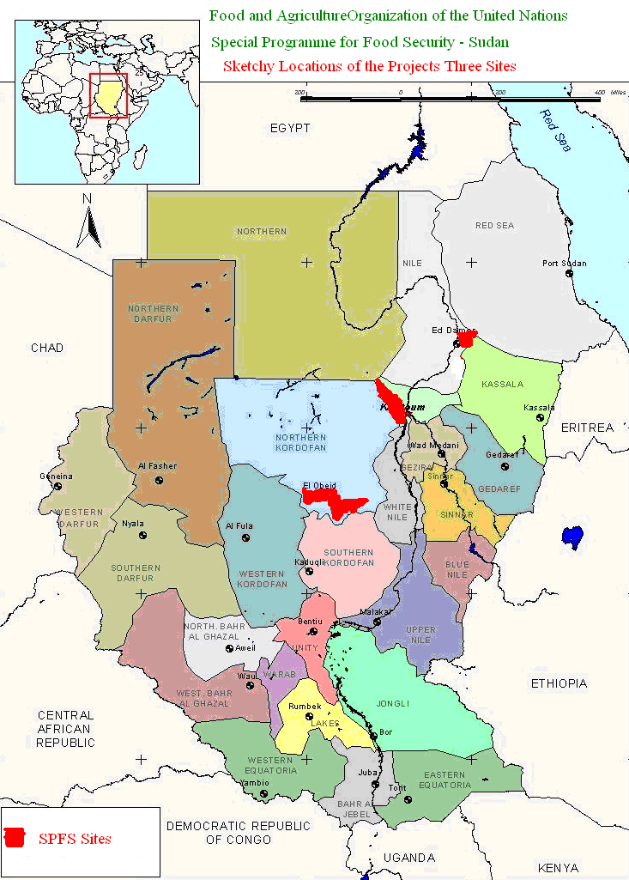
Source: Turkawi and Bello (2009)

Map1. FAO Special Program for Food Security Sites of North Kordofan, River Nile and Khartoum States-Sudan (old Sudan)

1.2. Purpose and Objective of the Study
This study aims to assess impact of the FAO’s Special Program for Food Security in the study area. It aims precisely to investigate the program contribution to improve crops production and income of its beneficiaries, and hence, achieve their food security.

2. Methodology
Study Area
The West Omdurman project areas lie in Ombadda locality in rural western parts of Khartoum State, Sudan. The population of the study area are basically nomads whose life was greatly affected by the 1980s drought and decreasing rainfall resulted in lesser flow of the major seasonal valleys such as Wadi El Mugadam, running throughout the area. The Western part is a desert area with herding as the major economic activity, while the Southern area is characterized by being a livestock and agricultural area. The nearest urban community is 86 kms and the more distant one is about 150 km from the outskirt of Omdurman town, boarding the Northern and North Kordofan States, White Nile State, and Karari locality in Khartoum State (Turkawi and Bello, 2009).
Data collection and analysis
From this locality, two villages covered by SPFS services, were purposively selected namely Um-Harout One, Um- Harout Two. The simple random sampling method was adopted to select 80 respondents (40 respondents from each), comprising 40 project participant and 40 non- participant. The total population of the study area was 1500 household. Table of random numbers was used to select 20 participants from each sampled village who represent direct project participants. Another group of 40 respondents as non-registered to the project was also selected (20 from each village)by means of accidental non- random sample method. Primary data were collected through field survey by using structured interview and observation.
Frequency distribution and T. test procedure were used to determine whether the observed difference between participant and non-participants in terms of the study variable were significant.

3. Results and Discussion
3.1 Sufficiency of product available for family
consumption

Table 1. Frequency distribution and percentages of respondents by level of consumption from cropproduction.
Consumption | P | NP | Total
 | F % | F % | F %
Yes  No  Total | 33 2.5  7 7.5  40 100 | 28 70.0  12 30.0  40 100 | 61 76.3  19 23.8  80 100

Table 1 indicates that 76.3% of the respondents commented that they use to consume sufficient amount of the crops production (82.5% and 70.0% for the participants (P) and non- participants (NP) respectively). This result indicate that the program enabled the beneficiaries to produce enough food to meet their needs with surplus that could be sold in the local markets or exported to other areas. Hence the program attained its objective of food security. This result is in line Alamgir and Arora (1991), FAO (1996) and the World Bank (1986) definitions of food security as adequate access to food for all sections of the population at all times. In other words they were able to produce food for active, healthy life and or ability to acquire food by purchase, or exchange.
3.2 Contribution of project to improving food and income security
Table 2 shows that 75% of the respondents confirmed that income generating activities and intensification of crops production they receive (from the program) have contributed in improving their household income and food security. The remaining 25%, who didn't achieve food and income security, attributed that to the overgrazing, disruption in water supply service and lack of protection fence. This finding also indicates the program interventions contribution to the beneficiaries’ food security and it is also consistent with the various definitions of food security (FAO, 1996, Imam, 1999, and the World Bank, 1986). It is clear that the improvement of the targeted group purchasing power enabled them to acquire enough food and other family needs and wants. It is observed that the improvement of the project beneficiaries is reflected in their consumption patterns and change in their life style as well as savings investment practices.

Table 2. Frequency distribution and percentages of respondents by contribution of project to improving food and income security.
Contribution | P | NP | Total
 | F % | F % | F %
Yes No  Total | - 100  - -  40 100 | 20 50  20 50  40 100 | 60 75  20 25  80 100

Results of T-test of significant of the observed difference between (P) and (NP) in SPFS in term of income before and after program intervention
Table 3 showed that there was significant difference between participants and non-participants group in term of income after program. This result indicated that the program succeeded in increasing the income for the beneficiaries.

Table 3. Results of T-test for P and NP by income before and after program
Variables | Group | Mean Score | Std dev | Mean dif | Std error dif | t | Sig
Income before program | *1 | 203.50 | 134.480 | 21.263 | 87.500 | 3.680 | ,002
 | *0 | 116.00 | 67.284 | 10.639 | 87.500 | 3.680
Income after program | 1 | 400.95 | 221.723 | 35.058 | 245.950 | 6.013 | ,005
 | 0 | 155.00 | 133.244 | 21.068 | 245.950 | 6.013
*1= P *0 = NP

Table 4. Results of t-test for P and NP in term of selected variables
Variables | Group | Mean Score | Std dev | Mean dif | Std error dif | t | Sig
Total Production of Abu Sabaeen | 1  0 | 175.18  58.43 | 185.283  47.886 | 116.750  116.750 | 29.296  7.571 | 3.858  3.858 | ,000
Total Production of Watermelon | 1  0 | 152.03  43.70 | 189.282  69.636 | 108.325  108.325 | 29.928  11.010 | 3.397  3.397 | ,000
Total Production of Okra | 1  0 | 25131.20  26.95 | 158125.140  30.771 | 25104.250  25104.250 | 25001.780  4.865 | 1.004  1.004 | ,000
Total Production of cucumber | 1  0 | 165.68  28.00 | 141.355  24.732 | 137.675  137.675 | 22.350  3.911 | 6.068  6.068 | ,000
Consumption of AbuSabaeen | 1  0 | 65.18  24.80 | 64.890  18.252 | 40.375  40.375 | 10.260  2.886 | 3.788  3.788 | ,000
Consumption of Watermelon | 1  0 | 54.45  15.65 | 60.594  22.484 | 38.800  38.800 | 9.581  3.613 | 3.789  3.789 | ,000
Consumption of Okra | 1  0 | 59.90  14.40 | 68.764  9.317 | 45.500  45.500 | 10.873  1.473 | 4.147  4.147 | ,000
Consumption of Cucumber | 1  0 | 53.55  13.25 | 52.832  11.383 | 40.300  40.300 | 8.353  1.800 | 4.716  4.716 | ,000
Net Income from AbuSabaeen | 1  0 | 121.25  33.63 | 141.466  33.550 | 87.625  87.625 | 22.368  5.305 | 3.812  3.812 | ,000
Net Income from Watermelon | 1  0 | 90.05  28.05 | 121.604  49.834 | 62.000  62.000 | 19.227  7.879 | 2.984  2.984 | ,000
Net Income from Okra | 1  0 | 106.55  12.30 | 188.766  25.300 | 94.250  94.250 | 29.847  4.000 | 3.130  3.130 | ,000
Net Income from Cucumber | 1  0 | 100.53  14.75 | 89.867  15.263 | 85.775  85.775 | 14.209  2.413 | 5.951  5.951 | ,000
Net Farm Income | 1  0 | 418.3750  88.7250 | 321.20628  98.15842 | 329.65000  329.65000 | 50.78717  15.52021 | 6.207  6.207 | ,000

4.3 Result of T-test analysis of total production
Table 4 indicated the result of T-test of significant of the observed different between participants and non-participants in SPFS in term of total production of selected crops. It showed that there was a significant difference between participants and non-participants in term of total production of Abusabeen. The mean scores for participants 175.18 and 58.43 for non-participants with t-value. 3.85. The results also revealed that there was a significant difference between participants and non-participants in term of total production of watermelon. The mean scores for participants is 152.03 and 43.70 for the non-participants group with a t- value 3.39. The table also reflected that there was a significant difference between participant and non-participants in term of total production of okra. The mean scores for two groups is 25131.20 and 26.95 respectively with a t- value 1.004. Moreover, the table showed that there was significant difference between participants and non-participants in term of total production of cucumber. The mean scores for participants is 165.68 and 28.00 for the non-participants group with a t- value 6.068.
Consumption from crops production
As in Table 4 t-test result indicated that there was significant difference between participants and non-participants group. This result reflected that participants group consumed more from Abusabeen production than the non-participants group. The table revealed that there was significant difference between two groups. With respect to their mean scores, which is 54.45 for the participants group and 15.65 for the non-participants group, with a t-value 3.789 so it was significant at, 000 level. Data in the table also indicated that there is significant difference between the participants and non-participants group. With respect to their mean scores, which is 53.55 for the participants group and 13.25 for the non-participants group, with a t-value 4.716 so it was significant at, 000 level.
Net income for crops under cultivation
Data in table 4 revealed that there is significant difference between two groups. With respect to their mean scores, which is 121.25 for the participants group and 33.63 for the non-participants group, with a t-value 3.812 so it was significant at, 000 level. The table showed that there is significant difference between participants and non-participants group. With respect to their mean scores, which is 90.05 for the participants group and 28.05 for the non-participants group, with a t-value 2.984 so it was significant at, 000 level. Table 4 also revealed that there was significant difference between two groups. With respect to their mean scores, which is 106.55 for the participants group and 12.30 for the non-participants group, with a t-value 3.130 so it was significant at, 000 level. Regarding net income from cucumber production the table showed that there was significant difference between two groups. With respect to their mean scores, which is 100.53 for the participants group and 14.75 for the non-participants group, with a t-value 5.951 so it was significant at ,000 level. Moreover results in table 4 reflected there was significant difference between participants and non-participants groups. With respect to their mean scores, which is 418.3750 for the participants group and 88.7250 for the non-participants group, with a t-value 6.207 so it was significant at, 000 level.

4. Conclusions And Recommendations
In conclusion, the study findings revealed that 76% respondents had used sufficient amounts from crops production. It is clear from the finding that the program has succeeded in improving income and food security of the target group. The study also revealed that there are some problems associated with implementation of the which include lack of protection fence, disruption in water supply services and overgrazing which hindered some participants to enjoy the project benefits. The study recommends expansion and replication of the existing program activities to include more people in the project area, with special emphasis on income egenerating activities. It is also recommended raise environmental awareness among the respondents especially women in order to take into consideration the environmental impact and the relationship between environment and poverty.

Correspondence to:
Abdel Raouf Suleiman Bello
Department of Agricultural Extension and Rural Society College of Food and Agriculture Sciences, King Saud University, Saudi Arabia, P.O. Box 2460, Riyadh 11451 Kingdom of Saudi Arabia
Email: raoufbello@yahoo.com

References
- Ali, S (2012). Agricultural Extension Systems in Sudan. In http://www.scribd.com/doc/86784926/Agricultural-Extension-System-in-SudanFinal.
- Algamir, A. and Arora, P. (1991). Providing food security for all. International Fund for Agricultural Development, New York, University Press, USA.
- Bello A (2014). Agricultural Extension in the Sudan: Background Development and Present. WULFENIA Journal .Vol.21, Issue.10:303-323.
- FAO, Publishing Report (1996). Special programfor food security (SPFS) publications division, Food and Agricultural Organization of the United Nationsviale delle terme di caracalla, 00loo, Rome, Italy.
- FAO, (2001). The Special Program for Food Security Document. Rome Italy.
- Suleiman I., Salih, A., Bello, A., Bannaga, A., and Abelmagid, H. (2008). Final Scoping Study-Sudan. Socio-Economic Development and Benefit Sharing Project (SDBS). Nile Basin Initiative, Entebbe, Uganda.
- Ministery of Information, Sudan; (2011). Sudan Land of Opportunities (Facts & Figures). (Pps 6- 10).
- Maxwell, S. (1991). To cure all hunger food policyand food security in Sudan, intermediate technology development group. (ed). Publication, London.
- Mohamed, A. and Ahmed A. (2006). Study on food security policies in Sudan, WFP Khartoum, Sudan.
- Province. M.Sc. Thesis in sustainable rural development, Ahfad University.
- Turkawi, A. and Bello A (2009). Special Programfor Food Security – Sudan, GCP/SUD/051/LIB) Beneficiary Assessment Report 2008. Consultancy Report (unpublished). FAO, Rome.
- WFP (2015). Food Security Update. In: file:///C:/Users/User/Desktop/Food%20security%20update%20v%202015.pdf.
- World Bank (1986). Poverty and hanger: Issuesand options for food security in developing countries. Washington DC, 1986.

12/25/2015

