Study of Temperature Trends of Nanded, Maharashtra, India

Karnewar Kailas and Avinash Kadam

Research Scholar and Assistant Professor
School of Earth Sciences, Swami Ramanand Teerth Marathwada University, Vishnupuri, Nanded 431606 Maharashtra India
Email- kvkarnewar@gmail.com

Abstract: In recent past uncommon behavior of climate specially temperature and rainfall attracted attention of not only climatologist but also all the citizens living in developing and developed country alike since climate change increase temperature of urban area as well as It increased extreme condition like heat wave, extreme rainfall etc. So taking this fact in consideration this paper attempt to study temperature trends of Nanded by analyzing data of annual maximum, minimum, mean temperature and by taking anomalies from 1969 to 2007. This analysis in linear trends reveals that maximum temperature, mean temperature, and minimum temperature of Nanded increased during this periods.
[Karnewar Kailas and Avinash Kadam. Study of Temperature Trends of Nanded, Maharashtra, India. World Rural Observ 2015;7(2):30-35]. ISSN: 1944-6543 (Print); ISSN: 1944-6551 (Online). http://www.sciencepub.net/rural. 5

Key words: Annual maximum, minimum, anomalies, climate change, temperature

1. Introduction
Climate change and global warming are recognized worldwide as the most crucial environmental dilemma that world experiencing today (working group 123 IPCC, 2007) (Anser khan et al., 2014). In recent past due to Climate change and global warming extreme events increased adversely affecting the economic activities like agriculture in developing countries. So most of the scientist, researcher, and climatologist focus their view on urban climate change. Since cities are the fundamental units for Climate change mitigation and adaptation. Some of the urban location is becoming increasingly vulnerable to natural hazard related to weather climate De and Dandekar, (2001).
The worlds 60% of population will be residing in cities by 2030 Bureau (2004), Amit Dorde et al., (2009). According to World Bank (2002) 80 % percent of future economic growth will occur in cities. So due to that urbanization land use and land pattern get changed. Urbanization transform natural landscape to artificial land scape and therefore alter radioactive, thermal roughness and moisture properties of the surface and the atmosphere above (Hung et al 2006). Urban areas have warmer air temperature relative to rural or suburban areas (Tayanc and Toros, (1997), Chung et al., 2004a and Trasilvova et al., 2008) heat islands is that cities tend to have lower albedos than the unbuilt (Oke, 1982). Compounding this albedo difference is the underlying morphology of cities (Golany, 1996). When solar radiation is reflected from a street surface some of it escapes the urban canopy, but some is intercepted and partially absorbed by exterior building walls. So, the effective albedo of a city can be significantly lower than that of the of any individual component surface (Sailor and Fan, 2002).
Several studies have attempted to assess the effect of urbanization and industrialization on temperature trends (Chung et al., 2004b, Gadgil and Dhorde 2005, Kumar et al., 2009, Dash and hunt 2007, Dhorde et al., 2009, Sajjad et al., 2009 and Tigga and Hema Malini, 2011). All over the world the urban areas are being affected by urban climate change. Increasing temperature of Dhaka (Alam and Golam Rabbani 2007), increasing of 2 ºC temperature of Sao Paolo since 1993, Edmilson et al., (2007). Increasing temperature tendency of Beijing temperature from 1977-2000 Liu et al., (2007) and Increasing annual mean temperature of Seoul during last 29 years Chung et al., (2004), increasing annual mean temperature of Beijing and Wuhan are the global example of urban climate change.
In India several studies conclude the same results like increase in annual mean temperature of Dehradun (Omvir Singh et al., 2013). Increase in annual maximum and mean temperature of Parbhani (Karnewar et al., 2015), increase in temperature of Buldhana (Deshmukh et al., 2013), Rupa Kumar and Hingane, (1988) investigated long term variation of seasonal and annual surface air temperature at six industrial and non-industrial cities each and concluded that the non-industrial station did not show significant trends and their either cooling tendency or cessation of warming after late 1950s at most of the industrial cities.
In this study population of the city has been used as an index of urbanization. Several other parameter such as land cover, land use change, automobile registration, and energy consumption and construction activities can be used as indices to indicate the degree of urbanization (Dorde et al., 2009). The increasing growth rate of Motor vehicle population observed on road in Nanded as on 31st march 1980-2000.

Table 1. Increasing growth rate of Motor vehicle observed on road in Nanded as on 31st march 1980-2000
years | 1980 | 1985 | 1990 | 1995 | 1996 | 1997 | 1998 | 1999 | 2000
No of vehicles | 5353 | 10908 | 23549 | 36084 | 40970 | 44939 | 52116 | 57803 | 63803
Source RTO office Nanded.

The population of Nanded at 1971 was 126,518 and it is 550,564 and observed increase is near about 430%. The increasing growth rate of population as decadal manner in Nanded district as for last six decades shown below in the following table.

Table 2. Farmers’ distribution by reasons for sustaining the adoption of maize – cassava intercrop technology
Year | Population (census) | Decadal growth | CAGR | CAGR from 1971
1971 | 126,518 | -- | ---- | ----
1981 | 191269 | 51 | 4.22 | 4.22
1991 | 309,316 | 62 | 4.92 | 4.92
2001 | 430,733 | 39 | 3.37 | 4.17
2011 | 550,564

Taking all this fact in consideration it would be interesting to study long term variation of surface air temperature at Nanded which is more urbanized city in Marathwada region of Maharashtra.

2. Data and methodology
2.1 Study area
Nanded is the second largest city in Marathwada division of Maharashtra situated on the bank of Godawari, having elevation 362m above sea level. , is the headquarters of Nanded District in the Marathwada. Nanded district is part of Marathwada Region in Maharashtra. Nanded district has a geographical area of 10,528 Sq. Km., which forms 3.41% of the total geographical area of Maharashtra State. The district is situated in the Deccan Plateau. The district of Nanded has between 18°.15' and 19°.55' North latitude and 77°.7' to 78°.15' east longitudes Yannawar et al., (2013).

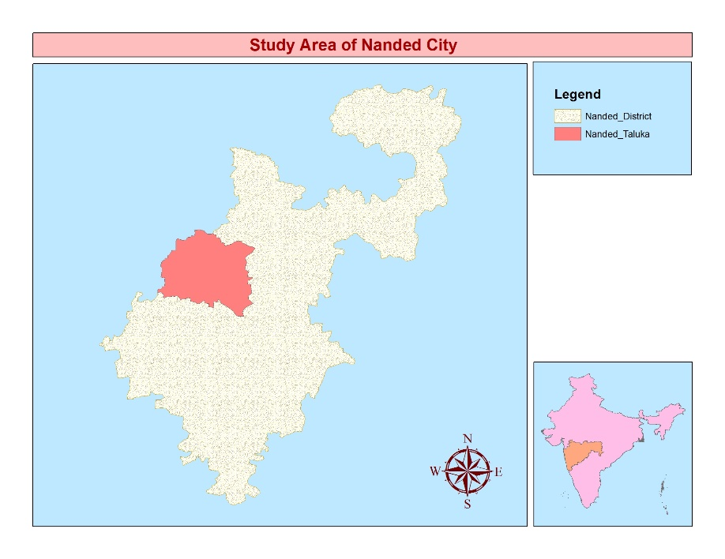
Figure: 1 showing study areas map of Nanded District

The daily temperature date recorded by IMD Pune for period 1969-2007 was collected. From daily time series data annual maximum and minimum and mean temperatures were derived to find out the possible changes in temperature. To determine a yearly variation in temperature series and to identify the warmest and coldest phases of 5 year moving average technique was adopted (Omvir et al., 2013). The linear regression method was used to analyze the behavior of annual maximum and minimum and mean temperatures for 39 years (1969-2007).
Additionally, for better understanding of the observed trends in temperature, anomalies of annual maximum and minimum and mean temperatures were also calculated. Anomalies are more accurate than absolute temperature to describe climatic variability. To analyze anomalies in maximum, minimum, mean temperature, the average annual maximum and minimum and mean temperatures were calculated for entire periods (1969-2007) and it was subtracted from yearly average maximum, minimum and mean temperatures Folland et al., (1990) and World meteorological organization (Lal, 2002) suggested 30 year period as standard period for calculating the average used to analyze anomalies and comparison were made with the result obtained using average from whole dataset. The temperature anomalies obtained were plotted against the linear trends observed were represented graphically. The linear trends value represented by the slope of simple least square regression line with time as the independent variable show the magnitude of rise or fall.

Result and discussion
4.1 Trends and anomalies in annual maximum temperature
The annual maximum temperature trends with 5 year moving average have been presented in figure 4.1 (a). The long term annual maximum temperature at Nanded found to be 34 °C during the study period. Four periods of warming and two periods of cooling during 1969-2007 figure 4.1 (a). Remarkable cooling period was during 1971-1975 figure 4.1 (a). The warmest year was 1971 with annual maximum temperature 35.8° C which was 1.8°C warmer than normal. The coolest years were 1975 with annual maximum temperature 32.7°C when drop was 1.3°C below normal. The linear trends in annual maximum temperature from 1969-2007 indicated the increasing trends. Observed increase was found 0.61º C. The increasing trends observed in annual maximum temperature is good agreement with finding of other urban studies on climate change (Bhutiani et al., 2007, 2010 and Omvir, 2013)

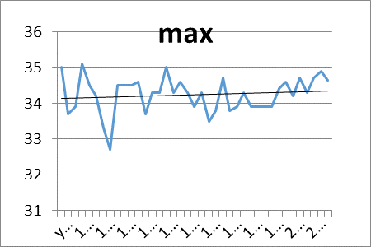
Fig 4.1 (a): Detected maximum temperature

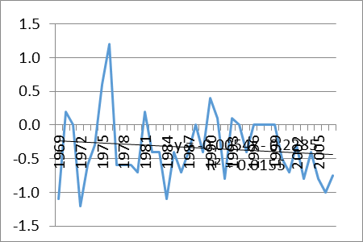
Fig 4.1 (b): anomalies of maximum temperature

4.2 Trends and anomalies in annual minimum temperature
The anomalies of temperature series data for annual maximum temperature have been presented in in figure 4.1(b). Positive anomalies of about 1. 2° C in annual maximum temperature 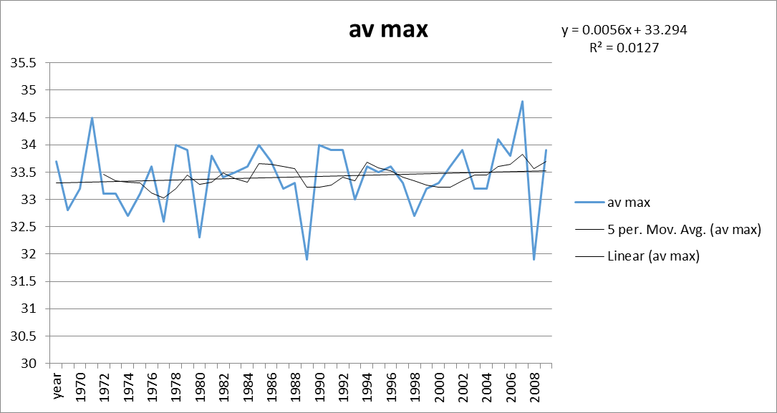was observed in 1976 and negative anomalies of about -1.2°C was observed in 1972.

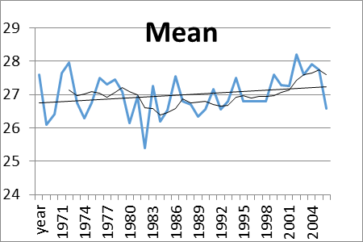
Fig 4.1 (c): Detected mean temperature

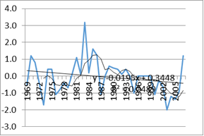
Fig 4.1 (d): Observed anomalies minimum temperature

The annual minimum temperature trends with 5 year moving average have been presented in figure 2 (b). The long term annual minimum temperature at Nanded found to be 20° C during the study period. Remarkable warming period was during 1976-1983 figure 4.2 (b). The warmest year was 2003 with annual minimum temperature 21.7 ºC which was 1.7°C warmer than normal. The coolest year was 1983 with annual minimum temperature 16.5 ºC when drop was 3.5°C below normal. The linear trends in annual minimum temperature from 1969-2007 indicated the increased trends. Observed increased was found –C the anomalies of temperature series data for annual maximum temperature have been presented in figure 4.2 (c) positive anomalies of about 3.2°C in annual maximum temperature was observed in 1983 negative anomalies of about -2.0º C was observed in 2003 of about -2 ºC. It was also observed from figure 4.2 (b) that positive anomalies are more seen. This is due to more urbanization since the population of Nanded increased.

4.3 Trends and anomalies in annual mean temperature
Both annual maximum and minimum temperature affect the annual mean temperature. The annual mean temperature trends with 5 year moving average have been presented in figure 4.3 (a). The long term annual mean temperature at Nanded found to be 27°C during the study period. Four periods of warming and three periods of cooling during 1969-2007 figure 4.1(a). Remarkable cooling period was during 1969-1972 figure 4.1(a). The warmest year with annual mean temperature was 2002 with annual mean temperature 28.2°C which was 1.2°C warmer than normal. The coolest year was 1982 with annual mean temperature 25.4°C when drop was 1.6° C below normal. The linear trends in annual mean temperature from 1969-2007 indicated the increasing trends. The increasing trends observed in annual mean temperature is good agreement with finding of other urban studies on climate change
The anomalies of mean temperature series data for annual maximum temperature have been presented in in figure 4. 3 (b). Positive anomalies of about 1.2°C in annual mean temperature was observed in 1982. It was also observed from figure 4.3 (b) that negative anomalies of about -1.6°C was observed in 2002.

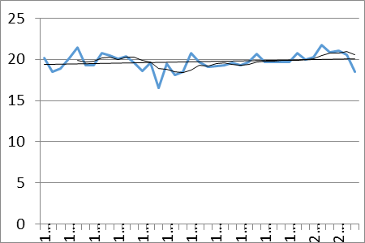
Fig 4.1 (e): Detected minimum temperature

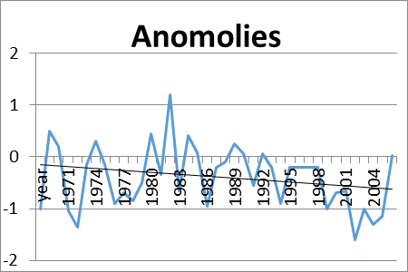
Fig 4.1 (f): Examined anomalies of mean temp

From the above result it is clear that the annual maximum and mean temperature shows increasing trends which are in good agreement with other findings Kothawale et al., (2002); Deshmukh et al., (2013) and Karnewar et al., (2015).

4．Conclusion
The present study analyzed the temperature data for 38 years from 1969 to 2007 at Nanded station for determination of temperature trends. From the above result it is clear that the annual maximum, annual minimum and annual mean temperature shows increasing trends which are in good agreement with other findings. In the linear trends the long term annual maximum temperature at Nanded found to be 34 °C during the study period. Four periods of warming and two periods of cooling were found .the long term annual minimum temperature at Nanded found to be 20° C during the study period. The long term annual mean temperature at Nanded found to be 27°C during the study period. Linear trends of mean temperature of Nanded shows increasing trends. The long term annual minimum temperature at Nanded found to be 20° C during the study period.

Acknowledgement:
We are thankful to the School of Earth Sciences, Swami Ramanand Teerth Marathwada University, Nanded for providing laboratory and library facilities.

Correspondence to:
Karnewar Kailas Research Scholar,
School of Earth Sciences, Swami Ramanand Teerth Marathwada University,
Nanded 431606 (Maharashtra) India.
Emails: kvkarnewar@gmail.com

References
- Alam M and Golam Rabbani MD (2007) Vulnerabilities and responses to climate change for Dhaka; Environ. Urban Vol. 19 pp. 81-97.
- Amit Dhorde, Anargh Dhorde and Alaka Gadgil (2009) Long term temperature trends at four largest cities of India during the twentieth century journal of Indian geophysics union Vol.13 No.2 pp. 85-97.
- Anser Khan, Soumendu Chatterjee, Dipak Bisai and Nilay Kanti Barman (2014) Analysis of change point in surface temperature time series using cumulative sum chart and bootstrapping for Asansol weather observation station, west Bengal, India; American journal on climate change Vol. 3 pp. 83-94.
- Bhutiyani M R, Kale V.S. and Pawar N.J. (2007) Long term trends in maximum, minimum and mean annual air temperature across the Northwestern Himalaya during twentieth century; Climate change 85 159-177.
- Chung U, Choi J and Yun J I (2004b) urbanization effect on the observed change in mean monthly temperature between 1951-1980 and 1971-2000 in Korea ;climate change Vol. 66 pp. 127-136.
- Chung YS, Yoon M B and Kim H S (2004a) On climate variations and changes observed in south Korea; climate change 66 151-161.
- Dash S K and Hunt JC (2007) variability of climate change; current Sci Vol. 96 pp. 782-788.
- De U S and Dandekar MM (2001) Natural disaster in urban areas: Deccan geographer Liu W, Ji C, Zhong J, Jiang X and Zheng Z 2007 Temporal characteristics of the Beijing urban heat island; Theo Appl. Climatol. Vol. 87 pp. 213–221.
- De U S and Prakasa Rao GS (2004) Urban climate trends the Indian Scenario; Indian Geophysics. Vol. 8 pp. 199-203.
- Deshmukh DT and Lunge HS (2013) A study of temperature and rainfall trends in Buldhana District of Vidharbha, India. International journal of Scientific and technology research Vol. 2.
- Edmilson F D, Rozoff Christopher M.,Cotton William R and Silva Dias Pedro L (2007) Interaction of urban heat island and sea breeze circulation during winter over the metro Politian area of Sao Paulo Brazil; Boundf layer Meteorol. Vol. 122 pp. 43-65.
- Folland C k., Millerc, Bader D, Crowe M, Jones, Plummer PP, Richman M., Parker D E., Rogers J. and Sholefield P (1999) Temperature indices for climate extremes; climatic change Vol. 42 pp. 31-43.
- Gadgil A and Dhorde A (2005) Temperature trends in twentieth century at Pune, India; Atmos. Environ. 26B 1-7.
- Godwin O. Atedhore, Peter A. O. Odjugo and alex E. Uriri (2011) Changing rainfall and anthropogenic-induced flooding: Impacts and adaption strategies in Benin city, Nigeria, Journal of Geography and Regional planning vol.4, pp42-52
- Golany GS, (1996) urban design morphology and thermal performance. Atmospheric Environment Vol. 30 No. 3 pp. 455-465.
- Hung T, Uchihama D, Ochi S and Yasuoka Y (2006) Assessment with satellite data of the urban heat island effects in Asian mega cities: Int. J Appl Earth observation and Geoinform Vol. 8 pp. 34-48.
- Intergovernmental panel on climate change (2007) The physical science basis: in contribution of working group 1 to the fourth assessment report of the Intergovernmental panel on climate change (eds) Soloma.
- IPCC (2007) climate change 2007: impact, adaptation and Vulnerary. In: M.L. Parry, OF. Canziani, J.P. Palutik of, P.J. vander Linder and C. E. Hanson. Eds., Contribution of Working group 1, 2 and 3 to the fourth assessment report of the Intergovernmental panel on climate change (IPCC), Cambridge University press, Cambridge.
- IPCC (2007) Climate change 2007: synthesis report. In: R. K. Pachuri and A. Reisinger, Eds. Contribution of Working group 1, 2 and 3 to the fourth assessment report of the Intergovernmental panel on climate change (IPCC), Cambridge University press, Cambridge.
- Karnewar Kailas and Kadam Avinash (2015) Rising temperature trends of Parbhani, Maharashtra, India researcher Vol.7 No.2 pp. 60-63.
- Kinguyum SM, Kilavi P, Omeny E, Muigai and AK, Njogu: climate change indices for Kenya, journal of meterologicy and related sciences.
- Kothawle DR, Revadekar JV and Rupa Kumar (2010) recent trends in pre-mansion daily temperature extremes over Indian. J. Earth Syst. Sci. Vol. 119 pp. 51-65.
- Kumar VP, Bindi M, Crisci A and Maracchi G, (2005) Detection of variation in air temperature at different time scale during the period 1889-1998 at Firenze, Italy; Climatic Change. Vol. 72 pp. 123-150
- Lal D S., (2002) Climatology, Sharda Pustak Bhawan, Allahabad, pp. 6.
- Liu W, Ji C, Zhong J, Jiang X and Zheng Z (2007) Temporal characteristics of the Beijing urban heat island; Theo Appl. Climatol. Vol. 87 pp. 213–221.
- Lu, A, He Y., Zhang, Z., Pang, H. and Gu, J., (2004) Regional structure of global warming across China during twentieth century. Climate research, Vol. 27, pp. 189-195.
- Oke TR, (1982) The Energetic Basis of the Urban Heat Island. Quarterly Journal of the Royal Meteorological Society Vol. 108 pp. 1-24.
- Omvir singh, Poonam Arya and Bhagvan sing Chaudhary June 2013” On rising temperature trends at Dehradun in Doon valley of Uttarakhand, India. Journal on Earth Science. Vol. 122, No. 3 pp. 613-622.
- Population Reference Bureau, 2004. United Nations, World Urbanization Prospects: The 2003 Revision Medium scenari.
- Qin S, D, Manning M, Chen Z, Marquise M, Avert K B, Tignor M and Miller HJ Cambridge University press, Cambridge.
- Rupa Kumar, K. Hingane, LS (1988) Long term variation of surface air temperature at major industrial cities of India, climate change Vol. 13, pp. 287-307.
- Sailor, D. J., Fan, H., (2002) Modeling the diurnal variability of effective albedo for cities Atmospheric Environment Vol. 36 No. 4 pp. 713-725.
- Sajjad SH, Hussain B, Khan MA, Raza A, Zaman B and Ahmed I (2009) On rising temperature trends of Karachi in Pakistan; Climatic Change. Vol. 96 pp. 539-547.
- Sheeba Afsar, Nasir Abbas and Bulbul Jan (2013): Comparative study of temperature and rainfall fluctuation in Hunza-nagar District. Journal of Basic and applied sciences, 2013, 9, pp151-156.
- Tayanc M and Toros H (1997) Urbanization effects on regional climate change in the case of four 20 larger cities of Turkey; Climatic Change Vol. 35 pp. 501-524
- Tigga A and Hema Malini B (2011) Temperature trends in Ranchi city, Jharkhand; Punjab Geogr. Vol. 7 pp. 20–31.
- Trusilova K, Jung M, Churkina G, Karstenes U, Heimann M and Claussen M (2008) Urbanization impacts on the climate in Europe: Numerical Experiment by the PSUNCAR Mesoscale Model (MM5); Journal of Applied Meteorology and Climatology. Vol. 47 pp. 1442-1455.
- World Bank, (2002) World Development Report 2002Building Institutions for Markets, New York: Oxford University Press for the World Bank.
- Yannawar VB, Bhosle AB, Khadke PA and Waghmare PB, (2013), Monitoring Physical Growth Of Nanded City By Using Geoinformatics Techniques, Researcher, Vol. 5 No. 2, pp. 80-86.

4/2/2015

