**Profitability Of Traditional Honey Production In Zuru Emirate, Kebbi State, Nigeria.**

Musa D Baba1, Jamilu S Dabai2, Ishaq D Sanchi1, Amina Y Sabo1

1Department of Agricultural Extension and Management, Kebbi State College of Agriculture Zuru, Nigeria.

2Department of Agricultural Technology, Kebbi State College of Agriculture Zuru, Nigeria.

Email: [musababs1970@yahoo.com](mailto:musababs1970@yahoo.com)

**Abstract:** The study examined the profitability traditional honey production in Zuru Emirate of Kebbi State, Nigeria. Multi-stage sampling technique was used for the study. The first stage involved selecting districts using proportionate random sampling technique, from Danko-Wasagu, Fakai, Sakaba and Zuru Local Government Areas of the Emirate. The second stage involved selecting purposively two villages from each of the districts selected. The third stage involved selecting honey producers using proportionate random sampling technique. Thus, one Hundred and forty five (145) honey producers constitute the sample size for the study. Primary data were collected using interview schedule. Data analysis was carried out using descriptive statistics, farm budgeting technique, financial analysis and Pearson product moment correlation. Result revealed that majority of honey producers in the study area were young and honey production is dominated by males (67.6%). About 69.7% of honey producers in the study area were married. Majority of honey producers in the study area were literate, only 13.8% of honey producers in the study area take honey production as their primary occupation. 42.1% of honey producers in the study area were within the range of 1 – 5 years’ experience in honey production. The budgetary analysis revealed that variable cost amounted to ~~N~~3, 880.46 accounting for 69.1% of the total cost of honey production, while fixed cost amounted to ~~N~~1, 737.31 accounting for the remaining 30.9% of the total cost of honey production in the study area. The total revenue of honey production was ~~N~~27, 817.17 and the net farm income was ~~N~~22, 199.40, indicating that honey production in the study area was profitable. Profitability index (PI) was 0.79; rate of return on investment was estimated at 395.2% and capital turnover (CTO) is 4.95. However, the major problem faced by honey producers in traditional honey production in the study area was inadequate capital, while on the test of hypothesis; no significant relationship was established between socio-economic characteristics of honey producers included in the analysis and profit in honey production. The hypothesis is therefore accepted. It is therefore recommended that loan facilities should be sought by honey producers in the study area to facilitate increase in scale of production and the adoption of modern techniques of honey production.

[Musa D Baba, Jamilu S Dabai, Ishaq D Sanchi, Amina Y Sabo. **Profitability Of Traditional Honey Production In Zuru Emirate, Kebbi State, Nigeria.** *World Rural Observ* 2014;6(3):44-49]. ISSN: 1944-6543 (Print); ISSN: 1944-6551 (Online). <http://www.sciencepub.net/rural>. 6

**Key words:** Profitability, Traditional, Honey, Production, Zuru Emirate.

**1.0 Introduction**

Apiculture is the practice and management of bees in a hive in such a way that it`s developmental stages will be observed and can be manipulated (Oyeleye, 2003). Human, have kept bees for the production and harvest of honey since 4,000 B.C (Halil and Nuray, 2007). Africa is the original home of honey bee, *Apis mellifera*. Africa and other tropical countries in the Caribbean and pacific therefore have highly appropriate habitat for bees. The common Africa honey bee in Nigeria is *Apis* *Mellifera adansonni* (Oluwaseun, 2009). Interest in bee keeping started with hunting and robbing of wild colonies in hollow cavities in trees and rocks (Halil and Nuray, 2007). Until the 19th century, when sugar cane became available, honey was the world most popular sweetener and today, it is still being used as cake, tea, jam and jelly sweeteners (Babatunde *et al*., 2007). Bee keeping is a sustainable form of agriculture that can provide rural people with a source of much needed income and nutrition therefore they have economic reasons to retain the natural habitat or modify it to boost honey product because it has potentials to increase yield such as other agricultural products (Babatunde *et al*.,2007). World honey production was over one million metric tonnes (MT) in 2003. Between the two basic market segments; table (direct consumption) and industrial (cosmetic, pharmaceutical, baking purpose), a major portion of the honey was sold as table honey. In 2003, China was the largest producer of honey in the world, producing over 310,756MT and consumed 146,112 MT. The average customs value was $ 0.52/kg. The Chinese government encourage bee keeping as a means to supplement rural incomes. The U.S was the second largest producer with 77,110MT followed by Argentina (FAO, 2003).

Argentina export over 9 0% of its honey and it’s the second largest exporter of honey behind China. On the world market, the U.S has a difficult time of competing. In order to compete against cheaper foreign honey, niche and specialty market for honey and other product have been successful developed in the U.S and Hawaii and further market needs to be developed to be competitive with lower priced honeys from China and Argentina. Although no world wax figure are available, the FAO estimate that approximately 17,000 – 30,000MT of wax was produced in 2003,although honey are produced in Nigeria but there is no fact and figure that can indicate the quantities of honey produced in Nigeria like the above mentioned countries (Oluwaseun, 2009).

**1.1 Objective of the study**

The objective of the study is to examine the profitability of traditional honey production in Zuru Emirate of Kebbi State, Nigeria. The specific objectives include: (1) Describe the socio-economic characteristics of traditional honey producers in the study area; (2) Determine the profitability and profitability index of traditional honey production in the study area; (3) Determine the rate of return and capital turnover of traditional honey production in the study area; (4) Identify problems associated with traditional honey production in the study area.

**1.2 Hypothesis**

There is no significant relationship between socio-economic characteristics of honey producers (Age, Sex, Marital status, educational background and Honey Production Experience) and profit in honey production in the study area.

**2.0 Methodology**

Zuru Emirate is one of the four Emirates in Kebbi state. The Emirate comprise of four Local Government Areas (LGAs) namely; Danko-Wasagu, Fakai, Sakaba and Zuru. The emirate is located within latitudes 11o and 12o N and longitudes 4o and 5o E of the equator (KBSG., 2003). The state was carved out of the former Sokoto State in 1991; the Emirate is located in the extreme South-eastern part of the state and covers an area of approximately 9,000 square kilometres. The estimated population of the Emirate is 582, 106 people (NPC, 2006). The average rainfall of the area is between 1025mm and 1050mm/annum. Mean temperature range between 310C and 380C, the rainy season is between April to October. The climatic condition of the area is characterized by hot and wet seasons as in the tropics; the months of November to February are the hamattan period (Girma, 2008).

Zuru Emirate comprises of four Local Government Areas (LGAs) namely; Danko-Wsasgu, Fakai, Sakaba and Zuru, with eight, four, two and six administrative districts, respectively. Multi-stage sampling technique was used for the study. The first stage involved selecting districts using proportionate random sampling technique. The second stage involved selecting purposively two villages from each of the districts selected; this is because of the concentration of honey producers in the villages selected. The third stage involved selecting honey producers using proportionate random sampling technique. Thus, One Hundred and forty five (145) honey producers constitute the sample size for the study. Interview schedule was used to collect primary data from honey producers. The data for the study was collected with the help of trained enumerators. Descriptive statistics such as frequency counts and percentage farm budgeting technique and financial analysis was used to analyse the data, while Pearson Product Moment Correlation was used to test the stated hypothesis.

**2.1 Models Specification**

The budgeting technique employed was the net farm income. The difference between the gross revenue (GR) and total cost (TC) gives the net revenue (NR), net farm income (NFI) is expressed as:

**NFI = GR – TC………………………..……….. (1)**

Where

NFI = Net Farm Income

TC = (TVC + TFC) =Px X

GR =Px Y

GR = Gross Return

Py = Unit Price of Output

Y = Quantity of Output

Px = Unit Price of Input

X = Quantity of Input

TC = Total Cost (~~N~~)

TFC = Total Fixed Cost (~~N~~)

TVC = Total Variable Cost (~~N~~)

Profitability index (PI) is the net farm income (NFI) per unit of gross revenue (GR) (Olukosi and Erhabor, 1988).

Therefore, **PI =** **NFI ………………..……. (2)**

**GR**

Where, PI = Profitability Index

NFI = Net Farm Income

GR = Gross Revenue

Rate of Return on Investmentis a performance measure used to evaluate the efficiency of an investment or to compare the efficiency of different investments. Rate of return on investment is net farm income divided by total cost of investment and is usually expressed as a percentage or ratio. Rate of return on investment is expressed as follows;

**RRI (%) = NFI x 100% …………..…………… (3)**

**TC**

Where, RRI = Rate of Return on Investment

NFI = Net Farm Income

TC = Total Cost

Capital Turnoveris a ratio of total revenue to total cost. Generally it measures the efficiency of a business and provides information about the business capability to deliver a return per naira of its capital investment. Capital turnover is expressed as follows;

**CTO = TR …………………………..……….. (4)**

**TC**

Where, CTO = Capital Turnover

TR = Total Revenue

TC = Total Cost

Pearson Product Moment Correlation is a method used to measure the strength of linear relationship between variables x and y. r can range from +1, i.e. perfect positive correlation where the variables change value in the same direction as each other, to -1, i.e. perfect negative correlation where Y decreases linearly as X increases. A coefficient of zero or near zero generally indicates no correlation.

**rxy**= N**∑XY-(∑X)(∑Y)**

**√ (N∑X2-(∑X)2 √(N∑Y2-(∑Y)2 …….. (5)**

Where,

Y = Profit in honey production

X1 = Age

X2 = Sex

X3 = Educational level

X4 = Marital status

X5 = Honey production experience

N = Number of observations

**3.0 Results and Discussion**

**3.1 Socio-economic Characteristics of Traditional Honey Producers**

Table 1 showed that 37.2% of honey producers are within the age bracket of 31 – 40 years, 27.6% are within the range of 41 – 50 years, 24.8% are within the age of 20 – 30 years, while the remaining 10.4% are between 51 and above years. This indicated that majority of honey producers in the study area are within the active and productive age. This tallied with the findings of Abere and Lameed (2012) that majority of honey producers in Yewa North are within the age range of 31 – 40 years. Majority (67.6%) of honey producers were males while the remaining 32.4% were females. This indicated that honey production in the study area is dominated by males. This could be as a result of the primitive system of honey production which predisposes only the men to practice. The result further revealed that 69.7% of honey producers in the study area were married while 30.3% were single. The above finding is in line with the findings of Onyekuru (2010) that majority of honey producers in Enugu were males and married.

**Table 1: Socio-economic Characteristics of Traditional Honey Producers**

|  |
| --- |
| **Variable Frequency Percentage** |
| **Age (Years)**  20 – 30 36 24.8  31 – 40 54 37.2  41 – 50 40 27.6  51 and above 15 10.4  **Total 145 100**  **Sex**  Male 98 67.6  Female 47 32.4  **Total 145 100**  **Marital Status**  Married 101 69.7  Single 44 30.3  **Total 145 100**  **Educational Background**  No formal education 36 24.8  Primary education 33 22.8  Secondary education 60 41.4  Tertiary education 16 11.0  **Total 145 100**  **Primary Occupation**  Civil Servant 16 11  Trading 36 24.8  Farming 73 50.4  Honey Production 20 13.8  **Total 145 100**  **Honey Production Experience (Years)**  1 – 5 61 42.1  6 – 10 54 37.2  11 – 15 21 14.5  16 – 20 9 6.2  **Total 145 100** |

Source: Field Survey Data, 2014.

Result further revealed that 75.2% of honey producers in the study are had one form of formal education or the other ranging from primary, secondary or tertiary education as against 24.8% that had no any form of formal education. Those that attended secondary schools were ranked highest with 41.4%, followed by those that attended primary schools with 22.8% and those that attended tertiary education with 11%. This result is supported by the findings of Onyekuru (2010) that majority of honey producers in Enugu are educated. The primary occupations of honey producers in the study area were farming, trading, studentship and civil service with 50.4%, 24.8%, 13.8% and 11%, respectively. This is combining with traditional honey production (secondary occupation) as additional means of income generating activity for livelihood. Result also showed that about 42.1% of honey producers in the study area had experience in production between 1 – 5 years, 37.2% 6 – 10 years, 14.5% had between 11 – 15 years and 6.2% had 16 – 20 years’ experience in honey production. Years of experience in any form of production helps in determining the accuracy in decision making and in allocation of scarce resources wisely. Farmers with more experience would be more efficient, have better understanding of the environment and market situations

**3.2 Budgetary and Financial Analysis of Traditional Honey Production**

Result of budgetary analysis for an average honey producer in the study area is presented in Table 2. The analysis revealed that variable cost amounted to ~~N~~3, 880.46 accounting for 69.1% of the total cost of honey production, while fixed cost amounted to ~~N~~1, 737.31 accounting for the remaining 30.9% of the total cost of honey production in the study area. The total revenue of the honey production was ~~N~~27, 817.17 and the net farm income was ~~N~~22, 199.40, indicating that honey production in the study area was profitable. This is contrary to the findings of Abere and Lameed (2012) in their study of production and profitability of honey in Yewa North, Nigeria, reported that fixed cost accounted for 91.5% while variable cost accounted for the remaining 8.5% of the total cost of production. The net farm income was ~~N~~188, 567.40, indicating that honey production in Yewa north was highly profitable. This could be attributed to the fact that honey producers in Yewa North are using the modern techniques of honey production as against the traditional system practiced by honey producers in Zuru Emirate.

Profitability index (PI) was 0.79, indicating that for every naira earned as revenue, 79 kobo returned to honey producer as net income. PI of 0.79 is likely to improve honey production by increasing the profit of honey producers. The rate of return on investment was estimated at 395.2%. Hence, for every naira invested on honey production generated 395.2% net income to an average honey producer. This implied that, to maximize profit accruing from honey production, there has to be a concerted effort directed at increasing the scale of production. Olukosi and Erhabor (1988) opined that the higher the rate of return on investment the better the success of farm business. The capital turnover (CTO) is greater than 1, which is 4.95, implying that for every naira invested about ~~N~~4.95 kobo returned to honey producer as revenue.

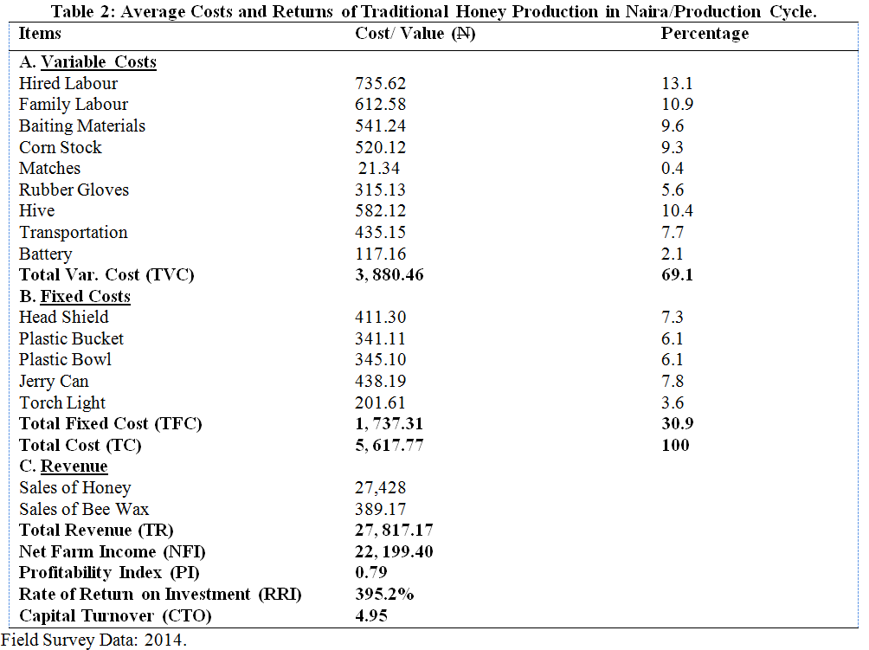

**3.3 Problems of Traditional Honey Production**

Table 3 showed that the major problem of traditional honey production in the study area was inadequate capital as it was ranked first. Others include lack of modern facilities 2nd, bee sting 3rd, inadequate extension services 4th, theft and predators 5th and disease incidence was ranked 6th. Inadequate capital as a major problem in traditional honey production could be the reason why honey producers could not adopt the modern system of honey production in the study area. This consequently limits the expansion of the enterprise.

**Table 3: Problems of Traditional Honey Production**

|  |
| --- |
| **Parameters Frequency Percentage Ranking** |
| Inadequate Capital 58* 33.3 1st  Lack of Modern Facilities 37* 21.3 2nd  Bee Sting 26* 14.9 3nd  Inadequate Extension Services 20* 11.5 4rd  Theft and Predators 19 10.9 5th  Disease Incidence 14 8.1 6th |

Source: Field Survey Data, 2013. *Multiple Responses

**3.4 Test of Hypothesis**

There is no significant relationship between socio-economic characteristics of honey producers and profit in honey production in the study area. The test of hypothesis revealed that age (r=0.050), sex (r=0.051), marital status (r=0.001) and honey production experience (r=0.076) of honey producers were found to have positive but non-significant relationship with profit in honey production. Educational background (r=-0.138) was found to have negative and non-significant relationship with profit in honey production. Thus, the hypothesis is thereby accepted.

**Table 4: Relationship between Socio-economic Characteristics of Honey Producers and Profit in Honey Production**

|  |
| --- |
| **Variables r-value** |
| Age (X1) 0.050  Sex (X2) 0.051  Marital Status (X3) 0.001  Educational Background (X4) -0.029  Honey Production Experience (X5) 0.076 |

Source: Field Survey Data, 2014.

**4.0 Conclusion and Recommendations**

Based on the findings of the study, it could be concluded that honey production in the study area was profitable and the major problem in traditional honey production in the study area was inadequate capital.

Honey producers in the study area should be encouraged to adopt modern system of honey production so as to take advantage of other products like propolis, royal jelly and bee wax to increase profitability. Loan facilities should be provided to the honey producers in the study area to facilitate increase in scale of production. Government should organize training, workshop and seminars for the honey producers in the study area towards modern and effective management of honey production in the study area.

**Acknowledgement:**

Authors are grateful to the management of College of Agriculture Zuru, Kebbi State for their support and cooperation towards the conduct of this research.

**Correspondence to:**

Musa D Baba

Department of Agricultural Extension and Management, College of Agriculture Zuru, PMB 1018. Kebbi State, Nigeria.

[musababs1970@yahoo.com](mailto:musababs1970@yahoo.com)

**References**

1. Abere S. A. and Lameed G. A. (2012). “Production and Profitability of Honey in Yewa North, Nigeria” *Mediterranean Journal of Social Sciences,* 3(15) 182-187.
2. Babatunde, R.O., E.O. Olorunsanya, O.A. Omotesho, and B.I. Alao. (2007). “Economics of honey production; Implication for poverty reduction and rural development” *Global approaches to extension practice,* 3(2): 23-29.
3. Food and Agriculture Organization of the United Nations (FAO), (2003). International trade in Non-Wood Forest Products: An overview. Misc/93/11 Working Paper. FAO, Rome. http://www.fao.org/docrep/X5326E/X5326E00.htm [accessed February 1, 2010].
4. Girma, S.A. (2008). Agro-climatology of Millet Production in Desert Fringe Zone of Nigeria, A Case Study of Kebbi State. Unpublished M.Sc dessertation. Federal University of Technology Minna, Niger state. 97Pp.
5. Halil, K and Nuray K. (2007). “Factor affecting honey production in Apiculture in Turkey” *Journal of Applied Science Research,* (3): 983-987.
6. Kebbi State Government (KBSG), (2003). Official Diary. Directorate of Information, Kebbi State, Nigeria, 26Pp.
7. National Population Commission (NPC), (2006). Provisional Census Figure of Nigeria 2006.
8. Olukosi, J. O. and P. O. Erhabor (1988). *Introduction to Farm Management Economics: Principles and Applications.* Zaria: Agitab Publishers Limited, Third Edition. 114 Pp.
9. Oluwaseun T. O, (2009). Economics of Honey production in Ijebu Division of Ogun State. Unpublished Msc. Thesis, Olabisi Onabanjo University, Ogun State, Nigeria.
10. Onyekuru A. N., E.C Okorji1 and N S Machebe (2010)*. “*Profitability Analysis of Honey Production in Nsukka Local Government Area of Enugu State, Nigeria” *Asian Journal of Experimental Biological science,* 1(1):166-169.
11. Oyeleye, B. (2003). Honey production in Nigeria. A Three-day Beekeeping and Honey Production Training Workshop conducted by Centre for Bee Research and Development (CEBRAD), Ibadan, held at the Faculty of Agriculture, University of Ilorin.

8/3/2014