Mineral composition, Antioxidants and Antimicrobial activities of freshwater algae (spirogyra genus) from Jomo Kenyatta University of Agriculture and Technology (JKUAT).

Rutikanga Adrien¹, Leonard Mwangi Gitu², Nathan Oyaro³

¹ Department of Applied Chemistry, College of Science and Technology, University of Rwanda, Kigali, Rwanda
² Department of Chemistry, Faculty of Sciences, Jomo Kenyatta University of Agriculture and Technology, Nairobi, Kenya
³ Department of Physical Sciences and Mathematics, school of Science, Maasai Mara University, Narok, Kenya
rutikad@gmail.com

Abstract: Dry biomass of algae is a good source of nutrients and biologically active substances, which in the recent years attracted the interest of the specialists in their search for natural, ecologically and healthy sound foods for the animals. The aim of the present study was to determine the mineral composition, the antioxidant and antimicrobial activities of the dry biomass of freshwater algae (spirogyra genus). The freshwater algae were collected in February and March 2010 at the pond of Jomo Kenyatta University of Agriculture and Technology (JKUAT). The Mineral content by acid digestion (HNO₃:HClO₄) in mg /100g was : 387.22 ± 38.72 Ca, 384.99 ± 39.17 Mg, 244.44±17.10 Fe, 2.53 ± 0.48 Cu, 7.25 ± 0.55 Zn, Phytochemical screening of methanolic and water extract showed the presence of alkaloids, steroids, flavonoids, tannins, terpenoids, but only the water extract showed the presence of total reducing sugars. The content of phenolic compounds and tannins was 10.63 ± 0.05g gallic acid/100g of extract and 0.399 ± 0.02g tannic acid/100g of dried sample and the level of flavonoids was 6.86 ± 0.14g Quercetin/100g of extract. The algal antioxidant activity expressed in a dose able to decrease the initial DPPH concentration by 50%, or IC₅₀ was 0.078 mg/ml. The antimicrobial activity of methanolic extract was efficient against Escherichia coli and Candida albicans. The water extract didn’t show any activity. The freshwater algae used in this study were identified as Spirogyra nitida associated Spirogyra weberi both filamentous green algae. The mineral composition showed that they contain minerals which give the possibility of using them as food for fish and also by human as food supplement. The levels of Ca, Mg and Fe were very high as the Spirulina and Chlorella are used as food supplement. The strains showed a relative antioxidant and antimicrobial activities.
[Rutikanga A., Mwangi GL.Oyaro N. Mineral composition, Antioxidants and Antimicrobial activities of freshwater algae (spirogyra genus) from Jomo Kenyatta University of Agriculture and Technology (JKUAT). World Rural Observ 2014;6(2):86-91]. ISSN: 1944-6543 (Print); ISSN: 1944-6551 (Online). http://www.sciencepub.net/rural. 14

Key words: Spirogyra, chemical composition, mineral composition

1. Introduction
Algae are simple organisms that are mainly aquatic and microscopic. Spirogyra is a filamentous algae, its cells form long, thin strands that, in vast numbers, contribute to the familiar green, slimy ‘blanket weed’ in ponds. Seen under the microscope, each filament consists of an extensive chain of identical cells. Spirogyra is the most common genus of Zygnemataceae and member of the freshwater algae. It exhibits the greatest diversity of the 12 to 13 genera recognized in this family of green algae (Transeau 1951, Randhawa 1959, Kadlubowska 1972). More than 400 species are presently recognized based on morphological characteristics: filament width, chloroplast number, type of endwall, details of the conjugation process, and size, shape and ornamentation of zygospores. All algae contain proteins, carbohydrates and lipids in varying proportions. They contain chlorophyll and make their food by photosynthesis.
The aim of the present study is to determine the mineral composition, the antioxidants and antimicrobial activities of the dry biomass of freshwater algae (spirogyra genus).

2. Materials and methods
2.1 Algal materials
The freshwater algae were collected from a pond in Jomo Kenyatta University of Agriculture and Technology (JKUAT) in small plastic container first for identification by Dr LukhobaCatherine, taxonomist from University of Nairobi. Algal samples for analysis were collected using a small funnel of net attached to a metal frame, then air dried.
2.2 Methanolic Extraction
The powdered of dried algae mixed with methanol was allowed to stand for 72 hours with shaking. It was then filtered through Whatman filter paper No. 1 and distilled using rotary evaporator (Bibby Sterilin Ltd, RE 100B, UK) at 60ºC. The resulting extracts were then subsequently labelled as methanol extracts and preserved in airtight containers until further use (Alanis et al., 2005).
2.3 Water extraction
Dried sample were mixed with hot distilled water in a conical flask for 1 hour. The mixture was first filtered through double layered muslin cloth and then centrifuged. The supernatant was then filtered through Whatman No.1 filter paper and then preserved aseptically in an airtight bottle at 5 ºC for later use.
2.4 Minerals analysis
Samples for mineral analysis were dissolved in hydrochloric acid and analyzed through Atomic Absorption Spectrophotometer (AAS) following the procedures described by (AOAC, 1995); (Gupta, 1999).
2.5 Phytochemicals analysis
Qualitative analysis was carried out to ascertain the presence of the different phytochemicals activities as described by (Trease and Evans, 1989) and (Harborne, 1998) before quantitative analysis was done. The various extracts were tested for reducing sugars, terpenoids, steroids, flavonoids, tannins and alkaloids, total phenols.
2.6 Antioxidants activities
The radical-scavenging activity of the methanolic extract was determined using diphenyl picryl hydrazyl radical (DPPH) according to (Ayoola et al, 2006).
2.7 Antimicrobial activities
The extracts were tested for antimicrobial activity using the Agar Well Diffusion Method (Ruiz, 2009).
2.8 Statistical analysis
Each data point was obtained by making at least 3 independent measurements. The results were expressed as mean ± SD. Statistical analysis were done using Microsoft Excel.

3. Results and Discussion
3.1 Mineral content of dried algal biomass by acid digestion
The Figure 1 showed the results of minerals content from acid digestion. The Calcium showed the highest content for acid digestion, 387.22 ± 38.72 followed by 384.99 ± 39.17 mg/100g for Mg, then 244.44±17.10 mg/100g and 39.84 ± 0.52 mg/100g for Fe, followed by 7.25 ± 0.55 mg/100g and 0.40 ± 0.02 mg/100g for Zn and finally 2.53 ± 0.48 mg/100g and 0.32 ± 0.04 mg/100g for Cu. The high value obtained of Ca from acid digestion is in range of other freshwater algae like Spirulina 700 mg/100g and Chlorella 266mg/100g (Mason, 2001). The value obtained for Mg is also in the range of Spirulina 400 mg/100g and Chlorella 333.3 mg/100g (Mason, 2001).

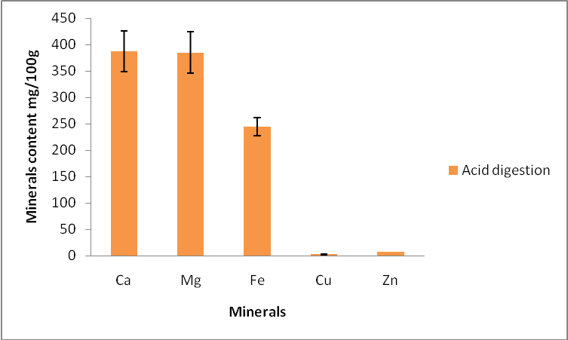
Figure 1: Mineral content of dried algal biomass by acid digestion

Acid digestion using acid mixture gives good results of minerals found in the dried algal biomass as shown in Figure 1 Calcium is one of the most important elements in the diet because it is a structural component of bones, teeth, and soft tissues and also essential in many of the body's metabolic processes. According to the results, calcium level are higher than other minerals in the Spirogyra genus but less in comparison with Spirulina as shown in table 1. The magnesium levels are as high as calcium content because the Magnesium is found in chlorophyll in green algae. It is even higher than other green algae (Chlorella) as shown in table 1. Iron is an essential component of haemoglobin, transporting oxygen in the blood to all parts of the body. It also plays a vital role in many metabolic reactions. Iron deficiency can cause anaemia resulting from low levels of haemoglobin in the blood. Iron deficiency is the most widespread mineral nutritional deficiency both in Britain and worldwide. The iron level are high (244 mg/100 g) which is more than the iron content of Spirulina a well know in food supplement as shown in table 1. It means that spirogyra can be a provider of iron supplement for food.

Table 1: Comparison of minerals levels in freshwater algae
Minerals | Freshwater algae
 | Spirogyra mg/100g | Spirulina¹  mg/100g | Chlorella¹ mg/100g
Ca | 387.22 ± 38.72 | 700 | 266.67
Mg | 384.99 ± 39.17 | 400 | 333.3
Fe | 244.44 ± 17.10 | 100 | 93
Zn | 7.25 ± 0.55 | 3 | 2.33
Cu | 2.53 ± 0.48 | 1.2 | -

3.2 Phytochemical analysis of methanolic and aqueous extract
Qualitative evaluation of phytochemicals was aimed at simply identifying the presence of individual group of substances. The presence of phytochemical compounds suggests the pharmacological activities of algal biomass (table 1).
Phytochemicals act as antioxidants, suppressors of tumor growth, anti-mutagens, enzyme modulators, chemical inactivators, and free radical scavengers. It is also reported that they have anti-aging properties. Therefore, their presence in algal extracts may justify the potential medicinal value of the freshwater algae. Flavonoids and tannins have been reported to have antimicrobial and antioxidant properties Stephen et al. (2009).
The total flavonoid contents were 6.863 ± 0.14 g quercetin equivalent/100g of extract while the total tannins were formed to be 0.399 ± 0.02 g tannic acid/100g of dried sample. Total phenol compounds, as determined by Folin Ciocalteu method, are reported as gallic acid equivalents were 10.63 ± 0.05 g gallic acid/100 g of extracts.

Table 2: Phytochemicals screening of extracts
active principle | methanolic extract | aqueous extract
Alkaloids | + | +
Steroids | + | +
Flavonoids | + | +
Tannins | + | +
Terpenoids | + | +
Total reducing sugars | - | +
- : Absent
+: Present

The result obtained in the current study are in the same range with (Ghasemi et al., 2009) who evaluated the total phenolic content of the citrus spp. samples (based on Folin Ciocalteu method) and flavonoids content (based on colorimetric AlCl₃ method). He found that the total phenolic content varied from 6.65 to 39.68 g gallic acid equivalent/100 g of extract while the flavonoids content varied from 0.03 to 3.11 g quercetin equivalent/100g of extract.
Phenols and polyphenolic compounds, such as flavonoids, are widely found in food products derived from plant sources, and they have been shown to possess significant antioxidant activities (Van Acker et al., 1996).
Alkaloids have proved to have pharmacological properties such as hypotensive activity, anticonvulsant activity, antiprotozoal, antimicrobial and antimalarial activities (Mallikharjuna et al., 2007). They also have pronounced physiological effects particularly on the nervous system (Stephen et al., 2009). Plants have the limitless ability to synthesize phenols or their derivatives. These phenolic compounds give the vegetable an astringent taste. They also bind proteins and may lower protein digestibility and quality as well as reducing the risk of heart disease and certain types of cancers.
3.3Antioxidant activities
Free radical scavenging activity of methanolic extracts of dried algal biomass was confirmed in this study. Figure 2 illustrates the percentage of Innhibition of DPPH versus concentration curve of methanol extracts. These results were compared with the standard curve of ascorbic acid (Figure 2). The decrease in absorbance as the concentration increase was taken as a measure of the extent of radical scavenging activity( Kizhiyedathu et al., 2005).

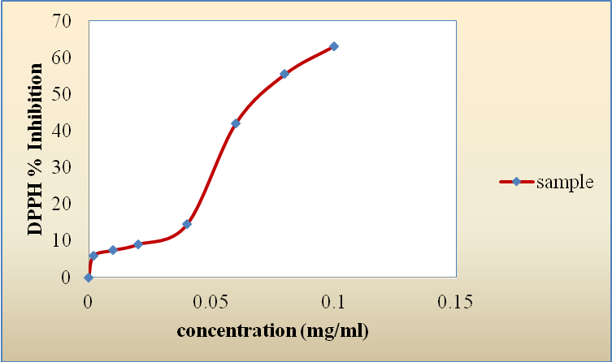
Figure 2: Free radical scavenging of methanolic extract.

The results of the free radical scavenging effect of Spirogyra showed an IC₅₀ of the sample of 0.078 mg/ml (Figure 2) which is lower in comparison to IC₅₀ of Ascorbic acid (0.008 mg/ml) The IC₅₀ is the concentration of extract which corresponds to 50% of inhibition. The free radical scavenging activity is valued according the percentage of inhibition of DPPH radical which is beyond 50% according to our results. The methanolic extract was found to have the maximum activity of 63.16 % at concentration of 100 μg/ml. The result of the free radical scavenging effect of Ascorbic acid was 96.96% at a concentration of 20 μg/ml. This good antioxidant activity of Spirogyra might be attributed to the presence of phytochemicals such as flavonoids (Kumar et al, 2005). Phenolic compounds are commonly found in plants, including algae, and have been reported to have a wide range of biological activities including antioxidant properties (Cox et al, 2010).
3.4 Antimicrobial activity
The antimicrobial activity of methanolic extract and aqueous extract was carried out by determining the zone of inhibition diameter. Only methanolic extract showed zone of inhibition against E.coli and C. albicans as shown on plates 1 and 2. The two extract did not show any inhibition against S. aureus as shown in Figure 3.
The highest zone of inhibition of methanolic extract against E.coli was 19.83 mm which corresponds to the concentration of 40 mg/ml. For C. albicans, the highest zone of inhibition was 15 mm which corresponds to the concentration of 80 mg/ml. In comparison to the positive controller, zone of inhibition were found by most of them against E. coli. Only two of them were active against S. aureus. Four out of eight of controllers show zone of inhibition against candida albicans. For the negative controls (water and methanol), there was no inhibition zone as shown on plates 3 and 4. It means that the inhibition of methanolic extract shown against e-coli and C. albicans was due to the extracts and not of the solvent.
The antimicrobial activity of Spirogyra genus is in accordance with other freshwater algae as Spirulina and Chlorella (Mason, 2001). Algae are generally known to have antimicrobial activities and the result showed that the methanol extract possessed a strong antimicrobial activity against gram-positive (E. coli) and fungi (C. albicans) as did antibiotics (standards) ( plate 5 and 6). However, the exact mechanism and the compound responsible for the antimicrobial activities were not investigated.

1: 1.57
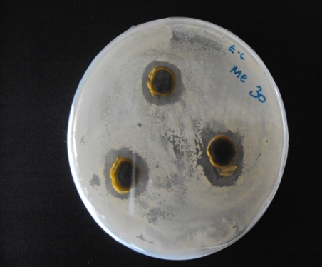
1: 1.70
Plate 1 : Inhibition of methanolic extract (30 mg/ml) against E. coli

1: 1.57
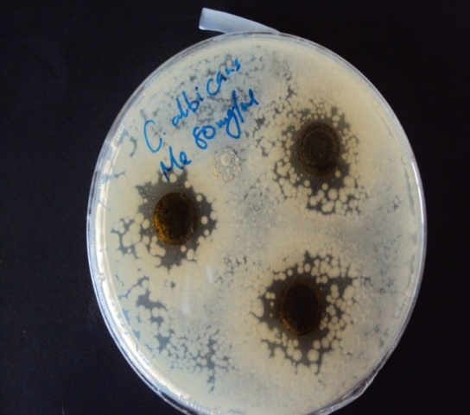
Plate 2: Inhibition of Methanolic extract (80 mg/ml) against C. albicans

1: 1.70
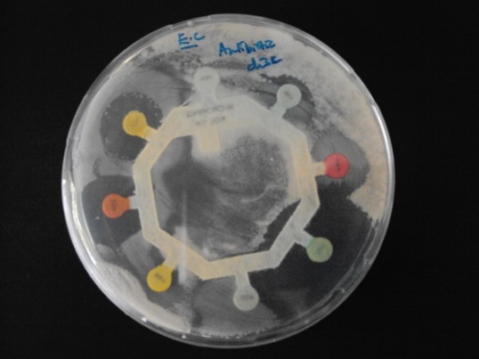
Plate 3 : Inhibition of positive control against E coli.

1: 2.12
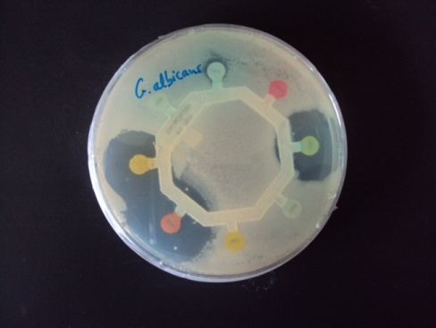
Plate 4 :Inhibition of positive control against C. albicans

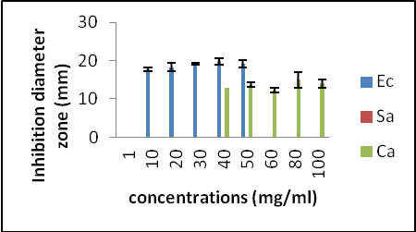
Figure 3: Antimicrobial activity of methanolic extract

Conclusion
The freshwater algae used in this study were identified as Spirogyra nitida associated Spirogyra weberi both filamentous green algae. The mineral composition showed that they contain minerals which give the possibility of using them as food for fish and also by human as food supplement. The levels of Ca, Mg and Fe were very high as the Spirulina and Chlorella are used as food supplement.
The antioxidant and antibacterial activities of the freshwater algae found in this study were explained by the presence of fatty acid and phytochemicals such flavonoids, tannins which are phenolic compounds.

Acknowledgements
I would like to thank the Student Financing Agency of Rwanda (SFAR) for the funds and Paul Karanja, chief technicians in the department of Food Science (JKUAT) for his assistance in conducting analyses.

Correspondence to:
Rutikanga Adrien
Department of Applied Chemistry
Faculty of Science
College of Science and Technology
University of Rwanda .Kigali, Rwanda
rutikad@gmail.com

References
- Alanis, AD., Glazada, F., Cervantes, JA., Tarres, J. and Ceballas, GM. (Antibacterial properties of some plants used in Mexican traditional medicine for the treatment of gastrointestinal disorders. Journal of Ethnopharmacology 2005: 100, 153 – 157.
- AOAC. Association of Official Analytical Chemists. Official Methods of Analysis, (14th edn.) 1995. Washington D. C, USA.
- Ayoola, G. A., Sofidiya, T., Odukoya, O. and Coker, HAB. Phytochemical screening and free radical scavenging activity of some Nigerian medicinal plants. Journal of Pharmaceutical Science and Pharmaceutical Practice 2006: 8, 133- 136.
- Cox, S., Abu-Ghannam, N. and Gupta, S. An assessment of the antioxidant and antimicrobial activity of six species of edible Irish seaweeds. International Food Research Journal 2010:, 17, 205-220.
- Ghasemi, K., Ghasemi, Y. and Ebrahimzadeh, MA. Antioxidant activity, phenol and flavonoid contents of 13 citrus species peels and tissues. Pakistan Journal of Pharmacy and Science 2009: 22, 277- 281
- Gupta, PK. Soil, plant, water and fertilizer analysis. Agro Botannica, J.N.Vyas Nagar, Bikaner 1999. pp 487
- Harborne, JB. Phytochemical Methods. A guide to modern techniques of plant analysis. (3rd edn.) Springer (India) Private Limited, New Delhi. 1998. pp. 5 12, 124 126.
- Kadłubowska, JZ. Chlorophyta V. Conjugales: Zygnemaceae. Zrostnicowate. In: Starmach K, Siemin´ska J(eds) Flora słodkowodna Polski, 12A. PWN, Krakow 1972 : pp 431
- Kizhiyedathu, PS., Ananthasankaran, J. and Chami, A. In vitro studies on antioxidant activity of lignans isolated from sesame cake extract. Journal of the Science of Food and Agriculture 2005: 85, 1779- 1783
- Kumar, RS., Sivakumar, T., Sunderam, RS., Gupta, M., Mazumdar UK., Gomathi, P., Rajeshwar, Y., Saravanan, S., Kumar, MS., Murugesh, K. and Kumar, KA. Antioxidant and antimicrobial activities of Bauhinia racemosa L. stem bark. Brazilian Journal of Medical and Biological Research, 2005: 38 , 1015- 1024.
- Mallikharjuna, PB., Rajanna, L. N., Seetharam, YN. and Sharanabasappa, GK. (Phytochemical Studies of Strychnos potatorum L.f.- A Medicinal Plant. E Journal of Chemistry 2007: 4, 510 - 518.
- Mason, R. (2001). Chlorella and Spirulina: Green supplements for balancing the body. Alternative and Complementary Therapies, 7, 161 165. http://www.liebertonline.com/doi/pdf/10.1089/107628001300303691 retrieved 25/05/2009
- Randhawa, MS. Zjgnemaceae. Indian Council of Agricultural Research, New Delhi, 1959: pp.478.
- Ruiz, V.M L., Silva, P. G. and Laciar A. L. Comparison of microplate, agar drop and well diffusion plate methods for evaluating hemolytic activity of Listeria monocytogenes. African Journal of Microbiology Research, 2009: 3, 319- 324.
- Stephen, UA., Abiodun, F., Osahon, O. and Ewaen, E. (2009). Phytochemical analysis and antibacterial activity of Khaya grandifoliola stem bark. Journal of Biological Sciences, 9, 63- 67.
- Transeau, EN. The Zjgnemataceae. The Ohio State University Press, Columbus, Ohio, 1951: pp.327.
- Trease, G.E. and Evans, WC. Pharmacognosy. (13th edn.) Bailliere Tindall Ltd. London, 1989.: pp 528.
- Van Acker, SA., van Den Berg, DJ., Tromp, M. N., Griffioen, DH,Van Bennekom, WP., van der Vijgh, WJ. and Bast, A. Structural aspects of antioxidant activity of flavanoids. Free Radical Biology and Medicine. 1996: 20, 331-342.

6/13/2014

