Diseases of a (Claries gariepinus) Fresh Water Fish from River Kaduna, Nigeria.

*Emere M C * D M Dibal

*Department of Biological Sciences, Nigerian Defence Academy P M B 2109 Kaduna, Nigeria
*Phone number of the corresponding author: +2348065482681
* E-mail of the corresponding author: otichiemere@yahoo.com

Abstract: Investigations into the diseases of Claries gariepinus from river Kaduna, Nigeria was carried out. The diseases found include Head and Lateral line erosions, skin lacerations, fin rots, velvet and ich: The bacterial diseases occurred more among the fishes but the ich disease was not commonly encountered. The female were more infected than the male whilst larger and heavier fishes had more disease infect.
[ Emere M C, D M Dibal. Diseases of a (Claries gariepinus) Fresh Water Fish from River Kaduna, Nigeria. World Rural Observ 2014;6(2):77-81]. ISSN: 1944-6543 (Print); ISSN: 1944-6551 (Online). http://www.sciencepub.net/rural. 12

Keywords: Diseases, Claries gariepinus, River Kaduna.

Introduction:
Fresh water fish constitute 41% of known species of fish. They dwell in fresh waters like Lakes and severs where salinity is as less as 0.05% fish are delicate area tures which are highly susceptible to (freshwater) fish diseases (Karthik, 2010). Fish is the most easily affordable source of animal protein to the average Nigerian family (Haruna 2006) yet Nigerian fresh water surface area have not succeeded in attaining fish food sufficiency (FAO, 1990).
Generally fish has great resistance to diseases so long as they are not weakened by bad treatment, unsuitable food, lack of oxygen and other adverse influences (Duijin Jnr. 1973). Most of the tropical fish diseases are due to bacterial, fungal, protozoa or parasitic infections. External factors such as lack of oxygen or chemical poisoning and physical wounds can also result in inflations diseases can manifest and affect different organs of fish and as a result affect fish productivity in many ways (Paperna, 1980), devalue their gesthetic quality and lower their economic profitability (Okorie, 1972).
The negative Impact of diseases cause profound pathological changes and often lead to the death of the fish thereby leading to enormous economic loss to the fish industry (Greets and Olleverier, 1996). Some Disease cause significant public concern about the edibility of infected fish. These diseases may be caused by some piscire, parasites which are transmissible to fish eating animals (Klinger and Francis Floyed, 2002). Common diseases of fish have been studied and reported in developed countries (Hoffman, 1976) but documented information of fish diseases in Nigeria is scanty (Bichi and Dawaki, 2010) Clarias gariepinus is common in rivers throughout Africa is highly priced and is in the catches of fishermen throughout the year in Kaduna, Nigeria. Studies on the biology, nutrition and growth have been carried out (Eyo and Olatunde, 2001, Banyighi et al, 2001, and Ovic 2002, Ojutiku 2008). Various diseases are associated with Claries gariepinus in the wild and cultured environment (Snebashinge 1995). The few works carried out on fish diseases include the works of Okageme et al (1986) on the diseases of cultured fish in lake Kainji, Nigeria Obiekeze et al (1988) studied the diseases of Chrysicthys nigrodigitatus from the Cross River estuary, Oniye Anunne (1993) worked on common fish diseases which Paperna (1996) studied parasites, infections and diseases of fishes in Africa. Diseases could constitute significant economic losses in fish production.
It is therefore important to study diseases conditions under natural conditions since it serves as a basis for providing needed information on the potential risk of diseases under intense management.
This paper therefore examines the diseases of the Clarias gariepinus from the freshwater, river Kaduna in Nigeria.

Materials and Methods:
Study Area: River Kaduna is centrally located in Kaduna city Nigeria, it runs from North to South with local industries and human habitation on both sides. It receives effluents from the industries and is used for irrigation and farming.
Investigations on diseases of Clarias gariepinus a freshwater fish from river Kaduna were conducted from March to June live fish samples were collected from Gamji gate location along river Kaduna. A total of 128 fish specimens were bought from the landings of the local fishermen fishing in river Kaduna. They were transported in plastic buckets to the development of Biological Sciences Department, Nigeria Defence Academy Kaduna. Total and standard length measurements were carried out following the methods of Olatunde (1989). The fish weights were measured to the nearest gram using a weighting method balance (Model AE 166 Sartonium GABH). Sexes were determined by observing the presence or absence of papilla. The male has a papilla close to the anal opening.
The external surfaces or skins, fins and gills were visually examined with the aid of a hand lens for pathological signs of external diseases or lesions. The gill lamellac were examined in wet mounts under BW magnification for abnormalities using a compound microscope. Diseases found were identified or diogonised using the identification guides of Herman (1990) Wissman (2006) and Karthik (2010).

Results:
A total of 128 fish specimen made up of 85 females and 43 males were examined for disease during the 4 months it invest (18.8%) out of the 85 females and 7 (16:27%) out the 43 males were infected by different diseases Table 1 summaries the percentage occurred of the diseases in males and females of Claries gariepinus. The rate of disease infection was more in females. The different types of diseases diagnosed include those caused by protozoans bacteria and fungil. The bacterial diseases were represented by fin rots (plate…) and Head and (Plate…) others include a parasitic disease, velvet and a protozoam. The intensity of each type of disease among specimen of C. garigs examined is shown in Table 2. This table reveals that bacterial diseases occurred most, followed by disease caused by protozoa. Among the protozoa disease “ich” or white spot disease was very commonly encountered as small white spots on the skin and fins. Table 3 revealed that fishes with stol length between 34 and 39cm and weight between were infected more by piscine diseases than others. The distribution of the diseases in the different parts of the body showed that the Skin was most affected by diseases followed by the gills etc.

Table 1 Disease infection in male, female of C. gariepinus in R. Kaduna.
Sex | No of fish examined | No of fish infected | Percentage (%) of infected
M | 43 | 7 | 16.27
F | 85 | 16 | 18.82

Table 2 Intensity of diseases among spines of C. gariepinus from River Kaduna
Diseases | No of fish examined | Total No of fish infected | No of fish infected by each diseases | % Intensity infection
Fin/Tail Rot | 128 | 23 | 5 | 21.73
“Ich” | 128 | 23 | 8 | 34.78
Lateral line erosion | 128 | 23 | 4 | 17
Velvet | 128 | 23 | 2 | 8.69
Lacerations | 128 | 23 | 4 | 17.39

Table 3 Variation of disease infection with weights in C gariepinus in River Kaduna.
Range in Weight (gm) | No of fish examined | No of fish infected | Percentage (%) of infected
20.5 – 24.0 | 17 | -
24.5 – 29.0 | 20 | -
29.5 – 34.0 | 19 | 3 | 15.78
34.5 – 39.0 | 21 | 6 | 28.57
39.5 – 33 | 20 | 5 | 25.0
44.5 – 49.0 | 16 | 5 | 31.25
49.5 – 54.0 | 15 | 4 | 26.66
 | 128

Table 4 Variation of disease infection with length in C gariepinus in River Kaduna.
Range in Length (gm) | No of fish examined | No of fish infected | Percentage (%) of infected
13.0 – 17.0 | 27
17.0 – 22.0 | 23 | 2 | 8.69
22.0 – 27.0 | 25 | 4 | 16.0
27.0 – 32.0 | 24 | 5 | 20.83
32.0 – 37.0 | 16 | 7 | 43.75
37.0 – 42.0 | 13 | 5 | 38.46
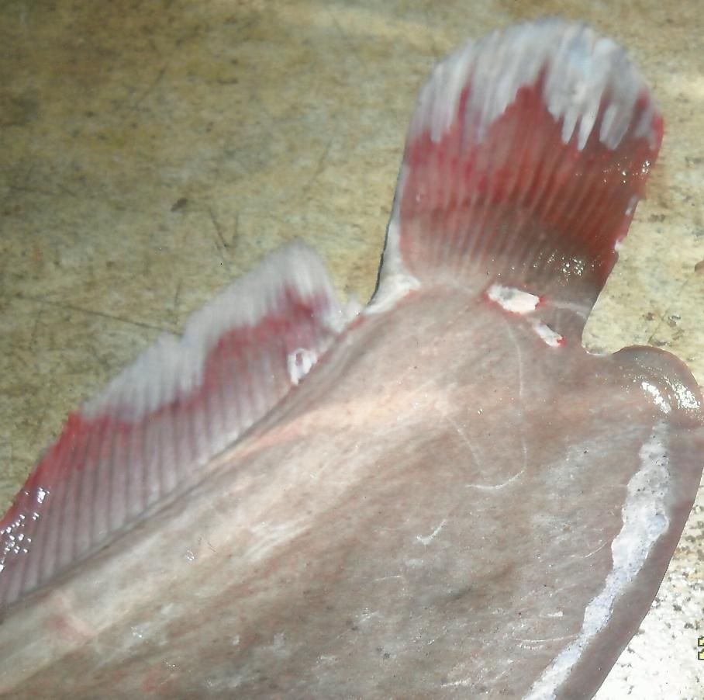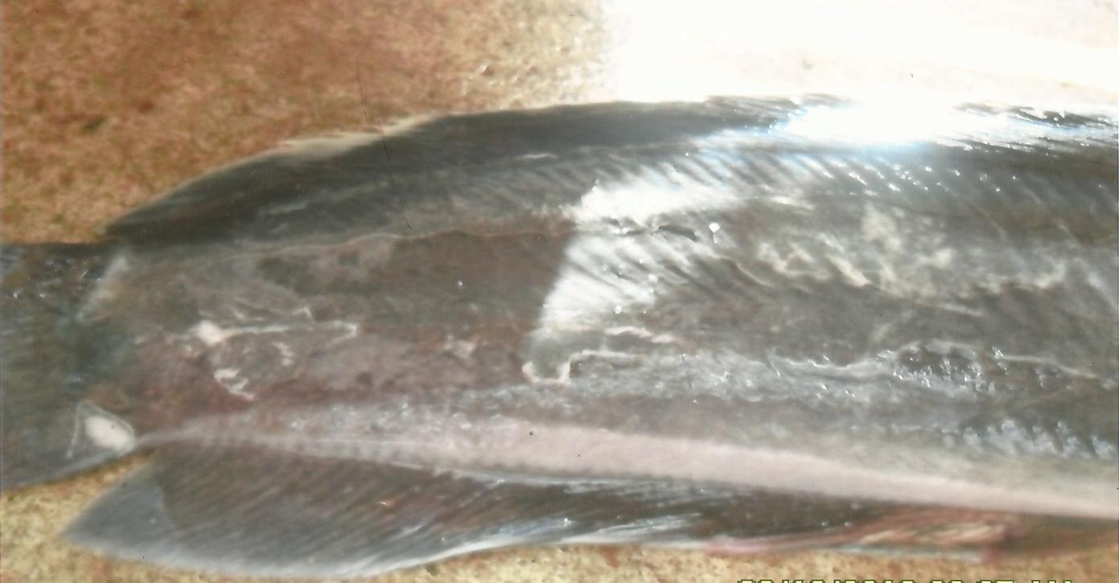
Plate 1a tail/fin Rot Plate 1b White spot or “ich

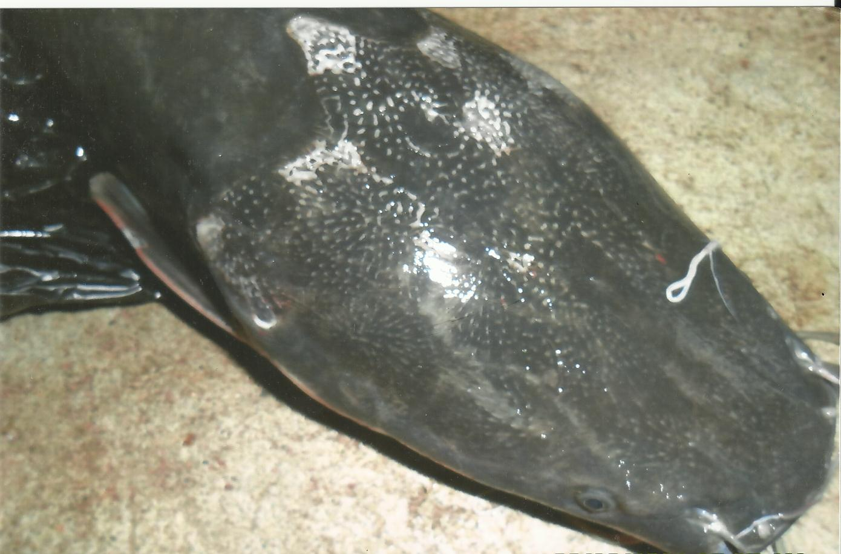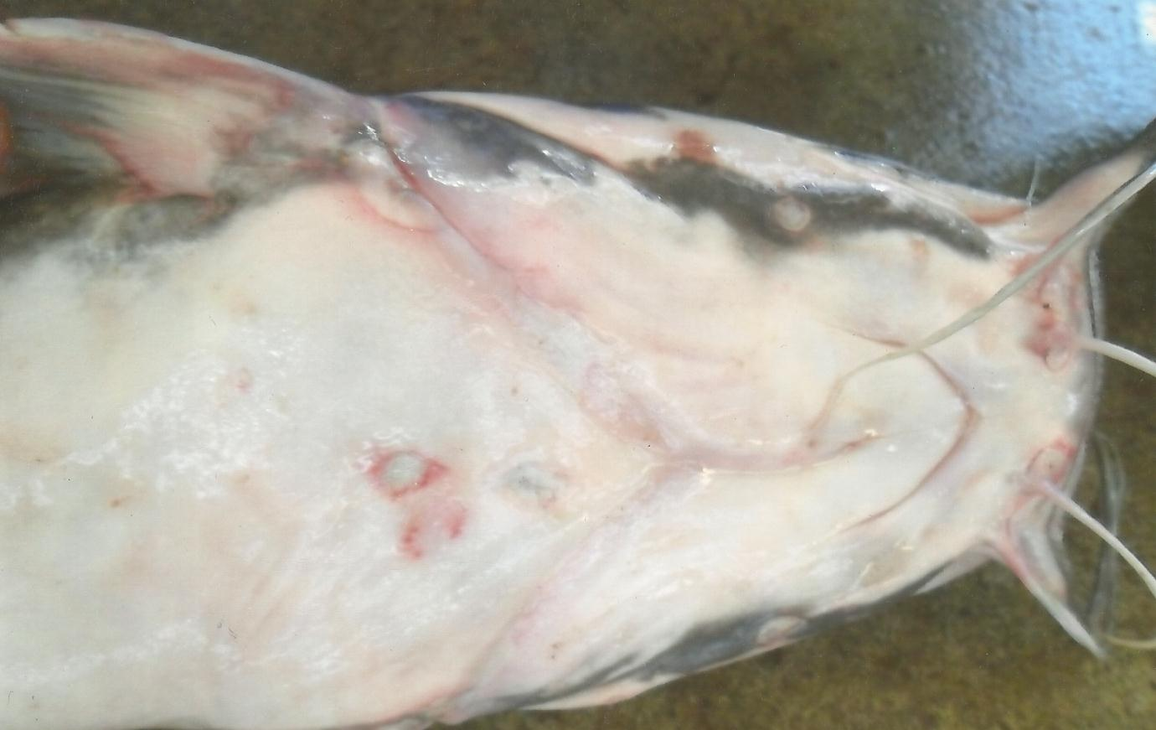
Plate 1c Erosion skin lesion Plate 1d Velvet Disease

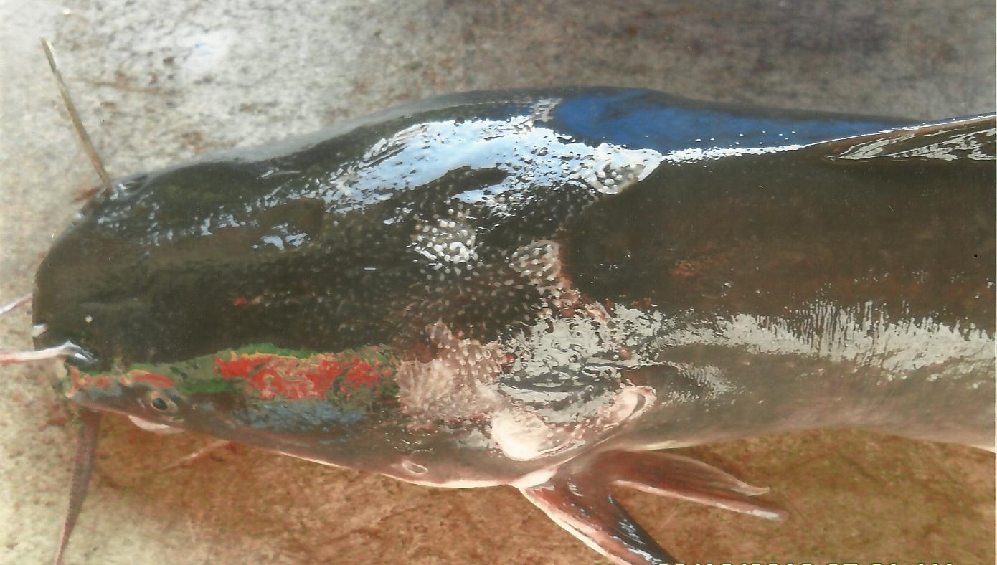
Plate 1e Head and Lateral line erosion

Discussion
The aquatic environment is constantly polluted from a variety of sources (Mastan et al 2009). Fish are highly susceptible to freshwater fish diseases in the natural water continuously being contaminated due to increased anthropogenic activity and industrial exploitation (Chandra – vathi and Reddy 1996). As such environmental changes in natural waters may impose high stress level in a fish thereby predisposing it to disease infection. According to Herman (1990) these factors are involved in every potential disease situation namely susceptible hosts, pathogenic organisms and predisposing environmental conditions. The investigation revealed that claries gariepinus in River Kaduna was infested by different diseases. These diseases were caused by bacteria, and protozoa parasite. Herman and Mayer (1990) had listed bacterial infections, fungi, parasite and toxic substances among others as natural causative agents of fish kills. Karthik (2010) had observed that most of the tropical fish diseases are due to bacterial, fungal, and protozoan infections. The protozoan disease “ich” was commonly encountered during the investigation. Mastan et al (2009) had reported that most of the commonly encountered fish parasites are protozoans. Herman and Mayer (1990) had noted that Ehthyophthirius multifilis a protozoan parasite that causes “ich” is an ubiquitous freshwater parasite. The disease “ich” or “white spot disease” appears as white spots called ichthyophthriasis or sand grain or gravel (Eissa 2004) or raised lesions along the body wall or skin, gills and fins. It is an obligate parasite capable of causing massive mortality within a short time and has a morbidity rate of up to 100% (Osman et al 2009) causing great economic loses in fish farms and this has been a problem to aquarists for generations. The rate of disease infections was more in females than males. This could be because the females harbor more parasites which could lead to diseases infections.
Emere (2001) had made such observations on some claries spices in river Kaduna. Ugwuozor (1987) had noted that these differences could be due probably to their feeding pattern. Larger and heavier fishes appeared to be infected more by the diseases. Probably because the larger and heavier fishes provided greater surfaces for infection, similar observations has been made by Okaeme (1989). The rate of disease infection of Clearies gariepinus in river Kaduna was low. This could be due to less crowded condition for the fish in the river. Hoffman and Bauer (1971) had reported that the prevalence of disease and parasites of freshwater fish under natural condition was usually low because of reduced risk of contact between parasites and the fish in an expanse of water. There were corrosive skin lesions on the body of the fish specimens due to disease attaches. Ribelin and Migakl (1975) had reported that fish disease could cause obvious pathological lesions ranging from lesions of the skin to that of the body vital organs.

References
- Bamyighi, H.A., Oniye, S.J. Balogun, J. K and Auta, J. (2001) Feed utilization and growth of juvenile catfish (Clarias gariepinus) fed on heat treated Barbara Groundnut (Vitgna subteranea verde (L) meal. Journal of Tropical Biosciences (1) 55 – 61.
- Bichi, A.H. and Dawaki, S.S. (2010) A survey of ecto parasites on the gills skin and fins of Oreochromis niloticus at Bagauda fish farm, Kano Nigeria. Bayero Journal of Pure and Applied Sciences, 3(1) 83 – 86.
- Chandravathi V.M and Reddy, S.L.N. (1996) lead nitrate exposure: in carbohyorates metabolism of fresh water fish J. Environ. Bio. 19 (1) 75 – 79.
- Duijin (Jnr.) C.V (1973) Diseases of the Parasites of some species of Clarias in river Kaduna Nigeria J. Sci. Engr. Tech. 8 (4) 3551 – 3559
- Eyo A.A, Olatunde A.A (2001) protein and Amino acid requirement of fish with particular reference to fisheries society of Nigeria (FISON) Lagos, Nigeria 58 – 71 pp.
- F.A.O (1990) National Review for Aquaculture development in Africa: Nigeria FAO Fisheries Circular No 770, 29:19.
- Grets, A, Ollevier, F.(1996) Endo parasitic helminthes of white spotted rabbit fish (saganus sutor) of the Kenyan Coast Belgium Journal of Zoology, 26:21 – 36.
- Haruna, A.B (2006) studies on the aspect of socio-economic factors influencing fish farming in Adamawa State, Nigeria – Journal of Arid Zone Fisheries 2:1.
- Herman, R.L. (1990). The role of infections agents in fish kills Resource Publication, 77:45 – 99.
- Herman R.L. and Meyer F.P. (1990) fish kills due to natural causes. Resource Publication 77:41 – 44.
- Hoffman, G.L and Bauer, O.N. (1971) fish parasitology in Water Resources. A review of reservoir fisheries and limnology. Special publication 18: 495 – 511.
- Hoffman, G.L (1976) fish diseases and parasites in relation to the environment. Fish Pathology, 10: 123 – 128.
- Karthik, N. (2010) freshwater fish diseases http://www.buzzle.com/artciles/reshwater-fish-diseases.html.
- Klinger R and Francis Floyol R. (2002). Introduction to fresh water fish parasites. Fisheries and Aquatic Science Department Floride Co-operative extension services.
- Mastan, S. Priya, G.L and Babu, EG; (2009) Hematological profile of clarias batrachus (Linn.) exposed to subhethal doses of lead nitrate. The Internal Journal of Hematology. ISSN. 1540 – 2649.
- Obiekezie, A.I. Moller H. and Anders, K (1988) Diseases of the African Esturine cat fish, Chrysicthys nigrodigitatus (Lacepede) from the Cross River estuary. Nig. Journal of Fish Biology, 32: 479 – 484.
- Ojutiku, R.O. (2008) Comparative survival and growth rate of clarias gariepinus and Heterouarias Hatchlings on live and frozen Dephnia Pakistan Journal of Nutrition, 4: 527 – 529.
- Oakaeme, A.N. Obiekezie, A.I. Rehmen, J. and Mark O.A. (1986) Infections and diseases of cultured fresh of Lake Kainji Area. Nigeria Journal of Fish Biology, 32:479 – 481.
- Okorie, D.O. (1972) Some major unsolved aspect of the dynamics of African fisheries as related to the question of national development and management. African Journal of Tropical Hydrobiology and Fishers Vol. 2 p. 32.
- Olatunde A.A. (1989) Some aspects of the biology of synodotis schall (Blocch-Schneider) in Zaria, Nigeria Journal of Aquatic Sciences, 4:49 – 54.
- Oniye S.J. and Annune, P.A. (1993) Common Fish diseases, prevention and control. Proceedings of the national workshop in fisheries extension delivery.
- Ovie S.I. and Ovie S.O. (2002) Fish larve rearing: The effect of pure/mixed zooplankton and artificial diet on the growth and survival of clarias gariepinus (Lineaus, 1758) larvae. Journal of Aquatic Sciences 17(1) 67 – 73.
- Paperna, I. (1980) Parasite, infection and diseases of fishes in Africa. An update. CFA Technical Paper No. 31 Rome, FAO pp 220.
- Ribelin W.E and Migakl, G. (1995) The pathology of fishes. University of Wisconsin Press Wisconsin. Pp 1004.
- Subashinghe, R. (1995) Disease control and Health management in Aquaticulture F.A.O Aquaculture Newsletter, 9:8 – 11.
- Ugwuozor G.N. (1987) A survey of helminth parasite of fish in Imo River, Nigerian Journal of Applied Fisheries and Hydrobiology 2:25 – 30.
- Wissman, M.A. (2006) Freshwater fish parasites: http://www.exoticpetiet.net/aqua/parasites.html.

5/16/2014

