The signiﬁcance of some ruminant animals as a contributor to livestock national greenhouse gas (GHG) emissions nowadays and in the near future under a changing climate

Fahim M. A.*¹; Kadah M. S.² and Abou Hadid A. F. ²

¹ Central Laboratory for Agricultural Climate, P.O. Box 296 Dokki, 12411 Giza, Egypt

² Climate Change Information Center, Giza, Egypt
ali.mohamed73@gmail.com

Abstract: The rearing of animals for domestic consumption invariably lead to the production of methane as a product of digestion. This study investigated the emission of GHG (e.g. methane and NO₂) from Egyptian buffalo during a last decade and projection period towards 2050. Approach used: animal population numbers were obtained from a national organization for animal census; estimation of methane was based on the IPCC Tier 1 methods. Available statistics show a significant increase in the numbers of buffalo. Buffalo heads increased to be 4.2m in 2012. Linearized models form was used to estimate animal numbers in 2050, which will be 7.4m heads. Mapping of buffalo population over governorates are created. Buffalo has emission 48.2% in 2012 from total GHG emission from livestock sector. Total annual emissions of CH₄ from buffaloes due to enteric fermentation and manure management revealed an increase from 186.5 Gg in year 1999 and 217.6 Gg in year 2005 to 233.2 Gg in 2012. While, in 2050, total annual GHG emission will increased to be 478.3 Gg with 51% increase than 2012. Regression analysis for projected trends of GHG du to manure management under chaining climate were obtained. The emission of methane from livestock has relatively stabilized in the past few years. This is expected to rise with the aggressive nature of people demands intervention in the agricultural sector with the special emphasis on expansion of cattle and goat population. To stem this expected increase in methane emission requires the formulation and adaptation of appropriate mitigation measures. This calls for further investigation of the factors affecting enteric fermentation and manure management.
[Fahim M. A.; Kadah M. S. and Abou Hadid A. F. The signiﬁcance of some ruminant animals as a contributor to livestock national greenhouse gas emissions nowadays and in the near future under a changing climate. World Rural Observ 2014;6(1):60-66]. ISSN: 1944-6543 (Print); ISSN: 1944-6551 (Online). http://www.sciencepub.net/rural. 12

Key Words: GHG, buffalo, enteric fermentation, manure management, regression analysis.

1. Introduction
Animal production in Egypt represents about 30% of total agricultural production. The majority of farms are family farms of less than one hectare, with mixed livestock and crop production. (Khelifa (2012). As estimated in the SADS-2030 (2010), livestock production currently represents some 24.5 % of the agricultural GDP. In general, under Egyptian conditions meat production is more important than milk production, with cows, buffaloes, sheep, goats and camels being the main animal types. The study of Khelifa (2012) provides long-term time-series data on the detailed development of Egyptian livestock population by sub-sectors and analyzes the most important trends, generally showing that during the last 20 years the stocking numbers have increased sharply (except for camels).
FAO (2013) report revealed that, global livestock sector contributes a significant share to anthropogenic GHG emissions, but it can also deliver a significant share of the necessary mitigation effort with emissions estimated at 7.1 gigatonnes CO₂-eq per annum, representing 14.5 percent of human-induced GHG emissions, the livestock sector plays an important role in climate change.
Beef and cattle milk production account for the majority of emissions, respectively contributing 41 and 20 percent of the sector’s emissions.
Ruminant animals are one of the most significant sources of greenhouse gases because of the CH₄ and CO₂ excreted by the animals. About 25% of global methane emissions originate from animal usbandry, mainly from enteric fermentation (80%) and also from manure (20%) (Olesen et al., 2006 and Amon et al., 2006). Therefore, this inventory aims to estimate GHG from buffaloes during last decade and in future incoming decades in Egypt.

2. Materials and methods
2.1. Study area and data sources
The study area is the buffalo production governorates in Egypt depend on the Agricultural Economics Affairs Sector data, Ministry of Agriculture and Land Reclamation data of 2013.
Available statistics used for the numbers of livestock of different kinds in 1999 to 2012 (Agricultural Economics Affairs Sector 2013). Table (1) showed the total number of buffalo for the last decade in Egypt.

Table (1): total number of animal in main governorates in Egypt during 1999, 2005 and 2012
Main production governorates | Time series
 | 1999 | 2005 | 2012
 | (1000s)
Behaira | 321 | 374 | 425
Gharbia | 252 | 291 | 279
Kafr El-Shiekh | 224 | 244 | 237
Dakahlia | 164 | 191 | 244
Sharkia | 292 | 338 | 435
Monufia | 272 | 302 | 351
Kayobia | 166 | 196 | 211
Giza | 167 | 157 | 176
Beni Souf | 139 | 173 | 159
Fayoum | 115 | 142 | 212
Menyia | 350 | 390 | 212
Asyut | 205 | 245 | 211
Sohag | 254 | 300 | 242
Qena | 211 | 241 | 213
Country total | 3330 | 3835 | 4165
Data source: Agricultural Economic Statistics Sector, Egypt, 2013.

2.2. Mapping of animal number over governorates
This dataset forms part of the old GRID Egyptian database that was developed with ArcGIS® 10.1 software. Data converted from row data to digital map. The analysis was supported by a team of CLAC (Central Laboratory for Agriculture Climate, ARC, Egypt) experts. The livestock data set which was digitized at a scale 1:600,000 with coordinate system World Geodetic System (WGS) 1984, deals with total number per governorate and animal category number per governorate.
2.3. Statistical analysis for prediction buffalo population number
Several methodologies have been used to estimate livestock populations and patterns at disaggregated levels. Statistical modeling of animal numbers and time series (production years) data was represented as y = f (x), where y is predicted number of animal, x is time series (production years). Correlations between (y) and (x) were studied to significantly determine (0.0≤R2≤1.0). Linearized models form for predicted number (y) versus the production years (x) during the periods of 1999 to 2012 and projection period of 2050.
2.4. Emissions from livestock and manure management
Livestock production can result in methane (CH₄) emissions from enteric fermentation and both CH₄ and nitrous oxide (N₂O) emissions from livestock manure management systems.

2.4.1 GHG emission estimation method
Basic characterization for Tier 1 method is likely to be sufficient for most animal species in most countries as recommended by IPCC (2006). This method depends on the annual population data from official national statistics (Agricultural Economics Affairs Sector 2013).
Methane is produced in herbivores as a by-product of enteric fermentation, a digestive process by which carbohydrates are broken down by micro-organisms into simple molecules for absorption into the bloodstream. The amount of methane that is released depends on the type of digestive tract, age, and weight of the animal, and the quality and quantity of the feed consumed. Estimating CH₄ produced during the storage and treatment of manure, and from manure deposited on pasture. The term ‘manure’ is used here collectively to include both dung and urine (i.e., the solids and the liquids) produced by livestock.

2.4.2 Emission Factors (EF) for enteric fermentation and manure management
Emission factors “Tier 1” IPPC 2006 methodology approach for methane emissions from enteric fermentation for buffalo for developing countries (i.e. Egypt) is 55 kg CH₄ head⁻¹ yr⁻¹. Whereas, Emission factors from manure management of No₂ for buffalo for temperate environment (i.e. Egypt) is 5 kg CH₄ head⁻¹ yr⁻¹ (IPPC 2006).

3. Results and discussion
3.1 Animal population data
Available statistics show a significant increase in the numbers of buffalo. The numbers of buffalo heads increased from 3.33m to 4.2m in 1999 and 2012, respectively (Fig. 1a). While, in 2007, buffalo population reached 3.9m heads, representing 167% of their number in 1980 (SADS-2030, 2010). Around 32.2% of the buffalo population is in Middle Delta region, against 22.4% in the Middle Egypt region.
3.2 Linear regression for projected animal population numbers
The following model presented in Fig. (1b) is the exponential equation as a result of regression analysis for individual animal category trends and time series (years) presented in following equations:

y = 6E-09e^{0.0135x}, R² = 0.7228
Where y is predicted number of buffaloes, e is exponential function. Correlations between (y) and (x) were studied to significantly determine (R²≤0.723) which have big fluctuation correlated relationships.

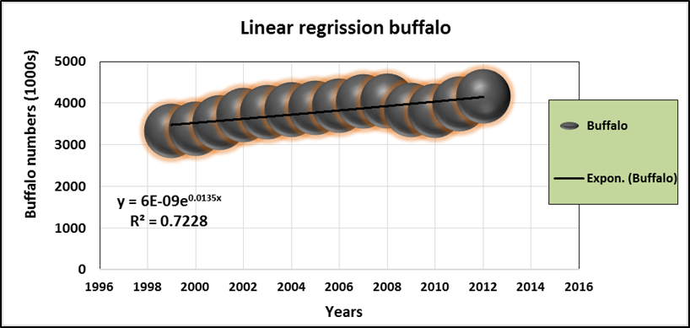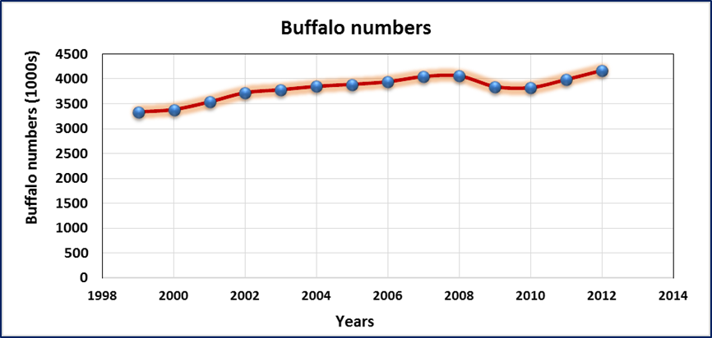
((b
((a

Figure (1): (a) is buffalo population trends and (b) is linearized models form for analysis of total numbers using time series of 1999-2012.

3.3 Estimation of buffalo population for projection period towards 2050
For production governorates, Behaira, Sharkia, Monufia, Gharbia and Dakahlia will be largest regions for total animal population depend on statistical analysis models in this study. Projection number for main production governorates and animal were illustrated in Tables (2). Studies around the world imply that the future impacts of climate change are of great concern (McCarthy et al 2001).

Table (2): Predicted number of buffalo* (1000s) in Egypt for projected period of 2050.
Regions | Behaira | Gharbia | Kafr El-Shiekh | Dakahlia | Sharkia | Monufia | Kayobia | Giza | Beni Souf | Fayoum | Menyia | Asyut | Sohag | Qena
Projected period of 2050 | (1000s)
 | 872 | 572 | 487 | 501 | 891 | 720 | 433 | 362 | 326 | 435 | 435 | 433 | 496 | 437
Country total | 7398

3.4 Mapping of buffalo for 2012 and projection period towards 2050
Available statistics show a significant increase in the numbers of buffalo. The numbers of buffalo heads increased from 4.2m to 7.4m in 2012, and projected period of 2050, respectively (Fig. 1a
and 1b). While, in 2007, buffalo population reached 3.9m heads, representing 167% of their number in 1980 (SADS-2030, 2010). Around 32.2% of the buffalo population is in Middle Delta region, against 22.4% in the Middle Egypt region.

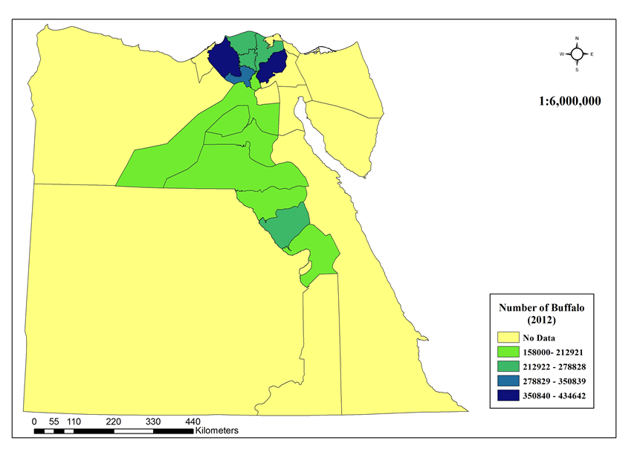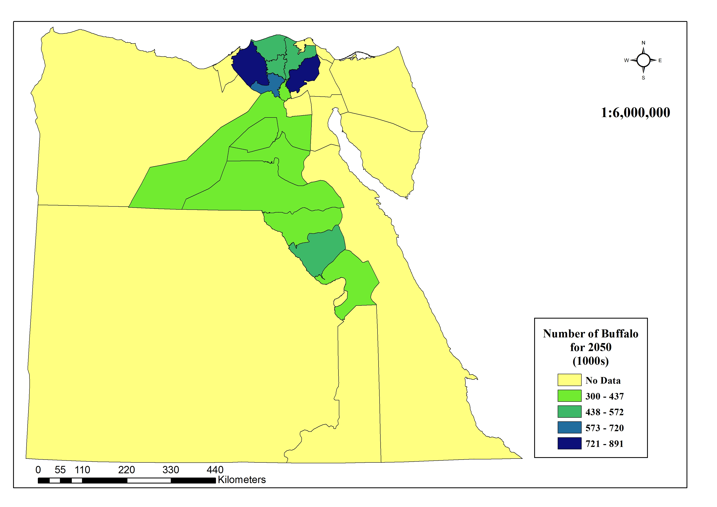
((b
((a

Figure (2): (a) is annual animal numbers of buffalo for main governorates in Egypt in 2012 and (b) is for projection periods towards 2050.

3.5 GHG emission for total animal for current periods of 1999-2012 and future projection period towards 2050
Three interval periods were selected to compare GHG emission form buffaloes in Egypt (e.g. 1999, 2005, 2012 and projection 2050). Table (3) showed that, annual GHG emission from enteric fermentation (1000t/yr), manure management (1000t/yr) and total annual emissions (Gg) for 1999, 2005, 2012 and projection period of 2050. Total annual emissions (Gg) are 186, 217, 233 and 478 for 1999, 2005, 2012 and 2050, respectively. Whereas, total annual GHG emissions will be increased in 2050 compare with 2012 by 51%.

Table (3): Annual GHG emissions ^{(*)} from livestock due to enteric fermentation, manure management and total annual emission for 1999, 2005, 2012 and projection period of 2050
GHG emission type | Periods
 | 1999 | 2005 | 2012 | 2050
Enteric fermentation (1000t/yr) | 183.150 | 213.675 | 229.075 | 469.786
Manure management (1000t/yr) | 3.330 | 3.335 | 4.165 | 8.542
Total annual emission (Gg) | 186.5 | 217.6 | 233.2 | 478.3
^{(*)} Methods of IPCC (Tier 1) to the 2006 IPCC Guidelines for National Greenhouse Gas Inventories (IPCC 2006).

3.5.1 GHG emissions due to enteric fermentation and manure management over governorates
Figure (3a) illustrates the total CH₄ emissions from buffaloes due to enteric fermentation for the periods of 2012 and 2050. Buffalo group was the key source of CH₄ emission from enteric fermentation. Whereas, Buffalo group has an emission GHG percentage 51% increased 2050 in comparison with 2012 due to increasing in animal population numbers. It is showed there are a positive increasing of the emission over time.
The largest portion of methane emitted from animals domesticated for production comes from enteric fermentation. Ruminant animals (i.e. buffalo) with their rumen or "fore stomach" are the major emitters of methane (FAO 2006).
For manure management GHG emission, Figure (3b) illustrates the total CH₄ emissions from buffaloes due to manure management for the periods of 2012 and 2050. Still buffalo group was the key source of N₂O emission from manure management. Whereas, Buffalo group has an emission GHG percentage 48% increased 2050 in comparison with 2012 due to increasing in animal population numbers and expected increase in temperatures (IPPC 2006).
In 2012 around 60% of the total annual GHG emissions (Gg) are concentrated in the Delta region, compared to 21% in Middle Egypt, while 18% of the total animal population is in Upper Egypt region. The same trend of 2050 for buffalo which is 61% of the total annual GHG emissions (Gg) are contributed in Delta region, compared with 20% in the Middle Egypt, and 19% in Upper Egypt (Figure 4).
The main regional governorates for total annual GHG emissions (Gg), largest governorate emitted is Sharkia governorates contributed around 12% from total annual GHG emissions over country in both periods of 2012 and 2050. While smallest one is Giza governorate contributed 4.1% from total annual GHG emissions over country (Figure 4).

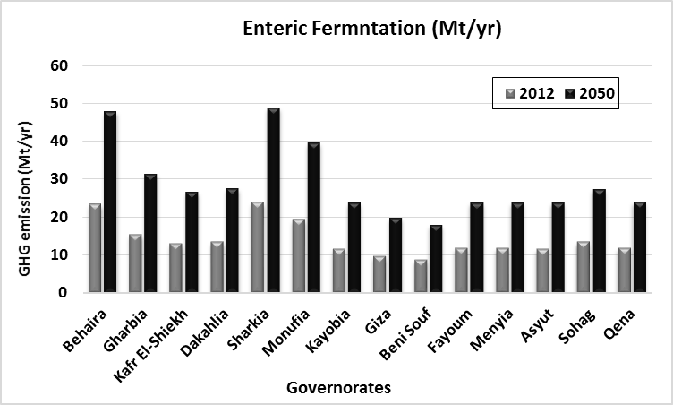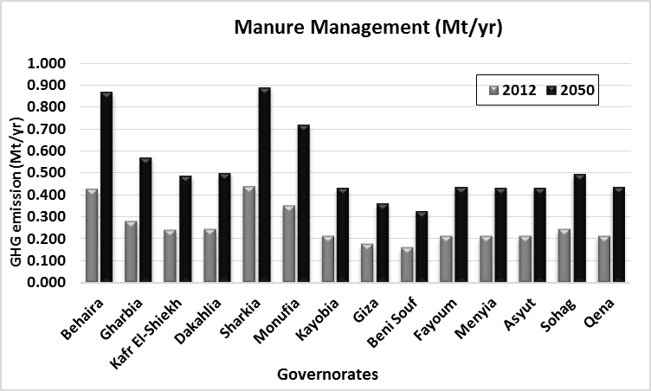
((a
((b

Figure (3): Total CH4 emissions (Mt) from livestock annual emission due to enteric fermentation, for periods of 2012 and 2050.

Figure (4): Total annual CH₄ emissions (Gg) from buffaloes due to enteric fermentation manure management, for periods of 2012 and 2050.

3.5.3 Future trends in livestock related emissions towards 2050
Results obtained from statistical analysis in sections 3.2 and 3.3 for obtaining total number of buffaloes in Egypt and depend on obtained results of estimation GHG emission for projection periods towards 2050. This results revealed that, GHG emission from buffalo group sector will increase dramatically. Whereas, total enteric fermentation in 2050 will increased to be 0.469 (Mt/yr), with 49% increase than 2012. Whereas, manure management will increase to be 8.5 (1000t/yr) with 50% increase than 2012. While the total annual GHG emission will increased to be 478 Gg with 49% increase than 2012. Most of animal categories will be increased in GHG emission. Figure (5a and 5b) illustrated map of distribution the total annual CH4 emissions (Gg) from buffaloes due to enteric fermentation manure management, for periods of 2012 and 2050.

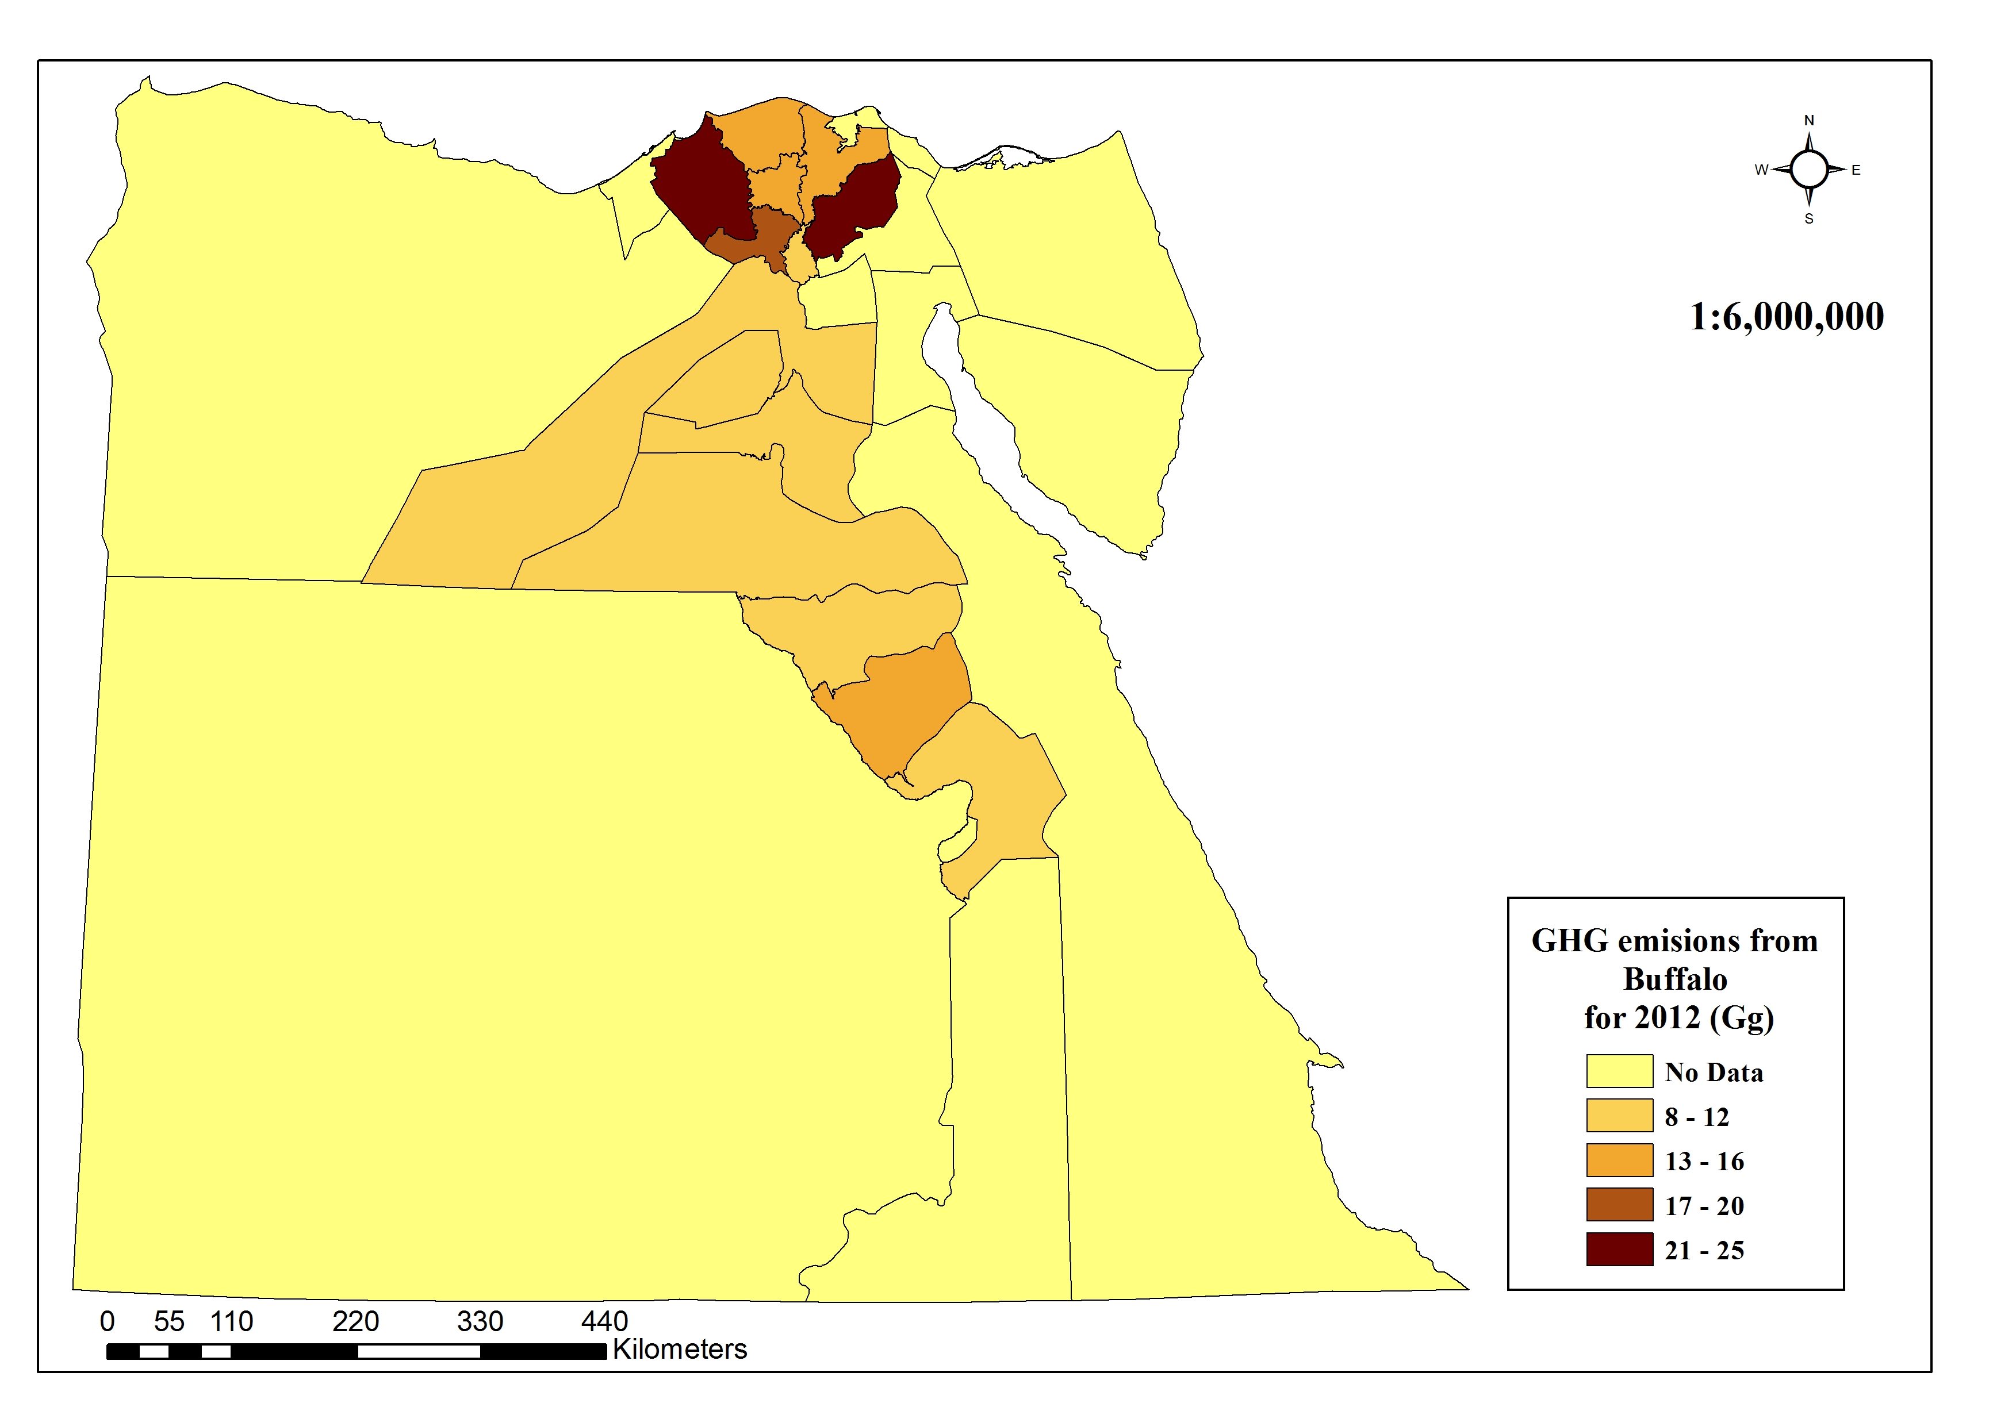
((b
((a

Figure (5): Total annual CH₄ emissions (Gg) from buffaloes due to enteric fermentation manure management, for periods of 2012 and 2050, (a) and (b), respectively.

3.6 Regression analysis for projected trends of GHG du to manure management under chaninching climate
Annual maximum and minimum temperatures for study periods (e.g. 1999, 2005, 2012 and 2050) were obtained (Figure 6a). The following model presented in Fig. (1b) is the exponential equation as a result of regression analysis for individual animal category trends and time series (years) presented in following equations:

y = 15.754e^{0.2333x}, R² = 0.771 …………… (1)

y = 10.272e^{0.1217x}, R² = 0.854 …………. (2)
Where y is predicted GHG emissions from manure management for buffaloes, e is exponential function. Correlations between (y) and (x) were studied to significantly determine (0.771≤R²≤0.854) which have big fluctuation correlated relationships. In equations 1 and 2, x is a maximum temperature and a minimum temperatures, respectively.
DEFRA (2011) revealed that, greenhouse gas (GHG) emission projections for UK agriculture based on activity and emission projections produced in the 2007 study, ‘Baseline Projections for Agriculture. Projecting over a 20 year horizon is inherently uncertain in any sector. However, uncertainties in projecting GHG emissions from the agricultural sector are particularly pronounced due to the nature of the sector (CAP support in particular) and the complexity of the natural systems that are the source of emissions.

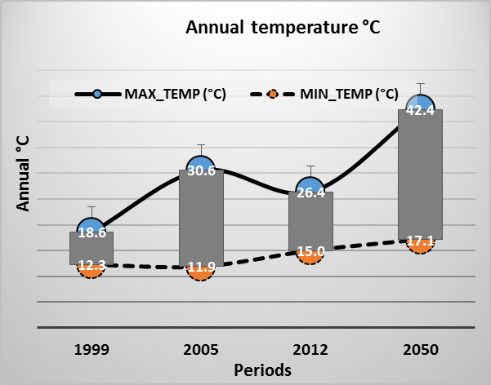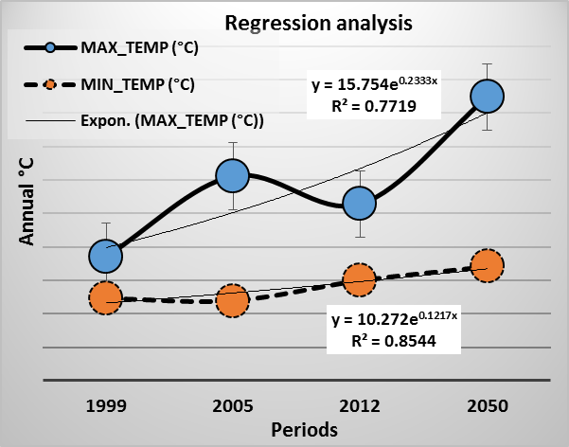
((a
((b

Figure (6): (a) is annual maximum and minimum temperatures for study periods and (b) is regression models (exponential) form for analysis of relationship between temperatures and GHG emission due to manure management for buffaloes.

3.7 Mitigation GHGs Emissions practices options for Egyptian livestock
It is vital that action be taken now to counter this threat. Actions should include measures to reduce agriculture’s role as a driving force for climate change, through the reduction of GHG emissions, as well as measures to mitigate and adapt to climate change (Fahim et al., 2013).
Kadah (2010) revealed that, as for the mitigation of GHG emissions from livestock production, improving feeding patterns and technologies to enhance veterinary care, and improving breeding programs represent the primary options. Changing feeding pattern of native dairy cattle resulted in improving milk productivity, with a CH₄ reduction by about 15-20%.
A number of barriers face mitigation policies in the livestock sector. These include:
- Institutional capacity and framework: The awareness of the sector stakeholders of the threats of climate change is limited, as information regarding climate change impacts over the different activities of the sector has not been widely shared and disseminated. Additionally, the current system of agricultural census doesn’t provide the required data for mitigation planning processes. Data exchange between the other economic sectors, sub-sectors, and governmental bodies is limited.
- Mitigation funds: The lack of the necessary institutional framework is limiting the ability of this sector in obtaining support from the current UNFCCC and Kyoto Protocol mitigation fund mechanisms.
- Knowledge and technology levels: The low knowledge and technology levels of the farmers represent the most significant constraint to mitigation policies in this sector. Increasing services efficiency is a basic step for the development of mitigation and adaptation strategies.
4. Conclusion
The livestock sector represents a significant source of greenhouse gas (GHG) emissions worldwide, generating carbon dioxide (CO₂), methane (CH₄) and nitrous oxide (N₂O) throughout the production process. Livestock contribute to climate change by emitting GHG either directly (e.g. from enteric fermentation and manure management) or indirectly (e.g. from feed-production activities and conversion of forest into pasture). The emission of methane from livestock has relatively stabilized in the past few years. GHG emission from buffalo group sector will increase dramatically. This is expected to rise with the aggressive nature of people demands intervention in the agricultural sector with the special emphasis on expansion of cattle and goat population. The mitigation of GHG emissions from livestock production, improving feeding patterns and technologies to enhance veterinary care, and improving breeding programs represent the primary options. To stem this expected increase in methane emission requires the formulation and adaptation of appropriate mitigation measures. This calls for further investigation of the factors affecting enteric fermentation and manure management.
References
- Amon, B., Kryvoruchko, V., Amon T. & Zechmeister-Boltenstern, S. 2006. Methane, nitrous oxide and ammonia emissions during storage and after application of dairy cattle slurry and influence of slurry reatment. Agric. Ecosyst. Environ. 112: 153–162.
- DEFRA (Department for Environment, Food and Rural Affairs). 2011. Ruminant Nutrition Regimes to Reduce Methane and Nitrogen Emissions. Project AC0209 Report. DEFRA, Procurements and Contracts Division (Science R&D Team). Accessed July 11, 2012 (http://randd.defra.gov.uk/dayocument.aspx?Document=AC0209_10114_FRP.pdf; accessed on 11 July 2012).
- Fahim M. A.; Hassanein M. K.; Khalil A. A.; Abolmaty S. M. and Abou Hadid A. F. 2013. Climate Change Adaptation Needs for Food Security in Egypt. Nature and Science 2013;11(12), 68-74.
- FAO 2013. Tackling Climate Change through Livestock. A global assessment of emissions and mitigation opportunities. FAO 2013, Rome. Pp 139.
- IPCC (Intergovernmental Panel on Climate Change). 2006. Chapter 10. Emissions from Livestock and Manure Management. In 2006 IPCC Guidelines for National Greenhouse Gas Inventories. Volume 4: Agriculture, Forestry and Other Land Use, pp. 10.1–10.87.
- Kadah, M.S. 2010. Agricultural Policies [6.1.1] Report. Project UNJP/EGY/022-LOA1. “Climate Change Risk Management in Egypt”2010. Pp 189.
- Khelifa H. H., 2012. Climate change risk management in Egypt, Assessment of climate change impacts on livestock, UNJP/EGY022 (2012).
- McCarthy, James., Canziani, Osvaldo F., Leary, Neil A., Dokken, David J. and White, Casey., eds. Climate Change 2001: Impacts, Adaptation, and Vulnerability, Cambridge: Cambridge University Press, Intergovernmental Panel on Climate Change, 2001.
- Olesen, J.E., Schelde, K., Weiske, A., Weisbjerg, M.R., Asman, W.A.H., Djurhuus, J., (2006): Modelling greenhouse gas emissions from European conventional and organic dairy farms. Agriculture, Ecosystems & Environment 112: 207-222.
- SADS-2030, 2010. The Sustainable Agricultural Development Strategy towards 2030. Agricultural Research & Development Council (ARDC), 2010. Pp 197.

1/12/2014

