Micro level study of daily migration – a case study of bhayegaon nanded india

Yannawar Vyankatesh B1, Kolhe Shankar M2 Kadam Avanish3& Bhosle A.B4

1, 2 Research Scholar & 3, 4 Assistant Professor

School of Earth Sciences, Swami Ramanand Teerth Marathwada University, Nanded, Maharashtra State, India

[vyanky@hotmail.com](mailto:vyanky@hotmail.com)

**Abstract:** Since last few decades India has experienced a rapid and unprecedented process of urbanization, created by the history’s largest flow of rural– urban migration in the world. This paper has provided a framework for thinking about the relationships between urban planning and migration. Our hope is that the work here will provide an anchor for future studies linking migration. The effects of migration on population trends and structures are well known, but they become more and more difficult to measure, following uncertainties on the size of flows and characteristics of migrants in a long time frame and cities becoming affected by both out and in-migration as well as daily/transit migration. Remittances change lifestyles and can have negative impact on health and environment while at the same times they increase access to communication technologies.

[Yannawar Vyankatesh B., Kolhe Shankar M., Kadam Avanish & Bhosle A.B. **Micro Level Study of Daily Migration – A Case Study of Bhayegaon Nanded India.** *World Rural Observ* 2014;6(1):39-43]. ISSN: 1944-6543 (Print); ISSN: 1944-6551 (Online). <http://www.sciencepub.net/rural>. 8

**Key words**: Daily migration, Migrant laborers, Employment, Nanded city

**1. Introduction**

Migration is the crossing of the boundary of a political or administrative unit for a certain minimum period of time. It includes the movement of refugees, displaced persons, uprooted people as well as economic migrants. Migration is the oldest action against poverty. It selects those who most want help. It is good for the country to which they go; it helps to break the equilibrium of poverty in the country from which they come. What is the perversity in the human soul that causes people to resist so obvious a good (Harris 2002). In Albania and India it was found that migration by male members of household s placed greater strains of responsibility on the young and reduced the informal family support networks for the old (Srivastava and Sasikumar 2003). The main reason for migration is for employment purposes. The collapse of the industrial sector in the early transition years, on the one hand, and the absence of a welfare state on the other, has pushed many workers outside the labour market and into poverty. By 2004, around 30 percent of Albanians were estimated to live below the poverty line; half of them in extreme poverty, subsisting on less than US$ 1 per day (Barjaba, 2004). Migration types are not neutral on its impact on population and development. In Asia, due to lack of political agreement on long-term and permanent migration schemes, such as green cards, migration consists mostly of ‘guest workers’ on short-term contracts that can be extended (Asis 2005, Abella 2005).

Almost all women of the unskilled and semi-skilled categories migrate unofficially, since the Bangladesh government has banned unskilled female migration. BMET’s database does not categories migrants according to age and educational status. Various micro studies have shown that most of the migrants were young (15 to 30 years of age) when they first migrated (Siddiqui and Abrar, 2000; Afsar, 2000) and many were either illiterate or had educational backgrounds from class one to Secondary School Certificate (SSC). Immigration data on Bangladeshis in the UK and US reveal that in both cases male immigrants outnumber the female immigrants. The gender ratio for the total number of Bangladeshis in the US in 1980 was 65% men and 35% women. Among those who came before 1959, the ratio was 83% men and 17% women. For those arriving between 1975 - 1980 the ratio was 60% men and 40% women. Among the new entrants in 1990s, the ratio is 65 men: 35 women. In the UK it is 109:100 (Wrench and Qureshi, 1996). Bangladeshi immigrants in the UK and the US have a range of educational backgrounds: professional, skilled, semi-skilled and unskilled. Migrants to the UK during the early 1920s, and also in the 1950s and 1960s, were mostly uneducated. In the US, those who went during the 1920s were mostly uneducated, but those who migrated during the 1950s and 1960s were educated professionals.

**1.1** **Objective of the study**

The urban population of India has rapidly increased in recent years & Nanded is not way from it. The aim of this study is to determine the Reasons of In-migration, out-migration and net migration levels of all peoples in village and village to urban migration flows.

**2. Methodology**

**2.1 Study Area:** Nanded district is part of Marathwada Region in Maharashtra. For the present study Bhayegaon is selected as study area. Nanded city is situated on the bank of Godavari River. Nanded district has a geographical area of 10,528 Sq. Km., which forms 3.41% of the total geographical area of Maharashtra State. The district is situated in the Deccan Plateau. The district of Nanded has between 18°.15' and 19°.55' North latitude and 77°.7' to 78°.15' east longitudes. The district has a geographical area of 10528 Sq. Km. Nanded is one of the fastest growing city of Marathwada regions of Maharashtra (Nanded Vision-2025).

Bhayegaon is a part of Nanded Tehsil having geographical area 354.44 Sq. Km and agriculture farmland 251.18 hectors. Irrigated farmland 154 hectors and UN irrigated farmland 200.44 Hectors. Geographical area has plane Godavari River near about distance 1.5 km East site and northern East 2 km and north site has nail Bhayegaon & Pinplagaon border East site has Godavari River old Bhayegaon was near about boundary Nature Disaster Flood do to that 1962 Migration to new place on lately hall or long distance to Godavari southwest has canon Bhayegaon to Nanded distance 14 kg from Nanded. The Bhayegaon village of has lies in between 18°.15' and 19°.55' North latitude and 77°.7' to 78°.15' East longitudes. Total Population of 1405 out of Male 723: Female 682, SC of Male 93: Female 92 and OBC Population i.e. Male 14: Female 13. Anonymous (2013)

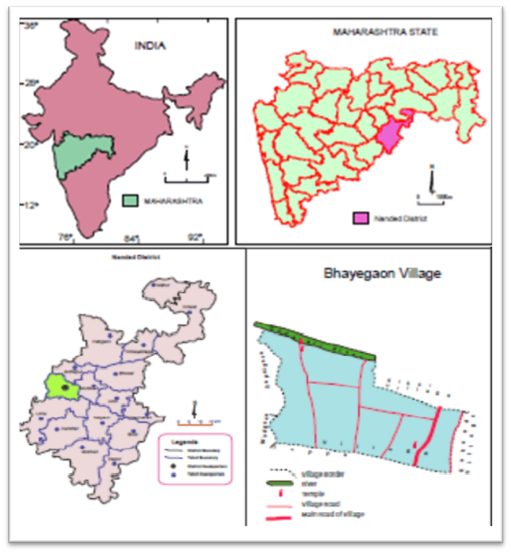

Figure 1: Location Map of Bhayegaon with Nanded, Maharashtra and India

**2.2 Methods:** We designed a questionnaire survey consisting of four parts dealing with: (1) the reasons why peoples choose to migrate; (2) the impact of people’s migration on the respondents’ respective villages; and (3) policy options for dealing with people migration. The questionnaire was pre-tested in the English and revised for clarity. In Bhayegaon, the questionnaire was administered in Marathi. Questionnaires were distributed and collected by research scholars working in the village included in the study. Phone calls or personal visits were conducted on two separate occasions over the course of 3 months as follow-up for those who had not yet completed the questionnaire. A total of 254 questionnaires were distributed. Two hundred fifty four questionnaires were returned for a response rate of 100%.

**2.3 Primary Data**

**2.3.1 Written Surveys:** This method provides immediate results; the involuntary nature of an in-person written survey makes this medium prone to response biases. This method is used to collect data from all sites of study area.

**2.3.2 Secondary Data:** The secondary data was collected from Gram Panchayat & Village Rashan Shop.

**2.4 Survey Questions:** Open-ended survey questions allow respondents to answer in their own words. They are also useful where the researcher is less familiar with the subject area and cannot offer specific response options. The results obtained from open-ended questions are also more difficult to analyze. Finally, it is more difficult to identify a single course of action from the broad range of responses that are received to open-ended questions.

Closed-ended questions with ordered choices require the respondent to examine each possible response independent of the other choices. These types of questions are easiest for respondents to answer and for researchers to analyze the data. These questions ask the respondent to compare possible responses and select one. Multiple choice questions are an example of this type. The researcher must ensure that the respondent is given a comprehensive selection of responses. Closed-ended questions with unordered choices are useful for ranking items in order of preference.

**3.** **Result and discussion**

The main findings may be summarized as the following points. First, the Indian rural-to-urban migration had been a dominant source of the growth. Second, while the Indian migration is accompanied by its economic growth, the direction of their causal link runs from the latter to the former, not vice versa. The downward time trend of the overall migration may imply rising costs of urbanization that limits the increase of migrants. Third, rural–urban income gap seems to be a strong driving force behind city ward migration of both inter and intra provinces.

Finally, geographic distances discourage inter province migrants, and intra province migration is positively associated with the size of provincial urban population. The migration rate is eight %, out migration is ten % and transit is one %. The results reported in this research are shown below tables and graphs respectively.

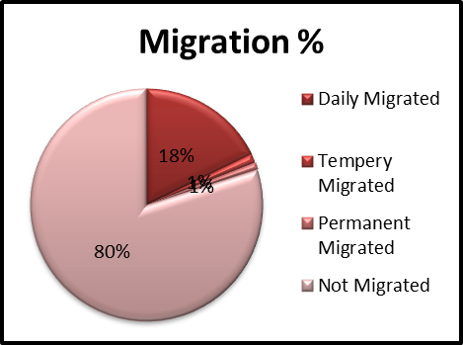

Fig.2: Observed variation of Migration

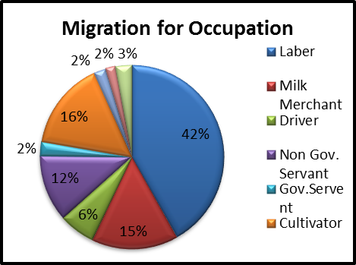

Fig.3: Showing Migration for Occupation

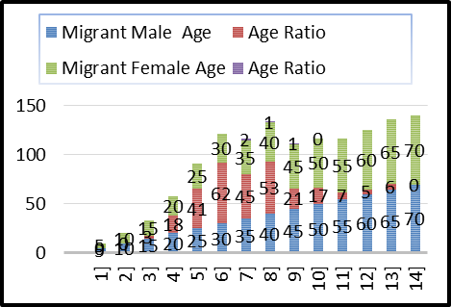

Fig.4: Noticed Migration of Age Ratio

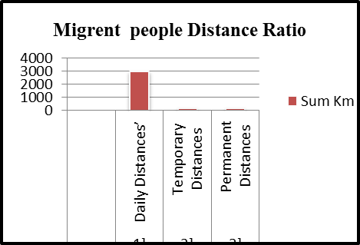

Fig.5: Showing Migration Distance Average Ratio

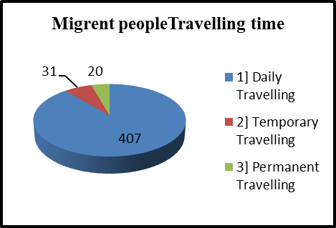

Fig.6: People’s Migration Travelling time Ratio

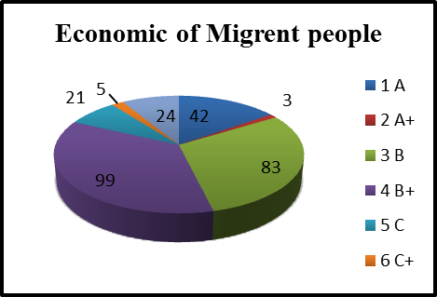

Fig.7: Examined Economic Migration Ratio

**3.1 Reasons for migration**

The basic reason for migration in village unemployment i.e. no or less sources of income for livelihood. Due to irregular electricity supply and there most agricultural activity are affecting adversely. Due to less distance between Nanded and Bhayegaon peoples come to know the importance of education so instead of educating their pupil in village they prefer Nanded.

Finally, the migrant laborers are getting considerably higher wages in Nanded city after migration for the work. The number of migrant laborers getting wages up to Rs. 200-350/day is very high as compare to village, so it can be said that generally fare wages are paid to the migrant laborers in Nanded city in all employment.

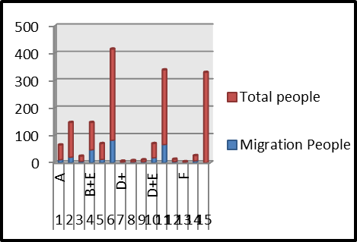

Fig.8: A Level of Time Migration Average.

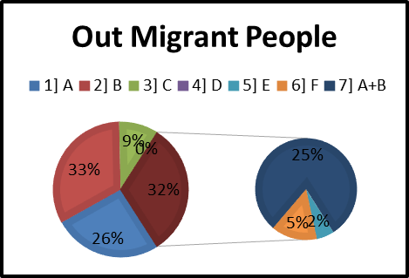

Fig.9: Out Time Migration of People

**3.2 Discussion**

Research examining male-only labor migration from Lesotho, mostly working as miners in South Africa in the 1970s and 80s, revealed that male migrants were predominantly concerned with spending their earnings on long-term investments that could support their households on retirement. The women in migrant households meanwhile were expected to undertake other economic activity, which could finance day to day living costs (Francis 2002). Mosses et al. (2002) found migration was tied to unequal social relations, social status and patterns of borrowing in source areas in the Bhil tribal villages in India. These latter examples are more closely related to the idea of migration being motivated not only by exogenous factors, such as environmental disasters or wars, but also endogenous factors embedded within source areas.

Literature also indicates that a form of 'transformative' social protection strategies provided by major labour sending countries with regards to international migrants are sensitization campaigns, which seek to sensitize migrants and prospective migrants on hazards related to migration such as HIV/AIDS, trafficking and illegal migration. The extent of this is notable in the Philippines, where sensitization on issues related to migration has been integrated into public school education (Villalba 2002). Finally, in Nanded city employment sectors are the major sector, providing employment to migrant laborers are: construction, brick kilns, industries, hotels, shops, household work, Hawkers Business and Transport business etc. The migrant laborers are getting considerably higher wages in Nanded city after migration for the work. The number of migrant laborers getting wages up to Rs 75 is very negligible i.e. 02 only, so it can be said that generally fare wages are paid to the migrant laborers in Nanded city in all employment (Hurne 2012).

**4．Conclusion and policy implications**

The policy implications regard migration and urban unemployment may be drawn from this study. First, the pace and scale of the city ward migration and urbanization should be determined by and consistent with economic growth as well as development levels. Second, the Indian government should be prepared to deal with increasing city ward migrants in the near future due to potential growing rural–urban income gap. The Indian authorities may have two policy options: one is to create jobs in urban industries and services, which is beyond the scope of this study, and the other is to control migration, which is related to the finding of this study.

Reducing the rural – urban income gap may be a powerful policy instrument to control the pace of migration and urbanization. Because migrants respond significantly to differentials between the rural and urban income, it is vitally important that imbalances between economic opportunities in rural and urban areas should be minimized. For example, since inter province migrants mainly move from inland rural areas to urban areas, any measures of reducing the inland – urban income disparities may not only decrease such migrants but also improve development opportunities for the vast in land areas.

**Acknowledgement:**

We are thankful to the School of Earth Sciences, Swami Ramanand Teerth Marathwada University, Nanded for providing laboratory and library facilities. I am thankful to the peoples of my village that helped in my research work.

**Correspondence to:**

Yannawar Vyankatesh Balajirao

School of Earth Sciences

Swami Ramanand Teerth Marathwada University Nanded, Maharashtra State, India

[vyanky@hotmail.com](mailto:vyanky@hotmail.com)

**References**

1. Abella M. I., (2005), Social Issues in the Management of Labour Migration in Asia and the Pacific, Asia Pacific Population Journal, Vol. 20 No.3, pp. 61-86.
2. Abraham Astor et al (2005) Physician migration: Views from professionals in Colombia, Nigeria, India, Pakistan and the Philippines, Social Science & Medicine, Vol. 61, pp. 2492–2500.
3. Afsar, R., Yunus, M. and Islam, S. (2000) Are Migrants Chasing after the Golden Deer: A Study on Cost Benefit Analysis of Overseas Migration by Bangladeshi labor Geneva: IOM [mimeo].
4. Anonymous (2013) Accessed at http://areaprofiler.gov.in/homepage.do
5. Asis M.M.B. (2005) Recent Trends in International Migration in Asia and the Pacific, Asia Pacific Population Journal, Vol. 20, No.3, pp. 15-38.
6. Barjaba, K. (2004) “Albania: Looking beyond borders”, mimeo, Washington DC: Migration Policy Institute.
7. Francis, E. (2002) 'Gender, Migration and Multiple Livelihoods: Cases from Eastern and Southern Africa', Journal of Development Studies Vol. 38, No.5.
8. Harris, N. (2002) Thinking the Unthinkable: the Immigration Myth Exposed, London, I. B. Tourist.
9. Hurne L.S. (2012) ‘A Critical Study of Labor Migration in Nanded District: From An Economic Angle’, Golden Research Thoughts, Vol. 2 No. 5. Pp.1-4.
10. Mosses, D. et al (2002) 'Brokered Livelihoods: Debt, Labour Migration and Development in Tribal Western India', Journal of Development Studies, Vol. 38 No. 5.
11. Nanded Vision-2025 (2006), City Development Plan, Nanded Waghala Municipal Corporation.
12. Siddiqui, T. and Abrar, C.R. (2000) Contribution of returnees: An analytical survey of post-return experience. Geneva: IOM and UNDP.
13. Srivastava, R. and S. K. Sasikumar (2003) 'An Overview of Migration in India, Its Impacts and Key Issues'. Refugee and Migratory Movements Research Unit, Bangladesh and DFID, UK.
14. Villalba, M. (2002) 'Philippines: Good Practices for the Protection of Filipino Women Migrant Workers in Vulnerable Jobs', GENPROM Working Paper No. 8, Series on Women and Migration, IL Geneva (available on-line at: www.ilo.org).
15. Wrench, J. and Qureshi, T. (1995) Higher Horizon: A Qualitative Study of Young Men of Bangladeshi Origin. London: The Stationery Office.

1/29/2014