Isolation and identification of Kilifia acuminata (Signoret) (Hemiptera: Coccidae) toxic compounds in Alphonso mango leaves

Abd Elrahman M. Monzer, Hesham A. Srour and Ahmed M. Abd El-Ghany

Plant Protection Research Institute, Agricultural research Center, Dokki, Giza, Egypt
hamsor98@hotmail.com

Abstract: Leave samples of Alphonso mango cultivar were extracted with solvents of different polarities (hexane, dichloromethane and methanol). Extracts were bio-assayed for their insect toxicity using mango shield scale Kilifia acuminate as bio-indicator. Of the three tested extracts, methanol extract showed high and significant toxicity against K. acuminata. Sephadex LH-20 column chromatography, preparative HPLC, and thin layer chromatography (TLC) were used to isolate compound(s) responsible for such toxic effect to facilitate their identification. GC/MS analysis of the isolated compound identified the phenolic compound pyrogallol (1,2,3-Trihydroxybenzene) as the main K. acuminata toxic compound in Alphonso mango leaves.
[Abd Elrahman M. Monzer, Hesham A. Srour and Ahmed M. Abd El-Ghany. Isolation and identification of Kilifia acuminata (Signoret) (Hemiptera: Coccidae) toxic compounds in Alphonso mango leaves. World Rural Observations 2013;5(4):114-119]. ISSN: 1944-6543 (Print); ISSN: 1944-6551 (Online). http://www.sciencepub.net/rural. 17

Key words: Mangifera indica, Kilifia acuminata, HPLC, TLC, GC/MS, Insecticide, Pyrogallol.

1. Introduction
In recent years, much effort has been focused on exploring plant chemical components as potential sources of commercial pest control agents or as lead compounds (Isman, 1999). In Egypt, mango, Mangifera indica L, is considered one of the most economic crops, where many local cultivars such as Alphonso, Baladi, Zebda, Hendi and Ewaisi, are successfully grown (El-Zohgbi and Mostafa. 2002). All parts of mango trees are liable to be infested with many serious pests during their growth stages. However, studies showed that leaf extracts of certain mango cultivars have toxic effects on several insects including mango shoot gall, Apsylla cistellata (Buckton) (Kumar, 1989), west Indian fruit fly Anastrepha oblique (Peña and Moyhuddin (1997) and scarab beetle Maladera matrida (Groysman and Shani, 2003). Of the Egyptian Mango cultivars, Salama et al, (1970), Monzer et al (2006 & 2007) and Salem, et al., (2006 & 2007) mentioned that Alphonso mango cultivar is usually avoided by the margardoid mealybug, Icerya seychellarum and the mango shield scale Kilifia acuminata and its leaf extracts showed insecticidal effects. Accordingly, this study was conducted to isolate and identify the possible insect-toxic compound(s) in mango leaves of Alphonso cultivar using Kilifia acuminate as a model insect species.
2. Materials and Methods:
Sample Collection:
Mango Leaves of Alphonso cultivar were collected from a Fisher mango orchard located in El-Saff, Giza Governorate. Fresh mature leaves were hand-plucked from three trees packed in plastic bags, hermetically sealed, labeled, and transported in icebox to the laboratory. Healthy leaves were maintained at –20°C until extracted (within one week).
Sample extraction:
Leaves were homogenized in a Tempest homogenizer, and were extracted with HPLC grade organic solvents of increasing polarity at room temperature (20ºC) with ratio of 10 ml solvent to 1.0 g fresh weight (FW) according to the method mentioned by Nicolescu et al. (2000). Extraction was performed in a Romo shaking apparatus with hexane, dichloromethane (DCM), and methanol, each for 48 hrs.
Sephadex Column Chromatography:
Sephadex LH-20 was employed in fractionating the methanol extract. A gradient was used starting with 100% water, and water-methanol mixtures, initially at 10% methanol in water and increasing by 10% to final concentration of 100% methanol.
Analysis of Fractions complexity:
As soon as column chromatography was completed, the obtained fractions were concentrated under a stream of nitrogen for complexity analysis using thin layer chromatographic plates (TLC) and visualized by spraying with vanillin reagent according to the method mentioned by Kirchner (1978).
Preparative high-performance liquid chromatography (HPLC):
Compounds in the bioactive fraction were separated using preparative HPLC according to the method described by Troszynska and Ciska (2002) HPLC series 1050 system (Hewlett Packard), equipped with a quaternary pump, an auto sampler, variable wavelength UV-Vis detector and Nova-pak C18 column (250 x 21.2 mm, 10 µm) was used. The column was operated at 25°C. The mobile phase was water/acetonitrile/acetic acid mixture (88:10:2, v/v/v). The flow rate was set to 3 ml/min. Elution was monitored at 280 nm and elute was collected manually over several runs after a signal was registered. Fractions which exhibited toxicity were freeze-dried and re-suspended in methanol for GC/MS analysis.
Gas Chromatographic-Mass Spectrometric (GC-MS) Analysis:
GC-MS was carried out with a HP 5972A mass spectrometer (Electron impact detector) coupled to HP-6890 GC equipped with a split-split less injector and a HP-5MS capillary column (30 m x 0.32 ID, 0.25 µm film thickness). Helium was used as the carrier gas at a flow rate of 1 ml/min. Injector temperature was 250°C; detector temperature was 280°C, and split less mode was chosen. Oven temperature was programmed from 50°C (2 min) to 80°C at 1.5°C/min and to 250°C at 10°C/min. Data were collected with HP Chemstation software (A.03.00) and searched against the Wiley registry of mass spectral data. All compounds reported was confirmed by comparison of their fragmentation patterns with those of authentic standards and also with those cited in the literature.
Insect collection:
Twigs bearing heavily, K. acuminata infested leaves of mango trees (Baladi cultivar) were collected from the previously mentioned orchard and sent immediately to the laboratory for performing toxicity test at the same day using K. acuminata first instar nymphs.
Toxicity bioassay:
To study the lethal effect of the crude extracts and the identified compounds on K. acuminate, the thin film procedure adopted from Pascual-Villalobos and Robledo (1998) was followed. Bioassays were conducted in standard 100 by 15 mm2 plastic. A piece of filter paper (Whatmann No. 2) was placed on inside the bottom of glass dish. Tested material was diluted with appropriate solvent to concentration equivalent to amount extracted from one mango leaf per 10 ml. Ten ml solvent solution of each tested material was sprayed on the filter paper lining each dish. After solvent evaporation at room temperature twenty K. acuminate first instar nymphs were released on the filter paper and the dish was covered. The experiments was conducted at 25±2°C and 65±5% relative humidity. The date on insect mortality was recorded after 24 hours of treatment. Individuals were considered dead based on the absence of response after mechanical stimulus using a fine hair brush. Toxicity was evaluated with corrected percent mortality using filter paper treated with the used solvent only. Corrected percent mortalities were calculated by Abbot’s formula (Abbot, 1925).
8. Data analysis
The entire assays were repeated three times each with three replicates and the results were combined for statistical analysis. The results are presented as percentage, although actual number of insects was used for statistical tests. Statistical significance was determined by analysis of variance (Duncan Multiple Range Test at P<0.05) using the software package Costat (Costat, 1992). Results are recorded as mean ± standard deviation (SD).
3. Results and Discussion:
As a first step in attempting to identify the components in Alphonso mango leaves that responsible for their toxicity against K. acuminate, Alphonso leaves were extracted with hexane, followed by dichloromethane (DCM), and then methanol to extract most bioactive classes of compounds. The amount extracted by each solvent was calculated by drying off the solvent from pre-weighed glass flasks and expressed as mg/leaf (Table 1). Toxicity bioassay using concentration equivalent to amount extracted from one mango leaf indicated that of the three crude extracts, methanol extract is by far the most toxic extract causing 100% mortality among nymphs of K. acuminata (Table 2). Accordingly, methanol extract was chosen for further analysis. GC analysis (Fig 1) showed that crude methanol extract contains many overlapping compounds. A total of 11 fractions were collected (M_{Alf-1}-M_{Alf-11}) according to their TLC profile by fractionating methanol extract using Sephadex LH-20 gel column chromatography. All of the obtained fractions were subjected to toxicity screening using amount from each fraction equivalent to that extracted from one leave and using K. acuminata nymphs as bio-indicators. Table (3) indicates that only fraction M_{Alf-1} that showed significant toxicity against K. acuminata nymphs. Accordingly, fractions M_{Alf-1} was chosen for further analysis. The complexity of fraction was checked by TLC using mixture of chloroform- methanol-acetic acid (90:10:1) as a mobile phase (Fig. 2). M_{Alf-1} fraction was further purified by preparative HPLC. Based on their UV spectra, 8 sub-fractions could be separated from fraction M_{Alf-1}. Table (3) indicated that sub-fraction M_{Alf-1A} shows significant toxicity against K. acuminata nymphs. When sub-fraction M_{Alf-1A} was analyzed using GC-MS, one peak was observed (Fig 3) with fragmentation pattern close to that of pyrogallol as represented by the Weiley electronic library (Fig 4). Accordingly, the bio-active compound in sub-fraction M_{Alf-1A} is preliminary identified as pyrogallol. Pyrogallol (1,2,3-Trihydroxybenzene) is reported in few plant species including paper birch, Betula papyrifera (Siegle, 1967), red maple, Acer rubrum wood and bark (Narayanan and Seshadri 1969), Acacia nilotica, Coriaria myrtifolia, Geranium thunbergii and Hypericum perforatum (Lydon & Duke 1989 and Duke, 1992), in addition to Emblica officinalis (Khan et al., 2002). No previous reports were found in the literature on the occurrence of pyrogallol in M. indica species. Pyrogallol is a well-known phenolic derivative that has bactericidal, nematicidal, insecticidal and feeding deterrence effects due to its strong oxidant properties (Jones and Klocke. 1987, Mason and Wasserman, 1987; Lydon & Duke 1989, and Manoukas, 1993). Auto-oxidation of pyrogallol produces highly reactive oxygen species that inhibit several vital enzymes in leaving cells resulting in their death (Tache et al., 1977 and Lee, et al., 1995). Pyrogallol was also reported to inhibit calcium fluxes (Vuorela et al., 2001). However, the results showed that crude methanol extract of Alphonso leaves induced significantly higher mortality percentage among K. acuminata nymphs than the isolated pyrogallol. This suggests that either there was a loss in the amount of the isolated pyrogallol during extraction procedure, or crude methanol extract contained other co-oxidant compound(s) which do not have toxic effect on K. acuminata nymphs but act as synergism for pyrogallol. Khan et al., (2002) demonstrated that certain plant secondary metabolites such as derivatives of 4H-pyranone and pipreronyl butoxide act as co-oxidant for pyrogallol possibly by inhibition of the mixed function oxydase enzyme systems of insects. Nevertheless, specific searches were made for such compounds (screening with GC-MS) in methanol extract of Alphonso leaves, but without success. However, it is suggested that the phenolic compound pyrogallol is the main K. acuminata toxic compound in Alphonso mango leaves, without ignoring the synergic effect of the other un-identified synergic and co-oxidant compounds.

Table 1:Amount extracted by each solvent from Alphonso leaves.
Solvents | (mg)/leaf*
Hexane | 52
Dichloromethane (DCM) | 66
Methanol | 103
Total | 221
*Number of leaves/kg FW of Alphonso leaves was 350

Table 2: Contact toxicity of different Alphonso leaf extracts against K. acuminata nymphs.
Test material | Mortality (%)
Hexane extract | 5.3± 6.7a
Dichloromethane (DCM) | 3.5±3.1a
Methanol extract | 100b
Arccosine-transformed values for % mortality were used for statistical analysis. Values (Mean ± SD) followed by different litters are significantly differ (P<0.05)
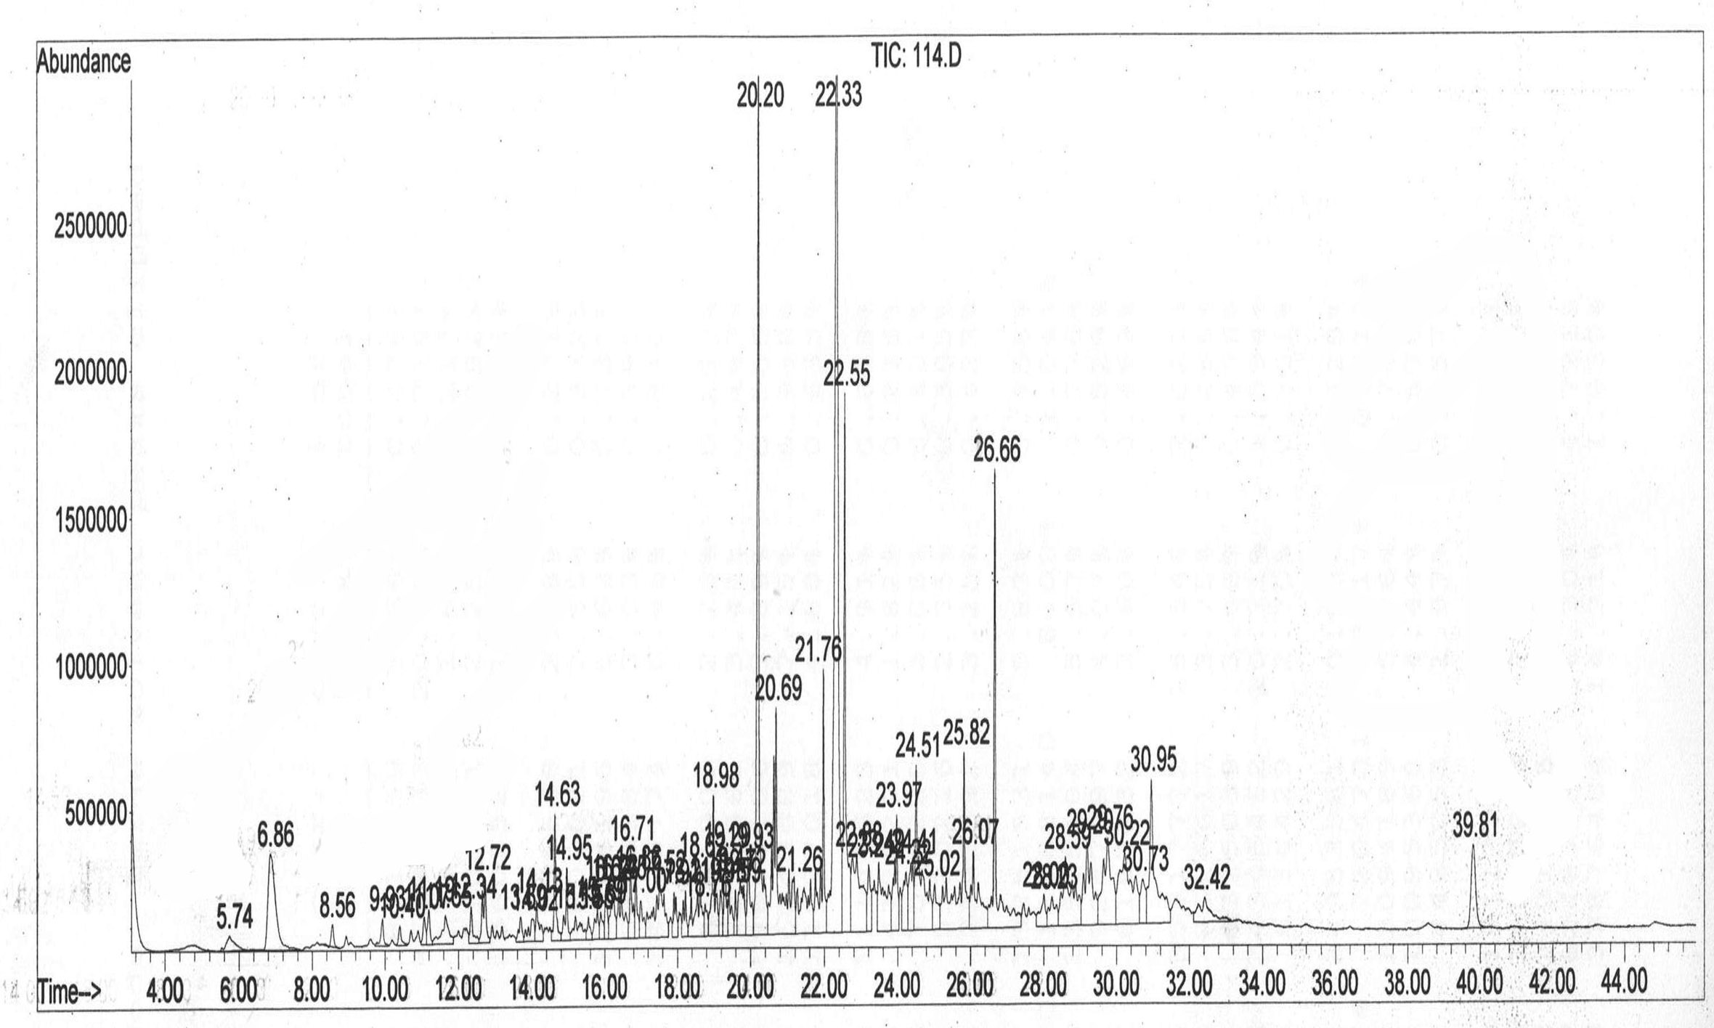
Figure (1): GC-MS spectra of methanol extracts of Alphonso mango leaves.

Table 3: Bioactivity of the eluted fractions from methanol extract of Alphonso leaves.
Fraction | % Methanol in water | Concentration | % Mortality*
 |  | μg/leaf
M_{Alf-1} | 0 | 4800 | 66.0 ± 7.2a
M_{Alf-2} | 10 | 2600 | 12.5 ± 5.3b
M_{Alf-3} | 20 | 3700 | 5.1 ± 4.3b
M_{Alf-4} | 30 | 2300 | 3.8 ± 4.0b
M_{Alf-5} | 40 | 12000 | 7.0 ± 4.4b
M_{Alf-6} | 50 | 10000 | 8.2 ± 5.3b
M_{Alf-7} | 60 | 11500 | 6.2 ± 4.9b
M_{Alf-8} | 70 | 7100 | 5.7 ± 4.2b
M_{Alf-9} | 80 | 10300 | 4.9 ± 5.1b
M_{Alf-10} | 90 | 5700 | 5.9 ± 4.4b
M_{Alf-11} | 100 | 22500 | 8.1 ± 3.4b
* Values ± SD followed by different litters within the same column are significantly differ (P<0.05)

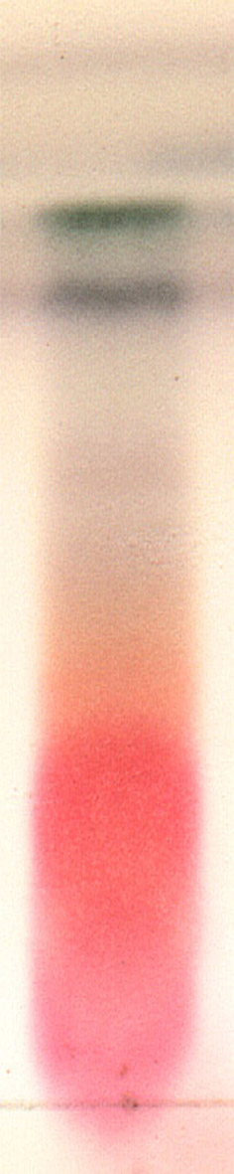

Figure (2): TLC image of M_{Alf-1} fraction using chloroform-methanol-acetic acid (50:10:1) as a mobile phase and stained with vanillin reagent.

Table 4: Bioactivity of the isolated compounds from M_{Alf-1} fraction using preparative HPLC.
Compound | Retention time  (min) | Concentration | % Mortality*
 |  | μg/leaf
M_{Alf-1A} | 3.8 | 300 | 35.0 ± 6.2a
M_{Alf-1B} | 4.8 | 282 | 7.5 ± 3.3b
M_{Alf-1C} | 5.2 | 333 | 5.1 ± 4.3b
M_{Alf-1D} | 5.9 | 840 | 5.3 ± 3.0b
M_{Alf-1E} | 9-9.5 | 56 | 4.8 ± 3.4b
M_{Alf-1F} | 14 | 1120 | 5.2 ± 5.3b
* Values ± SD followed by different litters within the same column are significantly differ (P<0.05)

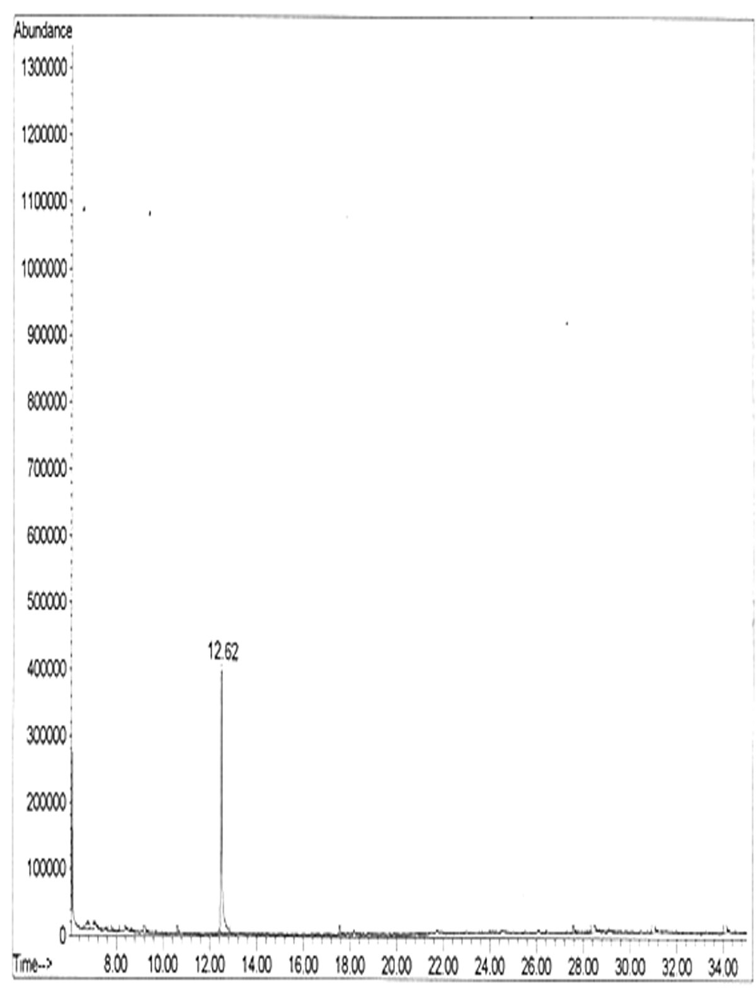
Figure 3. GC spectrum of sub-fraction M_{Alf-1A}
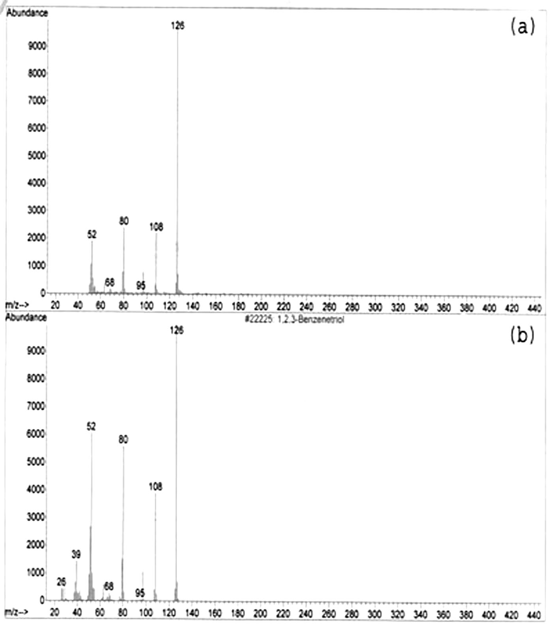
Figure 4. Mass spectral data of a) the compound identified in sub-fraction M_{Alf-1A}, b) Wiley lib spectral data of pyrogallol

References
Abbot, W. S. (1925) A method of computing the effectiveness of an insecticide. J. Econ. Entomol. 18: 265–267.
Costat, 1992. Software package, Costat, Graphics and Statistics Software for Scientists and Engineers (Cohort Inc), Berkeley, CA, USA.
Duke, J.A. 1992. Handbook of phytochemical constituents of herbs and other economic plants. Boca Raton, FL. CRC Press).
El-Zohgbi, M. and Mostafa G.A. 2002. Characterization of the geographic origin of mango pulp from Egypt, Brazil and Puerto Rico by ICP-MS. Zagazig-J. Agric. Res., 28(3): 629-639.
Groysman, M. and Shani A. 2003. Isolation of mango leaf components affecting feeding of Maladera matrida beetles. P. 306 in: Abstracts of presentations at the 20th Conference of the Entomological Society of Israel, February 11–12, ARO, The Volcani Center, Bet Dagan, Israel.
Isman, M. B. (1999) Pesticides based on plant essential oils. Pestic. Outlook, 68–72.
Jones, K.C. and Klocke J.A. 1987. Aphid feeding deterrence of ellagitannins and their phenolic hydrolysis hydroxylysis products and related phenolic derivatives. Entomol. Exp. Appl., 44 (3): 229-234.
Khan, M.T.H., Lampronti I., Martello D., Bianchi N., Jabbar S., Choudhuri M.S.K., Datt B.K. and Gambari R. 2002. Identification of pyrogallol as an antiproliferative compound present in extracts from the medicinal plant Emblica officinalis: Effects on in vitro cell growth of human tumor cell lines. Inter. J. Oncology, 20: 187-192.
Kirchner, J.G. 1978. “Thin Layer Chromatography” Techniques of Chemistry Series, Volum number XIV, 2nd Edition, Edmond S. Perry (Ed.), A Wiley-Interscience Pub., New York
Kumar K.K. 1989. Relative susceptibility of mango cultivars to mango psyllid, Apsylla cistellata Buckton (Psyllidae: Homoptera) and its control. Acta Hortic. 231, 581-586
Lee, S.F., Liang Y.C., and Lin J.K.. 1995. Inhibition of 1,2,4-benzenetriol-generated active oxygen species and induction of phase II enzymes by green tea polyphenols. Chemico-Biological Interactions 98 : 283-301
Lydon, J. and Duke, S. 1989. The potential of pesticides from plants, pp. 1-41 in Craker, L. & Simon, J., eds, Herbs, Spices & Medicinal Plants: Recent Advances in Botany, Horticulture, & Pharmacology, v. 4, Oryx Press, Phoenix, 1989, 267pp
Manoukas, A.G. 1993. The effect of some phenols on the larval performance of the olive fruit fly, Dacus oleae Gmel. (Dipt., Tephritidae). J. Appl. Ent., 116 (3): 303-307
Mason, T.L. and Wasserman B.P. 1987. Inactivation of red beet glucan synthase by native and oxidized phenolic compounds. Phytochemistry 26(8): 2197.2202.
Monzer M.A.; Salem M.S., Moussa S.F.M., Nour M.E. and El-Said M.I. (2007). Seasonal fluctuation of the Seychelles fluted scale, Iceria seychellarum (Westwood) on four mango cultivars in Egypt. Egypt. J. Agric. Res., 85(1): 77-88.
Monzer M.A.; Salem M.S., El-Said M.I. and Abd El-Ghany A.M. (2006). Resistance of Alphonso mango cultivars to the Margardoid mealybug, Iceria seychellarum (Westwood) in relation to leaf quality. I. Leaf secondary metabolites. Egypt. J. Agric. Res., 84(1): 17-29.
Narayanan, V., and Seshadri T.R. 1969. Chemical components of Acer rubrum wood and bark: Occurrence of procyanidin dimer and trimer. Indian J. Chem. 7(3):213-214.
Nicolescu, G., Giulacu-Purcarea V., Vladimirescu A., Hoanca D., Rosu A. and Chicioroaga S. 2000. Screening of some Romanian plants for their activity against medically important insects. Roum. Arch. Microbiol. Immunol., 59(3): 227-236.
Pascual-Villalobos, M.J. and Robledo A. 1998. Screening for anti-insect activity in Mediterranean plants. Industrial Crops and Products 8: 183–194.
Peña J. E. and Moyhuddin A. I. 1997. Insect Pests, p. 327-362. In R. E. Litz (ed.). The mango. CAB International, Wallingford, UK.
Salama H.S., Wassel G. and Saleh M.1970. Resistance of some varieties of mangifera Indica L. to scale insects infestation due to flavonoids. Current-Science, (39): 497-502.
Salem, M.S.; El-Said M.I.; El-Ghany A.M. and Monzer, M.A. 2006. Susceptibility of five mango cultivars to Iceria seychellarum (Westwood) in relation to leaf quality: III. Nutrients and inhibitors. Egypt. J. Agric. Res., 84(3): 697-711
Salem, M.S.; Monzer M.A., Nour M.E. and El-Said M.I.. 2007. Susceptibility of five mango cultivars to Seychelles fluted scale, Iceria seychellarum (Westwood) in relation to leaf quality: III. Leaf toughtness and anatomic characteristics. Egypt. J. Agric. Res., 85(1): 89-100.
Siegle, H. 1967. Microbiological and biochemical aspects of heartwood stain in Betula papyrifera. Can. J. Bot. 45(2):147-154.
Tache, J., Tache Y. and Kourounakis P. 1977. Influence of steroidal enzyme inducers on the toxicity of pyrogallol, pargyline and nialamide. Endocrinol. Exp., 11(1) 11-18.
Troszynska, A and Ciska, E. 2002. Phenolic compounds of seed coats of white and coloured varieties of pea (Pisum sativum L.) and their total antioxidant activity. Czech J. Food Sci., 20: 15–22.
Vuorela, J.P. Rauha J.P., Tammela P., Marjamyki K., Pasternack M., Tyrnqvish K. and vuorela H. 2001. Contrasting effects of simple aromatic compounds and flavonoids on calcium fluxes in clonal rat pituitary GH4C1 cells. Eur. J. Pharmacol. 414(2.3): 125.133.

9/11/2013

