Dynamic Analysis of Landscape on Forest Resources

Li Changsheng

School of Humanities and Social Sciences, Harbin Institute of Technology, 150001, P. R. China.
E-mail: lichangsheng100@163.com

Abstract To study the landscape change of natural forest resource, FRAGSTATS package of landscape space pattern was used. Landscape shape Index, Mean shape index, Area-weighted mean shape index, Double log fragile dimension, Mean patch fragile dimension, Area-weighted mean patch fragile dimension, Shannon's diversity index, Shannon's evenness index, Simpson's diversity index, Simpson's evenness index, Modified Simpson's evenness index and Modified Simpson's diversity index are calculated. The results showed that Area-weighted mean shape index, Double log fragile dimension and Mean patch fragile dimension decreased slightly, i.e. the Shape of patches (sub compartments) didn’t change a lot. The change of forest landscape was later than that of forest resource. The change of diversity index of patches was not obvious. But Relative patch richness and Patch richness density increased rapidly.
[Li Changsheng. Dynamic Analysis of Landscape on Forest Resources. World Rural Observ 2013;5(4):20-26]. ISSN: 1944-6543 (Print); ISSN: 1944-6551 (Online). http://www.sciencepub.net/rural. 4

Key words: forest resource, landscape dynamic, patch

In addition to the sustainable use of forest resources, sustainable forest management also includes changes of ecological landscape of forest resources (WU, 2000; GUO, et al, 2003). Studies on landscape of forest resources are very important (YANG ea al., 2003;HE, 2008). In order to study the landscape changes in forest resources of natural forest, in this paper, the landscape spatial pattern analysis software FRAGSTATS is used, which can analyze the landscape spatial pattern, for different size. FRAGSTATS for ArcView, which is a new version, as an integration extension of ArcView module, analysis of landscape spatial pattern, helping landscape ecologists and experts in natural resources analysis and demonstrate the natural landscape vegetation conditions( RIPPLE, et al, 1991).

1 Overviews of Study Area
Mangui forestry bureau is located at the northern part of western slope in Daxing’an Mountain, at Eerguna city and Genhe City in Hulunbeier League of the Inner Mongolia Autonomous Region, with 120 km long from east to west, and north-south width of 20 km. The total area of which is 390577 hm². The low hills below 1000 m account for 90.1% of the industry area. The highest elevation is 1409 m, and the minimum altitude is 507 m. in Green forest Whitewater River estuary. In the territory, the terrain is flat. Gentle slopes and valley areas account for 70%. It is a hilly slope terrain on the overall terrain and topography. The main river is Jiliu River, belonging to the Heilongjiang River as a tributary of the Eerguna River. Mangui forest belongs to cold temperate zone continental monsoon climate. Brown Coniferous forest soil is the zonal soil in this forest. Forest vegetation consists of the flora of Mongolia and the flora of East Siberia. The main forest types include Dahurian larch forest, Scotch pine forest, Asian white birch forest and poplar forest.

2 Research Methods
Three kinds of scales can be calculated by FRAGSTATS for ArcView( GARIGA，et al, 1994). As a limited patches mosaic landscape, FRAGSTATS for ArcView can calculate several landscape indexes, including 1 inlaid patch, Each kind of inlaid patches and the whole landscape. Consequently, the output results of FRAGSTATS for ArcView is settled as three kinds of files: Patch, Class and Land, formatted as dBase (.dbf).
Nearly 40 kinds of landscape index could be calculated by FRAGSTATS.（1）When the landscape index on the patch type level is interpreted, 8 indexes are chosen including type area, patch area, perimeter, type, the proportion of area, landscape similarity index, margin ratio, fragile dimension;（2）When the landscape index is interpreted on the Class type level, 14 indexes are chosen, including Patch area, Patch number, Average area of patches, Average shape index, Average patch fragile dimension, Patch area standard deviation, Proportion of landscape area accounted by patches, Total area of landscape, Largest patch index, Patch density, Variation coefficient of patch area, Average shape index weighted by area, Double log fragile dimension, Average patch fragile dimension weighted by area;（3）When the landscape index is interpreted on landscape level, 22 indexes are chosen, including Patch numbers, Average area of patches, Average shape index, Average patch fragile dimension, Patch area standard deviation, Landscape type proportion, Proportion of landscape area accounted by patches, Total area, Largest patch index, Patch density, Variation coefficient of patch area, Average shape index weighted by area, Double log fragile dimension, Average patch fragile dimension weighted by area, Shannon diversity index, Simpson diversity index, Modified Simpson diversity index, Simpson's evenness index, Modified Simpson's evenness index, Patch richness, Patch richness density, Relative patch richness.
The following index is applied mainly in the paper:
Landscape Shape Index:
（1）
Where A is the total area, E is the total length of the whole landscape.
Mean Shape Index:
（2）
Where is the amount of patch types from 1 to m of the landscape, j is the amount of patches from 1 to n of the landscape, p_{ij} is perimeter of the patch_{ij}, a_{ij} is the area of patch_{ij}, n is the amount of patches in the whole landscape, m is the amount of patch types.
Area-Weighted Mean Shape Index:
(3)
In this equation, the marks represent the same meanings with the ones in（2）.
Double Log Fragile dimension:

（4）

In this equation, the marks represent the same meanings with the ones in（2）.
Mean Patch Fragile dimension:
（5）
In this equation, the marks represent the same meanings with the ones in（2）.
Area-Weighted Mean Patch Fragile dimension:
（6）
In this equation, the marks represent the same meanings with the ones in (1),(2).
Shannon's Diversity Index:
（7）
Where P_{i} is the proportion that patch type accounted for the whole landscape, m is the patch type amount of the whole landscape.
Shannon's Evenness Index:
（8）
In this equation, the marks represent the same meanings with the ones in（7）.

Simpson's Diversity Index:
（9）
In this equation, the marks represent the same meanings with the ones in（7）.
Simpson's Evenness Index:
（10）
Where P_{i} is the proportion that patch type accounted for the whole landscape, m is the patch type amount of the whole landscape.
Modified Simpson's Evenness Index:
（11）
In this equation, the marks represent the same meanings with the ones in（10）.
Modified Simpson's Diversity Index:
（12）
In this equation, the marks represent the same meanings with the ones in（10）.

3 Results and Analysis
Landscape type = soil type + (the origin of forest territory × forest type × age group). According to forest investigational plan in 1996, soil type has been divided into 19 types, in which the origin of forest territory has been included, forest type has been divided into 11 types and age group in 5 levels, so the maximum amount of landscape types in this area=18+2×11×5=128.

3.1 Landscape index of different landscape types in 1967
Landscape index of different landscape types in 1967 are showed in table 1.

Table 1 Landscape index of different landscape types in 1967
Lands-cape type | Patch area (hm²) | Patch num-bers | Average patch area (hm²) | Average shape index | Average patch fragile dimension | proportion of landscape area (%) | Largest patch index | Patch density | Average shape index weighted by area | Double Log Fractal Dimens-ion | Average patch fragile dimension weighed by area
Young L. G. | 28413 | 851 | 33 | 1.78018 | 1.29799 | 8.50876 | .08684 | .25484 | 2.10169 | 1.29889 | 1.29536
Middle L. G. | 42656 | 969 | 44 | 1.77220 | 1.28888 | 12.77400 | .11978 | .29017 | 1.98713 | 1.28944 | 1.28401
Near-mature L. G. | 12856 | 286 | 44 | 1.74608 | 1.28465 | 3.85001 | .07786 | .08564 | 1.92372 | 1.28765 | 1.28168
Mature L. G. | 90236 | 2190 | 41 | 1.85736 | 1.29624 | 27.02254 | .13475 | .65582 | 2.03483 | 1.29616 | 1.28982
Over-mature L. G. | 723810 | 1054 | 68 | 1.78992 | 1.28067 | 21.67565 | .14673 | .31563 | 1.95485 | 1.28101 | 1.27509
Young P. S. M. | 363 | 18 | 20 | 1.70122 | 1.29798 | .10886 | .02485 | .00539 | 1.75511 | 1.35409 | 1.28946
Middle P. S. M. | 1553 | 38 | 40 | 1.69002 | 1.28404 | .46533 | .08384 | .01137 | 1.90280 | 1.30978 | 1.28195
Near-mature P. S. M | 958 | 40 | 23 | 1.54518 | 1.28529 | .28709 | .02186 | .01197 | 1.62091 | 1.30822 | 1.27264
Mature P. S. M. | 5608 | 199 | 28 | 1.57214 | 1.28064 | 1.67946 | .06588 | .05959 | 1.73362 | 1.28495 | 1.27617
Over-mature P. S. M | 3953 | 86 | 45 | 1.57441 | 1.26862 | 1.18396 | .05989 | .02575 | 1.70678 | 1.27923 | 1.26345
Young B. P. | 11664 | 381 | 30 | 1.64378 | 1.29123 | 3.49312 | .09582 | .11409 | 1.84218 | 1.29259 | 1.27996
Middle B. P | 16814 | 423 | 39 | 1.70270 | 1.28500 | 5.03545 | .11080 | .12667 | 1.89296 | 1.28703 | 1.28112
Near-mature B. P. | 1503 | 30 | 50 | 1.74335 | 1.28165 | .45016 | .05989 | .00898 | 1.95790 | 1.31487 | 1.28013
Mature B. P. | 3211 | 55 | 58 | 1.55664 | 1.25926 | .96157 | .05390 | .01647 | 1.61311 | 1.27651 | 1.25601
Over-mature B. P. | 226 | 4 | 56 | 1.41667 | 1.24549 | .06767 | .02844 | .00119 | 1.37072 | 1.55827 | 1.23638
Middle P. D. | 30 | 1 | 30 | 2.06373 | 1.31559 | .00898 | .00898 | .00029 | 2.06373 | .00000 | 1.31559
Middle P. H. | 63 | 5 | 12 | 1.74064 | 1.31053 | .01909 | .00748 | .00149 | 1.79761 | 1.55277 | 1.31046
Near-mature P. H. | 117 | 6 | 19 | 1.47495 | 1.27582 | .03504 | .01527 | .00179 | 1.68492 | 1.46536 | 1.28001
Mature P. H. | 619 | 16 | 38 | 1.58707 | 1.27314 | .18536 | .02994 | .00479 | 1.68206 | 1.33659 | 1.26953
Open forest | 62 | 1 | 62 | 2.34372 | 1.31749 | .01856 | .01856 | .00029 | 2.34372 | .00000 | 1.31749
Shrub | 2 | 1 | 2 | 1.47052 | 1.32544 | .00076 | .00076 | .00029 | 1.47052 | .00000 | 1.32544
Wasteland | 7409 | 210 | 35 | 1.74685 | 1.29304 | 2.21884 | .09283 | .06288 | 2.08685 | 1.29752 | 1.29337
Cutting blank | 290 | 5 | 58 | 1.92029 | 1.29792 | .08684 | .04192 | .00149 | 1.94663 | 1.54476 | 1.28378
Fire slash | 6042 | 84 | 71 | 1.68618 | 1.28134 | 1.80951 | .16170 | .02515 | 1.91894 | 1.29189 | 1.26173
Farm land | 1122 | 9 | 124 | 1.49727 | 1.24549 | .33599 | .10181 | .00269 | 1.51341 | 1.36419 | 1.23275
Water | 1255 | 5 | 251 | 8.04230 | 1.42977 | .37582 | .29047 | .00149 | 13.7719 | 1.72864 | 1.48826
Swamp | 23922 | 360 | 66 | 1.95783 | 1.29885 | 7.16391 | .12277 | .10780 | 2.16682 | 1.30066 | 1.28771
Building | 408 | 47 | 8 | 1.60557 | 1.31534 | .12220 | .01407 | .01407 | 1.78078 | 1.33555 | 1.30878
others | 185 | 4 | 46 | 1.30251 | 1.25391 | .05541 | .04791 | .00119 | 1.19902 | 1.56161 | 1.20935
Where: L. G.= Larix gmelini; P. S. M. = Pinus sylvestris var. monglica; B. P. = Betula platyphlla; P. D. = Populus davidiana; P. H. = Populus hsinganica.

3.2 Landscape index of different landscape types in 1996
Landscape index of different andscape types in 1996 are showed in table 2.

Table 2 Landscape index of different landscape types in 1996
Landscape type | Patch area(hm²) | Patch numbers | Average patch area (hm²) | Average shape index | Average patch fragile dimension | Proportion of landscape area (%) | Llargest patch index | the patch densty | Average shape index weighted by area | Double log fragile dimension | Average patch fragile dimension weighted by area
Young L. G. | 15491 | 393 | 39 | 1.76066 | 1.29043 | 3.92907 | .07101 | .09967 | 1.83667 | 1.29203 | 1.27674
Middle L. G. | 74637 | 1652 | 45 | 1.66506 | 1.27683 | 18.93009 | .08369 | .41899 | 1.66949 | 1.27582 | 1.26318
Near-mature L. G. | 27671 | 555 | 49 | 1.59818 | 1.26771 | 7.01830 | .05326 | .14076 | 1.55179 | 1.26780 | 1.25122
Mature L. G. | 110091 | 2478 | 44 | 1.61068 | 1.27110 | 27.92223 | .07101 | .62848 | 1.60677 | 1.27026 | 1.25804
Over-mature L. G. | 36158 | 752 | 48 | 1.65241 | 1.27374 | 9.17083. | .11159 | .19072 | 1.64737 | 1.27380 | 1.25929
L. G. Plantation | 1640 | 67 | 24 | 1.68115 | 1.29672 | 41604 | .05072 | .01699 | 1.91555 | 1.31101 | 1.29163
Young P. S. M. | 430 | 16 | 26 | 1.61441 | 1.28223 | .10910 | .03297 | .00405 | 1.69729 | 1.34629 | 1.27589
Middle P. S. M. | 2474 | 87 | 28 | 1.57291 | 1.28011 | .62755 | .03297 | .02206 | 1.68547 | 1.29054 | 1.27326
Near-mature P. S. M | 1993 | 43 | 46 | 1.54883 | 1.26489 | .50558 | .04311 | .01090 | 1.59586 | 1.28688 | 1.25452
Mature P. S. M. | 4207 | 140 | 30 | 1.51395 | 1.27066 | 1.06703 | .05326 | .03550 | 1.57419 | 1.27681 | 1.26321
Over-mature P. S. M | 1249 | 39 | 32 | 1.50195 | 1.27132 | .31686 | .03550 | .00989 | 1.50446 | 1.29492 | 1.25731
Young B. P. | 1746 | 53 | 32 | 1.65341 | 1.28556 | .44305 | .04058 | .01344 | 1.74429 | 1.30263 | 1.27080
Middle B. P | 24430 | 482 | 50 | 1.59405 | 1.26614 | 6.19625 | .06847 | .12224 | 1.59835 | 1.26722 | 1.25520
Near-mature B. P. | 19986 | 377 | 53 | 1.54088 | 1.25978 | 5.06909 | .04818 | .09561 | 1.56745 | 1.26146 | 1.25209
Mature B. P. | 287225 | 566 | 50 | 1.54225 | 1.26102 | 7.28493 | .05579 | .14355 | 1.55612 | 1.26184 | 1.25268
Over-mature B. P. | 6692 | 155 | 43 | 1.56474 | 1.26708 | 1.69750 | .05579 | .03931 | 1.58826 | 1.27247 | 1.25776
Young P. D. | 195 | 7 | 27 | 1.68068 | 1.29050 | .04966 | .01927 | .00177 | 1.62499 | 1.44959 | 1.26908
Middle P. D. | 2672 | 93 | 28 | 1.56924 | 1.28047 | .67788 | .05833 | .02358 | 1.69280 | 1.29019 | 1.27001
Near-mature P. D. | 1637 | 57 | 28 | 1.45489 | 1.26793 | .41543 | .03804 | .01445 | 1.52560 | 1.28395 | 1.25935
Mature P. D. | 1448 | 57 | 25 | 1.44335 | 1.26785 | .36734 | .02536 | .01445 | 1.50773 | 1.28405 | 1.26021
Over-mature P.D. | 331 | 15 | 22 | 1.39660 | 1.26592 | .08409 | .01648 | .00380 | 1.37922 | 1.33166 | 1.25225
Middle P. H. | 79 | 3 | 26 | 1.54112 | 1.26880 | .02003 | .00836 | .00076 | 1.56852 | 1.74334 | 1.27122
Near-mature P. H. | 130 | 3 | 43 | 2.14260 | 1.30636 | .03297 | .01750 | .00076 | 2.42398 | 1.80702 | 1.31727
Mature P. H. | 158 | 5 | 31 | 1.84933 | 1.29605 | .04007 | .01293 | .00126 | 1.97307 | 1.54217 | 1.30297
Over-mature P.H. | 250 | 7 | 35 | 1.84841 | 1.29432 | .06351 | .02054 | .00177 | 1.93204 | 1.45807 | 1.29355
Young S. S. | 11 | 1 | 11 | 1.37461 | 1.27285 | .00278 | .00278 | .00025 | 1.37461 | .00000 | 1.27285
Middle S. S. | 270 | 10 | 27 | 2.66247 | 1.34918 | .06868 | .01648 | .00253 | 2.98825 | 1.46374 | 1.35073
Near-mature S. S. | 197 | 9 | 21 | 2.68489 | 1.36099 | .05017 | .01217 | .00228 | 2.90421 | 1.49180 | 1.36465
Mature S. S. | 105 | 5 | 21 | 2.57290 | 1.34490 | .02663 | .01014 | .00126 | 3.03735 | 1.60236 | 1.36898
Middle broad-leaved  forest | 23 | 1 | 23 | 1.90994 | 1.30983 | .00583 | .00583 | .00025 | 1.90994 | .00000 | 1.30983
Over-mature broad-leaved  forest | 580 | 1 | 58 | 1.22752 | 1.22162 | .01471 | .01471 | .00025 | 1.22752 | .00000 | 1.22162
Open forest | 2300 | 67 | 34 | 1.75273 | 1.29558 | .58342 | .07608 | .01699 | 1.95500 | 1.30972 | 1.28842
Shrub | 1537 | 44 | 34 | 1.65205 | 1.27750 | .38992 | .03297 | .01115 | 1.82197 | 1.30012 | 1.27931
Afforestation | 3990 | 185 | 21 | 1.74242 | 1.30036 | 1.01206 | .03297 | .04692 | 2.04062 | 1.30562 | 1.29836
Nursery | 14 | 1 | 14 | 1.14474 | 1.23642 | .00355 | .00355 | .00025 | 1.14474 | .00000 | 1.23642
Wasteland | 689 | 65 | 10 | 1.54498 | 1.30372 | .17484 | .01623 | .01648 | 1.74761 | 1.31794 | 1.29512
Cutting blank | 1066 | 78 | 13 | 1.80425 | 1.31780 | .27037 | .04058 | .01978 | 2.22738 | 1.33081 | 1.32338
Fire slash | 1197 | 37 | 32 | 1.60141 | 1.28375 | .30382 | .03804 | .00938 | 1.77580 | 1.30915 | 1.27650
Farm land | 56 | 3 | 18 | 1.51499 | 1.28179 | .01426 | .00634 | .00076 | 1.51080 | 1.75617 | 1.27376
Pastureland | 217 | 9 | 24 | 1.97054 | 1.31763 | .05519 | .01369 | .00228 | 2.29362 | 1.44291 | 1.32688
Water | 285 | 30 | 9 | 1.80920 | 1.33845 | .07230 | .01065 | .00760 | 2.16342 | 1.37112 | 1.32728
Swamp | 15612 | 554 | 28 | 1.80729 | 1.30980 | 3.95975 | .10145 | .14050 | 2.08504 | 1.31057 | 1.29557
Building | 1683 | 48 | 35 | 1.74109 | 1.31768 | .42708 | .15724 | .01217 | 1.86187 | 1.33691 | 1.25651
Others | 56 | 5 | 11 | 1.51006 | 1.29860 | .01431 | .00938 | .00126 | 1.35854 | 1.53216 | 1.26033

Where: L. G.= Larix gmelini; P. S. M. = Pinus sylvestris var. monglica; B. P. = Betula platyphlla; P. D. = Populus davidiana; P. H. = Populus hsinganica; S. S. = Salix subfragiles.

3.3 Change of landscape index of main landscape types
Change of landscape index of main landscape types from 1967 to 1996 is showed in table 3.

Table 3 Change of landscape index of main landscape types from 1967 to 1996
Year | Patch numbers | Average area of patches | Average shape index | Average patch fragile dimension | Proportion of landscape area accounted by patches (%) | Largest patch index | Patch density | Average shape index weighted by area | Double log fragile dimension
1967 | 7378 | 45 | 1.78732 | 1.29062 | .29047 | 2.20943 | 120 | 1.29012 | 1.28414
1996 | 9333 | 42 | 1.63627 | 1.27681 | .15724 | 2.36711 | 92 | 1.27534 | 1.26174
Year | Average patch fragile dimension weighted by area | Shannon diversity index | Simpson diversity index | Modified Simpson diversity index | Simpson's evenness index | Modified Simpson's evenness index | Patch richness | Patch richness density | Relative patch richness
1967 | 2.21804 | .84464 | 1.86207 | .65870 | .87481 | .55298 | 29.0000 | .00868 | 100.0000
1996 | 2.39221 | .85725 | 1.94667 | .62842 | .87673 | .51138 | 45.0000 | .01141 | 97.82609

3.4 Some images of landscape index in 1996
Some images of landscape index in 1996 are showed in Fig.1—Fig. 4.
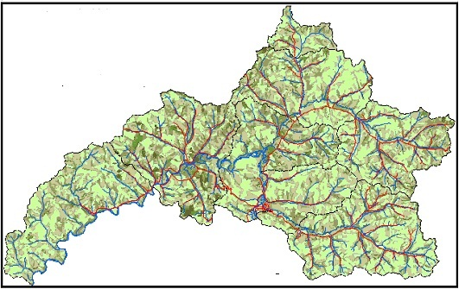
Fig. 1 Fragile dimension distribution image

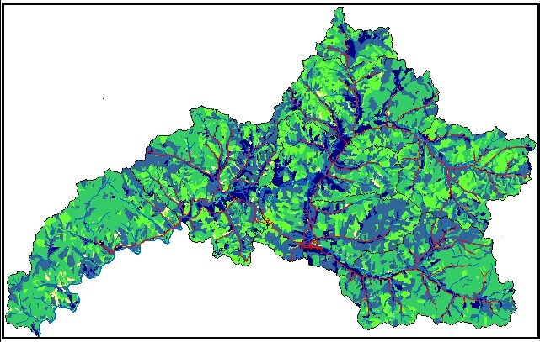
Fig. 2 Shape index distribution image

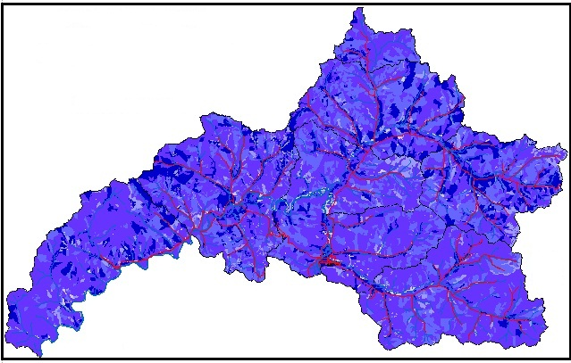
Fig. 3 Largest patch index distribution image

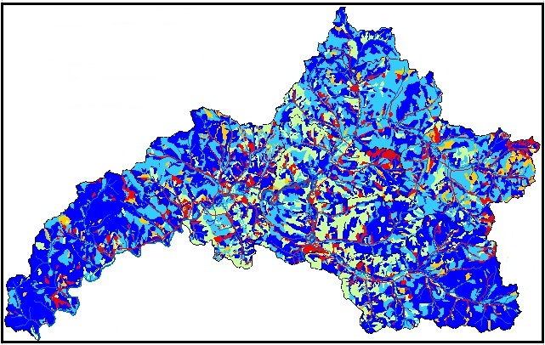
Fig. 4 Patch density distribution image

4 Conclusions
The territory that belongs to Mangui Forestry Bureau used to be primeval forest landscape in 1967. Because of the exploitation that has lasted for 40 years, a series of obvious difference had occurred in 1996. Following conclusions can be concluded by researching:
1) It is feasible to describe landscape on forest resources spatial data by Landscape shape index, Mean shape index, Area-weighted mean shape index, Double log fragile dimension, Mean patch fragile dimension, Area-weighted mean patch fragile dimension, Shannon's diversity index, Shannon's evenness index, Simpson's diversity index, Simpson's evenness index, Modified Simpson's evenness index and Modified Simpson's diversity Index.
2) Area-weighted mean shape index, Double log fragile dimension and Mean patch fragile dimension have decreased slightly for 40 years, reflecting that patch didn’t change a lot. The diversity index has not changed a lot. It can be concluded as the changes of forest landscape appear later than the changes of forest resources.
3) Landscape types have increased from 29 in 1967 to 44 in 1996, with the patch richness and the patch richness density having increased greatly for 40 years.

Acknowledgement
This research was supported by the scientific and technological project of Harbin Science and Technology Bureau, titled as “Yield Adjustment Technique of Forest Resource Based on Sustainable Management”, and the project number is 2013RFXXJ078.

References:
- Guo J P, ZHANG Y X. 2003. Advances and perspective of forest landscape ecology in China [J] (in Chinese). World Forestry Research, 16(5):46～49
- HE H S. 2008. Forest landscape models: Definitions, characterization, and classification [J]. Forest Ecology and Managements. 254:284-294
- Mc GARIGA L K， MARKS B. 1994. FRAGSTATS: Spatial pattern analysis program for quantifying landscape structure, Reference manual [M]. Oregon State University, Corvallis Oregon
- RIPPLE W J, BRADSHAW G A, SPIES T A. 1991. Measuring forest landscape patterns in the Cascade Range of Oregon, USA [J]. Biological Conservation, 57:73-88
- WU J G. 2000. Landscape ecology [M] (in Chinese). Beijing: Higher Education Press
- YANG G J, XIAO D N. 2003. Forest landscape pattern and fragmentation: a case study on Xishui Natural Reserve in Qilian Mountain [J] (in Chinese). Journal of Ecology, 22(5):56～61.

10/2/2013

