Geographical Distribution and Developmental Pattern of Buffalo in Egypt

M. K. Hassanein,S.M.Abolmaaty, A.A. Khalil,M. O. Taqi,Yassmin H. Essa, and H.H. Shawki

Central Laboratory for Agricultural Climate, Agricultural Research Centre, Giza- Egypt
Maaty2020@yahoo.com

Abstract: This study aims to investigate the buffalo geographical distribution, developmental pattern and the relationship between developmental pattern and drought in Egypt throughout 2001/ 2010. Geographic Information system (GIS) and remote sensing were used as a tool to create buffalo distribution maps and monitor drought conditions from 2001 to 2010. The results indicated that the buffalo census was increasing steadily from 2001 to 2008 and decreased from 2009 to 2010.This drop was highly at lower and Middle Egypt. There is an adverse relationship between buffalo census developmental and drought waves. However, drought is not the only factor that affects the buffalo developmental pattern but it could be one of the most critical ones. In conclusion, drought waves may buffalo's developmental pattern. Therefore, monitoring and forecasting drought waves each year are needed to overcome the expected risks.
[M. K. Hassanein, S.M. Abolmaaty, A.A. Khalil, M. O. Taqi, Yassmin H. Essa, and H.H. Shawki. Geographical Distribution and Developmental Pattern of Buffalo in Egypt. World Rural Observ 2013;5(4):14-19]. ISSN: 1944-6543 (Print); ISSN: 1944-6551 (Online). http://www.sciencepub.net/rural. 3

Key words: Buffalo, drought, GIS, land cover, VHI.

1. Introduction
Several international organizations have emphasized the potentiality of the buffalo in the economy of a number of developing countries, due to its ability to produce and reproduce under the harsh environmental conditions compared to the dairy cattle (Marai and Habeeb, 2010). Therefore, buffalo is one of the most important domestic ruminants in more than 40 countries; mostly in tropical and subtropical regions (Hinkoveski, 1990). In Egypt, buffalo is variably distributed all over the Nile valley and Nile delta. Thirty five percent of buffalo population in found in three governorates i.e. Elsharqia, ElMenia and ElBehaira. The majority of buffalo are concentrated around the Nile delta (Perera, 2011). According to (MALR, 2010) buffalo contributes by 46.97% of milk and 31.05% of meat production in Egypt.
Drought is the lack of precipitation over a large area and for an extensive period of time (McKee et al., 1995 and Agnew, 1999). The climate in Egypt is generally moderate. Egypt receives less than 80 mm of precipitation annually in most areas, although in the coastal areas it reaches 200 mm. It hardly ever rains during the summer. Therefore, according to drought definition, Egypt is semi-arid country and suffered from drought particularly in desert areas. The essential for quantification of drought impacts and monitoring in Egypt is of critical importance from political, economical, and environmental points of view. Several users are interested in reliable and accurate drought information in order to mitigate impact on surface and groundwater resources (NOAA, 2008).
As a result of the scarcity rainfall in Egypt, at most 200 mm unequally distributed and on limited areas; therefore, Egypt has poor rangeland, although vast areas between 4 and 10 million ha exist (Hegazi et al., 2005). According to FAO (2010) rangelands provide only 5% of animal feed in Egypt. Egypt depends largely on Egyptian clover (berseem) as the main forage crop during winter and spring and on crop residues and by-products during summer and autumn. Dry season forage is fibrous and low in contain of crude protein which is reflected on both animal productivity and distribution (Ben Salem and Smith, 2008). The cultivated area of berseem ranges from 1,050,000 to 1,260,000 ha annually in the Delta and Nile Valley. There is a competition in cultivated area between berseem and wheat, especially on old land, where the productivity is the highest for both crops. In addition, there is a wide gap between the available and the required animals feed. Therefore, it is competing with humans for the scarce land resources (Cassinget al., 2007). Also, buffalo feed in Egypt is insufficient, especially in feed ingredients of high protein content (IAEA, 2002). Furthermore, increased livestock production is invariably associated with an increase in livestock numbers(Thomas and Rangnekar, 2004). The animal numbers increased by a rising demand for animal products.
Thus, the environmental factors affect the quantity and the quality of the forage leading to poor animal nutrition, which is recognized as major factors for limiting the milk and meat production of buffaloes. Therefore, the effect of environmental factors including their risks on the numbers and distributions of buffaloes in Egypt need to be focused. The current study aims to investigate the geographical distribution of Egyptian buffalo, the developmental pattern, and the relationship between developmental pattern and dry season in Egypt.

2. Material and Methods
The Statistical data of buffalo census and distribution from 2001 to 2010 all over Egyptian governorates were collected from Sector of Economic Affairs, Ministry of Agriculture and Land Reclamation (MALR), Egypt. Then geographical distributional maps were done for buffalo all over Egyptian governorates by using ArcGIS 9.3.
Yearly rainfall always exists in Egypt during the period from October to May which considered as the agriculture winter season. Also, the major crop for animal feeding is cultivated approximately during the same period (MALR, 2008). According to the Moderate Resolution Imaging Spectroradiometer (MODIS), satellite images were collected at the same time approximately eight months.
Two types of satellite images were downloaded from The National Aeronautics and Space Administration (NASA) Web page (http://reverb.echo.nasa.gov/reverb/). The first type of image was the mean Normalized Difference Vegetation Index NDVI (MODIS/Terra Vegetation Indices 16-Day L3 Global 1km SIN Grid V005) to estimate Vegetation Condition Index (VCI), the Normalized Difference Vegetation Index (NDVI); images contained the mean of NDVI data within 15 days for particular area. The second downloaded image was the Brightness Temperature (BT) (MODIS/Terra Land Surface Temperature/Emissivity 8-Day L3 Global 1kmSIN Grid V005) to estimate Temperature Condition Index (TCI). BT images contained mean BT data for within 8 days for particular area.
Both types of satellite images were processed by using software of ERDAS imagine package V9.2 and ArcGIS Package V9.3. The ERDAS software was used for projection mosaic and compressed of the images. But, the ArcGIS was used for convert the raster to Shapefile and classification.
The Vegetation Health Index (VHI) was used amonitoring the drought situation which is based on estimation of green canopy stress or no stress from NOAA's Advanced Very High Resolution Radiometer (AVHRR-derived index), characterizing moisture, thermal conditions and total vegetation health(Kogan, 2001).
The VHI was derived (equation 1) from using particular time series (2001-2010) of the mean Normalized Difference Vegetation Index (NDVI) as the background value, this value was subtracted by currently year every 15-day NDVI data to obtain value of vegetation index, then the drought situation could be classified according the value of VHI.
This procedure was formalized by equations 1-3 (Thenkabailet al., 2004), where climatology was represented by the difference between 10 years absolute maximum and minimum NDVI and BT values for each pixel.

Where;
VCI (Vegetation Condition Index),
TCI (Temperature Condition Index)

The VCI values (equation 2) range from 0 to 100, where the low values represent stressed vegetation conditions, middle values represent fair conditions, and high values represent optimal or above-normal conditions.

Where;
NDVI (Normalized Difference Vegetation Index),
NDVImax, and NDVImin are the smoothed monthly NDVI, its multi-year absolute maximum and minimum, respectively.

The TCI values (equation 3) range from 0 to1, the value close to 0 indicates harsh weather conditions (due to high temperatures), relative to the composite period, middle values reflect fair conditions, and high values close to 1 reflect mostly favorable conditions.

Where; BT (Brightness temperature), BTmax, and BTmin are similar values for BT

After estimation of VHI projection for each monthly satellite image was done the coordinate system was converted from sinusoidal to WGS 84. Then, the images were reclassified on a monthly level into 6 recognized classes of VHI Pixel: 0, 10, 20, 30, 40 and 100 Where; (0=severe drought), (10= high drought), (20= drought), (30= moderate drought), (40= little drought), (100= no drought). The last step was reclassified the gained images again for all seasons of winter crop into two levels (0= drought), (1= no drought). Finally the output images were used to determine frequency of drought during each season on monthly basis and consecutive of all studied lifespan winter seasons.

3. Results and Discussion
Figure (1) shows the buffalo's distribution all over the Egyptian governorates during the period from 2001 to 2010. The buffalo census was fluctuated during the study period. Buffaloes are stationed mostly in Menia and Behera followed by El-Sharkia, while the lowest population of buffaloes were found out of valley governorates (New Valley, Matruh, Red sea, and Sinai peninsula) being between zero to two thousands individual buffalo. A slightly increasing in buffalo population from the period 2005 to 2010 was recorded in Suhag and Alexandria .Moreover, the buffalo's population in Aswan was gradually increased during the studied period from 2001 to 2010. But, the buffalo census in Giza, Fayoum and Bani-Sweif was stable during the study period.

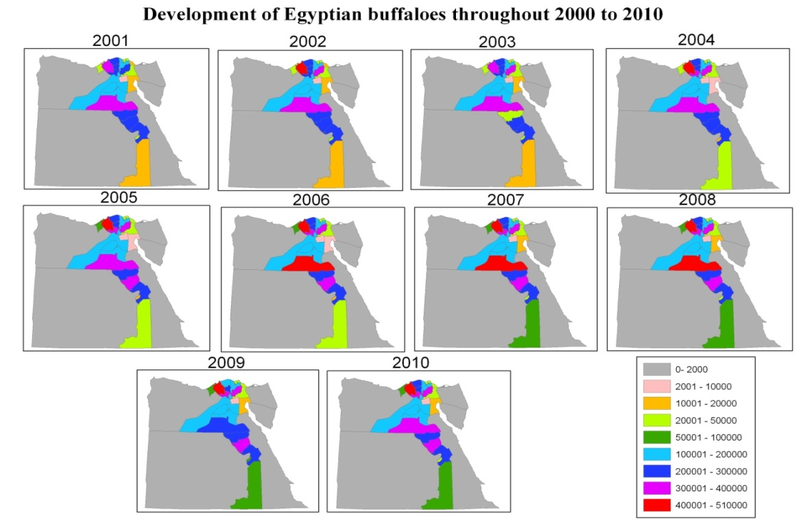
Figure 1: Buffaloes distribution all over the Egyptian governorates during the period 2001- 2010.

The results in Figure (2) show the developmental pattern of buffalo’s total numbers of Egypt from the time series between 2001 to 2010. As indicated by Cassing et al. (2007) livestock populations grow slowly and stable from year to year; furthermore the animal numbers increased by subsidized feed price (Ben Salem and Smith, 2008). The total number of buffaloes in Egypt in the year 2001 was approximately 3,380,000 head then according to Figure (2) the curve is showing steady increase and development in buffaloes populations from the period 2001 to 2008. A sudden reduction in the populations was noticed the years 2009 and 2010. Some studies expressed that the stagnation in livestock numbers is possibly reflect the limited availability of feed (Cassing et al., 2007); or the quality of feed as the dry season forage is fibrous and low in protein which is reflected on both animal productivity and distribution(Ben Salem and Smith, 2008).
Tables (1) illustrate total numbers of the buffaloes in the four major regions of Egypt: Lower Egypt (Delta), Middle Egypt, Upper Egypt, and Desert & New Lands. Data revealed that the drop of the developmental pattern of the curve during the last two years of 2009-2010 was due to highly decreasing of the populations of buffaloes in both lower and middle regions. The population of buffaloes in Upper Egypt and Desert & new lands were stable with few changes. However, the reduction in buffalo’s population in the last two years 2009&2010 during the studied period was approximately 150000, 100000 of buffalo’s head for Lower Egypt and Middle Egypt, respectively.

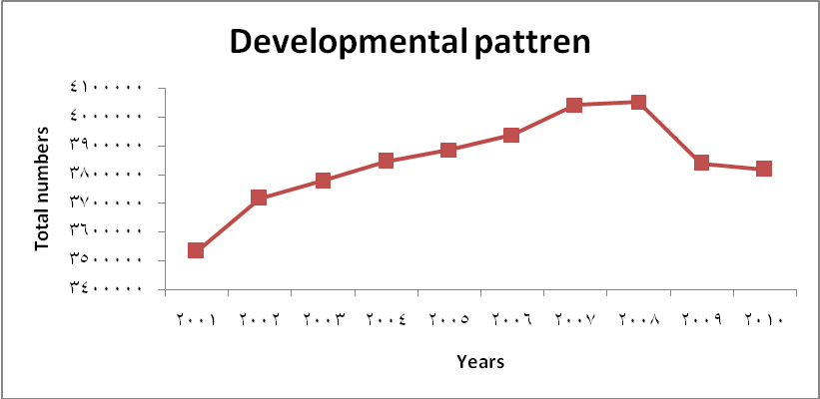
Figure 2: Buffaloes developmental pattern during the period 2001- 2010.

Table 1: Total numbers of buffalo in the four major regions of Egypt during the studied period from 2001 to 2010
Year  Region | Lower Egypt | Middle Egypt | Upper Egypt | Desert and New Lands
2001 | 1,941,107 | 790,663 | 757,267 | 44,207
2002 | 2,048,327 | 828,771 | 790,299 | 49,240
2003 | 2,066,685 | 845,515 | 815,902 | 52,790
2004 | 2,085,043 | 862,259 | 841,504 | 56,340
2005 | 2,106,890 | 867,564 | 853,824 | 56,814
2006 | 2,133,457 | 880,023 | 866,140 | 57,613
2007 | 2,162,812 | 872,631 | 940,835 | 65,532
2008 | 2,188,045 | 882,767 | 915,486 | 66,350
2009 | 2,111,658 | 741,435 | 917,629 | 67,999
2010 | 2,034,710 | 776,709 | 887,664 | 119,159

Buffalo is depending mainly in winter on barseem. As mentioned by IAEA (2002) Buffalo feed in Egypt is insufficient, especially in feed ingredients of high protein content. Harveat of winter crops such as barseem is between November to May. Berseem provides farm animals with the feedstuff rich in nutrients required for normal reproduction, growth, lactation, or maintenance of life processes. A satellite images in this period have been illustrated to identify the drought situation in Egypt of the seasons from 2000/2001 till 2009/2010.
As shown in Figure (3) VHI images of all studied lifespan seasons expressed the number of drought months during each winter season compared to the other seasons. The data revealed that season 2000/2001 followed by seasons 2007/2008, 2009/2010 and 2008/2009 had the highest number of drought months, respectively. Mild drought were recorded throughout months of season 2006/2007followed by 2004/2005 during the winter season. These results was in agreement with McKee et al. (1995) and Agnew (1999) who mentioned that primary cause of a drought event is the lack of precipitation for an extensive period of time. The drought scale here was based on the NDVI and TCI that affected by the rainfall rate and the temperature during the season, it is very clear that 2006/2007 and 2004/2005 seasons were not affected by both parameters (NDVI and TCI) and were the best winter seasons for vegetation coverage in Egypt.

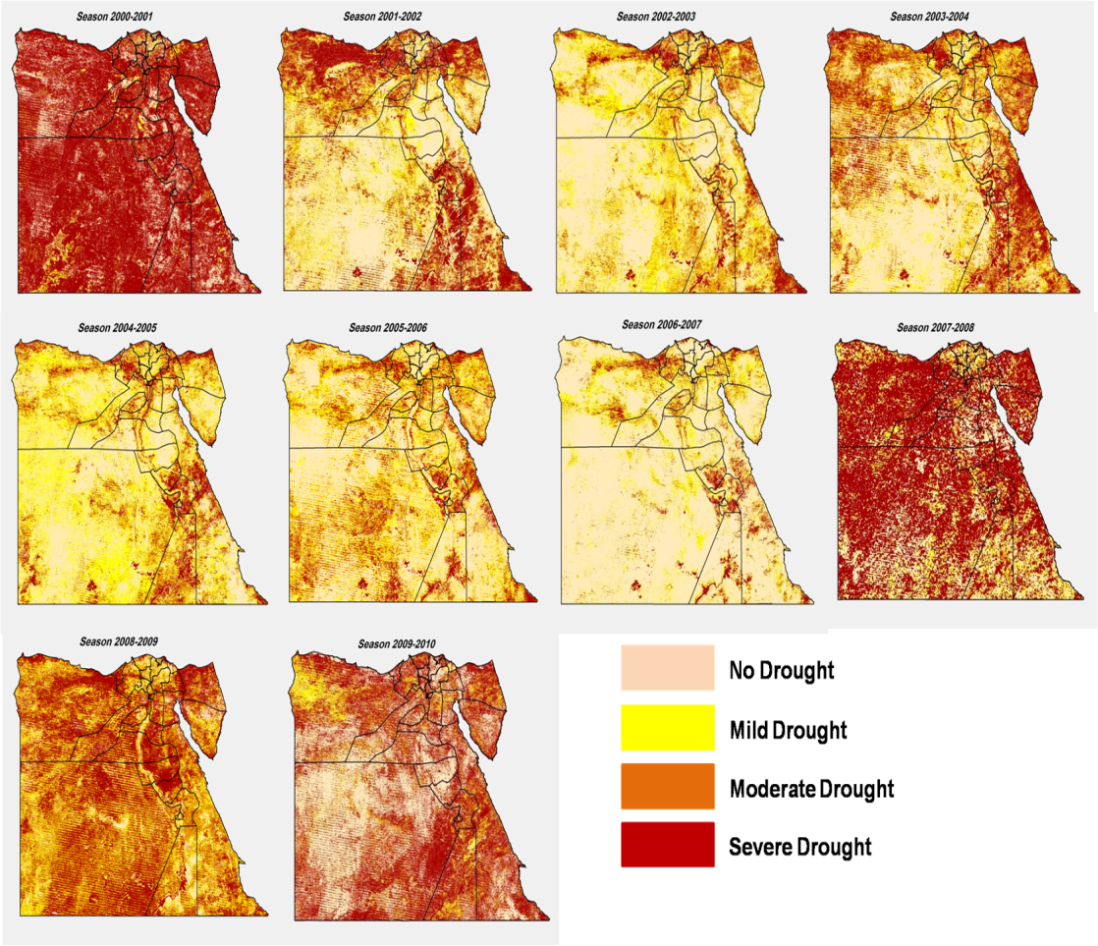
Figure 3: Seasonal drought months from 2000/2001 to 2009/2010 all over Egypt.

Analysis of the relationship among drought situations, buffalo's developmental pattern, and barseem production in Egypt of the studied period:
Data showed that there is a relationship between the drought situation and buffalo populations. In the cultivated season 2001/2002 the drought situation was the most severe season within all the other studied seasons and the populations of buffaloes were the lowest in the same way approximately 3,500,000 head. The developmental pattern of buffaloes had a steady increase as normal condition until a sudden drop were happened in years 2009 and 2010. By coupling these results with the drought images of 2008/2010, it was noticed that seasons had also a drought situation between moderate to severe in the most coverage areas of Egypt. It was also found that barseem production in Egypt have been decreased in the last two years 2009 and 2010 as shown in Table (2). In contrast, the difference between drought situation, buffalo's populations, barseem production of the years 2009 and 2010 was such a stable with little differences. Indeed, the drought may affect the forage productivity and its prices which will be back on the availability of animal feed. Thus, this shortage may be one of the main reasons that affected the developmental pattern as indicated also by (Fynn, 2008). Furthermore, livestock production is invariably associated with livestock numbers (Thomas and Rangnekar, 2004). However, the drought is not only the factor which affect the developmental pattern, since in the season 2007/2008 there were a severe drought in Egypt while the numbers of buffalo weren't dropped down meaning that drought was not the main factor that control the number of buffaloes. Many other factors such as (political view, diseases dissemination, heat stress, etc.) may affect the developmental pattern of buffaloes but drought will still have a critical role through affecting the availability, quality, and prices of forage needed for farm animal. Drought impacts and monitoring has a critical importance in political, economical, and environmental of Egypt. Drought should be taken into consideration in governmental future planning to get ready with providing forage in the expected years of drought. Several users are interested in reliable and accurate drought information in order to mitigate its impact (NOAA, 2008).

Table 2: Barseem total Production of Egypt in the seasons from 2000/2001 to 2009/2010.
Season | Barseem Production (Ton)
2000/2001 | 62,009,295
2001/2002 | 65,799,587
2002/2003 | 64,988,106
2003/2004 | 64,176,624
2004/2005 | 55,194,706
2005/2006 | 55,402,392
2006/2007 | 60,369,213
2007/2008 | 54,318,658
2008/2009 | 48,577,735
2009/2010 | 51,181,063

4. Conclusion
The investigation showed that there is a relationship between drought conditions monitored by remote sensing technique and the developmental curve of buffalo populations. Although the drought is not the only factor that affects the developmental pattern of buffalo, but it could be one of the most critical ones. There are many other factors which may affect buffalo population such as (diseases dissemination or else)but the strategy of the government toward providing alternative feed resources for farm animals during the expected dry seasons is the most important. Therefore, drought is one of the environmental risks that should be taken into consideration in governmental future planning for forage production in the expected dry seasons. Also, monitoring and forecasting drought situations for each year are needed to overcome the expected risks.

References
- Agnew C. T., 1999.Usingthe SPI to Identify Drought, Drought Network News, University of Nebraska, Lincoln New England, U.S.A, Vol. 12, No 1:pp 6-11.
- Ben Salem H. and T. Smith, 2008.Feeding strategies to increase small ruminant production in dry environments. Small Ruminant Research, 77: 174-194.
- Cassing J., S. Nassar, G. Siam and H. Moussa, 2007. Distortions to Agricultural Incentives in Egypt. Agricultural Distortions Working Paper, 36 P.
- FAO, 2005.Food and Agriculture Organization of the United Nations. FAOSTAT online statistical service. FAO. http://www.fao.org.
- FAO, 2010.Valuing Rangelands for the Ecosystem and Livelihood Services. Thirtieth FAO Regional Conference for the Near East. Khartoum, the Republic of the Sudan, 4–8 December 2010. Pub. NERC/10/ INF/6 December 2010.
- Fynn R., 2008. Drought effects on buffalo numbers in Kruger. Newsletter of the Grassland Society of Southern Africa, September 2008, Vol 8- No.3.
- Hegazi, A.M., M. Y. Afifi, M. A. El Shorbagy, A. A. Elwan and S. El-Demerdashe, 2005.Egyptian National Action Program to Combat Desertification. Arab Republic of Egypt, Ministry of Agriculture and Land Reclamation, UNCCD, Desert Research Centre, 128p.
- Hinkoveski T., 1990. Buffalo breeding in Bulgaria, Animal Science Papers and Reports (Warsaw). 6: 95-98.
- IAEA, 2002. Development and field evaluation of animal feed supplementation packages. Proceedings of the final review meeting of an IAEA Technical Co-operation Regional AFRA Project organized by the Joint FAO/IAEA Division of Nuclear Techniques in Food and Agriculture and held in Cairo, Egypt, 25–29 November 2000.
- Kogan, F.N., 2001. Operational space technology for global vegetation assessments. Bulletin of the American Meteorological Society, 82(9):1949–1964.
- MALR, 2008.Ministry of Agriculture and Land Reclamation, Economic Affairs Sector, Study of Statistics for Animal, Poultry and Fish Wealth.
- MALR, 2010. Ministry of Agriculture and Land Reclamation, Economic Affairs Sector, Study of Statistics for Animal, Poultry and Fish Wealth, pp. 1-50.
- Marai, I. F. M. and A. A. M. Habeeb, 2010. Buffalo's biological functions as affected by heat stress. Livest. Sci., 127: 89–109.
- McKee T. B., N. J. Doesken and J. Kleist, 1995. Drought monitoring with multiple time scales. Proceedings of the Ninth Conference on Applied Climatology, American Meteorological Society, Boston, pp. 233–236.
- NaSa WIST website .http://reverb.echo.nasa.gov/reverb/
- NOAA, 2008. Drought public fact sheet. http://www.nws.noaa.gov/os/brochures/climate/Drought.pdf
- Perera, B.M.A.O., 2011. Reproductive cycles of buffalo. Animal Reproduction Science, 124: 194–199.
- Thenkabail P.S., E. A. Enclona, M. S. Ashton and B. Van Der Meer, 2004. Accuracy assessments of hyperspectral waveband performance for vegetation analysis applications. Remote Sens. Environ., 91: 354376.
- Thomas D. and D. Rangnekar, 2004. Responding to the increasing global demand for animal products: implications for the livelihoods of livestock producers in developing countries. British Society of Animal Science Publication No. 33. Nottingham University Press, Nottingham, UK, pp. 1–35.
- Winterbach H.E.K., 1999. Habitat utilization, activity patterns and management of Cape buffalo in the Willem Pretorius Game Reserve. M. Sc. Thesis, Faculty of Natural, Agricultural and Information Sciences, University of Pretoria, 145 p.

9/25/2013

