Comparison of infiltration parameters obtained from revised and original USDA-NRCS method with the field measurements

Mostafa Ghahremannejad¹, Saeed Boroomandnasab¹, Abd Ali Naseri¹, Ali Sheini Dashtegol²

¹Department of Irrigation & Drainage, Shahid Chamran University, Ahvaz, Iran
²Sugarcane Research and Training Development, Khuzestan, Iran
m.gahraman@gmail.com

Abstract: Infiltration is perhaps the most crucial process affecting surface irrigation uniformity and efficiency as it is the mechanism that transfers and distributes water from the surface to the soil profile. It is essential to gage or predict the rate of infiltration in order to estimate the amount of water entering the soil and its distribution. In the absence of localized field data the USDA–NRCS intake families have often provided sufficient information for preliminary design, evaluation, or management of surface irrigation systems. Revised USDA-NRCS method used to adapting the parameters to new hydraulic conditions. This paper will evaluate Revised and original USDA-NRCS methods in Amirkabir sugar cane furrow irrigation systems. For this purpose the cumulative 6 hours infiltration (Z) estimated with two methods of original USDA-NRCS and revised USDA- NRCS, then compared with field measurement of Z. For evaluation of the results, four statistical indicators: average prediction error of model (Er), distribution into 45° line (λ), regression coefficient (R²) and average absolute error of model (Ea) were used. According to the results, revised USDA- NRCS method with average values of λ, R², Er and Ea respectively 1.45, %80, %45 and %45, overestimated the value of Z. but when for revised USDA-NRCS method used the border irrigation equations, this method with average values of λ, R², Er and Ea respectively 0.95, %84, %5 and %5.4 has the best predict of Z.
[Ghahremannejad M, Boroomandnasab S, Naseri AA. Sheini Dashdegol A. Comparison of infiltration parameters obtained from revised and original USDA-NRCS method with the field measurements. World Rural Observ 2012;4(2):82-89]. ISSN: 1944-6543 (Print); ISSN: 1944-6551 (Online). http://www.sciencepub.net/rural. 14

Key words: Infiltration parameters, Revised USDA-NRCS method, Original USDA- NRCS method, field measurement

1. Introduction
A survey of surface irrigation software users revealed that only a few estimation procedures are used in practice and that USDA personnel rely on the NRCS infiltration families (USDA-SCS, 1978; USDA-SCS, 1984) for routine applications(Bautista et al., 2001).
Infiltration families are general relationships that attempt to categorize the infiltration behavior of soils. Since NRCS manuals associate different family values with broad soil textural groups, USDA personnel typically select a family value for a field based solely on textural properties, without any field measurements. However, infiltration families can be used in combination with estimation methods, especially if the available evaluation data leads to a single volume balance relationship (Valiantzas et al., 2001; Strelkoff et al., 2009b; Bautista et al., 2009a).
In the 1950’s the USDA’s Soil Conservation Service (SCS) developed general intake relationships for border and basin irrigation systems. In the 1960’s the one-dimensional intake families were modified to give expressions for furrow irrigation. The original families were multiplied by an estimate of the wetted perimeter of the furrow to give a volumetric intake per unit length and then divided by the furrow spacing to yield a depth of infiltration.
Walker et al. (2006) discussed the assumptions and procedures used to develop the original NRCS families. Those families categorize infiltration behavior according to their steady-intake rate and were developed largely from border irrigation data. As such, those families have been more widely adopted in border/basin irrigation analyses than in furrow studies.
In 2004, NRCS decided to revise the families, largely with the goal of enhancing their applicability to furrow irrigation (Walker et al., 2006). In contrast with the original families, Walker et al. (2006) categorized infiltration based on the average rate during the first 6 h of opportunity time. The new families were developed from furrow infiltration measurements, and then adapted to border conditions. Those infiltration measurements were obtained under inflow rate, slope, cross section, and roughness conditions. Recognizing that these flow conditions affect flow depth and that flow depth affects infiltration in furrows, Walker et al. (2006) proposed procedures for adapting the parameters to new hydraulic conditions. Procedures are also provided for adapting the parameters to events late in the irrigation season. Another important aspect of the new families is the use of the Extended Kostiakov equation, which represents steady-state infiltration better than the Kostiakov formula employed by the original NRCS families. The procedures used to adapt the furrow infiltration parameters to different hydraulic conditions are empirical.
From the available data, Walker et al. (2006) developed relationships for the reference parameter values (Kref, aref, and f0ref) and reference hydraulic conditions (discharge Qref and wetted perimeter1 WPref) as a function of Fn, the family value. The reference K and B are then multiplied by the ratio of the wetted perimeter under the particular field conditions (slope, cross section, inflow rate) over Wpref. Hence, the assumption is that average infiltration characteristics over the entire furrow length vary linearly with changes in upstream wetted perimeter. This assumption is supported by the early work of Fangmeier and Ramsey (1978). Border and basin irrigation parameters are calculated by dividing the reference K and B by an equivalent wetted perimeter WPeqv which is calculated with the following expression, originally suggested in USDA-SCS (1974).

1.1 Objective of the study
The broad objective of the study is evaluation of revised and original USDA-NRCS method for estimating furrow irrigation infiltration parameters in sugarcane fields of Ahvaz.

1.2 Hypothesis
To determining of infiltration parameters, Field measurement is the best method.

2. Methodology

2.1 Field experiments
This research was carried out in ARC2-7 farm from January 2010 to December 2011. As one of the research fields of Sugarcane Research Center in Amir Kabir Sugarcane Planting and by Products Company of Khuzestan, the farm is located southwest of Iran. The soil had silty-loam texture with 28% sand, 43% silt, and 24% clay. The field work was conducted on one set of furrow irrigation. This set had three furrows1.8 m wide and 140 m long. The middle furrow of each set was used to take measurements, while the side furrows were used as buffering area. The intake family numbers in revised USDA-NRCS method (Fn) based on the average infiltration rate during the first 6 h of irrigation. In other words, the 6 h intake rate is determined by the cumulative intake that occurs in the first 6 h of irrigation divided by the 6 h or 360 min interval. To determine the Fn, double ring experiment were performed before irrigation. Then revised USDA-NRCS parameters and original USDA-NRCS parameters were determined. By measuring inflow, outflow, and calculating surface water storage, the volume of infiltrated water was determined. The advance and recession times were recorded at 14 points at 10 m intervals along each furrow. Seven irrigation events were examined. Fiberglass flumes (WSC) type II was used at the beginning and the end of each furrow in the first set where inflow/outflow measurements were to be taken. Experiments were carried out in order to determine the final infiltration rate (f₀) with the assumption of uniform soil infiltration characteristics. First, inflow and outflow of the furrow were measured at the beginning and the end of two Fiberglass WSC flumes. Then, when the flow reached a constant level, f0 was measured.
For each irrigation event, the flow depth in each flume was measured in order to determine the discharge in the flume by:
Q = cWH3/2 (1)
Where Q is the discharge (m3/s), W is the width of opening (in meter), H is the depth of flow (in meter) and c is a coefficient of discharge which depends on the geometry of the culvert. A typical value is 0.6.more precise can be taken from tables such as in USDA-ARS (1979).

Original USDA–NRCS method
Furrow irrigation intake was expressed as:
⁽²⁾

In which WP is the furrow wetted perimeter in m and w is the irrigated furrow spacing in m. The WP = w adjustment was limited to a value no greater than 1.0.

Revised USDA-NRCS method
Revised USDA-NRCS method uses the Kostiakov–Lewis equation, Eq (3), which adds a term for final or basic intake rate, F₀ in m3/m/min.
⁽³⁾
In which Z is the cumulative volume of infiltration per unit length, m³/m. The coefficient K has units of m³/m/mina while a is dimensionless. The cumulative intake in furrow can be expressed as an equivalent depth by:
⁽⁴⁾
Where w is the furrow spacing in m.
The values of the, K, and F₀ parameters for initial continuous flow furrow irrigation were selected and correlated with the NRCS Family Number, Fn. Then, general functions were developed to adjust the parameters to later continuous flow irrigation and both surge flow conditions. This analysis was perhaps more qualitative and subjective than quantitative as the data are widely scattered due to variations in field length, furrow shape, and slope (Walker et al. 2006). Equations for each intake parameter are given below:
⁽⁵⁾
) ⁽⁶⁾
⁽⁷⁾
Where Fn is the NRCS Family Number, a_{ref}, f_{0ref} and k_{ref} are respectively reference parameters of a, f₀ and k.
The furrow discharge associated with the respective data sets noted in Section 4.1 and used to determine the furrow intake equations was fitted by least squares to an expression representing the full range of the NRCS intake families. This ‘‘reference’’ discharge has been expressed as (Walker et al., 2006):
⁽⁸⁾
In which Q_{ref} is the reference discharge, in LPs, for a specific intake family number, Fn. The values of Q_{ref} are assumed to the same for all furrow irrigation intake families, i.e., initial and later continuous flow as well as initial and later surge flow conditions. Associated with Q_{ref} is a reference wetted perimeter, WP_{ref}, expressed in m, necessary to adjust intake parameters for variations in cross-section, roughness, and slope. Again using the available field data to determine a relationship between intake family and WP_{ref} yielded:
⁽⁹⁾
Since the horizontal intake in furrows is different than the vertical intake from the bottom of the furrows and should be different than the one-dimensional intake in borders and Basins, it is necessity to define an ‘‘equivalent’’ wetted perimeter, Wp_{eqv} that could be used to convert furrow reference intake parameters to border and basin values. Expressed as follows:
⁽¹⁰⁾
After determining the reference parameters, infiltration parameters can be adjusted as follows for the initial or later continuous and surge flow (Walker et al., 2006).
⁽¹¹⁾
⁽¹²⁾
⁽¹³⁾
Where ICF is the irrigation condition factor and WP is the wetted perimeter in new hydrolic condition. Other parameters have been previously described.

3. Results and discussion
The values of cumulative 6 hours infiltration (Z) estimated with two methods of original USDA-NRCS and revised USDA- NRCS, then compared with the results of field measurements. In revised USDA-NRCS method, once Z determined with the equations of furrow irrigation and another once determined with the equations of furrow irrigation. Results of these methods represented in table 2. Table 1 showed the values of reference parameters in revised USDA-NRCS method. The coefficient of irrigation condition factor (ICF) for the desired area was determined that the average numeric value equal to 0.82. According to the results of Walker et al. (2006), a typical later continuous intake can be estimated by ICF of 0.80. The average value of the 6 h intake rate (Fn) for the desired area is 0.46 and the average value of basic infiltration rate (f₀) is 0.48 which is larger than Fn. This is consistent with the results of Walker et al. (2006).

 | Table 1- Reference parameters in revised USDA-NRCS method
Irri | Fn | a_{ref} | f_{0ref} | K_{ref} | Q_{ref} | Wp_{ref} | Wp_{eqv} | ICF
Irri | (inch/hr) |  | (m³/m/min) | (m³/m/minª) | (lit/sec) | (m) | (m)
1 | 0.58 | 0.5319 | 0.00013 | 0.0018 | 1.4 | 0.25 | 0.57 | 0.84
2 | 0.50 | 0.5119 | 0.00012 | 0.0017 | 1.3 | 0.23 | 0.56 | 0.83
3 | 0.44 | 0.4937 | 0.00010 | 0.0015 | 1.2 | 0.22 | 0.55 | 0.82
4 | 0.42 | 0.4899 | 0.00010 | 0.0015 | 1.1 | 0.22 | 0.54 | 0.81
5 | 0.42 | 0.4885 | 0.00010 | 0.0015 | 1.1 | 0.22 | 0.54 | 0.81
6 | 0.43 | 0.4908 | 0.00010 | 0.0015 | 1.2 | 0.22 | 0.53 | 0.81
7 | 0.43 | 0.4920 | 0.00010 | 0.0015 | 1.2 | 0.22 | 0.53 | 0.82
average | 0.46 | 0.4998 | 0.0001 | 0.0016 | 1.20 | 0.23 | 0.55 | 0.82

Table 2- Values of cumulative of 6 hours infiltration (Z) estimated with three methods
Irri |  | Revised  USDA-NRCS | revised  USDA-NRCS | Field | Original
Irri |  | For furrow irrigation | For border irrigation | measurement | USDA-NRCS
1 |  | 0.202 | 0.106 | 0.113 | 0.057
2 |  | 0.185 | 0.093 | 0.099 | 0.051
3 |  | 0.170 | 0.082 | 0.087 | 0.050
4 |  | 0.163 | 0.078 | 0.081 | 0.049
5 |  | 0.163 | 0.077 | 0.081 | 0.049
6 |  | 0.167 | 0.080 | 0.084 | 0.049
7 |  | 0.169 | 0.081 | 0.085 | 0.049
Average |  | 0.174 | 0.106 | 0.0900 | 0.051

To compare these methods during the irrigation season and studding seasonal variability of infiltration, the cumulative 6-hour Infiltration average (Z) for each irrigation was calculated using three methods. shows the variation of Z for each method during the irrigation season. According to this figure for all methods, values ​​of cumulative infiltration reduced with irrigation number. But the reducing is not for all irrigation numbers and after the fourth irrigation Z is almost constant and it is increased with slightly rate. According to this figure, original USDA-NRCS method underestimated value of Z and revised USDA-NRCS method overestimated value of Z but when for revised USDA-NRCS method using the border irrigation equations, this method has the best estimate.
Fitting Curve of the field measurement and calculated points represented in Figures.2-4. As the Figures show, revised USDA-NRCS method with border irrigation equations has the best fitted of Z.
.

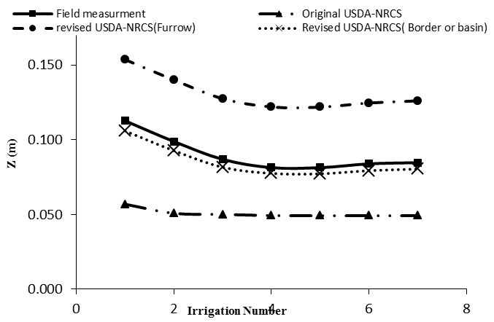

Figure 1- changes of Z for any method

Figure 2- Curve of fitting Z obtained field measurement and revised USDA-NRCS method with border irrigation equations

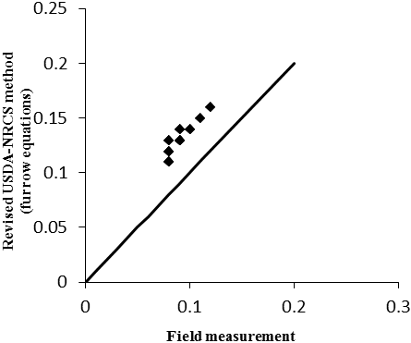
Figure 3- Curve of fitting Z obtained field measurement and revised USDA-NRCS method with furrow irrigation equations

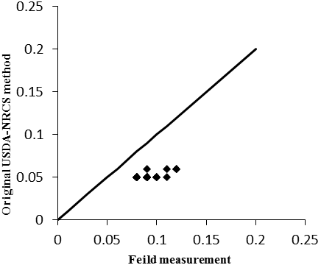
Figure 4- Curve of fitting Z obtained field measurement and original USDA-NRCS method

3.1 statistical analyzes
For evaluation of the results, four statistical indicators: average prediction error of model (Er), distribution into 45° line (λ), regression coefficient (R²) and average relative error of model (Ea) were used. These parameters defined as:
⁽¹⁴⁾
⁽¹⁵⁾
⁽¹⁶⁾
In these equations X_{pi} and X_{oi} is the predicted value and observed value, respectively.
Values of these indicators presented in Table 3. According to the results of this table, revised USDA- NRCS method using border irrigation equations with average values of λ, R², Er and Ea respectively 0.95, 84, 5 and 5.4 percent has the best prediction of cumulative infiltration and revised USDA- NRCS method using furrow irrigation equations with average values of λ, R², Er and Ea respectively 1.45, 80, 45 and 45 percent Had the highest error value. This error is probably due to specific shape of the furrows in this field that presented in Figure 5 So that furrows of this field with irrigated furrow spacing of 1.8(m) and deeps of 10 to 15(cm) are wide and shallow. Therefore these furrows have border properties and border irrigation equation for them is true.

Table 3- Values of statistical indicators
distribution into 45° line (λ) | average prediction error of model (%Er) | regression coefficient (R²) | average absolute error of model (%Ea) | Numbers of observation  (N) | Method
0.56 | 44 | 43 | 43 | 28 | Original USDA-NRCS method
1.45 | 45 | 80 | 45 | 28 | Revised USDA-NRCS method(furrow)
0.95 | 5 | 84 | 5.4 | 28 | Revised USDA-NRCS method(border)

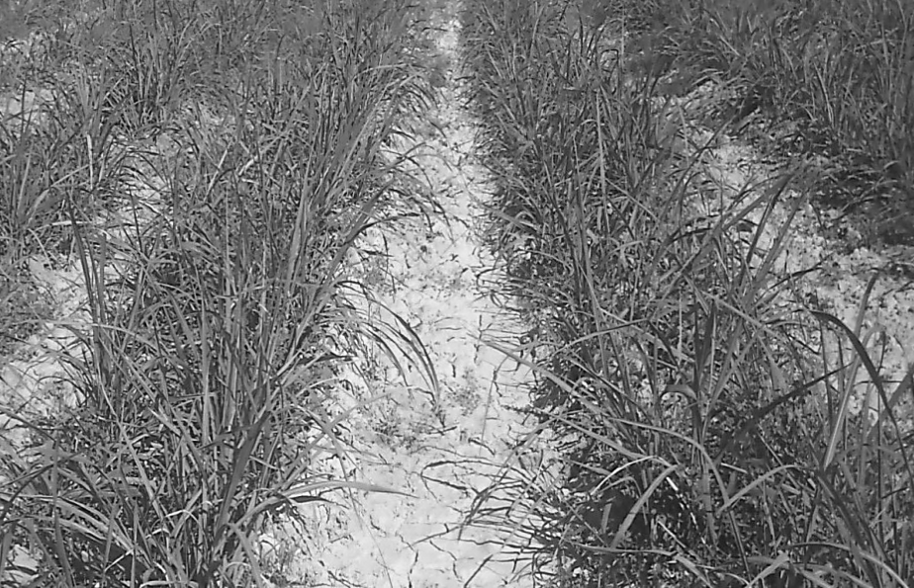
Figure 5- Shape of furrows in Amirkabir sugar can field

4．Conclusion
Field measurement methods of infiltration such as the volume balance method firstly required to high time-consuming and high cost of localized field measurements. Secondly, before the land preparation for preliminary design use of this method is not feasible. This paper has evaluated the possibility of using original and revised USDA-NRCS methods in Amirkabir sugar cane furrow irrigation systems. The results of this study show that the original USDA-NRCS method has underestimating of cumulative infiltration and revised USDA- NRCS method with furrow irrigation equations has the overestimating of cumulative infiltration. Also the coefficient of irrigation condition factor (ICF) for the studied area was determined. Average value of ICF is 0.82. The results of presented study also show values ​​of cumulative infiltration reduced with irrigation number. But the reducing is not for all irrigation numbers and after the fourth irrigation Z is almost constant and it is increased with slightly rate.
Finally, in the absence of localized field data to determining infiltration parameters in studied irrigation condition, applying the equations of border irrigations of revised USDA-NRCS method recommends.

Acknowledgement:
The authors would like to acknowledge the Excellency of Sugarcane Research and Training Development and By Products Khuzestan, Iran for their assistance.

Correspondence to:
Mostafa Ghahremannejad
Department of Irrigation & Drainage, Shahid Chamran University, Ahvaz, Iran
m.gahraman@gmail.com

References
- Bautista, E. and W.R Walker. 2010. Advances in Estimation of Parameters for Surface Irrigation Modeling and Management. An ASABE Conference Presentation. Paper Number: IRR10-9643
- Bautista, E., A.J. Clemmens, T.S. Strelkoff, and J. Schlegel, 2009. Modern analysis of surface irrigation systems with WinSRFR. Agric. Water Manage. 96: 1146–1154
- Bautista, E., M. English and D. Zerihun. 2001. Estimation of soil and crop hydraulic properties for surface irrigation: Theory and practice. ASAE Paper 01-2254. ASAE Int. Meeting. Sacramento, CA July 30-Aug 1.
- Fangmeier, D.D. and M.K. Ramsey. 1978. Intake characteristics of irrigation furrows. Trans. ASAE 21: 696–705.
- Strelkoff, T.S., A.J. Clemmens, and E. Bautista. 2009a. Field properties in surface irrigation management and design. J. Irrig. Drain. Eng. 135:525-536.
- Strelkoff, T.S., A.J. Clemmens, and E. Bautista. 2009b. Estimation of soil and crop hydraulic properties. J. Irrig. Drain. Eng. 135:537-555.
- US Department of Agriculture Natural Resources and Conservation Service, 2005. National Engineering Handbook, Part 623, Surface Irrigation. National Technical Information Service, Washington, DC, Chapter 4.
- USDA-NRCS (US Department of Agriculture, Natural Resources and Conservation Service). 1997. National Engineering Handbook. Part 652. Irrigation Guide. National Technical Information Service, Washington, DC
- USDA-SCS (US Department of Agriculture, Soil Conservation Service). 1974. National Engineering Handbook. Section 15. Border Irrigation. National Technical Information Service, Washington, DC, Chapter 4.
- USDA-SCS (US Department of Agriculture, Soil Conservation Service). 1984. National Engineering Handbook. Section 15. Furrow Irrigation. National Technical Information Service, Washington, DC, Chapter 5.
- Valiantzas, J. D., S. Aggelides, and A. Sassalou. 2001. Furrow infiltration estimation from time to a single advance point. Agric. Water Manage. 52:17–32.
- Walker, W.R. 2008. The effects of geometry and wetted perimeter on surface irrigation infiltration. In: Proc. World Environmental and Water Resources Congress 2008: Ahupua'a. ASCE-EWRI. May 12–16
- Walker, W.R., C. Prestwich, and T. Spofford. 2006. Development of the revised USDA-NRCS intake families for surface irrigation. Agric. Water Manage. 85: 157-16.

6/28/2012

