**Evalution of AquaCrop model application in irrigation management of Cotton**

Moloud Heidariniya 1, Abd Ali Naseri 2, Saeed Boroumandnasab3, Borhan Sohrabi Moshkabadi4, Ali Heidar Nasrolahi5

1 M.Sc (Irrigation and Drainage Engineering)

2 Department of Irrigation & Drainage, Water Sciences Engineering Facualty, Shahid Chamran University, Ahvaz, Iran

3 Department of Irrigation & Drainage, Water Sciences Engineering Facualty, Shahid Chamran University, Ahvaz, Iran

4 Professor, Department of Irrigation & Drainage, Agriculture and Natural Resources Facualty, Gorgan University, Gorgan, Iran

5 Ph.D Student, Department of Irrigation & Drainage, Water Sciences Engineering Facualty, Shahid Chamran University, Ahvaz, Iran

[h_moloud@yahoo.com](mailto:dr_charleso@yahoo.com)

**Abstract:** Agriculture is the most important factor of the world economy. So, water is the most necessary production factor. The maximum problem of Cotton agriculture is irrigation management in humid areas. If irrigation is applied earlier or with more than amount is needed, yield decrease is very much, especially in humid areas. In this project, The performance of AquaCrop model was tested for Cotton to decrease costly and long time field experiments. So, statistical indicators RMSE, AAD and R2 were calculated to evaluate model accuracy and deficit irrigation scenarios were assessed. The value of R2 is 0.7381 and 0.7638 for 2004 and 2005 respectively. Possible reasons for the discrepancies beween the simulated and measured results include simplifications in the model, inaccuracies in measurements and different varieties.Also, results show that stress increases yield before flowering.

[Nnadi FN, Nnadi C. **Evalution of AquaCrop model application in irrigation management of Cotton.** World Rural Observ 2012;4(2):55-59]. ISSN: 1944-6543 (Print); ISSN: 1944-6551 (Online). <http://www.sciencepub.net/rural>. 9

**Key words**: AquaCrop model, Cotton, statistical indicator

**1. Introduction**

The process of population increase is communicative in recent years, So that food requirement will be tow time in next fifty years. So, water requirement will increase too. One of the solutions for water shortage problem, is increase of water use efficiency.

Simulation models that quantify the effects of water on yield at the farm level can be valuable tools in water and irrigation management. Most of these models, however, are quaite sophisticated, demanding advanced skills for their calibration and operation require large number of parameters. The newly AquaCrop model (Raese et al.,2009; Steduto et al., 2009) is a user- friendly and practitioner – oriented type of model, as it maintains an optimal balance between accurancy, robustness and simplicity and requires a relatively small number of parameters (Heng et al.,2009). AquaCrop model is a valuable tool for estimating crop productivity under rainfed condition, supplementary and deficit irrigation, and on- farm water management strategies for improving the efficiency of water use in agriculture.

Maximum problem of Cotton agriculture, is irrigation management in humid areas. If irrigation is applied earlier or more than amount is needed, yield decrease is very much, especially in humid areas. Deficit irrigation will cause to flower diffusion and low production. So, crop ends his life and also, irrigation with more than requirement increases leafs growth and decreases flowering and yield severely.

Scientists have two theories about irrigation before flowering:

1. Some scientists believe that, If stress is applied at first stages, root growth increases and crop shows better reaction to summer water shortage.So, If we have shortage of water resources, It is better to apply stress for increasing root growth, So, Crop shows less sensivity in opposite of deficit irrigation in summer, in addition to better moisture and food elements suction.
2. Some scientists are against to apply stress at first stages and believe that it is important to apply first irrigation on time, to increase vegetation growth. Expriments show that sprigs yield that have sufficient growth before flowering, are better than sprigs that have had water stress (Sohrabi moshk abadi, 2006).

Some of projects that done with AquaCrop model has explainated in follow. Alizadeh et al (2009), evaluated AquaCrop model in deficit irrigation management of Wheat in Karaj. Prject results showed that AquaCrop has enough accuracy under complete and deficit irrigation. Heng et al(2009), parameterized and tested model for Maize. The largest deviation between simulated and measured values was 22% for biomass, and 24% for grain yield. Garcia- vila (2009), determined optimal level of applied irrigation water (AIW) for Cotton with use of AquaCrop model in southern Spain. Results showed that AquaCrop is useful tool to assist managers under water supply restriction.

**1.1 Objective of the study**

The objective of this study is assessment of AquaCrop model performance for Cotton with extensive data collected with Sohrabi moshkabadi (2006) in field experiments in Gorgan. Comparision of model results and field experiments and best management solution is determined finally.

**2. Methodology**

**2.1 Model Theory**

AquaCrop is drived from Doorenbos & Kessam (1979) approach, according to the following equation, relating yield to the consumed water:



(1)

Where Yx and Ya are the maximum and actual yield, ETx and ETa are the maximum and actual evapotranspiration, and KY is proportional coefficient between relative yield loss and relative reduction in evapotranspiration. AquaCrop separatese ET into crop transpiration (Tr) and soil evaporation(E). This evoids the confounding effect of the nonproductive consumptive use of water (E), wich is important especially during incomplete ground cover, and led to conceptual equation at the core of the AquaCrop growth engine:

$$B=WP × \sum{Tr}$$

(2)

Where WP is the water productivity (biomass per unit of cumulative transpiration), wich tends to be constant for a given climatic condition. By normalizing appropriately for different climatic condition, WP becomes a conservative parameter (Steduto et al., 2007). Thus, stepping from Eq [1] to Eq [2] has a fundamental implication for the robustness and generality of the model. The other improvement from Eq [1] to AquaCrop is the time scale used. In the case of Eq [1], the relationship is used seasonally or for different phases of the crop lasting weaks or mounth, While in the case of Eq[2], the relationship is used for daily time scale of crop response to water deficits(steduto et al., 2009). However, AquaCrop model is based on difficult processes, but needs to low and easy parameter. Input data are divided to four part: climatic, crop, soil and fiel management data.

Five sets of Cotton data were reported in phD desertations (Sohrabi moshkabadi, 2006), were used to calibrate and test AquaCrop model. All experiments were performed at Hashem abad station in Gorgan.

**2.2 Climatic data**

Climatic data were reported of Hashem abad weather station. The climate is medterranean and it has mild winters and rather dry summer. Mean relative humidity, maximum mean and minimum mean are respectively 71%, 22 and 13 centigrade.

**2.3 Soil Data**

The soil data of experimental area are reported in table 1.

Table1. Measured soil properties in Gorgan

|  |  |  |
| --- | --- | --- |
| **Thickness (m)** | **Fiel capacity (%)** | **Pemanent wilting point (%)** |
| 0-30 | 17.8 | 8.25 |
| 30-60 | 17.48 | 8.68 |
| 60-90 | 6.19 | 9.66 |

**2.4 Crop parameters**

**2.4.1 Conservative parameters**

Out of all the crop parameters in AquaCrop, 21 of them were demonstrated or assumed to be conservative (constant). some of these parameters were reported in table 2.

**2.4.2 User- specific parameter**

Site and crop specific parameters such as soil water characteristics, maximum roothing depth, sowing date, irrigation phenology are under the heading of user – specific input parameters. Some of these parameters are reported in table 3.

**2.5 Field Management**

All studied expriments includes one cotton cultivar (Say ekra) that were planted with plant spacing: 20 * 80 centimeter.

This project are includes five treatments of water irrigation with tree repeats in full chansy blocks.

1. Rainfed condition
2. Irrigation: 40% evaporation of A class evaporation basi
3. Irrigation: 70% evaporation of A class evaporation basi
4. Irrigation: 100% evaporation of A class evaporation basi
5. Irrigation: 120% evaporation of A class evaporation basi

Table 2. Conservative parameters were used to simulate studies in Hashem abad station-Gorgan

|  |  |  |
| --- | --- | --- |
| **Description** | **Value** | **Units or meaning** |
| Canopy growth coefficient (CGC) | 7.6% | Increase in CC relative to exiting per CC in GDD |
| Canopy decline coefficient (CDC) at senescence | 2.9% | Decline in CC relative to CCX per GDD |
| Water productivity normalized to year 2000 | 15 | G (biomass) m-2 , function of atmospheric CO2 |
| Leaf growth threshold p-upper | 0.2 | As fraction of TAW, above this leaf growth inhabited |
| Leaf growth threshold p- lower | 0.6 | Leaf growth stops completelt at this p |
| Stomatal conductance threshold p- upper | 0.6 | Above this stomatal begin to close |
| Senescense stress coefficient curve shape | 0.75 | Moderately convex curve |
| Refrence harvest index | 35% | Common for good condition |
| GDD. Growing degree day;  HI. Harvest index |  |  |

Table 3. Some of user- specific parameters were used to simulate studies in Hashem abad-Gorgan

|  |  |  |
| --- | --- | --- |
| **Year** | **RMSE** | **AAD** |
| 2004 | 1.97 | 1.92 |
| 2005 | 2.51 | 2.47 |

*DAP: Day After Plant

**3. Results and discussion**

**3.1** **Data Analysis**

The performance of the model evaluated using the following statistical parameter: the root mean square (RMSE), is calculated as:



(3)

And the Average Absolute Division(AAD) is calculated as:

(4) $$AAD=\frac{\left|S_{i}-O_{i}\right|}{n}$$

Where Si and Oi are the simulated and observes (measured) values respectively, N is the number of observation.

RMSE in Eq.3 and AAD in Eq.4 represents a measure of overall, or mean, devition between observed and simulated values. Therefore the closer the value is to zero, the better the model simulation performance.

The results of statistical indicators are presented in table 4. Results show that statistical indicators values in year 2004 are less than year 2005. Accuracy increase may caused by more accurate irrigation information and reduction of field experiments.

Table 4. The RMSE and AAD between measured yield and simulated values in Hashem abad-Gorgan- years 2004 and 2005.

|  |  |  |  |  |  |  |
| --- | --- | --- | --- | --- | --- | --- |
| **Plant**  **density** | **Flowering priod(day)** | | **emergence** | **Senescence** | | **Maturity** |
| Plant.m-2 | |  |  | DAP* |  | |
| 12 | 54 | | 18 | 144 | 177 | |

Review on previous researchs show that the values of RMSE in this plan- 1.97 and 2.51- are more than similar value in research of Farahani et al (2009) and Todorovic (2009)- 0.13 and 1.81 respectively- for Cotton. So, it can be said that simulation accuracy has decreased. It has been caused by errors of field experiments and simplification in the model.

Regression coefficient (R2) is also calculated for more accurate assessment in figure 1 and 2. The value of R2 for 2004 and 2005 years, show that simulation and mesuared results almost have high correlation. The most important reson for reduction of R2, is difference between varieties in model and this project. So, the results show that,it's better to make the crop file separately for different areas.

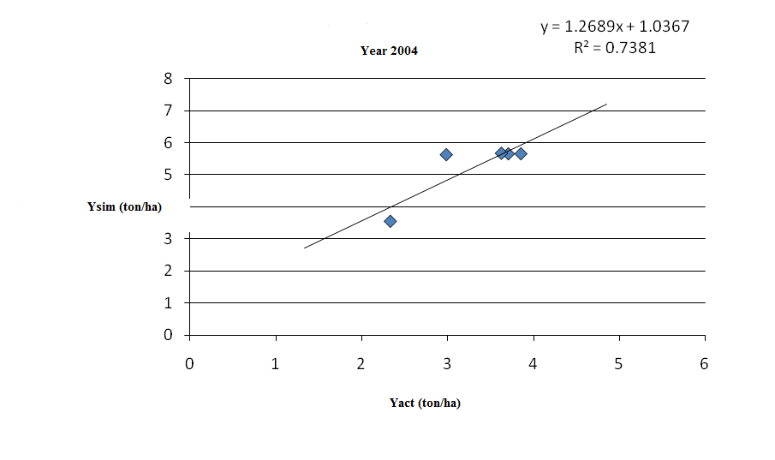

Figure 1. Simulated and measured yield of all irrigated treatments in the 2004 expriments conducted in Hashem abad- Gorgan

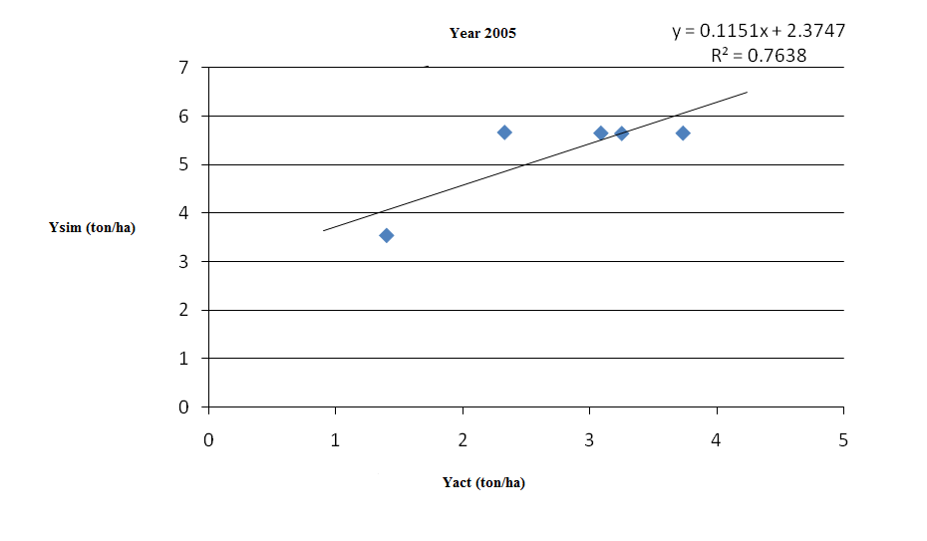

Figure 2. Simulated and measured yield of all irrigated treatments in the 2005 expriments conducted in Hashem abad- Gorgan

**Evalluation of deficit irrigation scenarios**

Considering to previous aguments and high accuracy of AquaCrop model we investigated two theories about Cotton irrigation.

1. full Irriigation after fowering(no irrigation before fowering)
2. Irrigation from first stage to end .

Results of scenarios simulation are seen in table 5. Results assessment show that irrigation before flowering and continue to end, causes to yield reduction. So, scenarios simulation ignores irrigation before flowering and shows that water stress before flowering, caused to root growth increase, less sencivity to water shortage in summer and yield increase.

Table 5. Assessment of simulation results of suggested scenarios.

|  |  |  |
| --- | --- | --- |
| **Irrigation from first stage to end** | **full Irriigation after fowering** | **Irrigation treatment** |
| 5.531 | 5.620 | 40% evaporation of basin |
| 5.625 | 5.665 | 70% evaporation of basin |
| 5.522 | 5.649 | 100% evaporation of basin |
| 5.525 | 5.645 | 120% evaporation of basin |

**Conclusions**

According to errors of field experiment, model simulation and difference between varieties, can be stated that AquaCrop has high accurency in simulation. But it’s proposed to test model for other crops such as Cotton, Shogerbeat, Soybean, Potato et cet, for more accurate evalution of model performance. Furthermor, it’s should be considered that crop data may be changed with studied variety and model accurency should be studied in low, moderate and severe stress, too.

To sum up, the model strikes a balance between accurency, simplicity, robustness, the low requirement of input data and ease of use, so, it is recommended to apply model for estimating yield and water productivity under rainfed, supplementary and deficit irrigation.

**Correspondence to:**

Moloud Heidariniya

Tel:+989386580592

[h_moloud@yahoo.com](mailto:h_moloud@yahoo.com)

**References**

1. Alizadeh H.A, Nazari B, Parsinezhad M, Ramezani etedali H, Janbaz H.R. AquaCrop model evalution for deficit irrigation management of Wheat in Karaj region. Iranian Journal of Irrigation and dranage. 2010; 2 (4): 273- 283.
2. Garcia- Vila M.G, Fereres E, Orgaz F, Steduto P. Deficit irrigation optimization of Cotton with AquaCrop. Agron, J. 2008;101: 477- 478.
3. Raes D, Steduto P, Hsiao T.C, Fereres E. AquaCrop- The FAO crop model for predicting yield response to water: II. Main algorithms and software description. Agron. J. 2009; 101:438-447.
4. Sohrabi moshkabadi, B. Use of sprinkle irrigation and infrared thermometer for cotton (Gossypium hirstum) irrigation scheduling in wet region. PhD dissertation. Shaid Chamran university of Ahvaz. Water engineering faculty. 2006.
5. Steduto P, Hsiao T.C, Fereres E. On the conservative behavior of biomass water productivity. Irrig. Sci. 2007; 25: 189- 207.
6. Steduto P, Hsiao T.C, Raes D, Fereres E. AquaCrop- The FAO crop model to simulate yield response to water: I. Consepts and underlying principles. Agron. J.2009; 101: 426-437.
7. Yang H. S, Dobermann A, Lindquist J.L, Walters D.T, Arkebaure T.J, Cassman, K.G. Hybrid-maize- a maize simulation model that combines two crop modeling approaches. Field Crops Res. 2004; 87:131-154.

5/5/2012