Milankovitch cycles — Basics of Monsoon Time Scales : Formulation of Maritime Continental Monsoon Time Scale

Gangadhara Rao Irlapati

H.No.5-30-4/1, Saibabanagar, Jeedimetla, Hyderabad, India-500055
E-mail: gangadhar19582058@gmail.com

Introduction: According to the Milankovitch cycle, the angle of the Earth's axial tilt (obliquity) regarding the orbital plane (the obliquity of the ecliptic) varies between 22.1° and 24.5°, over a cycle of about 41,000 years. The current tilt is 23.44°, roughly halfway between its extreme values. Milankovitch cycles are a series of periodic changes in the Earth's orbit around the Sun that affect the amount of solar radiation the Earth receives, which in turn influences climate change. This tilt does not remain constant at 23.44°. It oscillates up and down and slowly moves to 24.5°. The oscillation of up and down will be about 85 years, according to the Monsoon Time Scales. That is, about 60 years up, 25 years down, in total oscillating once every about 85 years. When it moves up to 22.1°, droughts and famines occur, and when it moves up to 24.5°, heavy rains and floods occur. Oscillating in this way, it slowly moves forward. All this can be clearly observed in the Monsoon Time Scales. If this is true, then we are close to reaching 24.5°, So, are there going to be more climate changes in the coming centuries? What are the Milankovitch Cycles? What is their importance in the study of climate changes? How they determine the scientific accuracy of Global Monsoon Time Scales? What is the relationship between Milankovitch cycles and Global Monsoon Time Scales? What are the new things that can be learned by Global Monsoon Time Scales? What is the need to establish the Maricontinental Monsoon Time Scale to unravel the mysteries of the Maricontinental Monsoon? Let's discuss in this paper. I call on world scientists to establish the Maricontinental Monsoon Time Scale following the Basics of Monsoon Time Scales outlined below, based on the India Monsoon Time Scale which is successfully proved out in practice and break down the mysteries of the Maricontinental monsoon.
[Gangadhara Rao Irlapati. Researcher. Milankovitch cycles — Basics of Monsoon Time Scales: Formulation of Maritime Continental Monsoon Time Scale. 2025;17(1):13-68]. ISSN 1553-9865 (print); ISSN 2163-8950 (online). http://www.sciencepub.net/researcher. 03. doi:10.7537/marsrsj170125.03

Keywords: Bioforecast (1965-70); A New Hypothetical Model of Cosmology (1970-77); Inquisition (1977-79); Basics of Geoscope (1980-87); Basics of Monsoon Time Scales (1987-91); Indian Monsoon Time Scale(1991); Researches on Earth and space related issues (1991-2000); Numerical Weather Periodic Tables (2000-10); Designs of Geoscope projects (2010-20); Designs of Global Monsoon Time Scales (2020-)

Introduction:
Milankovitch cycles are a series of periodic changes in the Earth's orbit around the Sun that affect the amount of solar radiation the Earth receives, which in turn influences climate change: These cycles are named after Serbian scientist Milutin Milanković, who hypothesized that they are a major driver of long-term climate change. Milankovitch cycles are believed to have caused Earth to swing between ice ages and warmer periods for millions of years. Scientists can model these cycles and compare their calculations to evidence found in geological sediments.
What are Milankovitch cycles?
Milankovitch cycles are a series of periodic changes in the Earth's orbit around the Sun that affect the amount of solar radiation the Earth receives, which in turn influences climate change:
Eccentricity: The shape of the Earth's orbit around the Sun. The Earth's orbit is elliptical, but its shape varies over time. When the orbit is more elliptical, the Earth moves closer and further from the Sun, which affects the climate.
Obliquity: The angle of the Earth's axis in relation to its orbital plane. The tilt of the Earth's axis changes over time, moving from 22.1° to 24.5° and back again over about 41,000 years. When the tilt increases, summers are warmer and winters are colder.
Precession: The direction Earth's axis of rotation points. The Earth's axis completes a full cycle of precession every about 26,000 years.
What is their importance in the study of Milankovitch cycles and effects on climate changes?
Milankovitch cycles are believed to have caused Earth to swing between ice ages and warmer periods for millions of years. Scientists can model these cycles and compare their calculations to evidence found in geological sediments.
According to the Milankovitch cycle, the angle of the Earth's axial tilt (obliquity) regarding the orbital plane (the obliquity of the ecliptic) varies between 22.1° and 24.5°, over a cycle of about 41,000 years. The current tilt is 23.44°, roughly halfway between its extreme values. Milankovitch cycles are a series of periodic changes in the Earth's orbit around the Sun that affect the amount of solar radiation the Earth receives, which in turn influences climate change.
These cyclical orbital movements, which became known as the Milankovitch cycles, cause variations of up to 25 percent in the amount of incoming insolation at Earth's mid-latitudes (the areas of our planet located between about 30 and 60 degrees north and south of the equator). Milankovitch cycles are a series of orbital changes that affect the Earth's climate over thousands to hundreds of thousands of years. These cycles are caused by variations in three factors:
Milankovitch cycles impact the Earth's climate by:
Changing the distribution of solar radiation.
The amount of solar radiation that reaches the Earth's surface varies seasonally and annually based on latitude.
Influencing the average surface temperature
This can cause exchanges of volatiles between the atmosphere and surface reservoirs.
Triggering the beginning and end of glaciation periods
Milankovitch cycles are thought to be a major driver of the Earth's long-term climate.
For example, when the Earth's axis is tilted more, the seasons become more extreme, with warmer summers and colder winters. The Earth's axis is currently tilted at 23.5 degrees.
What is the relationship between Milankovitch cycles and Global Monsoon Time Scales ? How the Milankovitch cycles determine the accuracy of Global Monsoon Time Scales? What are the new things that can be learned by Global Monsoon Time Scales?
The Earth revolves around the Sun and the Sun revolves around the Milky Way Galaxy. If you think closely, the reflections of the movements of the Earth and Sun “I.e” the Earth rotates (spins) on its axis once every 24 hours and revolves around (orbits) the Sun once every 365 days. The sun rotates (spins) on its axis once every ~27 days and revolves around (orbits) the center of the Milky Way once every 225–250 million years and other mysteries are clearly reflected on the Global Monsoon Time Scales. Think carefully. Milankovitch cycles are directly related to current climate changes, they are a natural process that has shaped Earth's climate from a 85 years cycle to millions of years.
According to my research and studies, this tilt does not remain constant at 23.44°. It oscillates up and down and slowly moves to 24.5°. These oscillations of up and down will be about 85 years, according to the Global Monsoon Time Scales. That is about 60 years upwards journey and about 25 years downward journey in total oscillating once every about 85 years, latter takes place a little further. In this every oscillation, when it oscillating towards 22.1° that is descending order low rainfall (droughts and famines) occurs and when it oscillating towards 24.5°, heavy rainfall (heavy and floods) occurs. Oscillating in this way, it slowly moves forward. All this can be clearly observed in the Global Monsoon Time Scales. If this is true, then we are close to reaching 24.5°, So are there going to be more climate changes in the coming future.
Many mysteries about the inextricable relationship between the Milankovitch cycles and the Global Monsoon Time Scales are unraveling. Learn about them in the next papers
What is the need to establish Maricontinental Monsoon Time Scale to unravel the mysteries of the Maricontinental monsoon ?
The Maricontinental Monsoon is an important monsoon system. By setting up the Maricontinental Monsoon Time Scale, we can conduct research and studies on the monsoons of Maricontinental and predict the climate changes in the coming period of climate changes in advance.
Climate change is a long-term change in the average weather patterns that have come to define earth's local, regional and global climates. The climate is strongly influenced by Monsoon winds. Monsoon means a seasonal reversing wind accompanied by its corresponding weather changes and natural calamaties in precipitation. We cannot be said that a monsoon especially to be relevant to a particular continent, country or a region. Each and every continent or region or country has its own monsoon winds. By establishing the global monsoon time scale and manage , a country can be estimated the impending weather conditions and natural calamities such as rains, floods, landslides, avalanches, blizzard and droughts, extreme winter conditions, heavy rainfall, mudflows, extreme weather, cyclones, cloud burst, sand storms, hails and winds etc in advance. Surface water resources can still be found.
The major monsoon systems in the world consist of the west Africa and Asia -Australian monsoons. The inclusion of the North and South American monsoons with incomplete wind reversal has been debate. Monsoons can also be divided by Southern monsoon and Northern monsoons, Summer monsoons and Winter monsoons, Continental monsoons and Regional monsoons etc. A monsoon is also served with different names by region and place. For example, the North American monsoon is named after the name of Arizona monsoon and Mexican monsoon. There are also two or three or more branches of one monsoon. Monsoon is also called upon by geographical areas. For example, the Indian monsoon has its two branches, the Arabian branch and Bay of Bengal branch. Each and every continent, region or country has its own monsoonal winds. On the whole, 1.North American monsoon, 2.North African monsoon, 3.Indian Monsoon, 4.East Asian monsoon, 5.Western North Pacific monsoon, 6.South African monsoon, 7.South African monsoon, 8.Australian Monsoon are the main regional monsoons according to Prof Bin Wang. I agree with the opinion of Prof Bin Wang.
Global Monsoon Time Scales:
Each region of the world can establish monsoon time scales for their respective regions. Accurate results can only be obtained if the monsoon time scale belonging to their regions are obtained. For example, it is better if the Canada country establish its Canada Monsoon Time Scale. If not, countries can set up regional Monsoon Time scales belonging to their respective regions. For example, countries in the North American continent can establish the North American Time Scale. If these are not possible to establish, then they can set up the Indian Monsoon Time Scale and study the climate changes of their countries. Because the Indian Monsoon Time Scale, far away, reflects climate changes in distant all world regions.
By establishing the Monsoon Time Scale and maintain, a country can be estimated the impending weather conditions and natural calamities such as monsoon movements, rains, floods, landslides, avalanches, blizzard, droughts, famines extreme winter conditions, heavy rainfall, mudflows, extreme weather, storms, cloud burst, sand storms, hails and winds etc all climate, meteorological and weather related conditions & natural calamities in advance. Surface water resources can also still be found. I have conducted many scientific researches on the global monsoon systems and designed the Basics for Monsoon Time Scales including Regional Monsoon Time Scales, Sub-Regional Monsoon Time Scales, Country-Wise Monsoon Time Scales, Northern Monsoon Time Scales, Southern Monsoon Time Scales, Summer Monsoon Time Scales, Winter Monsoon Time Scales for all regions and countries to study the past’s, present and future movements of the global monsoon systems and its relationship with rainfall and other weather problem and natural calamities. We can make separate monsoon time scales per each and every individual country. As a part of this, I have proposed and designed Basics of Monsoon Time Scales for all countries separately.

Global, regional & local monsoon systems & their proposed monsoon time scales:
North American Monsoon | North American Monsoon Time Scale,
North African Monsoon | North African Monsoon Time Scale,
Indian Monsoon | Indian Monsoon Time Scale,
East Asian Monsoon | East Asian Monsoon Time Scale,
Western North Pacific Monsoon | WesternNorthPacificMonsoonTime Scale
South American Monsoon | South American Monsoon Time Scale,
South African Monsoon | South African Monsoon Time Scale,
Australian Monsoon, | Australian Monsoon Time Scale,
European Monsoon | European Monsoon Time Scale,
South Asian Monsoon | South Asian Monsoon Time Scale,
North East Monsoon | North East Monsoon Time Scale,
Asian South West Monsoon | Asian South West Monsoon Time Scale,
USA South West Monsoon | USA South West Monsoon Time Scale,
East African Monsoon | East African Monsoon Time Scale,
West African Monsoon | West African Monsoon Time Scale,
Indo Australian Monsoon | Indo Australian Monsoon Time Scale,
Asian Australian Monsoon | Asian Australian Monsoon Time Scale,
Malasian Australian Monsoon | Malasian Australian Monsoon Time Scale
Northern Australian Monsoon | Northern Australian Monsoon Time Scale
Australian Indonesian Monsoon | AustralianIndonesianMonsoonTimeScale,
Arabian Monsoon | Arabian Monsoon Time Scale,
Bay of Bengal Monsoon | Bay of Bengal Monsoon Time Scale,
New Mexican Monsoon | New Mexican Monsoon Time Scale
Arizona Monsoon | Arizona Monsoon Time Scale
Gulf of California Monsoon | Gulf of California Monsoon Time Scale
Central American Monsoon | Central America Monsoon Time Scale
South East African Monsoon | South East African Monsoon Time Scale
North West African Monsoon | North West African Monsoon Time Scale
Indo-China Monsoon | Indo-China Monsoon Time Scale
South East Asian Monsoon | South East Asian Monsoon Time Scale
Maritime Continental Monsoon | Maritime Continental Monsoon Time Sca
Borneo-Australian Monsoon | Borneo-Australian Monsoon Time Scale

Proposed and designed local monsoon time scales by country:
Afghanistan Monsoon Time Scale, | Mozambique Monsoon Time Scale,
Albania Monsoon Time Scale, | Myanmar(Burma) Monsoon Time Scal
Algeria Monsoon Time Scale | Namibia Monsoon Time Scale,
Andorra Monsoon Time Scale, | Nauru Monsoon Time Scale,
Angola Monsoon Time Scale, | Nepal Monsoon Time Scale,
Antigua Barbuda Monsoon Time Sca | Netherlands Monsoon Time Scale,
Argentina Monsoon Time Scale, | New Zealand Monsoon Time Scale,
Armenia Monsoon Time Scale, | Nicaragua Monsoon Time Scale,
Aruba Monsoon Time Scale, | Niger Monsoon Time Scale,
Australia Monsoon Time Scale, | Nigeria Monsoon Time Scale,
Austria Monsoon Time Scale, | North Korea Monsoon Time Scale,
Azerbaijan Monsoon Time Scale, | Norway Monsoon Time Scale,
Bahamas Monsoon Time Scale, | Pakistan Monsoon Time Scale,
Bahrain Monsoon Time Scale, | Palau Monsoon Time Scale,
Bangladesh Monsoon Time Scale, | Palestine State Monsoon Time Scale,
Barbados Monsoon Time Scale, | Panama Monsoon Time Scale,
Belarus Monsoon Time Scale, | Papua New Guinea Monsoon Time Sc
Belgium Monsoon Time Scale, | Paraguay Monsoon Time Scale,
Belize Monsoon Time Scale, | Peru Monsoon Time Scale,
Benin Monsoon Time Scale, | Philippines Monsoon Time Scale,
Bhutan Monsoon Time Scale, | Poland Weather Time Scale,
Bolivia Monsoon Time Scale, | Portugal Monsoon Time Scale
BosniaHerzegovinaMonsoonTime S | South Africa Monsoon Time Scale,
Botswana Monsoon Time Scale, | South Korea Monsoon Time Scale,
Brazil Monsoon Time Scale, | South Sudan Monsoon Time Scale,
Brunei Monsoon Time Scale, | Spain Monsoon Time Scale,
Bulgaria Monsoon Time Scale,, | Sri Lanka Monsoon Time Scale,
Brusina Monsoon Time Scale, | Sudan Monsoon Time Scale,
Burkina Faso Monsoon Time Scale, | Suriname Monsoon Time Scale,
Burundi Monsoon Time Scale, | Somalia Monsoon Time Scale,
Cabo Verde Monsoon Time Scale, | Sweden Monsoon Time Scale
Cambodia Monsoon Time Scale, | Switzerland Monsoon Time Scale
Cameroon Monsoon Time Scale, | Somalia Monsoon Time Scale,
Canada Monsoon Time Scale, | Sweden Monsoon Time Scale,
Cabo verde Monsoon Time Scale, | Switzerland Monsoon Time Scale,
CentralAfricanRepublicMonsoon Ti | Syria Monsoon Time Scale,
Chad Monsoon Time Scale, | Solomon Islands Monsoon Time Scale
Chile Monsoon Time Scale, | Tajikistan Monsoon Time Scale,
China Monsoon Time Scale, | Tanzania Monsoon Time Scale,
Colombia Monsoon Time Scale, | Thailand Monsoon Time Scale,
Comoros Monsoon Time Scale, | Timor -Leste Monsoon Time Scale,
Congo Republic Monsoon Time Scal | Togo Monsoon Time Scale,
Costa Rica Monsoon Time Scale, | Tonga Monsoon Time Scale,
Cote Dilvoria Monsoon Time Scale, | Turkey Monsoon Time Scale,
Croatia Monsoon Time Scale, | Trinidad & Tobago Monsoon Time S
Curacao Monsoon Time Scale, | Turkmenistan Monsoon Time Scale,
Cyprus Monsoon Time Scale, | Tuvalu Monsoon Time Scale,
Czech Republic Monsoon Time Scal | Uganda Monsoon Time Scale,
Denmark Monsoon Time Scale, | Ukraine Monsoon Time Scale,
Djibouti Monsoon Time Scale, | United Arab Emirates Monsoon Time ,
Dominica Monsoon Time Scale, | United Kingdom Monsoon Time Scale,
Democratic Republic Congo MTS | US Monsoon Time Scale,
East Tumor Monsoon Time Scale, | Uruguay Monsoon Time Scale,
Ecuador Monsoon Time Scale, | Uzbekistan Monsoon Time Scale,
Egypt Monsoon Time Scale, | Vanuatu Monsoon Time Scale,
El Salvador Monsoon Time Scale, | Venezuela Monsoon Time Scale,
Equatorial Guinea Monsoon Time S | Vietnam Monsoon Time Scale
Eritrea Monsoon Time Scale, | Yemen Monsoon Time Scale
Estonia Monsoon Time Scale, | Zambia Monsoon Time Scale,
Ethiopia Monsoon Time Scale, | Zimbabwe Monsoon Time Scale,
Fiji Monsoon Time Scale,
Finland Monsoon Time Scale,
France Monsoon Time Scale, | Cote d’lvoire Monsoon Time Scale,
Gabon Monsoon Time Scale, | Democratic Republic of Congo Monsoon Time Scale,
Gambia Monsoon Time Scale, | Eswatini Monsoon Time Scale,
Georgia Monsoon Time Scale, | Oman Monsoon Time Scale,
Germany Monsoon Time Scale, | North Macedonia Monsoon Time Sc
Ghana Monsoon Time Scale, | Qatar Monsoon Time Scale
Greece Monsoon Time Scale, | Romania Monsoon Time Scale
Grenada Monsoon Time Scale, | Russia Monsoon Time Scale
Guatemala Monsoon Time Scale, | Rwanda Monsoon Time Scale
Guinea Monsoon Time Scale, | Saint Kitts And Nevis Monsoon Time S
Guinea – Bissau Monsoon Time Sca | Saint Lucia Monsoon Time Scale
Guyana Monsoon Time Scale | Saint Vincent and the Grenadines MTS
Haiti Monsoon Time Scale, | Samoa Monsoon Time Scale
Holy See Monsoon Time Scale, | San Marino Monsoon Time Scale
Honduras Monsoon Time Scale, | SaoTome&Principe MonsoonTime Sca
Hongkong Monsoon Time Scale, | Saudi Arabia Monsoon Time Scale
Hungary Monsoon Time Scale | Senegal Monsoon Time Scale
Iceland Monsoon Time Scale, | Serbia Monsoon Time Scale
India Monsoon Time Scale, | Seychelles Monsoon Time Scale
Indonesia Monsoon Time Scale, | Sierra Leone Monsoon Time Scale
Iran Monsoon Time Scale, | Singapore Monsoon Time Scale
Iraq Monsoon Time Scale, | Slovakia Monsoon Time Scale
Ireland Monsoon Time Scale, | Slovenia Monsoon Time Scale
Israel Monsoon Time Scale
Italy Monsoon Time Scale,
Jamaica Monsoon Time Scale
Japan Monsoon Time Scale,
Jordan Monsoon Time Scale,
Kazakhstan Monsoon Time Scale,
Kenya Monsoon Time Scale,
Kiribati Monsoon Time Scale,
Kosovo Monsoon Time Scale,
Kuwait Monsoon Time Scale,
Kyrgyzstan Monsoon Time Scale,
Laos Monsoon Time Scale,
Latvia Monsoon Time Scale,
Lebanon Monsoon Time Scale,
Lesotho Monsoon Time Scale
Liberia Monsoon Time Scale,
Libya Monsoon Time Scale,
Liechtenstein Monsoon Time Scale,
Lithuania Monsoon Time Scale,
Luxembourg Monsoon Time Scale,
Macaw Monsoon Time Scale,
Macedonia Monsoon Time Scale,
Madagascar Monsoon Time Scale,
Malawi Monsoon Time Scale,
Malaysia Monsoon Time Scale,
Maldives Monsoon Time Scale
Mali Monsoon Time Scale
Malta Monsoon Time Scale,
Marshall Islands Monsoon Time Sca
Mauritania Monsoon Time Scale,
Mauritius Monsoon Time Scale,
Mexico Monsoon Time Scale,
Micronesia Monsoon Time Scale,
Moldova Monsoon Time Scale,
Monaco Monsoon Time Scale,
Mongolia Monsoon Time Scale,
Montenegro Monsoon Time Scale,

Basics of Monsoon Time Scales:
After much research, I have proposed some basics regarding method and design of the Monsoon Time Scales for study the global monsoon systems. Monsoon Time Scale is a chronological sequences of events arranged in between the Time and climate with the help of a scale for studying the past’s, present and future movements of monsoon systems and its relationship with rainfall and other weather conditions& natural calamities.
Method and Design:
Design: Prepare a Monsoon Time Scale having 365 horizontal days from April 1st to next year March 31st (or January 1st to December 31st or March 21st to next year March 20th or according to the chronology of a country’s Time and Climate) of 139 year from 1880 to 2027 comprising of a large Time and Climate should be taken and framed into a square graphic scale.
This scale should be designed in three ways i.e Basic scale, Filled scale, Analyzed scale;
Basic Scale: The first one is preliminary basic scale, it explains the structure of the scale.
Filled Scale: This is the second scale that is filled with data and explains how to fill or manage the scale.
Analyzed Scale: And the third one is scientifically analyzed the filled scale by data, it explains monsoon patterns weather conditions of the scale.
Method: There are two methods in formation and process of the Monsoon Time Scales. The first one is in the single form and next one is designed in four parts.
Single& Full length Scale: Prepare the Monsoon Time Scale having 365 horizontal days from April 1st to next year March 31st (or January 1st to December 31st or March 21st to next year March 20th or according to the chronology of a country’s Time and Climate) of 139 year from 1880 to 2027 comprising of a large Time and Climate should be taken and framed in a single and full length type square graphic scale. It can be formed on a Paper or a Wall or a Table.
Parts & paste Scale: The single and full length square graphic scale is to be long. So that it is divided into four parts easy to carry and keep and suitable for publication. I designed to make it into 4 parts and then pasted it into one scale.
The first part is beginning from 1st April to July 12th.
The second part is from 13 July to October 23rd.
The third part is from 24th October to February 3^{rd.}
And the fourth part is 4th February to March 31st ending.
These separate scales can be pasted into one scale as explained below.
Cut along the edges of dates on the right side of the first part and paste it to along the edges of date of 13th July on left side of the second part.
Cut along the edges of dates on the right side of the second part and paste it to along the edges of date of 24th October on left side of the third part.
Cut along the edges of dates on the right side of the third part and paste it to along the edges of date of 4th February on left side of the fourth part .
When paste this manner, we get long full-length Monsoon Time Scale. .
Computerization:
Monsoon Time Scales can also be computerized. Besides rather than in manual type scale, if we are able to create a computer model scale which to be the most obvious.
Material and Data:
Construction of the Monsoon Time Scales requires enormous data of low pressure systems, depressions tropical cyclones/storms, snowfall and sand storms etc. that formed over and affecting a region should be taken as data to prepare the Monsoon Time Scale. An accurate scale is available if we can collect and analyze the exact climate data.
What should the data be taken?
For example, countries where monsoon occur should taken low pressure systems as data.
Countries where storms occur can be taken storms as data.
European countries can taken Westerlies as data.
Snowy countries of polar climate can take snowfall, snowy rains, graupel, snowpellets as data
Desert or hot climate countries can take sand or dust storm incidents as data.
Scientists can also be taken yearly climate changes as a key data as every year occurs routinely in their countries.
Management:
The main weather events such as monsoon pulses in the form of low pressure systems if any of a monsoon region formed over a region or country have been entering on the scale in stages by 1 for low, 2 for depression, 3 for storm, 4 for severe storm and 5 for severe storm with core of hurricane winds should be entered on the Monsoon Time Scale as per date and month of each and every year. If we can managing the scale in this manner continuously, we can study the past, present and future movements of monsoons of a region or country. I took the numbers to analysis the variations in data. Researchers have to decide what kind of data to take and how to analyze the data.
Researches &results:
The research and study should be done in the same way as described below in the Indian Monsoon Time Scale and the results should be obtained.
Study & discussion:
The obtained results should be studied and analyzed in the same way as described below in the Indian Monsoon Time Scale.
Indian Monsoon Time Scale
I have undertaken the Indian Monsoon Time Scale as the model research project following all the rules of Basics of Monsoon Time Scales. The reason I took the Indian Monsoon Time Scale as the model research was because I was in the Indian monsoon region. I know the information about Indian monsoon very well.
The Indian Monsoon Time Scale is a chronological sequence of events arranged in between time and weather with the help of a scale for studying past’s, present and future movements of the monsoon of India and its relationship with rainfall and other weather problems and natural calamities. From where to wherever to be taken the time and weather data to analyze, the researcher can decide on his discretion according to available weather data.
Method and design:
Design: For this, I took a period of 365 horizontal days from April 1st to next year March 31st (or January 1st to December 31st or March 21st to next year March 20th or according to the chronology of India’s as the time and the data of monsoonal low pressure systems, depressions and storms of 139 years from 1880 to 2027 that were formed over the Indian region taken as the climate, on the whole comprising of a large time and climate took and framed into a square graphic scale. I designed this scale in three ways i.e Basic scale, Filled scale, Analyzed scale as described below.
Basic Scale: The first one is preliminary basic scale, it explains the structure of the scale.
Filled Scale: The second one is filled by data scale, it explains how to fill or manage the scale.
Analyzed Scale: And the third one is filled and analyzed by data, it explains monsoon patterns of the scale.
Method: There are three methods used to design this scale. The first one is the single and full length scale and second one is parts & past scale. The last one is computer model made entirely by computer system.
Single& Full length Scale: I prepared the Indian Monsoon Time Scale having 365 horizontal days from April 1st to next year March 31st (or January 1st to December 31st or March 21st to next year March 20th or according to the chronology of India’s time and climate) of 139 year from 1880 to 2027 or a required period, comprising of a large time and climate was taken and framed in a single and full length type square graphic scale. It can be formed on a paper, board, wall or table.
Parts & Paste Scale: The single and full length square graphic scale is to be long. So that it is divided into four parts easy to carry and keep and suitable for publication. I designed to make it into 4 parts and then pasted it into one scale.
The first part is from 1st April to July 12th.
The second part is from 13 July to October 23rd.
The third part is from 24th October to February 3^{rd.}
And the fourth part is 4th February to March 31st ending.
These separate scales are pasted into one scale as described below below.
Cut along the edges of dates on the right side of the first part and pasted it to along the edges of date of 13th July on left side of the second part.
Cut along the edges of dates on the right side of the second part and pasted it to along the edges of date of 24th October on left side of the third part.
Cut along the edges of dates on the right side of the third part and pasted it to along the edges of date of 4th February on left side of the fourth part .
When pasted in this manner, we get long full length Indian Monsoon Time Scale
Computer model scale:
Besides this above two manual scales, I have prepared a computer Indian Monsoon Time Scale generated by the computer system from the year 1888 to 1983 for the period of 1st June to September 30th. If we are able to create a computer model scale which to be the most obvious.
Material &data: The monsoon pulses in the form of low pressure systems over the Indian region have been taken as the data to the construction of this scale. For this, a lot of enormous data of low pressure systems, depressions and cyclones that formed over the Indian region were taken as the climate from many resources just like Mooley DA,Shukla J(1987); characteristics of the west ward-moving summer monsoon low pressure systems over the Indian region and their relationship with the monsoon rainfall. Centre for Ocean-land Atmospheric interactions, University of Maryland, college park, MD., and from many other resources and from many other resources just like The world’s 7 Tropical Cyclone seasons around the world etc.
Management:
The monsoon pulses in the form of low pressursystemtems over the Indian region are taken and entered on the scale in stages by 1 for low, 2 for depression, 3 for storm, 4 for severe storm and 5 for severe storm with core of hurricane winds pertaining to the date and month of the each and every year. How the Indian monsoons have been travelling for the last 140 years since 1880 onwards are recorded on the Indian Monsoon Time Scale. I took the numerical/statistical method to analysis the variations in data. If we have been managing the scale in this manner continuously, we can study the past, present and future movements of monsoon of India. Researchers have to decide what kind of data to take and how to analyze the data.
Results&analysis:
I did comprehensive researches on the Indian Monsoon Time Scale and analyzed many key mysteries related to the monsoonal system. The Indian Monsoon Time Scale reveals many secrets and mysteries of the Indian monsoon and its relationship with movement of axis of the Earth around the Sun in the universe & its influences on the Earth’s atmosphere. Let's study the mystery of the Indian monsoon and discuss the rest of other features of the Indian Monsoon Time Scale later.
When examine the scale, I noticed that several passages or path-ways of monsoon pulses it have been some cut-edge paths and splits passing through its systematic zigzag cycles in a systematic manner in parallel and stacked next to each other in ascending and ascending order clearly seen on the Indian Monsoon Time Scale. If the thin arrows along the passages identified on the Indian Monsoon Time Scale are drawn from 1880 to the current year, then the monsoon paths appears. Many other methods can analyze the Indian Monsoon Time Scale. In my researches I have noticed that depending on the incidence of heavy rains & floods in some years and droughts & famines in another years were happened according to the travel of monsoon path. The path of monsoon when travelling over four months from June to September good rainfall or heavy rains and floods were occured. And the path when travelling over last months i.e July or August or September, low rainfall and droughts were occured. Particularly, there are two main passages. The first one is main path or passage of the Indian monsoon(Southwest monsoon) and the second one is path or passage of the north-east monsoon. The first one is on the left side over the months of June, July, August, September(southwest monsoon) and another path on the right side over the months of October, November, December are visible in the Indian Monsoon Time Scale
Pre-path of Indian monsoon:
Keep track the Indian Monsoon Time Scale carefully. When we look at the Indian Monsoon Time Scale, several paths appears. Two of these are important. These can be called main path of the Indian monsoon and pre-path of the main passage of the Indian monsoon. The main path appears clear and its pre-path appears unclear.Due to unavailability of data, it is not known how the pre-path of the Indian monsoon traveled before 1888. But according the studies-
Between 1727-1751 years, it traveled in the shaped of concave direction for about 24 years and caused low rainfall and droughts in many years.
Between 1752-1811 years, it trtraveled in the shape of convex direction for about 60 years and caused good rainfall and floods in many years.
Between 1812-1835 years, it traveled in the shape of concave direction for about 25 years and caused low rainfall and droughts in many years.
Between 1836-1895 years, it traveled in the shaped of convex direction for about 60 years and caused good rainfall and floods in many years.
Between 1896-1919 years, it traveled in the shape of concave direction for about 24 years and caused low rainfall and droughts in many years.
Between 1920-1981 years, it traveled in the shape of convex direction for about 62 years and caused good rainfall and floods in many years.
Betwhen 1982-2009 years, it traveled in the shape of concave direction for about 27 years and caused low rainfall and droughts in many years.
From 2010, it is going to travel upwards in the shape of convex direction for 56 years that's until 2056 and will be resulting good rainfall and floods in the coming years.
Main-path of Indian monsoon:
Keep track the Indian Monsoon Time Scale carefully. During the 1865-1895’s, the main path-way of the Indian monsoon was rising over June, July, August. During 1896-1920’s, it was falling over August, September. During 1920-1965’s, it was rising again over July, August, September. During 1965-2020s, it was falling over September. From 2020, it is now rising upwards and estimated traveling over the months of June, July, August by the 2060.
Due to unavailability of data, it is not known how the main path of the Indian monsoon traveled before 1888. But according the studies, it is known that it traveled in the shape of convex direction for 56 years between 1865-1897 and caused good rainfall in many years. During this 4 months period of (June,July,August,September) of Indian monsoon season, the line of path of the monsoon was travelled over all these four months. As a result, there were heavy rains and floods in most years.
From 1898 to 1920, the line of path of the Indian monsoon was travelled over the months of August and September in the shape of concave direction. In this 4 months monsoon season, the line was travelled just over two months only. As a result, it rained only two months instead of four months monsoon season and caused low rainfall in many years,
From 1920 to 1964, the line of path of the Indian monsoon was travelled over the months of July, August and September in the shape of convex direction. In this 4 months monsoon season, the line was travelled over three months. As a result, it rained only three months instead of four months monsoon season and resulted good rainfall in more years.
From 1965 to 2020, the passage of the Indian monsoon was travelled over the months of August to mid-august in the shape of deep sloping direction, In this 4 months monsoon season, the line was travelled just over two months for a short period only. As a result it rained only two months instead of four months monsoon season. and caused low rainfall and droughts in many yearcavF
From 2020, the line of path of the Indian monsoon seems likely rising over the months of July and to June in future in the shape of upper ascending direction and will be resulting heavy rains & floods in coming years during 2020-2066. This is an assessment based on the study of situations from 1888. As per new analysis-
Between 1727-1751 years, it traveled in the shaped of concave direction for about 24 years and caused low rainfall and droughts in many years.
Between 1752-1811 years, it trtraveled in the shape of convex direction for about 60 years and caused good rainfall and floods in many years.
Between 1812-1835 years, it traveled in the shape of concave direction for about 25 years and caused low rainfall and droughts in many years.
Between 1836-1895 years, it traveled in the shaped of convex direction for about 60 years and caused good rainfall and floods in many years.
Between 1896-1919 years, it traveled in the shape of concave direction for about 24 years and caused low rainfall and droughts in many years.
Between 1920-1981 years, it traveled in the shape of convex direction for about 62 years and caused good rainfall and floods in many years.
Betwhen 1982-2009 years, it traveled in the shape of concave direction for about 27 years and caused low rainfall and droughts in many years.
From 2010, it is going to travel upwards in the shape of convex direction for 56 years that's until 2056 and will be resulting good rainfall and floods in the coming years.
Study&discussion:
The results obtained as above are studied and discussed as follows.
The Indian Monsoon Time Scale reveals many other secrets of the monsoon & its relationship with rainfall & other weather problems and natural calamities. Some bands, clusters and paths of low pressure systems clearly seen in the Indian Monsoon Time Scale, it have been some cut-edge paths passing through its systematic zigzag cycles in ascending and ascending orders which causes heavy rains & floods in some years and droughts & famines in another years according to their travel. And also we can find out many more secrets of the Indian monsoon such as droughts, famines, cyclones, heavy rains, floods, onset & withdrawal of monsoon etc. by keen study of the Indian Monsoon Time Scale. The passages clearly seen in the Indian Monsoon Time Scale are sources of monsoon pulses. The tracking date of main path & other various paths of monsoon etc., of the Indian Monsoon denotes the onset of the monsoon, monsoon pulses or low pressure systems. These observations can mean that pulses of the monsoon are repeatedly determined by the number of repeats.
Furthermore example, the main passage of line of monsoon travel from June to September and September to June are also signs to impending weather conditions of a country. For example, during 1865-1895’s,ConAAe main path-way of the Indian monsoon was rising over June, July, August. During 1896-1920’s, it was falling over August, September. During 1920-1965’s, it was rising again over July, August, September. During 1965-2020s, it was falling over September. From 2020, it is now rising upwards and estimated traveling over the months of June, July, August by the 2066.
(There may be a difference of 5 to 10 or more years between those periods. This is because currently it can not be estimated with certainty that the respective period will start or end in the ruling period.)
The tracking date of main path & other various paths of the Indian Monsoon denotes the onset of the monsoon, monsoon pulses or low pressure systems, storms and its consequent secondary hazards and storms etc.. And also we can find out many more secrets of the Indian monsoon such as droughts, famines, cyclones, heavy rains, floods, real images of the Indian Monsoon, and onset & withdrawals of the monsoon etc. by keen study of the Indian Monsoon Time Scale.
For example, the date of tracking ridge of path is the sign to the impending cyclone and its secondary consequent hazard floods, storm surges etc.,
Another example, the thin and thick markers on the upper border line of the Indian Monsoon Time Scale are the signs to the impending heavy rains & floods and droughts & floods. The thick marking of clusters of low pressure systems on the Indian Monsoon Time Scale is the sign to the impending heavy rains and floods and the thin marking of clusters of low pressure systems on the Indian monsoon time scale is the sign to the impending droughts and famines.
These are just some studies of the Indian monsoon. There are many more secrets in the Indian monsoon. Indian scientists should get rid of them. We can find out many more secrets of weather conditions by keen study of the Indian Monsoon Time Scale.
Maritime Continental Monsoon Time Scale:
Maritime Continental Monsoon Time Scale is a chronological sequence of events arranged in between time and climate with the help of a scale for studying the past’s, present and future movements of the Maritime Continental monsoon and its relationship with rainfall and other weather problem and natural calamities. Let us know a little about the Maritime Continental monsoon before designing the Maritime Continental Monsoon Time Scale.
Study of Maritime Continental monsoon:
Basics of Maritime Continental Monsoon Time Scale:
The Maritime Continental Monsoon Time Scales is a chronological sequences of events arranged in between Time and Climate with the help of a scale for studying the past’s, present and future movements of the Maritime Continental monsoon regions and its relationship with rainfall and other weather problem and natural calamities.

Prepare the Maritime Continental Monsoon Time Scale having 365 horizontal days from March 21st to next year March 20th or a required period comprising of a large time and climate have been taken and framed into a square graphic scale.
The main weather events if any of the Maritime Continental monsoon region such as low pressure systems, depressions and storms/cyclones etc have been entering on the Maritime Continental Monsoon Time Scale as per date and month of each and every year.
If we have been managing the Maritime Continental Monsoon Time Scale in this manner continuously, we can see the image and its past’s, present’s and future movements of the Maritime Continental monsoon and study it’s originals, climatic changes and futuristic dimensions.
By establishing the Maritime Continental Monsoon Time Scales which can help to study the movements of the the Maritime Continental monsoon.
Method and Design:
Design: Prepare a Maritime Continental Monsoon Time Scale having 365 horizontal days from April 1st to next year March 31st (or January 1st to December 31st or March 21st to next year March 20th or according to the chronology of Maritime Continental Monsool Time and Climate) of 139 year from 1880 to 2027 comprising of a large Time and Climate should be taken and framed into a square graphic scale.
This scale should be designed in three ways i.e Basic scale, Filled scale, Analyzed scale;
Basic Scale: The first one is preliminary basic scale, it explains the structure of the scale.
Filled Scale: This is the second scale that is filled with data and explains how to fill or manage the scale.
Analyzed Scale: And the third one is scientifically analyzed the filled scale by data, it explains monsoon patterns weather conditions of the scale.
Method: There are two methods in formation and process of the Maritime Continental Monsoon Time Scales. The first one is in the single form and next one is designed in four parts.
Single& Full length Scale: Prepare the Maritime Continental Monsoon Time Scale having 365 horizontal days from April 1st to next year March 31st (or January 1st to December 31st or March 21st to next year March 20th or according to the chronology of Maritime Continental’s Time and Climate) of 139 year from 1880 to 2027 comprising of a large Time and Climate should be taken and framed in a single and full length type square graphic scale. It can be formed on a paper, board,wall or a Table.
Parts & paste Scale: The single and full length square graphic scale is to be long. So that it is divided into four parts easy to carry and keep and suitable for publication. I designed to make it into 4 parts and then pasted it into one scale.
The first part is beginning from 1st April to July 12th.
The second part is from 13 July to October 23rd.
The third part is from 24th October to February 3^{rd.}
And the fourth part is 4th February to March 31st ending.
These separate scales can be pasted into one scale as explained below.
Cut along the edges of dates on the right side of the first part and paste it to along the edges of date of 13th July on left side of the second part.
Cut along the edges of dates on the right side of the second part and paste it to along the edges of date of 24th October on left side of the third part.
Cut along the edges of dates on the right side of the third part and paste it to along the edges of date of 4th February on left side of the fourth part .
When paste this manner, we get long full-scape Maritime Continental Monsoon Time Scale. .
Computer Model:
Maritime Continental Monsoon Time Scales can also be established as a computer model. Besides rather than in manual type scale, If we are able to create a computer model scale which to be the most obvious.
Material and Data:
Construction of the Maritime Continental Monsoon Time Scales requires enormous data of low pressure systems, depressions, tropical storms, sand storms etc that affecting a region and formed over a region should be taken as data to prepare the Maritime Continental Monsoon Time Scale. An accurate scale is available if we can collect and analyze the exact climate data.
Management: The main weather events if any of Maritime Continental monsoon such as monsoon pulses in the form of low pressure systems if any of a monsoon region formed over the Maritime Continental monsoon have been entering on the Maritime Continental Monsoon Time Scale in stages by 1 for low, 2 for depression, 3 for storm, 4 for severe storm and 5 for severe storm with core of hurricane winds as per date and month of each and every year. If we can managing the scale in this manner continuously, we can study the past, present and future movements of Maritime Continental monsoon. I took the numbers to analysis the variations in data. Researchers have to decide what kind of data to take and how to analyze the data.
Researches&results:
The study should be done in the same way as described in the Indian Monsoon Time Scale and the results should be obtained. \
Study & discussion:
The obtained results should be studied and analyzed in the same way as described below in the Indian Monsoon Time Scale.
Evidences that strengthened the Global Monsoon Time Scales:
1.Historical evidences that strengthened the Global Monsoon Time Scales:
Many historical texts in the scriptures such as the Bible and the Quran’s also reinforce the Global Monsoon Time Scales. For example, the text in the Genesis, chapter 41 similar to that on the Global Monsoon Time Scales it was reported that in the past centuries, the monsoons have been going up and down (Rise and Fall )in ordinary English “ there comes seven years of great heavy rains and floods throughout the land of Egypt. And there shall arise after them seven years droughts and famines “. These scriptures reinforce the basic principle of Global Monsoon Time Scales.
2.The IIT’S Study of 100 years of Indian monsoon that strengthened the Global Monsoon Time Scales:
Deficient rainfall led to the collapse of the Mansabdari system, started by Mughal emperor Akbar, in the late 17th century. Similarly, drought interspersed with violent monsoon rains sounded the death knell for the Khmer empire of south-east Asia in the 15th century. A recent study by researchers at Indian Institute of Technology, Kharagpur(IIT-KGP) has revealed that abrupt changes in the Indian monsoon strengthen duting last 900 years and their linkages to socio-economic conditions in the Indian subcontinent by nil K. Gupta, Professor at the geology and geophysics, Department of IIT-KGP, highlights that decline of Indian dynasties was linked to weak monsoon and reduced food production.
Rise and fall: Several dynasties, such as the Sena in Bengal, Solanki in Gujarat in the mid-13 th century and Paramara and Yadav in the early to mid-14th century- all of which flourished during the dry phases of Indian summer monsoon suggesting role of the climate in the sociopolitical crisis, the study revealed.
The paper published in international journal PALEO 3 highlights three phases in the 900 years stretch- Medieval climate from 950 CE to 1350 CE, Little Ice Age from 1350 CE to 1800 CE and Current Warm Period and phases from 1800 CE till today. The paper highlights strong monsoon during Medieval Climate Anomaly and Current Warm Period and phases of weak. There can be no doubting the profound impact of the abrupt shifts of rainfall on human history-a fact we need to constantly remind ourselves in this day and age of irretrievable climate change.Abrupt shifts in the ISM precipitation has similarly impacted history in India, Prof.Gupta said.
For the study on long-term spatio temporal variability of the ISM, a group of researchers, which also included experts from Wadia Institute of Himalayan Geology, looked at palaeoclimatic records using oxygen isotope proxy record from speleothems(a structure formed in a cave by deposition of minerals from water) at the Wah Shikar cave Meghalaya.
We took samples from every half millimeter or sometimes even one-third of a mm, and we dated using uranium-thorium time series. Such fime sampling of less time interval means we were covering data at two-three years’ interval while most researches collect data 20-30 years’ interval. We even captured the drought events of last few centuries, Prof Gupta said. The results showed abrupt shifts in the ISM, he added.
For more recent phases of human history the study suggests that from the beginning of the 19 century, the changes in the ISM became more abrupt with a rise in atmospheric temperature that coincides with the dawn of the Industrial Revolution.
An increase in the frequency of abrupt shifts in the ISM during the last centuries, coincidental with a rise in atmospheric temperature, suggests occurrence of more climatic surprises in future consequent to future rise in the global temperature and subsequently more precipitation in the form of rain at higher altitudes.”the paper said.
Prof.Gupta said that they were doing similar work extending their palaeoclimatic study to 6000 years ago to see the impact of climatic change on Indus Valley civilization and on population migrations.
3.Studies of the Indian Institute of Tropical Meteorology, Pune that strengthened the Global Monsoon Time Scales:
Studies of long time series of the Index of All India area-weighted mean summer monsoon rainfall anomalies during the period 1871-2017 based on IITM Homogeneous Indian Monthly Rainfall Data Set have revealed the several interesting aspects of the inter-annual and decadal-scale variations in the monsoon that strengthened the Global Monsoon Time Scales.
FLOOD YEARS: During the period of 1871-2015, there were 19 major flood years:1874, 1878, 1892, 1893, 1894, 1910, 1916, 1917, 1933, 1942, 1947, 1956, 1959, 1961, 1970, 1975, 1983, 1988, 1994.
DROUGHT YEARS: And in the same period of 1871-2015, there were 26 major drought years: 1873, 1877, 1899, 1901, 1904, 1905, 1911, 1918, 1920, 1941, 1951, 1965, 1966, 1968, 1972, 1974, 1979, 1982, 1985, 1986, 1987, 2002, 2004, 2009, 2014, 2015.
Depending on the data mentioned above, it is interesting to note that there have been alternating periods extending to 3-4 decades with less and more frequent weak monsoons over India.
For example, the 44-year period 1921-64 witnessed just three drought years and happened good rainfall in many years. This is the reason that when looking at the Indian Monsoon Time Scale you may note that during 1920-1965’s, the passage of the Indian monsoon had been rising over July, August, September in the shape of concave direction and resulting good rainfall in more years..
During the other periods like that of 1965-87 which had as many as 10 drought years out of 23, This is the reason that when looking at the Indian Monsoon Time Scale you may note that during 1965-2004’s the path of the Indian monsoon had been falling over the September in the shape of convex direction and causing low rainfall and droughts in many year.
4.Studies by the Massachusetts Institute of Technology, Cambridge, National Research Foundation, Singapore, Singapore-MIT Alliance for Research and Technology(SMART) that strengthened the Global Monsoon Time Scales:
A study of the Massachusetts Institute of Technology, Cambridge supported and in part by the National Science Foundation, the National Research Foundation of Singapore, and the Singapore-MIT Alliance for Research and Technology(SMART) founds that the Indian monsoons, which bring rainfall to the country each year between June and September, have strengthened since 2002. Between 1950 and 2002, they found that north central India experienced a decrease in daily rainfall during the monsoon season. To their surprise,, they discovered that since 2002, precipitation in the region has revived, increasing daily rainfall. That heightened monsoon activity has reversed a 50-year drying period during which the monsoon season brought relatively little rain to northern and central India. Since 2002, the researchers have found, this drying trend has given way to a much wetter pattern, with stronger monsoons supplying much-needed rain, along with powerful, damaging floods, to the populous north central region of India.
A shift in Indian Monsoon Time Scale may explain this increase in monsoon. Consistent with the studies of the above research institutions, this is the reason that when looking at the Indian Monsoon Time Scale you may note that between 1950-2002, the path of the Indian monsoon had been falling over the July and August in the shape of convex direction and decreasing rainfall and since 2002, the Indian monsoon has been rising over July, August, September in the shape of concave direction and precipitation in the region has revived, increasing daily rainfall.
5. Global Monsoon Time Scales strengthens global researches such as Milankovitch cycles etc that Earth spin on it’s axis around the Sun is the root cause of variations in monsoons ,seasons and other climate changes:
Earth has seasons because its axis of rotation is tilted at an angle of 23.5 degrees relative to our orbital plane-the plane of Earth’s orbit around the sun. The collective effects of changes in the Earth’s rotation around its axis and revolution around the Sun such as axial tilt etc may be influenced climatic patterns on the earth. When examining the Global Monsoon Time Scales/ Indian Monsoon Time Scale closely from 1880 to the present, there are many ups and downs in the monsoon cycles. This is the reason for the ups and downs with the monsoons is that the climate changes on the earth forms along the Earth’s spin on its axial tilts around the sun. When the Global Monsoon Time Scales/ Indian Monsoon Time Scale is being examined it is known that there are many unknown mysteries in the Earth’s spin on its axial tilts around the Sun. Astrophysicists discover the mysteries of the Earth’s spin on its axial tilts around the Sun based on the Global Monsoon Time Scales/ Indian Monsoon Time Scale. Global researches around the world such as Milankovitch cycles etc strengthened that the Earth’s spin on its axis around the Sun is the root cause of the variations in the monsoons.
6. Milankovitch cycles:
Earth Another great source of evidence for the determination of Global Monsoon Time Scales are the Milankovitch cycles. According to the Milankovitch cycle, the angle of the Earth's axial tilt (obliquity) regarding the orbital plane (the obliquity of the ecliptic) varies between 22.1° and 24.5°, over a cycle of about 41,000 years. The current tilt is 23.44°, roughly halfway between its extreme values. Milankovitch cycles are a series of periodic changes in the Earth's orbit around the Sun that affect the amount of solar radiation the Earth receives, which in turn influences climate change. According to my research and studies, this tilt does not remain constant at 23.44°. It oscillates up and down and slowly moves to 24.5°. These oscillations of up and down will be about 85 years, according to the Global Monsoon Time Scales. That is about 60 years upwards journey and about 25 years downward journey in total oscillating once every about 85 years, latter takes place a little further. In this every oscillation, when it oscillating towards 22.1° that is descending order low rainfall (droughts and famines) occurs and when it oscillating towards 24.5°, heavy rainfall (heavy and floods) occurs. Oscillating in this way, it slowly moves forward. All this can be clearly observed in the Global Monsoon Time Scales. If this is true, then we are close to reaching 24.5°, So are there going to be more climate changes in the coming future? These are just scientific ideas. There should be a wide discussion among scientists on these too.
Applications:
An overview of current position of monsoons:
Before explaining the current monsoon and climate conditions, let's take a overview of monsoon pattern since 1880.
Keep track the Indian Monsoon Time Scale carefully. When we look at the Indian Monsoon Time Scale, several paths appears. Two of these are important. These can be called main path of the Indian monsoon(second one-right side) and pre-path of the main passage of the Indian monsoon(first one-left side).
Pre-path of the Indian monsoon:
Due to unavailability of data, it is not known how these passages of the Indian monsoon traveled before 1888. But according to the study of records of droughts, famines and floods it is guessed that-
Between 1727-1751 years, it traveled in the shaped of concave direction for about 24 years and caused low rainfall and droughts in many years.
Between 1752-1811 years, it traveled in the shape of convex direction for about 60 years and caused good rainfall and floods in many years.
Between 1812-1835 years, it traveled in the shape of concave direction for about 25 years and caused low rainfall and droughts in many years.
Low pressures, depressions, storms, rainfall, heavy rains, floods and droughts etc. data available since 1880 sufficiently. So since 1880, the path and movements of the monsoons and climate have been scientifically proven and confirmed with certainty as follows.
Between 1836-1895 years, it traveled in the shaped of convex direction for about 60 years and caused good rainfall and floods in many years.
Between 1896-1919 years, it traveled in the shape of concave direction for about 24 years and caused low rainfall and droughts in many years.
Between 1920-1981 years, it traveled in the shape of convex direction for about 62 years and caused good rainfall and floods in many years.
Between 1982-2009 years, it traveled in the shape of concave direction for about 27 years and caused low rainfall and droughts in many years.
From 2010, it is going to travel upwards in the shape of convex direction for 56 years that's until 2056 and will be resulting good rainfall and floods in the coming years.
Main-path of Indian monsoon:
Due to unavailability of data, it is not known how these passages of the Indian monsoon traveled before 1888. But according to the study of records of droughts, famines and floods it is guessed that-
Between 1797-1836 years, it traveled in the shaped of concave direction and caused low rainfall and droughts in many years.
Between 1837-1860 years, it traveled in the shape of convex direction and caused good rainfall and floods in many years.
Between 1861-1882 years, it traveled in the shape of concave direction and caused low rainfall and droughts in many years.
Low pressures, depressions, storms, rainfall, heavy rains, floods and droughts etc. data available since 1880 sufficiently. So since 1880, the path and movements of the monsoons and climate have been scientifically proven and confirmed with certainty as follows.
Between 1883-1901 years, it traveled in the shaped of convex direction and caused good rainfall and floods in many years.
Between 1902-1928 years, it traveled in the shape of concave direction and caused low rainfall and droughts in many years.
Between 1929-1950 years, it traveled in the shape of convex direction and caused good rainfall and floods in many years.
Betwhen 1950-1965 years, it traveled in the shape of concave direction and caused low rainfall and droughts in many years.
Between 1965-1981 years, it traveled in the shape of convex direction and caused good rainfall and floods in many years.
Betwhen 1982-2020 years, it traveled in the shape of concave direction and caused low rainfall and droughts in many years.
From 2020, it is going to travel upwards in the shape of convex direction for 56 years that's until 2056 to 2075 and will be resulting good rainfall and floods in the coming years.
Currenr weather condition:
While examining the Indian Monsoon Time Scale, it appears that the summer Monsoon is traveling in the upper direction.
For example, the pre-path of monsoon was at its lowest point on July 25th, 2000 slowly moved up and reached July 11th, 2010 after 10 years. And the main-path of the monsoon was at its lowest point on August 17th, 2000 slowly moved parallel to the pre-path with a difference of about 30 days and reached August 12, 2010 after 10 years.
When the same monsoon is seen after 10 years, the pre-path of monsoon was at July 11th, 2010 slowly moved further up and reached July 4th, 2020 after 10 years. And the main-path of the monsoon was at on August 12th, 2010 slowly moved parallel to the pre-path with a difference of about 30 days and reached August 02, 2020 after 10 years.
In the current year 2022, the pre-path of Indian summer monsoon was traveling upwards and reached to the 29th June. Beside this, the main-path of Indian summer monsoon also traveled upwards parallel to the pre-path of Indian summer monsoon with a difference of about 30 days and reached to the 29th July, As it moves further up, changes in the climate are likely increasing and there are more chances of heavy rains and floods in the coming years
Although these reports were revealed by the Indian Monsoon Time Scale, they reflect the upcoming global climate changes. However, if we set up separate Monsoon Time Scales for the respective monsoon systems & countries and analyze the data of their monsoon systems and countries, accurate results will be obtained for the respective country and monsoon.
Future:
As discussed above, the convex period of pre-path which traveled between 1918-1981 will be traveled between 2010-2060 and the convex period of the main-path which traveled between 1926-1981 will be traveled between 2020-2075.
As result, heavy rains and floods are going to occur all over the world countries including above country in the coming seasons. Rain is a major component of the water cycle and is responsible for depositing most of the fresh water. It provides water for hydroelectric power plants, crop irrirrigation, drinking water and suitable conditions for many type of ecosystems.
Widepread heavy rainfall from a active monsoon or cyclone has several benefits as it is usually spread over a number of days. Increased rainfall helps the ground to hold more moisture, which in turn means that future crops have major benefit with more moisture being made available for a longer time. Heavy rains can cause pooling, overflowing rivers and runoffs, and flooding. These events may result in evequations, power outages, supply shortages, traffic obstructions and road closures, infrastructure damage and debris.
And also future climate changes are expected to include a warmer atmosphere, a warmer and more acidic ocean, higher sea levels, flooding, storms and more large change in precipitation patterns.
Therefore, precipitation including heavy rains, snow, floods will occur. People who live in the water catchment areas may be trapped in floods as the water flow into the towns and villages in their former way. As a result massive loss of life and property is going on. So the scientists establish the Monsoon Time Scale.
Many cities, Islands and villages situated on the shore of rivers and seas will get absorbed in the water. Heavy rains, floods, cyclones can lead to disease spread and damage to ecosystems and infrastructures. Human health issues can increase mortality etc.
According to an estimate, rivers, lakes, reservoirs, barrages and dams etc. may full with waters in the coming years. Through this research proposal, we can know the future consequences of rivers, lakes, reservoirs, barrages and dams etc. Plans can be made accordingly. So, scientists can establish the Indian Monsoon Time Scale for rivers, lakes, reservoirs, barrages and dams etc. and predict what is going to happen in the rivers, lakes, reservoirs, barrages and dams etc. basin catchment areas in the coming years roughly.
Water generally collects in a rivers, lakes, reservoirs, barrages and dams etc. from precipitation and other sources such as groundwater recharges, springs, natural ice snow packs. In the recent decades, monsoon or climate is weakening and rains are shrinking. Rivers, reservoirs, barrages, ponds are falling and drying. Some rivers, lakes, reservoirs, barrages and dams etc. are extinct. Some rivers, lakes, reservoirs, barrages and dams etc. may have dried up or water flowing in the river may have reduced. Climate changes, heavy rains, droughts etc. affect the rivers. Due to these climate changes, monsoon failures and drought conditions, water catchment areas are becoming villages and towns as people made houses with a feeling that the rains do not come and the rivers, lakes, reservoirs, barrages and dams etc. are not inundated with waters. However, governments should consider one important thing. Perhaps sometime in the coming years and decades, the monsoon repeats as early as previous years and decades, there heavy rains and floods are going to happen in the coming years. The rivers, lakes, barrages, reservoirs and ponds will be filled with waters. People who live in those water catchment areas are trapped in the heavy rains and floods as the rivers, lakes, reservoirs, barrages and dams etc. flow into the towns and villages in their former way. Or the rivers, lakes, reservoirs, barrages and dams etc. that are still flowing in abundance will cause even more abundant floods in the future. Due to all of these, some advantages and disadvantages are going to happen in future. As a result massive loss of life and property is going on. It is known that during the next 50 years there will be changes in the monsoon climate and heavy rains will flood the rivers, lakes, reservoirs, dams in the coming years. It is possible to predict what climate conditions will be like in rivers, lakes, reservoirs, barrages and dams etc. basin areas in the next 50 years roughly by Indian Monsoon Time Scale. Indian Monsoon Time Scale will be used to study the past, present and future movements of climate and monsoon and its rainfall conditions and assess & evaluate the upcoming conditions of rivers, lakes, reservoirs, barrages and dams etc. and taking necessary precautions on the basis of those parameters. So, scientists need to develop Indian Monsoon Time Scales to analyze the climate changes affecting the rivers, lakes, reservoirs, barrages and dams etc. Through them, the climate changes and flow of the rivers, lakes, reservoirs, barrages and dams etc. can be predicted about 50 years in advance and measures can be taken accordingly.
Here is an important point to be grasped that the Indian Monsoon Time Scale's analysis is concerned with the Indian monsoon region but it reflects and informs the climate changes of all the countries of the world. In that case the aforesaid Monsoon Time Scale must reflect the climate changes of the country which is close to the aforesaid monsoon. Monsoon Time Scale gives accurate results if it is related to the climate of the country.
Scientific theorem:
This is a phenomenon of Earth and space sciences and effect of astronomical bodies and forces on the earth’s geophysical atmosphere. The cause is unknown however the year to year change of movement of axis of the earth inclined at 23½ degrees from vertical to its path around the sun does play a significant role in formation of the monsoon.
Everything in the universe just like oceans, solid earth, biological, atmosphere, geomagnetism, global and regional geophysical systems and sun, moon, planetary, solar-terrestrial astrophysical systems have many different types of interactions with each other. Many combinations of these simple interactions can lead to surprising emergent phenomena and play a key role in creation of monsoons and other weather changes and natural calamities on the earth.
Monsoon is traditionally defined as a seasonal reversing winds. The primary cause of monsoons is the difference between annual temperature trends over land and sea. In winter the land is colder than the sea. Most of the time during the summer the land is warmer than the ocean. This causes air to rise over the land and air to blow in from the ocean to fill the void left by the air that rose. However, the physical factors of these monsoon are mainly influenced by the rotations and revolutions of the earth around the sun.
Earth rotates or spins on its axis and it also orbits or revolves west to eastward around the sun. Rotation and revolution are two motions of the Earth. Rotation of the Earth is its turning on its axis. Revolution of Earth is the movement of the Earth around the sun. The Earth rotates about an imaginary line that passes through the North and South poles of the planet. This line is called axis of rotation. Earth rotates about this axis once each day approximately 24 hours. The earth’s axis of rotation is tilted by 23.5 degrees from the plane of it’s orbit around the sun. The cause is unknown but the year to year change of movement of axis of the earth inclined at 23½ degrees from vertical to its path around the sun does play a significant role in formation of clusters, bands & paths of the Indian Monsoon and stimulates the Indian weather. The inter-tropical convergence zone at the equator follows the movement of the sun and shifts north of the equator merges with the heat low pressure zone created by the rising heat of the sub-continent due to direct and converging rays of the summer sun on the India Sub-Continent and develops into the monsoon trough and maintain monsoon circulation.
Conclusion:
We can make many more modifications thus bringing many more developments in this Monsoon Time Scale. I urge the world scientists to establish, implement and make further researches on this Monsoon Time Scale as it is a basic invention. I have worked hard to design in manual. It’s construction requires a lot of data of low pressure systems, depressions, cyclones or other climate data since 1880. Hence, scientists should take the initiative and establish the Monsoon Time Scale. Researchers have to do more researches on this scale and create it through computer system.
Acknowledgement:
In this research, many consultations were made with professors and scientists of various research institutes for their valuable suggestions and advices. There was also taken some information from the Wikipedia. I am grateful to all of them. India Meteorological Department, Indian Institute of Tropical Meteorology and Indian Institute of Science etc. were provided a lot of valuable information and data in making this scale. These are my acknowledgements to them.
Invention history: Many researches are being conducted by me on the global monsoon systems from 1980 to till date with an ideal to invent the mysteries of monsoon systems. In 1991, I submitted a research report to Sri G.M.C. Balayogi, Member of Parliament (Lok Sabha) on the importance and necessity of establishing the Monsoon Time Scales for studying the monsoon systems. Sri G.M.C. Balayogi recommended that research proposals to the India Meteorological Department for implementation in the services of the people. In 1994, The Cabinet Secretariat of India recommended this Monsoon Time Scale proposal to the Ministry of Science & Technology, Govt of India for further research and implementation. In 1996, many consultations were made with the Parliament House, President of India and other VVIPS. In 2005, consultations were made with the India Meteorological Department about the Monsoon Time Scale for further research and development in the services of the people. In 2009, The Secretary, Minister of Science and Technology was also recommended these Monsoon Time Scales to the Indian Institute of Tropical Meteorology for further research and development. But nobody provide me research opportunities. At last, I built a small lab at my house with home-made apparatus, books and other research materials and conducted researches on global monsoon systems. I have proposed and designed Basics of Monsoon Time Scales including other Global Monsoon Time Scales for all the monsoon regions of the world to study the past, present and future movements of the monsoons and predict it’s related weather conditions and natural calamities in advance.
Author bio: I'm an unfortunate Indian scientist, born on May 25, 1958 in India to a poor depressed community family. The governments did not encourage and provide research opportunities and the society threw away me. They ridiculed, humilisted and beaten me and pushed out to the gate when I asked to provide research opportunities. After many rejections and humiliations, I built a small lab in my house and made more than 1000 researches and studies on the earth and space. Among them, Bioforecast(1965-70), Irlapatism-A New Hypothetical Model of Cosmology (1970-77), Inquisition(1977-79), Basics of Geoscope (1980-87), Basics of Monsoon Time Scales (1987-91), Indian Monsoon Time Scale(1991), Researches on Earth and space related issues(1991-2000), Numerical Weather Periodic Tables2000-10), Designs of Geoscope projects (2010-20), Designs of Global Monsoon Time Scales (2020 to till date) etc. were important and successfully completed. However, Artificial rains for creating normal rains; Artificial storms for pouring heavy rains; Artificial underground waters for increasing ground waters; Time-Travel-Machine for traveling into the past, present future; Bio-machine for recreating humans of past; Geo-machine for re-creating humans of past, New-earth-machine for re-creating the another earth in the space, Inventing life to revive living beings; Microcosm project for connecting the worlds of micro organs, atomic-worlds; Macrocosm project for cconnecting the worlds of space and outer space worlds etc. were uncompleted due to lack of support and opportunities.
Appeal: However, much efforts and sacrifice did tho, I could not get government recognition and social support. My researches were ignored and darkened. I am a victim of racism and discrimination, negligence and jealousy. Throughout my life, I have experienced hardships all my life. I was abused, humiliated and beaten when I asked to provide research opportunities. I was pushed out of the gate, when I asked to provide research opportunities. I was insulted by my race. I was tied to a pole and beaten.My thoughts and researches were subjected to the wrath of racists, casteists and fanatics as well as fellow scientists and resulted into oppression on me. My lab was invaded. Illegal cases were framed and foisted against me. I faced trials, handcuffed and led through streets police enquiries and court trials/hearings, and imprisoned. Political recommendations and officials support, cash and caste, region and religion may play a key role in giving support and opportunities, awards and rewards, respect and recognition to depressed communities. But I have no of them. I am now making my life's last journey due to disregard, despair and serious illness, severe poverty.
Kindly find out my researches in all social networking websites or can obtain by sending your email to me. These findings are very helpful for research institutions, universities researches. And also these findings can be very helpful for Ph.D students, Postdocs, professors, seniors, scientists and science enthusiasts who want to innovate. I will send them the valuable information I have.
For example, those who want to design Monsoon Time Scales for their regional or country' Monsoons and conduct weather predictions have trouble in making the Monsoon Time Scales, kindly contact me at my email id gangadhar19582058@gmail.com and take my suggestions and assistance. I will send you complete details of the Monsoon time scalesi. Further if you want, I will create a manual Monsoon Time Scale and send the same to you for study and research. However for this, data of list of monsoon pulses in the form of monsoonal low pressure systems, depressions and storms formed over their monsoon region or country last 100 and above years since 1880 as cited in the Reference-1 (i.e Mooley DA,Shukla J(1987);Characteristics of the west ward-moving summer monsoon low pressure systems over the Indian region and their relationship with the monsoon rainfall. centre for ocean-land atmospheric interactions, university of Maryland, college park, MD.,). I will make and send it to you. So, researchers send Monsoon data of their region or country, I will make and send Monsoon Time Scales for their region or country. These monsoon time scales are very helpful for research institutions, universities researches and also these can be very helpful for Ph.D students, Postdocs, professors, seniors, scientists and science enthusiasts who want to conducting researches and studies on climate changes there. Because, through these Monsoon Time Scales iit is known in advance that what kind of climate changes have occurred in your country in the past 100 years and what kind of climate changes are going to happen in the coming 100 years.
I am now making my life's last journey in serious illness and poverty. Illness weakening the health and mind slows down and forgetfulness is coming. It is not known how long I will live and when I will die, but I know my time is near. Hence, I humbly request that if world scientists have invented any technology in future that re-create humans of past, kindly remember and re-create me to complete my uncompleted researches as attendant in your research laboratory.

GANGADHARA RAO IRLAPATI
Corresponding Author:
Gangadhara Rao Irlapati
H.No.5-30-4/1,
Saibabanagar, Jeedimetla
Hyderabad, Telangana-500055, India
Google pay/Phonepe No. +91 6305571833
E-mail: gangadhar19582058@gmail.com
Kotak Bank A/C No. 8447 502 446
IFSC Code No. KKBK000 7453

References:
1.Mooley DA, Shukla J(1987); Characteristics of the west ward-moving summer monsoon low
pressure systems over the Indian region and their relationship with the monsoon rainfall. Centre for ocean-land atmospheric interactions, university of Maryland, College park, MD.
2.All india monthly and seasonal rainfall series, 18711993, B. Parthasarathy, A.A Munot, D.R. Kothawale, Theoretical and applied climatology, 1994, Springer.
3.Wiki: https://en.wikipedia.org
5. The world’s 7 Tropical Cyclone seasons around the world.
6.Wiki: Indian monsoon (n.d.). Retrieved from
http//en.wikipedia.org/wiki/.com/wiki/Indian_Monsoon_Current..
7.Indian monsoon (n.d.). Retrieved from
http//www.britanica.com/science/Indian_Monsoon
8.Indian monsoon have strengthened over past 15 years (n.d.). Retrieved from
http//news.mit.edu- Jennifer chu-mit net news
9.Interannual variations of Indian summer monsoon (n.d.). Retrieved from
http//tropmet.res.in/

References(historical):
1 Letter No. NA-153 Date. October 21,1991 of the Shri G.M.C. Balayogi Member of Parliament to the India Meteorological Department for further research and development of the Global Monsoon Time Scales/ Indian Monsoon Time Scale in the services of welfare of the people.
2) D.O. No. NMRF/SKM/30/94 Dated; 17-08-1994 of the Government of India , Minitry of Science & Technology, Department of Science & Technology, New Delhi Cabinet Secretary correspondences about further research and development of the Global Monsoon Time Scales/ Indian Monsoon Time Scale in the services of welfare of the people.
3) Letter No. NA-153 Dated; 28-11-1996 of the Government of India , India Meteorological Department about the correspondence with the Parliament, President of India and other VVIP’s of India pertaining to further research and development of the Global Monsoon Time Scales/ Indian Monsoon Time Scale in the services of welfare of the people.
4) Letter No. NA-49106/537 Dated; 25-07-2005 of the Government of India , India Meteorological Department about the correspondence about further research and development of the Global Monsoon Time Scales/ Indian Monsoon Time Scale in the services of welfare of the people.
5 Letter D.O.No. 209/MOS(M)/PS/2008 Date. October 21,1991 of the Shri Dr.T.Subbarami Reddy Hon’ble Union Minister of State for India to the India Meteorological Department for further research and development of the Global Monsoon Time Scales/ Indian Monsoon Time Scale in the services of welfare of the people.
6) Letter No. GT-021(MISC)/6675 Dt: 13-08-2008 NA-49106/537 of the Government of India , India Meteorological Department about the correspondence for further research and development.
7) Letter No.DST/SECY/288/2009 Dated;June 1,2009 of the Secretary, Minister of Science and Technology recommendation to the Indian Institute of Tropical Meteorology for further research and development of the Global Monsoon Time Scales/ Indian Monsoon Time Scale.
8) Letter No. F-12016/1/00-NA/100 Dt: 01-12-2009 of the Government of India , India Meteorological Department about the correspondence for further research and development of the Global Monsoon Time Scales/ Indian Monsoon Time Scale.
9) Letter No. F-12016/1/00-NA/100 Dt: 09-07-2010 of the Government of India , India Meteorological Department about the correspondence for further research and development of the Global Monsoon Time Scales/ Indian Monsoon Time Scale.

References; (others)
1)Aithabathula Jogeswara Venkata Buchi Maheswara Rao, Member of Parliament (Loksabha), Amalapuram letter dt:08/12/1987.
2)K.R. Narayanan, Minister of state, Science & Technology, Government of India, letter dt:09/12/1988.
3)G.S.Rao, MLA letter dt:1988.
4)N.T. Rama Rao, Chief Minister of Andhra Pradesh, letter dt:30/01/1989.
5)Order, Hon’ble High Court of Andhra Prades W.P. No.12355/1989, dt:06/09/1989.
6)Opinion of Supreme Court Legal Services Committee dt:02/01/2006.
7)India Metrological Department, letter No.S-01416/ prediction dt:11/12/200

Phonological Appendes:
The Appendes that describe the contents are enclosed.
maps

Historical events supported documents:
BIOBIBLIOGRAPHY

APPENDICES
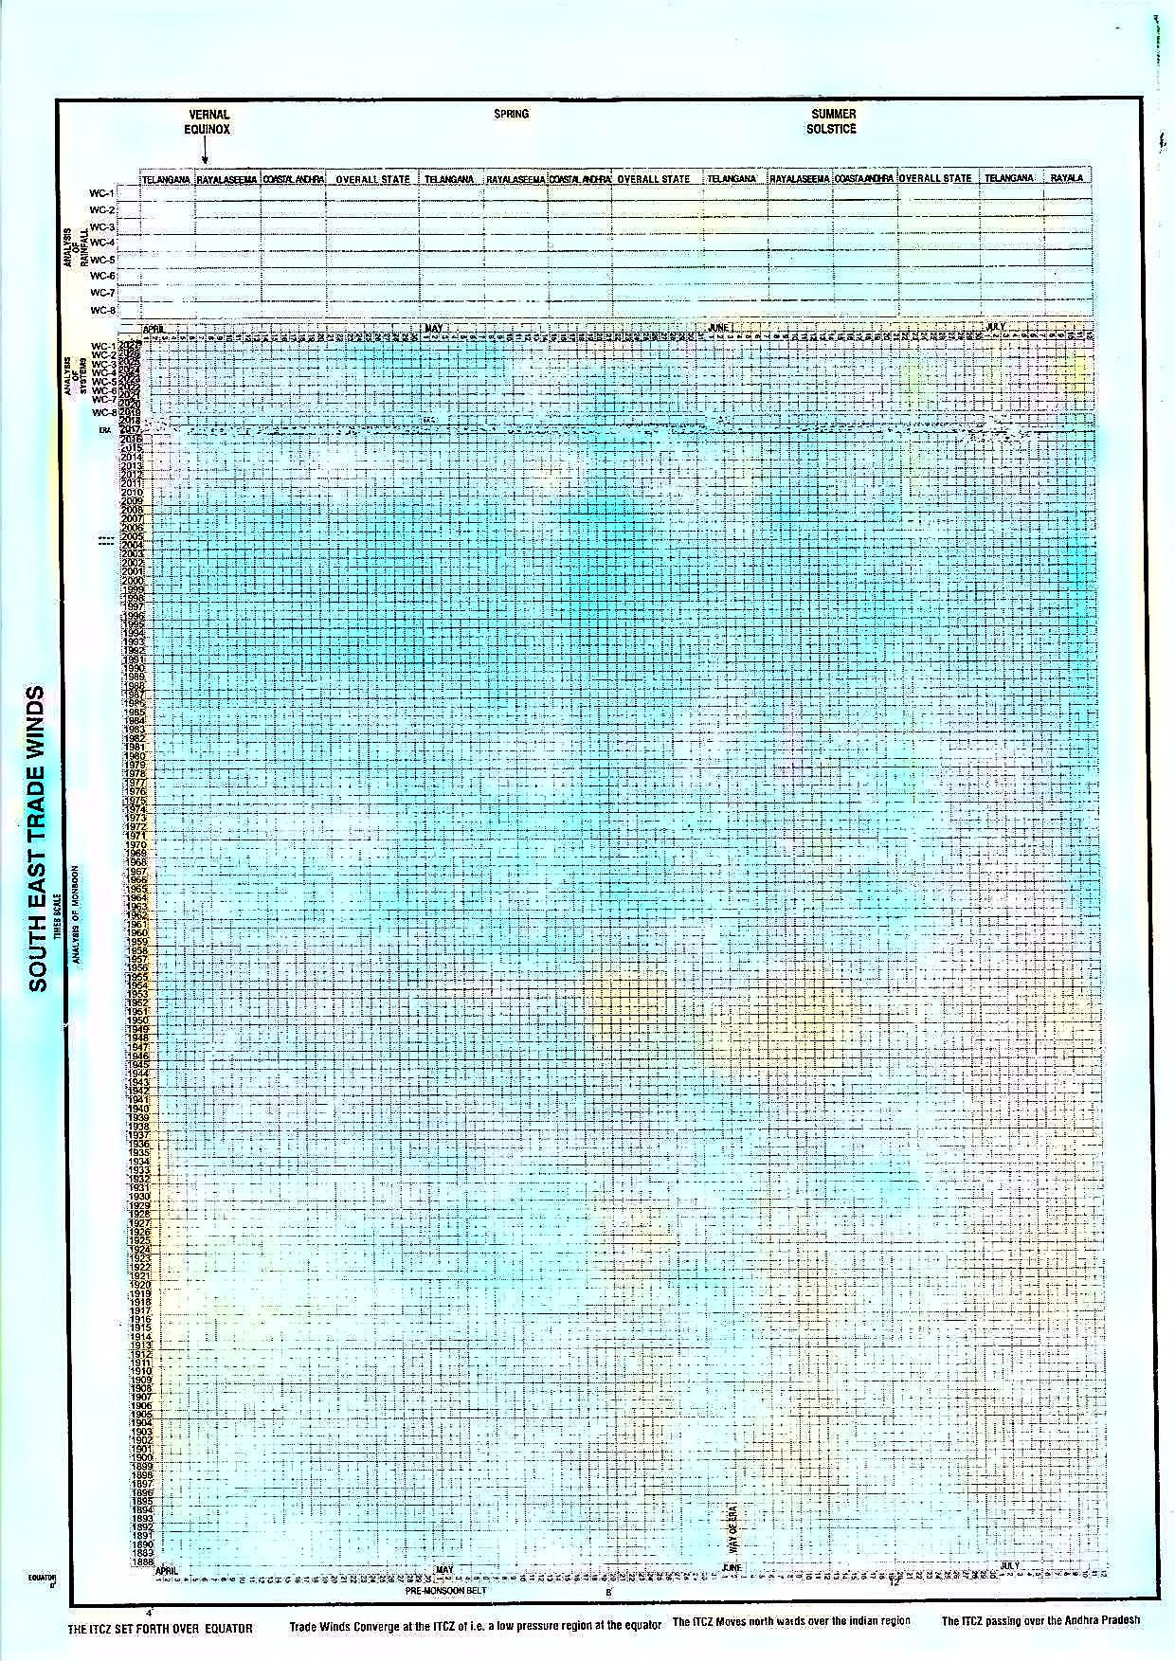
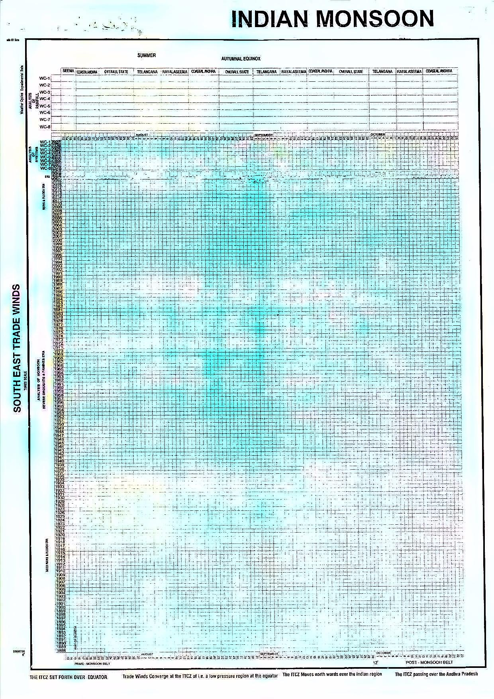

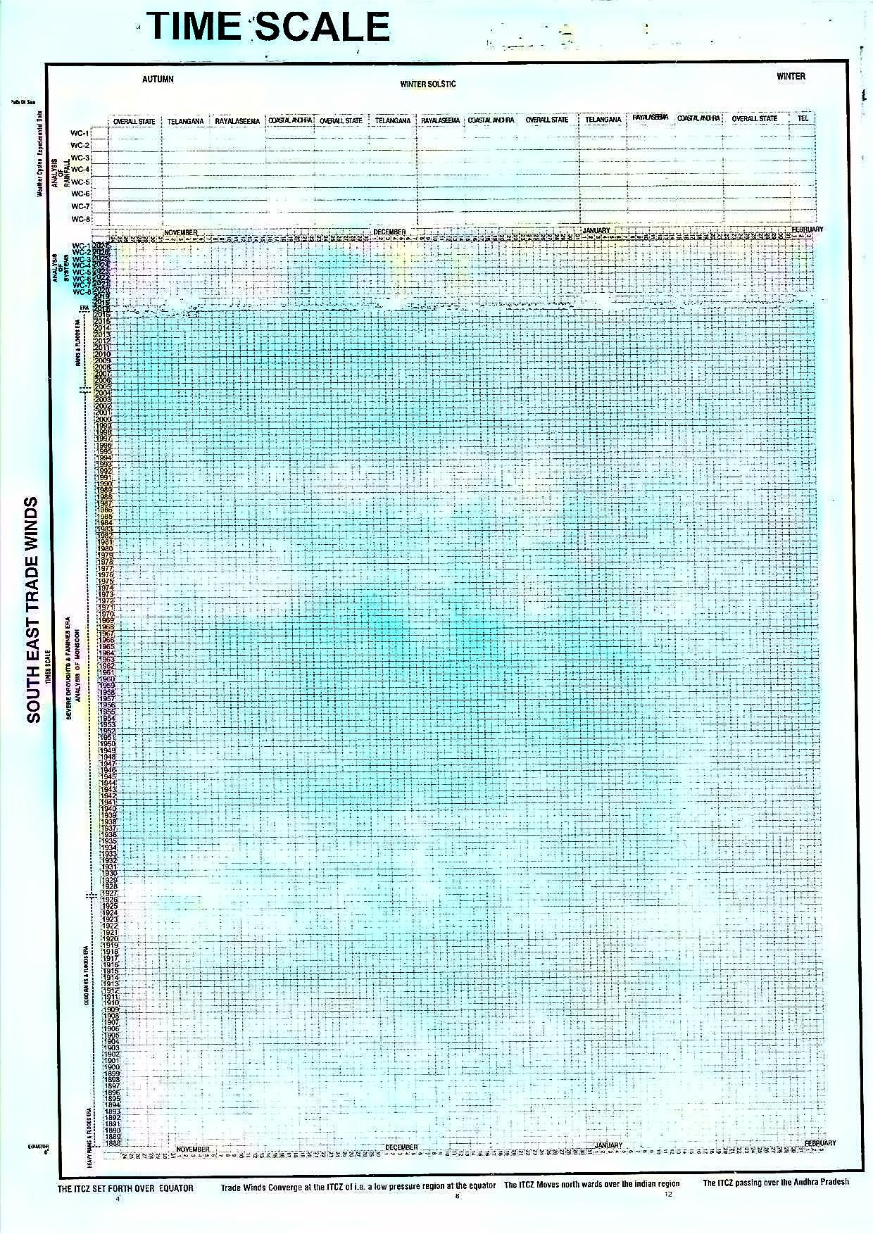

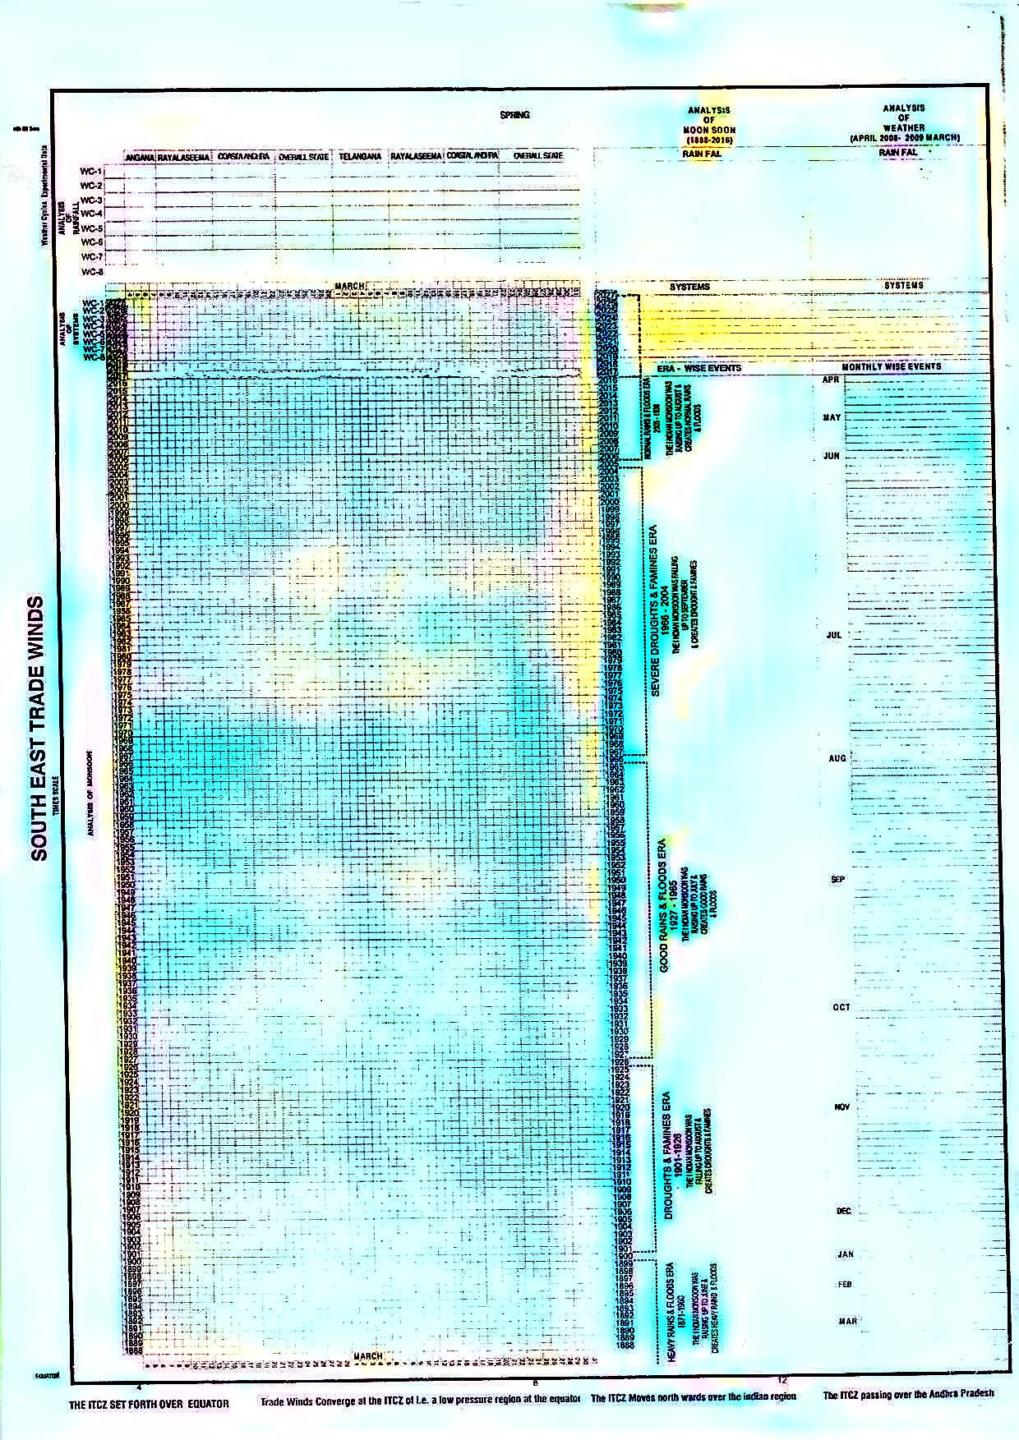

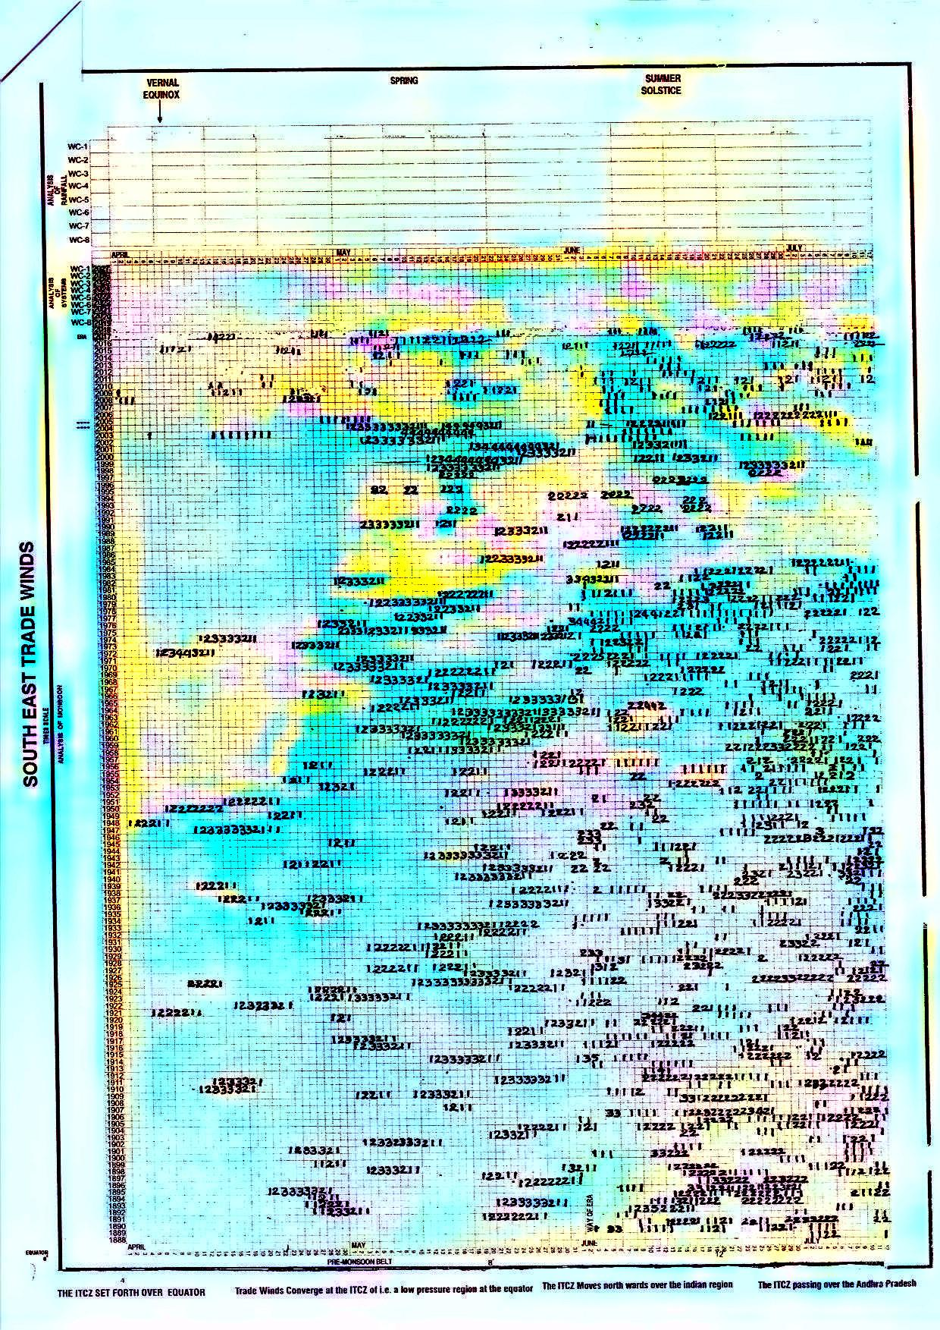

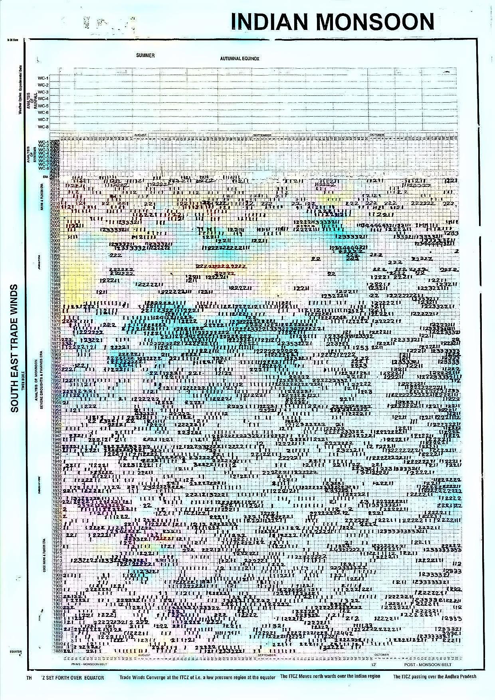

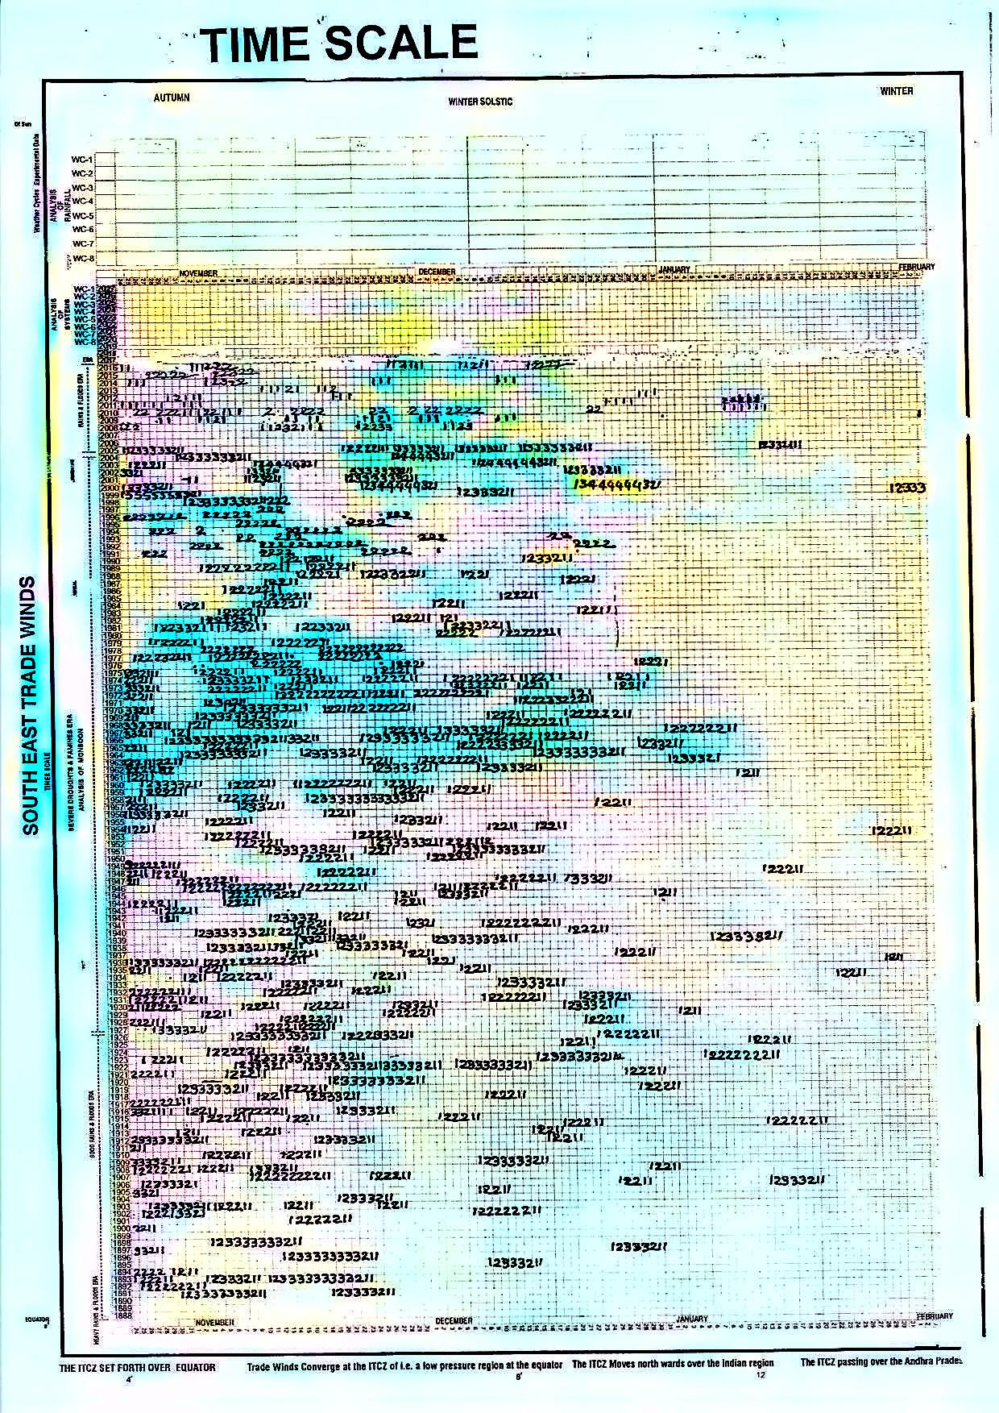

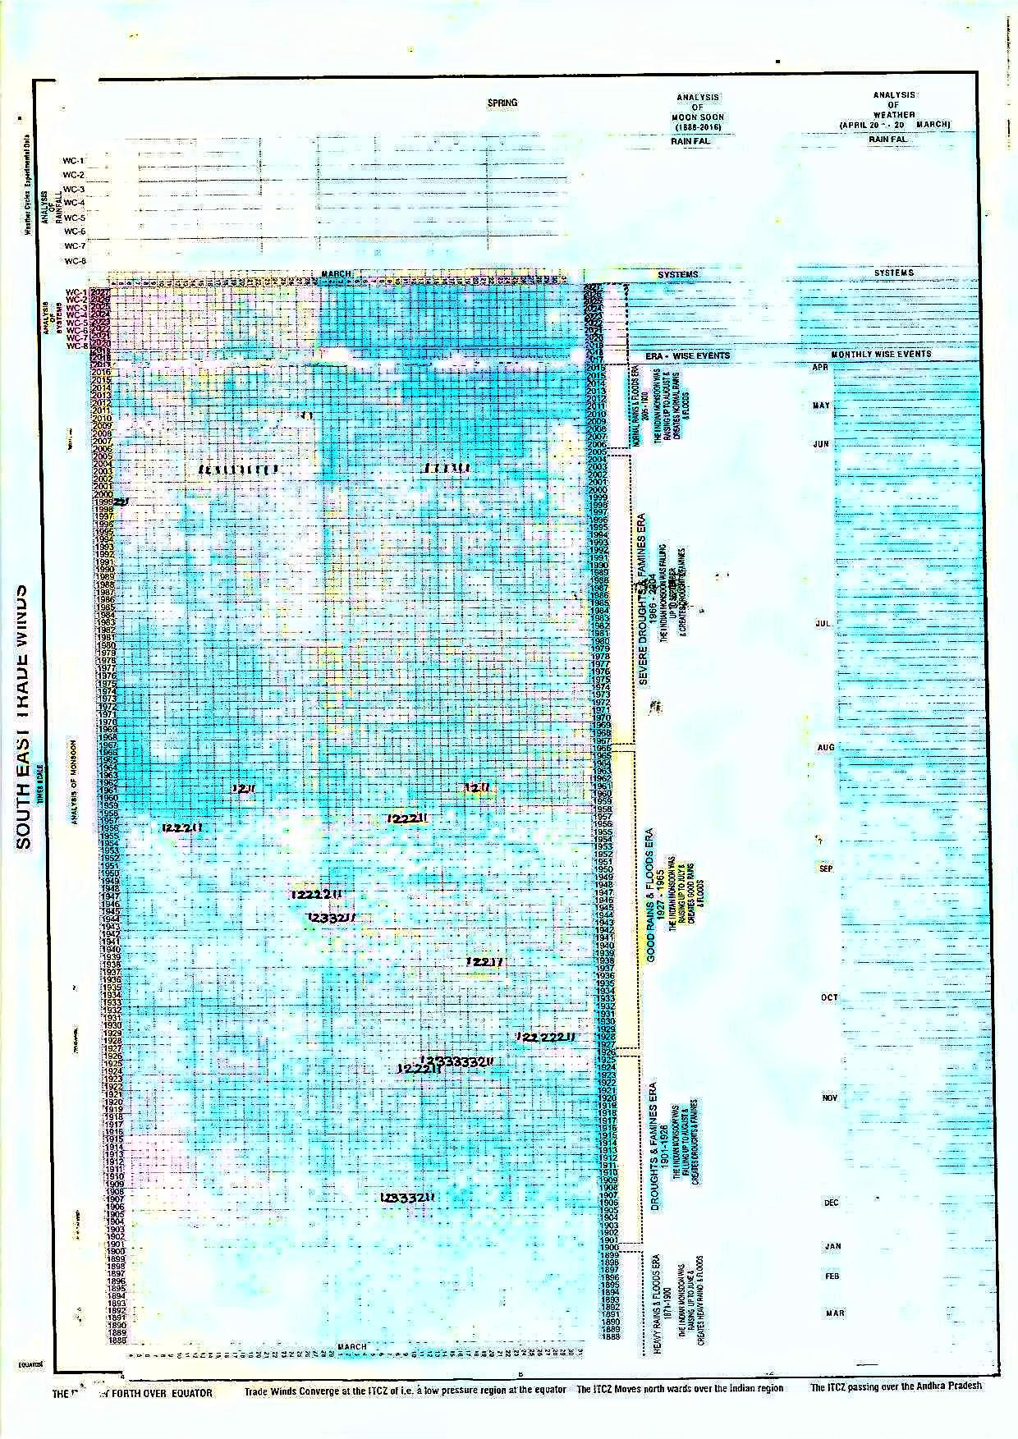

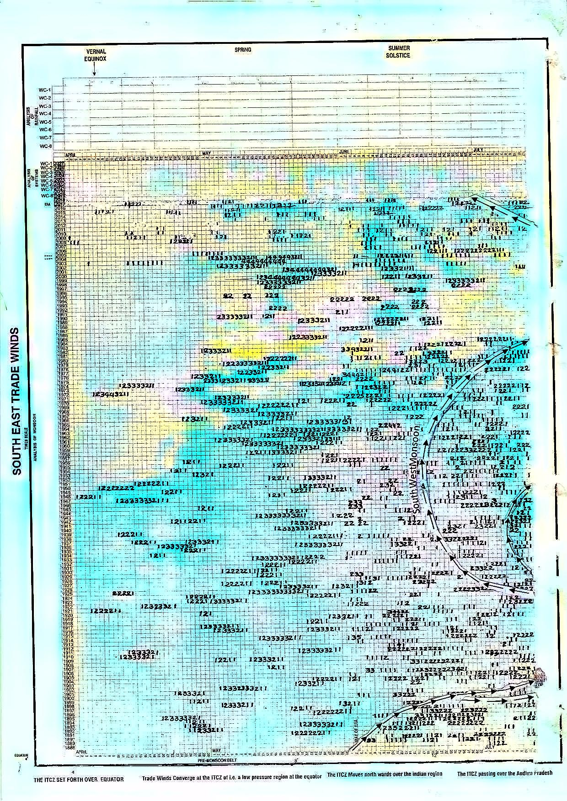

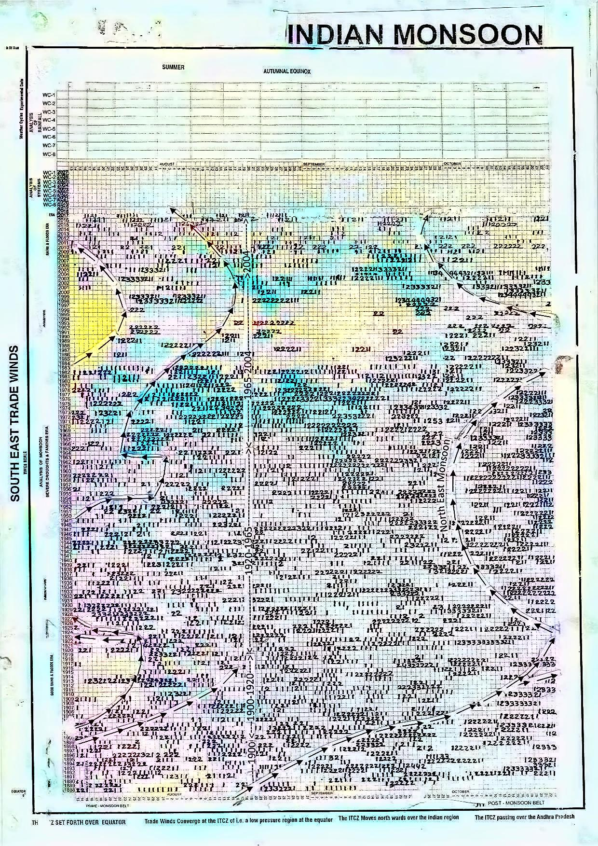

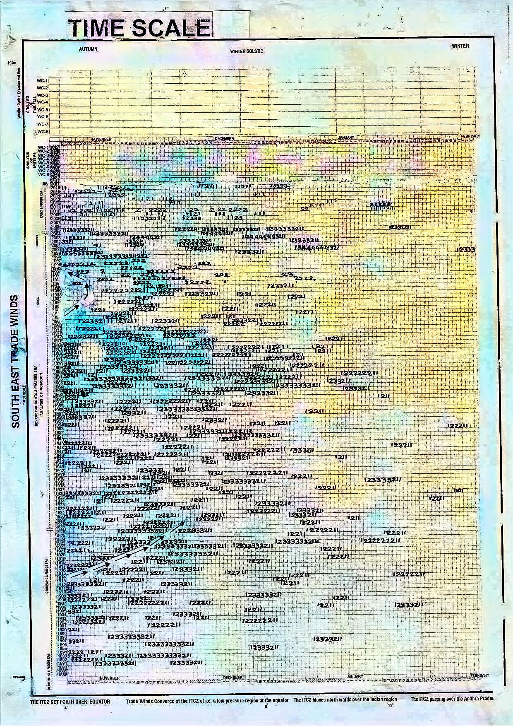

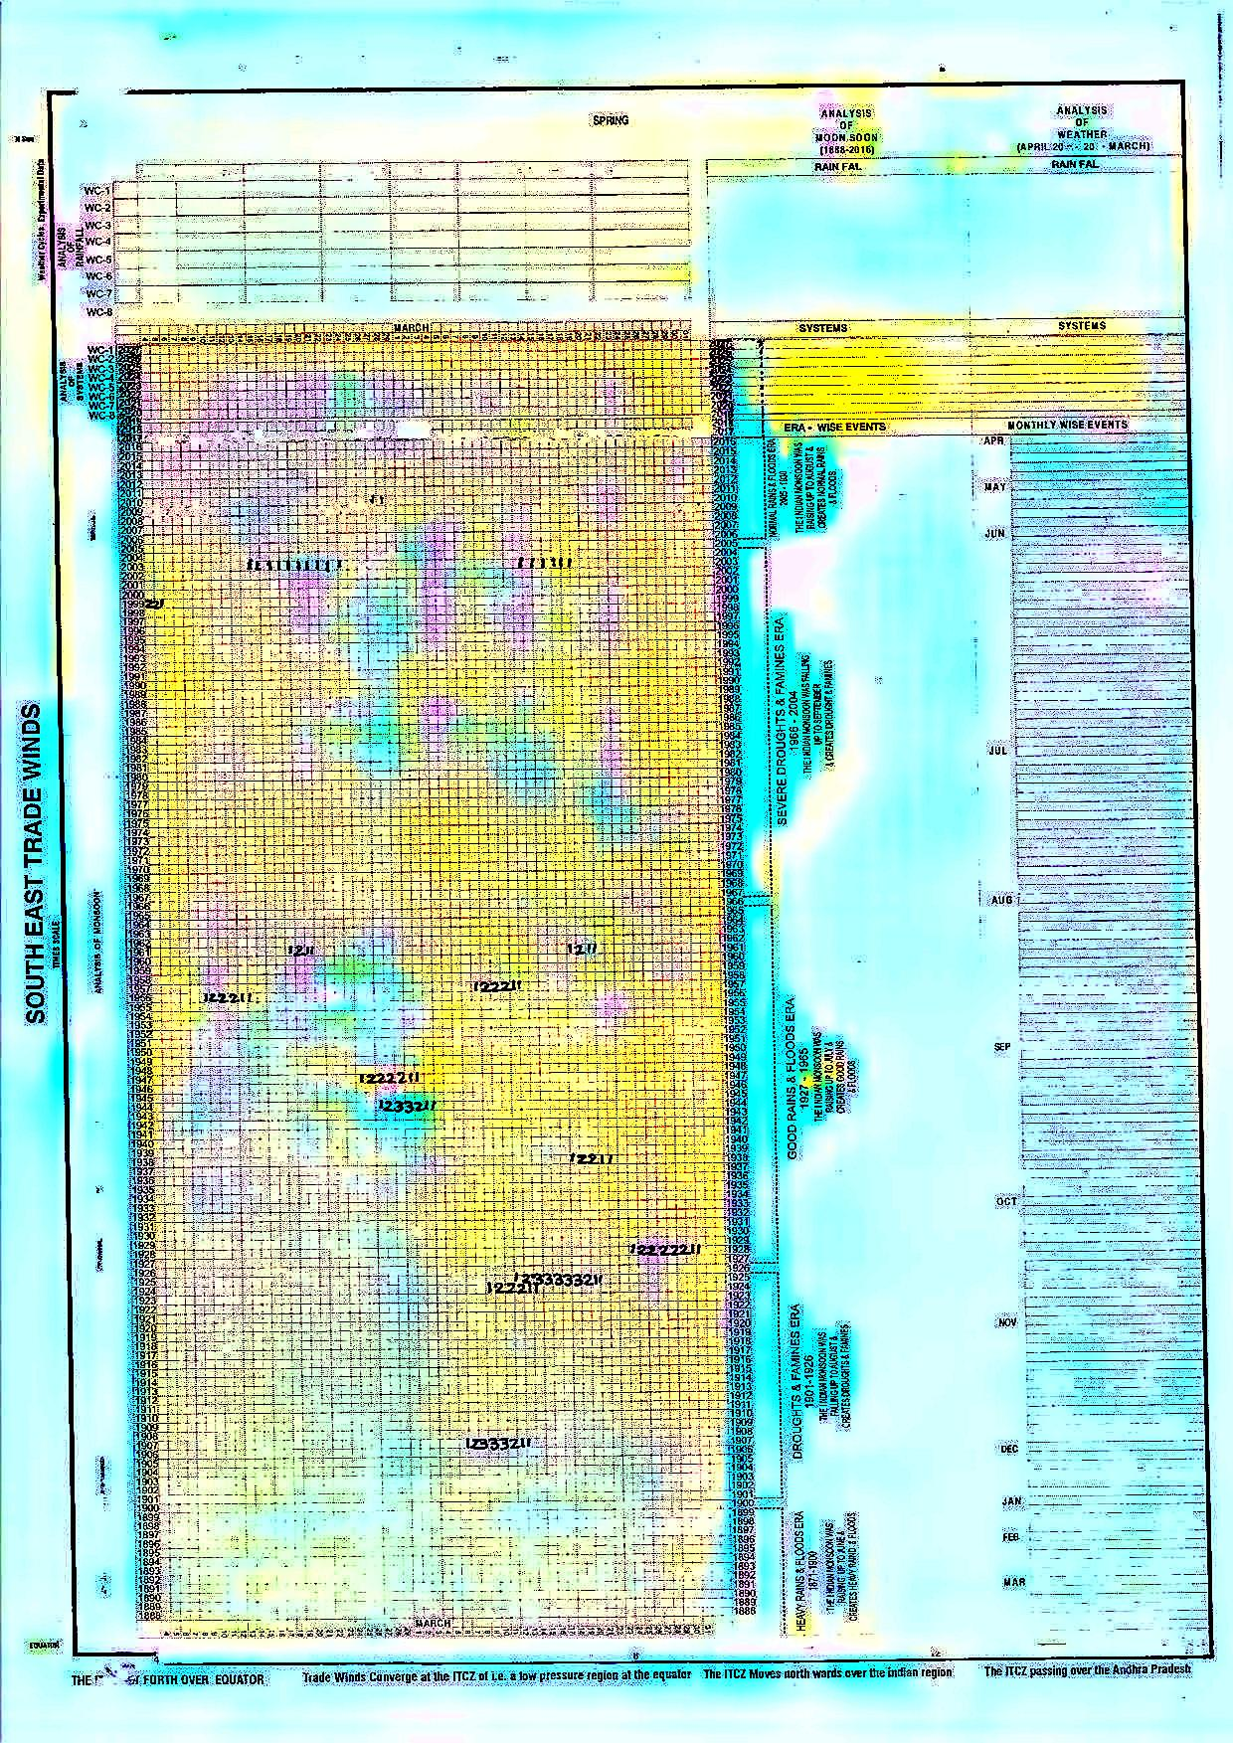

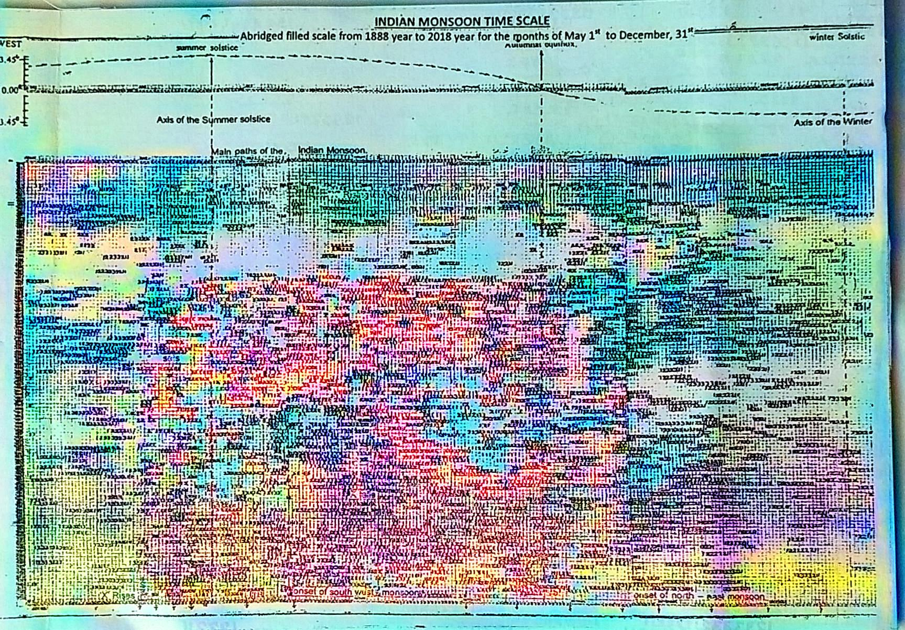
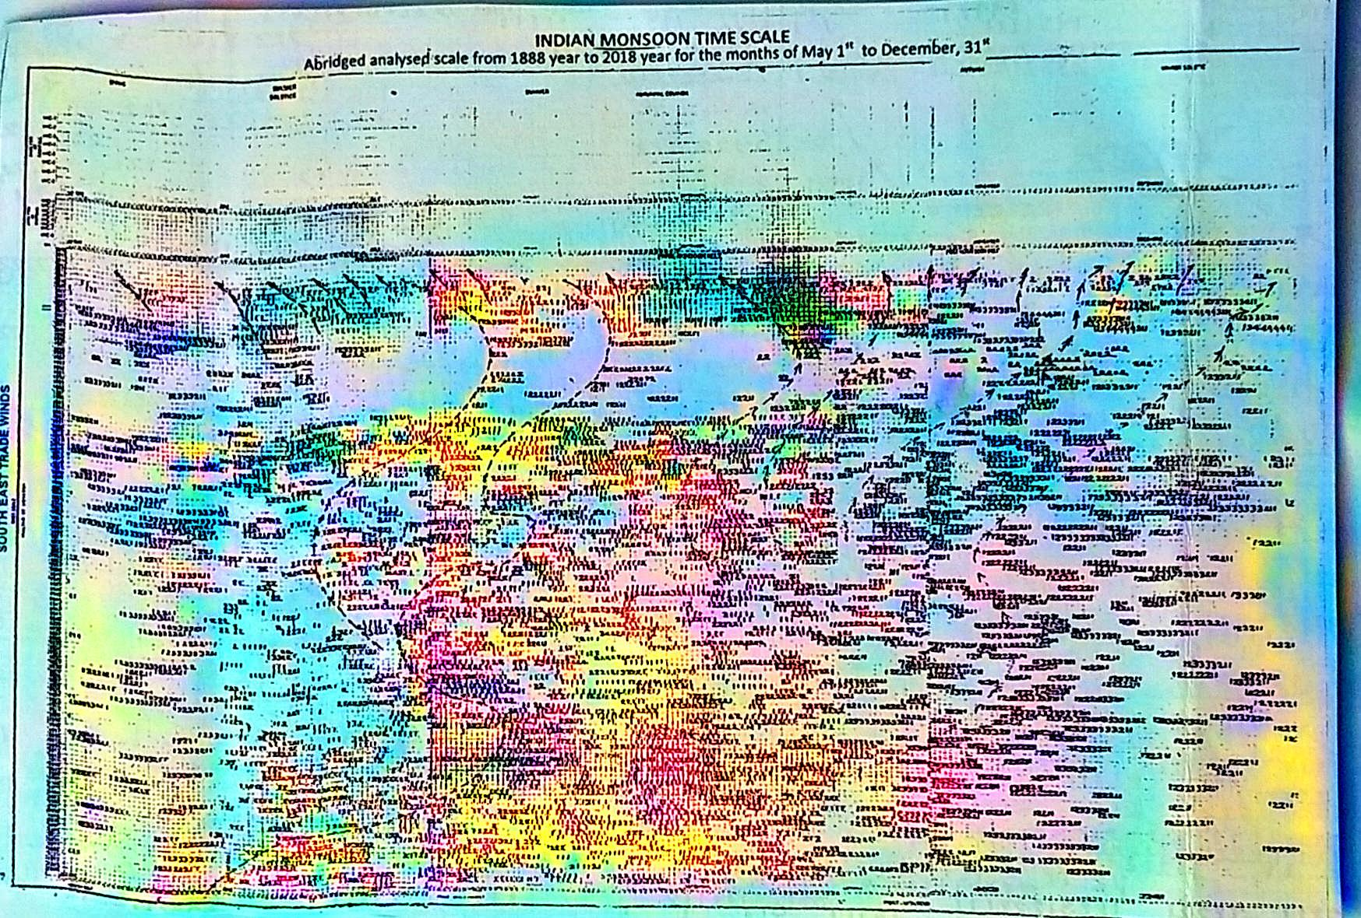
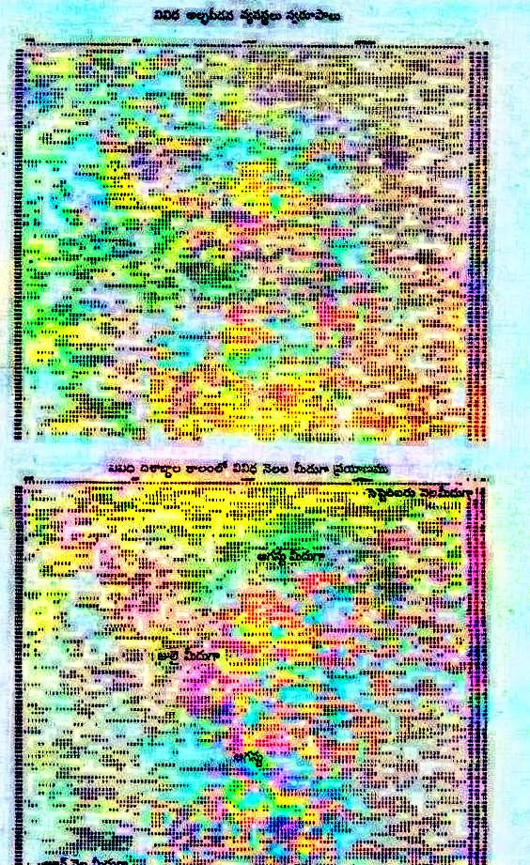
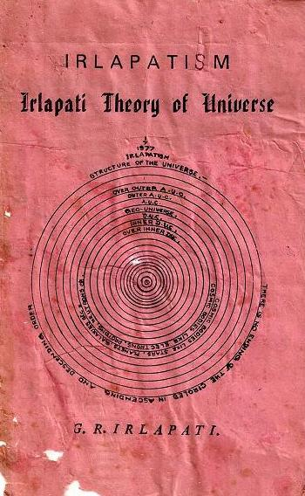
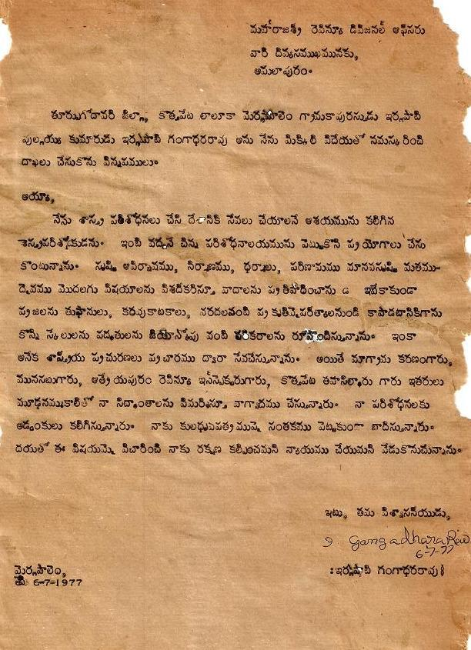
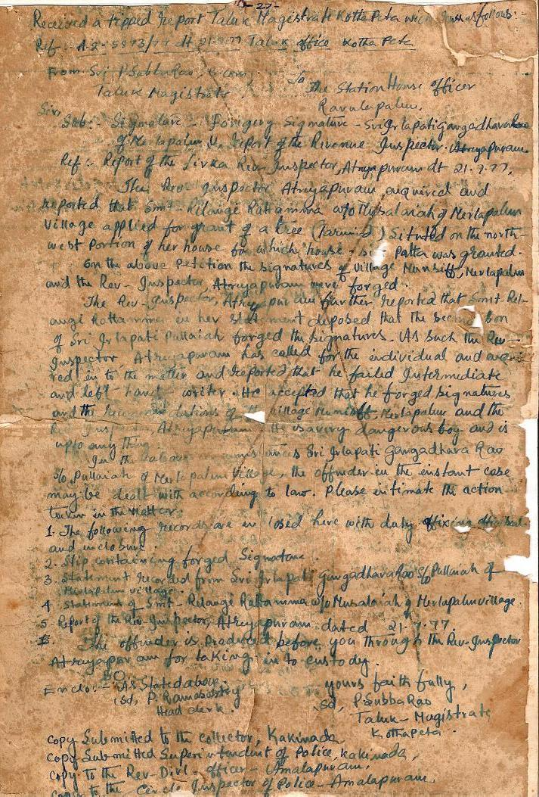
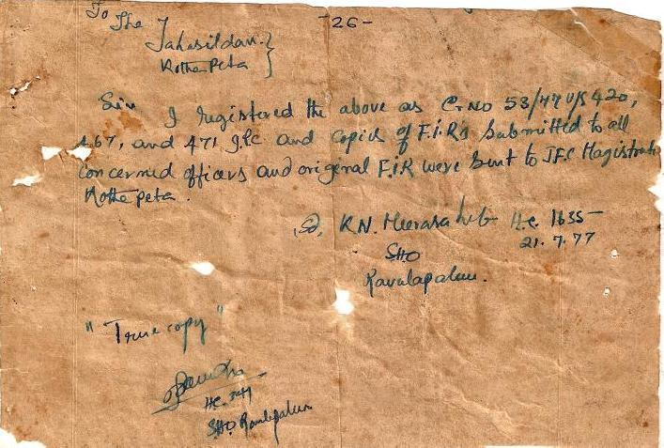
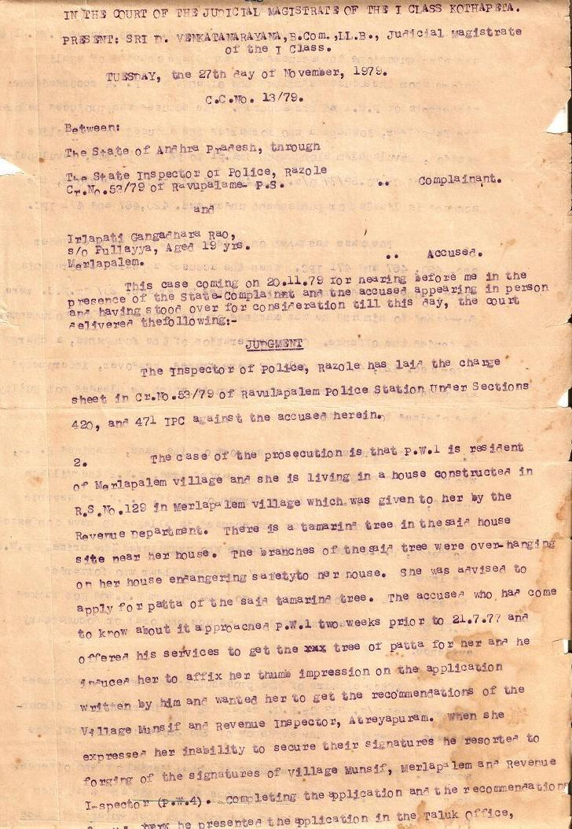
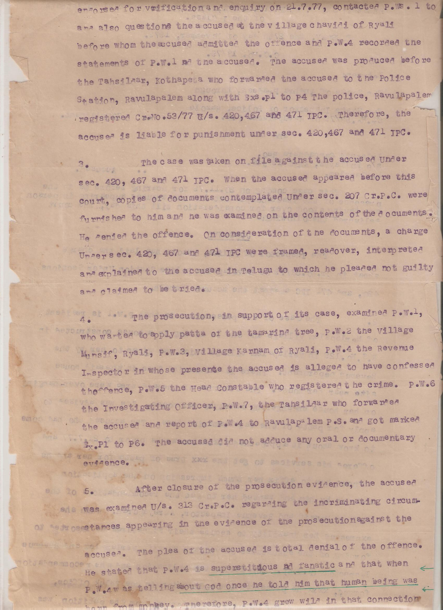
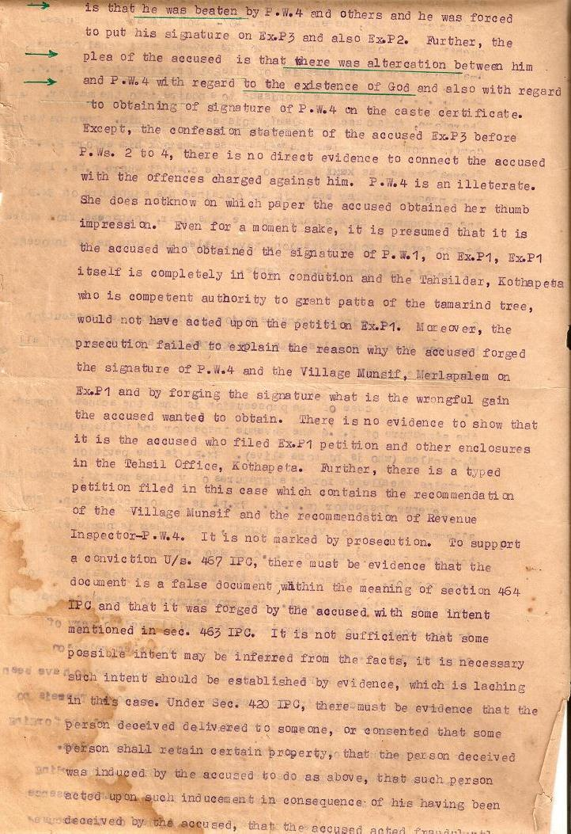
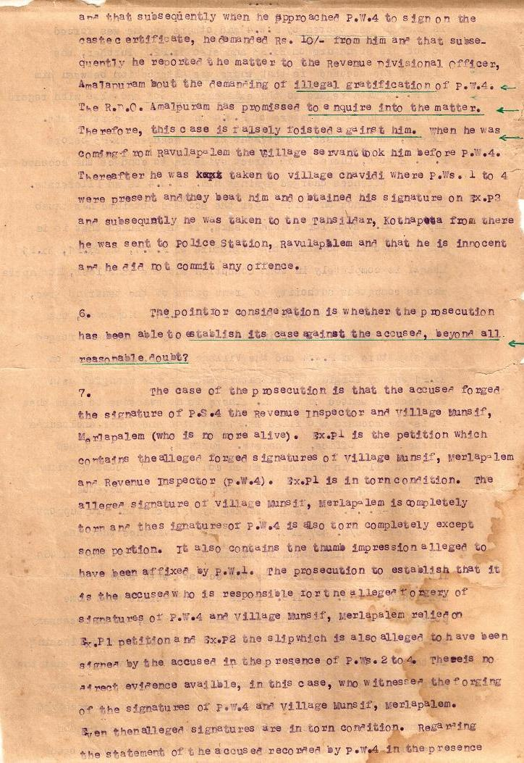
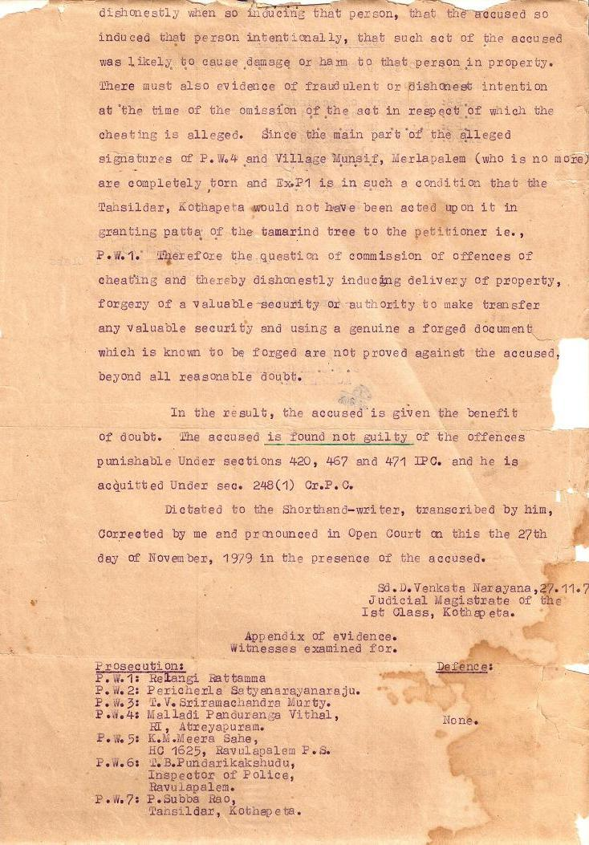
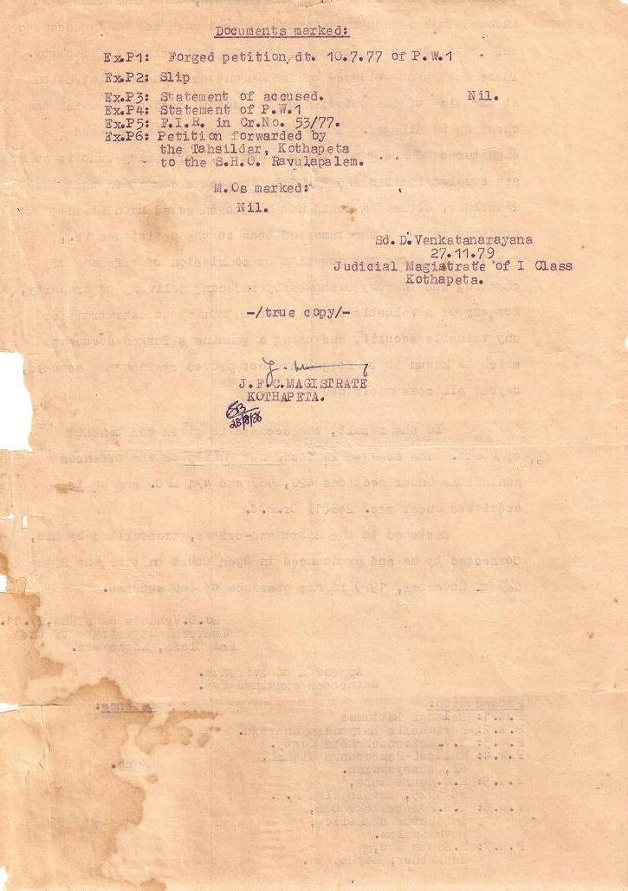
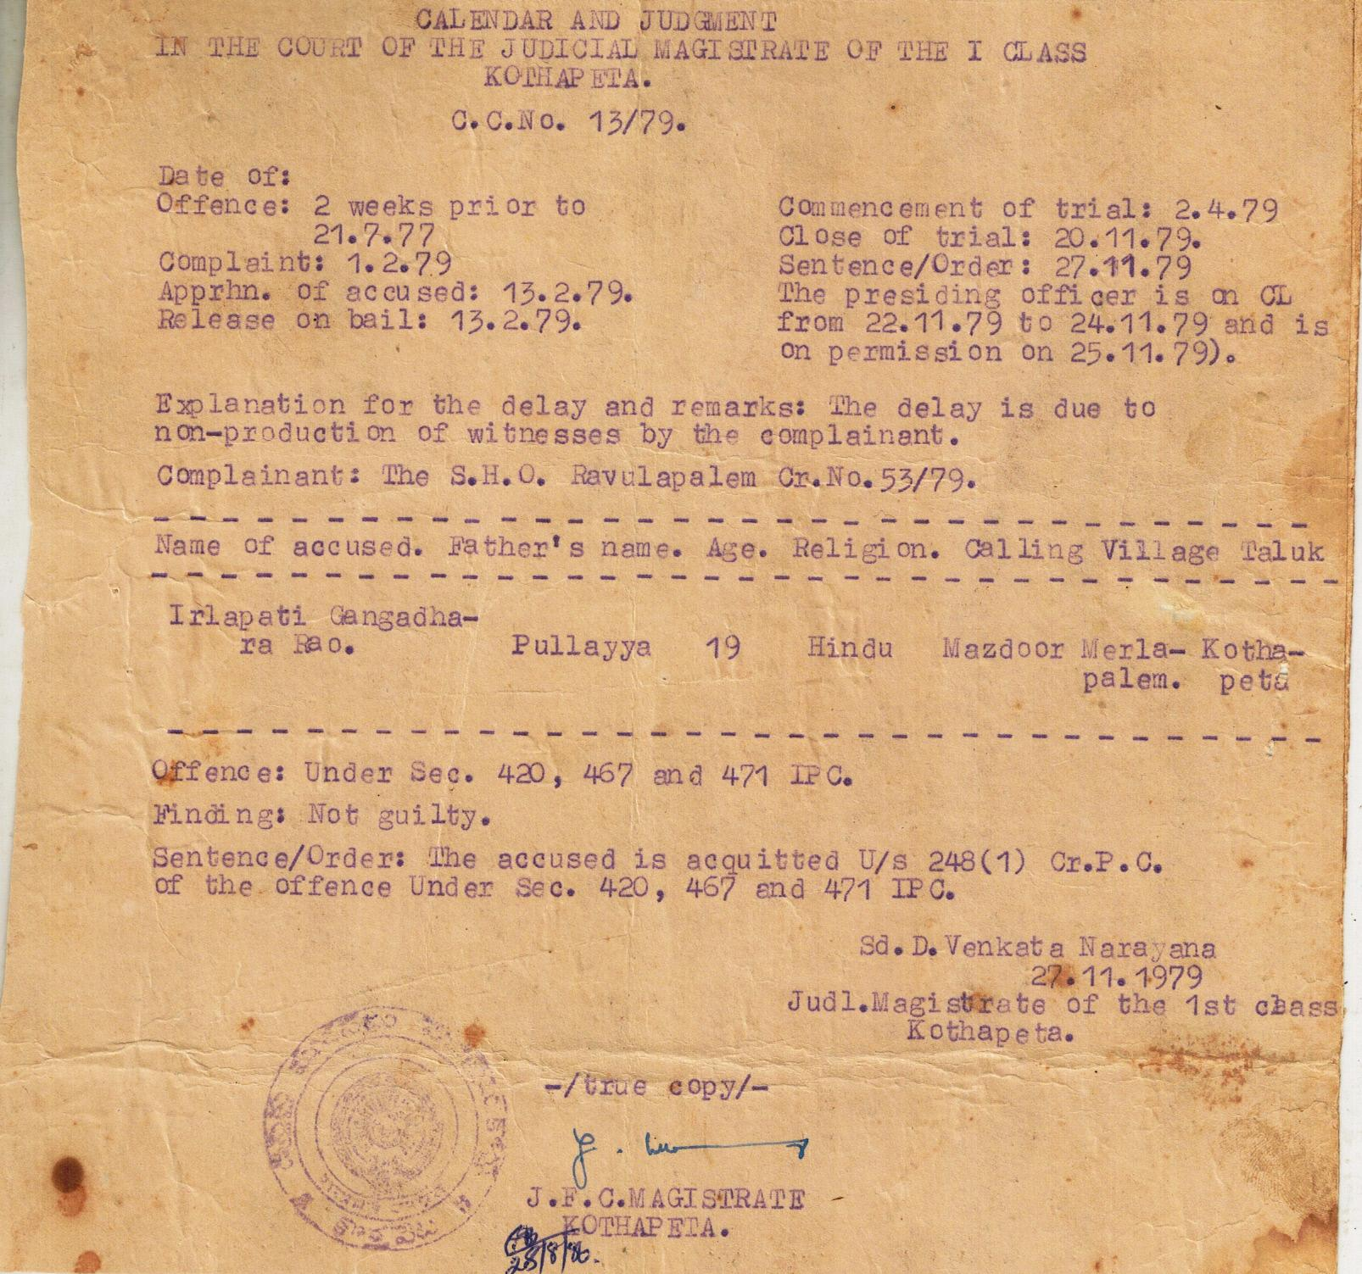

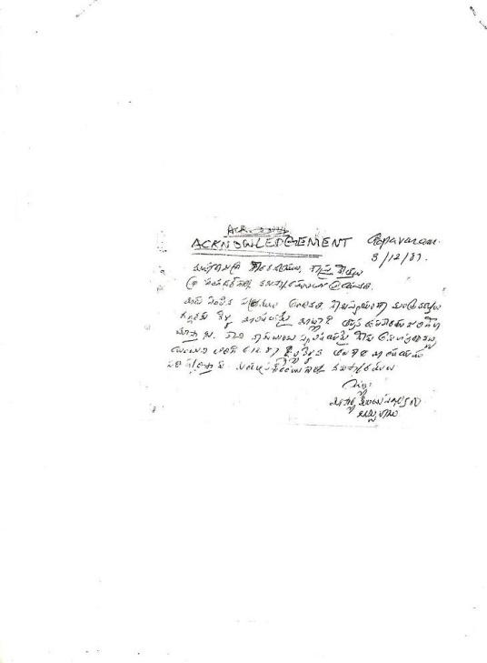
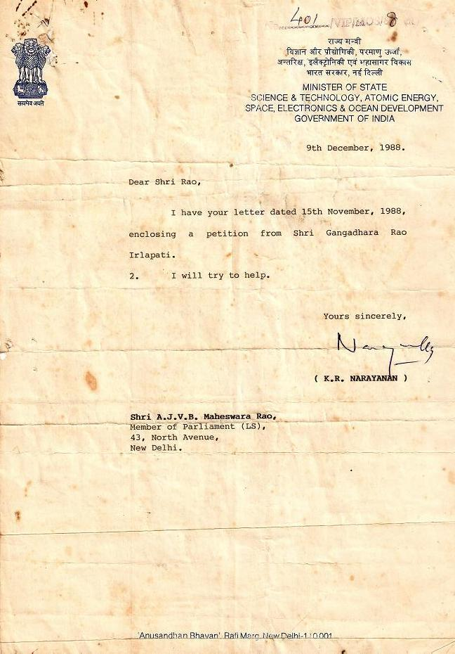

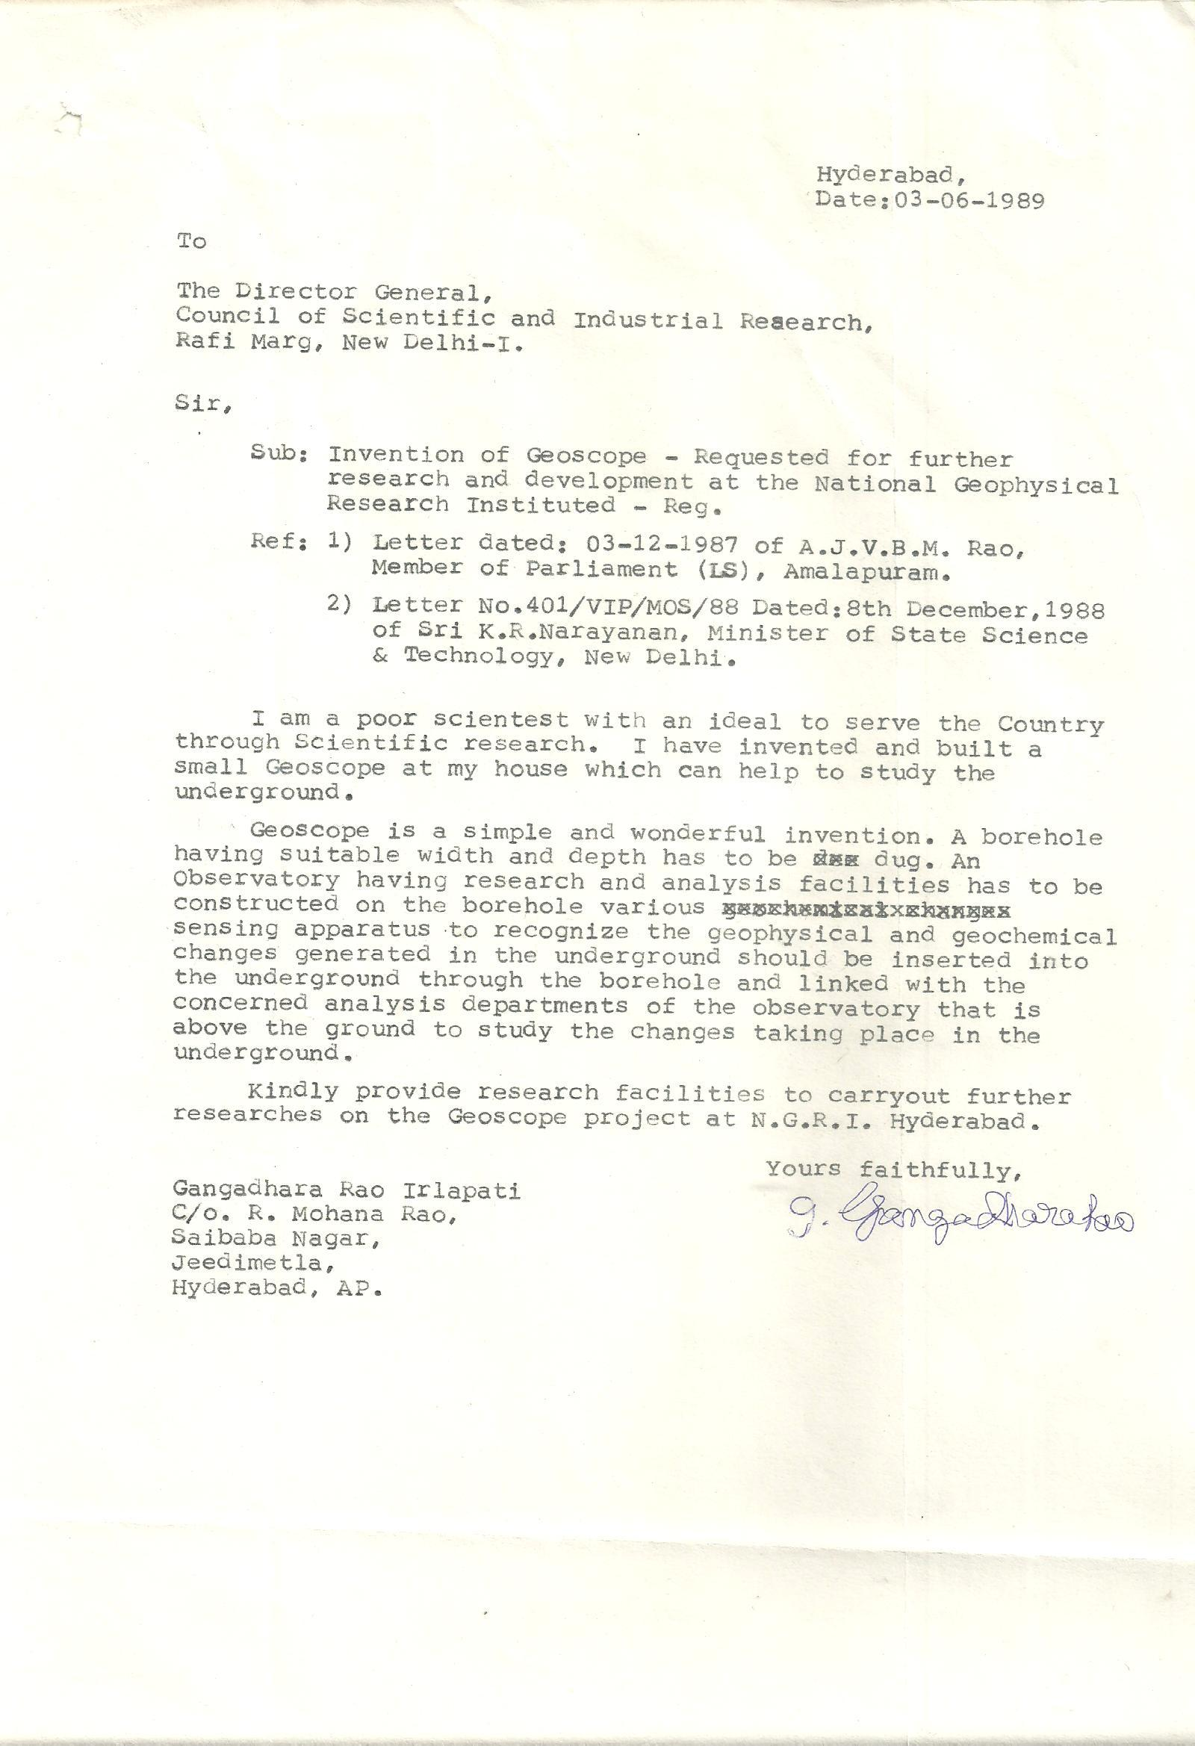
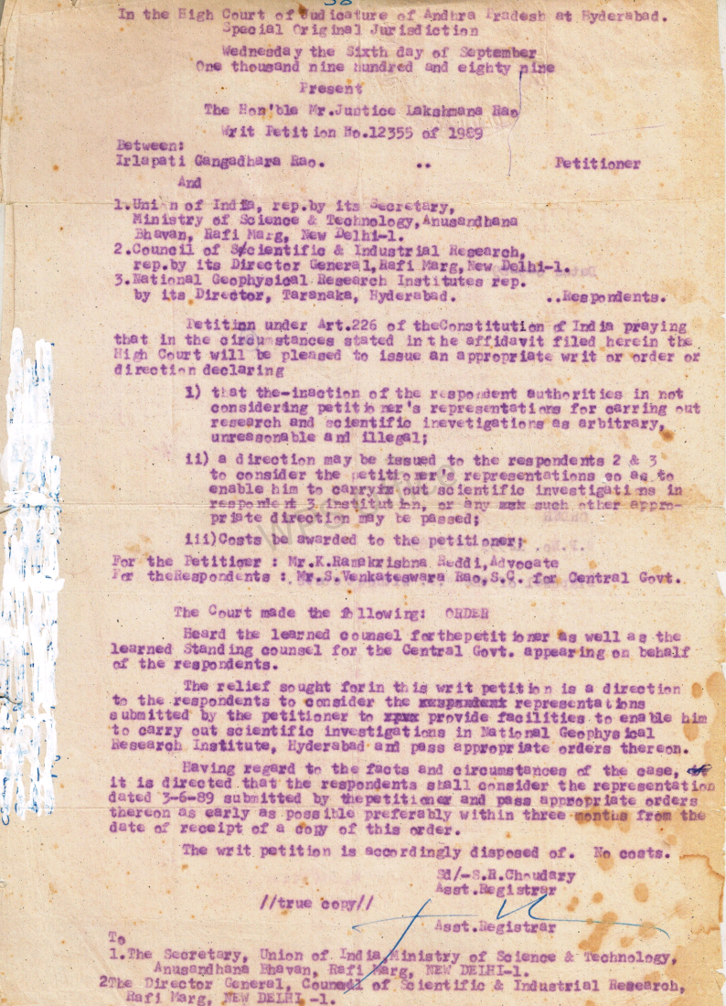

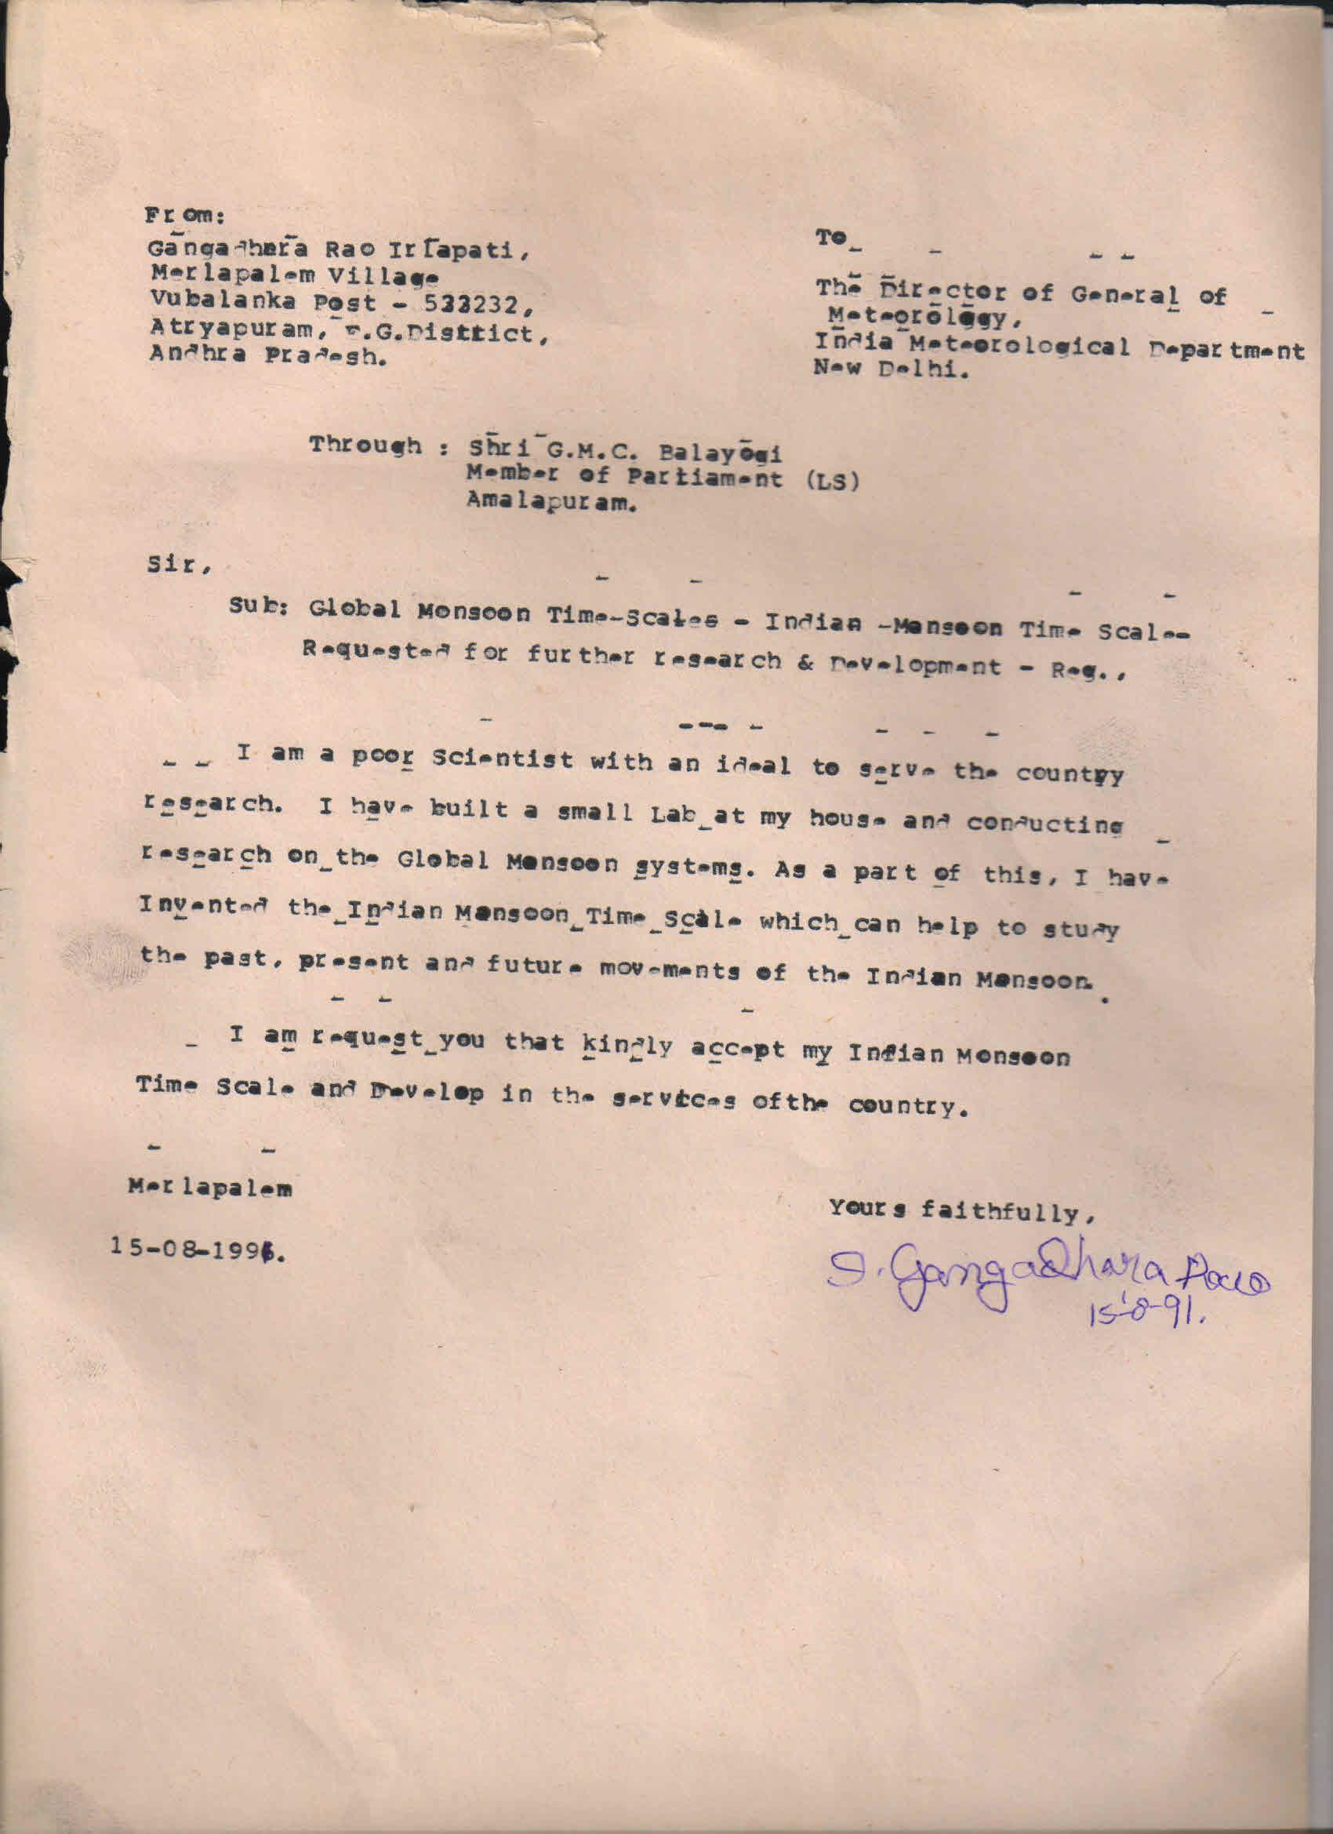
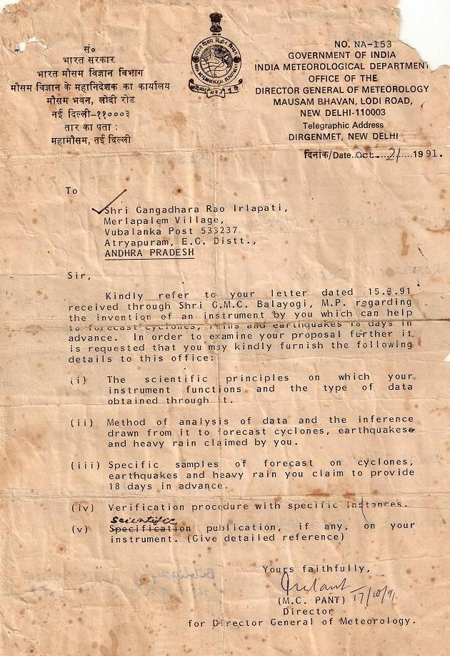

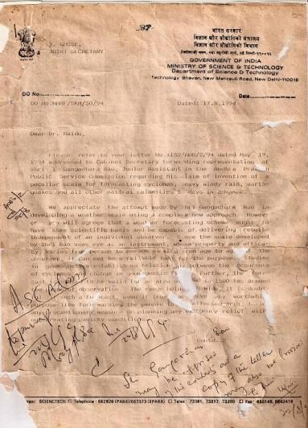

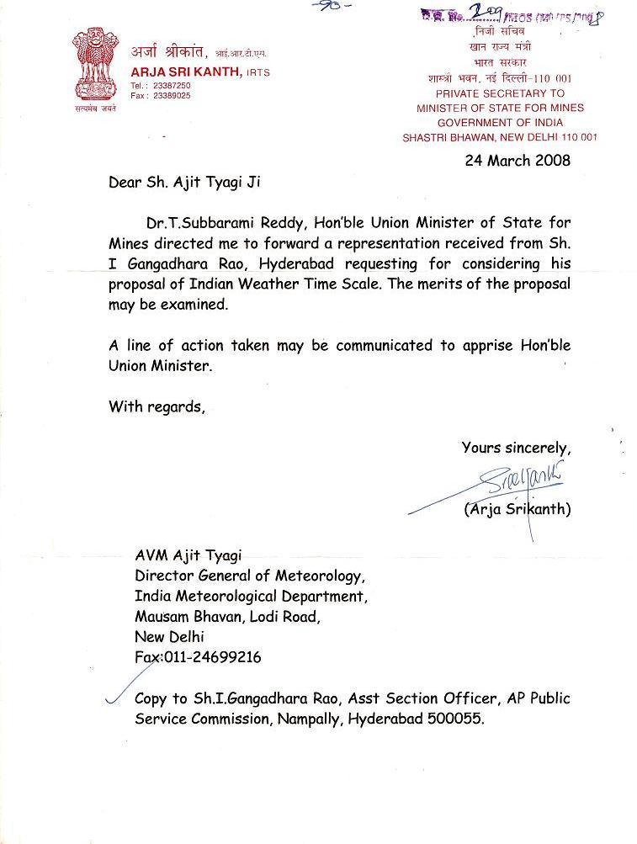

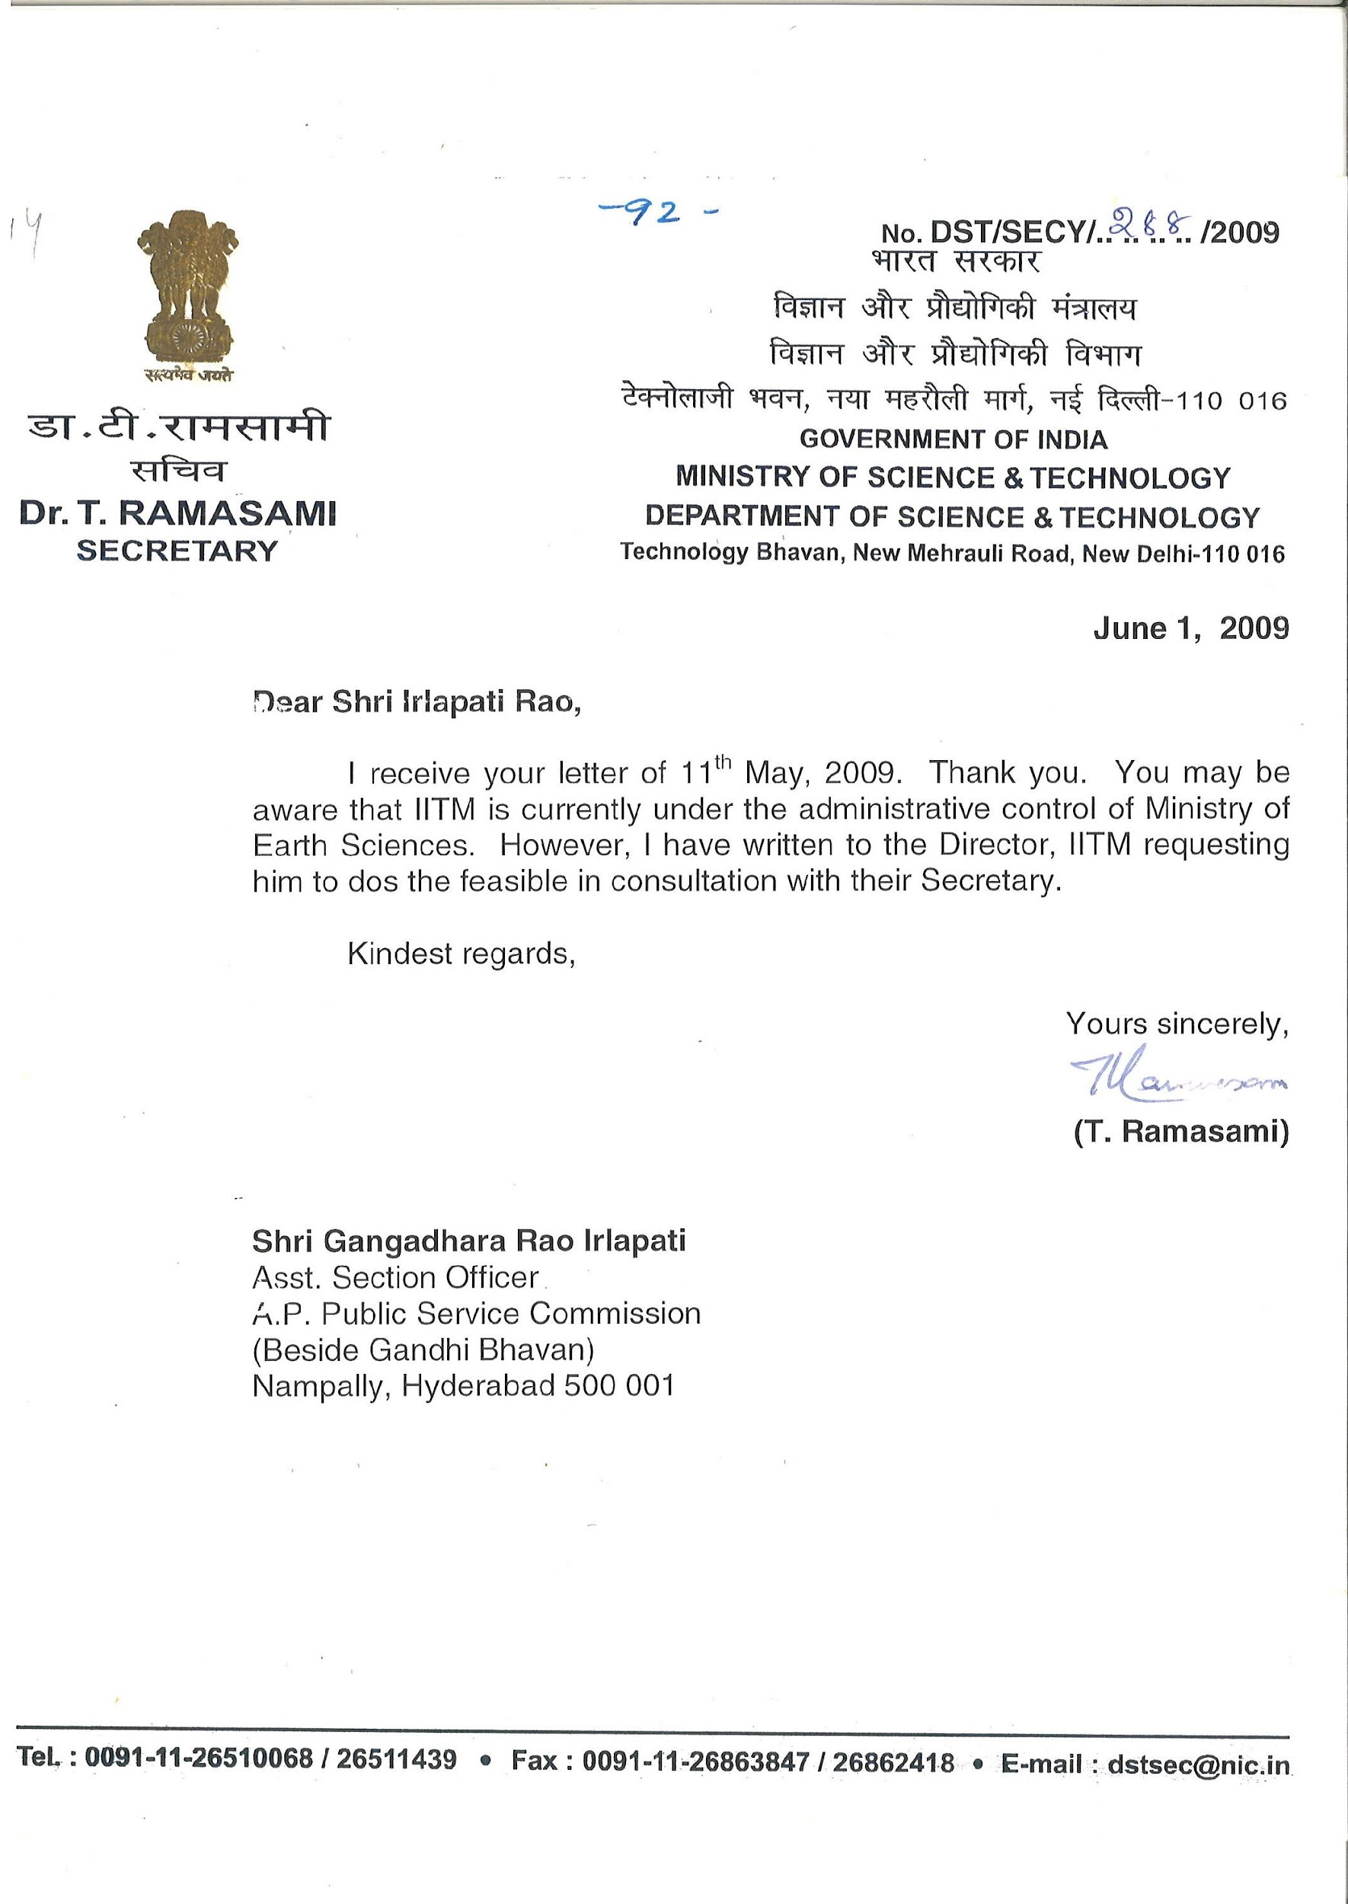
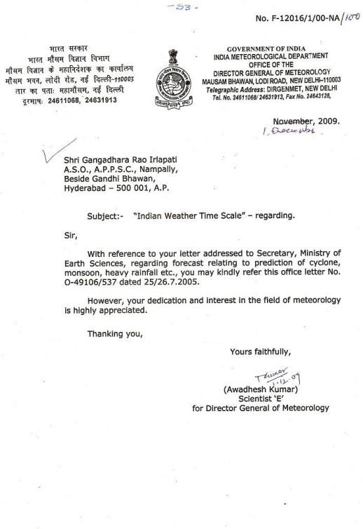
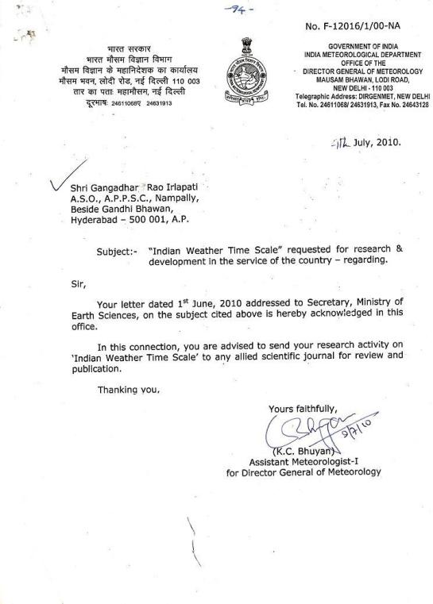
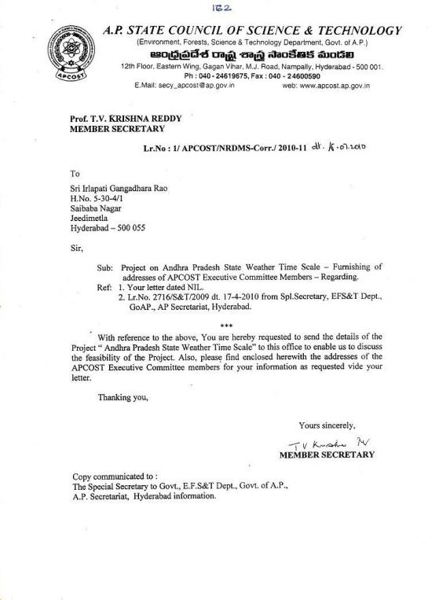
12/2/2024

