What will the weather conditions be like in 2024 ? and Indo-China Monsoon Time Scale

Gangadhar

H.No.5-30-4/1, Saibabanagar, Jeedimetla, Hyderabad, India-500055
Email: gangadhar19582058@gmail.com

Abstract: There are many mysteries and unsolved issues in the monsoonal climate and Weather systems that cannot explain and solve. I proposed and designed the Basics of Monsoon Time Scales for all world global, regional, local monsoon systems along with countries for unraveling the mysteries of climate, weather, monsoons; studying the characteristics of mechanism of climate, weather and monsoons and exercising the benefits of mankind and development of monsoonal climate and weather sciences. Based on the available data analysis of the Monsoon Time Scale when observing and examining the monsoonal track carefully since last 1880, we can note that- By 1880, the monsoonal track at peak and caused heavy rains and floods. Between 1900-1930, it was traveled in the low position and caused droughts and famines, Again 1930-85, it was traveling in the upper position and caused heavy rains and floods. Again 1985-2010, it was traveled in the lower position and caused droughts and famines. At present, the monsoonal track has been traveling upwards since 2010. Based on this monsoonal track observations of past, it is estimated that there will be climate changes in the coming years "i.e" heavy rains and floods will occur until around 2075 and droughts and famines will occur until 2150 all over the world countries. Through the establishment of Monsoon Time Scales, we can know the future consequences of the climate changes. Plans can be made accordingly. So, scientists can establish the Monsoon Time Scale and predict what is going to happen in the monsoonal climate in the coming years roughly. I call on the world scientists to establish the Indo-China Monsoon Time Scale following the Basics of Monsoon Time Scales outlined below, based on the India Monsoon Time Scale which is successfully proved out in practice which can help to study the past, present and future conditions of the Indo-China monsoon.
[Gangadhar. What will the weather conditions be like in 2024 ? and Indo-China Monsoon Time Scale. Researcher 2024;16(9):20-59]. ISSN 1553-9865 (print); ISSN 2163-8950 (online). http://www.sciencepub.net/researcher. 03. doi:10.7537/marsrsj160924.03

Keywords: Global Monsoons Time Scales, North American Monsoon Time Scale, North African Monsoon Time Scale, Indian Monsoons Time Scale, East Asian Monsoon Time Scale, Western North Pacific Monsoon Time Scale, South American Monsoon Time Scale, South African Monsoon Time Scale, Australian Monsoon Time Scale, European Monsoon Time Scale.

Introduction:
Monsoon Time Scale is a chronological sequence of events arranged in between time and climate with the help of a scale for studying the past’s, present and future movements of the climate, weather and monsoon of a region or country and its relationship with the climate, monsoon and rainfall and other weather problems and natural calamities.
Method and Design:
Design: Prepare a Monsoon Time Scale having 365 horizontal days from April 1st to next year March 31st (or January 1st to December 31st or March 21st to next year March 20th or according to the chronology of a region or country’s Time and Climate) of 139 year from 1880 to 2027 or whatever years you want comprising of a large Time and Climate should be taken and framed into a square graphic scale.
This scale should be designed in three ways i.e Basic scale, Filled scale, Analyzed scale;
Basic Scale: The first one is preliminary basic scale, it explains the structure of the scale.
Filled Scale: This is the second scale that is filled with data and explains how to fill or manage the scale.
Analyzed Scale: And the third one is scientifically analyzed the filled scale by data, it explains monsoon patterns, climate conditions and weather changes in the scale.
Method: There are two methods in formation and process of the Monsoon Time Scales. The first one is in the single form and next one is designed in four parts.
Single& Full length Scale: Prepare the Monsoon Time Scale having 365 horizontal days from April 1st to next year March 31st (or January 1st to December 31st or March 21st to next year March 20th or according to the chronology of a country’s Time and Climate) of 139 year from 1880 to 2027 or whatever years you want comprising of a large Time and Climate should be taken and framed in a single and full length type square graphic scale. It can be formed on a Paper or a Wall or a Table.
Parts & paste Scale: The single and full length square graphic scale is to be long. So that it is divided into four parts easy to carry and keep and suitable for publication. I designed to make it into 4 parts and then pasted it into one scale.
The first part is beginning from 1st April to July 12th.
The second part is from 13 July to October 23rd.
The third part is from 24th October to February 3^{rd.}
And the fourth part is 4th February to March 31st ending.
These separate scales can be pasted into one scale as explained below.
Cut along the edges of dates on the right side of the first part and paste it to along the edges of date of 13th July on left side of the second part.
Cut along the edges of dates on the right side of the second part and paste it to along the edges of date of 24th October on left side of the third part.
Cut along the edges of dates on the right side of the third part and paste it to along the edges of date of 4th February on left side of the fourth part .
When paste this manner, we get long full-length Indian Monsoon Time Scale. .
Computer Model:
Monsoon Time Scales can also be established as a computer model. Besides rather than in manual type scale, if we are able to create a computer model scale which to be the most obvious.
Material and Data:
Construction of the Monsoon Time Scales requires enormous data of low pressure systems, depressions tropical cyclones/storms or any data that formed over and affecting a region should be taken as data to prepare the Monsoon Time Scale. An accurate scale is available if we can collect and analyze the exact climate data.
Management:
The main weather events such as monsoon pulses in the form of low pressure systems if any of a monsoon region formed over a region or country have been entering on the scale in stages by 1 for low, 2 for depression, 3 for storm, 4 for severe storm and 5 for severe storm with core of hurricane winds should be entered on the Monsoon Time Scale as per date and month of each and every year. If we can managing the scale in this manner continuously, we can study the past, present and future movements of monsoons of a region or country. I took the numbers to analysis the variations in data. Researchers have to decide what kind of data to take and how to analyze the data.
Researches&results:
The research and study should be done in the same way as described below in the Indian Monsoon Time Scale and the results should be obtained.
Study & discussion:
The obtained results should be studied and analyzed in the same way as described below in the Indian Monsoon Time Scale.
Model scale: Before proposed and designed the above Monsoon Time Scale, I have undertaken the Indian Monsoon Time Scale as the model research project following all the rules to be followed in formulating the Basics of Monsoon Time Scales. The reason I took the Indian Monsoon Time Scale as the model research project was because I was in the Indian monsoon region. I know the information and data about Indian monsoon very well. Hence a comprehensive study of Indian monsoon incorporating the rules of model research project and I have proposed the Basics of Monsoon Time Scale. The following is the summary of the model research project, how the project was implemented, how I did the research, how I analyzed the data and how I obtained results etc. I designed the Indian Monsoon Time Scale as a model scale for the above Monsoon Time Scale and successfully proved out in practice. Hence, we can take this Indian Monsoon Time Scale as a model scale to design and innovate the above Monsoon Time Scale. Based on this, the scientists design the above Monsoon Time Scale.
Indian Monsoon Time Scale:
Keeping in view of study of the aforesaid Indian monsoon thoroughly, I have proposed some basics regarding method and design of the Indian Monsoon Time Scale. The Indian Monsoon Time Scale is a chronological sequence of events arranged in between time and weather with the help of a scale for studying past’s, present and future movements of the monsoon of India and its relationship with rainfall and other weather problems and natural calamities. From where to wherever to be taken the time and weather data to analyze, the researcher can decide on his discretion according to available weather data.
Method and design:
Design: In order to design the Basics of Monsoon Time Scale, I continued my researches based on the setting up of the Indian Monsoon Time Scale. The Indian Monsoon Time Scale is a chronological sequence of events arranged in between time and climate with the help of a scale for studying the past’s, present and future movements of the Indian monsoon and its relationship with rainfall and other weather problems and natural calamities.
For this, I took a period of 365 horizontal days from April 1st to next year March 31st (or January 1st to December 31st or March 21st to next year March 20th or according to the chronology of India’s as the time and the data of monsoonal low pressure systems, depressions and storms of 139 years from 1880 to 2027 that were formed over the Indian region taken as the climate, on the whole comprising of a large time and climate took and framed into a square graphic scale. I designed this scale in three ways i.e Basic scale, Filled scale, Analyzed scale as described below.
Basic Scale: The first one is preliminary basic scale, it explains the structure of the scale.
Filled Scale: The second one is filled by data scale, it explains how to fill or manage the scale.
Analyzed Scale: And the third one is filled and analyzed by data, it explains monsoon patterns of the scale.
Method: There are three methods used to design this scale. The first one is the single and full length scale and the second one is parts & paste scale. The last one is computer model made entirely by computer system.
Single& Full length Scale: I prepared the Indian Monsoon Time Scale having 365 horizontal days from April 1st to next year March 31st (or January 1st to December 31st or March 21st to next year March 20th or according to the chronology of India’s time and climate) of 139 year from 1880 to 2027 comprising of a large time and climate was taken and framed in a single and full length type square graphic scale. It can be formed on a paper, board, wall or table.
Parts & Paste Scale: The single and full length square graphic scale is to be long. So that it is divided into four parts easy to carry and keep and suitable for publication. I designed to make it into 4 parts and then pasted it into one scale.
The first part is from 1st April to July 12th.
The second part is from July13th to October 23rd.
The third part is from 24th October to February 3^{rd.}
And the fourth part is 4th February to March 31st ending.
These separate scales are pasted into one scale as described below below.
Cut along the edges of dates on the right side of the first part and pasted it to along the edges of date of 13th July on left side of the second part.
Cut along the edges of dates on the right side of the second part and pasted it to along the edges of date of 24th October on left side of the third part.
Cut along the edges of dates on the right side of the third part and pasted it to along the edges of date of 4th February on left side of the fourth part .
When pasted in this manner, we get long full length Indian Monsoon Time Scale
Computer model scale:
Besides this above manual scale, I have prepared a computer Indian Monsoon Time Scale generated by the computer system from the year 1888 to 1983 for the period of 1st June to September 30th. If we are able to create a computer model scale which to be the most obvious.
Material &data: The monsoon pulses in the form of low pressure systems over the Indian region have been taken as the data to the construction of this scale. For this, a lot of enormous data of low pressure systems, depressions and cyclones that formed over the Indian region were taken as the climate from many resources just like Mooley DA,Shukla J(1987); characteristics of the west ward-moving summer monsoon low pressure systems over the Indian region and their relationship with the monsoon rainfall. Centre for Ocean-land Atmospheric interactions, University of Maryland, college park, MD., and from many other resources and from many other resources just like The world’s 7 Tropical Cyclone seasons around the world etc.
Management:
The monsoon pulses in the form of low pressure systems over the Indian region are taken and entered on the scale in stages by 1 for low, 2 for depression, 3 for storm, 4 for severe storm and 5 for severe storm with core of hurricane winds pertaining to the date and month of the each and every year. How the Indian monsoons have been travelling for the last 140 years since 1880 onwards are recorded on the Indian Monsoon Time Scale. I took the numerical/statistical method to analysis the variations in data. If we have been managing the scale in this manner continuously, we can study the past, present and future movements of monsoon of India. Researchers have to decide what kind of data to take and how to analyze the data.
Results&analysis:
I did comprehensive researches on the Indian Monsoon Time Scale and analyzed many key mysteries related to the monsoonal system. The Indian Monsoon Time Scale reveals many secrets and mysteries of the Indian monsoon and its relationship with movement of axis of the Earth around the Sun in the universe & its influences on the Earth’s atmosphere. Let's study the mystery of the Indian monsoon and discuss the rest of other features of the Indian Monsoon Time Scale later.
When examine the scale, I noticed that several passages or path-ways of monsoon pulses it have been some cut-edge paths and splits passing through its systematic zigzag cycles in a systematic manner in parallel and stacked next to each other in ascending and ascending order clearly seen on the Indian Monsoon Time Scale. If the thin arrows along the passages identified on the Indian Monsoon Time Scale are drawn from 1880 to the current year, then the monsoon paths appears. Many other methods can analyze the Indian Monsoon Time Scale. In my researches I have noticed that depending on the incidence of heavy rains & floods in some years and droughts & famines in another years were happened according to the travel of monsoon path. The path of monsoon when travelling over four months from June to September good rainfall or heavy rains and floods were occured. And the path when travelling over last months i.e July or August or September, low rainfall and droughts were occured. Particularly, there are two main passages. The first one is main path or passage of the Indian monsoon(Southwest monsoon) and the second one is path or passage of the north-east monsoon. The first one is on the left side over the months of June, July, August, September(southwest monsoon) and another path on the right side over the months of October, November, December are visible in the Indian Monsoon Time Scale
Pre-path of Indian monsoon:
Keep track the Indian Monsoon Time Scale carefully. When we look at the Indian Monsoon Time Scale, several paths appears. Two of these are important. These can be called main path of the Indian monsoon and pre-path of the main passage of the Indian monsoon. The main path appears clear and its pre-path appears unclear. Due to unavailability of data, it is not known how the pre-path of the Indian monsoon traveled before 1888. But according the studies-
Between 1727-1751 years, it traveled in the shaped of concave direction for about 24 years and caused low rainfall and droughts in many years.
Between 1752-1811 years, it trtraveled in the shape of convex direction for about 60 years and caused good rainfall and floods in many years.
Between 1812-1835 years, it traveled in the shape of concave direction for about 25 years and caused low rainfall and droughts in many years.
Between 1836-1895 years, it traveled in the shaped of convex direction for about 60 years and caused good rainfall and floods in many years.
Between 1896-1919 years, it traveled in the shape of concave direction for about 24 years and caused low rainfall and droughts in many years.
Between 1920-1981 years, it traveled in the shape of convex direction for about 62 years and caused good rainfall and floods in many years.
Betwhen 1982-2009 years, it traveled in the shape of concave direction for about 27 years and caused low rainfall and droughts in many years.
From 2010, it is going to travel upwards in the shape of convex direction for 56 years that's until 2056 and will be resulting good rainfall and floods in the coming years.
Main-path of Indian monsoon:
Keep track the Indian Monsoon Time Scale carefully. During the 1865-1895’s, the main path-way of the Indian monsoon was rising over June, July, August. During 1896-1920’s, it was falling over August, September. During 1920-1965’s, it was rising again over July, August, September. During 1965-2020s, it was falling over September. From 2020, it is now rising upwards and estimated traveling over the months of June, July, August by the 2060.
Due to unavailability of data, it is not known how the main path of the Indian monsoon traveled before 1888. But according the studies, it is known that it traveled in the shape of convex direction for 56 years between 1865-1897 and caused good rainfall in many years. During this 4 months period of (June,July,August,September) of Indian monsoon season, the line of path of the monsoon was travelled over all these four months. As a result, there were heavy rains and floods in most years.
From 1898 to 1920, the line of path of the Indian monsoon was travelled over the months of August and September in the shape of concave direction. In this 4 months monsoon season, the line was travelled just over two months only. As a result, it rained only two months instead of four months Between 1797-1836 years, it traveled in the shaped of concave direction and caused low rainfall and droughts in many years.
Between 1837-1860 years, it traveled in the shape of convex direction and caused good rainfall and floods in many years.
Between 1861-1882 years, it traveled in the shape of concave direction and caused low rainfall and droughts in many years.
Between 1883-1901 years, it traveled in the shaped of convex direction and caused good rainfall and floods in many years.
Between 1902-1928 years, it traveled in the shape of concave direction and caused low rainfall and droughts in many years.
Between 1929-1950 years, it traveled in the shape of convex direction and caused good rainfall and floods in many years.
Betwhen 1950-1965 years, it traveled in the shape of concave direction and caused low rainfall and droughts in many years.
Between 1965-1981 years, it traveled in the shape of convex direction and caused good rainfall and floods in many years.
Betwhen 1982-2020 years, it traveled in the shape of concave direction and caused low rainfall and droughts in many years.
From 2020, it is going to travel upwards in the shape of convex direction for 56 years that's until 2056 and will be resulting good rainfall and floods in the coming years.
Study&discussion:
The results obtained as above are studied and discussed as follows.
The Indian Monsoon Time Scale reveals many other secrets of the monsoon & its relationship with rainfall & other weather problems and natural calamities. Some bands, clusters and paths of low pressure systems clearly seen in the Indian Monsoon Time Scale, it have been some cut-edge paths passing through its systematic zigzag cycles in ascending and ascending orders which causes heavy rains & floods in some years and droughts & famines in another years according to their travel. And also we can find out many more secrets of the Indian monsoon such as droughts, famines, cyclones, heavy rains, floods, onset & withdrawal of monsoon etc. by keen study of the Indian Monsoon Time Scale. The passages clearly seen in the Indian Monsoon Time Scale are sources of monsoon pulses. The tracking date of main path & other various paths of monsoon etc. of the Indian Monsoon denotes the onset of the monsoon, monsoon pulses or low pressure systems. These observations can mean that pulses of the monsoon are repeatedly determined by the number of repeats.
Furthermore example, the main passage of line of monsoon travel from June to September and September to June are also signs to impending weather conditions of a country. For example, during 1865-1895’s, the main path-way of the Indian monsoon was rising over June, July, August. During 1896-1920’s, it was falling over August, September. During 1920-1965’s, it was rising again over July, August, September. During 1965-2020s, it was falling over September. From 2020, it is now rising upwards and estimated traveling over the months of June, July, August by the 2066.
(There may be a difference of 5 to 10 or more years between those periods. This is because currently it can not be estimated with certainty that the respective period will start or end in the ruling period.)
The tracking date of main path & other various paths of the Indian Monsoon denotes the onset of the monsoon, monsoon pulses or low pressure systems, storms and its consequent secondary hazards and storms etc.. And also we can find out many more secrets of the Indian monsoon such as droughts, famines, cyclones, heavy rains, floods, real images of the Indian Monsoon, and onset & withdrawals of the monsoon etc. by keen study of the Indian Monsoon Time Scale.
For example, the date of tracking ridge of path is the sign to the impending cyclone and its secondary consequent hazard floods, storm surges etc.,
Another example, the thin and thick markers on the upper border line of the Indian Monsoon Time Scale are the signs to the impending heavy rains & floods and droughts & floods. The thick marking of clusters of low pressure systems on the Indian Monsoon Time Scale is the sign to the impending heavy rains and floods and the thin marking of clusters of low pressure systems on the Indian monsoon time scale is the sign to the impending droughts and famines.
These are just some studies of the Indian monsoon. There are many more secrets in the Indian monsoon. Indian scientists should get rid of them. We can find out many more secrets of weather conditions by keen study of the Indian Monsoon Time Scale.
Indo-China Monsoon Time Scale:
Indo-China Monsoon Time Scale is a chronological sequence of events arranged in between time and climate with the help of a scale for studying the past’s, present and future movements of the Indo-China monsoon and its relationship with rainfall and other weather problem and natural calamities. Let us know a little about the Indo-China monsoon before designing the Indo-China Monsoon Time Scale.
Study of Indo-China monsoon:
Basics of Indo-China Monsoon Time Scale:
The Indo-China Monsoon Time Scales is a chronological sequences of events arranged in between Time and Climate with the help of a scale for studying the past’s, present and future movements of the Indo-China monsoon regions and its relationship with rainfall and other weather problem and natural calamities.
Prepare the Indo-China Monsoon Time Scale having 365 horizontal days from March 21st to next year March 20th or a required period comprising of a large time and climate have been taken and framed into a square graphic scale.
The main weather events if any of the Indo-China monsoon region such as low pressure systems, depressions and storms/cyclones etc have been entering on the Indo-China Monsoon Time Scale as per date and month of each and every year.
If we have been managing the Indo-China Monsoon Time Scale in this manner continuously, we can see the image and its past’s, present’s and future movements of the Indo-China monsoon and study it’s originals, climatic changes and futuristic dimensions.
By establishing the Indo-China Monsoon Time Scales which can help to study the movements of the the Indo-China monsoon.
Method and Design:
Design: Prepare a Indo-China Monsoon Time Scale having 365 horizontal days from April 1st to next year March 31st (or January 1st to December 31st or March 21st to next year March 20th or according to the chronology of Indo-China Time and Climate) of 139 year from 1880 to 2027 comprising of a large Time and Climate should be taken and framed into a square graphic scale.
This scale should be designed in three ways i.e Basic scale, Filled scale, Analyzed scale;
Basic Scale: The first one is preliminary basic scale, it explains the structure of the scale.
Filled Scale: This is the second scale that is filled with data and explains how to fill or manage the scale.
Analyzed Scale: And the third one is scientifically analyzed the filled scale by data, it explains monsoon patterns weather conditions of the scale.
Method: There are two methods in formation and process of the Indo-China Monsoon Time Scales. The first one is in the single form and next one is designed in four parts.
Single& Full length Scale: Prepare the Indo-China Monsoon Time Scale having 365 horizontal days from April 1st to next year March 31st (or January 1st to December 31st or March 21st to next year March 20th or according to the chronology of Indo-China’s Time and Climate) of 139 year from 1880 to 2027 comprising of a large Time and Climate should be taken and framed in a single and full length type square graphic scale. It can be formed on a paper, board,wall or a Table.
Parts & paste Scale: The single and full length square graphic scale is to be long. So that it is divided into four parts easy to carry and keep and suitable for publication. I designed to make it into 4 parts and then pasted it into one scale.
The first part is beginning from 1st April to July 12th.
The second part is from 13 July to October 23rd.
The third part is from 24th October to February 3^{rd.}
And the fourth part is 4th February to March 31st ending.
These separate scales can be pasted into one scale as explained below.
Cut along the edges of dates on the right side of the first part and paste it to along the edges of date of 13th July on left side of the second part.
Cut along the edges of dates on the right side of the second part and paste it to along the edges of date of 24th October on left side of the third part.
Cut along the edges of dates on the right side of the third part and paste it to along the edges of date of 4th February on left side of the fourth part .
When paste this manner, we get long full-scape Indo-China Monsoon Time Scale. .
Computer Model:
Indo-China Monsoon Time Scales can also be established as a computer model. Besides rather than in manual type scale, If we are able to create a computer model scale which to be the most obvious.
Material and Data:
Construction of the Indo-China Monsoon Time Scales requires enormous data of low pressure systems, depressions, tropical storms, sand storms etc that affecting a region and formed over a region should be taken as data to prepare the Indo-China Monsoon Time Scale. An accurate scale is available if we can collect and analyze the exact climate data.
Management: The main weather events if any of Indo-China monsoon such as monsoon pulses in the form of low pressure systems if any of a monsoon region formed over the Indo-China monsoon have been entering on the Indo-China Monsoon Time Scale in stages by 1 for low, 2 for depression, 3 for storm, 4 for severe storm and 5 for severe storm with core of hurricane winds as per date and month of each and every year. If we can managing the scale in this manner continuously, we can study the past, present and future movements of Indo-China monsoon. I took the numbers to analysis the variations in data. Researchers have to decide what kind of data to take and how to analyze the data.
Researches&results:
The study should be done in the same way as described in the Indian Monsoon Time Scale and the results should be obtained. \
Study & discussion:
The obtained results should be studied and analyzed in the same way as described below in the Indian Monsoon Time Scale.
Evidences that strengthened the Global Monsoon Time Scales:

1.Historical evidences that strengthened the Global Monsoon Time Scales:
Many historical texts in the scriptures such as the Bible and the Quran’s also reinforce the Global Monsoon Time Scales. For example, the text in the Genesis, chapter 41 similar to that on the Global Monsoon Time Scales it was reported that in the past centuries, the monsoons have been going up and down (Rise and Fall )in ordinary English “ there comes seven years of great heavy rains and floods throughout the land of Egypt. And there shall arise after them seven years droughts and famines “. These scriptures reinforce the basic principle of Global Monsoon Time Scales.

2.The IIT’S Study of 100 years of Indian monsoon that strengthened the Global Monsoon Time Scales:
Deficient rainfall led to the collapse of the Mansabdari system, started by Mughal emperor Akbar, in the late 17th century. Similarly, drought interspersed with violent monsoon rains sounded the death knell for the Khmer empire of south-east Asia in the 15th century. A recent study by researchers at Indian Institute of Technology, Kharagpur(IIT-KGP) has revealed that abrupt changes in the Indian monsoon strengthen duting last 900 years and their linkages to socio-economic conditions in the Indian subcontinent by nil K. Gupta, Professor at the geology and geophysics, Department of IIT-KGP, highlights that decline of Indian dynasties was linked to weak monsoon and reduced food production.
Rise and fall: Several dynasties, such as the Sena in Bengal, Solanki in Gujarat in the mid-13 th century and Paramara and Yadav in the early to mid-14th century- all of which flourished during the dry phases of Indian summer monsoon suggesting role of the climate in the sociopolitical crisis, the study revealed.
The paper published in international journal PALEO 3 highlights three phases in the 900 years stretch- Medieval climate from 950 CE to 1350 CE, Little Ice Age from 1350 CE to 1800 CE and Current Warm Period and phases from 1800 CE till today. The paper highlights strong monsoon during Medieval Climate Anomaly and Current Warm Period and phases of weak. There can be no doubting the profound impact of the abrupt shifts of rainfall on human history-a fact we need to constantly remind ourselves in this day and age of irretrievable climate change.Abrupt shifts in the ISM precipitation has similarly impacted history in India, Prof.Gupta said.
For the study on long-term spatio temporal variability of the ISM, a group of researchers, which also included experts from Wadia Institute of Himalayan Geology, looked at palaeoclimatic records using oxygen isotope proxy record from speleothems(a structure formed in a cave by deposition of minerals from water) at the Wah Shikar cave Meghalaya.
We took samples from every half millimeter or sometimes even one-third of a mm, and we dated using uranium-thorium time series. Such fime sampling of less time interval means we were covering data at two-three years’ interval while most researches collect data 20-30 years’ interval. We even captured the drought events of last few centuries, Prof Gupta said. The results showed abrupt shifts in the ISM, he added.
For more recent phases of human history the study suggests that from the beginning of the 19 century, the changes in the ISM became more abrupt with a rise in atmospheric temperature that coincides with the dawn of the Industrial Revolution.
An increase in the frequency of abrupt shifts in the ISM during the last centuries, coincidental with a rise in atmospheric temperature, suggests occurrence of more climatic surprises in future consequent to future rise in the global temperature and subsequently more precipitation in the form of rain at higher altitudes.”the paper said.
Prof.Gupta said that they were doing similar work extending their palaeoclimatic study to 6000 years ago to see the impact of climatic change on Indus Valley civilization and on population migrations.

3.Studies of the Indian Institute of Tropical Meteorology, Pune that strengthened the Global Monsoon Time Scales:
Studies of long time series of the Index of All India area-weighted mean summer monsoon rainfall anomalies during the period 1871-2017 based on IITM Homogeneous Indian Monthly Rainfall Data Set have revealed the several interesting aspects of the inter-annual and decadal-scale variations in the monsoon that strengthened the Global Monsoon Time Scales.
FLOOD YEARS: During the period of 1871-2015, there were 19 major flood years:1874, 1878, 1892, 1893, 1894, 1910, 1916, 1917, 1933, 1942, 1947, 1956, 1959, 1961, 1970, 1975, 1983, 1988, 1994.
DROUGHT YEARS: And in the same period of 1871-2015, there were 26 major drought years: 1873, 1877, 1899, 1901, 1904, 1905, 1911, 1918, 1920, 1941, 1951, 1965, 1966, 1968, 1972, 1974, 1979, 1982, 1985, 1986, 1987, 2002, 2004, 2009, 2014, 2015.
Depending on the data mentioned above, it is interesting to note that there have been alternating periods extending to 3-4 decades with less and more frequent weak monsoons over India.
For example, the 44-year period 1921-64 witnessed just three drought years and happened good rainfall in many years. This is the reason that when looking at the Indian Monsoon Time Scale you may note that during 1920-1965’s, the passage of the Indian monsoon had been rising over July, August, September in the shape of concave direction and resulting good rainfall in more years..
During the other periods like that of 1965-87 which had as many as 10 drought years out of 23, This is the reason that when looking at the Indian Monsoon Time Scale you may note that during 1965-2004’s the path of the Indian monsoon had been falling over the September in the shape of convex direction and causing low rainfall and droughts in many year.

4.Studies by the Massachusetts Institute of Technology, Cambridge, National Research Foundation, Singapore, Singapore-MIT Alliance for Research and Technology(SMART) that strengthened the Global Monsoon Time Scales:
A study of the Massachusetts Institute of Technology, Cambridge supported and in part by the National Science Foundation, the National Research Foundation of Singapore, and the Singapore-MIT Alliance for Research and Technology(SMART) founds that the Indian monsoons, which bring rainfall to the country each year between June and September, have strengthened since 2002. Between 1950 and 2002, they found that north central India experienced a decrease in daily rainfall during the monsoon season. To their surprise,, they discovered that since 2002, precipitation in the region has revived, increasing daily rainfall. That heightened monsoon activity has reversed a 50-year drying period during which the monsoon season brought relatively little rain to northern and central India. Since 2002, the researchers have found, this drying trend has given way to a much wetter pattern, with stronger monsoons supplying much-needed rain, along with powerful, damaging floods, to the populous north central region of India.
A shift in Indian Monsoon Time Scale may explain this increase in monsoon. Consistent with the studies of the above research institutions, this is the reason that when looking at the Indian Monsoon Time Scale you may note that between 1950-2002, the path of the Indian monsoon had been falling over the July and August in the shape of convex direction and decreasing rainfall and since 2002, the Indian monsoon has been rising over July, August, September in the shape of concave direction and precipitation in the region has revived, increasing daily rainfall.

5. Global Monsoon Time Scales strengthens global researches such as Milankovitch cycles etc that Earth spin on it’s axis around the Sun is the root cause of variations in monsoons ,seasons and other climate changes:
Earth has seasons because its axis of rotation is tilted at an angle of 23.5 degrees relative to our orbital plane-the plane of Earth’s orbit around the sun. The collective effects of changes in the Earth’s rotation around its axis and revolution around the Sun such as axial tilt etc may be influenced climatic patterns on the earth. When examining the Global Monsoon Time Scales/ Indian Monsoon Time Scale closely from 1880 to the present, there are many ups and downs in the monsoon cycles. This is the reason for the ups and downs with the monsoons is that the climate changes on the earth forms along the Earth’s spin on its axial tilts around the sun. When the Global Monsoon Time Scales/ Indian Monsoon Time Scale is being examined it is known that there are many unknown mysteries in the Earth’s spin on its axial tilts around the Sun. Astrophysicists discover the mysteries of the Earth’s spin on its axial tilts around the Sun based on the Global Monsoon Time Scales/ Indian Monsoon Time Scale. Global researches around the world such as Milankovitch cycles etc strengthened that the Earth’s spin on its axis around the Sun is the root cause of the variations in the monsoons.
Applications:
An overview of current position of monsoons:
Before explaining the current monsoon and climate conditions, let's take a overview of monsoon pattern since 1880.
Keep track the Indian Monsoon Time Scale carefully. When we look at the Indian Monsoon Time Scale, several paths appears. Two of these are important. These can be called main path of the Indian monsoon(second one-right side) and pre-path of the main passage of the Indian monsoon(first one-left side).
Pre-path of the Indian monsoon:
Due to unavailability of data, it is not known how these passages of the Indian monsoon traveled before 1888. But according to the study of records of droughts, famines and floods it is guessed that-
Between 1727-1751 years, it traveled in the shaped of concave direction for about 24 years and caused low rainfall and droughts in many years.
Between 1752-1811 years, it traveled in the shape of convex direction for about 60 years and caused good rainfall and floods in many years.
Between 1812-1835 years, it traveled in the shape of concave direction for about 25 years and caused low rainfall and droughts in many years.
Low pressures, depressions, storms, rainfall, heavy rains, floods and droughts etc. data available since 1880 sufficiently. So since 1880, the path and movements of the monsoons and climate have been scientifically proven and confirmed with certainty as follows.
Between 1836-1895 years, it traveled in the shaped of convex direction for about 60 years and caused good rainfall and floods in many years.
Between 1896-1919 years, it traveled in the shape of concave direction for about 24 years and caused low rainfall and droughts in many years.
Between 1920-1981 years, it traveled in the shape of convex direction for about 62 years and caused good rainfall and floods in many years.
Between 1982-2009 years, it traveled in the shape of concave direction for about 27 years and caused low rainfall and droughts in many years.
From 2010, it is going to travel upwards in the shape of convex direction for 56 years that's until 2056 and will be resulting good rainfall and floods in the coming years.
Main-path of Indian monsoon:
Due to unavailability of data, it is not known how these passages of the Indian monsoon traveled before 1888. But according to the study of records of droughts, famines and floods it is guessed that-
Between 1797-1836 years, it traveled in the shaped of concave direction and caused low rainfall and droughts in many years.
Between 1837-1860 years, it traveled in the shape of convex direction and caused good rainfall and floods in many years.
Between 1861-1882 years, it traveled in the shape of concave direction and caused low rainfall and droughts in many years.
Low pressures, depressions, storms, rainfall, heavy rains, floods and droughts etc. data available since 1880 sufficiently. So since 1880, the path and movements of the monsoons and climate have been scientifically proven and confirmed with certainty as follows.
Between 1883-1901 years, it traveled in the shaped of convex direction and caused good rainfall and floods in many years.
Between 1902-1928 years, it traveled in the shape of concave direction and caused low rainfall and droughts in many years.
Between 1929-1950 years, it traveled in the shape of convex direction and caused good rainfall and floods in many years.
Betwhen 1950-1965 years, it traveled in the shape of concave direction and caused low rainfall and droughts in many years.
Between 1965-1981 years, it traveled in the shape of convex direction and caused good rainfall and floods in many years.
Betwhen 1982-2020 years, it traveled in the shape of concave direction and caused low rainfall and droughts in many years.
From 2020, it is going to travel upwards in the shape of convex direction for 56 years that's until 2056 to 2075 and will be resulting good rainfall and floods in the coming years.
Currenr weather condition:
While examining the Indian Monsoon Time Scale, it appears that the summer Monsoon is traveling in the upper direction.
For example, the pre-path of monsoon was at its lowest point on July 25th, 2000 slowly moved up and reached July 11th, 2010 after 10 years. And the main-path of the monsoon was at its lowest point on August 17th, 2000 slowly moved parallel to the pre-path with a difference of about 30 days and reached August 12, 2010 after 10 years.
When the same monsoon is seen after 10 years, the pre-path of monsoon was at July 11th, 2010 slowly moved further up and reached July 4th, 2020 after 10 years. And the main-path of the monsoon was at on August 12th, 2010 slowly moved parallel to the pre-path with a difference of about 30 days and reached August 02, 2020 after 10 years.
Based on the available data analysis of the Monsoon Time Scale when observing and examining the monsoonal track carefully since last 1880, we can note that- By 1880, the monsoonal track at peak and caused heavy rains and floods. Between 1900-1930,it was traveled in the low position and caused droughts and famines, Again 1930-85, it was traveling in the upper position and caused heavy rains and floods. Again 1985-2010, it was traveled in the lower position and caused droughts and famines. At present, the monsoonal track has been traveling upwards since 2010. Based on this monsoonal track observations of past, it is estimated that there will be climate changes in the coming years"i.e" heavy rains and floods will occur until around 2075 and droughts and famines will occur until 2150 all over the world countries.
Although these reports were revealed by the Indian Monsoon Time Scale, they reflect the upcoming global climate changes. However, if we set up separate Monsoon Time Scales for the respective monsoon systems & countries and analyze the data of their monsoon systems and countries, accurate results will be obtained for the respective country and monsoon.
Future:
As discussed above, the convex period of pre-path which traveled between 1918-1981 will be traveled between 2010-2060 and the convex period of the main-path which traveled between 1926-1981 will be traveled between 2020-2075.
As result, heavy rains and floods are going to occur all over the world countries including above country in the coming seasons. Rain is a major component of the water cycle and is responsible for depositing most of the fresh water. It provides water for hydroelectric power plants, crop irrirrigation, drinking water and suitable conditions for many type of ecosystems.
Widepread heavy rainfall from a active monsoon or cyclone has several benefits as it is usually spread over a number of days. Increased rainfall helps the ground to hold more moisture, which in turn means that future crops have major benefit with more moisture being made available for a longer time. Heavy rains can cause pooling, overflowing rivers and runoffs, and flooding. These events may result in evequations, power outages, supply shortages, traffic obstructions and road closures, infrastructure damage and debris.
And also future climate changes are expected to include a warmer atmosphere, a warmer and more acidic ocean, higher sea levels, flooding, storms and more large change in precipitation patterns.
Therefore, precipitation including heavy rains, snow, floods will occur. People who live in the water catchment areas may be trapped in floods as the water flow into the towns and villages in their former way. As a result massive loss of life and property is going on. So the scientists establish the Monsoon Time Scale.
Many cities, Islands and villages situated on the shore of rivers and seas will get absorbed in the water. Heavy rains, floods, cyclones can lead to disease spread and damage to ecosystems and infrastructures. Human health issues can increase mortality etc.
According to an estimate, rivers, lakes, reservoirs, barrages and dams etc. may full with waters in the coming years. Through this research proposal, we can know the future consequences of rivers, lakes, reservoirs, barrages and dams etc. Plans can be made accordingly. So, scientists can establish the Indian Monsoon Time Scale for rivers, lakes, reservoirs, barrages and dams etc. and predict what is going to happen in the rivers, lakes, reservoirs, barrages and dams etc. basin catchment areas in the coming years roughly.
Water generally collects in a rivers, lakes, reservoirs, barrages and dams etc. from precipitation and other sources such as groundwater recharges, springs, natural ice snow packs. In the recent decades, monsoon or climate is weakening and rains are shrinking. Rivers, reservoirs, barrages, ponds are falling and drying. Some rivers, lakes, reservoirs, barrages and dams etc. are extinct. Some rivers, lakes, reservoirs, barrages and dams etc. may have dried up or water flowing in the river may have reduced. Climate changes, heavy rains, droughts etc. affect the rivers. Due to these climate changes, monsoon failures and drought conditions, water catchment areas are becoming villages and towns as people made houses with a feeling that the rains do not come and the rivers, lakes, reservoirs, barrages and dams etc. are not inundated with waters. However, governments should consider one important thing. Perhaps sometime in the coming years and decades, the monsoon repeats as early as previous years and decades, there heavy rains and floods are going to happen in the coming years. The rivers, lakes, barrages, reservoirs and ponds will be filled with waters. People who live in those water catchment areas are trapped in the heavy rains and floods as the rivers, lakes, reservoirs, barrages and dams etc. flow into the towns and villages in their former way. Or the rivers, lakes, reservoirs, barrages and dams etc. that are still flowing in abundance will cause even more abundant floods in the future. Due to all of these, some advantages and disadvantages are going to happen in future. As a result massive loss of life and property is going on. It is known that during the next 50 years there will be changes in the monsoon climate and heavy rains will flood the rivers, lakes, reservoirs, dams in the coming years. It is possible to predict what climate conditions will be like in rivers, lakes, reservoirs, barrages and dams etc. basin areas in the next 50 years roughly by Indian Monsoon Time Scale. Indian Monsoon Time Scale will be used to study the past, present and future movements of climate and monsoon and its rainfall conditions and assess & evaluate the upcoming conditions of rivers, lakes, reservoirs, barrages and dams etc. and taking necessary precautions on the basis of those parameters. So, scientists need to develop Indian Monsoon Time Scales to analyze the climate changes affecting the rivers, lakes, reservoirs, barrages and dams etc. Through them, the climate changes and flow of the rivers, lakes, reservoirs, barrages and dams etc. can be predicted about 50 years in advance and measures can be taken accordingly.
Here is an important point to be grasped that the Indian Monsoon Time Scale's analysis is concerned with the Indian monsoon region but it reflects and informs the climate changes of all the countries of the world. In that case the aforesaid Monsoon Time Scale must reflect the climate changes of the country which is close to the aforesaid monsoon. Monsoon Time Scale gives accurate results if it is related to the climate of the country.
Scientific theorem:
This is a phenomenon of Earth and space sciences and effect of astronomical bodies and forces on the earth’s geophysical atmosphere. The cause is unknown however the year to year change of movement of axis of the earth inclined at 23½ degrees from vertical to its path around the sun does play a significant role in formation of the monsoon.
Everything in the universe just like oceans, solid earth, biological, atmosphere, geomagnetism, global and regional geophysical systems and sun, moon, planetary, solar-terrestrial astrophysical systems have many different types of interactions with each other. Many combinations of these simple interactions can lead to surprising emergent phenomena and play a key role in creation of monsoons and other weather changes and natural calamities on the earth.
Monsoon is traditionally defined as a seasonal reversing winds. The primary cause of monsoons is the difference between annual temperature trends over land and sea. In winter the land is colder than the sea. Most of the time during the summer the land is warmer than the ocean. This causes air to rise over the land and air to blow in from the ocean to fill the void left by the air that rose. However, the physical factors of these monsoon are mainly influenced by the rotations and revolutions of the earth around the sun.
Earth rotates or spins on its axis and it also orbits or revolves west to eastward around the sun. Rotation and revolution are two motions of the Earth. Rotation of the Earth is its turning on its axis. Revolution of Earth is the movement of the Earth around the sun. The Earth rotates about an imaginary line that passes through the North and South poles of the planet. This line is called axis of rotation. Earth rotates about this axis once each day approximately 24 hours. The earth’s axis of rotation is tilted by 23.5 degrees from the plane of it’s orbit around the sun. The cause is unknown but the year to year change of movement of axis of the earth inclined at 23½ degrees from vertical to its path around the sun does play a significant role in formation of clusters, bands & paths of the Indian Monsoon and stimulates the Indian weather. The inter-tropical convergence zone at the equator follows the movement of the sun and shifts north of the equator merges with the heat low pressure zone created by the rising heat of the sub-continent due to direct and converging rays of the summer sun on the India Sub-Continent and develops into the monsoon trough and maintain monsoon circulation.
Conclusion:
We can make many more modifications thus bringing many more developments in the Indo-China Monsoon Time Scale. I urge world scientists to establish, implement and make further researches on this scale.Indo-China Monsoon Time Scale I invented was a basic invention. I have worked hard to design in manual. It’s construction requires a lot of data of low pressure systems, depressions and cyclones since 1880. But such a large amount of data is not available to me. Scientists and research institutes may have the information. Hence, scientists should take the initiative and establish the Indo-China Monsoon Time Scale. Researchers have to do more researches on this scale and create it through computer systems.
Acknowledgement:
In this research, many consultations were made with professors and scientists of various research institutes for their valuable suggestions and advices. There was also taken some information from the Wikipedia. I am grateful to all of them. India Meteorological Department, Indian Institute of Tropical Meteorology and Indian Institute of Science etc. were provided a lot of valuable information and data in making this scale. These are my acknowledgements to them.
Author's bio: I'm an unfortunate Indian scientist, born on May 25, 1958 in India to a poor depressed community family. The governments did not encourage and provide research opportunities and the society threw away me. They ridiculed, humilisted and beaten me and pushed out to the gate when I asked to provide research opportunities. After many rejections and humiliations, I built a small lab in my house and made more than 1000 researches and studies on the earth and space. Among them, Bioforecast(1965-70), Irlapatism-A New Hypothetical Model of Cosmology (1970-77), Inquisition(1977-79), Basics of Geoscope (1980-87), Basics of Monsoon Time Scales (1987-91), Indian Monsoon Time Scale(1991), Researches on Earth and space related issues(1991-2000), Numerical Weather Periodic Tables2000-10), Designs of Geoscope projects (2010-20), Designs of Global Monsoon Time Scales (2020 to till date) etc. were important and successfully completed. However, Artificial rains for creating normal rains; Artificial storms for pouring heavy rains; Artificial underground waters for increasing ground waters; Time-Travel-Machine for traveling into the past, present future; Bio-machine for recreating humans of past; Geo-machine for re-creating humans of past, New-earth-machine for re-creating the another earth in the space, Inventing life to revive living beings; Microcosm project for connecting the worlds of micro organs, atomic-worlds; Macrocosm project for cconnecting the worlds of space and outer space worlds etc. were uncompleted due to lack of support and opportunities.
Invention history: Many researches are being conducted by me on the global monsoon systems from 1980 to till date with an ideal to invent the mysteries of monsoon systems. In 1991, I submitted a research report to Sri G.M.C. Balayogi, Member of Parliament (Lok Sabha) on the importance and necessity of establishing the Monsoon Time Scales for studying the monsoon systems. Sri G.M.C. Balayogi recommended that research proposals to the India Meteorological Department for implementation in the services of the people. In 1994, The Cabinet Secretariat of India recommended this Monsoon Time Scale proposal to the Ministry of Science & Technology, Govt of India for further research and implementation. In 1996, many consultations were made with the Parliament House, President of India and other VVIPS. In 2005, consultations were made with the India Meteorological Department about the Monsoon Time Scale for further research and development in the services of the people. In 2009, The Secretary, Minister of Science and Technology was also recommended these Monsoon Time Scales to the Indian Institute of Tropical Meteorology for further research and development. But nobody provide me research opportunities. At last, I built a small lab at my house with home-made apparatus, books and other research materials and conducted researches on global monsoon systems. I have proposed and designed Basics of Monsoon Time Scales including other Global Monsoon Time Scales for all the monsoon regions of the world to study the past, present and future movements of the monsoons and predict it’s related weather conditions and natural calamities in advance.
Appeal: However, much efforts and sacrifice did tho, I could not get government recognition and social support. My researches were ignored and darkened. I am a victim of racism and discrimination, negligence and jealousy. Throughout my life, I have experienced hardships all my life. I was abused, humiliated and beaten when I asked to provide research opportunities. I was pushed out of the gate, when I asked to provide research opportunities. I was insulted by my race. I was tied to a pole and beaten.My thoughts and researches were subjected to the wrath of racists, casteists and fanatics as well as fellow scientists and resulted into oppression on me. My lab was invaded. Illegal cases were framed and foisted against me. I faced trials, handcuffed and led through streets police enquiries and court trials/hearings, and imprisoned. Political recommendations and officials support, cash and caste, region and religion may play a key role in giving support and opportunities, awards and rewards, respect and recognition to depressed communities. But I have no of them. I am now making my life's last journey due to disregard, despair and serious illness, severe poverty.
Kindly find out my researches in all social networking websites or can obtain by sending your email to me. These findings are very helpful for research institutions, universities researches. And also these findings can be very helpful for Ph.D students, Postdocs, professors, seniors, scientists and science enthusiasts who want to innovate. I will send them the valuable information I have.
For example, those who want to design Monsoon Time Scales for their regional or country' Monsoons and conduct weather predictions have trouble in making the Monsoon Time Scales, kindly contact me at my email id gangadhar19582058@gmail.com and take my suggestions and assistance. I will send you complete details of the Monsoon time scalesi. Further if you want, I will create a manual Monsoon Time Scale and send the same to you for study and research. However for this, data of list of monsoon pulses in the form of monsoonal low pressure systems, depressions and storms formed over their monsoon region or country last 100 and above years since 1880 as cited in the Reference-1 (i.e Mooley DA,Shukla J(1987);Characteristics of the west ward-moving summer monsoon low pressure systems over the Indian region and their relationship with the monsoon rainfall. centre for ocean-land atmospheric interactions, university of Maryland, college park, MD.,). I will make and send it to you. So, researchers send Monsoon data of their region or country, I will make and send Monsoon Time Scales for their region or country. These monsoon time scales are very helpful for research institutions, universities researches and also these can be very helpful for Ph.D students, Postdocs, professors, seniors, scientists and science enthusiasts who want to conducting researches and studies on climate changes there. Because, through these Monsoon Time Scales iit is known in advance that what kind of climate changes have occurred in your country in the past 100 years and what kind of climate changes are going to happen in the coming 100 years.
I am now making my life's last journey in serious illness and poverty. Illness weakening the health and mind slows down and forgetfulness is coming. It is not known how long I will live and when I will die, but I know my time is near. Hence, I humbly request that if world scientists have invented any technology in future that re-create humans of past, kindly remember and re-create me to complete my uncompleted researches as attendant in your research laboratory.
GANGADHARA RAO IRLAPATI

Corresponding Author:
Gangadhara Rao I rlapati
H.No.5-30-4/1,
Saibabanagar, Jeedimetla
Hyderabad, Telangana-500055, India
Google/Phone pay A/C No. +91 630 557 1833
Kotak Bank A/C No. 8447 502 446
IFSC Code No. KKBK 000 7453
E-mail: gangadhar19582058@gmail.com

References:
1.Cover page of the book Irlapatism,-Irlapati Theory of Universe was published on 1st july,1977 by the supporters.
2.Report to the Revenue Divisional Officer. Amalapuram on 6-7-1977 about persecutions and torments of the fanatic people.
3.Orders of the Taluk Magistrate, kothapeta A-2-5873/77 Dt. 21-07-77 Taluk Office, Kothapeta declared him as a dangerous boy and up to anything and issued sentence to punish him and handed over to the police station, Ravulapalem.
4.Arrested by the police on July 21, 1977. A case was registered C.No.53/77 and he was remanded.
5.The Judgment of the Hon’ble Additional Judicial First Class Magistrate Court, Kothapeta C.C.No. 13/79 in which he was found not guilty and acquitted on November 27,1979.
6.Calendar and Judgment C.C.No. 13/79 of the Court of the Judicial Magistrate of the 1 Class,Kothapeta.
7.Aithabathula Jogeswara Venkata Buchi Maheswara Rao, Member of Parliament (Loksabha), Amalapuram letter dt:08/12/1987. In 1987, Sri A.J.V.B.M. Rao Honble Member of Parliament was recommended the Geoscope proposals to Sri K.R.Narayanan, Union Minister of Science& Technology, New Delhi. (became the then President of India) for further research and development in the services country.
8.In 1988, Sri K.R.Narayanan was recommended the Geoscope project proposals to the Council of Scientific & Industrial Research in the capacity of Vice-President, Council of Scientific & Industrial Research for further research and implementation.
9.In 1989, As per the directions of the Council of Scientific & Industrial Research, a detailed report on the Geoscope project was submitted to the National Geophysical Research Institute for further research and implementation.
10.In 1989, The Honble High-Court of Andhra Pradesh was also issued orders to the Government of India, Council of Scientific & Industrial Research, New Delhi, National Geophysical Research Institute, Hyderabad for provision of research facilities to carry out scientific investigations on the Geoscope Project Proposals. When I met the N.G.R.I, they are insulted, refused to provide research facilities and pushed out to the gate.
11.G.S.Rao, MLA letter dt:1988.
12.N.T. Rama Rao, Chief Minister of Andhra Pradesh, letter dt:30/01/1989.
13.Order, Hon’ble High Court of Andhra Prades W.P. No.12355/1989, dt:06/09/1989.
14.Supreme Court Legal Services Committee dt:02/01/2006.
15.India Metrological Department, letter No.S-01416/ prediction dt:11/12/200
16. Letter No. NA-153 Date. October 21,1991 of the Shri G.M.C. Balayogi Member of Parliament to the India Meteorological Department for further research and development of the Global Monsoon Time Scales/ Indian Monsoon Time Scale in the services of welfare of the people
17. D.O. No. NMRF/SKM/30/94 Dated; 17-08-1994 of the Government of India , Minitry of Science & Technology, Department of Science & Technology, New Delhi Cabinet Secretary correspondences about further research and development of the Global Monsoon Time Scales/ Indian Monsoon Time Scale in the services of welfare of the people.
18. Letter No. NA-153 Dated; 28-11-1996 of the Government of India , India Meteorological Department about the correspondence with the Parliament, President of India and other VVIP’s of India pertaining to further research and development of the Global Monsoon Time Scales/ Indian Monsoon Time Scale in the services of welfare of the people.
19Letter No. NA-49106/537 Dated; 25-07-2005 of the Government of India , India Meteorological Department about the correspondence about further research and development of the Global Monsoon Time Scales/ Indian Monsoon Time Scale in the services of welfare of the people.
20. Letter D.O.No. 209/MOS(M)/PS/2008 Date. October 21,1991 of the Shri Dr.T.Subbarami Reddy Hon’ble Union Minister of State for India to the India Meteorological Department for further research and development of the Global Monsoon Time Scales/ Indian Monsoon Time Scale in the services of welfare of the people
21. Letter No. GT-021(MISC)/6675 Dt: 13-08-2008 NA-49106/537 of the Government of India , India Meteorological Department about the correspondence for further research and development.
22. Letter No.DST/SECY/288/2009 Dated;June 1,2009 of the Secretary, Minister of Science and Technology recommendation to the Indian Institute of Tropical Meteorology for further research and development of the Global Monsoon Time Scales/ Indian Monsoon Time Scale.
23.Letter No. F-12016/1/00-NA/100 Dt: 01-12-2009 of the Government of India , India Meteorological Department about the correspondence for further research and development of the Global Monsoon Time Scales/ Indian Monsoon Time Scale.
24.Letter No. F-12016/1/00-NA/100 Dt: 09-07-2010 of the Government of India , India Meteorological Department about the correspondence for further research and development of the Global Monsoon Time Scales/ Indian Monsoon Time Scale.

APPENDICES:.
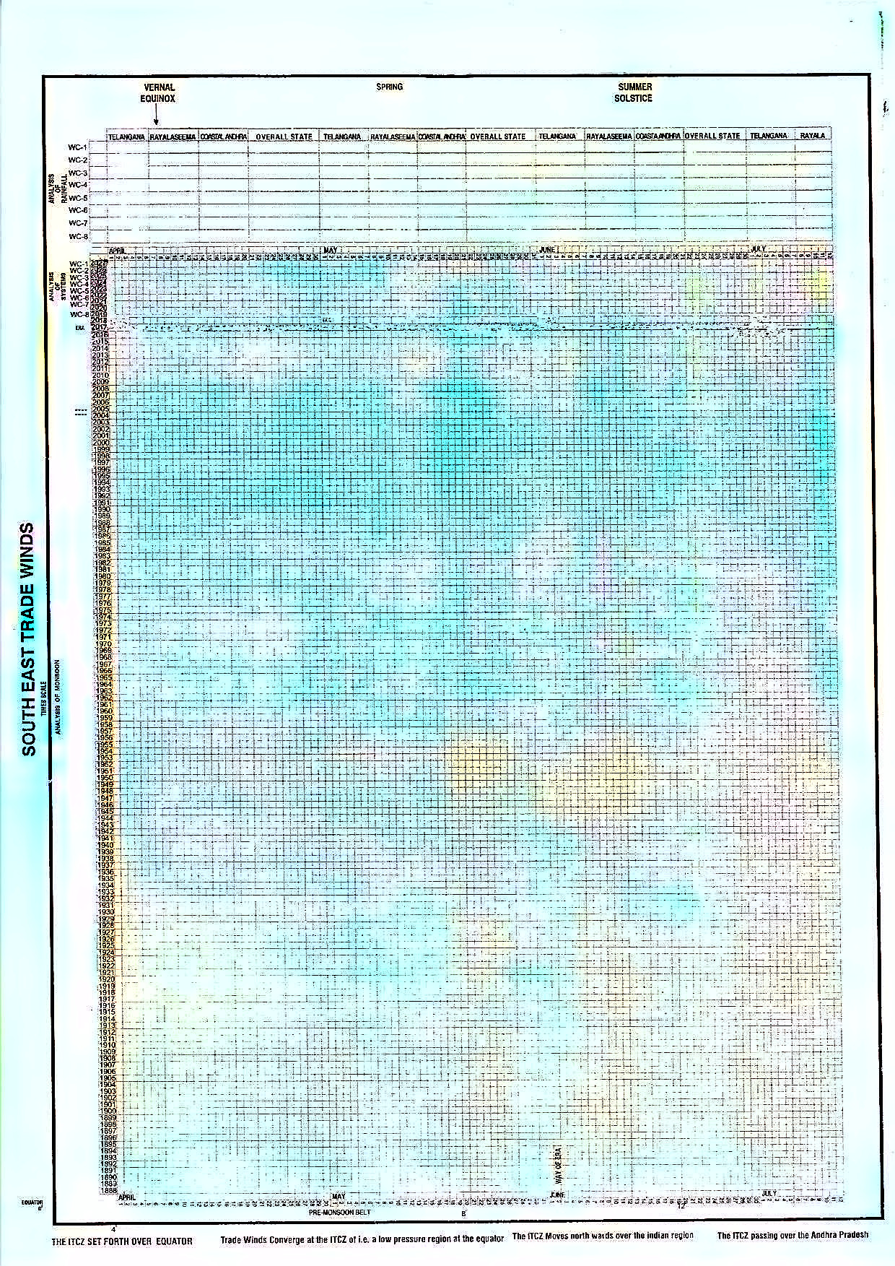
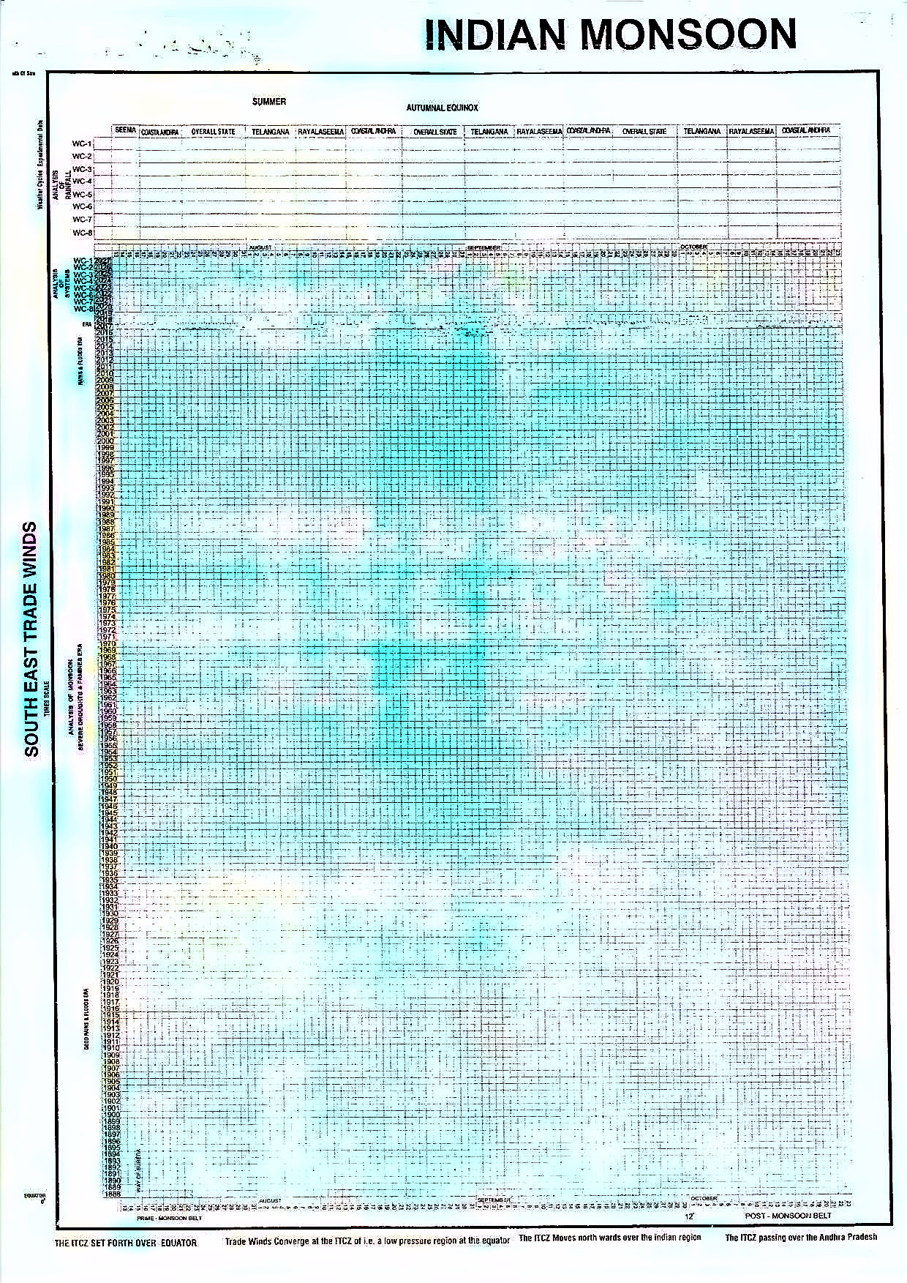

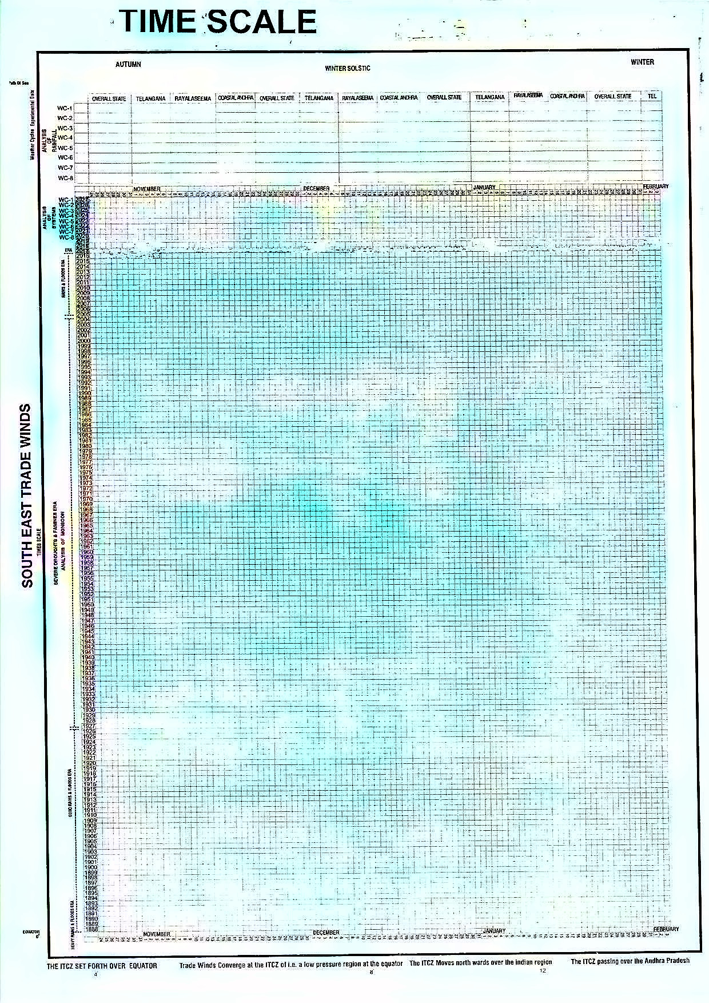

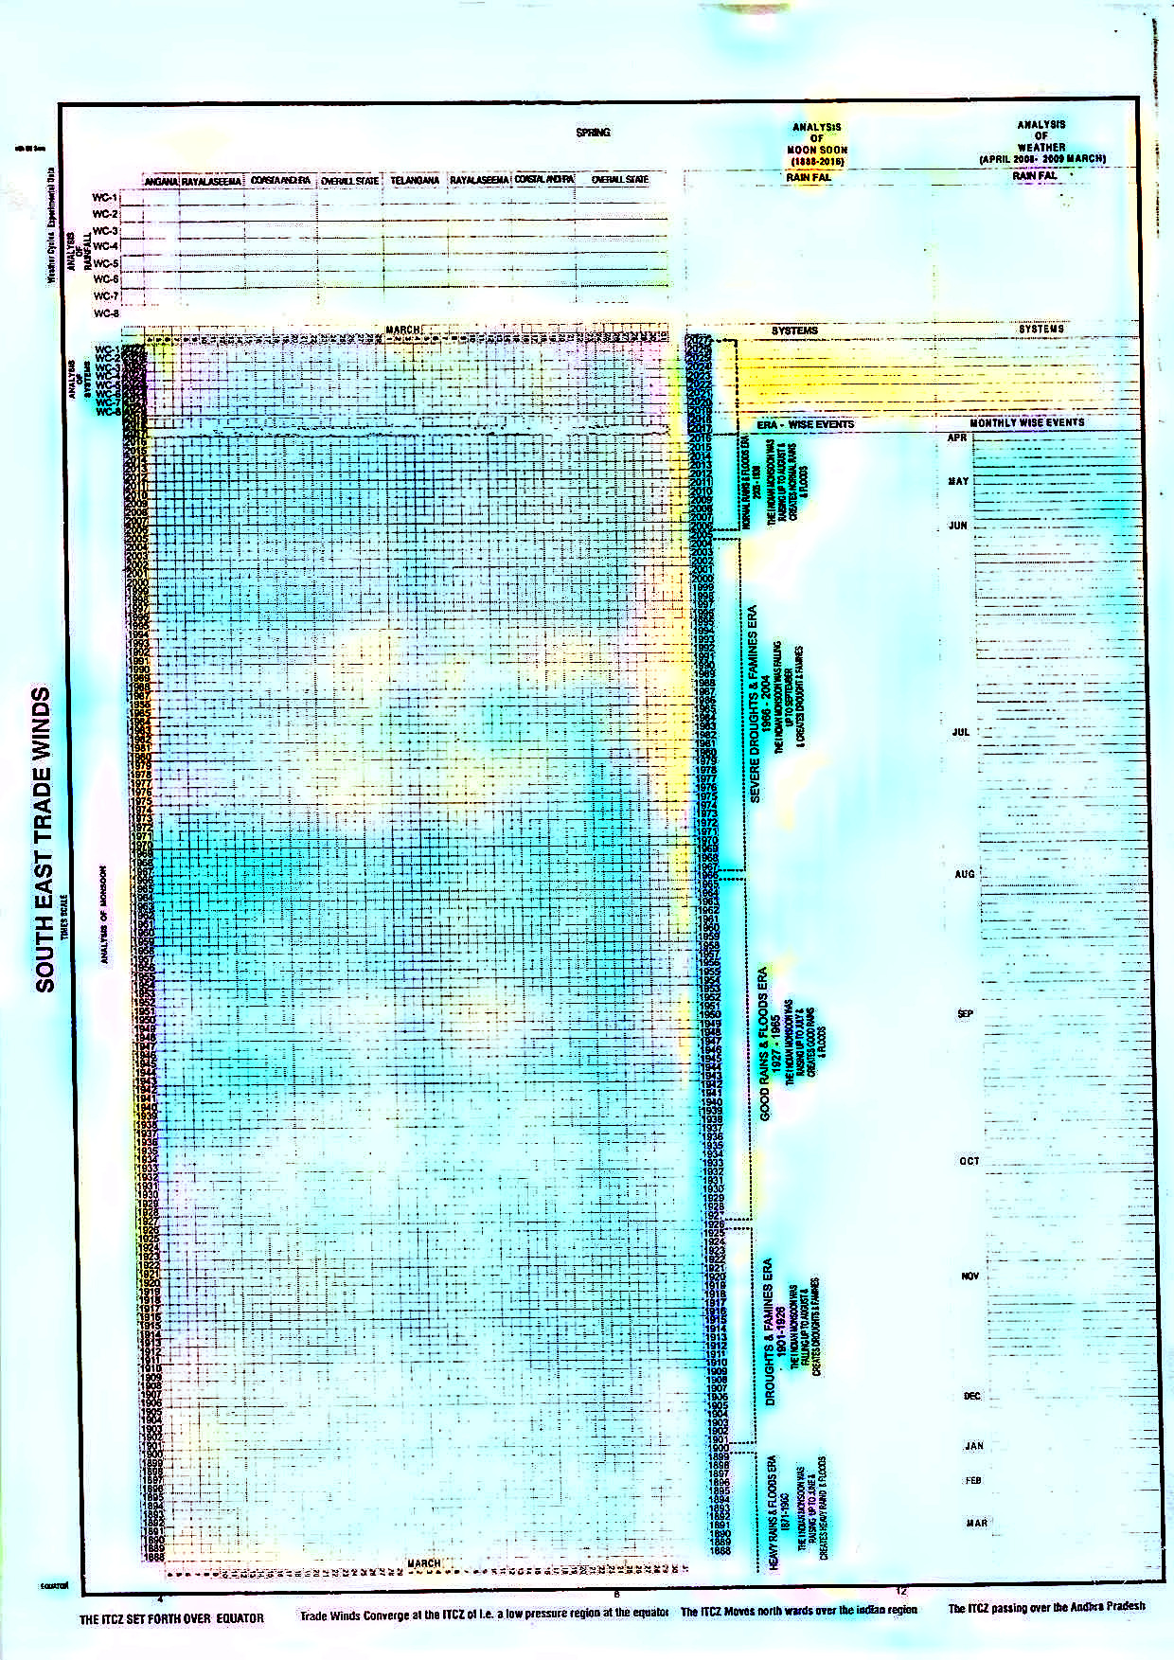

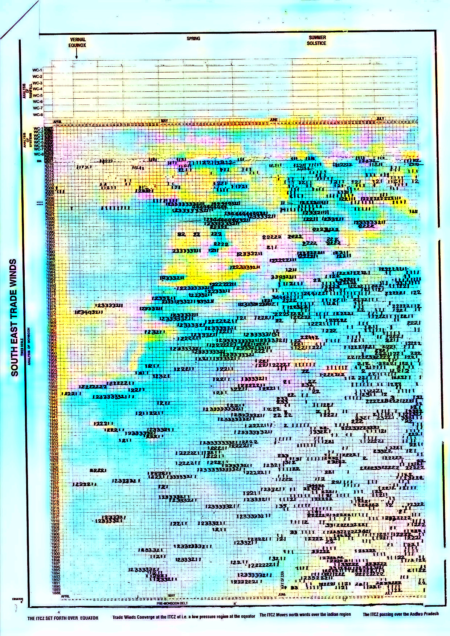

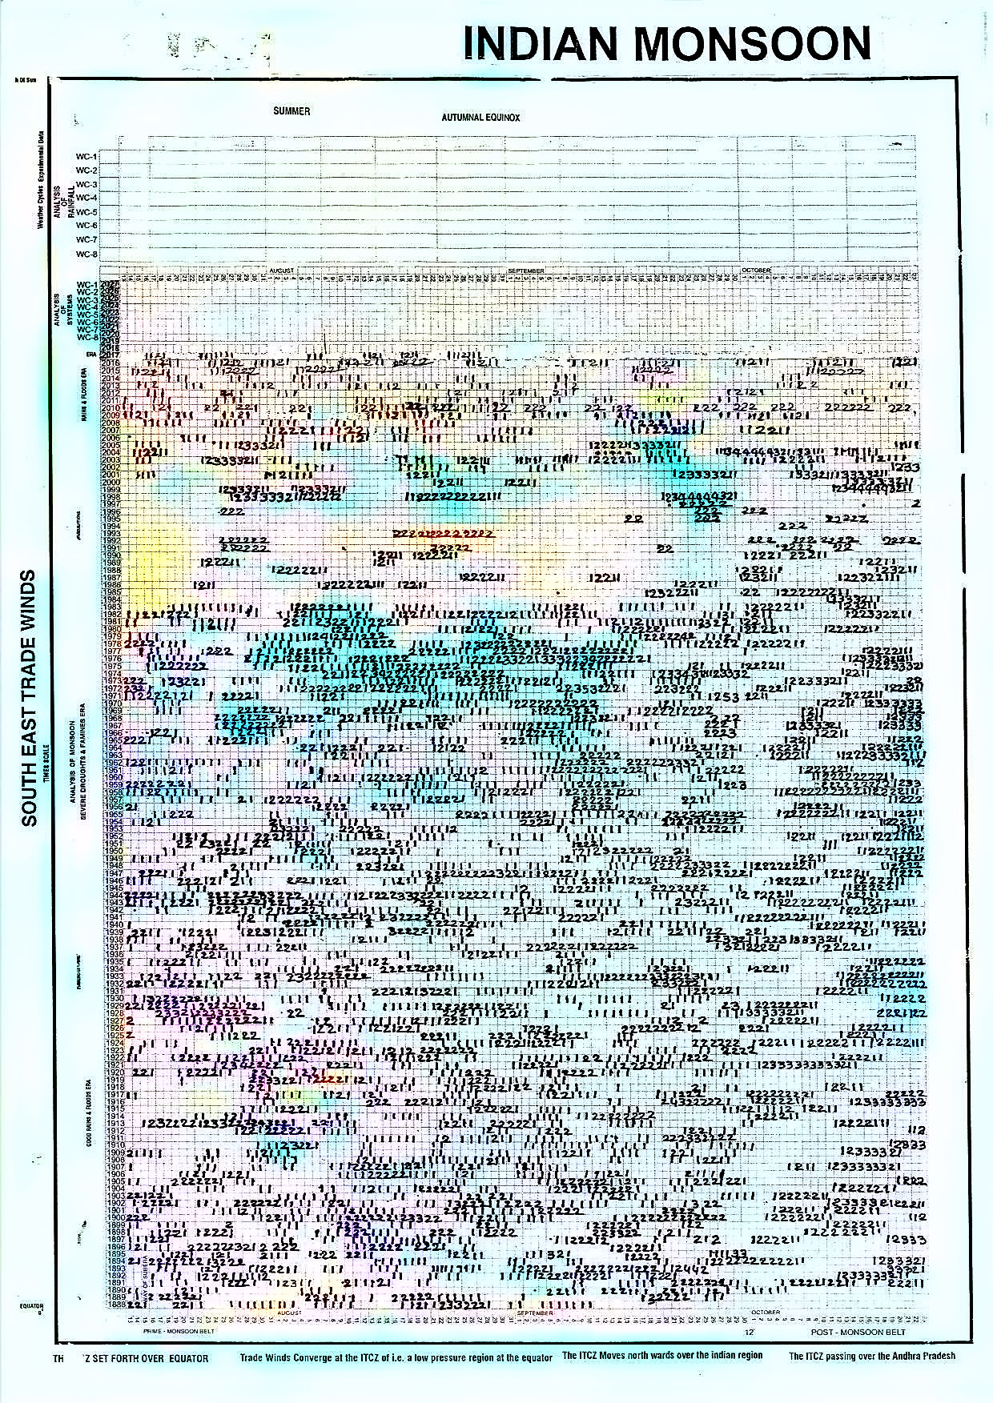

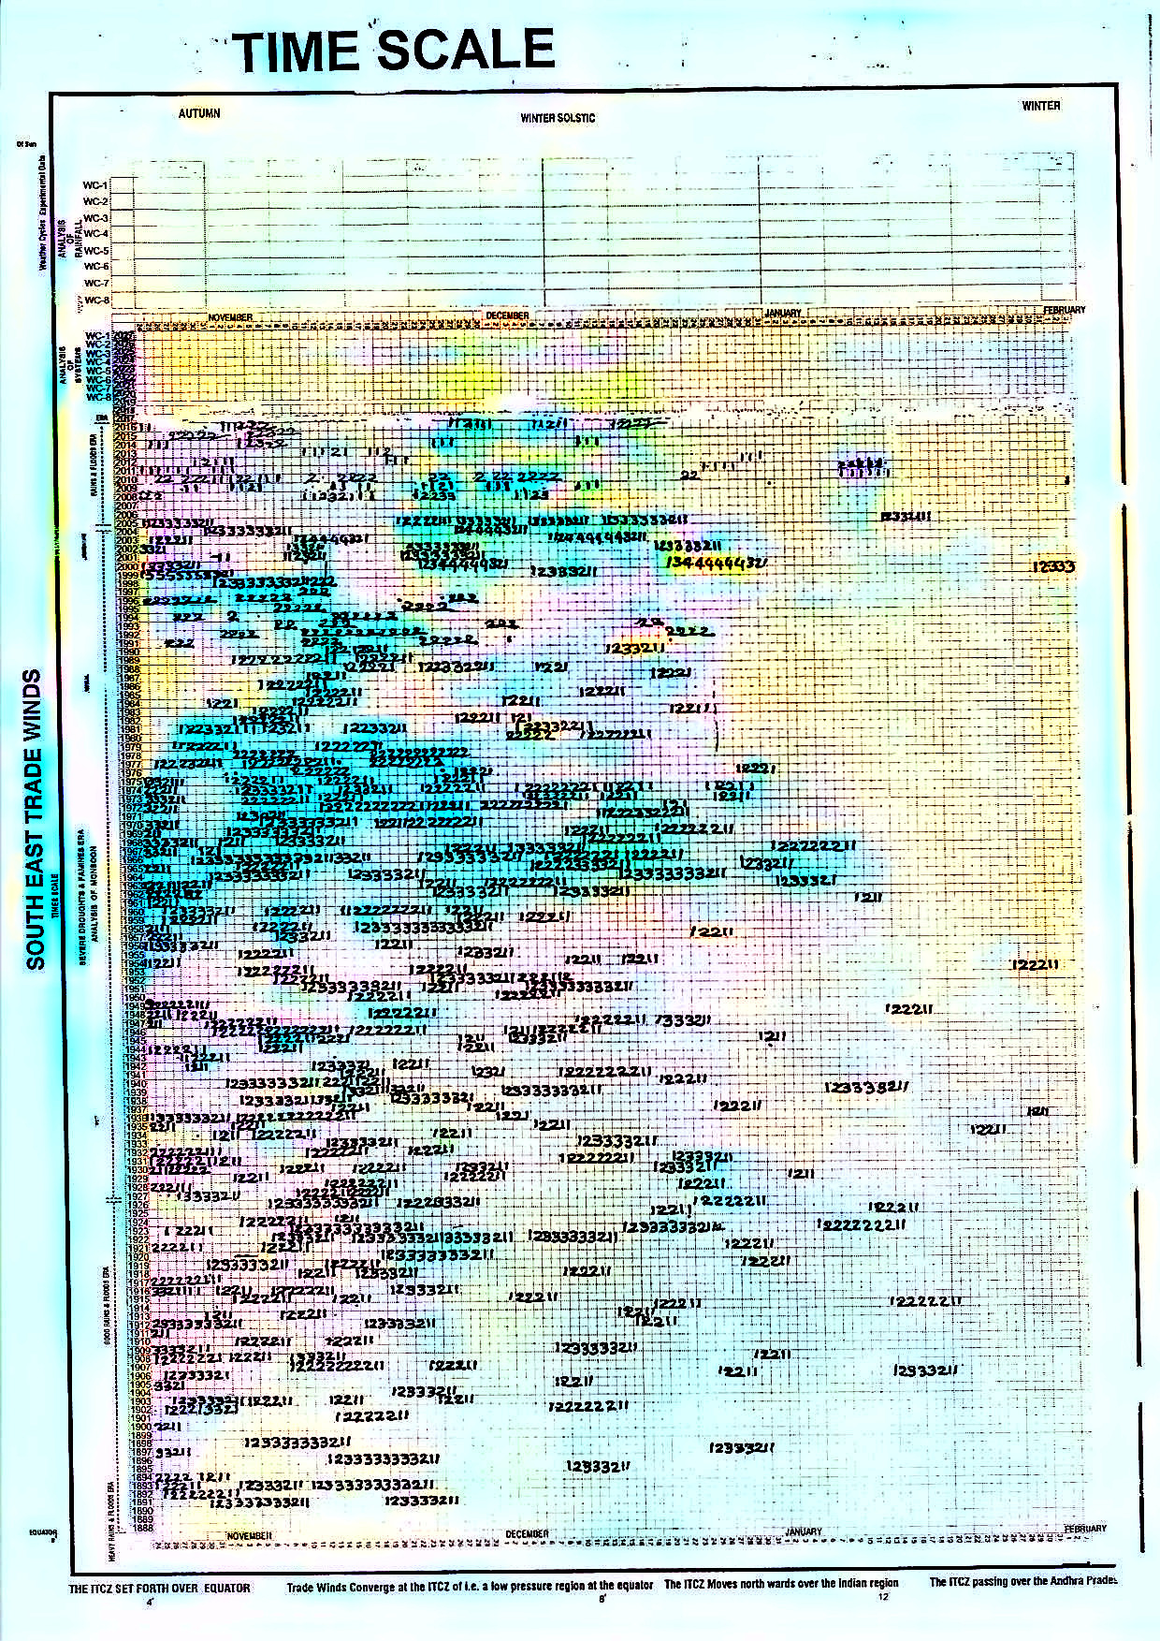

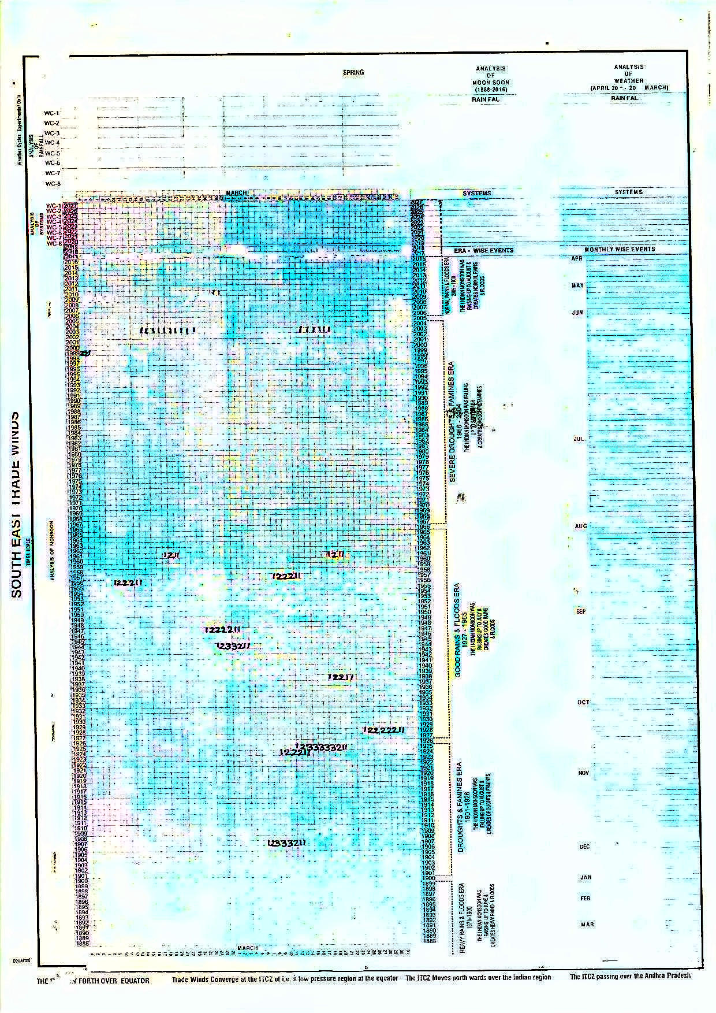

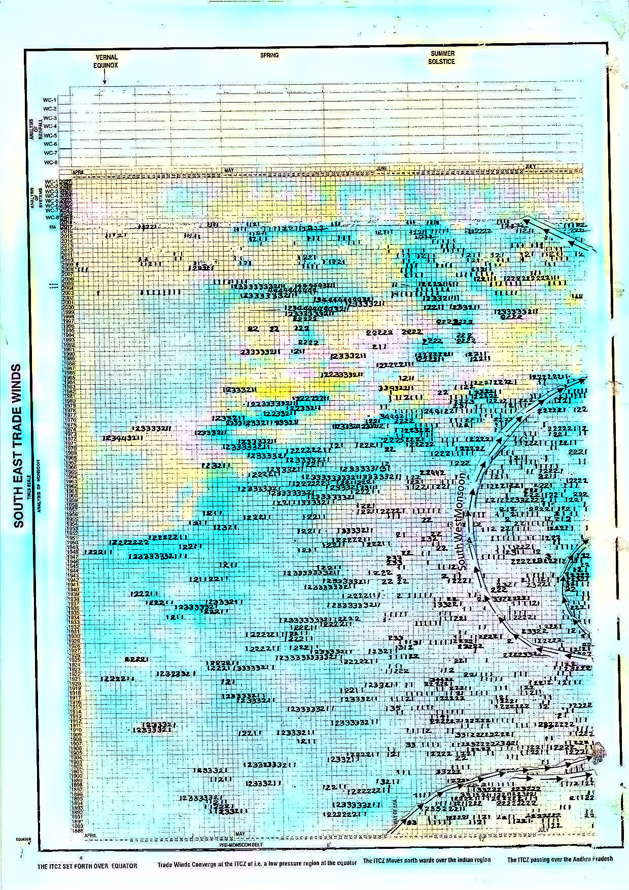

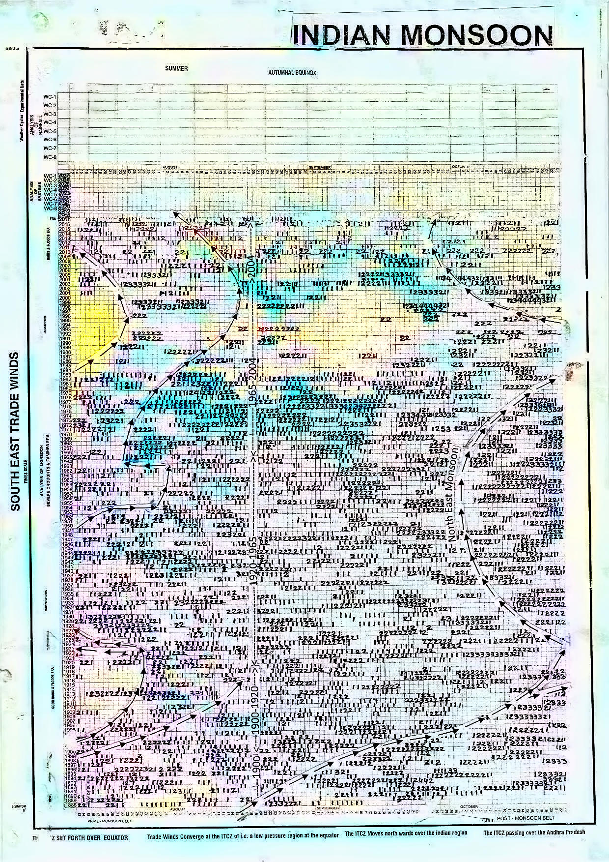

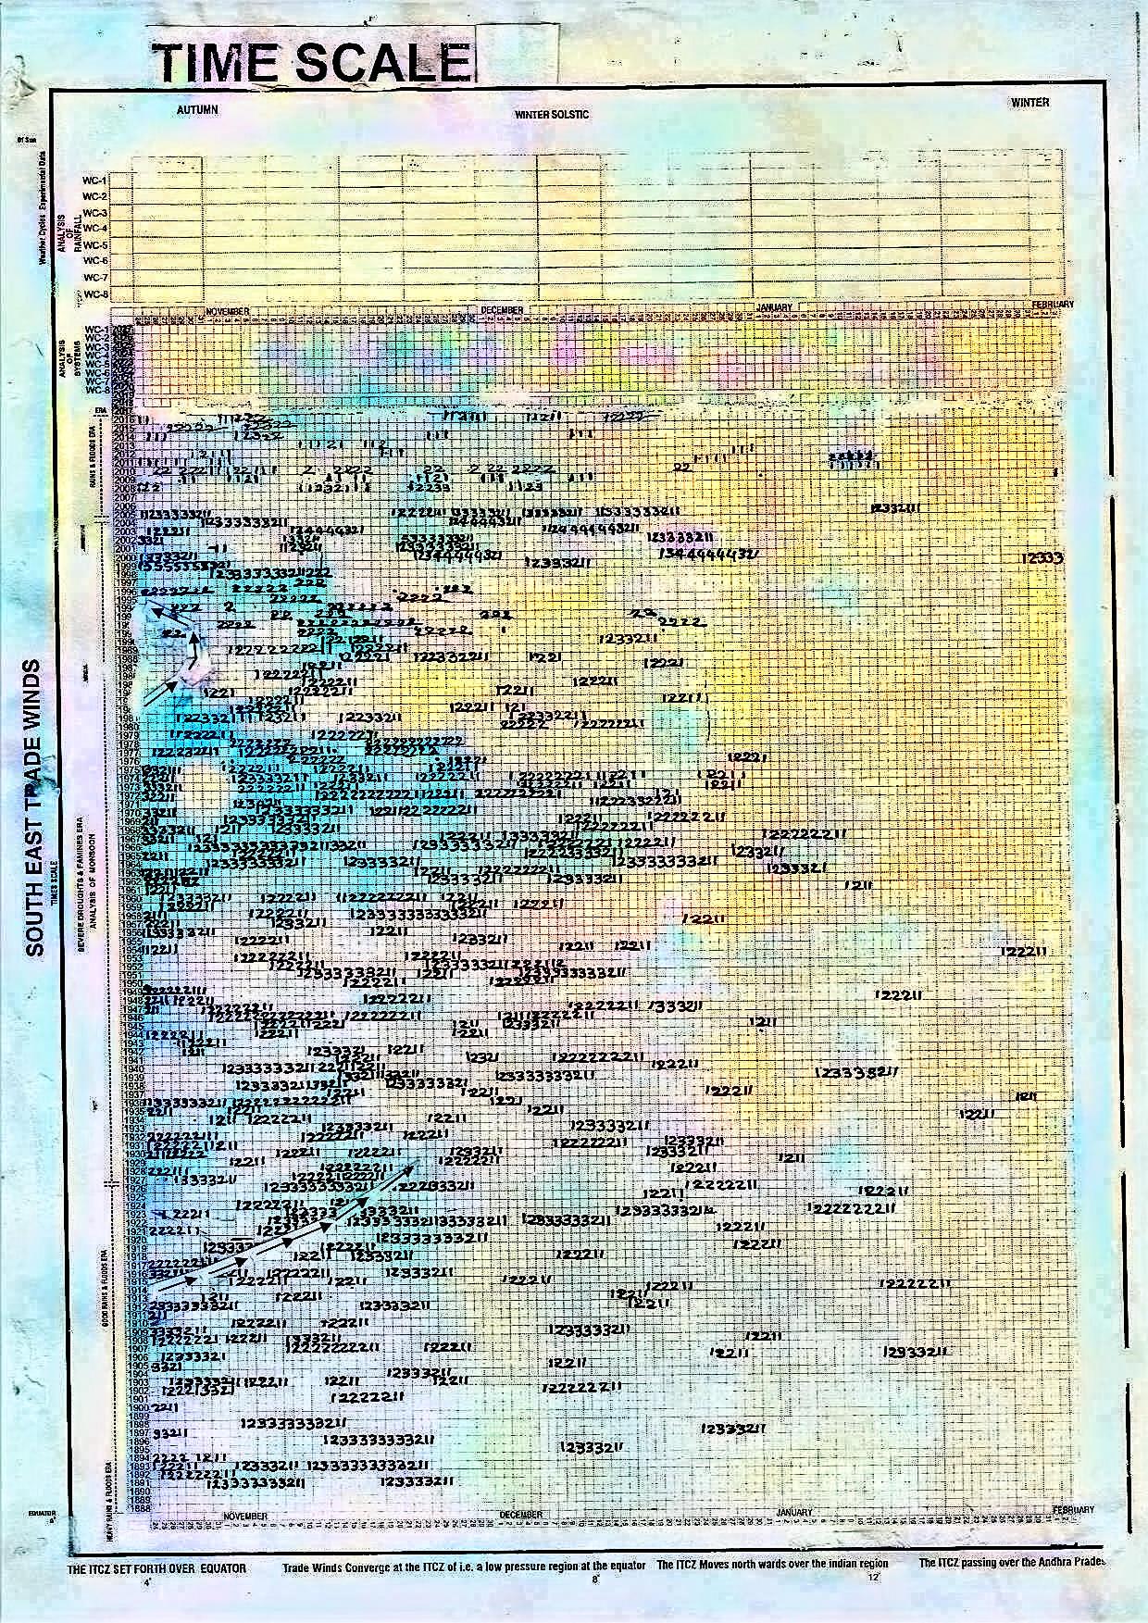

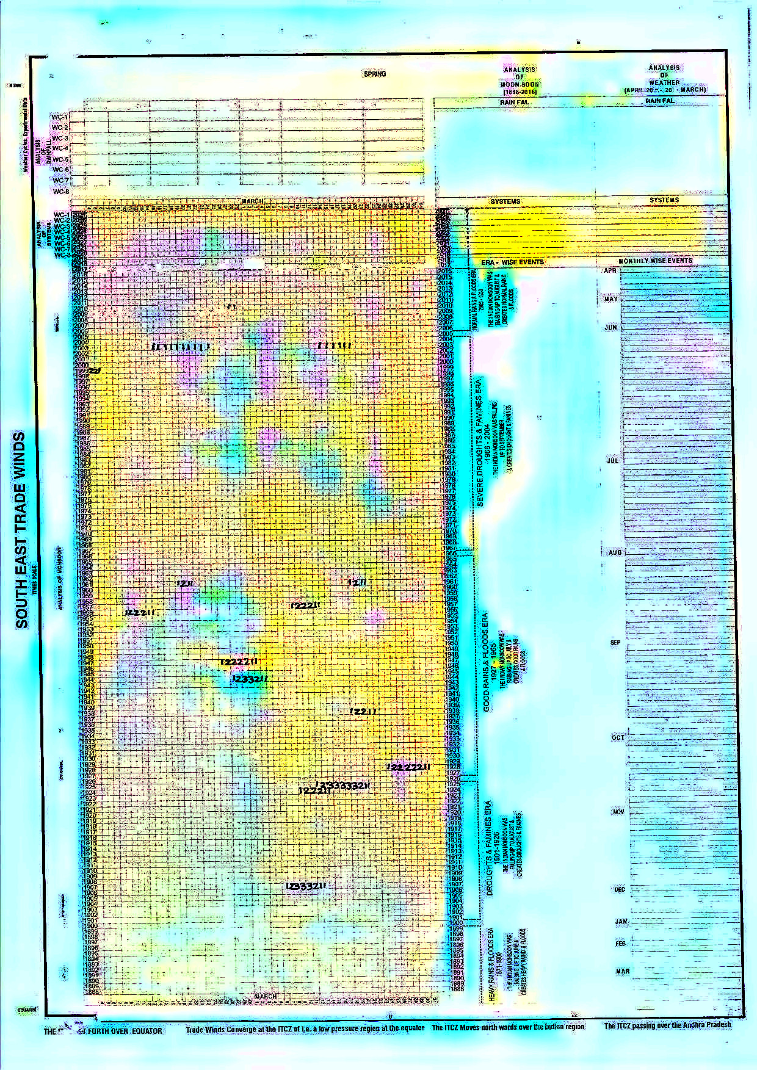
Indian monsoon time scales(when four parts are pasted)
