Management of Phytophthora and Rhizome Rot Diseases in Small Cardamom Using ICAR-IIHR Arka Microbial Consortium Technology

Sudhakar Soundarajan¹, D. Kalaivanan², G. Selvakumar² and Swathi H Dibbad²

¹Subject Matter Specialist (Plant Protection), ICAR- Krishi Vigyan Kendra, Idukki, Kerala
²ICAR-Indian Institute of Horticultural Research, Hesaraghatta Lake Post, Bengaluru

Abstract: This technology was introduced by ICAR-KVK, Santhanpara in IDUUKI district of Kerala for addressing the problems faced by small cardamom farmers of the district who were facing various problems like Azukhal disease, Rhizome rot, Bacterial blight, dropping of capsules and death of roots due to a variety of factors like lack of nutrient uptake, Phytophthora and Clump rot infection. The Microbial consortium technology was taken up as an on-farm trial and FLDs. It was found that drenching of small cardamom plant with Mixing of 20 gm Arka Microbial Consortium per litre of water and drenching 5-6 litre of this solution per small cardamom plant during May-June, August September and January months (Three times in a year performed significantly better in terms of reduction in Azukal, Clump rot, Nematodes. Technology assessment and demonstration of the technology has shown that AMC applied small cardamom field were showing early initiation of new shoots during pre-monsoon showers, less nematode (5.8%), less Azukal disease incidence (6.2 %), less Rhizome rot disease incidence (4.3 %) and have also recorded higher dry cardamom yield of (1.85 q/ha) compared to farmers practice yield range of (1.32 q/ha) after 4 years of AMC application.
[Sudhakar, S., Kalaivanan, G., Selvakumar and Dibbad, S.H. Management of Phytophthora and Rhizome Rot Diseases in Small Cardamom Using ICAR-IIHR Arka Microbial Consortium Technology. Researcher 2024;16(8):1-5]. ISSN 1553-9865 (print); ISSN 2163-8950 (online). http://www.sciencepub.net/researcher. 01. doi:10.7537/marsrsj160824.01.

Keywords: Management; Phytophthora; Rhizome Rot Diseases; Cardamom; ICAR-IIHR; Arka; Microbial Consortium; Technology

Introduction
Small cardamom, known as the ‘queen of spices’, which belongs to the family Zingiberaceae, is a rich spice obtained from the seeds of perennial plants Elettaria Cardamomum (Chempakam and Sindhu 2008) . They are recognized by their small seed pods: triangular in cross-section and spindle-shaped, with a thin, papery outer shell and small, black seeds; Elettaria pods are light green and smaller, while Amomum pods are larger and dark brown. Cardamom has a strong, unique taste, with an intensely aromatic, resinous fragrance. Black cardamom has a distinctly more smoky, though not bitter, aroma, with a coolness some consider similar to mint. It is one of the highly prized spices of the world and is the third most expensive spice after saffron and vanilla. Cardamom is one of those spices that cross the sweet boundary between desserts and main dishes. The original home of this spice is the mountains of the south- western parts of the Indian Peninsula. India had a virtual monopoly of cardamom until recently. Cardamom cultivation in India is confined to three states: Kerala, Karnataka and Tamil Nadu. However, now it is cultivated in Guatemala, Sri Lanka, Thailand, Loas, Nepal, Vietnam, Costa Rica, Mexico and Tanzania. The natural habitat of cardamom is the evergreen forests of Western Ghats. It is found to grow within an altitude ranging between 600 and 1200 meters above MSL. Though considerable variations both in the total rainfall pattern and its distributions are noticed in the cardamom tracts (900-4000 mm), a well distributed rainfall of 1500-2500 mm with not less than 200 mm summer showers and mean temperature of 15 to 25ºC would be ideal. Cardamom generally grows well in forest loamy soils that are acidic in nature, the preferable pH being 5.5-6.5. Cardamom soils are high in organic matter and nitrogen, low to medium in available phosphorous and medium to high in available potassium (Vijayan A. K, 2018).
Major constraints in small cardamom cultivation
The production and productivity of small cardamom (Elettaria cardamomum) is beset with many constraints and among them plant diseases play a major role. The pathogens such as Phytophthora meadii, Pythium vexans, Rhizoctonia solani were mainly responsible for causing an array of diseases in the past in plantations. The development of plant disease requires suitable host tissue, a compatible pathogen, and prevalence of suitable microclimatic conditions. Rot diseases (Azhukal or capsule rot) caused by Phytophthora meadii and clump rot caused by Pythium vexans occur in a severe form during monsoon season and results in significant crop loss. The disease also occurs in nursery seedlings in the form of damping off or seedling rot. The incidence of capsule rot or clump rot has been reported as a severe problem in the cardamom plantations a decade ago and lose in yield of small cardamom was by 50 percent. On the infected leaves, water-soaked lesions appear first followed by rotting and shredding of leaves along the veins. The infected capsules become dull greenish brown and decay. This emits a foul smell and subsequently they shed. Application of different fungicides to manage these problems in soils, has only added to environmental hazards besides increasing the cost of cultivation.
Azhukal /capsule rot/fruit rot disease
Cardamom is affected mainly with a diseases like Azhukal disease /capsule rot / fruit rot caused by Phytophthora parasitica car. Nicotianae / Phytophthora palmivora. Symptoms can appear on tender and matured leaves. Large circular, irregular, water-soaked spots with black colour appear on leaves. The exposed portion of the unopened leaves may rot. Grey patches of irregular spots with brown margin are formed at the base of the leaf sheath. The basal portion rots and the pseudo stem break away at the collar region. The infection spreads to the underground plants and the rhizomes rot. Small light brown lesions appear in the green tender fruits which falls off in 3-6 days leaving the small fruit stalk. The tip of inflorescence also rots.
Soft rot or rhizome rot disease
Another important disease of cardamom is soft rot or rhizome rot caused by Pythium aphanidermatum/ P. vexans / P. myriotylum. The infection starts at the collar region of the pseudo stems and progresses upwards as well as downwards. The collar region of the affected pseudo stem becomes water soaked and the rotting spreads to the rhizome resulting in soft rot. At a later stage root infection is also noticed. Foliar symptoms appear as light yellowing of the tips of lower leaves which gradually spreads to the leaf blades. In early stages of the disease, the middle portion of the leaves remain green while the margins become yellow. The yellowing spreads to all leaves of the plant from the lower region upwards and is followed by drooping, withering and drying of pseudo stem.
Management of azhukal and rhizome rot disease
Chemical control measures
With respect to the management of azhukal disease, removal and burning of infected plants, avoid moving of rhizomes from diseased areas to healthy area for planting. Provide proper drainage. Three sprays with Bordeaux mixture @ 1% in May, June and July. Soil drench with Bordeaux mixture @ 1 % (or) Copper oxychloride (COC) 0.25%. Management of soft rot or rhizome rot includes treatment of seed rhizomes with mancozeb 0.3% for 30 minutes before storage and once again before planting reduces the incidence of the disease. Cultural practices such as selection of well drained soils for planting is important for managing the disease, since stagnation of water predisposes the plant to infection. Seed rhizomes are to be selected from disease free gardens, since the disease is also seed borne. Once the disease is located in the field, removal of affected clumps and drenching the affected and surrounding beds with mancozeb @ 0.3% checks the spread of the disease.
Role of phosphonate fungicides in the management of soil borne diseases
The common chemical name for Aliette® is fosetyl-aluminum (fosetyl-Al). The discovery of the unique downward systemic transport properties of these phosphonate fungicides was of great significance for the control of soil-borne diseases caused by Phytophthora. Fosetyl-Al is the only commercially available fungicide known to be systemically transported in a downward direction in plants. This property permits the fungicide to be applied to foliage or tree trunks in order to control root diseases caused by Phytophthora (Mark Fenn and Michael D. Coffey, 1987).
Biological control measures
In the biological control of capsule rot and rhizome rot, bioagents play an important role in an eco-friendly system of disease management to fight against the plant pathogens in a totally safe manner avoiding the use of expensive and hazardous chemical fungicides. Field control of capsule rot disease using Trichoderma viridae and Trichoderma harzianum was achieved and has further developed a simple carrier come multiplication medium for Trichoderma application in the field (Vijayan A. K, 2018). Arka Microbial Consortium (AMC) is a novel technology released from ICAR-IIHR, Bengaluru for plant nutrition and health management in horticultural crops. It is a consortium of 3 unique bacterial strains viz., Bacillus, Pseudomonas and Azotobacter. It can be applied through either soil drenching or drip bio fertigation. This synergistic effect of the formulated microbes can help in sustainable production of crops at a reasonable cost. This technology was introduced by ICAR-KVK, Santhanpara in Idukki district of Kerala for addressing the problems faced by small cardamom farmers of the district who were facing various problems like azhukal disease and rhizome rot. The technology gained popularity with the farmers and it is being followed by more than 5327 farmers of the district covering an area of 12,452 ha and further popularized through FLDs and other extension activities.
Field trials on management of rot diseases and clump rot conducted at KVK, Idukki
Field trials on management of rot diseases and clump rot in small cardamom was carried out using different treatments of chemicals, biological agents and bio-fertilizer in farmer’s field at Santhanpara, Udumbanchola, Vandanmedu, Nedumkandam, Kattapana, Rajakadu and Rajakumari village of Idukki District in Kerala for five years during 2016-2021. The treatments included spraying of 1% Bordeaux mixture (T1), spraying with Bordeaux mixture and drenching of Fosetyl Al 80% WP (T2), soil application of Trichoderma along with FYM (T3), spraying of Potassium Phosphonate 3ml/l and drenching of Arka Microbial Consortium (AMC) 10 g per lit (T4) and untreated check (T5). For each treatment, 400 small cardamom plants were taken. AMC was drenched four times, during May-June, August-September, November- December and January-February months. The observations on percent capsule rot, rhizome rot and root rot (%) were recorded. The percent was calculated at five areas (1.0 square meter) randomly selected in the area of small cardamom.

The formulas used are given below:

- Percent capsule rot infection = No. of plants infected X 100
Total no. of plants

- Percent rhizome rot infection = No. of plants infected X 100
Total no. of plants

- Percent leaf infection = No. of leaves infected per plant X 100
Total no. of plants

The least capsule rot (4.23%), rhizome rot (5.14%), leaf infection (3.15%) was observed in the treatment involving spraying of Potassium Phosphonate and drenching of Arka Microbial Consortium. The highest capsule rot (65.1%), rhizome rot (51.8%), leaf infection (42.3%) of Phytophthora and Rhizome rot was observed in untreated check which was followed by the treatments T1, T2, T3. The highest dry small cardamom yield (1.73 q/ha) was recorded in the treatment involving AMC application which was followed by the treatment T3 (1.68 q/ha), T2 (1.65 q/ha) and T1 (1.42 q/ha). The least dry small cardamom yield was observed in untreated check (0.90 q/ha). The benefit cost ratio of 3.10 was highest in the AMC treatment. The least benefit cost ratio of 1.40 was observed in untreated check, which was followed by the treatment T3 (3.00), T2 (2.89) and T1 (2.65).

Table 1. Assessment of phytophthora and rhizome rot diseases in small cardamom

Treatment | Details | Percent capsule rot | Percent  rhizome rot | Per cent leaf infection | Dry cardamom yield q/ha | B:C
T1 | Spraying of 1% Bordeaux mixture | 21.30 | 18.10 | 9.80 | 1.42 | 2.65
T2 | Spraying with Bordeaux mixture and drenching of Fosetyl Al 80% WP | 16.40 | 17.20 | 7.40 | 1.65 | 2.89
T3 | Soil application of Trichoderma along with FYM | 9.61 | 8.21 | 17.90 | 1.68 | 3.00
T4 | Spraying of Potassium Phosphonate 3ml/l and drenching of Arka Microbial Consortium (AMC) | 4.23 | 5.14 | 3.15 | 1.73 | 3.10
T5 | Untreated check | 65.10 | 51.80 | 42.30 | 0.90 | 1.40
Management of phytophthora and rhizome rot in small cardamom with Arka Microbial Consortium – A Farmers Experience

Mr. Nallamuthu a tribal farmer of Pachapulkudi Village, Devikulam Taluk, Idukki District of Kerala state is cultivating small cardamom on 2.5 acres. Every year his plantation was affected by Phytophthora and Rhizome rot and he has to uproot the plants. During this crucial period, he came into contact with help of KVK, Idukki and TSP project also supplied the Arka Microbial Consortium (AMC) technology from ICAR-IIHR. On the advice of the firm, he had taken up spraying and drenching of powder formulation of Arka Microbial Consortium @ 2 kg / 200 litres of water, on the small cardamom plantation at fortnightly intervals. Gradually he observed the recovery of the disease affected plants and continued the practice for the past three years. The plants are becoming greenish and reduced drooping of leaves, Rhizome rot and shoot lodging are not observed during the monsoon period. By adopting this practice, he has been able to effectively manage Phytophthora and Rhizome rot in his plantation over the three-year period. An average yield of dry capsules yield was observed around 400 kg/ acre. After adoption of this technology, it saves the cost of chemicals application Rs. 4,500 per ha. The cost of application of AMC is Rs. 4,400/ha as compared to regular chemical application where it costs Rs. 21,000/ha. So, the reduction in cost of cultivation per ha is Rs. 65,000. The total net return gained per ha is Rs. 279,000/- due to introduction of ICAR-IIHR-AMC technology.
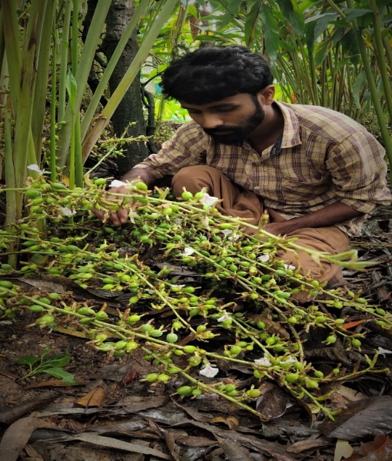

Conclusion
The technology gained popularity with the farmers and it is being followed by more than 5000 farmers of the district covering an area of 12,000 ha and further popularized through FLDs and other extension activities. After adoption of this technology, it saves the cost of chemicals application Rs. 4,500 per ha. The cost of application of AMC is Rs. 4,400/ha as compared to regular chemical application where it costs Rs. 21,000/ha. So, the reduction in cost of cultivation per ha is Rs. 65,000. The total net return gained per ha is Rs. 2, 79,000 due to introduction of AMC technology. The total economic benefits accrued since its release (2017) is estimated at Rs. 27.84 crore during the period 2017 to 2021. To accelerate the adoption, KVK, Idukki has established AMC Production Unit at KVK premises with the financial support of revolving fund and 14,846 kg of AMC has been produced and supplied to 5327 no. of farmers since 2017. Therefore, the AMC technology has spread to 12,452 ha of the small cardamom plantation areas and the KVK is realizing Rs. 11.50 lakhs sale annually.

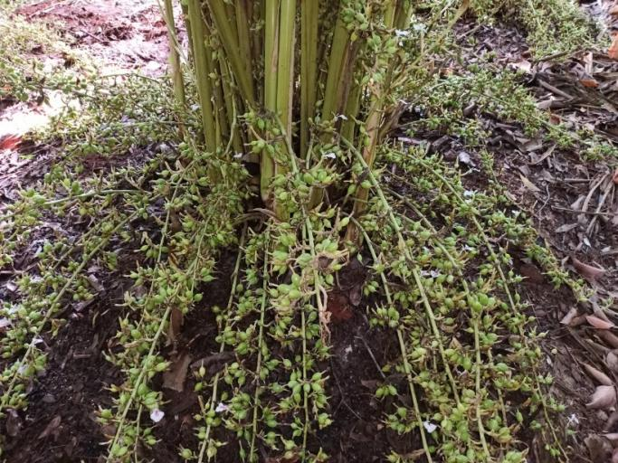
References
- Chempakam, B. and Sindhu, S., 2008. Small cardamom. Chemistry of spices, p.41.
- Srinivasan, R. and Kalaivanan, D., 2022. Soil quality Assessment for Improving Large Cardamom Productivity in North Sikkim. Spice India, p.17.
- Mark Fenn and Michael D. Coffey, 1987. Phosphonate Fungicides for Control of Diseases Caused by Phytophthora. California Avocado Society, 71: 241-249.
- Vijayan, A. K., 2018. Small cardamom production technology and future prospects. International Journal of Agriculture Sciences, ISSN, pp.0975-3710.

5/22/2024

