Statistical Computational interpretation of Physicochemical Groundwater Quality in proximity to designated Tea Plantations in Lakhimpur District, Assam, India

Ranjit Paul¹, Tarun Chandra Taid², Bhabajit Bhuyan ³

^{1.} Department of Computer Science, North Lakhimpur College (Autonomous), Lakhimpur, Assam, India, 787031
^{2.}Department of Zoology, North Lakhimpur College (Autonomous), Lakhimpur, Assam, India, 787031
^{3.} Department of Chemistry, North Lakhimpur College (Autonomous), Lakhimpur, Assam, India, 787031
bhabajitb@rediffmail.com

Abstract: There is an increasing concern related to water quality issues throughout the developing countries. There is a lack of data on different environmental aspects related to the tea gardens of Assam. Ground water quality and its impact on human health in and around five selected tea gardens of Lakhimpur district, Assam, India was assessed with a view to strengthen the water quality database of the region so that appropriate measures can be adopted, at the planning level, to keep the contamination of water at the minimum. Twenty ground water samples were chemically and statistically analyzed by adopting standard procedures. The observed variations in quality of water samples inside and outside tea gardens may be due to the high permeability of tea garden soils combined with the relatively short distance to the water table making these areas particularly sensitive to contamination. Excessive rainfall or over irrigation may also cause downward movement of water through the soil profile. The experimental values of physicochemical parameters were compared with the World Health Organisation and ISI water quality standards. It was found that people use water for drinking purposes mostly from tubewells, borewells and supply water sources, which need purification before drinking. Univariate statistics were used to test distribution normality for each water quality parameter. Statistical observations on the experimental data show that the distributions of various water quality parameters in the study area were widely off normal. The present study, however, fulfilled only the limited purpose of strengthening database, which may help in formulating strategies for future.
[Paul R, Taid TC, Bhuyan B. Statistical Computational interpretation of Physicochemical Groundwater Quality in proximity to designated Tea Plantations in Lakhimpur District, Assam, India. Researcher 2024;16(7):37-43]. ISSN 1553-9865 (print); ISSN 2163-8950 (online). http://www.sciencepub.net/researcher. 03. doi:10.7537/marsrsj160724.03.

Keywords: pH, Alkalinity, Hardness, Kurtosis, Skewness etc.

1. Introduction
All life is dependent on water and of all the environmental concerns that the developing countries are facing today, is the lack of adequate quality of potable water. Safe water is a precondition for health and development and yet it has been taken for granted in much of the developed world. Access to safe drinking water is essential to health, a basic human right and a component of effective policy for health protection. Drinking water sources are under increasing threat from contamination with far reaching consequences for the health and also for the economic and social development of the area concerned. Pollution of fresh water occurs due to three major reasons- excess nutrients from sewage, wastes from industries, mining and agriculture (Mayback et al., 1989). The standards set by the regulatory bodies should always be observed to ensure that the health of consumers is not compromised. In particular, the effects of contaminants should always be established before releasing the standards to suppliers and consumers. W.H.O has given a set of guideline values
for drinking water quality (WHO, 2004). These guideline values, along with tolerance limits prescribed by the Indian Standard Institute (ISI) (Trivedy, R.K, 1990) and EPA standards of USA are also important in assessing water quality (Train, R.E., 1979). Water pollution studies in India have received remarkable momentum in recent times. Most of the studies are, however, related to rivers (Kataria et al., 1995, Sing et al., 1999, Sing et al., 2000, P. Mandal et.al 2010, S. N. Thitame and G. M. Pondhe, 2010, R.and Karthikeyan, P. 2013 Umamaheshwari S .Ccme. 2016, Bhuyan B, 2010). Thus, every effort should be made to achieve drinking-water quality as safe as practicable. The present research has been carried out to study some of the physic-chemical water quality parameters in and around some selected tea gardens of Lakhimpur district, Assam and to interpret the results statistically.

2. Material and Methods
The study area Lakhimpur district is situated in the eastern parts of India on the northeast corner of Assam. Located between mighty Brahmaputra River and Himalayan foothills of Arunachal Pradesh, the district is largely plain with some hills. The district lies between 26⁰48/ and 27⁰53/ northern latitude and 93⁰42/ and 94⁰20/ eastern longitude (approximately). The District covers an area of 2,977 sq. km out of which 2,957 sq. km is rural and 20 sq. km is urban. Lakhimpur District falls in the sub-tropical climatic region, and enjoys monsoon type of climate. The district experiences a dry and hot summer season when compared to the other parts of Assam. Autumns are dry, and warm. Winters extend from the month of October to February, and are cold and generally dry. There are nine large Tea gardens apart from several small tea gardens in the district of Lakhimpur, Assam. These gardens are situated near the banks of river Dikrong, Ranganadi and Subansiri respectively. The major tea producer of the district include Ananda Tea Estate, Johing Tea Estate, Sirajuli Tea Estate, Dirzo Tea Estate, Harmuuty Tea Estate, Koilamari Tea Estate, Doloohat Tea Estate, Kakoi Tea Estate and Silanibari Tea Estate. Separate water samples were collected by random selection and compiled together in plastic bottles to set a representative sample in and around the five selected tea gardens of Lakhimpur district, Assam during June to November, 2023 (Table-1). Temperature, pH and conductivity were determined quickly after sampling. Samples were protected from direct sun light during transportation (Tata, 1987). The physical parameters studied were Temperature, Colour, Odour, Conductivity, Total Solid (TS), Total Dissolved Solid (TDS) and Total Suspended Solid (TSS). The chemical parameters studied are pH, Alkalinity, Chloride (Cl⁻), Sulphate (SO₄⁻⁻), Nitrate (NO₃⁻), Total Hardness, Calcium (Ca), Magnesium (Mg) and Iron (Fe). Analytical procedures as described in “Standard Methods for the Examination of Water and Wastewater” (APHA, 1995) were adopted for physico-chemical analysis of water samples.Univariate statistics were used to test distribution normality for each water quality parameter. The confidence interval was calculated at 0.05 level. Skewness and kurtosis values were calculated to express how the shapes of sample frequency distribution curves differ from ideal Gaussian (normal). Skewness was calculated as third moment of the population mean. In asymmetrical distributions, skewness can be positive or negative. Kurtosis was calculated as fourth moment of the population to describe the heaviness of the tails for a distribution. Some more statistical estimates derived from the normal distribution in the form of sample variance, 1st, 2nd and 3rd Quartile, Inter Quartile Range (IQR) were also made in the present study to find out the distribution pattern of the data and other related information Details of these may be found in standard books on statistics and software packages (Meloun M, Militky J, Forina M., 1992).

3. Results
The water test values of physicochemical parameters of water samples were graphically represented in Figure 1 and 2 respectively. To look into the trend and distribution patterns of investigated water quality parameters, data were exposed to several statistical treatments, which have been briefly discussed in methodology section. A conventional descriptive statistics based on normal distribution has been presented in Tables 2 and 3.

Table 1. Water sampling locations
Sample No | Source | Place | Sample No | Source | Place
A1 | Supply Water | Tea Garden | B5 | Ring Well | Outside Tea Garden
A2 | Tube Well | Tea Garden | B6 | Tube Well | Outside Tea Garden
B1 | Supply Water | Outside Tea Garden | A7 | Supply Water | Tea Garden
B2 | Tube Well | Outside Tea Garden | A8 | Tube Well | Tea Garden
A3 | Supply Water | Tea Garden | B7 | Ring Well | Outside Tea Garden
A4 | Tube Well | Tea Garden | B8 | Tube Well | Outside Tea Garden
B3 | Tube Well | Outside Tea Garden | A9 | Supply Water | Tea Garden
B4 | Ring Well | Outside Tea Garden | A10 | Tube Well | Tea Garden
A5 | Supply Water | Tea Garden | B9 | Tube Well | Outside Tea Garden
A6 | Tube Well | Tea Garden | B10 | Tube Well | Outside Tea Garden

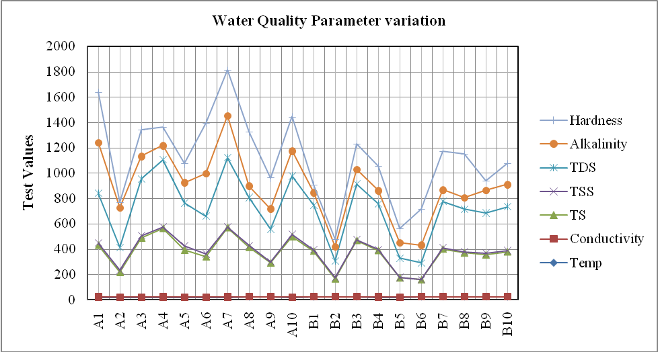

Figure.1: Water test values in and around tea gardens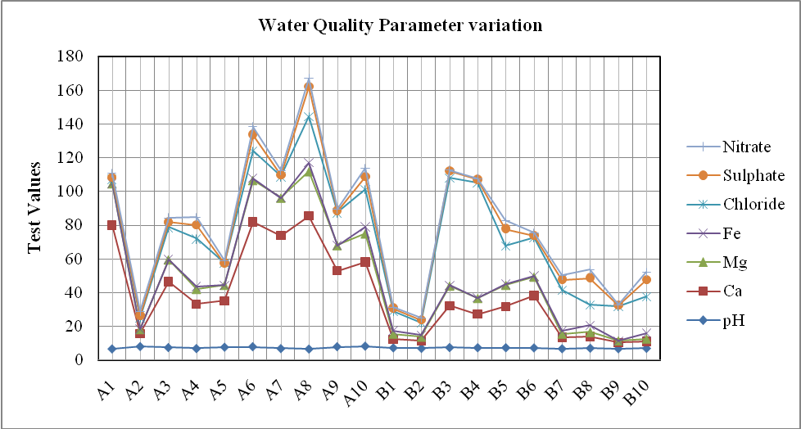
Figure.2: Water test values in and around tea gardens
Tables 2: Descriptive Statistics of Experimental Data
Statistics | Temp.  (⁰C) | Conductivity  (mmho/cm) | TS  (mg/L) | TSS  (mg/L) | TDS  (mg/L) | Alkalinity (mg/L) | Hardness (mg/L)
Mean | 21.4 | 0.70 | 350.5 | 10.9 | 339.8 | 175.8 | 220.2
Median | 21.0 | 0.71 | 362.0 | 9 | 348 | 142.0 | 203.0
Min | 19.0 | 0.23 | 134.0 | 1 | 133 | 90.0 | 40.3
Max | 23.0 | 1.03 | 548.0 | 32 | 550 | 400.0 | 425.0
Range | 4.0 | 0.80 | 414.0 | 31 | 417 | 310.0 | 384.7
Standard Deviation | 1.3 | 0.30 | 122.2 | 7.4 | 121.6 | 94.1 | 122.9
Standard Error | 0.3 | 0.10 | 27.3 | 1.6 | 27.2 | 21.1 | 27.5
Variance | 1.621 | 0.064 | 14927.520 | 54.345 | 14784.060 | 8863.432 | 15096.120
Kurtosis | -1.178 | -1.022 | -0.394 | 2.286 | -0.388 | 0.513 | -1.150
Skewness | -0.177 | -0.423 | -0.372 | 1.261 | -0.262 | 1.280 | 0.147
Percentile 25 | 20.0 | 0.52 | 321.0 | 8 | 300 | 110.0 | 141.2
Percentile 50 | 12.0 | 0.70 | 293.3 | 9 | 283 | 131.7 | 162.7
Percentile 75 | 22.0 | 0.84 | 410.0 | 15 | 395 | 180.0 | 300.0
IQR | 2.0 | 0.32 | 89.0 | 7.0 | 95.0 | 70.0 | 158.8
Confidence Limit | [20.8-22.0] | [0.60-0.80] | [293.3-407.6] | [7.4-14.3] | [282.9-396.7] | [131.7-219.9] | [162.7-277.7]

Tables 3: Descriptive Statistics of Experimental Data

Statistics | pH | Ca  (mg/L) | Mg  (mg/L) | Fe  (mg/L) | Chloride  (mg/L) | Sulphate  (mg/L) | Nitrate  (mg/L)
Mean | 7.2 | 31.0 | 11.0 | 1.5 | 22.0 | 5.4 | 2.6
Median | 7.2 | 24.8 | 9.4 | 0.7 | 19.3 | 2.1 | 2.4
Min | 6.5 | 3.6 | 1.0 | 0.1 | 2.4 | 0.0 | 0.0
Max | 8.2 | 79.0 | 26.3 | 5.2 | 68.1 | 17.9 | 4.9
Range | 1.7 | 75.4 | 25.3 | 5.1 | 65.7 | 17.9 | 4.9
Standard Deviation | 0.5 | 25.9 | 8.4 | 1.6 | 16.6 | 5.3 | 1.8
Standard Error | 0.1 | 5.8 | 1.9 | 0.4 | 3.7 | 1.2 | 0.4
Variance | 0.251 | 669.185 | 70.872 | 2.486 | 274.299 | 27.568 | 3.234
Kurtosis | -0.769 | -0.805 | -0.884 | 0.315 | 3.982 | 0.473 | -1.488
Skewness | 0.497 | 0.692 | 0.523 | 1.214 | 1.961 | 1.138 | 0.118
Percentile 25 | 6.8 | 6.8 | 2.6 | 0.4 | 12.5 | 1.2 | 1.2
Percentile 50 | 7.2 | 25.6 | 10.2 | 0.8 | 19.7 | 2.7 | 2.5
Percentile 75 | 7.4 | 45.0 | 15.0 | 2.0 | 22.7 | 8.4 | 4.6
IQR | 0.6 | 38.2 | 12.4 | 1.6 | 10.2 | 7.2 | 3.4
Confidence Limit | [7.0-7.4] | [18.9-43.1] | [7.1-15.0] | [0.8-2.2] | [14.2-29.7] | [2.9-7.8] | [1.8-3.4]

4. Discussions
Water temperature should not be influenced by human activities beyond natural seasonal fluctuations. To do so could disrupt ecosystems. Good temperatures are dependent on the type of stream. In general water temperatures should be between 20 °C to 32 °C. Temperature varies at different sampling stations in the study area. The variation is mainly due to the locations of the sampling stations and their exposure to sun. It ranges between 19⁰C to 23⁰C.
Colour is monitored through visual observation only. Colour of water may be indicative of large quantities of organic chemicals and inadequate treatment. While colour itself is not usually objectionable from the standpoint of health, its presence is aesthetically objectionable and suggests that the water samples in the present study may need additional treatment since seven samples have colours that are not suitable for drinking. It may be due to oxidation of dissolved iron particles in water that changes the iron to white, then yellow and finally to red-brown solid particles that settle out of the water. Seven samples of the present study have also objectionable odour.
Total dissolved solids, consequently, (W.H.O limit: 500 mg/L) may have an influence on the acceptability of the water in general. In addition, high TDS value may be an indication of the presence of excessive concentration of some specific substance, not included in the Safe Drinking Water Act, which would make the water aesthetically objectionable to the consumer. Although there are no direct health concerns, the high concentration may be objectionable through taste. The variations are observed in TDS, TS and TSS among the sampling stations which need improvement of filtration techniques since most of the suspended solids can be removed by filtration. It is important to keep in mind that water with a very lower TDS concentration may be corrosive and corrosive waters may leak toxic metals. TSS constitutes particles of different sizes ranging from coarse to fine colloidal particles and impart turbidity of water. TSS of water samples from tea gardens ranged from 2 to 32 mg/L with an average of 14.9 mg/L: where as for outside tea gardens, it ranged from 1 to 10 mg/L with an average of 6.8 mg/L, indicating water samples inside tea gardens is more turbid. TSS concentrations in our study area exceed the maximum admissible limit (5 mg/L) of United States Public Health (USPH) Standard (De, A.K., 1996). The variation in TDS, TS and TSS are mainly due to ionic composition of water and the factors like rainfall and biota cause changes in their concentrations.
pH is a numerical expression that indicates the degree to which a water is acidic or alkaline and is an operational parameter. The pH scale is logarithmic rather than linear. The acceptable range for drinking water pH is from 6.5 to 8.5 (WHO, 2005). In all the sampling stations studied pH are within the W.H.O guide lines values for safe drinking water. In the study area the variation of pH is narrow and in general the pH is towards the alkaline side. Significant positive skewness and negative kurtosis value for pH in the study area indicates a flat distribution with a long tail on the right of the median.
Conductivity is an important property of aqueous solution that determines its capacity to carry an electric current. This ability depends entirely on the presence of ions, their total and relative concentrations, mobility, and also on the temperature of the liquid. The electrical conductance (EC) of water in the study area has values greater than the maximum permissible limit (300 µmho cm⁻¹) of USPH except for two samples (De, A.K. 1996). Thus, EC of the area has potential to cause specific ion toxicity in water. The width of the third quartile for EC is greater than the second quartile in the area, which for a symmetric distribution should be equal. The width of quartiles for EC in the study zone also represents a long asymmetric tail.
Alkalinity is the sum total of components present in the water, which have the tendency to elevate the pH to the alkaline side of neutrality. Alkalinity around 150 mg/L has been found to be conducive to higher productivity of water bodies (Ball, 1994). Philipose, 1959, found higher values of total alkalinity in polluted waters. The aesthetic limit is set at a maximum of 500mg/L. In the present study total alkalinity ranges from 90 mg/L to 400 mg/L. The distributions of alkalinity appear to be asymmetric and sharp with the common feature of third quartile being wider than the second and positive kurtosis values.
The water hardness of the study area ranges from 40.3 mg/L to 425 mg/L. It is observed that the water is moderately hard for maximum part of the study and eight samples have crossed the maximum limit prescribed by W.H.O for potability purposes. In the study area significant positive skewness suggests a flat distribution with long asymmetric tail on the right of the median.
Calcium and magnesium are important constituents of drinking water and have both direct and indirect health significance. In the present study the calcium concentration slightly exceed the ISI limit of 75 mg/L (Trivedy, 1990) in some samples. Magnesium is found to be within the ISI limit of 30 mg/L. The distributions for both appear to be asymmetric and flat as evident from quartile, positive skewness and negative kurtosis values.
Iron at 1.0 mg/L can cause the bitter astringent taste of water. Also at this concentration iron will cause reddish-brown staining of laundry, porcelain, dishes, utensils and even glassware. Iron can form deposits, which are build up in pipelines, pressure tanks, water heaters and water softeners. Since the pH of the investigated water samples are slightly towards the alkaline side, the solubility of iron, therefore, decreases which may be due to the formation of sulphide mineral or low solubility hydroxide and oxide minerals. The iron concentration is highest at source A8 which is 5.2 mg/L and minimum at source at A7 (0.1 mg/L). The higher concentration of iron in tube well water with respect to supply water may be due to soil origin and age-old iron pipes used. The data exceed the WHO guide line value of 0.3 mg/L in most of the cases. From Normal Distribution Analysis (NDA), it is apparent that the distribution of iron is not normal as is established from the differences between mean and median values.
Nitrate (NO₃⁻) (WHO Limit: 50mg/L) is the most stable oxidized form of combined nitrogen in most environmental media. In excessive amount it poses a health risk. The toxicity of nitrate in human is due to the body's reduction of nitrate to nitrite. Although the nitrate contents of investigated samples are within the tolerance limit prescribed for potability, the gastric problems associated with the people of the study area may be due to the slow exposure of nitrate through waters over a long period of time. The distribution of nitrate is sharp and positively skewed with a flat distribution.
Chloride content above the permissible limit (WHO limit: 250 mg/L) changes the taste of water which may become objectionable to the consumer. The salty taste imparted by chloride is variable and dependent on the chemical composition of the water. The slight salty taste of eight water samples may be due to the presence of chloride in small concentration, however, it is not harmful in moderate quantity. No fixed trend of variation of chloride among the sampling stations could be ascertained which may be due to precipitation, evaporation, human activity and waste disposal.
Sulphate occurs naturally in water and may be present in natural water in concentrations ranging from a few to several thousand mg/L. Higher concentration of sulphate (W.H.O limit: 250 mg/L) in drinking waters can cause scale formation, taste effects and laxative effects with excessive intake. The sulphate concentrations of water under study are within the approved WHO guide line values for safe drinking water. From NDA, it is apparent that the distributions of sulphate and chloride are off normal as interpreted from the various statistical data in the area. Kurtosis and skewness in each set of samples is also indicative of the asymmetric nature of the distributions.

4. Conclusion
Access to safe water is indeed a fundamental human right and a crucial factor for health and development. It's disheartening that so many people, especially in the developing world, still lack access to clean and safe water sources. Ground water quality and its impact on human health in and around the tea gardens of Lakhimpur district, Assam, India were assessed. The experimental values of physicochemical parameters were compared with the World Health Organization and ISI water quality standards. Statistical observations on the experimental data show that the distribution of all the studied parameters of the study area under investigation exhibits an asymmetric distribution with a long asymmetric tail either on the right or left side of the median. Since the width of the third percentile is consistently greater than the second percentile for each investigated parameter, it suggests that there is a notable spread or variability in the data. Differences among mean, mode and median, significant skewness and kurtosis values indicate that the distribution of various water quality parameters in the study area were widely off normal. Thus, the intrinsic water quality is not encouraging due to unsymmetrical distribution of various water quality parameters and it is recommended to test the potability of groundwater of the study area before using.

Acknowledgements:
Authors are grateful to Prof. H. P. Sarmah, Former Head, Department of Environmental Science, Gauhati University, Guwahati, Assam, India for his kind support and technical advice.

Corresponding Author:
Dr. Bhabajit Bhuyan
Associate Professor
Department of Chemistry
North Lakhimpur College (Autonomous)
Lakhimpur, Assam, India, 787031
Telephone: +91(9435084627);
E-mail: bhabajitb@rediffmail.com

References
- Mayback, M., D.V. Chapman and R. Helmer (eds.). Global Environment Monitoring System: Global Fresh Water Quality, Basil Blackwell Ltd., Oxford, 1989; 107-163.
- WHO. Guide Lines for Drinking Water Quality, 3rd Edition, World Health Organisation, Jeneva, 2004.
- IS:10500. Indian standards of Drinking Water Specification, Bureau to Indian Standards (BIS),New Delhi, India, 1991.
- Trivedy, R. K. (ed), Quality Criteria of Drinking Water prescribed by Indian Standard Institute (ISI), In: Environment Directory of India, Enviro Media, Karad (India) 1990; 279-281.
- Train, R.E. Quality Criteria for water USEPA, Washington DC, 1979.
- Kataria, H.C., and Jain, O.P.Physico-chemical Analysis of river Ajnar, Ind. J. Env .Prot.,1995; 15(8):569-571.
- Sing, B.N. and Rai, S., Physico-chemical studies of Ganga river at Varanasi, J. Environ. Poll. 1999; 6(1):43-46.
- Sing, R.K., Iqbal, S.A. mand Seth, P.C. Assessment of water quality of river Narmada at Hoshangabad, Orient J. Chem (Eng.). 2000;16(3):499-502.
- P. Mandal, R. Upadhyay, and A. Hasan. Seasonal and spatial variation of Yamuna River water quality in Delhi, India, Environmental Modeling & Assessment. 2010; 170 (1–4); 661–670.
- S. N. Thitame and G. M. Pondhe. Assessment of seasonal variation in physico-chemical characteristics and quality of Pravara River water for irrigation use in Sangamner, Dist Ahmednagar, Maharashtra. J. Chem. Pharm. Res. 2010; 2(2): 316-320
- Venkatachalapathy, R.and Karthikeyan, P. Physical, Chemical and Environmental Studies on Cauvery River in Parts of Tamil Nadu (Mettur and Bhavani). Universal Journal of Environmental Research and Technology. 2013; 3(3): 415-422.
- Umamaheshwari S .Ccm., Water Quality Index in River Cauvery Basin at Talakadu, South India.. International journal of plant, Animal and Environmental Sciences. 2016; 1(6)
- Bhuyan B, A Study on Arsenic and Iron Contamination of Groundwater in Three Development Blocks of Lakhimpur District, Assam, India. Report and Opinion. 2010; 2(6): 82-87
- Tata, S. N. (Chief ed.). Hand Book of Agriculture, I.C.A.R, New Delhi.1987.
- A.P.H.A. Standard Methods for the Examination of Water and Wastewater, 19th ed. American Public Health Association, Washington DC. 1995.
- Meloun, M., Militky, J., Forina, M. Chemometrics for Analytical Chemistry, Vol. 1: PC-aided Statistical Data Analysis; Ellis Horwood Ltd: Chichester, England, 1992.
- Dey, A. K. Environmental Chemistry, 3rd Edition, New Age International (P) Limited, Publishers, New Delhi, Appendix 2, 1996; 355.
- Dey, A. K. Environmental Chemistry, 3rd Edition, New Age International (P) Limited, Publishers, New Delhi. 1996; 226.
- Ball, R. C. Fertilization of lake, Good or Bad, Michigen, Conserv. 1994; 7-14.
- Philipose, M.T. Freshwater phytoplankton of Inland Fisheries, Proc. Symp. Algology ICAR, New Delhi. 1995; 272-291.

6/21/2024

