My understanding and experience in treating diseases such as brain cancer, pain, ankylosing spondylitis, etc

Sun Chunwu

Yangzhou City, Jiangsu Province, China, mainly engaged in research on natural sciences, etc;
Retired unit, Jiangsu Yangzhou Huading Electrical Appliance Group Co., Ltd
Visiting Professor at the Talent Education and Training Center of the China Management Science Research Association
Email: yzscw0514@163.com WeChat account scw20171020 Postal code 225008

Abstract: It should not be mistaken that the virus is causing cancer cells to grow excessively. Long term use of radiotherapy and chemotherapy inevitably requires patients to receive water and intravenous infusion, forming a new molecular structure of the body to ensure the survival and recovery environment of living cells. The human body is a complex system, such as having more or less water, high or low water temperature, fast or slow water flow rate, and injecting water into the skin. The same hot water that is consumed is processed by the stomach and has different effects on chronic patients. Water can alleviate pain, but it can also worsen the condition. If long-term abuse of hanging water infusion is used, it actually disrupts the unity of qi and blood movements in the human body, and does not cure the root cause of the disease. The problem of causing genes to undergo mutation and suddenly evolve into a new gene from their original form of existence.
[Sun Chunwu. STUDY ON POPULAR PROTESTS AND SOCIAL STRUCTURES. Researcher 2024;16(7):7-36]. ISSN 1553-9865 (print); ISSN 2163-8950 (online). http://www.sciencepub.net/researcher. 02. doi:10.7537/marsrsj160724.02.

Keywords: ellipse, gene, fever, leukemia, cancer, AIDS, immunity, fasting, relaxation of mind, prevention and treatment of traditional Chinese medicine, western medicine, diet and individual

More than 40 years ago, due to overwork and malnutrition, as well as frequent cold baths in the river, I suffered from severe cold and genetic factors. Firstly, I had appendicitis and intestinal adhesions after surgery. At the age of 26, I developed ankylosing spondylitis, which became increasingly severe. After work, he works tirelessly at home inventing new products and writing books about lunar doctors. He also suffers from rheumatic heart disease and brain cancer, which is an old disease in big hospitals. Famous doctors in big hospitals say it cannot be cured, such as ankylosing spondylitis, a senior professor at the Beijing Air Force General Hospital, a senior professor at Shanghai Huashan Hospital, a private doctor who used to be Chairman Liu Shaoqi, and director Chen Qiliang of the Orthopedics Department of Yangzhou Hospital. They all say it is not easy to cure and it is an immortal cancer. The only thing they can do is force their waist to bend 90 degrees in bed and then straighten up.
But my mother helped me hire a famous local old wizard, and when she came to my house, she saw me with a waist and a gloomy expression on my face, If she falls ill and becomes unconscious due to evil energy, her spell is like brewing a cup of strong tea, and only the patient says a few words,. Then use chopsticks to poke open the patient's mouth, feed a cup of hot tea water into the patient, and even put two vitamin B pills into the patient, called elixirs. In less than two hours, the patient will wake up
And for my illness, she said that not being able to cheat money is a real illness. She asked the old Chinese medicine practitioner, Director Dai, to treat it. Director Dai said that at least one hundred or ten doses of traditional Chinese medicine should be taken, each dose costing ten yuan, which is still the cheapest medicine. But since I was poor and didn't have the money to treat my illness, I didn't seek medical treatment everywhere. I often read medical books and magazines, and later learned to treat my own illness.
If we first understand the fish living in water, the water they drink every day is contaminated by various industrial harmful substances and wastewater flowing into rivers and into the ocean, which also pollutes the water. Moreover, in order to survive, they may also encounter issues such as battles over guns and food. The high temperature generated by the pushing, friction, and heating inside the fish body is indeed cooled by water, so the food consumed in the fish belly is not burned by the high temperature and evolves into more nutrients. If red blood cells, white blood cells, water, sugar, fat, protein, potassium and calcium salts are mixed in the fish's blood, the fish will grow faster day by day and will not develop cancer. But it's not that fish don't have lungs that they don't develop cancer.
In addition, wild bears are kept in zoos for tourists to enjoy, and they are under more mental pressure, developing cancer within a few years. And in the natural forest, where bears are raised in the wild, none of them develop cancer. Also, according to the Great World magazine, Canadian scientists have studied Salome prostitutes for 10 years. Why did they not become infected with AIDS after 20 years of employment and became AIDS at home after being closed for several years.
These are preliminary discussions on how white blood cells (i.e. white blood cells), red blood cells, cancer cells, HIV and genes are generated in advance. For example, in the temporoparietal junction area of the human brain, the external hot air flows to the heart circle, forming the soul of a spiritual system. The air flow entering the holes in the temporoparietal junction area of the brain is copied into particles by the vortex, and then thrown out of the system's centrifugal force to exercise and store on the heart. That is to say, what kind of gas mass does it have? It is aggregated and replicated into a particle, also known as the material soul system.
The amount of white blood cells replicated by the airflow entering the heart due to the external hot air flowing towards the particle is determined by the magnitude of the centrifugal pushing force, or the amount of red blood cells converted from the centrifugal pushing force is determined by the magnitude of the frictional force.
Simply put, in nature, like dragons, they can live for thousands of years. When they are in a state of low energy, that is, hunger, their brains and bodies remain alert and sharp. It is to initiate the replication of energy storage cells, such as water molecules, sugars, fats, proteins, etc., after a full meal, and begin to decompose Some high-quality cells will eat weak and ineffective cells, do self recycling, and also help the body clean itself. It is the Japanese biologist Yoshitaka Oki, who explained the mechanism and function of autophagy in cells and was awarded the Nobel Prize in Medical Physiology in 2016.

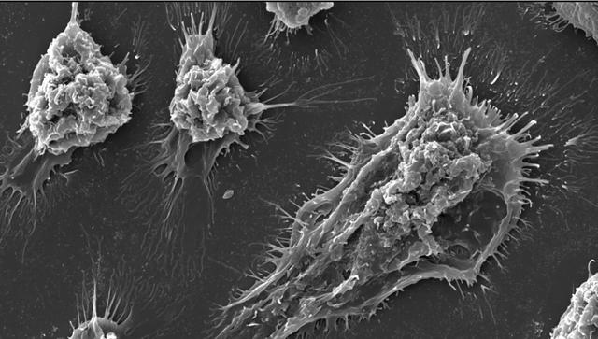

Professor Sebastian Hiller, the head of the research team at the Biozentrum Center at the University of Basel, also explained, "The usual understanding is that cells then expand and eventually burst due to increased osmotic pressure. We are currently solving the problem of how cells truly rupture. The protein ninjurin-1 does not burst like a balloon, but rather provides a breakpoint on the cell membrane, leading to rupture in specific areas."
In the final stage of its life, cells do not simply burst. On the contrary, a specific protein serves as a breakthrough point for cell membrane rupture. SNI doctoral student Maurice Degen (Center for Biology at the University of Basel) explained how this mechanism operates. By utilizing advanced technologies such as high-sensitivity microscopy and nuclear magnetic resonance spectroscopy, scientists have been able to elucidate the mechanism by which ninjurin-1 induces membrane rupture at the individual atomic level. Ninjurin-1 is a small protein embedded in the cell membrane.
Cells are also replaced every 7 days, blood cells every 28 days, and bone cells every 7 years. New cells are human stem cells that continuously replicate various cells in the human body. When stem cells weaken, people begin to age. Only brain cells remain unchanged throughout the body, while adult brain cells will only decrease and not increase again.
To clarify the question, I want to uncover how cells evolve? The mechanism of cell membrane rupture? How are the fragments of cells after "and disintegration" evolved into new cells or new genes by centripetal rotation? I use the elliptical movement trend chart of problem solving to explain the origin and prevention of leukemia, cancer, HIV and other diseases with pictures and texts.
As shown by comparing the elliptical diagram to the cavity field in the heart, when the diffused air in the human body enters the upper part of the cavity in the heart, such as the gas or small molecules on the magnetic attraction surface field, turbulence occurs, and accelerates from top to bottom on the tension surface field and regenerative force surface field. The mass of gas or small molecules is replicated with more centrifugal force energy during acceleration, and also gains inertial force. Therefore, the gas crosses the magnetic repulsive surface field and impacts upwards towards the gravitational surface field. [See figure below]

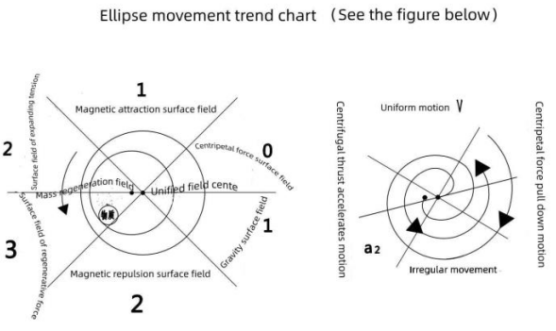

Due to the lack of energy replenishment in gas motion, it is instead subjected to opposite frictional forces, gravity, and other forces that consume the motion on the gravitational surface field. Therefore, gases or small molecules move upwards to slow down, contract and bend in an elliptical motion to reduce energy consumption. This elliptical motion is called centripetal motion in physics, therefore, it obtains the forces of centripetal pull, suction, and universal gravity, and forms a vortex around it.
It's like a table tennis ball falling from a height of one meter onto a hard ground, losing about twenty centimeters each time it bounces back, but this height still exceeds the radius of the center of the one meter high circle by fifty centimeters. Firstly, it forms a large outer circle like a circular ring formed by cosmic radiation, marking the birth of a quantity. Representing the outer ring as the outer shell of a cell, it has evolved into six different force surface fields due to factors such as mass, force, velocity, time, and location during the surrounding process. After the combination of different substances, there are small holes between small molecules on the shell, resulting in several small holes on the shell and large holes inside the shell. Having a cavity plays three roles. On the one hand, it causes different temperatures and pressures inside and outside the shell cavity. For example, some patients hang water for infusion every day, and the water entering the body is converted into hot air flow by the fever temperature. It flows into the low-temperature eccentric cavity field inside the cell, including the airflow formed by small molecules of drugs and fragments of apoptotic cells in the infusion, and revolves around the center of a field It plays a unified role in locating objects in the surrounding field and achieving maximum motion. A unified field.
Just like the Earth's rotational pole. Or just like the function of the central government, when there is a contradiction between the amount of energy replicated by objects on the scene, it has a unified force and inherits the effect of intelligent energy. At this point, the airflow enters a unified field and is spun into a small, off center circle by the system's centrifugation, known as the center of the replicated energy regeneration field. Or like the tilt pole of the Earth. It represents a magical and intelligent regeneration field that combines quality and space. The centripetal force is small, and the airflow entering the center and subsequent small molecules are stored in clusters by vortices in the regeneration field. It is also a fully functional three-dimensional sphere of new cells, which not only self replicates more energy, but also has the function of transformation.
But the genes that diffuse air, water molecules, sugars, fats, etc., and rotate towards the center are just loose like two-dimensional graphs, serving as tools for replicating more energy. There is no conversion function like the stomach. Human beings only have one genome, with approximately 20-30000 genes. The human genome, also known as the human genome, is composed of 22 pairs of chromosomes, one X chromosome, and one Y chromosome. The human genome contains approximately 3.16 billion DNA base pairs. A base pair is a pair of matching bases (i.e. A-T, G-C, A-U interactions) connected by hydrogen bonds.
There are approximately 100 trillion cells in the human body, each containing a DNA sequence of 3 billion base pairs, which contains approximately 700000 to 100000 genes. There are approximately 35000 functional genes that possess gene expression ability, protein. And the large amount of oxygen required for cellular metabolism.
It is known that genes do not have the function of transformation and are only a tool for replicating more energy. If researchers invent new drugs. Interventions for treating cancer can cause some tumor cells to die. In addition, cells in neurodegenerative diseases (such as Parkinson's disease) or life-threatening diseases (such as sepsis) also die prematurely, and the use of new drugs to modify genes can lead to potential side effects and even interfere with immunity. Disrupt the unity of work within the body's systems.
I don't need to dwell on the issue of genes here. Only focusing on external hot air flow and small molecules, they are continuously swirled into clusters towards the low-temperature eccentric cavity within the cell. A portion of the air diffuses out of the cell wall and is actually blocked by the skin, unlike the hot air in the body rushing out of the small holes on the skin, swirling into hair or growing into long, tubular hair outside the skin. The airflow blocked by the skin can only vortex into crowns outside the cell membrane wall.
With the large coronal disk, the centripetal rotation force is enhanced, and it is also the source of suction and gravity. The hot air flow inside the skin, including small molecules of drugs and antibiotics that are infused into the skin with water, is sucked into the low-temperature eccentric hole field inside the cell by the vortex, replicated into several small molecules and small atoms, and stored in the mass regeneration field. The size of the centrifugal rotation force, duration, and geographical conditions are then sent into six force surface fields in sequence. The hot air flow outside the cell wall and small molecules in drugs are continuously introduced into the low-temperature eccentric hole field inside the cell. Due to the incoming and outgoing airflow, there is pushing, friction, and heating inside the cell, evolving into high temperature and high pressure. These replicated small molecules and atoms are transformed into proteins, cell shells, and non infectious coronaviruses. Or the number of patients who have been treated with new drugs and given intravenous fluids can lead to problems such as viral translocation.
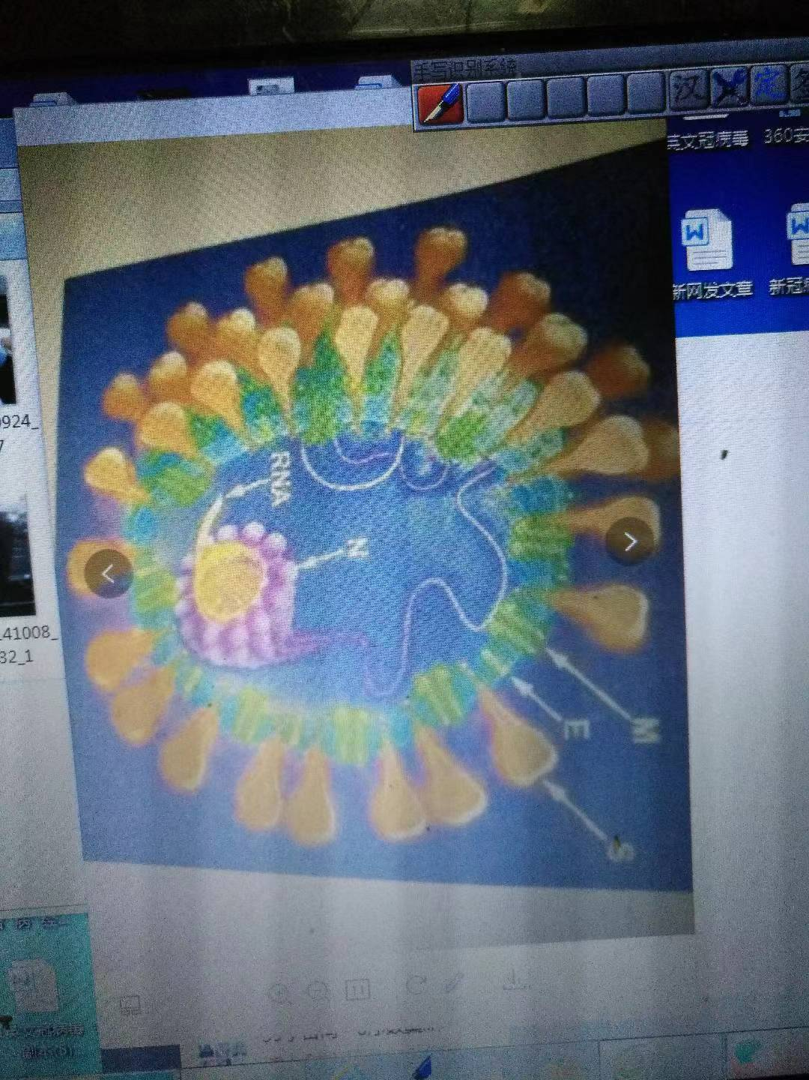

Unless pathogens or viruses are artificially invented by virus experts with a certain political purpose, the viruses produced can only be transmitted to animals and humans.
How can cells die? The water people absorb every day, as well as the oxygen they breathe and various nutrients, evolve into qi and blood body fluids in their bodies, such as entering the heart in a centripetal vortex. They are then spun into several white blood cells by the heart, thrown out of the heart by centrifugal force, and evolved into more red blood cells. They are all stored in the body, making people grow taller and smarter. As people age, various parts of their body, especially their skin, undergo atrophy, loss of elasticity, and aging, and their height also becomes shorter. Those cells that are replicated every day are stored in the body, and many of them are arranged in a crowded manner, causing external gas to pass through the pores of the skin and slowly deliver oxygen to the lungs. The carbon dioxide toxic gas converted from inside the lungs is also difficult to spread out of the body in a timely manner through the pores between cells. More small molecules can be continuously replicated within the cell at every moment, and are pushed and rubbed by centrifugal forces to evolve into high temperature and pressure, converting more small molecules into bilirubin.
And some aging and pathological cells, like a woman's large belly during pregnancy, grow beyond their limits day by day. The shell of this part of the cell is like an animal that does not have a birth canal during childbirth, as explained by Morris Degen, the first author of this study and a doctoral fellow at the Swiss Institute of Nanoscience. Large lesions and pores are first formed by two ninjurin-1 proteins initially gathering together and inserting a wedge into the membrane, followed by many proteins adhering to the initial wedge.
It is the continuous evolution of more bile and white matter within cells. It is also possible that the temperature is high and accumulates on the regeneration field as shown in the elliptical diagram. This segment of the cell membrane is first decayed, causing the cells to lose their systematicity, accelerating the decay one by one, transforming into water and gas, and leading to apoptosis of fragments. This cell never ends its life. It cannot be excreted from the body in a timely manner during urination It is as the qi and blood in the body even move to a certain point, circling towards the center to form new genes. Or enter the eccentric hole field of the original gene through centripetal rotation, and be replicated into several new cells or cancer cells and atoms by the vortex.
My explanation is more specific in uncovering the issue of cell birth, aging, disease, and death. Only by uncovering the structural issues of genes can we self replicate more energy. But genes do not have the function of transformation, and the quality of randomly evolved genes also changes with the amount of airflow and substances in the body. As a normal person, after drinking hot water and food, it is processed by the stomach to produce constant temperature water and evolved qi, which are transported to various parts of the body. For example, centripetal airflow enters the heart and is replicated into several new white blood cells by vortices. When pushed out of the heart by centrifugal force, the white blood cells store iron elements such as qi in the food they usually eat, which is pushed, rubbed, and transformed into red blood cells. People have a life of vitality and work. The amount of food that boys and girls eat every day is increasing, with cells busy replicating and genes busy replicating, producing more cells and small molecules. Being inside the body, people grow taller day by day. There must also be debris with side effects in the body. Just like when a mobile phone goes online every day, there is too much garbage and other waste, otherwise it will be difficult to access the internet without cleaning it up.
If someone often gets sick from the cold, frequently receives intravenous fluids in the hospital, or if their mother was pregnant in their previous life, they worked hard, lacked nutrition, and even had high mental pressure or environmental pollution, the airflow would be passed on to the next generation. If the airflow entering the heart is replicated into white blood cells by vortices, it greatly reduces the amount and cannot convert into high-energy red blood cells. Easy to develop leukemia. And some large spherical cells in the body store more small molecules and other elements, leading to the evolution of more cancer cells.
Due to various reasons, various types of garbage are constantly produced in the body. Cancer cells cannot clear so much garbage in the body, and the excess is stored in the body and circulated with the blood.
The blood viscosity of general children is relatively low, while the body of elderly people has accumulated more small molecules, red blood cells, white blood cells, platelets, water, sugars, fats, proteins, potassium salts, and calcium salt mixtures over the past few decades. Accumulation results in high blood viscosity, making elderly people more susceptible to diseases such as arteriosclerosis and high blood pressure.
Moreover, an increasing amount of dust from cremation and burning of corpses, after entering the sky, spreads from top to bottom into the air and is breathed by plants, animals, and humans. Before China's reform and opening up, there were Japanese dignitaries at the Daming Temple in Yangzhou. When they came to implement the first visit of the war monk for a thousand years, they tasted Yangzhou's specialty Pingshan green tea and asked the tour guide if there was a crematorium here? Because there is a smell of cremated corpses in the tea. The tour guide contacted the Foreign Trade Bureau, and upon investigation, it was confirmed that there is a Pingshan Tea Plantation behind the Daming Temple. There is a small crematorium on the hillside not far away, and the crematorium was immediately relocated to Xiaomao Mountain. From then on, foreign guests have said that the green tea in Yangzhou Pingshan is green in color and fragrant in taste, which is really good tea.
There is an ancient saying in traditional Chinese medicine: a thousand colds are easy to remove, but one dampness is difficult to remove. Blowing air conditioning, eating cold food, improper diet, high mental stress, and humid living areas are all the culprits that exacerbate moisture in the human body. If not discharged in a timely manner, it will hide in the body, causing hidden dangers.
If moisture rises, it will cause spots and pimples, with oily skin all over the face. If moisture is injected, it will cause a series of gynecological diseases and damage the body. Moisture on the skin can cause skin diseases such as eczema, while moisture entering the bones can lead to diseases such as arthritis and shoulder periarthritis. Dampness will first invade the spleen and stomach, then stay in the kidneys, and then invade the heart and lungs. At the same time, dampness will invade the liver, gallbladder, bladder, and other organs, and none of them will be spared.
As the body's heat flows towards the randomly formed genes and a centripetal spiral arm, it is sent into the gene eccentric hole field. Regardless of its quality or quantity, small molecules, red blood cells, white blood cells, platelets, water, sugars, fats, proteins, potassium salts, and calcium salt mixtures are vortexed and replicated into more cell shells or cancer cells, stored in the gene eccentric hole field, continuously pushed out by centrifugal forces, evolving into a centrifugal cyclone arm. Medical theory states that the human genome, consisting of one X chromosome and one Y chromosome, contains approximately 3.16 billion DNA base pairs. A base pair is a pair of matching bases. But genes do not have the function of transformation,
The ability to replicate into more cancer cells also requires a force to convert the waste inside the cancer cells into chemical elements. But cancer cells do not have the powerful transformation function like HIV. It has become a problem of cancer.
Some young people, during the process of development, are under immense mental pressure for a long time, unable to confide in others, or have irregular careers, such as having to work hard at night after being full and hungry, or even getting sick and seeking medical treatment through intravenous fluids. The evolved cells are like people on an empty stomach. Without gas, empty shell cells cannot provide more gas to cancer cells. Instead, consuming more nutrients within cancer cells, cancer cells cannot accelerate the disposal of accumulated waste, nor can they convert small molecules into chemical elements such as proteins.
So teenagers are prone to developing leukemia. Cancer, on the other hand, is a chronic disease caused by growing up and worrying too much, lacking rest and nutrients, and even chemicals entering the body. Both traditional Chinese medicine and Western medicine have new knowledge in micro sports, and there are drugs and methods to cure this disease.
At the same time, some people tend to eat meat and foods with high iron content. The air converted from these foods is in the cells, which is affected by cold or mental stress. Pushing, rubbing, and heating can lead to increased humidity and fever in the body. Fever can be treated with water infusion, or by eating cold watermelons or drinking cold drinks to reduce the fever. However, 70% of the water in the body is transformed into haze and heavy humidity, making it more difficult for cells to spin in the body and breathing. Pushing, rubbing, and heating can cause the patient's high fever to develop into pneumonia. Antibiotics are also added to the water infusion to kill viruses. Just like how the temperature during steelmaking produces different grades of steel, it provides for gene replication. Because genes are not those small molecules that can be transformed into new quality machine models, no matter how good or bad or how many, they are all vortex packaged and copied into HIV. Or when cells divide, shrink, shrink, shrink, shrink, shrivel, and apoptosis cells and small antibiotic molecules are still stored in the body. With the movement of qi and blood circulation, they are easy to be whirled into HIV.
This HIV, such as the iron element of the meat or potatoes that we usually eat too much, is pushed into the magnetic force. With the magnetic force, it is like having a migrant worker to absorb elements with high iron content, such as red blood cells, and also drugs, such as antibiotics, in the water infusion. Whether the HIV is good or bad, it is all whirled into a gas ball, which is copied into HIV. Therefore, HIV is more powerful than the gene function, and it can also be used to specialize in lymphophilia and destroy the Great Wall. Causing greater harm to patients.
Some wealthy women also eat too much and eat too well, lack exercise, and are reluctant to donate money to help the poor. Based on the excessive airflow in their bodies and the level of mental stress, they are vortex replicated into lipomas that stay somewhere on their bodies, and as their bodies become obese, lipomas also grow day by day. In addition, some people have itchy skin and their dirty hands constantly scratch, which can cause external symptoms such as boils to grow inside the skin, or if the infusion is done quickly, it can lead to problems such as water lumps at the infusion site.
Let's take a look at the first picture, which shows a large orange fruit grown by plants. It is also the same as the six force surface fields on the ellipse, and each force surface field has three different masses: large, medium, and small. How many small molecules have been replicated. As the external hot air flow and small molecules enter the large eccentric hole field and are pushed out by the centrifugal force converted by the system, the force is formed. There are also centrifugal arms in the large hole, which are sequentially transported to various field force surfaces inside the fruit, causing the fruit to gradually evolve into water and small molecules. Similar to nuclear fusion, all small molecule proteins and other proteins are simultaneously produced, and the growth and ripening of the orange are accelerated day by day, making it edible.
The second picture shows the airflow of tree growth, which is made according to the magnitude and speed of the force received by the quality, as well as the geographical conditions. Firstly, the centripetal hot air vortex enters one side of the seed and grows a bud. The airflow is thrown out for centrifugal rotation, which grows into the other half of the leaf. The centrifugal rotation that is transformed accelerates the movement force, not only causing the other side of the leaf to grow, but also causing the airflow on this branch to move and grow leaves one after another. However, the difference between increasing and gradually decreasing is arranged in sequence. And every time more hot air is replicated on the tree trunk, a new bud grows around the trunk, such as at a certain point, and evolves into a branch, arranged in a spiral upward around the tree. But the branches do not grow symmetrically into systematic large trees. The growth of trees also follows the conservation of energy. The first picture below is a photo of a real fruit being cut open.

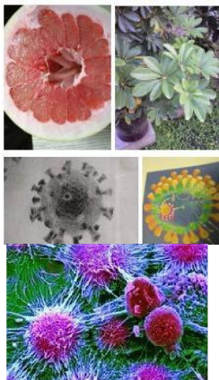

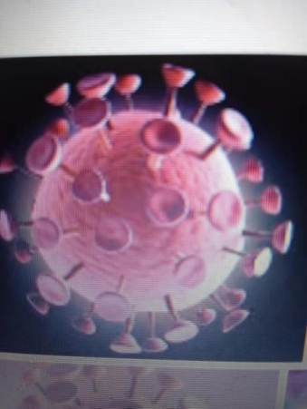
Cancer cell diagram

This picture is a coronal disk evolved from the HIV shell[The third and fourth images in this book are all coronavirus images.]
By understanding the origin and function of cells, cancer cells and HIV, people do not need to panic. Because antibiotics are not effective for infectious bacteria, attention to these matters during treatment can speed up the cure of disease. There are no side effects either.
When a person feels severe discomfort in a certain part of the body, even with pain and a low fever, they become less and less energetic to do things. At this time, you should first go to the big hospital to ask Western medicine for treatment. If you are normal, you should first check and take photos, draw blood to turn the eyelid into a CD, etc., when you are diagnosed with leukemia, cancer or AIDS. Even the spiral arms of genes are intermittent, and the gene chain has been disrupted by the virus. It may be due to factors such as smoking and drinking alcohol, or eating fruits and vegetables that should not be eaten, as well as excessive night sickness, that leukemia or cancer should be treated,
If scientific instruments are used to determine what illness someone has? This approach looks scientific In fact, it was overlooked that everyone has different tolerance to diseases. During physical examinations, mental stress and an increase in diseases such as colds and old age may occur during winter or summer,
Patients who have been diagnosed with leukemia or cancer through precise instrument testing should not be afraid to seek medical attention everywhere in order to recover soon. It is not an acute or infectious disease, but a systemic chronic disease that cannot be cured immediately in medicine, such as leukemia. Moreover, there is no accurate answer to the cause of leukemia in Western medicine, so methods such as blood transfusion are adopted. Firstly, it requires a lot of money to treat the disease.
At this time, do not bear too much mental burden, and make long-term mental preparations to cooperate with doctors for treatment. Whether staying in the hospital or at home, it is necessary to first seek medical treatment from a doctor. For example, traditional Chinese medicine diagnoses tumors formed by qi stagnation, blood stasis, and phlegm obstruction. Traditional Chinese medicine prescribes drugs to treat diseases such as cancer. The patient first soaked the Chinese medicine in the water in the casserole for 20 minutes, then heated it up to boil for about eight minutes, and then heated it gently for about 15 minutes. Cool it for two minutes, then poured it into more than half of the bowl of medicine soup. Drink the remaining hot, and can't drink cold Chinese medicine soup, including the traditional Chinese patent medicines and simple preparations bought back, and can't take the medicine orally in cold water. It is also one of the keys to speed up the cure of the disease. No matter how bitter the medicine is, you must persist in drinking it once in the morning and once in the evening. The hot Chinese medicine soup after drinking is first filled with medicine in the intestines, which first replenishes a large amount of hot water for the patient. Secondly, the Chinese medicine is boiled and dissolved in the hot medicine soup water at high temperature, which can be absorbed and transformed more easily when entering the body and various organs After being processed by the stomach, it can be scientifically allocated to the necessary organs for use. Especially for patients with fever, getting more heat from water and medication can accelerate the removal of moisture from the body. Like a bowl of hot Chinese medicine soup, it usually weighs twenty times more than the injected water, and has better efficacy than cold water infusion with hanging water, without any side effects.
Just like a master of Qigong unleashing a greater force, Hot Medicine Soup's hot air causes cells to expand, pushing and squeezing each other, causing billions of cells in the body to expand, resulting in smaller voids between cells.
If the patient wears a hat on their head and socks on their feet, the first step is to make it difficult for the hot air flow inside their body to escape from their head and feet. The patient can't blow the air conditioner, and should eat less and eat more every day, such as drinking hot broth or fish soup, or drinking hot bean Congee several times a day, and eating delicious salty dishes made with ginger powder, garlic powder and spicy pepper seasoning, but can't eat cold food. For example, in winter, cut an apple into three or four pieces, put it in a large tea cup, fill it with boiling water, cover it, and for about two minutes, you can eat the hot apple meat with belt. After eating, take a walk or run a dozen steps in place at home, take a shower and soak in bubbles in the bathroom every week, and wipe your whole body. You can also use your own fists, such as facing your hands and arms, and punch your legs or feet one or two times from the top to accelerate the removal of moisture from the body. In winter, do not wear leather clothes or shoes. Wear warm and lightweight clothes such as down jackets. The looser the elastic band of one's own underwear, the better. If a girl's bra band is also looser, the better. Alternatively, replace it with a fabric strip as the belt.
Due to prolonged illness, people's bodies become weaker and weaker, but if they become tighter and tighter, it can cause unnamed pain around the waist or breasts. Even if it develops to whole body pain, it is also caused by severe deficiency of kidney energy. It is necessary to replace it with a cloth strip as a belt. Moreover, when lying in bed every day, you can scratch and pinch the muscles or painful areas, or apply plaster to relieve pain and promote blood circulation. Moreover, taking orally the traditional Chinese medicine or Western medicine prescribed by the doctor can effectively treat both the symptoms and the root cause. By exerting various immune functions within the body, patients can increase their vitality and speed up their recovery. Otherwise, relying solely on medication for disease prevention and treatment will slow down the effectiveness.
If the patient has been taking traditional Chinese medicine for half a month and does not feel good, it is convenient to write down the condition at home. If the body is still weak, eating without taste, and there is pain in a certain area. If diagnosed with brain cancer. Just tell the doctor if there is any trauma or rheumatism on my body that I suffered more than ten years ago, is it related? Is it related to blood blockage causing headaches? Are you still too upset about something? Can the doctor first prescribe a few boxes of Chuanxiong powder and try it for a few days? To avoid forgetting to mention some medical matters when going. The doctor obtains more information about the condition, and the effect of taking new Chinese medicine is getting better and better time by time, which can effectively treat the disease and reduce misdiagnosis.
Of course, this chronic disease cannot be cured by taking ten or twenty doses of a prescription. It may even take two to three years to recover.
In short, it is important to adhere to drinking hot traditional Chinese medicine soup, or to drink more hot water and take Western medicine tablets orally. All can cure the disease. But one cannot eat indiscriminately, and must obey the doctor's instructions on what medication to take and the dosage. If one is facing financial difficulties and has experience taking medication, such as feeling heat in the soles of the feet, kidney yin deficiency, chest tightness, and chest pain in the precordial area. You can also try taking Liuwei Dihuang Pills first, and then take compound Danshen tablets half an hour later. While nourishing yang, tonifying the kidney, and strengthening the body, you can also promote blood circulation, remove blood stasis, regulate qi, and relieve pain. Drink half a bowl of hot water each time. Take one less tablet of the first medication and pay attention to any adverse reactions after taking it. If there is, drink plenty of hot water and take medication, then go to bed to rest or sleep, and the medication will neutralize. I haven't found any adverse reactions after eating for a few years.
After another week of taking medication, increasing nutrition, and staying in bed regularly to rest and sleep, if the patient is energetic, they will continue to take the right medication. If you have kidney yang deficiency, you cannot take Liu Wei Di Huang Wan. Eating it can have a counterproductive effect on the recovery of the disease, so you cannot take it again. You should take pills like Guifu Dihuang or take medication prescribed by a doctor. If you still feel some discomfort in your limbs, lower back and leg pain, or numbness in your hands and feet after taking medication, you can also take Tianma Wan, which is a medicine from Li Shizhen Pharmaceutical Group, just like taking it at noon. Due to the variety of Tianma Pills, this medicine may be suitable for treating head disease, dispelling wind and dampness, unblocking collaterals and relieving pain, and tonifying the liver and kidneys. Eat Liu Wei Di Huang Wan in the morning and evening, or take one less pill. The two medications are taken separately at different times and generally do not have any side effects. If you have taken Tianma pills, your body will feel cramped and your lower back and leg pain will be relieved. You can also take it for a few more days to consolidate your condition. Alternatively, you can consult a doctor and prescribe medication that is suitable for the improvement of your condition at that time. For example, buying Chuanxiong powder from a traditional Chinese medicine store can have a more direct and effective treatment for mental illness.
If there is urgency, frequency, and incomplete urination: peel off about one pound of loofah, chop it into small pieces, boil it in a pot, add white sugar and boil it in soup and water. Drink hot soup and eat loofah once in the morning and evening, without strict dosage, until you get well. Loofah has quick effects.
I feel pain when urinating, so I boiled pig trotters and water to drink. It doesn't have any taste, so I cooked two in a day. Boil about 150 grams of water, drink twice a day, and drink half a bowl of hot soup each time. After drinking for a few days, the pain will disappear.
If there is excessive urination, it is prostate disease. Dig a few pounds of purslane from rural areas, wrap a cloth around about half a pound each time, and break it up. Squeeze out the juice of purslane from the cloth bag. It's best to drink hot purslane juice twice a day, half a bowl at a time, and it will clear in a few days.
Urinary frequency self created folk formula, 50g of leek seeds, water eight liang, decoct and take about an hour after breakfast and dinner every day. Take effect three times at once. Verification rate 100/%
Prostate enlargement (frequent urination, urgency): Main ingredients: 10g peach kernels, 20g winter melon seeds. Folk prescription usage: Add 2 bowls of water to the above prescription and boil it into one bowl. Drink it once, twice a day, each time with a new one. Alternatively, you can boil two portions of water together, one bowl in the morning and one bowl in the evening, for a treatment period of 15 days, and it will start to improve after 10 days. Avoid: radish and fava beans
Effect: This folk recipe has been eaten by several people, please rest assured to use it. It can also be tried for male and female urinary incontinence Prescription for treating frequent urination, urgency, and frequent waking up at night: 20g of Yizhiren and 30g of Cornus officinalis. A total of 3 payments are required. Therapeutic effect: After taking one dose, do not wake up at night. After taking three doses, sleep until dawn at night. Solution: ① Yizhiren has the effects of warming the kidney, consolidating essence, and reducing urine, warming the spleen, stopping diarrhea, and absorbing saliva. It is commonly used in the treatment of enuresis due to kidney deficiency and frequent urination. ② Shanzhuying has the effects of tonifying the liver and kidneys, consolidating essence and stopping excess, and consolidating essence and reducing urine.
If you have eye disease, but it's not an external injury, let me introduce a prescription for you to take a look when the sun rises in the morning. Well, I'll watch for about 20 minutes at noon. Well, I'll watch the sun for ten days and a half later. You will definitely see great results. You don't need to spend a penny. If you are busy, you can watch less for a while, and if you are not busy, you can watch more for a while. Well, there is no time limit. The energy of this sun is so high that the eyes can see clearly, without itching or pain. There is no need to even wear glasses.
——It is compiled by Wang Zhensheng and Hu Bing's folk recipe studio in Xinzhuang Village, Jintan Town, Daming County, Handan, Hebei Province.
If the body suddenly catches a cold and has a fever, it is not advisable to take Liuwei Dihuang Pills, Ginseng Dropping Pills, and Whole Deer Pills as Chinese herbal supplements. After the fever subsides, you can eat it again if your body is normal
At this point, the fever should be cured first. If I wear single clothes for a long time after busy work outside or taking a shower in the bathroom in winter, catch a cold or even have a fever, I will wear a large cotton register to keep warm when I return home. Then, I can release the two blankets on the bed, or put a hot water bag in one of the blankets. Cut the ginger into seven or eight pieces, add two teaspoons of pepper, or even two teaspoons of brown sugar, and put them together in a teacup. Pour a cup of hot water and put it on the table first. Then, pour half of the basin of hot water to wash hands and feet for about two minutes. Heat the ginger tea in the teacup and drink the remaining heat. If there is no hot water bag in the blanket, I will not take off my sanitary clothes and socks, and go to bed to avoid a fever at night If you have a fever, it will also subside in the second half of the night. But the next day, I rest and sleep at home, and drink a cup of hot ginger tea every morning and evening. It takes about three days for my cold to recover.
When a person sleeps in bed, it accelerates the movement of qi and blood in the body, adjusts the structure of cold and hot energy, and enhances the body's immune system. When not having a fever, after waking up every day, drink a hot soup made from red clover, astragalus, and goji berries, and add some brown sugar. Or drink the hot soup made from the nutritional meal spirulina southern claw powder produced by China Yangzhou Perfect Daily Necessities Co., Ltd., which provides comprehensive nutritional supplementation and adjustment for the body.
If it were treated by Western medicine doctors, the first step would be to classify humans as having only one genome, approximately 20-30000 genes. The human genome, also known as the human genome, is composed of 22 pairs of chromosomes, one X chromosome, and one Y chromosome. The human genome contains approximately 3.16 billion DNA base pairs. A base pair is a pair of matching bases (i.e. A-T, G-C, A-U interactions) connected by hydrogen bonds.
There are approximately 100 trillion cells in the human body, each containing a DNA sequence of 3 billion base pairs, which contains approximately 700000 to 100000 genes. There are approximately 35000 functional genes that possess gene expression ability, protein. And the large amount of oxygen required for cellular metabolism.
Cancer is a pathological product. Will not evade the cell death program. New drugs must be utilized. Treating cancer causes some tumor cells to die. In addition, in neurodegenerative diseases (such as Parkinson's disease) or life-threatening diseases (such as sepsis), new drugs are used to modify genes, It can cure the disease as soon as possible.
But it is not advisable to abuse the daily injection of medication, especially by hanging water for infusion into the patient's body. This is because the infusion is cold water and the patient's body temperature is about 37 degrees Celsius, which has evolved into increasingly thick haze. Traditional Chinese medicine says that it is due to heavy dampness and obstructed meridians. Just like in spring morning when heavy fog gradually rises and the front cannot be seen clearly, it makes the patient's body like billions of small cells, breathing more and more difficult, and the fever has not yet subsided. It is believed that the efficacy of the drug in fighting against the virus has been exerted, and then hanging water for infusion for a few more days may kill all the virus and the disease will be cured.
If there is such thinking, the illness will worsen day by day and may miss the opportunity to cure it.
If Western medicine requires patients to drink hot water and take Western medicine orally, or make Western medicine into plaster patches such as far-infrared patches or Western medicine and apply them to the affected area, the efficacy of which can directly reach the ointment blindness of the disease, and the disease recovers quickly without any side effects. Moreover, the cost of treating the disease is low, and Western medicine can also cure so-called lung cancer and other diseases.
Western medicine may categorize cancer diseases as carcinogenic, such as tobacco, alcohol, tea, fertilizers, pesticides, and plastics. It is unknown whether it is caused by multiple drops of water or intravenous fluids entering the patient's body, such as pneumonia evolving into tuberculosis and lung cancer.
Western medicine requires patients to drink hot water and take Western medicine tablets or hot oral liquids. Then, Western medicine can be made into patches such as far-infrared patches or ointments made with Western medicine and applied to the affected area. The efficacy of the patches can directly reach the affected area, and the disease can be cured faster without any side effects. Moreover, the cost of treating the disease is low, and Western medicine can cure diseases such as lung cancer. Of course, it is also important for patients to do a good job of personal care and treatment. For example, in cold winter, they should wear hats on their heads and socks on their feet. They should also use less or cannot use air conditioners. They should sleep in a hot bed and seriously recuperate or sleep every day. In the middle of every day after taking medicine, they can also drink hot tea with more black tea leaves, or eat less hot bean Congee and eat delicious salty dishes. Because bean Congee is used as both tea and rice, and it is easier to absorb nutrition, including drinking hot tea, to make the patient's body system active and transform more heat. The fluid and water that have not been fully absorbed in the chest cavity gradually disappear after a few days, and the blood clots that have condensed in the blood vessels begin to dissolve again. After a cerebral infarction, the blood circulation returns to normal, and the serious illness gradually improves day by day. When you are seriously ill, do not hang water for infusion. To prevent consequences.
Why do critically ill patients drink hot traditional Chinese medicine soup and wear hats on their heads and socks on their feet. Due to the patient's long-term suspension of water infusion, the moisture inside the patient's body has increased. Although hot traditional Chinese medicine decoction fills the intestines, it immediately reduces the moisture inside the patient's body. More heat enters the cells and expands, pushing each cell to expand, causing billions of small cells to expand. The gap between cells is smaller, giving the patient mental strength and accelerating the recovery of the disease.
The patient drinks two cups of hot medicine soup every day, which helps to expel less moisture from the body. If the patient wears a hat on their head and socks on their feet, the first step is to prevent the hot airflow from running out of their head and feet. If the patient sleeps in a hot bed, it will expel more moisture from their body, and even the patient may feel much sicker as soon as they wake up. Of course, those who serve patients should observe carefully. On the one hand, do not cover two beds in summer, and on the other hand, even in winter, it is important to understand the patient's physical condition and tolerance. Because it is not a problem with infectious bacteria or viruses.
Patients also need to learn various skills in disease prevention and treatment. It is also important to take medicine three times and regulate oneself seven times in order to accelerate the complete recovery of the disease. If sick or not, when sleeping, waking up, or taking a nap, unless pregnant women, obese individuals, or those who have undergone surgery, lie down in bed every week or even every day to sleep for a while, depending on their physical condition. When sleeping on the bed, you can also shake your buttocks 20 or 30 times, or take deep breaths, and then exhale lightly. When relaxing your mind, such as at the navel or in the pain area, you can expel toxic gas from your body once during breathing or exhaling, and the patient will immediately feel energized. Or sing a few old songs. When singing silently, be sure to lean down on the bed and relax at the belly button, because the constant breathing during singing can release the toxic gas in the body time and time again. When lying on the bed or lying down, eliminate all distractions in your mind and relax your whole body and affected areas. You can expel moisture from your body time and time again when exhaling, and convert more kidney qi and red blood cells. It also delivers new energy to the body and mind, reduces the consumption of respiratory energy, and enhances disease resistance.
Because animals do not have the habit of sleeping on all fours, their five organs and six bowels are less compressed, The movement of various organs in the body is also less obstructed, and toxic gases can be timely discharged from the body, reducing the chance of illness. In human civilization, the female soul in particular makes a centripetal rotation force. Every day, if you lie prone on the bed for a while and then sleep on your side, you can scratch your fingers on your breasts, chest and stomach for ten or twenty times, which can relax muscles, promote blood circulation and dissipate blood stasis, and also prevent breast cancer and other diseases. Lying down on the bed can also accelerate the central nervous system, cervical spine, lumbar spine, gastrointestinal and other areas. They can quickly relax and rest, enhance immunity, and prevent illness.
But before lying down on the bed, the bed surface should be cleaned thoroughly to prevent dust from entering the nostrils. In winter and spring, when lying down on the bed, the back of the body should be covered with a sheet, and even a hat and mask should be worn. To avoid prolonged exposure to cold while lying down. Also prevent dust from inhaling cool air into the lungs.
The second thing to remember is that if you have been ill for a long time without a filial son, do what you can do on your own. For example, if you feel uncomfortable on the body every day, use your hands to gradually rub or tap dozens of times from light to heavy. Before going to bed, hold your palms on your ears and quickly rub them for a few or twenty times. Then, use your four fingers to stroke your chest and stomach more than ten times, which helps to relax your muscles, promote blood circulation, dispel blood stasis, and dispel toxic gases in your stomach, playing a preventive and therapeutic role. And run a dozen or so steps in place every day; Thirdly, rinsing your mouth with water or brushing your teeth with a toothbrush immediately after eating sweets can enhance your ability to prevent dental diseases. And wear less tight clothing, the looser the elastic band on the underwear head, the better. Or pull your underwear up to your buttocks before going to sleep. But the bed surface should not be cold. It is advisable for teenagers after the age of six to use cloth strips as the waistband instead of elastic bands. Or take care not to tie the pants too tightly for children. Also, if there is a cold snap, it is important to add a piece of clothing in a timely manner and not take off your cotton jacket too early in spring, otherwise the child may have a fever if the cold snap occurs again. Go to the bathroom every week to take a shower and soak, wipe your whole body, and avoid getting cold after taking a shower. Also, avoid drinking cold drinks or eating cold meals in the refrigerator.
If a patient, in their previous work or in their interactions with others during times of poverty, engages in irrational and ungrateful behavior that offends or causes guilt, even causing greater harm to them. It is up to the patient to offer incense or burn some paper money at home every day, silently recount past events, pray for the blessings of the Bodhisattva deity, and also make personal repentance. The patient will feel more relaxed spiritually. Or ask the family to bring some gifts to their doorstep to apologize and explain clearly that they have been forgiven. In the future, patients should also take pleasure in doing good deeds, so that they can gradually relax and forget the guilt and illness caused by mental stress.
If a patient has a heart disease or is obese and is sleeping, and feels about to go into shock, they should immediately turn over and lean on the bed within 5 minutes to take deep breaths. Then, they should exhale lightly and do it continuously for more than ten minutes. When you immediately turn over and lie down on the bed, relax your heart and let it beat easily, you can escape the danger of life. But you can't get up, sleep on the warm bed on your left or right side, rest or sleep again. You can only get out of bed when your body returns to normal. Moreover, it is important to pay more attention to bed rest these days.
If the patient is already unconscious, they may feel terrifying and uncomfortable like falling from a high altitude, and even lose consciousness, but they can also save themselves. At this time, there are various nutrients in the billions of cells in the body, and the cells are still exercising for three days, such as evolving or transforming the water and proteins inside the cells. Healthy cells will also eat dead and bad small cells when they are not eating them, maintaining their activity for a few more days. So, the patient's consciousness can be controlled and the exhalation of cells can be prolonged. When there is enough air inside the cell, it can rush out of the cell and also out of the heart wall, forming small holes between the cells. Even small molecules such as vaccines trapped between these small holes can be flushed out, and the patient's heart can immediately beat again within two to three minutes. It is also the patient's mental or spiritual power that saved their life. Otherwise, no one will have time to help the patient escape from life-threatening situations.
I once saw on Baidu that a senior American doctor gave a diagnosis of President Clinton's various difficult illnesses, stating that he would live for another six months at the longest. At that time, although I didn't know the specific situation of his illness, I immediately posted a comment based on the online display of Clinton's work and life after he didn't become president, saying that the doctor's diagnosis was unscientific only based on his illness. Because President Clinton was seriously ill, but he also went to various places to paste the cold buttocks of rich people with a hot face, and donated so much money, all of which was used for research on the prevention and treatment of AIDS cancer, including his own home, which also donated more than 100000 yuan. This is a great good deed that has accumulated great merit. So, when a person is doing good things, the force of heaven is helping them and doing good things is grinding away many accumulated dampness and toxic gases in the body. Moreover, the iron element in the special blood in the body is pushed and rubbed to generate magnetism, doing good things with more and greater force, and evolving magnetism into electromagnetic waves.
This electromagnetic wave has the function of a universal instrument, which can regulate or massage the coordination of various organs in the body, as well as receive important signals in advance, automatically alarm the brain, nervous system or soul system, and take appropriate preventive measures to block the harm of sudden disasters. It also helps to prolong life, even for more than ten years, and the livelier he becomes, the happier his heart becomes. At the same time, he has a virtuous and talented wife named Hillary, who carefully takes care of and cares for him, and the credit for prolonging his life cannot be underestimated. If President Clinton were to read the reprint of the novel "Tai Chi Talks to the World" again to prevent and treat diseases, everything in peacetime would truly be indifferent to fame and fortune. He would want to think about the happiest memories of his life and seek health care, and even live for more than ten years. You see, not only will he be alive ten years later, but he will also be busy running for the presidency of the United States for Hillary.
And another computer tycoon in the United States, younger than Clinton and without President Clinton suffering from various difficult illnesses, with assets worth billions of yuan, only spending billions of yuan to treat his own illness, but still giving up and returning home to live in the air.
The three families should try their best to care about the patient's physical and mental longing for a long time, or persuade them to change their thinking or environment to change the things they miss. Family members should never let the patient's body weaken after surgery or chemotherapy. When the patient complains verbally, it is better to open up the patient's thoughts and not to contradict them or not care about them. This approach not only worsens the patient's condition. And for some family members, looking back in the future may bring some mental pressure. Some bad habits of family members can also lead to the consequences of bad diseases. It may not necessarily be a genetic issue.
Patients can also seek help from traditional Chinese medicine every twenty days or so to report any discomfort they feel after taking the medicine and ask them to prescribe some more Chinese medicine to accompany them. If you feel that your body is much better, your appetite and aroma have improved, and you have regained your energy, then summarize what medications are good to take as a doctor and insist on taking them again, without necessarily going to the hospital for treatment.
If the patient has white blood, they should eat more foods and fruits and vegetables to supplement kidney qi, and pay attention to physical and mental maintenance. For example, when stir frying vegetables with red skin peanut oil or cooking soup, this oil has high nutritional components. For example, resveratrol is a naturally occurring polyphenolic substance with strong biological properties, which has the benefits of detoxification, blood supplementation, hemostasis, blood pressure and lipid lowering, cancer prevention, anti-aging, and longevity in the human body. When the body is weak, you can also eat and drink hot white radish stewed meat soup, fish soup, or mixed vegetable soup to increase nutritional supply. For better health, you can eat fish or meat. Eating meat is more nutritious. Also, be careful not to eat leftover fish or meat that has been cooked for a long time and left in the refrigerator. Also, avoid eating burnt chunks of meat and cold dishes, and avoid drinking cold drinks. You can also use three or four taels of yam twice a day to peel off the skin, cut it into small pieces, soak it in honey, and eat it, which can help treat leukemia. This is an introduction from a computer blogger about traditional Chinese medicine. Of course, one should also take traditional Chinese medicine or take Liuwei Dihuang pills in combination to have a more effective and faster treatment of leukemia without any side effects.
Patients suffering from cancer and AIDS should also eat vegetables, fruits and aquatic products that are beneficial to disease treatment. For example, eat laver, kiwi fruit, strawberry, garlic, carrots, papaya, pineapple, potatoes, drink hot black tea, or drink hot bean Congee with food or drink, don't only eat one or two kinds of food for a long time.
Family members even use superstitious words and things to open up their minds. For example, the three generations of ancestors in the family know that you have suffered a lot in your daily life, and others do not understand that you are a good person. The three generations of ancestors kneel in front of the statue of Guanyin Mother Buddha every day to pray for your speedy recovery and good fortune. Patients can also offer incense and burn paper money, silently praying for the blessings of the Bodhisattva deity to recover as soon as possible. Alternatively, if a person has done something wrong in the past, they can burn more paper money to give to the deceased, which will relieve their mental state. Of course, both oneself and the family need to summarize that important matters place an excessive mental burden on the patient. When my mother was pregnant, she was under high mental pressure and lacked nutrition. It is necessary to clarify issues such as chemical pollution in order to better treat these diseases together.
Some women have a stubborn personality and are confident in missing someone who is particularly important, including teenagers. We need to do a good job in four aspects to cooperate with disease treatment. Although smoking and drinking may not necessarily be the main cause of illness. During the Wuhan epidemic in the past two years, American scientists sent two photos showing that smokers had clean lungs and were found to be innocent in the photos. People born with COVID-19 virus are very dark in their lungs in the photo. People who drink alcohol are also more likely to live longer than those who drink too much. However, it is better to smoke less when they are ill. People who drink alcohol should not drink cold wine in winter. They should keep the wine warm before drinking. If they have liver cancer, they should not drink alcohol as it can worsen their condition and even endanger their lives.
Also, it is necessary to clean up the bed under the bed and at the head of the bed, whether there are too many miscellaneous items, books, or asbestos piled up. Due to the messy text under the bed, such as in books, emitting different wave frequencies, it affects the patient's sleep. Bedding blankets should not be made of unsterilized artificial cotton, and indoor winters should not be too cool or windy. Otherwise, patients with head disease, ankylosing spondylitis, and severe colds should wear a hat to sleep. Of course, residential buildings should not be too hot in summer, and should not be too cold in winter, like a top floor building. Since the air conditioner is on all night until dawn, the electromagnetic wave will interfere with the rest of the nervous system. The incidence rate is easy to increase.
If you are depressed in marriage, you can also put a copper gourd or a concentric knot at the bedside. If you are afflicted with evil energy, place a gossip chart on the doorstep. If you feel depressed for the sake of fame and career, place a small pagoda of Wenchang on your desk, or use handicrafts such as the soaring wings of Dapeng to boost your spirits. Indoor, you can also use the fragrance you like or use moxibustion medicine for fragrance. If you have experience in treating diseases, you can also go to the pharmacy to purchase various commonly used medications and external plasters related to the disease and keep them at home. Traditional Chinese medicine pills such as Liuwei Dihuang Pill, Tianma Pill [Li Shizhen Pharmaceutical Group Drug], Zhuangyao Jianshen Pill, Dalian Shenglvgu Engineering Co., Ltd.'s Ginseng Dropping Pill, Quanlu Pill, Zhuxiang Zhengqi Water, and plasters for application. Huangshi Sanitary Materials Pharmaceutical Co., Ltd. produces musk bone strengthening ointment. Alternatively, use Shangshi Jietong Gao, Zhenjiang Gao, Scorpion Poison King Huoluo Gao, and Wind Oil Essence as backup medicines. Then, buy massage acupoint books, massage hammers, and medical books and keep them at home. Place the ointment, Scorpion Poison King Huoluo Gao, and Wind Oil Essence by the bedside or pillow, and apply them to the affected area at any time.
Patients should not think recklessly. Let bygones be bygones. To create a relaxed environment is to create vitality. If the liver qi is strong during illness and cannot integrate with society or family, there is no greater sense of happiness. Only by looking down on oneself and not caring about everything, can one reduce mental pressure with physical and mental relaxation, and be more tolerant to prevent and treat various diseases. If you are unhappy, you can also sleep in bed and lean forward, singing a few passionate songs. Take turns singing two or three times, because when singing to breathe, it releases toxic gases from the body time and time again. Singing is also the best immune function for disease prevention and treatment. But it should be based on the patient's emotions and not too much persuasion. You can also read books and newspapers that are beneficial for the recovery of the disease. When reciting 'Amitabha Buddha in the South', one should be respectful, honest, and recite it several hundred times without interruption in order to have an auxiliary therapeutic effect. Because the pronunciation of the word "Buddha" is a signal to relax mental stress and can expel toxins from the body. Or chat with the opposite sex for a while. One can either focus on one thing, slowly recite and relax several times, or use the thumb to mechanically move the middle section of the second section of the index finger up and down, moving it up and down slightly faster for about 15 minutes, or intentionally guarding the dantian or navel, which can help relieve mental stress and cooperate with treatment. Research in the United States: A 13% reduction in appetite may extend life by more than 10 years.
When anyone else is sitting, standing, or lying in bed, their mind should forcefully loop their ten toes backwards for about ten minutes, then use their mind to open their ten toes for about ten minutes, and then move their big toes repeatedly like nodding for about eight minutes. When doing these movements, it is important to maintain mental relaxation and avoid overthinking, in order to clear the six major meridians of the human body and ensure smooth flow of qi and blood. You can do them two or three times a day. Or use your fingers to vigorously rub and rub the ten toes and soles of your feet, as well as the water gushing from your feet for twenty to thirty miles, to prevent illness.
If possible, take care of one person and do morning and evening exercises twice a day for the patient. Let the patient lie down on the bed first, start from the back and gradually move towards the feet. Then, gently and quickly tap, rub, and massage in combination. When doing the second session, make sure your hands are slightly heavy and fast. When the patient feels a slight soreness during rubbing, it can alleviate the pain. It also accelerates the airflow in the system to circulate towards the lesion, playing a role in relaxing tendons and promoting blood circulation. But when doing massage, tapping, scratching, and kneading, it should be done according to the patient's tolerance and the severity of their specific area. Pain in the chest and stomach can be alleviated by scratching and scratching with fingernails for more than ten times, instead of massaging or tapping the affected area. It helps to expel moisture from the patient's body, and within about an hour each time, the patient will immediately feel faster than taking medication.
If the patient sits on an orange, they should start by lifting themselves from their shoulders and using light and fast fists to move, tap, or rub the acupoints on the kidney and waist rings. The kidney and waist rings can enhance physical fitness on both sides of the waist, and the acupoints are on both sides of the thighs and buttocks. Frequent tapping and rubbing can help relax muscles and promote blood circulation. Afterwards, the palms of both hands should quickly respond to the thrusts and heat, quickly cover the ears with the palms of both hands, and then move to the upper and lower sides of the head of the temple. Use both hands to rub and massage back and forth for one to twenty times, which can alleviate the dizziness in the mind. In the future, tap and massage the hands and arms one by one, then rub and massage about three centimeters outside the armpit and ten times at the concave part of the arm to expel toxic gases from the cardiovascular system. Next, press the lung detoxification acupoint, first targeting the root of the tiger's penis on one hand's thumb, which is the midpoint between the first and second metacarpal bones. Hold it down with your fingers, and when the patient feels sore or bloated, gently massage with a little force for one to twenty times.
When bending the tip of one hand's little thumb towards the palm of the hand, and the other hand's big thumb towards the lower part of the little thumb, press and hold the acupoint. If you feel a bit sour or painful, use some force to rub or hold it for about 15 minutes. It is best to sleep on the side of the bed and inhale deeply. You can also slowly exhale the toxic gas from the mind, and the mind will not become drowsy. The effect is faster than taking medicine, and there are no side effects. Patients can also relax their minds and even hold their breath until a slight toxic gas is expelled from their minds, which immediately gives them the energy to work. Due to the continuous movement of blood in the body, patients often experience restless and restless thinking, which transports toxic gases into the bloodstream. Therefore, if the next day your mind is dull and your body is powerless. It can also be done again. When there is no illness, one can prevent it.
In the future, tap, rub, and massage your legs in sequence. When you reach Zusanli and the spring under your feet, including the entire soles of your feet, there are over 200 acupoints throughout your body. Regular massage of Zusanli is an important acupoint for treating all chronic diseases, enhancing disease resistance, and prolonging life. The spring under your feet is also an important acupoint to enhance physical fitness and expel toxic gases from your body. Focus on rubbing and massaging it 20-30 times. If one hand is tired from doing a full body massage, switch hands or punch at the same time When pressing down on the root of the upper groove on the foot between the big toe and the two toes with the fingers, if the patient feels swelling or pain, they should rub or hold it down. The patient should also mentally relax the root of the upper groove on the foot for about 8 minutes. It can expel toxic gases from the liver in the long term and has health benefits for the liver.
Returning to the same process as above, start from the shoulder and back, and go back and forth about three to five times to massage, tap, grab, rub, and massage all over the body. Severely ill patients only do it once or twice a day. If possible, men and women should work together. When the patient is being beaten, scratched, rubbed, and massaged, their mind should be relaxed and they should not speak. Patients can also be asked to massage each other, with the aim of relaxing mental stress and promoting blood circulation to accelerate the removal of heavy dampness from the patient's body; Illness improves quickly.
When I was seriously ill, I was a 95 year old man with a stroke. I did three health massages at each acupoint every day for treatment. Firstly, place a tall and short wooden stool on the ground, and when I need to sit down, I will knock, scratch, rub, and massage the patient's lesion or acupoint. You can also buy a massage hammer for ten yuan and use it to hit the shoulders, back, waist, legs, and feet to reduce the physical exertion of the massager, and the effect is good. Flexibly use alternating tapping, grabbing, and kneading with both hands during massage. I also intend to relax at my own lesion site. Sometimes tapping, scratching, and massaging patients for about an hour can make them sweat from exhaustion, and the effect feels better. After finishing, I also washed my hands with soap and hot water once.
I also lie in bed to rest or take a nap. In the past two years, various forms have been used to increase happiness and moderate exercise to promote blood circulation and qi circulation. It can relax and reduce blood pressure in the nervous system, respiratory system, and digestive system, playing an auxiliary role in treating diseases and achieving immediate results. As my body gets better and better, eight months later, the elderly person with a stroke also walks normally. Of course, I also take care of elderly stroke patients. Even when lying in bed, I use my mental power to deform and bend my hands or legs, and insist on controlling the airflow in this area. It is not allowed to bend and circulate, forming a normal hand or leg posture. If my mental power forces me to feel soreness in a certain area of my hands or legs, I use my fingers to rub and stretch the soreness with some force, which has a better effect on relaxing muscles and promoting blood circulation. Long term patients have more convenient hand and foot movements, and their walking posture is better. The elderly with a stroke should persist in eating on their own and not be fed by others. It only gradually accelerated until three months later when my hands were able to recover and eat on my own. Feet can walk.

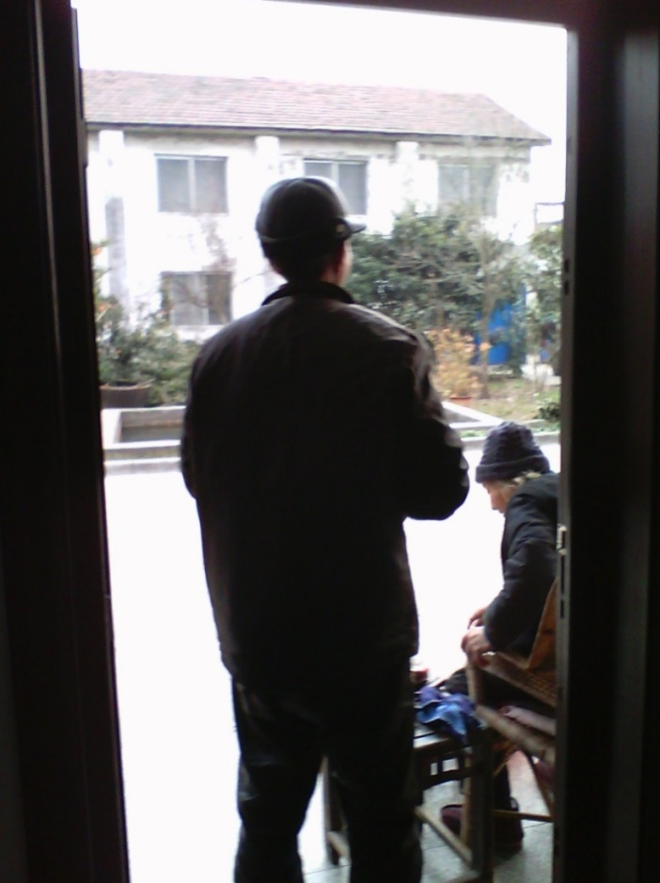
I intended to encourage the elderly person to stand up and exercise every time, but I was completely focused and didn't dare to be careless. I was always ready to go up and help her stand up, take the elderly person for a walk, and she also relaxed her mental pressure.

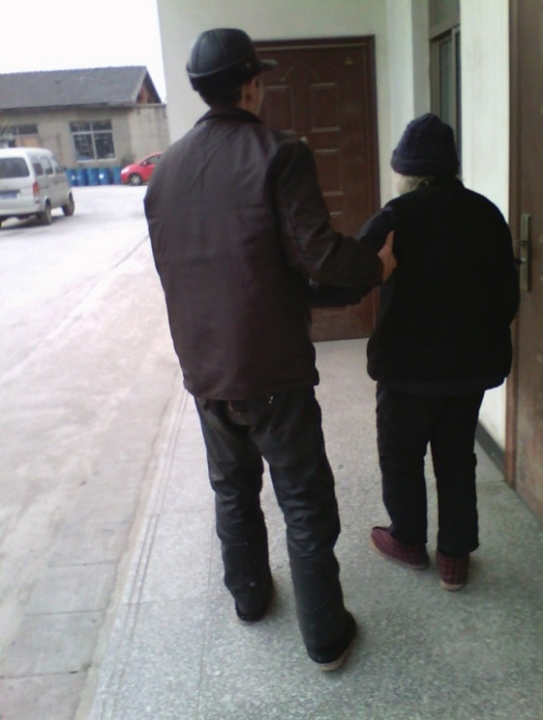

Although I hold the elderly person for a walk with both hands, I gently hold them with one hand. When I feel that the elderly person is struggling to walk, I hold onto my arms with both hands as if giving them a cane. I walk in the courtyard two or three times a day, including my colleague's stroke, which accelerates my recovery.

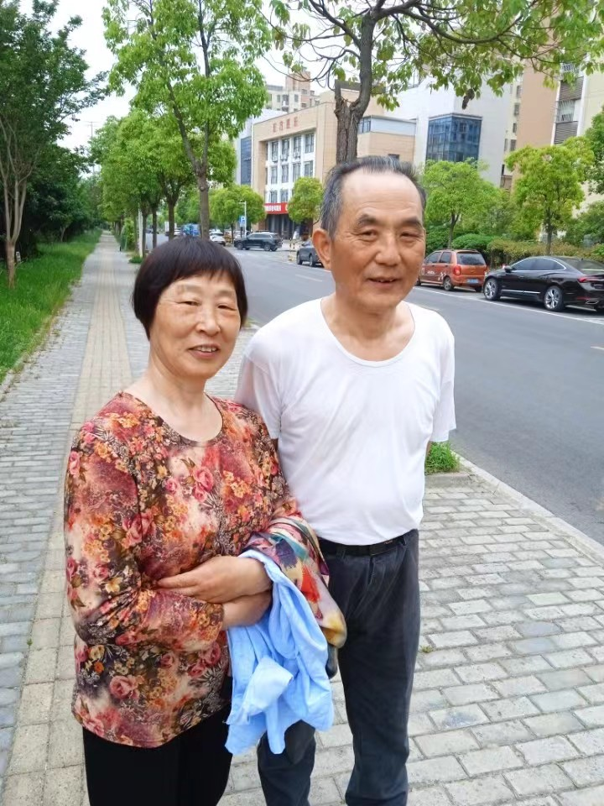

If you have breast cancer pain, you should pay more attention to it. You can also sleep in the hot quilt to avoid getting cold. First, gently touch the four fingers like scratching the breast pain and the surrounding area for 20 or 30 times. If you feel effective, do it with your hands several times a day, and then go to bed. Every day, you can also use Chinese herbal paste or powder that can relax tendons, activate blood, dissipate blood stasis, and relieve pain to smear on the pain, so that the toxic gas in the affected area is also heavy and can be gradually dissipated. Because the patient's mental pressure is high, so that heavy moisture has evolved in the breast, so that breast pain occurs. Even for young girls with breast pain during their developmental period, they can gently touch the affected area and the surrounding area with their own hands dozens of times. The bra they usually wear should not be too tight or breathable. When treating pain, do not wear a bra. When sleeping in a hot bed at home, do not sleep directly in front of your body. Instead, lean your body forward and place a hot water bag next to the painful breast. Put one arm on the pillow and lean down to make the affected area close to the heat source for physical therapy. You can also relax your mind and take a light breath in the affected area, or even hold your breath without breathing. When you release your breath to the limit each time, hold your breath. The toxic gas from the painful area was naturally discharged first, immediately alleviating the pain. After breathing normally for a few minutes, do it a few more times a day. If it doesn't hurt, don't do it or do some health care. Also, keep your mood comfortable, avoid getting cold, wear less tight clothing, and don't be upset. It's important to do these things well so that you won't feel pain again in the future.
Even if the breast becomes inflamed and thickened, we cannot treat this pain. If we continue to use water and intravenous fluids every day to treat the pain, we can only drink hot water and take Chinese medicine or Western medicine tablets orally. We can also relax ourselves in the inflamed and thickened area of the breast, making it more painful. We can even hold our breath and relax the inflamed and thickened area. If we persist in relaxing in the inflamed and thickened area every day, we can repeatedly expel toxic gas, accelerate the anti-inflammatory, blood circulation, and pain relief of the inflamed and thickened area, and the disease will be cured.
But one should avoid eating fish, shrimp, and spicy food, as well as cold drinks and meals. During illness, try to use less or no air conditioning, drink hot water two or three times a day, rest or sleep seriously, and take a shower in the bathroom every week. Bubble your breasts in hot water and rub them with your own hands. This will remove the moisture inside the breast cells, prevent breast pain, and prevent diseases such as colds.
If there is soreness on the body, as long as it is not an inflamed or ulcerated wound or an inconvenient area for applying ointment, plasters such as Mabikang or Zhenjiang ointment can also be applied, and even several small plasters can be applied to the affected area. And it will be applied continuously for several months or even decades to relieve the pain at the lesion. However, any plaster should not be massaged as it can easily damage the skin of the affected area. Alternatively, before applying the plaster, tap and rub the affected area for one or two minutes before applying it. If convenient, place a hot water bag on the plaster to enhance the penetration of the effect into the lesion. As long as the skin is not itchy, and even when taking a hot bath in the bathroom every week, the plaster should only be changed. Unless there is a severe illness, a new ointment should be changed every one or two days. You can also apply Musk Pain Relieving Lotion or Scorpion Poison King Huoluo Gao to the affected area and quickly apply it 20-30 times. If the old injury is painful due to weather changes or excessive fatigue caused by previous injuries. Applying Zhenjiang ointment to the affected area has a particularly strong analgesic effect. Zhenjiang plaster can also be divided into two pieces and placed on two thin plastic pieces measuring 15 centimeters square. The plaster should be applied to the outside of the body to dissolve in time and not easily stick to clothes. When changing the plaster, use a plastic bag to press it onto the melted black plaster, and repeatedly stick the black plaster that has been stuck to the skin at the site of the body's pain to the plastic bag. If the plaster dissolves on clothes or blankets, put more laundry detergent on the plaster and wash it several times with water. Finally, the plaster on the clothes will be washed with laundry detergent and there will be no plaster left. During the application of the plaster, do not let cool air invade the body. Do not eat spicy food. In winter, wear lightweight and warm clothes such as down jackets, and avoid heavy clothes such as leather jackets and shoes.
At the same time, for inflamed or even purulent cancer lesions and itching around the wound, do not touch it with your hands. After medication treatment, wrap the affected area with gauze or other protective materials. When lying in bed, concentrate and relax in the most uncomfortable purulent area, making it more painful. When reaching the limit of relaxation, the lesion immediately releases toxic gas to alleviate pain. Frequent concentration and relaxation of the purulent area can accelerate inflammation and relieve pain. It also regulates the movement structure and energy structure of the pain area, accelerating blood circulation at the lesion area, promoting early anti-inflammatory and purulent treatment, and improving the condition.
Please believe that as long as it is not a patient who has undergone surgery, the above is a daily routine of tapping, scratching, and rubbing the patient's entire body, and going to the bathroom to wash once a week, although it is a sign of treatment. But it will not cause secondary harm to the patient. If every time the whole body is pounded, rubbed, and massaged, it accelerates the relaxation of tendons, promotes blood circulation, and repels the heavy dampness in the body, the patient immediately feels the pain on the body relieved, and the person also has vitality and energy. The traditional Chinese medicine or western medicine taken orally with hot water or hot tea, the plaster and food to be pasted, and the careful care to enlighten the patient's mind are comprehensive and systematic ways to treat the root causes. In this way, we can treat the symptoms and root causes together, and speed up the recovery of leukemia, cancer, AIDS and other diseases as soon as possible.
You can also choose to eat, maintain health, prevent diseases, and cure diseases like the old monk from the fruit forest of Shaolin Temple. He is 103 years old and has a fairy like demeanor. Spiritually stirring, the sound is like a bell, the vigorous steps are like flying, seemingly over sixty years old. Some people seek longevity. Master said, "A bowl of cereal health Congee every day". It can also make all malignant tumors disappear! The old monk Guolin passed on the secret recipe to Dr. Xu Shangde. Ingredients: Brown rice, black glutinous rice, millet, wheat, buckwheat, thicket, oats, lotus seeds, oats, and red Job's tears mixed in portions. The above ten can be cooked simultaneously.
Method 1: At night, wash one cup of rice with water, add seven cups of water, put it into a simmering pot and bring to a boil. Cook for another fifteen minutes, then cover it in an outer pot. It can be consumed before work the next morning. Can be cooked a little more for three or four days of consumption. Method 2: In the evening, soak three cups of ten grains in water for 3 hours, put them into an electric rice cooker, add 5 cups of water and cook them into dry rice. After cooling, put them in the refrigerator. Before going to work the next morning, take a suitable amount and add four cups of water to cook porridge. Note: If children do not like to eat due to taste, they can add a few dried longan or raisins. Excellent flavor, strong memory, excellent academic performance
Ingredients: Grains health Congee. According to scientific analysis, it contains more than 100 substances beneficial to human health, such as vitamins B (B1, B2, B6, B9, B12), C, A, E, K, D, minerals (calcium, iron, magnesium, potassium), trace elements (zinc, molybdenum, manganese, germanium), enzymes, antioxidants, cellulose, amino acids, and biotin. It has the function of lowering blood pressure, cholesterol, removing thrombus, and relieving nerves. It has no less effect than medicine on constipation, hypertension, skin diseases, appendicitis, insomnia, and angular stomatitis, and most importantly, it has no side effects.
White rice, due to the removal of sugar bran and germ, only contains carbohydrates and provides only calories, with a much lower nutritional value than ten grains of rice. To live a long and healthy life, it is important to eat a variety of foods every day to supplement the enzymes needed for daily metabolism. Eating ten grains more can prevent modern civilized diseases such as arteriosclerosis, stroke, gout, myocardial infarction, and cancer. PS: Brown rice, black glutinous rice, millet, wheat, buckwheat, foxtail millet, oats, lotus seeds, oats, and red Job's tears are mostly sold in supermarkets. Only foxtail millet may need to go to a traditional Chinese medicine shop, where they are usually available
Kidney is the foundation of innate constitution, with sufficient kidney qi. In the theory of traditional Chinese medicine health preservation, nourishing the kidney is nourishing the life! The reason why walnut, sesame and black bean Congee is widely respected is that this recipe covers the "three black" ingredients for tonifying the kidney and strengthening the kidney: black beans, black rice, black sesame, Chinese wolfberry for clearing the liver and improving eyesight, walnut kernel for brain and intelligence, and hawthorn for spleen and digestion. [Walnut sesame black bean Congee], [Recipe] 10g walnut, 10g black sesame, 10g black bean, 5g hawthorn, 5g medlar, 10g black rice (this is the amount of two people). 【 Production Method 】 Black beans and black rice should be soaked for at least one hour in advance. Grind the walnuts, add black beans, black rice, hawthorn, black rice, and walnuts to the pot, bring to a boil, and simmer over low heat for at least half an hour. Add black sesame and goji berries, boil for half an hour, make a paste, and then add rock sugar to eat.
Nowadays, people often blow air conditioners in winter and summer, and like to drink cold drinks, which makes their bodies more cold and hot. They have evolved from the increase of moisture in their bodies to become haze. If they cannot be discharged from the body in time, they are prone to various diseases, general weakness, sleepiness, and skin eczema. Friends can eat red bean barley porridge for conditioning. In daily life, not paying attention to some small details may become the trigger for tumors. So, what else should we pay attention to in order to prevent tumors? What foods cannot be eaten? Let's take a look together The following three unhealthy dietary habits can easily cause swelling
1. Overeating warm food, the so-called warm food, refers to food that is directly felt to be too hot or too hot; One refers to warm and hot foods that belong to the classification of traditional Chinese medicine properties. Due to excessive heat, it is easy to damage the epithelial cells of the digestive tract mucosa, so foods of this nature are most likely to induce tumors in the digestive system 2. Chinese medicine believes that the diet should be balanced with the five flavors, and foods that are sweet, bitter, sour, spicy, and salty should be consumed evenly. Any preference for one flavor can lead to the occurrence of diseases. Among the factors that cause tumors, excessive fat, sweetness, thickness, and saltiness are common factors. 3. Eating denatured and moldy foods: Aflatoxin has been recognized as the strongest carcinogen, and Aspergillus flavus is rich in moldy grains, corn, and peanuts. This bacterium is easy to grow and reproduce in warm and humid environments, and research has found that it can induce multiple types of tumors in experimental animals. This factor is an important reason for the high incidence of cancer in certain regions of Asia and Africa. For people with high mental stress or rheumatism, they can also drink medicinal wine infused with medicinal herbs every day, or drink less wine (but they must have a full mouthful of vegetables to eat, and cannot drink alcohol alone. In winter, they should put the wine glass in a small bowl, pour boiling water into the wine glass later, then pour boiling water into the bowl, and then put the empty wine glass into the hot water in the bowl. Pour in the wine, and take warm sips of hot wine, drinking only one or two drinks per meal, especially not drinking too much cold beer) to add fun to life. It can emit filthy poisonous gas in the body, but drinking too much strong Baijiu will damage the body. So, after drinking alcohol, it is important to lie in bed and sleep for one or two hours, which will make the patient more energetic and energetic. You can also grind half a kilogram of black beans in a German small steel mill for about seven minutes, then put them in a glass bottle and pour them onto the waxed bean noodles. Afterwards, take a small spoonful every day to eat, which can not only improve beauty but also prevent diseases such as colds.
Patients should have the determination to face death as if they are returning home, or only recall the happy past of life, so that they will experience less pain in their hearts. If I had fainted from an allergic reaction to penicillin injections in the medical room of the factory, I was taken to West Lake Hospital for rescue. There was another time when my illness couldn't be cured, so I ate the seeds of the traditional Chinese medicine herb used by an elderly Miao woman in Guizhou. It was the size of a fava bean, and I only ate a small corner. For about two minutes, I felt my throat dry, so I went to bed. After three minutes, my hands and feet gradually became cold, and the fear of falling from a high altitude became unconscious. The doctor came to the factory to check the blood pressure meter. The golden needle kept piercing my nose and my genitals were unconscious. Seeing that I didn't know what medicine I was taking, I immediately left without rescue. At this moment, my mother and wife both cried and said that I had not enjoyed happiness, and I understood in my heart that it was even more difficult. After thinking that I didn't do anything wrong, I immediately felt much better in my heart. I finally came back to life the next day, but I had no strength for eight days. The illness has not completely healed.
If suffering from ankylosing spondylitis, it is a chronic inflammatory disease that mainly affects the central axis skeleton and peripheral joints, belonging to the category of rheumatism, and cannot be cured or cured temporarily. It may be caused by multiple factors such as genetic factors and environmental factors (such as frequent exposure to cold, tiring daily life, or exposure to strong ultraviolet arc radiation, which kills many cells and proteins in the body, or being infected and frequently taking cold baths). The disease mainly affects young men and women in their twenties and thirties, but it is more common in young men. In the early stages, it presents as chronic lower back pain, which can develop from the lumbar spine to the chest and neck vertebrae, and even affect major joints such as the hip, knee, and shoulder, resulting in increased pain, limited mobility, and even partial rigidity in corresponding areas. At this point, if an imaging examination is performed, it may be found that there are already osteophytes (commonly known as "bone spurs") between the spinal vertebrae. Slowly, these bone spurs will lead to spinal and joint stiffness, presenting as a hunchback with a high incidence and disability rate. Ankylosing spondylitis can also be complicated by various diseases. 25% of patients have conjunctivitis, iritis, uveitis or uveitis, and 2% to 10% of patients have cardiovascular symptoms. Easy to cause loss of labor capacity for patients, seriously affecting their daily lives. Ankylosing spondylitis, although not fatal, is very torturous and is often referred to as the "immortal cancer".
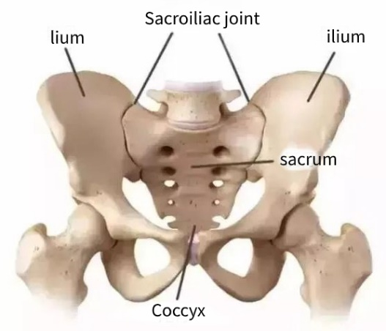
The sacroiliac joint carries the entire weight of the upper body
The development of rigidity is an asymptotic process and will not be achieved overnight:
Immune disorders lead to inflammation → repeated inflammation leads to pathological new bone production → pathological new bone continues to grow and connect → bone fusion and rigidity. "Pain" is only the "surface" of the disease, but treatment cannot only focus on the "surface", but also on the "inside": controlling inflammation pain is caused by inflammation, and controlling inflammation is the key to relieving symptoms; Inhibiting pathological new bone formation is the basis for bone fusion rigidity and even disability, so close attention should be paid to bone structure progression.
At present, there are many therapeutic drugs in clinical practice, mainly including the following categories:
Non steroidal anti-inflammatory drugs: are well-known anti-inflammatory and pain relieving drugs, which are first-line medications for treating ankylosis and help alleviate joint pain and swelling; Two biological agents: Many biological agents have been approved for marketing in China for the treatment of ankylosing spondylitis, changing the treatment pattern of ankylosing spondylitis. According to different targets, there are currently two main types of biological agents, one is anti-tumor necrosis factor α The second type of inhibitor is the novel interleukin-17A inhibitor. Both can quickly and effectively control inflammation and alleviate symptoms. Improving the condition with anti rheumatic drugs: it has certain benefits for patients with concurrent peripheral arthritis [2]; Corticosteroid drugs: commonly known as "hormones", can be considered for local injection in patients with concomitant peripheral arthritis, but cannot be used in large quantities throughout the body for a long time.
Because ankylosing spondylitis is an inflammatory progressive disease, patients cannot simply judge the treatment effect based on whether it hurts or not. It is still necessary to regularly visit the hospital for follow-up. Doctors should check whether inflammation is under control and whether bone damage is progressing through hematological and imaging examinations.
Medically, it is believed that ankylosing spondylitis is not a typical lumbar muscle strain or sprain, and "rest" is not helpful. Scientific exercise is more beneficial for disease control! Regular low-intensity exercise (such as walking, swimming, strength training, yoga, etc.) can reduce pain levels, enhance mobility and balance, improve health, and enhance overall quality of life.
But I am poor and have gained experience in treating ankylosing spondylitis. The actual patient suffered from long-term illness and pain, resulting in weak physical fitness. In addition, wearing cotton padded clothes and shoes in spring and winter increases the patient's spinal pressure, and then swimming, strength training, and yoga are performed. The angular momentum of the weight of wearing cotton clothes and shoes in winter can be calculated mathematically to increase the weight by several times, making the waist more prone to hunching and worsening the pain.
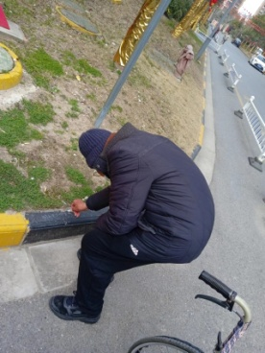
Previous waist and back photos
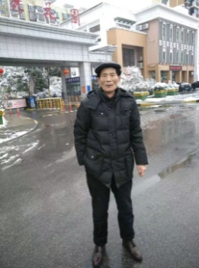

Now my waist has finally straightened up
Doctors from major hospitals all say that it is a disease that cannot be cured medically at present. When the pain is severe, hormone medication can only be taken for a few days to relieve the pain. However, it cannot cure the root cause. If taken regularly, it can also damage the stomach.
I will not work from now on and will stay at home waiting for work. Every day, I will clean the bed thoroughly and keep it warm. Every day, I will lie on the pillow or beside the bed, even if my head is outside the bed. As my waist is very bent, it is about 90 degrees, and it is not convenient to lie on the bed. For three and a half years, I will not be able to straighten up. Therefore, I will place a pillow beyond the bed, and my head and half of my face will be placed on the pillow beside the bed, making it convenient to force my waist to gradually straighten up Whether lying on the sofa to rest or sleep, it is forced to bend down and then straighten up. Every time I lie on the bed for at least an hour, or even for three hours of exercise, I keep rubbing my hands against the most curved part of my waist and rubbing it dozens of times. Only then do I feel less uncomfortable at the most protruding part of my waist and get out of bed to do household chores or take care of children.
Every time I lie on the cotton quilt on the bed, and based on my own feelings, I should turn over and sleep to the left or right, just as I do. When I sleep on my side and my waist is relaxed, I can use my fingers to first apply the most protruding part of my waist with my fingers. I can also apply snake king bone penetrating ointment, or mugwort ointment or scorpion venom king meridian activating ointment to the acupoints and affected areas, and apply some force to the abacus beads on my waist bend more than ten times, feeling the hot and pleasant sensation of applying it to my waist bend. When you feel a little pain from scratching or rubbing, just lie on the bed and relax your mind at the most prominent part of your waist, loose and loose.
You can also take a deep breath and then relax your mind. When you exhale lightly, your body will immediately shake violently once at the limit of relaxation, relaxing the protruding area of your waist and feeling much more relaxed in the bending area. Turn over to the left or right and lie down on the bed, breathing normally for more than ten minutes. Continue for about an hour in the future or hold your hand and mechanically flick your thumb around the second section of your index finger about a hundred or ten times. It also means to relax the whole body or the navel and eyes, rest or sleep quietly, which increases the energy of the patient like a nutritional supplement, because the maximum consumption in the human body is respiratory energy.
As long as there is time for years and months, persist in lying on the soft bed surface several times a day, and force your eyes to close their minds and look straight ahead, not towards your navel [Otherwise, in the future, my head will tilt back and my eyes will be even more uncomfortable] I have persisted for decades, even striving to straighten my waist and neck when walking, before returning to a normal state. But I can't get rid of my roots in this lifetime. If I'm tired or it's going to rain, and my body feels uncomfortable, I'll first tap and hit my waist pain area with my hands for a few dozen times, then apply some ointment for health care. Whenever I have time, I'll lie in bed or sleep or rest on the sofa, and take a shower in the bathroom once a week. After taking a shower, I can't catch a cold, I can't drink cold water orally, and it can better drive away the moisture in the body cells and ensure smooth blood flow. Of course, I also need to use less air conditioning. Because the hot air flow from the air conditioning enters the body for a long time, it will convection with the temperature inside the body, causing the water in the body to evolve into haze, which will worsen the moisture. Moreover, electromagnetic waves can interfere with it. Rest the nervous system. Avoid wearing heavy clothes and shoes, and sleep on a wooden bed to prevent the waist from carrying heavy loads.
When the waist straightens up, the actual illness enters the lower part of the head and becomes even more uncomfortable. For example, the lips and hands are numb, bone calcification, and if not handled properly, the central nervous system is more compressed. Chordal dizziness and other symptoms can quickly lead to the patient's death. The patient also worries about the consequences by the age of 70. They even try to finish or improve some things in their hands as soon as possible. As I worked hard to improve the content and article abstract of this book, the biggest problem was wearing glasses at five times the size of a hundred, which made it difficult to read words clearly. The magnifying glass was not very effective, and the head was heavy and the body was weak, making it even more uncomfortable. It was so difficult to change a word. The only spiritual strength was that Yu Gong dug mountains every day and how steel became the author. Paul's book writing experience inspired me time and time again to revise the book content well, which was not only for readers but also for myself.
Therefore, I also pay close attention to treating the problem of inconvenient head rotation. Every day, I often nod my head more than ten times, then mentally write about ten eight characters from the left eight shape, then twist my head along the eight shape to write about ten eight characters, and then nod my head more than ten times. Then, twist my head along the eight shape to write about ten eight characters, and force my head to be as low as possible to the chest. I close my eyes and look towards the navel without breathing, and when I expel toxic gas, my body shakes. Shake your head a few more times to turn left, and then shake your head a few more times to turn right. Although it's impossible to shake or nod my head, I still insist on doing it. Because for over thirty years, I have been forced to straighten my waist while lying on the bed, but my head has already tilted back and my head is stiff. It is even more inconvenient to go down the stairs. Grasping my hair with my hands and pulling it down increases the weight in front of my body before I can go down the stairs. And the most uncomfortable thing at this time is the dry pain in both eyes. After decades of lying on the bed and forcing the waist to straighten up, the eyes also tilt back with the head So it's inconvenient to look down due to dry and painful eyes
Another treatment for sciatica relies on receiving gold needles and taking medication. The hospital is far away from me, and I haven't been able to afford it for two months. The actual effect is also slow. I have found that this disease is caused by overwork and the influence of cold and cold on the meridians. It is also due to insufficient kidney qi in patients, and one positive energy cannot suppress all evil factors.
At this time, patients should rest in bed at home seriously, stand less, and in summer, they cannot sleep on a cool mat. They even need to wear long pants and long sleeves to hang their clothes. When lying on a warm bed every day, first apply the scorpion venom king activating collaterals ointment, and quickly apply more than 20 times to the legs with neuralgia. They can also apply the two kidney bases on their waist to strengthen their body. Apply the buttocks again on both sides of the upper thighs, and apply and wipe on the Huantiao acupoint for more than 20 times. In the future, if there is still pain in the leg, apply more than ten times to the affected area. When lying on a warm bed; And with the painful leg, use some force to bring the knee closer to the chest, and then use your fingers to grasp and pinch the most painful area with some force, even relaxing your mind in the most painful area. At this time, hold your breath and not breathe to relax it, making the painful area more painful. When you need to hold your breath and relax to the limit of pain, the nerve pain will even stop in one or two minutes. Or alleviate the pain. In the future, when sleeping on the left or right side of the body, rest or sleep by placing the painful leg on the non painful leg. Rest or sleep. If the pain returns the next day, do it two or three times a day, and use some force to grab the painful area, relax it, and relieve the pain.
In winter, you should also wear lightweight and warm clothes and shoes such as down jackets. Do not put heavy objects in your pockets. Do not wear heavy clothes such as leather jackets or shoes. Even in summer, do not wear heavy clothes such as leather shoes. Sleep on a wooden bed, stand less and let your legs rest. You can also drink hot ginger tea regularly because ginger can dispel cold and dampness and has various health benefits. It is also possible to apply dampness relieving and pain relieving ointment to any nerve pain area on one leg, from the waist and kidney meridians and Huantiao all the way to the root of the foot, or even more than ten patches. If one patch is missing, the pain relieving effect will be poor. You can change the plaster every two to three days, but after applying it, do not scratch or rub the nerve pain area on the plaster, otherwise it is easy to scratch the skin where the plaster is applied and cause infection. Go to the warm pool in the bathroom for about five days to take a bath and soak in bubbles. Bathing without getting cold or drinking cold water can effectively remove moisture from the body's cells, promote smooth circulation of qi and blood, and accelerate the recovery of neuralgia as soon as possible. Of course, it's also important to use less air conditioning. Due to the prolonged heat flow from air conditioning entering the body, the water inside the body evolves into haze through temperature convection, resulting in increased humidity Moreover, electromagnetic waves can interfere with the rest of the nervous system. It is important to pay attention to these things in order to quickly grasp and pinch the nerve pain area for a few minutes, and then the pain will be relieved after a few days or about a month.
You can first apply your fingernails to the uncomfortable areas, such as tachycardia, arrhythmia, or any slight pain or discomfort you feel when touching your own hands. Then, apply your fingers up and down to the uncomfortable areas and draw circles on them for more than ten times. You can also apply a large damp and painful ointment or Zhenjiang ointment to the upper part of the heart to relieve discomfort.
For chronic diseases such as systemic leukemia or cancer, in the next stage, in addition to selectively taking care of the above methods, you should focus on treating the disease by drinking traditional Chinese medicine hot herbal soup or drinking hot water and taking Western medicine prescribed medication. And make a good choice of self-care methods that are suitable for you. During this period, you can moderately increase the amount of exercise, such as getting out of bed and engaging in activities every day after getting enough sleep, such as practicing Tai Chi, doing gymnastics, running and dancing in place for about 20 times, washing clothes, or dancing moderately. You can choose to do any exercise you want. When couples sleep in separate rooms, they can also engage in sexual activity for about half a month, as it is not an infectious disease, which is also beneficial for the patient's mental relaxation. But they also need to stay away from work for a long time or work on their own, so that they can rest and receive treatment at home every day without any restrictions.
Do not mistake it for the virus causing the proliferation of vitiligo cells. If long-term use of radiotherapy and chemotherapy, it is necessary to use water infusion to form a new molecular structure of the body, to ensure the survival and recovery environment of living cells.
The human body is a complex system, such as high or low water temperature, fast or slow water flow rate, and injection into the skin. When entering the stomach for treatment, there is also a certain level of attention to detail. Water can alleviate pain, but it can also worsen the condition. If long-term abuse of hanging water infusion occurs, it actually disrupts the unity of qi and blood movements in the body, and does not go to the root of the disease. The consequence of causing genes to undergo mutations and suddenly evolve from their original form into a new gene. Western medicine treats infectious diseases and acute surgical diseases, such as antibiotics used in water infusion. Within 48 hours, pneumonia will subside, and patients will also have vitality and energy. If the patient continues to receive water infusion to consolidate their illness for a period of time, it can be calculated through measurement. Assuming that a person weighs 130 pounds, the additional accumulated water received by the patient's body cannot exceed their weight. If the patient receives an average of about one pound of water infusion per day, continuous water infusion for one month is equivalent to thirty pounds. If continuous water infusion is carried out for five months, it will result in 150 kilograms of water. These small molecules of damp drugs in the water may weigh two to three kilograms in total. The accumulation of more and more is not stored in the stomach, but cannot be processed and excreted with urine and urine. But rather small molecules of damp drugs in the water, which exist in the patient's body and enter the lung wall slowly. The small molecules in the drugs vortex and accumulate outside the lung membrane, forming water lumps that block water from flowing into the small holes on the lungs. And the water in the patient's lungs evolved into thick phlegm due to the temperature of the fever, causing the patient to cough and even develop diseases such as tuberculosis, making breathing more difficult. If an oxygenator is used to push the thick phlegm that has evolved in the lungs into the small holes and holes on the lungs, it may even worsen the condition. And the excess water that has not been fully absorbed into the body also accumulates in the chest cavity.
During the World War, there were too many wounded to treat the wound before it could be infected by bacteria. The invention of injection and later antibiotics in water infusion had a special effect on bacteria, and the patient's fever immediately subsided within 24 hours. Western medicine immediately took effect on infected wounds. At that time, it was not possible to detect the problem of hanging water for infusion in a short period of time, and there were side effects after long-term use for chronic diseases.
Today, the incidence rate and mortality rate of leukemia, cancer, AIDS, and various viruses and other diseases in the world are increasing, so we must limit the amount of water infusion. Or drinking hot traditional Chinese medicine soup to treat illness, or making radiotherapy and chemotherapy drugs into oral medicine, drinking hot water to take Western medicine orally, and excreting the useless through stomach treatment through defecation and defecation.
Otherwise, the airflow and small molecules in the patient's body will suddenly change from their original form of existence to a new form of existence when they rotate towards the center, which is the sudden emergence of a new gene that replaces the original gene. There is a new memory code on this gene. In the future, if there is an outbreak of war, injury to patients, or similar events such as terror and intimidation, it will make more people who used to receive intravenous fluids and induce weaker physical resistance, making it easier to get sick or worsen the condition.
So, there are more small molecules in the body that, if combined with the patient's painful airflow during treatment, can be replicated by a new gene vortex system, like a snowball, into a complete and new cancer cell with poor quality. Or HIV and other viruses [It is really the water hanging on the water that destroys the efficacy of chemoradiotherapy drugs and also promotes the generation of cancer cells resistant to treatment. In medical theory, there is no detailed introduction in this regard. For example, there are strict requirements for the water hanging on the water for infusion, and medical instruments cannot see how the gas moves in the body, and the problems shown in the micro movement of water entering the body.
Doctors can use medication to treat diseases according to medical theory. Otherwise, no one can bear the responsibility for medical accidents. For example, during the epidemic in Wuhan, thousands of doctors wore anti infective protective clothing for a long time, and they were also under great mental pressure. They were also busy treating patients with COVID-19 day and night, and they were so tired that they fell ill. They were also treated with the same medicine, and several doctors died successively.] So, any doctor hopes to cure the patient as soon as possible. It is not the responsibility of the doctor, but rather a problem caused by imperfect medical theory and methods.
Today, according to medical textbooks, patients with chronic diseases who are infected with viruses can receive intravenous infusion of water for three days based on their condition. If there is an effect, it should be stopped for about 3 to 4 days before only hanging water for three more days as a treatment course. The speed of hanging water should not be too fast, that is, the hanging bottle should not be hung too high. For patients with normal hanging water volume, only one kilogram of water can be hung per day. It is best to use water infusion equipment to maintain a water temperature that is as high as the patient's body temperature, or even one or two degrees, which will reduce the moisture in the patient's body and accelerate the recovery of the disease.
Due to fever, the immune function in the body is activated, causing patients to drink hot tea several times a day and sleep in bed for a few days. The temperature of a fever can reduce 70% of the body's water due to exposure to cold or mental stress, resulting in a decrease in haze. Many cells in the patient's body spin easily and are less affected by moisture, leading to a faster recovery from fever.
Otherwise, cancer cells in the patient's body compete with other cells for the force of water and gas, which disrupts the movement and energy structures in the body, exacerbating the relationship between the patient's various tissue structures and making it difficult to coordinate for a while. Just like the high temperature in summer, thunderstorms, and cloudy days with low air pressure, the fish in the river are prone to hypoxia and death. Summer is also the season when bacteria are most likely to reproduce and are prone to contracting diseases and dying. Summer is also the peak season for fish to feed, and fish are also greedy, making it easy for them to survive.
These three questions are all in line with the situation of patients with fever. Firstly, the temperature converts the water used for infusion into haze, which is also known as heavy dampness in traditional Chinese medicine. Cells are prone to hypoxia. However, it is better to hang water and intravenous fluids for patients every day, which can lead to more haze. Cells are even more hypoxic, and small molecules in drugs used in water and intravenous fluids, as well as small molecules in vaccine drugs used in injections, are stored more and more in various structures of the patient's body, making it easier to survive like a fish And more small molecules, such as bacteria in summer water, are more likely to breed and get sick. Even at this time, the patient's body temperature is feverish, and the force of pushing, squeezing, and friction processes various substances, such as meat and potatoes with high iron content, which evolve into a plasma state, making the body weaker and even more painful and unbearable. If the patient takes painkillers again, it can lead to major problems such as poisoning or worsening of the condition and coma. Or sudden cessation of ion state, making it difficult for patients to survive.
For example, scientists have learned from observations and experiments that the atmosphere is divided into the troposphere, stratosphere, mesosphere, ionosphere, and exosphere, which are plasma. The ionosphere can reflect shortwave radio waves, allowing them to propagate far away on Earth. Due to the presence of ionized free electrons and charged ions, plasma has high conductivity and strong coupling with electromagnetic fields. If the ion state is suddenly interrupted, it is difficult for the patient to survive.
Through the above examples, Western medicine can effectively treat infectious diseases and acute external diseases. However, for systemic chronic diseases, if Western medicine treats patients with water infusion for a long time, there are consequences of side effects. This is the problem of imperfect medical theory.
Traditional Chinese medicine has a good effect on chronic diseases such as cancer, but for thousands of years, traditional Chinese medicine has only established theories based on qi and blood. Neglecting that about 70% of people's bodies are warm water, with only a small portion of qi and blood. Moreover, the supplement of primitive energy comes from the evolution of water into qi and blood. Of course, traditional Chinese medicine decoctions traditional Chinese medicine with water and gives patients hot Chinese medicine soup. With the hot qi of hot Chinese medicine soup, it penetrates everywhere, increasing the patient's essence, qi, and spirit, and accelerating their recovery.
So the theory of Chinese and Western medicine must be unified and established on physics or natural sciences, and after both medical theories are improved and perfected. When treating diseases, it is important to flexibly utilize water, especially taking care of patients. If they cannot drink cold water to take medication, they should drink hot Chinese medicine soup or take hot water to take Western medicine tablets orally. After taking medication, they should go to bed and sleep, etc., in order to achieve better therapeutic effects without any side effects.
In the past three years of the epidemic in Wuhan, the government has allocated trillions of yuan to support Western Traditional Chinese Medicine in ending the epidemic. However, the greater the national investment, the higher the incidence rate is, which reflects that the misdiagnosis of this epidemic is to treat and prevent seasonal plague as an infectious disease. The second mistreatment should be taking medication with hot water, and can be treated with hanging water infusion, which can lead to long-term consequences. 3. Misleading, Chong Tong reported the incidence rate and death rate of various diseases in normal years as COVID-19 virus disease, causing consequences even several times more than infectious diseases. Four common people mistakenly believe that in winter, they wash their hands with tap water several times a day to disinfect. And the virus is afraid of high temperature, such as the high temperature of the air conditioner at home, which also leads to an increase in the incidence rate. Tracing back to the source, firstly, changes in climate and environment, and secondly, infusion of water into the body, not into the stomach for treatment. Three media over propaganda, four nucleic acid tests and vaccines that have no therapeutic effect are not aerosol inhalation anti epidemic drugs, and some people manipulate the incidence rate are all problems of traceability.
Scientists have to publish articles on the COVID-19 pandemic again in September 2022 on websites such as Baidu, without any cost or medication, just in a few important words. Finally, on December 5, 2022, China ended the COVID-19. WHO announced the end of the world's COVID-19 at the end of February 2023. The European Union has also destroyed many vaccines without nucleic acid testing, and has not found a second big rebound in the epidemic so far.
No one praises a scientist, let alone awards. Also permanently banned by Toutiao and Baidu.
The amount of virus infection depends on the number of times a patient receives intravenous fluids, the type and amount of medication used, as well as the patient's physical strength or geographical environment In hot or cold regions of Africa, the quality of viruses that have evolved in the patient's body also varies. But it only parasitizes within the cell, being trapped in an eccentric hole field by the cell, and the vortex replicates more energy, which is the virus. It is inside the cell, not even found in autopsy, such as when the heart is infected with the virus. Because viruses are just empty shells of proteins, like dead bodies.
I am a brave and fearless scientist, and my personal experience is that more than forty years ago, I suffered from various illnesses and low fever that did not subside. I was afraid to say a word, couldn't open my eyes, couldn't read clearly. My teeth also fell out, and I was deaf. I had to eat a bowl of rice several times in order to avoid being forced to finish. Most of the time I spent in semi coma and pain. Although I did all these things within 15 years, I did not completely cure my illness. If ankylosing spondylitis and brain cancer pain occur, especially during rainy weather or excessive fatigue, the pain will worsen. But I persisted in my beliefs and flexibly chose the diseases that suited me, such as drinking hot traditional Chinese medicine soup or drinking hot water and oral Western medicine tablets. I also took good care of myself in all aspects, which improved the effectiveness of medication and enhanced immunity. Finally, I lived for more than 40 years without dying, and various diseases gradually improved. If I first treat sciatica and Meili's comprehensive dizziness, I will rent a house at my house and receive two traditional Chinese medicines for gastrodia elata from Shiqiao Yin Chen Shi. When I cook an old mother chicken, I will put them together. After cooking, I will take the soup with the chicken and drink it hot. The dizziness will be cured in the future. Rheumatic heart disease, intestinal adhesions after surgery, ankylosing spondylitis, finally straightened the waist, and cured the pain of brain cancer.
And my classmates, colleagues, and family and friends in the factory, totaling more than 30 people, are not as seriously ill as me. Moreover, their economic conditions are very good, and their seniority is not as big as mine. They have indeed passed away and returned home one by one, surviving in the air.
For the study of cancer, brain cancer pain, I am not one thing, at home to do a good job of personal health care, such as cold winter, wear a hat on the head, wear socks on the feet, do not use air conditioning, lie on the bed every day to sleep for a while, or do deep breathing, breath out again and again, the idea to relax the whole body, or pain, When I breathe or exhale, I can expel toxic gas from my body again and again, and I immediately feel refreshed. Or sing some old songs. Or lying on the bed, eliminate all thoughts on the mind, and even hold your breath to relax to the limit, the brain cells first discharge a slight gas, but also reduce the energy consumption of breathing gas, enhance disease resistance. You can also do this several times after breathing normally again. Every day also for the whole body at least to such as Yongquan foot three li ring jump kidney more than two ears, the head and sun points, such as hands four fingers grasping sun point 30 or so, immediately promote blood circulation qi dispersing blood stasis, brain cancer pain reduction.
I also pay for scientific research to get the money out, still owe more than 500,000 yuan, equivalent to now more than 50 million yuan, had to personally experience, published the moon song scientific research tears song entrepreneurial song bitter to the society for help sympathy, but no one understands, at least two thousand yuan published an article, published more than 10,000 yuan, just to Ma Editor-in-Chief natural science magazine hundreds of yuan published an article training ah. Therefore, I even boil a cup of boiling water, reluctant to waste water and electricity. Therefore, for a long time, like a dragon in a state of low energy hunger, cook a meal of black beans with a small steel mill first ground with rice a pot cooked into a semi-cooked dry porridge, eat two or three days, big beans sauce after noon dishes, and when the morning and evening dishes, eat more than ten years of bitter days. He's deaf, he can't read in his eyes, he's got no teeth. It may be that some of the better cells will eat the weaker and side effects of cancer cells, helping the body to clean itself up. But I do not eat cold food is not greedy cold, after eating at home to walk or run in place a dozen steps, every week bath bubble wipe the whole body. Getting rid of moisture in the body faster. I don't wear leather or shoes. Only wear warm and light clothing such as down jackets.
When the brain cancer pain is bad, the pharmacy of traditional Chinese medicine buys Chuanxiong powder, put a small bag into a bowl each time, pour less than half a bowl of boiling water and drink it, you can also directly pour the Chuanxiong powder into your mouth, and drink a few mouthfuls of hot water, and the brain cancer pain is much better after ten minutes. I also drink Tieguanyin tea brewed hot red tea two or three times a day, I sleep on the left or right side of the bed to rest or sleep two or three times a day, because chronic patients sleep in bed, it accelerates the movement of Qi and blood in the body and cold and hot energy structure has been adjusted to enhance human immunity. And I am not liver cancer, so I also drink a total of two health care wine twice a day.
I am still alive after decades of brain cancer pain may be because I have been in a low-energy hunger state like a dragon for a long time, and some high-quality cells will eat the weak and side effects of aging cancer cells to help the body do self-cleaning garbage. Second, do a good job of personal health care, such as four fingers on the hands of the pain about 30 next time, immediately promote blood circulation qi to disperse blood stasis, brain cancer pain to reduce pain. I drink Tieguan-yin hot red tea two or three times a day, often drink hot bean porridge, and eat salty dishes and food, every day in bed on the left or right side to sleep into the hot bed to rest or sleep or lie on the bed, eliminate all distractions on the mind, and even hold the breath to relax to the limit, or do deep breathing, and then gently exhale again and again when the breath, the intention to relax the whole body, or the pain, When you can breathe or exhale, such as the brain cells first discharge a slight gas, but also reduce the consumption of breath energy of people who have been ill for a long time, do these things, it will enhance the resistance to disease and prolong life.
If the cancer patient has been hanging water infusion for even three months, a critical illness notice has been issued. The patient should go home immediately to save himself. Sleeping on the side of a warm bed often hold your breath, or breathe deeply, the idea must relax when you breathe out again and again, first the poison gas at the lesion, is held, or the idea to relax before breathing out the gas at the lesion is released, and then breathe out the gas gently after several times. Breathe normally for a while, and then repeat for ten minutes each time, or sleep on your side or on your side to sleep in a warm bed. If you wear a hat on your head in winter, wear socks on your feet, and even wear socks when you sleep, the heat flow in your body does not run away from the top of your head and the bottom of your feet, and the haze in your cells is gradually reduced. Every day, he also scratched the lesion with four fingers dozens of times, and drank hot tea two or three times. Or drink hot bean porridge, take salty dishes with taste, if there are conditions to take a hot bath every week, can not eat cold food, immediate effect to health, disease prevention can also cure cancer, prolong life.
If ankylosing spondylitis is left behind, the head and neck are stiff and inconvenient to turn and look down are not convenient, all day long, full of no strength, just want to sleep in bed. Do not want to do anything, although the oral administration of strong gastroma Guzhong pills, but also side bed with hands interlocked fingers behind the head of the neck, after doing deep breathing, and the intention to relax and breathe out again and again, even the mind is uncomfortable the poison gas at the lesion, is held, or the intention to relax and breathe out the poison gas at the lesion before the breath, feel the mind relaxed, but also breathe normally for a while, Do this for more than ten minutes, and the head should be dozens of points up and down or the head around the figure 8 circle more than 10 times, so that the mind is not dizzy. Including cerebral infarction are easy to smooth, don't do it today, if the mind is dizzy tomorrow, do it again.
Because of the deep inhalation of sufficient gas, the gas is added to the cell, the idea is relaxed, the gas is discharged from the lesion, and the breath plays a health care role when it is breathed out again and again.
Also, the patient no longer hangs water infusion at home, and the moisture in the body can not increase. Smooth channels and collaterals. It makes the cells in the body spin easily, and the patient has vitality." You will feel hungry or fart in the stomach, indicating that the five organs in the stomach begin to unimpeded. Drinking hot bean porridge or drinking hot nutrient soup, the various structures in the body increase the force of heat and nutrients, enhance immunity and speed up the disease.
Due to different medical conditions and even different self-care methods, this content is only for patients to refer to and flexibly choose from, ensuring that you spend less money, suffer less pain, and have happiness every day.

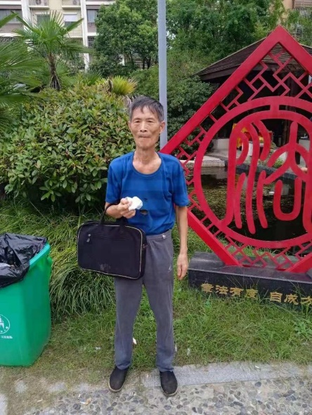

No doctor can restore any patient with ankylosing spondylitis with a 90 degree curvature in the world to the appearance of my waist straightening up now.

If boasting is impossible, it is impossible to receive attachment: President Bush's reply in November 2008

On half of President Bush, thank you for your response

We recommend hearing your views and welcome your suggestions

Due to the large volume of email received, the White House can not respond to every message

Thank you again for taking the time to write

My suggestion was finally published ten days later in the December 5th, 2008 issue of Yangzhou Evening News. On the 2nd, American researchers reported that frequent exposure to CT scans increased the risk of cancer in patients.

Reference:
- Genetic network, Wikipedia, and other materials
- My understanding and application of Tai Chi diagram
- Nature and Science English paper "Establishment of the Unified Field Theory".
- Why can't genes only replicate energy
- "Potato Juice Therapy - More and More People Treating Diseases" on Baomeng NetEase Blog
- Http://scw88888888. blog. 163. com/Blog "Soul Theory", Research on Unified Field Theory, "Theory of Cosmic Rotation and Evolution"
- Daqianwei Magazine
- 360 Comprehensive Search Network: "Cancer is not a disease? Disrupting the shocking view of traditional medicine"

This article is for expert reference only. Only fulfilling scientific responsibilities and contributing to the country and saving the people, there is no motivation to harm any party, no pursuit of fame or fortune, and no acceptance of any negative criticism.

5/25/2024

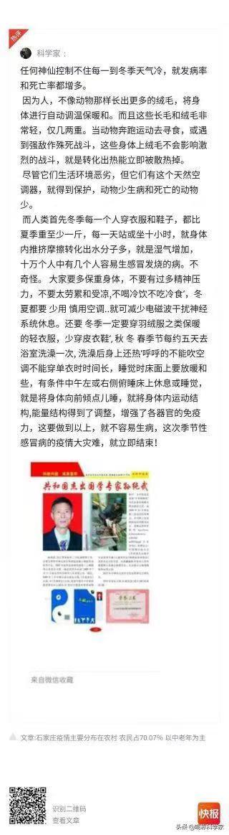

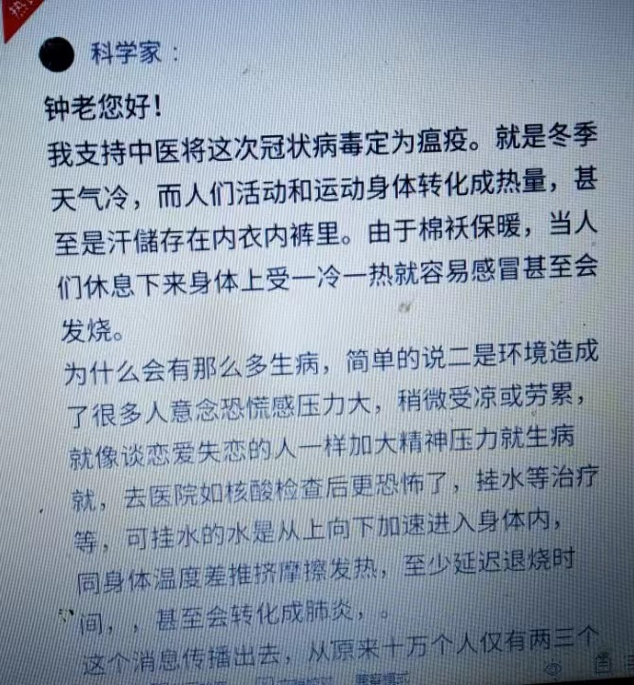
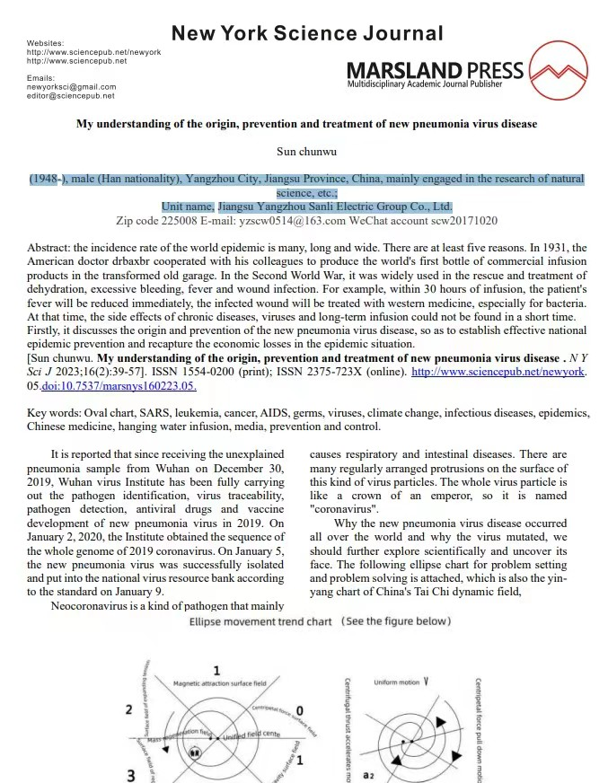

The words written before me, Yang Jing (8)
Content Introduction 9
Table of Contents (10)
"New Highlights of Natural Science" (11)
Chapter 1 Strange Radiance
Chapter 2: The Origin of the Universe 27
Chapter 3 Origins of All Things 54
Chapter 4 Wukong's Landing on the Moon 59
Chapter 5 How Can Cancer Not be Cured 79
Six Chapters: Good and Evil Will Always Have a Return 105
Chapter 7: A Heavy and Long Way to Go 131
Chapter 8 Causes and Prevention of Earthquakes 152
Chapter 9: Unleashing the Eight Trigrams 170
Chapter 10 Preliminary Exploration of the Study of Unified Field Theory 196
Chapter 11 "Research on Cosmic Rotation Evolutionary Chemistry 201"
Chapter 12 Research on Seismic Evolution Chemistry 210
Chapter 13: Carbon Dioxide is Not the culprit of Climate Warming 220
Chapter 14 Why the Ice Age Arrives Irregularly 230
Chapter 15: Cosmic Microwave Background Radiation Circles
Chapter 15 230
Chapter 16 Why Genes Can Only Copy Energy 235
Chapter 16, Chapter 17: Why did the Soviet Union experience the UFO explosion over Tonks 271
Chapter 18: Why did Malaysia Airlines MH370 lose contact on its way to Beijing? 275
Chapter 19: Ordinary People Afraid of Online Viruses
Chapter 20 Request for Immediate Stop of Radiochemical Therapy for Leukemia 287
Chapter 21 "My Understanding of the Origin and Prevention of Novel Pneumonia Virus Disease 1 2 3 341"
Chapter 22: The Theory of the Soul 363
Chapter 23: Ordinary People are Scared Out of fear by Online Talking about Tiger and Turning pale 366
Chapter 24 My Experience in Disease Prevention and Treatment for Reference 368
Chapter 25<Is Cancer Not a Disease? three hundred and seventy-one
Chapter 26 Reproduction of Various First Aid Methods for Reference Only 374
Chapter 27: The Name Shaping of Tang Monk's Three Apprentices 379
Chapter 28 My Opinion on "Amitabha Buddha in the South" 371
Chapter 29 Moon Appreciation Songs 372
Chapter 30 Tears of Scientific Research 373
Chapter 31: The Bitter Song of Entrepreneurship 374
Chapter 32 Poetry 376
Chapter 33 Xinhua Online Hall of Fame Sun Chunwu 378
Chapter 34 Eccentric Vortex Engine Plan 400
Energy refers to a tool that replicates more or less energy.
The operator assumes that physical problems discovered and developed continuously will not hold onto pillars. For example, using tools such as riding bicycles or cars, the distance traveled will be different at the same time

