Analysis of the Restoration of Cotton Robes in the Western Han Dynasty

HOU Dongyu¹, GUO Zixuan^{1,2}, DENG Tianyuan³

(1. School of Textile and Garments, Hebei University of Science and Technology, Shijiazhuang, Hebei 050018, China; 2. Hebei Textile and Garment Engineering Technology Research Center, Shijiazhuang, Hebei 050018, China; 3. Zhejiang Sci-Tech University, Zhejiang Hangzhou, 310018, China.)

Abstract: The magnificent Chinese Xia, with its thousand years of ancient history, has created a brilliant and splendid costume culture. Chinese traditional costume culture wants to be valued and supported by all walks of life, and can only stand in the forest of world culture if it is based on the root of traditional culture. As an important part of traditional costume culture, the structure of traditional robes and uniforms not only contains the ancient people's concept of ritual, aesthetic interest and value orientation, but also is a symbol of ancient working people's wisdom. Therefore, combing the structure of traditional robe can enrich the knowledge of traditional costume culture. Taking the printed and colored red gauze robe of the Western Han Dynasty as the basis of research, the high knowledge of ancient people on costume making and the pursuit of costume comfort are indirectly verified through the experiments of collar edge structure, sleeve edge structure. In modern clothing design, we can learn and draw lessons from ancient clothing structure, and the design concept of ancient for the present can be regarded as the protection and inheritance of traditional clothing culture. The research results can improve the theoretical study of the garment structure and provide methods and scientific basis for the study of its restoration research.
[HOU Dongyu, GUO Zixuan, DENG Tianyuan. Analysis of the Restoration of Cotton Robes in the Western Han Dynasty. Researcher 2023;15(9):66-74] ISSN 1553-9865 (print); ISSN 2163-8950(online) http://www.sciencepub.net/researcher. 09. doi:10.7537/marsrsj150923.09.

Keywords: Other disciplines of clothing technology; Western Han dynasty cotton robe; Shape structure；Collar edge; Sleeve edge; Comfort

The printed and colored purpura cotton robe unearthed from the No. 1 Han Tomb of Mawangdui of the Western Han Dynasty in Changsha has a printed and colored purpura yarn as its face and a plain yarn as its edge and inner part. The pattern on the coat is composed of branches and leaves bud, stamens and hoho, branches and vines are printed with Yangwen plate, called "printing", and the rest of the patterns are painted by hand, that is, the so-called applied color. As shown in Figure 1, the printed and colored purple-dyed cotton robe is a tailored robe. Its style features are: hand over the right skirt, down sleeve. The neckline curve of the robe is in the shape of a pipa, and the back neckline shows an arc depression [1]. The collar, the sleeves, the skirt, and the train were fitted with broad trims. There are many diagonal dividing lines on the edge of the garment.
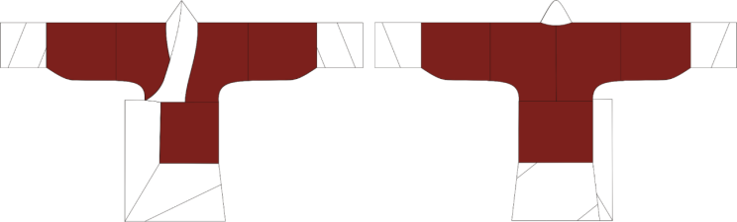
Fig. 1 Style diagram of printed and colored magnet-cotton robe

The jacket is cut 2 pieces, the sleeve is cut 2 pieces, and the bottom is cut 3 pieces [2], and the cuff, hem and collar are all cut on the diagonal. Modern clothing cuffs are small, in order to prevent the deformation of the cuff, the weft yarn with small deformation is generally used for the cuff. However, the sleeve edge of this garment is made of half-width white yarn, which is rolled and sewed into a barrel shape and folded from the outer end to the inner end according to the length of the cuff edge to form the face and inside of the cuff edge, forming a double-layer structure [3]. The production diagram is shown in Figure 3. When winding the cuff edge, the yarn direction of the fabric changes from warp to skew yarn [4], which makes the cuff have strong elasticity, the cuff bending is natural and beautiful, and enhances the luster of the silk fabric. Some scholars have explained the cuff as wide as 29cm, thinking that the wide cuff reflects the noble identity and status of the tomb owner, enhancing the beauty of the clothing, but weakening the need for warmth of the clothing. The hem of the skirt of the robe is cut diagonally. Compared with the straight hem, diagonally cut increases the drape of the hem, making the hem of the robe more fit to the human body and satisfying the aesthetic demand [5].
The traditional clothing adopts a flat cross structure, giving people a neat and elegant feeling. The cut body reduces the complexity of the process, and the cutting of the fabric cleverly uses the width of the fabric. The relationship between garment structure and human body was analyzed by means of sample making and structure drawing. The relationship between the yarn direction of the collar edge and the comfort, the width of the cuff edge and the Angle of the folding and the length of the cloth used were investigated by experiment.
1. Collar edge structure analysis
1.1 Logistic regression model of ordered variables
Ordered variable Logisitic regression model is similar to linear regression model in that both of them are used to analyze the influence of independent variables on dependent variables, but Logisitic regression model is suitable for data analysis where dependent variables are classified data [6]. Ordered variable regression is based on the method proposed by Mc Cullagh, and its mathematical model is as follows:

$${\text{η}}_{\text{ij}}\left\lceil {\text{π}}_{\text{ij}}\left(\text{Y≤j}\right)\right\rceil \text{=}\frac{{\text{α}}_{\text{j}}\text{-}\left({\text{β}}_{\text{1}}{\text{X}}_{\text{i1}}\text{+…+}{\text{β}}_{\text{p}}{\text{X}}_{\text{ip}}\right)}{{\text{σ}}_{\text{i}}}\text{ j=(1,2…J-1)}$$ | (1-1)

Where i（1,2…,m） -- the number of groups of variable X;
j（1,2…J） -- the number of categories of dependent variable Y;
k（1,2…p） -- the independent variable (X1,... XP) number;
α_{j} -- constant term; β_{k} -- regression coefficient; σ_{i} - scale parameter;
π_{ij}(Y≤j)=π_{i1+。。。}π_{ij} - cumulative probability of dependent variable Y ≤ j;
ηij[πij(Y≤j)] - link function of cumulative probability πij(Y≤j).

1.2 Collar edge comfort test
(1) The experimental basis takes the collar edge structure of printed colored red cotton robe as an example, which is composed of straight yarn collar edge and diagonal yarn collar edge, as shown in Figure 5. The ancients cleverly used the elastic characteristics of skew yarn, and the skew yarn was used around the neck. After ironing and stretching, the amount of outer neckline could be increased, which could increase the activity space of the neck and improve the comfort of the robe.

The yarn direction of the straight yarn collar edge is parallel to the cloth edge, but the yarn Angle of the diagonal yarn collar edge is unknown, the width of the collar edge is 18cm, which is a wider edge, easy to produce friction with the neck, resulting in discomfort, while the diagonal cut collar edge can better reduce discomfort. Embodies the ancient people's pursuit of beauty and comfort. The diagonal yarn collar edge is 15cm behind the center line, ensuring the comfort of the left side of the neck. Its structure diagram is shown in Figure 2.

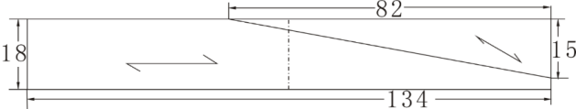
Fig. 2 Collar structure diagram

According to the literature query, the cloth width in the Western Han Dynasty was 50cm. Taking the width of the cloth as the restriction condition and each fixed point of the diagonal yarn collar edge as the fixed point rotation, the rotation Angle interval was 0-35°, 12-22° and 0-22° respectively, and the interval set was found to be 0-35°, as shown in Figure 3.

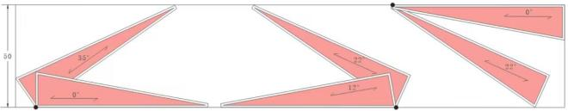
Fig. 3 Yarn Angle of collar edge

(2) Experimental purpose
The relationship between the yarn Angle of the collar edge and the comfort of the collar edge was investigated by experiment.
(3) Experimental methods
In this experiment, the length of the collar edge with a width of 15cm was taken as an example, and the slope of the fabric was divided into 8 experimental groups, which were 0°, 5°, 10°, 15°, 20°, 25°, 30°, 35°. After sewing the top edge and the body, elongate the outer collar of the skew yarn collar edge with an iron, and set it, measure the original length of the collar edge and the length after stretching and calculate the difference. All the production of the collar edge is made by the same person, and the average value of the three data is taken during measurement. After the sample clothes were made, 200 young women aged 20-22 were selected for wearing experiments, and the comfort evaluation of different sloping collar edges was completed in turn.
(4) Experimental results and analysis
Through the production of the collar edge, the collar edge of 0° to 35° can be obtained, as shown in Figure 8. It can be obviously observed from the picture that there are more folds on the side of the collar edge of 0° to 15°, and the collar edge is not extended. The 20°-35° collar edge is relatively flat, without too many folds. It can be seen that the skew yarn collar edge is stretched by ironing, so that the collar outer mouth is lengthened, reducing the constraint on the neck, and its beauty is also improved.
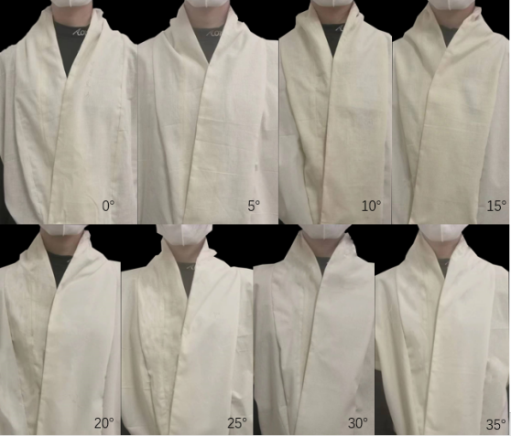
Fig. 4 Sample collar edge of 0°-35°

The experimental data of bevel cut collar edge length S1 before ironing, bevel cut collar edge length S2 after ironing and expansion amount S3 can be obtained through measurement and calculation. The detailed data are shown in Table 1. As shown in Figure 9, the values of S1, S2 and S3 all increase with the increase of yarn inclination. When the yarn Angle of the collar edge is small, its expansion amount is small, but when the yarn Angle of the collar edge is large, its expansion amount is large, so that it produces a certain gap amount in the neck.

Tab. 1 The relationship between the yarn direction of the collar edge and the amount of yarn spread
Yarn Angleθ(°) | S1(cm) | S2（cm） | S3（cm）
0 | 82 | 82 | 0
5 | 82.5 | 82.9 | 0.4
10 | 82.6 | 83.2 | 0.6
15 | 82.6 | 83.9 | 1.3
20 | 82.9 | 84.4 | 1.5
25 | 83.0 | 85 | 2
30 | 83.0 | 85.9 | 2.9
35 | 83.2 | 87.3 | 4.1

The comfort evaluation of 200 wearers is shown in Figure 2. It can be seen from the table that the number of wearers' comfort evaluation increases with the increase of the Angle of the skew collar edge yarn. The results show that with the increase of the yarn Angle of the collar edge, its comfort is improved correspondingly.

Tab. 2 The relationship between yarn direction and comfort of the collar edge
Yarn Angleθ(°) | Very uncomfortable | Uneasiness | Normal | Comfort | Very comfortable
0 | 39 | 136 | 14 | 9 | 2
5 | 38 | 129 | 22 | 8 | 3
10 | 31 | 136 | 22 | 8 | 3
15 | 26 | 121 | 36 | 12 | 5
20 | 18 | 122 | 41 | 11 | 8
25 | 7 | 84 | 64 | 36 | 9
30 | 3 | 58 | 59 | 52 | 28
35 | 2 | 41 | 62 | 52 | 43

In order to explore the relationship between yarn slope and comfort, the ordered variable Logisitic regression model was used to predict the comfort evaluation. The dependent variable in the data was comfort evaluation divided into five levels: very uncomfortable, uncomfortable, average, comfortable, and very comfortable. Selecting the slope of the yarn direction of the collar edge as the independent variable, it can be seen that the independent variable has 8 dimensions, namely 0°, 5°, 10°, 15°, 20°, 25°, 30° and 35°. The empirical model of wearer satisfaction and collar slope can be written as y= (w1,w2,w3,w4,w5,w6,w7,w8) +μ, where y is comfort, w1-W8 is the influence factor of 8 dimensions, and μ is the error term or random disturbance term. Using Logit link function in regression analysis of ordered variables can be further written as:

$\text{ln}\frac{{\text{π}}_{\text{j}}\left(\text{Y≤j}\right)}{\text{1-}{\text{π}}_{\text{j}}\left(\text{Y≤j}\right)}$=ln$\frac{{\text{π}}_{\text{1}}\text{+…}{\text{π}}_{\text{j}}}{{\text{π}}_{\text{(j+1)}}\text{+…}{\text{π}}_{\text{j}}}$=${\text{α}}_{\text{j}}\text{-}\left({\text{β}}_{\text{1}}{\text{X}}_{\text{1}}\text{+…+}{\text{β}}_{\text{p}}{\text{X}}_{\text{p}}\right)$ | (1-2)

Y -- explained variable;e;
J -- five levels of comfort j= 1,2,3,4,5 (very uncomfortable, uncomfortable, average, comfortable, very comfortable);
p represents the Angle of the skew yarn at the p collar edge that affects the comfort p=1,2,... ,8.
From this, the probability of J-1 prediction models with cumulative logit can be obtained as follows:
$${\text{π}}_{\text{j}}（\text{Y≤j}）\text{=}\frac{\text{exp[}{\text{α}}_{\text{j}}\text{-}（{\text{β}}_{\text{1}}{\text{X}}_{\text{1}}\text{+}{\text{β}}_{\text{P}}{\text{X}}_{\text{P}}）\text{]}}{\text{1+exp[}{\text{α}}_{\text{j}}\text{-}（{\text{β}}_{\text{1}}{\text{X}}_{\text{1}}\text{+…+}{\text{β}}_{\text{P}}{\text{X}}_{\text{P}}）\text{]}}$$ | (1-3)

Table 3 shows the results of parallel line test. Since the significance P value =0.935>0.05 indicates that the position of the comfort cut point will not cause changes in the regression coefficients of each skew yarn Angle, the model passes the parallel line test and can be further analyzed.

Tab. 3 Parallel line test table
Model | -2 Logarithmic likelihood | Chi-square(i) | df | Significance P-value
Null hypothesis | 153.417 | — | — | —
routine | 141.233 | 12.184 | 21 | 0.935

More accurate in the multivariate ordered Logitic regression model is the likelihood ratio test. The null hypothesis of this test is that the coefficient of all the null hypothesis independent variables is zero, as shown in Table 4. After all the independent variables are included, the significance P-value is less than 0.001, so the null hypothesis is rejected and the model is meaningful as a whole.

Tab. 4 Model fitting information table
-2 Logarithmic likelihood | Chi-square(i) | df | Significance P-value
629.718 | — | — | —
153.417 | 476.301 | 7 | 0.000

Table 5 shows the parameter estimation and test results, where the estimated value (E) is the regression coefficient and intercept; Wald is Chi-square value, and the larger the value, the stronger the significance of the estimated value. A 95% confidence interval (CI) means that the estimate has a 95% probability of falling within the interval. Taking the straight yarn collar edge as an example, the Logtic model which can be substituted into formula 5-3 to list the cumulative probabilities between different subgroups is as follows:
$$\hat{\text{p}}\text{（comfort≤1）=}\frac{\text{exp（-4.447+3.096）}}{\text{1+exp（-4.447+3.096）}}$$
And so on $\hat{p}$(comfort ≤2) =0.86, $\hat{p}$(comfort ≤3) =0.96, $\hat{p}$(comfort ≤4) =0.99, so the probability value of comfort level is very uncomfortable is 0.21, and the probability of discomfort is 0.86-0.21=0.65. The average probability is 0.96-0.86=0.1, the probability of comfort is 0.99-0.96=0.03, and the probability of comfort is 1-0.99=0.01. The predicted predicted value ratio is 42,130,20,6,2, and the predicted result is similar to the observed value. The overall verification shows that 89% of the difference between the predicted value and the observed value is less than 10, which further indicates that the model has a good fit.

Tab. 5 Model test estimation and test results table
 |  | Estimate(E) | Wald | df | Significance | 95% Confidence interval of
 |  |  |  |  |  | Lower limit value | Upper limit value
Threshold value | [comfort=1] | -4.447 | 691.076 | 1.000 | 0.000 | -4.779 | -4.116
 | [comfort=2] | -1.275 | 86.117 | 1.000 | 0.000 | -1.545 | -1.006
 | [comfort=3] | 0.036 | 77.251 | 1.000 | 0. 000 | -.220 | 0.292
 | comfort=4] | 1.385 | 90.463 | 1.000 | 0.000 | 1.100 | 1.670
Position | [0°=1.00] | -3.096 | 222.041 | 1.000 | 0.000 | -3.503 | -2.689
 | [5°=2.00] | -2.947 | 204.154 | 1.000 | 0.000 | -3.352 | -2.543
 | [10°=3.00] | -2.823 | 189.881 | 1.000 | 0.000 | -3.225 | -2.422
 | [15°=4.00] | -2.378 | 142.652 | 1.000 | 0.000 | -2.768 | -1.987
 | [20°=5.00] | -2.130 | 118.552 | 1.000 | 0.000 | -2.513 | -1.746
 | [25°=6.00] | -1.151 | 39.047 | 1.000 | 0.000 | -1.513 | -0.790
 | [30°=7.00] | -0.410 | 30.452 | 1.000 | 0.023 | -0.763 | -0.057
 | [35°=8.00] | 0.000 | 0.000 | 0.000 | 0.000 | 0.000 | 0.000

Through formula: odds ratio (OR) = exp (E) to calculate the Angle of oblique yarn relative to 35 ° oblique yarn advantage than were 0.04, 0.05, 0.06, 0.1, 0.12, 0.3, 0.6, that is less than 35 ° oblique yarn led edge comfort are less than 35 degrees oblique yarn collar rim. It can be seen from the advantage ratio that the comfort of 0,°5,10° diagonal yarn collar edge is poor. There is little difference in comfort between 15° and 20° skew collar edges. The 20° skew yarn collar edge is an inflection point of comfort, and the comfort of 25° and 30° skew yarn collar edge has been significantly improved, as shown in Figure 10. It can be concluded from the experiment that the comfort of the collar edge is improved with the increase of the slope of the collar edge, the comfort of the skew yarn collar edge below 20° is lower, and the comfort of the skew yarn collar edge above 20° is higher. 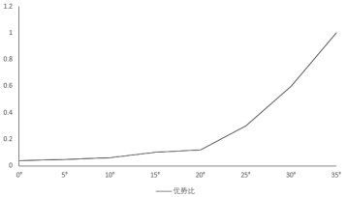
Fig. 5 Line chart of change of dominance ratio

2. Cuff structure analysis
2.1 Linear regression model
Linear regression analysis is the most basic regression analysis method, which assumes that there is a linear relationship between the independent variable and the dependent variable. The mathematical model of linear regression is shown in Formula 5-4. For linear models, the estimation method is generally used to estimate the relevant parameters. Taking unary linear regression as an example, the estimation of unknown parameters α and β satisfying the formula is called the least square estimation of unknown parameters α and β, and the estimated relevant parameters are the core of regression analysis and the basis of prediction.

${\text{y}}_{\text{i}}\text{=}{\text{α}}_{\text{i}}$+${\text{β}}_{\text{i1}}{\text{x}}_{\text{1}}$+${\text{β}}_{\text{i2}}{\text{x}}_{\text{2}}$+…+${\text{β}}_{\text{ik}}{\text{x}}_{\text{k}}$+${\text{ε}}_{\text{i}}$ | (2-1)

Where ${\text{y}}_{\text{i}}$-- explained variable;
${\text{α}}_{\text{i}}$-- The intercept term of the model
${\text{β}}_{\text{ik}}$-- Parameters to be estimated
${\text{ε}}_{\text{i}}$-- error term

2.2 Cuff structure experiment
(1) Experimental basis
As mentioned above, the winding cuff before the Han Dynasty is a unique cuff design, which uses the winding method to increase the elasticity of the cuff at the same time, and cleverly solves the problem of fabric splicing caused by the cuff due to the cloth. According to the literature inquiry, the width of the winding cuff of robe in the Western Han Dynasty was between 20cm-30cm, and a half piece of cloth, that is, 25cm wide, was used to make the cuff edge.
As shown in Figure 6, it is a schematic diagram of cuff folding. The cuff shape is formed by winding, then a cylindrical cuff is formed by cutting, and a double cuff is formed by folding inward. It can be seen from the schematic diagram that the final sleeve stitching line is actually the fabric edge, and the yarn of the sleeve edge is parallel to the stitching line.

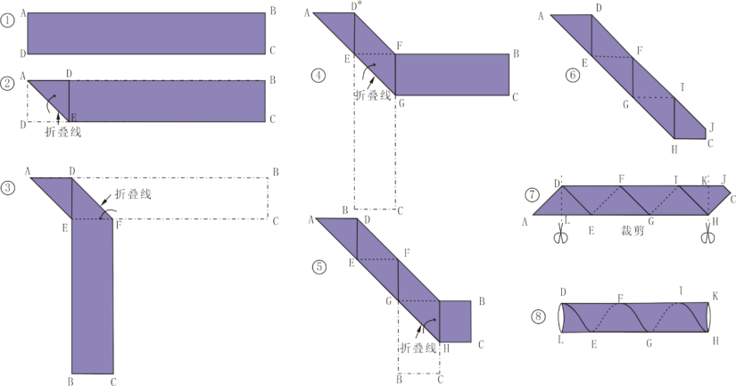
Fig. 6 Schematic diagram of cuff folding

(2) Experimental purpose
This section will verify the law of changes in cuff related properties under different cuff widths by experimental methods, and try to summarize the linear relationship between cuff of different widths and the length and folding Angle of the cloth used.
(3) Experimental methods
In this experiment, the length of 10cm cuff edge is taken as an example, and the width of the cuff S1 is divided into 10 levels, which are 20cm, 21cm, 22cm, 23cm, 24cm, 25cm, 26cm, 27cm, 28cm, 29cm and 30cm, as shown in Figure 7. Measure the folding Angle A1 (the Angle formed by the hem and the cloth edge) of the fabric during the production process, and measure the value of the fabric slope A2 of the sleeve edge, the length of the fabric used L1 and the maximum shape variable L2 of the length after the production is completed. All the cuffs are made by the same person, and the average of the three measurements is taken.

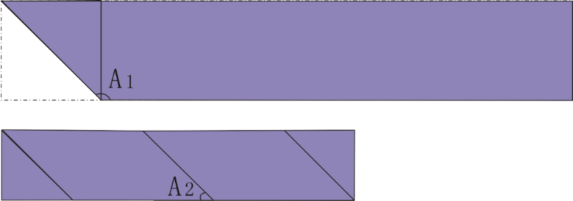
Fig. 7 Measuring method of yarn slope and folding Angle

- Experimental results and analysis
By making cuff edges, experimental pictures of cuffs ranging from 20cm wide to 30cm wide can be obtained, as shown in Figure 14. It can be clearly observed from the picture that the yarn Angle of the cuff edge increases with the increase of the cuff width.

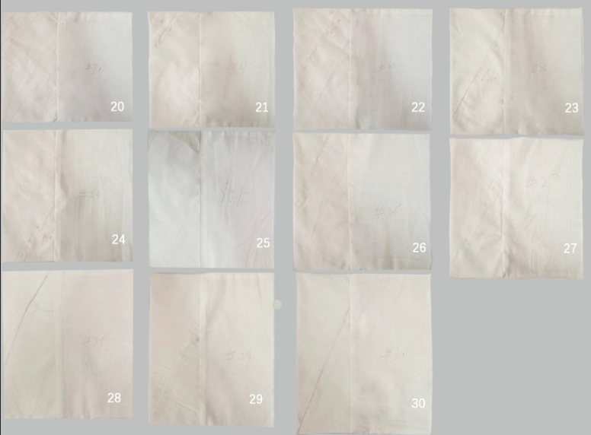
Fig. 8 20-30cm wide cuff

The experimental data in Table 6 can be obtained by measuring the length L1 of the cloth, the maximum shape variable L2, the folding Angle A1, and the yarn slope A2 of the cuff edge.

Tab. 6 Data recording table of cuff related indexes of different widths
S₁（cm） | L₁（cm） | L₂（cm） | A₁（°） | A₂（°）
20 | 37.6 | 3.1 | 126 | 55
21 | 39 | 2.8 | 124 | 58
22 | 40.7 | 2.7 | 123 | 60
23 | 44 | 2.6 | 122 | 62
24 | 46 | 2.5 | 120 | 63
25 | 47.5 | 2.5 | 119 | 65
26 | 50 | 2.3 | 117 | 67
27 | 53 | 2.2 | 115 | 68
28 | 54 | 2.2 | 113 | 70
29 | 56 | 2.1 | 110 | 71
30 | 58.5 | 2 | 109 | 72

The data were imported into SPSS for correlation analysis, and the correlation analysis table in Table 7 was obtained. When the correlation coefficient reaches 0.7-1.0, it is considered as a strong correlation, and when the significance level is less than 0.01, it is considered that the correlation between the data is more reliable and the data results are convincing. According to Table 7, pearson correlation coefficients are all greater than 0.9, and significance is less than 0.01, indicating that cuff width is highly correlated with fold Angle A1, fabric slope A2, fabric length L1, and maximum shape variable L2 in the length direction.
Tab. 7 Correlation analysis table
 |  | Cuff width（cm） | L1（cm） | L2（cm） | A1（°） | A2（°）
S₁（cm） | Pearson correlation | 1 | 0.998** | -0.979** | -0.993** | 0.993**
 | Significance (double tail) | — | 0.000 | 0.000 | 0.000 | 0.000
L₁（cm） | Pearson correlation | 0.998** | 1 | -0.977** | -0.988** | 0.990**
 | Significance (double tail) | 0.000 | — | 0.000 | 0.000 | 0.000
L₂（cm） | Pearson correlation | -0.979** | -0.977** | 1 | 0.963** | -0.989**
 | Significance (double tail) | 0.000 | .000 | — | 0.000 | 0.000
A₁（°） | Pearson correlation | -0.993** | -0.988** | 0.963** | 1 | -0.977**
 | Significance (double tail) | 0.000 | 0.000 | 0.000 | — | 0.000
A₂（°） | Pearson correlation | 0.993** | 0.990** | -0.989** | -0.977** | 1
 | Significance (double tail) | 0.000 | 0.000 | 0.000 | 0.000 | —

Data were imported into spss for linear regression analysis, cuff width value was set as independent variable, folding Angle A1 and cloth length used as dependent variable, and Table 8 was obtained. Where B is the non-standardized regression coefficient, Beta is the standardized coefficient, and the absolute values of t are all greater than 2, indicating that the regression equation has a good prediction effect, and the significance level Sig is less than 0.01, indicating that the established regression equation is meaningful.

Tab. 8 Linear regression statistical scale
 |  | Nonnormalized coefficient |  | Standard coefficient | t | Sig.
 |  | B | Standard error | Beta
A1 | （constant） | 160.727 | 1.735 | — | 92.660 | 0.000
 | Cuff width（cm） | -1.709 | 0.069 | -0.993 | -24.829 | 0.000
L1 | （constant） | -5.427 | 1.188 | — | -4.567 | 0.001
 | Cuff width（cm） | 2.131 | 0.047 | 0.998 | 45.181 | 0.000

Table 8 shows that:
A1=160.727-1.709*S1 | （2-2）
L1=-5.427+2.131*S1 | （2-3）

3. Conclusion
(1) The skew yarn Angle and comfort feeling of the collar edge are analyzed. The results show that the comfort of the collar edge with 0-20° yarn direction is poor, the comfort of the collar edge with 20° yarn direction is the inflection point of comfort, and the comfort of the collar edge with 25-35° yarn direction is significantly improved.
(2) The relationship between the width of different cuffs, the Angle of the cuff edge and the length of the cloth used was analyzed, and the results showed that: Folding Angle A1 is highly negatively correlated with cuff width S1, and the relationship follows A1=160.727-1.709*S1; fabric length L1 is highly positively correlated with cuff width S1, and the relationship follows L1=-5.427+2.131*S1.

References:

[1] Liu Ruipu, Shao Xinyan, Ma Ling, et al. A study on the structure of classical Chinese clothing -- a study on the structure of typical robes in the late Qing Dynasty and the early Republic of China. Beijing: Guangming Daily Press,2009:7
[2] Li Laiyu. Clothing of the owner of Mawangdui Tomb No. 1 -- Yunxiang clothes series.
http://www.kaogu.cn/cn/kaoguyuandi/kaogubaike/2015/0820/51196.html,2015-08-20
[3] Mr. Goody. Mawangdui unearthed costumes at a glance.
http://minsu.httpcn.com/info/html/2019727/PWCQUYRNM EXV.shtml,2019-7-27
[4] Zhou Yongxiang. Selection and application of yarn direction of clothing fabric. Chinese Manual,2021(01):55-56
[5] Zhang Ling. The structural characteristics and tailoring skills of Qu Train robes in Han Dynasty -- A case study of female costumes unearthed from Mawangdui No.1 Han Tomb. Fashion Guide,2016,5(02):47-54
[6] Huang Wen-wen. Statistical analysis and application of SPSS. Beijing: Publishing House of Electronics Industry,2016:232.

9/22/2023

