Cleavage site analysis of Highly Pathogenic H5N1 Avian Influenza Isolates from Egypt.

¹Maha, A.N. Gamal,²Eman M. S. El-Nagar and ¹Soliman, Y.A.

¹Central Laboratory for Evaluation of Veterinary Biologics (CLEVB), Agricultural Research Center (ARC), Cairo.
²Veterinary serum and vaccine research institute (VSVRI), Agricultural Research Center (ARC), Cairo.
(dryousefadel@gmail.com )

Abstract: Avian influenza virus A (AIV) is found in most instances in birds, and rarely in humans. Sporadic confirmed cases of human infection have been reported since 1997 by H5N1 subtype. In the current study, a highly pathogenic avian influenza subtype H5N1 was isolated from infected birds and confirmed by PCR and sequencing. Sequence analysis revealed some degree of heterogeneity between different isolates in different years. The poly-basic amino acid sequence of the isolated virus was similar to the highly pathogenic strains of H5N1 (PQ↓ (G/R) EKRRKKR↓GLF) with some strains having differences in the (G>R) a singleamino acid within the cleavage site motif. The deduced amino acid sequence analysis of the isolated 9 strains of HPAI(H5N1 subtype) revealed a high degree of homology.
[Maha, A.N. Gamal, Eman M. S. El-Nagar and Soliman, Y.A. Cleavage site analysis of Highly Pathogenic H5N1 Avian Influenza Isolates from Egypt.. Researcher 2023;15(9):1-11] ISSN 1553-9865 (print); ISSN 2163-8950 (online) http://www.sciencepub.net/researcher. 01.doi:10.7537/marsrsj150923.01.

Keywords: avian influenza; Hemagglutinin gene; highly pathogenic; cleavage site; sequencing.

Introduction:
Avian influenza is caused by a virus member of the family Orthomyxoviridae, genus influenza virus A. Diagnosis depends on the isolation of the virus followed by molecular characterization of the cleavage site to declare its pathogenicity nature. Infections in birds are characterized by a wide variety of clinical manifestations that may vary according to the species, the strain of the virus, the host's immune status, the presence of any secondary exacerbating organisms, and environmental conditions (OIE 2012).
Infection in chickens with highly pathogenic avian influenza virus (HPAIV) H5N1 is similar to infection with other HPAIV viruses (Perkins and Swayne 2001; Els et al., 1989 and Palese et al., 1974). the most noticed symptoms include swollen hemorrhagic necrotic wattle and comb, congested, cyanosed shank and claws with the development of Dermal hemorrhagic spots that considered to be the classical signs. Hemorrhageand comamay lead to peracute death without clinical signs (Swayne 1997 and Kobayashi et al., 1996). Gross lesions include subcutaneous edema, mottled pancreas, petechial hemorrhage on the surface of serosa, splenomegaly, renomegaly, systemic congestion and hemorrhage, pulmonary congestion and /or hemorrhage and edema with lung consolidation, conjunctival hyperemia, edema and hemorrhage of the enteric tract.

Avian influenza virus’s pathogenicity depends on the sequence of the cleavage site; HPAIV possess multiple basic amino acid residues, which is a prerequisite factor for pathogenicity in chicken, while the low pathogenic avian influenza virus (LPAIV) strains do not. HA sequences with monobasic cleavage site (e.g. HA1-PSIQVR-GL-HA2) are cleaved by tryptase produced by respiratory and digestive tract epithelium (Luczo et al., 2015 ; Whittaker 2001; Chen et al., 2004 and Air and Laver 1989). haemagglutinin gene sequences with polybasic amino acid cleavage sites (e.g. HA1-KKREKR-GL-HA2), allow proteolysis by proteases such as furine and pro-protein-convertase6 (PC6) found in Golgi apparatus of all cells (Horimoto et al., 1994 and Thorlund et al., 2011). AIV with polybasic cleavage sites has an unlimited distribution network and may cause fatal systemic infection. A cleavage sequence containing several basic amino acids is more readily activated by cellular proteases present in a variety of cells distributed throughout the body compared with a cleavage sequence containing only a single basic amino acid, which can be cleaved by a limited range of cellular proteases. It is well-accepted that influenza viruses containing multiple basic amino acids have multiple sites of virus replication and produce more severe infections in birds and mammals (Zambon, 2001).
Since these 2 genes are the most important genes that shape and characterize the pathogenicity of AIV, the current research focuses on the molecular characterization and genotypic analysis of these 2 genes in seven different AIV strains that were isolated from Egypt.

Material and Methods:
1. Virus isolation:
Tracheae of morbidor freshly died chickens from poultry farms showing severe clinical signs of influenza infection (Table 1) were swabbed. The swabs were soaked in phosphate-buffered saline (pH7.2) containing 100 U/ml penicillin and 100µg/ml streptomycin. The solution was then centrifuged at 7000rpm/10min/4 °C, then inoculation in 9-day-old SPF chicken eggs (Wu et al., 2008and Xu et al., 1999) via the allantoic route. The eggs were incubated at 37°C in a humid chamber until embryo death (usually within 24 hours) and the chorioallantoic fluid was collected and clarified by centrifugation.

2. Virus identification:
The clarified virus was identified by haemagglutination (HA) (Killian 2008) and haemagglutination inhibition (HI) assays (Katz et al., 2009, and Potter and Oxford 1979) using monospecific antisera against H5N1. The validity of the results was assessed against a negative control serum. Monospecific antisera against Newcastle disease virus (NDV) and Adenovirus were used to test the purity of the isolated H5N1 stains from extraneous haemagglutinating agents.

2.3. Amplification of the cleavage site of the H5N1 and the full N1 gene from all the 7 isolated HPAIV by RT-PCR amplification
Avian influenza RNA was purified from the clarified Allantoic fluid (Sambrook et al., 1989), by QIAamp Viral RNA Mini Kit (Qiagen Germany, cat #52904), according to the manufacturer’s instructions. The cleavage site of the H5N1 isolates was amplified using AffinityScript®One-Step RT-PCR Kit (Agilent USA, cat # 600188). Fifty nanograms of the purified RNA were included in each reaction using primers that target the cleavage site of the HA gene or the full-length neuraminidase H5 gene (Table 2). The amplicons were separated by electrophoresis on a 1% agarose and the size of the amplicons was determined using SynGenetool software V4.01 (SynGen Corporation, Cambridge, England). A previously well-identified HPAIV (Soliman et al., 2016) was included as a positive control.
2.4. Sequencing:
The complete nucleotide sequences of the cleavage sites and full-lengthhaemagglutinin gene of the 9 isolated strains of HPAI-H5N1 were studied in the current paper. For the preparation of the gene for sequencing, the PCR product was separated on 1% low melting agarose. The corresponding bands were purified with the Biospin PCR purification kit (Biobasic cat # BSC03S1) as described by the manufacturer. Sequencing was performed using ABI PRISM 3730XL Analyzer using BigDyeTM Terminator Cycle Sequencing Kits with AmpliTaq® DNA polymerase (FS enzyme Applied Biosystems), following the protocols supplied by the manufacturer. Samples were subjected to electrophoresis in an ABI 3730 xl sequencer (applied biosystem) in a single-pass sequencing process that was performed on each template using the primer used for PCR amplification.

2.5. Analysis:
The nucleotide and deduced amino acid sequence analysis and the phylogenetic trees were performed using Lasergene DNASTAR software Version 15.For comparison different Egyptian isolates were retrieved from the gene bank (https://www.ncbi.nlm.nih.gov/nuccore) and used for nucleotide and deduced amino acid sequence alignment using ClastalW algorithm as well as phylogenetic tree alignment.

Table 1. the geographic distribution and the chicken breeds of the isolated strains of (HPAT-H5N1 subtype) during 2010-2015
Virus mane | year of sampling | breed of the birds | province
A/chicken/ Kalyobia/ch1.12.3/2010(H5N1) | Dec-10 | Cobb | Kalyobia
A/chicken/ Kalyobia/ch1.12.5/2010(H5N1) | Dec-10 | Baladi | Kalyobia
A/chicken/ Sharkia /ch2.1.6/2011(H5N1) | Jan-11 | White Lohmann | Sharkia
A/chicken/ Kalyobia /ch2.1.7/2011(H5N1) | Jan-11 | Cobb | Kalyobia
A/chicken/Mansoura/ch2.2.12/2011(H5N1) | Feb-11 | Arbo | Mansoura
A/chicken/ Kalyobia/ch2.1.10/2011(H5N1) | Jan-10 | White Lohmann | Kalyobia
A/chicken/ Kalyobia/ch2.2.18/2011(H5N1) | Feb-11 | White Lohmann | Kalyobia
A/chicken/ Kalyobia/ch11.5.9/2014(H5N1) | May-14 | Cobb | Kalyobia
A/chicken/ Gharbia/ch15.1.12/2015(H5N1) | Jan-15 | Baladi | Gharbia

Table 2 primer sequences used for amplification of the cleavage site and the full length haemagglutinin gene of HAPI isolates
Primer name | Target gene | Sequencing primer (5'- 3') | Expected amplicon size
CsH5-f | Cleavage site | 5’–CCT-CCA-GAA-TAT-GCG-TAG -3’ | 315 bp
CsH5-r |  | 5’ - TAC-CAA- CCG- TCT- ACC- ATG- CCG -3’.
H5-f | H5 gene | 5’ - AGCAAAAGCAGGAGGTTAAAAGGA-3’. | 1710 bp
H5-r |  | 5’ - TAGCAACAAGGAGGTTTTTGAACAACC -3’.

Results:

1. Virus isolation and characterization:
The clinical signs of AIV infection in poultry farms included a drop in egg production, hemorrhagic spots on the leg shafts, and swollen cyanotic combs. In the postmortem examination (PM), there was severe muscular hemorrhage, with petechial hemorrhage on the peritoneum and coronary fat. The mortality rate increased ~ 90% of the birds within 3 days. Dead birds were transported, on ice, to the lab and individual swabs were taken from the trachea and inoculated in the SPF embryonated chicken eggs.
.2. Hemagglutination test.
Chorio-allantoic fluid obtained from all inoculated eggs was subjected first to rapid (slide) HA assay to test for the presence of haemagglutinating agents. Those with negative results were excluded from the study (usually no embryonic deaths were observed with these samples till72 h post-inoculation), the samples gave HA ranged from 9 -12 log2 which mainly depends on virus concentration in the tested samples.
3. Hemagglutination inhibition test.
The chorioallantoic fluid of the samples was diluted to obtain 4HA unit which was used for HI assay using anti-H5N1 monospecific antisera, NDV antisera, or Adeno monospecific antisera. All the test samples gave no reaction with the monospecific antisera against NDV or Adenovirus, but all samples gave positive inhibition to the agglutination using the monospecific antisera against H5N1. The titer ranged from 6 – 9 log2.
4. RT-PCR:
SPF eggs with embryo mortalities within 24 h and positive HA and HI were subjected to further analysis by RT-PCR using specific primers directed towards the H5 cleavage site and the full-length H5 gene of the HPAIV. A clear visible band with a molecular size of ~ 315 bp having high intensity was seen for the cleavage siteand 1710 bp for the full H5 gene (Figure 1).

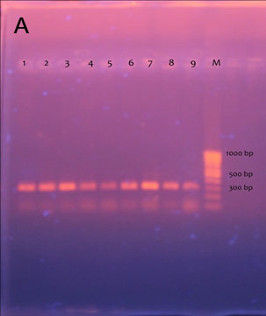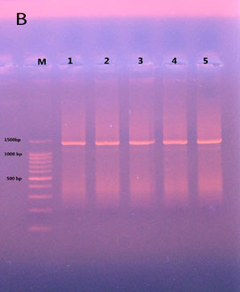
Figure 1 A representative amplification of the cleavage site (A) and the full length haemagglutinin gene (B) from the isolated HPAI

5. Sequencing analysis of the cleavage site of the H5 gene and the full H5 gene:
Thefull-length H5 gene sequence of the 9 isolated strains of HPAI-H5N1 along with the retrieved sequence was aligned based on both the nucleotide and deduced amino acid sequence (Figure 2), and the phylogenetic tree has been constructed.
Based on the nucleotide sequence, all Egyptian isolated were grouped into four closely related groups all belonging to clade 2.2. With a difference not exceeding 2% of the total nucleotide compositions (Figure 4). When deduced amino acid was aligned and the phylogenetic tree was constructed (Figure 5) however, the isolated were gathered in only 3 groups with all the currently studied isolated grouped in the 2ndgroup. It was noticed also the GD isolate of China(the first isolated H5N1 strain in GD provincial of China) was widely apparat from all the Egyptian isolates with on the bases of nucleotide or deduced amino acid sequence.
Concerning the cleavage site (Figure 3), only 2 substitutions were found among the studied strains of HPAI-H5N1 where G>R in one isolate (chicken-1.12.3-CLEVB-2010) this mutation is found in the first isolate of H5N1 in china ( Goode-GD-97) isolate and in one isolate of 2013 (chicken-13133S-2013). The remaining studied isolates retain the cleavage site motif signature of GERRRKKR.

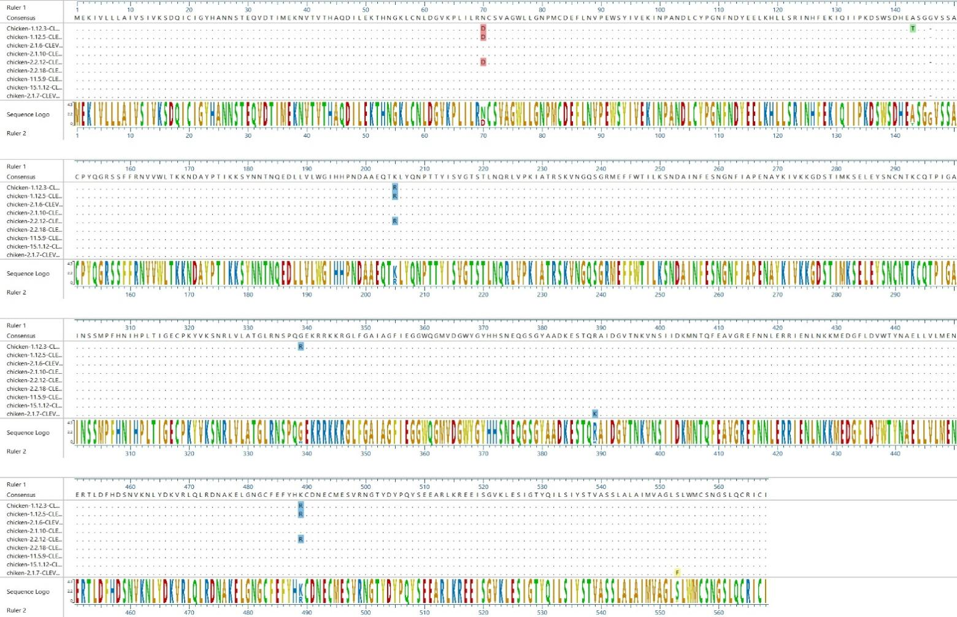
Figure 2. The deduced amino acid sequence alignment of the 9 HAPI-H5N1 Egyptian isolates of the current study

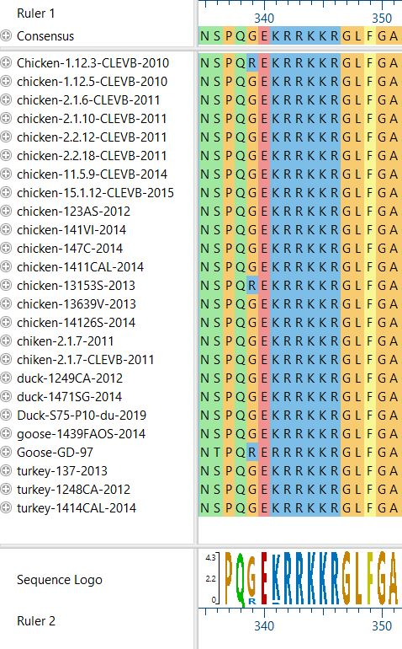

Figure 3.Alignment of the deduced amino acid sequences of the cleavage site of the isolated HPAI-H5N1 strains . The Alignment comparison of the deduced amino acid sequences of the cleavage site of the H5 gene showed the Egyptian AI viruses. Note the HA cleavage sequence was conserved in most sequence (GEKRRKKRG) with the exception of 3 strains

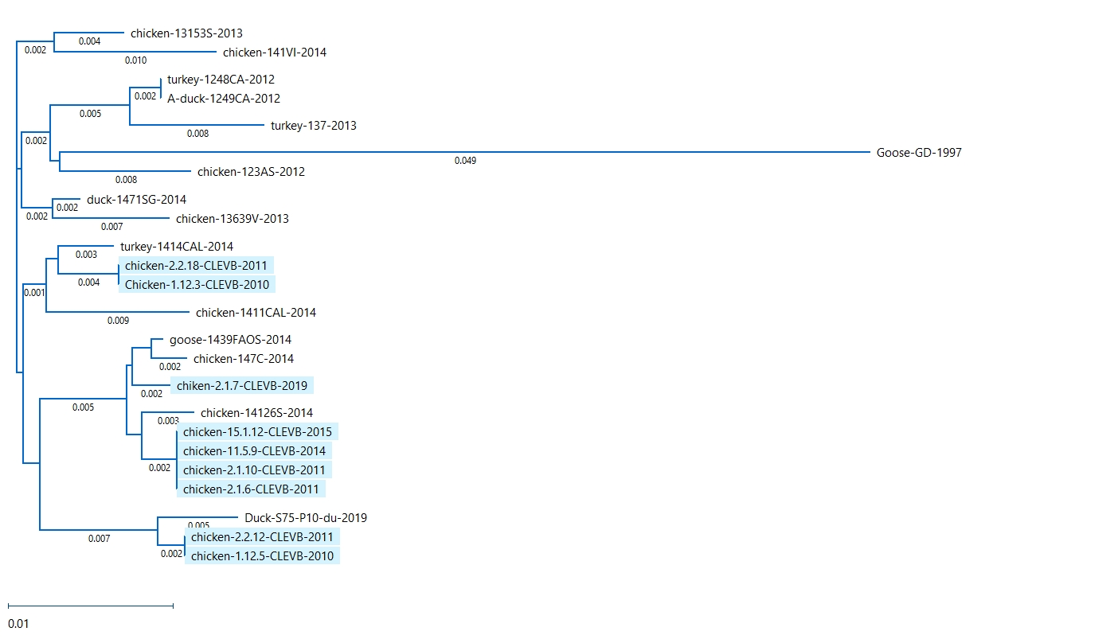
Figure 4. the phylogenetic tree constructed based on nucleotide sequence of the full H5 of the strains isolated in the current study ( blue labelled) as well as other Egyptian isolates retrieved from the gene bank covering the period from 2010-2019

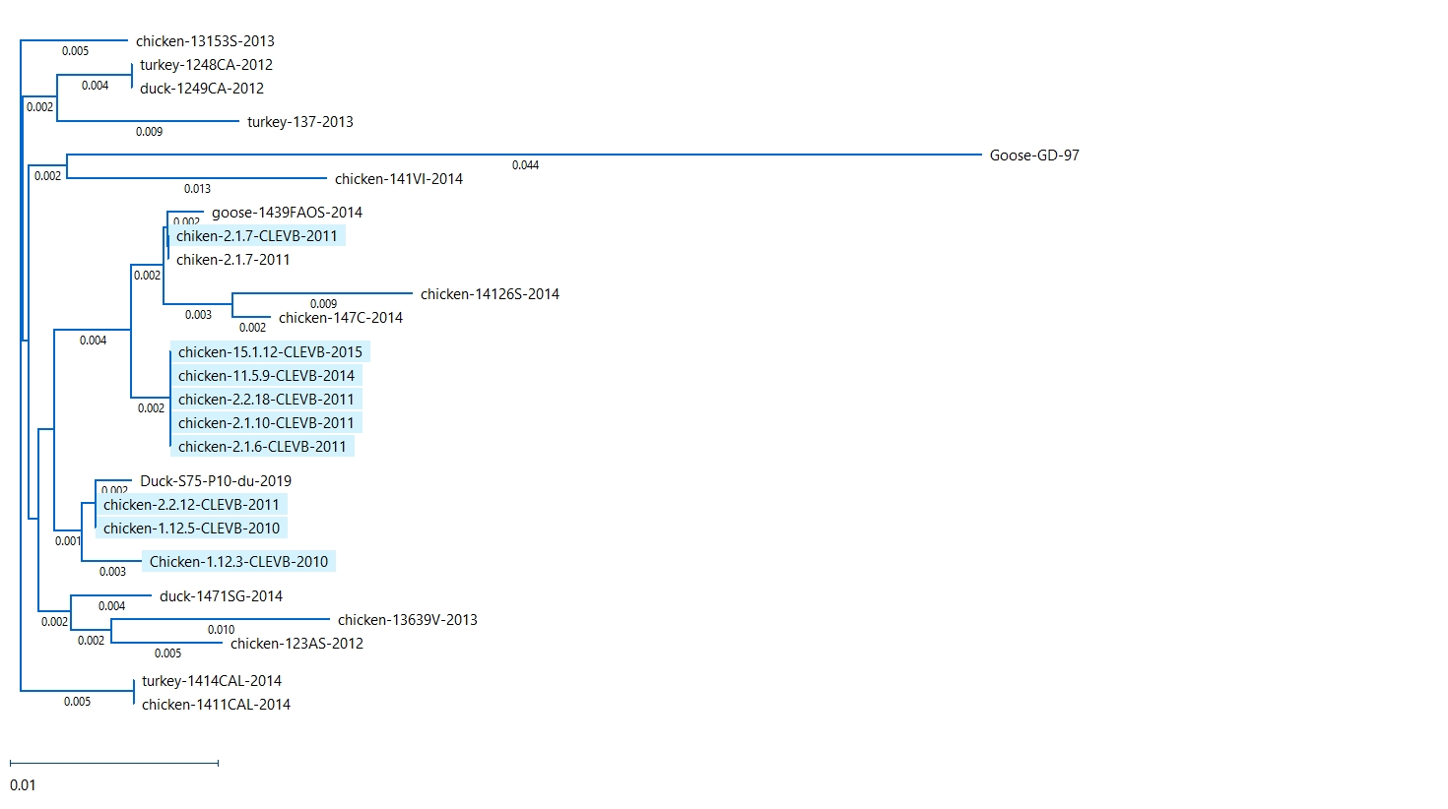
Figure 5. The phylogenetic tree constructed based on the deduced amino acid sequence of the full H5 of the strains isolated in the current study ( blue labeled) as well as other Egyptian isolates retrieved from the gene bank covering the period from 2010-2019

Discussion:

Since re-emerging in 2003, avian influenza viruses of the H5N1 subtype have spread from Southeast Asia across central Asia and the Middle East into Europe and Africa by infecting wild birds and poultry. New influenza viruses are emerging each year and are leading to significant genetic variation among H5N1 viruses (Wu, 2008).
AIV which is characterized by intravenous pathogenicity indices of greater than 1.2is termed highly pathogenic (Hoffmann et al., 2007). HPAIV characteristics were only maintained in the strains of H5 and H7 subtypes that cause disastrous epidemic disease in poultry (Capua and Mutinelli, 2001). The presence of a polybasic cleavage motifwith subtilisin-sensitive endoproteolytic properties within the haemagglutinin (HA) precursor protein (HA₀) has been envisagedto be a candidate marker for HPAIV (Perdue and Suarez 2000). AIV strains of low pathogenicity, in contrast, reveal a monobasic composition at this site, which is targeted by tissue-specific, trypsin-like proteases.
Samples were taken from the freshly harvested chickens of representative governorates and subjected to extensive molecular characterization of the cleavage site of the H5 gene. The farms, from which the samples were taken, had mortalities that approached 100%, with few symptoms in most cases. Some farms with relatively low mortalities showed the classical symptoms in the form of hemorrhagic spots on the shank and coronary tissue. These findings were also reflectedin the virus titration; some of the isolates gave a very high HA titer, which was validated by back titration of the virus, and the HI titer using 4HA units, which also gave a very high titer. These findings may be attributed to the high viral load in the farms or the absence of appropriate vaccination programs; also, some inadequate protocols for vaccinations might provoke immune stressors, which might result in vaccination-induced mutations that admit the virus to escape the immune response (Cameron et al., 2008).
The isolates were subjected to further molecular investigations through the amplification of the cleavage site of the HA gene. All the tested strains gave a positive amplicon at 300bp for the CS denoting the H5N1 nature of all isolates.
All of the seven H5N1 isolates from Egypt belong to the highly pathogenic avian influenza as they contained the amino acid sequence PQGE (R/G/) RRKKR↓GLF at the cleavage site in the HA molecule, indicating their high virulence (Luczo et al., 2015 and Horimoto et al., 1995) and representing the clade 2.2. Other slightly different sequenceshave been seen in other clades (clade 2.3) whereas the sequence QRERRRKKR or QRESRRKKR were isolated from 2003 -2007 in South East Asia (Susanti et al., 2008). This cleavage sequence was slightly different from that of A/Hong Kong/156/97(H5N1) virus PQRERRRKKR↓G as the 3rd amino acid was substituted from R in Hong Kong strains to G in all Egyptian strains except only 2 isolated (Figure 3) (Subbarao et al., 1998). Avian influenza viruses with high and low levels of pathogenicity differ in their cleavage sequence, the former possess multiple basic amino acid residues, while the latter does not. A cleavage sequence containing sundry basic amino acids is more readily activated by cellular proteases present in a variety of cells distributed throughout the body compared with a cleavage sequence containing only a single basic amino acid, which can be cleaved by a limited range of cellular proteases. HA sequences with monobasic cleavage site (e.g. HA1-PSIQVR-GL-HA2) are cut by tryptase yielded from respiration and digestive tract epithelia (Whittaker 2001; Chen et al., 2004). on the other hand however, the presence of polybasic amino acids at the cleavage site (e.g. HA1-KKREKR-GL-HA2) allow the proteolysis process to be advocated by proteases such as furin and pro-protein-convertase 6 (PC6) found in Golgi apparatus of all cells (Horimoto et al. 1994). AI virus with polybasic cleavage sites have an unlimited distribution network and may cause fatal systemic infection.
These strains with high virulence signature have been observed in only two of the 17 described HA subtypes in birds that emerge only occasionally but can cause devastating mortality in poultry flocks (Horimoto et al., 1995). The insertion responsible for the ubiquitous cleavage adds additional basic amino acids at the cleavage site (Senne et al., 1996and Munch et al.,2001), with a minimal motif of R/L-X-R/L-R. Until recently, this mutation had been found only in avian viruses of the H5 and H7 subtypes, subtypes that were not thought to infect humans. This barrier was broken dramatically in 1997 in Hong Kong when 16 people were infected with an avian H5N1 influenza virus (CDC 1998; CDC 2006 and CDC 2011).
Phylogenetic analysis of the 9 isolates strains revealed that all samples were grouped togetherwith 99 % confidence except isolate chicken-1.12.3-CLEVB-2010 which showed some degree of heterogeneity. These strains shared similar amino acid sequences at the cleavage site {PQ↓ (G/R) EKRRKKR↓GLF} and also the same HA titer (11 log 2) and HI titer.

Conclusion:
In conclusion, Egyptian isolates from different governorates showed minimal differences in either HA or HI titer and very low degree of heterogeneity on the level of nucleotide and amino acid sequence specifically at the cleavage site of the HA gene and full H5 gene.
Compliance with Ethical Standards
This research did not receive any specific grant from funding agencies in the public, commercial, or not-for-profit sectors.
Conflict of Interest:
The authors declare that they have no conflict of interest.
Ethical approval:
“All procedures performed in studies involving animals were in accordance with the ethical standards of the institution or practice at which the studies were conducted.”

Corresponding Author:
Dr. Yousef adel
Department of Biotechnology
Central Laboratory for Evaluation of Veterinary Biologics (CLEVB), Agricultural Research Center (ARC), Cairo.
Telephone: 0111888023
- mail: dryousefadel@gmail.com

References:
- OIE,.Terrestrial Animal Health Code.avian influenza2012. www.oie.int/eng/normes/mcode/en_chapter_2.7.12.htmS, 2005.
- Perkins, L.E. and Swayne, D.E.Pathobiology of A/chicken/Hong Kong/220/97 (H5N1) avian influenza virus In seven gallinaceous species. Vet Pathol. .2001Mar;38(2):149-64
- Els, M.C.; Laver, W.G. and Air, G.M. Sialic acid is cleaved from glycol conjugates at the cell surface when influenza virus neuraminidases are expressed from recombinant vaccinia viruses. Virology 1989.. 170(1):346-351.
- Palese, P; Tobita, K.; Ueda, M.; and Compans, R.W. Characterization of temperature sensitive influenza virus mutants defective in neuraminidase. Virology; 1974.61:39-410.
- Swayne, D.E..Vaccines for list A poultry disease: emphasies on avian influenza.Dev.Biolo (Basel) 1997114:201-212
- Kobayashi, Y.; Horimoto, T.; Kawaoka, Y.;Alexander, D.J. and Itakura, C. Pathological studies of chickens experimentally infected with two highly Pathogenic avian influenza viruses. Avian Pathol. 1996 Jun; 25(2):285-304
- Luczo,M. J. et.al., Molecular pathogenesis of H5 highly pathogenic avian influenza: the role of the haemagglutinin cleavage site motif, Medical Virology 2015 Vol. 25 Issue 6 Pages 406-430
- Whittaker, G.R.Intracellular trafficking of influenza virus: Clinical implication forMolecular medicine.
Expert Reviews in Molecular Medicine 2001
- Chen,H.; Deng,G.;Li, Z.; Tian,G.; Li,Y.; Jiao, P.; Zhang, L.; Liu,Z.; Webster,R.G. and Yu,K. The evolution of H5N1 influenza viruses in ducks in southern China. Proc. Natl. Acad. Sci. USA 2004.101:10452 10457
- Air, G.M. and Laver, W.G. The neuraminidase of influenza virus. Proteins. 1989.; 6(4):341- 356.
- Horimoto, T.; Nakayana, K.; Smeekens, S.P.; and Kawaoka, Y. Proprotein processing endoproteases PC6 and furin both activate heamagglutinin of virulent avian influenza viruses. J. Virol., 1994.68, 6074-6078
- Thorlund, K.; Awad, T.; Boivin, G.; and Thabane, L. A systematic review of influenza resistance to the neuraminidase inhibitors. BMC Infect Dis. 2011.;11:134-146
- Zambon, M. C. The pathogenesis of influenza in humans. Rev.MedVirol 2001,11, 227–241.
- Wu W. et al., Antigenic Profile of avian H5N1 viruses in Asia from 2002–2007. of Virology , 2008,84:1798-1807.
- Xu, X., K. Subbarao, J. Cox, and Y. Guo. Genetic characterization of the pathogenic influenza A/Goose/Guangdong/1/96 (H5N1) virus: Similarity of its hemagglutinin gene to those of H5N1 viruses from the 1997 outbreaks in Hong Kong. Virology 1999.261:15-19
- Killian, M.L. Hemagglutination Assay for the Avian Influenza Virus ,Methods in Molecular Biology 2008. (436) : 47-52
- Katz, J., K. Hancock, V. Veguilla, W. Zhong, X.H. Lu, H. Sun, E. Butler, L. Dong, F. Liu, Z.N. Li, J. DeVos, P. Gargiullo, and N. Cox. Serum Cross-Reactive Antibody Response to a Novel Influenza A (H1N1) Virus After Vaccination with Seasonal Influenza Vaccine .Morbid. Mortal. Weekly Rep. 2009., 58 (19), 521-524
- Potter, C.W., and J.S. Oxford. Determinants of immunity to influenza infection in man. Br Med Bull, 1979. 35: 69-75
- Soliman, Y.A.; Maha, A.N. Gamal and Khalil, S. A .Generation of Plasmid Vector Coding for Neuraminidase Gene NA1 of Highly Pathogenic Avian Influenza H5N1 Subtype Alexandria Journal of Veterinary Sciences ,2016.Vol. 51(2): 101-111.
- Hoffmann, B. T. Harder, E. Starick, K. Depner, O. Werner, and M. Beer. Rapid and Highly Sensitive Pathotyping of Avian Influenza A H5N1 Virus by Using Real-Time Reverse Transcription-PCR J. Clinical Microbio. 2007., 45 (2): 600–603
- Capua, I., and F. Mutinelli. Low pathogenicity (LPAI) and highly pathogenic (HPAI) avian influenza in turkeys and chicken. A color atlas and text on avian influenza. PapiEditore, Bologna, Italy. 2001. p. 13–20.
- Perdue, M. L., and D. L. Suarez. Structural features of the avian influenza virus hemagglutinin that influence virulence.Vet. Microbiol. 2000. 74: 77–86.
- Cameron, C.M. M. J. Cameron, J. F. Bermejo-Martin, L. Ran, L. Xu, P. V. Turner, R. Ran, A. Danesh, Y. Fang, P.M. Chan, N. Mytle, T. J. Sullivan, T. L. Collins, M. G. Johnson, J. C. Medina, T. Rowe and David J. Kelvin. Gene Expression Analysis of Host Innate Immune Responses during Lethal H5N1 Infection in FerretsJ.Virol. 2008., 82 (22): 11308–11317
- Horimoto, T. E. Rivera, J. Pearson, D. Senne, S. Krauss, Y. Kawaoka, and R. Webster G. Origin and molecular changes associated with emergence of a highly pathogenic H5N2 influenza virus in Mexico.Virology , 1995.213, 223–230.
- Susanti,R.; Retno, D.; Soejoedono, I.; Gusti Ngurah, K.; Mahardika,I. andWayan, T.Identification of Pathogenicity of Avian Influenza Virus SubtypeH5N1from Waterfowls Base on Amino Acid Sequence of Cleavage Site Haemagglutinin Protein .Indonesian Journal of Biotechnology, 2008.Vol. 13, No. 2, pp. 1069-1.
- Subbarao, K., A. Klimov, and J.Katz , characterization of an avian influenza A (H5N1) virus isolated from a child with a fatal respiratory illness. Science 1998. 279: 393–396.
- Senne, D. A., Panigrahy, B., Kawaoka, Y., Pearson, J. E., Su¨ss,J., Lipkind, M., Kida, H. and Webster, R. G. Survey of the haemagglutinin (HA) cleavage site sequence of H5 and H7 avian influenza viruses: amino acid sequence at the HA cleavage site as a Marker of pathogenicity potential. Avian Dis. 1996. 40, 425 437.
- Munch, M.; Nielsen, L.P.; Handberg, K.J. and Jorgensen, P.H., Detection and subtyping (H5 and H7) of avian type A influenza virus by Reverse transcription-PCR and PCR-ELISA. Arch. Virol. 2001., 146, 87-97.
- Mitnaul, L.J.; Castrucci, M.R.; Murti, K.G. and Kawaoka, Y.The cytoplasmic tail of influenza a virus neuraminidase (NA) affects NA incorporation into virions, virion morphology, and virulence in mice but is not essential for virus replication. J. Virol. 1996. 70(2):873-879.
- Centers for Disease Control (CDC) .Update: Isolation of avian influenza A (H5N1) viruses from human – Hong Kong, 1997 – 1998 Morb. Mortal. Wkly Rep. 46: 1245–1247.
- CDC.CDC Centers for Disease Control and Prevention 2005, Influenza .viruses. 2006; 24:6729 6733
- CDC. Estimating Seasonal Influenza-Associated Deaths in the United States: CDC2011. Study Confirms Variability of Flu.

8/22/2023

