The Gomti River in India will be overflowing with floods in the coming years till 2056's Indian Monsoon Time Scale is warning

Gangadhara Rao Irlapati

H.No.5-30-4/1,Saibabanagar,Jeedimetla,,Hyderabad,India-500055
Email: gangadhar19582058@gmail.com
Google pay A/C No. +91 99 89 239 159

Abstract: Water generally 4d climate changes, heavy rains, droughts affect the Gomtivriver. It is possible to predict what climate conditions will be like in river basin catchment areas in the next 50 years roughly through Monsoon Time Scales. According to an estimate, Gomti river will overflow with floods in the coming years. Through this research proposal we can know the future consequences of that Gomti river. Plans can be made accordingly. So, scientists can establish Monsoon Time Scale for that Gomti river basin catchment areas and predict what is going to happen in that above river basin catchment areas in the coming 50 years roughly.
[Gangadhara Rao Irlapati. The Gomti River in India will be overflowing with floods in the coming years till 2056's Indian Monsoon Time Scale is warning. Researcher 2023;15(8):61-106] ISSN 1553-9865 (print); ISSN 2163-8950 (online) http://www.sciencepub.net/researcher. 06. doi:10.7537/marsrsj150823.06.

Keywords: Global Monsoons Time Scales, North American Monsoon Time Scale, North African Monsoon Time Scale, Indian Monsoons Time Scale, East Asian Monsoon Time Scale, Western North Pacific Monsoon Time Scale, South American Monsoon Time Scale, South African Monsoon Time Scale, Australian Monsoon Time Scale, European Monsoon Time Scale.

Introduction:
A River is a natural flowing water course. Water generally collects in a river from precipitation and other sources such as groundwater recharges, springs, natural ice snow packs. In the recent decades, monsoon or climate is weakening and rains are shrinking. Rivers, reservoirs, ponds are falling and drying. Some rivers are extinct. Some rivers may have dried up or water flowing in the river may have reduced. Due to these climate changes, monsoon failures and drought conditions, water catchment areas are becoming villages and towns as people made houses with a feeling that the rains do not come and the rivers are not inundated with waters. However, governments should consider one important thing. Perhaps sometime in the coming years and decades, the monsoon repeats as early as previous years and decades, there heavy rains and floods are going to happen in. The rivers, reservoirs and ponds will be filled with waters. People who live in those water catchment areas are trapped in the heavy rains and floods as the river flow into the towns and villages in their former way. Or the rivers that are still flowing in abundance will cause even more abundant floods in the future. Due to all of these, some advantages and disadvantages are going to happen in future. As a result massive loss of life and property is going on. It is known that during the next 50 years there will be changes in the monsoon climate and heavy rains will flood the rivers in the coming years including the Gomti river. Monsoon Time Scale will be used to study the past, present and future movements of climate and monsoon and its rainfall conditions and assess & evaluate the upcoming conditions of the aforesaid Gomti river and taking necessary precautions on the basis of those parameters. So, scientists around the world need to develop Monsoon Time Scales to analyze the climate changes affecting their countries' rivers. Through them, the climate changes and flow of the rivers of the respective countries can be predicted about 50 years in advance and measures can be taken accordingly. So the governments and the people take this into consideration and pretend. Let’s discuss this issue now.
Major global monsoon systems &proposed global monsoon time scales:
Monsoon means a seasonal reversing wind accompanied by its corresponding weather changes and natural calamaties in precipitation. We cannot be said that a monsoon especially to be relevant to a particular continent, country or a region. Each and every continent or region or country has its own monsoon winds. By establishing the global monsoon time scale and manage , a country can be estimated the impending weather conditions and natural calamities such as rains, floods, landslides, avalanches, blizzard and droughts, extreme winter conditions, heavy rainfall, mudflows, extreme weather, cyclones, cloud burst, sand storms, hails and winds etc in advance. Surface water resources can still be found.
The major monsoon systems in the world consist of the west Africa and Asia -Australian monsoons. The inclusion of the North and South American monsoons with incomplete wind reversal has been debate. Monsoons can

also be divided by Southern monsoon and Northern monsoons, Summer monsoons and Winter monsoons, Continental monsoons and Regional monsoons etc. A monsoon is also served with different names by region and place. For example, the North American monsoon is named after the name of Arizona monsoon and Mexican monsoon. There are also two or three or more branches of one monsoon. Monsoon is also called upon by geographical areas. For example, the Indian monsoon has its two branches, the Arabian branch and Bay of Bengal branch. Each and every continent, region or country has its own monsoonal winds. On the whole, 1.North American monsoon, 2.North African monsoon, 3.Indian Monsoon, 4.East Asian monsoon, 5.Western North Pacific monsoon, 6.South African monsoon, 7.South African monsoon, 8.Australian Monsoon are the main regional monsoons according to Prof Bin Wang. I agree with the opinion of Prof Bin Wang.
Global Monsoon Time Scales:
By establishing the Global Monsoon Time Scale and maintain, a country can be estimated the impending weather conditions and natural calamities such as monsoon movements, rains, floods, landslides, avalanches, blizzard, droughts, famines extreme winter conditions, heavy rainfall, mudflows, extreme weather, storms, cloud burst, sand storms, hails and winds etc all climate, meteorological and weather related conditions & natural calamities in advance. Surface water resources can also still be found. I have conducted many scientific researches on the global monsoon systems and designed the Basics for Global Monsoon Time Scales including Regional Monsoon Time Scales, Sub-Regional Monsoon Time Scales, Country-Wise Monsoon Time Scales, Northern Monsoon Time Scales, Southern Monsoon Time Scales, Summer Monsoon Time Scales, Winter Monsoon Time Scales for all regions and countries to study the past’s, present and future movements of the global monsoon systems and its relationship with rainfall and other weather problem and natural calamities. We can make separate monsoon time scales per each and every individual country. As a part of this, I have proposed and designed Basics of Global Monsoon Time Scales for all countries separately.
Regional monsoons and their monsoon time scales:
Therefore, the main regional Monsoons are eight. Those are 1.North American monsoon, 2.North African monsoon, 3.Indian Monsoon, 4.East Asian monsoon, 5.Western North Pacific monsoon, 6.South African monsoon, 7.South African monsoon, 8.Australian Monsoon. So, first of all I proposed and designed the monsoon time scales for all these regional Monsoon systems.
North American Monsoon Time Scale
North African Monsoon Time Scale
Indian Monsoon Time Scale
East Asian Monsoon Time Scale
Western North Pacific Monsoon Time Scale
South American Monsoon Time Scale
South African Monsoon Time Scale
Australian Monsoon Time Scale
Associated monsoons and their monsoon time scales:
There are some associated monsoons such as South Asian monsoon, North East Monsoon, East Africa monsoon, West Africa monsoon. I also proposed and designed monsoon time scales for them.
South-Asian Monsoon Time Scale
North-East Monsoon Time Scale
East-African Monsoon Time Scale
Indo-china Monsoon Time Scale
South East Asian Monsoon Time Scale
Indian Indochina Monsoon Time Scale
West African Monsoon Time Scale
East African Monsoon Time Scale
South East African Monsoon Time Scale
North West Africa Monsoon Time Scale
Major monsoons and their monsoon time scales:
There are some major or continental monsoons such as South west monsoon, Indo-australian monsoon, Asian-australian monsoon, Malasian-australian monsoon, Australian-indonesian monsoon etc. I also proposed and designed monsoon time scales for them.
South-West Monsoon Time Scale
Indo-Australian Monsoon Time Scale
Asian-Australian Monsoon Time Scale
Malasian-Australian Monsoon Time Scale
Northern-Australian Monsoon Time Scale
Australian-Indonesian Monsoon Time Scale
Borneo Australian Monsoon Time Scale
Maritime Continental Monsoon Time Scale
Some monsoons have branches. For example Indian monsoon has two branches that are Arabian monsoon and Bay of Bengal monsoon. I also proposed and designed monsoon time scales for them.
Arabian Monsoon Time Scale
Bay of Bengal Monsoon Time Scale
In some regions the same Monsoon goes by different names depending on the place. I also proposed and designed monsoon time scales for them.
New Mexican Monsoon Time Scale
Central American Time Scale
Gulf of California Monsoon Time Scale
South West Monsoon Time Scale
Arizona Monsoon Time Scale
Some regions have different type of Monsoons from regional Monsoons such as European monsoon. I also proposed and designed monsoon time scales for them.
European Monsoon Time Scale
Global Monsoon Time Scale – a chronological sequence of events arranged in between time and weather with the help of a scale for studying the past’s, present and future movements of monsoon of a country and its relationship with rainfall and other weather problem and natural calamities.
Prepare a global monsoon time scale having 365 horizontal days from March 21st to next year March 20th of a required period comprising of a large time and weather have been taken and framed into a square graphic scale. The main weather events if any of the country’s weather have been entering on the scale as per date and month of the each and every year. If we have been managing the scale of a region or country in this manner continuously, we can study the past, present and future movements

of the monsoon of a region or country. We can make separate monsoon time scales per each and every individual country. I have invented the following global monsoon time scales. All researchers of those countries need to learn about their regional monsoons. Construct their countrie’s monsoon time scales
Indian monsoon time scale
Australian monsoon time scale
North-american monsoon time scale
South-am,erican monsoon time scale
Western north pacific monsoon time scale
East-asian monsoon time scale
North-african monsoon time scale
South-african monsoon time scale
European monsoon time scale
South-asian monsoon time scale
North-east monsoon time scale
South-west monsoon time scale
East-african monsoon time scale
West-african monsoon time scale
Indo-australian monsoon time scale
Asian-australian monsoon time scale
Malasian-australian monsoon time scale
Northern-australian monsoon time scale
Australian-indonesian monsoon time scale
Basics of Monsoon Time Scales:
After much research, I have proposed some basics regarding method and design of the Global Monsoon Time Scales for study the global monsoon systems. Global Monsoon Time Scale is a chronological sequences of events arranged in between the Time and Climate with the help of a scale for studying the past’s, present and future movements of monsoon systems and its relationship with rainfall and other weather conditions& natural calamities.
Method and Design:
Design: Prepare a Global Monsoon Time Scale having 365 horizontal days from April 1st to next year March 31st (or January 1st to December 31st or March 21st to next year March 20th or according to the chronology of a country’s Time and Climate) of 139 year from 1880 to 2027 comprising of a large Time and Climate should be taken and framed into a square graphic scale.
This scale should be designed in three ways i.e Basic scale, Filled scale, Analyzed scale;
Basic Scale: The first one is preliminary basic scale, it explains the structure of the scale.
Filled Scale: This is the second scale that is filled with data and explains how to fill or manage the scale.
Analyzed Scale: And the third one is scientifically analyzed the filled scale by data, it explains monsoon patterns weather conditions of the scale.
Method: There are two methods in formation and process of the Global Monsoon Time Scales. The first one is in the single form and next one is designed in four parts.
Single& Full length Scale: Prepare the Global Monsoon Time Scale having 365 horizontal days from April 1st to next year March 31st (or January 1st to December 31st or March 21st to next year March 20th or according to the chronology of a country’s Time and Climate) of 139 year from 1880 to 2027 comprising of a large Time and Climate should be taken and framed in a single and full length type square graphic scale. It can be formed on a Paper or a Wall or a Table.
Parts & paste Scale: The single and full length square graphic scale is to be long. So that it is divided into four parts easy to carry and keep and suitable for publication. I designed to make it into 4 parts and then pasted it into one scale.
The first part is beginning from 1st April to July 12th.
The second part is from 13 July to October 23rd.
The third part is from 24th October to February 3^{rd.}
And the fourth part is 4th February to March 31st ending.
These separate scales can be pasted into one scale as explained below.
Cut along the edges of dates on the right side of the first part and paste it to along the edges of date of 13th July on left side of the second part.
Cut along the edges of dates on the right side of the second part and paste it to along the edges of date of 24th October on left side of the third part.
Cut along the edges of dates on the right side of the third part and paste it to along the edges of date of 4th February on left side of the fourth part .
When paste this manner, we get long full-length Indian Monsoon Time Scale. .
Computer Model:
Global Monsoon Time Scales can also be established as a computer model. Besides rather than in manual type scale, if we are able to create a computer model scale which to be the most obvious.
Material and Data:
Construction of the Global Monsoon Time Scales requires enormous data of low pressure systems, depressions tropical cyclones/storms (and also sand storms etc) that formed over and affecting a region should be taken as data to prepare the Global Monsoon Time Scale. An accurate scale is available if we can collect and analyze the exact climate data.
Management:
The main weather events such as monsoon pulses in the form of low pressure systems if any of a monsoon region formed over a region or country have been entering on the scale in stages by 1 for low, 2 for depression, 3 for storm, 4 for severe storm and 5 for severe storm with core of hurricane winds should be entered on the Global Monsoon Time Scales as per date and month of each and every year. If we can managing the scale in this manner continuously, we can study the past, present and future movements of monsoons of a region or country. I took the numbers to analysis the variations in data. Researchers have to decide what kind of data to take and how to analyze the data.
Researches &results:
The research and study should be done in the same way as described below in the Indian Monsoon Time Scale and the results should be obtained.
Study & discussion:
The obtained results should be studied and analyzed in the same way as described below in the Indian Monsoon Time Scale.
Model scale: Before proposed and designed the Basics of Monsoon Time Scale, I have undertaken the Indian Monsoon Time Scale as the model research project following all the rules to be followed in formulating the basics of Basics of Global Monsoon Time Scales. The reason I took the Indian Monsoon Time Scale as the model research project was because I was in the Indian monsoon region. I know the information and data about Indian monsoon very well. Hence a comprehensive study of Indian monsoon incorporating the rules of model research project and I have proposed the basics of the Basics of Global Monsoon Time Scales. The following is the summary of the model research project, how the project was implemented, how I did the research, how I analyzed the data and how I obtained results etc. I designed the Indian Monsoon Time Scale as a model scale for Global Monsoon Time Scales and successfully proved out in practice. Hence, we can take this Indian Monsoon Time Scale as a model scale to design and innovate the Monsoon Time Scale. Based on this the scientists design the Monsoon Time Scale.
Study of Indian Monsoon:
The phenomena of Indian Monsoon is global in character, affecting a large portion of Asia, parts of Africa (sahel) and Northern Australia and other parts of the world. Monsoon is originally winds prevailing in the Indian Ocean, which blow South.West from October to April now generally winds which blow in opposite directions at different seasons of the year. Similar in origin to land and sea breezes, but on well developed over southern and eastern Asia, where the wet summer monsoon from the South West is the outstanding feature of the climate.
The Indian monsoon is often referred to seasonal reversal of winds over the Indian ocean especially in the Arabian sea, that blow from the south-west during one half of the year and form the north-east during the other. Almost all the eastern hemisphere of the tropics has a monsoon climate. Summer monsoon is a regular phenomena only in the sense that it comes every year. But its onset, its activity during the season, and its withdrawal are subject to variation that sometimes are large
Monsoon winds are most pronounced in the summer season of either hemisphere that is during June to September in the northern hemisphere and in January and February in southern hemisphere. Monsoon circulations are mainly owing to: Differential heating of land and ocean. The deflection of wind due to the rotation of earth. The Indian ocean is locked by land to the north by the Asian continent. This geographical feature gives rise to extreme thermal contrast between the land in ther north and ocean in the south in both summer and winter which is the crucial factor in the development of the most pronounced circulation in this part of the globe, while the large scale features of the monsoon are repetitive from year to year; large anomalies occur in both in circulation as well as in rainfall. The monsoon region includes almost half of the African continent, South and East Asia and northern Australia.
Normal dates of onset of monsoon: Summer monsoon of the northern hemisphere has two components. Indian summer monsoon and East Asian summer monsoon. The Indian summer monsoon is characterized by south westerly flow in the Arabian seas and south Bay of Bengal and the East Asian monsoon by southerly or south easterly or south easterly flow in the lower troposphere. The onset of summer monsoon takes place over the main land of India by 1st June. It gradually proceeds northward and by the middle of July whole of the India comes under the grip of monsoon currents. The onset and progress of monsoon show considerable inter-annual variability. The standard deviation of the dates of onset along the south coast of India, south of 20⁰ N is 6-7 days, whereas, it is 7-8 days over North India. The mean date of onset of monsoon over southern Kerala is 2nd June and standard devotion is 8days. At Mumbai, the onset date of 10th June, over Delhi it varies from 15 June, over Delhi it varies from 15 June to 20 July. The mean date of onset over Delhi is 5 July..
The northward advance of monsoon is usually associated with disturbances. There is a pronounced tendency for the formulation of low pressure system at the leading edge o the monsoon current. It was found that in about 75% of occasion’s advance of monsoon associated with some synoptic systems. A feeble trough in the low level depression and the cyclonic storms, it is termed as onset vortex.
The advance of monsoon towards the month the north is not always a steady march, the activity of monsoon weakens after an advance of 500km and a fresh pulse is needed to advance the monsoon further. This fscientistgangadhar1ally in the form of low pressure system like a depression over the Bay of Bengal. Over North India, monsoon generally advances from east to west along with the monsoon easterlies which is known as a bay current. A late onset is more harmful over northern India than similar delayed onset of monsoon by more than 10 days over Himachal Pradesh. Jammu and Kashmir in North India and West Rajasthan and Gujarat in North West and western India is likely to cause deficient rainfall over these areas.
Withdrawal:
The normal date of withdrawal of south-west monsoon from a station is taken as middle date of 5day period. Such dates of withdrawal are obtained for all the stations and map showing the isoclines of normal dates of withdrawal from western most parts of West Rajasthan commences by 1st September.
North – East Monsoon:
Onset of north –east monsoon: The onset of northeast monsoon normally takes place over South Peninsula (Tamil Nadu, South Costal Andhra Pradesh, Rayalaseema and interior south Karnataka) at about 15 October. The onset does show some variability from year to year. Withdrawal of northeast monsoon from south peninsula is almost complete by Mid-December. Northeast monsoon rainfall is important for the growth of rabi crops in south peninsula. .
Western Disturbances:
Primary mid-latitude depressions move across Europe and North Asia. Secondaries and territories of these forms in lower latitudes. The territories affect north and central India during the period Mid-November to about end of April. They generally move from west to east. In winter these come to the lowest latitude. These systems which affect the Indian weather have been termed as western disturbances.
A western disturbance is defined as a low or a trough of low pressure at the surface, or a trough or cyclonic circulation in the wind above the surfaResultsMember to March is the main period when these affect Indian weather. On an average about 2 such per month may affect the Indian weather during this period. The frequency may be one each in November and April.
The approach of a western disturbance is heralded by high clouds. As the system approaches, the clouds thicken and lower and start giving precipitation which may be drizzle or light to moderate rain. After some time the rainfall would cease. Later a thundershower may occur the thereafter little clouding or cloud –free skies would be observed. In the rear of these disturbances, cold wave may abate after a couple of days.
Basics of Indian Monsoon Time Scale:
Keeping in view of study of the aforesaid Indian monsoon thoroughly, I have proposed some basics regarding method and design of the Indian Monsoon Time Scale. The Indian Monsoon Time Scale is a chronological sequence of events arranged in between time and weather with the help of a scale for studying past’s, present and future movements of the monsoon of India and its relationship with rainfall and other weather problems and natural calamities. From where to wherever to be taken the time and weather data to analyze, the researcher can decide on his discretion according to available weather data.
Method and design:
Design: In order to design the Basics of Monsoon Time Scale, I continued my researches based on the setting up of the Indian Monsoon Time Scale. The Indian Monsoon Time Scale is a chronological sequence of events arranged in between time and climate with the help of a scale for studying the past’s, present and future movements of the Indian monsoon and its relationship with rainfall and other weather problems and natural calamities.
For this, I took a period of 365 horizontal days from April 1st to next year March 31st (or January 1st to December 31st or March 21st to next year March 20th or according to the chronology of India’s as the time and the data of monsoonal low pressure systems, depressions and storms of 139 years from 1880 to 2027 that were formed over the Indian region taken as the climate, on the whole comprising of a large time and climate took and framed into a square graphic scale. I designed this scale in three ways i.e Basic scale, Filled scale, Analyzed scale as described below.
Basic Scale: The first one is preliminary basic scale, it explains the structure of the scale.
Filled Scale: The second one is filled by data scale, it explains how to fill or manage the scale.
Analyzed Scale: And the third one is filled and analyzed by data, it explains monsoon patterns of the scale.
Method: There are three methods used to design this scale. The first one is the single and full length scale and second one is parts & past scale. The last one is computer model made entirely by computer system.
Single& Full length Scale: I prepared the Indian Monsoon Time Scale having 365 horizontal days from April 1st to next year March 31st (or January 1st to December 31st or March 21st to next year March 20th or according to the chronology of India’s time and climate) of 139 year from 1880 to 2027 comprising of a large time and climate was taken and framed in a single and full length type square graphic scale. It can be formed on a paper, board, wall or table.
Parts & Paste Scale: The single and full length square graphic scale is to be long. So that it is divided into four parts easy to carry and keep and suitable for publication. I designed to make it into 4 parts and then pasted it into one scale.
The first part is from 1st April to July 12th.
The second part is from 13 July to October 23rd.
The third part is from 24th October to February 3^{rd.}
And the fourth part is 4th February to March 31st ending.
These separate scales are pasted into one scale as described below below.
Cut along the edges of dates on the right side of the first part and pasted it to along the edges of date of 13th July on left side of the second part.
Cut along the edges of dates on the right side of the second part and pasted it to along the edges of date of 24th October on left side of the third part.
Cut along the edges of dates on the right side of the third part and pasted it to along the edges of date of 4th February on left side of the fourth part .
When pasted in this manner, we get long full length Indian Monsoon Time Scale
Computer model scale:
Besides this above manual scale, I have prepared a computer Indian Monsoon Time Scale generated by the system from the year 1888 to 1983 for the period of 1st June to September 30th. If we are able to create a computer model scale which to be the most obvious.
Material &data: The monsoon pulses in the form of low pressure systems over the Indian region have been taken as the data to the construction of this scale. For this, a lot of enormous data of low pressure systems, depressions and cyclones that formed over the Indian region were taken as the climate from many resources just like Mooley DA,Shukla J(1987); characteristics of the west ward-moving summer monsoon low pressure systems over the Indian region and their relationship with the monsoon rainfall. Centre for Ocean-land Atmospheric interactions, University of Maryland, college park, MD., and from many other resources and from many other resources just like The world’s 7 Tropical Cyclone seasons around the world etc.
Management:
The monsoon pulses in the form of low pressure systems over the Indian region are taken and entered on the scale in stages by 1 for low, 2 for depression, 3 for storm, 4 for severe storm and 5 for severe storm with core of hurricane winds pertaining to the date and month of the each and every year. How the Indian monsoons have been travelling for the last 140 years since 1880 onwards are recorded on the Indian Monsoon Time Scale. I took the numerical/statistical method to analysis the variations in data. If we have been managing the scale in this manner continuously, we can study the past, present and future movements of monsoon of India. Researchers have to decide what kind of data to take and how to analyze the data.
Results&analysis:
I did comprehensive researches on the Indian Monsoon Time Scale and analyzed many key mysteries related to the monsoonal system. The Indian Monsoon Time Scale reveals many secrets and mysteries of the Indian monsoon and its relationship with movement of axis of the Earth around the Sun in the universe & its influences on the Earth’s atmosphere. Let's study the mystery of the Indian monsoon and discuss the rest of other features of the Indian Monsoon Time Scale later.
When examine the scale, I noticed that several passages or path-ways of monsoon pulses it have been some cut-edge paths and splits passing through its systematic zigzag cycles in a systematic manner in parallel and stacked next to each other in ascending and ascending order clearly seen on the Indian Monsoon Time Scale. If the thin arrows along the passages identified on the Indian Monsoon Time Scale are drawn from 1880 to the current year, then the monsoon paths appears. Many other methods can analyze the Indian Monsoon Time Scale. In my researches I have noticed that depending on the incidence of heavy rains & floods in some years and droughts & famines in another years were happened according to the travel of monsoon path. The path of monsoon when travelling over four months from June to September good rainfall or heavy rains and floods were occured. And the path when travelling over last months i.e July or August or September, low rainfall and droughts were occured. Particularly, there are two main passages. The first one is main path or passage of the Indian monsoon(Southwest monsoon) and the second one is path or passage of the north-east monsoon. The first one is on the left side over the months of June, July, August, September(southwest monsoon) and another path on the right side over the months of October, November, December are visible in the Indian Monsoon Time Scale
Pre-path of Indian monsoon:
Keep track the Indian Monsoon Time Scale carefully. When we look at the Indian Monsoon Time Scale, several paths appears. Two of these are important. These can be called main path of the Indian monsoon and pre-path of the main passage of the Indian monsoon. The main path appears clear and its pre-path appears unclear.Due to unavailability of data, it is not known how the pre-path of the Indian monsoon traveled before 1888. But according the studies-
Between 1727-1751 years, it traveled in the shaped of concave direction for about 24 years and caused low rainfall and droughts in many years.
Between 1752-1811 years, it trtraveled in the shape of convex direction for about 60 years and caused good rainfall and floods in many years.
Between 1812-1835 years, it traveled in the shape of concave direction for about 25 years and caused low rainfall and droughts in many years.
Between 1836-1895 years, it traveled in the shaped of convex direction for about 60 years and caused good rainfall and floods in many years.
Between 1896-1919 years, it traveled in the shape of concave direction for about 24 years and caused low rainfall and droughts in many years.
Between 1920-1981 years, it traveled in the shape of convex direction for about 62 years and caused good rainfall and floods in many years.
Betwhen 1982-2009 years, it traveled in the shape of concave direction for about 27 years and caused low rainfall and droughts in many years.
From 2010, it is going to travel upwards in the shape of convex direction for 56 years that's until 2056 and will be resulting good rainfall and floods in the coming years.
Main-path of Indian monsoon:
Keep track the Indian Monsoon Time Scale carefully. During the 1865-1895’s, the main path-way of the Indian monsoon was rising over June, July, August. During 1896-1920’s, it was falling over August, September. During 1920-1965’s, it was rising again over July, August, September. During 1965-2020s, it was falling over September. From 2020, it is now rising upwards and estimated traveling over the months of June, July, August by the 2060.
Due to unavailability of data, it is not known how the main path of the Indian monsoon traveled before 1888. But according the studies, it is known that it traveled in the shape of convex direction for 56 years between 1865-1897 and caused good rainfall in many years. During this 4 months period of (June,July,August,September) of Indian monsoon season, the line of path of the monsoon was travelled over all these four months. As a result, there were heavy rains and floods in most years.
From 1898 to 1920, the line of path of the Indian monsoon was travelled over the months of August and September in the shape of concave direction. In this 4 months monsoon season, the line was travelled just over two months only. As a result, it rained only two months instead of four months monsoon season and caused low rainfall in many years,
From 1920 to 1964, the line of path of the Indian monsoon was travelled over the months of July, August and September in the shape of convex direction. In this 4 months monsoon season, the line was travelled over three months. As a result, it rained only three months instead of four months monsoon season and resulted good rainfall in more years.
From 1965 to 2020, the passage of the Indian monsoon was travelled over the months of August to mid-august in the shape of deep sloping direction, In this 4 months monsoon season, the line was travelled just over two months for a short period only. As a result it rained only two months instead of four months monsoon season. and caused low rainfall and droughts in many yearcavF
From 2020, the line of path of the Indian monsoon seems likely rising over the months of July and to June in future in the shape of upper ascending direction and will be resulting heavy rains & floods in coming years during 2020-2066. This is an assessment based on the study of situations from 1888. As per new analysis-
Between 1727-1751 years, it traveled in the shaped of concave direction for about 24 years and caused low rainfall and droughts in many years.
Between 1752-1811 years, it trtraveled in the shape of convex direction for about 60 years and caused good rainfall and floods in many years.
Between 1812-1835 years, it traveled in the shape of concave direction for about 25 years and caused low rainfall and droughts in many years.
Between 1836-1895 years, it traveled in the shaped of convex direction for about 60 years and caused good rainfall and floods in many years.
Between 1896-1919 years, it traveled in the shape of concave direction for about 24 years and caused low rainfall and droughts in many years.
Between 1920-1981 years, it traveled in the shape of convex direction for about 62 years and caused good rainfall and floods in many years.
Betwhen 1982-2009 years, it traveled in the shape of concave direction for about 27 years and caused low rainfall and droughts in many years.
From 2010, it is going to travel upwards in the shape of convex direction for 56 years that's until 2056 and will be resulting good rainfall and floods in the coming years.
Study&discussion:
The results obtained as above are studied and discussed as follows.
The Indian Monsoon Time Scale reveals many other secrets of the monsoon & its relationship with rainfall & other weather problems and natural calamities. Some bands, clusters and paths of low pressure systems clearly seen in the Indian Monsoon Time Scale, it have been some cut-edge paths passing through its systematic zigzag cycles in ascending and ascending orders which causes heavy rains & floods in some years and droughts & famines in another years according to their travel. And also we can find out many more secrets of the Indian monsoon such as droughts, famines, cyclones, heavy rains, floods, onset & withdrawal of monsoon etc. by keen study of the Indian Monsoon Time Scale. The passages clearly seen in the Indian Monsoon Time Scale are sources of monsoon pulses. The tracking date of main path & other various paths of monsoon etc., of the Indian Monsoon denotes the onset of the monsoon, monsoon pulses or low pressure systems. These observations can mean that pulses of the monsoon are repeatedly determined by the number of repeats.
Furthermore example, the main passage of line of monsoon travel from June to September and September to June are also signs to impending weather conditions of a country. For example, during 1865-1895’s, the main path-way of the Indian monsoon was rising over June, July, August. During 1896-1920’s, it was falling over August, September. During 1920-1965’s, it was rising again over July, August, September. During 1965-2020s, it was falling over September. From 2020, it is now rising upwards and estimated traveling over the months of June, July, August by the 2066.
(There may be a difference of 5 to 10 or more years between those periods. This is because currently it can not be estimated with certainty that the respective period will start or end in the ruling period.)
The tracking date of main path & other various paths of the Indian Monsoon denotes the onset of the monsoon, monsoon pulses or low pressure systems, storms and its consequent secondary hazards and storms etc.. And also we can find out many more secrets of the Indian monsoon such as droughts, famines, cyclones, heavy rains, floods, real images of the Indian Monsoon, and onset & withdrawals of the monsoon etc. by keen study of the Indian Monsoon Time Scale.
For example, the date of tracking ridge of path is the sign to the impending cyclone and its secondary consequent hazard floods, storm surges etc.,
Another example, the thin and thick markers on the upper border line of the Indian Monsoon Time Scale are the signs to the impending heavy rains & floods and droughts & floods. The thick marking of clusters of low pressure systems on the Indian Monsoon Time Scale is the sign to the impending heavy rains and floods and the thin marking of clusters of low pressure systems on the Indian monsoon time scale is the sign to the impending droughts and famines.
These are just some studies of the Indian monsoon. There are many more secrets in the Indian monsoon. Indian scientists should get rid of them. We can find out many more secrets of weather conditions by keen study of the Indian Monsoon Time Scale.
1.Historical evidences that strengthened the Global Monsoon Time Scales:
Many historical texts in the scriptures such as the Bible and the Quran’s also reinforce the Global Monsoon Time Scales. For example, the text in the Genesis, chapter 41 similar to that on the Global Monsoon Time Scales it was reported that in the past centuries, the monsoons have been going up and down (Rise and Fall )in ordinary English “ there comes seven years of great heavy rains and floods throughout the land of Egypt. And there shall arise after them seven years droughts and famines “. These scriptures reinforce the basic principle of Global Monsoon Time Scales.
2.The IIT’S Study of 100 years of Indian monsoon that strengthened the Global Monsoon Time Scales:
Deficient rainfall led to the collapse of the Mansabdari system, started by Mughal emperor Akbar, in the late 17th century. Similarly, drought interspersed with violent monsoon rains sounded the death knell for the Khmer empire of south-east Asia in the 15th century. A recent study by researchers at Indian Institute of Technology, Kharagpur(IIT-KGP) has revealed that abrupt changes in the Indian monsoon strengthen duting last 900 years and their linkages to socio-economic conditions in the Indian subcontinent by nil K. Gupta, Professor at the geology and geophysics, Department of IIT-KGP, highlights that decline of Indian dynasties was linked to weak monsoon and reduced food production.
Rise and fall: Several dynasties, such as the Sena in Bengal, Solanki in Gujarat in the mid-13 th century and Paramara and Yadav in the early to mid-14th century- all of which flourished during the dry phases of Indian summer monsoon suggesting role of the climate in the sociopolitical crisis, the study revealed.
The paper published in international journal PALEO 3 highlights three phases in the 900 years stretch- Medieval climate from 950 CE to 1350 CE, Little Ice Age from 1350 CE to 1800 CE and Current Warm Period and phases from 1800 CE till today. The paper highlights strong monsoon during Medieval Climate Anomaly and Current Warm Period and phases of weak. There can be no doubting the profound impact of the abrupt shifts of rainfall on human history-a fact we need to constantly remind ourselves in this day and age of irretrievable climate change.Abrupt shifts in the ISM precipitation has similarly impacted history in India, Prof.Gupta said.
For the study on long-term spatio temporal variability of the ISM, a group of researchers, which also included experts from Wadia Institute of Himalayan Geology, looked at palaeoclimatic records using oxygen isotope proxy record from speleothems(a structure formed in a cave by deposition of minerals from water) at the Wah Shikar cave Meghalaya.
We took samples from every half millimeter or sometimes even one-third of a mm, and we dated using uranium-thorium time series. Such fime sampling of less time interval means we were covering data at two-three years’ interval while most researches collect data 20-30 years’ interval. We even captured the drought events of last few centuries, Prof Gupta said. The results showed abrupt shifts in the ISM, he added.
For more recent phases of human history the study suggests that from the beginning of the 19 century, the changes in the ISM became more abrupt with a rise in atmospheric temperature that coincides with the dawn of the Industrial Revolution.
An increase in the frequency of abrupt shifts in the ISM during the last centuries, coincidental with a rise in atmospheric temperature, suggests occurrence of more climatic surprises in future consequent to future rise in the global temperature and subsequently more precipitation in the form of rain at higher altitudes.”the paper said.
Prof.Gupta said that they were doing similar work extending their palaeoclimatic study to 6000 years ago to see the impact of climatic change on Indus Valley civilization and on population migrations.
3.Studies of the Indian Institute of Tropical Meteorology, Pune that strengthened the Global Monsoon Time Scales:
The All-India area-weighted mean summer monsoon rainfall, based on a homogeneous rainfall data set of 306 raingauges in India, developed by the Indian Institute of Tropical Meteorology, is widely considered as a reliable index of summer Monsoon activity over the Indian region.
Studies of long time series of the Index since 1871 have revealed several interesting aspects of the interannual and decadal scale variations in the monsoon as well as it regional and global teleconnections strengthened the Global Monsoon Time Scales.
All-India Summer Monsoon Rainfall (AISMR) Anamolies during 1871-2015.
FLOOD YEARS: During the period of 1871-2015, there were 19 major flood years, defined as years with AISMR in excess of one standard deviation above the mean (I.e., anomaly exceeding +10%).
1874, 1878, 1892, 1893, 1894, 1910, 1916, 1917, 1933, 1942, 1947, 1956, 1959, 1961, 1970, 1975, 1983, 1988, 1994.
DROUGHT YEARS: During the period of 1871-2015, there were 26 major drought years defined as years with AISMR less than one standard deviation below the mean (ie., anomaly below -10%).
1873, 1877, 1899, 1901, 1904, 1905, 1911, 1918, 1920, 1941, 1951, 1965, 1966, 1968, 1972, 1974, 1979, 1982, 1985, 1986, 1987, 2002, 2004, 2009, 2014, 2015.
Depending on the data mentioned above, it is interesting to note that there have been alternating periods extending to 3-4 decades with less and more frequent weak monsoons over India.
For example, the 44-year period 1921-64 witnessed just three drought years and happened good rainfall in many years. This is the reason that when looking at the Indian Monsoon Time Scale you may note that during 1920-1965’s, the passage of the Indian monsoon had been rising over July, August, September in the shape of concave direction and resulting good rainfall in more years..
During the other periods like that of 1965-87 which had as many as 10 drought years out of 23, This is the reason that when looking at the Indian Monsoon Time Scale you may note that during 1965-2004’s the path of the Indian monsoon had been falling over the September in the shape of convex direction and causing low rainfall and droughts in many year.
4.Studies by the Massachusetts Institute of Technology, Cambridge, National Research Foundation, Singapore, Singapore-MIT Alliance for Research and Technology(SMART) that strengthened the Global Monsoon Time Scales:
A study of the Massachusetts Institute of Technology, Cambridge supported and in part by the National Science Foundation, the National Research Foundation of Singapore, and the Singapore-MIT Alliance for Research and Technology(SMART) founds that the Indian monsoons, which bring rainfall to the country each year between June and September, have strengthened since 2002. Between 1950 and 2002, they found that north central India experienced a decrease in daily rainfall during the monsoon season. To their surprise,, they discovered that since 2002, precipitation in the region has revived, increasing daily rainfall. That heightened monsoon activity has reversed a 50-year drying period during which the monsoon season brought relatively little rain to northern and central India. Since 2002, the researchers have found, this drying trend has given way to a much wetter pattern, with stronger monsoons supplying much-needed rain, along with powerful, damaging floods, to the populous north central region of India.
A shift in Indian Monsoon Time Scale may explain this increase in monsoon. Consistent with the studies of the above research institutions, this is the reason that when looking at the Indian Monsoon Time Scale you may note that between 1950-2002, the path of the Indian monsoon had been falling over the July and August in the shape of convex direction and decreasing rainfall and since 2002, the Indian monsoon has been rising over July, August, September in the shape of concave direction and precipitation in the region has revived, increasing daily rainfall.
5. Global Monsoon Time Scales strengthens global researches such as Milankovitch cycles etc that Earth spin on it’s axis around the Sun is the root cause of variations in monsoons ,seasons and other climate changes:
Earth has seasons because its axis of rotation is tilted at an angle of 23.5 degrees relative to our orbital plane-the plane of Earth’s orbit around the sun. The collective effects of changes in the Earth’s rotation around its axis and revolution around the Sun such as axial tilt etc may be influenced climatic patterns on the earth. When examining the Global Monsoon Time Scales/ Indian Monsoon Time Scale closely from 1880 to the present, there are many ups and downs in the monsoon cycles. This is the reason for the ups and downs with the monsoons is that the climate changes on the earth forms along the Earth’s spin on its axial tilts around the sun. When the Global Monsoon Time Scales/ Indian Monsoon Time Scale is being examined it is known that there are many unknown mysteries in the Earth’s spin on its axial tilts around the Sun. Astrophysicists discover the mysteries of the Earth’s spin on its axial tilts around the Sun based on the Global Monsoon Time Scales/ Indian Monsoon Time Scale. Global researches around the world such as Milankovitch cycles etc strengthened that the Earth’s spin on its axis around the Sun is the root cause of the variations in the monsoons.
How to predict the future of the Gomti river:
Keep track the Indian Monsoon Time Scale carefully. When we look at the Indian Monsoon Time Scale, several paths appears. Two of these are important. These can be called main path of the Indian monsoon(second one-right side) and pre-path of the main passage of the Indian monsoon(first one-left side). Due to unavailability of data, it is not known how these passages of the Indian monsoon traveled before 1888. But according to the study of records of droughts, famines and floods-
Pre-path of the Indian monsoon:
Between 1727-1751 years, it traveled in the shaped of concave direction for about 24 years and caused low rainfall and droughts in many years.
Between 1752-1811 years, it trtraveled in the shape of convex direction for about 60 years and caused good rainfall and floods in many years.
Between 1812-1835 years, it traveled in the shape of concave direction for about 25 years and caused low rainfall and droughts in many years.
Between 1836-1895 years, it traveled in the shaped of convex direction for about 60 years and caused good rainfall and floods in many years.
Between 1896-1919 years, it traveled in the shape of concave direction for about 24 years and caused low rainfall and droughts in many years.
Between 1920-1981 years, it traveled in the shape of convex direction for about 62 years and caused good rainfall and floods in many years.
Betwhen 1982-2009 years, it traveled in the shape of concave direction for about 27 years and caused low rainfall and droughts in many years.
From 2010, it is going to travel upwards in the shape of convex direction for 56 years that's until 2056 and will be resulting good rainfall and floods in the coming years.
Main-path of Indian monsoon:
Between 1727-1751 years, it traveled in the shaped of concave direction for about 24 years and caused low rainfall and droughts in many years.
Between 1752-1811 years, it trtraveled in the shape of convex direction for about 60 years and caused good rainfall and floods in many years.
Between 1812-1835 years, it traveled in the shape of concave direction for about 25 years and caused low rainfall and droughts in many years.
Between 1836-1895 years, it traveled in the shaped of convex direction for about 60 years and caused good rainfall and floods in many years.
Between 1896-1919 years, it traveled in the shape of concave direction for about 24 years and caused low rainfall and droughts in many years.
Between 1920-1981 years, it traveled in the shape of convex direction for about 62 years and caused good rainfall and floods in many years.
Betwhen 1982-2009 years, it traveled in the shape of concave direction for about 27 years and caused low rainfall and droughts in many years.
From 2010, it is going to travel upwards in the shape of convex direction for 56 years that's until 2056 and will be resulting good rainfall and floods in the coming years.
As discussed above, the convex period of pre-path which traveled between 1918-1981 will be traveled between 2010-2060 and the convex period of the main-path which traveled between 1926-1981 will be traveled between 2020-2075. As result, heavy rains and floods are going to be happen in the coming seasons. Therefore, heavy rains will occur all over the world and flood Gomti river. People who live in those water catchment areas may be trapped in the heavy rains and floods as the water flow into the towns and villages in their former way. As a result massive loss of life and property is going on. So the scientists establish the Indian Monsoon Time Scale to analyze Indian Monsoon that affecting the Gomti river.
Scientific theorem:
This is a phenomenon of Earth and space sciences and effect of astronomical bodies and forces on the earth’s geophysical atmosphere. The cause is unknown however the year to year change of movement of axis of the earth inclined at 23½ degrees from vertical to its path around the sun does play a significant role in formation of the monsoon.
Everything in the universe just like oceans, solid earth, biological, atmosphere, geomagnetism, global and regional geophysical systems and sun, moon, planetary, solar-terrestrial astrophysical systems have many different types of interactions with each other. Many combinations of these simple interactions can lead to surprising emergent phenomena and play a key role in creation of monsoons and other weather changes and natural calamities on the earth.
Monsoon is traditionally defined as a seasonal reversing winds. The primary cause of monsoons is the difference between annual temperature trends over land and sea. In winter the land is colder than the sea. Most of the time during the summer the land is warmer than the ocean. This causes air to rise over the land and air to blow in from the ocean to fill the void left by the air that rose. However, the physical factors of these monsoon are mainly influenced by the rotations and revolutions of the earth around the sun.
Earth rotates or spins on its axis and it also orbits or revolves west to eastward around the sun. Rotation and revolution are two motions of the Earth. Rotation of the Earth is its turning on its axis. Revolution of Earth is the movement of the Earth around the sun. The Earth rotates about an imaginary line that passes through the North and South poles of the planet. This line is called axis of rotation. Earth rotates about this axis once each day approximately 24 hours. The earth’s axis of rotation is tilted by 23.5 degrees from the plane of it’s orbit around the sun. The cause is unknown but the year to year change of movement of axis of the earth inclined at 23½ degrees from vertical to its path around the sun does play a significant role in formation of clusters, bands & paths of the Indian Monsoon and stimulates the Indian weather. The inter-tropical convergence zone at the equator follows the movement of the sun and shifts north of the equator merges with the heat low pressure zone created by the rising heat of the sub-continent due to direct and converging rays of the summer sun on the India Sub-Continent and develops into the monsoon trough and maintain monsoon circulation.
Conclusion:
So, scientists can conduct researches on this proposal, establish the Indian Monsoon Time Scale for the Gomti river basin catchment areas and predict what is going to happen in that Gomti river basin catchment areas in the coming 50 years roughly.
Acknowledgement:
In this research, I have consulted many professors of several universities and scientists of various research institutes for their valuable suggestions and advices. There was also taken some information from the Wikipedia. I am grateful to all of them. India Meteorological Department, Indian Institute of Tropical Meteorology and Indian Institute of Science etc. were provided a lot of valuable information and data in making this scale. These are my acknowledgements to them.
Auther bio:
I'm an unfortunate Indian scientist, born on May 25, 1958 in India to a poor depressed community family. The governments did not encourage and provide research opportunities and the society threw away me. They ridiculed and humiliated me when I asked to provide research opportunities. After many rejections and humiliations, I built a small lab in my house and made more than 1000 researches, studies and postulates on the earth and space science from my childhood 1965 to old age 2022. Among them, Bio-forecast(1965-70), Irlapatism-A New Hypothetical Model of Cosmology(1970-77), Inquest and imprisonment(1977-79), Geoscope(1980-87), Basics of Monsoon Time Scales(1987-91), Indian Monsoon Time Scale(1991), Disaster management prevention and mitigation policies(2000-10), Global Monsoon Time Scales(2010-2022) etc. were important and successfully completed. However, Artificial rains for creating normal rains, Artificial storms for pouring heavy rains, Artificial underground waters for increasing ground waters, Time-Travel-Machine for traveling into the past, present future, Geo-machine for re-creating humans of past, Earth-machine for re-creating the another earth in the space, Inventing the life, Microcosm project for connecting and entering the worlds of micro organs, atomic-worlds, Macrocosm project for connecting and entering the worlds of space and outer space worlds and postulates like "photon is a gigantic universe as same as our universe and atom in which there are galaxies, stars, planets similar as in our universe and/or electrons, protons, neutrons similar as in atom; atom is a gigantic universe as same as our universe in which there are galaxies, stars, planets in the form of electrons, protons and neutrons and there are continents, oceans, countries, living beings on some neutrons similar as on the earth; the universe seen around our earth is a tiny atom in another ascending world etc. remains uncompleted due to lack of support and opportunitieopportunities
Many researches are being conducted by me on the global monsoon systems from 1980 to till date with an ideal to invent the mysteries of the Indian monsoon systems. In 1991, I submitted a research report to Sri G.M.C. Balayogi, Member of Parliament (Lok Sabha) on the importance and necessity of establishing the Indian Monsoon Time Scale along with other Global Monsoon Time Scales for studying the monsoon systems. Sri G.M.C. Balayogi recommended that research report to the India Meteorological Department for implementation in the services of the people. In 1994, The Cabinet Secretariat of India recommended this Indian Monsoon Time Scale to the Ministry of Science & Technology, Govt of India for further research and implementation. In 1996, many consultations were made with the Parliament House, President of India and other VVIPS. In 2005, consultations were made with the India Meteorological Department about the Indian Monsoon Time Scale for further research and development in the services of the people. In 2009, The Secretary, Minister of Science and Technology was also recommended the Indian Monsoon Time Scale to the Indian Institute of Tropical Meteorology for further research and development. But nobody provide me research opportunities. At last, I built a small lab at my house with home-made apparatus, books and other research materials and conducted researches on global monsoon systems. I have proposed and designed basics of Global Monsoon Time Scales including other Global Monsoon Time Scales for all the monsoon regions of the world to study the past, present and future movements of the global monsoons and predict it’s related weather conditions and natural calamities in advance.
However, much efforts and sacrifice did tho, I could not get government recognition and social support. My researches were ignored and darkened. I am a victim of racism and discrimination, negligence and jealousy. Throughout my life I have experienced hardships all my life. I was abused, humiliated and beaten when I asked to provide research opportunities. I was pushed out of the gate, when I asked to provide research opportunities. I was insulted by my caste/race. I was tied to a pole and beaten.My thoughts and researches were subjected to the wrath of racists, casteists and fanatics as well as fellow scientists and resulted into oppression on me. My lab was invaded laboratory. Illegal cases were framed and foisted against me. I faced trials, handcuffed and led through streets police enquiries and court trials/hearings, and imprisoned. Political recommendations and officials support, cash and caste, region and religion may play a key role in giving support and opportunities, awards and rewards, respect and recognition to depressed communities. But I have no of them. I am now making my life's last journey due to disregard and despair and serious illness and severe poverty that's no food to eat, no fabrics to put on and no money to take treatment.
Appeal:
Kindly find out my researches in all social networking websites or can obtain by sending your email to me. These findings are very helpful for research institutions, universities researches. And also these findings can be very helpful for Ph.D students, Postdocs, professors, seniors, scientists and science enthusiasts who want to innovate. I will send them the valuable information I have.
For example, those who want to design Monsoon Time Scales for their regional or country Monsoons and conduct weather predictions have trouble in making the Monsoon Time Scales, kindly contact me at my email id gangadhar19582058@gmail.com and take my suggestions and assistance. I will send you complete details of this scale. Further if you want, I will create a manual Monsoon Time Scale and send the same to you for study. However for this, data of list of monsoon pulses in the form of monsoonal low pressure systems, depressions and storms formed over their monsoon region or country last 100& above years since 1880 as cited in the Reference-1 (i.e Mooley DA,Shukla J(1987);Characteristics of the west ward-moving summer monsoon low pressure systems over the Indian region and their relationship with the monsoon rainfall. centre for ocean-land atmospheric interactions, university of Maryland, college park, MD.,) have been taken as the data to establish this scale.I will make and send it and if you have kind heart send an amount as you like in the form of bank cheque or to my Google pay A/C No. +91 99 89 239 159 because I have no food to eat, no fabrics to put on and no money to buy medicines. So, researchers send Monsoon data of their region or country, I will make and send Monsoon Time Scales for their region or country. These monsoon time scales are very helpful for research institutions, universities researches and also these can be very helpful for Ph.D students, Postdocs, professors, seniors, scientists and science enthusiasts who want to conducting researches and studies on climate changes there. Because, through these Monsoon Time Scales iit is known in advance that what kind of climate changes have occurred in your country in the past 100 years and what kind of climate changes are going to happen in the coming 100 years.
I am now making my life's last journey in serious illness and poverty with no food to eat, no fabrics to put on and no money to take treatment for cardiovascular asthma. Illness weakening the health and mind slows down and forgetfulness is coming. It is not known how long I will live and when I will die, but I know my time is near. Hence, I humbly request that if world scientists have invented any technology in future that re-create humans of past, kindly remember and re-create me to complete my uncompleted researches as attendant in your research laboratory.

Corresponding Author:
Gangadhara Rao I rlapati
H.No.5-30-4/1,
Saibabanagar, Jeedimetla
Hyderabad, Telangana-500055, India
Google pay A/C No. 99 89 239 159
E-mail: gangadhar19582058@gmail.com

References(subject):
1. Mooley DA, Shukla j(1987); Characteristics of the west ward moving summer monsoon low pressure systems over the Indian region and their relationship with the monsoon rainfall.
Wiki:
2.Indian Monsoon (n.d.). Retrieved from
http//en.wikipedia.org/wiki/.com/wiki/Indian_Monsoon_Current.
3.Indian Monsoon (n.d.). Retrieved from
http//www.britanica.com/science/Indian_Monsoon
4.Indian Monsoon Rainfall Record of the past century, Indian Institute of Tropical Meteorology
Dr.D.R.Kothawale, Dr.Jayashree Revadekar, http://www.tropmet.res.ina
References(historical):
- Letter No. NA-153 Date. October 21,1991 of the Shri G.M.C. Balayogi Member of Parliament to the India Meteorological Department for further research and development of the Global Monsoon Time Scales/ Indian Monsoon Time Scale in the services of welfare of the people
- D.O. No. NMRF/SKM/30/94 Dated; 17-08-1994 of the Government of India , Minitry of Science & Technology, Department of Science & Technology, New Delhi Cabinet Secretary correspondences about further research and development of the Global Monsoon Time Scales/ Indian Monsoon Time Scale in the services of welfare of the people.
- Letter No. NA-153 Dated; 28-11-1996 of the Government of India , India Meteorological Department about the correspondence with the Parliament, President of India and other VVIP’s of India pertaining to further research and development of the Global Monsoon Time Scales/ Indian Monsoon Time Scale in the services of welfare of the people.
- Letter No. NA-49106/537 Dated; 25-07-2005 of the Government of India , India Meteorological Department about the correspondence about further research and development of the Global Monsoon Time Scales/ Indian Monsoon Time Scale in the services of welfare of the people.
- Letter D.O.No. 209/MOS(M)/PS/2008 Date. October 21,1991 of the Shri Dr.T.Subbarami Reddy Hon’ble Union Minister of State for India to the India Meteorological Department for further research and development of the Global Monsoon Time Scales/ Indian Monsoon Time Scale in the services of welfare of the people.
- Letter No. GT-021(MISC)/6675 Dt: 13-08-2008 NA-49106/537 of the Government of India , India Meteorological Department about the correspondence for further research and development.
- Letter No.DST/SECY/288/2009 Dated;June 1,2009 of the Secretary, Minister of Science and Technology recommendation to the Indian Institute of Tropical Meteorology for further research and development of the Global Monsoon Time Scales/ Indian Monsoon Time Scale.
- Letter No. F-12016/1/00-NA/100 Dt: 01-12-2009 of the Government of India , India Meteorological Department about the correspondence for further research and development of the Global Monsoon Time Scales/ Indian Monsoon Time Scale.
- Letter No. F-12016/1/00-NA/100 Dt: 09-07-2010 of the Government of India , India Meteorological Department about the correspondence for further research and development of the Global Monsoon Time Scales/ Indian Monsoon Time Scale.

Phonological Appendes:
The Appendes that describe the contents are enclosed.
Historical events supported documents:
The documents that supports the events in the history of the invention are enclose

APPENDICES:.
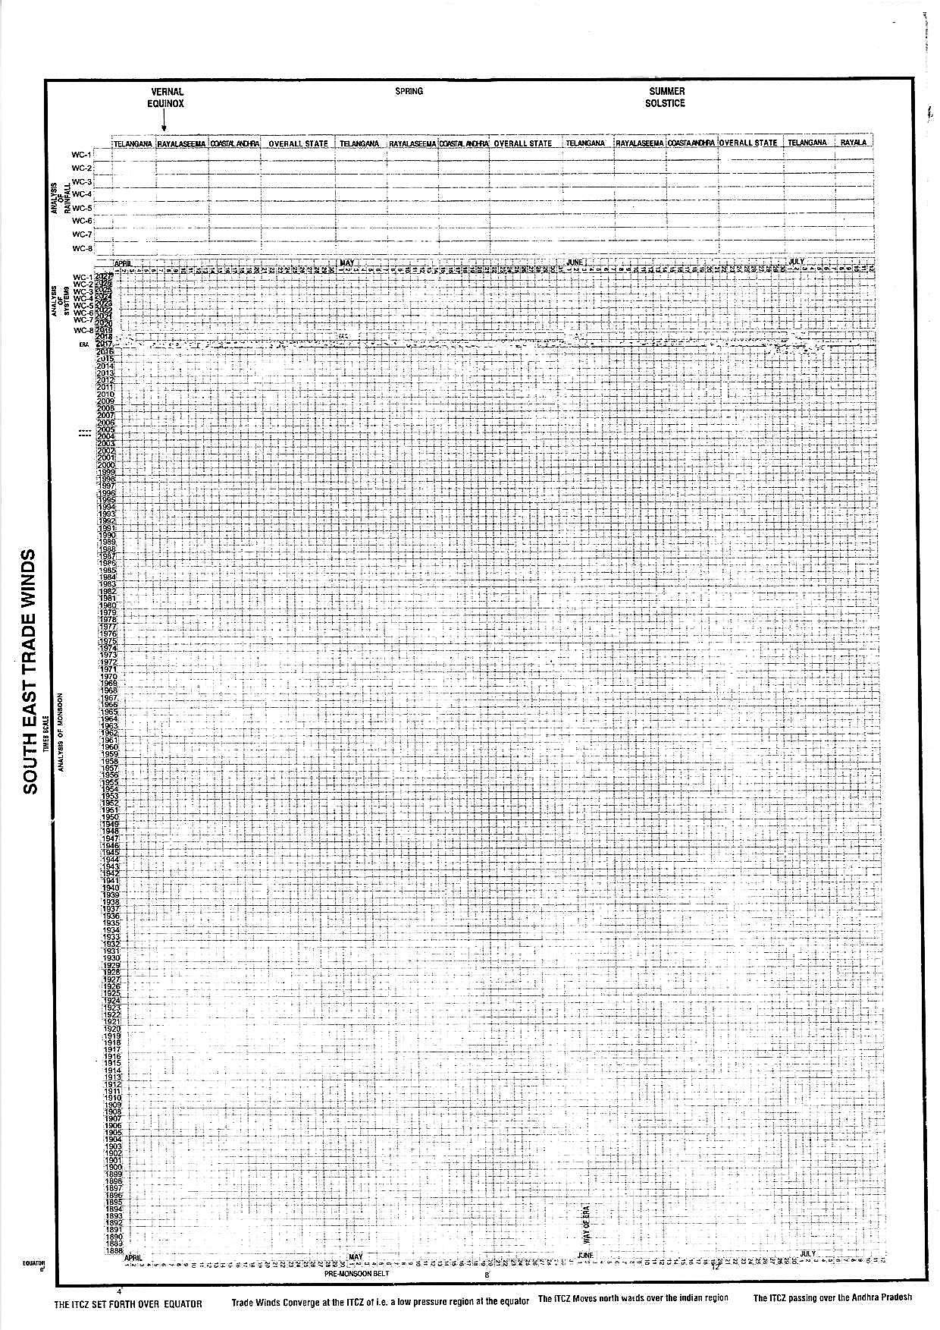
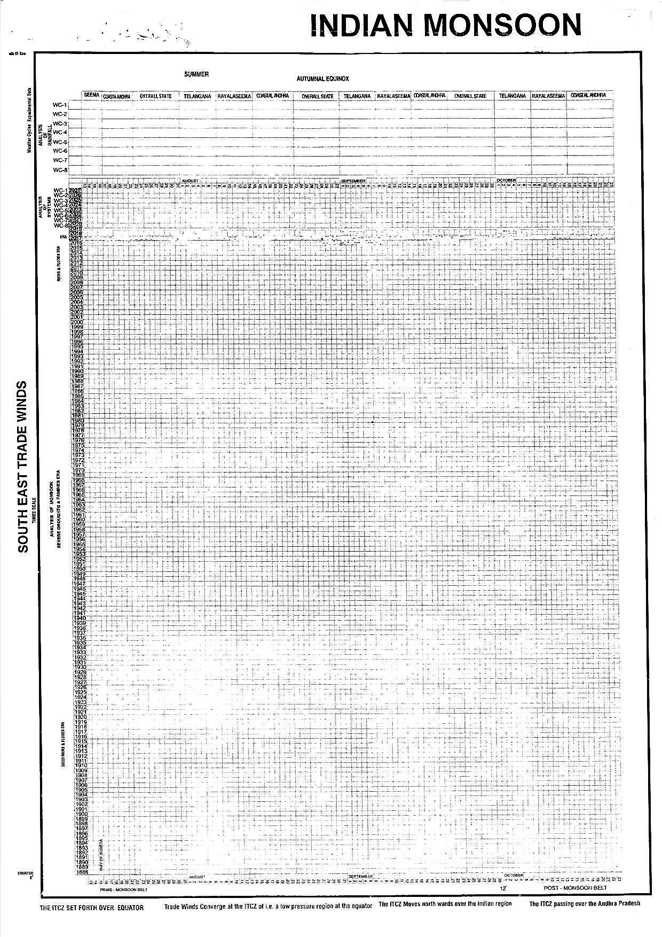
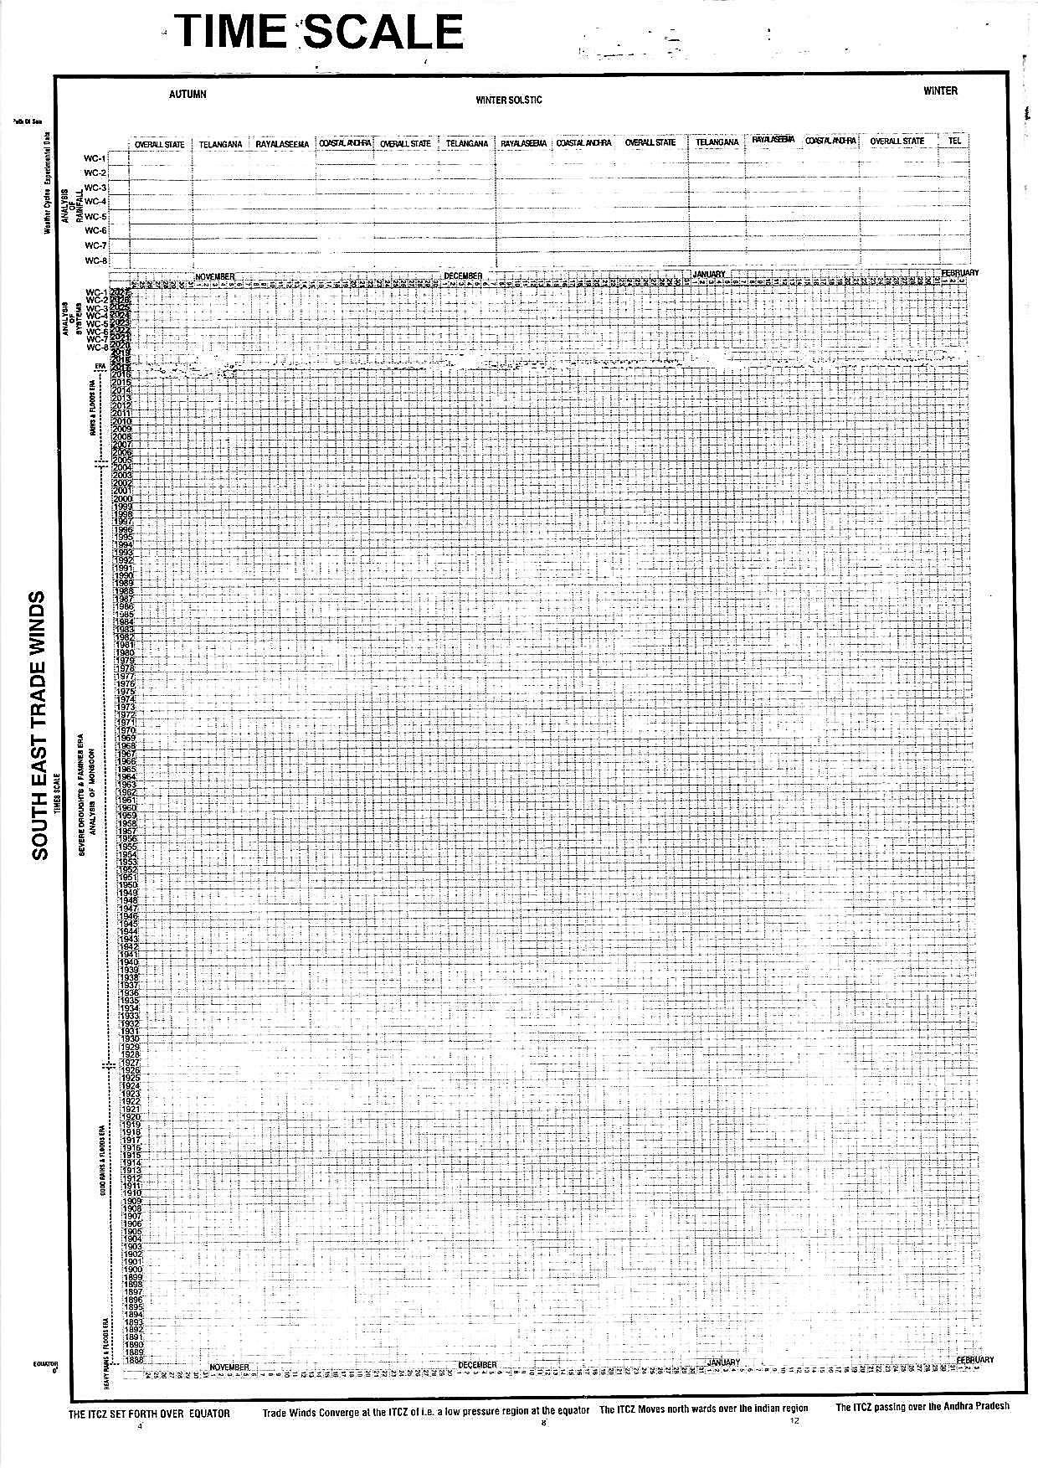
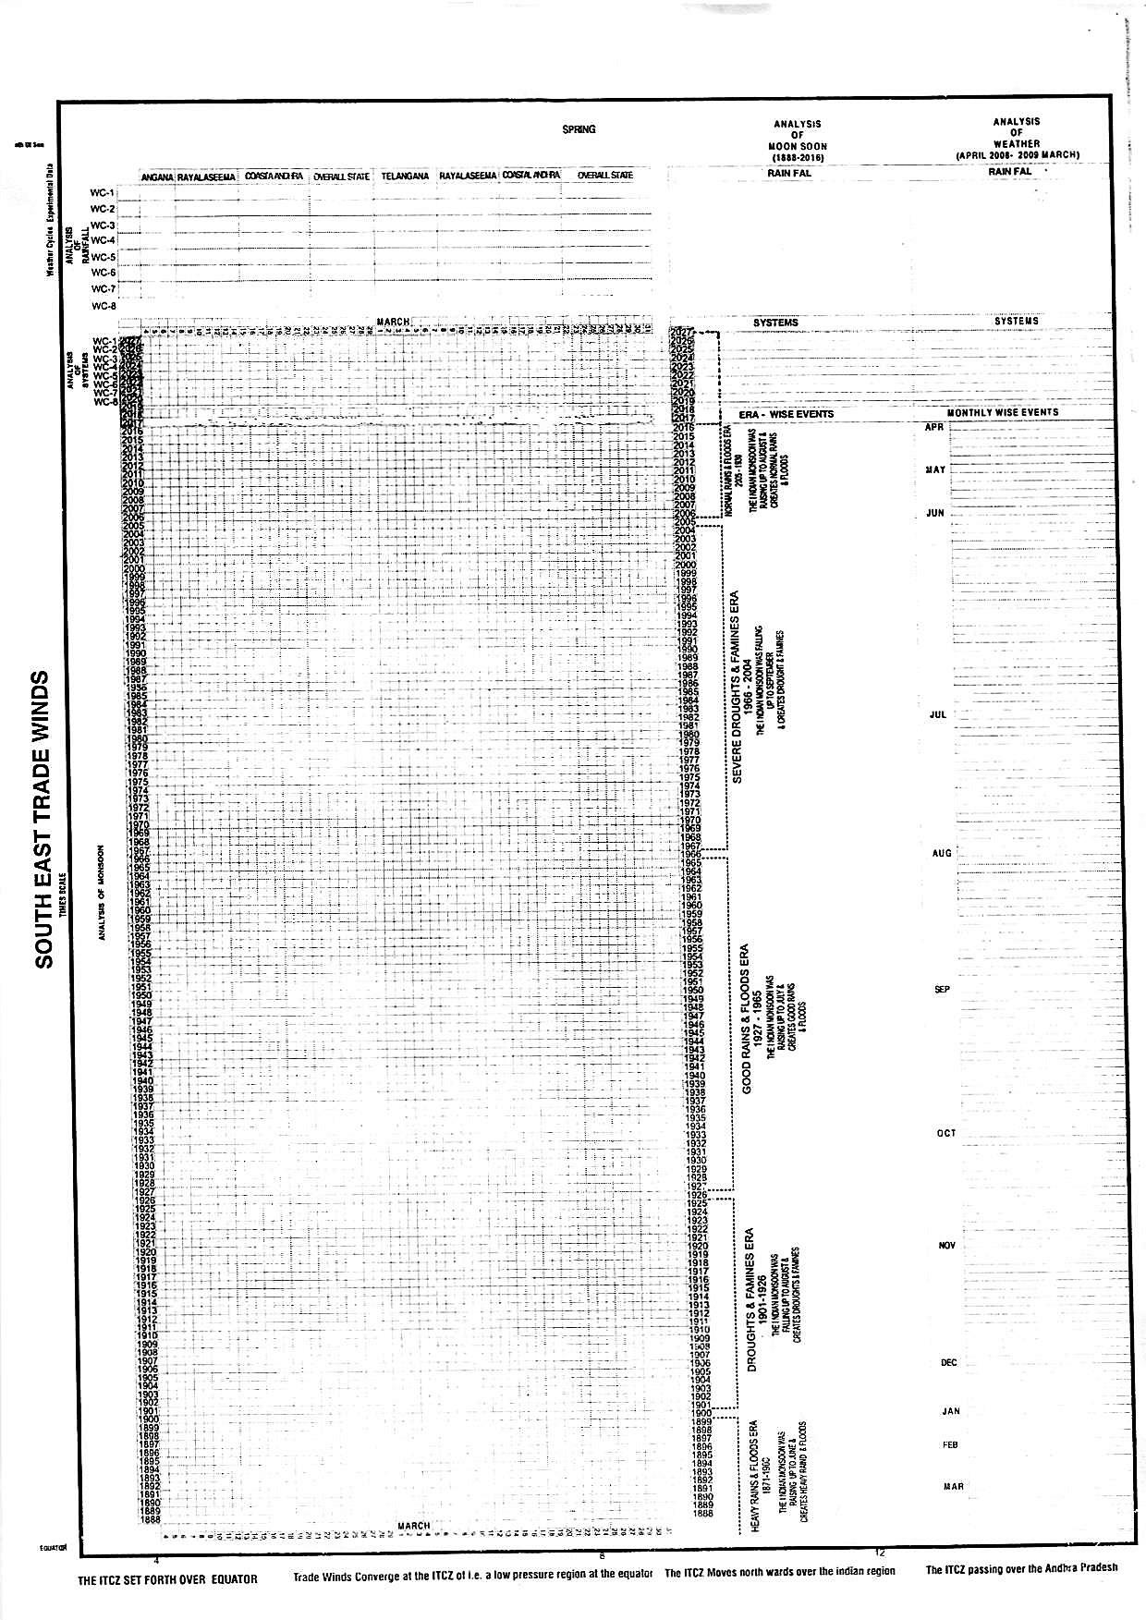
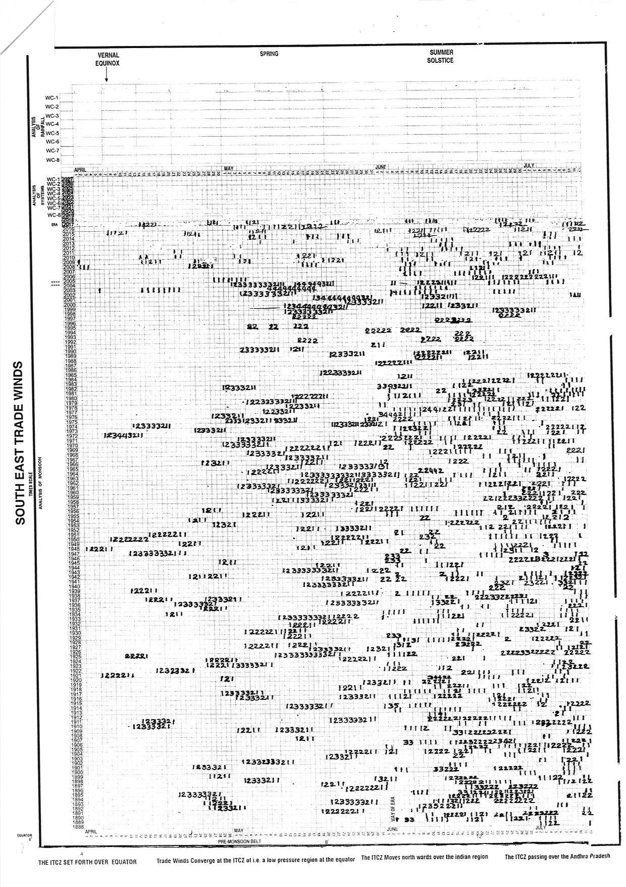
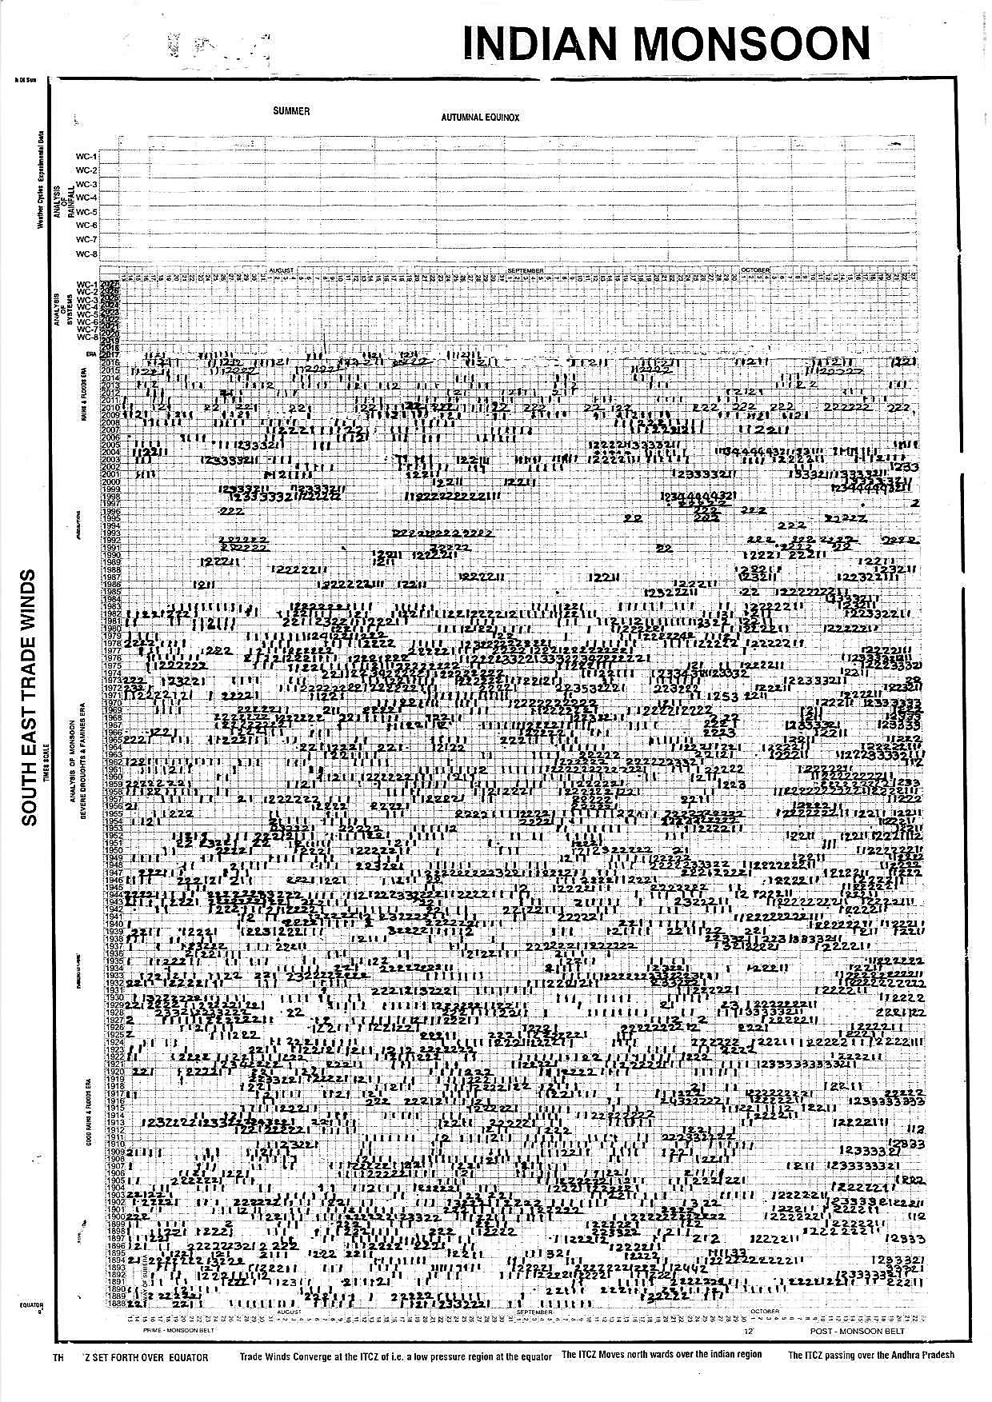
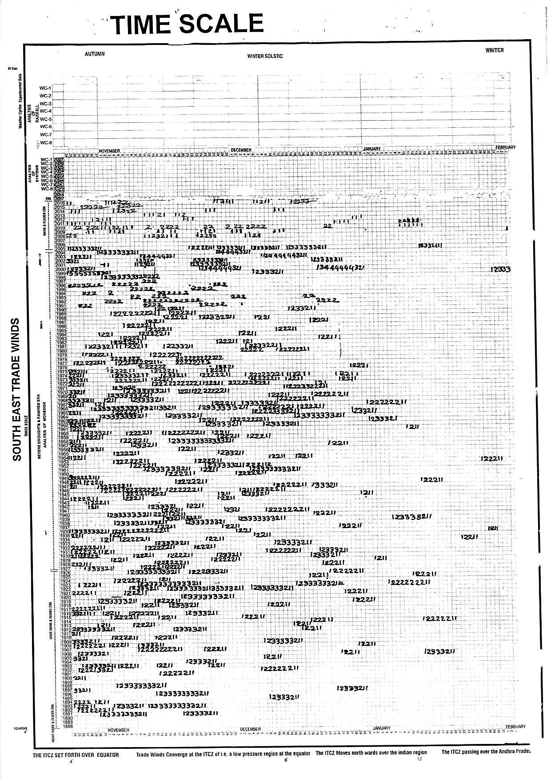
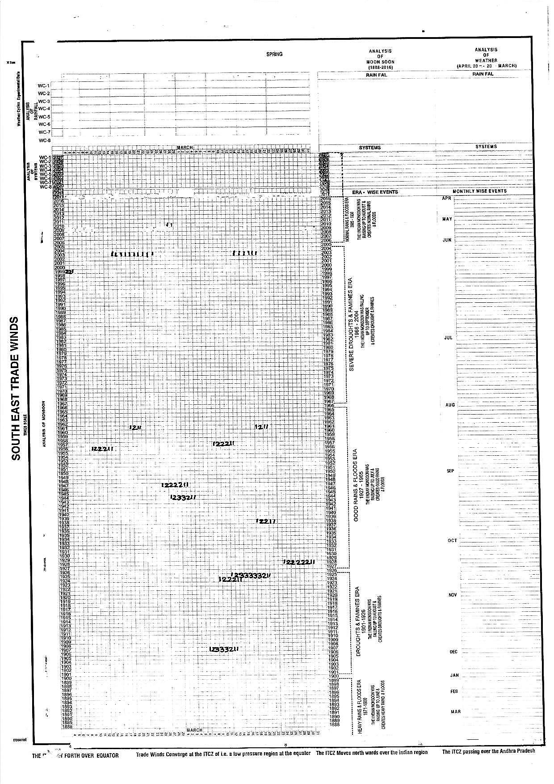
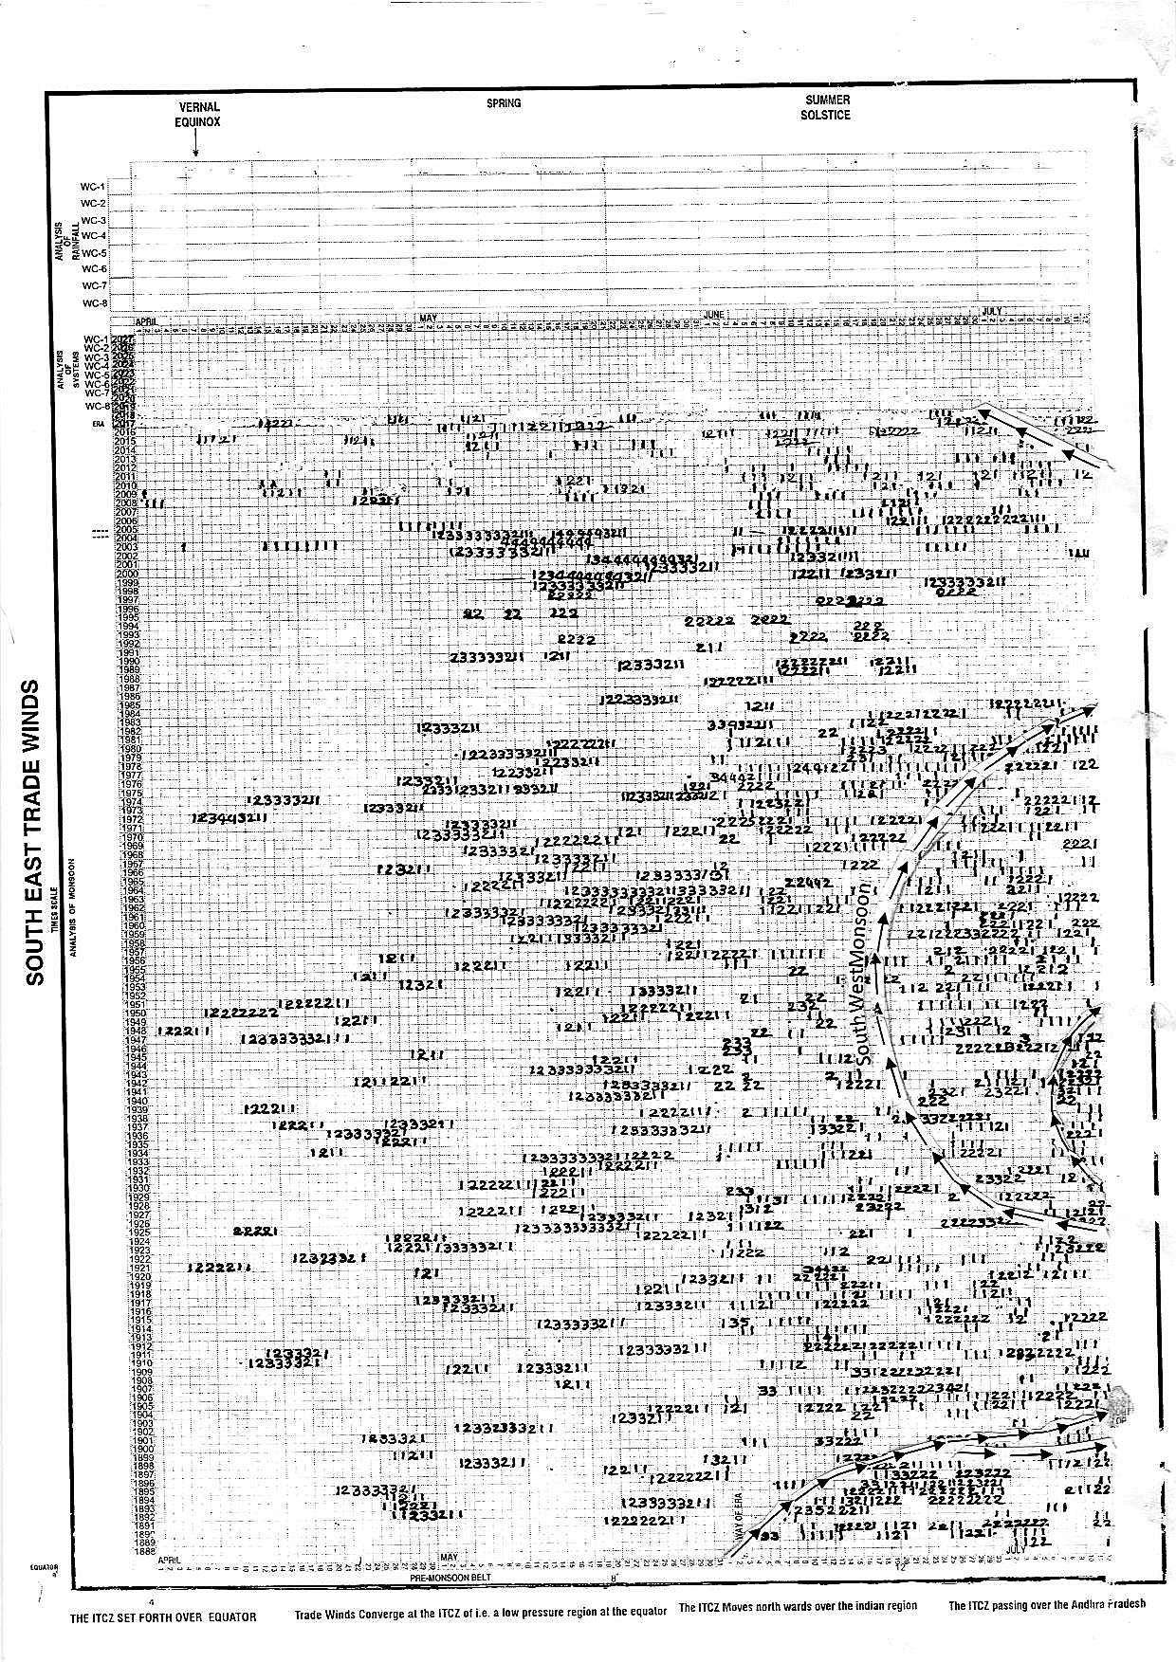
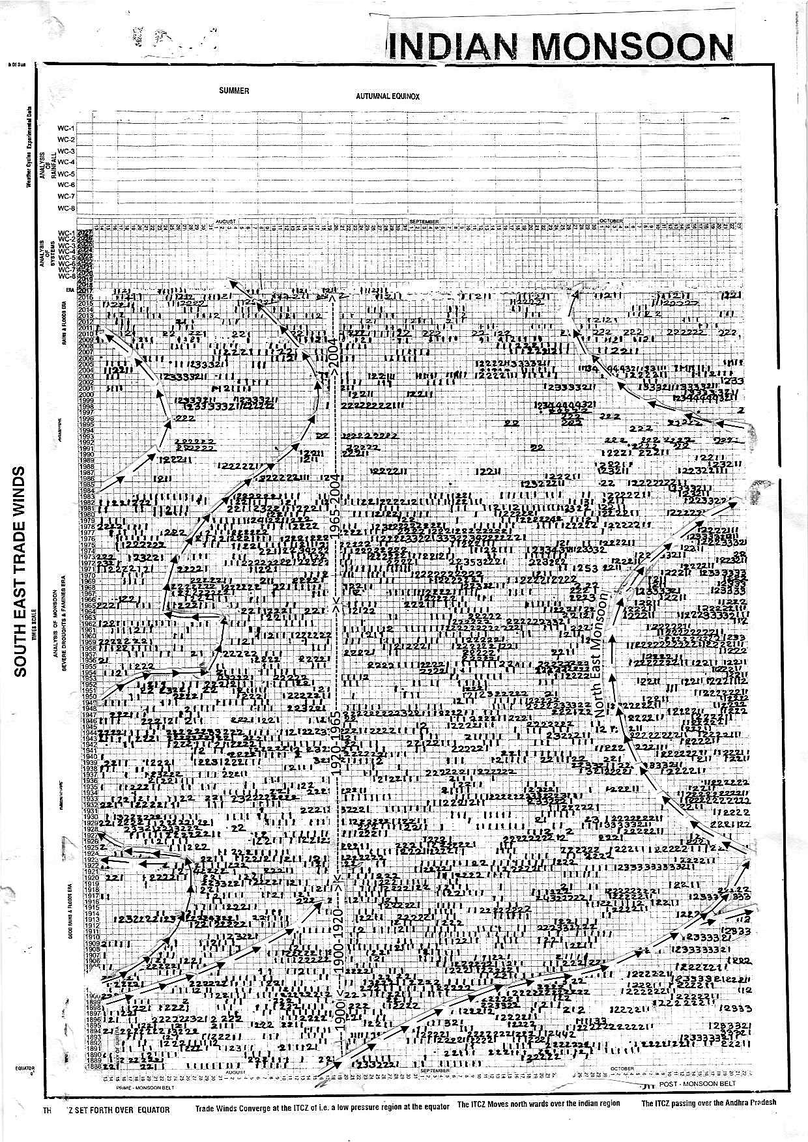
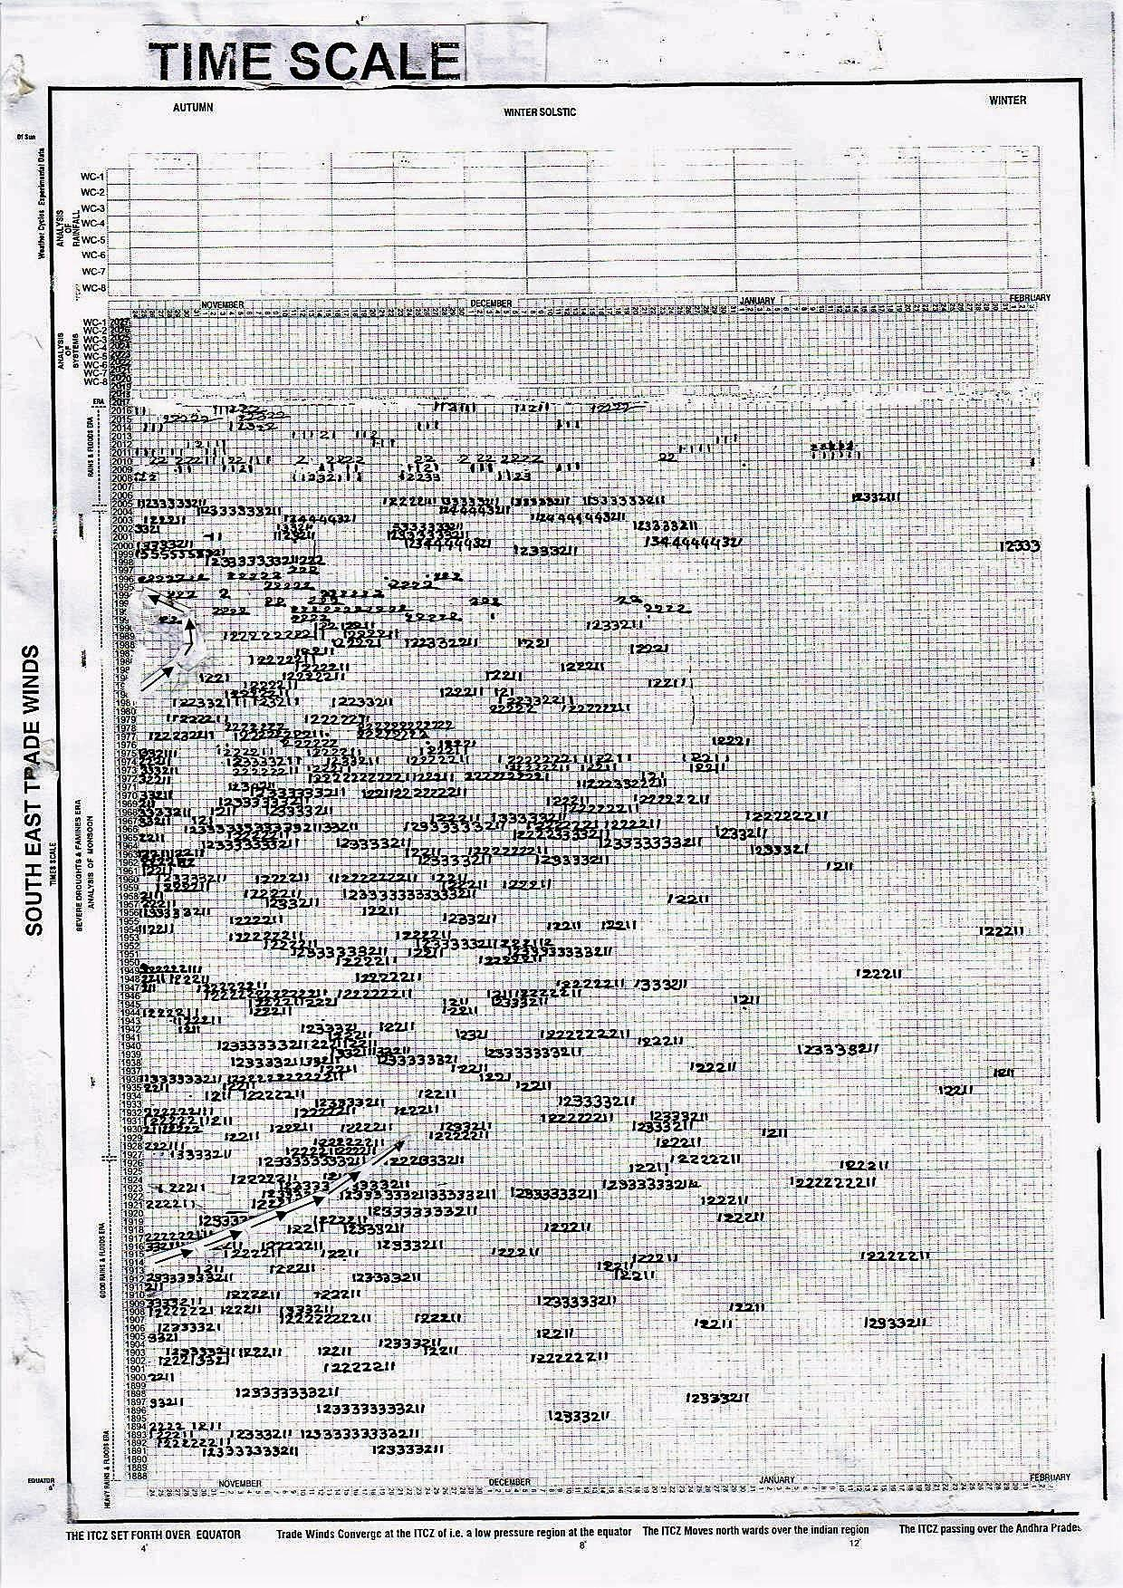
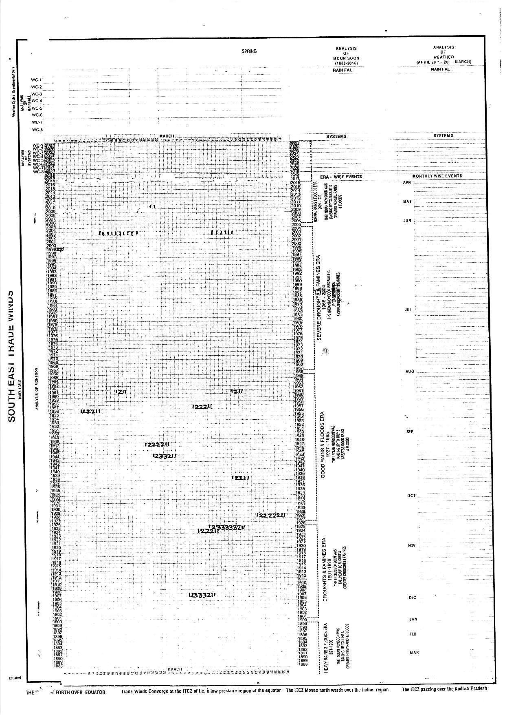

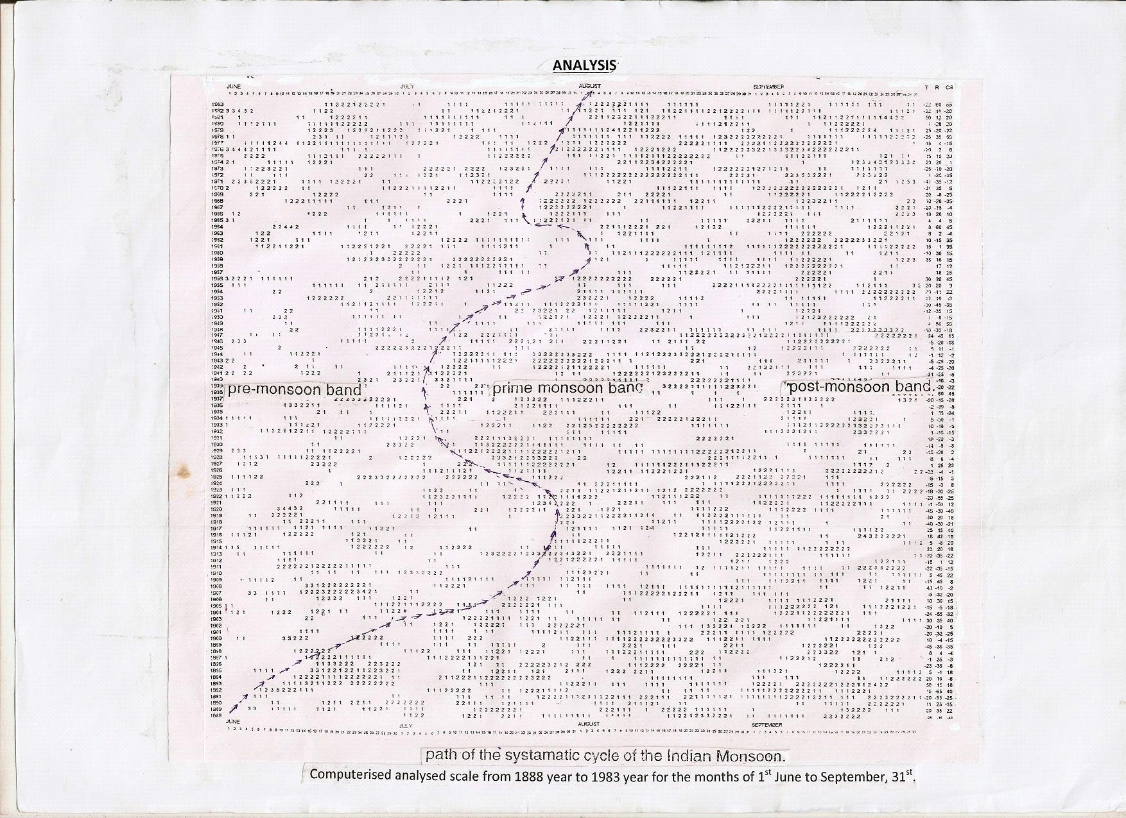
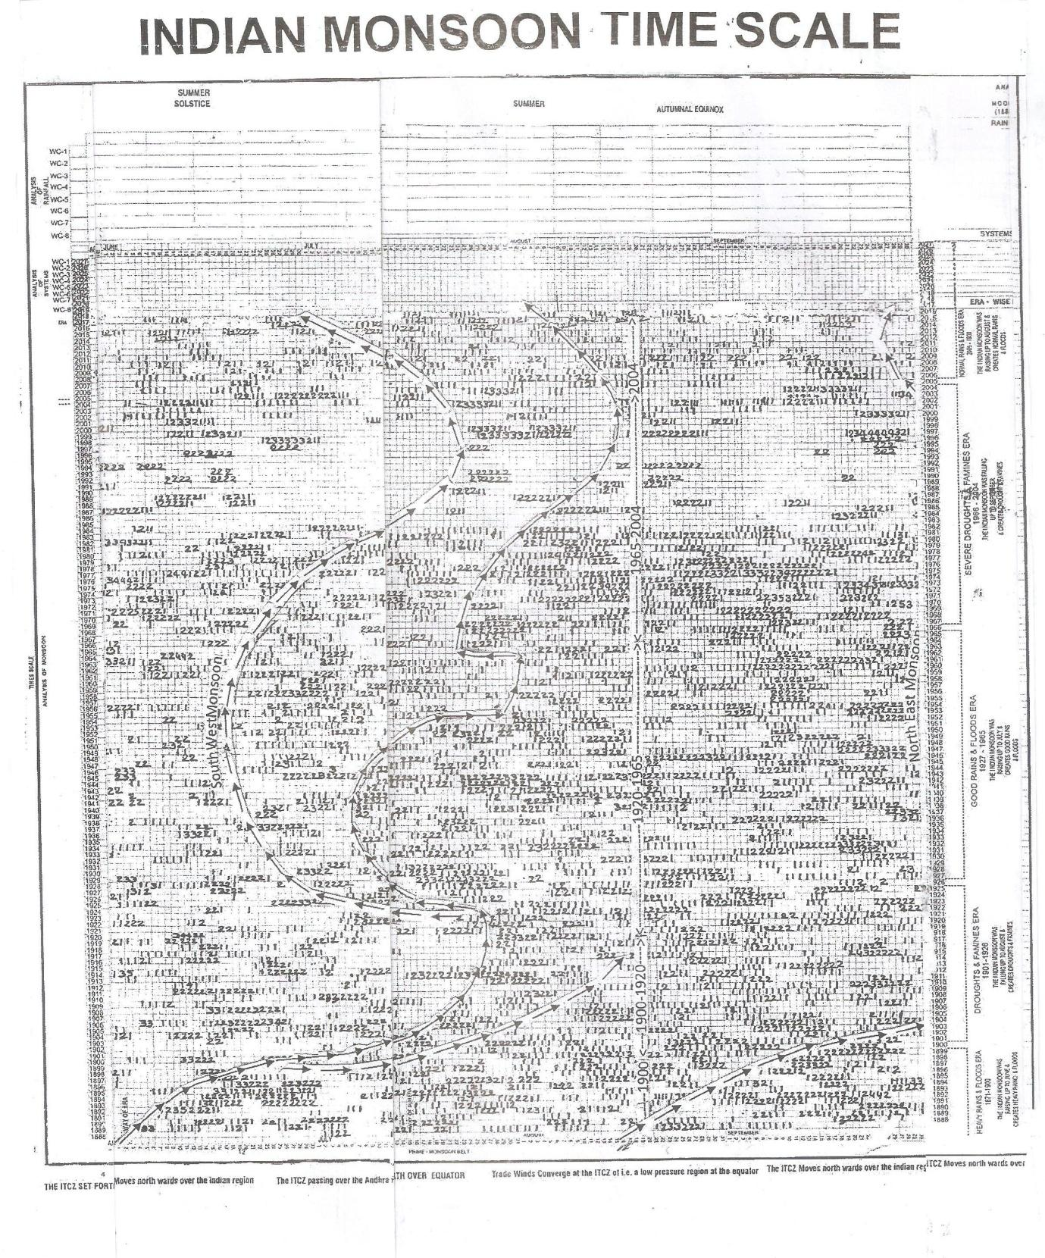

Indian monsoon time scales(when four parts are pasted)
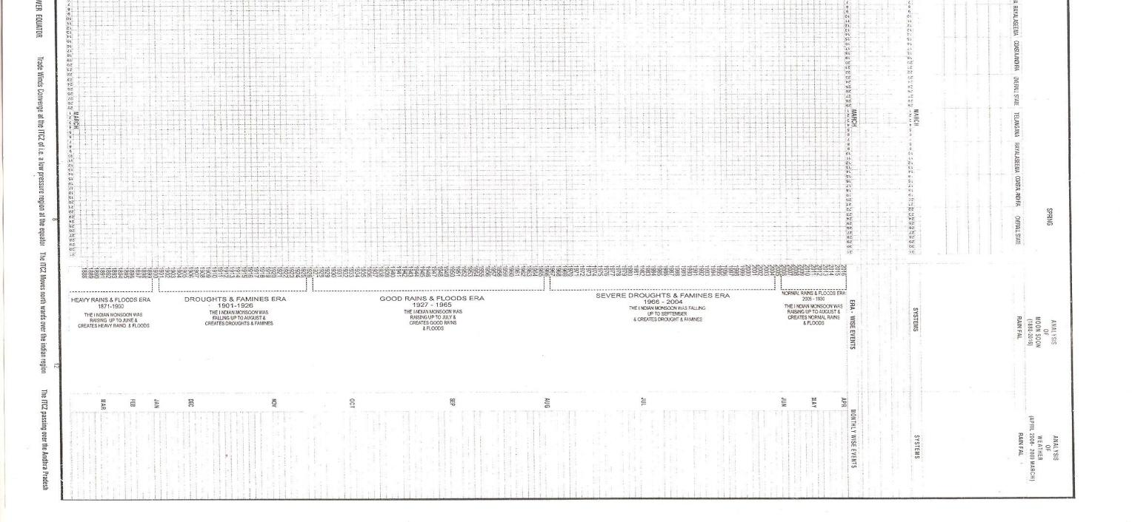
FILLED SCALE

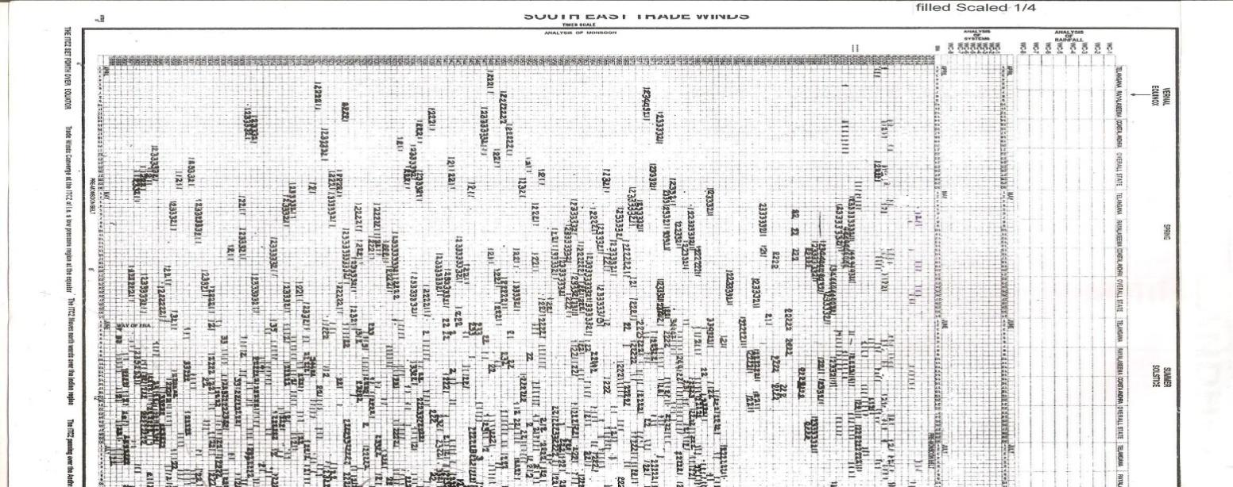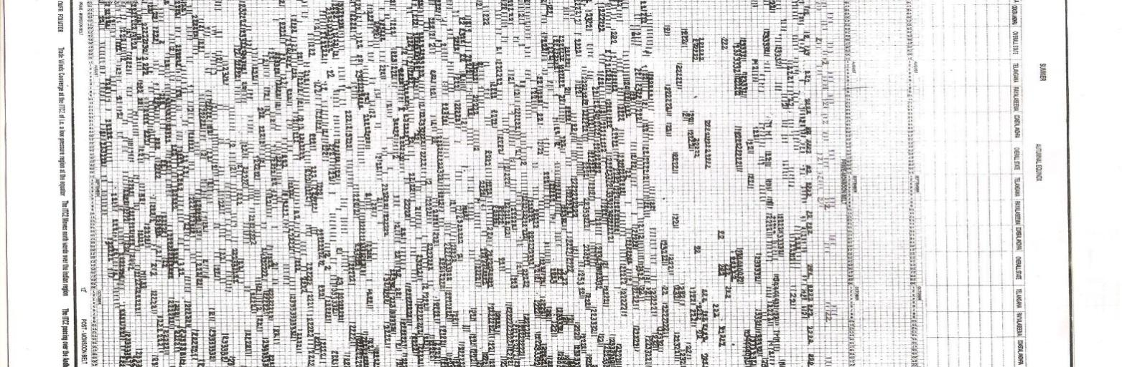

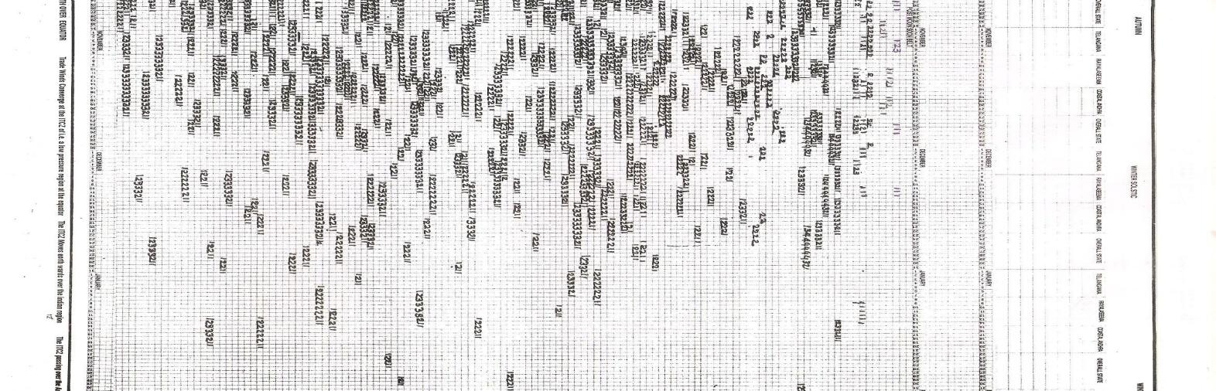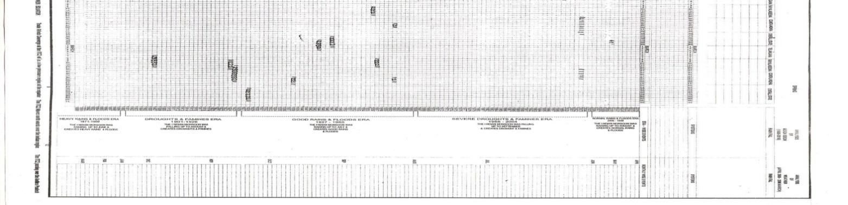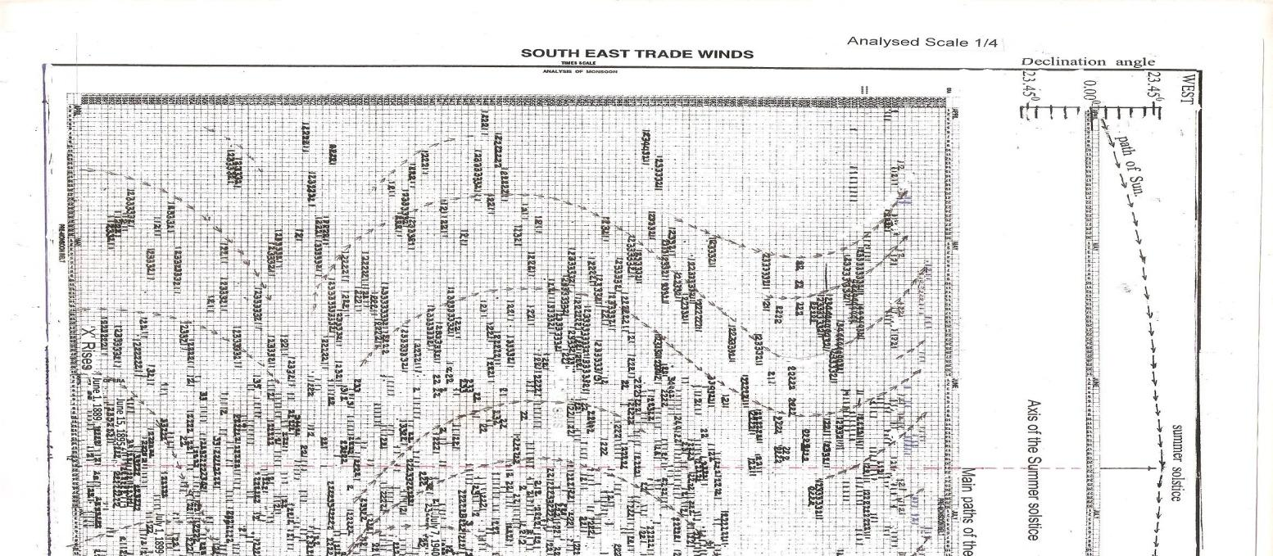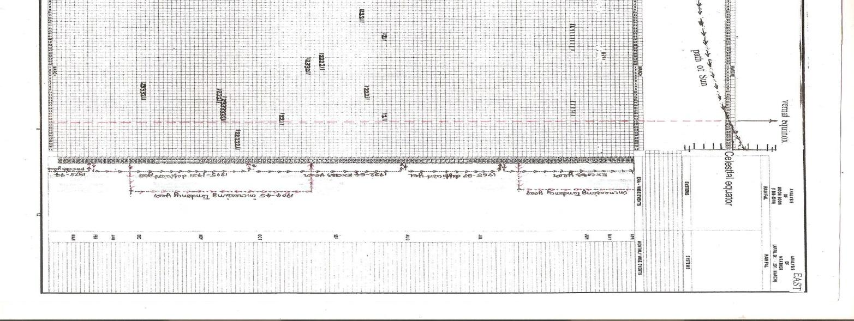

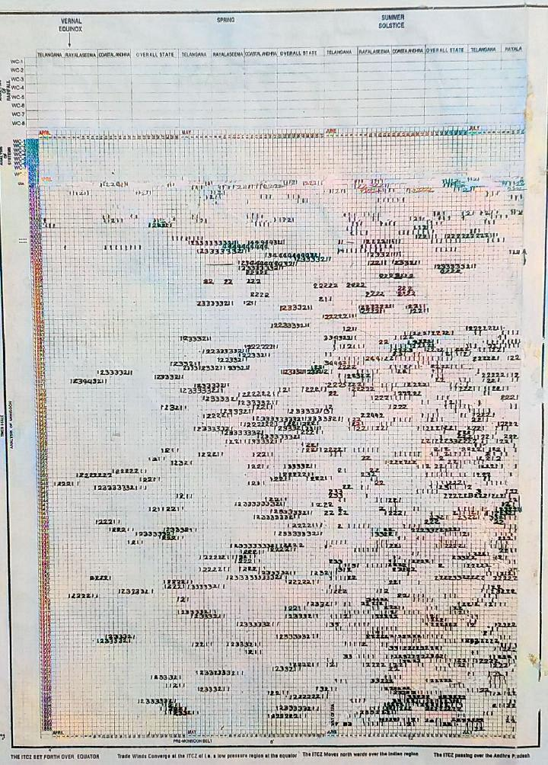

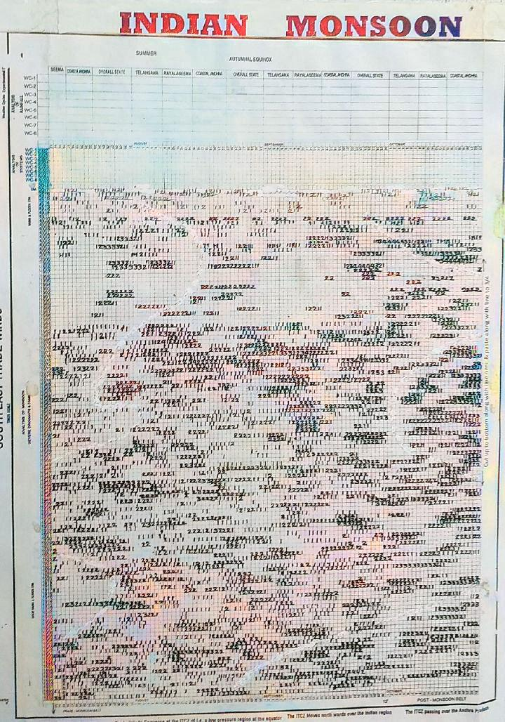

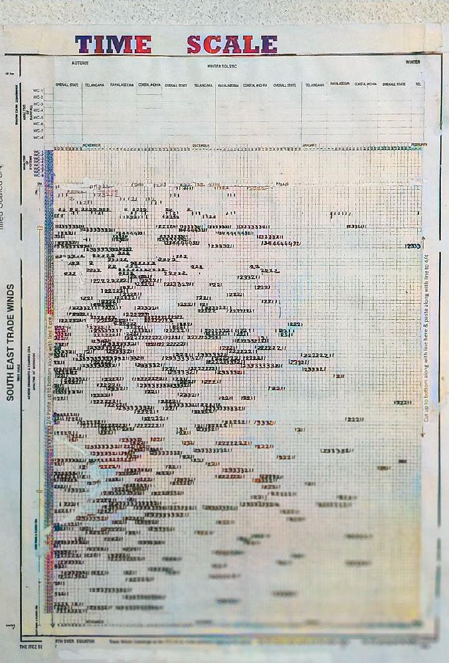

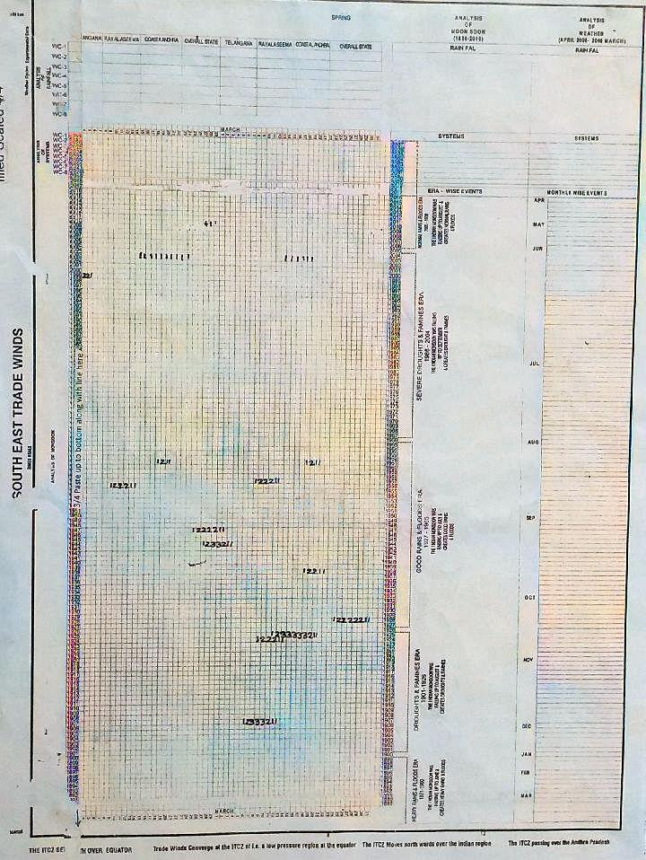

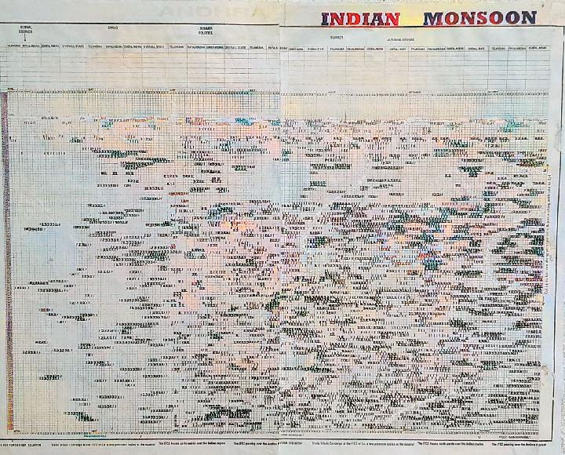

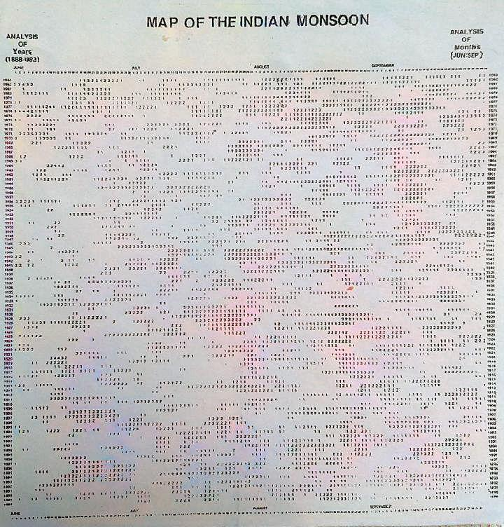

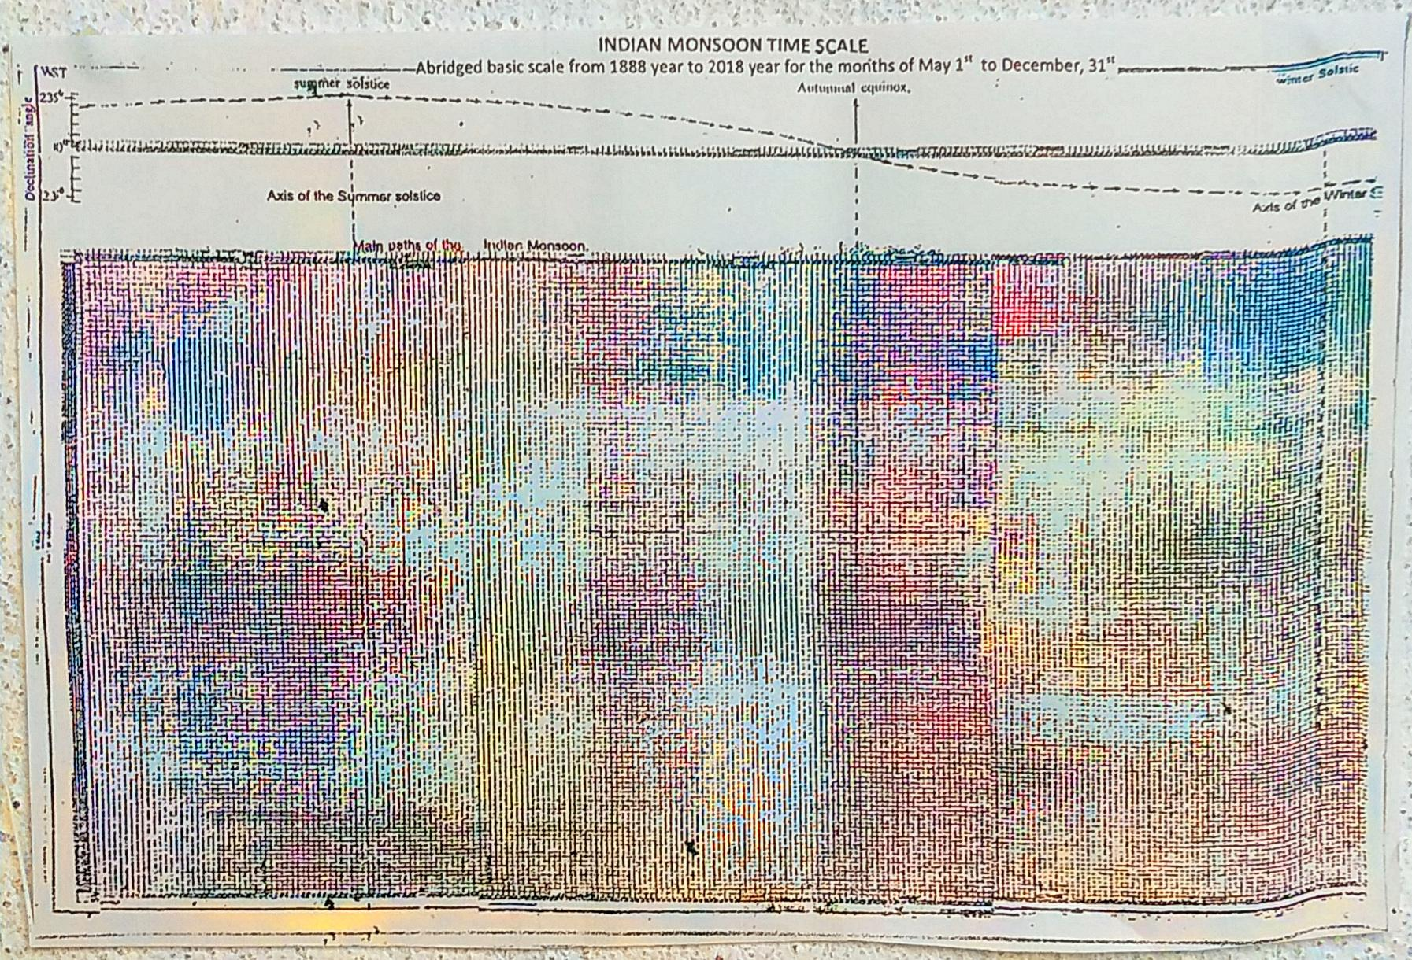

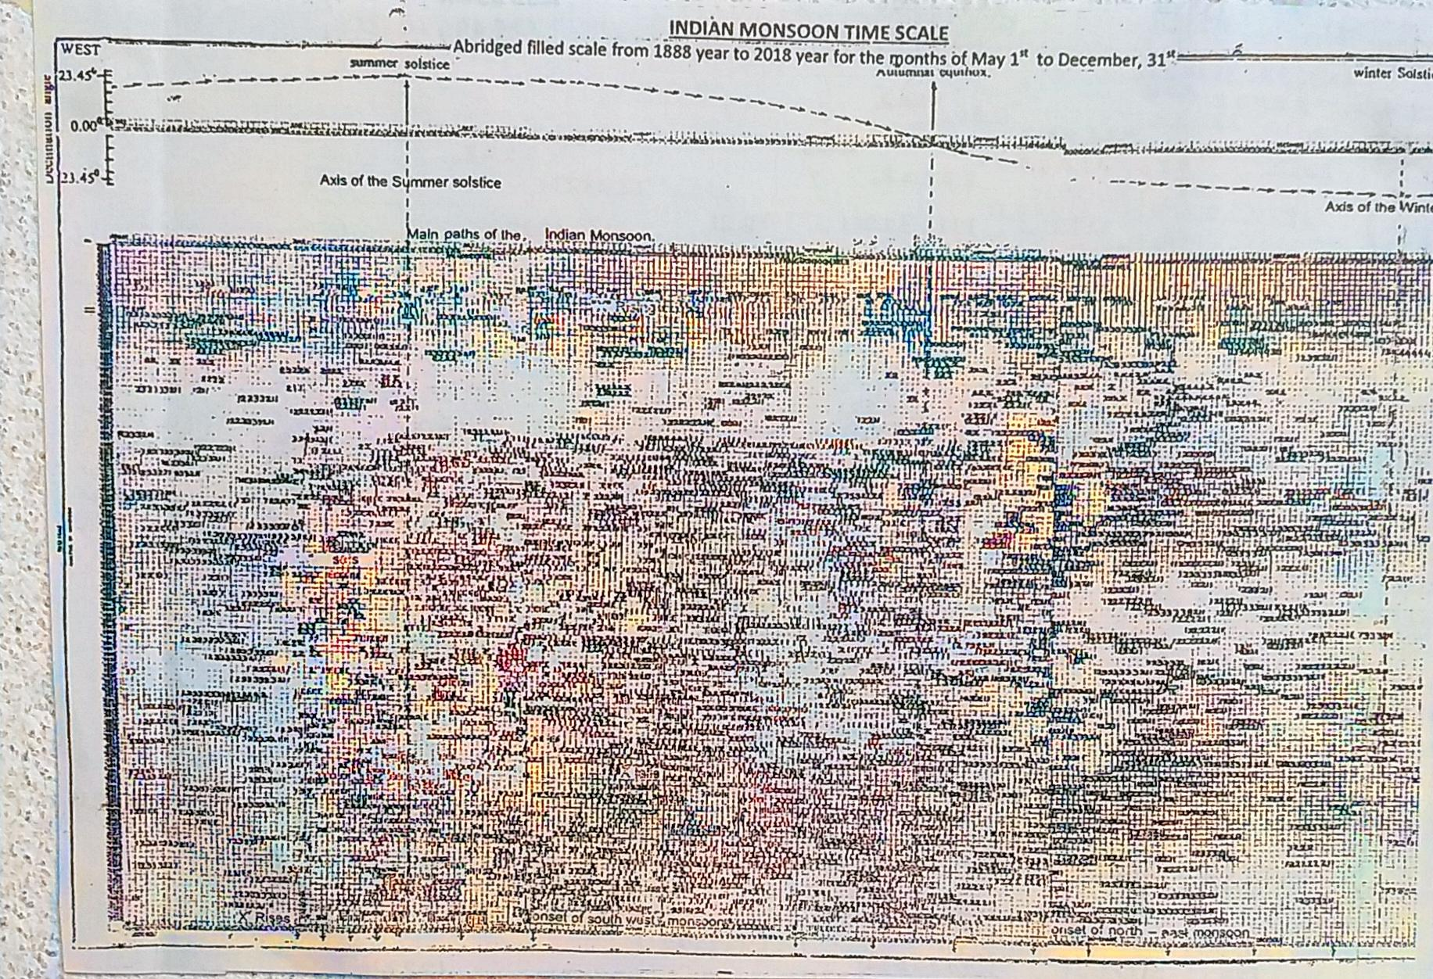

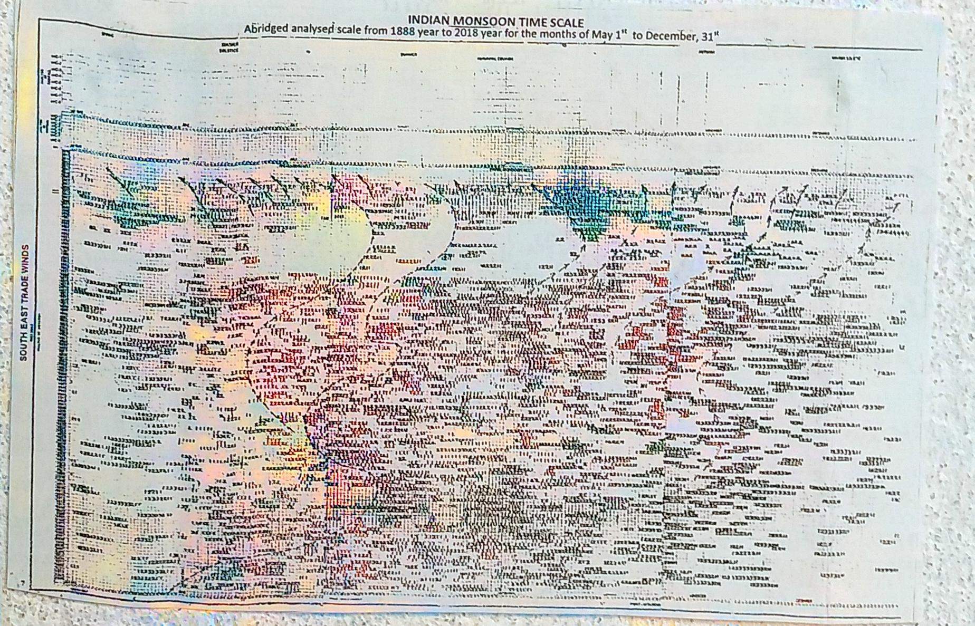

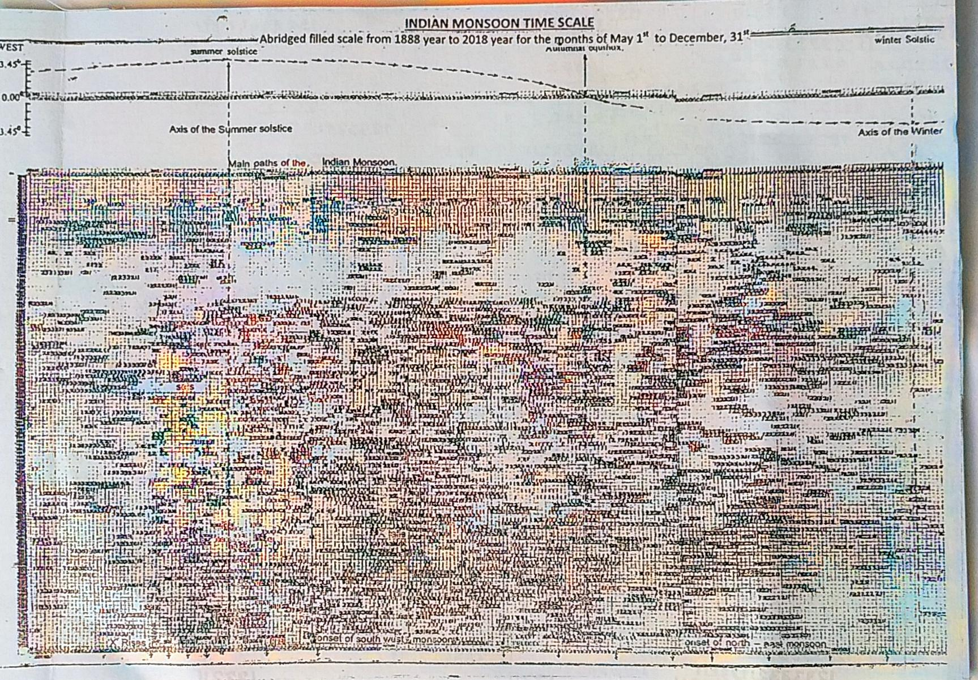

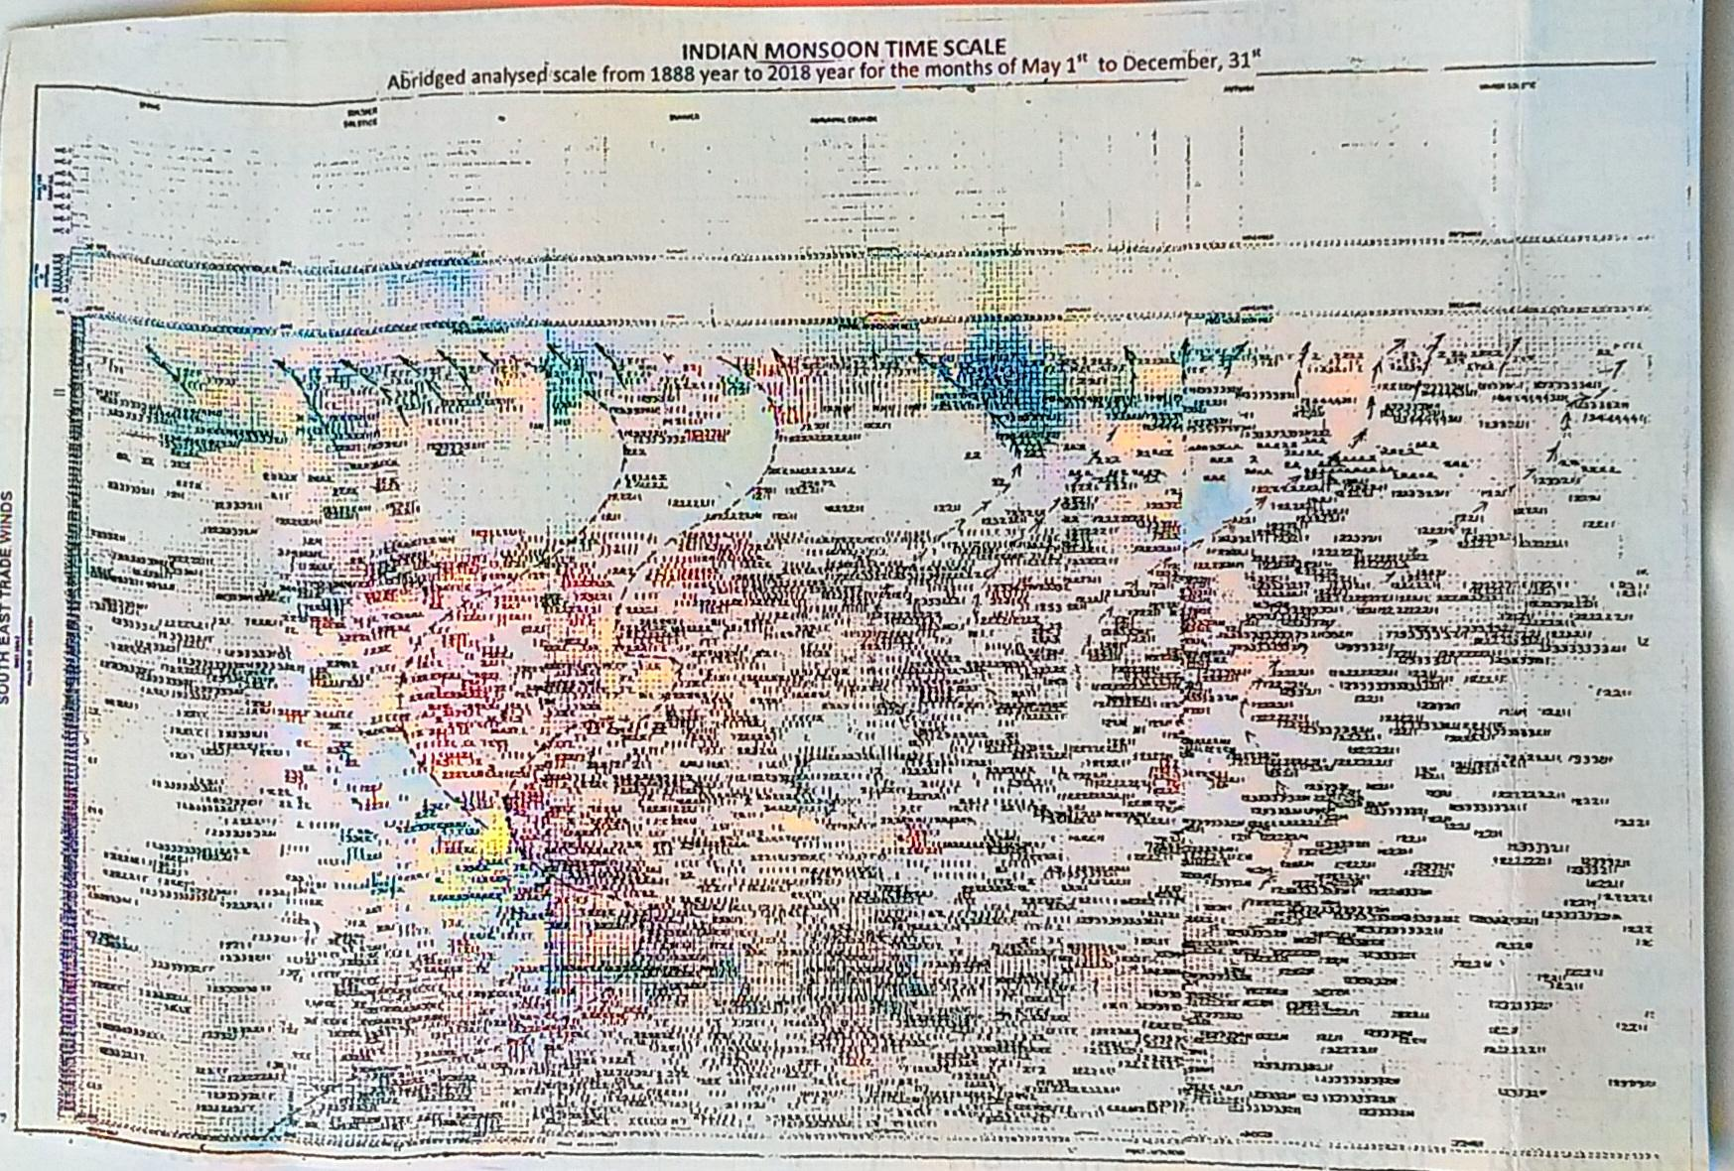

F

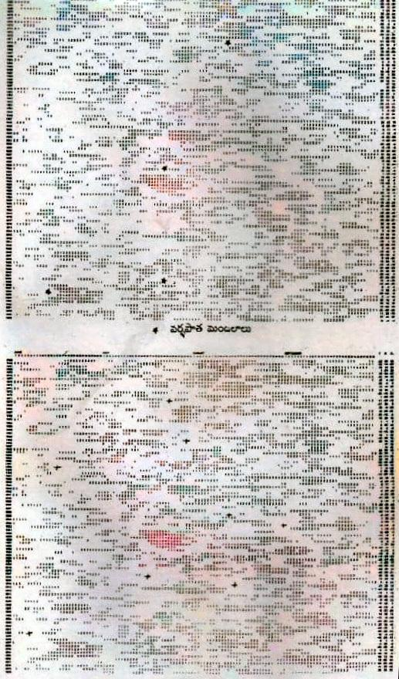

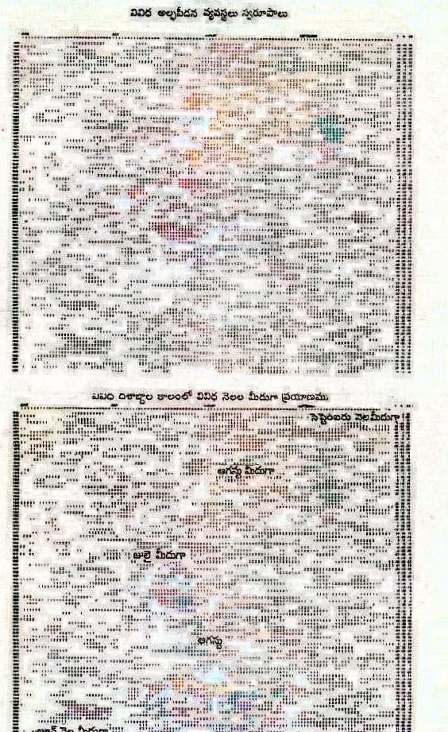

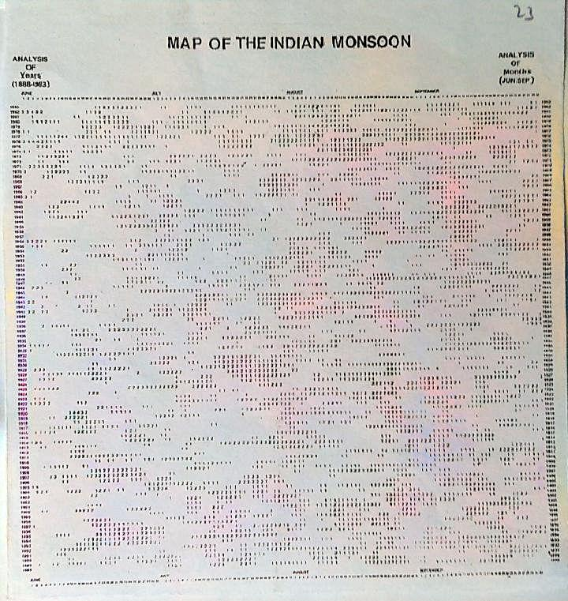

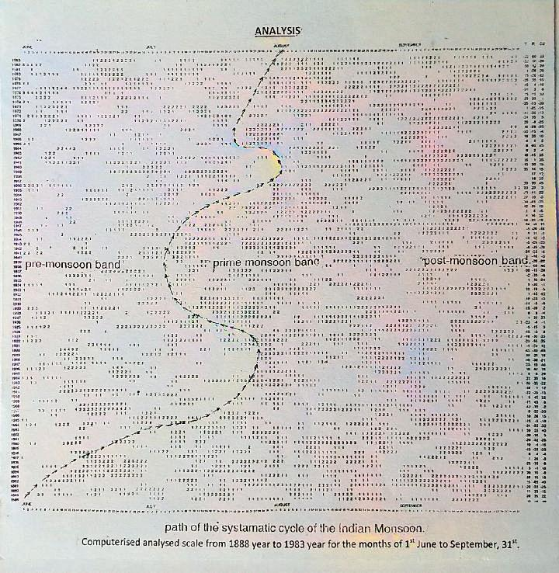

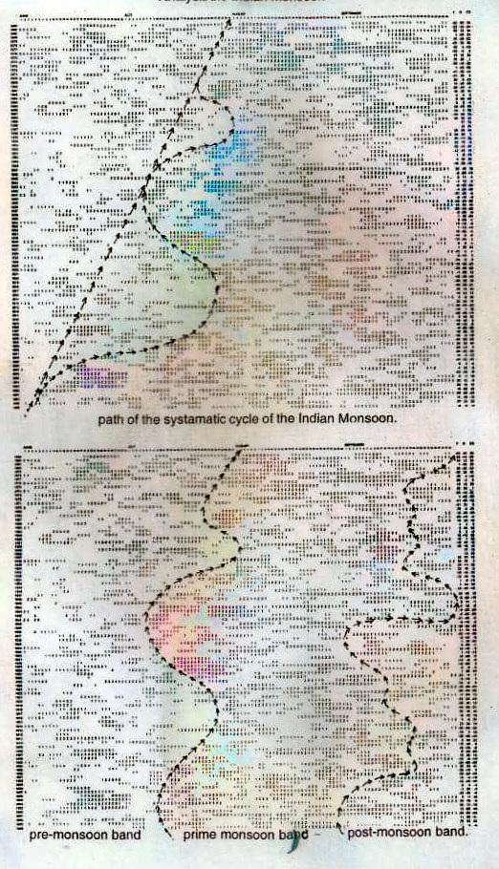

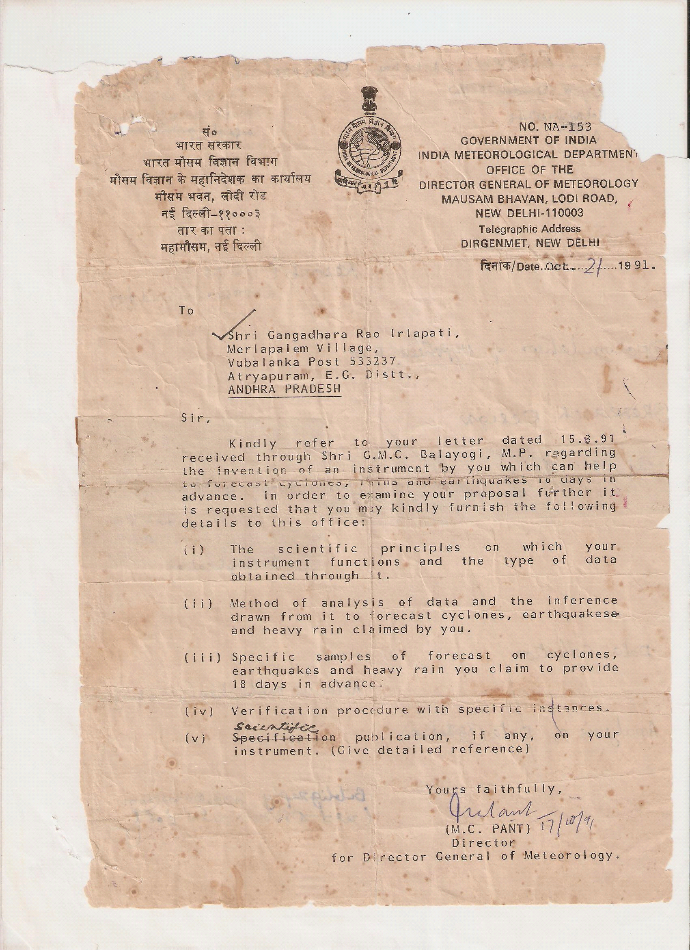

8/22/2023

