Benishangul Gumuz Regional State office of the President Lowlands Livelihood Resilience Project

Prepared by: Worku Dessalegn (Rangeland specialist)

Asossa, Ethiopia

[Worku Dessalegn. Benishangul Gumuz Regional State office of the President Lowlands Livelihood Resilience Project. Researcher2023;15(8):11-46]ISSN1553-9865(print);ISSN2163-8950(online)http://www.sciencepub.net/researcher. 03.doi:10.7537/marsrsj150823.03.

Keywords: Benishangul; Gumuz; Regional; State; office; Livelihood’ Resilience’ Project

Table of Contents
Table of Contents 12
List of tables 13
List of figures 13
List of appendix 14
Executive summary xiv
GLOSSAY 15
Acronyms and abbreviations 19
1. General Introduction 20
1.1. Background to the lowlands livelihoods resilience program 20
1.2. Purpose of the RMIP 21
1.3. Relevant laws and policies 21
1.4 Introduction to participatory rangeland management process 22
2. General description of the rangeland cluster 24
1.4. Location and administrative boundaries 24
1.5. Agro-Ecology xxv
1.6. Climate xxvi
1.7. Geology and soils xxvii
1.8. Vegetation xxviii
1.9. Socio-economic data xxix
2.6.1 Population distribution and size xxix
2.6.2 Education xxix
2.6.3 Human health service xxx
2.6.4 Water resources xxxi
2.6.5 Agriculture services xxxi
2.6.6 Irrigation xxxii
2.6.7 Livelihoods xxxii
2.6.8 Participation in the economy by gender xxxiv
1.10. Conflict xxxv
3. Preparation 37
1.11. Establish the RMIP team 37
1.12. Agreements with the community xxxvii
1.13. Transect visit and inventory of PRM done in the area xxxviii
1.14. Menge cluster rangeland resource and users 39
1.14.1. Rangeland resource 39
1.14.2. Rangeland resource users 44
1.15. Rangeland management institution and rangeland units and sub-units Error! Bookmark not defined.
1.16. Community-based rangeland management institution , Error! Bookmark not defined.
1.16.1. Roles and responsibilities of formal and traditional institutions Error! Bookmark not defined.
1.17. Rangeland unit Error! Bookmark not defined.
1.18. Rangeland resource assessment results and recommendations Error! Bookmark not defined.
1.19. Problem analysis and ranking Error! Bookmark not defined.
1.19.1. Problem analysis Error! Bookmark not defined.
1.19.2. Problem Ranking Error! Bookmark not defined.
4. Rangeland management plan Error! Bookmark not defined.
1.20. Vision of the community Error! Bookmark not defined.
1.21. Strategic Objectives (SOs) Error! Bookmark not defined.
1.22. Strategic Intervention (SI) Error! Bookmark not defined.
1.23. Rangeland Management Action Plan (2015-2025) Error! Bookmark not defined.
5. Rangeland Management and Investment Plan (RMIP) Error! Bookmark not defined.
1.24. General objectives of the rangeland management and investment plan Error! Bookmark not defined.
1.25. Five year (2013-2017) RMIP of Menge cluster … to be compensated within three years plan (2015-2017 EFY) Error! Bookmark not defined.
6. References Error! Bookmark not defined.
7. Appendix Error! Bookmark not defined.

List of tables
Table 1: The total land area of Menge cluster 25
Table 2: Agro-Ecology of Menge cluster xxv
Table 3: Ten years average maximum and minimum temperature of Menge cluster 27
Table 4: Population size of Menge cluster districts xxix
Table 5: Coverage of School Infrastructure in the Cluster 30
Table 6: Health infrastructure of Menge cluster districts 30
Table 7: Menge cluster water supply schemes distribution for humane use xxxi
Table 8: Menge cluster agricultural services 32
Table 9: Small scale irrigation schemes and irrigated land xxxii
Table 10: Average land coverage by major crops in Menge cluster 33
Table 11: Livestock population of Menge cluster districts xxxiii
Table 12: Source of income in Menge cluster 34
Table 13: Gender based access and control analysis. 34
Table 14: Conflict analysis of Menge cluster 36
Table 15: List of taskforce members regrouped to formulate RMIP for Menge cluster Error! Bookmark not defined.
Table 16: Number of community representative, elders and experts participated on RMIP formulation for Menge cluster xxxvii
Table 17: Seasonal calendar 43
Table 18: Rangeland condition historical trend analysis 44
Table 19: Stakeholder analysis and mapping 46
Table 20: Existing (traditional/formal) rangeland management institutions Error! Bookmark not defined.
Table 21: Rangeland management unit of Menge cluster Error! Bookmark not defined.
Table 22: Rural access roads of Menge cluster Error! Bookmark not defined.
Table 23: Recommended new routes (roads) to address the problems of sub-districts Error! Bookmark not defined.
Table 24: Major problems/challenges and alternative solutions/strategies Error! Bookmark not defined.
Table 25: Problem prioritization Error! Bookmark not defined.

List of figures
Figure 1: The stages of the PRM process, modified from (Flintan and Cullis 2010) xxiii
Figure 2: Map of Menge cluster (cluster one) xxiv
Figure 3: Agro-ecology map of Menge cluster xxv
Figure 4: Elevation and slop classification map of Menge cluster xxvi
Figure 5: Major soil types of Menge cluster xxvii
Figure 6: Drainage map of Menge cluster 28
Figure 7: Land use pattern (land cover of rangeland in cluster one) 29
Figure 8: Conflict hotspot areas in Menge cluster xxxv
Figure 9: Refresher training for regional and district experts xxxvii
Figure10: Launching program xxxviii
Figure 11: Rangeland resource of the cluster 39
Figure 12: Participatory resource mapping: community members lay out the relative locations of rangeland resources and infrastructure on the ground. xl
Figure 13: Hand drawn map of Menge cluster rangeland resource xli
Figure 14: Validation of Menge cluster rangeland resource map 41
Figure 15: Digital resource map of Menege cluster 42
Figure 16: Rangeland units of Menge cluster Error! Bookmark not defined.
Figure 17: Incense resource Error! Bookmark not defined.
Figure 18: Grazing land features Error! Bookmark not defined.
Figure 19: Livestock mobility rout in the cluster Error! Bookmark not defined.

List of appendix
Appendix 1: List of rangeland resources and rangeland sub-units (resource assessment) Error! Bookmark not defined.
Appendix 2: Problems pairwise ranking Error! Bookmark not defined.

Executive summary
Lowland Livelihood Resilient Project (LLRP) is a Pastoral and Agro pastoral Community focused project designed by the Ministry of Peace and lined ministries with technical and financial support from the World Bank and IFAD. The project aimed to improve the livelihood of Pastoral and Agro-Pastoral Communities in Ethiopia. Benishangul Gumuz is one of the intervene region of LLRP project and in the region 9/nine/ districts are supported by project grouped in to three clusters.
Rangelands are uncultivated land covered with natural vegetation capable of providing habitat for domestic and wild animals. Rangelands play a vital role in providing the community with goods and services. Rangelands provide society with a variety of products that include food, manure, wildlife, recreation, mineral, timber, energy, and biodiversity services. Given that Rangeland Management Plan (RMP) is the toolkits enable to manage and develop natural resource on sustainable basis, on the other hand Rangeland Management and Investment Plan (RMIP) is set of strategic activities drawn from RMP prepare through full participation community representatives who aware their area, socio-economic and environmental issues very well. With this background this RMP and RMIP has prepared for Menge cluster districts namely Abramo, Menge and Oundulu through participating the community representatives following the PRM stages step by steps. Accordingly, the finding of the study revealed that, cluster is endowed with potential vast rangeland resource providing the community with goods, and services. Vast grazing land, forest land, water resource, minerals, wild life, potential cultivation land, major public infrastructure and social infrastructures, NTFP are some of the rangeland resources found in the cluster. Generally, the area is rich with fertile land suitable for high value cereal, oil pulses crops and fruit production, livestock and apiculture rearing, rivers for irrigation and fish resources, minerals like gold and coal, and economically important trees like bamboo and incense.
Road inaccessibility, decline of livestock production and productivity, lack of light/Electricity/, lack of standard school and expansion problem, limited number of bridges, human disease, decline of crop production and productivity, shortage of water supply for human as well as for livestock , lack of alternative income source, land degradation, unemployment, lack of O-class, shortage of mail grain, inaccessibility of mobile network, lack of appropriate technology that detects gold, lack of livestock market center, inaccessibility of microfinance, are the major challenges constraining the livelihood of the cluster community.
Thus, to address the livelihood challenges of the cluster, the community has ranked these problems using pairwise ranking system. Then after, the vision of this cluster rangeland livelihood improvement has been set. To achieve the vision and to improve the livelihood of the community, six strategic objectives and a total of twenty-seven strategic innervations have been framed. Finally, for each strategic intervention, a set of activities have been identified and rangeland investment plan (RMIP) of this cluster has done for long term (ten years) and short term (five years) to address the identified problems in five main pillars namely; natural resource and pasture development, water resource development, small scale irrigation development, market infrastructure development and other economic infrastructures development.

15

GLOSSAY
Absorptive capacity | The ability of people, assets and systems to prepare for, mitigate, or prevent negative impacts of hazards to preserve and restore essential basic structures and functions, for example through protection, robustness, preparedness, and/or recovery.
Adaptive capacity | The ability of people, assets and systems to adjust, modify or change characteristics and actions to moderate potential future impacts from hazards to continue to function without major qualitative changes, for example through diversity, redundancy, integration, connectedness, and/or flexibility.
Adaptive management | A principle of learning by doing; adaptive management involves an iterative process of implementing a management strategy based on specific goals, monitoring the results, and adjusting the strategy based on lessons learned from observation of results
Agricultural produce | All produce of agricultural or livestock, processed or raw (e.g. cereals, pulses, horticulture, aquaculture, livestock, forestry) as well as its derivatives (such as milk, skins and hides, honey etc.).
Agricultural Production and Marketing Contracts | Contracts between producers and contractors, as described in the 2018 Proclamation to Provide for Agricultural Production and Marketing Contracts. MoA is responsible for promoting, facilitating and coordinating Agricultural Production and Marketing Contracts. Each Regional State will appoint an appropriate regional body. The contracts govern agricultural produce supply and procurement between producers (in the case of LLRP, mainly CIGs) and contractors of any type.
Alien Invasive Plants (AIP) | A species introduced, usually by human intervention, into an area outside of historical range, that increases its population rapidly and transforms local ecosystems.
Beneficiary community | A group of people (pastoral, agro-pastoral, or other community members) in one of the project implementation areas, defined by the kebele to which they belong.
Browse (n) | The proportion of leafs, twigs, and other parts of trees and shrubs that can be consumed by herbivores.
Bush encroachment | An increase in density of indigenous woody plants in their native ecosystem, or the invasion of indigenous woody plants into nearby treeless ecosystems.
Carrying capacity | The theoretical number of animals, usually expressed in livestock units, that can be carried on a given area of land. The carrying capacity varies from year to year with seasonal rainfall, and is heavily influenced by key resources such as wetlands and seasonal floodplains which may increase the overall carrying capacity of a rangeland
CDD approach | A community consultation method for empowering communities to be part of their local area development. The approach has been institutionalized into local Government planning processes under PCDP and will continue to be used, especially under the community investment fund, and in kebeles already familiar with the process.
Cluster | A specified unit of the project with two or more adjacent Woredas geographically suitable to get connected with strategic investments
Common Interest Group (CIG), | In the context of LLRP is a producer’s group, bulking group, business group or any other kind of economic common interest group of 5-25 members, most likely residents of the same kebele, with a common interest for a certain activity, for example production, marketing, petty trade or similar. It may be an informal partnership of producers with a business orientation. It is important to note that it differs from a traditional community group, in that it is purely economic in nature and may cut across social, tradition or cultural groups, to the extent that this facilitates livelihoods improvements. It also differs from common interest groups promoted with the intention of groups becoming primary agricultural cooperatives, though they may choose this path, if they so wish. CIGs are the “producers” as identified in the Proclamation to Provide for Agricultural Production and Marketing Contracts. Two types of CIGs may be eligible for project support (matching grants):
Community Action Plan (CAP) | A planning document developed as part of the CDD approach. It determines the location of sub-projects, steps and schedule for implementation, resource requirements, and individual’s payments towards the community contribution, delineates roles and responsibilities in implementation, and decides on mitigation measures if any social or environmental effects are anticipated.
Community Consultation | A discussion process with community groups and their representatives at different levels and different stages for planning of project activities, monitoring and learning. Community consultation is used throughout project components.
Community Development Plan (CDP) | A planning document developed under the CDD approach. It is a comprehensive 3 year rolling plan which elaborates a development vision, economic aspirations, obstacles and solutions. It is developed by communities at kebele level.
Community Facilitators | Community-based individuals who support the communities in provision of services (for free or at a fee). The project may engage with existing community facilitators and/or train new or additional ones, and it may support them directly in their mobile outreach work to communities. Examples include Community Animal Health Workers (CAHWs), lead farmers or others.
Community Group | It is a group of individuals with a common interest or social characteristics within a traditional or formal institution. While the beneficiary community may relate to a whole kebele or ethnic group, it is important to note that the word “community” refers equally to sub-sets of these larger groups, e.g. women’s, youth etc.
Community Investment Fund (CIF) | The instrument to finance demand-driven social and economic services infrastructure identified under the CDD approach. It envisages community procurement, community involvement in construction, management and oversight as well as cash or in-kind contributions.
Community Social Mapping | Refers to a participatory planning tool to study social relationships and social differentiation and gain a general overview of a community and the features important to the local people.
Land Degradation | A reduction of the biological and economic productivity of an area of land, which may include processes such as accelerated soil erosion and changes in associated hydrological processes, significant changes in soil chemistry and structure, and a long-term loss in vegetation cover or significant and detrimental changes in the composition and structure of the vegetation.
Direct beneficiaries | Are people or groups who directly derive benefits from an intervention of the project.
Forage (n) | The total biomass available for herbivores to consume. It may refer to both natural and cultivated forage
Forb | Any herbaceous, non-grassy plant. Usually separated from shrubs (short, woody plants) and trees (tall, woody plants) and grasses, sedges or reeds. Some forbs are important for nutrition, such as many legumes, while others may be poisonous or weedy plants.
Grazing/grazing lands | The biomass or the area of grass forage available to herbivores
Income Generating Activity (IGA) | Is used in a broad sense, but mainly identifying smaller business which women, youth and other target groups can do as a side-business to ear additional income. This could be beekeeping, making baskets, drying fruits or vegetables etc.
Innovation | Is adoption of new ways to do something. It may entail changes in thinking, of processes, organizations or outcomes. It involves the application of new knowledge acquired through learning, research or experience.
Institutionalization | It is the integration of project approaches or processes into the regular/existing Government systems and processes.
Kebele | It refers to the lowest tier of Government administration.
Key resources | Areas of the rangeland that provide additional fodder, particularly during dry seasons and droughts. They are often small areas relative to the entire rangeland, but have a disproportionate increase in productivity relative to the area of the rest of the rangeland. Key resources include wetlands and floodplains, as well as croplands where animals can graze on crop residues, and cultivated pastures.
Livelihood Resilience | Refers to a heightened system capacity to anticipate, respond to and recover from hazards. Resilience-building, as described by the World Bank, involves strengthening three specific capacities:
Micro-finance Institutions (MFIs) | Are as defined by the Ethiopian Microfinance Association, AEMFI. As per 2018, there are 34 members with an aggregate gross loan portfolio of USD 951 million and 3.8 million active borrowers. They cover up to 75% of the country, but operating resources are constrained.
Open Market CIGs: | Are CIGs who intend to supply the market (without an Agricultural and Marketing Contract), who are eligible for project matching grants on the basis of a business plan.
Overgrazing | The result of the metabolic requirements of grazing animals exceeding the production potential of a rangeland, such that the
Participatory planning | It refers to a process by which a community reaches a given socio-economic goal by diagnosing its problems and charting a course of action to overcome them.
Participatory Rural Appraisal / Participatory Leaning and Action | Are two terms often used synonymously to describe a consultative method to learn about communities, their resources and act. Technically, the former focuses more on identification while the latter emphasizes plural action.
Pastoral and Agro-pastoral Field Schools (P/APFS) | Are mobile, outreach activities of the extension services. They are adaptations of the Farmer Field School approach developed by FAO and are based on a trainer/lead farmer facilitation role towards participatory research and production enhancement.
Pastoral and Agro-pastoral research and extension groups (PAPREGs) | Are groups organized to test, adapt and apply new technologies (for example through on-farm demonstration plots), as guided by regional universities and research stations.
Private Sector | Is defined as a legal entity which is owned by 51% or more by a private person or company. It may also mean an individual person, not acting on behalf of Government, such as a pastoralist or a farmer.
Producers | Are individuals or partnerships of individuals who engage in production of agricultural produce (raw or processed). These may include pastoralist, agro-pastoralist and women groups livestock, crop or horticulture producers, as well as micro and small enterprises managed by youths, those not engaged in the pastoralism or others. These may be formed into CIGs, primary or federated cooperatives, traditional clan and sub-clan structures or any other entity supported under the project.
Productive Partnerships | Are project-facilitated partnerships between producers and contractors. The partnerships would help in addressing the demand-supply gap and communicate market signals in terms of quantity, quality specifications, pricing, logistics etc. The productive partnerships may, or may not, materialize in Agricultural Production and Marketing Contracts, and may, or may not, be financed under the CIG Productive Alliance or Open Market mechanisms.
Productivity | In the context of agro-pastoral and pastoral systems, refers to the production of plants or animals, or plant and animal products such as meat and grain, on a given area of land in a single year. Often expressed as kg/ha/year.
Public Private Partnership | Refers to a partnership between Government and a private sector entity in provision of goods or services to the public. Different modalities may be implemented, from complete outsourcing, to partial partnership for example for operation and maintenance, to contracting out parts of a road construction, for example. PPPs may be used to ensure a commercial mindset behind investments, which Government may not always be able to, for example in provision of animal health services to farmers.
Rangeland Management & Investment Plans | The main planning tool of the project and is linked to the spatial rangeland-centered entry-point. The plans comprise: five components: a) natural resource and pasture development; b) water resource development; c) irrigation development, d) market infrastructure, and e) other economic infrastructure and are developed in consultation with communities, customary institutions, government officials and technical experts, through the Rangeland Management Committees.
Rangelands and Rangeland Management | Land in which the indigenous vegetation is predominantly grasses, grasses interspersed with acacia type trees, forbs or shrubs that may be grazed or browsed, and is used as a natural ecosystem for the production of wildlife or livestock. Additionally, they provide other goods and services, such as mineral, recreation, energy, and biodiversity services to humanities (Holechek et al., 2011). Range management is the manipulation of rangeland components (animals, soil, water, fire, topography, water, vegetation, etc.) to obtain the optimum combination of goods and services for society on a sustained basis. Range management is informed by Range science, which is the organized body of scientific knowledge upon which range management is based on. Range science provides the facts about how natural processes operate.
Rangelands | Are geographically defined areas, in accordance with the pastoral and agro-pastoral lifestyles and livelihood patterns. A rangeland may include various grazing areas (dry season and wet-season), water points, farming land, areas for production of fodder, wetlands, forests, settlements, urban areas, markets and other features. Rangelands cut across administrative boundaries and may be as large as 700,000 ha or more. There may be regional differences in the definition, which also depends on the extent of mobility and coping strategies deployed during calamities such as droughts.
Rangelands | It is the project entry point definition developed to encompass the project rangelands. It consists of a geographical unit, combining several (2-6) woredas, and may include all or some of the kebeles of the woredas.
Resilience | In the context of rangelands, resilience is the quantity of perturbations (e.g. drought, overgrazing) that a system can absorb before it becomes permanently altered
Shelf project | A project document containing the complete details of a potential project that is ready to be implemented, including feasibility studies, funding requirements, and goals.
Sub-projects | The mechanism through which single investments are executed. In LLRP, sub-projects are the financing and implementation modality of the Rangeland Management and Investment Plans (Component 1.2) and for CIF projects (Component 3.1). In both cases, prioritized projects are identified through a participatory community-driven approach. Projects may be implemented through community contributions or outsourced to a service provider, depending on the scope of the project.
Training of Trainers (ToT) | A global concept also used within the project. It refers to training community facilitators (or others, including potentially project staff) with the specific objective of enabling them to train others on the same technical issue. It this enables the project to have greater outreach.
Transformation drivers | Are supplier, traders, entrepreneurs and other private sector actors that the project will engage with to catalyze the expected transformation. They are at least one step after production in the livestock value chains. They may serve as aggregators and models to demonstrate the viability of new approaches to increase resilience of pastoralists and agro-pastoralists for provide potential development pathways including generating employment opportunities for youth. The project will engage with them not as producers but as linkage for market services.
Transformative capacity | The ability to create a fundamentally new system to avoid negative impacts from hazards.
Woreda | Is the administrative unit/level of Government and is the main center for flow of funds and implementation of investment activities of the project.

20 Acronyms and abbreviations
ABE | Adult Basic Education
AEFP | Authority of Environment and Forest Protection
AHP | Animal Health Post
BGRS | Benishangul Gumuz Regional State
BoANR | Bureau of Agriculture and Natural Resource
BoRLAI | Bureau of Rural Land Administration and Investment
BoWIER | Bureau of Water, Irrigation and Energy Resource
BoRRT | Bureau of Rural Road Transport
CAP | Community Action Plan
CDD | Community Driven Development
CDP | Community Development Project
CIF | Community Interest Fund
CIG | Community Interested Group
CRGE | Ethiopian Climate Resilience Green Economy
DRMO | Disaster Risk Management Office
DW | Deep Well
ESIF | Ethiopian Strategic Investment Framework
EFAD | International Fund for Agricultural Development
FDRE | Federal Democratic Republic of Ethiopia
FTC | Farmer Training Center
GTP | Growth and Transformation Plan
HD | Hand Dug well
HH | Household
IFAD | International Fund for Agricultural Development
IDDRSI | IGAD’s Drought Disaster Resilience Sustainable Initiatives
IGAD | Intergovernmental Authorities on Development
INBAR | International Network for Rattan and Bamboo
LLRP | Lowland Livelihood Resilience Project
MoA | Ministry of Agriculture
MoP | Ministry of Peace
OP | Operational Policies
NTFP | Non-Timber Forest Product
PAP | Pastoral and Agro-Pastoralist
PCDP | Pastoral Community Development Project
PDO | Project Development Objective
PFM | Participatory Forest Management
PIM | Project Implementation Manual
RMI | Rangeland Management Institution
RMIP | Rangeland Management and Investment Plan
PRM | Participatory Rangeland Management
R-PCU | Regional Project w Coordination Unit
RPLLRP | Regional Pastoral Livelihoods Resilience Project
SECAP | Social, Environmental and Climate Assessment Procedures
SO | Strategic Objective
SI | Strategic Intervention
SLM | Sustainable Land Management
SNNPR | Southern Nation Nationality and People Region
SW | Shallow Well
WB | World Bank
WBISPP | Woody Biomass Inventory and Strategic Planning Project

General introduction

Background to the lowlands livelihoods resilience program
Lowland Livelihood Resilient Project (LLRP) is a Pastoral and Agro pastoral Community focused project designed by the Ministry of Peace and lined ministries with technical and financial support from the World Bank and IFAD. The project aimed to improve the livelihood of Pastoral and Agro-Pastoral Communities in Ethiopia. The project was designed to bring a transformation in the livelihood of pastoralist and agro-pastoralists (PAP) communities through a rangeland centered entry point which plans public investments in a holistic way, incorporating pastoral rangeland and natural resource management, climate change adaptation and mitigation, development of pastoral and agro-pastoral value chains and related alternative livelihoods, nutrition, and job creation.
Understanding the challenges and existing opportunities in the PAP areas like; droughts, rangeland degradation, conflict and insecurity, and increasing constraint of accessing of pasture land due to land encroachment and weakening of traditional customary institution is pertinent to design target investment to solve these challenges. Lowlands Livelihood Resilience Project (LLRP) was designed to have four interrelated components in realizing the Project Development Objective (PDO) of the project to improve livelihood resilience of PAP communities in Ethiopia.
AS per the revision made, the project is implemented in 7 arid and semiarid regions of the county, namely, Afar, Benishangul-Gumuz, Gambella, Oromia, SNNPR, Somali Regional States and South West Ethiopia Region. Initially when the project was designed, including Guba, Bulen and Wombera woredas, nine districts were selected from Benishangul Gumuz Region State (BGRS) as the project intervention area of the LLRP per the sited criteria, particularly “livestock movement. However, later Cluster one district namely, Guba, Bulen and Wombera have been replaced by the new districts called Abramo, Menge, and Oundulu due to everlasting security problems in these districts. Hence, in BGRS currently the project has been executed in three cluster or nine districts such as; Abramo, Menge, and Oundulu named as the first cluster, Kurmuk, Sherkole, and Mao-Komo second cluster and Odabilidigilu, Sedal and Aglometi (Dembe) the third cluster.
The theory of change of this project is to increase resilience including: (i) absorptive capacity, through rangeland and natural resource management interventions, strategic investments and improved basic social service delivery, which will help communities and pastoral and agro-pastoral system to absorb drought shocks and reduce asset losses, (ii) adaptive capacity, through livelihood improvement and by helping beneficiaries adopt climate smart agriculture and investing in research systems will contribute towards better adapting to changing climate; and (iii) transformative capacity, through market linkages, small scale irrigation, and livelihood diversification, that provide a basis for more fundamental socioeconomic changes and help beneficiary reduce their dependence on rain fed agricultural system.
To achieve this, the project will combine three complementary layers of investments. Component 1 focuses on improving the natural resource endowment and financing strategic investment; component 2 improves public service delivery and supports market access to optimize the utilization of investments made in the first component and diversification to reduce pressure off natural resources; and component 3 builds the capacity of institutional environment and supports social services delivery to ensure long term livelihoods sustainability. The Integrated Rangeland Development and Management has restructured to have three sub-components namely integrated rangeland management planning, supporting strategic investment and conflict management and secure access to key natural resources. These sub-components are aimed to bring a transformation in the livelihood of agro-pastoralists in the project woredas by improving the rangeland and pasture development as well as social and economic infrastructure development.
This project will build on the long-standing experience of the Pastoral Community Development Project (PCDP) for inclusive development through CDD-oriented service delivery, the Regional Pastoral Livelihoods Resilience Project (RPLLRP) and other related projects under the IGAD’s Drought Disaster Resilience Sustainable Initiatives (IDDRSI) livelihoods resilience framework. Further emphasis will be put on rangeland and natural resource management, livelihood improvement and diversification and market access aspects to enhance the livelihoods resilience dimensions of the interventions.
As indicated on the project implementation manual (PIM), the entire finally approved subproject activities to be financed under the component one of the projects shall be identified first through preparation of comprehensive rangeland management and investment plan (RMIP) for all rangelands clusters. RMIP is set of strategic investment plan drawn from participatory rangeland management plan that has vision set by the community. RMIP will be developed through full participation of the PAP communities in the planning processes under the facilitation of the regional taskforce. Hence this document presents the PRM and RMIP of cluster one or Menege cluster (Abramo, Menege and Oundulu woredas)

Purpose of the RMIP
Human being has relay on natural resource to sustain its livelihood. Particularly PAP communities have highly depended on natural resources since their major income is livestock rearing. The dependency on natural resource rangeland natural resources are usually used by the local communities (permanent resource users), neighboring communities living around the cluster (secondary or occasional users) and used by broad (outsiders). The use of these resources is mostly based on locally agreed norms but sometimes using these resources without these norms might lead to conflict among users. Generally, during the use of rangeland by these PAP communities, the resource might be over exploited and resulting in reduction of the productivity of the rangeland due to resource degradation. The ever increasing human population and poor resource management is the major challenge exacerbating natural resource degradation. In the recent years, natural resource degradation is being the major challenge leads decline of productivity and production. Apart from these problems, the area where the PAP communities have being living has also problems of social and economic infrastructures. Thus, these will worsen the livelihood of the PAP communities. Accordingly, there is a need to enhance the livelihood of the PAP communities through improvement of productivity of the rangeland just by conserving the natural resources, expanding social and economic infrastructures, and this will be achieved by developing Rangeland Management Investment Plan (RMIP).
In response, a process of participatory rangeland management (PRM) has been developed to improve the management of rangeland resources and their security of access for local rangeland users. The purpose of this PRM and RMIP is to identify community prioritized problems to be supported by the Lowland Livelihood Resilience Project. In addition, this guideline will help government policy and decision makers to establish effective range management as a basis for the sustainable development of the rangelands.
LLRP intervention will follow the RMIP, and therefore The Rangeland Management and Investment Plan is the core document for the LLRP. Since LLRP follows CDD approach, RMIP identify key investments in each rangeland cluster that will meet the needs of the communities in line with goals of the project. Investments related to natural resource and pasture development, water resource development, SSI, market infrastructure development and other economic infrastructure developments identified by the pastoral and agro- pastoral communities are prioritized in the RMIP. The document outlines the main challenges and solutions of the community to any agency or company wishing to invest in infrastructure, markets, or rangeland-related projects in the area. The RMIP will minimize duplication of effort and result in strategic targeted interventions which give the greatest “return on investment”, either in social development, environment management, or financial returns.
The Participatory Rangeland Management process is used to engage the relevant stakeholders particularly PAP communities with the results of that engagement. It also identifies the mechanisms by which the investments will be evaluated, monitored and managed, and the institutions responsible for different components of the project.

Relevant laws and policies
The design, implementation and operation of this project depend on the rights and obligations set in the constitution of Federal Democratic Republic of Ethiopia (Proclamation No.1/1995). Accordingly, the FDRE constitution it gives a right to use the land, natural resources and right to improve livelihood (Article 40 sub article 3 to 6; Article 41 sub article 8; Article 43 sub article 1 and 2). Additionally, it also gives right to have access to social services (access to public health and education, clean water, food and social security) (Article 90 sub article 1) and during implementation of the project, it also relays on promotion of the participation of communities and ensure the participation of women in equality with men in all economic and social development endeavors, based in the right specified at Article 89 sub article 4 to 7. Nevertheless, the constitution also gives restrictions and obligation on the use of natural resources which is known as social and environmental safeguard (Article 44 sub article 2: social safe guard) and (Article 92 sub to article 2, 4: environmental safeguard). Thus, this project has been proposed based on the right given in this constitution and it also will respect and obey the environmental and social safeguards as stated at the EFDRE constitution.
Additionally, there are several laws and policies which support and encourage the proper use of natural resources like biodiversity, water resources, and land, environment, pastoral and agro-pastoral etc. policies in the country. National proclamations and guidelines pertinent to the project and where environmental management of the RMIP will be implemented and evaluated based on the existing environmental and social management systems of the county. National Proclamations and guidelines pertinent to the project include the following.
- Proclamation No.1/1995 Proclamation of the Constitution of the Federal Democratic Republic of Ethiopia,
- Proclamation No.381/2004: Proclamation No. 381/2004 Institute of Biodiversity Conservation and Research Establishment /Amendment! Proclamation
- Proclamation No. 299/2002 Environmental Impact Assessment Proclamation Federal Negarit Gazeta-No. 11 3rd December, 2002-Page 1951
- Proclamation No. 197J2000 Ethiopian Water Resources Management Proclamation Federal Negarit Gazeta-No 25 9th March 2000, page 1251
- Federal Democratic Republic of Ethiopia, Pastoral development implementation strategy: (MoP, 2020)
- Food Security Strategy (2002): targeted mainly at chronically food-insecure, moisture-deﬁcit and pastoral areas. Watershed based water harvesting and introduction of high value crops, livestock, and agro-forestry development.
- The Ethiopian Strategic Investment Framework (ESIF): meant to address low agricultural productivity and land degradation; Provides a holistic and integrated strategic planning framework under which government and civil society stakeholders can work together to remove barriers, overcome the bottle-necks, and promote scaling up of Sustainable Land Management (SLM) within Ethiopia.
- Ethiopia’s Natural Resources Policy: ecological processes and life support systems are sustained, and biodiversity preserve. Focus on soil husbandry and sustainable agriculture; forest and woodland management and protection, and on genetic diversity of species and ecosystem biodiversity.
- The Ethiopian National Conservation Strategy: a holistic view of natural, human-made and cultural resources and their use and abuse.
- The Ethiopian Climate Resilience Green Economy (CRGE): achieve climate resilient and green middle-income economy status by 2025 with zero net emissions.
- Engagement in the Construction of Hydro-dams (90/145): manage the upper catchments of dams in such a manner as to reduce silt loads and ensure the sustainability of the investments made in them.
- Watershed and Agro-Forestry Strategy: strategic issues from the two strategies considered for action in the guideline.
- The Ethiopian Growth and Transformation Plan (GTP II - 2015/16-2019/20): expansion of small-scale irrigation in tandem with natural resource conservation to increase agricultural productivity and production.
International Conventions which this project obeys and guided includes; World Bank (WB) Safeguard policies, and IFAD corporate mainstreaming priorities. World Bank Safeguard Policies (Operational Policies, OP) which this project will guide includes: OP 4.01 Environmental Assessment; OP 4.04 Natural Habitats; OP 4.10 Indigenous/Underserved People; OP 4.11 Physical Cultural Resources; OP 4.36 Forests; OP 4.37 Safety of Dams; OP 7.50 Projects on International Waterways. IFAD’s corporate mainstreaming priorities where this project is fully compliant, including the Gender Equality and Women’s Empowerment Policy (2012), the Policy on Improving Access to Land and Tenure Security (2008); the Environment and Natural Resource Management Policy (2012); and IFAD's Social, Environmental and Climate Assessment Procedures (SECAP, 2017)
Generally, this RMIP project development used the opportunities vested on these local and international policies, lows and directives of national proclamations. Moreover, during the implementation of this project, it also obeys the rules, regulations and safety measures stated under these proclamations. It will also be evaluated based on the guiding principles of these policies and lows.

Introduction to participatory rangeland management process
Participatory Rangeland Management (PRM) is a key tool in unlocking the potential of rangelands in Ethiopia. PRM is a collaborative process involving all stakeholders in a community in order to develop a common understanding of the challenges faced by a community, and solutions to those challenges. The PRM processes unite science as well as community leadership and participation and bring together modern and traditional rangeland managers to plan and develop the Rangeland management investment plan.
The key principle of Participatory Rangeland Management is that solutions for challenges faced by PAP communities should be driven and owned by the communities themselves, while funding agencies and government institutions plays a role of enabling institutions.
The LLRP teams received training in PRM, before initially implementing the practice in two woredas in Somali region to gain experience in the process. The PRM followed the three stage approaches outlined by Flintan and Cullis (2010) with an additional stage preparation. The three phases, plus the preparation phase (phase 0) are summarized below.
Preparation phase: Initially, rangeland clusters were identified in the appraisal phase, each cluster consisting of 2-6 Woredas in each of six regions (Afar, Somali, Oromia, SNNPR, Gambela, and Benishangul-Gumuz). In total, 100 Woredas were selected for inclusion in the project.
The selection of woredas was based on balancing the requirements of each of the three components of the LLRP: integrated natural resource management; livelihood diversification and market access; and improving basic services and capacity building.
The preparation phase includes training of project implementation personnel in the PRM process and in the principles of rangeland management, resource inventory mapping and preparation of rangeland management plans. Once the personnel have been appointed and trained, preliminary discussions were implemented with stakeholders to arrange for the PRM process to begin. This includes: selection of participants with a clear emphasis on demographic representation, particularly gender representation, youth, and representatives from different rangeland user groups, and Training of Trainers (ToT) to propagate the principles of PRM throughout the project implementation institutions.
Investigating PRM: This phase involves gathering as much information as possible about the target rangelands, the resources in the rangelands and their users. Much of this phase is desktop assessment and preliminary discussions with stakeholders. The key institutions, both traditional and formal, are identified at this stage.
Negotiating PRM: This phase involves the identification of the appropriate community-led rangeland management institution to take ownership of the rangeland management plan, negotiation of the boundaries of the rangeland management unit with all stakeholders, and developing a consensus on the equitable and sustainable management of rangeland resources. The goal of negotiation is to develop a rangeland management plan with defined goals, and identifies the resources, the roles of different institutions, and the stakeholders and beneficiaries, in a formal agreement. The negotiation phase includes the development of project budgets, funding mechanisms and agencies, and oversight and feedback mechanisms to improve governance.
Implementation PRM: - Implementing the agreed rangeland management plan is the final stage of PRM. The implementing agency is the community-based rangeland management institute, with assistance from government and other funding institutions. Monitoring and evaluation of the program is important to ensure that goals are being met, and a decision-making process that is flexible and adaptive to changing circumstances and can learn from mistakes and successes is crucial to the successful implementation of the RMIP.

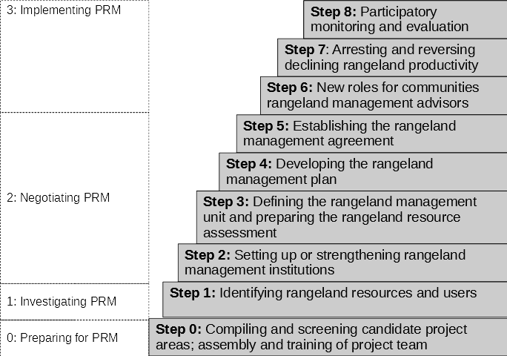
Figure 1: The stages of the PRM process, modified from (Flintan and Cullis 2010)
24

General description of the rangeland cluster
The Benishangul Bumuz regional state is one of the regional states of the Federal Democratic Republic of Ethiopia located in the Western and North-western part of the country between 8⁰9587N' -12⁰0012’N Latitude and 34⁰104984E’ to -36⁰6940’E longitudes. The region shares boundary with Amhara in the North and North East, Oromia in the South and South East, South Sudan in the South West, and Sudan in the West. The regional State is divided into three zonal administrations with 22 districts and three urban administrations, including the capital city of the region, Assosa. The total area of the region is 50380.00 square kilometers.
Among the 22 district of the region, 9/nine/ districts grouped under three clusters have been intervention area of the LLRP project. Menge Cluster is the new cluster substituted Bulen cluster due to sustained security problem in Bulen district clusters.

Location and administrative boundaries
Rangeland cluster one or Menege cluster is one of the Lowland Livelihood Resilience project (LLRP) intervention areas comprises three districts namely Abramo, Menege and Oundulu. Administratively, the cluster is laid under Asossa zone. As per the Project Implementation Manual (PIM) districts that has connected with common rangeland and adjacent to each other are grouped as a rangeland cluster. However, Abramo districts is not bordered with the rest two adjacent district of the cluster, even though they assigned as cluster one or Menege cluster by the regional Cabinet. Oura is one the regional district found in between of Abramo and the rest two districts namely Menege and Oundulu of the cluster. Menge cluster is situated at the Western part of the region that has share boundary with Mao-Komo and Bambasi district in the South, Kurmuk and Sherkole district in North, South Sudan in the West, and Bulidigilu districts in the East.
Administratively, Menge cluster (cluster one) is divided in to 71 sub-district/kebeles and three rural town of which Abramo, Menege and Oundulu district has 41, 20 and 10 rural kebele respectively.

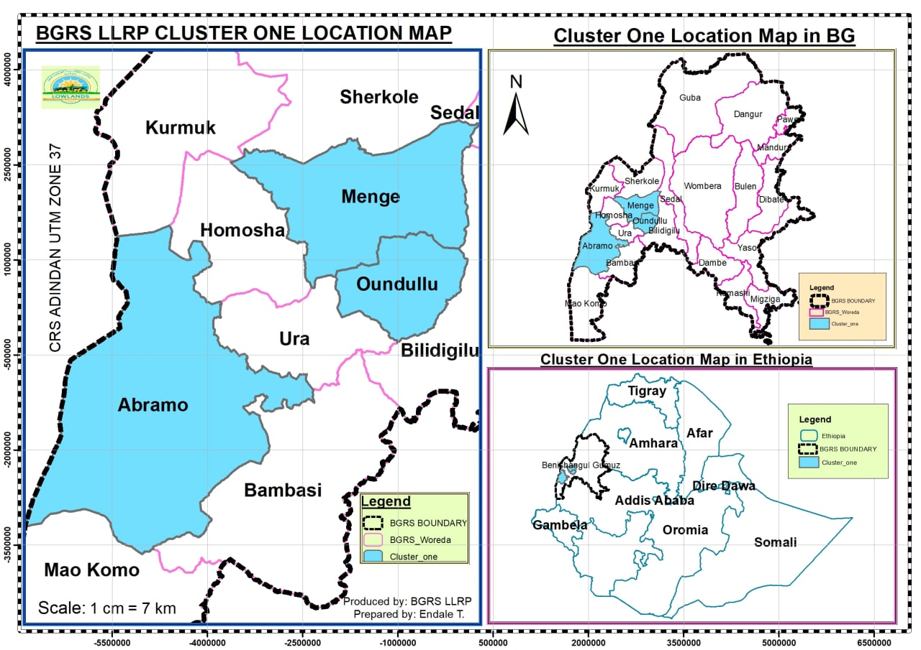
Figure 2: Map of Menge cluster (cluster one)

The total area of the cluster is 388,840Ha which is 7.7 percent of the total land mass of the region. Of the total land area cultivated land comprises 111,064Ha; all-season grazing land comprises 13,666Ha; forests and shrub and wood grass land totally comprise 258356Ha of the total area.

25
Table 1: The total land area of Menge cluster
S/No | Land use pattern (LUP) | Land use pattern of Menge Cluster Districts in Ha
 |  | Aberamo Districts | Menge Districts | Oundullu Districts | Total of Menge Cluster LUP
1 | Grazing Land | 7,441.50 | 1,033.45 | 5,191 | 13,666
2 | Savanna grass land | 56,910.00 | 29,429.80 | 948 | 87,288
3 | Shrub Land | 593.9 | 8,512.00 | 797 | 9,903
4 | Wet land | 105 | 680.37 | 1,014 | 1,799
5 | Cultivated Land | 64,642.05 | 26,000.00 | 20,422 | 111,064
6 | Forest | 101,520.00 | 41,845.00 | 17,800 | 161,165
7 | Irrigated land | 2,444.00 | 432 | 273 | 3,149
8 | Other | 409.23 | 199.72 | 197.35 | 806
 | Total | 234,065.68 | 108,132.34 | 46,642.35 | 388,840
Source: Agriculture Office 2014 report of Menge cluster districts

Agro-Ecology
Agro-ecologically the cluster is unanimously falling under 51.82% moist lowland and 41.6% dry lowland and 6.54 % dry midland. The detail agro ecology information has shown in the below table and figure.

Table 2: Agro-Ecology of Menge cluster
S/No | Name of District | Altitude |  | Agro-Ecology |  |  | Rain fall |  | Temperature
 |  | lower | higher | Midland | Moist lowland | Dry lowland | Min | Max | Min | Max
1 | Abramo | 559 | 2034 | 8.59 | 48.69 | 42.72 | 840 | 1844.8 | 14.6 | 34.5
2 | Menge | 609 | 1659 | 1.61 | 59.54 | 38.86 | 581 | 1501 | 14.4 | 35.8
3 | Oundulu | 709 | 1434 | - | 62.02 | 37.98 | 764 | 1444 | 15.1 | 37.05
Source: Regional Metrology Agency and own computation using GIS
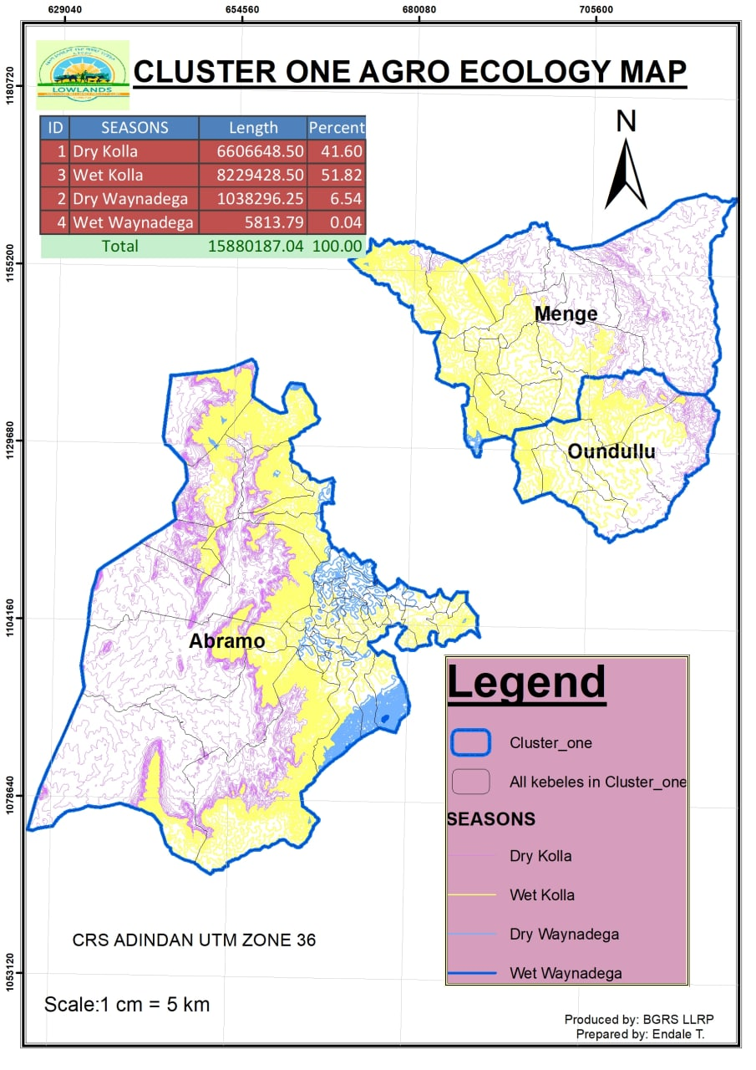
Figure 3: Agro-ecology map of Menge cluster

The topography which refers to the configuration of the land surface has a large impact on whether a field can be used for various purposes. Relief is a component of this topography that refers to the difference in height between the hills and depressions in the field. The topographic relief, therefore, affects the type of land use, water and soil conservation requirements and water erosion control practices. The shape and arrangement of topographic landforms and the type of surface waterway network also influence irrigation management.
Land forms are described foremost by their morphology and not by their genetic origin or processes responsible for their shape (FAO, 2006). The dominant slope is the most important differentiating criterion, followed by relief intensity. In this case the dominant slope of the cluster ranges mostly from 0 - 2%, 2 - 8%, 8-15%, 15-30% and above 30%. Thus, the major landform of the cluster area fall within the spectrum of flat plain to moderately steep surface, with an altitude ranging between 541 to 2061 meter.

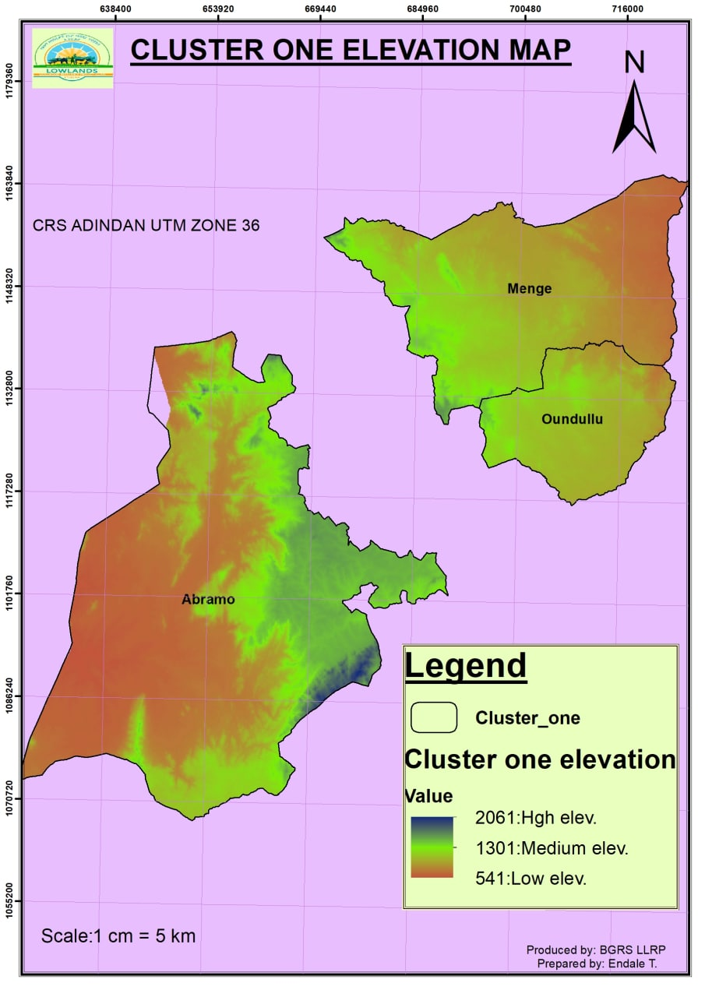
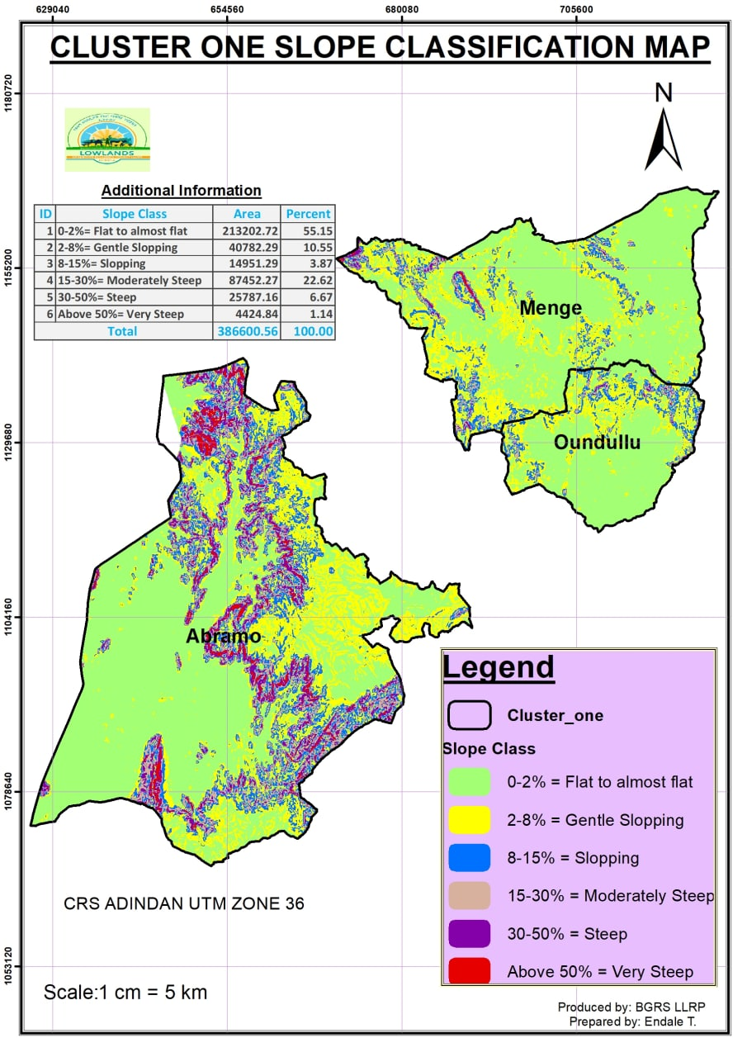
Figure 4: Elevation and slop classification map of Menge cluster

Climate
According to the discussion result, the climate of the cluster is characterized by a single maximum rainfall pattern runs from May to November. The maximum rainfall is recorded between mid-June to September last week.
According to the National Meteorology of Ethiopia Asossa Branch records for the last ten years, Abramo, Menge and Oundulu districts were receive 840mm-1844.8mm, 581mm-1501mm and 764mm-1444mm rain fall per year respectively and the monthly average maximum, minimum temperature was 14.6^{O}C -34.5 ^{O}C, 14.4 ^{O}C -35.8 ^{O}C and 15.1 ^{O}C -37.05 ^{O}C respectively. Generally, as the cluster, the average minimum and maximum temperature ranges from 14.7 ^{O}C to 35.8 ^{O}C.

Table 3: Ten years average maximum and minimum temperature of Menge cluster
District |  | Jan | Feb | Mar | Apr | may | June | July | Aug | Sep | Oct | Nov | Dec
Abramo | Max | 32.7 | 34.1 | 34.5 | 32.8 | 29.4 | 27.6 | 26.7 | 26.5 | 24.8 | 28.1 | 30 | 31.8
 | Min | 15.5 | 16.7 | 17.6 | 18.2 | 17.1 | 17.1 | 16.6 | 16.3 | 16.4 | 16.1 | 15.4 | 14.6
Menge | Max | 32.9 | 34.9 | 35.8 | 35.5 | 32.5 | 29.7 | 29.1 | 28.6 | 29.4 | 29.5 | 31.2 | 32.5
 | Min | 15.5 | 17.1 | 18.5 | 19.4 | 19.3 | 18.9 | 18.2 | 17.7 | 17.6 | 17 | 13.8 | 14.4
Oundulu | Max | 34.1 | 36.1 | 37.1 | 36.5 | 33.6 | 30.9 | 30.3 | 29.8 | 30.7 | 30.7 | 32.4 | 33.7
 | Min | 16.1 | 17.5 | 19.1 | 20.1 | 20.3 | 19.9 | 19.2 | 18.7 | 18.5 | 17.8 | 16.2 | 15.1
Cluster average | Max | 35.0 | 35.8 | 34.9 | 31.8 | 29.4 | 28.7 | 28.3 | 28.3 | 29.4 | 31.2 | 32.7 | 35.0
 | Min | 17.1 | 18.4 | 19.2 | 18.9 | 18.6 | 18.0 | 17.6 | 17.5 | 17.0 | 15.1 | 14.7 | 17.1
Source: National meteorology of Ethiopia Asossa branch office report (2014)

Geology and soils
Based on the data obtained from GIS analysis, the cluster has 8 soil types namely Acrisols, Cambisols, Xerosols, Leptosols, Nitosols, Vertisols, Yermosols, and Solonchacks (Fig. 5). These soils have relatively good agricultural potentials and are found in different parts of the cluster districts. Together with climate and terrain, soil conditions determine the agricultural production potentials of a given area for a biophysical perspective. Major soil association are classified on the basis of predominant chemical and physical properties, derived from parent materials and modified by weathering and other transformative processes.

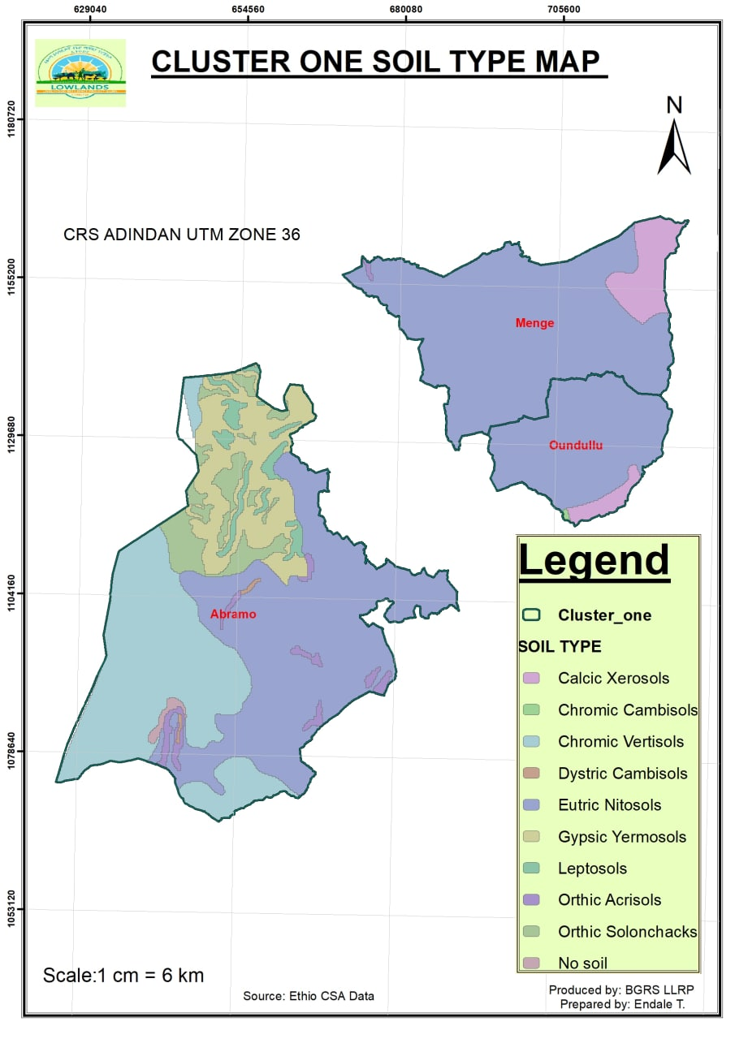
Figure 5: Major soil types of Menge cluster

Drainage is influenced by soil texture, soil type and soil depth. Drainage in turn affects soil moisture and, which affects plant growth. Drainage is one of the important physical characteristics of soil. Well drained soils are good for agriculture and other plant growth in general. For example, Vertisols have water logging problem and it is not well drained, which do not allow many crop types to grow through they are rich in soil nutrients. Generally, Benishangul Gumuz region has well drained soils; that is why the region is mainly characterized as sloppy terrains.

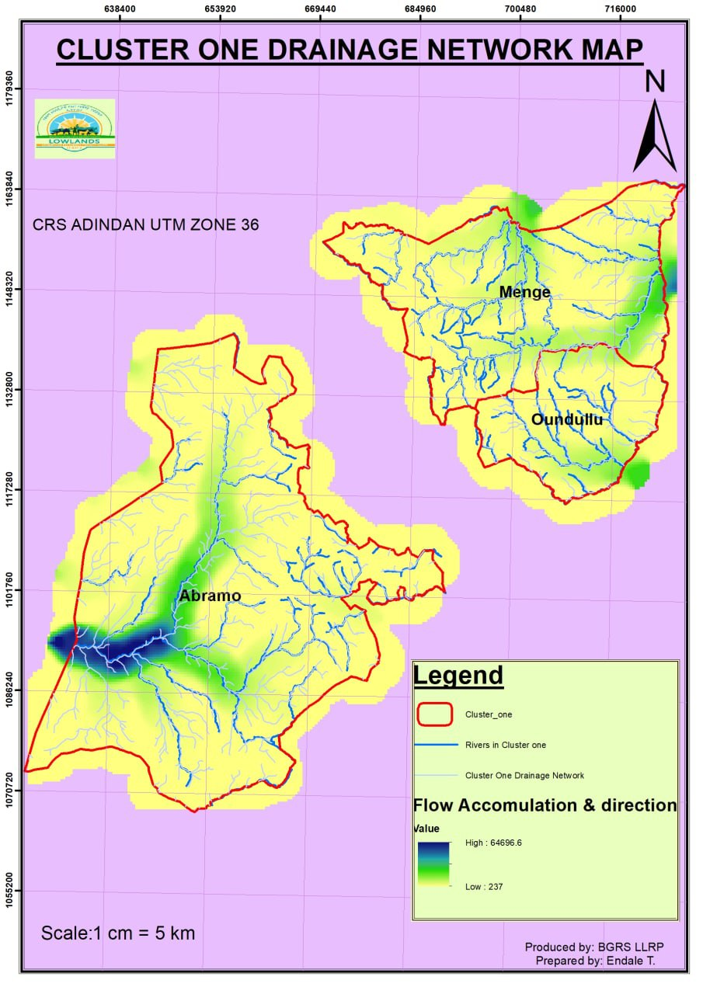
Figure 6: Drainage map of Menge cluster

Vegetation
Vegetation in Benishangul Gumuz Region is part of Combretum - Terminalia Broadleaved Deciduous Woodland and Wooded Grassland which extends from the foot hills of western escarpment of western Ethiopia to the cost of Senegal. This vegetation in Ethiopia was first described as the Broad-leaved deciduous woodland and wooded grassland vegetation which was later described as Combretum - Terminalia Broadleaved Deciduous Woodland Ecosystem. This ecosystem is dominated by the woody plant species such as; Lannea Fruticosa, Flueggea Virosa, Grewia Mollis, Pterocarpus Lucens, Combretum Collinum, Terminalia Laxiflora and Stereospermum Kunthianum; and grasses including; Hyparrhenia Rufa and Pennisetum Thunbergii (Dereje & Dawit, 2020). Since the ecology of Menge cluster has dry and wet lowland features, it is characterized by Combretum - Terminalia Broadleaved Deciduous Woodland and long savanna grass Ecosystem.
In terms of land‐use patterns, the cluster’s land mass is predominantly comprised of forestland, cultivated land, grazing land, savanna grass land, and marginal land (Fig. 7). There are eight types vegetation in the cluster, namely: dense forest, riverine forest, broad-leaved deciduous wood lands, shrub lands, Boswellia papyrifera wood land and bamboo thickets (INBAR, 2010).
There are economically important vegetation’s that support the livelihoods of the community found in the cluster. Bamboo and incenses is the major NTFP, in which the community has been benefited from the rangeland resource. However these resources have been degraded gradually due to different factors. The discussion revealed that, wildfire caused by charcoal making, incense tapping harvesting, farmland clearing, mineral site clearing etc., is the major factor deteriorating vegetation cover and potentials in the cluster. In general wildfire, deforestation, farmland encroachment, infeasible investments, overgrazing (particularly in Abramo district), expansion of settlement, land tenure insecurity, etc… are the factors affecting land use patterns /land cover changes in the cluster.

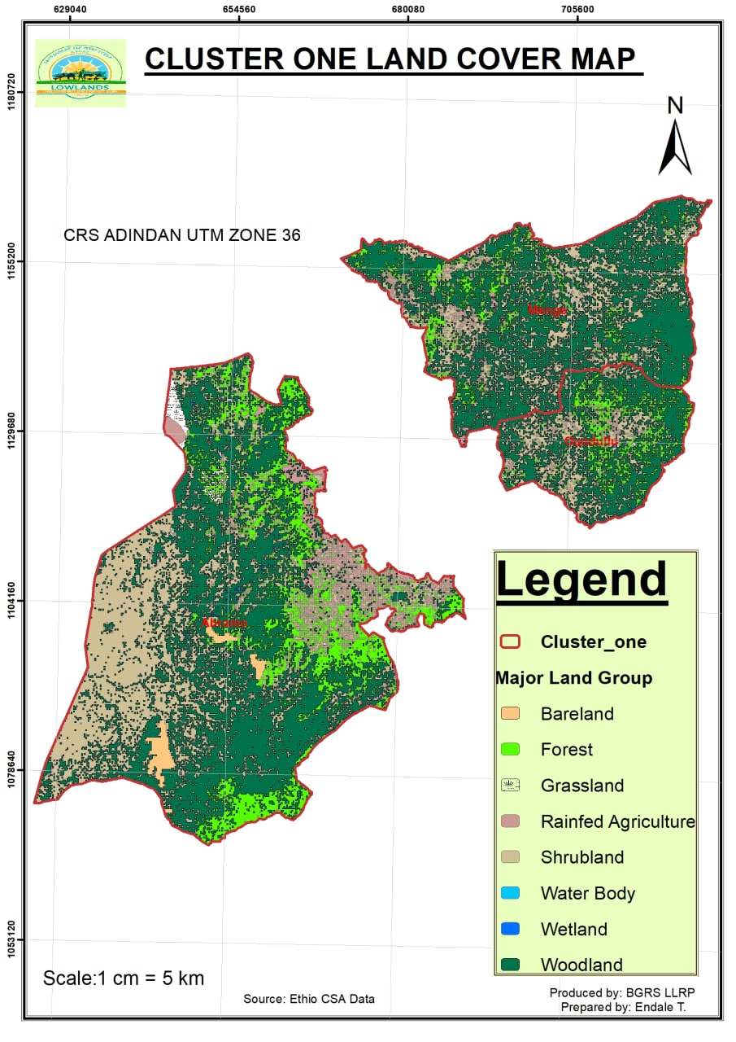
Figure 7: Land use pattern (land cover of rangeland in cluster one)

2.6 Socio-economic data

Population distribution and size
According to rangeland cluster districts health office report (2014), the total population number of the cluster is estimated to be 105,257 (47.7% female) of which the total number of the household is 22,115. The population growth rate has been estimated to be 2.5 percent per annum in the year 2014 and with an estimated density of 19.26 people per square kilometer. The cluster has hosts one native ethnic groups namely Berta, and other ethnic groups like Oromo, Amhara Agew and Tigre are living in the cluster.

Table 4: Population size of Menge cluster districts
Districts | Population size |  |  | Household size |  |  | Average Household size | Proportions of PAP
 | Male | Female | Total | Male | Female | Total
Abramo | 22,667 | 18,630 | 41,297 | 6,729 | 1,903 | 8,632 | 4.7 | 100%AP
Menge | 21,159 | 20,086 | 41,245 | 7,332 | 1,833 | 9,165 | 4.5 | 100%AP
Oundulu | 11,217 | 11,498 | 22,715 | 2,116 | 2,202 | 4,318 | 5 | 100%AP
Total | 55,043 | 50,214 | 105,257 | 16,177 | 5,938 | 22,115 | 4.7 | 100%AP
Source: Health office 2014 report of Menge cluster districts

Education
Education is the only means of improving the overall living standards and raising the technical and cultural level of the people. It is the vehicle for abolishing backward and harmful traditional and customs that hamper development. Availability of skilled manpower is directly linked with educational status and availability of educational facilities. However other factors such as cultural values of the society, use of school-age children labor, etc. also affect access to education besides availabilities of schools.
According to the cluster districts Education office 2014 report, there are 60 Junior and primary school (grade 1-8), 1 secondary school (grade 9-10), and 4 preparatory school (grade 11-12).

30
Table 5: Coverage of School Infrastructure in the Cluster
S/No. | Education | Districts of Menge cluster |  |  | Total
 |  | Aberamo | Menge | Oundullu
1 | O-Class | 0 | 3 | 0 | 3
2 | 1-6 | 13 | 10 | 0 | 23
3 | 1-8 | 19 | 10 | 8 | 37
4 | 9-10 | 0 | 1 | 0 | 1
5 | Preparatory (9-12) | 2 | 1 | 1 | 4
 | Total | 34 | 25 | 9 | 68
Source: Education office 2014 report of the cluster districts.

Destruction of school, shortage of classroom and furniture, poor quality of existing classrooms, lack of water and toilet in school compounds are the most constraints challenging the process of learning and teaching system in the cluster. Beside this, out of 71 kebeles of the cluster totally 68 kebeles has no O-class Education infrastructure even though children’s are attending their education from all kebeles. Also out of 71 kebeles of the districts totally 11 kebeles have no school infrastructure.
So, to improve the enrollment of students it would be recommended to construct stander schools and fulfillment with toilet and water based on the kebele demands.

Human health service
Regarding Human health infrastructure, in the cluster there is 5 health center, 20 clinics, 61 health post, 2 drug store 9 pharmacies and 1 Hospital. Among sub district of the cluster, 8 sub districts have no health infrastructure as a result they must travel long distance to get health services. For sever health problems, the residents of the cluster have get health service from Asossa city and Najo Hospital. In general, the health coverage in the cluster is less due to road inaccessibility and small number of health infrastructure particularly health center as compared to population size.

Table 6: Health infrastructure of Menge cluster districts
Menge cluster districts | Description |  | Type of health services/institutions |  |  |  |  |  | Total
 |  |  | Health Center | Clinics | Health Post | Pharmacy | Drug Store | Hospital
Aberamo | Quantity |  | 2 | 8 | 37 | 4 |  |  | 51
 | Ownership | Gov't | 2 | 0 | 37 | 0 |  |  | 39
 |  | Private | 0 | 8 | 0 | 4 |  |  | 12
 | Benefiting kebeles |  | 2 | 8 | 37 | 4 |  |  | -
Menge | Quantity |  | 2 | 9 | 15 | 2 | 2 | 1 | 31
 | Ownership | Gov't | 2 | 0 | 15 | 2 | 0 | 1 | 20
 |  | Private | 0 | 9 | 0 | 0 | 2 | 0 | 2
 | Benefiting kebeles |  | 2 | 9 | 15 | 2 | 2 | 20 | -
Oundullu | Quantity |  | 1 | 3 | 9 | 3 | 0 | 0 | 16
 | Ownership | Gov't | 1 | 0 | 9 | 0 | 0 | 0 | 10
 |  | Private | 0 | 3 | 0 | 3 | 0 | 0 | 6
 | Benefiting kebeles |  | 1 | 2 | 9 | 2 | 0 | 0 | -
Total | Quantity |  | 5 | 20 | 61 | 9 | 2 | 1 | 98
 | Ownership | Gov't | 5 | 0 | 61 | 6 | 0 | 1 | 81
 |  | Private | 0 | 20 | 0 | 3 | 2 | 0 | 16
 | Benefiting kebeles |  | 5 | 20 | 61 | 9 | 2 | 20 | -
Source: Health office 2014 report of the cluster districts.

Water resources
Water is a renewable endowed natural resource which is vital for all living thing to survive. Water is a life; water has wide function in day-to-day activity of human being. Shortage of water is the major constraint challenging human being everywhere in Ethiopia particularly in low land areas. In rural Ethiopia, although considerable efforts have been made to improve and expand access to potable water supply, many Ethiopian rural communities still suffer from lack of safe and potable water. Climate change resulting from deforestation and expansion of irrigation and settlement and population growth are the main cause for drying of surface and ground water. In the cluster particularly in Abramo and Oundulu districts shortage of water for both human and livestock are the critical challenges affecting the livelihoods of the community.
According to the data collected from district water offices in 2014, water supply schemes like Hand Dug Well (HDW); Deep Well (DW) and Shallow Well (SW) and rivers are the source of water for both human being and livestock. In the cluster out of 367 developed water schemes up to data (2014 EFY) 305 water schemes (HDW, DW, SW, spring) and 12 Perennial Rivers (Abramo 9, Menge 2, and Oundulu 1) are serving the community and livestock in the cluster. According to the data obtained from district offices the total water supply coverage of the cluster is laid between 56.4% and 38%. As indicated in the table below among 71 sub districts of the cluster only 19 sub districts have getting sufficient water while the remaining 52 has facing water shortage. Additionally, according to the data collected from district offices out of 71 sub districts of the cluster 31 sub districts (Abramo 16, Menge 10 and Oundulu 5) has facing water shortage for livestock.

Table 7: Menge cluster water supply schemes distribution for humane use
Menge cluster districts | Description | Type of water supply schemes |  |  |  | Total | Coverage
 |  | Hand dug well | Deep well | Sallow well | Spring
Aberamo | Functional water points | 51 | 1 | 89 | 3 | 144 | 40.9
 | Benefiting kebeles | 33 | 1 | 38 | 3 | 40
Menge | Functional water points | 35 | 3 | 65 | 1 | 104 | 56.4
 | Benefiting kebeles | 13 | 3 | 18 | 1 | 19
Oundullu | Functional water points | 31 | 0 | 26 | 0 | 57 | 38
 | Benefiting kebeles | 10 | 0 | 9 | 0 | 10
Total | Functional water points | 117 | 4 | 180 | 4 | 305 | 45.1
 | Benefiting kebeles | 62 | 4 | 65 | 6 | 106
Source: Water supply office 2014 report of Menge cluster districts.

Agriculture services
The Government of Ethiopia is highly committed to sustainably increase agricultural production and productivity to meet the growing demand for food, industrial raw materials, and foreign currency earnings. In order to respond the growing demand of different stakeholders, there is a need of dynamic and proactive extension system. Rigorous and vibrant extension system is a key policy instrument for necessary behavioral and attitudinal changes and creating demands on national agricultural extension programs. The Ethiopian agricultural extension system is heavily dependent on Farmer Training Centers (FTCs) and trained DAs that give extension support to farmers and agro-pastoralists. Accordingly, the cluster has 26 (36%) Farmer Training Center (FTC), and 42 (58%) Animal Health Post (AHP).

32
Table 8: Menge cluster agricultural services
S/No. | Agricultural services (ASs) | Aberamo | Menge | Oundullu | Total ASs and benefited kebles/districts
 |  |  |  |  | Quantity | Benefiting Kebeles | Lacking Kebeles /Districts
1 | PTC/FTC | 24 | 8 | 2 | 34 | 34 | 37kebele
2 | Livestock Clinic (per districts) | 0 | 0 | 0 | 0 | 0 | 3(districts)
3 | Animal Health Post | 39 | 5 | 3 | 47 | 47 | 24 kebele
4 | Livestock Market Center (Per districts) | 0 | 0 | 0 | 0 | 0 | 3(districts)
Source: Agricultural office 2014 report of Menge cluster districts.

Irrigation
The cluster particularly Abramo district has potential permanent rivers for irrigation development. In the cluster there are 12 permanent rivers and among these 9 rivers are found in Abramo district and the remaining is found in Menge and Oundulu district. These shows there are some experience of irrigation production and it might need some support to harness the potential of the water resource of the area. So afar there is 5 small scale irrigation scheme (weir) in Abramo district of Menge cluster that support irrigation.

Table 9: Small scale irrigation schemes and irrigated land
No | Cluster Woredas | Small-scale irrigation schemes | Irrigated area in hectare | Potential area in hectare | Water source
1 | Aberamo | Diversion weir (5 weir) | 193 | 241 | River
 |  | Traditional | 1,088 | 1,406 | River
2 | Menge | Diversion weir | 0 | 0
 |  | Traditional | 432 | 604 | River
3 | Oundullu | Diversion weir | 0 | 0
 |  | Traditional | 273 | 1,647 | River
 | Cluster One Total | Diversion weir | 193 | 241 | River
 |  | Traditional | 1,793 | 3,657 | River
 |  | Total | 1,986 | 3,898 | River
Source: Agricultural office 2014 report of Menge cluster districts

Livelihoods
The community of the cluster has practicing mixed agricultural farming system to support their livelihood. Cereal, pulses and cash crops such as Sorghum, Millet, Maize, Ground Nut, Sesame, Teff, Soya bean, Niger, Haricot bean and Okra is cultivating in the cluster. Beside these crops fruits like papaya, Mango, Guava, Banana, Lemon, Avocado, Coffee is cultivating in the cluster. Also vegetable such as Onion, Tomato, Cabbage, and Green pepper is cultivated in the cluster with rain feed and irrigation.

33
Table 10: Average land coverage by major crops in Menge cluster
No. | Major Crops | Coverage in Ha in average |  |  | Total
 |  | Abramo | Menge | Oundulu
1 | Sorghum | 17,199.0 | 12,269.0 | 9,123.0 | 38,591.0
2 | Maize | 16,975.0 | 6,837.0 | 2,342.0 | 26,154.0
3 | Teff | 5,299.0 |  |  | 5,299.0
4 | Seasame |  | 1,077.0 | 1,341.0 | 2,418.0
5 | Soybean | 4,965.0 | 1,063.0 | 26.0 | 6,054.0
6 | Haricot bean | 4,083.0 | 919.0 | 620.0 | 5,622.0
7 | Okra |  | 644.0 |  | 644.0
8 | Ground net |  | 509.0 | 287.0 | 796.0
9 | Nuge |  | 90.0 |  | 90.0
10 | Others | 16,121.1 | 2,592.0 | 6,683.0 | 25,396.1
 | Total | 64,642.1 | 26,000.0 | 20,422.0 | 111,064.1
Source: Agricultural office 2014 report of Menge cluster districts

As an agro-pastoralist the cluster community has also engage in rearing livestock like cattle, sheep, goat, poultry, equines, and beekeeping to support their livelihoods. Gold mining and extraction of incense and gum are also the main income source for the community resides in the cluster.

Table 11: Livestock population of Menge cluster districts
S/No | Livestock population | Livestock population of entire woreda
 |  | Aberamo | Menge | Oundullu | Cluster one
1 | Cattle | 13,213 | 783 | 109 | 14,105
2 | Camel | 0 | 0 | 0 | 0
3 | Goats | 11,512 | 53,814 | 14,675 | 80,001
4 | Sheep | 37,72 | 3,354 | 596 | 3,950
5 | Donkey | 3,874 | 5,412 | 3,679 | 12,965
6 | Horse | 0 | 0 | 0 | 0
7 | Mule | 0 | 2 | 0 | 2
8 | Bee colony | 27576 | 2,075 | 0 | 29,651
9 | Poultry | 21489 | 0 | 20,074 | 41,563
Source: Agricultural office 2014 report of Menge cluster districts

The cluster is endowed with fertile potential land suitable for crop production and livestock rearing, and minerals like gold and coal, and economically important trees like bamboo and incense. According to discussion result held with the cluster community, gold mining and livestock product are the primary source of income next to crop production in the cluster to sustain their livelihood. NTFP are the important sources of food, cash income, and assets to buffer against shocks. In general, a mixed farming system, involving both crop production and livestock rearing activities, is the dominant type of production system. In general, the community of the cluster has totally characterized by Agro-pastoral livelihood system.

34
Table 12: Source of income in Menge cluster
No | Sectors | % share contribution
 |  | Abramo | Menge | Oundulu
1 | Crop Products | 61 | 41 | 20
2 | Livestock | 30 | 22 | 20
3 | Mineral (Gold, Construction Sand etc.) | 3 | 30 | 50
4 | Petty Trade | 6 | 7 | 10
Source: Agricultural office 2014 report of Menge cluster districts

Participation in the economy by gender
Gender equality has an important role in the economic development. As per the assessment result held with the community women stands in the first place to access the resource in the cluster then men and youths. This implies that women might have burden due to their engagement to the tasks related to these resources to improve their livelihood. As indicated in the below table (table: 13) except beekeeping and petty trade women are playing a leading role in agriculture production, resource protection and development. Nevertheless, control of these resources women’s and youths have fewer roles than mane. In general, the participation of women’s and youths in economic development to maintain the livelihood of the household is good.

Table 13: Gender based access and control analysis.
No | Types of resources | Access |  |  | Control
 |  | Women | Men | Youth | Women | Men | Youths
1 | Land
1.1 | Grazing/ pasture | √ | √ | √ |  | √
1.2 | Cultivated
1.2.1 | Rain fed | √ | √ | √ | √ | √
1.2.2 | Irrigable | √ | √ | √ |  | √
2 | Water
2.1 | Drinking water for human & Animals | √ |  | √ | √ | √ | √
2.2 | Irrigation | √ | √ | √ |  | √
3 | Livestock’s
3.1 | Cattle | √ | √ | √ | √ | √
3.3 | Sheep & Goat | √ | √ | √ | √ | √
3.4 | Calves | √ |  | √ | √ | √
3.5 | Beekeeping |  | √ |  |  | √
4 | Livestock’s/Animal products
4.1 | Milk, meat, eggs, honey | √ | √ | √ | √ | √
5 | Crops, vegetable & fruits products
5.1 | Crops | √ | √ | √ | √ | √
5.2 | Vegetables | √ | √ | √ | √ | √
5.3 | Fruits | √ | √ | √ | √ | √
6 | Other off-farm products
6.1 | Charcoal | √ | √ |  | √
6.2 | Petty trade |  | √ | √ | √ | √ | √
6.3 | Cash | √ | √ | √ | √ | √
Source: Community Consultation report (2015 EFY).

Conflict
Conflict is a hazard that constraining development and eroding development gains, restricting movements of people and livestock, disrupting markets and public services, and even resulting in the loss of life in Pastoral and agro-pastoral areas. Conflict is a common phenomenon in the rangeland cluster, and it is a result of interrelated drivers emerging from economic factors. Competition for natural resource significantly contributes to violent conflict in the cluster. The specific triggers for conflict, as identified during the consultation with the community are competition for cultivation land, grazing land, mineral and NTFP. The discussion result revealed that, conflicts do happen within cluster. Conflicts within cluster are between farmers of different kebeles and within kebele. Within cluster conflicts arise from competition for rangeland resources like cultivation land, and minerals and NTFP.

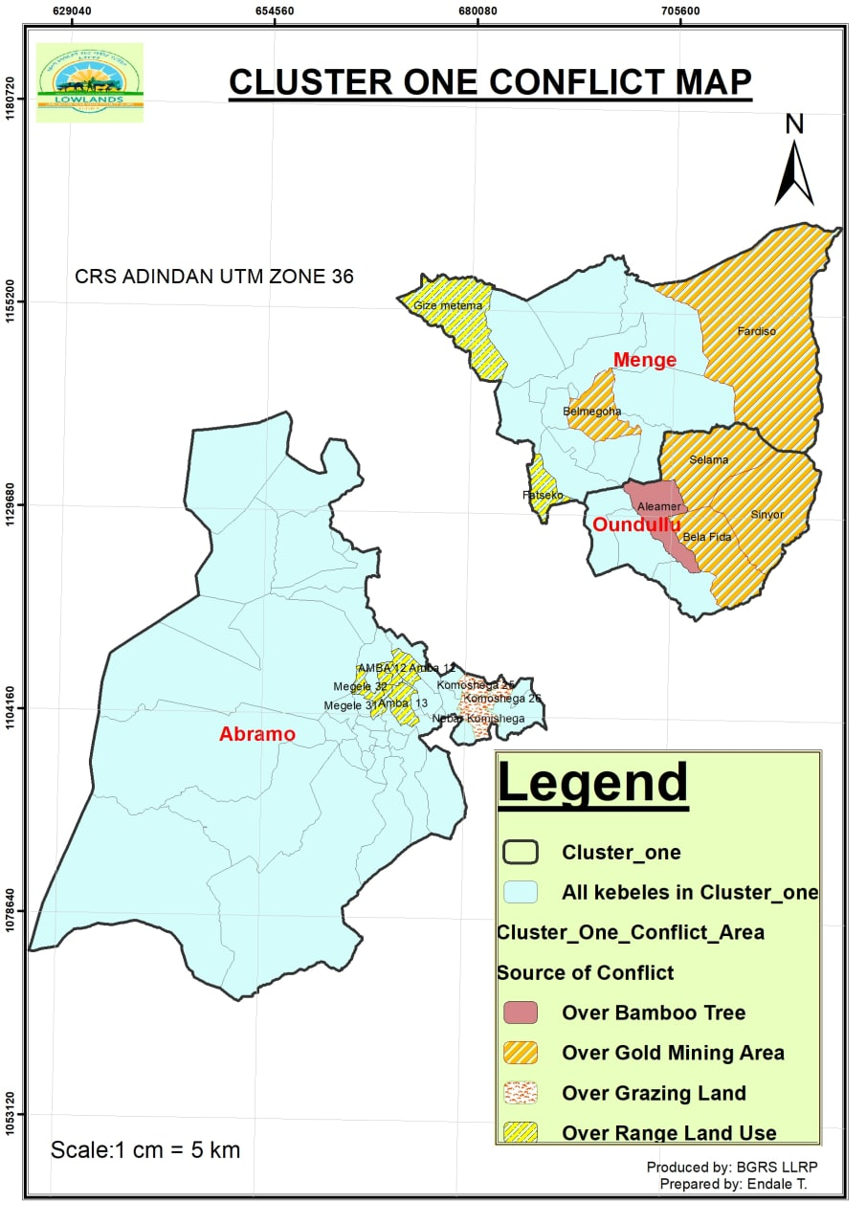
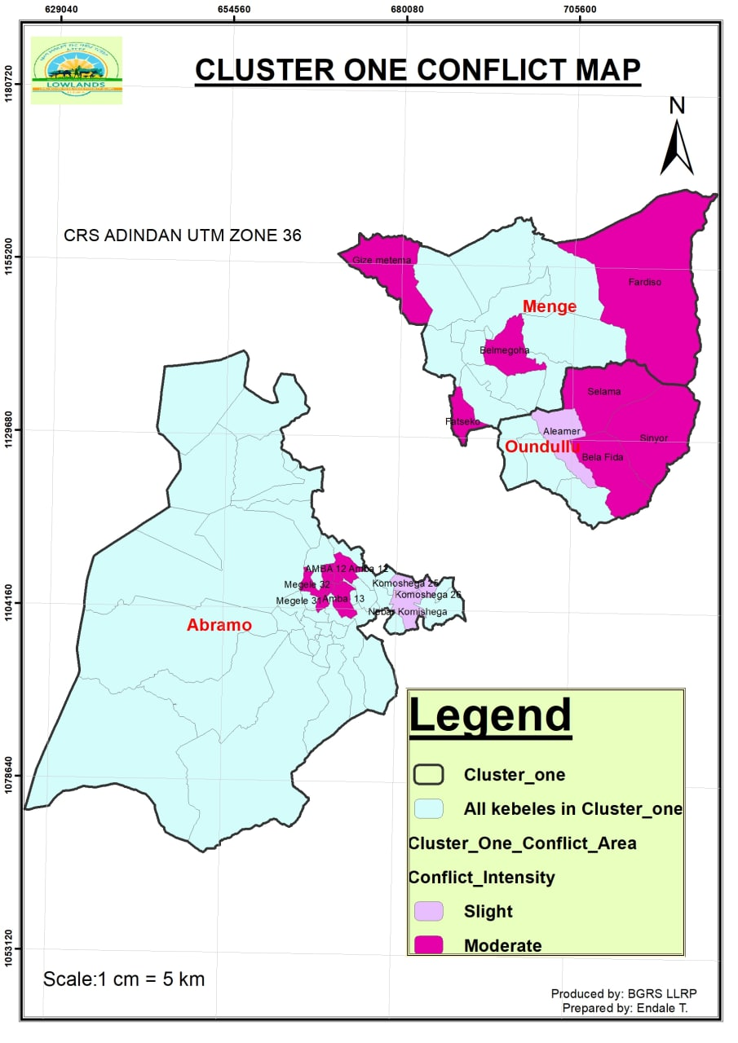
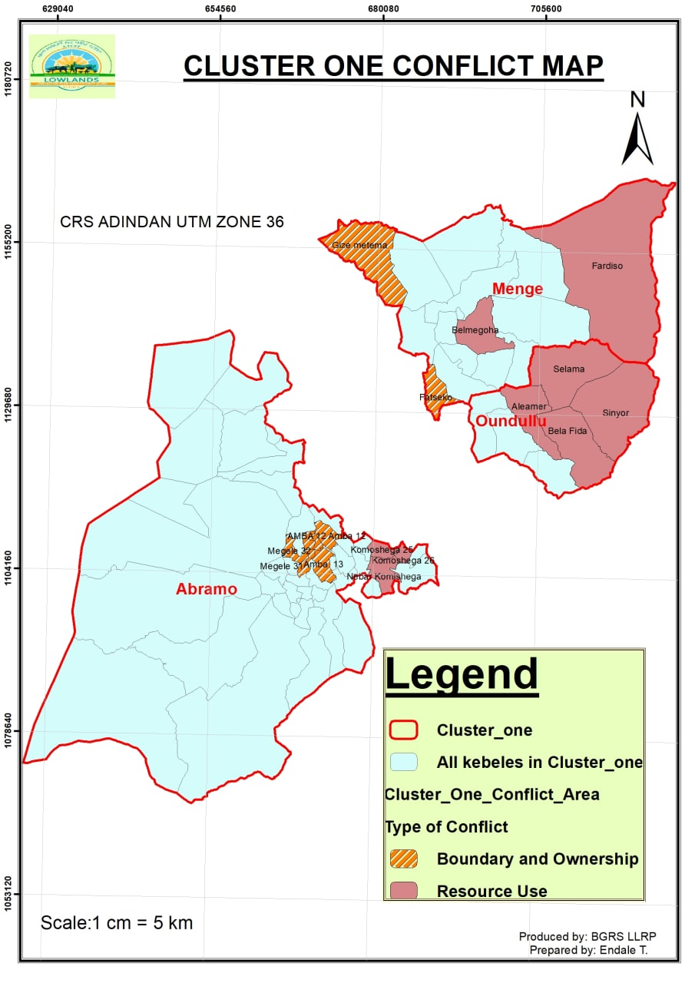
Figure 8: Conflict hotspot areas in Menge cluster

Competition over the resource is the driving factors of conflict in the cluster. Most of the time conflicts has been erupted during dry season due to competition overgrazing land, beginning of summer season due to conflict on cultivation land border; and throughout the year due to competition over minerals. Even though conflict is the regular phenomena it has no impact on the cluster community. So far the community has not faced loss of life and deterioration of development gained as a result of conflict.
The Community discussion shows that, there is traditional conflict handling platforms in the cluster. There are elders who have recognition from the community that can negotiate farmers or groups or kebeles getting in conflicts. In the cluster joint committee were established to solve any conflict happen with in the kebele or district level. However, these committee and elders have not got capacity building.
Management of conflict in the cluster needs to focus on a) adhering to by-laws; b) work on awareness creation on the effect of the conflict; c) empowering cultural institutions and building their capacity in conflict management; d) and fostering intercommunity dialogue; e) implementation of integrated rangeland resources management with adjacent rangeland cluster community.

Table 14: Conflict analysis of Menge cluster
S/NO. | Types of Conflicts | Resource | Conflict hotspots | Conflict intensity | Adverse effects (consequences) | Driving factors | Seasonality | Frequency | Major actors
1 | Conflict over Resource | Grazing land | Abramo Woreda (Komishga 25, Nebera komishiga 25,26,34, Afa Megele) | Slight | Nothing | Computation over resource | Dry season | Yearly | Farmers
 |  | Gold | - Menege Woreda (Fardose, Shegole, Shendi, and Belmigoha)  - Oundulu Woreda (Signor, Belafida, Selama and Belimili) | Moderate | Nothing of human, but the practice has degrading natural resource | Computation between legal and illegal miners | Throughout the year | Yearly | - Host community  - Sudanese refuge
 |  | Bamboo (NTFP) | - Oundulu Woreda (Alhamer, Signor) | Slight | Nothing | Computation over harvesting of bamboo | Throughout the year | Yearly | Both kebele community
2 | Conflict on Rangeland ownership /land tenure/ (boundary conflict) | Grazing and cultivation land | - Abram Woreda (Amba 12,29, Shederiya Megele 13,31,32 kebele)  - Menege Woreda (Shegol, Gizemetema, and Fatseko)  - Oundul Woreda (Signor and Selama) | Moderate | Nothing | Computation over resource | During the begging crop cultivation | Yearly | Farmers
Source: Community Consultation report (2015 EFY).

Preparation

Establish the RMIP team
The preparation towards the development of the RMP and RMIP started with the establishment of the PRM taskforce. The role of taskforce is to facilitate community discussion and to collect secondary data from respective cluster districts. To produce the document one rangeland specialist from the project coordination unit will assign. Accordingly, to formulate the Rangeland Management and Investment Plan (RMIP) for Menge rangeland cluster of Lowland Livelihood Resilience Project (LLRP), the taskforce composed of multidisciplinary subject matter specialist has established from respective cluster districts.
Following the establishment of the taskforce, the Regional Project Coordination Unit (R-PCU) has provided training by the Rangeland specialist on preparation of RMIP, Rangeland management concept and Participatory Rangeland Management (PRM) for the taskforce of cluster districts to equip with technical knowledge.

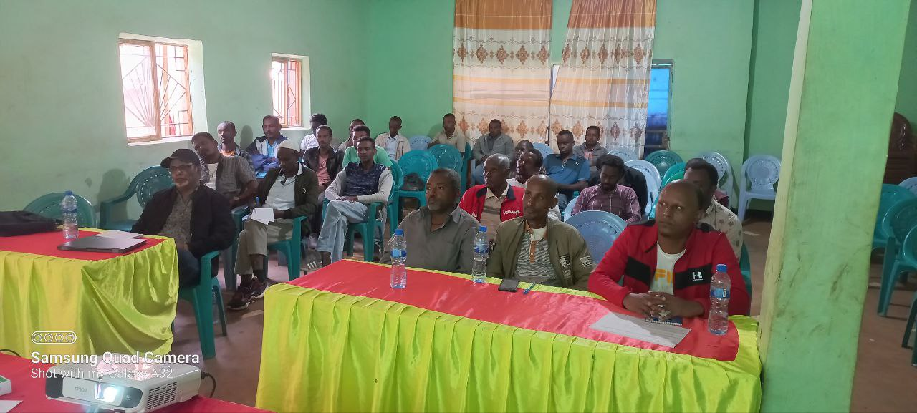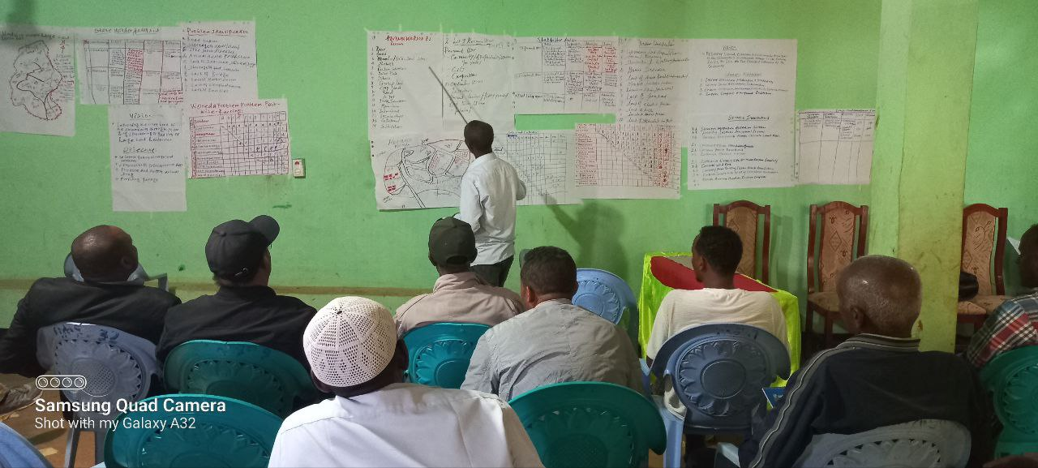

Figure 9: Refresher training for regional and district experts

Agreements with the community
Following the accomplishment of refreshment training, the RMIP formulation team has organized logistics and venue at Asossa district to conduct Participatory Rangeland Management Planning (PRMP). To conduct community discussion and to collect relevant information about the rangeland cluster, community representative who knows socio-economic situation of their area very well elders and model agro-pastoralists was selected from each kebele to participate on the discussion. Similarly, famous elder who knows their district well were also selected for district level and participated in the discussion. As indicated in the table below totally, 98 (16F) community representatives and experts were participated on Rangeland Management Planning (RMP).

Table 15: Number of community representative, elders and experts participated on RMIP formulation for Menge cluster
No. | Menge cluster districts | No of kebele per districts | No of community representatives including translators |  |  | No of elders | No of experts (facilitators) |  | Total number of participants
 |  |  | M | F | T |  | District | Regional TF | M | F | T
1 | Abramo | 41 | 27 | 6 | 33 | 2 | 4 | 5 | 38 | 6 | 44
2 | Menge | 20 | 13 | 10 | 23 | 2 | 4 | 5 | 24 | 10 | 34
3 | Oundulu | 10 | 9 | 0 | 9 | 2 | 4 | 5 | 20 | 0 | 20
Total |  | 71 | 49 | 16 | 65 | 6 | 12 | 15 | 82 | 16 | 98

Following the presence of all stakeholders on the meeting organized at Asossa, the objective of the meeting as well as overview of the project was explained to the participants and overall schedule of the PRM process was planned with the participation of the participants. Overall, in the first day meeting to get community agreement and willingness, the general overview of the project, importance of RMIP and mission as well as the scope of the meeting was elaborated clearly for the meeting participants.

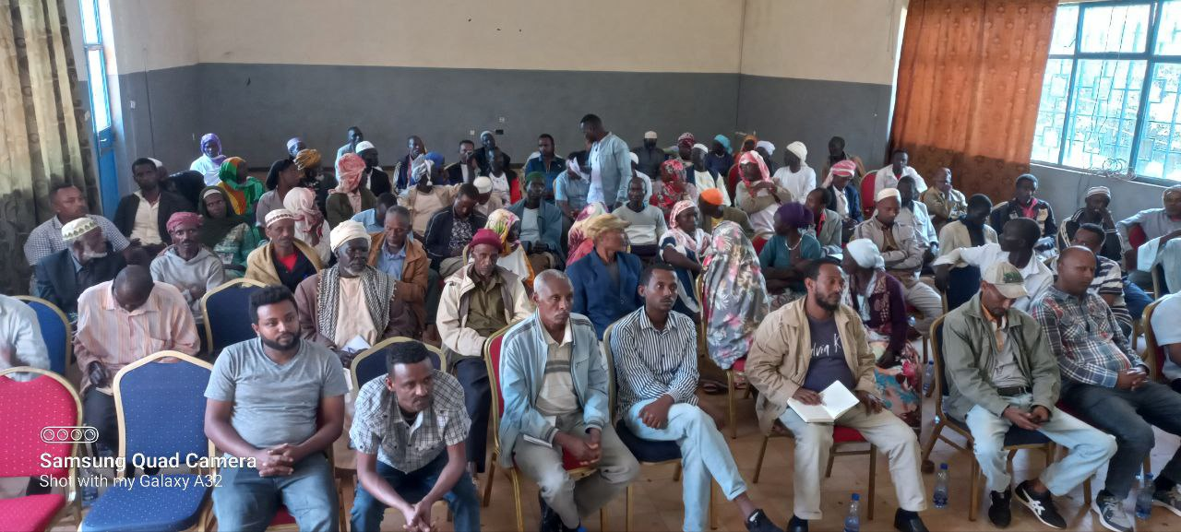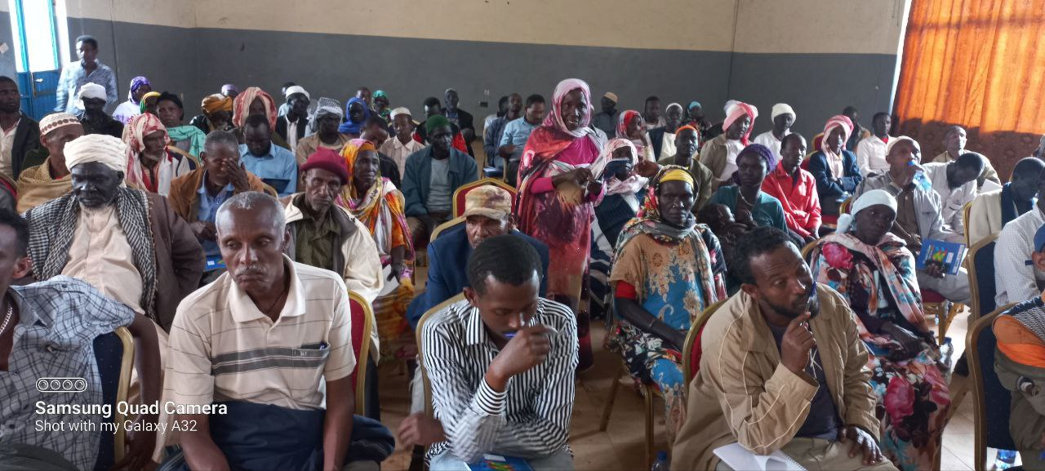
Figure10: Launching program

Transect visit and inventory of PRM done in the area
To understand the cluster rangeland condition, potentials, vegetation composition, development gaps and general ecosystem, the RMIP preparation team were drive to the districts. The cluster is endowed with potential vegetation which is vital for agro-pastoral production system (Fig. 11). The team has found that the rangeland resource particularly the vegetation is physically found in good conditions. On the hands, based on the team observation, there is a development gaps in these districts, for instance infrastructures like road were the major problems in these districts. Additionally, according to the field observation water for both livestock and human, wild fire is the other challenge constraining livelihood improvement system.
To ensure full alignment with existing plans and to minimize duplication of efforts in the management of investments, the RMIP team has assessed any plan related with PRM in the districts and ensures that there is no plans and ongoing investment related with PRMP. On the other hand, the team has collected secondary data which are vital for the preparation the RMIP.

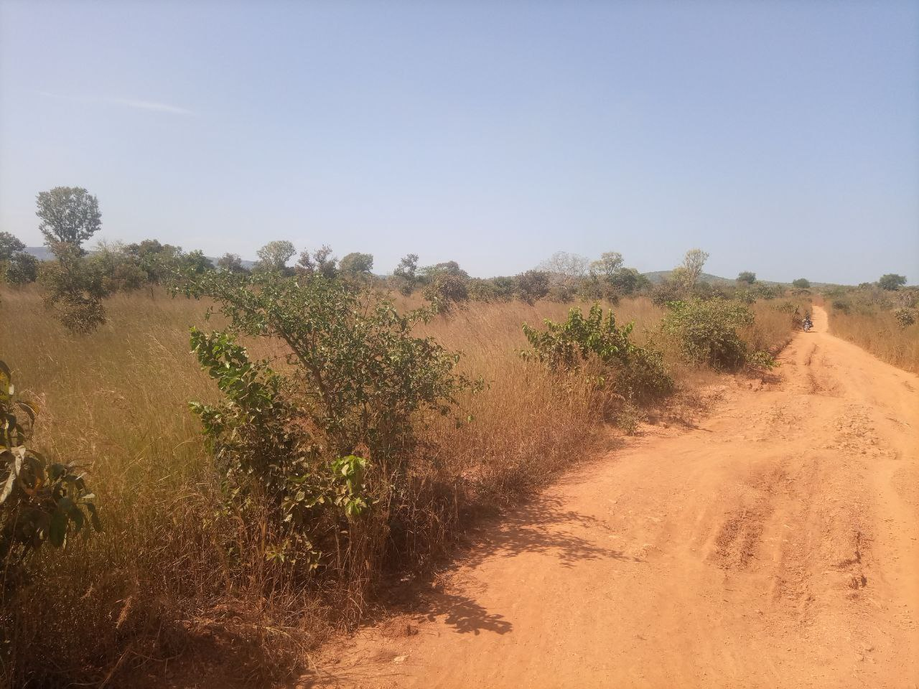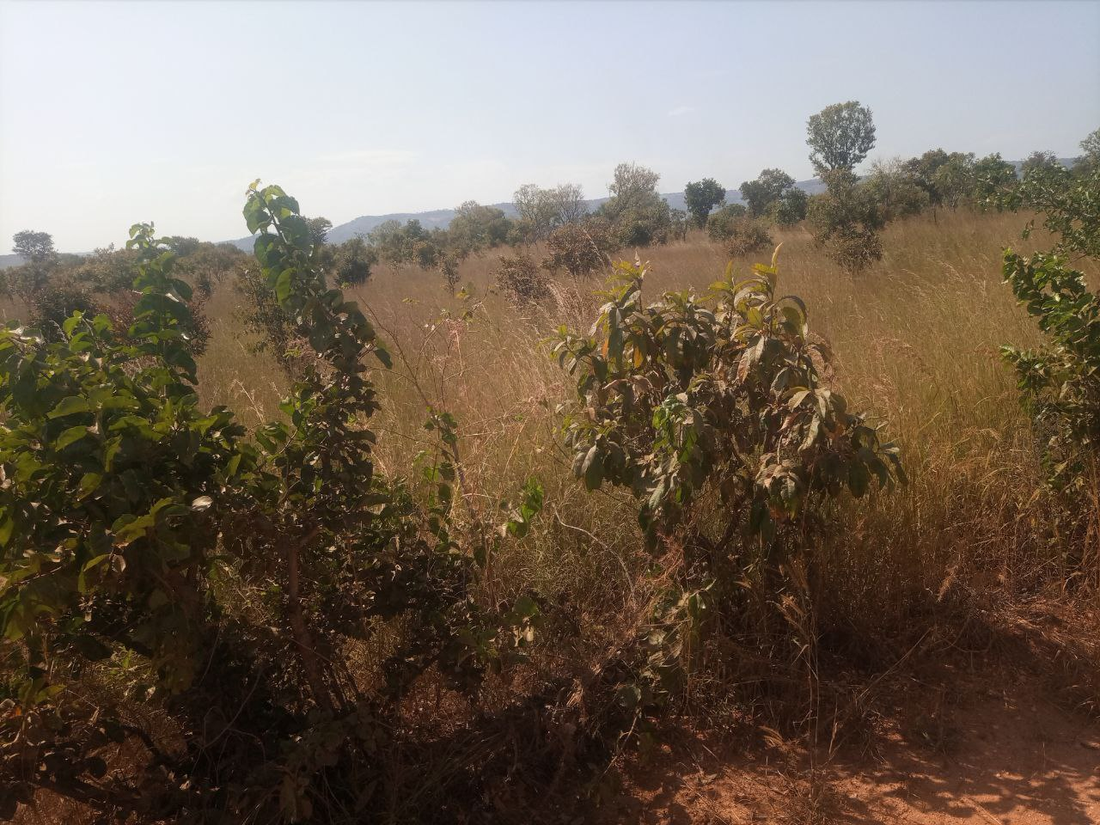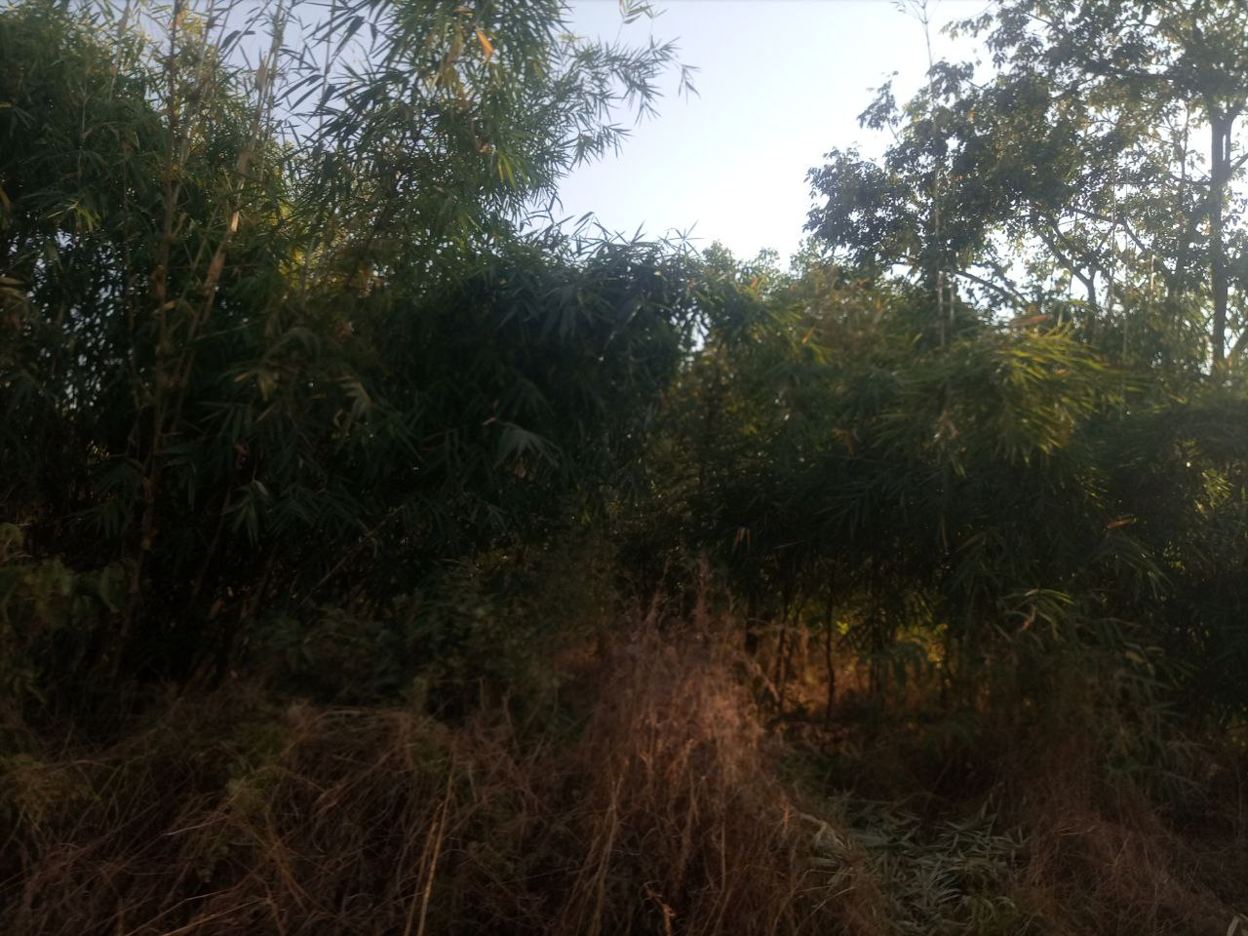
Figure 11: Rangeland resource of the cluster

Menge cluster rangeland resource and users

Rangeland resource
Rangelands play a vital role in providing the community with goods and services. Rangelands provide society with a variety of products that include food, manure, wildlife, recreation, mineral, timber, energy, and biodiversity services. Forage for livestock is the primary contribution of rangelands to human in developing countries. For the overall rangeland management and development planning it is important to aware the control and access mechanisms set in place and the types and condition of resources in the rangeland. With this background the established team were disused with the community representatives about rangeland resource of the cluster. Based on the discussion result, Menge cluster is unanimously falling under Moist and Dry Lowland agro ecology. Thus, the area is endowed with different resources which are the basis for agro-pastoral community livelihood system. According to the findings of the discussion held with the community, the cluster has naturally riches with different range land resource such as; all season grazing land, forest land dominated with incense and gums, bamboo and other economic tree species, wetland, grass land, savanna grass land (tall grass), dominated with shrubs and bushes, minerals (such as; gold, marble, coal) Rivers, cultivation land, commercial farms, irrigated land, construction material such as, sand and rock, livestock such as, cattle, shoats, equines, bee colony, and wild animals. In addition to the natural resource the cluster has endowed with socio economic infrastructure such as, water schemes (HD, BH), all-weather road, schools, human health facilities, animal health posts, and FTC, etc…(see Appendix 1).
Unlike other arid and semiarid lowland area where pastoralist relay for production system, the cluster have no define wet and dry season grazing land, but it has potential rangeland resource suitable for raring of livestock, agricultural production. Also it has potential of non-timber forest product (bamboo, incense and gums, medicinal plants) and minerals mining. Beside vast rangeland resources contribute for livelihood improvement, the cluster has shares vast boundary with South Sudan which might plays a vital role for the socioeconomic development. The rangeland resources of the cluster are found in good condition except some resource such as forest lands grass lands, water resources, livestock resource etc.

Rangeland resource mapping
Participatory rangeland resource mapping is a valuable process and a set of activities for better understanding and developing sustainable rangeland management. It gives an opportunity for the communities to contribute to planning and decision-making processes as part of an integrated participatory rangeland management planning and implementation approach. Participatory rangeland resource mapping helps to understand the use of rangeland resources, the location of the rangeland, access, and seasonality of these resources. Accordingly, each district found in the cluster had laydown/sketch their own district boundary on the ground and then indicated the sources on appropriate location.

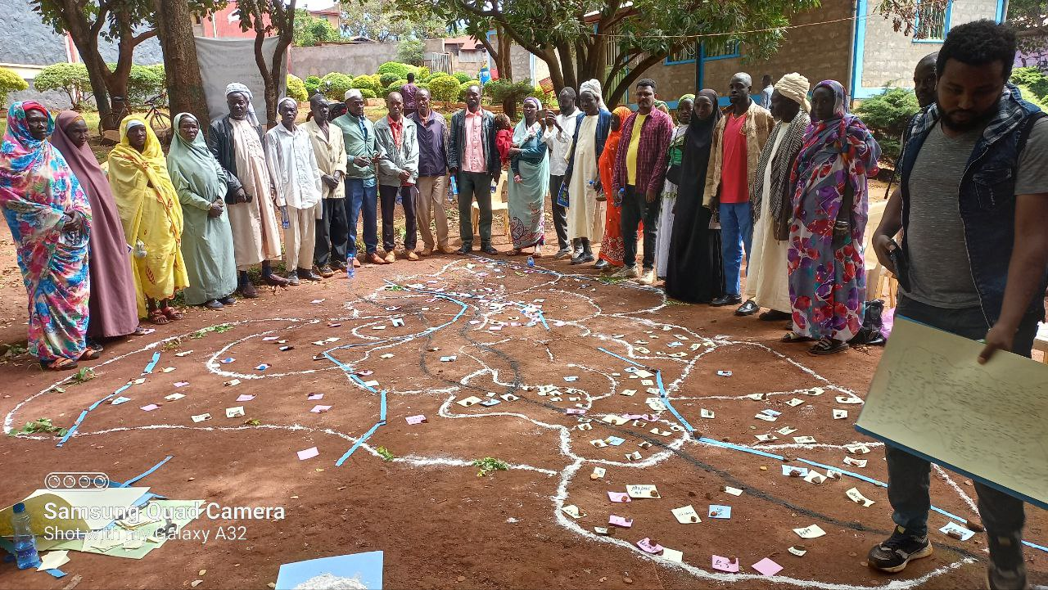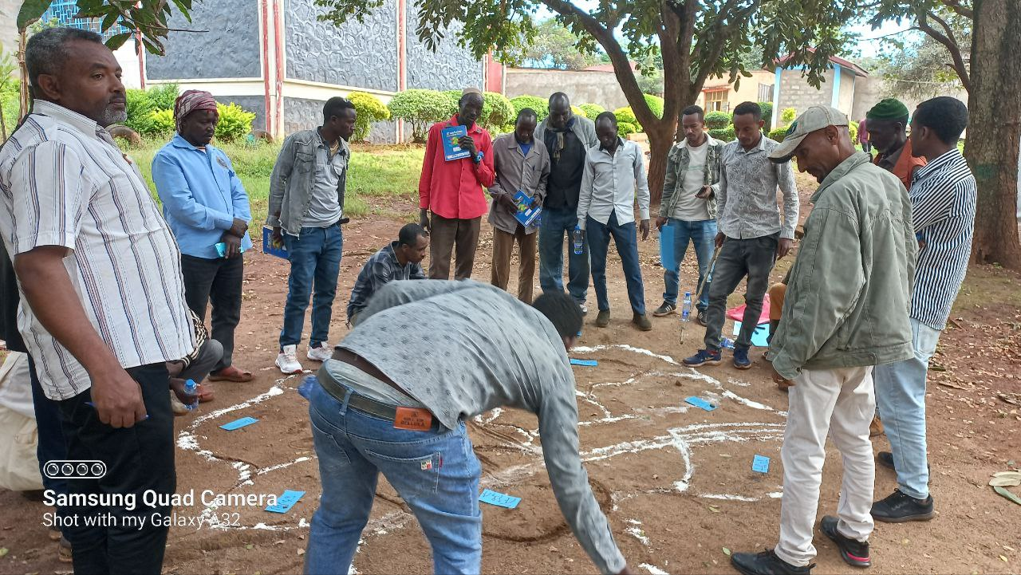
Menge district rangeland resource map Oundulu district rangeland resource map
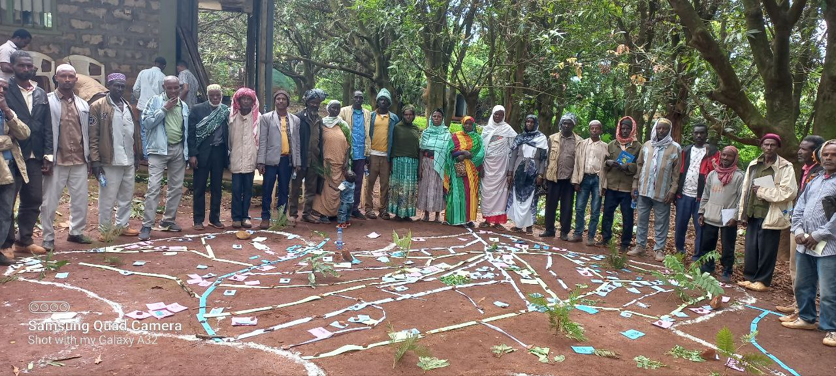
Abramo rangeland resource map
Figure 12: Participatory resource mapping: community members lay out the relative locations of rangeland resources and infrastructure on the ground.

During the discussion, resource inventory has done exhaustively. Accordingly, the resources indicated in the map incudes; grazing areas, rout of livestock for grazing and watering, settlement, basic infrastructure (road, education, human health post, animal health post, FTC, livestock market center etc.), mountain areas, cultivated land, irrigated land, forest land, water resources (surface and ground water), roads (main and feeders), mineral areas etc. Beside this hot spot problems related to rangeland resources was identified and indicated on the map. After drawing the woreda boundary and indicating resources the mapping team has converted ground sketched map into paper and compile districts map in to a cluster map

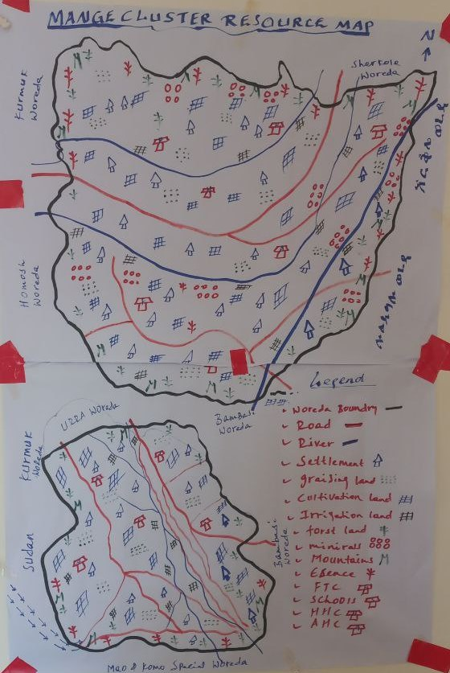
Figure 13: Hand drawn map of Menge cluster rangeland resource

For common understanding of available rangeland resources and their location, resource map sketch on the paper were presented for the community and eventually, they validated it and finally, the validated map was digitized and digitized cluster map was produced.

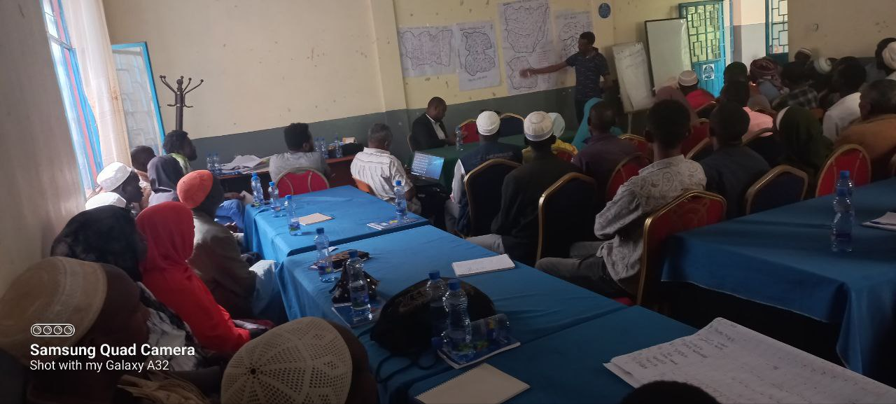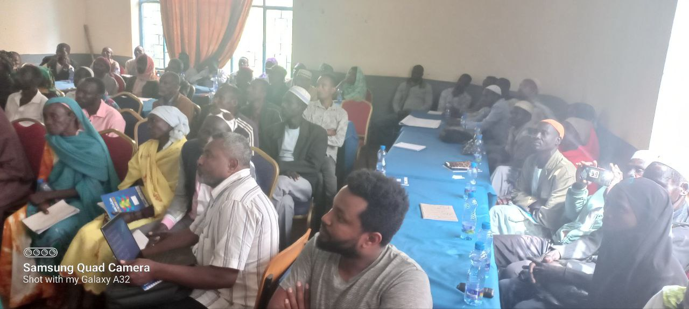
Figure 14: Validation of Menge cluster rangeland resource map

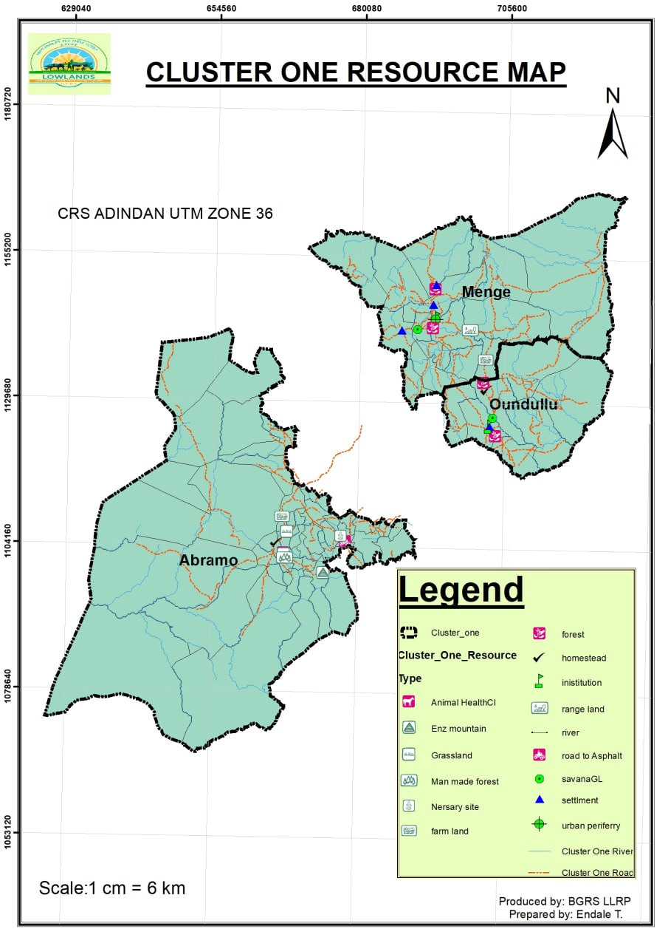
Figure 15: Digital resource map of Menege cluster

Seasonal calendar
For successful intervention and management of resources, understanding seasonality of events is quite important. As indicated in the table below the occurrence of events or activities is varied per annum. For instance, in the district rainfall is starting on May and end of October, and during this season, rain feed crop cultivations practiced in the cluster.
Community consultation result shows that, even though there is no separated dry and wet season grazing land, there is excess forage for livestock from May to November and, February to March is the season where the community face shortage of forage for their livestock. Outsider’s resource users (‘Fellatas’) immigrate to the cluster and stay there for five months from November to March.

Wildfire is the major problem exacerbating rangeland degradation in the cluster. In the cluster burning of rangeland resource with wild fire stays for four months from December 15th to March/April, but March to April is the pick time where extensive burning happed.
Human and livestock diseases and shortage of food is the challenges consternating the livelihood of community in the cluster. According to the discussion result the outbreak of human disease s depends on the entrance and exit of rain fall i.e., from June to October. Similarly, livestock diseases occurred from June to October and also happed in April Similarly, shortage of food for human is occur from June-August, and for livestock shortage of feed occur from February to April.

Table 16: Seasonal calendar
Events | Jan | Feb | Mar | Apr | May | Jun | Jul | Aug | Sep | Oct | Nov | Dec
Rainfall |  |  |  |  | X | X | X | X | X | X
Mobility to Dry season grazing (‘Felata’) | X | X | X | X |  |  |  |  |  |  |  | X
Access to enclosure | X | X | X | X
Own Forage development |  |  |  |  |  |  | X | X | X | X
High livestock price | X |  |  | X | X |  |  |  | X
Crop cultivation (rain feed) | X |  |  |  | X | X | X | X | X | X | X | X
Crop cultivation Irrigation | X | X | X | X |  |  |  |  |  | X | X | X
Soil and water conservation | X | X | X
High Livestock supply for market |  |  | X | X |  |  |  |  | X
Water shortage |  |  | X | X | X
Human disease outbreak |  |  |  |  |  | X |  |  |  | X
Livestock disease outbreak |  |  |  | X |  | X |  |  | X | X
Crop pest outbreak |  |  |  |  |  | X |  |  | X | X
Food shortage (human) |  |  |  |  |  |  | X | X
Food shortage (livestock) |  | X | X | X
Livestock Move in to the woreda from outside | X | X | X | X |  |  |  |  |  |  | X | X
Source: Community consultation, 2015

Historical timeline (temporal trend analysis)
The change in ecosystem functions can be analyzed through a change in land use land cover change. Environmental and social livelihood implications such as rangeland degradation, bush encroachment, soil degradation, livestock loss, biodiversity loss and poverty increased resulted from these changes. According to Musa, et al, 2017, these cumulative effects contributed to rangeland degradation and poverty in the cluster. In this regard, historical timeline is crucial to understand rangeland resource condition and PAP practical historical trend through different historical periods. This enables to evaluate change or condition of all resources in the cluster and analysis of resources trend through time. In cluster the rangeland condition is evaluated under regimes namely Haile-Selassie, Dergu and current time.

As described in the table below, the coverage and potential of basic rangeland resources such as; coverage of preferred species, grazing land, incense and gum, medicinal plant, forest land, and availability and potentials of water resource and forage is declining highly from time to time (regime to regime). The main reasons for reduction of these resources are increased crop land encroachment, natural resource degradation, wild fire, expansion of settlement, shifting cultivation etc.,. Thus, this indicates that, there is pressure on the rangeland resource from time to time and this in turns affected the livelihood of the agro-pastoral community if sustainable measurements not taken on time. On the other side, accessibility to safe and potable water, gum and resin production, coverage of cultivation lands, utilization of irrigation and crop productivity and production are increasing from time to time which has impact in improving the livelihood of the community. Additionally, there are some events /activities which are increased from time to time but had a negative effect on the livelihoods of the agro-pastoralist communities. These are expansion of invasive species, mobility patterns (frequency), land degradation, severity of erosion, natural hazards, food insecurity, livestock disease, settlement etc.

Table 17: Rangeland condition historical trend analysis
No. | Events | Haile-Selassie Regime |  | Dergu  Regime | EPDRF
1 | Potential of water | **** |  | *** | *
2 | Accessibility to safe and potable water | - |  | * | ***
3 | Coverage preferred vegetation species | **** |  | *** | *
4 | Coverage of grazing land | **** |  | *** | **
5 | Use of fire ( frequency and intensity) | **** |  | *** | **
6 | Gum and resin production | - |  | ** | ****
7 | Use of Medical plants | **** |  | *** | *
8 | Availability of medicinal plant | **** |  | *** | **
9 | Invasive species | - |  | * | **
10 | Coverage of Cultivation lands | * |  | ** | ***
11 | Land degradation | * |  | ** | ***
12 | Food security | * |  | ** | ***
13 | Crop productivity | * |  | ** | ***
14 | Crop production | * |  | ** | ***
15 | Availability of Forage | **** |  | *** | **
16 | Livestock disease | * |  | ** | ****
17 | Forest coverage & condition | **** |  | *** | *
Source: Community consultation, 2015

Rangeland resource users
For effective and inclusive management of rangeland resources on sustainable basis, undertaking an in-depth review of who are using, controlling and developing these resources, and assessing their rights of access for use is crucial for efficient rangeland management. Stakeholder analysis is useful in understanding key stakeholders, their rights, responsibilities, relationships and the type of benefits derived from each resource. It also helps in understanding in more details the problems and opportunities related to resource utilization. The other aspect the analysis reveals is the potential risks and actual conflict between user-groups, and the different relationships between them.
Different levels of stakeholders have been identified in the clusters during public consultation periods.
- Primary resource users
The primary resource users identified in the cluster are;
- Communities/Agro-pastoralist (Women, youth, Men) who are permanently living in the cluster.
- Community members who are organized as cooperative/CIG
These users have the right to cultivate crop, grazing livestock, harvest farm tool, to collect grass, rear livestock, collect Non-Timber Forest Product (NTFP) like medicinal plant, wild root, fruit, bamboo; charcoal making, beekeeping, collect construction materials (sand and stone), mine gold, use timber product, collect wood for fuel, watering animals, access social services etc. to improve their livelihoods. As a result, they gain revenue by selling crop products; livestock and their products; fruits and roots; minerals (gold, construction sand and stones); NTFP (resin, grass, bamboo). As per the community discussion result, the responsibility of the primary users is protecting natural resource from illegal users, planting tree as forest development, guard forest against fire, awareness creation, performing soil and water conservation activity, protect deforestation, farmland encroachment etc., Primary resource users have mutual relationship with local government and all occasional users except Sudanese Refuge and also have conflict with outsider
- Occasional resource users
The occasional resource users are;
- Investors who engage on Gold Mining, incense production and Agriculture
- Neighboring cluster woredas
- Sudanese Refuge who engaged on gold mining
Occasional resource users are accessing the range land to collect wild roots, fruits, fuel wood, grass, and bamboo; graze livestock; watering livestock; mining gold; collection of incense; produce crop and accessing social services. The responsibility of occasional users is planting tree (forest development), soil and water conservation, paying royalty and tax and protecting natural resource, transformation of technology and skill, respect culture of the host community, conduct voluntary activity. The occasional users get revenue from NTFP, livestock and their product, mineral and crop production. Additionally, the occasional users create job for the primary users and sometimes they support the host community by full filling some basic social services. Except Sudanese refuge, all occasional resource users have mutual relation with local Government and have no any relation with outsiders
- Outsiders resource users
The ‘Fellatas’ are the only outsider’s resource users in the cluster. Outsiders have the right to access grazing, watering, and collecting NTFP such as bamboo and accessing marketing. The users have no responsibility to manage the range land resource. But has the revenue they get income from livestock and their products. The relation they have with primary and local government is conflict due to overexploitation of rangeland resource.

According to community consultation result, primary and occasional users in the cluster have access and user right on rangeland resources freely except closure forest. In the cluster it is not allowed to use wood trees for house construction even firewood to protect deforestation even though the community are accessing forest for firewood, house construction, selling forest product like bamboo pole illegally. Additionally, mineral area and construction resources are free to access but the users must pay some money like royalty for Kebele administration office. In general, different resources in the cluster is managed and controlled according to the government rules and regulation.
According to PRM discussion result they have no access rule for all resource except for forest resource. As a resource access rule, the community will ask kebele administration for permission to use forest product for house construction, furniture, fence construction. In the district other resources such as grazing land savanna grassland, water resource, and mineral spot area are accessed by the community of the kebele without any permission.
Rangeland resource such as forest, mineral spot area, savanna grass land, grazing land, surface water, farmland, incense, irrigated land, livestock, grass land, sand and rock etc… are the major natural resource identified in the cluster. Generally, the community (different stakeholders) use these resources in different ways such as, forest, for construction of house, for timber production, fuel wood, as a medicinal plant, for food specially bamboo shoot, and different wild fruits and incense for income generation. They also use mineral spot for gold extraction as income generation; savanna grass land for house roof shedding and fencing; surface and ground water for livestock and human drinking, washing clothes and gold extraction; farm land for crop production and grazing; irrigated land for fruit and vegetable production; livestock for income generation, for farming, meat, milk, skin production and transportation (equine); , grass land; for grazing of the livestock; and rock and sand for construction of house and as income generation.

Table 18: Stakeholder analysis and mapping
S/no | Stake holder | Right | Responsibility | Relationship | Revenue
1 | Permanent | - To cultivate crop, graze livestock, harvest farm tool, collect grass, rear livestock, collect medicinal plant, collect NTFP like bamboo, make charcoal, collect wild root and fruit, bee keeping, collect construction materials (sand and stone ), mine Gold, use timber product, collect wood for fuel, watering animals, access social services, recreation, access social and economic services | - To protect natural resource from illegal users, plant tree, guard forest against fire, awareness creation, performing Soil and water conservation activity, not deforest, to not cultivate communal land, manage tree cutting, conduct rehabilitation of degraded land through physical soil and water conservation, pay tax | - Thy have mutual relationship with occasional users and local government except Sudanese Refuge and outsider | - Income from crop product  - Livestock income and product  - Income from wild coffee, fruit and roots selling  - Income for mineral products (gold, stone and sand)  - Income from NTFP (resins, bamboo, grass other cells)  - Income from created job opportunity
2 | Occasional | - To collect wild Roots and fruits  - To collect fuel wood  - To collect grass  - To collect bamboo  - To graze  - To water  - Gold mining  - Incense production  - Cultivate crop  - Access social services | - to plant tree  - Soil and water conservation  - Protect the NR (investors)  - Pay royalty  - Paying tax  - Be legal having working license  - Transformation of technology and skill  - Respect culture of the host community  - Conduct voluntary activity | - Except Sudanese refuge they have mutual relation with local Government. On the other hand thy don’t have any relation with outsiders | - NTFC product and income  - Livestock product and income  - Income from minerals  - Income from crop production  - For primary user they create job opportunity, fulfill basic social and Economic infrastructures
3 | Outsider | - Grazing  - Watering  - Accessing forest product (medicinal plant)  - Accessing social services (market) | - None | - With local government conflict | - Revenue from sale of live livestock.
Source: Community Consultation report (2015)

8/22/2023

