An International Journal

Researcher
(Researcher)

ISSN 1553-9865 (print); ISSN 2163-8950 (online), Monthly
Volume 15 - Issue 7 (Cumulated No. 169), July 25, 2023

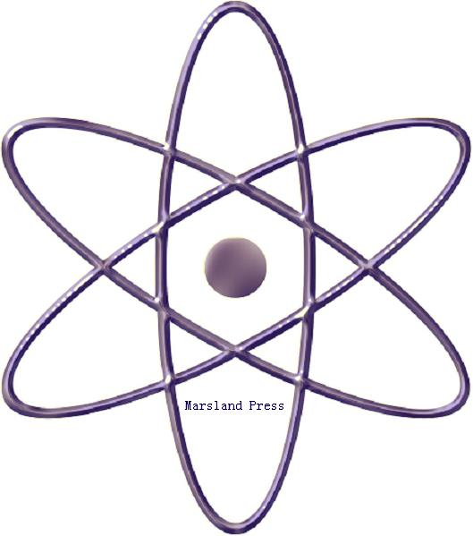

Marsland Press

310 West 18th Street, New York, NY 10011, USA

http://www.sciencepub.net
editor@sciencepub.net
naturesciencej@gmail.com

718-404-5362

Researcher

ISSN 1553-9865 (print); ISSN 2163-8950 (online); Monthly

The Researcher is a peer reviewed international journal with a purpose to enhance our natural and scientific knowledge dissemination in the world. Papers submitted could be reviews, objective descriptions, research reports, opinions/debates, news, letters, and other types of writings that are nature and science related. All manuscripts submitted will be peer reviewed and the valuable papers will be considered for the publication after the peer review. The Authors are responsible to the contents of their articles.

Marsland Press

310 West 18th Street, New York, NY 10011, USA

http://www.sciencepub.net
editor@sciencepub.net
naturesciencej@gmail.com

718-404-5362

ISSN 1553-9865
© 2023 Marsland Press

