Geographical Models Of Enclaves / Exclaves In The Type Of “Matryoshka”

Jumakhanov Shavkatjon Zairjanovich

Namangan State University, Docent of the Department of Geography
The Republic of Uzbekistan, Namangan region, Namangan city
E-mail address: shavkat_72@mail.ru

Annotation. The article describes a complex of enclaves, which is one of the specific topological types of enclaves, and, in this regard, the theoretical aspects of enclaves of several orders - such as "matryoshka". Geographic models of this type of enclave are also described.
[Jumakhanov Sh. Z. Geographical models of enclaves / exclaves in the type of “Matryoshka”. Researcher 2023;15(7):1-8]. ISSN 1553-9865 (print); ISSN 2163-8950 (online). http://www.sciencepub.net/researcher. 01. doi:10.7537/marsrsj150723.01.

Key words: enclave, exclave, enclave complex, “geopolitical archipelago”, “matryoshka”, delimitation, demarcation.

1. Introduction.
The current geopolitical situation is more important than ever with its subtlety. In particular, international relations, although based on open foreign economic relations, have a limited impact on economic laws, on the contrary, many important relations in the world economy are subject to political programs [12, - P. 3]. For example, most of the current and ongoing conflicts in the world, interstate conflicts, are associated with regional conflicts.
One of the factors that serves as a "hot spot" in the emergence of specific situations in the global geopolitical arena are enclave / exclave zones. They are directly or indirectly related to most of the existing conflicts occurring in the world [13, - P. 3].

2. The main part.
It is known that as a result of incorrect delimitation and demarcation of borders at different times, the territory of one state remained a part of another. For example, a territory belonging to a similar country, but located within the borders of another state, is called an enclave [23, - P. 84]. In this case, it is an enclave in relation to the surrounding state in terms of location, an exclave in relation to the state to which it belongs [11].
Enclaves / exclaves are classified as territorial units in terms of approach, topology and management, as well as in terms of population and size of the territory [4, - P. 8]. In this sense, enclaves / exclaves that cause territorial, geopolitical and geo-economic conflicts in many regions are “islands on land” that completely remain in the geography of another state. In particular, the types of enclaves in the form of archipelagos and "nesting dolls" are analyzed below.
Enclave complex. Although most of the existing complete enclaves are isolated, in some regions the enclaves are located close to each other in a small area, forming "geopolitical archipelagos."
Depending on the state of political stability and mutual goodwill in interstate relations, a particular enclave / exclave can serve as a support for the harmonization of “warm” relations or exacerbation of “cold” relations. The presence of not one, but several enclaves requires increased attention to such territories several times over.
In particular, such enclaves are mainly the Ganges basin (Bangladesh ↔ India), the Fergana Valley (Uzbekistan ↔ Kyrgyzstan), the Caucasus (Armenia ↔ Azerbaijan), the Middle East (Cyprus ↔ Northern Cyprus), the Gibraltar basin (Spain, Morocco), the Rhine basin (Belgium and the Netherlands, Belgium ↔ Germany).
Since most of the enclaves that make up this "geopolitical archipelago" are much smaller in size, they are usually considered part of a larger administrative unit, both politically and administratively. If the area of ​​the enclave in the complex is larger, it can be managed at the district or municipal level. However, there are also enclaves that can exceed hundreds of states. The Alaska semi-enclave is a prime example of this. The US enclave covers an area of ​​over 1,7 million km². However, such large territorial units are characteristic not for a complex of enclaves, but for enclaves with a single location. An example of a large enclave in the topology of the archipelago is the Uzbek enclave of Sokh in the Fergana Valley. More than 77,6 thousand people live in this enclave with an area of ​​221 km² [17].
Consequently, such territorial “dense” enclaves / exclaves can serve as “hot spots” surrounding neighboring states and interconnected by the main state, or a hotbed of destabilization of the geopolitical situation.
Matryoshka enclaves. A “geopolitical archipelago” or a complex of enclaves located close to each other in one area sometimes has such a location that they are not close to each other, but within each other. For example, such a location can be explained in the form of "matryoshka" [11, - P. 51].
In particular, the location of the exclave of a neighboring state within a larger enclave reflects their orderly location in the topology (Figure 1).
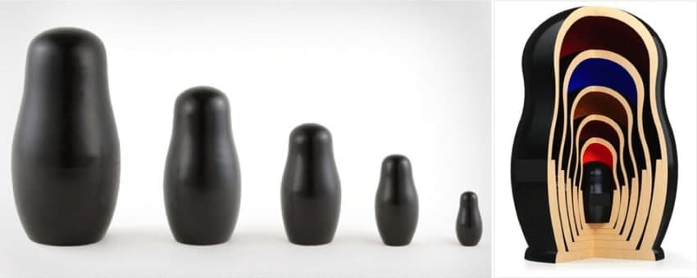
Figure 1. "Matryoshka" - a complex of orderly forms with an internal location
- the first order - the usual enclaves with a tripartite relationship (primary enclaves);
- the second order - enclaves within the enclave (secondary enclaves);
- the third order - a tertiary enclave located inside the secondary enclave, etc.
Territorial units of this type have the most complex structure in the geography of enclaves. This complexity is particularly evident in the tertiary-order enclave. In particular, from the third-order enclave in the center of the matryoshka to the mother state, the following territorial relations are observed in the enclave complex: tertiary enclave → surrounding secondary enclave → primary enclave belonging to the mother state → surrounding “continental” state → mother state. In the primary and secondary enclaves, the process is relatively simplified.
Hence, the problems of transport, land, water, energy and security in the enclaves that make up the enclave complex require their separate study. In the world, this type of enclave / exclave includes Bangladesh and India, Belgium and the Netherlands, the United Arab Emirates and Oman [11, - P. 52] as the “product” of the most imperfect demarcation between states has led to a sharpening of geopolitical relations.
Enclaves emerged as political entities over time, and their subsequent "dissolution" was reflected in the "waves" of enclave formation. In particular, in the second half of the decade of the XXI century, as a result of improvements in the delimitation and demarcation of the Ganges basin [20], this type of enclave / exclave was "digested" by the surrounding states.
The situation in enclaves of this type has regional characteristics (Table 1). That is, their formation is inextricably linked with the historical, cultural, socio-economic and geographical features of the region. Matryoshka-type enclaves require special study in terms of the relevance of the geopolitical and geoeconomic situation, and it is important to analyze the models based on the factors that led to the formation of "matryoshka" in the last quarter of a century.

Table 1. Geographical models of "Matryoshka" type enclaves
European model | South Asian model | Middle East model
Integration factor | Ethnic and religious factors | Territorial and social factors
Baarle:  Baarle-Hertog  Baarle-Nassau | Kooch Behar:  Cooch Behar of India  Cooch Behar of Bangladesh | “Arabicturban”:  Madha  Nakhwa

The table is formed by the author

Each of these models has its own characteristics, problems and solutions. In particular, the analytical data for each of them are given below, and the forms of manifestation are explained.

European model: The model of these enclaves is based on integration, the existence of which is associated with the geopolitical "warm" environment in the main and surrounding countries.
Baarle. There are 22 Belgian enclaves in the Netherlands, which in turn contain seven second-order Dutch enclaves. There is also another Dutch-owned first-order separate enclave in Belgium (Figure 2). The Baarle complex and its matryoshka-type enclaves can serve as a model not only for regular enclaves but also for all enclave / exclave areas in other regions in terms of their existing geopolitical atmosphere.

For example, if enclaves / exclaves serve as a geopolitical “hot spot” or a means of pressure between countries that have entered into a vector relationship with them, they are a factor that further strengthens integration in the Baarle region. The complex border and the intertwining of the Belgian and Dutch territories in the complex do not adversely affect the political and economic life in the enclaves, as well as the attitude of the population (Figure 3). As a result of the accession of both countries to the European Union, and thus, the further strengthening of neighborly relations, the enclave / exclave problems have been resolved between the parties [11, - P. 136] The part of the enclaves in the Baarle complex belonging to the Belgian government is called Baarle-Hertog, and the part belonging to the Netherlands is called Baarle-Nassau.
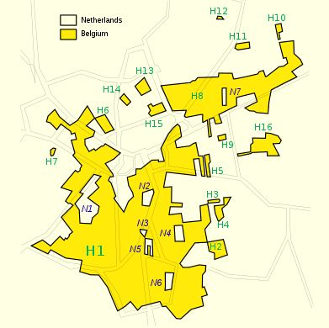
Figure 2. Baarle is a “matryoshka” [21]
The South Asian model: This model originated on the border of two countries that are ethnically, religiously and culturally different from each other in general, and their long-term existence has caused many disagreements and problems.

Cooch Behar. The “geopolitical archipelago” between India and Bangladesh was called the Pasha (roja) enclaves in the second half of the twentieth century as one of the most confusing border issues in the world [19]. This year the Maharaja of Cooch Behar and a series of small wars will be put to an end by the emperor Babur. The armies will retain the fortified areas they have occupied, from that moment on, as topologically as they are. The existing population in them is still a feudal exclave to the country to which it belongs in terms of taxation and administration. According to geopolitician Ritz Jones, fifty years later, efforts by the British company East India to remove the non-conforming boundary in such ‘loophole’ areas failed because the population of the feudal enclaves was assimilated rather than assimilated by the surrounding state population. preferred [22]. For complex historical reasons, more than 200 enclaves in Cooch Behar along the India-Bangladesh border - small parts of sovereignty completely surrounded on all sides by another state - have been added to the map.
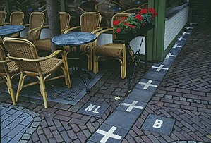
Figure 3. The “border” between the Belgian and Dutch enclaves / exclaves [25]
Between 1947 and 1949, as a result of Pakistan's and India's secession from Britain, ethnic and border issues in the border areas became increasingly political. After the partition of India, Rangpur joined East Pakistan (Bangladesh). The state of Kuch Bihar and its enclaves / exclaves had the potential to join India or East Pakistan. Cooch Behar Municipality was incorporated into India in 1949. The desire to "remove" most of the enclaves from the enclave was reflected in the 1958 Agreement between the Prime Minister of India Jawaharlal Nehru and the Prime Minister of Pakistan Feroz Khan Nun on the "Exchange of Territories between the Two Countries." However, due to the fact that the land exchange is not fully in line with the country’s constitution, it will be amended by Decision No. 3 to facilitate the implementation of the agreement by the Supreme Court of India. However, the amendment was not accepted due to opposition to the relocation of the South Berubari enclave [9]. Later, as India’s relations with Pakistan deteriorated, the issue remained unresolved.
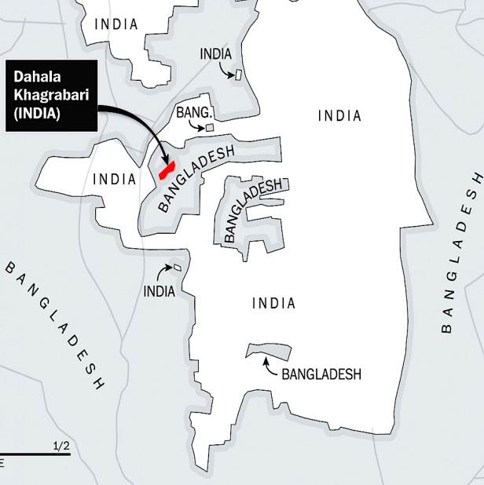
Figure 4. The first, second and third order enclaves in Cooch Behar
As a result of the liberation struggle in eastern Pakistan, Bangladesh (East Pakistan) seceded from Pakistan in 1971 [24]. The Cooch Behar enclave complex was formed in the north-western border zone of the “newborn” state and in the north-eastern border zone of India (Figure 4). As a result, civic powers and opportunities in the resulting enclave / exclave population were questioned. Even they were not taken into account in the electoral process in the motherland. In addition, they were cut off from public facilities such as water, energy and resource use. Theoretically, while enclave residents need a visa to cross the national borders of the state around them, the visa is only issued to travel to major cities in the home state. However, the transition from orderly enclaves to the host state will have to go through several stages (Figure 1). Other needy migration of the population, as a result, has led to specific conflicts.
In 1974, for the first time, India-Bangladesh held border talks to reduce such conflicts. On May 16, 1974, Indira Gandhi and Sheikh Mujibur Rahman signed the Agreement on the Boundaries of the Land, which provided for the exchange of enclaves, which caused conflicts [1]. Under the treaty, India retained the Berubari Union enclave №12, while Bangladesh retained the third-order DahalaKhagrabari exclave with India, providing a corridor (178 x 85 meters) with India called the Tin Bingha. Bangladesh quickly ratified the treaty in 1974, but India failed to do so. The delimitation and demarcation of the 6.1-kilometer border area in West Bengal, Tripura and Assam will not be fully implemented. The Tin Bingha corridor was leased to Bangladesh in 1992 under local opposition.

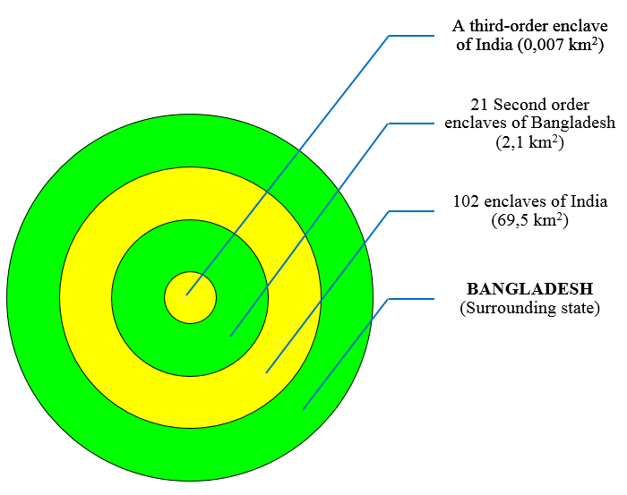  A. Complex of first and second order  enclaves | 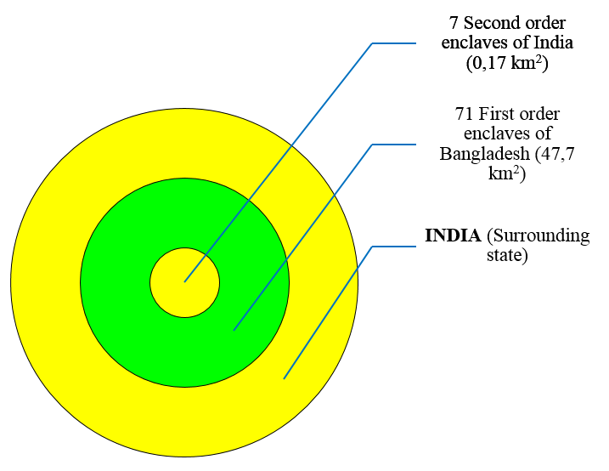  B. Complex of first, second and third order enclaves

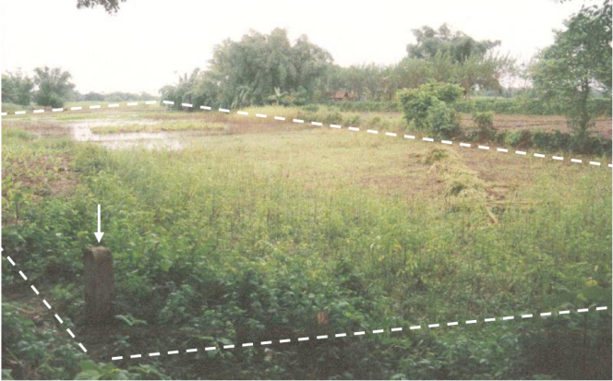

Figure 5. The only third-order enclave in the world is DahalaKhagrabari [10]

In 1997, a list of enclaves / exclaves was compiled by the two countries to address border discrepancies. Four years later, two joint border working groups will be formed to work out the details of the enclaves. A joint registration will take place in May 2007, and in September 2011 India will sign an additional protocol to the 1974 Land Border Agreement with Bangladesh [18].
Through this, in 2015 the governments of the two states intended to replace many enclaves, giving citizens the opportunity to choose their citizenship [16]. The exchange of enclaves is scheduled to take place in stages from July 31, 2015 to June 30, 2016. On July 31, 2015, many enclaves were exchanged, and on November 30 this year, the resettlement of the enclave population was completed [6]. After the implementation of this project, the enclave / exclave areas in the world were reduced by half and many problems in the Ganges basin were eliminated.
This means that for a long time, the main part of the model in the Cooch Behar region, which was "divided" by ethnic and religious factors, "became history."
For a long time, this model took to its “liver” a rice field called DahalaKhagrabari(Indian exclave), the only third-order enclave in the world (Figure 5). The signing of an agreement between the two countries on the existing problems on the issue of enclaves allowed the population of the enclaves to choose citizenship. Through this, most of the religious-ethnic "islands" were eliminated.
Middle East model: The formation of the first and second-order enclaves in this model and the formation of the "matryoshka" are inextricably linked with the process of choosing a political space due to the social will of the population in the area.
"Arabicturban." Another of the several-order enclave-type “matryoshkas” are the Madha and Nahwa enclaves in the northeast of the Arabian Peninsula (Figure 6).
Madha is the first-order enclave of the Sultanate of Oman's Musandam Province, with an area of 75 km² [26] and a population of almost 3 000 [7].
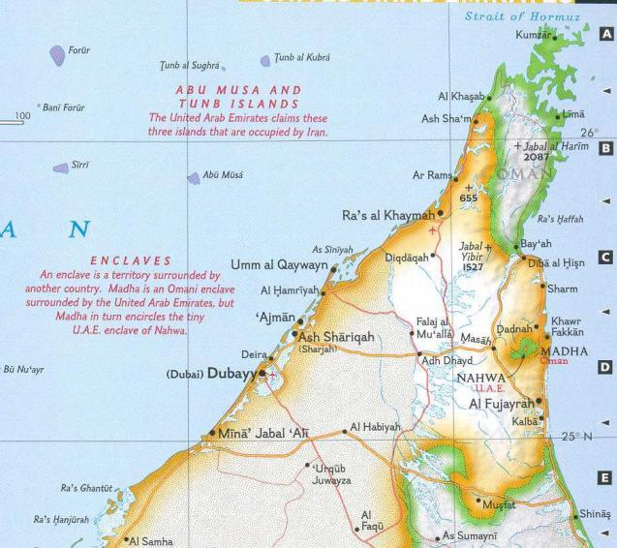
Figure 6. "Arabic turban"
Nahwa is a second-order enclave belonging to the Emirate of Sharjah in the United Arab Emirates, located within the enclave of Madha. It covers an area of 5,26 km² [27] and has a population of over 1 000 [14].
Given that both enclaves / exclaves belong to the Arab states and are formal in nature, it would be appropriate to apply the term "Arabic turban" to them. They are also compared to "fried eggs" in some sources due to their location in a very hot area and their cartographic appearance[2].
The emergence of the "Arabic turban" dates back to the second quarter of the twentieth century. For example, In the late 1930s or early 1940s the leaders of the four rival clans who ruled the Musandam Peninsula (Al-Qassimi of Ras Al-Khaimah, Al-Qassimi of Sharjah, Al-Sharqi of Fujairah, and the Bu Said of
Oman) gathered a group of village elders of Madha and posed a question on to which sheikhdom the Madhanis want to pose allegiance to. It became clear that the villagers of what is now Nahwa had chosen Sharjah, and the villagers who surrounded it had chosen Musandam. After negotiations between the tribal chiefs and Julian Walker, the British representative to the Commonwealth, the boundaries were demarcated and later completed in 1969 [3]. In particular, the independence of Oman and the UAE in 1971 [15] turned Madha and Nahwa into international enclaves.
Currently, there are almost no conflicts between the two enclaves. So Increasing regional cooperation is an objective,sustainable and irreversible trend [29, -P. 517], and the population speaks Arabic in both parts of the Arabic turban. The currencies of the two countries are also used in the transaction, but Madha has a slight "fine" for using the emirate dirham instead of the Oman rial, which means that there is only a slight imbalance in prices. Visas are not required for entry and exit from enclaves [8]. In addition, they are connected to each other by a quality highway, which does not serve as a kind of "support" in geopolitical processes. In particular, based on the model to which they belong, the existence of these enclaves is not related to the delimitation-demarcation of any political forces, but to the choice of the existing rural population here half a century ago.

CONCLUSION.
In general, on the basis of regional models of enclaves of the "matryoshka" type of several orders, it is appropriate to cite the following:
- geopolitical and geo-economic problems related to the characteristics of the enclave due to the integration factor in the European model are not considered;
- conflicts and disagreements among the population have been repeated for many years due to religious and ethnic differences in the enclaves belonging to the South Asian model. The agreement between the two countries means that no matter how much the disputed territories are abolished and the enclave population is given the opportunity to choose citizenship, the enclaves can be regulated;
- in the enclaves of the Middle East model, ethnic, religious and linguistic commonalities were observed, and only political will played a key role in the formation of the enclaves. At the same time, trade relations between the enclave + mother state + the surrounding state (enclave territory with such a function in the "matryoshka") and the fact that transport transit is controlled only by customs, but not used as a means of geopolitical pressure. indicates that the node is not, and so on.

Based on the above analysis, it can be said that:
- the transition from several orderly enclaves to the host state in areas where neighborly relations are not well established leads to complex, conflict situations. In this regard, vector relations should be organized in a positive way;
- conflicts may arise over time between enclaves formed in an ethnically and religiously diverse region and the surrounding state. With this in mind, it is necessary to create a humanitarian environment in the area where there is a complex of enclaves, to establish political institutions that analyze these types of social processes;
- in cases where enclave / exclave disputes have become a major factor in the deterioration of interstate relations, the enclave should be terminated through enclave exchanges, territorial exchanges or other means;
- solutions related to the "matryoshka" between countries with positive integration processes and active interaction should be used in drafting model agreements for other regions, etc.
This means that if cooperation between the main and surrounding states is established properly, the enclave / exclave areas will not be a "source of fire" on the borders, but will serve as a "ring" that will further strengthen and bind ties.

REFERENCES
- Cons Jason The Tin Bigha corridor. India will retain the southern half of South Berubari Union No.12. The Daily Star, October 2007. - Vol. II.
- Franc Jacobs The mysterious enclave complex of Madha and Nahwa [Online] // Big think. - 23 July, 2010. - May 27, 2021. - https://bigthink.com/strange-maps/60-madha-and-nahwa
- John Henzell Madha village's pledge of allegiance changed the map forever".. Retrieved. The National, January 27, 2012.
- Jumakhanov Sh.Z., Toshpulatov A.M. The enclave/exclave areas as a geographic category: problems and solutions. South Asian Academic Research Journal // Academicia / ed. Rai B. S.. – Jagadhri: "CDL College of Education", March 2020.- 10 : Vol. III. - p. 123. - ISBN: 2249-7137.
- Qayumov A., Sarafov I., Tillaboyeva M., Fedorko V. Geografiya (Jahon iqtisodiy va ijtimoiy geografiyasi) [Darslik] / ed. Qudratov Z. - 2019 : "O'zbekiston", Toshkent. - B. 176. - ISBN: 978-9943-01563-0.
- Taylor Adam Say goodbye to the weirdest border dispute in the world [Report]. "The Washington Post", 2015.
- Vaidya Sunil K. Tremors cause panic in Madha village in Oman [Online] // wikipedia.org. - Gulf News, May 10, 2013. - May 27, 2021. - https://en.wikipedia.org/wiki/Madha#cite_note-4
- Veldwijk Iris Madha and Nahwa Exclaves in Oman + UAE—Traveling Through the Donut Hole [Online] // mindofahitchhiker.com. - April 1, 2021. - May 27, 2021. - https://mindofahitchhiker.com/madha-and-nahwa-exclaves-oman-uae-traveling-through-the-donut-hole/
- Whyte B.R. Waiting for the Esquimo: An Historical and Documentary Study of the Cooch Behar Enclaves of India and Bangladesh (1 ed.). Melbourne, Australia: School of Anthropology, Geography and Environmental Studies, University of Melbourne. [Report]. - Melbourne: University of Melbourne, 2019. - p. 502. - ISBN 9780734022080.
- Whyte R. Brendan An historical and documentary study of the Cooch Behar enclaves of India and Bangladesh [Book] / ed. Sudhir Roy. - Melbourne: "Posterra crescam laude", 2002. - p. Australia. - ISBN: 0734022085.
- Винокуров Е.Ю. Теория анклавов [Монография]. - Калининград : "Терра Балтика", 2007. - стр. 342. - ISBN: 978-5-98777-015-3.
- Жалилов А.Т. Геосиёсий талқинда жаҳон сиёсатидаги баъзи тенденциялар. - Тошкент, 2019.
- Жумаханов Ш.З., Мирзаахмедов М.С., Солиев И.Р. Анклав ва эксклав ҳудудлар географияси [Монография]. - Наманган : "Наманган", 2014. – Б. 128. - ISBN 978-9943-4210-9-7.
- Зайцев В., Токарева А., Федуненко Е., Чернышева Е., Шкуренко О.. Все анклавы мира, 2018. https://www.kommersant.ru/doc/2674108
- Эргашев Ш., Бобоматов Т., Турсунов Н. Жаҳон мамлакатлари [Маълумотнома] / Масъул муҳаррир: Фармонов Р.. - Тошкент : "O'ZBEKISTON", 2017. – Б. 320. ISBN: 978-9943-01-893-8.
- Bangladesh, India to swap 162 land parcels [Google News]. "Agence France-Presse", Archived from the original on 21 February 2014.
- Farg’ona viloyati ma’muriy-hududiy bo’linishi. 01.01.2020. [Online]. - 2020 йил 1-Yanvar. – 2021.05.10. https://farstat.uz/uploads/tahliliy/Farg%E2%80%98ona%20viloyatining%20ma%60muriy-hududiy%20bo%60linishi+++.pdf
- India & Bangladesh Land Boundary Agreement. Ministry of External Affairs Government of India, March 1, 2015.
- India and Bangladesh discuss 'pasha' enclaves: Recognition of landlocked areas won in card games to be raised during India PM's visit. - Al Jazeera, September 6, 2011.
- India–Bangladesh enclaves [Report] : Wikipedia. - 2021 : https://en.wikipedia.org/wiki/India%E2%80%93Bangladesh_enclaves#References
- Regiones dentro de regiones, países dentro de países: Enclaves, la geografía demencial [Report]. - 2019.
- The weirdest border in the world is about to disappear. - June 26, 2015.
- The World book encyclopedia [Book] : Encyclopedia. - Chicago : "World book", 1994. - ISBN 0-7166-0094-3.
- Бангладеш : Материал из Википедии. - 2019. https://ru.wikipedia.org/wiki/Бангладеш
- Барле-Нассау: Википедия. - 2019. https://ru.wikipedia.org/wiki/Барле-Нассау
- Мадха [В Интернете] // Википедии. - 15 Август 2020 г.. - 27 Май 2021 г.. - https://ru.wikipedia.org/wiki/Мадха
- Нахва [В Интернете] // Википедия. - 11 Март 2019 г. - 27 Май 2021 г.. - https://ru.wikipedia.org/wiki/Нахва
- Ўзбекистон Миллий энциклопедияси. Энциклопедия. – Тошкент: “Ўзбекистон Миллий энсиклопедияси”, 2000. - Б. 351.
- Jumakhanov, S. Z., &Toshpulatov, A. M. (2019). Geopolitical view of the Central Asian region: Uzbekistan's geographical location in the region and its relationship. ISJ Theoretical & Applied Science, 11 (79), P. 515-519.http://T-Science.org
- Каримжон М. Боймирзаев, Исмоилжон К. Мирзахмедов, Музаффар Ҳ. Шералиев, & Муқаддас А. Тиланова (2022). ШИМОЛИЙ ФАРҒОНАНИНГ ГЕОЭКОЛОГИК ҲОЛАТИ ВА УЛАРНИ ОПТИМАЛЛАШТИРИШ МАСАЛАЛАРИ. Journal of Geography and Natural Resources, 2 (1), 41-49. doi: 10.37547/supsci-jgnr-02-01-05
- Mirzahmedov, I. K. (2020). Use And Protection Of Natural Resources Of Kokand Oasis. Nature and Science, (12 (18)), 49.

6/22/2023

Of the 240 countries in the world, only 29 have an area of more than 1 million km² [5, - P. 4].
Matryoshka (rRus. “матрёшка”) is a type of puppet, a set of shrinking toy shapes placed inside
The turban (Persian, "knot") is the headdress of Muslim men [28]. Due to the appearance of the turban, the author introduced the term "Arabic turban" in relation to these first and second-order enclaves.
Musandam itself is a semi-enclave belonging to the Sultanate of Oman
Relations between the main state-enclave territory-mother state

