**An intelligent model for a smart vehicle tracking system.**

Kusanhyel Francis Usman, Yusufu Gambo, Omega Sarjiyus*

Adamawa State University Mubi, Adamawa State, Nigeria

Department of Computer Science, Adamawa State University, Mubi, Adamawa State, Nigeria

[sarjiyus@gmail.com](mailto:sarjiyus@gmail.com)

# ABSTRACT: This paper presents a comprehensive overview of an intelligent model for a smart vehicle tracking system. This system utilizes advanced technologies such as Global Positioning Satellites (GPS) and GSM to provide real-time vehicle tracking and control. By installing an “onboard module” in the tracked vehicle, owners can accurately monitor its location and access up-to-date information. The system’s main objective is to enable users to operate, observe, and track vehicles in real-time, providing vital fleet management functionalities like routing, tracking, and dispatching, It enhances onboard information and security. With its potential applications across the transport and logistics industries, this system ensures uninterrupted service, efficient data processing, and improved scalability. A server-side application is employed to process the incoming data from client applications. We built the system’s server component using Apache Kafka, a reliable and scalable platform utilized for event streaming capabilities and Hibernate ORM for efficient storage and processing of relational mapping. Additionally, third-party React libraries are employed on the client side to provide an interactive interface, allowing clients to view GPS data and vehicle information on a map. The development process leveraged IntelliJ IDEA as the integrated development environment. The system is divided into two main parts: tracking and monitoring. The tracking component is implemented using the Android/iOS platform on the client side in conjunction with the server-side functionalities. This comprehensive system caters to the diverse needs of users, offering real-time vehicle tracking capabilities accessible through a standard web browser. By combining cutting-edge technologies and a user-friendly interface, the developed model establishes a robust foundation for efficient vehicle tracking, ensuring real-time monitoring and enhanced operational control. We thoroughly examine the literature review, methodology, results, and discussion of the intelligent model for smart vehicle tracking. Our analysis encompasses gaining insights, assessing effectiveness, evaluating findings, and engaging in an enriching discussion. Ultimately, we present a comprehensive and concise conclusion, offering valuable insights and potential areas for future research.

[Adamawa State University Mubi, Adamawa State, Nigeria. **An intelligent model for a smart vehicle tracking system. Kusanhyel Francis Usman, Yusufu Gambo, Omega Sarjiyus**. *Researcher* 2023;15(6):18-26]. ISSN 1553-9865 (print); ISSN 2163-8950 (online). <http://www.sciencepub.net/researcher>.04.doi:[10.7537/marsrsj15062](http://www.dx.doi.org/10.7537/marsrsj150623.04)3.04.

**Keywords:** Intelligent, Map, Real-Time, Tracking, Vehicle

# 1. INTRODUCTION

GPS technology has brought about significant benefits in asset tracking, including individuals and physical assets. For businesses, knowing employees’ whereabouts can be crucial for their well-being and operational efficiency [1]. Additionally, unauthorized personal utilization of company vehicles may lead to elevated expenses and potential legal obligations [17]. GPS tracking offers a solution to manage the efficient use of company assets by providing specific data on employee location and setting parameters for off-hours movement, unauthorized vehicle usage, and geo-fencing (restricting vehicle operation within specific boundaries) [21].

As the economy rapidly develops, the demand for real-time tracking and monitoring of moving objects grows. In particular, transportation and operational management are vital in logistics and the transportation industry. The advent of Global Positioning Technology enables precise positioning of moving vehicles, while wireless communication technology allows for remote monitoring and control [2]. Consequently, logistics companies and civilian vehicles increasingly adopt GPS technology for positioning, navigation, and surveillance.

This study centres around developing a vehicle tracking system that utilizes GPS and Google/Open Street Map for tracking and locating vehicles. The design incorporates an embedded application that monitors the vehicle’s movement and automatically generates reports on demand. By sending requests to the modem’s number, users receive replies indicating the vehicle’s latitude and longitude position. The research involves integrating technologies such as GPS, GSM, and GIS to implement a real-time intelligent model for vehicle tracking.

# 2. LITERATURE REVIEW

A vehicle tracking device pertains to an electronic device employed to either identify the owner or monitor the location of a vehicle [26]. It employs technologies such as GPS and radio navigation systems, which rely on satellites and ground-based stations, to determine the vehicle’s location [7]. By employing software and digital mapping, users can access vehicle information such as location, speed, and distance traveled via the Internet. The collected data can be stored, downloaded, and subsequently analyzed on a computer at a base station. This system plays a crucial role in monitoring vehicles within specific timeframes, making it increasingly popular for safeguarding valuable cars against theft and aiding recovery. A vehicle tracking system typically comprises three main components: a mobile vehicle unit, a database, a fixed base station, and a software system [13].

Initially developed by the United States Government and military, the Global Positioning System (GPS) was originally intended for surveillance purposes. Collaboratively designed by the Department of Defense [16], GPS is a satellite navigation system primarily utilized for navigation [14].

Vehicle tracking devices are typically classified into “passive” and “active.” Passive devices store GPS location, speed, heading, and trigger events, and the data is retrieved for analysis once the vehicle reaches a specified location. Passive systems are capable of wireless data transfer, often utilizing auto-download functionality. In contrast, active devices collect identical information but transmit it immediately. It enables timely assessment by connecting to computer or data centers via cellular or satellite networks [18].

Modern vehicle tracking devices commonly combine active and passive tracking features. When the device establishes a secured connection to the cellular network, it promptly sends data to a server. However, if network connectivity is lost, the device securely stores data internally and transmits it to the server later when the connection is restored. This hybrid approach guarantees uninterrupted tracking and data collection, offering adaptability and dependability in diverse settings [8].

Passive trackers do not provide real-time monitoring of movement. With a passive GPS tracker, tracking every movement of the monitored person or object is impossible. Instead, the data stored within the passive tracker needs to be downloaded to a computer. Once the tracking details have been downloaded, they can be viewed and analyzed.

Once we have collected all the required information from a passive tracker, it can be reinstalled on the same or a different vehicle. It is important to note that passive tracking devices are highly dependable in terms of their reliability, people mainly choose passive trackers because these devices are less expensive than active trackers. One notable advantage of most passive GPS tracking devices is their affordability, as they typically do not incur monthly fees. This cost-effective aspect makes passive trackers an economical choice for tracking needs. Users can acquire and utilize passive trackers without the burden of ongoing subscription expenses, resulting in a budget-friendly tracking solution.

Unlike passive devices, active GPS trackers enable real-time viewing of tracking data. Once an activity tracker is installed on a vehicle, users can conveniently access location information, stop durations, speed, and other tracking details from the convenience of their home or office. Active GPS trackers are particularly suitable for monitoring vehicles that require regular tracking [8]. Although active tracking devices tend to be pricier compared to passive devices and often involve monthly fees, their cost is typically justified. With an active GPS tracker equipped with a dependable interface and excellent tracking software, users can efficiently and swiftly track various assets or individuals with ease.

When individuals envision a GPS tracking device, they often think of a real-time tracker that provides live updates. These trackers can be affixed to various objects, with users monitoring all activities from the convenience of their home computer. For instance, by placing a real-time tracker on a vehicle, one can observe its stops, alternate routes, and idle periods in real-time. Real-time GPS trackers are commonly classified as "active" trackers, whereas trackers without real-time tracking capabilities are often referred to as "passive" trackers. The distinction between active and passive trackers lies in their ability to provide real-time location updates and monitoring. Active trackers transmit data in real-time, allowing users to track and monitor the location and movements of the tracked object or individual in real-time. In contrast, passive trackers store location data, which can be downloaded and analyzed later[10].

Real-time trackers offer several advantages, with convenience being the foremost benefit. Unlike passive trackers that require data download to a computer, real-time trackers eliminate the need for waiting. With dedicated software enabling users to track objects in real-time, monitoring the progress of any item simply involves accessing a computer interface. This instantaneous access allows for immediate observation and tracking of an object's movements without any delay.

Contemporary vehicle tracking devices often integrate both active and passive tracking capabilities. In situations where a cellular network is accessible and the tracking device is connected, it promptly transmits data to a server. However, when network connectivity is unavailable, the device securely stores data internally and initiates transmission to the server at a later point when the network connection is reestablished.

In the past, vehicle tracking involved the installation of a box within the vehicle, which could be powered by either a battery or connected to the vehicle’s power system. This method remains prevalent for precise vehicle locating and tracking. However, there is a growing interest among companies in the utilization of emerging cell phone technologies that offer the capability to track multiple entities. Numerous publications have addressed GPS tracking systems, but most of them rely on external hardware interfaces for implementation. Achieving precise target tracking without using external modems or tracking chips to obtain the user’s exact location still presents significant challenges.

In a study conducted by [21], a wireless sensor network was proposed for monitoring bus transportation systems and recording the arrival time of buses at bus stops. The system was designed to detect delays and track the arrival time of buses at bus stops. The proposed approach suggests utilizing minimal information, specifically the arrival time of buses at bus stops, to enhance the transport system. The algorithms presented aim to perform analyses such as detecting bus delays, determining likely causes of delays, and predicting the expected arrival time of buses at bus stops. Additionally, the study compares different design options of Wireless Sensor Networks (WSN) applicable to bus transportation systems. However, this approach does not account for positioning location and communication between devices that are physically separated and rely on emitted signals for communication over short or long distances [25].

A system based on a mobile ad hoc network was proposed to enhance safety and provide information to parents about their children’s travel to and from school [16]. The system utilized Android terminals equipped with wireless LAN and Bluetooth devices with ad hoc communication capabilities. However, it was noted that the system faced a challenge in distant tracking due to the limited coverage range of Bluetooth services.

The research conducted by [6] presents a tracking system that utilizes GPS, a GSM modem, and a microcontroller to monitor the movement of equipped vehicles. The GPS receiver captures location data and converts it into NMEA 0183 format, which is then processed by a MATLAB-based GUI application. The system could be enhanced by integrating the GSM modem with the GUI, reducing the operator’s involvement and increasing system reliability.

The study conducted by [11] focuses on a vehicle tracking and management system that employs GPRS, GSM, the Internet, and GPS. This system is particularly useful for fleet operators to monitor employee driving behaviour. It incorporates web and mobile applications, utilizing the JAVA 2 Enterprise Edition platform (J2EE5), JAVA 2 Standard Edition Platform (J2SE 6), and J2ME MIDP (Mobile Information Device Profile). The integration of CLDC and SMS alerts were also implemented to notify users about specific events. Potential areas for improvement include enhancing the application’s services and improving the graphical user interface (GUI)[15][19].

# 3. METHODOLOGY

To enhance the functionality of the vehicle tracking system beyond basic positioning, it is crucial to improve the accuracy of vehicle positioning and incorporate additional management information derived from map-matching geographical features. The research employs a statistical model as the vehicle moving model to enhance the accuracy of the tracking system and minimize GPS positioning errors. This model takes into account system noises that can result in the vehicle’s perceived route being positioned outside the actual road on which it is moving.

In order to amend GPS positioning data, map-matching algorithms are proposed, which utilize the nearest location and appropriate moving angles. These algorithms leverage road geographic information extracted from electronic maps. By combining these algorithms with the statistical model, the positioning system of the vehicle can be significantly improved in terms of accuracy and navigation functions.

The proposed system comprises two modules that work collaboratively to achieve the project objectives. The first module is responsible for the tracking part, which is installed on an Android phone and embedded within the vehicle. This module facilitates the tracking and positioning of the vehicle using GPS technology. The second module is designed for monitoring the location of the first module. It receives and processes the location data transmitted by the tracking module, providing real-time monitoring capabilities.

The integration of these two modules enables comprehensive vehicle tracking and monitoring, contributing to the overall effectiveness and functionality of the intelligent vehicle tracking system.

# 3.1 A Map Matching Method for GPS

The Map-Matching Search Algorithm addresses the task of determining the positioning location and facilitating communication between two or more devices, even when they are located at varying distances from each other. This algorithm leverages the signals emitted by the devices involved to achieve this objective. By processing and analyzing the emitted signals, the algorithm enables accurate positioning and facilitates effective communication between the devices, regardless of whether they are situated nearby or far apart. Map matching search algorithms play a crucial role in comparing path geometries. In digital road maps, roads are typically represented as piecewise linear curves within the network. A common and straightforward approach to map matching involves matching the estimated position from the positioning system to the nearest road segment, known as point-to-arc mapping. However, despite its ease of implementation, this method possesses several disadvantages.

**P2P3P4**

D

C

A

G

F

E



B

A

E



C

D

B

*Figure 2 Arc-to-arc map matching*

*Figure 1 Point-to-arc map matching*

The point-to-arc mapping method used in map matching algorithms lacks the utilization of historical information regarding the vehicle’s motion. Consequently, this can lead to mismatches, as demonstrated in Figure 1. For instance, when considering the sequence of estimated positions P0, P1, P2, and P3, it becomes apparent that the vehicle follows the path of road segments AB and BC. However, due to insufficient consideration for previously estimated positions, the point-to-arc method erroneously matches points P1 and P2 to the closest road segment BE instead.

Using the point-to-arc method in route guidance systems can lead to incorrect guidance instructions being given to the driver when mismatches occur. Moreover, in dense urban street networks, the point-to-arc method may oscillate position between closely situated parallel roads. An alternative geometric method called arc-to-arc mapping can be employed to address some of these limitations. The arc-to-arc method is a technique that matches a piecewise linear curve created by a sequence of estimated positions to a relevant path within the network. This matching process is based on evaluating the closeness or similarity between the curve and potential paths. By considering the geometric characteristics and proximity of the estimated positions to the network paths, the arc-to-arc method determines the most appropriate match, enabling accurate mapping and tracking of the vehicle's trajectory within the network.

Field trials have shown the arc-to-arc method consistently outperforms other approaches, the simple point-to-arc method, it falls short compared to a point-to-arc method incorporating vehicle heading information. This is due to situations like the one depicted in Figure 2, where the piecewise linear curve formed by points P0, P1, P2, P3, and P4 is equally close and similar to two potential paths, namely ABF and BCE.

Incorporating topological information can be beneficial to enhance geometric-based algorithms. This involves considering only the road segments directly connected to the current travel road. However, it is important to note that this approach may lead to an initial incorrect match, resulting in subsequent incorrect matches. Another approach is the utilization of probabilistic algorithms, which utilize statistical error models of the positioning sensor to define a confidence region within which the true vehicle position may lie. Only road segments within this region are considered for map matching. While these algorithms can quickly recover from wrong matches, they require more computational time.

Accurately identifying the road on which the vehicle travels in dense urban road networks can be challenging. Map-matching algorithms may only be able to determine the likelihood of the vehicle being on certain roads and less likely on others. Fuzzy logic has proven effective in handling such ambiguous situations, as map matching involves decision-making processes with inherent ambiguity. Therefore, fuzzy logic-based algorithms are commonly employed for map matching.

This study proposes an efficient map-matching algorithm suitable for systems with limited computational resources, such as handheld devices like Android devices. The map-matching problem is effectively tackled by dividing it into two distinct tasks. The first task involves accurately identifying the road on which the vehicle is traveling, ensuring the correct road of travel is determined. The second task focuses on determining the precise location of the vehicle along the identified road. By addressing these two tasks separately, we can effectively solve the map-matching problem and provide accurate information about the vehicle's location and the road it is traversing. We utilize a straightforward fuzzy rule-based inference system for road identification.

# 3.2 Adaptation of the Vehicle Tracking System with Map-matching Search Algorithm

Map-Matching Search Algorithm handles the positioning location and communication between two or more devices over a short or long distance apart(Using the University of ilorin as a case study), using the signals emitted from them.

The workability of the proposed system is divided into two phases, namely:

**Tracking Part:** The tracking phase involves installing the tracking component on an Android or an apple phone, which will be integrated into the vehicle. This component enables real-time monitoring of the vehicle.

**Monitoring Part:** The second phase focuses on monitoring the location of the tracking component using Google Maps on a separate Android device. The algorithm employed for this purpose is a Map-matching search algorithm integrated with fuzzy rule-based logic. This combination allows for accurate and precise matching of the tracked vehicle’s location to the corresponding road network on the map. This algorithm will work as an intermediary between the first and the second part, where it will determine the positional output of the device inside the vehicle (first phase) in terms of its latitude and longitude and then converts it into X and Y coordinates and the coordinate will then be sent as a signal to the monitoring part (Google Map module) to determine the vehicle location.

# Pseudo code for Map-matching Search Algorithm

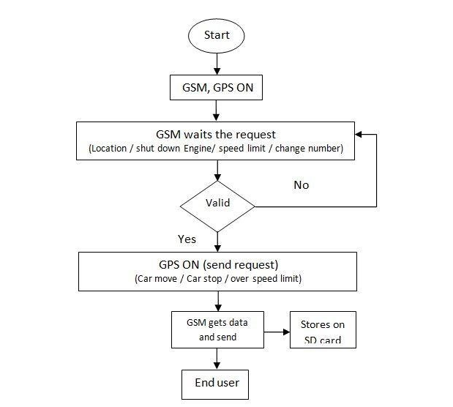

*Figure 3 The map-tracking flowchart*

# 4. RESULTS

The developed vehicle tracking system successfully utilizes GPS technology to receive and transmit a tracked vehicle’s location data, such as latitude and longitude. This data is sent to a web server via an HTTP request. To visualize the vehicle’s real-time location, a PHP web page containing Google Maps is loaded in a browser. The system ensures continuous power supply to the SIM module by utilizing the device power and car battery as a backup in case of device battery discharge. Once the vehicle’s location data is obtained, it is transmitted to the server for further processing.

Additionally, a web application was developed to provide users with a user-friendly interface for viewing the vehicle’s location on the map. HTML, PHP, and JavaScript were utilized to create dynamic web pages. The PHP script incorporates an embedded Google Map, enabling the display of the map with specified parameters to the user. The integration of the Google Maps API key allows for the seamless embedding of the map within the PHP script. Furthermore, the script handles the functionality of fetching and storing data into a database using POST and GET methods, respectively, in accordance with the map matching algorithm.

The combination of these components and functionalities contributes to the overall effectiveness and usability of the vehicle tracking system. Users can access real-time vehicle location information through the web application, enhancing monitoring and control capabilities. The successful implementation of the system demonstrates its potential for various applications in tracking and managing vehicles.

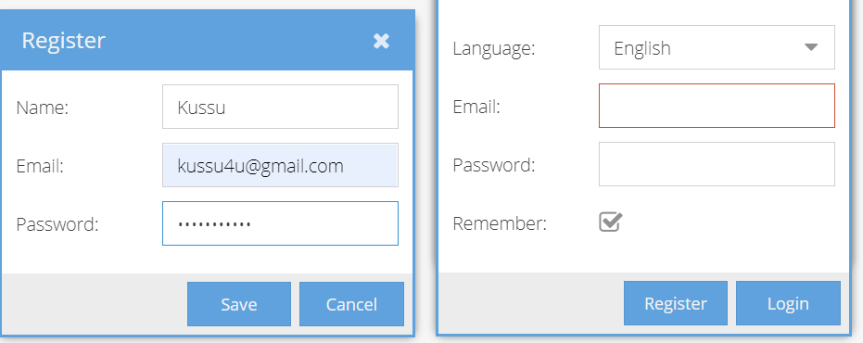

*Figure 4 Server registration and login page*

Vehicle Tracking System Server Snapshot

The depicted figure showcases the default admin page, which displays device properties specific to the selected client. It is important to note that the server has the capability to support multiple clients simultaneously. The device properties presented include the client’s physical address with a high level of accuracy, up to the nearest 0.09 km. Other displayed properties include battery level, coordinates, current protocol, distance from the server, and motion status (indicating whether the vehicle is in motion).

Following the implementation of the user interface, PHP scripts were developed to handle form interactions between the administrator and the agent. These scripts also facilitated the handling of POST and GET functions, enabling the exchange of data with the database. The admin user possesses superuser privileges, granting them unrestricted access to the entire system. The manager user, on the other hand, has extended capabilities allowing for the management of a designated subset of users and the ability to register new users. Ordinary users, referred to as “User,” possess the authority to manipulate their assigned objects and add new ones. Additionally, service administrators can create a manager user for each client, establish user and device limits, and oversee their respective activities.

A pivotal feature of the system is the inclusion of notifications, represented by the standard tracker object that can create and establish connections with other objects such as devices and groups. Notifications are transmitted through the Firebase platform, offering two distinct options: notifications to the official manager application and direct Firebase notifications to custom mobile applications. Web notifications, which manifest as simple pop-up windows within the web interface or mobile application, provide real-time delivery without any noticeable delays. These notifications can be configured to include sound, effectively capturing the user’s attention. Another notification option available is email notifications, which can be configured at two levels: server-wide parameters and per-user configuration, allowing users to define their own email notification preferences within their user attributes.

By incorporating these notification features, the system ensures timely and efficient communication between the application and its users, enhancing overall user experience and system functionality.

# 4.1 Motion, Trips, and Stops

The Motion, Trips, and Stops module were implemented to establish a standardized approach for handling device motion within the tracker. While certain devices provide direct reporting of motion attributes, others rely on the automatic calculation based on speed and a specified speed threshold parameter. Furthermore, computed attributes are utilized to correct and refine the motion data. The module ensures consistent and accurate representation of device motion, enabling reliable tracking and analysis of trips and stops, as shown in Figure 6.

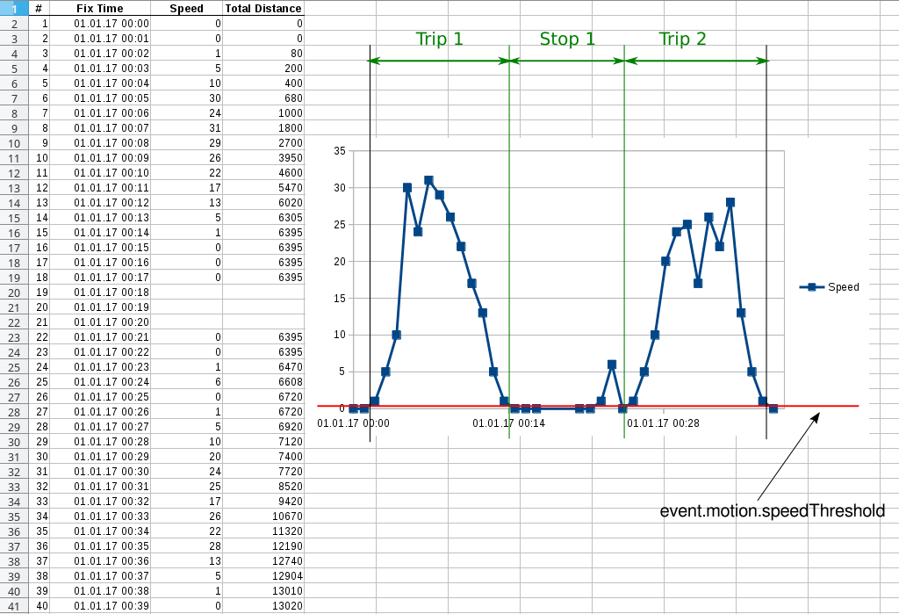

Figure 1Trips and stops

# 5. SUMMARY AND CONCLUSION

In this paper, we presented an intelligent model for a smart vehicle tracking system that utilizes advanced technologies such as GPS and GSM to provide real-time tracking and control of vehicles. The system’s main objective is to enable users to operate, observe, and track vehicles in real time, offering essential fleet management functions such as tracking, routing, dispatching, and enhancing onboard information and security. The system consists of two main parts: tracking and monitoring.

The tracking component is implemented using the Android/iOS platform on the client side, in conjunction with server-side functionalities. By installing an “onboard module” in the tracked vehicle, owners can accurately monitor its location and access up-to-date information. The server component of the system is developed using Java programming language and the Spring Framework, with Apache Kafka for event streaming capabilities and Hibernate ORM for efficient storage and processing of relational mapping.

The developed model establishes a robust foundation for efficient vehicle tracking, ensuring real-time monitoring and enhanced operational control. By combining cutting-edge technologies and a user-friendly interface, the system provides uninterrupted service, efficient data processing, and improved scalability. It caters to the diverse needs of users in the transport and logistics industries, offering real-time vehicle tracking capabilities accessible through a standard web browser.

The research also explored various map-matching algorithms to improve the accuracy of vehicle positioning and incorporate additional management information derived from map-matching geographical features. The integration of statistical models, map-matching algorithms, and GPS technology significantly improves the accuracy and navigation functions of the vehicle tracking system.

In conclusion, the intelligent model for a smart vehicle tracking system presented in this paper offers a comprehensive solution for real-time tracking and monitoring of vehicles. The system’s advanced features, such as GPS technology, GSM communication, and map-matching algorithms, ensure accurate positioning, efficient data processing, and enhanced operational control. With its potential applications in the transport and logistics industries, the system provides essential fleet management functions and improves efficiency and scalability in vehicle tracking operations. Future work can focus on further refining the map-matching algorithms and expanding the system’s capabilities to meet the evolving needs of users.

# 6. FURTHER RESEARCH

GPS tracking devices offer numerous benefits, but they also have limitations. Poor weather conditions and obstacles like tall buildings can hinder GPS connectivity and lead to inaccurate results. Indoor tracking is particularly challenging as GPS signals struggle to penetrate buildings effectively. Additionally, multipath errors can occur when signals bounce off reflective surfaces, compromising accuracy. Adverse weather conditions, reduced satellite availability in certain areas, and battery drain are additional limitations. Alternative tracking technologies like cellular-based tracking or hybrid systems that combine GPS with other positioning methods can be explored to overcome these challenges. Considering these limitations when implementing a GPS tracking system and evaluating alternative solutions based on specific tracking needs and environmental conditions is essential.

# REFERENCES

1. Almomani, I. (2017). Ubiquitous GPS Vehicle Tracking and Management System. *International Journal of Machine Learning and Computing*, 1-5.
2. Bharath, C. H., Vijay, K. P., Anil, R. P., & Abhishek, B. (2018, January 23). A Major Project on Vehicle racking System Using GSM and GPS. *A Major Project on Vehicle Tracking System Using GSM and GPS*, pp. 1-9.
3. Bone, D., & Stuart. (2012). The Economic Benefits of Commercial GPS Use in the U.S.and the The Economic Benefits of Commercial GPS Use in the U.S.and the. *International Journal of Computer Science and Information Technologies*, 04-10.
4. Bradbury, J. (2019, April 28). *Rewire Security*. Retrieved from Rewire Security: https://www.rewiresecurity.co.uk/blog/gps-tracking-satellite-history
5. Chakradhara, R. (2016). Vehicle Tracking System. *International Journal of Computer Science and Information Technologies*, 4-6.
6. Charles, H. (2019, April 26). *GPS History - GPS tracking satellite history in summary*. Retrieved from GPS History - GPS tracking satellite history in summary: https://www.fleetistics.com/resources/gps-history-benefits/
7. Chen, H. C. (2016). Toward Real-Time Precise Point . *International Conference on Advanced Science and Engineering*, 02-10.
8. Francis, K., Gambo, Y., & Omega, S. (2019). A Model for Smart Vehicle Tracking: A Review. *Journal of Scientific Research & Reports*, 1-5.
9. Franczyk, & Vanstone. (2018, February 4). Vehicle warning system. *The Analysis of Directional Time Series*, pp. 03-10.
10. Goffin, E., Lamoral-Theys, D., Tajeddine, N., Tullio, P. D., Mondin, L., Lefranc, F., . . . Pirotte, B. (2012). N-Aryl-N'-(chroman-4-yl)ureas and thioureas display in vitro anticancer activity and selectivity on apoptosis-resistant glioblastoma cells: screening, synthesis of simplified derivatives, and structure-activity relationship analysis. *European Journal of Medicinal Chemistry, 54*, 834-844. Retrieved 9 16, 2021, from https://sciencedirect.com/science/article/pii/s0223523412004023
11. Hapsari, S., & Pramana, I. (2016). Design of Vehicle Position Tracking System Using Short Message Services And Its Implementation on FPGA. *Adventure Works Press* (pp. 02-12). Shangai: Work Press.
12. Hasan, K. R. (2009). Cost Effective GPS-GPRS Based Object Tracking System. *International Multi Conference of Engineers and Computer Scientists*, (pp. 18-20). Hong Kong.
13. Humphries, M. (2012). *A realtime vehicle tracking system*. Retrieved 4 27, 2019, from http://ieeexplore.ieee.org/xpl/freeabs_all.jsp?isnumber=31411&arnumber=1460936&count=100&index=79
14. Jacobsen, R. H., Aliu, D., & Ebeid, E. S. (2017). *A Low-Cost Vehicle Tracking Platform using Secure SMS*. Retrieved 4 27, 2019, from http://findresearcher.sdu.dk/portal/en/publications/a-lowcost-vehicle-tracking-platform-using-secure-sms(9389a1d1-1fb1-488c-89bd-591719621ea1).html
15. Kakuda. (2017). Location Based Services for Mobiles: Technologies and Standards. *Journal of Information Engineering and Applications*, 2-4.
16. Khondker Hasan, M. R. (2009). Cost Effective GPS-GPRS Based Tracking System. *International Multi-Conference of Engineers and Computer Scientists* (pp. 1-3). Hong Kong: International MultiConference of Engineers and Computer Scientists.
17. Michael, G. a. (2017). Analyzing the Benefits of GPS Technology within the commercial Environment. . *Research Gate* , 4-8.
18. Mountain, R. (2019, March 12). *The Difference Between Active and Passive GPS Tracking Devices*. Retrieved from The Difference Between Active and Passive GPS Tracking Devices: https://rmtracking.com/blog/2009/05/25/the-difference-between-active-and-passive-gps-tracking-devices/
19. Nilesh, M. N. (2008). Real Time Tracking of Complete tracking system using GPS. Google. *International Journal of Computer Science and Information Technologies*, 2-4.
20. Ramani, R., Valarmathy, S., Suthanthira, V., Selvaraju, S., Thiruppathi, S., & Thangam, R. (2013). Vehicle Tracking and Locking System Based on GSM and GPS. *International Journal of Intelligent Systems and Applications, 5*(9), 86-93. Retrieved 4 27, 2019, from http://mecs-press.org/ijisa/ijisa-v5-n9/ijisa-v5-n9-10.pdf
21. Sadaphalt. (2019). Design and Implementation Of vehicle Tracking System Using GPS. *Journal of Information Engineering and Applications*, 3.
22. Sanchit, B. (2013). Vehicle tracking system, using GPS and Google Map. *Adventu*, International Journal of Computer Science and Information Technology .
23. Suresh, G., & Tewksbury, R. (2013). Locations of Motor Vehicle Theft and Recovery. *American Journal of Criminal Justice, 38*(2), 200-215. Retrieved 9 16, 2021, from https://link.springer.com/article/10.1007/s12103-012-9161-7
24. Tamil, E., & Saleh. (2016). A Mobile Vehicle Tracking System with GPS/GSM Technology. *5th Student Conference on Research and Development* (pp. 02-04). Malaysai: Permala Bangi.
25. Tan, H. (2010). Design and Implementation of Vehicle Monitoring System Based on . *Second International Conference on Information Technology and* , 413 - 416.
26. Yadav, K. (2018). GSM & GPS Based Vehicle Theft Control System. *International Research Journal of Engineering and Technology (IRJET)*, 2-5.

6/22/2023