ZAMIN GROWS IN THE NATIONAL NATURE GARDEN AND IS USED IN FOLK MEDICINEROSES - SPECIAL PROPERTIES OF UNIQUE MEDICINAL PLANTS BELONGING TO THE ROSACEAE FAMILY
Translated from Uzbek to English - www.onlinedoctranslator.com

¹Sakiev Kabiljon Bosimovich
Research Institute of Environment and Nature Protection Technologiesk.sakiev@bk.ru
²Torakulova Dilnoza Egamberdievna
Student of the Department of Biotechnology, Faculty of Engineering Technologies, Tashkent State Technical University
³Borasulov AkmalMirayimovich
Head of the Agrobiotechnology Department of the Tashkent branch of the Samarkand State University of Veterinary Medicine, Animal Husbandry and Biotechnology,
bioinformatics-genetics@mail.ru
⁴Sattarov Muzaffar Eshtemirovich
Head of the National Collection of Microorganisms for Production at the Tashkent Research Institute of Vaccines and Serums,m_sattorov@mail.ru

Abstract: In this articlein folk medicine, tea is drunk from apricot kernels when the heart aches and in cases of heart disease. Apricot fruit gives a person medicine, helps in case of anemia. Abu Ali ibn Sina used apricot fruit to treat gastrointestinal diseases.The glue collected from the bark of the tree is used in scientific medicine in the preparation of dressings and oil emulsions.Apricot kernel oil is widely used in the pharmaceutical industry.Zomin National Nature Park is a place that naturally preserves the gene pool of valuable plants necessary for humans. Medicinal, aromatic, honey, cooking, food, decorative, building materials, and other groups of plants that have become important in human life are widespread.Problems of preservation and reproduction of rare and disappearing plant species are becoming more difficult. If measures are not taken in time to determine their distribution in one or another area, to study the population situation, to take into account the factors affecting the disappearance of species, the problems may deepen.In conclusion, we can say that Zomin National Park is a place rich in medicinal plants.
[Sakiev K. at. El.Zamin Grows In The National Nature Garden And Is Used In Folk MedicineRoses - Special Properties Of Unique Medicinal Plants Belonging To The Rosaceae Family. Researcher 2023;15(3):50-53]. ISSN 1553-9865 (print); ISSN 2163-8950 (online). http://www.sciencepub.net/researcher. 08
doi:10.7537/marsrsj150323.08.

Keywords: Zamin, garden, medicinal, family, nature park.

Introduction
Zomin National Nature Park is extremely rich in various useful plants. There are more than 1,000 species of plants growing wild in the region, and medicinal properties of more than 107 species have been identified.40-45% of currently prepared medicines are made from medicinal plant raw materials. It is known that phytopreparations prepared from raw materials of medicinal plants have several advantages over drugs produced by artificial (chemical) means. Phytopreparations have a gentle effect on the human body, allergic conditions may occur in rare cases, the preparations do not cause a cumulative state in the organs.Medicinal plants contain hydrocarbons, organic acids, polysaccharides, starch, protein, fatty and fatty acids, essential oils, alkaloids, tannins, saponins, glucosides, bitter substances, phytoncides, trace elements, vitamins, mineral salts and other substances. Due to the general effect of these substances, plants have healing properties [1].
At present, the impact of anthropogenic factors is causing the ecosystem to become stable, new species to form and existing species to decrease [2].A number of anthropogenic factors affect the flora of Zomin National Nature Park. In particular, in the area and outside it, the population is carelessly grazing cattle, loss of natural reserves for the purpose of planting agricultural crops on the mountain slopes, use for fuel, unplanned harvesting of large quantities for medicinal purposes, cutting of trees and use for road construction, natural disasters (floods, natural due to fire, climate failure and droughts) causes the reduction of flora [3].
According to the results of observation conducted in the region, rare medicinal plants are distributed in the middle and upper parts of the high hills and mountains of the region. Due to the population living in the upper hill and lower mountain parts, many plants have been witnessed to be depleted. The main reason for the decline of the medicinal plants of the Zomin National Nature Park is that they are collected in large quantities by the population as spices, medicine and fodder. According to the results, there are 107 species of medicinal plants distributed in the region, of which 11 species are rare, 5 species are included in the Red Book of the Republic of Uzbekistan (2019) [4-5].

Materials and Methods:
Uzbekistan is included in the "Red Book", especially the rare species of hyacinths and tulips are preserved in this area [6].Zomin National Nature Park useful plants according to their life form: 1-year herbs - 35, 2-year herbs - 10, perennial herbs - 23 and semi-shrubs - 8.Zomin National Nature Park is rich in useful plants, the mountain forest, subalpine region has various types of plants and is spread across regions [7].
The rare medicinal plants in the regions where we conducted research are rosaceae - a number of medicinal plants belonging to the Rosaceae family are widespread and are used in folk medicine for the treatment of diseases. Below we will focus on medicinal plants belonging to this family growing in the Zomin National Nature Park and their specific characteristics.
Blue monkey Rubus caesius L.Roses are shrubs or semi-shrubs belonging to the Rosaceae family. The one-year stem grows erect (lying) or arched. Stems are cylindrical, branched with thorns, 60-150 cm long. The leaves are three-bladed, complex, arranged in a row on the stem and branches with a long band. Leaf lobes are ovate, sharp-pointed, tooth-shaped. The flowers are white, five-lobed, gathered in a shield-shaped peduncle. The fruit is a blue-yellow, juicy, complex wet fruit with seeds. It blooms in May-June. It bears fruit in June-August.In Zomin National Nature Park, it grows on mountain slopes to mid-mountain terrain, along streams, on rocky mountain slopes, in ravines, among bushes, and other terrains.
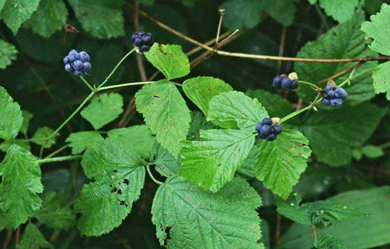
Figure 1. Blue monkey - Rubus caesius L. - Ejevica sizaya

Chemical composition:Blue monkey fruit contains 45 mg% vitamin C, 2.2 mg% organic acids, 0.3 mg% carotene, 0.3 mg% sugars (4.3% glucose, 8% fructose, 6.5% sucrose) , there are anthocyanins and other substances. The leaves, fruits, and flowers and roots of the plant are harvested as raw materials in folk medicine.
Usage:Monkey leaf herb is widely used as a diuretic. It is also used as an antiseptic and blood purifier. Medicinal forms obtained from the root are used as a diuretic and anti-inflammatory. Fruit and fruit juice can be used as a fever reducer, raw fruit as an expectorant.
Use in folk medicine:If crushed monkey leaf tincture is drunk 3-4 times before meals, it is useful in the treatment of bleeding, colds, and various skin diseases.Crushed leaves can be applied to lice and other wounds. If the mouth and throat are rinsed with the tincture, it has an anti-inflammatory effect. Delicious jam and liqueurs are made from its fruit.
Namatak - Rosa L.Rosehips are 1.5-3 m tall thorny shrubs belonging to the Rosaceae family. The branches are flexible, covered with brown-red bark, prickly. The leaves are complex with odd feathers, arranged in a series of bands on the stem. The leaf has 5-7 ovate, saw-shaped edges. The flowers are large, single or 2-3 on the stems and branches. The flowers are red, pink, yellow, white, and the false juicy fruit formed instead of flowers has many nuts. It blooms in April-August. Fruiting occurs in September-October.

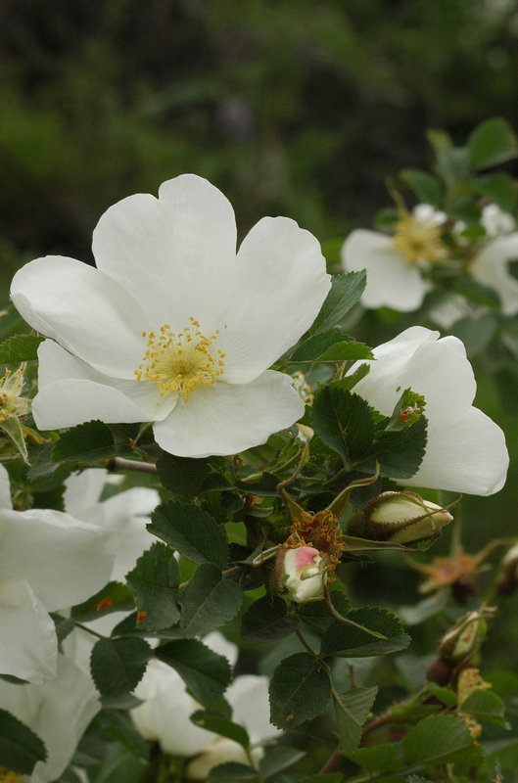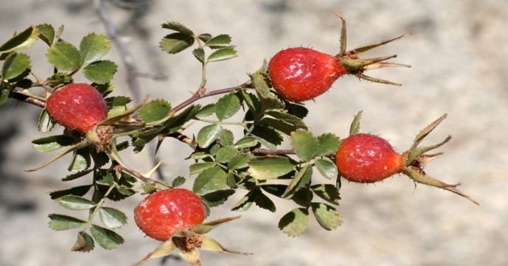
Figure 2. Namatak - Rosa L. – Shipovnik

Namatak species grow in all areas of the Zomin National Nature Park in the forests, mountain slopes, stream banks, bushes, roadsides and other places. In Zomin National Nature Park, you can find 6 species of grass.
The main species used: Begger's rose - Rosa Beggeriana Schrenk. – rosehip Beggera, rose hip – Rosa canina L. – rosehip Sobachy, rosehip Fedchenko – Rosa fedshencoana Rgl. – shingle Fedchenko, Kokan namatagi – Rosa kokanica Rgl. ex Juz. - ceiling tiles are Kokandsky types.
Currently, all types of namatak listed in the folk medicine of Uzbekistan can be used.
Chemical composition;
Namatak fruit contains vitamins C, V2, K1, R, carotene, sugar, flavoring agents, citric and malic acids, flavonoids, pectin and other substances.
Usage:Namatak fruit tincture is rich in vitamins and is widely used as a strengthening agent for the endocrine system in atherosclerosis. Due to the presence of vitamin R with ascorbic acid, it is used as a means of softening the walls of blood vessels and reducing their brittleness.Namatak seed has astringent, diuretic and anti-inflammatory effects.
Use in folk medicine:Drinking 100 ml of a decoction made from ground nematak root 4 times before meals helps in the treatment of malaria and dissolves kidney stones.In addition, foot paralysis and weakness are treated by taking a bath.Namatak fruit tincture is recommended to drink 100 ml 2-3 times before meals in case of anemia, impotence, atherosclerosis, kidney and liver diseases. In addition, it helps in cases of colds and avitaminosis.
Tincture of ground namatak leaves, taken 2 tablespoons with honey 2-3 times before meals, helps in healing wounds that are difficult to heal.If you drink 50 ml of Namatak nut powder 4-5 times before meals, it can dissolve kidney and bladder stones. Fruits are included in various collections.
Simple apricot -Armeniaca vulgaris Lam. Rosaceae is a tree 5-8, sometimes up to 17 m tall, belonging to the Rosaceae family. The body and branches are covered with brown bark, the leaves are ovate, oblong-ovate, sharp-pointed, serrated, arranged in a row on the stem and branches with the help of a long band. Flowers are white or pink, 5-lobed. The fruit is a golden, yellow, reddish, berry of various shapes and sizes, with a pleasant taste and smell, with seeds. It blooms without leaves in March-April, the fruit ripens in June-August.

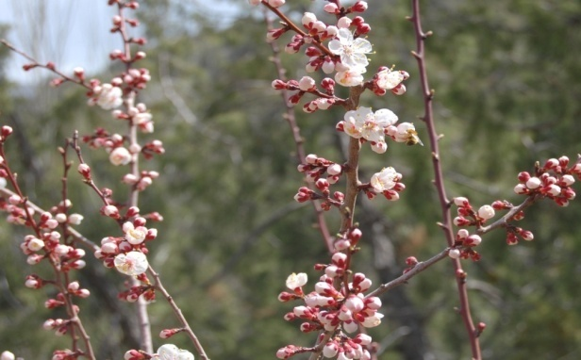
Figure 3. Simple apricot -Armeniaca vulgaris Lam. - Common apricot

In the wild, it grows in the Zomin National Nature Park on the hills of the mountain, on the banks of streams.
Chemical composition;
The soft part of the fruit contains sugars, carotene, organic acids, vitamins C and RR, flavonoids, pectin, minerals, flavoring substances, oil in the seeds, emulsin enzyme. The bitter variety of apricot contains amygdalin glycoside. Apricot is mainly cultivated as a delicious and very useful fruit.
Usage:
In folk medicine, tea is drunk from apricot kernels when the heart aches and in cases of heart disease. Apricot fruit gives a person medicine, helps in case of anemia. Abu Ali ibn Sina used apricot fruit to treat gastrointestinal diseases.The glue collected from the bark of the tree is used in scientific medicine in the preparation of dressings and oil emulsions.
Apricot kernel oil is widely used in the pharmaceutical industry.Zomin National Nature Park is a place that naturally preserves the gene pool of valuable plants necessary for humans. Medicinal, aromatic, honey, cooking, food, decorative, building materials, and other groups of plants that have become important in human life are widespread.

Conclusion:
Problems of preservation and reproduction of rare and disappearing plant species are becoming more difficult. If measures are not taken in time to determine their distribution in one or another area, to study the population situation, to take into account the factors affecting the disappearance of species, the problems may deepen.In conclusion, we can say that Zomin National Park is a place rich in medicinal plants.
There are many species that have not yet been identified and studied in the flora of the Republic of Uzbekistan. So far, more than 600 known medicinal plants have been studied in the flora of the Republic of Uzbekistan. In the future, new types of medicinal plants will be identified, their scientific aspects will be studied, and promising ways of their rational use will be developed.When using medicinal plant resources, this balance will not change if the rules of their collection and preparation are followed so as not to affect the ecological balance of plant groups. Otherwise, as a result of unreasonable use of plants, most plant species will disappear and their reserves will decrease.

References:
- Mirzahmedov, I. K. (2020). Use And Protection Of Natural Resources Of Kokand Oasis. Nature and Science, (12 (18)), 49.
- Sakiev KB, Barakaev SM, Sattarov ME Rare medicinal plants growing in Zamin National Park and their conservation / European journal of Agricultural and Rural Education. ISSN (E) 2660-5643. Journal Impact Factor: 7.354 Volume 3, Issue 11. November, 2022. pp. 5-12.
- Sattarov M., Saqiev Q., Abdug'abbarov Sh., Torakulova D., Mekhribonova S. Unique biological landscape and biodiversity of Zomin National Nature Park // Journal of Ecology Bulletin. No. 1 (1) 2022. T.: 17-21 p.
- Book of registration of flora objects and other information // Zomin, 2020.
- Red Book of the Republic of Uzbekistan, Tashkent, 2019.
- N.S.Abdullaeva Mery po sokhraniniyu lesov v Zaaminsky National Nature Park // Materialy konferentsii molodyx uchenyx. Termiz: Izd-vo "Tafkkur",2016. S. 654-655.
- Abdullaeva N.S.,Khodzhimatov O.K., Karshiboeva N.Kh., Yangibaeva Z.A. Gubotsvetnye Zaaminskogo natsionalnogo naturalgo parka // Bulletin of Orenburgskogo nauchnogo tsentra UrO RAN (electronic journal). 2017. No. 1. S. 1-7.
- Sakiev Q.B., Torakulova D.E., Nizamova D.O., Sattarov M.E. Rare medicinal plants belonging to the Asteraceae family, which grow in the Zomin National Nature Park and are used in folk medicine.Journal of Pharmacy, Immunity and Vaccine, No. 3, Tashkent. 2022. p. 109-119.

3/16/2023

