VARIABILITY OF MICRONUTRIENTS IN SELECTED SOILS OF A GUINEA SAVANNAH AGRO-ECOLOGY OF OYO STATE, SOUTHWESTERN NIGERIA

Julius R. Orimoloye,* and Adeola D. Aderiye-Femi

Department of Soil Resources Management, University of Ibadan, Ibadan, Nigeria
*for correspondence: juliusorimoloye@gmail.com
Abstract: Micronutrients are key determinants in the vital physiological processes of photosynthesis and respiration in plants and deficiencies in micronutrients could lead to significant yield loss in crops. The status of micronutrients in soil has not been given adequate attention in soil fertility studies. This study was carried out to exermine the vertical and spatial variability of selected micro-nutrients (Mn, Fe, Cu and Zn) within and across four soil types which were Oshe Series (Oxyaquic Haplustalf), Fashola Series (Typic Plinthustalf); Temidire Series (Rhodic Plinthustalf) and Kishi series (Kanhaplic Haplustalf) identified on a landscape near Ogbomosho in Oyo State. Soil samples were collected in grids of 150 x 200m at depths of 0-15cm, 15-30cm, 30-60cm and 60-90cm across the approximately 250 ha study area. The soils were subjected to routine analysis using standard laboratory procedures. The analytical results of the pH, organic C, exchangeable cation exchange capacity and extractable micronutrients (Fe, Mn, Cu and Zn) were subjected to descriptive analysis to determine the vertical and spatial variability of these micronutrients in the study area using the critical values of the co efficient of variation. Soil reactions were slightly acidic and tend towards neutral with mean pH of 6.1 - 6.7 which are ideal for most crops. The ECEC and the organic carbon (OC) were observed to be relatively moderate in content and variation across the landscape which is an indication of a relatively fertile soil. The micronutrients (Mn, Fe, Cu, and Zn) were above their critical level and they have low variation both vertically and spatially across the mapping units except for Zn which had high variation in Fashola soil series. while soils of this area are relatively good in native nutrients, the weak aggregations and sandy nature of surface soils are prone to erosion which could lead to rapid degradation. The soils should be properly managed through a proper site specific fertility management programme to maintain a good nutrient status for continuous cropping.
[Julius R. Orimoloye, and Adeola D. Aderiye-Femi. VARIABILITY OF MICRONUTRIENTS IN SELECTED SOILS OF A GUINEA SAVANNAH AGRO-ECOLOGY OF OYO STATE, SOUTHWESTERN NIGERIA
.Researcher2023;15(3):1-7].ISSN1553-9865 (print);ISSN2163-8950 (online).http://www.sciencepub.net/researcher. 01.doi:10.7537/marsrsj150323.01.

Keywords: Micronutrients, Soil properties, plant nutrition, Guinea Savannah

INTRODUCTION
The soil is a production factor in agriculture that needed to be understood before it could be improved (Hartemink, 2016). Plant nutrients in higher plants especially crops are categorized as macronutrients when taken up as required, in high concetrarations. The micronutrients like Zinc, Copper, Iron, Manganese, Molybdenum, Chlorine and Boron are very essential to growth and physiology of plants but are needed in smaller quantities. The importance of micronutrients for different physiological processes in plant life has been a subject matter in many previous researches (Mengel et al., 2001; Nazakat et al.,2012). It has therefore been established that deficiency in any of the nutrients may result into whole crop failure or significant loss of yield.
Micronutrients are essentially cofactors in enzyme systems and are involved in many redox reactions. Other vital functions of micronutrients in plants include osmotic balance, energy fluxes and utilization of the macronutrients (Memon et al., 2012). The key physiological processes of photosynthesis and respiration that are vital to growth and yield of crops are driven by micronutrients (Mengel et al., 2001; Gao et al., 2008). Deficiencies or disproportionate supply of micronutrients can impede vital physiological and reproductive processes in plants thus limiting yield in field crops (Patil, 2008). Rehman et al., (2012) reported that Zinc deficiency is a major yield-limiting factor for rice (Oryza sativa L.) production in many Asian countries. Micronutrients are primarily sourced from the weathering of parent rocks and primary minerals in the soil, however, Zinc, Boron and Molybdenum are reportedly scarce in parent rocks (Voorman, 2012).
Soils are said to be fertile when nutrients are readily available in the right form and proportions and this is an important factor that determines the growth, yield and quality of field crops. Extractable micronutrients: Zinc (Zn), Copper (Cu), Iron (Fe) and Manganese (Mn), are involved in various enzymes and other physiologically active molecules such as nucleic acids, proteins, chlorophyll, growth regulators, carbhydrates lipids and secondary metabolites in plants. They are essential in crops for genetic variations, environmental resilience, stress tolerance etc (Gao et al., 2008).
There has been an upsurge in research interest on crop growth and yield in the guinea Savanah Agroecology of Nigeria with the realization of the enourmous potentials on food security. Micronutrients as a limiting factor in this agroecology is due to long term cropping which has removed measurable amounts of these nutrients (Orimoloye et al., 2015). Widespread use of animal measures which has decreased and also top soil has been removed through erosion (Voss, 1998). It is reasonable therefore to pay attention to the adequacy of micronutrients for crop production in this agroecology, although required in smaller quantities than the macronutrients they are just as important for proper plant nutrition. Micronutrient has been reported to be deficient in most agricultural soils in the Savannah. Zinc is deficient in a number of agricultural lands as well as Boron (Paa, 1990). The deficiency of copper, molybdenum, and manganese were smaller. It was generalized that the concentration of micronutrients in plants can be linked to the soil. Ability to extract and utilize nutrients from soils differ with plant species. Other factors include varietal differences, genetic and environmental adaptations through human selection or breeding programmes as copper efficiency appears in cereals has been attributed to a single major gene (Graham et al., 1987). In manganese a manganese deficient soil, Khabaz-Saberi et al. (2008) reported that a polygenic trait can be usefully manipulated in breeding progamme using molecular markers to develop efficient Mn utilizing crops. Soil micronutrient deficiencies especially for Zinc, Boron and Molybdenum has been ascertained to result in lower crop yields.
For a sustainable food security in Nigeria, information on nutrient status, availability and dynamics in soils has become imperative. The need for assessing the status of micronutrients in tropical soils for agricultural productivity has been reiterated (Chaudhari et al., 2012). The spatial and vertical distribution of available micronutrients is required to better estimate the capacity of soils to supply adequate and proportionate amount of these nutrients to plants on a sustainable basis. This study was carried out, therefore, to determine the status of micronutrients and evaluate the vertical and spatial variability of these micronutrients in the identified soil types in a typical Gunea Savannah agroecology in Southwestern Nigeria.

MATERIALS AND METHODS
Description and Location of the Study Area
The study was conducted at Oko maro village near Ogbomosho, Orire Local Government Area (LGA) of Oyo state. The field is located between Latitude 8.52123 – 8.53515⁰ N and Longitude 4.23503 – 4.24660⁰ E. The area lies mostly on the plains which are punctuated by rocky outcrops of schists and quartzites with series of hills having slopes up to 8% and elevations reaching 119-155m meters. Average daily temperature ranges between 25C (77F) and 35C (95F) almost through-out the year. Rainfall figures averaged 1200mm. the area is characterized by derived savannah agro-ecology.

Field work
This study was carried out along with a soil survey described by Orimoloye et al. (2015). Transects were laid 200 m apart and examination points were sited at 150m interval along the transects. At each examination point, samples were collected at depths 0 – 15cm, 15 – 30cm, 30 – 60cm, 60 – 90cm and 90 – 120cm, except where impervious under-layer or high water table did not permit angering to the depth of 120cm. Soil types were delianated and were further studied in detail in standard soil profiles measuring 2m by 1.5 m to a depth of 1.8 m. Soil samples collected from examination points and the soil horizons were subjected to routine soil analysis.

Laboratory analysis
The soil samples collected were air dried, crushed, and passed through 2mm and 0.5mm mesh sieve. The particle size analysis was carried out using the Bouyous hydrometer method. Soil pH was determined in 1:1 soil-solution ratio of water and KCl using glass electrode pH meter (Electrometric method). Organic carbon was analyzed using the dichromate wet oxidation method of Walkley and Black (1934). Total Nitrogen was determined by the Kjedahl oxidation method. Available phosphorus was extracted with Bray P1 solution (Bray and Kurtz, 1945) and P concentrations were assayed using the ascorbic acid blue colour method (Murphy and Riley 1962). Exchangeable bases (K, Na, Ca and Mg) and micronutrients (Cu, Zn, Fe and Mn) were extracted with Melich III solution. Na and K were determined by flame photometry while all other bases and micronutrients were by Atomic Absorption Spectrophotometry (AAS). Exchangeable acidity (Al³⁺ and H⁺) was leached in 1N KCl and was titrated against 0.01N NaOH. Effective Cation Exchange Capacity (ECEC) was calculated as the summation of the values of exchangeable cations and exchangeable acidity.

Soil Taxonomic Classification
The soil types on the study area were classified using the guidelines of USDA Soil Taxonomy (Soil Survey Staff, 2014) and the World Reference Base (WRB) system (FAO/IUSS, 2014). The higher category classifications were correlated with the classification system of soils on basement complex parent rock origin in Savnnah areas as described by Murdoch et al. (1976).

Statistical Analysis
Descriptive statistics: mean, standard deviation and coefficient of variation for each mapping unit and profile pits was calculated using GenStat package. The variability of each property was measured by the coefficient of variation (CV) expressed as percentage. The higher the CV, the more variable the property. The levels of variability were evaluated using the critical values for coefficient of variation as described by Olatunji et al., (2007)

Table 1: Taxonomic classification of mapping units on the study site.

Soil Mapping Unit | Area | Local  (Murdoch et al 1976) | USDA Soil Taxonomy  (Soil Survey Staff 2014) | WRB  (FAO, 2014)
 | (%)
Mapping unit (IHM 01) | 14.34 | Oshe Series | Oxyaquic Haplustalf | Stagnic Luvisol (Fluvic)
Mapping unit (IHM 02) | 35.73 | Fashola Series | Typic Plinthustalf | Petric Plinthosol (Eutric)
Mapping unit (IHM 03) | 8.66 | Temidire Series | Rhodic Plinthustalf | Petroplinthic Lixisol (Rhodic, Eutric)
Mapping unit (IHM 04) | 41.27 | Kishi Seies | Kanhaplic Haplustalf | Haplic Lixisol (Vetic)

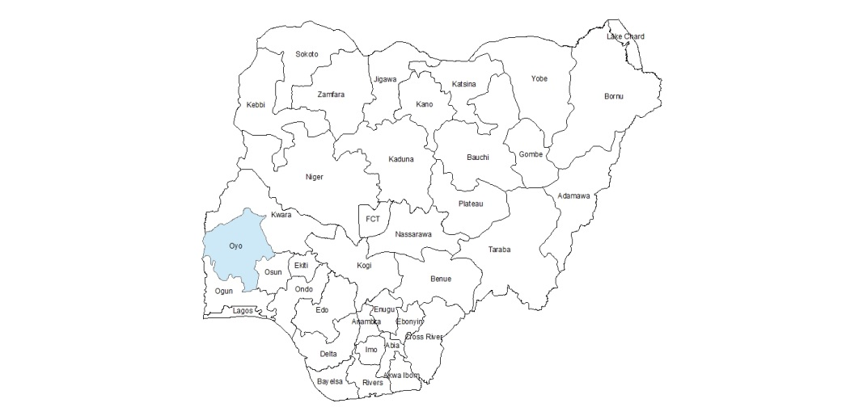
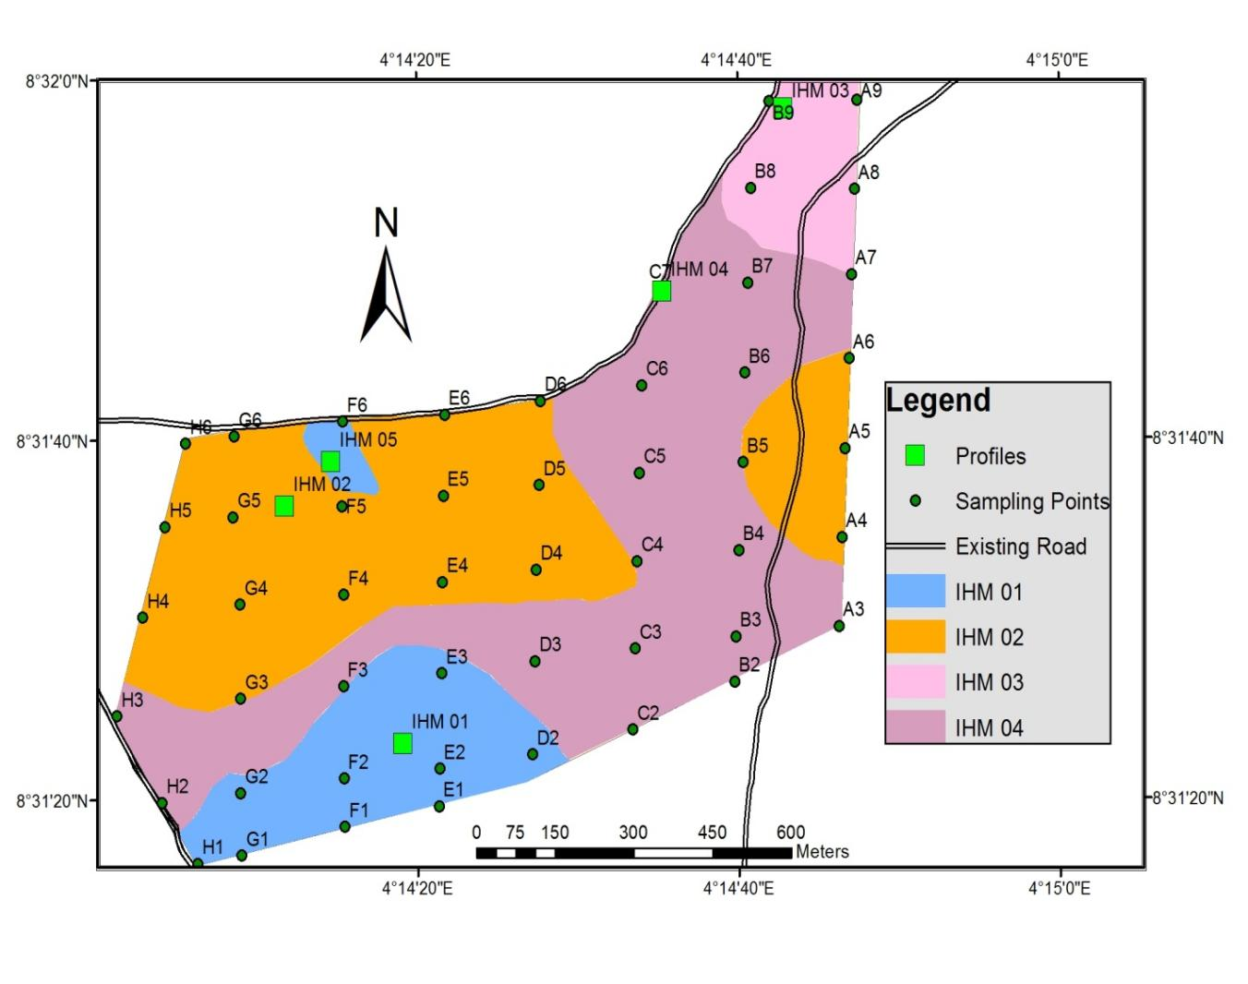

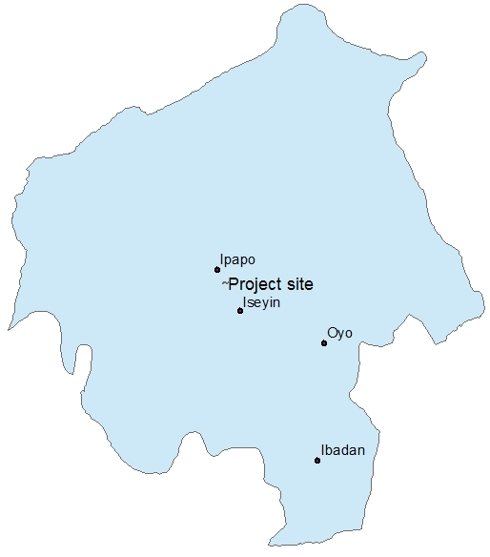

Figure 1: Soil map of the study location showing the soil mapping units and sampling points.

RESULTS AND DISUSSION
Four (4) soil mapping units were discovered in the study site and the taxonomic classification together with the proportion of land area covered by each soil type are presented in Table 1. The soil in mapping unit IHM 01 is classified as Oxyaqic Haplustalf by USDA soil taxonomy and Stagnic Luvisol Fluvic by WRB. This mapping unit is at the lower slope of the study area with impeded drainage and water-logging and covers 14.50 Ha of the total land area which is about 14.43%. Hydro-morphic mottles present in the profile pit indicate that there is fluctuation in the water table. Iron-Manganese concretions were observed from 60cm depth. Parent material is granite gnesis and the profile length is 153cm. Soil colour ranges from gray to Olive yellow; with soil texture ranging from Sandy loam on the top soil to Sandy Clay Loam down the profile pit. The soils are slightly acidic with pH value ranging from 6.2 - 6.5. Soils in this mapping unit have high base saturation with mean values 99.01% and 99.25% for vertical and spatial respectively. The CV micro-nutrients vertically include: Manganese; 8.27%, Iron 10.48%, copper 4.72%, and zinc 32.30%; while those (CV) obtained spatially at 0-30cm include: Manganese: 10.92%, Iron 12.93%, Copper 0.49%, Zinc; 28.80%. Organic carbon ranges from moderate to very high for both the vertical and spatial distribution with mean values of 9.77 and 20.33 respectively.
Soils in mapping unit IHM 02 are classified as Typic plinthustulf (USDA Soil Taxonomy) and Petric plinthusol (WRB). It Occupies 35.73% of the total study area. The parent material is sedentary, the land is well drained, lithology is banded gnesis and physiography position is hill crest. Soil samples were also taken from spatial designations with 0-30cm depth at 20m apart. Soil colour ranges from dark brown to brown with loamy sand texture. Soils in this mapping unit are slightly acidic. Values for co efficient of variation for micronutrients present in the soils from samples gotten from this mapping unit vertically and spatial include: Manganese; 5.71, 11.76 respectively, for Iron; 22.81, 13.66 respectively, for copper; 5.61, 13.01 respectively, and zinc; 59.41, 78.09. Organic carbon ranges from low to high with mean values 9.98 vertically and 19.20 spatially. Cation exchange capacity is moderate with mean values of 5.07 vertically and 6.93 spatially. Base saturation is high with mean values for vertical and spatial designations of 96.47% and 99.25% respectively.
Soils in mapping IHM-03 unit are classified as Rhodic Plinthastalf (USDA Taxonomy) or Petroplinthitc Lixisol (WRB). It occupies 8.66 % of the study area. The land is well drained, Lithology is banded gnesis, Physiographic position is hill crest. Soils in this mapping unit are slightly acidic, with a predominant texture sandy clay loam in the middle horizons. Values for the co efficient of variation for micronutrient present in soils samples from this soil vertically and spatially include manganese: 4.78 and 0.39 respectively, Iron: 10.19 and 10.10 respectively, copper: 15.15 and 6.92 respectively and zinc: 32.0 and 20.53. Organic carbon ranges from low to high with mean values of 9.03 and 19.04. Cation exchange capacity is moderate with values; 4.71 and 6.46, base saturation is high with values 98.39% and 99.07%.
The soil in mapping unit IHM-04 was classified as Kanhaplic Haplustalf (USDA soil taxonomy) or Haplic Lixisols (WRB). The Soils are well drained occurring at middle slope, they are Sandy clay textured soil, with yellowish brown colour having a mixture of pear-shaped iron manganese concretions and quartz gravel occurring at 100cm depth of the soil. effective depth was 170cm. Soils in this mapping unit are slightly acidic with values for co efficients of variation for micronutrients present vertically and spatially as follow: Manganese; 6.46 and 31.58 respectively, iron; 4.82 and 18.71 respectively, copper; 8.18 and 10.41 respectively, Zinc; 15.50 and 29.46 respectively. Organic carbon ranges from moderate to high with mean values 7.16 vertically and 19.76 spatially. Cation exchange capacity is moderate, Base saturation is high with values; 95.26% and 99.16%.

Table 2: Vertical variability of micro-nutrients in selected soils of the Guinea Savannah Agroecology.
 | Oshe Series  (Oxyaquic Haplustalf) |  |  |  | Fashola Series  (Typic Plinthustalf) |  |  |  | Temidire Series (Rhodic Plinthustalf) |  |  |  | Kishi Series  (Kanhaplic Haplustalf)
Variables | Mean | SD | CV % |  | Mean | SD | CV % |  | Mean | SD | CV % |  | Mean | SD | CV %
pH in water | 6.2 | 0.4 | 6.4 |  | 6.2 | 0.3 | 4.84 |  | 6.4 | 0.3 | 4.67 |  | 6.5 | 0.2 | 3.06
OC (g/mg) | 9.77 | 5.20 | 53.22 |  | 9.98 | 4.79 | 47.99 |  | 9.03 | 4.45 | 0.49 |  | 7.16 | 1.56 | 21.79
ECEC (cmol/kg) | 7.77 | 4.97 | 63.96 |  | 5.07 | 1.14 | 22.49 |  | 4.71 | 0.47 | 9.98 |  | 4.62 | 0.44 | 9.52
B sat. (%) | 99.01 | 0.5 | 0.50 |  | 96.47 | 4.88 | 5.06 |  | 98.39 | 0.66 | 0.67 |  | 95.26 | 4.45 | 4.67
Mn (mg/kg) | 238.6 | 19.74 | 8.27 |  | 231.5 | 13.23 | 5.71 |  | 178.75 | 8.54 | 4.78 |  | 155.0 | 10.02 | 6.46
Fe (mg/kg) | 119.0 | 12.47 | 10.48 |  | 124.5 | 28.41 | 22.81 |  | 162.75 | 16.58 | 10.19 |  | 166.8 | 8.04 | 4.82
Cu (mg/kg) | 1.06 | 0.05 | 4.72 |  | 1.07 | 0.06 | 5.61 |  | 0.99 | 0.15 | 15.15 |  | 1.10 | 0.09 | 8.18
Zn (mg/kg) | 1.61 | 0.52 | 32.30 |  | 1.70 | 1.01 | 59.41 |  | 1.75 | 0.56 | 32.0 |  | 1.29 | 0.20 | 15.50
SD= Standard deviation, CV= Co-efficient of variation.

Table 3: Spatial variability of micro-nutrients in selected soils of the Guinea Savannah Agroecology.
 | Oshe Series  (Oxyaquic Haplustalf) |  |  |  | Fashola Series  (Typic Plinthustalf) |  |  |  | Temidire Series (Rhodic Plinthustalf) |  |  |  | Kishi Series  (Kanhaplic Haplustalf)
Variables | Mean | SD | CV% |  | Mean | SD | CV% |  | Mean | SD | CV% |  | Mean | SD | CV%
pH in water | 6.5 | 0.28 | 4.34 |  | 6.7 | 0.32 | 4.82 |  | 6.5 | 0.34 | 5.29 |  | 6.58 | 0.30 | 4.51
OC (g/mg) | 20.33 | 5.18 | 25.50 |  | 19.20 | 14.28 | 74.38 |  | 19.04 | 7.68 | 40.34 |  | 19.76 | 19.17 | 17.02
ECEC (cmol/kg) | 6.71 | 0.58 | 8.72 |  | 6.93 | 1.40 | 20.20 |  | 6.45 | 1.13 | 7.45 |  | 6.77 | 0.91 | 13.41
B sat. (%) | 99.25 | 0.06 | 0.06 |  | 99.25 | 0.14 | 0.14 |  | 99.07 | 0.39 | 0.39 |  | 99.16 | 0.21 | 0.21
Mn (mg/kg) | 235.0 | 25.66 | 10.92 |  | 221.2 | 26.01 | 11.76 |  | 99.07 | 0.39 | 0.39 |  | 218.45 | 68.98 | 31.58
Fe (mg/kg) | 152.9 | 19.76 | 12.93 |  | 157.9 | 21.58 | 13.66 |  | 140.00 | 4.14 | 10.10 |  | 150.45 | 28.15 | 18.71
Cu (mg/kg) | 1.08 | 0.14 | 0.49 |  | 1.07 | 0.14 | 13.01 |  | 1.28 | 0.09 | 6.92 |  | 1.22 | 0.12 | 10.41
Zn (mg/kg) | 1.71 | 0.49 | 28.80 |  | 2.88 | 2.25 | 78.09 |  | 2.70 | 0.55 | 20.53 |  | 2.71 | 0.80 | 29.46

The micro-nutrients Mn, Fe, Cu were observed to have low variability both vertically and spatially across the mapping units while Zn was found to vary moderately in IHM 01 and IHM 03 but high in IHM 02. The low variability of the micro-nutrients Mn, Fe, and Cu recorded indicates that these micro-nutrients are very much available and stable in the soil. The high variability observed with Zn in IHM 02 may be due to the physiographic position (hill crest) where these mapping units are located. Voss (1998), noted that the reason for high variability of nutrients is due to long term cropping which might through crop harvesting, removed substantial amounts of nutrients, while erosion and denudation also has removed part of the top soil.

CONCLUSION
The soils of this region are slightly acidic and tend towards neutral at which most plant nutrients are made available to plants. The soils were well supplied with micro-nutrients (Mn, Fe, Cu and Zn) with low variation both vertically and spatially across the soil types indicating a relative even distribution. However, soils of the humid tropics are subjected to intense minerallisation rates that causes rapid decline in soil nutrients after they were opened up for cultivation. It is advised that soils of this area should be properly managed to maintain its nutrient status and management should be site specific.

REFERENCES
[1] Chaudhari, P.R., D.V. Ahire and V.D. Ahire. 2012.Correlationbetweenphysico-chemicalproperties and available nutrients in sandy loamsoils of Haridwar. J. Chem. Bio. Phy. Sci., 2 (3):1493-1500.
[2] FAO/IUSS (2014). World Reference Base for Soil Resources (2014). International soil classification system for naming soils and creating legends for soil maps. World Soil Resources. Reports No. 106. FAO, Rome. http://www.fao.org/3/i3794en/I3794en.pdf
[3] Gao, S., R. Yan, M. Cao, W. Yang, S. Wang and F.Chen. 2008. Effect of copper on growth, antioxidant enzyme and phenylalanine ammonia-lyse activities in Jatropha curcas I.,seedling. Plant Soil Environ. 54:117-122.
[4] Graham R. D., Ascher J.S. Ellis P. A. E., Shephere K.W. 1987. Transfer to wheat of the copper efficiency factor carried on rye chromosome arm 5RL. Plant and soil 99: 107 -114.
[5] Hartemink A. E. (2016). The definition of soil science the early 1800s. Advances in Agronomy 137: 73-126.
[6] Khabaz-Saberi, H., Graham, R., Pallotta, M., Rathjen, A. J. and Williams, K.. (2008). Genetic markers for manganese efficiency in durum wheat. Plant Breeding. 121. 224 - 227. 10.1046/j.1439-0523.2002.00690.x
[7] Memon, M., Jamro, G. M., Memon, N.N., Memon K.S. and Akhtar, M. S. 2012. Micronutrient availability assessment of Tomato grown intaluka Badin, Sindh. Pakistani Journal of Botany, 44(2): 649-654.
[8] Mengel, K., E.A. Kirkby, H. Kosegarten and T.Appel. 2001. Principles of Plant Nutrition.Kluwer Academic Publishers, Dordrecht, The Netherlands.
[9] Murdoch, G., J.O. Atere, G. Colborne, E.I. Olomu and E.M. Odugbesan, (1976). Soils of the Western state savannah in Nigeria. Ministry of Overseas Development, Tolworth Tower, Surbiton, Surrey, England, pp: 3-11.
[10] Nazakat, N., Nawaz, M. S. Cheema N. M. and Khan, M. A.2012. Zinc and Iron application tooptimized seed yield of Mustard. Pakistani Journal of Agricultural Research, 25 (1): 28-33.
[11] Nazif, W., S. Parveen and I. Saleem. 2006. Status ofmicronutrients in soils of district Bhimber (Azad Jammu and Kashmir). Journal of Agriculture and Biolgical Sciences, 1 (2): 35-40.
[12] Olatunji O.O.M., Ogunkunle A.O. and Tabi F.O. (2007). Influence of parent material and topography on some soil properties in southwestern Nigeria. Nigeria Journal of Soil Science and Environmental Resources 7:1-6.
[13] Orimoloye, J. R., Oshunsanya, S. O. and Akinbola, G. E. (2015). Soil survey and land evaluation of Fabufarms, Ikanyin village, Iseyin Local Government Area, Oyo State
[14] Paa S. 1990. Micronutrient assessment at country levels: an international study, FAO soils bulletin no 63 FAO, Rome.
[15] Patil, E. 2008. Effect of foliar application of micronutrients on growth and yield components of tomato (Lycopersicon esculentum Mill.). Karnataka Journal of Agricultural Science, 21(3): 428-430.
[16] Rehman, H., T. Aziz, M. Farooq, A. Wakeel and Z. Rengel. 2012. Zinc nutrition in rice productionsystems. Plant and Soil. 361: 203–226.
[17] Soil Survey Staff (2014). Keys to Soil Taxonomy. 12th Edition, USDA Natural Resources Conservation Service, P. 332.
[18] Voorman R. (2012). Micronutrients in agriculture and the world food system. Future scarcity and the world food studies (Sow- VU VU University of Amsterdam.
[19] Voss R. (1998). Department of Agronomy Lowa state university, Amens, IA 50011.
[20] Warington, K. (1923). The effect of boric acid and borax on the broad bean and certain other plants. Annals of Botany 37: 629–672.

2/25/2023

