Amfilochia Geoscope & its exploration of earthquakes

Gangadhara Rao Irlapati

H.No.5-30-4/1,Saibabanagar,Jeedimetla,,Hyderabad,India-500055
Email: gangadhar19582058@gmail.com
Google/Phone pay A/C No. +91 630 557 1833

Abstract: Amfilochia is a seismic activity region. Earthquakes are caused by tectonic plates, volcanic eruptions, geological faults, man-made activities and some other minor causes. It is the sudden movement of earth's crust. Tectonic plates are pieces of the earth's crust and upmost mantle. The earthquake belts exists along boundaries of tectonic plates. Earthquakes occur at transforms plate boundaries creating strike-slip lines, cracks in earth's crust where planets meet. They occur where plates are sub ducting, spreading, slipping or colliding. Geoscope Amfilochia is proposed and designed by me in 1987 for all world seismic zones, faults, belts, tectonic plates in easy and modern ways for unraveling the mysteries of the earth's underground and resources, studying the mechanism of geological hazards and exercising the benefits of mankind. India is also a dangerous earthquake prone area. Geoscope can be set up in the Amfilochia seismic area to study and predict the earthquakes 24 hours in advance.
[Gangadhara Rao Irlapati. Amfilochia Geoscope&its exploration of earthquakes. Researcher 2023;15(2):46-129]. ISSN 1553-9865 (print); ISSN 2163-8950 (online). http://www.sciencepub.net/researcher. 05.
doi:10.7537/marsrsj150223.05.

Keywords: Geoscope, National Geoscope System/National Geoscope Projects.

Introduction:
Amfilochia is significant earthquake hotspot. Scientists should be set up Geoscope at Amfilochia's seismic points. Earthquakes can be warned by continously studying the Amfilochia's underground. Now let's know about the Amfilochia Geoscope.
I invented the Geoscope in 1987 with an ideal to serve the world people from the earth’s related matters. This is not what Buckminster had proposed in 1962. My invention is completely different, intended to study the earth’s underground and earth’s surface for public purposes. The basic aim of invention is that create an architecture to take and keep the entire underground to be under control in the name of Geoscope by establishing in between the underground data procurement apparatus and surface data analysis laboratory with the help of a deep well with many revolutionary proposals just like to study the the underground mysteries; explore the underground resources; predict the geological hazards; attract the sea waters to the underground areas of deserts through the layers by electro-ionization; attract the vaporized sea waters to the desert plains through the sky by geo-magnetizing atmosphere when the weather is surrounded by water molecules during trough or low pressure areas; create artificial cyclones, artificial rains etc by constantly managing the Geoscope proposed by me in 1987. Many researches &studies have been conducted by me on the Geoscope system. It has done more developments by world scientists in future. Let us discuss some about the Geoscope in this article.
Every thing in the world around us is built upon the earth. Knowledge of earth science is important. Geoscope is very useful in studying the earth science, earth mining and mineral resources, earth resources to explore and underground structure, seismic exploration, geothermal, geological, geophysical state and underground mysteries, geological hazards and its prediction methods are important.
Geological hazards and disasters, however, still inflict a major economic and social cost. Earthquakes is one of the geological hazards. Earthquakes resulting from the sudden release of energy in the Earth's lithosphere that creates seismic waves. Earthquakes can range in size from those that are so weak that they cannot be felt to those violent enough to toss people around and destroy whole cities. When the epicenter of a large earthquake is located offshore, the seabed may be displaced sufficiently to cause a tsunami. Earthquakes can also trigger landslides, and occasionally volcanic activity. Earthquakes are caused mostly by rupture of geological faults, but also by other events such as volcanic activity, landslides, mine blasts, and nuclear tests. An earthquake's point of initial rupture is called its focus or hypocenter. The epicenter is the point at ground level directly above the hypocenter. I have conducted many studies on the geological hazards and invented the Geoscope which can help to predict the geological hazards in advance.
Earth sciences and geological hazards. An earthquake (also known as a quake, tremor or temblor) is the shaking of the surface of the Earth, resulting from the sudden release of energy in the Earth's lithosphere that creates seismic waves. Earthquakes can range in size from those that are so weak that they cannot be felt to those violent enough to toss people around and destroy whole cities. Earthquakes are caused mostly by rupture of geological faults, but also by other events such as volcanic activity, landslides, mine blasts, and nuclear tests. An earthquake's point of initial rupture is called its focus or hypocenter. The epicenter is the point at ground level directly above the hypocenter.
I conducted many researches and studies on the geological sciences &hazards and invented the Geoscope which can help to study, explore and predict the geological hazards in advance. Geoscope is proposed and designed by me in 1987 for all world seismic zones,faults, belts, tectonic plates in easy and modern ways for unraveling the mysteries of the earth's underground structure and properties such as underground oceans, deep underground mysteries etc., studying the mechanism of geological hazards and underground resources and exercising the benefits of mankind and development of the earth science. This is not what Buckminster Fuller had made in 1962 and also similar structures continue to be found worldwide and it has different and lofty visions and ambitions, and not only detecting earthquakes but also intended for ground-based inventions like Artificial rains, Artificial storms, Artificial underground waters, Time-Travel-Machine, Geo-machine, Earth-machine, Re-creation of humans of past, Connecting with micro organs and Atomic worlds through Microcosm project and connecting with outer space worlds through Microcosm etc. World scientists should consider all similar Geoscope establishments together one as Geoscope. Kindly recognize me as the inventor of Geoscope or at least naming my name for any parts of the Geoscope keeping in view of my sacrifice and services in developing the Geoscope.
World scientists need to further develop Geoscope and make it to useful to the public.

Construction:
Geoscope means- a mechanical architecture established in between the underground and observatory with the help of bore-well proposed for conducting geological studies to know the earthquakes, ores and water currents etc.

A borehole having suitable width and depth has to be dug. An observatory having research &analysis facilities has to be constructed on the borehole Apparatus & sensors to recognize the geo- physical and geo-chemical changes generated in the underground such as foreshocks, chemical changes, electrogeopulses, micro-vibrations, pressure, geomagnetic forces etc should be inserted into the underground and linked with the concerned analysis sections of the observatory that is above the ground to study the changes taking place in the underground.
That means-relative results of geological & geographical researches &developments of past, present and future should be interposed, coordinated and constantly developed. The apparatus related to the geology and geography such as Richter scale etc also should be set in the observatories of the Geoscope. we can make many more modern ideas& modifications thus bringing many more improvements & developments in the Geoscope.

Many kinds of super high remote sensing technology in the area of sensor physics, signal processing used specially image processing ,electromagnetic detection technology etc should be used in the Geoscope. Geophysical deep underground detectors and mineral exploration equipments , natural gas sensors etc should be used in the Geoscope. Electromagnetic sensors may also be used in the
Materials and Methods:
A borehole having suitable width and depth has to be dug in the area of the Amfilochia. An observatory having the most modern high-tech research facilities has to be constructed on that bore-well. Most modern mechanical systems like electronic, physical and chemical sensors and apparatus to recognize the underground physical and chemical conditions such as the underground mineral resources, rise and fall of the underground water levels, micro-vibrations and waves generated in the underground, differences in pressure, temperature and other seismic activities in the underground should be inserted into the underground and linked with the concerned research and study departments of the observatory that is above the bore-well to research and study the conditions and changes taking place in the underground. The results of researches of the geophysical and geological sciences just like Richter scale etc., also should be setup in the Geo-scope. Many kinds of super high remote sensing technology in the area of sensor physics, signal processing used specially image processing ,electromagnetic detection technology etc should be used in the Geo-scope. Geophysical deep underground detectors and mineral exploration equipments, natural gas sensors etc should be used in the Geo-scope. Electromagnetic sensors may also be used in the Geo-scope project.etc. That means relative results of geological & geophisical researches &developments of past, present and future should be interposed, coordinated and constantly developed. We can make many more modern ideas& modifications thus bringing many more improvements & developments in the Geo-scope.
Types of geoscopes:
Geoscope can be built in many types and various forms just like simple Geoscope Model, Home-Made Geoscope model and Micro-Geoscope Model. Simple Geoscope Model is having simple construction involving no expenditure that is a deep well having suitable width and depth has to be dug. Construct a room over the well. Wash the inner walls of the room with white lime. Fix an ordinary electric bulb in the room. That is enough. Home-made Geoscope is also very simple and easy construction involves no expenditure moreover even students, children’s and science enthusiasts can make the Home-made Geoscope and detect the earth-quakes 24 to 28 hrs in advance. By making certain changes and alterations, a house having a well can be converted into a Geoscope i.e., wash the inner walls of that house with white lime. Fix ordinary electric bulbs in the room. The Home-made Geoscope is complete. Both these two are very easy methods. Besides these two methods, Micro-Geoscope is an elaborate construction. It is a modern technology system consisting of surface laboratory and underground research facilities. For this model a deep bore-well having suitable width and depth has to be dug. A surface laboratory having the most modern high-tech underground research facilities has to be constructed on that bore-well to study, analyze and recognize the underground conditions. Underground research apparatus should be inserted into the underground and linked with the concerned research and study departments of the laboratory that is above the bore-well to research and study the conditions and changes taking place in the underground.

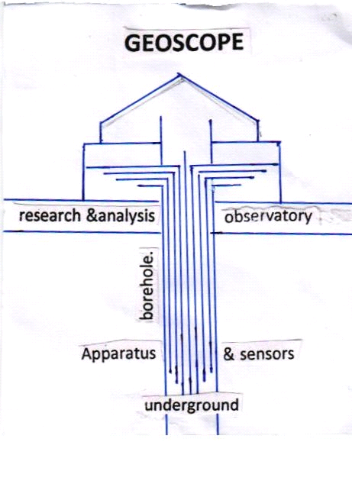

Simple geoscope method: This is a simple construction involving no expenditure. A deep well having suitable width and depth has to be dug in the area of the Amfilochia. Construct a room over the well. Wash the inner walls of the room with white Lime. Fix an ordinary electric bulb in the room.
Observe the colour of the room lighting daily. When the bulb glows, the light in room generally appears white in colour, but before occurrence of an earth-quake, the room lighting turns blue in colour. The onset of earth-quake can be guessed by this “Seismic luminescence Emission”
Principle: Due to stress of continental plates and some other reasons on a place where there are favourable chances for earth-quake to occur, the pressure is induced in the underground. As a result, there is a steady rise in the pressure around the focus centre. Because of the large disparity in the magnitude of energies involved, gas anomalies such as (a) Helium emission (b) Chemico-seismic anomalies such as sulphur, calcium, nitrogen etc., chemical compounds (c) Seismic atomic radiations of radioactive mineral compounds such as radon show up much earlier even at large distance from the epic-centre which enter the well through the underground springs. These gas anomalies occupy the room in this manner; emit radiation which gives ultrviolet blue colour (sometimes red) to the room.
Home-made geoscope method: This construction involves no expenditure. Even students, children’s and science enthusiasts can make the Home-Made Geoscope and detect the earth-quakes 24 to 28 hrs in advance. By making certain changes and alterations, the houses in the area of the Amfilochia having a well can be converted into a Geoscope i.e., wash the inner walls of the house with white Lime fIx ordinary electric bulbs in the room.
Observe the colour of the room lighting in the house daily. When the bulb glows, the light in room generally appears white in colour, but before occurrence of an earth-quake, the room lighting turns blue in colour. The onset of earth-quake can be guessed by this “Seismic luminescence Emission”
Principle: Due to stress of continental plates and some other reasons on a place where there are favourable chances for earth-quake to occur, the pressure is induced in the underground. As a result, there is a steady rise in the pressure around the focus centre. Because of the large disparity in the magnitude of energies involved, gas anomalies such as (a) Helium emission (b) Chemico-seismic anomalies such as sulphur, calcium, nitrogen etc., chemical compounds (c) Seismic atomic radiations of radioactive mineral compounds such as radon show up much earlier even at large distance from the epic-centre which enter the well through the underground springs. These gas anomalies occupy the room in this manner; emit radiation which gives ultrviolet blue colour (sometimes red) to the room.

Modern geoscope method: A borehole having suitable width and depth has to be dug into the underground in the area of the Amfilochia. A surface laboratory having the most modern high-tech underground research facilities has to be constructed on that bore-well to research and study the conditions and changes taking place in the underground. Electronic, physical and chemical sensors and apparatus, super high remote sensing technology in the area of sensor physics, signal processing used specially image processing ,electromagnetic detection technology, deep underground detectors and mineral exploration equipments, natural gas sensors, electromagnetic sensors etc to recognize the underground physical and chemical conditions such as the underground mineral resources, rise and fall of the underground water levels, micro-vibrations and waves generated in the underground, differences in pressure, temperature and other seismic activities in the underground etc should be inserted into the underground and linked with the concerned research and analyze departments of the above surface underground research laboratory that is above the bore-well to analyze the conditions and changes taking place in the underground. That means researches &developments of past, present and future should be interposed, coordinated and constantly developed. We can make many more modern ideas& modifications thus bringing many more improvements & developments in the Geoscope.
Management: Observe the geophysical & geochemical changes such as foreshocks, chemical changes, ground water levels, strain in rocks, thermal anomalies, seismic-luminescence gas anomalies, electrogeopulses, micro-vibrations, pressure, geomagnetic forces, etc taking place in the underground. The onset of earthquakes can be guessed by analyzing the aforesaid studies in the concerned analysis sections of the laboratory that is above the well.
Central data processing center:
In this system, there should be established Local Geoscope centers and Central Data Processing Centre in the area of the India. for managing the system in a coordinated manner.
One or more required number of Geoscopes should be established in the area of the Amfilochia. The observation personnel in the respective Geoscope centers should watch the onset of earthquakes day and night.
There should be established a Central Data Processing Centre to co-ordinate and codify the information supplied by the Local Geoscope Centres of the Amfilochia in a coordinated manner.
Whenever any Local Geoscope Centre sends warning about the onset of earthquakes, the observation personal should immediately send the information to its central data processing centre. The central data processing centre analyze the information supplied by the local geoscope centre and estimates the epicentre, time, area to be affected urban places etc., details of the impending earthquake and send to the authorities, and media and warnings in advance to take precautions.
Results and analysis:
Many investigations were carried out and successfully proved out in practice. The risk of earthquakes in Andhra Pradesh is less but the source is greater in north India and other regions in the world including the Amfilochia where the establishment of the Geoscope is very useful to study and predict the earthquakes. Among them, electrogeogram test is one that’s thought to be the heartbeat of the underground. Similarly, the study of the luminescent phenomena, electromagnetic emission and light radiation, thermo-luminescence and fracto-mechanoluminescence are others. Several researches and studies have been conducted as described above and obtained many key results.
Seismicluminiscence study: Gas anomalies emission: Over the centuries, there have been many reports of earthquake lights, both before and while the ground is shaking.
Most rock contain small amounts of gases that can be isotopically distinguished from the normal atmospheric gases. There are reports of spikes in the concentrations of such gases prior to a major earthquake; this has been attributed to release due to pre-seismic stress or fracturing of the rock. One of these gases is radon, produced by radioactive decay of the trace amounts of uranium present in most rock. Radon is useful as a potential earthquake predictor because it is radioactive and thus easily detected, and its short-half life makes radon levels sensitive to short-term fluctuations. The earthquakes with which these changes are supposedly linked were up to a thousand kilometers away, months later, and not at a magnitudes. In some cases the anomalies were observed at a distant site, but not at closer sites.
And, the lights are caused by electrical properties of certain rocks. The earthquake lights can take many different shapes, forms, and colors. Common forms of earthquake lights include bluish flames that appear to come out of the ground at ankle height; orbs of light called ball lightning that float in the air for tens of seconds or even minutes; and quick flashes of bright light that resemble regular lightning strikes, except they come out of the ground instead of the sky and can stretch up to 200 meters. When nature stresses certain rocks, electric charges are activated. The lights can occur hours to days before major earthquakes and also during actual shaking. They have been recorded at distance of up to 160 kilometers from the epicenter. Earthquake lights are likely to be very helpful with earthquake prediction. To study seismic luminescence Geoscope can be built in many forms just like Simple geoscope model, Home-made geoscope model and Modern geoscope model etc.
Construct the simple geoscope should be placed in the area of the Amfilochia described above to study the seismic luminescence as follows. This is a simple model involving no expenditure. A well having suitable width and depth has to be dug. Construct a room over the well. Wash the inner walls of the room with white Lime. Fix an ordinary electric bulb in the room.
Construct home-made geoscope should be placed in the area of the Amfilochia described above to study the seismic luminescence as follows. This is also very simple and easy model involves no expenditure. Even students, children’s and science enthusiasts can make the Home-Made Geoscope and detect the earth-quakes 24 to 28 hrs in advance. By making certain changes and alterations, a house having a well can be converted into a Geoscope i.e., wash the inner walls of that house with white Lime. Fix ordinary electric bulbs in the room.
The two Geoscope structures described above are easy to construct, easy to use and easy to analyze the Seismic luminescence study. Observe the colour of the room lighting daily. When the bulb glows, the light in room generally appears white in colour, but before occurrence of an earth-quake, the room lighting turns ultra violet blue in colour. The onset of earth-quake can be guessed by this “Seismic luminescence emission”
In modern methods to analyze the seismic luminescence, a deep bore-well having suitable width and depth has to be dug. A laboratory having most modern high-technological research and analysis facilities including a mechanical system to analyze the seismic luminescence and gas anomalies emerging from underground has to be constructed on that well. All types of modern sensors and apparatus including a mechanical system to catching/grabbing/absorbing the seismic luminescence or gas anomalies emerging from the underground to recognize the seismic luminescence and other seismic activities should be inserted into the underground and linked with the concerned research analyzing sections of the laboratory that is above the well to observe, study, research and analyze the seismic luminescence and seismic changes existing and taking place in the underground. By that earthquakes can be warned by analyzing the luminescence as given the above.
Observe the fracto luminescence gas anomalies existing and taking place in the underground. The onset of earthquakes can be guessed by analyzing the aforesaid seismic luminescence studies in the concerned analysis sections of the laboratory that is above the well.
Due to stress of continental plates and some other reasons on a place where there are favourable chances for earth-quake to occur, the pressure is induced in the underground. As a result, there is a steady rise in the pressure around the focus centre. Because of the large disparity in the magnitude of energies involved, gas anomalies such as shown below show up much earlier even at large distance from the epic-centre which enter the well through the underground springs.
(a) Emission of Helium, Hydrogen etc
(b)Emission of chemico-seismic evaporation anomalies such as sulphur, calcium, nitrogen etc., ,
(c)Emission of seismic atomic radiations such as radon from radioactive mineral compounds etc
These gas anomalies occupy the room in this manner; emit radiation which gives blue colour (sometimes red) to the room.
Collect and analyze the above mentioned gas anomalies and seismic luminescence in the concerned section established in laboratory that is above the well. Study the gas anomalies and seismic luminescence in the research and analysis sections of the Geoscope daily 24 hours 365 days. When the gas anomalies or seismic luminescence are released the earthquakes can be considered.
Here is a very important is to be grasped. Before occurring of an earthquake, gas anomalies as stated above such as radon, helium, hydrogen and chemico-mineral evaporations such as sulphur, calcium, nitrogen and other fracto-luminescence radiations show up earlier even at large distances from the epicentre due to stress, disturbances, shock waves and fluctuations in the underground forces. These gas anomalies & fracto luminescence radiations and other chemical evaporations enter into the well through the underground springs. When these anomalies occupy the simple Geoscope rooms or Home-made Geoscope rooms above the well, the room lighting turns violet in colour. The light in the room scattered in the presence of these gas anomalies, fracto-luminescence radiations and other chemico-mineral evaporations the ultra violet radiation is emitted more and the room lighting turns in violet colour. Our eye catches these variations in the radiation of the lighting in the room easily since-
The violet rays having smaller wave length
The violet rays having property of extending greatly
The light becoming weak in the violet region
The eyes having greater sensitivity to violet radiation
Due to all these reasons, the room may appear violet in colour then we can predict the impending earth quakes 12 hours in advance. This principle is also applies to the section built in modern research and analysis methods that is above the well

Electrogeogram Test:. This is also easy study to recognize the impending earth quake. A borehole having suitable width and depth has to be dug in the area of the Amfilochia.
An earth wire or rod should be inserted into the underground by the borehole and linked with the concerned analysis section having apparatus to detect, compare measure of the electric currents of the electric circuit of the earth systems. Otherwise by observing the home electric fans.etc. We can also study the electrogeopulses studies to predict the impending earth quake.
Observe the changes in the electric currents of the earth system 24 hours, 365 days. From a power station, the electricity is distributed to the far-off places. Normally the circuit of the power supply being completed through the earth system. Whenever if the disturbances occurs in the layers of the earth’s underground, the fluctuation rate will be more due to the earth quake obstructions such as pressure, faults, vibrations, water currents etc., of the earth’s underground. So we can forecast the impending earth quake by observing the obstruction of electric currents of circuit of the earth system in the observatory of the Geoscope and also by the obstruction sounds in the electric fans etc.
Study and discussion:
Many studies and experiments have been carried out on the Geoscope project and all were successfully proved out in practice. And also several designs have been proposed to study and explore the underground. The risk of earthquakes in Andhra Pradesh is less but the source is greater in North India and other regions in the world including the Amfilochia where the establishment of the Geoscope is very useful.
Applications:
Geoscope is to detect natural calamities such as earthquakes etc. as well as underground resources. Along with these, I have also made some proposals just like artificial rains to another new earth in the space based on the Geoscope. Their details are given below.
By setting up the National Geoscope Project in the area of the Amfilochia and maintain, that country can be predicted the impending earthquakes, volcanic hazards(and storm surges ,tsunamis etc consequence secondary hazards due to the earthquakes occur in the womb that means underground of the sea or ocean if the country have the chances of occurring of these disasters) in advance. And also the country can be predicted mineral and underground resources by inserting many kinds of super high remote sensing technology in the area of sensor physics, signal processing used specially image processing , electromagnetic detection technology and geophysical deep underground detectors and mineral exploration equipments, natural gas sensors etc in the underground through the Geoscope. Setting up the National Geoscope Project and maintain will also be useful in emerging industries such as geothermal and geo-sequestration etc.
Geoscopes should be designed in the possible coastal areas where tsunamis are likely to occur. A tsunami or tidal wave, also known as a seismic sea wave, is a series of enormous waves in displacement of a large volume of water body caused by the earthquakes, underground landsides, volcanic eruptions, asteroids generally in an ocean or a large lake. Tsunamis can travel 20-30 miles per hour with waves 10-100 feet high. The effects of tsunamis are devastating. Tsunami damage is first caused by the immense force of the tidal wave hitting the shoreline. I conducted some studies on the tsunamis. Some studies have been conducted by me on the tsunamis to study and predict the tsunamis and designed the Geoscope in 1987 to keeping the tsunamis. Geoscope should be designed in the coastal areas of the sea and earthquakes and its consequent secondary hazards such as tidal forces, rogue waves, tsunami can be predicted by virtue of performing studies as described above. Geoscope is very useful in studying,, predicting and mitigating the tsunamis and it’s dangers.
Geoscopes should be designed in the possible areas where landslides are likely to occur and the earthquakes and it secondary consequent hazards such as landslides mud slides, mass movements, sink holes, coastal erosion, lahars, mud flows, etc can be estimated by virtue of performing studies as described above.
Geoscopes should be designed in the volcano areas and volcanic activities such as volcanic gases, and steam generated eruptions, explosive eruption of high – silica lava, effusive eruption of low-silica lava, debris flow and carbon dioxide emission etc can be predicted by virtue of performing studies as described above. Let’s discuss about some of the key studies.
By setting up the National Geoscope projects and maintain, a country can be predicted the impending earthquakes, volcanic hazards(and storm surges ,tsunamis etc consequence secondary hazards due to the earthquakes occur in the womb that means underground of the sea or ocean if the country have the chances of occurring of these disasters) in advance
And a country can be predicted mineral and underground resources by inserting many kinds of super high remote sensing technology in the area of sensor physics, signal processing used specially image processing electromagnetic detection technology and geophysical deep underground detectors and mineral exploration equipments , natural gas sensors etc in the underground by using the Geoscope.
Setting up the National Geoscope Project and maintain will also be useful in emerging industries such as geothermal and geo-sequestration etc.
Geoscope projects can be built where the earthquakes are likely to occur and study the earthquakes.
Build Geoscope in the seismic areas and earthquakes can be predicted by virtue of performing studies as described above.
I started Geoscope with a lot of goals and ideas. Some of them were cited below. I have done some researches thoroughly and have done some more unfinished research. However, due lack of research opportunities, some of them were only preliminary studies. The world scientists are completing the remaining research work intended in the Geoscope.
Artificial rains: Artificial rains research proposal is proposed and designed by me and prepared a scientific methodology with some clues and ideas to create artificial rains and also keep them under our control and pour rains in the required desert and rain-prone areas and tried to conduct researches I have prepared the necessary basic research notes for this but uncompleted due to lack of support and opportunities.and tried to conduct researches. I have prepared the necessary basic research notes for this but uncompleted due to lack of support and opportunities. I call on world scientists to conduct researches on this subject. .
Artificial storms: Artificial storms has proposed and designed by me with a scientific methodology with some clues and ideas through this it is possible to pour rains in required deserts and rain prone areas to save people from droughts and famines and tried to conduct researches. I have prepared the necessary basic research notes for this but uncompleted due to lack of support and opportunities. I call on world scientists to conduct researches on this subject.
Artificial underground waters: Artificial undergtound waters has proposed and designed by me with a scientific methodology with some clues and ideas through this it is possible to increase underground waters in required rain prone areas to save people from droughts and famines and tried to conduct researches I have prepared the necessary basic research notes for this but uncompleted due to lack of support and opportunities.and tried to conduct researches. I have prepared the necessary basic research notes for this but uncompleted due to lack of support and opportunities. I call on world scientists to conduct researches on this subject.
Inventing life: Inventing life is proposed and designed by me to invent life with a scientific methodology through some clues and ideas through this it is possible to revive living beings and tried to conduct researches I have prepared the necessary basic research notes for this but uncompleted due to lack of support and opportunities.and tried to conduct researches. I have prepared the necessary basic research notes for this but uncompleted due to lack of support and opportunities. I call on world scientists to conduct researches on this subject.
Superhuman: Superhuman has proposed and designed by me with a scientific methodology with some clues and ideas. We can create super humans by ….he has super strength, super speed, super agility, super reflexes, super dexterity, super levitation, super flight, super invulnerability, super stamina, super jumping, super healing factor, super longevity, super immortality, super senses, super hearing, super olfaction, super telescopic vision, super x-ray vision, super microscopic vision, super eidetic memory or photographic memory, super genius level intellect, super solar energy absorption, super heat vision, super breath, super freeze breath, super dexterity, super invisibility and intangibility by vibrate his molecules, super outer space travel and super inner atomic space travel. He could fly so fast he could travel through time, his strength was enough to move the planet, his invulnerability became pretty much absolute, and he was given a raft of sensory powers-heat vision and even super ventriloquism. I tried to conduct researches I have prepared the necessary basic research notes for this but uncompleted due to lack of support and opportunities.and tried to conduct researches. I have prepared the necessary basic research notes for this but uncompleted due to lack of support and opportunities. I call on world scientists to conduct researches on this subject.
Re-creation of humans of past: Re-creation of humans of past has proposed and designed by me with a scientific methodology with some clues and ideas to re-create humans of past and tried to conduct researches I have prepared the necessary basic research notes for this but uncompleted due to lack of support and opportunities.and tried to conduct researches. I have prepared the necessary basic research notes for this but uncompleted due to lack of support and opportunities. I call on world scientists to conduct researches on this subject.
Bio-machine: Bio-Machine Research Project Proposal is proposed and designed by me with a scientific methodology with some clues and ideas to binvent it to create humans of past and tried to conduct researches I have prepared the necessary basic research notes for this but uncompleted due to lack of support and opportunities.and tried to conduct researches. I have prepared the necessary basic research notes for this but uncompleted due to lack of support and opportunities. I call on world scientists to conduct researches on this subject.
Time-machine: Time-machine has proposed and designed by me with a scientific methodology with some clues and ideas through this it is possible to travel into past and tried to conduct researches I have prepared the necessary basic research notes for this but uncompleted due to lack of support and opportunities.and tried to conduct researches. I have prepared the necessary basic research notes for this but uncompleted due to lack of support and opportunities. I call on world scientists to conduct researches on this subject.
Geo-machine: Geo-machine has proposed and designed by me with a scientific methodology with some clues and ideas through this it is possible to re-create humans of past whose images embedded in the earth's magnetic layers and tried to conduct researches I have prepared the necessary basic research notes for this but uncompleted due to lack of support and opportunities.and tried to conduct researches. I have prepared the necessary basic research notes for this but uncompleted due to lack of support and opportunities. I call on world scientists to conduct researches on this subject.
New Earth project: New Earth Research Project Proposal was proposed and designed by me with methodology with some clues and ideas through this it is possible to re-create a similar earth of past of Earth in the space which is embedded in the gravitational layers binvent it and go back into past time and tried to conduct researches I have prepared the necessary basic research notes for this but uncompleted due to lack of support and opportunities.and tried to conduct researches. I have prepared the necessary basic research notes for this but uncompleted due to lack of support and opportunities. I call on world scientists to conduct researches on this subject.
Microcosm project: Microcosm Research Project Proposal was proposed and designed by me with a scientific methodology with some clues and ideas through this means connecting inner-worlds of atom directly in microscopic ways or entering into the through microscopic forms (Here is a important point is to be grasped that one second of us equal to an era in the atomic world.) and tried to conduct researches I have prepared the necessary basic research notes for this but uncompleted due to lack of support and opportunities.and tried to conduct researches. I have prepared the necessary basic research notes for this but uncompleted due to lack of support and opportunities. I call on world scientists to conduct researches on this subject.
Macrocosm: Macrocosm Project Proposal was proposed and designed by me with methodology with some clues and ideas that means connecting outer-geo-worlds directly in microscopic ways or entering into the outer-geo-worlds in macroscopic forms (Here is a very important is to be grasped that our one era is equal to a second in that outer-geo-worlds) and tried to conduct researches I have prepared the necessary basic research notes for this but uncompleted due to lack of support and opportunities.and tried to conduct researches. I have prepared the necessary basic research notes for this but uncompleted due to lack of support and opportunities. I call on world scientists to conduct researches on this subject.
Conclusion:
we can make many more researches and studies on the Amfilochia Geoscope thus bringing many more developments and modifications in that Amfilochia Geoscope. Recognize me as the father of Geoscope who has worked hard to create an mechanical architecture, establishing in between the underground and observatory with the help of a bore-well to study the the underground mysteries, explore the underground resources and predict the geological hazards by constantly studying the underground through the Geoscope systems.
Author bio: I'm an unfortunate Indian scientist, born on May 25, 1958 in India to a poor depressed community family. The governments did not encourage and provide research opportunities and the society threw away me. They ridiculed and humiliated me when I asked to provide research opportunities. After many rejections and humiliations, I built a small lab in my house and made more than 1000 researches, studies and postulates on the earth and space science from my childhood 1965 to old age 2022. Among them, Bio-forecast(1965-70), Irlapatism-A New Hypothetical Model of Cosmology(1970-77), Inquest and imprisonment(1977-79), Geoscope(1980-87), Basics of Monsoon Time Scales(1987-91), Indian Monsoon Time Scale(1991), Disaster management prevention and mitigation policies(2000-10), Global Monsoon Time Scales(2010-2022) etc. were important and successfully completed. However, Artificial rains for creating normal rains, Artificial storms for pouring heavy rains, Artificial underground waters for increasing ground waters, Time-Travel-Machine for traveling into the past, present future, Geo-machine for re-creating humans of past, Earth-machine for re-creating the another earth in the space, Inventing the life, Microcosm project for connecting and entering the worlds of micro organs, atomic-worlds, Macrocosm project for connecting and entering the worlds of space and outer space worlds and postulates like "photon is a gigantic universe as same as our universe and atom in which there are galaxies, stars, planets similar as in our universe and/or electrons, protons, neutrons similar as in atom; atom is a gigantic universe as same as our universe in which there are galaxies, stars, planets in the form of electrons, protons and neutrons and there are continents, oceans, countries, living beings on some neutrons similar as on the earth; the universe seen around our earth is a tiny atom in another ascending world etc. remains uncompleted due to lack of support and opportunities.
Mainly during 1980 to 87, many researches &studies have been conducted by me to invent a device that should be used to study and solve the mysteries of the earth’s underground. As a result of those researches and studies, I proposed an architecture in the name of Geoscope in 1987 with many revolutionary proposals. This is not what Buckminster had proposed in 1962. In 1986, Geoscope was presented to Sri A.J.V.B.M. Rao, Hon’ble Member of Parliament(Lok.Sabha.), Amalapuram for consideration and necessary action. Sri A.J.V.B.M. Rao sent this Geoscope proposal to Sri K.R. Narayanan, the Hon’ble Minister of State for Science and Technology, New Delhi (later President of India) in 1987 for further research and development in the services of people. In 1988, Sri K.R.Narayanan, Hon’ble Minister of State for Science and Technology was issued orders to the Council of Scientific and Industrial Research, New Delhi in the capacity of Vice-President, Council of Scientific and Industrial Research to take further research and develop the Geoscope. In 1989, The Hon’ble High Court of Andhra Pradesh was also issued orders to the Government of India, Ministry of Science & Technology, Council of Scientific and Industrial Research to provide research facilities to carry out researches &studies on the Geoscope at National Geophysical Research Institute, Hyderabad for implementation in service of the country. Later many representations were also submitted to the government and research organizations to provide research facilities to carry out further researches on the Geoscope but the governments and research organizations did not support and provide research opportunities to me. I was envied by research institutes, scientists and subjected to incessant verbal insults. I sacrificed my life for the past 46 years in developing the Geoscope to serve the people. But I am an unfortunate scientist who could not get recognition as the inventor of Geoscope. I am now making my life’s last journey due to pains and poverty & disregard and despair. Under the aforesaid circumstance I am making this appeal to the world scientists to recognize me as the inventor of Geoscope & its related Geoscope architectures.
However, much efforts and sacrifice did tho, I could not get government recognition and social support. My researches were ignored and darkened. I am a victim of racism and discrimination, negligence and jealousy. Throughout my life I have experienced hardships all my life. I was abused, humiliated and beaten when I asked to provide research opportunities. I was pushed out of the gate, when I asked to provide research opportunities. I was insulted by my caste/race. I was tied to a pole and beaten.My thoughts and researches were subjected to the wrath of racists, casteists and fanatics as well as fellow scientists and resulted into oppression on me. My lab was invaded laboratory. Illegal cases were framed and foisted against me. I faced trials, handcuffed and led through streets police enquiries and court trials/hearings, and imprisoned. Political recommendations and officials support, cash and caste, region and religion may play a key role in giving support and opportunities, awards and rewards, respect and recognition to depressed communities. But I have no of them. I am now making my life's last journey due to disregard and despair and serious illness and severe poverty that's no food to eat, no fabrics to put on and no money to take treatment.
Appeal:
However, much efforts and sacrifice did tho, I could not get government recognition and social support. My researches were ignored and darkened. I am a victim of racism and discrimination, negligence and jealousy. Throughout my life, I have experienced hardships all my life. I was abused, humiliated and beaten when I asked to provide research opportunities. I was pushed out of the gate, when I asked to provide research opportunities. I was insulted by my race. I was tied to a pole and beaten.My thoughts and researches were subjected to the wrath of racists, casteists and fanatics as well as fellow scientists and resulted into oppression on me. My lab was invaded. Illegal cases were framed and foisted against me. I faced trials, handcuffed and led through streets police enquiries and court trials/hearings, and imprisoned. Political recommendations and officials support, cash and caste, region and religion may play a key role in giving support and opportunities, awards and rewards, respect and recognition to depressed communities. But I have no of them. I am now making my life's last journey due to disregard, despair and serious illness, severe poverty that's no food to eat, no fabrics to put on and no money to take treatment.
Kindly find out my researches in all social networking websites or can obtain by sending your email to me. These findings are very helpful for research institutions, universities researches. And also these findings can be very helpful for Ph.D students, Postdocs, professors, seniors, scientists and science enthusiasts who want to innovate. I will send them the valuable information I have.
For example, those who want to design Monsoon Time Scales for their regional or country' Monsoons and conduct weather predictions have trouble in making the Monsoon Time Scales, kindly contact me at my email id gangadhar19582058@gmail.com and take my suggestions and assistance. I will send you complete details of the Monsoon time scalesi. Further if you want, I will create a manual Monsoon Time Scale and send the same to you for study and research. However for this, data of list of monsoon pulses in the form of monsoonal low pressure systems, depressions and storms formed over their monsoon region or country last 100 and above years since 1880 as cited in the Reference-1 (i.e Mooley DA,Shukla J(1987);Characteristics of the west ward-moving summer monsoon low pressure systems over the Indian region and their relationship with the monsoon rainfall. centre for ocean-land atmospheric interactions, university of Maryland, college park, MD.,). I will make and send it to you. If you have kind heart send an amount as you like in the form of bank cheque or to my Google/Phone pay A/C No. +91 630 557 1833 because I have no food to eat, no fabrics to put on and no money to buy medicines. So, researchers send Monsoon data of their region or country, I will make and send Monsoon Time Scales for their region or country. These monsoon time scales are very helpful for research institutions, universities researches and also these can be very helpful for Ph.D students, Postdocs, professors, seniors, scientists and science enthusiasts who want to conducting researches and studies on climate changes there. Because, through these Monsoon Time Scales iit is known in advance that what kind of climate changes have occurred in your country in the past 100 years and what kind of climate changes are going to happen in the coming 100 years.
I am now making my life's last journey in serious illness and poverty with no food to eat, no fabrics to put on and no money to take treatment for cardiovascular asthma. Illness weakening the health and mind slows down and forgetfulness is coming. It is not known how long I will live and when I will die, but I know my time is near. Hence, I humbly request that if world scientists have invented any technology in future that re-create humans of past, kindly remember and re-create me to complete my uncompleted researches as attendant in your research laboratory.
GANGADHARA RAO IRLAPATI

Corresponding Author:
Gangadhara Rao I rlapati
H.No.5-30-4/1,
Saibabanagar, Jeedimetla
Hyderabad, Telangana-500055, India
Google/Phone pay A/C No. +91 630 557 1833
Kotak Bank A/C No. 8447 502 446
IFSC Code No. KKBK 000 7453
E-mail: gangadhar19582058@gmail.com

References:
- 1.Cover page of the book Irlapatism,-Irlapati Theory of Universe was published on 1st july,1977 by the supporters.
- 2.Report to the Revenue Divisional Officer. Amalapuram on 6-7-1977 about persecutions and torments of the fanatic people.
- 3.Orders of the Taluk Magistrate, kothapeta A-2-5873/77 Dt. 21-07-77 Taluk Office, Kothapeta declared him as a dangerous boy and up to anything and issued sentence to punish him and handed over to the police station, Ravulapalem.
- 4.Arrested by the police on July 21, 1977. A case was registered C.No.53/77 and he was remanded.
- 5.The Judgment of the Hon’ble Additional Judicial First Class Magistrate Court, Kothapeta C.C.No. 13/79 in which he was found not guilty and acquitted on November 27,1979.
- 6.Calendar and Judgment C.C.No. 13/79 of the Court of the Judicial Magistrate of the 1 Class,Kothapeta.
- 7.Aithabathula Jogeswara Venkata Buchi Maheswara Rao, Member of Parliament (Loksabha), Amalapuram letter dt:08/12/1987. In 1987, Sri A.J.V.B.M. Rao Honble Member of Parliament was recommended the Geoscope proposals to Sri K.R.Narayanan, Union Minister of Science& Technology, New Delhi. (became the then President of India) for further research and development in the services country.
- 8.In 1988, Sri K.R.Narayanan was recommended the Geoscope project proposals to the Council of Scientific & Industrial Research in the capacity of Vice-President, Council of Scientific & Industrial Research for further research and implementation.
- 9.In 1989, As per the directions of the Council of Scientific & Industrial Research, a detailed report on the Geoscope project was submitted to the National Geophysical Research Institute for further research and implementation.
- 10.In 1989, The Honble High-Court of Andhra Pradesh was also issued orders to the Government of India, Council of Scientific & Industrial Research, New Delhi, National Geophysical Research Institute, Hyderabad for provision of research facilities to carry out scientific investigations on the Geoscope Project Proposals. When I met the N.G.R.I, they are insulted, refused to provide research facilities and pushed out to the gate.
- 11.G.S.Rao, MLA letter dt:1988.
- 12.N.T. Rama Rao, Chief Minister of Andhra Pradesh, letter dt:30/01/1989.
- 13.Order, Hon’ble High Court of Andhra Prades W.P. No.12355/1989, dt:06/09/1989.
- 14.Supreme Court Legal Services Committee dt:02/01/2006.
- 15.India Metrological Department, letter No.S-01416/ prediction dt:11/12/200
- 16. Letter No. NA-153 Date. October 21,1991 of the Shri G.M.C. Balayogi Member of Parliament to the India Meteorological Department for further research and development of the Global Monsoon Time Scales/ Indian Monsoon Time Scale in the services of welfare of the people
- 17. D.O. No. NMRF/SKM/30/94 Dated; 17-08-1994 of the Government of India , Minitry of Science & Technology, Department of Science & Technology, New Delhi Cabinet Secretary correspondences about further research and development of the Global Monsoon Time Scales/ Indian Monsoon Time Scale in the services of welfare of the people.
- 18. Letter No. NA-153 Dated; 28-11-1996 of the Government of India , India Meteorological Department about the correspondence with the Parliament, President of India and other VVIP’s of India pertaining to further research and development of the Global Monsoon Time Scales/ Indian Monsoon Time Scale in the services of welfare of the people.
- 19Letter No. NA-49106/537 Dated; 25-07-2005 of the Government of India , India Meteorological Department about the correspondence about further research and development of the Global Monsoon Time Scales/ Indian Monsoon Time Scale in the services of welfare of the people.
- 20. Letter D.O.No. 209/MOS(M)/PS/2008 Date. October 21,1991 of the Shri Dr.T.Subbarami Reddy Hon’ble Union Minister of State for India to the India Meteorological Department for further research and development of the Global Monsoon Time Scales/ Indian Monsoon Time Scale in the services of welfare of the people
- 21. Letter No. GT-021(MISC)/6675 Dt: 13-08-2008 NA-49106/537 of the Government of India , India Meteorological Department about the correspondence for further research and development.
- 22. Letter No.DST/SECY/288/2009 Dated;June 1,2009 of the Secretary, Minister of Science and Technology recommendation to the Indian Institute of Tropical Meteorology for further research and development of the Global Monsoon Time Scales/ Indian Monsoon Time Scale.
- 23.Letter No. F-12016/1/00-NA/100 Dt: 01-12-2009 of the Government of India , India Meteorological Department about the correspondence for further research and development of the Global Monsoon Time Scales/ Indian Monsoon Time Scale.
- 24.Letter No. F-12016/1/00-NA/100 Dt: 09-07-2010 of the Government of India , India Meteorological Department about the correspondence for further research and development of the Global Monsoon Time Scales/ Indian Monsoon Time Scale.

BIOBIBLIOGRAPHY
The major events in my life and references of some important research publications are also listed below along with supported documents in a chronological order. The only important ones are given below. Many more publications and services that are done but not listed in the references below.

1 | 25th May, 1958 | Born in a group of lowest social caste system( ranked as Mala in scheduled caste) traditionally to be untouchable in India.
 | May25,1958 | I, Gangadhara rao irlapati, an unfortunate Indian scientist born on 25th May,1958 in a group of lowest social caste system( ranked as Mala in scheduled caste) traditionally to be untouchable in India. Parents: Pullaiah Irlapati(father),Manikyam Irlapati(mother); Brothers&Sisters:Sampath Rao Irlapati(brother),Saroja Irlapati(sister),Bhagyam Irlapati(sister), Gangadhara Rao Irlapati(self), Kalavathi Irlapati(sister), Balaji Irlapati(brother); Spouse: Satyavathi Irlapati; Children: Pullaiah Naidu Irlapati(son), Prudhvi Irlapati(son), Saroja(daughter); My wife and childrens are argumentative, negative and ill-tempered who vehemently opposed my researches and they were mentally torturing me.
 | Education | I acquired scientific interest and conscious inherently by birth. I did primary education from 1 to 5 th classes in Government Elementary High School, Merlapalem(1963-1968); 6th & 7th classes in Government Upper Primary School, Vubalanka(1969-1971); 8TH to 10TH classes at Government High School, Ravulapalem (1971-74); Intermediate 11+12 classes at M.G.Jr. College, Atreyapuram(1974-76). I studied graduation B.A. degree in Andhra University(1985-89) and obtained post-graduation M.Sc degree in disaster mitigation sciences from Sikkim Manipal University(2001-03).
 | Researches | With an ideal to serve the people from weather problems and natural calamities through scientific researches, I went around governments and organizations for research support and opportunities. But the Governments and councils did not encourage and provide opportunities; officials & researchers ridiculed me and pushed out. My thoughts angered the fundamentalists and superstitious. Despite being oppressed and not getting research opportunities, I built a small lab at my house with availabl resources and mathematical instruments, drawings, designs, home-made apparatus, scrap reference books and did many researches and studies on anticipating weather changes and natural calamities that can be performed either in easy methods or at complicating infrastructure; either with big amount or at no cost; either by common researchers or by great researchers from 1965 to present. But the governments did not encourage and provide research opportunities and the society threw away me. They ridiculed and humiliated me when I asked to provide research opportunities. After many rejections and humiliations, I built a small lab in my house and made more than 1000 researches, studies and postulates on the earth and space science from my childhood 1965 to old age 2022. Among them, Bioforecast(1965-70), Irlapatism-A New Hypothetical Model of Cosmology (1970-77), Inquisition(1977-79), Basics of Geoscope (1980-87), Basics of Monsoon Time Scales (1987-91), Indian Monsoon Time Scale(1991), Researches on Earth and space related issues(1991-2000), Numerical Weather Periodic Tables2000-10), Designs of Geoscope projects (2010-20), Designs of Global Monsoon Time Scales (2020-) etc. were important and successfully completed. However, Artificial rains for creating normal rains, Artificial storms for pouring heavy rains, Artificial underground waters for increasing ground waters, Time-Travel-Machine for traveling into the past, present future, Geo-machine for re-creating humans of past, Earth-machine for re-creating the another earth in the space, Inventing the life, Microcosm project for connecting and entering the worlds of micro organs, atomic-worlds, Macrocosm project for connecting and entering the worlds of space and outer space worlds and postulates like "photon is a gigantic universe as same as our universe and atom in which there are galaxies, stars, planets similar as in our universe and/or electrons, protons, neutrons similar as in atom; atom is a gigantic universe as same as our universe in which there are galaxies, stars, planets in the form of electrons, protons and neutrons and there are continents, oceans, countries, living beings on some neutrons similar as on the earth; the universe seen around our earth is a tiny atom in another ascending world etc. remains uncompleted due to lack of support and opportunitieopportunities. In addition, I tried to find out some inventions on the basis of some super research ideas/proposals but could not do further researches on those research ideas due to lack of opportunities. Besides these, I have done also various other services and play active role in many fields science popularization programmes, modern scientific ideas of hierarachical, infinite and innumerable universes, mysteries and rational thoughts of the creation and cosmo and general taking an active part in issues such as literacy programmes, remedial programmes, rationalize programmes, etc that concerned greater good of the community associated with many organizations like Peoples Action For Rural Awakening, Ravulapalem. Apart from these,
2 | 1965-70 | Started little experiments at the age of 7th year, with home-made apparatus, mathematical box and pencils etc and invented the Lisposcope(1965) Discovered some bubble like objects later named as Biolumucells (Boiluminiscent micells(1966)). I found the relationship between the weather changes and the number of micells later it was named as Bio-forecast effect(1969).
 | Bioforecast | From 1965 to 1970, I started doing researches and studies around 10th year of my childhood. Organisms such as animals, fish, birds, reptiles, and insects etc have a biological genetic forecasting system that predics weather changes and disasters in advance. Many researches and studies did on this biological genetic forecasting system between 1965 to 1970, and invented Lisposcope in 1965, Biolumicells (Bioluminescent micells) in 1966, and Bioforecast effect in 1969. These are my first inventions which can help to forecast the weather changes 18 days in advance. I tried to break the mystery of how organisms can detect weather changes and disasters in advance.  This system was efficiently conducted and proved in the presence many researchers and institutions. Although weakened by forecasting property with less successive rate, it is a primary and natural biological genetic forecasting method.The important prediction of the Bio-forecast was proved in 1991. In 1991, the Andhra Pradesh State Council of Science & Technology, The Andhra Pradesh Remote Sensing Applications Centre and the Andhra Pradesh Science Centre were conducted experiments on the relationship between the biosphere and atmosphere (explore the inter-connection of earths geomagnetic field with natural calamities and their effect on human impulse). In these observations, the maximum level of the Biolumicells were recorded between 7th to 11th of April, 1991. It is the sign of the ensuring cyclone of the 28th April 1991. The three directors of the said institutions were met in the Andhra Pradesh State Council of Sciences & Technology on 9TH, April 1991 and discussed about the prediction. As predicted on 9th April 1991, in the meeting a severe cyclone was formed in Bay of Bengal and strike the Bangladesh on 28th April 1991. As a result, thousands of people were killed and crores of rupees property was damaged. This is the Great prediction by the Bio-forecast and the remaining predictions were weak. Global researchers can do more research and develop on this natural biological genetic forecasting method and use it for the welfare of global humanity.
3 | 1970-77 | Built a small lab with home-made apparatus, small telescope, mathematical instruments, collected a number of books relating to the cosmology along with sacred books and did immense chapters on the origin, structure. nature and evolution of the creation. Discussed the same with professors&lecturers and taken their views. Finally, I proposed a hypothesis with several postulations and proposals. In 1977 on 1st july, A book was published in the name of Irlapatism-Irlapati Theory of Universe.The proposals in the book were instantly repulsed by the superstitious. As a result I was subjected to the anger of fanatic people and officials. My lab was destroyed and copies of the books of my theory were burned.
 | Irlapatism | Between 1970-77 years I have done extensive researches and studies on the origin, nature, structure and evolution of the creation and proposed basics of creation. Based on those basics, A New Hypothetical Model of Cosmology was proposed in 1977. A book was also published and released on 1st july,1977 in the name of Irlapatism-Irlapati Theory of Universe by the supporters. All matters pertaining to the cration such as Origin, Structure, Nature and Evolution were widely discussed in this hypothesis. According to this Hypothesis Irlapatism the creation is made up of universes in infinite number that are having similar structure and properties, embedded one in each other and extended in ascending and descending order in the form of a super fluid substance amalgamation. To explain and justify this model, there are three universes so far known to us (a) Geo-Universe (b) Atomic-Universe (c) Photon-Universe. These three are having similar structure and properties, embedded one in each other and extended in ascending and descending order.
 | Inquisition | These Basics of creation particularly my views on underground can be controlled by a system named National Geoscope System, artificial rains can be poured, artificial storms can be created, artificial underground waters can be increased, time-machine, space-machine, geo-machine, images of living beings living on earth are preserved in the earths magnetic field and they can be created by a machine named geo-machine and most important of all the atom has a gigantic internal structure similar to our universe and there are worlds, continents, seas, countries, humans on the neutrons and our gigantic universe seen around oetc restore and recreate people in past by images that are preserved in the earths magnetic field by new technologies just like Geo-Machine; establishment of human habitations on inter-planets; to have relationship with living beings on the Neutrons; to have relationship with living beings on the planets in the outside worlds of our Geo-universe etc were instantly traduced, exposed to the anger of fanatic people and got into violent altercations. As a result, I was subjected to the anger of fanatic people and officials. My lab was destroyed and the copies of books of the hypothesis were burned. I reported these persecutions and torments to the Revenue Divisional Officer. Amalapuram in july,1977. The Revenue Divisional Officer was conducted an enquiry about this matter. While returning from an enquiry, on forenoon, July 21st, 1977, I was attacked by a mob and they had taken me forcely to the Village Chavadi, Ryali, there superstitious people were met and where I was beat up. Followed by an altercation about the basics and ideas of the book, they beaten and forced me to put signatures on some prepared documents, and an offence falsely framed and foisted against me. After intense tortures, I was sent to the Taluk Magistrate, Kothapeta and persuaded to renounce my views and ideas. The superstitious people succeeded me in sentencing. The Taluk Magistrate was declared me as A dangerous boy and up to anything and issued sentence to punish and handed over to the Police Station, Ravulapalem. I was arrested on July 21, 1977. A case was registered and I was kept remand for some months in sub-jail and remaining period interrogated periodically. I had been driving with chains through the streets of Kothapeta from Sub-jail to Court during the timings of presenting to court. The trials were done from April 2, 1979 to November 20,1979. After many trials and arguments, the Honble Additional Judicial First Class Magistrate Court was found me not guilty and acquitted on November 27,1979.
4 | Petition Dated:6th july,1977 | I submitted a petition to the Revenue Divisional Officer. Amalapuram about these torments after publication of my theory of creation.
5 | July,1977 | While returning from the enquiry, I was attacked by a mob and they had taken me forcely to the Village Chavadi, Ryali, there superstitious people were met and where I was beat up. Followed by an altercation about the ideas of my hypothesis, they beaten and forced me to put sign on some prepared documents, and an offence falsely framed and foisted against me.
6 | Taluk Magistrate Report,  Report No.A-2-5873/77.Dt.July 21st A.N 1977 | After tortures, I was sent to the Taluk Magistrate, Kothapeta.. The superstitious succeeded me in sentencing. The Taluk Magistrate was declared me as A Dangerous Boy and Upto Anything and issued sentence to punish me and handed over to the police station.. .
7 | 53/77  July,22^{nd,} F.N 1977. | A case was registered against me. I was kept remanded in sub-jail. I had been driving with chains through the streets of Kothapeta from Sub-Jail to Court during the timings of presenting to court.
8 | Additional Judicial  First Class Magistrate Court  Judgment&judgment. C.C.No.13/79, | The trials were done from April 2, 1979 to November 20,1979.
9 | Additional Judicial  First Class Magistrate Court  Judgment.No.13/79,  Dt.27th November,1979  Page No.1 | Judgment
10 | Additional Judicial  First Class Magistrate Court  Judgment.No.13/79,  Dt.27th November,1979  Page No.2, para-5,lines 5-9, | The thing that came up in the inquest was that the superstitious and fanatic people grew wild on the logic of the Creation&God issue in my hypothesis of creation I published and distributed.
11 | Additional Judicial  First Class Magistrate Court  Judgment.No.13/79,  Dt.27th November,1979  Page No.3, para-5,lines 10-12 | The thing that came up in the inquest was that an enquiry was conducted by the Revenue Divisional Officer
12 | Additional Judicial  First Class Magistrate Court  Judgment.No.13/79,  Dt.27th November,1979  Page No.3, para-5, line-13 | The thing that came up in the inquest was that a case was falsely framed and foisted against him.
13 | Additional Judicial  First Class Magistrate Court  Judgment.No.13/79,  Dt.27th November,1979  Page No.3, para-6, line 14-19 | Taken, beaten and obtained his signatures forcely; produced before the Tahsildar and handed over to the police station.
14 | Additional Judicial  First Class Magistrate Court  Judgment.No.13/79,  Dt.27th November,1979  Page No.3, para-6, | The thing that came up in the inquest was that establishing a case against him, beyond all reasonable doubt ?
15 | Additional Judicial  First Class Magistrate Court  Judgment.No.13/79,  Dt.27th November,1979  Page No.4, para-7, line-1 | The thing that came up in the inquest was that he was beaten
16 | Additional Judicial  First Class Magistrate Court  Judgment.No.13/79,  Dt.27th November,1979  Page No.4, para-7, line 3&4 | The thing that came up in the inquest was that there was a altercation regarding the existence of God(Theory of creation)
17 | Additional Judicial  First Class Magistrate Court  Judgment.No.13/79,  Dt.27th November,1979 | The thing that came up in the inquest was that the Honble Additional Judicial First Class Magistrate Court was found me not guilty and acquitted me on 27th,November 1979.
18 | 1980-82 | 1980-82: I suffered serious financial problems; I did not have food to eat, fabrics to put on and there was no house to live. However I built a small lab with home-made apparatusn and did immense many studies and experiments to propose a revolutionary architecture in the name of Geoscope.
19 | 1982-87 | Joined in the Gram Panchayat Forest Scheme(1982-87) to contend financial difficulties. I made that opportunity favorable to researches and played active role in the fields of social forest schemes, environmental protection programmes, urban forestry and other awareness programmes of environmental protection under the Gram Panchayat, Merlapalem and made many studies in the fields of Agricultural meteorology, climate and crops, farming systems, weather & its effects on environment, interactions of weather with grasses, trees, agro-ecosystems, yield forecasting, disaster management, environmental pollutions, climate change etc that concerned greater good of the nature and environment.
 | 1980-87 | From 1980, I started working out t Geoscope and designed the Basics of Geoscope for all world countries
 | Basics of Geoscope | Between 2000-10, I conducted many researches and studies on the world geological regions and applied them to the Geoscope and proposed and designed the Geoscopes for all world regions and countries with many proposals such as studying all over earth system dealing with the physical and chemical composition and its atmosphere including geological hazrds; breaking the underground mysteries; searching&exploring the underground resources; predicting&mitigating the geological hazards; attracting the deep underground/sea waters to the areas of deserts and rain shadow areas through the layers by electro-ionization and increase the underground waters; attracting the vaporized atmosphere/sea waters to the desert/rainshadow areas through the sky by electrically geo-magnetized atmosphere when the weather is surrounded by water molecules during the trough or low pressure areas; creating artificial storms and making them to our control by moving desert/rainshadow areas and pour rains; restoring and recreating people in past by images that are preserved in the earths magnetic field by new technologies just like Geo-Machine etc. These are not what Buckminster had proposed Geoscope in 1962. Geoscope proposed by me is completely different intended to study the earths underground&surfaceground for public purposes.  The Geoscope is a geological system that studies the underground by setting up a number of Geoscopes in different locations and analyzing the data in a coordinated manner. For example, to study earthquakes one or more required number of Geoscopes should be established in the expected earthquake zones. The observation personnel in the respective Geoscopes should watch the onset of earthquakes day and night. There should be established a Regional Geoscope Centre at every expected quake zone to co-ordinate and codify the information supplied by the local Geoscope Centers of the zone. There should be established a central processing centre to co-ordinate and codify the information supplied by the local geoscope centres from all over country in a coordinated manner. Whenever a local geoscope centre sends warning about the onset of earthquakes, the observation personal should immediately send the information to its centralrocessing centre. The central processing center should analyze the information supplied by the local geoscope centre and estimates the epi-centre, time, area to be affected urban places etc., details of the impending earthquake and send to the authorities, and media and warnings in advance to take precautions.  In 2003, The Secretary, Andhra Pradesh Public Service Commission was forwarded a research project to the Chief Ministers Office for implementation of a drought combat poroject. .
20 | A.J.V.B.M. Rao  Honble Member  ofParliament Lr.Dated:3rd,December,1987 | Sri A.J.V.B.M. Rao Honble Member of Parliament was recommended the Geoscope proposals to Sri K.R.Narayanan, Union Minister of Science& Technology, New Delhi. (became the then President of India) for further research and development in the services country.
 | 1987-91 | Between 1980-87, I proposed and started making Basics of Monsoon Time Scales for all world local, regional, and global monsoon
 | Basics of Monsoon Time Scales | Monsoons are crucial in the climate system; a seasonal reversing wind accompanied by its corresponding weather changes and natural calamities in precipitation and moves according to the gravitational forces. We cannot be said that a monsoon especially to be relevant to a particular continent, region or country. Each and every continent, region or country has its own seasonal monsoonal winds. So monsoon system is spread all over the globe. Between 1987-91, many researches were conducted by me on the world local, regional and global monsoon systems and proposed Basics for Monsoon Time Scales to study the pasts, present and future movements of monsoon systems and its relationship with rainfall and other weather problem and natural calamities.  In 1991, A detailed report on the Global Monsoon Time Scales (Indian Monsoon Time Scale) was submitted to the Director General of Meteorology, India Meteorological Department for further research and implementation.  In 1991, Shri G.M.C. Balayogi, Honble Member of Parliament was forwarded the Global Monsoons Time Scales (Indian Monsoon Time ScalE) to the Indian Meteorological Department for implementation in services of the nation.
21 | DalitVoiceJournal PageNo.20,21,June&July,1988 | The Dalit Voice Journal published a story on the inventions&discoveries Lisposcope, Geoscope and A New Hypothetical Model of Cosmology etc and its consequences.
22 | Minister,State,  Science&Technology,  Government of India,  No.401/VIP/MOS/88  1988 Dated 9th,December,1988 | Sri K.R.Narayanan was recommended the Geoscope project proposals to the Council of Scientific & Industrial Research in the capacity of Vice-President, Council of Scientific & Industrial Research for further research and implementation.
23 | Dated:03rd, June,1989 | As per the directions of the Council of Scientific & Industrial Research, a detailed report on the Geoscope project was submitted to the National Geophysical Research Institute for further research and implementation.
24 | GramPanchayat,  Melapalem,P.R.No1988, 13th,December,1988. | Gram Panchayat, Merlapalem Village was sent a resolution to the Government to approve his inventions and discoveries just like Theory of creation, Monsoons Time Scale etc.
25 | Honble High-Court of Andhra Pradesh.  Writ Petition No.12355,  Dated: 6th September,1989 | The Honble High-Court of Andhra Pradesh was also issued orders to the Government of India, Council of Scientific & Industrial Research, New Delhi, National Geophysical Research Institute, Hyderabad for provision of research facilities to carry out scientific investigations on the Geoscope and Monsoon Time Scales Project Proposals. When I met the N.G.R.I, they are insulted, refused to provide research facilities and pushed out to the gate.
26 | 1988 | Shri G. Surya Rao, Honble M.L.A was forwarded the Monsoons Time Scales projects to the Chief Minister of Andhra Pradesh for implementation in the welfare of the people.
27 | Chief Minister,  Andhra Pradesh,  CMP No.17/Rev/L/89.  Dated:30th January,1989 | Sri N.T.Rama Rao, The Chief Minister of Andhra Pradesh was issued orders for implementation of th Monsoons Time Scales in the welfare of the people.
28 | 1989 | I went to Coconut Research Institute as per orders of the A.P.Agricultural University to conduct of fundamental experiments on some research projects by predicting climate changes through Monsoon Time Scales, attracting the sea waters to the underground areas of deserts through the layers by electro-ionization; attracting the vaporized sea waters to the desert areas through the sky by electrically geo-magnified atmosphere when the weather is surrounded by water molecules during the trough of low pressure areas. During this researches, I was man-handled.
29 | 1989-90 | I conducted some experiments on Monsoon Time Scales, magnetic waters and research projects that attract the vaporized sea waters to the desert plains through the sky by geo-magnetizing atmosphere when the atmosphere is surrounded by the water molecules during the low pressure areas and also conducted fundamental experiments on a research project by which attracting the sea waters to the underground areas of deserts through the layers by electro-ionization; at Central Tobacco Research Institute, Rajamundry.
 | 1991 | In 1991 I proposed Indian Monsoon Time Scale.
30 | Lr.Dated:15thAugust, 1991 | A detailed report on the Monsoon Time Scales was submitted to the Director General of Meteorology, India Meteorological Department through Shri G.M.C. Balayogi, Honble Member of Parliament for further research and implementation..
31 | Indian Meteorological  Department  Lr.No.NA-153,  Dated:21st October,1991 | Shri G.M.C. Balayogi, Honble Member of Parliament was forwarded these Monsoons Time Scales to the Indian Meteorological Department for implementation in welfare of the nation.
32 | Lr.Dated:1st November,1991 | According to the Indian Meteorological Department , I was sent a detailed report about the Global Monsoons Time Scales including Indian Monsoon Time Scale to the Indian Meteorological Department for implementation in welfare of the nation.
 | 1991-2000 | Between 1991-2000, I researched on the relationship among the earth and space related issues and discovering many mysteries.
33 | Andhra Pradesh  StateCouncil Science&Technology,  Proc.No.ADMN/RESEARCH/231/91 25TH June,1991 | A Project was jointly had been organized by Andhra Pradesh State Council Science & Technology, Andhra Pradesh State Remote Sensing Applications Centre and Andhra Pradesh Science Centre on the inter-connection of Earths Geomagnetic field with natural calamties and their effect on human impulse and also to prepare a project that attract the vaporized Sea waters to the desert plains through the sky of geo-electromagnetizing atmosphere when the atmosphere is surrounding by the water molecules during the low pressure times and attracts the sea/undergroung waters to the desert underground areas through the layers by electro-ionization; During that research, The Director shouted biggerly and insulted among the staff for asking some money for food at that time I had no food to eat and no fabrics to put on.
 | 1991-2000 | There are many myths, mysteries, truths, beliefs in the cosmology that current theories can not explain. Some issues in the cosmology are theoretical, meaning that existing theories seem incapable of of explaining a certain observed phenomenon or experimental result. The others are experimental, meaning that there is a difficulty in creating an experiment to test a proposed theory or investigate a phenomenon in greater detail. Some pertain to one-off events, unusual occurrences that have not repeated and whose causes therefore remain unclear. Between 1991-2000, I conducted many researches and studies on the relationships between the space and the earth proposed many things for studying the structure and properties of the cosmos; unraveling the mysteries of the cosmos and exercising the benefits of mankind and development of the astronomy. This theory led to many discoveries of the cosmology and many mysteries regarding the cosmology can be answered based on these as that all things in the creation which may be photon to atom, and cyclone to galaxy have the similar basic principles.
35 | Peoples Action  for Rural Awakening.  5TH October,1993 | I joined in the Peoples Action for Rural Awakening. I played active role in remedial and rationalize programmes and general taking an active part in issues such as literacy programme, science popularization programmes, remedial programmes, rationalize programmes,modern scientific ideas, ideas of hierarachical, infinite and innumerable universes, mysteries and rational thoughts of the cosmos etc that concerned greater good of the community associated with the organization of Peoples Action for Rural Awakening,Ravulapalem.
36 | 1993 | I joined as Junior Assistant in A.P.P.S.C, Hyderabad. Financially convenient.
43 | Cabinet Secretariate of India  DO.No.NMRF/SKM/30/94,Dated:17th August,1994 | Consultations were made with The Cabinet Secretary of India for implementation of the Global Monsoons Time Scales including Indian Monsoon Time Scale.
48 | India  Meteorological Department,  No.NA-150,  Dated:28th November,1996 | Consultations were made with the President of India and other VVIP through the Lok Sabha Secretariat for further research and implementation of the Indian Monsoon Time Scale(Global Monsoons Time Scales)
49 | 2000 | Many Universities had expreesed their complements on the Irlapatism-A New Hypothetical Model of Cosmology.
 | 2000-10 | Between 2000-10, I did many researches regarding the Designs of Numerical Weather Periodic Tables for all world countries.
 | Numerical Weather Periodic Tables | Astro-Meteorology or Meteorological Astronomy is a pseudoscience that attempts to forecast the weather changes and natural calamities. It is fact that the postion and motion of celestial objects can be used to predict both seasonal climate and weather.. Between 1991-2000 years, I conducted many researches and studies on the relationship between weather changes and gravitational forces and designed the Numerical Weather Periodic Tables on the basis of Metonic cycle.  I designed the Numerical Weather Periodic Tables with 21 blocks, each block containing certain prescribed cycle of years in which similar calendar years repeating one after another that leads similar weather conditions of those previous years to future years likely repeating every year approximately to study the monsoon and its weather conditions and natural calamities. Numerical Weather Periodic Tables are very useful in estimating climate many years in advance.  Many Consultations were made with the Directorate of Statistics and Economics regarding implementation of the Weather Periodic Time Scales. In 2005, Consultations were made with the Indian Meteorological Department for implementation of the Weather Periodic Time Scales. In 2006, Sri D. Sambaiah, Honble M.L.A was forwarded the Weather Periodic Time Scales to the Chief Minister of Andhra Pradesh for implementation in the welfare of the people. Consultations were made with the Commissioner for Disaster Management for implementation of Weather Periodic Time Scales. In 2009, Consultations were made with the Addl. Commissioner for Disaster Management for implementation of Weather Periodic Time Scales. In 2009, The Secretary, Andhra Pradesh Public Service Commission was forwarded Weather Periodic Time Scales to the Commissioner for Disaster Management for implementation. In 2010, A detailed research project on the Weather Periodic Time Scales was submitted to the Indian Meteorological Department for further research and development. In 2010, Negotiations with the A.P State Council of Science & Technology are conducted related to implementation of Weather Periodic Time Scales.
59 | Directorate of Statistics and Economics Lr.No.2851.plg.X1/A2/2004-4 Dated:15th October,2004 | Consultations were made with the Directorate of Statistics and Economics regarding implementation of the Astro-Climatic Weather Time Scales.I collected a lot of rainfall & systems data and assess, assimilate, analyze the data and carried out many studies and prepared hundreds of numerical weather forecasting scales. Each scale containing certain prescribed cycle of years in which leads similar calendar years repeating one after another, the same repeating years leads similar weather conditions of those years also likely repeating each and every year of the same cycle approximately.
60 | India Meteorological Department No.49106 Dt: 25th July,2005 | A detailed research project on the Indian Monsoon Time Scale was submitted to the Indian Meteorological Department for further research and development.
61 | Commissioner for  Disaster Management, 2008 | Consultations were made with the Commissioner for Disaster Management for implementation of a disaster management project.,
62 | 2005 | Consultations were made with the Secretary, Ministry of Science & Technology for further research and implementation of Geoscope and Indian Monsoon Time Scale.
63 | A.P. State  LegalServices Authority,ROCNo.7387/LSA/2OO5 Dated:26th November,2005 | I was proposed a project which can help to forecast the cyclones in advance. The A.P. State Legal Services Authority was forwarded that project proposals to the Chief Minister of Andhra Pradesh for implementation through the Disaster Management Department.
64 | 2005 | Consultations were made with the Indian Meteorological Department for implementation of the Weather Time Scales and Indian Monsoons Time Scales. Collected a lot of rainfall & systems data and assess, assimilate, analyze the data and carried out many studies and prepared hundreds of numerical weather forecasting scales. Each scale containing certain prescribed cycle of years in which leads similar calendar years repeating one after another, the same repeating years leads similar weather conditions of those years also likely repeating each and every year of the same cycle approximately.
65 | Supreme Court  LegalServices Authority,ROCNo.8664/2OO5 Dated:2nd june, ,2006 | Consultations were made with the Honble Supreme Court Legal Services Committee to implement the Geoscope in the services of welfare of the people.
66 | A.P State Council of Science & Technology,Lr.No.0393/S&T/2006-1,Dated:19th January, 2006 | Negotiations were made with the A.P State Council of Science & Technology for implementation of a research project to recreate artificial rains and cyclones.
67 | D. Sambaiah, Honble M.L.A  Dated:15th April,2006 | Sri D. Sambaiah, Honble M.L.A was forwarded the Indian Monsoons Time Scales and Weather Time Scales to the Chief Minister of Andhra Pradesh for implementation in the welfare of the people.
74 | Commissioner for  Disaster Management,Lr.No:6524/DM-111,Dated:19th February,2008 | Consultations were made with the Commissioner for Disaster Management for implementation of a disaster management project.,
75 | Minister of State for Mines  Lr.No.209/MOS/PS/2008 | I presented preliminary findings from my study about the world global monsoon systems and its effects on the Indian monsoon to sri Dr.P.Subbarami Reddy. Sri Dr.P.Subbarami Reddy, Honble Minister of State was forwarded these project proposals to the Indian Meteorological Department for implementation.
76 | India Meteorological  Department  No.GT-02(MISC)/6675  Dt:8th August,2008 | Consultations were made with the Indian Meteorological Department for implementation of the Indian Monsoon Time Scale/Global Monsoons Time Scales. .
77 | Asst.Commissioner  Disaster Manasgement  25241/8th july, 2009 | The Andhra Pradesh State Weather Time Scale Project was sent to the Times Foundation for offer their remarks Indian Weather Time Scales are containing certain prescribed cycle of years in which leads similar calendar years repeating one after another, the same repeating years leads similar weather conditions of those years also likely repeating each and every year of the same cycle approximately.
78 | 6655/Dt: 13-8-2008 | Indian Weather Time Scale was submitted to the India Meterological Department. A lot of rainfall & systems data and assess, assimilate, analyze the data and carried out many studies and prepared hundreds of numerical weather forecasting scales. Each scale containing certain prescribed cycle of years in which leads similar calendar years repeating one after another, the same repeating years leads similar weather conditions of those years also likely repeating each and every year of the same cycle approximately.
79 | Secretary, Ministry of Science & Technology,Lr.No. 2009 | The secretary for the Department of Science & Technology was sent the Indian Monsoon Time Scale to the Indian Institute of Trophical Meterology
80 | Asst.Commissioner  Disaster Manasgement  25241/8th july, 2009 | Consultations were made with the Addl. Commissioner for Disaster Management for implementation of a project.
81 | Indian Meteorological Department, No.S-01416/Prediction.Dated:9th December,2009 | A detailed research project on the Indian Monsoon Time Scale was submitted to the Indian Meteorological Department for further research and development.
82 | Indian Meteorological Department, No.S-01416/Prediction.Dated:9th December,2009 | A detailed research project on the Geoscope was submitted to the Indian Meteorological Department for further research and development.
83 | DisasterMangementDepartment, Lr.No.25241/DM.111(3)/2009Dt:8-7-2009 | A seminar was conducated in the Disaster Mangement on 13-7-2009 regarding the Indian monsoon movements and its weather changes and natural calamities
84 | 869/Dt: 15-7-2009 | The Secretary, Andhra Pradesh Public Service Commission was forwarded a research project to the Commissioner for Disaster Management for implementation.
85 | India Meteorological Department No.F12016 Dt: 1-12-2009 | Some experiments & studies were conducted on the Indian Weather Time Scale and submitted to the India Meteorological Department
86 | India Meteorological Department No.S-01416 Dt: 9-12-2009 | Some experiments & studies were conducted on Geoscope and submitted to the India Meteorological Department
 | 2010 | From 2010 I started making Designs of Geoscope projects for all world countries.
87 | Indian Meteorological Department, No.F-12016/1/00-NA  Dt: 9-7-2010 | Many studies were carried out on the Indian weather chronologically and formulated the Indian Weather Time Scale in which collected a lot of rainfall & systems data and assess, assimilate, analyze the data and carried out many studies and prepared hundreds of numerical weather forecasting scales. Each scale containing certain prescribed cycle of years in which leads similar calendar years repeating one after another, the same repeating years leads similar weather conditions of those years also likely repeating each and every year of the same cycle approximately and sent the same to the India Meteorological Department
88 | Andhra Pradesh State council of Science&Technology Lr.No.1/APCOST/NRDMS-Dt:16-7-2010 | Negotiations with the A.P State Council of Science & Technology are conducted related to implementation of the A.P State Weather Time Scale.
 | 2010-20 | Between 2010-20 I designed several Geoscope projects to all world countries.
 | Designs of Geoscope | Between 2000-10, I conducted many researches and studies on the world geological regions and applied them to the Geoscope and proposed and designed the Geoscopes for all world regions and countries with many proposals such as studying all over earth system dealing with the physical and chemical composition and its atmosphere including geological hazrds; breaking the underground mysteries; searching&exploring the underground resources; predicting&mitigating the geological hazards; attracting the deep underground/sea waters to the areas of deserts and rain shadow areas through the layers by electro-ionization and increase the underground waters; attracting the vaporized atmosphere/sea waters to the desert/rainshadow areas through the sky by electrically geo-magnetized atmosphere when the weather is surrounded by water molecules during the trough or low pressure areas; creating artificial storms and making them to our control by moving desert/rainshadow areas and pour rains; restoring and recreating people in past by images that are preserved in the earths magnetic field by new technologies just like Geo-Machine etc. These are not what Buckminster had proposed Geoscope in 1962. Geoscope proposed by me is completely different intended to study the earths underground&surfaceground for public purposes.  The Geoscope is a geological system that studies the underground by setting up a number of Geoscopes in different locations and analyzing the data in a coordinated manner. For example, to study earthquakes one or more required number of Geoscopes should be established in the expected earthquake zones. The observation personnel in the respective Geoscopes should watch the onset of earthquakes day and night. There should be established a Regional Geoscope Centre at every expected quake zone to co-ordinate and codify the information supplied by the local Geoscope Centers of the zone. There should be established a central processing centre to co-ordinate and codify the information supplied by the local geoscope centres from all over country in a coordinated manner. Whenever a local geoscope centre sends warning about the onset of earthquakes, the observation personal should immediately send the information to its centralrocessing centre. The central processing center should analyze the information supplied by the local geoscope centre and estimates the epi-centre, time, area to be affected urban places etc., details of the impending earthquake and send to the authorities, and media and warnings in advance to take precautions.  In 2003, The Secretary, Andhra Pradesh Public Service Commission was forwarded a research project to the Chief Ministers Office for implementation of a drought combat poroject. .
89 | 2020 | From 2020, I started making Designs of Monsoon Time Scales for all world local, regional and global mo
 | Designs of Monsoon Time Scales | Monsoons are crucial in the climate system; a seasonal reversing wind accompanied by its corresponding weather changes and natural calamities in precipitation and moves according to the gravitational forces. We cannot be said that a monsoon especially to be relevant to a particular continent, region or country. Each and every continent, region or country has its own seasonal monsoonal winds. So monsoon system is spread all over the globe. From 2020, many researches were conducted by me on the world local, regional and global monsoon systems and proposed basics for local, regional and global monsoon time scales including regional monsoon time scales, sub-regional monsoon time scales, northern monsoon time scales, southern monsoon time scales, summer monsoon time scales, winter monsoon time scales and country-wise monsoon time scales for all regions and countries to study the pasts, present and future movements of the global monsoon systems and its relationship with rainfall and other weather problem and natural calamities.  At present, many researches are being conducted on the global monsoon systems with an ideal to invent the mysteries of the world global monsoon systems and formulating the Basics of the Global Monsoons, Regional Monsoons, Sub-Regional Monsoons and Country-wise local Monsoons, Northern, Southern, Summer and Winter wise Monsoons to predict the weather changes and natural calamities in advance and to take mitigation measures.
 | Uncompleted missions | There are some unsolved inventions in the field of scientific researches. World scientists should pay attention to the failures. I started basic level researches on more than 100 such ideas and prepared research notes but could not complete due to lack of support and opportunities. I am placing these before the world scientists. I hope these inspire the world scientists and carry out researches in that direction.  I tried to find out many inventions on the basis of some super research ideas. The proposals for these researches are placed before the respective research Institutes described above. But I am not giving research facilities and could not do further researches on those research ideas due to lack of opportunities. My goal is keeping the entire underground under into the control of Geoscope to study the underground mysteries, exploring underground resources; predicting geological hazards; attracting sea waters to the underground areas of deserts through the layers by electro-ionization; attracting the vaporized sea waters to the desert areas through the sky by electrically geo-magnified atmosphere when the weather is surrounded by water molecules during the trough of low pressure areas, creating storms and making our control by moving them to desert areas and pour rains; creating artificial rains; travelling into the past by using new technologies just like Time-machine; restoring and recreating people in the past by using new biotechnologies just like Bio-machine; restoring and recreating people in past by images that are preserved in the earths magnetic field by new technologies just like Geo-machine; establishing of human habitations on inter-planets; having relationship with living beings on the Neutrons; having relationship with living beings on the planets in the outside worlds of our Geo-universe; creating another similar earth worlds by tracing out images of earth of previous years or centuries by space-machine etc but couldnt complete due to lack of support and opportunities.  Artificial rains: Artificial rains has proposed&designed me through this it is possible to pour rains in required desert and rain prone areas to save people from droughts and famines. Artificial Rains Research Proposal is proposed and designed by me and prepared a scientific methodology with some clues and ideas to create artificial rains and also keep them under our control and pour rains in the required desert and rain-prone areas and tried to conduct researches . I have prepared the necessary research basic notes for this but uncompleted due to lack of support&opportunities.I call on world scientists to do researches that create Artificial rains.  Artificial cyclones: Artificial storms has proposed and designed by me with a scientific methodology with some clues and ideas hrough this it is possible to pour rain waters in required desert and rain prone areas to save people from droughts and famine. I have prepared the necessary research basic notes for this but uncompleted due to lack of support&opportunities. I call on world scientists to do researches that create Artificial storms.  Artificial underground waters: Artificial underground waters has proposed and designed by me with a scientific methodology with some clues and ideas through it is possible to increase underground waters in required desert and rain prone areas to save people from droughts and famines. I have prepared the necessary research basic notes for this but uncompleted due to lack of support&opportunities. I call on world scientists to do researches that create Artificial underground waters.  Invention of life: Invention of life has proposed and designed by me to invent life with a scientific methodology with some clues and ideas through this it is possible to revive living beings. I have prepared the necessary research basic notes for this but uncompleted due to lack of support&opportunities. I call on world scientists to do researches that invent life.  Super-human: Super-human has proposed and designed by me with a scientific methodology with some clues and ideas which we can create super humans by ….he has super strength, super speed, super agility, super reflexes, super dexterity, super levitation, super flight, super invulnerability, super stamina, super jumping, super healing factor, super longevity, super immortality, super senses, super hearing, super olfaction, super telescopic vision, super x-ray vision, super microscopic vision, super eidetic memory or photographic memory, super genius level intellect, super solar energy absorption, super heat vision, super breath, super freeze breath, super dexterity, super invisibility and intangibility by vibrate his molecules, super outer space travel and super inner atomic space travel. He could fly so fast he could travel through time, his strength was enough to move the planet, his invulnerability became pretty much absolute, and he was given a raft of sensory powers-heat vision and even super ventriloquism. I have prepared necessary research basic notes for this but uncompleted due to lack of support&opportunities. I call on world scientists to do researches that invent Super-human..  Re-creation of humans of past: Re-creation of humans of past has proposed and designed by me with a scientific methodology with some clues and ideas to re-create humans of past through this it is possible to humans of the past can be re-created. I have prepared the necessary research basics notes for this but uncompleted due to lack of support&opportunities. I call on world scientists to do researches that re-creation of humans of past.  Bio-machine: Bio-Machine Research Project Proposal is proposed and designed by me with a scientific methodology with some clues and ideas to binvent it to create humans of past. I have prepared the necessary research basics notes for this but uncompleted due to lack of support&opportunities. I call on world scientists to do researches that re-create humans of past..  Time-machine project: Time-machine project I has proposed and designed by me with a scientific methodology with some clues and ideas through this it is possible to we travel to past and live. I have prepared the necessary research basic notes for this but uncompleted due to lack of support&opportunities. I call on world scientists to do researches that invent Time-machine..  Geo-machine project: Geo-machine has proposed and designed by me with a scientific methodology with some clues and ideas through this it is possible to re-create humans of past who are embedded in the earth magnetic layers. I have prepared the necessary research basic notes for this but uncompleted due to lack of support&opportunities. I call on world scientists to do like Geo-machine.  New-Earth-machine project: New-Earth-machine project has proposed and designed by me with a scientific methodology with some clues and ideas through this it is possible to re-create siresearchesmilar earth of past in the space which is embedded in the gravitational layers. New Earth Research Project Proposal was proposed and designed by me with methodology to binvent it and go back into past time I have prepared the necessary research basic notes for this but uncompleted due to lack of support&opportunities. I call on world scientists to do researches that Earth-machine project.  Microcosm project: Microcosm project has proposed and designed by me with a scientific methodology with some clues and ideas through this means connecting inner worlds of the atom directly in microscopic ways or entering into the atom microscopic foms. (Here is a very important point to be grasped that one second of us equal to is an era in the atom world world people.). Mission Travel into Atom Research Project Proposal was designed by me with methodology to binvent it and go back into past time.I have prepared the necessary research basic notes for this but uncompleted due to lack of support&opportunities. I call on world scientists to do researches that Microcosm project .  Macrocosm project: Microcosm project has proposed and designed by me with a scientific methodology with some clues and ideas that means connecting Outer-Geo-Worlds directly in macroscopic ways or entering into the Outer-Geo-Worlds in macroscopic forms. (Here is a very important point to be grasped that our one era is equal to a second in that outer-geo-worlds.). Travel Outer-worlds Project Proposal was designed by me with methodology to binvent it and go back into past time. I have prepared the necessary research basic notes for this but uncompleted due to lack of support&opportunities. I call on world scientists to do researches that Macrocosm project.
90 | Appeal | However, much efforts and sacrifice did tho, I could not get government recognition and social support. My researches were ignored and darkened. My researches such as Irlapatism-A New Hypothetical Model of Cosmology, the existence of God in the gigantic universe is questionable, Artificial rains for creating normal rains; Artificial storms for pouring heavy rains and floods; Artificial underground waters for increasing ground waters; Time-Travel-Machine for traveling into the past, present future; Geo-machine for re-creating humans of past from the images of past eras embedded in the layers of earth's magnetic field; Earth-machine for re-creating another earth in the space; Inventing the life; Microcosm project for connecting and entering the worlds of micro organs, atomic-worlds; Macrocosm project for connecting and entering the worlds of space and outer space worlds etc. were subjected to the wrath of racists, casteists, fanatics as well as fellow scientists and resulted into the oppression and humiliations on me. My lab was invaded. Illegal cases were framed and foisted against me. I was faced trials, handcuffed and led through streets during the police enquiries and court hearings and imprisoned. I am a victim of racism and discrimination, negligence and jealousy. Political recommendations and officials support, cash and caste, region and religion may play a key role in giving support and opportunities, awards and rewards, respect and recognition to depressed communities. But I have no of them. At last, I am now making my life's last journey due to disregard and despair with illness and poverty. Illness weakening the health and mind slows down and forgetfulness is coming. It is not known how long I will live and when I will die, but I know my time is near. I humbly request the world scientists that if world scientists have invented any technology in future that re-create humans of past, kindly remember and re-create me to complete my uncompleted researches.

APPENDICES:.
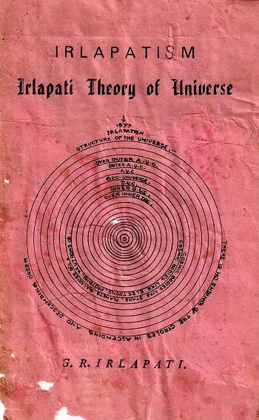
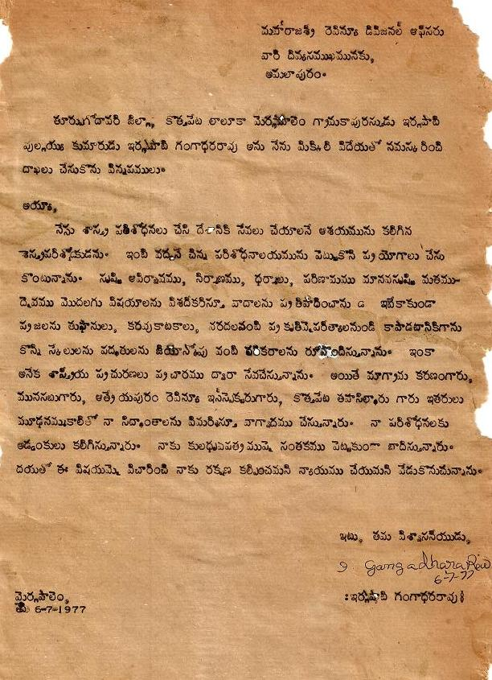
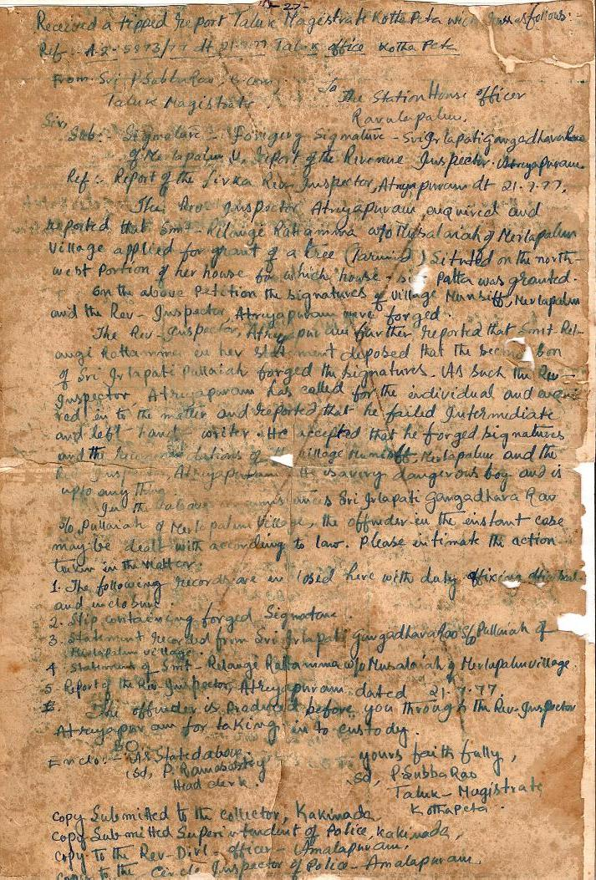
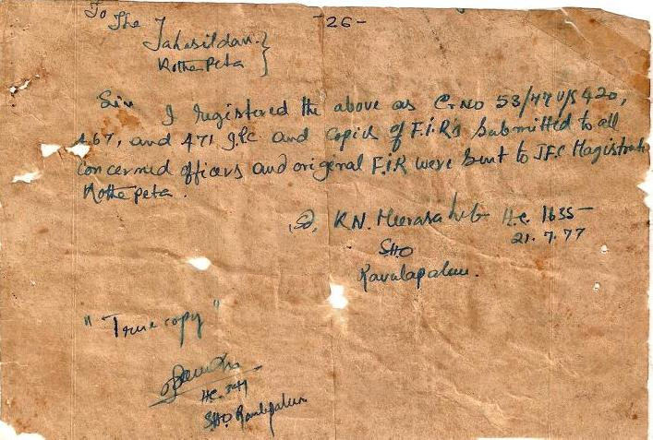
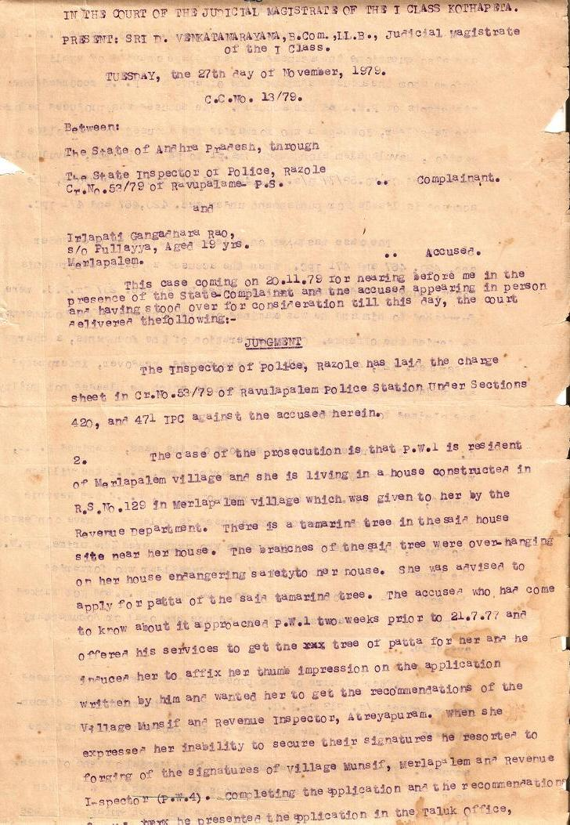
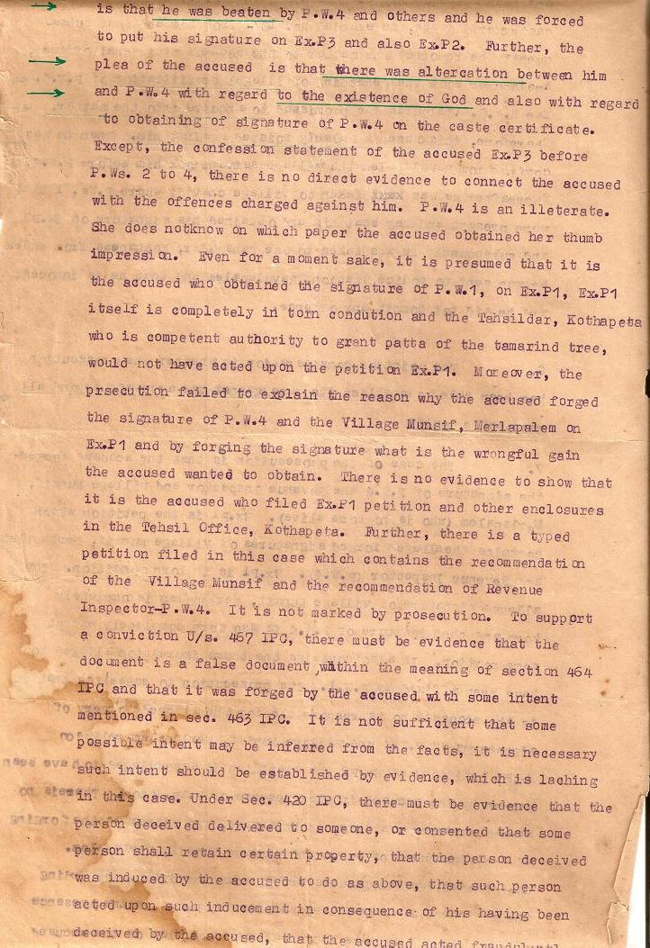
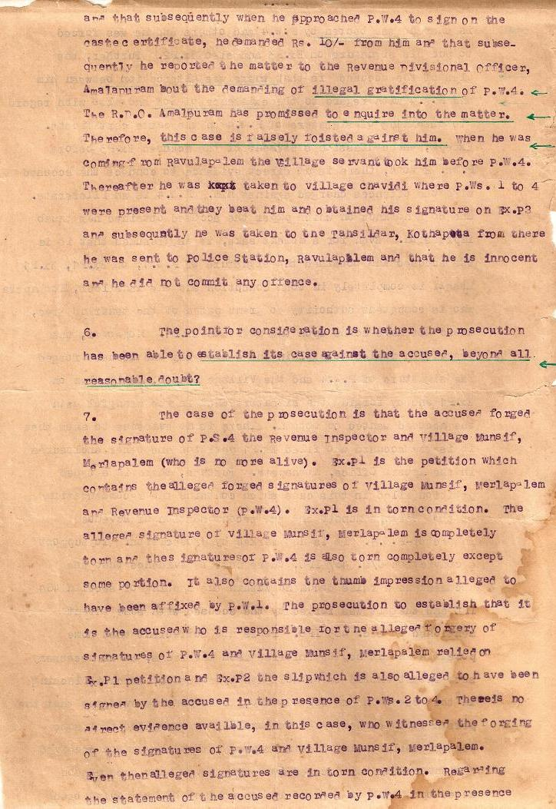
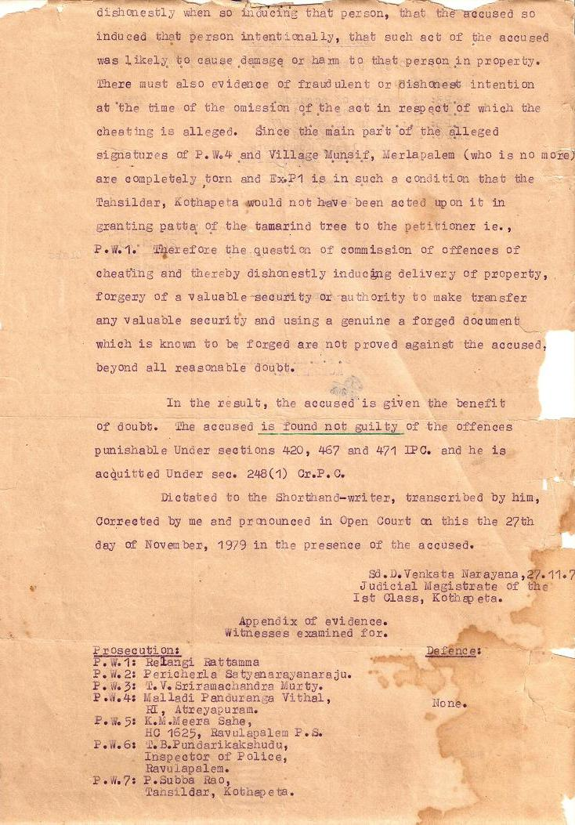
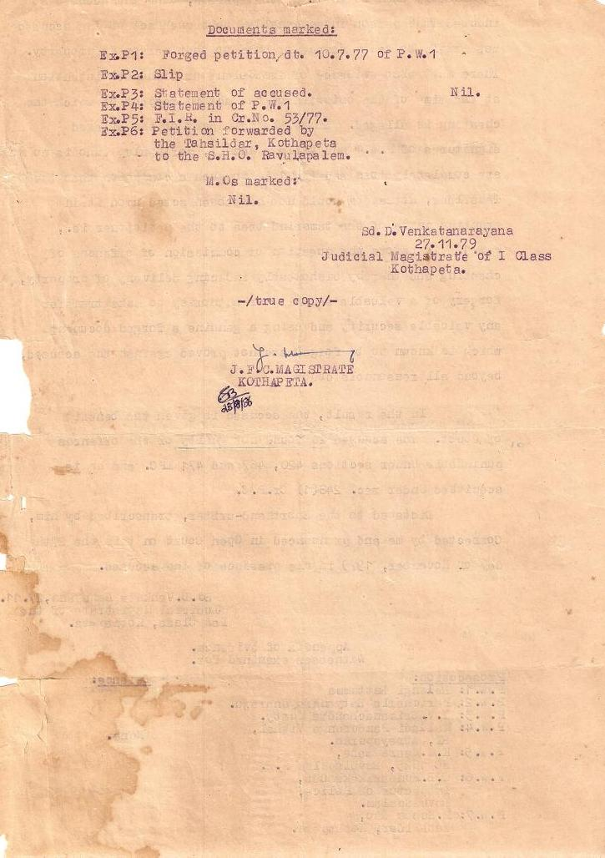
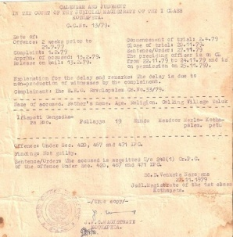
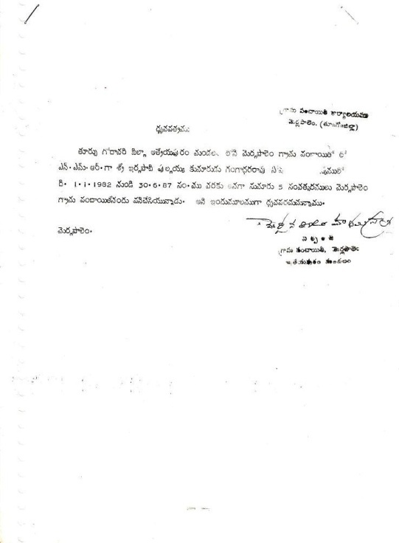
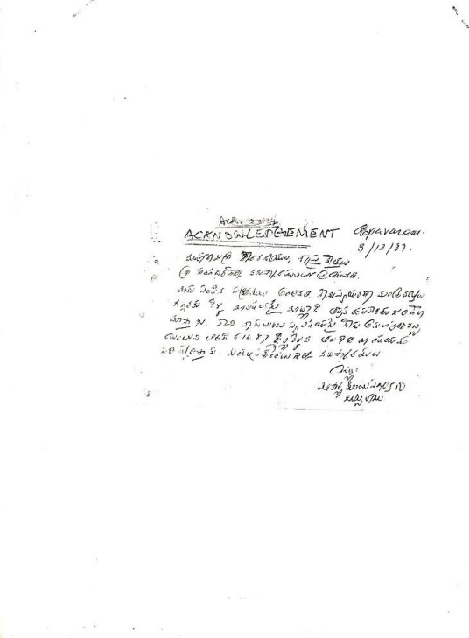
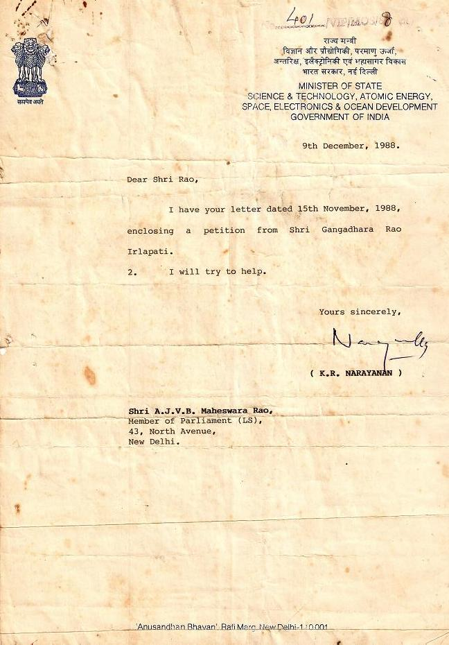

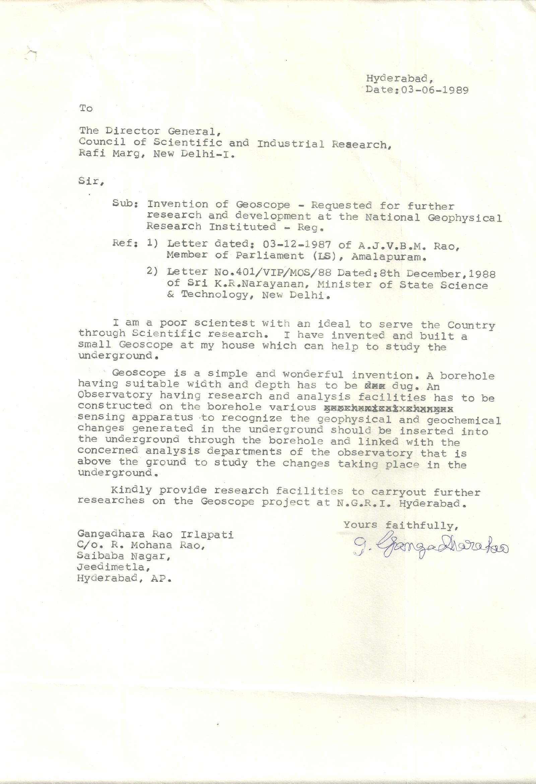
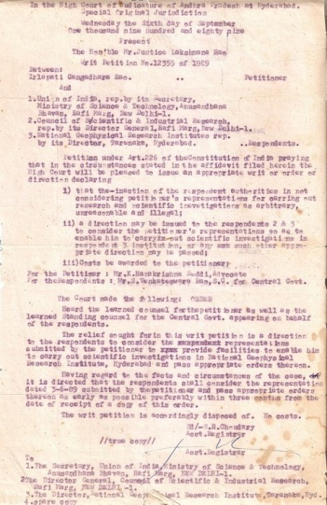
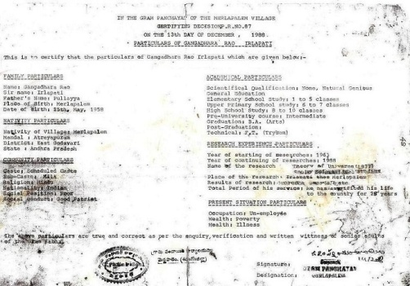
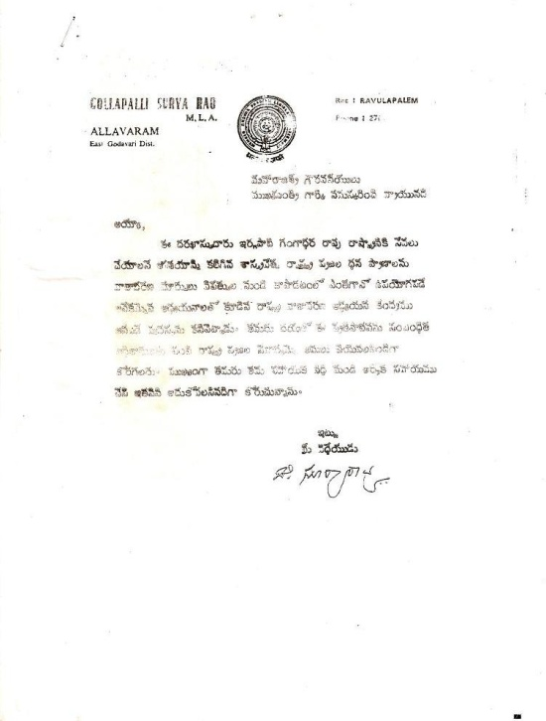
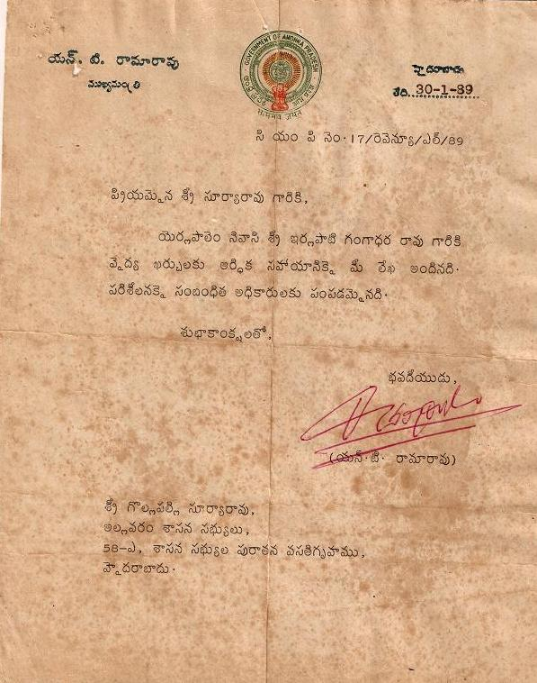

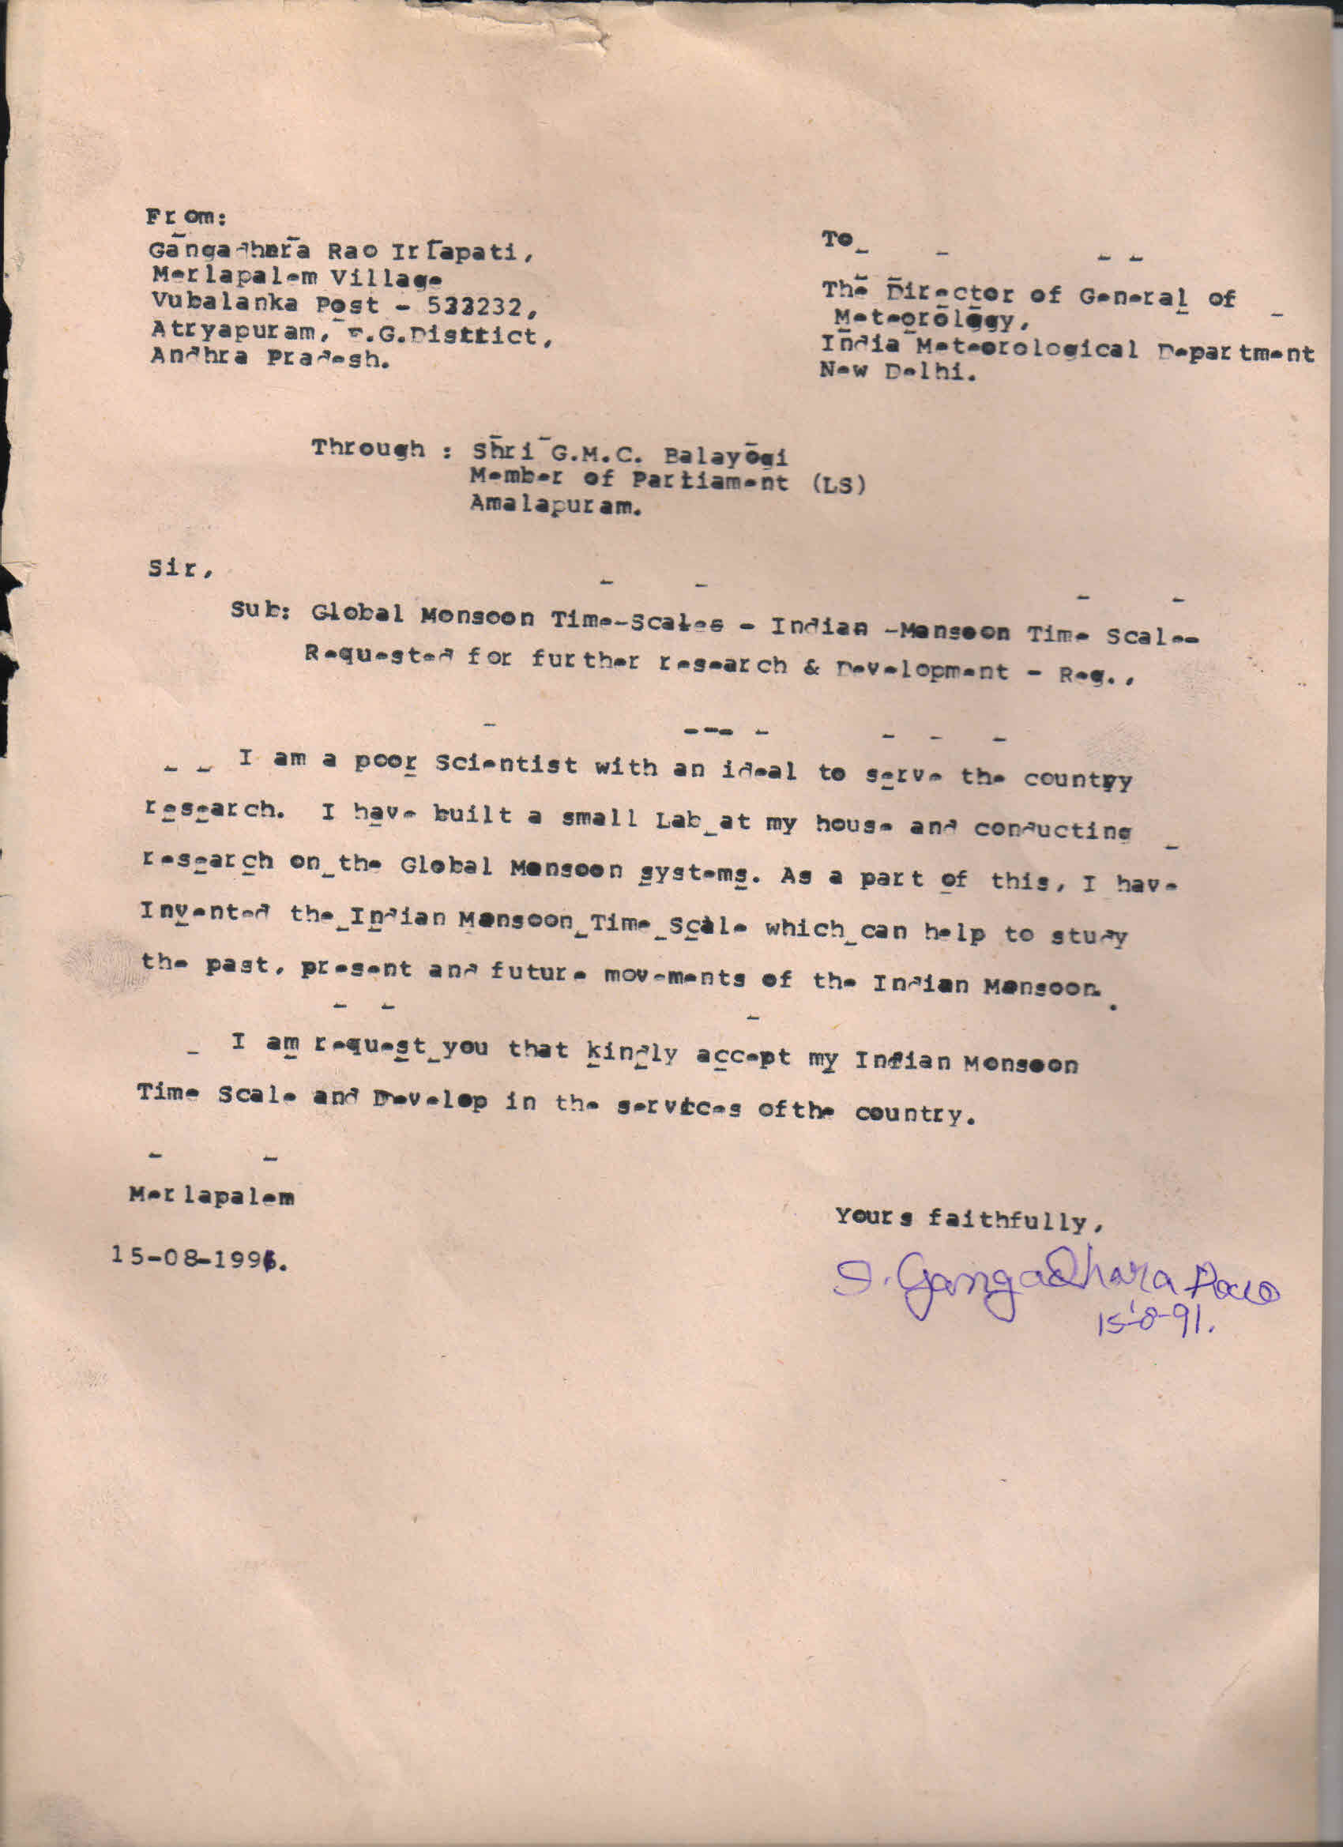
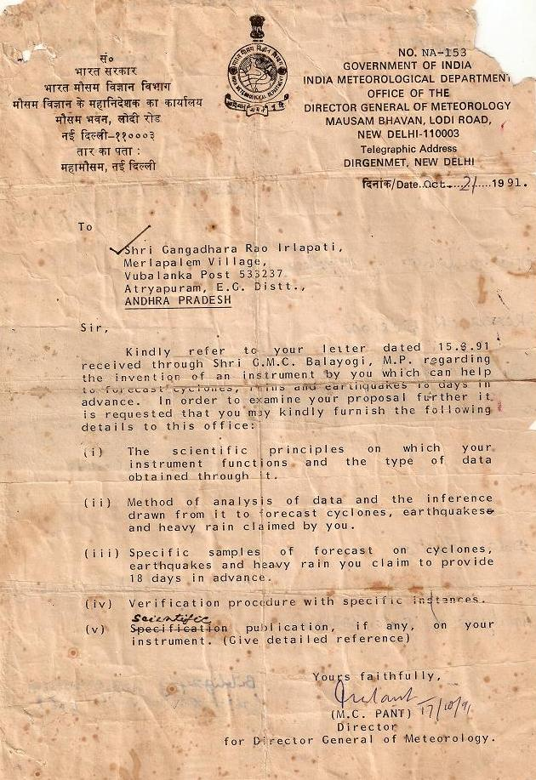
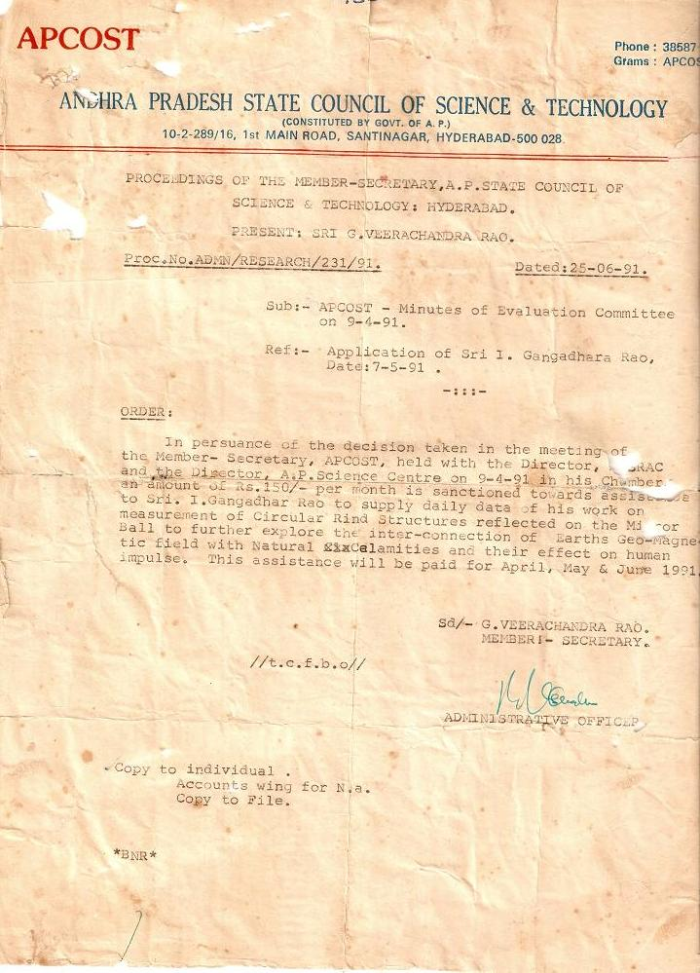

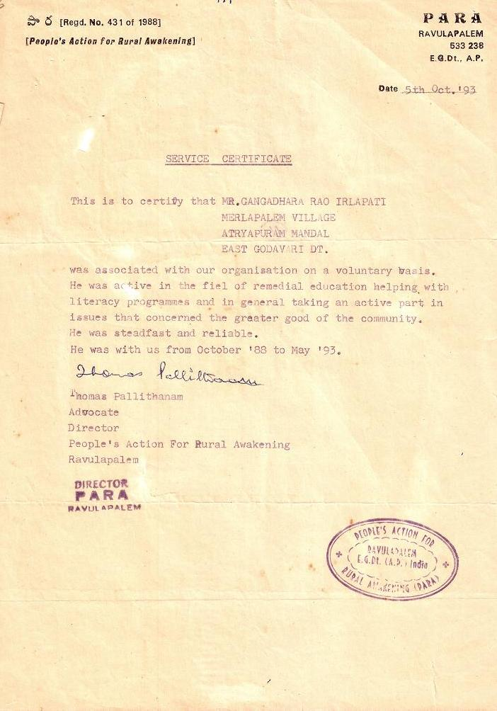
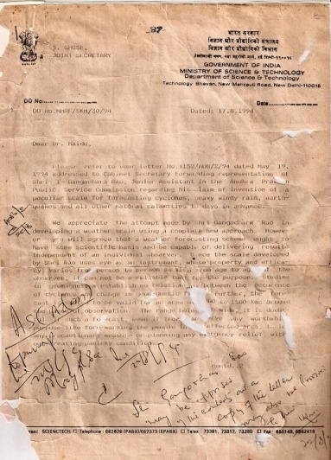
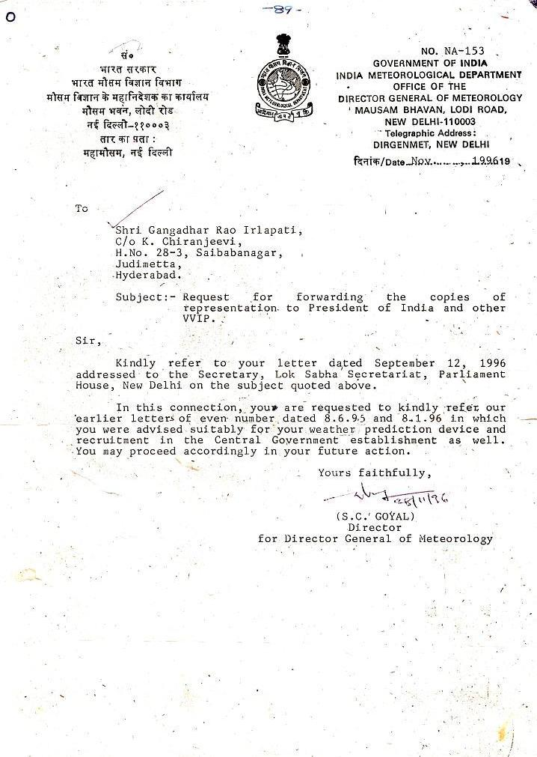
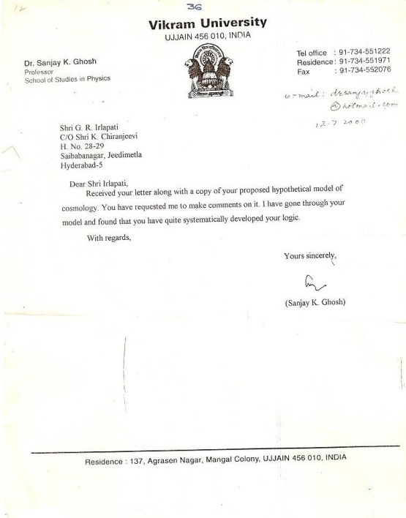
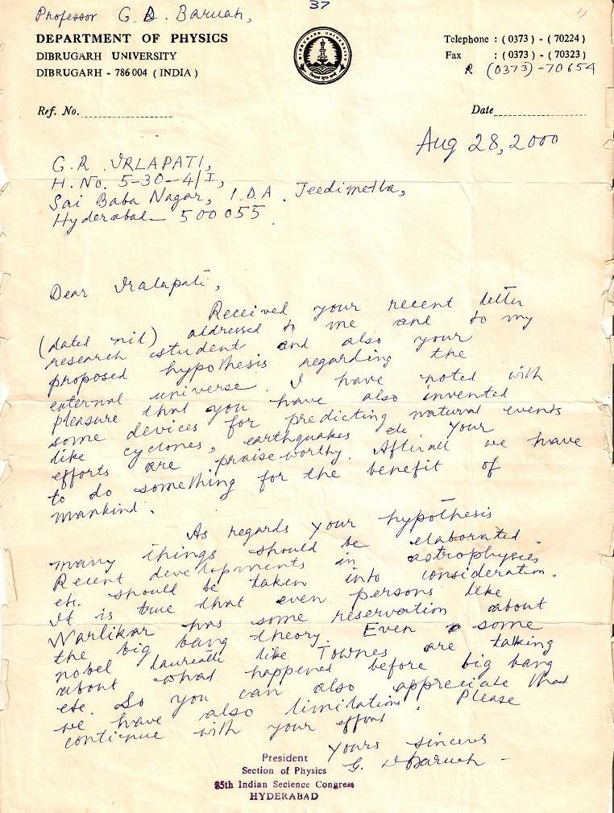
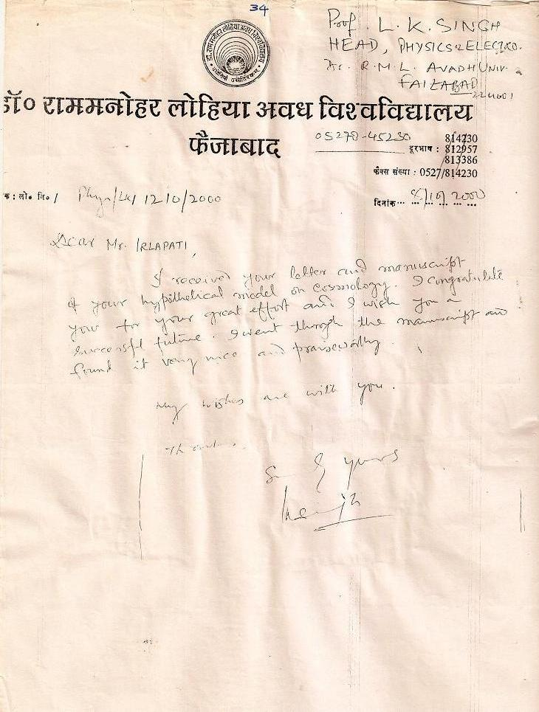
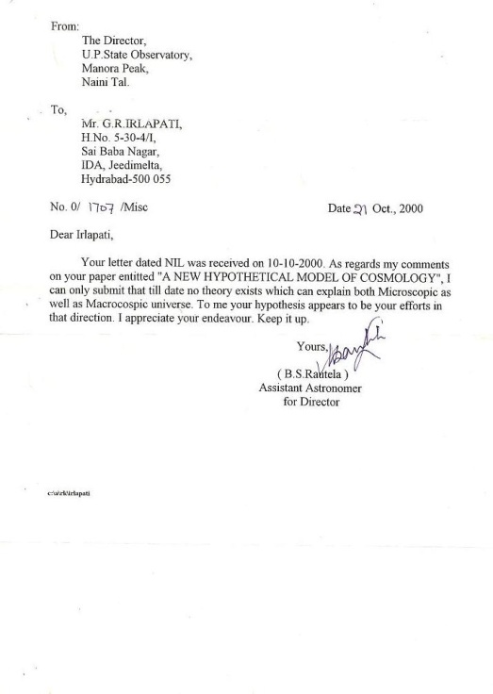

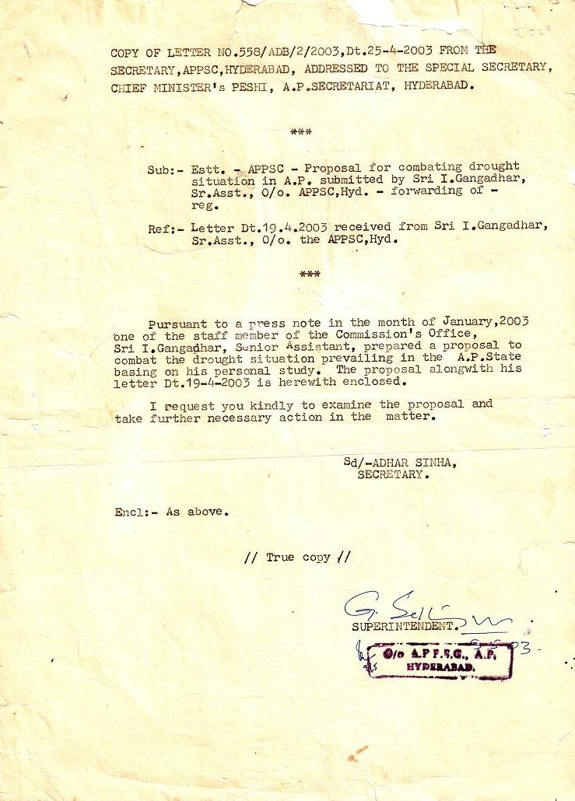
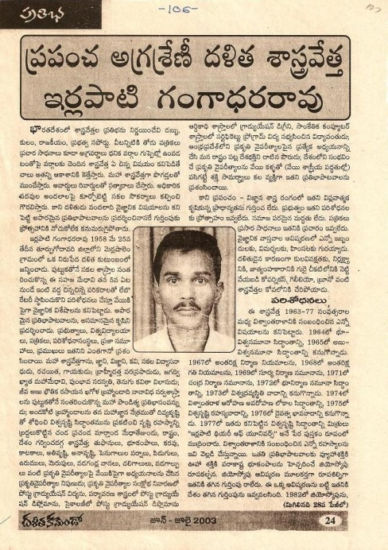
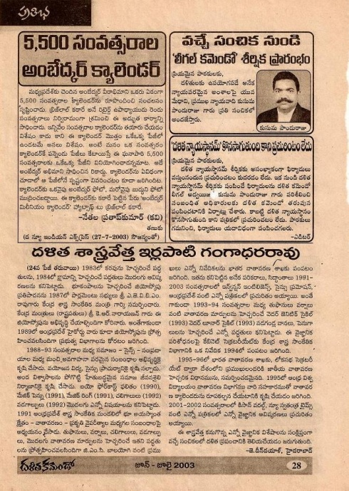
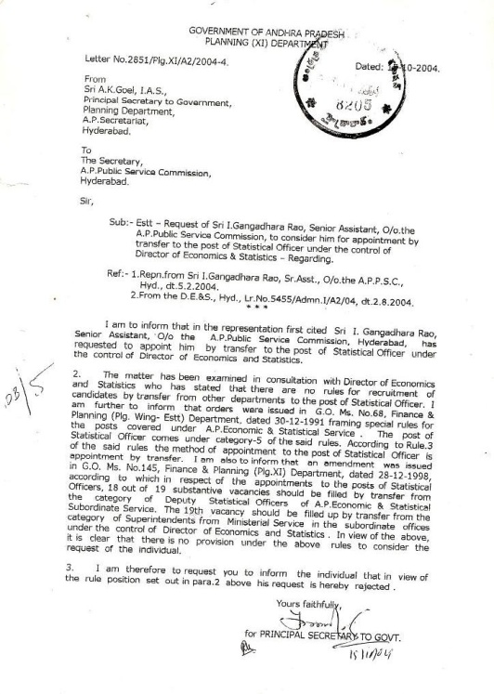
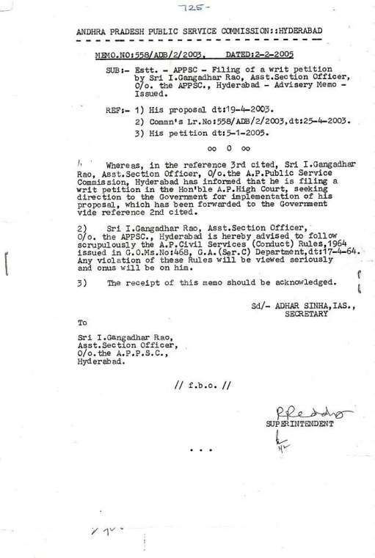
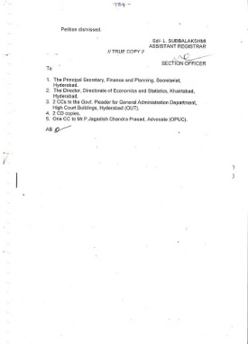
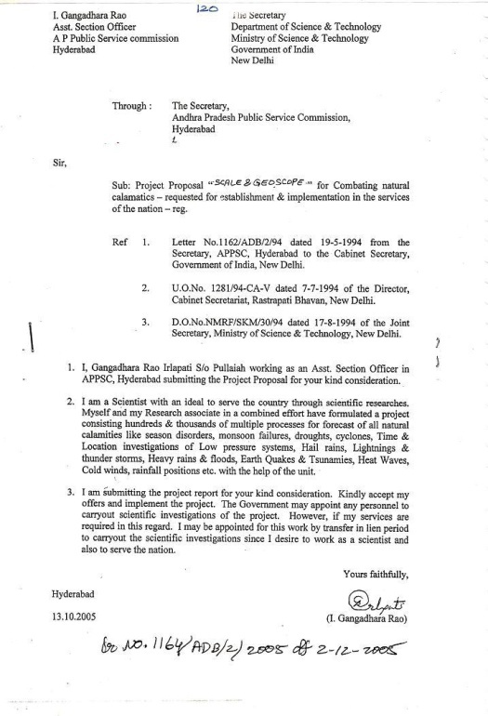
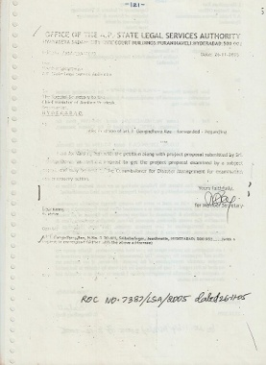
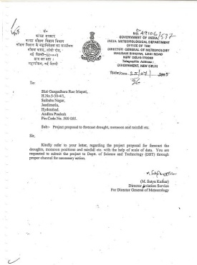
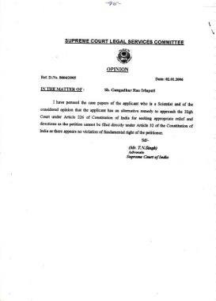
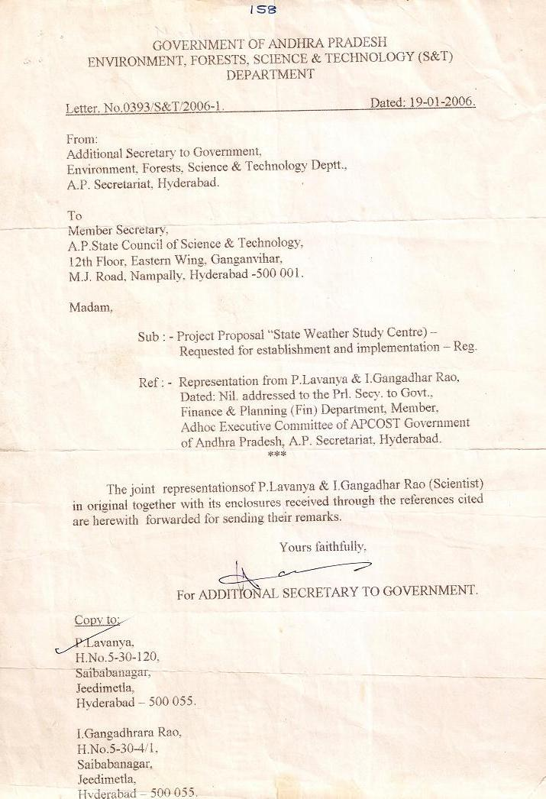
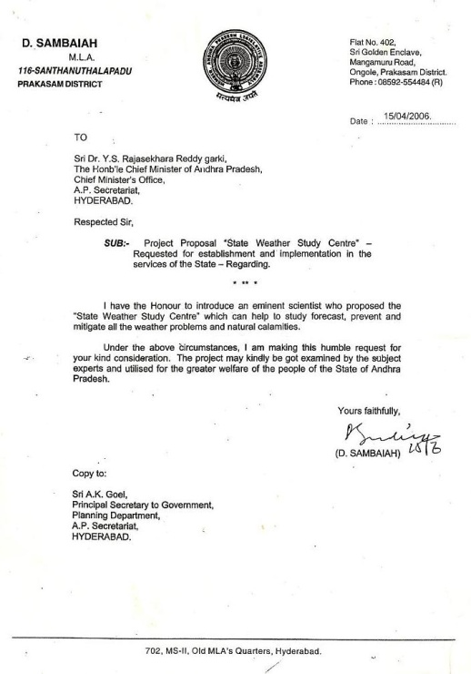

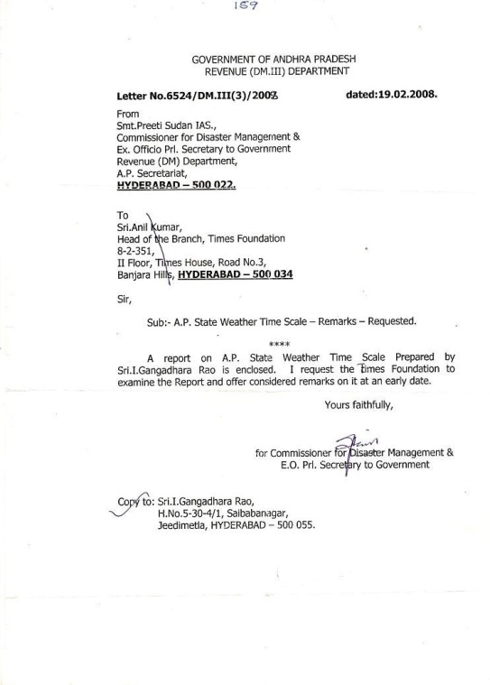
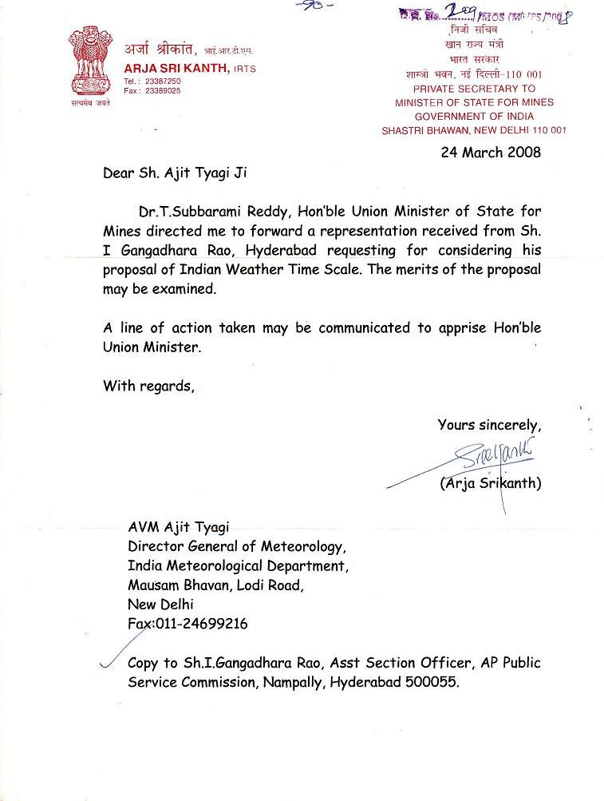
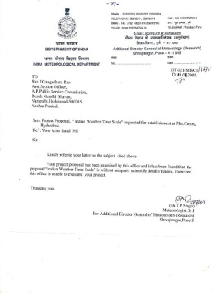
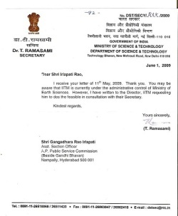
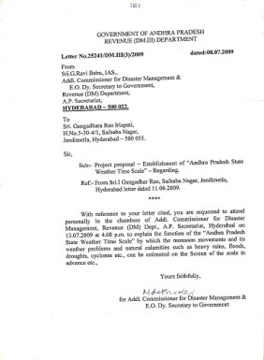
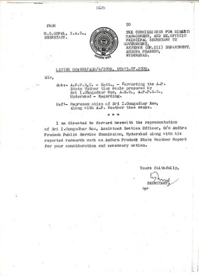
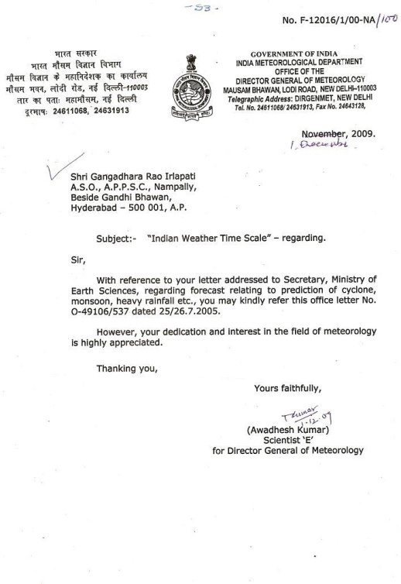
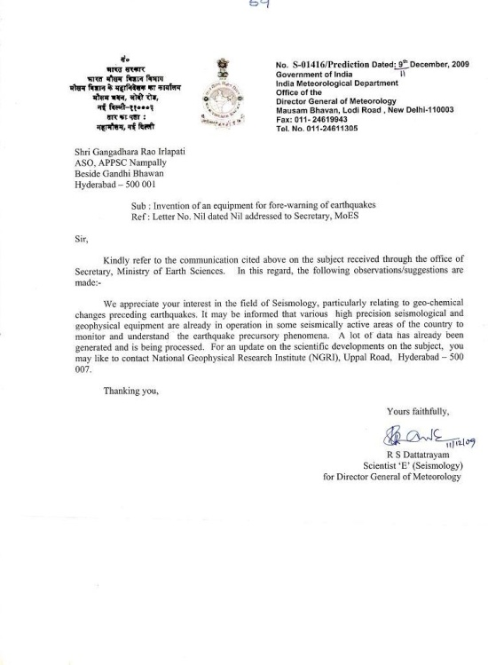
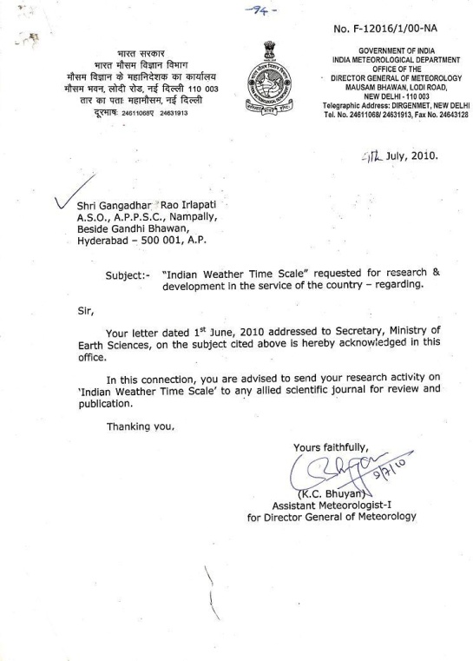
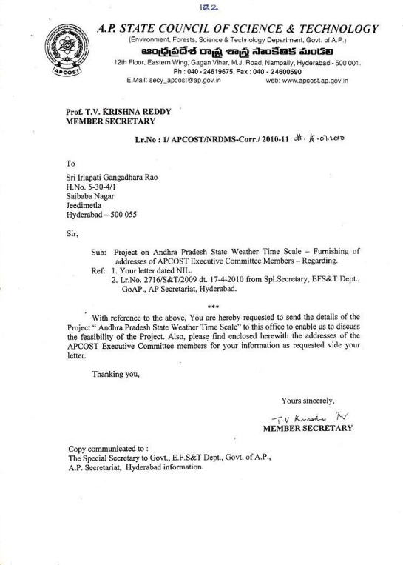
…
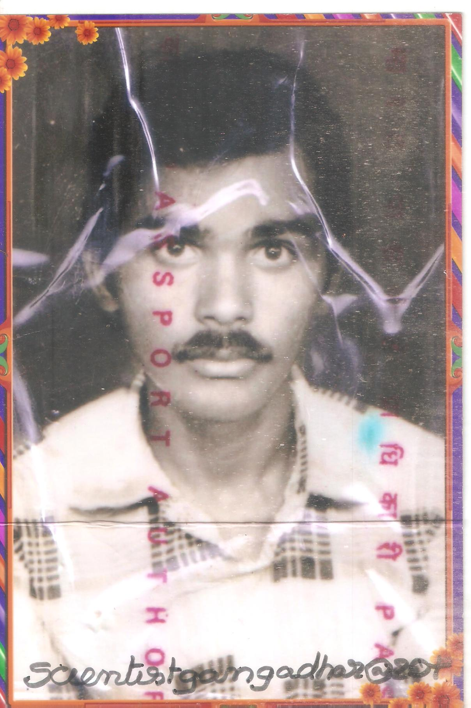

. 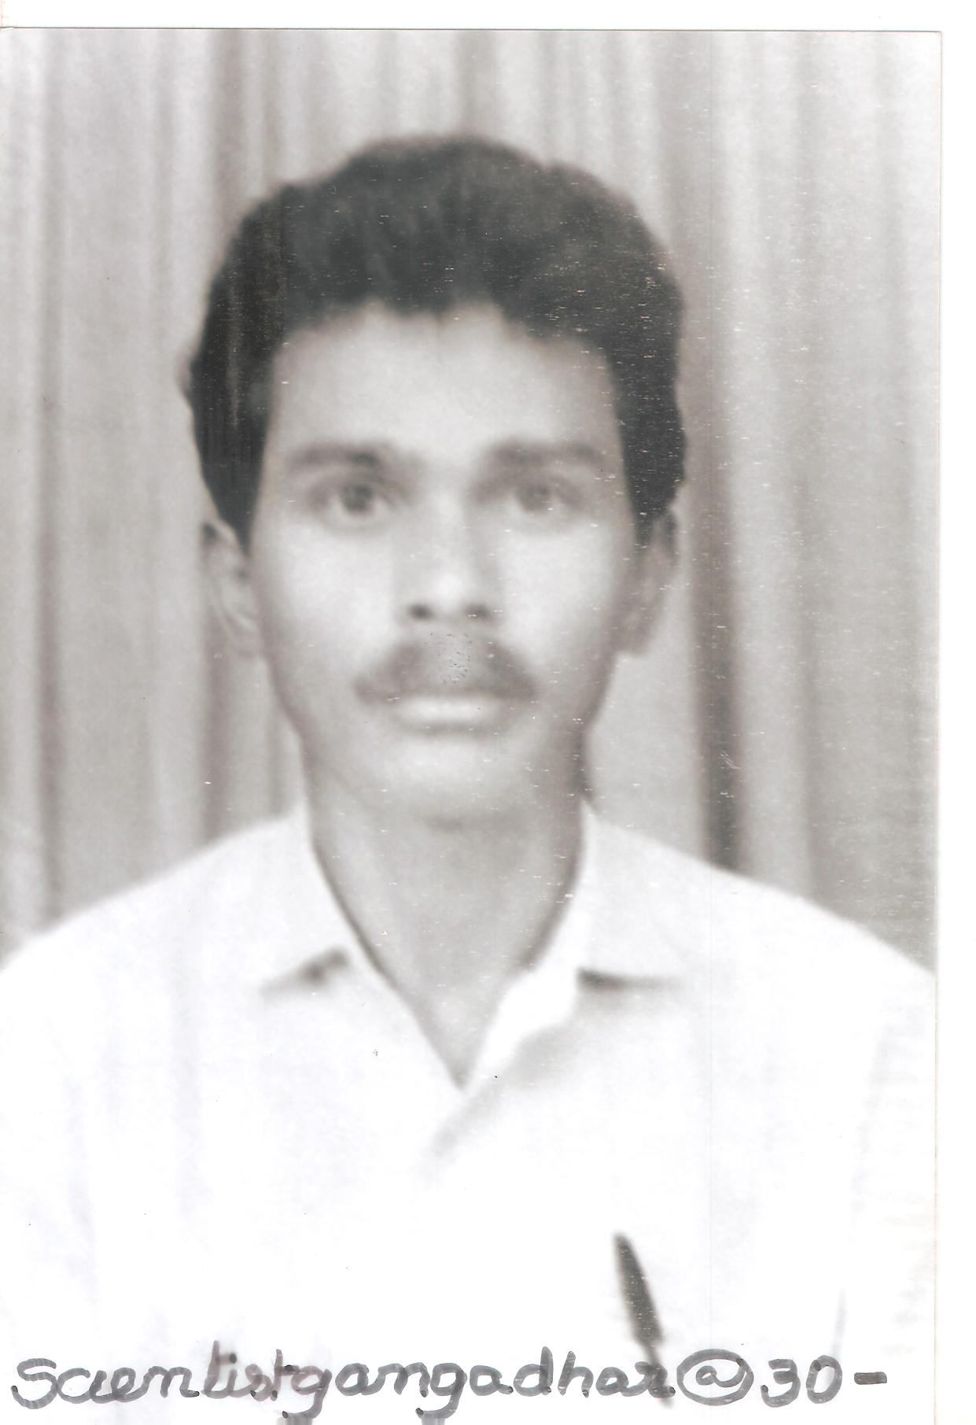

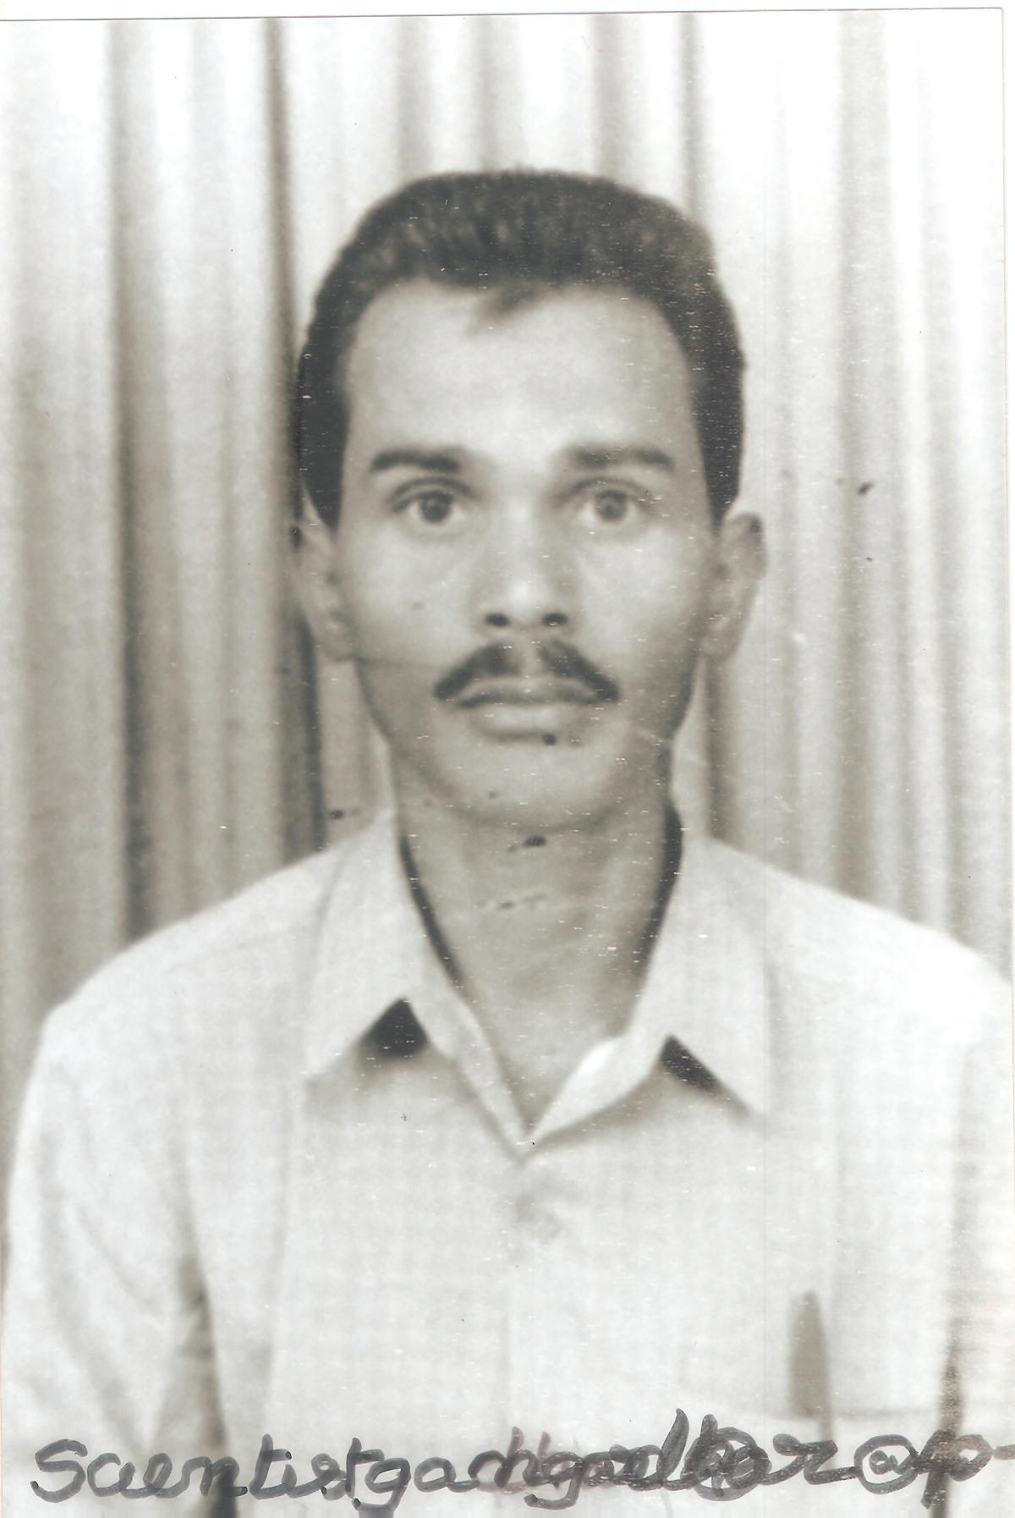

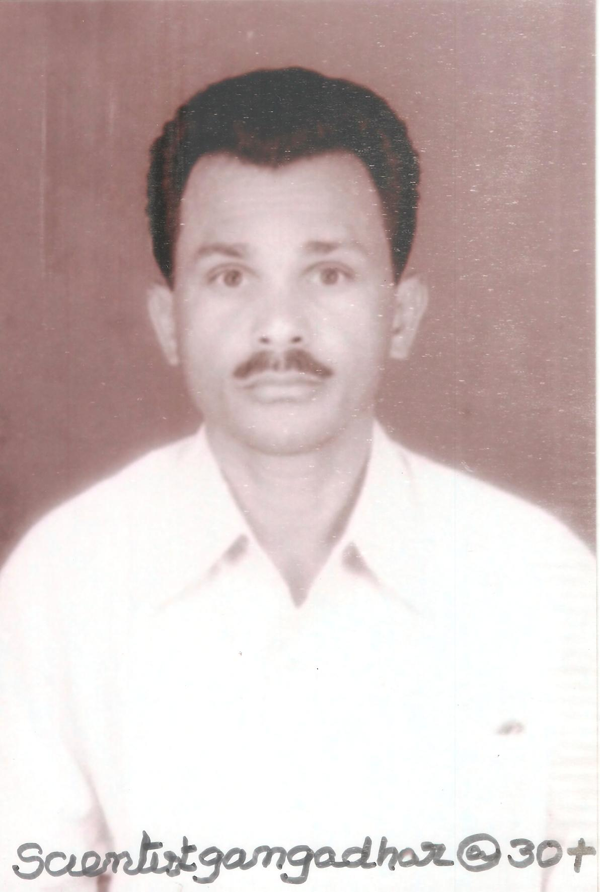

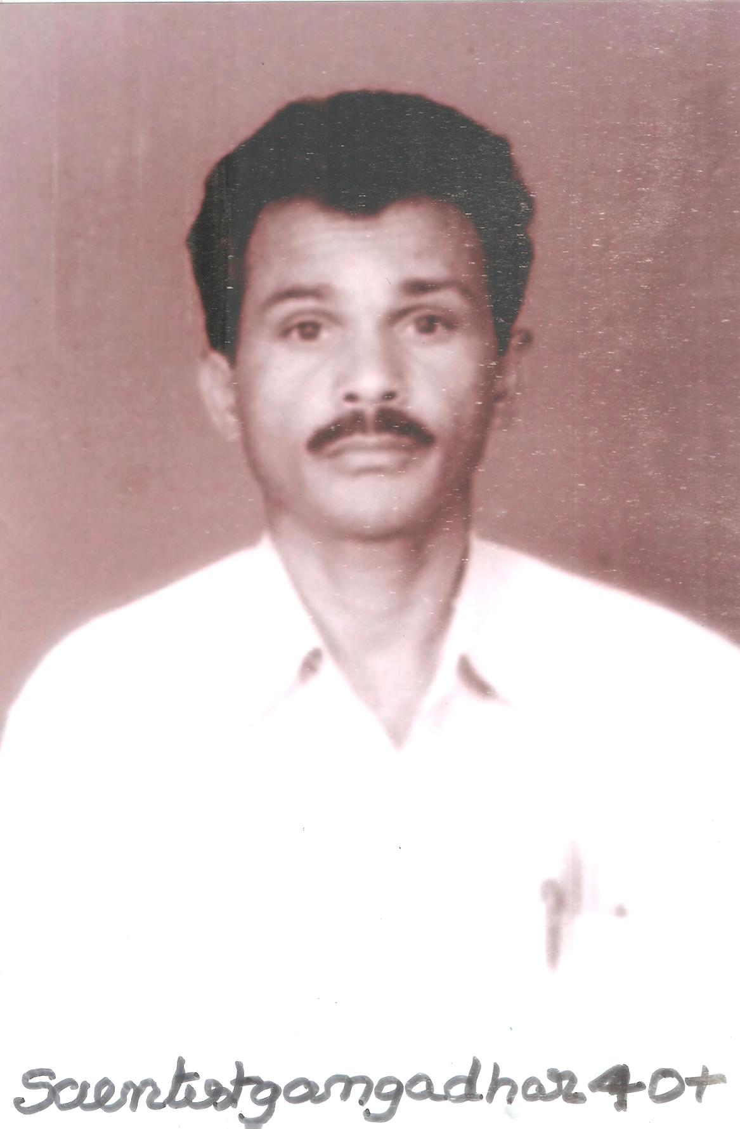

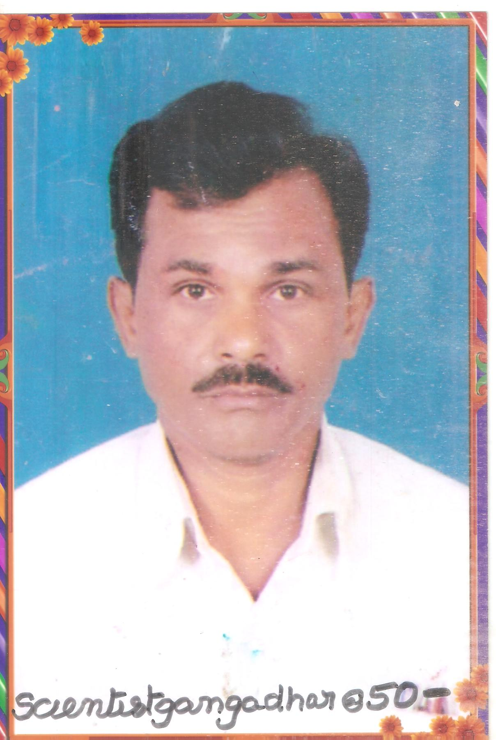

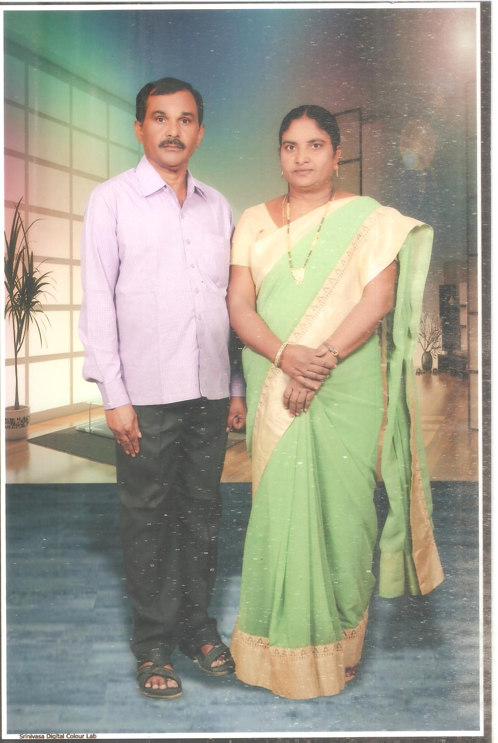

2/2/2023

