PREVALENCE OF TICKS BORNE DISEASES IN SELECTED DOMESTIC MAMMALS OF DISTRICT PESHAWAR

Imtiaz Khan

Department of Chemical and Life Sciences Qurtuba University of Science and Information Technology Peshawar KpK Pakistan
Corresponding email author Imtiazkhansafi91@gmail.com

ABSTRACT: An extensive study of 563 samples both on- season (June-August, 2020) and off season (December 2020- March 2021) was conducted in Peshawar, the capital territory of Khyber Pakhtunkhwa in context of ticks borne diseases in selected domestic mammal i.e. cow, buffalo, sheep, goat, horse, dog and donkey. The primary data was collected in two phases (on-season and off-season) through random sampling on infected (ticks borne) species. Out of total 563 collected samples, 312 samples were collected for on-season and 251 samples were collected for off season. The method that was adopted for the research was laboratory analysis on blood samples that were collected from Selected Domestic Mammals and interviews from owner of the infected Selected Domestic Mammals. During the on-season the number of samples collected from cow were 166, buffalo 9, sheep 32, goat 60, horse 10, dog 26, and donkey 10 in which the positivity ratio was 80%, 44%, 77%, 60%, 50%, 81%, 90% respectively. During the off-season the number of collected samples from cow were 100, Buffalo 13, sheep 11, goat 79, horse 10, dog 28, donkey 10 in which the positivity ratio was 77%, 31%, 73%, 80%, 60%, 79%, 40% respectively. Our study concluded that the most prevalent parasite was Anaplasma, followed by theileria and the least dominant was babesia. It was also found that the most disease prone specie was dog (80% positivity) followed by cow (79%), Sheep (76%), Goat (71%), donkey (65%), horse (55%) and buffalo (36%). The overall positivity percentage of the collected samples in the Selected Domestic Mammals of the study area was 74% and negativity percentage was 26% which shows an alarming situation for district Peshawar, therefore the suggestions and recommendation proposed by this thesis report should be adopted at town, tehsil and district level on emergency basis.
[Imtiaz Khan, PREVALENCE OF TICKS BORNE DISEASES IN SELECTED DOMESTIC MAMMALS OF DISTRICT PESHAWAR. Researcher 2023;15(1):23-53]. ISSN 1553-9865 (print); ISSN 2163-8950 (online). http://www.sciencepub.net/researcher. 06.doi:10.7537/marsrsj150123.06.

Keywords: Anemia, Haemo-parasitic diseases, Prevalence, Tick born disease, Risk factors, etc.

Pakistan is an agricultural nation with a sizable population of cattle that are adapted to the local environment. Buffalo, cattle, goats, and sheep make up the majority of our livestock; their populations are 33.7 million, 38.3 million, 64.9 million, and 28.8 million, respectively. Sheep play a crucial role and hold a prominent position in the livestock business, considerably boosting Pakistan's economy [1]. In most of the developing and impoverished countries of the world, parasitism is regarded as a significant risk factor for the production of small ruminants and often results in significant economic losses [2]. Theileriosis, Anaplasmosis, and Babesiosis are just a few of the haemo-parasitic diseases that small ruminants are particularly susceptible to [3] . Tropical and subtropical areas of the world have a disproportionately high rate of parasite disease onset [4]. Anaplasma marginale and Anaplasma phagoctophilum are the culprits behind anaplasmosis in small ruminants. Fever, anaemia, jaundice, anorexia, respiratory symptoms, a decrease in milk supply, and reproductive issues in small ruminants are the most typical clinical indicators of anaplasmosis [5-7]. Due to decreased weight gain and productivity losses, this condition causes enormous economic costs [8]. In tropical and subtropical areas of the world, theileriosis affects domestic animals and is spread by ticks, primarily Hyalomma. Lacrimation, anorexia, swelling of the superficial lymph nodes, enlargement of the spleen, liver, and icterus are some of the clinical indications of theileriosis [9]. Babesia ovis, an intraerythrocytic protozoan parasite that is the cause of babesiosis, is spread by ticks. Haemoglobinuria, anaemia, and a febrile state are all clinical indicators of babesiosis. Ticks of the Rhiphicephalus genus infect small ruminants with Babeia ovis. Pakistan's subtropical climate provides a good setting for the growth of tick populations, which are a key sign of hemo-parasitic disorders. According to Eshetu [10]. several tick species, including Hyalomma species, which are the most prevalent in Pakistan, Rhiphicephalus species, Ixodidae species, and Boophilus species, play a significant role in the transmission of hemo-parasitic disorders [11]. The majority of earlier research has focused on the incidence of haemo-parasitic diseases in Pakistani cattle, but there is little information on the epidemiology of tick-borne diseases in small ruminants. An essential indicator for the prediction of tick-borne diseases is the serum biochemistry and haematological profile. The present study was investigated in district Peshawar KpK. The different types of animals were checked in district Peshawar KpK Region. The various animal’s percentage were determined. The most prevalent parasite was Anaplasma, followed by theileria and the least dominant was babesia. It was also found that the most disease prone specie was dog (80% positivity) followed by cow (79%), Sheep (76%), Goat (71%), donkey (65%), horse (55%) and buffalo (36%). The overall positivity percentage of the collected samples in the Selected Domestic Mammals of the study area was 74% and negativity percentage was 26% which shows an alarming situation for district Peshawar, therefore the suggestions and recommendation proposed by this thesis report should be adopted at town, tehsil and district level on emergency basis.

OBJECTIVES OF THE STUDY
- To determine the prevalence of tick borne diseases (Anaplasmosis, Theileriosis, and Babesiosis) in selected domestic mammals (SDM) of district Peshawar.
- To compare the seasonal variation [summer (on season) VS winter (off season)] of these parasites for.
- To determine the positivity and negativity percentage ratio of parasites in selected domestic mammals (SDM) from the collected samples.
- To determine parasite wise percentage ration in each species of SDM in the study area. 5. To determine more disease prone specie out of the SDM from the collected samples in the study area.
- To determine the season wise Dominant Parasite in the selected domestic mammals (SDM) of the study area.
- To determine the dominant Parasite in the selected domestic mammals (SDM) of the study area.
- To determine the overall Positivity percentage ratio of the collected Samples in the SDM of the study area.
- To point out health problems associated with tick born parasite in the selected domestic mammals (SDM) of the study area.
- To give suggestion and recommendation in improving the current situation of tick borne diseases in the study area.

Literature Review
Diseases are spread by ticks to both people and animals. Ticks cause significant financial losses to livestock and have a variety of harmful particular effects on hosts who are cattle. Blood loss is directly caused by ticks acting as potential vectors for helminth infections and hemoprotozoa. Even though their bites can cause skin damage, large populations of ticks that are consuming red blood cause anaemia and lower live weight in cattle animals. Ticks are responsible for significant monetary losses because they can infect cattle with rickettsial, viral, and protozoal illnesses. The focus of this review is the significance of ticks and how to manage them. Ticks have been managed with the aid of a vaccination, a spray, chemicals, etc.[12]
This investigation looked at the distribution and prevalence of the parasites Theileria, Babesia, and Anaplasma that are transmitted by ticks and affect ruminants that appear to be in good health. In the current study, blood parasites were detected in 1101 blood samples collected from 690 cattle (Bos indicus), 243 buffaloes (Bubalus bubalis), 108 sheep, and 60 goats between June 2013 and June 2016. [13]
In order to identify the species present and which ones were most prevalent, ticks were collected from sheep and goats in Pakistan's Federally Administered Tribal Areas (FATA). We discovered that the two most prevalent species on small ruminants in the area were Rhipicephalus sanguineus and Haemaphysalis sulcata out of 1,450 ticks collected from 290 animals representing six agencies of the FATA region. In general, we found that from our sampling, Rhipicephalus ticks were more prevalent (57.2%) than Haemaphysalis ticks (27.6%) and Hyalomma ticks (15.2%). At our study sites, we also discovered that geography and the month of the year were two significant predictors of tick infestations in goats and sheep. Tick management programmes in the FATA region can target particular species when they are most abundant by using the knowledge gained from this study.[14]
The predominant hemoparasitic disease affecting both large and small ruminants in Pakistan is theileriosis. The goal of the current one-year study, which ran from October 2017 to September 2018, was to determine the prevalence and risk factors of theileriosis in livestock in ten locations of the Malakand Division. 1437 blood samples in all (240 sheep, 658 cows, 340 buffaloes, and 199 goats) were gathered. The prevalence of theileriosis was 3.20 percent (46/1437) overall. Cows had the highest occurrence (5.62%), followed by goats (3.02%), buffalos (0.59%), and sheep (0.42%). Theileriosis in livestock was also considerably influenced by the herd's location, with the Asbanr region having the highest occurrence. The current study shows disease incidence and relationships with animal species, location, season, age and sex of the animal, herd size, infection history, and tick infestation. In order to lower the prevalence of the disease in livestock, appropriate tick management measures, breeding resistant breeds, and identifying carrier animals will be helpful. [15]
This is the first study aimed at estimating seroprevalence in sheep and goats in the Charsadda District, where anaplasma spp. infection in small ruminants is a severe health issue. In order to better understand the disease's contributing components and develop innovative strategies for anaplasmosis control in livestock, more research is required. [16]

METHOD AND MATERIALS
2.0 Study design: The design of the study was as under;
- Blood sample collection of tick borne SDM.
- Interview of the owners.
- Laboratory analysis.
- Thesis report writing.
  - Pre-survey planning:
Before the start of the research work a pre-survey planning was done in which all the aspects were looked. It includes sample collection strategy, Sample transfer strategy, sample testing facility selection and arranging other resources required for successful completion of research.
    - Data collection:
2.2.1 Secondary data collection:
Secondary data for the research study was collected from the following sources.
- Library of Qurtuba University of science and information technology Peshawar.
- Central library, Peshawar University. 3) VRI (veterinary research institute Peshawar)
- Wild life department library Peshawar.
- Different sites from the Internet.
2.2.2 Primary data collection:
2.2.2.1 Data collection tools:
3.2.2.1.1 Interview:
For the collection of various health associated problems regarding ticks-borne diseases sample to sample interview was conducted and documented from the owner of the SDM in the study area
2.2.2.1.2 Personal observation:
For the blood sample collection, the personal observation method was adopted to choose only tick borne specie.
  - Inclusion criteria:
The principle inclusions for the study were all the SDMs with tick borne in the study area.
  - Exclusion criteria:
The principle exclusion for the study was all those tick free SDMs.
  - Study population:
563 blood samples of SDMs were collected from the all surveyed population of the study area.
2.5 Field visits:
A number of field visits were conducted in on-season (June 2020 to August 2020) and off-Season (December 2020 to March 2021), and blood samples were collected by visiting door-to-door, various yard and various farms and weekly maweshae mandi from the willing owners.
Besides blood sample collection from tick-borne SDMs interviews of the owners was also recorded and documented regarding the health associated issues of SDMs.
2.6 Sampling:
Primary data was collected through random sampling in various urban and rural localities of the study area and the total of 563 samples were collected in sterilized syringes i.e. 5 CC or 10 CC, saved in EDTA (Ethylenediamine Titraacitic Acid) tube or vacutainer tube and kept in tube box kit. Brought the tubes of samples to the Disease investigation laboratory directorate of epidemiology livestock in diary development department (EXT) KPK Bacha khan Chowk Peshawar for scientific research and analyzed the samples for the diagnosis of different species i.e. Theileria-a blood borne parasite, it only affects the cattle and is primarily transmitted by ticks. Anaplasma phagocytophillum and Babesia (Nuttallia).

2.7 Equipment’s and Logistics
2.8.1 Equipment’s:
The following equipment’s were used during field visits to the study area.
- Syringes ranging from 5cc to 30cc with sized 1-inch or 18-gauge needle were used.
- Mask for the preventions of different toxic substances and to prevent the spread of infection.
- Gloves used for the prevention of cuts and also used as chemotherapy agents, it also acts as a barrier to prevent the possible transmission of disease.
- Overall/Apron used for the protection from dirt, germs, hazards, chemicals etc.
- Slides used for the placement of samples to be studied under microscope.
- Cover slip to protects the microscopes objective lens from contacting the specimen,
- Oil Solution/Cedar wood oil used to increase the resolving power of a microscope. High absorption of blue and UV light, , a tendency to harden on lenses due to uneven volatility, acidity, and changing viscosity (diluting with solvent changes the index and dispersion). Immersion oil increases the resolving power of the microscope by replacing the air gap between the immersion objective lens and cover glass with a high refractive index medium and reducing light refraction.
- Binocular/Compound Microscope to observe presence of parasites in the blood samples
- Methanol for fixing the smear slide.
- Giemsa stain used for the demonstration of some microorganism: The “neutral” dyes combining the basic dye methylene blue and the acid dye eosin, give a wide color range when staining. The pH of the staining solution is critical and ideally should be adjusted for different fixatives.
- Giemsa stain is a gold standard staining technique that is used for both thin and thick smears to examine blood for Ticks parasites, a routine check-up for other blood parasites and to morphologically differentiate the nuclear and cytoplasm of Erythrocytes, leucocytes and Platelets and parasites.
- EDTA/Heparin Tube used extensively in the analysis of blood. It is an anticoagulant for blood samples for CBC/FBCs, where the EDTA chelates the calcium present in the blood specimen, arresting the coagulation process and preserving blood cell morphology.
The mechanism of EDTA anticoagulant action is based on inhibition of thrombocyte aggregation and various reactions of hemostatic cascade due to chelation of free Ca²⁺ ions. Blood cells of various animals show different reactions to various anticoagulants.
- Alcohol bottle used as a solvent, this makes the chemical a perfect fit in any educational or research lab dealing with chemistry or biochemistry. The denaturants used are approximately equal parts isopropyl alcohol and methanol.
- Cotton used to stop the blood after sample taking from the animals and also use for cleaning.
- Tube box kit: A test tube holder's purpose is for holding test tubes in place, but they can also be useful for holding pipettes and stirring rods as well, and a test tube rack holds multiple test tubes in place. Some test tube racks can hold up to 40 test tubes.
- Digital camera: A digital camera was used and more than 200 pictures were taken of the different of tick borne SDMs, from various yards, laboratory equipment and samples labeling.
- Biohazard box used to dispose of solid or liquid items contaminated with blood or other potentially infectious materials (OPIM).
2.8.2 Logistics:
The study area was explored via Motorcycle and various maweshae mandi by foots.
  - Data analysis:
After collecting the blood samples, they were labelled, classified, tabulated, and subsequently analyzed under binocular microscope by using various related regents/ chemicals and obtain results were recorded in MS office, excel spread sheet.
2.10Duration of the study:
Research study was completed in 9 months in two seasons i.e. summer and winter. Sumer season includes June to August 2020 and winter i.e. December 2020 to April 2021.
  - Limitations of the study:
Some of the limitations that were faced during the data collection are as follows.
    - Primary limitation of the study was that samples were collected only form the willing owners.
    - Most of the respondent’s especially illiterate were usually unaware of various symptoms and other health related problems and were un expressive on various questions.
    - Most of the people were not available at their houses; the available people were busy in working at their fields and had no time to participate in the study.
2.12 Measures to overcome limitation of the study:
To mitigate the above limitation in the study, the following measures were taken; 1) Stress was given on only the key questions.
    - The participants were ensured that this is purely an academic research study, conducted as partial fulfillment for the degree of M.Sc in Zoology.
    - The participants were also ensured that it’s all for their own benefits.
2.13 Anaplasmosis Test Material and Method/Procedure:

3.14.1 Sample collection
- We used PPE (personal protective Equipment) for field work against the dust and other toxic substances,
- We used 10mL syringes for cow and buffalos and 5mL syringe for goat and sheep.
- The needle was used in the sized of 18-gauge needle.
- 18 or 20-gauge needle may be used for either IM or SQ (Sub-Cutaneous) injections.
2.13.2 Lab Diagnosis:
All laboratory work was performed in District diagnostic laboratory Peshawar.
2.13.3 Method:
The area from where the sample was to be taken was cleaned with cotton. The needle of the syringe was inserted into the vein with an angle of 25 to 45 or 60 to 90-degree. 18guage or 1 inch needle was used. The syringes accompanying the needle were not more than 5CC; but there is nothing wrong with having a 10CC syringe. Syringe was not filled up completely with blood. 3 to 5 mL or (3 to 5 cc) of blood was allowed to enter the syringe. The needed tubes were attached to remove the proper volume of blood.
Blood can be collected from the jugular vein in all ages of cattle and from the tail vein in older cattle. A “Red Top” Vacutainer (rubber-capped test tube) is the preferred tube for collecting samples. Restrain the animals with the head elevated and pulled to the right or left to expose jugular groove on either side. Needle was removed the same way as was inserted.
Pressure was applied to the area to stop excess bleeding with a gauze or cotton swab. Tube was labeled with identifying the numbers or name of the animals. Sample number and name of the farm or place. The tube was put back in its place usually the box that contained the kit has a built-tray to place the vacutainer tubes in. The tubes was Placed in that box with the bubbles wrap surrounding each tube to protect them.

2.13.4 Process
After transportation the samples to the lab processes for the identification of different types of Species.

2.13.5 Observation
After processing of blood sampling in lab, different species were observed; Anaplasmosis, Babesiosis, Theileriosis.
Thin Blood smear were prepared for microscopic examination according to the standard protocol. The slide was allowed to air-dry before being fixed with absolute methanol.
Fixed smear were stained with 10% Giemsa and examined by using compound microscope under oil immersion lens (100X). About 25 fields were examined from each slide for the presence of Anaplasma and the number of infected erythrocytes. Anaplasma was identified on the basis of its morphology.

2.13.6 Detection of Theileria annulata in blood samples of Cattle
Primarily, a thin layer smear was prepared from ear sublime vein blood from cattle randomly selected and was fixed with methanol and stained with Giemsa dye. Also, 9 mL blood samples were obtained from their jugular vein in tubes containing 1 mL of 0.1 M (3.2 %) buffered citrate solution. Giemsa-stained blood smears were examined for the presence of parasites;
At least 50 microscopically areas were carefully examined for Theileria piroplasms under the oil immersion lens. The presence of even single piroplasm was considered positive.

2.14 Detection 0f Babesiosis
Babesiosis also called Red Water Fever and Tick Fever. Babesiosis is usually diagnosed by blood smear. An examination of a blood smear may be done when a complete blood count (CBC) shows abnormal results. We will examine blood sample under the microscope to look for Babesia parasites inside red blood cells. Successful diagnosis of babesiosis by blood smear often depends on the individual's degree of infection. Sometimes multiple smears need to be examined.
The presence of the Babesia parasites in the infected red blood cells confirms a babesiosis diagnosis. However, Babesia parasites can be difficult to distinguish from other parasites in a blood smear.
Certain CBC findings may be consistent with, but not specific for, babesiosis. These include:
- Decreased red blood cells, hemoglobin and hematocrit
- Decreased platelet numbers (thrombocytopenia)
- Normal or slightly decreased white blood cell count

2.15.1 Precautions
The main way to prevent Babesiosis is avoiding tick bites. As with all tick-borne diseases, these measures include:
- Handle needle with care.
- Do not drop the test tube! Handle the test tube carefully to avoid damaging them.
- Animals it used to being handled can make it dangerous to take blood samples from, especially from the neck region.
- Avoiding overgrown grass or brush
- Wearing long pants, long-sleeved shirts, and socks when outdoors
- Tucking pant legs into socks
- Applying insect repellent
- Showering soon after being outdoors
- Checking your entire body for ticks after time outdoors.

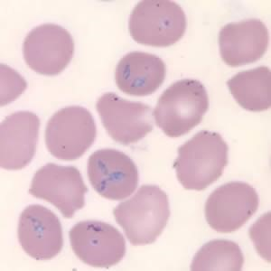

Figure 3.1 Showing the Babesia Paratite
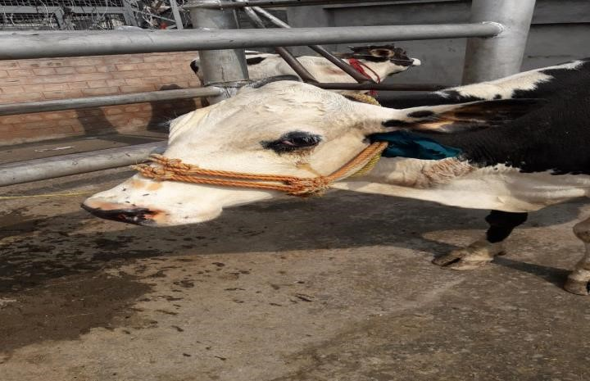

Figure 3.2 Showing tick on Cow body
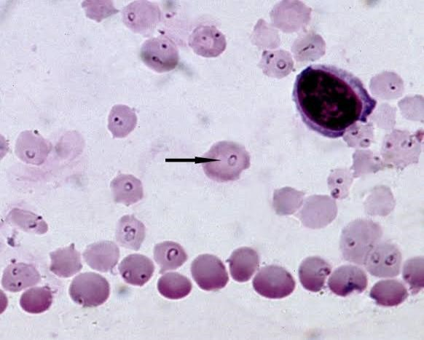
Figure 3.3 Showing Theliria Parasite in a Blood Sample
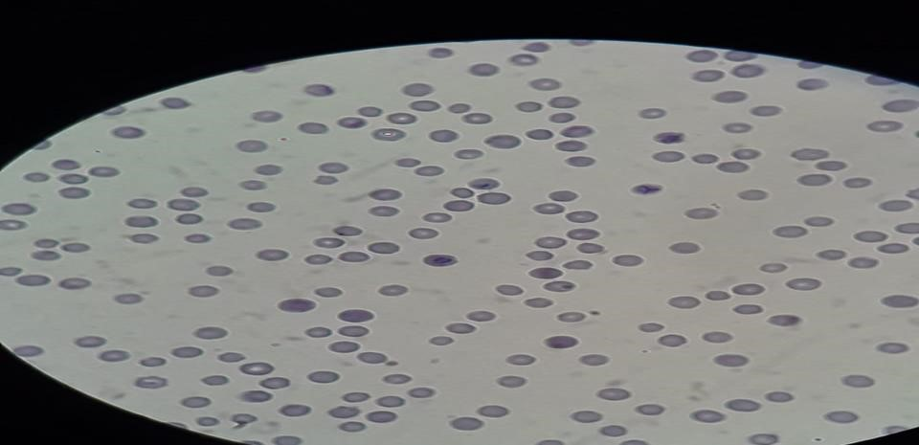

Figure 3.4 Showing Anaplsma Parasite in a Blood Sample
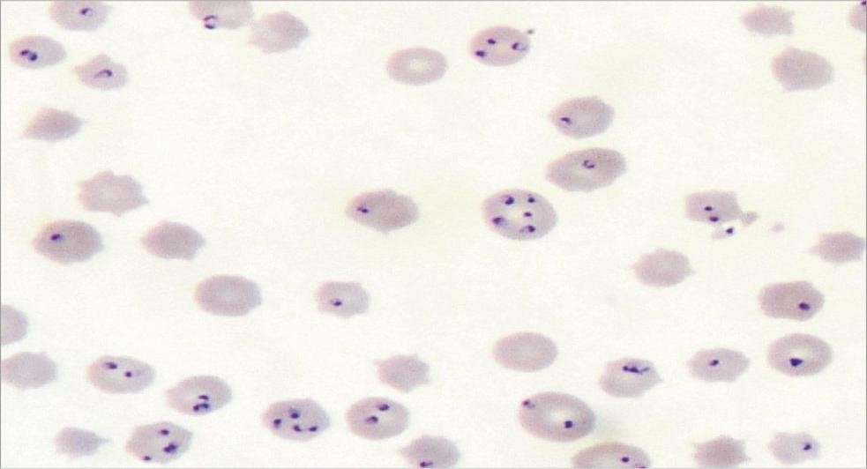

Figure 3.5 Showing Babesia Parasite In a Blood Sample
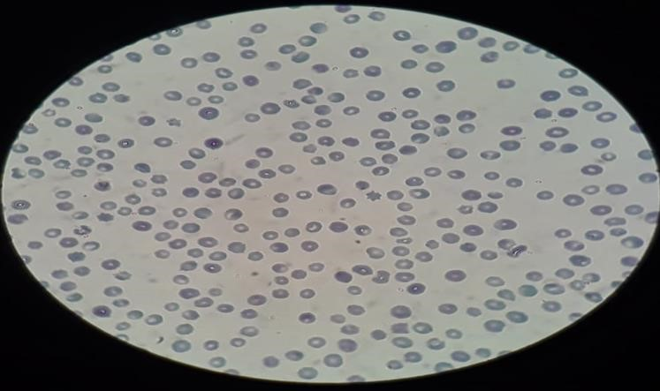
Figure 3.6 Showing Theliria Parasite in a Slide

Figure 3.7 Showing the Theliria Parasite in a Slide
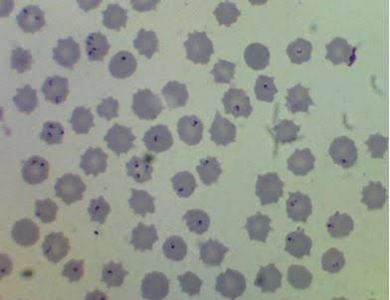

Figure 3.8 Showing the Cow Suffered from the Theileria
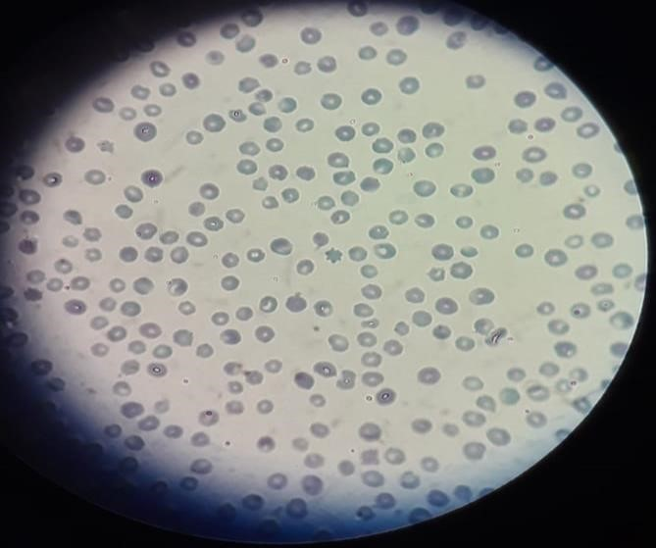
Figure 3.9 Showing Babesia parasite In the Slide

RESULTS AND DISCUSSION

3.1 Prevalence of tick born parasites in the on-season (summer)
Peshawar is a vast district comprising of an area of about 1257 Km² consisting of rural and urban areas. Many of the households have domestic mammals for various purposes. The primary data was collected within two phases through random sampling. In the first phase the samples were collected within the on-season of ticks in the months of June, July and August 2020. In a total 312 samples were collected from various domestic mammals from various areas and the prevalence of ticks borne parasites was analyzed. Out of the total 312 samples, 166 samples were collected from cows, 9 samples were collected from buffalos, 31 samples were collected from sheep, 60 samples were collected from goat, 10 samples were collected from horse, and 26 samples were collected from dog and 10 samples from donkey.
Out of the total collected 166 collected samples for cow 132 samples were analyzed to be positive, having various types of tick borne parasites while the remaining 34 resulted out to be negative having no parasite. For the buffalo out of the total 9 samples, 4 were analyzed to be positive while the remaining 5 resulted out to be negative. For the sheep out of the total 31 samples 24 were positive while the remaining 7 were negative. For goat out of the total 60 samples 36 were positive while the remaining 24 were negative. For horse out of the 10 samples 5 were positive while 5 were negative. For dog out of the total 26 samples 21 were positive while the rest of 5 were negative. For donkey out of the 10 samples collected 9 were positive while 1 was negative.
Since people are less likely to be conscious of ticks in developed environments and ignorant of increased infection in ticks in spring and fall, seasonal change in infected tick density has substantial consequences for Lyme disease transmission. These elements could increase the number of tick bites that result in Lyme disease.[11]
The negativity and positivity ratio for various domestic animals for the on-season are elaborated by the following table 3.1 and graph 3.1.

Species | Positive | Negative | Total
Cow | 132 | 34 | 166
Buffalo | 4 | 5 | 9
Sheep | 24 | 7 | 31
Goat | 36 | 24 | 60
Horse | 5 | 5 | 10
Dog | 21 | 5 | 26
Donkey | 9 | 1 | 10
Total |  |  | 312
Table 3.1 on season Ticks born Parasite prevalence in SDM of District Peshawar

2
13
4
24
36
5
21
9
34
5
7
24
5
5
1
16
6
9
31
60
10
26
10
0
10
20
30
40
50
60
70
80
90
100
110
120
130
140
150
160
170
180
Cow
Bufallo
Sheep
Goat
Horse
Dog
Donkey
On Season Ticks Born Parasite Prevalence In All Selected Species
Positive
Negative
Total
Graph 3.1 showing prevalence of tick born parasites in the on-season

3.2 Prevalence of tick born parasites in the off-season
Similarly in the second phase random sampling was carried out in the off-season of ticks in the months of December, 2020, January, February and March 2021. In the off-season a total of 251 samples were collected from various domestic mammals from different areas of Peshawar district. Out of the total 251 samples, 100 samples were collected from cows, 13 from buffalo, 11 from sheep, 79 from goat, 10 from horse, 28 from dog, and 10 from donkey.
Out of the total 100 samples for cow 77 were analyzed as positive while 23 were negative. For buffalo out of the total 13 samples 4 were positive and the remaining 9 were negative. For sheep out of the total 11 samples 8 were positive and the remaining 3 were negative. For goat out of the total 79 samples 63 were positive while 16 were negative. For horse out of the total 10 samples 6 were positive and 4 were negative. For dog out of the total 28 samples 22 were positive and 6 were negative. For donkey out of the total 10 samples 4 were positive while the remaining 6 were negative.
The negativity and positivity ratio for various domestic animals for the off-season are elaborated by the following table 3.2 and graph 3.2.

Species | Positive | Negative | Total
Cow | 77 | 23 | 100
Buffalo | 4 | 9 | 13
Sheep | 8 | 3 | 11
Goat | 63 | 16 | 79
Horse | 6 | 4 | 10
Dog | 22 | 6 | 28
Donkey | 4 | 6 | 10
Total |  |  | 251
Table: 3.2 off Season Ticks Born Parasite Prevalence in All Selected Species
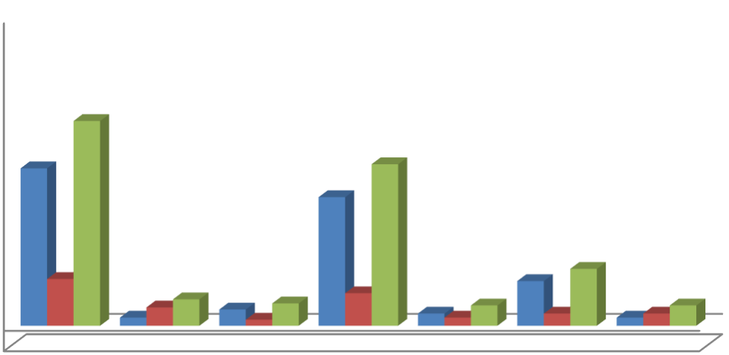

-10
10
30
50
70
90
110
130
150
Cow
Bufallo
Sheep
Goat
Horse
Dog
Donkey
77
4
8
63
6
22
4
23
9
3
16
4
6
6
100
13
11
79
10
28
10
Off Season Ticks Born Parasite Prevalence In All Selected Species
Positive
Negative
Total
Graph 3.2 showing prevalence of tick born parasites in the off-season…

3.3 Comparison of on- season and off-season Parasite prevalence
During both the phases of primary data collection a total of 563 samples were collected from various location of district Peshawar. Out of them 312 samples were collected in the on-season and 251 samples were collected in the off-season. The results of both the phases were compared and the following conclusions were made.
For cows a total of 166 samples were collected in the on-season and 100 samples were collected in the 0ff-season. Out of which 132 samples were positive for the presence of parasites in the on-season and 77 were found positive for the off-season. Similarly 34 samples were found negative during the on-season while 23 were found negative during the off-season.
For buffalo a total of 9 samples were collected during the on-season and 13 samples were collected during the off-season. Out of which 4 were found positive during the on season and 4 were also found positive during the off season. Similarly 5 were found negative during the on season and 9 were found negative during the off season.
For sheep 31 samples were collected in the on-season and 11 samples were collected during the off-season. Out of which 24 were found positive for on-season and 8 were found positive for off-season. Similarly 7 were found negative for on-season and 3 were found negative for off-season.
For goats 60 samples were collected during the on-season and 79 samples were collected for off-season. Out of which 36 samples were found positive for on-season and 63 were found positive for off-season. Similarly 24 samples were found negative for on-season and 16 samples were found negative for off-season.
For horse a total of 10 samples were collected for both on and off seasons. Out of which 5 were found positive for on-season and 6 were found positive for off-season. Similarly 5 samples were found negative for off-season and 4 were found negative during the offseason.
For dog a total of 26 samples were collected during the on-season and 28 samples were collected during the off-season. Out of which 21 were found positive for on-season and 22 were found positive during the off-season. Similarly 5 were found negative during the on season and 6 were found negative during the off season
For donkey a total of 10 samples were collected for both on and off seasons. Out of which 9 samples were found positive for on-season and 4 were found positive for offseason. Similarly 1 sample was found negative for on-season and 6 were found negative for off-season.
In a total 231 samples were found positive during the on season and 184 were found positive during the off-season. Similarly 81 samples were found negative during the onseason and 76 were found negative during the off-season.
The comparison for positivity and negativity of all the collected samples is summarized in the following table 3.3 and graph 3.3

Species | On season  Positive | Off season positive | On season  Negative |  | Off season  Negative
Cow | 132 | 77 | 34 |  | 23
Buffalo | 4 | 4 | 5 |  | 9
Sheep | 24 | 8 | 7 |  | 3
Goat | 36 | 63 | 24 |  | 16
Horse | 5 | 6 | 5 |  | 4
Dog | 21 | 22 | 5 |  | 6
Donkey | 9 | 4 | 1 |  | 6
Total | 231 | 184 | 81 |  | 67
Table 3.3 Showing on season and off season Comparison of Ticks born Parasite prevalence in SDM of District Peshawar
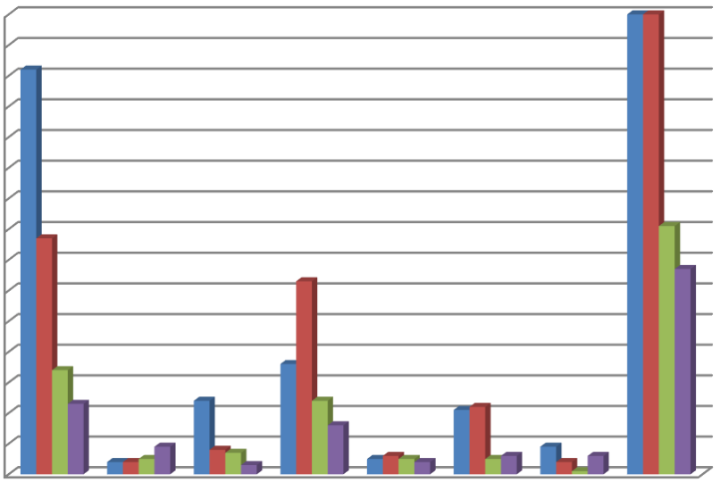

0
10
20
30
40
50
60
70
80
90
100
110
120
130
140
150
Cow
Bufallo
Sheep
Goat
Horse
Dog
donkey
Total
On season and off season Comparison of Ticks born Parasite
prevalance in SDM of District Peshawar
On season +ve
Off season +ve
On season -ve
Off season -ve
Graph 3.3 on season and off season Comparison of Ticks born Parasite prevalence in
SDM of District Peshawar…

3.3 Parasite wise percentage ration in each species of SDM in the study area.
The Data was analyzed for parasite wise percentage ratio in each species of SDM and the following results come to the surface.

3.4.1 Percentage Positivity ratio of parasites in cow samples for on-season
For the on-season a total of 166 samples were collected. 132 out of them were found positive while 34 were found negative.

Specie | Positive | Negative
Cow | 132 | 34
Total |  | 166
Table 3.4 Showing On-Season positivity data of Cow Blood Sample

80
%
20
%
On Season Positivity Ratio of Cow Blood sample
Positive
Negative
Graph 3.4 showing on-Season Positivity Ratio of Cow Blood Sample
3.4.2 Percentage Positivity ratio of parasites in cow blood samples for off-season During the off-season a total of 100 samples were collected out of which 77 were found positive while 23 were found negative.
Species | Positive | Negative
Cow | 77 | 23
Total |  | 100
Table 3.5 Showing Off-season positivity data of Cow Blood sample

77
%
23
%
Off Season Positivity Ratio of Cow Blood sample
Positive
Negative
Graph 3.5 showing off-Season Positivity Ratio of Cow Blood Sample.

3.4.3 Percentage Positivity ratio of parasites in Buffalo samples for on-season For the buffalo a total of 9 samples were collected during the on season out of which 4 samples were found positive while 5 were found negative.
Specie | Positive | Negative
Buffalo | 4 | 5
Total |  | 9
Table 3.6 Showing On-season positivity data of Buffalo Blood sample

44
%
56
%
On Season Positivity Ratio of Buffalo
Blood sample
Positive
Neagtive
Graph 3.6 showing on-Season Positivity Ratio of Buffalo Blood Sample
3.4.4 Percentage Positivity ratio of parasites in Buffalo samples for off-season For the buffalo a total of 13 samples were collected during the off season out of which 4 samples were found positive while 9 were found negative.
Specie | Positive | Negative
Buffalo | 4 | 9
Total |  | 13
Table 3.7 Showing off-Season Positivity data of Buffalo Blood Sample

31
%
69
%
Off Season Positivity Ratio of Buffalo
Blood sample
Positive
Neagtive
Graph 3.7 showing off-Season Positivity Ratio of Buffalo Blood Sample
3.4.5 Percentage Positivity ratio of parasites in Sheep samples for on-season For sheep a total of 31 samples were collected during the on-season out of which 24 samples were found positive while 7 were found negative.
Specie | Positive | Negative
sheep | 24 | 7
Total |  | 31
Table 3.8 Showing on-Season Positivity data of Sheep Blood Sample

77
%
23
%
On Season postitivity Ratio of Sheep
blood sample
Positive
Negative
Graph 3.8 showing on-Season Positivity Ratio of Sheep Blood Sample
3.4.6 Percentage Positivity ratio of parasites in Sheep samples for off-season For sheep a total of 11 samples were collected during the off-season out of which 8 samples were found positive while 3 were found negative.
Specie | Positive | Negative
Sheep | 8 | 3
Total |  | 11
Table 3.9 Showing off-Season Positivity data of Sheep Blood Sample

73
%
27
%
Off season positivity Ratio of Sheeep blood Sample
Positive
Negative
Graph 3.9 showing off-Season Positivity Ratio of Sheep Blood Sample

3.4.7 Percentage Positivity ratio of parasites in Goat samples for on-season For goat a total of 60 samples were collected during the on-season out of which 36 samples were found positive while 24 were found negative.
Specie | Positive | Negative
Goat | 36 | 24
Total |  | 60

Table 3.10 Showing on-Season Positivity data of Goat Blood Sample

Positive
60
%
Negative
40
%
On Season Postitivity Ratio of Goat blood sample
Graph 3.10 showing on-Season Positivity Ratio of Goat Blood Sample

3.4.8 Percentage Positivity ratio of parasites in Goat samples for on-season For goat a total of 79 samples were collected during the off-season out of which 63 samples were found positive while 16 were found negative.
Specie | Positive | Negative
Goat | 63 | 16
Total |  | 79
Table 3.11 Showing off-Season Positivity data of Goat Blood Sample

80
%
20
%
Off Season Postitivity Ratio of Goat blood sample
Positive
Negative
Graph 3. 11 showing off-Season Positivity Ratio of Goat Blood Sample

3.4.9 Percentage Positivity ratio of parasites in Horse samples for on-season For horse a total of 10 samples were collected during the on-season out of which 5 samples were found positive while 5were found negative.
Species | Positive | Negative
Horse | 5 | 5
Total |  | 10
Table 3.12 Showing on-Season Positivity data of Horse Blood Sample

Positive
50
%
Negative
50
%
On Season Positivity Ratio of Horse Blood sample
Graph 3.12 showing on-Season Positivity Ratio of Horse Blood Sample

3.4.10 Percentage Positivity ratio of parasites in Horse samples for off-season For horse a total of 10 samples were collected during the off-season out of which 6 samples were found positive while 4 were found negative.
Specie | Positive | Negative
Horse | 6 | 4
Total |  | 10
Table 3.13 Showing off-Season Positivity data of Horse Blood Sample

60
%
40
%
Off Season Positivity Ratio of Horse Blood sample
Positive
Negative
Graph 3.13 showing off-Season Positivity Ratio of Horse Blood Sample

3.4.11 Percentage Positivity ratio of parasites in Dog samples for on-season For dog a total of 26 samples were collected during the on-season out of which 21 samples were found positive while 5 were found negative.
Specie | Positive | Negative
Dog | 21 | 5
Total |  | 26
3.14 Showing on-Season Positivity data of Dog Blood Sample

81
%
19
%
On Season Postitivity Ratio of Dog blood sample
Positive
Neagtive
Graph 3.14 showing on-Season Positivity Ratio of Dog Blood Sample

3.4.12 Percentage Positivity ratio of parasites in Dog samples for off-season For dog a total of 28 samples were collected during the off-season out of which 22
samples were found positive while 6 were found negative.
Specie | Positive | Negative
Dog | 22 | 6
Total |  | 28
Table 3.15 Showing off-Season Positivity data of Dog Blood Sample

79
%
21
%
Off Season Postitivity Ratio of Dog blood sample
Positive
Neagtive
Graph 3.15 showing off-Season Positivity Ratio of Dog Blood Sample

3.4.13 Percentage Positivity ratio of parasites in Donkey samples for on-season For donkey a total of 10 samples were collected during the on-season out of which 9 samples were found positive while 1 was found negative.
Specie | Positive | Negative
Donkey | 9 | 1
Total |  | 10
Table 3.16 Showing on-Season Positivity data of Donkey Blood Sample

Positive
90
%
Neagtive
10
%
On Season Positivity Ratio of Donkey Blood sample
Graph 3.16 showing on-Season Positivity Ratio of Donkey Blood Sample

3.4.14 Percentage Positivity ratio of parasites in Donkey samples for off-season For donkey a total of 10 samples were collected during the off-season out of which 4 samples were found positive while 6 was found negative.
Specie | Positive | Negative
Donkey | 4 | 6
Total |  | 10
Table 3.17 Showing off-Season Positivity data of Donkey Blood Sample

Positive
40
%
Neagtive
60
%
Off Season Positivity Ratio of Donkey Blood sample
Graph 3.17 showing off-Season Positivity Ratio of Donkey Blood Sample….

3.5.1 Parasite wise Percentage ratio in each species of SDM in study area
The Data was analyzed for Parasite wise Percentage in each species of SDM in study area and the following results come to the surface.

3.5.2 Parasite wise Percentage ratio of cow on season
During the on-season 134 samples were found positive for parasites. The parasites for three diseases were found in these samples. Out of the 134 positive samples 72 were found to contain parasites for Anaplasma, 57 were found to contain parasites for Theileria and 3 were found to contain parasite for Babesia.

Specie | Anaplasma | Theileria | Babesia
Cow | 72 | 57 | 3
Total |  |  | 132
Table 3.18 Showing on-season Parasite wise data of Cow blood Sample

54
%
44
%
2
%
Parasite wise Percentage Ratio of cow blood Samples On season
Anaplasma
Theileria
Babesia
Graph 3.18 showing on-Season Parasite wise Positivity Ratio of Cow Blood Sample

3.5.3 Parasite wise Percentage ratio of cow off season
During the off-season 100 samples were found positive for parasites. The parasites for three diseases were found in these samples. Out of the 100 positive samples 62 were found to contain parasites for Anaplasma, 35 were found to contain parasites for Theileria and 3 were found to contain parasite for Babesia.

Specie | Anaplasma | Theileria | Babesia
cow | 62 | 35 | 3
Total |  |  | 100
Table 3.19 Showing off-season Parasite wise data of cow Blood Sample

62
%
35
%
3
%
Parasite wise Percentage Ratio of cow blood Samples
off season
Anaplasma
Theileria
Babesia
Graph 3.19 showing off-Season Parasite wise Positivity Ratio of Cow Blood Sample

3.5.4 Parasite wise Percentage ratio of Buffalo on season
Out of the 4 positive samples for the on-season in buffalo samples only Anaplasma was found in all the samples and no Theileria and Babesia were found.

Specie | Anaplasma | Theileria | Babesia
Buffalo | 4 | 0 | 0
Total |  |  | 4
Table 3.20 Showing on-season Parasite wise data of buffalo Blood Sample

100
%
0
%
Parasite wise Percentage Ratio of Buffalo blood
Samples On season
Anaplasma
Theileria
Babesia
Graph 4.20 showing on-Season Parasite wise Positivity Ratio of Buffalo Blood Sample

3.5.5 Parasite wise Percentage ratio of buffalo off season
Out of the 4 positive samples for the off-season in buffalo samples only Anaplasma was found in all the samples and no Theileria and Babesia were found
Specie | Anaplasma | Theileria | Babesia
Buffalo | 4 | 0 | 0
Total |  |  | 4
Table 3.21 Showing off-season Parasite wise data of buffalo Blood Sample

100
%
0
%
Parasite wise Percentage Ratio of Buffalo blood
Samples Off season
Anaplasma
Theileria
Babesia
Graph 3.21 showing off-Season Parasite wise Positivity Ratio of Buffalo Blood Sample

3.5.6 Parasite wise Percentage ratio of Sheep on season
Out of the 26 positive samples for the on-season in sheep samples Anaplasma parasite was found in 19 samples, Theileria was found in 7 samples and no Babesia was found

Specie | Anaplasma | Theileria | Babesia
Sheep | 19 | 7 | 0
Total |  |  | 26
Table 3.22 Showing on-season Parasite wise data of Sheep Blood Sample

73
%
27
%
0
%
Parasite wise Percentage Ratio of Sheep blood Samples
On season
Anaplasma
Theileria
Babesia
Graph 3.22 showing on-Season Parasite wise Positivity Ratio of Sheep Blood Sample

3.5.7 Parasite wise Percentage ratio of Sheep off season
Out of the 8 positive samples for the off-season in sheep samples Anaplasma parasite was found in 7 samples, Theileria was found in 1 sample and no babesia was found

Specie | Anaplasma | Theileria | Babesia
Sheep | 7 | 1 | 0
Total |  |  | 8
Table 3.23 Showing off-season Parasite wise data of Sheep Blood Sample

87
%
13
%
0
%
Parasite wise Percentage Ratio of Sheep blood Samples
Off season
Anaplasma
Theileria
Babesia
Graph 3.23 showing off-Season Parasite wise Positivity Ratio of Sheep Blood Sample

4.5.8 Parasite wise Percentage ratio of Goat on season
Out of the 35 positive samples for the on-season in goat samples Anaplasma parasite was found in 32 samples, Theileria was found in 3 samples and no babesia was found

Specie | Anaplasma | Theileria | Babesia
Goat | 32 | 3 | 0
Total |  |  | 35
Table 3.24 Showing on-season Parasite wise data of Goat Blood Sample

Anaplasma
91
%
Theileria
9
%
Babesia
0
%
Other
0
%
Parasite wise Percentage Ratio of Goat blood Samples
On season
Graph 3.24 showing on-Season Parasite wise Positivity Ratio of Goat Blood Sample

3.5.9 Parasite wise Percentage ratio of Goat off season
Out of the 33 positive samples for the on-season in goat samples Anaplasma parasite was found in 22 samples, Theileria was found in 11 samples and no babesia was found.

Specie | Anaplasma | Theileria | Babesia
Goat | 22 | 11 | 0
Total |  |  | 33
Table 3.25 Showing off-season Parasite wise data of Goat Blood Sample

67
%
33
%
0
%
Parasite wise Percentage Ratio of Goat blood
Samples Off season
Anaplasma
Theileria
Babesia
Graph 3.25 showing off-Season Parasite wise Positivity Ratio of Goat Blood Sample

3.5.10 Parasite wise Percentage ratio of Horse on season
Out of the 6 positive samples for the on-season in horse samples Anaplasma parasite was found in 3 samples, Theileria was found in 1 sample and babesia was found in 1 sample

Specie | Anaplasma | Theileria | Babesia
Horse | 3 | 1 | 2
Total |  |  | 6
Table 3.26 Showing on-season Parasite wise data of Horse Blood Sample

50
%
17
%
33
%
Parasite wise Percentage Ratio of Horse blood Samples
On season
Anaplasma
Theileria
Babesia
Graph 3.26 showing on-Season Parasite wise Positivity Ratio of Horse Blood Sample

3.5.11 Parasite wise Percentage ratio of Horse off season
Out of the 5 positive samples for the off-season in horse samples Anaplasma parasite was found in 3 samples, Theileria was found in no sample and babesia was found in 2 samples

Specie | Anaplasma | Theileria | Babesia
Horse | 3 | 0 | 2
Total |  |  | 5
Table 3.27 Showing off-season Parasite wise data of Horse Blood Sample

60
%
0
%
40
%
Parasite wise Percentage Ratio of Horse blood Samples
Off season
Anaplasma
Theileria
Babesia
Graph 3.27 showing off-Season Parasite wise Positivity Ratio of Horse Blood Sample

3.5.12 Parasite wise Percentage ratio of Dog on season
Out of the 21 positive samples for the on-season in dog samples Anaplasma parasite was found in 20 samples, Theileria was found in no sample and Babesia was found in 1 sample.

Specie | Anaplasma | Theileria | Babesia
Dog | 20 | 0 | 1
Total |  |  | 21
Table 3.28 Showing on-season Parasite wise data of Dog Blood Sample
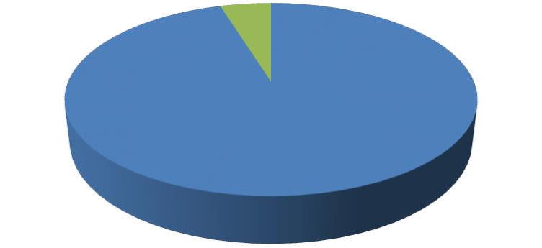

95
%
0
%
5
%
Parasite wise Percentage ratio of Dog on season
Anaplasma
Theileria
Babesia
Graph 3.28 showing on-Season Parasite wise Positivity Ratio of Dog Blood Sample

3.5.13 Parasite wise Percentage ratio of Dog off season
Out of the 22 positive samples for the off-season in dog samples Anaplasma parasite was found in 20 samples, Theileria was found in no sample and babesia was found in 2 samples

Specie | Anaplasma | Theileria | Babesia
Dog | 20 | 0 | 2
Total |  |  | 22
Table 3.29 Showing off-season Parasite wise data of Dog Blood Sample

100
%
0
%
Parasite wise Percentage ratio of Dog off season
Anaplasma
Theileria
Babesia
Graph 3.29 showing off-Season Parasite wise Positivity Ratio of Dog Blood Sample

3.5.14 Parasite wise Percentage ratio of Donkey on season
Out of the 9 positive samples for the on-season in donkey samples Anaplasma parasite was found in 3 samples, Theileria was found in 1 sample and babesia was found in 5 samples

Specie | Anaplasma | Theileria | Babesia
Donkey | 3 | 1 | 5
Total |  |  | 9
Table 3.30 Showing on-season Parasite wise data of Donkey Blood Sample
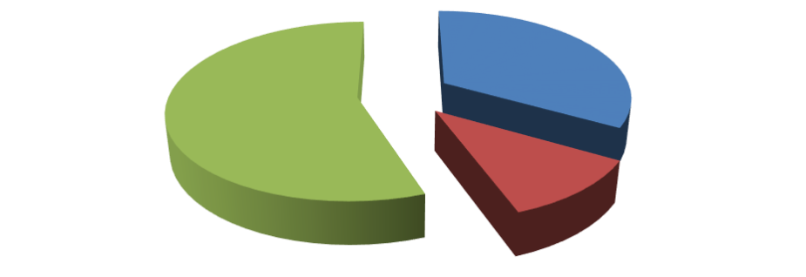

Anaplasma
33
%
Theileria
11
%
Babesia
56
%
Parasite wise Percentage ratio of Donkey on season
Graph 3.30 showing on-Season Parasite wise Positivity Ratio of Donkey Blood Sample

3.5.15 Parasite wise Percentage ratio of Donkey off season
Out of the 4 positive samples for the on-season in donkey samples Anaplasma parasite was found in 1 sample, Theileria was found in no sample and babesia was found in 3 samples

Specie | Anaplasma | Theileria | Babesia
Donkey | 1 | 0 | 3
Total |  |  | 4
Table 3.31 Showing off-season Parasite wise data of Donkey Blood Sample

Anaplasma
25
%
Theileria
0
%
Babesia
75
%
Parasite wise Percentage ratio of Donkey off season
Graph 3.31 showing off-Season Parasite wise Positivity Ratio of Donkey Blood
Sample…

3.6 Disease Prone Specie out of SDM in the study area
During the analysis of the tick born parasites a total of seven species were selected for the study purpose from the domestic mammals and the specie which was at greatest risk from the parasite was analyzed. The results showed that out of the selected samples for each SDM the highest percentage for positivity was shown by in dog which is 80%. Similarly the positivity percentage for other SDM is: 79% for cows, 36 % for buffalo, 76% for sheep, 71% for goat, 55% for horse, and 73% for donkey. The below table and graph summarizes the results.

Species | Positive | Negative | Total | Percentage
Cow | 209 | 57 | 266 | 79%
Buffalo | 8 | 14 | 22 | 36%
Sheep | 32 | 10 | 42 | 76%
Goat | 99 | 40 | 139 | 71%
Horse | 11 | 9 | 20 | 55%
Dog | 43 | 11 | 54 | 80%
Donkey | 13 | 7 | 20 | 65%
Total | 415 | 148 | 563 | 73.71%
Table. 3.32 showing disease Prone Specie out of SDM in the study area
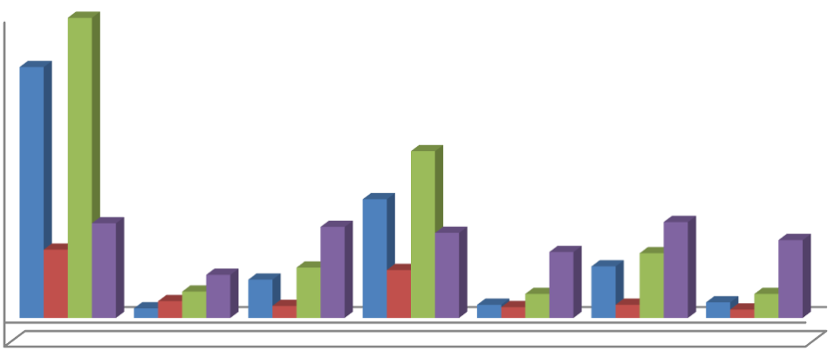

-20
10
40
70
100
130
160
190
220
250
Cow
Bufallo
Sheep
Goat
Horse
Dog
Donkey
209
8
32
99
11
43
13
57
14
10
40
9
11
7
266
22
42
139
20
54
20
79
36
76
71
55
80
65
Disease Prone Specie out of SDM of District Peshawar
Postive
Negative
total
Percentage
Graph 3.32 showing disease Prone Specie out of SDM in the study area….

3.7 The most dominant parasite during the on and off season of the selected area One of the objective of the study was to find out the most dominant parasite during the on and off season. The findings of the collected samples in the study area showed that the most prevailing parasite during the on season was Anaplasma. Out of the total 231 positive cases for the on season 151 cases were positive for Anaplasma, 69 were found positive for Theileria and 11 were found positive for Babesia.
Similarly for the off season out of the total positive 176 positive cases for various parasites the highest number was shown by parasites for Anaplasma which was 121, 47 positives cases were reported for Theileria and 8 for Babesia.

 | Cow  On | Buffalo  On | Sheep  On | Goat  On | Horse  On | Dog  On | Donke y On | Total
Anaplasma | 70 | 4 | 19 | 32 | 3 | 20 | 3 | 151
Theileria | 57 | 0 | 7 | 3 | 1 | 0 | 1 | 69
Babesia | 3 | 0 | 0 | 0 | 2 | 1 | 5 | 11
Table. 3.33 showing Dominant Parasite in summer (on Season)

 | Cow  Off | Buffalo  Off | Sheep  Off | Goat  Off | Horse  Off | Dog  Off | Donkey  Off | Tot  al
Anaplas ma | 63 | 4 | 7 | 22 | 4 | 20 | 1 | 121
Theileri a | 35 | 0 | 1 | 11 | 0 | 0 | 0 | 47
Babesia | 3 | 0 | 0 | 0 | 2 | 0 | 3 | 8
Table. 3.34 showing Dominant Parasite in winter (off season)…

3.8 To determine the dominant Parasite in the SDM of the study area
Study was also aimed at finding out the most common parasite out of the SDM. The results for both the seasons showed that within the study area the most common parasite was found out to be Anaplasma whose positive cases were reported out to be 272. The positive cases for Theileria were found out to be 116 and for Babesia the positive cases were 19.

Parasite | Anaplasma | Theileria | Babesia
On season | 151 | 69 | 11
Off season | 121 | 47 | 8
Total | 272 | 116 | 19
Table. 3.35 showing Dominant Parasite in (SDM) of the study area…

4.9 The overall Positivity percentage ratio of the collected Samples in the SDM To find out the overall positivity percentage the results showed that out of the total 563 collected samples 514 were positive for the presence of parasite while 148 showed no presence of parasite. So the overall positivity ratio was found out to be 73.72 percent.

Total Samples | Positive Samples | Negative Samples
563 | 415 | 148
Total Samples %age | Positivity Percentage | Negativity Percentage
100 | 73.72 | 26.28
Table. 3.36 showing the overall Positivity percentage ratio of the collected Samples in the
SDM

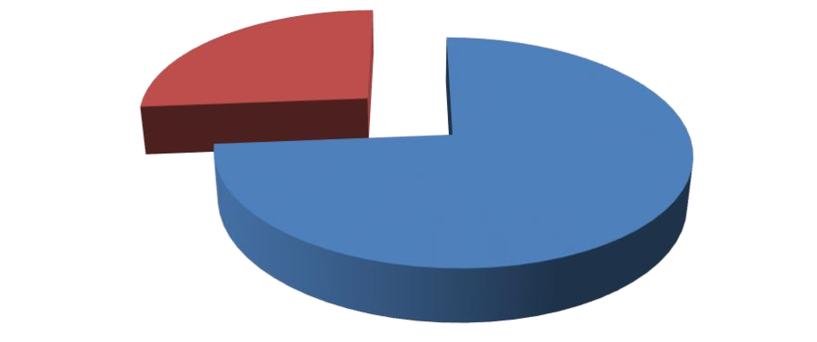

Positivity
Percentage
74
%
Negativity
Percentage
26
%
The Overall Positivity Percentage of the Collected
Samples in the SDM
Graph 3.33 showing the overall Positivity percentage ratio of the collected Samples in the
SDM…

CONCLUSION AND RECOMMENDATIONS
Peshawar s one of the oldest cities in Asia and is the capital of Khyber Pakhtunkhwa. Most of the people of the city keep domestic mammals in their houses for various purposes. But amongst the other problems ticks borne parasites pose one of the largest threat to their domestic mammals. The main objective of the study was to find out the prevalence of tick borne parasite in the domestic mammals of district Peshawar.
The study revealed that Anaplasma, Theileria, and Babesia are the main ticks borne parasites of the SDM in the study area. The study was carried out in two season i.e onseason from June to August 2020 and off-season from December 2020 to February 2021. A total of 563 samples were collected from various infected SMD of the study area. Out of these 312 samples were collected during the on-season and 251 samples were collected during the off-season. During the on-season the positivity ratio for cow, buffalo, sheep, goat, horse, dog, and donkey was 80%, 44%, 77%, 60%, 50%, 81% and 90% respectively. The off-season showed the positivity ratio for cow, buffalo, sheep, goat, horse, dog, and donkey was 77%, 31%, 73%, 80%, 60%, 79% and 40% respectively. Anaplasmosis was found to be the most common parasite while the most disease prone specie was found to be dog with 80% positivity ratio among the SDM. The overall positivity ratio was found out to be 74% from amongst the infected SDM. In the last various suggestions were recommended to control these parasites at the earliest.

CONCLUSION
An extensive study was carried out to find the prevalence of ticks borne parasites in the SDM of District Peshawar. Various objectives were made before the study and the following conclusions were made
- The positive cases during the on-season for cow, buffalo, sheep, goat, horse, dog and donkey were 132 out of 166, 4 out of 9, 24 out of 31, 36 out of 60, 5 out of 10. 21 out of 26, and 9 out of 10 respectively.
- The positive cases during the off-season for cow, buffalo, sheep, goat, horse, dog and donkey were 77 out of 100, 4 out of 13, 8 out of 11, 63 out of 79, 6 out of 10. 22 out of 28, and 4 out of 10 respectively.
- The percentage prevalence of the positivity ratio shows that cow, buffalo, sheep, dog, and donkey had high positivity percentage during the on-season while goat and horse had high positivity percentage during the off-season
- Parasite wise analysis shows that Anaplasma was the most common parasite in all the SDM followed by Theileria and then by Babesia
- The most disease prone specie to the parasite was found out to be in the descending order from dog cow sheep goat donkey horse and buffalo
- The overall positivity ratio of SDM for the collected samples was found out to be
73.72%

SUGGESTION AND RECOMMENDATIONS

- Local community must be aware about the harmful effects of ticks and their associated parasites.
- For awareness regarding tick borne diseases we should use our already existing social setup i.e. masajid, hujras etc to aware our live stocks owners/farmers about the fatality of such parasites.
- For awareness campaign relevant Government body, NGOs and other social workers should be directed and motivated.
- Immediately isolate any cow, Buffalo, dog etc. show signs of tick borne diseases, this will prevent further spread of diseases to other animals.
- People living in tick endemic area should inspect their domestic animals. If a tick is found embedded in animal pull it out using tweezer.
- Daily, weekly and monthly naked eye checking of the domestic’s mammals should be conducted to avoid the spread of the Ticks.
- Use available insecticides in yard areas that will reduce the number of ticks.
- Use Avaricides (agent Used to kill ticks) properly to Kill ticks.
- Powder of diatoms can also be applied throughout yard or single animals to kill ticks.
- Use of oral medicine such as Afoxolaner is one of the most popular method get rid of ticks.
- Injectable compounds are also effective for some Ticks such as blue Ticks.
- Use of Anti Ticks vaccine is the most effective method.
- A LYMErix is a vaccine to prevent between 76 to 92 percent of infections, Hundreds and thousands and people got it.
- Use predators of Ticks like birds, rodents or Ants which play a role in reducing free living Ticks.
- It is recommended to treat newly introduced cattle before they are placed with the rest of herd.
- Never mix newly purchased animals with the already existing stock before treatment.
- Spray Nematodes into yard in order to kill the ticks (Nematodes are microscopic parasites they only harm insects and arachnids) ❖ Use grass or hey free form ticks and avoid contact with other animals ❖ Tick repellent shampoo should be used to repel ticks.
- Keep lawns trimmed at home and near domestic mammals to avoid ticks and latching onto a host.
- Placing a barrier between lawns and mammals keeping areas, can help keep ticks from moving onto mammals.
- Do a final, full-body tick check at the end of the day (also check children and pets), and remove ticks promptly.
- Spreading ashes are diatomic in nesting sites and areas where the birds dust bath the soft tick problem can be somehow controlled are greatly reduced.
- Dry leaves of Lantana, Eucalyptus, Neem, Pyrethrum and typhrosia added to ashes in nest and dust bath areas greatly reduced number of soft ticks.
- Use primarily local breeds which are more resistant to ticks than exortic breeds or cross breeds.
- Spraying cattle before moving them to new pausters.
- Various classes of acaricides such as diazinon, ehtion, propanur, methoxychlor. Tonophen, pyrethrin, amitres, etc can effectively reduce ticks borne diseases.
- Owners of small ruminants should take special care of their animals.
- Good management practices accounts for tick’s eradications in large animals.

AKNOWLEDGEMENTS
All praises be to Allah, the most Merciful and Beneficent Who gave man the power to think and act accordingly. I am thankful to Almighty Allah Who enabled me to have this contribution.
I am very much thankful to my research supervisor Mr. Sahibzada Muhammad Jawad, Lecturer Department of Zoology, Qurtaba University of Science and Information Technology Peshawar for his kind supervision, guidance, timely response, generous suggestions and technical advice during surveying as well as report writing of this research study.I also greatly appreciate the kind efforts of Mr. Sarfaraz Khan, Laboratory Technician, Veterinary Hospital, Bacha Khan Chowk Peshawar for his valuable guidance and laboratory help during research activities. I always found him very much alive, full of zeal, vitality and intellectual curiosity. Without his ideas, remarks and endless interest this work could not have been carried out and completed. I am indebted to all the teachers of the Department of Zoology, Qurtaba University of Science and Information Technology Peshawar for giving valuable suggestions and to encourage me to pursue my studies with spirit and confidence.I am much obliged to my family for the financial help, and my parents, brothers and sisters to pray for me to achieve my goals. I am much pleased to appreciate my class fellows for their help during the course of the research work.

REFERENCES
- (PES) Pakistan Economic Survey (2013–14). Ministry of Finance, Islamabad: Government of Pakistan. 2014: 23–41.
- Skyes AR (1994). Parasitism and production in farm animals. Anim. Prod. 59: 155-172. https://doi.org/10.1017/ S0003356100007649
- Maske DK, Bhilegaonkar NG, Sardey MR (1990). Prevalence of parasitic infections in domestic animals at Nagpur Maharashtra. J. Vet. Parasitol. 4(2): 23-25.
- Stuen S, Bergstrom K, Palm E (2002). Reduced weight gain due to subclinical Anaplasma phagocytophilum (formerly Ehrlichia phagocytophila) infection. Exp. Appl. Acarol. 28: 209–215. https://doi.org/10.1023/A:1025350517733
- Stuen S, Nevland S, Moum T (2003). Fatal cases of Tickborne fever (TBF) in sheep caused by several 16S rRNA gene variants of Anaplasma phagocytophilum. Ann. N. Y. Acad. Sci. 990: 433–434. https://doi.org/10.1111/j.1749-6632.2003. tb07407.x
- Garcia-Perez A L, Barandika J, Oporto B, Povedano I, Juste RA (2003). Anaplasma phagocytophila as an abortifacient agent in sheep farms from northern Spain. Ann. N. Y. Acad. Sci. 990: 429–432. https://doi.org/10.1111/j.1749-6632.2003. tb07406.x
- Razmi GR, Dastjerdi K, Hossieni H, Naghibi A, Barati F, Aslani MR (2006). An epidemiological study on Anaplasma infection in cattle, sheep, and goats in Mashhad Suburb, Khorasan Province, Iran. Ann. N. Y. Acad. Sci. 1078: 479– 481. https://doi.org/10.1196/annals.1374.089
- Matsumoto K, Joncour G, Davoust B, Pitel PH, Chauzy A, Collin E, Morvan H, Vassallo N, Brouqui P(2006). Anaplasma phagocytophilum infection in cattle in France. Ann. N. Y. Acad. Sci. 1078: 491–494. https://doi. org/10.1196/annals.1374.092
- Naz S, Maqbool A, Ahmed S, Ashraf K, Ahmed N, Saeed K, Latif M, Iqbal J, Ali Z, Shafi K, Nagra IA (2012). Prevalence of theileriosis in small ruminants in Lahore-Pakistan. J. Vet. Anim. Sci. 2: 16-20.
- Atif FA, Muhammad SK, Hafiz JI, Ghulam MA, Ejaz A, Sami U (2012). Prevalence of Anaplasma marginale, Babesia bigemina and Theileria annulata infections among cattle in Sargodha District, Pakistan. Afr. J. Agric. Res. 7(22): 33023307.
- Roome, A., Spathis, R., Hill, L., Darcy, J. M., & Garruto, R. M. (2018, July). Lyme disease transmission risk: seasonal variation in the built environment. In Healthcare (Vol. 6, No. 3, p. 84). MDPI.
- Waqar Ahmad Khan & Dr. Shahid Ali Shah. (2022). Ticks in Cattle: Their Importance and Chemical and Treatment Control. LC International Journal of STEM (ISSN: 2708-7123), 3(2), 31–48. https://doi.org/10.5281/zenodo.6844503
- Rashid, M. I. (2018). Epidemiology of tick-borne infection in ruminants in Peshawar. J. Adv. Parasitol, 5(1), 6-10.
- Khan, A., Nasreen, N., Niaz, S., Sajjad Ali Shah, S., Mitchell III, R. D., Ayaz, S., ... & De León, A. P. (2019). Tick burden and tick species prevalence in small ruminants of different agencies of the Federally Administered Tribal Areas (FATA), Pakistan. International Journal of Acarology, 45(6-7), 374-380.
- Mohsin, M., Hameed, K., Kamal, M., Ali, A., Rafiq, N., Usman, T., ... & Yousafzai, G. J. (2022). Prevalence and risk factors assessment of theileriosis in livestock of Malakand Division, Pakistan. Journal of the Saudi Society of Agricultural Sciences, 21(4), 242-247.
- Khan, A., Mitchell III, R. D., Niaz, S., Ayaz, S., Khattak, I., Naeem, H., ... & Zaman, M. A. (2019). Seroprevalence of Anaplasma spp. among sheep and goats in Charsadda District, Pakistan. Small Ruminant Research, 176, 5-10.

1/18/2023

