GANGADHARA RAO IRLAPATI
who made researches on the Geo-machine

Gangadhara Rao Irlapati

C. H.No.5-30-4/1,Saibabanagar,Jeedimetla,,Hyderabad,India-500055
Email: gangadha19582058@gmail.com
C c Google pay A/C No.+91 9989239159

Abstract
There is a need to do researches on some things which are unsolved in science. Geo-Machine is one of them. I tried to my best to create Geo-Machine in modern methods through this it is possible to re-create humans of past who are embedded in the earth magnetic layers and tried to conduct researches but uncompleted due to lack of support and opportunities. I call on world scientists to do researches that create Geo-machine. The researches and studies done by me on the Geo-machine can be useful and inspiring for future generations. So, scientists can study the researches, studies and published works I have done thoroughly and go up with solutions to solve the issue.
[Gangadhara Rao Irlapati. GANGADHARA RAO IRLAPATI who made researches on the Geo-machine.Researcher2022;14(11):30-228] ISSN1553-9865(print);ISSN2163-8950(online)
http://www.sciencepub.net/researcher. 05.doi:10.7537/marsrsj141122.05.

Key words: Bioforecast(1965-70), Irlapatism-A New Hypothetical Model of Cosmology (1970-77), Geoscope (1980-87), Basics of Monsoon Time Scales (1987-91), North American Monsoon Time Scale (1991), North African Monsoon Time Scale (1991), Indian Monsoon Time Scale (1991), East Asian Monsoon Time Scale (1991), Western North Pacific Monsoon Time Scale (1991), South African Monsoon Time Scale (1991), South African Monsoon Time Scale (1991), Australian Monsoon Time Scale (1991), Numerical Weather Periodic Tables ( 1991-2000 ), National Geoscope projects (2000-10), Global Monsoon Time Scales (2010-22)

Introduction:
Early life: I, Gangadhara rao irlapati, an unfortunate Indian scientist born on 25th May,1958 in a group of lowest social caste system( ranked as Mala in scheduled caste) traditionally to be untouchable in India. Parents: Pullaiah Irlapati(father),Manikyam Irlapati(mother); Brothers&Sisters:Sampath Rao Irlapati(brother),Saroja Irlapati(sister),Bhagyam Irlapati(sister), Gangadhara Rao Irlapati(self), Kalavathi Irlapati(sister), Balaji Irlapati(brother); Spouse: Satyavathi Irlapati; Children: Pullaiah Naidu Irlapati(son), Prudhvi Irlapati(son), Saroja(daughter); My wife and childrens are argumentative, negative and ill-tempered who vehemently opposed my researches and they were mentally torturing me.

Education: I acquired scientific interest and conscious inherently by birth. I did primary education from 1 to 5 th classes in Government Elementary High School, Merlapalem(1963-1968); 6th & 7th classes in Government Upper Primary School, Vubalanka(1969-1971); 8TH to 10TH classes at Government High School, Ravulapalem (1971-74); Intermediate 11+12 classes at M.G.Jr. College, Atreyapuram(1974-76). I studied graduation B.A. degree in Andhra University(1985-89) and obtained post-graduation M.Sc degree in disaster mitigation sciences from Sikkim Manipal University(2001-03).

Researches&studies:
I am a science enthusiast and experimenter with an ideal to serve the scientific development and public service, I went around government offices and research organizations for research support and opportunities. But the Governments & councils did not encourage&provide opportunities; officials & researchers ridiculed me and pushed out. My thoughts angered the fundamentalists & superstitious. Despite being oppressed and not getting research opportunities, I built a small lab at my house with availabl resources & mathematical instruments, drawings, designs, home-made apparatus, scrap reference books and have did over a 1000 researches and studies on anticipating weather changes and natural calamities that can be performed either in easy methods or at complicating infrastructure; either with big amount or at no cost; either by common researchers or by great researchers from 1965 to present. Among them, Bio-forecast(1965-70), Irlapatism-A New Hypothetical Model of Cosmology(1970-1977), Geoscope (1980-1987), Basics of Monsoon Time Scales (1987-91), Indian Monsoon Time Scale (1991), Numerical Weather Periodic Tables(2000-2006), Designs of Geoscope(2000-10), Designs of Global Monsoon Time Scales (2010-20), Basics of Global Monsoon Time Scales(2006-2012) are crucial. In addition, I tried to find out some inventions on the basis of some super research ideas/proposals but could not do further researches on those research ideas due to lack of opportunities. Besides these, I have done also various other services and play active role in many fields science popularization programmes, modern scientific ideas of hierarachical, infinite and innumerable universes, mysteries and rational thoughts of the creation and cosmo and general taking an active part in issues such as literacy programmes, remedial programmes, rationalize programmes, etc that concerned greater good of the community associated with many organizations like Peoples Action For Rural Awakening, Ravulapalem. Apart from these,
Bioforecast(1965-70):
From 1965 to 1970, I started doing researches and studies around 10th year of my childhood. Organisms such as animals, fish, birds, reptiles, and insects etc have a biological genetic forecasting system that predics weather changes and disasters in advance. Many researches and studies did on this biological genetic forecasting system between 1965 to 1970, and invented Lisposcope in 1965, Biolumicells (Bioluminescent micells) in 1966, and Bioforecast effect in 1969. These are my first inventions which can help to forecast the weather changes 18 days in advance. I tried to break the mystery of how organisms can detect weather changes and disasters in advance.
This system was efficiently conducted and proved in the presence many researchers and institutions. Although weakened by forecasting property with less successive rate, it is a primary and natural biological genetic forecasting method.The important prediction of the Bio-forecast was proved in 1991. In 1991, the Andhra Pradesh State Council of Science & Technology, The Andhra Pradesh Remote Sensing Applications Centre and the Andhra Pradesh Science Centre were conducted experiments on the relationship between the biosphere and atmosphere (explore the inter-connection of earths geomagnetic field with natural calamities and their effect on human impulse). In these observations, the maximum level of the Biolumicells were recorded between 7th to 11th of April, 1991. It is the sign of the ensuring cyclone of the 28th April 1991. The three directors of the said institutions were met in the Andhra Pradesh State Council of Sciences & Technology on 9TH, April 1991 and discussed about the prediction. As predicted on 9th April 1991, in the meeting a severe cyclone was formed in Bay of Bengal and strike the Bangladesh on 28th April 1991. As a result, thousands of people were killed and crores of rupees property was damaged. This is the Great prediction by the Bio-forecast and the remaining predictions were weak. Global researchers can do more research and develop on this natural biological genetic forecasting method and use it for the welfare of global humanity.
Time-line:
In 1965, I started my earlier experiments at the age of 7th year, with home-made apparatus, mathematical box and pencils etc and invented the Lisposcope(1965) . .
In 1966, Discovered some bubble like objects later named as Biolumucells (Boiluminiscent micells(1966)).
In 1969, I found the relationship between the weather changes and the number of micells later it was named as Bio-forecast effect(1969).
Irlapatism-A New Hypothetical Model of Cosmology (1970-77):
Between 1970-77 years I have done extensive researches and studies on the origin, nature, structure and evolution of the creation and proposed basics of creation. Based on those basics, A New Hypothetical Model of Cosmology was proposed in 1977. A book was also published and released on 1st july,1977 in the name of Irlapatism-Irlapati Theory of Universe by the supporters. All matters pertaining to the cration such as Origin, Structure, Nature and Evolution were widely discussed in this hypothesis. According to this Hypothesis Irlapatism the creation is made up of universes in infinite number that are having similar structure and properties, embedded one in each other and extended in ascending and descending order in the form of a super fluid substance amalgamation. To explain and justify this model, there are three universes so far known to us (a) Geo-Universe (b) Atomic-Universe (c) Photon-Universe. These three are having similar structure and properties, embedded one in each other and extended in ascending and descending order.
These Basics of creation particularly my views on underground can be controlled by a system named National Geoscope System, artificial rains can be poured, artificial storms can be created, artificial underground waters can be increased, time-machine, space-machine, geo-machine, images of living beings living on earth are preserved in the earths magnetic field and they can be created by a machine named geo-machine and most important of all the atom has a gigantic internal structure similar to our universe and there are worlds, continents, seas, countries, humans on the neutrons and our gigantic universe seen around oetc restore and recreate people in past by images that are preserved in the earths magnetic field by new technologies just like Geo-Machine; establishment of human habitations on inter-planets; to have relationship with living beings on the Neutrons; to have relationship with living beings on the planets in the outside worlds of our Geo-universe etc were instantly traduced, exposed to the anger of fanatic people and got into violent altercations. As a result, I was subjected to the anger of fanatic people and officials. My lab was destroyed and the copies of books of the hypothesis were burned. I reported these persecutions and torments to the Revenue Divisional Officer. Amalapuram in july,1977. The Revenue Divisional Officer was conducted an enquiry about this matter. While returning from an enquiry, on forenoon, July 21st, 1977, I was attacked by a mob and they had taken me forcely to the Village Chavadi, Ryali, there superstitious people were met and where I was beat up. Followed by an altercation about the basics and ideas of the book, they beaten and forced me to put signatures on some prepared documents, and an offence falsely framed and foisted against me. After intense tortures, I was sent to the Taluk Magistrate, Kothapeta and persuaded to renounce my views and ideas. The superstitious people succeeded me in sentencing. The Taluk Magistrate was declared me as A dangerous boy and up to anything and issued sentence to punish and handed over to the Police Station, Ravulapalem. I was arrested on July 21, 1977. A case was registered and I was kept remand for some months in sub-jail and remaining period interrogated periodically. I had been driving with chains through the streets of Kothapeta from Sub-jail to Court during the timings of presenting to court. The trials were done from April 2, 1979 to November 20,1979. After many trials and arguments, the Honble Additional Judicial First Class Magistrate Court was found me not guilty and acquitted on November 27,1979.

Time-line:
From 1970 to 1977 years, I collected a number of books related to the origin, structure, nature and evolution of the Universe along with a little Telescope and did immense chapters on the origin, structure. nature and evolution of the universe. Discussed the same with professors&lecturers and taken their views. Finally, I proposed a hypothesis with several postulations and proposals. In 1977 on 1st july, A book was published in the name of Irlapatism-Irlapati Theory of Universe(A.1).The proposals in the book were instantly repulsed by the superstitious. As a result I was subjected to the anger of fanatic people and officials. My lab was destroyed and copies of books of my theory were burned.
In 1977 6th julY, I reported these torments to the Revenue Divisional Officer. Amalapuram. (A.2)
In 1977, While returning from the enquiry, I was attacked by a mob and they had taken me forcely to the Village Chavadi, Ryali, there superstitious people were met and where I was beat up. Followed by an altercation about the ideas of my hypothesis, they beaten and forced me to put sign on some prepared documents, and an offence falsely framed and foisted against me.
In july 21st A.N 1977, After tortures I was sent to the Taluk Magistrate, Kothapeta.. The superstitious succeeded me in sentencing. The Taluk Magistrate was declared me as A Dangerous Boy and Upto Anything and issued sentence to punish me and handed over to the police station. (A.3 ). .
In july,22^{nd,} F.N 1977., A case was registered. I was kept remanded in sub-jail. (A.4) I had been driving with chains through the streets of Kothapeta from Sub-Jail to Court during the timings of presenting to court.
Between 1977-79, I was interrogated periodically.
In 1979, The trials were done from April 2, 1979 to November 20,1979.
On 27th,November 1979,The Honble Additional Judicial First Class Magistrate Court was found me not guilty and acquitted.

Between 1980-82 years, I suffered serious financial problems; I did not have food to eat, fabrics to put on and there was no house to live. However I started many studies and experiments on the Geoscope project(1987) to propose revolutionary investigations in Geophysics.

Environmental and ecosystem programs:
In 1982, I joined in the Gram Panchayat Forest Scheme(1982-87) to contend financial difficulties. I made that opportunity favorable to researches and played active role in the fields of social forest schemes, environmental protection programmes, urban forestry and other awareness programmes of environmental protection under the Gram Panchayat, Merlapalem and made many studies in the fields of Agricultural meteorology, climate and crops, farming systems, weather & its effects on environment, interactions of weather with grasses, trees, agro-ecosystems, yield forecasting, disaster management, environmental pollutions, climate change etc that concerned greater good of the nature and environment.
Geoscope(1980-87)
I conducted many researches and studies between the years of 1980- 87 and proposed a system/architecture in the name of Geoscope with many proposals such as studying all over earth system dealing with the physical and chemical composition and its atmosphere including geological hazrds; breaking the underground mysteries; searching&exploring the underground resources; predicting&mitigating the geological hazards; creating the artificial underground waters and attracting the deep underground/sea waters to the areas of deserts and rain shadow areas through the layers by electro-ionization and increase the Artificial underground waters; creating artificial rains and attracting the vaporized atmosphere/sea waters to the desert/rainshadow areas through the sky by electrically geo-magnetized atmosphere when the weather is surrounded by water molecules during the trough or low pressure areas through the Artificial rains; creating artificial cyclones and making them to our control by moving desert/rainshadow areas and pour rains; re-creating humans of past, restoring and recreating people in past by images that are preserved in the earths magnetic field by new technologies just like Geo-Machine. My goal is keeping the entire underground under into the control of Geoscope to study the underground mysteries, exploring underground resources; predicting geological hazards; attracting sea waters to the underground areas of deserts through the layers by electro-ionization; attracting the vaporized sea waters to the desert areas through the sky by electrically geo-magnified atmosphere when the weather is surrounded by water molecules during the trough of low pressure areas, creating storms and making our control by moving them to desert areas and pour rains; creating artificial rains; travelling into the past by using new technologies just like Time-machine; restoring and recreating people in the past by using new biotechnologies just like Bio-machine; restoring and recreating people in past by images that are preserved in the earths magnetic field by new technologies just like Geo-machine; establishing of human habitations on inter-planets; connecting with living beings on the atomic worlds and neutrons; connecting relationship with living beings on the planets in the outside worlds of our Geo-universe; creating another similar earth worlds by tracing out images of earth of previous years or centuries by space-machine etc but couldnt complete due to lack of support and opportunities.
This is not what Buckminster had proposed Geoscope in 1962. The Geoscope proposed by me is completely different intended to study the earths underground&surfaceground for public purposes.
Geoscope means- a mechanical architecture established in between the underground and observatory with the help of bore-well proposed for conducting geological studies to know the earthquakes, ores and water currents etc. Basic design of the Geoscope is consisting of surface laboratory and underground research facilities. A borehole having suitable width and depth has to be dug into the underground.. A surface laboratory having the most modern high-tech underground research facilities has to be constructed on that bore-well. Electronic, physical and chemical sensors and apparatus to recognize the physical and chemical conditions should be inserted into the underground and linked with the concerned research and analyze departments of the laboratory that is above the bore-well to research, study and analyze the conditions and changes taking place in the underground. That means researches j&developments of past, present and future should be interposed, coordinated and constantly developed.
In 1986, Proposal of geoscope was presented to Sri A.J.V.B.M. Rao, Honble Member of Parliament(Lok.Sabha.), Amalapuram for consideration and necessary action. Sri A.J.V.B.M. Rao sent this geoscope proposal to Sri K.R.Narayanan, the Honble Minister of State for Science and Technology, New Delhi (later President of India) in 1987 for further research and development in the services of people. In 1988, Sri K.R.Narayanan, Honble Minister of State for Science and Technology was issued orders to the Council of Scientific and Industrial Research, New Delhi in the capacity of Vice-President, Council of Scientific and Industrial Research to take further research and develop the Geoscope. In 1989, The Honble High Court of Andhra Pradesh was also issued orders to the Government of India, Ministry of Science & Technology, Council of Scientific and Industrial Research to provide research facilities to carry out researches &studies on the Geoscope at National Geophysical Research Institute, Hyderabad for implementation in service of the country. Later many representations were also submitted to the government and research organizations to provide research facilities to carry out further researches on the Geoscope.
Time-line:
1987, Sri A.J.V.B.M. Rao Honble Member of Parliament was recommended the Geoscope proposals to Sri K.R.Narayanan, Union Minister of Science& Technology, New Delhi. (became the then President of India) for further research and development in the services country.
In 1988, Sri K.R.Narayanan was recommended the Geoscope project proposals to the Council of Scientific & Industrial Research in the capacity of Vice-President, Council of Scientific & Industrial Research for further research and implementation.
In 1989, As per the directions of the Council of Scientific & Industrial Research, a detailed report on the Geoscope project was submitted to the National Geophysical Research Institute for further research and implementation.
In 1989, The Honble High-Court of Andhra Pradesh was also issued orders to the Government of India, Council of Scientific & Industrial Research, New Delhi, National Geophysical Research Institute, Hyderabad for provision of research facilities to carry out scientific investigations on the Geoscope Project Proposals. When I met the N.G.R.I, they are insulted, refused to provide research facilities and pushed out to the gate.
Local government recommendations:
In 1988, Gram Panchayat, Merlapalem Village sent a resolution to the Government to approve his inventions and discoveries just like Indian Monsoons Time Scale.(A.13)
In 1988, Shri G. Surya Rao, Honble M.L.A was forwarded the Indian Monsoons Time Scale projects to the Chief Minister of Andhra Pradesh for implementation in the welfare of the people. (A.14)
In 1989, Sri N.T.Rama Rao, The Chief Minister of Andhra Pradesh was issued orders for implementation of the Indian Monsoons Time Scales in the welfare of the people. (A.15)

In 1989, I went to Coconut Research Institute as per orders of the A.P.Agricultural University to conduct of fundamental experiments on a research project by which attracting the sea waters to the underground areas of deserts through the layers by electro-ionization; attracting the vaporized sea waters to the desert areas through the sky by electrically geo-magnified atmosphere when the weather is surrounded by water molecules during the trough of low pressure areas. During this researches, I was man-handled.
From 1989-90, I conducted some experiments on magnetic water and a research project that attract the vaporized sea waters to the desert plains through the sky by geo-magnetizing atmosphere when the atmosphere is surrounded by the water molecules during the low pressure areas at Central Tobacco Research Institute, Rajamundry.
Basics of Monsoon Time Scales (1987-91):
Monsoons are crucial in the climate system; a seasonal reversing wind accompanied by its corresponding weather changes and natural calamities in precipitation and moves according to the gravitational forces. We cannot be said that a monsoon especially to be relevant to a particular continent, region or country. Each and every continent, region or country has its own seasonal monsoonal winds. So monsoon system is spread all over the globe. Between 1987-91, many researches were conducted by me on the world local, regional and global monsoon systems and proposed Basics for Monsoon Time Scales to study the pasts, present and future movements of monsoon systems and its relationship with rainfall and other weather problem and natural calamities.
In 1991, A detailed report on the Global Monsoon Time Scales (Indian Monsoon Time Scale) was submitted to the Director General of Meteorology, India Meteorological Department for further research and implementation.(A.16).
In 1991, Shri G.M.C. Balayogi, Honble Member of Parliament was forwarded the Global Monsoons Time Scales (Indian Monsoon Time ScalE) to the Indian Meteorological Department for implementation in services of the nation. (A.17)
Indian Monsoon TimIRLAPATH(1991 Many researches and studies on monsoonal climate changes and studies over a period of 1987-91 and proposed the Basics of Monsoon Time Scales. As a part of these researches, I proposed and designed the Indian Monsoon Time Scale in 1991 as a model scale for preparing the Global Monsoon Time Scales which can help to study the past, present and future movements of the Indian monsoon and its weather conditions and natural calamities in advance.. Hence, we can take this Indian Monsoon Time Scale as a model scale to design and innovate all Global Monsoon Time Scales. Many researches were conducted by me on the Indian Monsoon Time Scale.
I have prepared Indian Monsoon Time Scale having 365 horizontal days from March 21st to next year March 20th (or from 1st April to next year March 31st ) of 139 years from 1888 to 2027 or a required period comprising of a large time and weather have been taken and framed into a square graphic scale. The monsoon pulses in the form of low pressure systems over the Indian region have been entering on the scale in stages by 1 for low, 2 for depression, 3 for storm, 4 for severe storm and 5 for severe storm with core of hurricane winds pertaining to the date and month of the each and every year. If we have been managing the scale in this manner continuously, we can study the past, present and future movements of monsoon of India.
In 1991, I submitted project proposal to the Honble Prime Minister of India through Sri G.M.C. Balayogi, Member of Parliament (Lok Sabha) on the importance and necessity of establishment of the Indian Monsoon Time Scale. Sri G.M.C. Balayogi, Member of Parliament (Lok Sabha) had submitted this invention of Indian Monsoon Time Scale to the Honble Prime Minister of India and requested for further research and development in the services of the nation through the India Meteorological Department. The Honble Prime Minister of India sent those project proposals to the India Meteorological Department and requested for further research and development in the services of the nation. At the directions of the India Meteorological Department I have sent a detailed report on the Indian Monsoon Time Scale to the India Meteorological Department. In 1994, The Cabinet Secretariat of India was also recommended this Indian Monsoon Time Scale to the Ministry of Science & Technology, Government of India for further research and implementation. In 1996, many consultations were made with the Parliament House, President of India and other VVIPS. In 2005, consultations were made with the India Meteorological Department about the Indian Monsoon Time Scale for further research and development in the services of the people. In 2009, The Secretary, Minister of Science and Technology was also recommended the Indian Monsoon Time Scale to the Indian Institute of Tropical Meteorology for further research and development.
In 1991, A Project was jointly had been organized by Andhra Pradesh State Council Science & Technology, Andhra Pradesh State Remote Sensing Applications Centre and Andhra Pradesh Science Centre on the inter-connection of Earths Geomagnetic field with natural calamties and their effect on human impulse and also to prepare a project that attract the vaporized Sea waters to the desert plains through the sky of geo-electromagnetizing atmosphere when the atmosphere is surrounding by the water molecules during the low pressure times and attracts the sea/undergroung waters to the desert underground areas through the layers by electro-ionization; During that research, The Director shouted biggerly and insulted among the staff for asking some money for food at that time I had no food to eat and no fabrics to put on.
Numerical Weather Periodic Tables(1991-2000);
Astro-Meteorology or Meteorological Astronomy is a pseudoscience that attempts to forecast the weather changes and natural calamities. It is fact that the postion and motion of celestial objects can be used to predict both seasonal climate and weather.. Between 1991-2000 years, I conducted many researches and studies on the relationship between weather changes and gravitational forces and designed the Numerical Weather Periodic Tables on the basis of Metonic cycle.
I designed the Numerical Weather Periodic Tables with 21 blocks, each block containing certain prescribed cycle of years in which similar calendar years repeating one after another that leads similar weather conditions of those previous years to future years likely repeating every year approximately to study the monsoon and its weather conditions and natural calamities. Numerical Weather Periodic Tables are very useful in estimating climate many years in advance.
Many Consultations were made with the Directorate of Statistics and Economics regarding implementation of the Weather Periodic Time Scales. In 2005, Consultations were made with the Indian Meteorological Department for implementation of the Weather Periodic Time Scales. In 2006, Sri D. Sambaiah, Honble M.L.A was forwarded the Weather Periodic Time Scales to the Chief Minister of Andhra Pradesh for implementation in the welfare of the people. Consultations were made with the Commissioner for Disaster Management for implementation of Weather Periodic Time Scales. In 2009, Consultations were made with the Addl. Commissioner for Disaster Management for implementation of Weather Periodic Time Scales. In 2009, The Secretary, Andhra Pradesh Public Service Commission was forwarded Weather Periodic Time Scales to the Commissioner for Disaster Management for implementation. In 2010, A detailed research project on the Weather Periodic Time Scales was submitted to the Indian Meteorological Department for further research and development. In 2010, Negotiations with the A.P State Council of Science & Technology are conducted related to implementation of Weather Periodic Time Scales.

From 1988-93, I joined in the Peoples Action for Rural Awakening. I played active role in remedial and rationalize programmes and general taking an active part in issues such as literacy programme, science popularization programmes, remedial programmes, rationalize programmes,modern scientific ideas, ideas of hierarachical, infinite and innumerable universes, mysteries and rational thoughts of the cosmos etc that concerned greater good of the community associated with the organization of Peoples Action for Rural Awakening,Ravulapalem.
In 1993, I joined as a junior Assistant in A.P.P.S.C, Hyderabad. Financially convenient.
In 1994, Consultations were made with The Cabinet Secretary of India for implementation of the Indian Monsoons Time Scale.
In 1996, Consultations were made with the President of India and other VVIP through the Lok Sabha Secretariat for further research and implementation of the Indian Monsoon Time Scale(Global Monsoons Time Scales)
In 2000, Many Universities had sent their complements on the Irlapatism-A New Hypothetical Model of Cosmology
In 2004, Consultations were made with the Directorate of Statistics and Economics regarding implementation of the Astro-Climatic Weather Time Scales.
In 2005, Consultations were made with the Secretary, Ministry of Science & Technology for further research and implementation of Geoscope and Indian Monsoon Time Scale.
By 2005, I was proposed a project which can help to forecast the cyclones in advance. The A.P. State Legal Services Authority was forwarded that project proposals to the Chief Minister of Andhra Pradesh for implementation through the Disaster Management Department.
In 2005, Consultations were made with the Indian Meteorological Department for implementation of the Weather Time Scales and Indian Monsoons Time Scales.
In 2006, Consultations were made with the Honble Supreme Court Legal Services Committee to implement the Geoscope in the services of welfare of the people
In 2006, Negotiations were made with the A.P State Council of Science & Technology for implementation of a research project to recreate artificial rains and cyclones.
In 2006, Sri D. Sambaiah, Honble M.L.A was forwarded the Indian Monsoons Time Scales and Weather Time Scales to the Chief Minister of Andhra Pradesh for implementation in the welfare of the people.
In 2008, Consultations were made with the Commissioner for Disaster Management for implementation of a disaster management project.,
In 2008, Consultations were made with the Commissioner for Disaster Management for implementation of a disaster management project.,
Designs of Geoscope (2000-10):
Between 2000-10, I conducted many researches and studies on the world geological regions and applied them to the Geoscope and proposed and designed the Geoscopes for all world regions and countries with many proposals such as studying all over earth system dealing with the physical and chemical composition and its atmosphere including geological hazrds; breaking the underground mysteries; searching&exploring the underground resources; predicting&mitigating the geological hazards; attracting the deep underground/sea waters to the areas of deserts and rain shadow areas through the layers by electro-ionization and increase the underground waters; attracting the vaporized atmosphere/sea waters to the desert/rainshadow areas through the sky by electrically geo-magnetized atmosphere when the weather is surrounded by water molecules during the trough or low pressure areas; creating artificial storms and making them to our control by moving desert/rainshadow areas and pour rains; restoring and recreating people in past by images that are preserved in the earths magnetic field by new technologies just like Geo-Machine etc. These are not what Buckminster had proposed Geoscope in 1962. Geoscope proposed by me is completely different intended to study the earths underground&surfaceground for public purposes.
The Geoscope is a geological system that studies the underground by setting up a number of Geoscopes in different locations and analyzing the data in a coordinated manner. For example, to study earthquakes one or more required number of Geoscopes should be established in the expected earthquake zones. The observation personnel in the respective Geoscopes should watch the onset of earthquakes day and night. There should be established a Regional Geoscope Centre at every expected quake zone to co-ordinate and codify the information supplied by the local Geoscope Centers of the zone. There should be established a central processing centre to co-ordinate and codify the information supplied by the local geoscope centres from all over country in a coordinated manner. Whenever a local geoscope centre sends warning about the onset of earthquakes, the observation personal should immediately send the information to its centralrocessing centre. The central processing center should analyze the information supplied by the local geoscope centre and estimates the epi-centre, time, area to be affected urban places etc., details of the impending earthquake and send to the authorities, and media and warnings in advance to take precautions.
In 2003, The Secretary, Andhra Pradesh Public Service Commission was forwarded a research project to the Chief Ministers Office for implementation of a drought combat poroject. .

Designs of local, regional, global monsoon time scales (2010-20):
Monsoons are crucial in the climate system; a seasonal reversing wind accompanied by its corresponding weather changes and natural calamities in precipitation and moves according to the gravitational forces. We cannot be said that a monsoon especially to be relevant to a particular continent, region or country. Each and every continent, region or country has its own seasonal monsoonal winds. So monsoon system is spread all over the globe. Between 2010-20, many researches were conducted by me on the world local, regional and global monsoon systems and proposed basics for local, regional and global monsoon time scales including regional monsoon time scales, sub-regional monsoon time scales, northern monsoon time scales, southern monsoon time scales, summer monsoon time scales, winter monsoon time scales and country-wise monsoon time scales for all regions and countries to study the pasts, present and future movements of the global monsoon systems and its relationship with rainfall and other weather problem and natural calamities.

In 2008, Consultations were made with the Commissioner for Disaster Management for implementation of a disaster management project.,
In 2009, The Secretary, Ministry of Science & Technology was forwarded the Indian Monsoon Time Scale (Global Monsoons Time Scales) to the Indian Institute of Tropical Meteorology for implementation.
In 2008, Consultations were made with the Indian Meteorological Department for implementation of the Indian Monsoon Time Scale/Global Monsoons Time Scales. .
In 2008, I presented preliminary findings from my study about the world global monsoon systems and its effects on the Indian monsoon to sri Dr.P.Subbarami Reddy. Sri Dr.P.Subbarami Reddy, Honble Minister of State was forwarded these project proposals to the Indian Meteorological Department for implementation.
In 2009, Consultations were made with the Addl. Commissioner for Disaster Management for implementation of a project.
n 2008, Consultations were made with the Commissioner for Disaster Management for implementation of a disaster management project.,
In 2009, The Secretary, Ministry of Science & Technology was forwarded the Indian Monsoon Time Scale (Global Monsoons Time Scales) to the Indian Institute of Tropical Meteorology for implementation.
In 2008, Consultations were made with the Indian Meteorological Department for implementation of the Indian Monsoon Time Scale/Global Monsoons Time Scales. .
In 2008, I presented preliminary findings from my study about the world global monsoon systems and its effects on the Indian monsoon to sri Dr.P.Subbarami Reddy. Sri Dr.P.Subbarami Reddy, Honble Minister of State was forwarded these project proposals to the Indian Meteorological Department for implementation.
In 2009, Consultations were made with the Addl. Commissioner for Disaster Management for implementation of a project.
In 2009, The Secretary, Andhra Pradesh Public Service Commission was forwarded a research project to the Commissioner for Disaster Management for implementation.
In 2009, A detailed research project on the Indian Monsoon Time Scale was submitted to the Indian Meteorological Department for further research and development.
In 2009, A detailed research project on the Geoscope was submitted to the Indian Meteorological Department for further research and development. )
In 2010, A detailed research project on the Indian Weather Time Scale was submitted to the Indian Meteorological Department for further research and development.
In 2010, Negotiations with the A.P State Council of Science & Technology are conducted related to implementation of the A.P State Numerical Weather Periodic Tables. .
In 2009, The Secretary, Andhra Pradesh Public Service Commission was forwarded a research project to the Commissioner for Disaster Management for implementation.
In 2009, A detailed research project on the Indian Monsoon Time Scale was submitted to the Indian Meteorological Department for further research and development.
In 2009, A detailed research project on the Geoscope was submitted to the Indian Meteorological Department for further research and development.
In 2010, A detailed research project Numerical Weather Periodic Tables was submitted to the Indian Meteorological Department for further research and development.
In 2010, Negotiations with the A.P State Council of Science & Technology are conducted related to implementation of the A.P State Weather Time Scale.
In 2018, I retired from the job.Again there were financial difficulties..
Uncompleted missions:
There are some unsolved inventions in the field of scientific researches. World scientists should pay attention to the failures. I started basic level researches on more than 100 such ideas and prepared research notes but could not complete due to lack of support and opportunities. I am placing these before the world scientists. I hope these inspire the world scientists and carry out researches in that direction.
I tried to find out many inventions on the basis of some super research ideas. The proposals for these researches are placed before the respective research Institutes described above. But I am not giving research facilities and could not do further researches on those research ideas due to lack of opportunities. My goal is keeping the entire underground under into the control of Geoscope to study the underground mysteries, exploring underground resources; predicting geological hazards; attracting sea waters to the underground areas of deserts through the layers by electro-ionization; attracting the vaporized sea waters to the desert areas through the sky by electrically geo-magnified atmosphere when the weather is surrounded by water molecules during the trough of low pressure areas, creating storms and making our control by moving them to desert areas and pour rains; creating artificial rains; travelling into the past by using new technologies just like Time-machine; restoring and recreating people in the past by using new biotechnologies just like Bio-machine; restoring and recreating people in past by images that are preserved in the earths magnetic field by new technologies just like Geo-machine; establishing of human habitations on inter-planets; having relationship with living beings on the Neutrons; having relationship with living beings on the planets in the outside worlds of our Geo-universe; creating another similar earth worlds by tracing out images of earth of previous years or centuries by space-machine etc but couldnt complete due to lack of support and opportunities.
Artificial rains: Artificial rains has proposed&designed me through this it is possible to pour rains in required desert and rain prone areas to save people from droughts and famines. Artificial Rains Research Proposal is proposed and designed by me and prepared a scientific methodology with some clues and ideas to create artificial rains and also keep them under our control and pour rains in the required desert and rain-prone areas and tried to conduct researches . I have prepared the necessary research basic notes for this but uncompleted due to lack of support&opportunities.I call on world scientists to do researches that create Artificial rains.
Artificial cyclones: Artificial storms has proposed and designed by me with a scientific methodology with some clues and ideas hrough this it is possible to pour rain waters in required desert and rain prone areas to save people from droughts and famine. I have prepared the necessary research basic notes for this but uncompleted due to lack of support&opportunities. I call on world scientists to do researches that create Artificial storms.
Artificial underground waters: Artificial underground waters has proposed and designed by me with a scientific methodology with some clues and ideas through it is possible to increase underground waters in required desert and rain prone areas to save people from droughts and famines. I have prepared the necessary research basic notes for this but uncompleted due to lack of support&opportunities. I call on world scientists to do researches that create Artificial underground waters.
Invention of life: Invention of life has proposed and designed by me to invent life with a scientific methodology with some clues and ideas through this it is possible to revive living beings. I have prepared the necessary research basic notes for this but uncompleted due to lack of support&opportunities. I call on world scientists to do researches that invent life.
Super-human: Super-human has proposed and designed by me with a scientific methodology with some clues and ideas which we can create super humans by ….he has super strength, super speed, super agility, super reflexes, super dexterity, super levitation, super flight, super invulnerability, super stamina, super jumping, super healing factor, super longevity, super immortality, super senses, super hearing, super olfaction, super telescopic vision, super x-ray vision, super microscopic vision, super eidetic memory or photographic memory, super genius level intellect, super solar energy absorption, super heat vision, super breath, super freeze breath, super dexterity, super invisibility and intangibility by vibrate his molecules, super outer space travel and super inner atomic space travel. He could fly so fast he could travel through time, his strength was enough to move the planet, his invulnerability became pretty much absolute, and he was given a raft of sensory powers-heat vision and even super ventriloquism. I have prepared necessary research basic notes for this but uncompleted due to lack of support&opportunities. I call on world scientists to do researches that invent Super-human..
Re-creation of humans of past: Re-creation of humans of past has proposed and designed by me with a scientific methodology with some clues and ideas to re-create humans of past through this it is possible to humans of the past can be re-created. I have prepared the necessary research basics notes for this but uncompleted due to lack of support&opportunities. I call on world scientists to do researches that re-creation of humans of past.
Bio-machine: Bio-Machine Research Project Proposal is proposed and designed by me with a scientific methodology with some clues and ideas to binvent it to create humans of past. I have prepared the necessary research basics notes for this but uncompleted due to lack of support&opportunities. I call on world scientists to do researches that re-create humans of past..
Time-machine project: Time-machine project I has proposed and designed by me with a scientific methodology with some clues and ideas through this it is possible to we travel to past and live. I have prepared the necessary research basic notes for this but uncompleted due to lack of support&opportunities. I call on world scientists to do researches that invent Time-machine..
Geo-machine project: Geo-machine has proposed and designed by me with a scientific methodology with some clues and ideas through this it is possible to re-create humans of past who are embedded in the earth magnetic layers. I have prepared the necessary research basic notes for this but uncompleted due to lack of support&opportunities. I call on world scientists to do like Geo-machine.
New-Earth-machine project: New-Earth-machine project has proposed and designed by me with a scientific methodology with some clues and ideas through this it is possible to re-create siresearchesmilar earth of past in the space which is embedded in the gravitational layers. New Earth Research Project Proposal was proposed and designed by me with methodology to binvent it and go back into past time I have prepared the necessary research basic notes for this but uncompleted due to lack of support&opportunities. I call on world scientists to do researches that Earth-machine project.
Microcosm project: Microcosm project has proposed and designed by me with a scientific methodology with some clues and ideas through this means connecting inner worlds of the atom directly in microscopic ways or entering into the atom microscopic foms. (Here is a very important point to be grasped that one second of us equal to is an era in the atom world world people.). Mission Travel into Atom Research Project Proposal was designed by me with methodology to binvent it and go back into past time.I have prepared the necessary research basic notes for this but uncompleted due to lack of support&opportunities. I call on world scientists to do researches that Microcosm project .
Macrocosm project: Microcosm project has proposed and designed by me with a scientific methodology with some clues and ideas that means connecting Outer-Geo-Worlds directly in macroscopic ways or entering into the Outer-Geo-Worlds in macroscopic forms. (Here is a very important point to be grasped that our one era is equal to a second in that outer-geo-worlds.). Travel Outer-worlds Project Proposal was designed by me with methodology to binvent it and go back into past time. I have prepared the necessary research basic notes for this but uncompleted due to lack of support&opportunities. I call on world scientists to do researches that Macrocosm project.
At present, many researches are being conducted on the global monsoon systems with an ideal to invent the mysteries of the world global monsoon systems and formulating the Basics of the Global Monsoons, Regional Monsoons, Sub-Regional Monsoons and Country-wise local Monsoons, Northern, Southern, Summer and Winter wise Monsoons to predict the weather changes and natural calamities in advance and to take mitigation measures..
However, much efforts and sacrifice did tho, I could not get government recognition and social support. My researches were ignored and darkened. I am a victim of racism and discrimination, negligence and jealousy. Throughout my life I have experienced hardships all my life. I was abused, humiliated and beaten when I asked to provide research opportunities. I was pushed out of the gate, when I asked to provide research opportunities. I was insulted by my caste/race. I was tied to a pole and beaten.My thoughts and researches were subjected to the wrath of racists, casteists and fanatics as well as fellow scientists and resulted into oppression on me. My lab was invaded laboratory. Illegal cases were framed and foisted against me. I faced trials, handcuffed and led through streets police enquiries and court trials/hearings, and jail remanded. Political recommendations and officials support, cash and caste, region and religion may play a key role in giving support and opportunities, awards and rewards, respect and recognition to depressed communities. But I have no of them. I am now making my life's last journey due to disregard and despair and serious illness and severe poverty that's no food to eat, no fabrics to put on and no money to take treatment.
Appeal:
Kindly find out my researches in all social networking websites or can obtain by sending your email to me. These findings are very helpful for research institutions, universities researches. And also these findings can be very helpful for Ph.D students, Postdocs, professors, seniors, scientists and science enthusiasts who want to innovate. I will send them the valuable information I have.
For example, those who want to design Monsoon Time Scales for their regional or country Monsoons and conduct weather predictions have trouble in making the Monsoon Time Scales, kindly contact me at my email id gangadhar19582058@gmail.com and take my suggestions and assistance. I will send you complete details of this scale. Further if you want, I will create a manual Monsoon Time Scale and send the same to you for study. However for this, data of list of monsoon pulses in the form of monsoonal low pressure systems, depressions and storms formed over their monsoon region or country last 100& above years since 1880 as cited in the Reference-1 (i.e Mooley DA,Shukla J(1987);Characteristics of the west ward-moving summer monsoon low pressure systems over the Indian region and their relationship with the monsoon rainfall. centre for ocean-land atmospheric interactions, university of Maryland, college park, MD.,) have been taken as the data to establish this scale.I will make and send it and if you have kind heart send an amount as you like in the form of a Bank cheque or to my Googlepay A/C No.+91 9989239159. So, researchers send Monsoon data of their region or country, I will make and send Monsoon Time Scales for their region or country. These monsoon time scales are very helpful for research institutions, universities researches and also these can be very helpful for Ph.D students, Postdocs, professors, seniors, scientists and science enthusiasts who want to conducting researches and studies on climate changes there. Because, through these Monsoon Time Scales iit is known in advance that what kind of climate changes have occurred in your country in the past 100 years and what kind of climate changes are going to happen in the coming 100 years.
I am now making my life's last journey in serious illness and poverty with no food to eat, no fabrics to put on and no money to take treatment for cardiovascular asthma. Illness weakening the health and mind slows down and forgetfulness is coming. It is not known how long I will live and when I will die, but I know my time is near. Hence, I humbly request that if world scientists have invented any technology in future that re-create humans of past, kindly remember and re-create me to complete my uncompleted researches as attendant in your research laboratory.
GANGADHARA RAO IRLAPATI
Corresponding author:
GANGADHARA RAO IRLAPATI
H.No.5-30-4/1, Saibabanagar, Jeedimetla, Hyderad, India-500055
Google pay A/C. No. +91 9989239159

References:
- Cover page of the book Irlapatism,-Irlapati Theory of Universe was published on 1st july,1977 by the supporters.
- Report to the Revenue Divisional Officer. Amalapuram on 6-7-1977 about persecutions and torments of the fanatic people.
- Orders of the Taluk Magistrate, kothapeta A-2-5873/77 Dt. 21-07-77 Taluk Office, Kothapeta declared him as a dangerous boy and up to anything and issued sentence to punish him and handed over to the police station, Ravulapalem.
- Arrested by the police on July 21, 1977. A case was registered C.No.53/77 and he was remanded.
- The Judgment of the Hon’ble Additional Judicial First Class Magistrate Court, Kothapeta C.C.No. 13/79 in which he was found not guilty and acquitted on November 27,1979.
- Calendar and Judgment C.C.No. 13/79 of the Court of the Judicial Magistrate of the 1 Class,Kothapeta.
- Aithabathula Jogeswara Venkata Buchi Maheswara Rao, Member of Parliament (Loksabha), Amalapuram letter dt:08/12/1987. In 1987, Sri A.J.V.B.M. Rao Honble Member of Parliament was recommended the Geoscope proposals to Sri K.R.Narayanan, Union Minister of Science& Technology, New Delhi. (became the then President of India) for further research and development in the services country.
- In 1988, Sri K.R.Narayanan was recommended the Geoscope project proposals to the Council of Scientific & Industrial Research in the capacity of Vice-President, Council of Scientific & Industrial Research for further research and implementation.
- In 1989, As per the directions of the Council of Scientific & Industrial Research, a detailed report on the Geoscope project was submitted to the National Geophysical Research Institute for further research and implementation.
- In 1989, The Honble High-Court of Andhra Pradesh was also issued orders to the Government of India, Council of Scientific & Industrial Research, New Delhi, National Geophysical Research Institute, Hyderabad for provision of research facilities to carry out scientific investigations on the Geoscope Project Proposals. When I met the N.G.R.I, they are insulted, refused to provide research facilities and pushed out to the gate.
- G.S.Rao, MLA letter dt:1988.
- N.T. Rama Rao, Chief Minister of Andhra Pradesh, letter dt:30/01/1989.
- Order, Hon’ble High Court of Andhra Prades W.P. No.12355/1989, dt:06/09/1989.
- Supreme Court Legal Services Committee dt:02/01/2006.
- India Metrological Department, letter No.S-01416/ prediction dt:11/12/200
- Letter No. NA-153 Date. October 21,1991 of the Shri G.M.C. Balayogi Member of Parliament to the India Meteorological Department for further research and development of the Global Monsoon Time Scales/ Indian Monsoon Time Scale in the services of welfare of the people
- D.O. No. NMRF/SKM/30/94 Dated; 17-08-1994 of the Government of India , Minitry of Science & Technology, Department of Science & Technology, New Delhi Cabinet Secretary correspondences about further research and development of the Global Monsoon Time Scales/ Indian Monsoon Time Scale in the services of welfare of the people.
- Letter No. NA-153 Dated; 28-11-1996 of the Government of India , India Meteorological Department about the correspondence with the Parliament, President of India and other VVIP’s of India pertaining to further research and development of the Global Monsoon Time Scales/ Indian Monsoon Time Scale in the services of welfare of the people.
- Letter No. NA-49106/537 Dated; 25-07-2005 of the Government of India , India Meteorological Department about the correspondence about further research and development of the Global Monsoon Time Scales/ Indian Monsoon Time Scale in the services of welfare of the people.
- Letter D.O.No. 209/MOS(M)/PS/2008 Date. October 21,1991 of the Shri Dr.T.Subbarami Reddy Hon’ble Union Minister of State for India to the India Meteorological Department for further research and development of the Global Monsoon Time Scales/ Indian Monsoon Time Scale in the services of welfare of the people
- Letter No. GT-021(MISC)/6675 Dt: 13-08-2008 NA-49106/537 of the Government of India , India Meteorological Department about the correspondence for further research and development.
- Letter No.DST/SECY/288/2009 Dated;June 1,2009 of the Secretary, Minister of Science and Technology recommendation to the Indian Institute of Tropical Meteorology for further research and development of the Global Monsoon Time Scales/ Indian Monsoon Time Scale.
- Letter No. F-12016/1/00-NA/100 Dt: 01-12-2009 of the Government of India , India Meteorological Department about the correspondence for further research and development of the Global Monsoon Time Scales/ Indian Monsoon Time Scale.
- Letter No. F-12016/1/00-NA/100 Dt: 09-07-2010 of the Government of India , India Meteorological Department about the correspondence for further research and development of the Global Monsoon Time Scales/ Indian Monsoon Time Scale.

TIME-LINE(EVENTS OF LIFE IN CHRONOLOGICAL ORDER)
The main events in my life and references of some important research publications are also listed below along with supported documents in a chronological order. The only important ones are given below. Many more publications and services that are done but not listed in the references below.

1 | 25th May, 1958 | Born in a group of lowest social caste system( ranked as Mala in scheduled caste) traditionally to be untouchable in India.
2 | 1965-70 | Started little experiments at the age of 7th year, with home-made apparatus, mathematical box and pencils etc and invented the Lisposcope(1965) Discovered some bubble like objects later named as Biolumucells (Boiluminiscent micells(1966)). I found the relationship between the weather changes and the number of micells later it was named as Bio-forecast effect(1969).
3 | 1970-77 | Built a small lab with home-made apparatus, small telescope, mathematical instruments, collected a number of books relating to the cosmology along with sacred books and did immense chapters on the origin, structure. nature and evolution of the creation. Discussed the same with professors&lecturers and taken their views. Finally, I proposed a hypothesis with several postulations and proposals. In 1977 on 1st july, A book was published in the name of Irlapatism-Irlapati Theory of Universe.The proposals in the book were instantly repulsed by the superstitious. As a result I was subjected to the anger of fanatic people and officials. My lab was destroyed and copies of the books of my theory were burned.
4 | Petition Dated:6th july,1977 | I submitted a petition to the Revenue Divisional Officer. Amalapuram about these torments after publication of my theory of creation.
5 | July,1977 | While returning from the enquiry, I was attacked by a mob and they had taken me forcely to the Village Chavadi, Ryali, there superstitious people were met and where I was beat up. Followed by an altercation about the ideas of my hypothesis, they beaten and forced me to put sign on some prepared documents, and an offence falsely framed and foisted against me.
6 | Taluk Magistrate Report,  Report No.A-2-5873/77.Dt.July 21st A.N 1977 | After tortures, I was sent to the Taluk Magistrate, Kothapeta.. The superstitious succeeded me in sentencing. The Taluk Magistrate was declared me as A Dangerous Boy and Upto Anything and issued sentence to punish me and handed over to the police station.. .
7 | 53/77  July,22^{nd,} F.N 1977. | A case was registered against me. I was kept remanded in sub-jail. I had been driving with chains through the streets of Kothapeta from Sub-Jail to Court during the timings of presenting to court.
8 | Additional Judicial  First Class Magistrate Court  Judgment&judgment. C.C.No.13/79, | The trials were done from April 2, 1979 to November 20,1979.
9 | Additional Judicial  First Class Magistrate Court  Judgment.No.13/79,  Dt.27th November,1979  Page No.1 | Judgment
10 | Additional Judicial  First Class Magistrate Court  Judgment.No.13/79,  Dt.27th November,1979  Page No.2, para-5,lines 5-9, | The thing that came up in the inquest was that the superstitious and fanatic people grew wild on the logic of the Creation&God issue in my hypothesis of creation I published and distributed.
11 | Additional Judicial  First Class Magistrate Court  Judgment.No.13/79,  Dt.27th November,1979  Page No.3, para-5,lines 10-12 | The thing that came up in the inquest was that an enquiry was conducted by the Revenue Divisional Officer
12 | Additional Judicial  First Class Magistrate Court  Judgment.No.13/79,  Dt.27th November,1979  Page No.3, para-5, line-13 | The thing that came up in the inquest was that a case was falsely framed and foisted against him.
13 | Additional Judicial  First Class Magistrate Court  Judgment.No.13/79,  Dt.27th November,1979  Page No.3, para-6, line 14-19 | Taken, beaten and obtained his signatures forcely; produced before the Tahsildar and handed over to the police station.
14 | Additional Judicial  First Class Magistrate Court  Judgment.No.13/79,  Dt.27th November,1979  Page No.3, para-6, | The thing that came up in the inquest was that establishing a case against him, beyond all reasonable doubt ?
15 | Additional Judicial  First Class Magistrate Court  Judgment.No.13/79,  Dt.27th November,1979  Page No.4, para-7, line-1 | The thing that came up in the inquest was that he was beaten
16 | Additional Judicial  First Class Magistrate Court  Judgment.No.13/79,  Dt.27th November,1979  Page No.4, para-7, line 3&4 | The thing that came up in the inquest was that there was a altercation regarding the existence of God(Theory of creation)
17 | Additional Judicial  First Class Magistrate Court  Judgment.No.13/79,  Dt.27th November,1979 | The thing that came up in the inquest was that the Honble Additional Judicial First Class Magistrate Court was found me not guilty and acquitted me on 27th,November 1979.
18 | 1980-82 | 1980-82: I suffered serious financial problems; I did not have food to eat, fabrics to put on and there was no house to live. However I built a small lab with home-made apparatusn and did immense many studies and experiments to propose a revolutionary architecture in the name of Geoscope.
19 | 1982-87 | Joined in the Gram Panchayat Forest Scheme(1982-87) to contend financial difficulties. I made that opportunity favorable to researches and played active role in the fields of social forest schemes, environmental protection programmes, urban forestry and other awareness programmes of environmental protection under the Gram Panchayat, Merlapalem and made many studies in the fields of Agricultural meteorology, climate and crops, farming systems, weather & its effects on environment, interactions of weather with grasses, trees, agro-ecosystems, yield forecasting, disaster management, environmental pollutions, climate change etc that concerned greater good of the nature and environment.
20 | A.J.V.B.M. Rao  Honble Member  ofParliament Lr.Dated:3rd,December,1987 | Sri A.J.V.B.M. Rao Honble Member of Parliament was recommended the Geoscope proposals to Sri K.R.Narayanan, Union Minister of Science& Technology, New Delhi. (became the then President of India) for further research and development in the services country.
21 | DalitVoiceJournal PageNo.20,21,June&July,1988 | The Dalit Voice Journal published a story on the inventions&discoveries Lisposcope, Geoscope and A New Hypothetical Model of Cosmology etc and its consequences.
22 | Minister,State,  Science&Technology,  Government of India,  No.401/VIP/MOS/88  1988 Dated 9th,December,1988 | Sri K.R.Narayanan was recommended the Geoscope project proposals to the Council of Scientific & Industrial Research in the capacity of Vice-President, Council of Scientific & Industrial Research for further research and implementation.
23 | Dated:03rd, June,1989 | As per the directions of the Council of Scientific & Industrial Research, a detailed report on the Geoscope project was submitted to the National Geophysical Research Institute for further research and implementation.
24 | GramPanchayat,  Melapalem,P.R.No1988, 13th,December,1988. | Gram Panchayat, Merlapalem Village was sent a resolution to the Government to approve his inventions and discoveries just like Theory of creation,Indian Monsoons Time Scale etc.
25 | Honble High-Court of Andhra Pradesh.  Writ Petition No.12355,  Dated: 6th September,1989 | The Honble High-Court of Andhra Pradesh was also issued orders to the Government of India, Council of Scientific & Industrial Research, New Delhi, National Geophysical Research Institute, Hyderabad for provision of research facilities to carry out scientific investigations on the Geoscope Project Proposals. When I met the N.G.R.I, they are insulted, refused to provide research facilities and pushed out to the gate.
26 | 1988 | Shri G. Surya Rao, Honble M.L.A was forwarded the Indian Monsoons Time Scale projects to the Chief Minister of Andhra Pradesh for implementation in the welfare of the people.
27 | Chief Minister,  Andhra Pradesh,  CMP No.17/Rev/L/89.  Dated:30th January,1989 | Sri N.T.Rama Rao, The Chief Minister of Andhra Pradesh was issued orders for implementation of the Indian Monsoons Time Scales in the welfare of the people.
28 | 1989 | I went to Coconut Research Institute as per orders of the A.P.Agricultural University to conduct of fundamental experiments on a research project by which attracting the sea waters to the underground areas of deserts through the layers by electro-ionization; attracting the vaporized sea waters to the desert areas through the sky by electrically geo-magnified atmosphere when the weather is surrounded by water molecules during the trough of low pressure areas. During this researches, I was man-handled.
29 | 1989-90 | I conducted some experiments on magnetic water and a research project that attract the vaporized sea waters to the desert plains through the sky by geo-magnetizing atmosphere when the atmosphere is surrounded by the water molecules during the low pressure areas and also conducted fundamental experiments on a research project by which attracting the sea waters to the underground areas of deserts through the layers by electro-ionization; at Central Tobacco Research Institute, Rajamundry.
30 | Lr.Dated:15thAugust, 1991 | A detailed report on the Global Monsoon Time Scales including Indian Monsoon Time Scale) was submitted to the Director General of Meteorology, India Meteorological Department through Shri G.M.C. Balayogi, Honble Member of Parliament for further research and implementation..
31 | Indian Meteorological  Department  Lr.No.NA-153,  Dated:21st October,1991 | Shri G.M.C. Balayogi, Honble Member of Parliament was forwarded these Global Monsoons Time Scales (Indian Monsoon Time Scale) to the Indian Meteorological Department for implementation in welfare of the nation.
32 | Lr.Dated:1st November,1991 | According to the Indian Meteorological Department , I was sent a detailed report about the Global Monsoons Time Scales including Indian Monsoon Time Scale to the Indian Meteorological Department for implementation in welfare of the nation.
33 | Andhra Pradesh  StateCouncil Science&Technology,  Proc.No.ADMN/RESEARCH/231/91 25TH June,1991 | A Project was jointly had been organized by Andhra Pradesh State Council Science & Technology, Andhra Pradesh State Remote Sensing Applications Centre and Andhra Pradesh Science Centre on the inter-connection of Earths Geomagnetic field with natural calamties and their effect on human impulse and also to prepare a project that attract the vaporized Sea waters to the desert plains through the sky of geo-electromagnetizing atmosphere when the atmosphere is surrounding by the water molecules during the low pressure times and attracts the sea/undergroung waters to the desert underground areas through the layers by electro-ionization; During that research, The Director shouted biggerly and insulted among the staff for asking some money for food at that time I had no food to eat and no fabrics to put on.
34 | Invention Intelligence.  Page No.473,November,1991 | The Invention Intelligence has published an articles on Lisposcope.
35 | Peoples Action  for Rural Awakening.  5TH October,1993 | I joined in the Peoples Action for Rural Awakening. I played active role in remedial and rationalize programmes and general taking an active part in issues such as literacy programme, science popularization programmes, remedial programmes, rationalize programmes,modern scientific ideas, ideas of hierarachical, infinite and innumerable universes, mysteries and rational thoughts of the cosmos etc that concerned greater good of the community associated with the organization of Peoples Action for Rural Awakening,Ravulapalem.
36 | 1993 | I joined as Junior Assistant in A.P.P.S.C, Hyderabad. Financially convenient.
37 | Invention  Intelligence,  Page No.273,286,  December ,1993 | The Invention Intelligence has published an article on the Bioforecast in the name of A Human Weather Forecasting Scale.
38 | Telugu Science Journal  Page. No.93,94,September, | The Telugu Science Journal has published an article on the Bioforecasting System in the name of Water Drop Experiments..
39 | Telugu Science Journal  Page. No.96,97,September,1993 | The Telugu Science Journal has published an article on the Bioforecasting System in the name of Natural Calamities and its Forecasting Methods..
40 | Agricultural Science Journal  Page. No.37 to 40,January,1994 | The Agricultural Science Journal has published an articles on the Bioforecasting system in the name of Magic Ring..
41 | Andhra prades h Journal  Page. No.37=-40,February,,1994 | The Andhra Pradesh Journal has published an articles on the Bioforecasting system in the name of A Scale Forecasting Weather Changes 18 Days in Advance.
42 | SciencePromotor,  Page No.266,May&June, 1994 | The Science Promotor Journal has published an articles on the Lisposcope.
43 | Cabinet Secretariate of India  DO.No.NMRF/SKM/30/94,Dated:17th August,1994 | Consultations were made with The Cabinet Secretary of India for implementation of the Global Monsoons Time Scales including Indian Monsoon Time Scale.
44 | Andhra pradesh Journal  Page. No.37-39,September,,1994 | The Andhra Pradesh Journal has published an articles on A New Hypothetical Model of Cosmology .
45 | Andhra prades h Journal  Page. No.31-36,November,1994 | The Andhra Pradesh Journal has published an articles on the Geoscope project.
46 | SciencePromotor,  Page No.41,June&July, 1995 | The Science Promotor Journal has published an articles on the Geoscope project.
47 | SciencePromotor,  Page No.43,June,July, 1994 | The Science Promotor Journal has published an articles on the Geoscope project.
48 | India  Meteorological Department,  No.NA-150,  Dated:28th November,1996 | Consultations were made with the President of India and other VVIP through the Lok Sabha Secretariat for further research and implementation of the Indian Monsoon Time Scale(Global Monsoons Time Scales)
49 | 2000 | Many Universities had expreesed their complements on the Irlapatism-A New Hypothetical Model of Cosmology.
50 | January 29th,2001 | The Eenadu Daily News Magazine has published a story on the invention of Geoscope project.
51 | Viswa Magazine,Page  No.5,May, 2002 | The Viswa Magazine has published a story on the Irlapatism-A New Hypothetical Model of Cosmology .
52 | Kisan World,  Times,Page No.21,July, 2002 | The Kisan World journal has published the Geoscope project and National Geoscope Forecasting System .
53 | New Swatantra  Page No.39,May,2002 | The New Swatantra Times Magazine has published a story on the Irlapatism-A New Hypothetical Model of Cosmology
54 | New Swatantra  Times,February, 2003 | The New Swatantra Times Magazine has published a story on the Defence Disaster Warfare.
55 | No.558/ADB/2003,Dated:25th April,2003 | The Secretary, Andhra Pradesh Public Service Commission was forwarded a research project to the Chief Ministers Office for implementation of a drought combat poroject.
56 | Dalit Commendo Magazine, Page No.24-28,June,July, 2003 | The Dalit Commendo Magazine has published a detailed story on the biography with praise THE GREAT DALIT SCIENTIST
57 | Andhra Prabha Magazine, 30th October,2003 | The Andhra Prabha daily news journal has published a story on the Astro-Climate Weather Time Scales
58 | Varth Magazine, 30th October,2003 | The Vaartha daily news journal has published a story on the Indian Monsoon Time Scale.
59 | Directorate of Statistics and Economics Lr.No.2851.plg.X1/A2/2004-4 Dated:15th October,2004 | Consultations were made with the Directorate of Statistics and Economics regarding implementation of the Astro-Climatic Weather Time Scales.I collected a lot of rainfall & systems data and assess, assimilate, analyze the data and carried out many studies and prepared hundreds of numerical weather forecasting scales. Each scale containing certain prescribed cycle of years in which leads similar calendar years repeating one after another, the same repeating years leads similar weather conditions of those years also likely repeating each and every year of the same cycle approximately.
60 | India Meteorological Department No.49106 Dt: 25th July,2005 | A detailed research project on the Indian Monsoon Time Scale was submitted to the Indian Meteorological Department for further research and development.
61 | Commissioner for  Disaster Management, 2008 | Consultations were made with the Commissioner for Disaster Management for implementation of a disaster management project.,
62 | 2005 | Consultations were made with the Secretary, Ministry of Science & Technology for further research and implementation of Geoscope and Indian Monsoon Time Scale.
63 | A.P. State  LegalServices Authority,ROCNo.7387/LSA/2OO5 Dated:26th November,2005 | I was proposed a project which can help to forecast the cyclones in advance. The A.P. State Legal Services Authority was forwarded that project proposals to the Chief Minister of Andhra Pradesh for implementation through the Disaster Management Department.
64 | 2005 | Consultations were made with the Indian Meteorological Department for implementation of the Weather Time Scales and Indian Monsoons Time Scales. Collected a lot of rainfall & systems data and assess, assimilate, analyze the data and carried out many studies and prepared hundreds of numerical weather forecasting scales. Each scale containing certain prescribed cycle of years in which leads similar calendar years repeating one after another, the same repeating years leads similar weather conditions of those years also likely repeating each and every year of the same cycle approximately.
65 | Supreme Court  LegalServices Authority,ROCNo.8664/2OO5 Dated:2nd june, ,2006 | Consultations were made with the Honble Supreme Court Legal Services Committee to implement the Geoscope in the services of welfare of the people.
66 | A.P State Council of Science & Technology,Lr.No.0393/S&T/2006-1,Dated:19th January, 2006 | Negotiations were made with the A.P State Council of Science & Technology for implementation of a research project to recreate artificial rains and cyclones.
67 | D. Sambaiah, Honble M.L.A  Dated:15th April,2006 | Sri D. Sambaiah, Honble M.L.A was forwarded the Indian Monsoons Time Scales and Weather Time Scales to the Chief Minister of Andhra Pradesh for implementation in the welfare of the people.
68 | NewsTimes,PageNo.24,January, 2007 | The News Times Magazine has published a story on the Indian Monsoon Time Scale.
69 | A.P.NGO Magazine  Times,January,2007 | The A.P.NGO Magazine has published a biographical story.
70 | Vartha Magazine,  4th june,J2007 | The Vaartha News Magazine has published a story on the drought combating project.
71 | Employees voice,  2007 | TheEmployees Voice has published a story on the researcher.
72 | Andhra Bhumi Magazine,  4th March,2007 | The Andhra Bhumi Magazine has published a story on the scientist.
73 | News Book  P.No24/2007 | State-wise, Region-wise and district-wise weather charts were published in the News Book.
74 | Commissioner for  Disaster Management,Lr.No:6524/DM-111,Dated:19th February,2008 | Consultations were made with the Commissioner for Disaster Management for implementation of a disaster management project.,
75 | Minister of State for Mines  Lr.No.209/MOS/PS/2008 | I presented preliminary findings from my study about the world global monsoon systems and its effects on the Indian monsoon to sri Dr.P.Subbarami Reddy. Sri Dr.P.Subbarami Reddy, Honble Minister of State was forwarded these project proposals to the Indian Meteorological Department for implementation.
76 | India Meteorological  Department  No.GT-02(MISC)/6675  Dt:8th August,2008 | Consultations were made with the Indian Meteorological Department for implementation of the Indian Monsoon Time Scale/Global Monsoons Time Scales. .
77 | Asst.Commissioner  Disaster Manasgement  25241/8th july, 2009 | The Andhra Pradesh State Weather Time Scale Project was sent to the Times Foundation for offer their remarks Indian Weather Time Scales are containing certain prescribed cycle of years in which leads similar calendar years repeating one after another, the same repeating years leads similar weather conditions of those years also likely repeating each and every year of the same cycle approximately.
78 | 6655/Dt: 13-8-2008 | Indian Weather Time Scale was submitted to the India Meterological Department. A lot of rainfall & systems data and assess, assimilate, analyze the data and carried out many studies and prepared hundreds of numerical weather forecasting scales. Each scale containing certain prescribed cycle of years in which leads similar calendar years repeating one after another, the same repeating years leads similar weather conditions of those years also likely repeating each and every year of the same cycle approximately.
79 | Secretary, Ministry of Science & Technology,Lr.No. 2009 | The secretary for the Department of Science & Technology was sent the Indian Monsoon Time Scale to the Indian Institute of Trophical Meterology
80 | Asst.Commissioner  Disaster Manasgement  25241/8th july, 2009 | Consultations were made with the Addl. Commissioner for Disaster Management for implementation of a project.
81 | Indian Meteorological Department, No.S-01416/Prediction.Dated:9th December,2009 | A detailed research project on the Indian Monsoon Time Scale was submitted to the Indian Meteorological Department for further research and development.
82 | Indian Meteorological Department, No.S-01416/Prediction.Dated:9th December,2009 | A detailed research project on the Geoscope was submitted to the Indian Meteorological Department for further research and development.
83 | DisasterMangementDepartment, Lr.No.25241/DM.111(3)/2009Dt:8-7-2009 | A seminar was conducated in the Disaster Mangement on 13-7-2009 regarding the Indian monsoon movements and its weather changes and natural calamities
84 | 869/Dt: 15-7-2009 | The Secretary, Andhra Pradesh Public Service Commission was forwarded a research project to the Commissioner for Disaster Management for implementation.
85 | India Meteorological Department No.F12016 Dt: 1-12-2009 | Some experiments & studies were conducted on the Indian Weather Time Scale and submitted to the India Meteorological Department
86 | India Meteorological Department No.S-01416 Dt: 9-12-2009 | Some experiments & studies were conducted on Geoscope and submitted to the India Meteorological Department
87 | Indian Meteorological Department, No.F-12016/1/00-NA  Dt: 9-7-2010 | Many studies were carried out on the Indian weather chronologically and formulated the Indian Weather Time Scale in which collected a lot of rainfall & systems data and assess, assimilate, analyze the data and carried out many studies and prepared hundreds of numerical weather forecasting scales. Each scale containing certain prescribed cycle of years in which leads similar calendar years repeating one after another, the same repeating years leads similar weather conditions of those years also likely repeating each and every year of the same cycle approximately and sent the same to the India Meteorological Department
88 | Andhra Pradesh State council of Science&Technology Lr.No.1/APCOST/NRDMS-Dt:16-7-2010 | Negotiations with the A.P State Council of Science & Technology are conducted related to implementation of the A.P State Weather Time Scale.
89 | Vol.1, Issue.1, June 201527-38 | Indian Monsoon Time Scale Journal of Environment, Ecology Family and Urban Studies
90 | Vol.5, Issue.1, June 2015 39-50 | Global Monsoon Time Scale  Journal of environment,Ecology Family and Urban Studies
91 | Vol.5, Issue.1, December 2015 -1-6 | Geoscope  International journal of Earthquake engineering and Geological Sciences
92 | Vol.5, Issue.1, December 2015 -7-12 | A New Hypothetical Model of Cosmology (Irlapatism-Irlapati Theory of Universe) International journal of Earthquake engineering and Geological studies
93 | Vol.4, Issue-8, August 2015 | Bioforecast American Based Research Journal
94 | Vol.4, Issue-10, October-2015 | A New Hypothetical Moder of cosmology American Based Research Journal
95 | Vol.4, Issue-11, Novembver-2015 | Geoscope American Based Research Journal
96 | Vol.4, Issue-12,December-2015 | Global Monsoon Tome Scale American Based Research Journal
97 | Vol.4, Issue-12, December-2015 | Lisposcope experiments American Based research Journal
98 | Vol.1, Issue-2, December-2015 | Geoscope Best Journals
99 | Vol.3, Issue-1,2016 | Discoveries & InventionsINTJL of Geo informatics
100 | Jan, 2016 PNO.24-31 | Bioforecast north Asian international Research Journal
101 | Vol.3, Issue-2,2016 | An overview on Bioforecast international Journal of academic Research
102 | Vol.3,Issue-2, 2016 | A new hypothetical model of cosmology international Journal of academic research
103 | Vol.3,Issue-2, 2016 | G.R. Irlapatis Geoscope International Jouornal of academic Research
104 | Vol.3,Issue-2, 2016 | Global monsoon time scale international Journal of academic research
105 | Vol.3,Issue-2, 2016 | Indian monsoon time scale international journal of academic research
106 | Vol.3,Issue-2, 2016 | Indian monsoon time scale international journal of academic research
107 | Jan | Global monsoon time scale loop.frontiers.org
108 | Trans stellar JEEFUS Volume-I, issue-I,  -27-38 June, 2015@ TJPRC Pvt. Ltd, Chennai, India | Indian Monsoon Time Scale, Gangadhara Rao Iralapati
109 | Trans stellar JEEFUS Volume-5, issue-4,  -7-12 December , 2015@ TJPRC Pvt. Ltd, Chennai, India | A New Hypothetical Modal of Cosmology (Formely published as Iralapatism  Irlapati Theory or Universe) Gangadhara Rao Iralapati
110 | Trans stellar JEEFUS Volume-5, issue-4,  -1-6 December , 2015 @ TJPRC Pvt. Ltd, Chennai, India | Geoscope  Gangadhara Rao Iralapati
111 | American Based Research Journal Volume-4, issue -12, Dec-2015, 63 Smedley lane cheetanohil road, Manchestar M 8XG England | Lisposcope Experiments  Gangadhara Rao Iralapati  ISSN (2304-7151)
112 | American Based Research Journal Volume-4, issue -10, Oct-2015, 63 Smedley lane cheetanohil road, Manchestar M 8XG England | A New Hypothetical Modal of Cosmology (Formely published as Iralapatism  Irlapati Theory or Universe) Gangadhara Rao Iralapati  ISSN (2304 -7151)
113 | American Based Research Journal Volume-4, issue -11, Nov-2015, 63 Smedley lane cheetanohil road, Manchestar M 8XG England | Geoscope  Gangadhara Rao Iralapati  ISSN (2304 -7151)
114 | American Based Research Journal Volume-4, issue -12, Nov-2015, 63 Smedley lane cheetanohil road, Manchestar M 8XG England | Global Monsoon Time Scale  Gangadhara Rao Iralapati  ISSN (2304 -7151)
115 | Academic Arena Volume.8, Spl. Issue.5, 1-23 Supplement issue 5, May 25,2016 Marsland Press, Newyork, USA. | Western North Pacific Monsoon Time Scale  (Basics of the Western North Pacific Monsoon Time Scale  ) Gangadhara Rao Iralapati  ISSN 1553  992 X (Print)  ISSN 2158  771X (Online)  WWW. Sciencepub.net/academic-1  Doi: 10:7537/ marsaaj 0805 & 1601.
116 | Academic Arena Volume.8, Spl. Issue.5, 24-46, Supplement issue 5, May 25,2016 Marsland Press, Newyork, USA. | North American Monsoon Time Scale  (Basics of the North American Monsoon Time Scale  ) Gangadhara Rao Iralapati  ISSN 1553  992 X (Print)  ISSN 2158  771X (Online)  WWW. Sciencepub.net/academic-2  Doi: 10:7537/ marsaaj 0805 & 1602.
117 | Academic Arena Volume.8, Spl. Issue.5, 47-69 Supplement issue 5, May 25,2016 Marsland Press, Newyork, USA. | South American Monsoon Time Scale  (Basics of the South American Monson Time Scale  ) Gangadhara Rao Iralapati  ISSN 1553  992 X (Print)  ISSN 2158  771X (Online)  WWW. Sciencepub.net/academic-3  Doi: 10:7537/ marsaaj 0805 & 1603.
118 | Academic Arena Volume.8, Spl. Issue.5, 70-92 Supplement issue 5, May 25,2016 Marsland Press, Newyork, USA. | Arizona Monsoon Time Scale  (Basics of the Arizona Monsoon Time Scale  ) Gangadhara Rao Iralapati  ISSN 1553  992 X (Print)  ISSN 2158  771X (Online)  WWW. Sciencepub.net/academic-4  Doi: 10:7537/ marsaaj 0805 & 1604.
119 | Academic Arena Volume.8, Spl. Issue.5, 93-115 Supplement issue 5, May 25,2016 Marsland Press, Newyork, USA. | Mexican Monsoon Time Scale  (Basics of the Mexican Monsoon Time Scale  ) Gangadhara Rao Iralapati  ISSN 1553  992 X (Print)  ISSN 2158  771X (Online)  WWW. Sciencepub.net/academic-5  Doi: 10:7537/ marsaaj 0805 & 1605.
120 | Academic Arena Volume.8, Spl. Issue.5, 116- 138 Supplement issue 5, May 25,2016 Marsland Press, Newyork, USA. | Maritime continent Monsoon Time Scale  (Basics of the Maritime continent Monsoon Time Scale  ) Gangadhara Rao Iralapati  ISSN 1553  992 X (Print)  ISSN 2158  771X (Online)  WWW. Sciencepub.net/academic-6  Doi: 10:7537/ marsaaj 0805 & 1606.
121 | Academic Arena Volume.8, Spl. Issue.5, 139 -161 Supplement issue 5, May 25,2016 Marsland Press, Newyork, USA. | East Asian Monsoon Time Scale  (Basics of the East Asian Monsoon Time Scale  ) Gangadhara Rao Iralapati  ISSN 1553  992 X (Print)  ISSN 2158  771X (Online)  WWW. Sciencepub.net/academic-7  Doi: 10:7537/ marsaaj 0805 & 1607.
122 | Academic Arena Volume.8, Spl. Issue.5, 162-184 Supplement issue 5, May 25,2016 Marsland Press, Newyork, USA. | South East Asian Monsoon Time Scale  (Basics of the South East Asian Monsoon Time Scale  ) Gangadhara Rao Iralapati  ISSN 1553  992 X (Print)  ISSN 2158  771X (Online)  WWW. Sciencepub.net/academic-8  Doi: 10:7537/ marsaaj 0805 & 1608.
123 | Academic Arena Volume.8, Spl. Issue.5, 185 -207 Supplement issue 5, May 25,2016 Marsland Press, Newyork, USA. | South Asian Monsoon Time Scale  (Basics of the South Asian Monsoon Time Scale  ) Gangadhara Rao Iralapati  ISSN 1553  992 X (Print)  ISSN 2158  771X (Online)  WWW. Sciencepub.net/academic-9  Doi: 10:7537/ marsaaj 0805 & 1609.
124 | Academic Arena Volume.8, Spl. Issue.5, 208-230 Supplement issue 5, May 25,2016 Marsland Press, Newyork, USA. | Asian Australian Monsoon Time Scale  (Basics of the Asian Australian Monsoon Time Scale  ) Gangadhara Rao Iralapati  ISSN 1553  992 X (Print)  ISSN 2158  771X (Online)  WWW. Sciencepub.net/academic-10  Doi: 10:7537/ marsaaj 0805 & 1610.
125 | Academic Arena Volume.8, Spl. Issue.5, 231-253 Supplement issue 5, May 25,2016 Marsland Press, Newyork, USA. | Australian Monsoon Time Scale  (Basics of the Australian Monsoon Time Scale  ) Gangadhara Rao Iralapati  ISSN 1553  992 X (Print)  ISSN 2158  771X (Online)  WWW. Sciencepub.net/academic-11  Doi: 10:7537/ marsaaj 0805 & 1611.
126 | Academic Arena Volume.8, Spl. Issue.5, 254 -276, Supplement issue 5, May 25,2016 Marsland Press, Newyork, USA. | North Australian Monsoon Time Scale  (Basics of the North Australian Monsoon Time Scale  ) Gangadhara Rao Iralapati  ISSN 1553  992 X (Print)  ISSN 2158  771X (Online)  WWW. Sciencepub.net/academic-12  Doi: 10:7537/ marsaaj 0805 & 1612.
127 | Academic Arena Volume.8, Spl. Issue.5, 277-299, Supplement issue 5, May 25,2016 Marsland Press, Newyork, USA. | Malaysian Australian Monsoon Time Scale  (Basics of the Malaysian Australian Monsoon Time Scale  ) Gangadhara Rao Iralapati  ISSN 1553  992 X (Print)  ISSN 2158  771X (Online)  WWW. Sciencepub.net/academic-13  Doi: 10:7537/ marsaaj 0805 & 1613.
128 | Academic Arena Volume.8, Spl. Issue.5, 300-322, Supplement issue 5, May 25,2016 Marsland Press, Newyork, USA. | Indo- Australian Monsoon Time Scale  (Basics of the Indo- Australian Monsoon Time Scale  ) Gangadhara Rao Iralapati  ISSN 1553  992 X (Print)  ISSN 2158  771X (Online)  WWW. Sciencepub.net/academic-14  Doi: 10:7537/ marsaaj 0805 & 1614.
129 | Academic Arena Volume.8, Spl. Issue.5, 323 -345, Supplement issue 5, May 25,2016 Marsland Press, Newyork, USA. | North Monsoon Time Scale  (Basics of the North Monsoon Time Scale  ) Gangadhara Rao Iralapati  ISSN 1553  992 X (Print)  ISSN 2158  771X (Online)  WWW. Sciencepub.net/academic-15  Doi: 10:7537/ marsaaj 0805 & 1615.
130 | Academic Arena Volume.8, Spl. Issue.5, 346-368, Supplement issue 5, May 25,2016 Marsland Press, Newyork, USA. | South Monsoon Time Scale  (Basics of the South Monsoon Time Scale  ) Gangadhara Rao Iralapati  ISSN 1553  992 X (Print)  ISSN 2158  771X (Online)  WWW. Sciencepub.net/academic-16  Doi: 10:7537/ marsaaj 0805 & 1616.
131 | Academic Arena Volume.8, Spl. Issue.5, 369 - 391, Supplement issue 5, May 25,2016 Marsland Press, Newyork, USA. | European Monsoon Time Scale  (Basics of the European Monsoon Time Scale  ) Gangadhara Rao Iralapati  ISSN 1553  992 X (Print)  ISSN 2158  771X (Online)  WWW. Sciencepub.net/academic-17  Doi: 10:7537/ marsaaj 0805 & 1617.
132 | Academic Arena Volume.8, Spl. Issue.5, 392- 414, Supplement issue 5, May 25,2016 Marsland Press, Newyork, USA. | East African Monsoon Time Scale  (Basics of the East African Monsoon Time Scale  ) Gangadhara Rao Iralapati  ISSN 1553  992 X (Print)  ISSN 2158  771X (Online)  WWW. Sciencepub.net/academic-18  Doi: 10:7537/ marsaaj 0805 & 1618.
133 | Academic Arena Volume.8, Spl. Issue.5, 415 - 437, Supplement issue 5, May 25,2016 Marsland Press, Newyork, USA. | West African Monsoon Time Scale  (Basics of the West African Monsoon Time Scale  ) Gangadhara Rao Iralapati  ISSN 1553  992 X (PrintISSN 2158  771X (Online)  WWW. Sciencepub.net/academic-19  Doi: 10:7537/ marsaaj 0805 & 1619.
133 | Academic Arena Volume.8, Spl. Issue.5, 438- 460, Supplement issue 5, May 25,2016 Marsland Press, Newyork, USA. | North African Monsoon Time Scale  (Basics of the West African Monsoon Time Scale  ) Gangadhara Rao Iralapati  ISSN 1553  992 X (Print)  ISSN 2158  771X (Online)  WWW. Sciencepub.net/academic-20  Doi: 10:7537/ marsaaj 0805 & 1620.
134 | Academic Arena Volume.8, Spl. Issue.5, 461 -483 Supplement issue 5, May 25,2016 Marsland Press, Newyork, USA. | South African Monsoon Time Scale  (Basics of the South African Monsoon Time Scale  ) Gangadhara Rao Iralapati  ISSN 1553  992 X (Print)  ISSN 2158  771X (Online)  WWW. Sciencepub.net/academic-21  Doi: 10:7537/ marsaaj 0805 & 1621.
135 | Academic Arena Volume.8, Spl. Issue.5, 484 -488 Supplement issue 5, May 25,2016 Marsland Press, Newyork, USA. | My Studies on the African Monsoon Time Scale  (Basics of the My Studies on the Monsoon Time Scale  ) Gangadhara Rao Iralapati  ISSN 1553  992 X (Print)  ISSN 2158  771X (Online)  WWW. Sciencepub.net/academic-22  Doi: 10:7537/ marsaaj 0805 & 1622.
136 | International Journal of Application of Innovation in Engineering Management Volume -5, issue -7 July 2016 | Bio Forecast  Gangadhara Rao Iralapati  ISSN 2319 -4847
137 | International Journal of Application of Innovation in Engineering Management Volume -5, issue -1 July 2016 | Gepscope  Gangadhara Rao Iralapati  ISSN 2319 -4847
138 | International Journal of Application of Innovation in Engineering Management Volume -5, issue -2 February 2016 | A New Hypothetical Modal of Cosmology  Gangadhara Rao Iralapati  ISSN 2319 -4847
139 | International Journal of Application of Innovation in Engineering Management Volume -5, issue -2 February 2016 | Indian Monsoon Time Scale  Gangadhara Rao Iralapati  ISSN 2319 -4847
140 | Report and Opinion Volume -8, issue 4,  1-10, April 25, 2016 Marshland Press, Newyork, USA. | G. R. Iralapatis, Gepscope,  Gangadhara Rao Iralapati  ISSN 1553 -9873 (Print)  ISSN 2375  7205 (Online)  WWW. Sciencepub.net/Report .1  doi:1.7537/marsroj08041601
141 | Report and Opinion Volume -8, issue 4,  11-38, April 25, 2016 Marshland Press, Newyork, USA. | G. R. Iralapatis, Gepscope,  Gangadhara Rao Iralapati  ISSN 1553 -9873 (Print)  ISSN 2375  7205 (Online)  WWW. Sciencepub.net/Report .2  doi:1.7537/marsroj08041602
142 | Report and Opinion Volume -8, issue 3,  48-51, March 25, 2016 Marshland Press,  New york, USA. | India Whether Time Scale  Gangadhara Rao Iralapati  ISSN 1553 -9873 (Print)  ISSN 2375  7205 (Online)  WWW. Sciencepub.net/Report .7  doi:1.7537/marsroj 08031607
143 | Report and Opinion Volume -8, issue 3,  52 -55, March 25, 2016 Marshland Press,  New york, USA. | Bio Forecast  Gangadhara Rao Iralapati  ISSN 1553 -9873 (Print)  ISSN 2375  7205 (Online)  WWW. Sciencepub.net/Report .8  doi:1.7537/marsroj 08031608.
145 | Report and Opinion Volume -8, issue 3,  56 -81, March 25, 2016 Marshland Press,  New york, USA. | A New Hypothetical Modal of Cosmology  Gangadhara Rao Iralapati  ISSN 1553 -9873 (Print)  ISSN 2375  7205 (Online)  WWW. Sciencepub.net/Report .9  doi:1.7537/marsroj 08031609.
146 | SSRG International Journal of Geo informatics and Geological Sciences, Vol -3, issue -1, 9-37,SSRG  IJGGS Journal | Discoveries and Inventions  Gangadhara Rao Iralapati  ISSN :2393 -9206.
147 | SSRG International Journal of Geo informatics and Geological Sciences, Vol -3, issue -2 (4)  February, 2016 | An overview on Bio forecast  Gangadhara Rao Iralapati  ISSN :2348 -7666.
148 | SSRG International Journal of Geo informatics and Geological Sciences, Vol -3, issue -2 (4)  February, 2016 | A new Hypothetical Model of Cosmology  Gangadhara Rao Iralapati  ISSN :2348 -7666.
149 | SSRG International Journal of Geo informatics and Geological Sciences, Vol -3, issue -2 (4)  February, 2016 | G.R.Irlapatis Geoscope  Gangadhara Rao Iralapati  ISSN :2348 -7666.
150 | SSRG International Journal of Geo informatics and Geological Sciences, Vol -3, issue -2 (5)  February, 2016 | Indian Weather Time Scales  Gangadhara Rao Iralapati  ISSN :2348 -7666.
151 | SSRG International Journal of Geo informatics and Geological Sciences, Vol -3, issue -2 (5)  February, 2016 | Indian Monsoon Time Scale  Gangadhara Rao Iralapati  ISSN :2348 -7666.
152 | SSRG International Journal of Geo informatics and Geological Sciences, Vol -3, issue -2 (4)  February, 2016 | Global Monsoon Time Scales  Gangadhara Rao Iralapati  ISSN :2348 -7666.
153 | Journal of Geography & Natural Disasters  Rao, J Geogr. Nat. Disaster 2016 , 6-1 | Asthoclimatic Weather Forecasting Study Time Scales  Gangadhara Rao Iralapati  ISSN :2167  0587
154 | North Asian International Research Journal consortium  24-31 | Bio Forecast  Gangadhara Rao Iralapati  ISSN :2167  0587
155 | Best Journals  JHAMS Volume-1, issue -2 , 11-16, December-2015. | Geoscope  Gangadhara Rao Iralapati  ISSN :2167  0587
156 | Researcher , Vol -8, Supplement I, 1-39, Special issue-I, September -2016 Marsland Press,  Newyork, USA | Result of Research Physics  Indian Monson Time Scale, A new Hypothetical Model of Cosmology, Bio- forecast.  ISSN 1553 -9865 (Print)  ISSN 2163 -8950 (online)  WWW.Sciencepub. Net/ researcher -1  Doi:10.7537/marssji0801S16.01
157 | Researcher , Vol -8, Supplement I, 40-74, Special issue-I, September -2016 Marsland Press,  Newyork, USA | Result of Research on Space Physics  Indian Monsoon Time Scale, A new Hypothetical Model of Cosmology, Bio- forecast.  ISSN 1553 -9865 (Print)  ISSN 2163 -8950 (online)  WWW.Sciencepub. Net/ researcher -2  Doi:10.7537/marssji0801S16.02
158 | Researcher , Vol -8, Supplement I, 75-106, Special issue-I, September -2016 Marsland Press,  Newyork, USA | Result of Research on Astrometeorlagy  Indian Monsoon Time Scale, India Weather Time Scale  ISSN 1553 -9865 (Print)  ISSN 2163 -8950 (online)  WWW.Sciencepub. Net/ researcher -3  Doi:10.7537/marssji0801S16.03
159 | Researcher , Vol -8, Supplement I,  107-132, Special issue-I, September -2016 Marsland Press,  Newyork, USA | Result of Research on Cosmology  A new Hypothetical Model of Cosmology, (Irlapatism)  ISSN 1553 -9865 (Print)  ISSN 2163 -8950 (online)  WWW.Sciencepub. Net/ researcher -4  Doi:10.7537/marssji0801S16.04
160 | Researcher , Vol -8, Supplement I,  133-161, Special issue-I, September -2016 Marsland Press,  Newyork, USA | Result of Research on Astronomy  Irlapatism  Irlapati Theory of Universe  ISSN 1553 -9865 (Print)  ISSN 2163 -8950 (online)  WWW.Sciencepub. Net/ researcher -5  Doi:10.7537/marssji0801S16.05
161 | Researcher , Vol -8, Supplement I,  162 -190, Special issue-I, September -2016 Marsland Press,  Newyork, USA | Result of Research on Astronomers  A new Hypothetical Model of Cosmology  ISSN 1553 -9865 (Print)  ISSN 2163 -8950 (online)  WWW.Sciencepub. Net/ researcher -6  Doi:10.7537/marssji0801S16.06
162 | Researcher , Vol -8, Supplement I,  191-194, Special issue-I, September -2016 Marsland Press,  Newyork, USA | Result of Research on Bio Physics  LispoScope, Biolumicalls, Bio- Forecast  G.R. Irlapatis Geoscope, Indian Weather Time Scale  ISSN 1553 -9865 (Print)  ISSN 2163 -8950 (online)  WWW.Sciencepub. Net/ researcher -7  Doi:10.7537/marssji0801S16.07
163 | Researcher , Vol -8, Supplement I,  195 -212 , Special issue-I, September -2016 Marsland Press,  Newyork, USA | Result of Research on Geo-Physics  LispoScope, Biolumicalls, Bio- Forecast  G.R. Irlapatis Geoscope, Indian Weather Time Scale  ISSN 1553 -9865 (Print)  ISSN 2163 -8950 (online)  WWW.Sciencepub. Net/ researcher -8  Doi:10.7537/marssji0801S16.08
164 | Researcher , Vol -8, Supplement I,  213 -241 , Special issue-I, September -2016 Marsland Press,  Newyork, USA | Result of Research on Astroclimtology  Irlapatism Irlapati Theory of Universe  Indian Weather Time Scale  ISSN 1553 -9865 (Print)  ISSN 2163 -8950 (online)  WWW.Sciencepub. Net/ researcher -9  Doi:10.7537/marssji0801S16.09
165 | Researcher , Vol -8, Supplement I,  242 -278 , Special issue-I, September -2016 Marsland Press,  Newyork, USA | Result of Research on Geo-Science  G.R.Irlapatis Geoscope  ISSN 1553 -9865 (Print)  ISSN 2163 -8950 (online)  WWW.Sciencepub. Net/ researcher -10  Doi:10.7537/marssji0801S16.10
166 | Researcher , Vol -8, Supplement I,  279-291 , Special issue-I, September -2016 Marsland Press,  Newyork, USA | Result of Research on Geology  G.R.Irlapatis Geoscope  ISSN 1553 -9865 (Print)  ISSN 2163 -8950 (online)  WWW.Sciencepub. Net/ researcher -11  Doi:10.7537/marssji0801S16.11
167 | Researcher , Vol -8, Supplement I,  292 -321 , Special issue-I, September -2016 Marsland Press,  Newyork, USA | Result of Research on Atmospheric Sciences  Indian Monsoon Time Scale, Indian Weather Time Scale, Bio-forcast  ISSN 1553 -9865 (Print)  ISSN 2163 -8950 (online)  WWW.Sciencepub. Net/ researcher -12  Doi:10.7537/marssji0801S16.12
168 | Researcher , Vol -8, Supplement I,  292 -321 , Special issue-I, September -2016 Marsland Press,  Newyork, USA | Result of Research on Atmospheric Sciences  Indian Monsoon Time Scale, Indian Weather Time Scale, Bio-forcast  ISSN 1553 -9865 (Print)  ISSN 2163 -8950 (online)  WWW.Sciencepub. Net/ researcher -12  Doi:10.7537/marssji0801S16.12
169 | Researcher , Vol -8, Supplement I,  322-359 , Special issue-I, September -2016 Marsland Press,  Newyork, USA | Result of Research on Earth Sciences  G.R. Irlapatis Geo-Scope, Indian Monsoon Time Scale,  ISSN 1553 -9865 (Print)  ISSN 2163 -8950 (online)  WWW.Sciencepub. Net/ researcher -13  Doi:10.7537/marssji0801S16.13
170 | Researcher , Vol -8, Supplement I,  360-395 , Special issue-I, September -2016 Marsland Press,  Newyork, USA | Result of Research on Meteorology  Indian Monsoon Time Scale, Bio- forecast, Indian Weather Time Scale  ISSN 1553 -9865 (Print)  ISSN 2163 -8950 (online)  WWW.Sciencepub. Net/ researcher -14  Doi:10.7537/marssji0801S16.14
171 | Researcher , Vol -8, Supplement I,  396 - 407 , Special issue-I, September -2016 Marsland Press,  Newyork, USA | Result of Research on Seismology  G.R. Irlapatis, Geo-scope  ISSN 1553 -9865 (Print)  ISSN 2163 -8950 (online)  WWW.Sciencepub. Net/ researcher -15  Doi:10.7537/marssji0801S16.15
172 | Researcher , Vol -8, Supplement I,  408-448 , Special issue-I, September -2016 Marsland Press,  Newyork, USA | Result of Research on Natural Climates  Indian Monsoon Time Scale, Bio- forecast, Indian Weather Time Scale  ISSN 1553 -9865 (Print)  ISSN 2163 -8950 (online)  WWW.Sciencepub. Net/ researcher -16  Doi:10.7537/marssji0801S16.16
173 | Researcher , Vol -8, Supplement I,  449-467 , Special issue-I, September -2016 Marsland Press,  Newyork, USA | Result of Research on Geography  G.R. Irlapatis Geography, Indian Weather Time Scale  ISSN 1553 -9865 (Print)  ISSN 2163 -8950 (online)  WWW.Sciencepub. net/ researcher -17  doi:10.7537/marssji0801S16.17
174 | Researcher , Vol -8, Supplement I,  468 -499 , Special issue-I, September -2016 Marsland Press,  Newyork, USA | Result of Research on Monsoon Sciences  Indian Monsoon Time Scale, Bio-forecast  ISSN 1553 -9865 (Print)  ISSN 2163 -8950 (online)  WWW.Sciencepub. net/ researcher -18  doi:10.7537/marssji0801S16.18
175 | Researcher , Vol -8, Supplement I,  500-535 , Special issue-I, September -2016 Marsland Press,  Newyork, USA | Result of Research on Climatology  Indian Monsoon Time Scale, Indian Weather Time Scale  ISSN 1553 -9865 (Print)  ISSN 2163 -8950 (online)  WWW.Sciencepub. net/ researcher -19  doi:10.7537/marssji0801S16.19
176 | Researcher , Vol -8, Supplement I,  536-565 , Special issue-I, September -2016 Marsland Press,  Newyork, USA. | Result of Research on Weather changes & natural Hazards  Indian Monsoon Time Scale, G.R. Irlapatis Geo- Scope, Biofore cast , Indian Weather Time Scale.  ISSN 1553 -9865 (Print)  ISSN 2163 -8950 (online)  WWW.Sciencepub. net/ researcher -20  doi:10.7537/marssji0801S16.20
177 | New York Science Journal Vol-9, 53 -87 September 25,2016 Marsaland Press,  Newyork, USA. | Result of Research on Weather changes & natural Hazards  Gangadhara Rao Irlapati  ISSN 1554 -0200 (Print)  ISSN 2375 -723X (online)  WWW.Sciencepub. net/ New york . 9  doi:10.7537/marsnys090916.09
178 | Academic Arena Vol.8, issue-9, September -2016 Marsland Press,  Newyork, USA. | Result of Research on Monsoon Sciences  Gangadhara Rao Irlapati  ISSN 1553 -992X (Print)  ISSN 2158 -771X (online)  WWW.Sciencepub. net/ New york . 9  doi:10.7537/marsaaj080916.06
179 | Academia Arena  (Marshland Press, USA) Volume-9, Spl issue-1,  01-49, January 25, 2017.  ISSN 1553  992 X (Print),  ISSN 2158  771 X (Online), | A study on Argentina Climate and Natural Calamities, Argentina Monsoon Time Scale,  Argentina National Geo-scope Project.  Irlapatism - A new Hypothetical model of Cosmology,  G.R.Irlapaties Geo-scope (1980),  Indian Monsoon Time Scale (1991)  http/www.sciencepub.net/academia.1  doi:10.7537/marsaaj 0901 & 1701
180 | Academia Arena  (Marshland Press, USA) Volume-9, Spl issue-1,  50-75, January 25, 2017.  ISSN 1553  992 X (Print),  ISSN 2158  771 X (Online), | A study on Albania Climate and Natural Calamities, Albania Monsoon Time Scale,  Albania National Geo-scope Project.  Irlapatism - A new Hypothetical model of Cosmology,  G.R.Irlapaties Geo-scope (1980),  Indian Monsoon Time Scale (1991)  http/www.sciencepub.net/academia.1  doi:10.7537/marsaaj 0901 & 1702
181 | Academia Arena  (Marshland Press, USA) Volume-9, Spl issue-1,  76-124, January 25, 2017.  ISSN 1553  992 X (Print),  ISSN 2158  771 X (Online), | A study on Angola Climate and Natural Calamities, Angola Monsoon Time Scale,  Angola National Geo-scope Project.  Irlapatism - A new Hypothetical model of Cosmology,  G.R.Irlapaties Geo-scope (1980),  Indian Monsoon Time Scale (1991)  http/www.sciencepub.net/academia.1  doi:10.7537/marsaaj 0901 & 1703
182 | Academia Arena  (Marshland Press, USA) Volume-9, Spl issue-1,  125-153, January 25, 2017.  ISSN 1553  992 X (Print),  ISSN 2158  771 X (Online), | A study on Algeria Climate and Natural Calamities, Algeria Monsoon Time Scale,  Algeria National Geo-scope Project.  Irlapatism - A new Hypothetical model of Cosmology,  G.R.Irlapaties Geo-scope (1980),  Indian Monsoon Time Scale (1991)  http/www.sciencepub.net/academia.1  doi:10.7537/marsaaj 0901 & 1704
183 | Academia Arena  (Marshland Press, USA) Volume-9, Spl issue-1,  154-164, January 25, 2017.  ISSN 1553  992 X (Print),  ISSN 2158  771 X (Online), | A study on Armenia Climate and Natural Calamities, Armenia Monsoon Time Scale,  Armenia National Geo-scope Project.  Irlapatism - A new Hypothetical model of Cosmology,  G.R.Irlapaties Geo-scope (1980),  Indian Monsoon Time Scale (1991)  http/www.sciencepub.net/academia.1  doi:10.7537/marsaaj 0901 & 1705
184 | Academia Arena  (Marshland Press, USA) Volume-9, Spl issue-1,  165-175, January 25, 2017.  ISSN 1553  992 X (Print),  ISSN 2158  771 X (Online), | A study on Australia Climate and Natural Calamities, Australia Monsoon Time Scale,  Australia National Geo-scope Project.  Irlapatism - A new Hypothetical model of Cosmology,  G.R.Irlapaties Geo-scope (1980),  Indian Monsoon Time Scale (1991)  http/www.sciencepub.net/academia.1  doi:10.7537/marsaaj 0901 & 1706
185 | Academia Arena  (Marshland Press, USA) Volume-9, Spl issue-1,  176-186, January 25, 2017.  ISSN 1553  992 X (Print),  ISSN 2158  771 X (Online), | A study on Austria Climate and Natural Calamities, Austria Monsoon Time Scale,  Austria a National Geo-scope Project.  Irlapatism - A new Hypothetical model of Cosmology,  G.R.Irlapaties Geo-scope (1980),  Indian Monsoon Time Scale (1991)  http/www.sciencepub.net/academia.1  doi:10.7537/marsaaj 0901 & 1707
186 | Academia Arena  (Marshland Press, USA) Volume-9, Spl issue-1,  187-197, January 25, 2017.  ISSN 1553  992 X (Print),  ISSN 2158  771 X (Online), | A study on Ajerbaijan Climate and Natural Calamities, Ajerbaijan Monsoon Time Scale,  Ajerbaijan National Geo-scope Project.  Irlapatism - A new Hypothetical model of Cosmology,  G.R.Irlapaties Geo-scope (1980),  Indian Monsoon Time Scale (1991)  http/www.sciencepub.net/academia.1  doi:10.7537/marsaaj 0901 & 1708
187 | Academia Arena  (Marshland Press, USA) Volume-9, Spl issue-1,  197-208, January 25, 2017.  ISSN 1553  992 X (Print),  ISSN 2158  771 X (Online), | A study on Bahrain Climate and Natural Calamities, Bahrain Monsoon Time Scale,  Bahrain a National Geo-scope Project.  Irlapatism - A new Hypothetical model of Cosmology,  G.R.Irlapaties Geo-scope (1980),  Indian Monsoon Time Scale (1991)  http/www.sciencepub.net/academia.1  doi:10.7537/marsaaj 0901 & 1709
188 | Academia Arena  (Marshland Press, USA) Volume-9, Spl issue-1,  209-257, January 25, 2017.  ISSN 1553  992 X (Print),  ISSN 2158  771 X (Online), | A study on Bahamas Climate and Natural Calamities, Bahamas Monsoon Time Scale,  Bahamas National Geo-scope Project.  Irlapatism - A new Hypothetical model of Cosmology,  G.R.Irlapaties Geo-scope (1980),  Indian Monsoon Time Scale (1991)  http/www.sciencepub.net/academia.1  doi:10.7537/marsaaj 0901 & 1710
189 | Academia Arena  (Marshland Press, USA) Volume-9, Spl issue-1,  258-268, January 25, 2017.  ISSN 1553  992 X (Print),  ISSN 2158  771 X (Online), | A study on Barbados Climate and Natural Calamities, Barbados Monsoon Time Scale,  Barbados National Geo-scope Project.  Irlapatism - A new Hypothetical model of Cosmology,  G.R.Irlapaties Geo-scope (1980),  Indian Monsoon Time Scale (1991)  http/www.sciencepub.net/academia.1  doi:10.7537/marsaaj 0901 & 1711
190 | Academia Arena  (Marshland Press, USA) Volume-9, Spl issue-1,  269-279, January 25, 2017.  ISSN 1553  992 X (Print),  ISSN 2158  771 X (Online), | A study on Belarus Climate and Natural Calamities, Belarus Monsoon Time Scale,  Belarus National Geo-scope Project.  Irlapatism - A new Hypothetical model of Cosmology,  G.R.Irlapaties Geo-scope (1980),  Indian Monsoon Time Scale (1991)  http/www.sciencepub.net/academia.1  doi:10.7537/marsaaj 0901 & 1712
191 | Academia Arena  (Marshland Press, USA) Volume-9, Spl issue-1,  280-290, January 25, 2017.  ISSN 1553  992 X (Print),  ISSN 2158  771 X (Online), | A study on Belize Climate and Natural Calamities,  Belize Monsoon Time Scale,  Belize National Geo-scope Project.  Irlapatism - A new Hypothetical model of Cosmology,  G.R.Irlapaties Geo-scope (1980),  Indian Monsoon Time Scale (1991)  http/www.sciencepub.net/academia.1  doi:10.7537/marsaaj 0901 & 1713
192 | Academia Arena  (Marshland Press, USA) Volume-9, Spl issue-1,  291-301, January 25, 2017.  ISSN 1553  992 X (Print),  ISSN 2158  771 X (Online), | A study on Belgium Climate and Natural Calamities, Belgium Monsoon Time Scale,  Belgium National Geo-scope Project.  Irlapatism - A new Hypothetical model of Cosmology,  G.R.Irlapaties Geo-scope (1980),  Indian Monsoon Time Scale (1991)  http/www.sciencepub.net/academia.1  doi:10.7537/marsaaj 0901 & 1714
193 | Academia Arena  (Marshland Press, USA) Volume-9, Spl issue-1,  302-312, January 25, 2017.  ISSN 1553  992 X (Print),  ISSN 2158  771 X (Online), | A study on Benin Climate and Natural Calamities,  Benin Monsoon Time Scale,  Benin National Geo-scope Project.  Irlapatism - A new Hypothetical model of Cosmology,  G.R.Irlapaties Geo-scope (1980),  Indian Monsoon Time Scale (1991)  http/www.sciencepub.net/academia.1  doi:10.7537/marsaaj 0901 & 1715
194 | Academia Arena  (Marshland Press, USA) Volume-9, Spl issue-1,  313-323, January 25, 2017.  ISSN 1553  992 X (Print),  ISSN 2158  771 X (Online), | A study on Bolivia Climate and Natural Calamities, Bolivia Monsoon Time Scale,  Bolivia National Geo-scope Project.  Irlapatism - A new Hypothetical model of Cosmology,  G.R.Irlapaties Geo-scope (1980),  Indian Monsoon Time Scale (1991)  http/www.sciencepub.net/academia.1  doi:10.7537/marsaaj 0901 & 1716
195 | Academia Arena  (Marshland Press, USA) Volume-9, Spl issue-1,  324-354, January 25, 2017.  ISSN 1553  992 X (Print),  ISSN 2158  771 X (Online), | A study on Bosnia and Herzegovina Climate and Natural Calamities,  Bosnia and Herzegovina Monsoon Time Scale,  Bosnia and Herzegovina National Geo-scope Project.  Irlapatism - A new Hypothetical model of Cosmology,  G.R.Irlapaties Geo-scope (1980),  Indian Monsoon Time Scale (1991)  http/www.sciencepub.net/academia.1  doi:10.7537/marsaaj 0901 & 1717
196 | Academia Arena  (Marshland Press, USA) Volume-9, Spl issue-1,  355-365, January 25, 2017.  ISSN 1553  992 X (Print),  ISSN 2158  771 X (Online), | A study on Botswana Climate and Natural Calamities, Botswana Monsoon Time Scale,  Botswana National Geo-scope Project.  Irlapatism - A new Hypothetical model of Cosmology,  G.R.Irlapaties Geo-scope (1980),  Indian Monsoon Time Scale (1991)  http/www.sciencepub.net/academia.1  doi:10.7537/marsaaj 0901 & 1718
197 | Academia Arena  (Marshland Press, USA) Volume-9, Spl issue-1,  366-414, January 25, 2017.  ISSN 1553  992 X (Print),  ISSN 2158  771 X (Online), | A study on Andorra Climate and Natural Calamities, Andorra Monsoon Time Scale,  Andorra National Geo-scope Project.  Irlapatism - A new Hypothetical model of Cosmology,  G.R.Irlapaties Geo-scope (1980),  Indian Monsoon Time Scale (1991)  http/www.sciencepub.net/academia.1  doi:10.7537/marsaaj 0901 & 1719
198 | Academia Arena  (Marshland Press, USA) Volume-9, Spl issue-1,  415-425, January 25, 2017.  ISSN 1553  992 X (Print),  ISSN 2158  771 X (Online), | A study on Anligua and Barbuda Climate and Natural Calamities,  Anligua and Barbuda Monsoon Time Scale,  Anligua and Barbuda National Geo-scope Project.  Irlapatism - A new Hypothetical model of Cosmology,  G.R.Irlapaties Geo-scope (1980),  Indian Monsoon Time Scale (1991)  http/www.sciencepub.net/academia.1  doi:10.7537/marsaaj 0901 & 1720
199 | Academia Arena  (Marshland Press, USA) Volume-9, Spl issue-2,  01-11, February 25, 2017.  ISSN 1553  992 X (Print),  ISSN 2158  771 X (Online), | A study on Brunei Climate and Natural Calamities,  Brunei Monsoon Time Scale,  Brunei National Geo-scope Project.  Irlapatism - A new Hypothetical model of Cosmology,  G.R.Irlapaties Geo-scope (1980),  Indian Monsoon Time Scale (1991)  http/www.sciencepub.net/academia.1  doi:10.7537/marsaaj 0901 & 1701
200 | Academia Arena  (Marshland Press, USA) Volume-9, Spl issue-2,  12-22, February 25, 2017.  ISSN 1553  992 X (Print),  ISSN 2158  771 X (Online), | A study on Brazil Climate and Natural Calamities,  Brazil Monsoon Time Scale,  Brazil National Geo-scope Project.  Irlapatism - A new Hypothetical model of Cosmology,  G.R.Irlapaties Geo-scope (1980),  Indian Monsoon Time Scale (1991)  http/www.sciencepub.net/academia.1  doi:10.7537/marsaaj 0901 & 1702
201 | Academia Arena  (Marshland Press, USA) Volume-9, Spl issue-2,  23-33, February 25, 2017.  ISSN 1553  992 X (Print),  ISSN 2158  771 X (Online), | A study on Bulgaria Climate and Natural Calamities, Bulgaria Monsoon Time Scale,  Bulgaria National Geo-scope Project.  Irlapatism - A new Hypothetical model of Cosmology,  G.R.Irlapaties Geo-scope (1980),  Indian Monsoon Time Scale (1991)  http/www.sciencepub.net/academia.1  doi:10.7537/marsaaj 0901 & 1703
202 | Academia Arena  (Marshland Press, USA) Volume-9, Spl issue-2,  34-44, February 25, 2017.  ISSN 1553  992 X (Print),  ISSN 2158  771 X (Online), | A study on Burundi Climate and Natural Calamities, Burundi Monsoon Time Scale,  Burundi National Geo-scope Project.  Irlapatism - A new Hypothetical model of Cosmology,  G.R.Irlapaties Geo-scope (1980),  Indian Monsoon Time Scale (1991)  http/www.sciencepub.net/academia.1  doi:10.7537/marsaaj 0901 & 1704
203 | Academia Arena  (Marshland Press, USA) Volume-9, Spl issue-2,  45-55, February 25, 2017.  ISSN 1553  992 X (Print),  ISSN 2158  771 X (Online), | A study on Burkina Faso limate and Natural Calamities, Burkina Faso Monsoon Time Scale,  Burkina Faso National Geo-scope Project.  Irlapatism - A new Hypothetical model of Cosmology,  G.R.Irlapaties Geo-scope (1980),  Indian Monsoon Time Scale (1991)  http/www.sciencepub.net/academia.1  doi:10.7537/marsaaj 0901 & 1705
204 | Academia Arena  (Marshland Press, USA) Volume-9, Spl issue-2,  56-66, February 25, 2017.  ISSN 1553  992 X (Print),  ISSN 2158  771 X (Online), | A study on Combadia Climate and Natural Calamities, Combadia Monsoon Time Scale,  Combadia National Geo-scope Project.  Irlapatism - A new Hypothetical model of Cosmology,  G.R.Irlapaties Geo-scope (1980),  Indian Monsoon Time Scale (1991)  http/www.sciencepub.net/academia.1  doi:10.7537/marsaaj 0901 & 1706
205 | Academia Arena  (Marshland Press, USA) Volume-9, Spl issue-2,  67-77, February 25, 2017.  ISSN 1553  992 X (Print),  ISSN 2158  771 X (Online), | A study on Colmbia Climate and Natural Calamities, Colmbia Monsoon Time Scale,  Colmbia National Geo-scope Project.  Irlapatism - A new Hypothetical model of Cosmology,  G.R.Irlapaties Geo-scope (1980),  Indian Monsoon Time Scale (1991)  http/www.sciencepub.net/academia.1  doi:10.7537/marsaaj 0901 & 1707
206 | Academia Arena  (Marshland Press, USA) Volume-9, Spl issue-2,  78-88, February 25, 2017.  ISSN 1553  992 X (Print),  ISSN 2158  771 X (Online), | A study on Congo Climate and Natural Calamities,  Congo Monsoon Time Scale,  Congo National Geo-scope Project.  Irlapatism - A new Hypothetical model of Cosmology,  G.R.Irlapaties Geo-scope (1980),  Indian Monsoon Time Scale (1991)  http/www.sciencepub.net/academia.1  doi:10.7537/marsaaj 0901 & 1708
207 | Academia Arena  (Marshland Press, USA) Volume-9, Spl issue-2,  89-99, February 25, 2017.  ISSN 1553  992 X (Print),  ISSN 2158  771 X (Online), | A study on Comoros Climate and Natural Calamities, Comoros Monsoon Time Scale,  Comoros National Geo-scope Project.  Irlapatism - A new Hypothetical model of Cosmology,  G.R.Irlapaties Geo-scope (1980),  Indian Monsoon Time Scale (1991)  http/www.sciencepub.net/academia.1  doi:10.7537/marsaaj 0901 & 1709
208 | Academia Arena  (Marshland Press, USA) Volume-9, Spl issue-2,  100-110, February 25, 2017.  ISSN 1553  992 X (Print),  ISSN 2158  771 X (Online), | A study on Cuba Climate and Natural Calamities,  Cuba Monsoon Time Scale,  Cuba National Geo-scope Project.  Irlapatism - A new Hypothetical model of Cosmology,  G.R.Irlapaties Geo-scope (1980),  Indian Monsoon Time Scale (1991)  http/www.sciencepub.net/academia.1  doi:10.7537/marsaaj 0901 & 1710
209 | Academia Arena  (Marshland Press, USA) Volume-9, Spl issue-2,  111-121, February 25, 2017.  ISSN 1553  992 X (Print),  ISSN 2158  771 X (Online), | A study on Croatia Climate and Natural Calamities, Croatia Monsoon Time Scale,  Croatia National Geo-scope Project.  Irlapatism - A new Hypothetical model of Cosmology,  G.R.Irlapaties Geo-scope (1980),  Indian Monsoon Time Scale (1991)  http/www.sciencepub.net/academia.1  doi:10.7537/marsaaj 0901 & 1711
210 | Academia Arena  (Marshland Press, USA) Volume-9, Spl issue-2,  122-132, February 25, 2017.  ISSN 1553  992 X (Print),  ISSN 2158  771 X (Online), | A study on Costa Rica Climate and Natural Calamities, Costa Rica Monsoon Time Scale,  Costa Rica National Geo-scope Project.  Irlapatism - A new Hypothetical model of Cosmology,  G.R.Irlapaties Geo-scope (1980),  Indian Monsoon Time Scale (1991)  http/www.sciencepub.net/academia.1  doi:10.7537/marsaaj 0901 & 1712
211 | Academia Arena  (Marshland Press, USA) Volume-9, Spl issue-2,  133-143, February 25, 2017.  ISSN 1553  992 X (Print),  ISSN 2158  771 X (Online), | A study on Cole DIvoire Climate and Natural Calamities, Cole DIvoire Monsoon Time Scale,  Cole DIvoire National Geo-scope Project.  Irlapatism - A new Hypothetical model of Cosmology,  G.R.Irlapaties Geo-scope (1980),  Indian Monsoon Time Scale (1991)  http/www.sciencepub.net/academia.1  doi:10.7537/marsaaj 0901 & 1713
212 | Academia Arena  (Marshland Press, USA) Volume-9, Spl issue-2,  144-154, February 25, 2017.  ISSN 1553  992 X (Print),  ISSN 2158  771 X (Online), | A study on Czech Climate and Natural Calamities,  Czech Monsoon Time Scale,  Czech National Geo-scope Project.  Irlapatism - A new Hypothetical model of Cosmology,  G.R.Irlapaties Geo-scope (1980),  Indian Monsoon Time Scale (1991)  http/www.sciencepub.net/academia.1  doi:10.7537/marsaaj 0901 & 1714
213 | Academia Arena  (Marshland Press, USA) Volume-9, Spl issue-2,  155-165, February 25, 2017.  ISSN 1553  992 X (Print),  ISSN 2158  771 X (Online), | A study on Cyrus Climate and Natural Calamities,  Cyrus Monsoon Time Scale,  Cyrus National Geo-scope Project.  Irlapatism - A new Hypothetical model of Cosmology,  G.R.Irlapaties Geo-scope (1980),  Indian Monsoon Time Scale (1991)  http/www.sciencepub.net/academia.1  doi:10.7537/marsaaj 0901 & 1715
214 | Academia Arena  (Marshland Press, USA) Volume-9, Spl issue-2,  166-176, February 25, 2017.  ISSN 1553  992 X (Print),  ISSN 2158  771 X (Online), | A study on Combodia Climate and Natural Calamities, Combodia Monsoon Time Scale,  Combodia National Geo-scope Project.  Irlapatism - A new Hypothetical model of Cosmology,  G.R.Irlapaties Geo-scope (1980),  Indian Monsoon Time Scale (1991)  http/www.sciencepub.net/academia.1  doi:10.7537/marsaaj 0901 & 1716
215 | Academia Arena  (Marshland Press, USA) Volume-9, Spl issue-2,  177-187, February 25, 2017.  ISSN 1553  992 X (Print),  ISSN 2158  771 X (Online), | A study on Capeverde Climate and Natural Calamities, Capeverde Monsoon Time Scale,  Capeverde National Geo-scope Project.  Irlapatism - A new Hypothetical model of Cosmology,  G.R.Irlapaties Geo-scope (1980),  Indian Monsoon Time Scale (1991)  http/www.sciencepub.net/academia.1  doi:10.7537/marsaaj 0901 & 1717
216 | Academia Arena  (Marshland Press, USA) Volume-9, Spl issue-2,  188-198, February 25, 2017.  ISSN 1553  992 X (Print),  ISSN 2158  771 X (Online), | A study on China Climate and Natural Calamities, China Monsoon Time Scale,  China National Geo-scope Project.  Irlapatism - A new Hypothetical model of Cosmology,  G.R.Irlapaties Geo-scope (1980),  Indian Monsoon Time Scale (1991)  http/www.sciencepub.net/academia.1  doi:10.7537/marsaaj 0901 & 1718
217 | Academia Arena  (Marshland Press, USA) Volume-9, Spl issue-2,  199-209, February 25, 2017.  ISSN 1553  992 X (Print),  ISSN 2158  771 X (Online), | A study on Chile Climate and Natural Calamities,  Chile Monsoon Time Scale,  Chile National Geo-scope Project.  Irlapatism - A new Hypothetical model of Cosmology,  G.R.Irlapaties Geo-scope (1980),  Indian Monsoon Time Scale (1991)  http/www.sciencepub.net/academia.1  doi:10.7537/marsaaj 0901 & 1719
218 | Academia Arena  (Marshland Press, USA) Volume-9, Spl issue-2,  210-220, February 25, 2017.  ISSN 1553  992 X (Print),  ISSN 2158  771 X (Online), | A study on Cameroon Climate and Natural Calamities, Cameroon Monsoon Time Scale,  Cameroon National Geo-scope Project.  Irlapatism - A new Hypothetical model of Cosmology,  G.R.Irlapaties Geo-scope (1980),  Indian Monsoon Time Scale (1991)  http/www.sciencepub.net/academia.1  doi:10.7537/marsaaj 0901 & 1720
219 | Academia Arena  (Marshland Press, USA) Volume-9, Spl issue-3,  01-11, March 25, 2017.  ISSN 1553  992 X (Print),  ISSN 2158  771 X (Online), | A study on Canada Climate and Natural Calamities, Canada Monsoon Time Scale,  Canada National Geo-scope Project.  Irlapatism - A new Hypothetical model of Cosmology,  G.R.Irlapaties Geo-scope (1980),  Indian Monsoon Time Scale (1991)  http/www.sciencepub.net/academia.1  doi:10.7537/marsaaj 0901 & 1701
220 | Academia Arena  (Marshland Press, USA) Volume-9, Spl issue-3,  12-22, March 25, 2017.  ISSN 1553  992 X (Print),  ISSN 2158  771 X (Online), | A study on Chad Climate and Natural Calamities, Chad Monsoon Time Scale,  Chad National Geo-scope Project.  Irlapatism - A new Hypothetical model of Cosmology,  G.R.Irlapaties Geo-scope (1980),  Indian Monsoon Time Scale (1991)  http/www.sciencepub.net/academia.1  doi:10.7537/marsaaj 0901 & 1702
221 | Academia Arena  (Marshland Press, USA) Volume-9, Spl issue-3,  23-33, March 25, 2017.  ISSN 1553  992 X (Print),  ISSN 2158  771 X (Online), | A study on Central Africa Climate and Natural Calamities, Central Africa Monsoon Time Scale,  Central Africa National Geo-scope Project.  Irlapatism - A new Hypothetical model of Cosmology,  G.R.Irlapaties Geo-scope (1980),  Indian Monsoon Time Scale (1991)  http/www.sciencepub.net/academia.1  doi:10.7537/marsaaj 0901 & 1703
222 | Academia Arena  (Marshland Press, USA) Volume-9, Spl issue-3,  34-44, March 25, 2017.  ISSN 1553  992 X (Print),  ISSN 2158  771 X (Online), | A study on Demark Climate and Natural Calamities, Demark Monsoon Time Scale,  Demark National Geo-scope Project.  Irlapatism - A new Hypothetical model of Cosmology,  G.R.Irlapaties Geo-scope (1980),  Indian Monsoon Time Scale (1991)  http/www.sciencepub.net/academia.1  doi:10.7537/marsaaj 0901 & 1704
223 | Academia Arena  (Marshland Press, USA) Volume-9, Spl issue-3,  45-55, March 25, 2017.  ISSN 1553  992 X (Print),  ISSN 2158  771 X (Online), | A study on Djiboute Climate and Natural Calamities, Djiboute Monsoon Time Scale,  Djiboute National Geo-scope Project.  Irlapatism - A new Hypothetical model of Cosmology,  G.R.Irlapaties Geo-scope (1980),  Indian Monsoon Time Scale (1991)  http/www.sciencepub.net/academia.1  doi:10.7537/marsaaj 0901 & 1705
224 | Academia Arena  (Marshland Press, USA) Volume-9, Spl issue-3,  56-66, March 25, 2017.  ISSN 1553  992 X (Print),  ISSN 2158  771 X (Online), | A study on Dominica Climate and Natural Calamities, Dominica Monsoon Time Scale,  Dominica National Geo-scope Project.  Irlapatism - A new Hypothetical model of Cosmology,  G.R.Irlapaties Geo-scope (1980),  Indian Monsoon Time Scale (1991)  http/www.sciencepub.net/academia.1  doi:10.7537/marsaaj 0901 & 1706
225 | Academia Arena  (Marshland Press, USA) Volume-9, Spl issue-3,  67-77, March 25, 2017.  ISSN 1553  992 X (Print),  ISSN 2158  771 X (Online), | A study on Dominica Republic Climate and Natural Calamities,  Dominica Republic Monsoon Time Scale,  Dominica Republic National Geo-scope Project.  Irlapatism - A new Hypothetical model of Cosmology,  G.R.Irlapaties Geo-scope (1980),  Indian Monsoon Time Scale (1991)  http/www.sciencepub.net/academia.1  doi:10.7537/marsaaj 0901 & 1707
226 | Academia Arena  (Marshland Press, USA) Volume-9, Spl issue-3,  78-88, March 25, 2017.  ISSN 1553  992 X (Print),  ISSN 2158  771 X (Online), | A study on Ecuador Climate and Natural Calamities, Ecuador Monsoon Time Scale,  Ecuador National Geo-scope Project.  Irlapatism - A new Hypothetical model of Cosmology,  G.R.Irlapaties Geo-scope (1980),  Indian Monsoon Time Scale (1991)  http/www.sciencepub.net/academia.1  doi:10.7537/marsaaj 0901 & 1708
227 | Academia Arena  (Marshland Press, USA) Volume-9, Spl issue-3,  89-99, March 25, 2017.  ISSN 1553  992 X (Print),  ISSN 2158  771 X (Online), | A study on Egypt Climate and Natural Calamities, Egypt Monsoon Time Scale,  Egypt National Geo-scope Project.  Irlapatism - A new Hypothetical model of Cosmology,  G.R.Irlapaties Geo-scope (1980),  Indian Monsoon Time Scale (1991)  http/www.sciencepub.net/academia.1  doi:10.7537/marsaaj 0901 & 1709
228 | Academia Arena  (Marshland Press, USA) Volume-9, Spl issue-3,  100-110, March 25, 2017.  ISSN 1553  992 X (Print),  ISSN 2158  771 X (Online), | A study on EL Salvador Climate and Natural Calamities, EL Salvador Monsoon Time Scale,  EL Salvador National Geo-scope Project.  Irlapatism - A new Hypothetical model of Cosmology,  G.R.Irlapaties Geo-scope (1980),  Indian Monsoon Time Scale (1991)  http/www.sciencepub.net/academia.1  doi:10.7537/marsaaj 0901 & 1710
229 | Academia Arena  (Marshland Press, USA) Volume-9, Spl issue-3,  111-121 March 25, 2017.  ISSN 1553  992 X (Print),  ISSN 2158  771 X (Online), | A study on Equatorial Guinea Climate and Natural Calamities,  Equatorial Guinea Monsoon Time Scale,  Equatorial Guinea National Geo-scope Project.  Irlapatism - A new Hypothetical model of Cosmology,  G.R.Irlapaties Geo-scope (1980),  Indian Monsoon Time Scale (1991)  http/www.sciencepub.net/academia.1  doi:10.7537/marsaaj 0901 & 1711
230 | Academia Arena  (Marshland Press, USA) Volume-9, Spl issue-3,  122-132, March 25, 2017.  ISSN 1553  992 X (Print),  ISSN 2158  771 X (Online), | A study on Eslonia Climate and Natural Calamities, Eslonia Monsoon Time Scale,  Eslonia National Geo-scope Project.  Irlapatism - A new Hypothetical model of Cosmology,  G.R.Irlapaties Geo-scope (1980),  Indian Monsoon Time Scale (1991)  http/www.sciencepub.net/academia.1  doi:10.7537/marsaaj 0901 & 1712
231 | Academia Arena  (Marshland Press, USA) Volume-9, Spl issue-3,  133-143, March 25, 2017.  ISSN 1553  992 X (Print),  ISSN 2158  771 X (Online), | A study on Eritreaador Climate and Natural Calamities, Eritreaador Monsoon Time Scale,  Eritreaador National Geo-scope Project.  Irlapatism - A new Hypothetical model of Cosmology,  G.R.Irlapaties Geo-scope (1980),  Indian Monsoon Time Scale (1991)  http/www.sciencepub.net/academia.1  doi:10.7537/marsaaj 0901 & 1713
232 | Academia Arena  (Marshland Press, USA) Volume-9, Spl issue-3,  144-154, March 25, 2017.  ISSN 1553  992 X (Print),  ISSN 2158  771 X (Online), | A study on Ethiopia Climate and Natural Calamities, Ethiopia Monsoon Time Scale,  Ethiopia National Geo-scope Project.  Irlapatism - A new Hypothetical model of Cosmology,  G.R.Irlapaties Geo-scope (1980),  Indian Monsoon Time Scale (1991)  http/www.sciencepub.net/academia.1  doi:10.7537/marsaaj 0901 & 1714
233 | Academia Arena  (Marshland Press, USA) Volume-9, Spl issue-3,  155-165, March 25, 2017.  ISSN 1553  992 X (Print),  ISSN 2158  771 X (Online), | A study on Fiji Climate and Natural Calamities,  Fiji Monsoon Time Scale,  Fiji National Geo-scope Project.  Irlapatism - A new Hypothetical model of Cosmology,  G.R.Irlapaties Geo-scope (1980),  Indian Monsoon Time Scale (1991)  http/www.sciencepub.net/academia.1  doi:10.7537/marsaaj 0901 & 1715
234 | Academia Arena  (Marshland Press, USA) Volume-9, Spl issue-3,  166-176, March 25, 2017.  ISSN 1553  992 X (Print),  ISSN 2158  771 X (Online), | A study on Finland Climate and Natural Calamities, Finland Monsoon Time Scale,  Finland National Geo-scope Project.  Irlapatism - A new Hypothetical model of Cosmology,  G.R.Irlapaties Geo-scope (1980),  Indian Monsoon Time Scale (1991)  http/www.sciencepub.net/academia.1  doi:10.7537/marsaaj 0901 & 1716
235 | Academia Arena  (Marshland Press, USA) Volume-9, Spl issue-3,  177-187, March 25, 2017.  ISSN 1553  992 X (Print),  ISSN 2158  771 X (Online), | A study on France Climate and Natural Calamities,  France Monsoon Time Scale,  France National Geo-scope Project.  Irlapatism - A new Hypothetical model of Cosmology,  G.R.Irlapaties Geo-scope (1980),  Indian Monsoon Time Scale (1991)  http/www.sciencepub.net/academia.1  doi:10.7537/marsaaj 0901 & 1717
236 | Academia Arena  (Marshland Press, USA) Volume-9, Spl issue-3,  188-198, March 25, 2017.  ISSN 1553  992 X (Print),  ISSN 2158  771 X (Online), | A study on Guinea-Bissau Climate and Natural Calamities,  Guinea-Bissau Monsoon Time Scale,  Guinea-Bissau National Geo-scope Project.  Irlapatism - A new Hypothetical model of Cosmology,  G.R.Irlapaties Geo-scope (1980),  Indian Monsoon Time Scale (1991)  http/www.sciencepub.net/academia.1  doi:10.7537/marsaaj 0901 & 1718
237 | Academia Arena  (Marshland Press, USA) Volume-9, Spl issue-3,  199-209, March 25, 2017.  ISSN 1553  992 X (Print),  ISSN 2158  771 X (Online), | A study on Guinea Climate and Natural Calamities, Guinea Monsoon Time Scale,  Guinea National Geo-scope Project.  Irlapatism - A new Hypothetical model of Cosmology,  G.R.Irlapaties Geo-scope (1980),  Indian Monsoon Time Scale (1991)  http/www.sciencepub.net/academia.1  doi:10.7537/marsaaj 0901 & 1719
238 | Academia Arena  (Marshland Press, USA) Volume-9, Spl issue-3,  210-220, March 25, 2017.  ISSN 1553  992 X (Print),  ISSN 2158  771 X (Online), | A study on Guatemala Climate and Natural Calamities,  Guatemala Monsoon Time Scale,  Guatemala National Geo-scope Project.  Irlapatism - A new Hypothetical model of Cosmology,  G.R.Irlapaties Geo-scope (1980),  Indian Monsoon Time Scale (1991)  http/www.sciencepub.net/academia.1  doi:10.7537/marsaaj 0901 & 1720
239 | Academia Arena  (Marshland Press, USA) Volume-9, Spl issue-4,  01-11, April 10, 2017.  ISSN 1553  992 X (Print),  ISSN 2158  771 X (Online), | A study on Grenada Climate and Natural Calamities, Grenada Monsoon Time Scale,  Grenada National Geo-scope Project.  Irlapatism - A new Hypothetical model of Cosmology,  G.R.Irlapaties Geo-scope (1980),  Indian Monsoon Time Scale (1991)  http/www.sciencepub.net/academia.1  doi:10.7537/marsaaj 0901 & 1701
240 | Academia Arena  (Marshland Press, USA) Volume-9, Spl issue-4,  12-22, April 10, 2017.  ISSN 1553  992 X (Print),  ISSN 2158  771 X (Online), | A study on Greece Climate and Natural Calamities, Greece Monsoon Time Scale,  Greece National Geo-scope Project.  Irlapatism - A new Hypothetical model of Cosmology,  G.R.Irlapaties Geo-scope (1980),  Indian Monsoon Time Scale (1991)  http/www.sciencepub.net/academia.1  doi:10.7537/marsaaj 0901 & 1702
241 | Academia Arena  (Marshland Press, USA) Volume-9, Spl issue-4,  23-33, April 10, 2017.  ISSN 1553  992 X (Print),  ISSN 2158  771 X (Online), | A study on Chana Africa Climate and Natural Calamities, Chana Africa Monsoon Time Scale,  Chana Africa National Geo-scope Project.  Irlapatism - A new Hypothetical model of Cosmology,  G.R.Irlapaties Geo-scope (1980),  Indian Monsoon Time Scale (1991)  http/www.sciencepub.net/academia.1  doi:10.7537/marsaaj 0901 & 1703
242 | Academia Arena  (Marshland Press, USA) Volume-9, Spl issue-4,  34-44, April 10, 2017.  ISSN 1553  992 X (Print),  ISSN 2158  771 X (Online), | A study on Germany Climate and Natural Calamities, Germany Monsoon Time Scale,  Germany National Geo-scope Project.  Irlapatism - A new Hypothetical model of Cosmology,  G.R.Irlapaties Geo-scope (1980),  Indian Monsoon Time Scale (1991)  http/www.sciencepub.net/academia.1  doi:10.7537/marsaaj 0901 & 1704
243 | Academia Arena  (Marshland Press, USA) Volume-9, Spl issue-4,  45-55, April 10, 2017.  ISSN 1553  992 X (Print),  ISSN 2158  771 X (Online), | A study on Georgia Climate and Natural Calamities, Georgia Monsoon Time Scale,  Georgia National Geo-scope Project.  Irlapatism - A new Hypothetical model of Cosmology,  G.R.Irlapaties Geo-scope (1980),  Indian Monsoon Time Scale (1991)  http/www.sciencepub.net/academia.1  doi:10.7537/marsaaj 0901 & 1705
244 | Academia Arena  (Marshland Press, USA) Volume-9, Spl issue-4,  56-66, April 10, 2017.  ISSN 1553  992 X (Print),  ISSN 2158  771 X (Online), | A study on Gambia Climate and Natural Calamities, Gambia Monsoon Time Scale,  Gambia National Geo-scope Project.  Irlapatism - A new Hypothetical model of Cosmology,  G.R.Irlapaties Geo-scope (1980),  Indian Monsoon Time Scale (1991)  http/www.sciencepub.net/academia.1  doi:10.7537/marsaaj 0901 & 1706
245 | Academia Arena  (Marshland Press, USA) Volume-9, Spl issue-4,  67-77, April 10, 2017.  ISSN 1553  992 X (Print),  ISSN 2158  771 X (Online), | A study on Gabon Republic Climate and Natural Calamities,  Gabon Republic Monsoon Time Scale,  Gabon Republic National Geo-scope Project.  Irlapatism - A new Hypothetical model of Cosmology,  G.R.Irlapaties Geo-scope (1980),  Indian Monsoon Time Scale (1991)  http/www.sciencepub.net/academia.1  doi:10.7537/marsaaj 0901 & 1707
246 | Academia Arena  (Marshland Press, USA) Volume-9, Spl issue-4,  78-88, April 10, 2017.  ISSN 1553  992 X (Print),  ISSN 2158  771 X (Online), | A study on Guyana Climate and Natural Calamities, Guyana Monsoon Time Scale,  Guyana National Geo-scope Project.  Irlapatism - A new Hypothetical model of Cosmology,  G.R.Irlapaties Geo-scope (1980),  Indian Monsoon Time Scale (1991)  http/www.sciencepub.net/academia.1  doi:10.7537/marsaaj 0901 & 1708
247 | Academia Arena  (Marshland Press, USA) Volume-9, Spl issue-4,  89-99, April 10, 2017.  ISSN 1553  992 X (Print),  ISSN 2158  771 X (Online), | A study on Haiti Climate and Natural Calamities, Haiti Monsoon Time Scale,  Haiti National Geo-scope Project.  Irlapatism - A new Hypothetical model of Cosmology,  G.R.Irlapaties Geo-scope (1980),  Indian Monsoon Time Scale (1991)  http/www.sciencepub.net/academia.1  doi:10.7537/marsaaj 0901 & 1709
248 | Academia Arena  (Marshland Press, USA) Volume-9, Spl issue-4,  100-110, April 10, 2017.  ISSN 1553  992 X (Print),  ISSN 2158  771 X (Online), | A study on Honduros Climate and Natural Calamities, Honduros Monsoon Time Scale,  Honduros National Geo-scope Project.  Irlapatism - A new Hypothetical model of Cosmology,  G.R.Irlapaties Geo-scope (1980),  Indian Monsoon Time Scale (1991)  http/www.sciencepub.net/academia.1  doi:10.7537/marsaaj 0901 & 1710
249 | Academia Arena  (Marshland Press, USA) Volume-9, Spl issue-4,  111-121 April 10, 2017.  ISSN 1553  992 X (Print),  ISSN 2158  771 X (Online), | A study on Hungary Guinea Climate and Natural Calamities,  Hungary Guinea Monsoon Time Scale,  Hungary Guinea National Geo-scope Project.  Irlapatism - A new Hypothetical model of Cosmology,  G.R.Irlapaties Geo-scope (1980),  Indian Monsoon Time Scale (1991)  http/www.sciencepub.net/academia.1  doi:10.7537/marsaaj 0901 & 1711
250 | Academia Arena  (Marshland Press, USA) Volume-9, Spl issue-4,  122-132, April 10, 2017.  ISSN 1553  992 X (Print),  ISSN 2158  771 X (Online), | A study on Isreal Climate and Natural Calamities, Isreal Monsoon Time Scale,  Isreal National Geo-scope Project.  Irlapatism - A new Hypothetical model of Cosmology,  G.R.Irlapaties Geo-scope (1980),  Indian Monsoon Time Scale (1991)  http/www.sciencepub.net/academia.1  doi:10.7537/marsaaj 0901 & 1712
251 | Academia Arena  (Marshland Press, USA) Volume-9, Spl issue-4,  133-143, April 10, 2017.  ISSN 1553  992 X (Print),  ISSN 2158  771 X (Online), | A study on Ireland Climate and Natural Calamities, Ireland Monsoon Time Scale,  Ireland National Geo-scope Project.  Irlapatism - A new Hypothetical model of Cosmology,  G.R.Irlapaties Geo-scope (1980),  Indian Monsoon Time Scale (1991)  http/www.sciencepub.net/academia.1  doi:10.7537/marsaaj 0901 & 1713
252 | Academia Arena  (Marshland Press, USA) Volume-9, Spl issue-4,  144-154, April 10, 2017.  ISSN 1553  992 X (Print),  ISSN 2158  771 X (Online), | A study on Iran Climate and Natural Calamities,  Iran Monsoon Time Scale,  Iran National Geo-scope Project.  Irlapatism - A new Hypothetical model of Cosmology,  G.R.Irlapaties Geo-scope (1980),  Indian Monsoon Time Scale (1991)  http/www.sciencepub.net/academia.1  doi:10.7537/marsaaj 0901 & 1714
253 | Academia Arena  (Marshland Press, USA) Volume-9, Spl issue-4,  155-165, April 10, 2017.  ISSN 1553  992 X (Print),  ISSN 2158  771 X (Online), | A study on Iraq Climate and Natural Calamities,  Iraq Monsoon Time Scale,  Iraq National Geo-scope Project.  Irlapatism - A new Hypothetical model of Cosmology,  G.R.Irlapaties Geo-scope (1980),  Indian Monsoon Time Scale (1991)  http/www.sciencepub.net/academia.1  doi:10.7537/marsaaj 0901 & 1715
254 | Academia Arena  (Marshland Press, USA) Volume-9, Spl issue-4,  166-176, April 10, 2017.  ISSN 1553  992 X (Print),  ISSN 2158  771 X (Online), | A study on Iceland Climate and Natural Calamities, Iceland Monsoon Time Scale,  Iceland National Geo-scope Project.  Irlapatism - A new Hypothetical model of Cosmology,  G.R.Irlapaties Geo-scope (1980),  Indian Monsoon Time Scale (1991)  http/www.sciencepub.net/academia.1  doi:10.7537/marsaaj 0901 & 1716
255 | Academia Arena  (Marshland Press, USA) Volume-9, Spl issue-4,  177-187, April 10, 2017.  ISSN 1553  992 X (Print),  ISSN 2158  771 X (Online), | A study on Indonesia Climate and Natural Calamities, Indonesia Monsoon Time Scale,  Indonesia National Geo-scope Project.  Irlapatism - A new Hypothetical model of Cosmology,  G.R.Irlapaties Geo-scope (1980),  Indian Monsoon Time Scale (1991)  http/www.sciencepub.net/academia.1  doi:10.7537/marsaaj 0901 & 1717
256 | Academia Arena  (Marshland Press, USA) Volume-9, Spl issue-4,  188-198, April 10, 2017.  ISSN 1553  992 X (Print),  ISSN 2158  771 X (Online), | A study on Italy Climate and Natural Calamities, Italy Monsoon Time Scale,  Italy National Geo-scope Project.  Irlapatism - A new Hypothetical model of Cosmology,  G.R.Irlapaties Geo-scope (1980),  Indian Monsoon Time Scale (1991)  http/www.sciencepub.net/academia.1  doi:10.7537/marsaaj 0901 & 1718
257 | Academia Arena  (Marshland Press, USA) Volume-9, Spl issue-4,  199-209, April 10, 2017.  ISSN 1553  992 X (Print),  ISSN 2158  771 X (Online), | A study on Japan Climate and Natural Calamities,  Japan Monsoon Time Scale,  Japan National Geo-scope Project.  Irlapatism - A new Hypothetical model of Cosmology,  G.R.Irlapaties Geo-scope (1980),  Indian Monsoon Time Scale (1991)  http/www.sciencepub.net/academia.1  doi:10.7537/marsaaj 0901 & 1719
258 | Academia Arena  (Marshland Press, USA) Volume-9, Spl issue-4,  210-220, April 10, 2017.  ISSN 1553  992 X (Print),  ISSN 2158  771 X (Online), | A study on Jamaica Climate and Natural Calamities, Jamaica Monsoon Time Scale,  Jamaica National Geo-scope Project.  Irlapatism - A new Hypothetical model of Cosmology,  G.R.Irlapaties Geo-scope (1980),  Indian Monsoon Time Scale (1991)  http/www.sciencepub.net/academia.1  doi:10.7537/marsaaj 0901 & 1720
259 | Academia Arena  (Marshland Press, USA) Volume-9, Spl issue-5,  01-11, April 10, 2017.  ISSN 1553  992 X (Print),  ISSN 2158  771 X (Online), | A study on Jordan Climate and Natural Calamities,  Jordan Monsoon Time Scale,  Jordan National Geo-scope Project.  Irlapatism - A new Hypothetical model of Cosmology,  G.R.Irlapaties Geo-scope (1980),  Indian Monsoon Time Scale (1991)  http/www.sciencepub.net/academia.1  doi:10.7537/marsaaj 0901 & 1701
260 | Academia Arena  (Marshland Press, USA) Volume-9, Spl issue-5,  12-22, April 10, 2017.  ISSN 1553  992 X (Print),  ISSN 2158  771 X (Online), | A study on Kyrgystan Climate and Natural Calamities, Kyrgystan Monsoon Time Scale,  Kyrgystan National Geo-scope Project.  Irlapatism - A new Hypothetical model of Cosmology,  G.R.Irlapaties Geo-scope (1980),  Indian Monsoon Time Scale (1991)  http/www.sciencepub.net/academia.1  doi:10.7537/marsaaj 0901 & 1702
261 | Academia Arena  (Marshland Press, USA) Volume-9, Spl issue-5,  23-33, April 10, 2017.  ISSN 1553  992 X (Print),  ISSN 2158  771 X (Online), | A study on Kuwait Africa Climate and Natural Calamities, Kuwait Africa Monsoon Time Scale,  Kuwait Africa National Geo-scope Project.  Irlapatism - A new Hypothetical model of Cosmology,  G.R.Irlapaties Geo-scope (1980),  Indian Monsoon Time Scale (1991)  http/www.sciencepub.net/academia.1  doi:10.7537/marsaaj 0901 & 1703
262 | Academia Arena  (Marshland Press, USA) Volume-9, Spl issue-5,  34-44, April 10, 2017.  ISSN 1553  992 X (Print),  ISSN 2158  771 X (Online), | A study on Kosovo Climate and Natural Calamities, Kosovo Monsoon Time Scale,  Kosovo National Geo-scope Project.  Irlapatism - A new Hypothetical model of Cosmology,  G.R.Irlapaties Geo-scope (1980),  Indian Monsoon Time Scale (1991)  http/www.sciencepub.net/academia.1  doi:10.7537/marsaaj 0901 & 1704
263 | Academia Arena  (Marshland Press, USA) Volume-9, Spl issue-5,  45-55, April 10, 2017.  ISSN 1553  992 X (Print),  ISSN 2158  771 X (Online), | A study on Kirbati Climate and Natural Calamities, Kirbati Monsoon Time Scale,  Kirbati National Geo-scope Project.  Irlapatism - A new Hypothetical model of Cosmology,  G.R.Irlapaties Geo-scope (1980),  Indian Monsoon Time Scale (1991)  http/www.sciencepub.net/academia.1  doi:10.7537/marsaaj 0901 & 1705
264 | Academia Arena  (Marshland Press, USA) Volume-9, Spl issue-5,  56-66, April 10, 2017.  ISSN 1553  992 X (Print),  ISSN 2158  771 X (Online), | A study on Kenya Climate and Natural Calamities,  Kenya Monsoon Time Scale,  Kenya National Geo-scope Project.  Irlapatism - A new Hypothetical model of Cosmology,  G.R.Irlapaties Geo-scope (1980),  Indian Monsoon Time Scale (1991)  http/www.sciencepub.net/academia.1  doi:10.7537/marsaaj 0901 & 1706
265 | Academia Arena  (Marshland Press, USA) Volume-9, Spl issue-5,  67-77, April 10, 2017.  ISSN 1553  992 X (Print),  ISSN 2158  771 X (Online), | A study on Kazakhstan Republic Climate and Natural Calamities,  Kazakhstan Monsoon Time Scale,  Kazakhstan National Geo-scope Project.  Irlapatism - A new Hypothetical model of Cosmology,  G.R.Irlapaties Geo-scope (1980),  Indian Monsoon Time Scale (1991)  http/www.sciencepub.net/academia.1  doi:10.7537/marsaaj 0901 & 1707
266 | Academia Arena  (Marshland Press, USA) Volume-9, Spl issue-5,  78-88, April 10, 2017.  ISSN 1553  992 X (Print),  ISSN 2158  771 X (Online), | A study on Laos Climate and Natural Calamities,  Laos Monsoon Time Scale,  Laos National Geo-scope Project.  Irlapatism - A new Hypothetical model of Cosmology,  G.R.Irlapaties Geo-scope (1980),  Indian Monsoon Time Scale (1991)  http/www.sciencepub.net/academia.1  doi:10.7537/marsaaj 0901 & 1708
267 | Academia Arena  (Marshland Press, USA) Volume-9, Spl issue-5,  89-99, April 10, 2017.  ISSN 1553  992 X (Print),  ISSN 2158  771 X (Online), | A study on Latvia Climate and Natural Calamities,  Latvia Monsoon Time Scale,  Latvia National Geo-scope Project.  Irlapatism - A new Hypothetical model of Cosmology,  G.R.Irlapaties Geo-scope (1980),  Indian Monsoon Time Scale (1991)  http/www.sciencepub.net/academia.1  doi:10.7537/marsaaj 0901 & 1709
268 | Academia Arena  (Marshland Press, USA) Volume-9, Spl issue-5,  100-110, April 10, 2017.  ISSN 1553  992 X (Print),  ISSN 2158  771 X (Online), | A study on Lesotho Climate and Natural Calamities, Lesotho Monsoon Time Scale,  Lesotho National Geo-scope Project.  Irlapatism - A new Hypothetical model of Cosmology,  G.R.Irlapaties Geo-scope (1980),  Indian Monsoon Time Scale (1991)  http/www.sciencepub.net/academia.1  doi:10.7537/marsaaj 0901 & 1710
269 | Academia Arena  (Marshland Press, USA) Volume-9, Spl issue-5,  111-121 April 10, 2017.  ISSN 1553  992 X (Print),  ISSN 2158  771 X (Online), | A study on Lebanon Guinea Climate and Natural Calamities,  Lebanon Guinea Monsoon Time Scale,  Lebanon Guinea National Geo-scope Project.  Irlapatism - A new Hypothetical model of Cosmology,  G.R.Irlapaties Geo-scope (1980),  Indian Monsoon Time Scale (1991)  http/www.sciencepub.net/academia.1  doi:10.7537/marsaaj 0901 & 1711
270 | Academia Arena  (Marshland Press, USA) Volume-9, Spl issue-5,  122-132, April 10, 2017.  ISSN 1553  992 X (Print),  ISSN 2158  771 X (Online), | A study on Lithunia Climate and Natural Calamities, Lithunia Monsoon Time Scale,  Lithunia National Geo-scope Project.  Irlapatism - A new Hypothetical model of Cosmology,  G.R.Irlapaties Geo-scope (1980),  Indian Monsoon Time Scale (1991)  http/www.sciencepub.net/academia.1  doi:10.7537/marsaaj 0901 & 1712
271 | Academia Arena  (Marshland Press, USA) Volume-9, Spl issue-5,  133-143, April 10, 2017.  ISSN 1553  992 X (Print),  ISSN 2158  771 X (Online), | A study on Liechtenstein Climate and Natural Calamities, Liechtenstein Monsoon Time Scale,  Liechtenstein National Geo-scope Project.  Irlapatism - A new Hypothetical model of Cosmology,  G.R.Irlapaties Geo-scope (1980),  Indian Monsoon Time Scale (1991)  http/www.sciencepub.net/academia.1  doi:10.7537/marsaaj 0901 & 1713
272 | Academia Arena  (Marshland Press, USA) Volume-9, Spl issue-5,  144-154, April 10, 2017.  ISSN 1553  992 X (Print),  ISSN 2158  771 X (Online), | A study on Liberia Climate and Natural Calamities, Liberia Monsoon Time Scale,  Liberia National Geo-scope Project.  Irlapatism - A new Hypothetical model of Cosmology,  G.R.Irlapaties Geo-scope (1980),  Indian Monsoon Time Scale (1991)  http/www.sciencepub.net/academia.1  doi:10.7537/marsaaj 0901 & 1714
273 | Academia Arena  (Marshland Press, USA) Volume-9, Spl issue-5,  155-165, April 10, 2017.  ISSN 1553  992 X (Print),  ISSN 2158  771 X (Online), | A study on Libya Climate and Natural Calamities,  Libya Monsoon Time Scale,  Libya National Geo-scope Project.  Irlapatism - A new Hypothetical model of Cosmology,  G.R.Irlapaties Geo-scope (1980),  Indian Monsoon Time Scale (1991)  http/www.sciencepub.net/academia.1  doi:10.7537/marsaaj 0901 & 1715
274 | Academia Arena  (Marshland Press, USA) Volume-9, Spl issue-5,  166-176, April 10, 2017.  ISSN 1553  992 X (Print),  ISSN 2158  771 X (Online), | A study on Mozambique Climate and Natural Calamities, Mozambique Monsoon Time Scale,  Mozambique National Geo-scope Project.  Irlapatism - A new Hypothetical model of Cosmology,  G.R.Irlapaties Geo-scope (1980),  Indian Monsoon Time Scale (1991)  http/www.sciencepub.net/academia.1  doi:10.7537/marsaaj 0901 & 1716
275 | Academia Arena  (Marshland Press, USA) Volume-9, Spl issue-5,  177-187, April 10, 2017.  ISSN 1553  992 X (Print),  ISSN 2158  771 X (Online), | A study on Myammar Climate and Natural Calamities, Myammar Monsoon Time Scale,  Myammar National Geo-scope Project.  Irlapatism - A new Hypothetical model of Cosmology,  G.R.Irlapaties Geo-scope (1980),  Indian Monsoon Time Scale (1991)  http/www.sciencepub.net/academia.1  doi:10.7537/marsaaj 0901 & 1717
276 | Academia Arena  (Marshland Press, USA) Volume-9, Spl issue-5,  188-198, April 10, 2017.  ISSN 1553  992 X (Print),  ISSN 2158  771 X (Online), | A study on Morocco Climate and Natural Calamities, Morocco Monsoon Time Scale,  Morocco National Geo-scope Project.  Irlapatism - A new Hypothetical model of Cosmology,  G.R.Irlapaties Geo-scope (1980),  Indian Monsoon Time Scale (1991)  http/www.sciencepub.net/academia.1  doi:10.7537/marsaaj 0901 & 1718
277 | Academia Arena  (Marshland Press, USA) Volume-9, Spl issue-5,  199-209, April 10, 2017.  ISSN 1553  992 X (Print),  ISSN 2158  771 X (Online), | A study on Montenegro Climate and Natural Calamities, Montenegro Monsoon Time Scale,  Montenegro National Geo-scope Project.  Irlapatism - A new Hypothetical model of Cosmology,  G.R.Irlapaties Geo-scope (1980),  Indian Monsoon Time Scale (1991)  http/www.sciencepub.net/academia.1  doi:10.7537/marsaaj 0901 & 1719
278 | Academia Arena  (Marshland Press, USA) Volume-9, Spl issue-5,  210-220, April 10, 2017.  ISSN 1553  992 X (Print),  ISSN 2158  771 X (Online), | A study on Moldova Climate and Natural Calamities, Moldova Monsoon Time Scale,  Moldova National Geo-scope Project.  Irlapatism - A new Hypothetical model of Cosmology,  G.R.Irlapaties Geo-scope (1980),  Indian Monsoon Time Scale (1991)  http/www.sciencepub.net/academia.1  doi:10.7537/marsaaj 0901 & 1720
279 | Academia Arena  (Marshland Press, USA) Volume-9, Spl issue-6,  01-11, April 10, 2017.  ISSN 1553  992 X (Print),  ISSN 2158  771 X (Online), | A study on Monaco Climate and Natural Calamities, Monaco Monsoon Time Scale,  Monaco National Geo-scope Project.  Irlapatism - A new Hypothetical model of Cosmology,  G.R.Irlapaties Geo-scope (1980),  Indian Monsoon Time Scale (1991)  http/www.sciencepub.net/academia.1  doi:10.7537/marsaaj 0901 & 1701
280 | Academia Arena  (Marshland Press, USA) Volume-9, Spl issue-6,  12-22, April 10, 2017.  ISSN 1553  992 X (Print),  ISSN 2158  771 X (Online), | A study on Malawi Climate and Natural Calamities, Malawi Monsoon Time Scale,  Malawi National Geo-scope Project.  Irlapatism - A new Hypothetical model of Cosmology,  G.R.Irlapaties Geo-scope (1980),  Indian Monsoon Time Scale (1991)  http/www.sciencepub.net/academia.1  doi:10.7537/marsaaj 0901 & 1702
281 | Academia Arena  (Marshland Press, USA) Volume-9, Spl issue-6,  23-33, April 10, 2017.  ISSN 1553  992 X (Print),  ISSN 2158  771 X (Online), | A study on Malaysia Climate and Natural Calamities, Malaysia Monsoon Time Scale,  Malaysia National Geo-scope Project.  Irlapatism - A new Hypothetical model of Cosmology,  G.R.Irlapaties Geo-scope (1980),  Indian Monsoon Time Scale (1991)  http/www.sciencepub.net/academia.1  doi:10.7537/marsaaj 0901 & 1703
282 | Academia Arena  (Marshland Press, USA) Volume-9, Spl issue-6,  34-44, April 10, 2017.  ISSN 1553  992 X (Print),  ISSN 2158  771 X (Online), | A study on Mali Climate and Natural Calamities,  Mali Monsoon Time Scale,  Mali National Geo-scope Project.  Irlapatism - A new Hypothetical model of Cosmology,  G.R.Irlapaties Geo-scope (1980),  Indian Monsoon Time Scale (1991)  http/www.sciencepub.net/academia.1  doi:10.7537/marsaaj 0901 & 1704
283 | Academia Arena  (Marshland Press, USA) Volume-9, Spl issue-6,  45-55, April 10, 2017.  ISSN 1553  992 X (Print),  ISSN 2158  771 X (Online), | A study on Maldives Climate and Natural Calamities, Maldives Monsoon Time Scale,  Maldives National Geo-scope Project.  Irlapatism - A new Hypothetical model of Cosmology,  G.R.Irlapaties Geo-scope (1980),  Indian Monsoon Time Scale (1991)  http/www.sciencepub.net/academia.1  doi:10.7537/marsaaj 0901 & 1705
284 | Academia Arena  (Marshland Press, USA) Volume-9, Spl issue-6,  56-66, April 10, 2017.  ISSN 1553  992 X (Print),  ISSN 2158  771 X (Online), | A study on Marshall Islands Climate and Natural Calamities, Marshall Islands Monsoon Time Scale,  Marshall Islands National Geo-scope Project.  Irlapatism - A new Hypothetical model of Cosmology,  G.R.Irlapaties Geo-scope (1980),  Indian Monsoon Time Scale (1991)  http/www.sciencepub.net/academia.1  doi:10.7537/marsaaj 0901 & 1706
285 | Academia Arena  (Marshland Press, USA) Volume-9, Spl issue-6,  67-77, April 10, 2017.  ISSN 1553  992 X (Print),  ISSN 2158  771 X (Online), | A study on Malta Climate and Natural Calamities, Malta Monsoon Time Scale,  Malta National Geo-scope Project.  Irlapatism - A new Hypothetical model of Cosmology,  G.R.Irlapaties Geo-scope (1980),  Indian Monsoon Time Scale (1991)  http/www.sciencepub.net/academia.1  doi:10.7537/marsaaj 0901 & 1707
286 | Academia Arena  (Marshland Press, USA) Volume-9, Spl issue-6,  78-88, April 10, 2017.  ISSN 1553  992 X (Print),  ISSN 2158  771 X (Online), | A study on Mauretives Climate and Natural Calamities, Mauretives Monsoon Time Scale,  Mauretives National Geo-scope Project.  Irlapatism - A new Hypothetical model of Cosmology,  G.R.Irlapaties Geo-scope (1980),  Indian Monsoon Time Scale (1991)  http/www.sciencepub.net/academia.1  doi:10.7537/marsaaj 0901 & 1708
287 | Academia Arena  (Marshland Press, USA) Volume-9, Spl issue-6,  89-99, April 10, 2017.  ISSN 1553  992 X (Print),  ISSN 2158  771 X (Online), | A study on Mauritania Climate and Natural Calamities, Mauritania Monsoon Time Scale,  Mauritania National Geo-scope Project.  Irlapatism - A new Hypothetical model of Cosmology,  G.R.Irlapaties Geo-scope (1980),  Indian Monsoon Time Scale (1991)  http/www.sciencepub.net/academia.1  doi:10.7537/marsaaj 0901 & 1709
288 | Academia Arena  (Marshland Press, USA) Volume-9, Spl issue-6,  100-110, April 10, 2017.  ISSN 1553  992 X (Print),  ISSN 2158  771 X (Online), | A study on Madagascar Climate and Natural Calamities, Madagascar Monsoon Time Scale,  Madagascar National Geo-scope Project.  Irlapatism - A new Hypothetical model of Cosmology,  G.R.Irlapaties Geo-scope (1980),  Indian Monsoon Time Scale (1991)  http/www.sciencepub.net/academia.1  doi:10.7537/marsaaj 0901 & 1710
289 | Academia Arena  (Marshland Press, USA) Volume-9, Spl issue-6,  111-121 April 10, 2017.  ISSN 1553  992 X (Print),  ISSN 2158  771 X (Online), | A study on Macedonia Guinea Climate and Natural Calamities, Macedonia Guinea Monsoon Time Scale,  Macedonia Guinea National Geo-scope Project.  Irlapatism - A new Hypothetical model of Cosmology,  G.R.Irlapaties Geo-scope (1980),  Indian Monsoon Time Scale (1991)  http/www.sciencepub.net/academia.1  doi:10.7537/marsaaj 0901 & 1711
290 | Academia Arena  (Marshland Press, USA) Volume-9, Spl issue-6,  122-132, April 10, 2017.  ISSN 1553  992 X (Print),  ISSN 2158  771 X (Online), | A study on Micronesia Climate and Natural Calamities, Micronesia Monsoon Time Scale,  Micronesia National Geo-scope Project.  Irlapatism - A new Hypothetical model of Cosmology,  G.R.Irlapaties Geo-scope (1980),  Indian Monsoon Time Scale (1991)  http/www.sciencepub.net/academia.1  doi:10.7537/marsaaj 0901 & 1712
291 | Academia Arena  (Marshland Press, USA) Volume-9, Spl issue-6,  133-143, April 10, 2017.  ISSN 1553  992 X (Print),  ISSN 2158  771 X (Online), | A study on Maxico Climate and Natural Calamities, Maxico Monsoon Time Scale,  Maxico National Geo-scope Project.  Irlapatism - A new Hypothetical model of Cosmology,  G.R.Irlapaties Geo-scope (1980),  Indian Monsoon Time Scale (1991)  http/www.sciencepub.net/academia.1  doi:10.7537/marsaaj 0901 & 1713
292 | Academia Arena  (Marshland Press, USA) Volume-9, Spl issue-6,  144-154, April 10, 2017.  ISSN 1553  992 X (Print),  ISSN 2158  771 X (Online), | A study on Mongolia Climate and Natural Calamities, Mongolia Monsoon Time Scale,  Mongolia National Geo-scope Project.  Irlapatism - A new Hypothetical model of Cosmology,  G.R.Irlapaties Geo-scope (1980),  Indian Monsoon Time Scale (1991)  http/www.sciencepub.net/academia.1  doi:10.7537/marsaaj 0901 & 1714
293 | Academia Arena  (Marshland Press, USA) Volume-9, Spl issue-6,  155-165, April 10, 2017.  ISSN 1553  992 X (Print),  ISSN 2158  771 X (Online), | A study on Niger Climate and Natural Calamities, Niger Monsoon Time Scale,  Niger National Geo-scope Project.  Irlapatism - A new Hypothetical model of Cosmology,  G.R.Irlapaties Geo-scope (1980),  Indian Monsoon Time Scale (1991)  http/www.sciencepub.net/academia.1  doi:10.7537/marsaaj 0901 & 1715
294 | Academia Arena  (Marshland Press, USA) Volume-9, Spl issue-6,  166-176, April 10, 2017.  ISSN 1553  992 X (Print),  ISSN 2158  771 X (Online), | A study on Nigeria Climate and Natural Calamities, Nigeria Monsoon Time Scale,  Nigeria National Geo-scope Project.  Irlapatism - A new Hypothetical model of Cosmology,  G.R.Irlapaties Geo-scope (1980),  Indian Monsoon Time Scale (1991)  http/www.sciencepub.net/academia.1  doi:10.7537/marsaaj 0901 & 1716
295 | Academia Arena  (Marshland Press, USA) Volume-9, Spl issue-6,  177-187, April 10, 2017.  ISSN 1553  992 X (Print),  ISSN 2158  771 X (Online), | A study on Nepal Climate and Natural Calamities, Nepal Monsoon Time Scale,  Nepal National Geo-scope Project.  Irlapatism - A new Hypothetical model of Cosmology,  G.R.Irlapaties Geo-scope (1980),  Indian Monsoon Time Scale (1991)  http/www.sciencepub.net/academia.1  doi:10.7537/marsaaj 0901 & 1717
296 | Academia Arena  (Marshland Press, USA) Volume-9, Spl issue-6,  188-198, April 10, 2017.  ISSN 1553  992 X (Print),  ISSN 2158  771 X (Online), | A study on Netherlands Climate and Natural Calamities, Netherlands Monsoon Time Scale,  Netherlands National Geo-scope Project.  Irlapatism - A new Hypothetical model of Cosmology,  G.R.Irlapaties Geo-scope (1980),  Indian Monsoon Time Scale (1991)  http/www.sciencepub.net/academia.1  doi:10.7537/marsaaj 0901 & 1718
297 | Academia Arena  (Marshland Press, USA) Volume-9, Spl issue-6,  199-209, April 10, 2017.  ISSN 1553  992 X (Print),  ISSN 2158  771 X (Online), | A study on Newzealand Climate and Natural Calamities, Newzealand Monsoon Time Scale,  Newzealand National Geo-scope Project.  Irlapatism - A new Hypothetical model of Cosmology,  G.R.Irlapaties Geo-scope (1980),  Indian Monsoon Time Scale (1991)  http/www.sciencepub.net/academia.1  doi:10.7537/marsaaj 0901 & 1719
298 | Academia Arena  (Marshland Press, USA) Volume-9, Spl issue-6,  210-220, April 10, 2017.  ISSN 1553  992 X (Print),  ISSN 2158  771 X (Online), | A study on Nicaragua Climate and Natural Calamities, Nicaragua Monsoon Time Scale,  Nicaragua National Geo-scope Project.  Irlapatism - A new Hypothetical model of Cosmology,  G.R.Irlapaties Geo-scope (1980),  Indian Monsoon Time Scale (1991)  http/www.sciencepub.net/academia.1  doi:10.7537/marsaaj 0901 & 1720
299 | Academia Arena  (Marshland Press, USA) Volume-9, Spl issue-7,  01-11, April 10, 2017.  ISSN 1553  992 X (Print),  ISSN 2158  771 X (Online), | A study on Nauru Climate and Natural Calamities,  Nauru Monsoon Time Scale,  Nauru National Geo-scope Project.  Irlapatism - A new Hypothetical model of Cosmology,  G.R.Irlapaties Geo-scope (1980),  Indian Monsoon Time Scale (1991)  http/www.sciencepub.net/academia.1  doi:10.7537/marsaaj 0901 & 1701
300 | Academia Arena  (Marshland Press, USA) Volume-9, Spl issue-7,  12-22, April 10, 2017.  ISSN 1553  992 X (Print),  ISSN 2158  771 X (Online), | A study on Namabia Climate and Natural Calamities, Namabia Monsoon Time Scale,  Namabia National Geo-scope Project.  Irlapatism - A new Hypothetical model of Cosmology,  G.R.Irlapaties Geo-scope (1980),  Indian Monsoon Time Scale (1991)  http/www.sciencepub.net/academia.1  doi:10.7537/marsaaj 0901 & 1702
301 | Academia Arena  (Marshland Press, USA) Volume-9, Spl issue-7,  23-33, April 10, 2017.  ISSN 1553  992 X (Print),  ISSN 2158  771 X (Online), | A study on Norway Climate and Natural Calamities, Norway Monsoon Time Scale,  Norway National Geo-scope Project.  Irlapatism - A new Hypothetical model of Cosmology,  G.R.Irlapaties Geo-scope (1980),  Indian Monsoon Time Scale (1991)  http/www.sciencepub.net/academia.1  doi:10.7537/marsaaj 0901 & 1703
302 | Academia Arena  (Marshland Press, USA) Volume-9, Spl issue-7,  34-44, April 10, 2017.  ISSN 1553  992 X (Print),  ISSN 2158  771 X (Online), | A study on North Korea Climate and Natural Calamities, North Korea Monsoon Time Scale,  North Korea National Geo-scope Project.  Irlapatism - A new Hypothetical model of Cosmology,  G.R.Irlapaties Geo-scope (1980),  Indian Monsoon Time Scale (1991)  http/www.sciencepub.net/academia.1  doi:10.7537/marsaaj 0901 & 1704
303 | Academia Arena  (Marshland Press, USA) Volume-9, Spl issue-7,  45-55, April 10, 2017.  ISSN 1553  992 X (Print),  ISSN 2158  771 X (Online), | A study on Palestina Climate and Natural Calamities, Palestina Monsoon Time Scale,  Palestina National Geo-scope Project.  Irlapatism - A new Hypothetical model of Cosmology,  G.R.Irlapaties Geo-scope (1980),  Indian Monsoon Time Scale (1991)  http/www.sciencepub.net/academia.1  doi:10.7537/marsaaj 0901 & 1705
304 | Academia Arena  (Marshland Press, USA) Volume-9, Spl issue-7,  56-66, April 10, 2017.  ISSN 1553  992 X (Print),  ISSN 2158  771 X (Online), | A study on Panama Climate and Natural Calamities, Panama Monsoon Time Scale,  Panama National Geo-scope Project.  Irlapatism - A new Hypothetical model of Cosmology,  G.R.Irlapaties Geo-scope (1980),  Indian Monsoon Time Scale (1991)  http/www.sciencepub.net/academia.1  doi:10.7537/marsaaj 0901 & 1706
305 | Academia Arena  (Marshland Press, USA) Volume-9, Spl issue-7,  67-77, April 10, 2017.  ISSN 1553  992 X (Print),  ISSN 2158  771 X (Online), | A study on Pakistan Climate and Natural Calamities, Pakistan Monsoon Time Scale,  Pakistan National Geo-scope Project.  Irlapatism - A new Hypothetical model of Cosmology,  G.R.Irlapaties Geo-scope (1980),  Indian Monsoon Time Scale (1991)  http/www.sciencepub.net/academia.1  doi:10.7537/marsaaj 0901 & 1707
306 | Academia Arena  (Marshland Press, USA) Volume-9, Spl issue-7,  78-88, April 10, 2017.  ISSN 1553  992 X (Print),  ISSN 2158  771 X (Online), | A study on Palam Climate and Natural Calamities, Palam Monsoon Time Scale,  Palam National Geo-scope Project.  Irlapatism - A new Hypothetical model of Cosmology,  G.R.Irlapaties Geo-scope (1980),  Indian Monsoon Time Scale (1991)  http/www.sciencepub.net/academia.1  doi:10.7537/marsaaj 0901 & 1708
307 | Academia Arena  (Marshland Press, USA) Volume-9, Spl issue-7,  89-99, April 10, 2017.  ISSN 1553  992 X (Print),  ISSN 2158  771 X (Online), | A study on Peru Climate and Natural Calamities, Peru Monsoon Time Scale,  Peru National Geo-scope Project.  Irlapatism - A new Hypothetical model of Cosmology,  G.R.Irlapaties Geo-scope (1980),  Indian Monsoon Time Scale (1991)  http/www.sciencepub.net/academia.1  doi:10.7537/marsaaj 0901 & 1709
308 | Academia Arena  (Marshland Press, USA) Volume-9, Spl issue-7,  100-110, April 10, 2017.  ISSN 1553  992 X (Print),  ISSN 2158  771 X (Online), | A study on Philippnies Climate and Natural Calamities, Philippnies Monsoon Time Scale,  Philippnies National Geo-scope Project.  Irlapatism - A new Hypothetical model of Cosmology,  G.R.Irlapaties Geo-scope (1980),  Indian Monsoon Time Scale (1991)  http/www.sciencepub.net/academia.1  doi:10.7537/marsaaj 0901 & 1710
309 | Academia Arena  (Marshland Press, USA) Volume-9, Spl issue-7,  111-121 April 10, 2017.  ISSN 1553  992 X (Print),  ISSN 2158  771 X (Online), | A study on Poland Climate and Natural Calamities,  Poland Monsoon Time Scale,  Poland National Geo-scope Project.  Irlapatism - A new Hypothetical model of Cosmology,  G.R.Irlapaties Geo-scope (1980),  Indian Monsoon Time Scale (1991)  http/www.sciencepub.net/academia.1  doi:10.7537/marsaaj 0901 & 1711
310 | Academia Arena  (Marshland Press, USA) Volume-9, Spl issue-7,  122-132, April 10, 2017.  ISSN 1553  992 X (Print),  ISSN 2158  771 X (Online), | A study on Portugal Climate and Natural Calamities, Portugal Monsoon Time Scale,  Portugal National Geo-scope Project.  Irlapatism - A new Hypothetical model of Cosmology,  G.R.Irlapaties Geo-scope (1980),  Indian Monsoon Time Scale (1991)  http/www.sciencepub.net/academia.1  doi:10.7537/marsaaj 0901 & 1712
311 | Academia Arena  (Marshland Press, USA) Volume-9, Spl issue-7,  133-143, April 10, 2017.  ISSN 1553  992 X (Print),  ISSN 2158  771 X (Online), | A study on Qatar Climate and Natural Calamities,  Qatar Monsoon Time Scale,  Qatar National Geo-scope Project.  Irlapatism - A new Hypothetical model of Cosmology,  G.R.Irlapaties Geo-scope (1980),  Indian Monsoon Time Scale (1991)  http/www.sciencepub.net/academia.1  doi:10.7537/marsaaj 0901 & 1713
312 | Academia Arena  (Marshland Press, USA) Volume-9, Spl issue-7,  144-154, April 10, 2017.  ISSN 1553  992 X (Print),  ISSN 2158  771 X (Online), | A study on Romania Climate and Natural Calamities, Romania Monsoon Time Scale,  Romania National Geo-scope Project.  Irlapatism - A new Hypothetical model of Cosmology,  G.R.Irlapaties Geo-scope (1980),  Indian Monsoon Time Scale (1991)  http/www.sciencepub.net/academia.1  doi:10.7537/marsaaj 0901 & 1714
313 | Academia Arena  (Marshland Press, USA) Volume-9, Spl issue-7,  155-165, April 10, 2017.  ISSN 1553  992 X (Print),  ISSN 2158  771 X (Online), | A study on Rwanda Climate and Natural Calamities, Rwanda Monsoon Time Scale,  Rwanda National Geo-scope Project.  Irlapatism - A new Hypothetical model of Cosmology,  G.R.Irlapaties Geo-scope (1980),  Indian Monsoon Time Scale (1991)  http/www.sciencepub.net/academia.1  doi:10.7537/marsaaj 0901 & 1715
314 | Academia Arena  (Marshland Press, USA) Volume-9, Spl issue-7,  166-176, April 10, 2017.  ISSN 1553  992 X (Print),  ISSN 2158  771 X (Online), | A study on Russia Climate and Natural Calamities,  Russia Monsoon Time Scale,  Russia National Geo-scope Project.  Irlapatism - A new Hypothetical model of Cosmology,  G.R.Irlapaties Geo-scope (1980),  Indian Monsoon Time Scale (1991)  http/www.sciencepub.net/academia.1  doi:10.7537/marsaaj 0901 & 1716
315 | Academia Arena  (Marshland Press, USA) Volume-9, Spl issue-7,  177-187, April 10, 2017.  ISSN 1553  992 X (Print),  ISSN 2158  771 X (Online), | A study on Sudan Climate and Natural Calamities,  Sudan Monsoon Time Scale,  Sudan National Geo-scope Project.  Irlapatism - A new Hypothetical model of Cosmology,  G.R.Irlapaties Geo-scope (1980),  Indian Monsoon Time Scale (1991)  http/www.sciencepub.net/academia.1  doi:10.7537/marsaaj 0901 & 1717
316 | Academia Arena  (Marshland Press, USA) Volume-9, Spl issue-7,  188-198, April 10, 2017.  ISSN 1553  992 X (Print),  ISSN 2158  771 X (Online), | A study on Srilanka Climate and Natural Calamities, Srilanka Monsoon Time Scale,  Srilanka National Geo-scope Project.  Irlapatism - A new Hypothetical model of Cosmology,  G.R.Irlapaties Geo-scope (1980),  Indian Monsoon Time Scale (1991)  http/www.sciencepub.net/academia.1  doi:10.7537/marsaaj 0901 & 1718
317 | Academia Arena  (Marshland Press, USA) Volume-9, Spl issue-7,  199-209, April 10, 2017.  ISSN 1553  992 X (Print),  ISSN 2158  771 X (Online), | A study on Sierra Leone Climate and Natural Calamities, Sierra Monsoon Time Scale,  Sierra National Geo-scope Project.  Irlapatism - A new Hypothetical model of Cosmology,  G.R.Irlapaties Geo-scope (1980),  Indian Monsoon Time Scale (1991)  http/www.sciencepub.net/academia.1  doi:10.7537/marsaaj 0901 & 1719
318 | Academia Arena  (Marshland Press, USA) Volume-9, Spl issue-7,  210-220, April 10, 2017.  ISSN 1553  992 X (Print),  ISSN 2158  771 X (Online), | A study on Singapore Climate and Natural Calamities, Singapore Monsoon Time Scale,  Singapore National Geo-scope Project.  Irlapatism - A new Hypothetical model of Cosmology,  G.R.Irlapaties Geo-scope (1980),  Indian Monsoon Time Scale (1991)  http/www.sciencepub.net/academia.1  doi:10.7537/marsaaj 0901 & 1720
319 | Academia Arena  (Marshland Press, USA) Volume-9, Spl issue-8,  01-11, April 10, 2017.  ISSN 1553  992 X (Print),  ISSN 2158  771 X (Online), | A study on Saudi Arabia Climate and Natural Calamities,  Saudi Arabia Monsoon Time Scale,  Saudi Arabia National Geo-scope Project.  Irlapatism - A new Hypothetical model of Cosmology,  G.R.Irlapaties Geo-scope (1980),  Indian Monsoon Time Scale (1991)  http/www.sciencepub.net/academia.1  doi:10.7537/marsaaj 0901 & 1701
320 | Academia Arena  (Marshland Press, USA) Volume-9, Spl issue-8,  12-22, April 10, 2017.  ISSN 1553  992 X (Print),  ISSN 2158  771 X (Online), | A study on Semegal Climate and Natural Calamities, Semegal Monsoon Time Scale,  Semegal National Geo-scope Project.  Irlapatism - A new Hypothetical model of Cosmology,  G.R.Irlapaties Geo-scope (1980),  Indian Monsoon Time Scale (1991)  http/www.sciencepub.net/academia.1  doi:10.7537/marsaaj 0901 & 1702
321 | Academia Arena  (Marshland Press, USA) Volume-9, Spl issue-8,  23-33, April 10, 2017.  ISSN 1553  992 X (Print),  ISSN 2158  771 X (Online), | A study on Serbian Climate and Natural Calamities, Serbian Monsoon Time Scale,  Serbian National Geo-scope Project.  Irlapatism - A new Hypothetical model of Cosmology,  G.R.Irlapaties Geo-scope (1980),  Indian Monsoon Time Scale (1991)  http/www.sciencepub.net/academia.1  doi:10.7537/marsaaj 0901 & 1703
322 | Academia Arena  (Marshland Press, USA) Volume-9, Spl issue-8,  34-44, April 10, 2017.  ISSN 1553  992 X (Print),  ISSN 2158  771 X (Online), | A study on Seychelles Climate and Natural Calamities, Seychelles Monsoon Time Scale,  Seychelles National Geo-scope Project.  Irlapatism - A new Hypothetical model of Cosmology,  G.R.Irlapaties Geo-scope (1980),  Indian Monsoon Time Scale (1991)  http/www.sciencepub.net/academia.1  doi:10.7537/marsaaj 0901 & 1704
323 | Academia Arena  (Marshland Press, USA) Volume-9, Spl issue-8,  45-55, April 10, 2017.  ISSN 1553  992 X (Print),  ISSN 2158  771 X (Online), | A study on San Marino Climate and Natural Calamities, San Marino Monsoon Time Scale,  San Marino National Geo-scope Project.  Irlapatism - A new Hypothetical model of Cosmology,  G.R.Irlapaties Geo-scope (1980),  Indian Monsoon Time Scale (1991)  http/www.sciencepub.net/academia.1  doi:10.7537/marsaaj 0901 & 1705
324 | Academia Arena  (Marshland Press, USA) Volume-9, Spl issue-8,  56-66, April 10, 2017.  ISSN 1553  992 X (Print),  ISSN 2158  771 X (Online), | A study on Sao Tomo and Principe Climate and Natural Calamities, Sao Tomo and Principe Monsoon Time Scale,  Sao Tomo and Principe National Geo-scope Project.  Irlapatism - A new Hypothetical model of Cosmology,  G.R.Irlapaties Geo-scope (1980),  Indian Monsoon Time Scale (1991)  http/www.sciencepub.net/academia.1  doi:10.7537/marsaaj 0901 & 1706
325 | Academia Arena  (Marshland Press, USA) Volume-9, Spl issue-8,  67-77, April 10, 2017.  ISSN 1553  992 X (Print),  ISSN 2158  771 X (Online), | A study on Saint Vincent Climate and Natural Calamities, Saint Vincent Monsoon Time Scale,  Saint Vincent National Geo-scope Project.  Irlapatism - A new Hypothetical model of Cosmology,  G.R.Irlapaties Geo-scope (1980),  Indian Monsoon Time Scale (1991)  http/www.sciencepub.net/academia.1  doi:10.7537/marsaaj 0901 & 1707
326 | Academia Arena  (Marshland Press, USA) Volume-9, Spl issue-8,  78-88, April 10, 2017.  ISSN 1553  992 X (Print),  ISSN 2158  771 X (Online), | A study on Samoa Climate and Natural Calamities, Samoa Monsoon Time Scale,  Samoa National Geo-scope Project.  Irlapatism - A new Hypothetical model of Cosmology,  G.R.Irlapaties Geo-scope (1980),  Indian Monsoon Time Scale (1991)  http/www.sciencepub.net/academia.1  doi:10.7537/marsaaj 0901 & 1708
327 | Academia Arena  (Marshland Press, USA) Volume-9, Spl issue-8,  89-99, April 10, 2017.  ISSN 1553  992 X (Print),  ISSN 2158  771 X (Online), | A study on Saint Kitts Climate and Natural Calamities, Saint Kitts Monsoon Time Scale,  Saint Kitts National Geo-scope Project.  Irlapatism - A new Hypothetical model of Cosmology,  G.R.Irlapaties Geo-scope (1980),  Indian Monsoon Time Scale (1991)  http/www.sciencepub.net/academia.1  doi:10.7537/marsaaj 0901 & 1709
328 | Academia Arena  (Marshland Press, USA) Volume-9, Spl issue-8,  100-110, April 10, 2017.  ISSN 1553  992 X (Print),  ISSN 2158  771 X (Online), | A study on Saint Lucia Climate and Natural Calamities, Saint Lucia Monsoon Time Scale,  Saint Lucia National Geo-scope Project.  Irlapatism - A new Hypothetical model of Cosmology,  G.R.Irlapaties Geo-scope (1980),  Indian Monsoon Time Scale (1991)  http/www.sciencepub.net/academia.1  doi:10.7537/marsaaj 0901 & 1710
329 | Academia Arena  (Marshland Press, USA) Volume-9, Spl issue-8,  111-121 April 10, 2017.  ISSN 1553  992 X (Print),  ISSN 2158  771 X (Online), | A study on Solomon Islands Climate and Natural Calamities, Solomon Islands Monsoon Time Scale,  Solomon Islands National Geo-scope Project.  Irlapatism - A new Hypothetical model of Cosmology,  G.R.Irlapaties Geo-scope (1980),  Indian Monsoon Time Scale (1991)  http/www.sciencepub.net/academia.1  doi:10.7537/marsaaj 0901 & 1711
330 | Academia Arena  (Marshland Press, USA) Volume-9, Spl issue-8,  122-132, April 10, 2017.  ISSN 1553  992 X (Print),  ISSN 2158  771 X (Online), | A study on Somalia Climate and Natural Calamities, Somalia Monsoon Time Scale,  Somalia National Geo-scope Project.  Irlapatism - A new Hypothetical model of Cosmology,  G.R.Irlapaties Geo-scope (1980),  Indian Monsoon Time Scale (1991)  http/www.sciencepub.net/academia.1  doi:10.7537/marsaaj 0901 & 1712
331 | Academia Arena  (Marshland Press, USA) Volume-9, Spl issue-8,  133-143, April 10, 2017.  ISSN 1553  992 X (Print),  ISSN 2158  771 X (Online), | A study on Slovakia Climate and Natural Calamities, Slovakia Monsoon Time Scale,  Slovakia National Geo-scope Project.  Irlapatism - A new Hypothetical model of Cosmology,  G.R.Irlapaties Geo-scope (1980),  Indian Monsoon Time Scale (1991)  http/www.sciencepub.net/academia.1  doi:10.7537/marsaaj 0901 & 1713
332 | Academia Arena  (Marshland Press, USA) Volume-9, Spl issue-8,  144-154, April 10, 2017.  ISSN 1553  992 X (Print),  ISSN 2158  771 X (Online), | A study on Slovania Climate and Natural Calamities, Slovania Monsoon Time Scale,  Slovania National Geo-scope Project.  Irlapatism - A new Hypothetical model of Cosmology,  G.R.Irlapaties Geo-scope (1980),  Indian Monsoon Time Scale (1991)  http/www.sciencepub.net/academia.1  doi:10.7537/marsaaj 0901 & 1714
333 | Academia Arena  (Marshland Press, USA) Volume-9, Spl issue-8,  155-165, April 10, 2017.  ISSN 1553  992 X (Print),  ISSN 2158  771 X (Online), | A study on South Sudan Climate and Natural Calamities, South Sudan Monsoon Time Scale,  South Sudan National Geo-scope Project.  Irlapatism - A new Hypothetical model of Cosmology,  G.R.Irlapaties Geo-scope (1980),  Indian Monsoon Time Scale (1991)  http/www.sciencepub.net/academia.1  doi:10.7537/marsaaj 0901 & 1715
334 | Academia Arena  (Marshland Press, USA) Volume-9, Spl issue-8,  166-176, April 10, 2017.  ISSN 1553  992 X (Print),  ISSN 2158  771 X (Online), | A study on Spain Climate and Natural Calamities, Spain Monsoon Time Scale,  Spain National Geo-scope Project.  Irlapatism - A new Hypothetical model of Cosmology,  G.R.Irlapaties Geo-scope (1980),  Indian Monsoon Time Scale (1991)  http/www.sciencepub.net/academia.1  doi:10.7537/marsaaj 0901 & 1716
335 | Academia Arena  (Marshland Press, USA) Volume-9, Spl issue-8,  177-187, April 10, 2017.  ISSN 1553  992 X (Print),  ISSN 2158  771 X (Online), | A study on South Korea Climate and Natural Calamities, South Korea Monsoon Time Scale,  South Korea National Geo-scope Project.  Irlapatism - A new Hypothetical model of Cosmology,  G.R.Irlapaties Geo-scope (1980),  Indian Monsoon Time Scale (1991)  http/www.sciencepub.net/academia.1  doi:10.7537/marsaaj 0901 & 1717
336 | Academia Arena  (Marshland Press, USA) Volume-9, Spl issue-8,  188-198, April 10, 2017.  ISSN 1553  992 X (Print),  ISSN 2158  771 X (Online), | A study on South Africa Climate and Natural Calamities, South Africa Monsoon Time Scale,  South Africa National Geo-scope Project.  Irlapatism - A new Hypothetical model of Cosmology,  G.R.Irlapaties Geo-scope (1980),  Indian Monsoon Time Scale (1991)  http/www.sciencepub.net/academia.1  doi:10.7537/marsaaj 0901 & 1718
337 | Academia Arena  (Marshland Press, USA) Volume-9, Spl issue-8,  199-209, April 10, 2017.  ISSN 1553  992 X (Print),  ISSN 2158  771 X (Online), | A study on Swedon Climate and Natural Calamities, Swedon Monsoon Time Scale,  Swedon National Geo-scope Project.  Irlapatism - A new Hypothetical model of Cosmology,  G.R.Irlapaties Geo-scope (1980),  Indian Monsoon Time Scale (1991)  http/www.sciencepub.net/academia.1  doi:10.7537/marsaaj 0901 & 1719
338 | Academia Arena  (Marshland Press, USA) Volume-9, Spl issue-8,  210-220, April 10, 2017.  ISSN 1553  992 X (Print),  ISSN 2158  771 X (Online), | A study on Switzerland Climate and Natural Calamities, Switzerland Monsoon Time Scale,  Switzerland National Geo-scope Project.  Irlapatism - A new Hypothetical model of Cosmology,  G.R.Irlapaties Geo-scope (1980),  Indian Monsoon Time Scale (1991)  http/www.sciencepub.net/academia.1  doi:10.7537/marsaaj 0901 & 1720
339 | Academia Arena  (Marshland Press, USA) Volume-9, Spl issue-9,  01-11, April 10, 2017.  ISSN 1553  992 X (Print),  ISSN 2158  771 X (Online), | A study on Suriname Climate and Natural Calamities, Suriname Monsoon Time Scale,  Suriname National Geo-scope Project.  Irlapatism - A new Hypothetical model of Cosmology,  G.R.Irlapaties Geo-scope (1980),  Indian Monsoon Time Scale (1991)  http/www.sciencepub.net/academia.1  doi:10.7537/marsaaj 0901 & 1701
340 | Academia Arena  (Marshland Press, USA) Volume-9, Spl issue-9,  12-22, April 10, 2017.  ISSN 1553  992 X (Print),  ISSN 2158  771 X (Online), | A study on Swaziland Climate and Natural Calamities, Swaziland Monsoon Time Scale,  Swaziland National Geo-scope Project.  Irlapatism - A new Hypothetical model of Cosmology,  G.R.Irlapaties Geo-scope (1980),  Indian Monsoon Time Scale (1991)  http/www.sciencepub.net/academia.1  doi:10.7537/marsaaj 0901 & 1702
341 | Academia Arena  (Marshland Press, USA) Volume-9, Spl issue-9,  23-33, April 10, 2017.  ISSN 1553  992 X (Print),  ISSN 2158  771 X (Online), | A study on Syria Climate and Natural Calamities,  Syria Monsoon Time Scale,  Syria National Geo-scope Project.  Irlapatism - A new Hypothetical model of Cosmology,  G.R.Irlapaties Geo-scope (1980),  Indian Monsoon Time Scale (1991)  http/www.sciencepub.net/academia.1  doi:10.7537/marsaaj 0901 & 1703
342 | Academia Arena  (Marshland Press, USA) Volume-9, Spl issue-9,  34-44, April 10, 2017.  ISSN 1553  992 X (Print),  ISSN 2158  771 X (Online), | A study on Talwan Climate and Natural Calamities, Talwan Monsoon Time Scale,  Talwan National Geo-scope Project.  Irlapatism - A new Hypothetical model of Cosmology,  G.R.Irlapaties Geo-scope (1980),  Indian Monsoon Time Scale (1991)  http/www.sciencepub.net/academia.1  doi:10.7537/marsaaj 0901 & 1704
343 | Academia Arena  (Marshland Press, USA) Volume-9, Spl issue-9,  45-55, April 10, 2017.  ISSN 1553  992 X (Print),  ISSN 2158  771 X (Online), | A study on Tajikistan Climate and Natural Calamities, Tajikistan Monsoon Time Scale,  Tajikistan National Geo-scope Project.  Irlapatism - A new Hypothetical model of Cosmology,  G.R.Irlapaties Geo-scope (1980),  Indian Monsoon Time Scale (1991)  http/www.sciencepub.net/academia.1  doi:10.7537/marsaaj 0901 & 1705
344 | Academia Arena  (Marshland Press, USA) Volume-9, Spl issue-9,  56-66, April 10, 2017.  ISSN 1553  992 X (Print),  ISSN 2158  771 X (Online), | A study on Tamzania Climate and Natural Calamities, Tamzania Monsoon Time Scale,  Tamzania National Geo-scope Project.  Irlapatism - A new Hypothetical model of Cosmology,  G.R.Irlapaties Geo-scope (1980),  Indian Monsoon Time Scale (1991)  http/www.sciencepub.net/academia.1  doi:10.7537/marsaaj 0901 & 1706
345 | Academia Arena  (Marshland Press, USA) Volume-9, Spl issue-9,  67-77, April 10, 2017.  ISSN 1553  992 X (Print),  ISSN 2158  771 X (Online), | A study on Thailand Climate and Natural Calamities, Thailand Monsoon Time Scale,  Thailand National Geo-scope Project.  Irlapatism - A new Hypothetical model of Cosmology,  G.R.Irlapaties Geo-scope (1980),  Indian Monsoon Time Scale (1991)  http/www.sciencepub.net/academia.1  doi:10.7537/marsaaj 0901 & 1707
346 | Academia Arena  (Marshland Press, USA) Volume-9, Spl issue-9,  78-88, April 10, 2017.  ISSN 1553  992 X (Print),  ISSN 2158  771 X (Online), | A study on Togo Climate and Natural Calamities,  Togo Monsoon Time Scale,  Togo National Geo-scope Project.  Irlapatism - A new Hypothetical model of Cosmology,  G.R.Irlapaties Geo-scope (1980),  Indian Monsoon Time Scale (1991)  http/www.sciencepub.net/academia.1  doi:10.7537/marsaaj 0901 & 1708
347 | Academia Arena  (Marshland Press, USA) Volume-9, Spl issue-9,  89-99, April 10, 2017.  ISSN 1553  992 X (Print),  ISSN 2158  771 X (Online), | A study on Timor Laste Climate and Natural Calamities, Timor Laste Monsoon Time Scale,  Timor Laste National Geo-scope Project.  Irlapatism - A new Hypothetical model of Cosmology,  G.R.Irlapaties Geo-scope (1980),  Indian Monsoon Time Scale (1991)  http/www.sciencepub.net/academia.1  doi:10.7537/marsaaj 0901 & 1709
348 | Academia Arena  (Marshland Press, USA) Volume-9, Spl issue-9,  100-110, April 10, 2017.  ISSN 1553  992 X (Print),  ISSN 2158  771 X (Online), | A study on Tunisia Climate and Natural Calamities, Tunisia Monsoon Time Scale,  Tunisia National Geo-scope Project.  Irlapatism - A new Hypothetical model of Cosmology,  G.R.Irlapaties Geo-scope (1980),  Indian Monsoon Time Scale (1991)  http/www.sciencepub.net/academia.1  doi:10.7537/marsaaj 0901 & 1710.
349 | Academia Arena  (Marshland Press, USA) Volume-9, Spl issue-9,  111-121 April 10, 2017.  ISSN 1553  992 X (Print),  ISSN 2158  771 X (Online), | A study on Trinidad Climate and Natural Calamities, Trinidad Monsoon Time Scale,  Trinidad National Geo-scope Project.  Irlapatism - A new Hypothetical model of Cosmology,  G.R.Irlapaties Geo-scope (1980),  Indian Monsoon Time Scale (1991)  http/www.sciencepub.net/academia.1  doi:10.7537/marsaaj 0901 & 1711
350 | Academia Arena  (Marshland Press, USA) Volume-9, Spl issue-9,  122-132, April 10, 2017.  ISSN 1553  992 X (Print),  ISSN 2158  771 X (Online), | A study on Turkey Climate and Natural Calamities, Turkey Monsoon Time Scale,  Turkey National Geo-scope Project.  Irlapatism - A new Hypothetical model of Cosmology,  G.R.Irlapaties Geo-scope (1980),  Indian Monsoon Time Scale (1991)  http/www.sciencepub.net/academia.1  doi:10.7537/marsaaj 0901 & 1712
351 | Academia Arena  (Marshland Press, USA) Volume-9, Spl issue-9,  133-143, April 10, 2017.  ISSN 1553  992 X (Print),  ISSN 2158  771 X (Online), | A study on Turkmenistan Climate and Natural Calamities, Turkmenistan Monsoon Time Scale,  Turkmenistan National Geo-scope Project.  Irlapatism - A new Hypothetical model of Cosmology,  G.R.Irlapaties Geo-scope (1980),  Indian Monsoon Time Scale (1991)  http/www.sciencepub.net/academia.1  doi:10.7537/marsaaj 0901 & 1713
352 | Academia Arena  (Marshland Press, USA) Volume-9, Spl issue-9,  144-154, April 10, 2017.  ISSN 1553  992 X (Print),  ISSN 2158  771 X (Online), | A study on Tuvalu Climate and Natural Calamities, Tuvalu Monsoon Time Scale,  Tuvalu National Geo-scope Project.  Irlapatism - A new Hypothetical model of Cosmology,  G.R.Irlapaties Geo-scope (1980),  Indian Monsoon Time Scale (1991)  http/www.sciencepub.net/academia.1  doi:10.7537/marsaaj 0901 & 1714
353 | Academia Arena  (Marshland Press, USA) Volume-9, Spl issue-9,  155-165, April 10, 2017.  ISSN 1553  992 X (Print),  ISSN 2158  771 X (Online), | A study on Tonga Climate and Natural Calamities,  Tonga Monsoon Time Scale,  Tonga National Geo-scope Project.  Irlapatism - A new Hypothetical model of Cosmology,  G.R.Irlapaties Geo-scope (1980),  Indian Monsoon Time Scale (1991)  http/www.sciencepub.net/academia.1  doi:10.7537/marsaaj 0901 & 1715
354 | Academia Arena  (Marshland Press, USA) Volume-9, Spl issue-9,  166-176, April 10, 2017.  ISSN 1553  992 X (Print),  ISSN 2158  771 X (Online), | A study on Ukraine Climate and Natural Calamities, Ukraine Monsoon Time Scale,  Ukraine National Geo-scope Project.  Irlapatism - A new Hypothetical model of Cosmology,  G.R.Irlapaties Geo-scope (1980),  Indian Monsoon Time Scale (1991)  http/www.sciencepub.net/academia.1  doi:10.7537/marsaaj 0901 & 1716
355 | Academia Arena  (Marshland Press, USA) Volume-9, Spl issue-9,  177-187, April 10, 2017.  ISSN 1553  992 X (Print),  ISSN 2158  771 X (Online), | A study on Uganda Climate and Natural Calamities, Uganda Monsoon Time Scale,  Uganda National Geo-scope Project.  Irlapatism - A new Hypothetical model of Cosmology,  G.R.Irlapaties Geo-scope (1980),  Indian Monsoon Time Scale (1991)  http/www.sciencepub.net/academia.1  doi:10.7537/marsaaj 0901 & 1717
356 | Academia Arena  (Marshland Press, USA) Volume-9, Spl issue-9,  188-198, April 10, 2017.  ISSN 1553  992 X (Print),  ISSN 2158  771 X (Online), | A study on United Kingdom Climate and Natural Calamities, United Kingdom Monsoon Time Scale,  United Kingdom National Geo-scope Project.  Irlapatism - A new Hypothetical model of Cosmology,  G.R.Irlapaties Geo-scope (1980),  Indian Monsoon Time Scale (1991)  http/www.sciencepub.net/academia.1  doi:10.7537/marsaaj 0901 & 1718
357 | Academia Arena  (Marshland Press, USA) Volume-9, Spl issue-9,  199-209, April 10, 2017.  ISSN 1553  992 X (Print),  ISSN 2158  771 X (Online), | A study on United Arab Emirates Climate and Natural Calamities, United Arab Emirates Monsoon Time Scale,  United Arab Emirates National Geo-scope Project.  Irlapatism - A new Hypothetical model of Cosmology,  G.R.Irlapaties Geo-scope (1980),  Indian Monsoon Time Scale (1991)  http/www.sciencepub.net/academia.1  doi:10.7537/marsaaj 0901 & 1719
358 | Academia Arena  (Marshland Press, USA) Volume-9, Spl issue-9,  210-220, April 10, 2017.  ISSN 1553  992 X (Print),  ISSN 2158  771 X (Online), | A study on Uruguay Climate and Natural Calamities, Uruguay Monsoon Time Scale,  Uruguay National Geo-scope Project.  Irlapatism - A new Hypothetical model of Cosmology,  G.R.Irlapaties Geo-scope (1980),  Indian Monsoon Time Scale (1991)  http/www.sciencepub.net/academia.1  doi:10.7537/marsaaj 0901 & 1720
359 | Academia Arena  (Marshland Press, USA) Volume-9, Spl issue-10,  01-11, April 10, 2017.  ISSN 1553  992 X (Print),  ISSN 2158  771 X (Online), | A study on USACanada Climate and Natural Calamities, on USACanada Monsoon Time Scale,  on USACanada National Geo-scope Project.  Irlapatism - A new Hypothetical model of Cosmology,  G.R.Irlapaties Geo-scope (1980),  Indian Monsoon Time Scale (1991)  http/www.sciencepub.net/academia.1  doi:10.7537/marsaaj 0901 & 1701
360 | Academia Arena  (Marshland Press, USA) Volume-9, Spl issue-10,  12-22, April 10, 2017.  ISSN 1553  992 X (Print),  ISSN 2158  771 X (Online), | A study on Uzbekistan Climate and Natural Calamities, Uzbekistan Monsoon Time Scale,  Uzbekistan National Geo-scope Project.  Irlapatism - A new Hypothetical model of Cosmology,  G.R.Irlapaties Geo-scope (1980),  Indian Monsoon Time Scale (1991)  http/www.sciencepub.net/academia.1  doi:10.7537/marsaaj 0901 & 1702
361 | Academia Arena  (Marshland Press, USA) Volume-9, Spl issue-10,  23-33, April 10, 2017.  ISSN 1553  992 X (Print),  ISSN 2158  771 X (Online), | A study on Venezuela Climate and Natural Calamities, Venezuela Monsoon Time Scale,  Venezuela National Geo-scope Project.  Irlapatism - A new Hypothetical model of Cosmology,  G.R.Irlapaties Geo-scope (1980),  Indian Monsoon Time Scale (1991)  http/www.sciencepub.net/academia.1  doi:10.7537/marsaaj 0901 & 1703
362 | Academia Arena  (Marshland Press, USA) Volume-9, Spl issue-10,  34-44, April 10, 2017.  ISSN 1553  992 X (Print),  ISSN 2158  771 X (Online), | A study on Vanuatu Climate and Natural Calamities, Vanuatu Monsoon Time Scale,  Vanuatu National Geo-scope Project.  Irlapatism - A new Hypothetical model of Cosmology,  G.R.Irlapaties Geo-scope (1980),  Indian Monsoon Time Scale (1991)  http/www.sciencepub.net/academia.1  doi:10.7537/marsaaj 0901 & 1704
363 | Academia Arena  (Marshland Press, USA) Volume-9, Spl issue-10,  45-55, April 10, 2017.  ISSN 1553  992 X (Print),  ISSN 2158  771 X (Online), | A study on Vietnam Climate and Natural Calamities, Vietnam Monsoon Time Scale,  Vietnam National Geo-scope Project.  Irlapatism - A new Hypothetical model of Cosmology,  G.R.Irlapaties Geo-scope (1980),  Indian Monsoon Time Scale (1991)  http/www.sciencepub.net/academia.1  doi:10.7537/marsaaj 0901 & 1705
364 | Academia Arena  (Marshland Press, USA) Volume-9, Spl issue-10,  56-66, April 10, 2017.  ISSN 1553  992 X (Print),  ISSN 2158  771 X (Online), | A study on Yemen Climate and Natural Calamities, Yemen Monsoon Time Scale,  Yemen National Geo-scope Project.  Irlapatism - A new Hypothetical model of Cosmology,  G.R.Irlapaties Geo-scope (1980),  Indian Monsoon Time Scale (1991)  http/www.sciencepub.net/academia.1  doi:10.7537/marsaaj 0901 & 1706
365 | Academia Arena  (Marshland Press, USA) Volume-9, Spl issue-10,  67-77, April 10, 2017.  ISSN 1553  992 X (Print),  ISSN 2158  771 X (Online), | A study on Zambia Climate and Natural Calamities, Zambia Monsoon Time Scale,  Zambia National Geo-scope Project.  Irlapatism - A new Hypothetical model of Cosmology,  G.R.Irlapaties Geo-scope (1980),  Indian Monsoon Time Scale (1991)  http/www.sciencepub.net/academia.1  doi:10.7537/marsaaj 0901 & 1707
366 | Academia Arena  (Marshland Press, USA) Volume-9, Spl issue-10,  78-88, April 10, 2017.  ISSN 1553  992 X (Print),  ISSN 2158  771 X (Online), | A study on Zimbabwe Climate and Natural Calamities, Zimbabwe Monsoon Time Scale,  Zimbabwe National Geo-scope Project.  Irlapatism - A new Hypothetical model of Cosmology,  G.R.Irlapaties Geo-scope (1980),  Indian Monsoon Time Scale (1991)  http/www.sciencepub.net/academia.1  doi:10.7537/marsaaj 0901 & 1708
367 | Academia Arena  (Marshland Press, USA) Volume-9, Spl issue-10,  89-99, April 10, 2017.  ISSN 1553  992 X (Print),  ISSN 2158  771 X (Online), | A study on Omen Climate and Natural Calamities, Omen Monsoon Time Scale,  Omen National Geo-scope Project.  Irlapatism - A new Hypothetical model of Cosmology,  G.R.Irlapaties Geo-scope (1980),  Indian Monsoon Time Scale (1991)  http/www.sciencepub.net/academia.1  doi:10.7537/marsaaj 0901 & 1709
368 | Academia Arena  (Marshland Press, USA) Volume-9, Spl issue-10,  100-110, April 10, 2017.  ISSN 1553  992 X (Print),  ISSN 2158  771 X (Online), | A study on Afghanistan Climate and Natural Calamities, Afghanistan Monsoon Time Scale,  Afghanistan National Geo-scope Project.  Irlapatism - A new Hypothetical model of Cosmology,  G.R.Irlapaties Geo-scope (1980),  Indian Monsoon Time Scale (1991)  http/www.sciencepub.net/academia.1  doi:10.7537/marsaaj 0901 & 1710
369 | Academia Arena  (Marshland Press, USA) Volume-9, Spl issue-10,  111-133, April 10, 2017.  ISSN 1553  992 X (Print),  ISSN 2158  771 X (Online), | A study on on what is going in the North American Monsoon Storms peak season Climate and Natural Calamities,  on what is going in the North American Monsoon Storms peak season Monsoon Time Scale,  on what is going in the North American Monsoon Storms peak season National Geo-scope Project.  Irlapatism - A new Hypothetical model of Cosmology,  G.R.Irlapaties Geo-scope (1980),  Indian Monsoon Time Scale (1991)  http/www.sciencepub.net/academia.1  doi:10.7537/marsaaj 0901 & 1711
370 | Academia Arena  (Marshland Press, USA) Volume-9, Spl issue-10,  134-152 April 10, 2017.  ISSN 1553  992 X (Print),  ISSN 2158  771 X (Online), | A study on a review on the Hypothetical Model of Cosmology Climate and Natural Calamities,  a review on the Hypothetical Model of Cosmology Monsoon Time Scale,  a review on the Hypothetical Model of Cosmology National Geo-scope Project.  Irlapatism - A new Hypothetical model of Cosmology,  G.R.Irlapaties Geo-scope (1980),  Indian Monsoon Time Scale (1991)  http/www.sciencepub.net/academia.1  doi:10.7537/marsaaj 0901 & 1712
371 | Academia Arena  (Marshland Press, USA) Volume-9, Spl issue-10,  153-181, April 10, 2017.  ISSN 1553  992 X (Print),  ISSN 2158  771 X (Online), | A study on Argentina Climate and Natural Calamities, Argentina Monsoon Time Scale,  Argentina National Geo-scope Project.  Irlapatism - A new Hypothetical model of Cosmology,  G.R.Irlapaties Geo-scope (1980),  Indian Monsoon Time Scale (1991)  http/www.sciencepub.net/academia.1  doi:10.7537/marsaaj 0901 & 1713
372 | Academia Arena  (Marshland Press, USA) Volume-9, Spl issue-10,  182-230, April 10, 2017.  ISSN 1553  992 X (Print),  ISSN 2158  771 X (Online), | A study on Albania Climate and Natural Calamities, Albania Monsoon Time Scale,  Albania National Geo-scope Project.  Irlapatism - A new Hypothetical model of Cosmology,  G.R.Irlapaties Geo-scope (1980),  Indian Monsoon Time Scale (1991)  http/www.sciencepub.net/academia.1  doi:10.7537/marsaaj 0901 & 1714
373 | Academia Arena  (Marshland Press, USA) Volume-9, Spl issue-10,  231-259, April 10, 2017.  ISSN 1553  992 X (Print),  ISSN 2158  771 X (Online), | A study on Angola Climate and Natural Calamities, Angola Monsoon Time Scale,  Angola National Geo-scope Project.  Irlapatism - A new Hypothetical model of Cosmology,  G.R.Irlapaties Geo-scope (1980),  Indian Monsoon Time Scale (1991)  http/www.sciencepub.net/academia.1  doi:10.7537/marsaaj 0901 & 1715
374 | Academia Arena  (Marshland Press, USA) Volume-9, Spl issue-10,  260-270, April 10, 2017.  ISSN 1553  992 X (Print),  ISSN 2158  771 X (Online), | A study on Algeria Climate and Natural Calamities, Algeria Monsoon Time Scale,  Algeria National Geo-scope Project.  Irlapatism - A new Hypothetical model of Cosmology,  G.R.Irlapaties Geo-scope (1980),  Indian Monsoon Time Scale (1991)  http/www.sciencepub.net/academia.1  doi:10.7537/marsaaj 0901 & 1716
375 | Academia Arena  (Marshland Press, USA) Volume-9, Spl issue-10,  271-299, April 10, 2017.  ISSN 1553  992 X (Print),  ISSN 2158  771 X (Online), | A study on Armenia Climate and Natural Calamities, Armenia Monsoon Time Scale,  Armenia National Geo-scope Project.  Irlapatism - A new Hypothetical model of Cosmology,  G.R.Irlapaties Geo-scope (1980),  Indian Monsoon Time Scale (1991)  http/www.sciencepub.net/academia.1  doi:10.7537/marsaaj 0901 & 1717
376 | Academia Arena  (Marshland Press, USA) Volume-9, Spl issue-10,  300-328, April 10, 2017.  ISSN 1553  992 X (Print),  ISSN 2158  771 X (Online), | A study on Austalia Climate and Natural Calamities, Austalia Monsoon Time Scale,  Austalia National Geo-scope Project.  Irlapatism - A new Hypothetical model of Cosmology,  G.R.Irlapaties Geo-scope (1980),  Indian Monsoon Time Scale (1991)  http/www.sciencepub.net/academia.1  doi:10.7537/marsaaj 0901 & 1718
377 | Academia Arena  (Marshland Press, USA) Volume-9, Spl issue-10,  329-357, April 10, 2017.  ISSN 1553  992 X (Print),  ISSN 2158  771 X (Online), | A study on Austria Climate and Natural Calamities, Austria Monsoon Time Scale,  Austria National Geo-scope Project.  Irlapatism - A new Hypothetical model of Cosmology,  G.R.Irlapaties Geo-scope (1980),  Indian Monsoon Time Scale (1991)  http/www.sciencepub.net/academia.1  doi:10.7537/marsaaj 0901 & 1719
378 | Academia Arena  (Marshland Press, USA) Volume-9, Spl issue-10,  358-386, April 10, 2017.  ISSN 1553  992 X (Print),  ISSN 2158  771 X (Online), | A study on Azerbaijan Climate and Natural Calamities, Azerbaijan Monsoon Time Scale,  Azerbaijan National Geo-scope Project.  Irlapatism - A new Hypothetical model of Cosmology,  G.R.Irlapaties Geo-scope (1980),  Indian Monsoon Time Scale (1991)  http/www.sciencepub.net/academia.1  doi:10.7537/marsaaj 0901 & 1720
379 | Report and Opinion  (Marsland press, U.S.A)  Volume-9, Issue-1,  1-3, April 25, 2017,  ISSN 1553  9873 (Print),  ISSN 2375-7205 (Online). | A study on the Limnic Eruptions & its Forecasting Methods  (G.R. Irlapatis Geo-scope)  Gangadhara Rao Irlapti,  Global Monsoon Time Scale,  Indian Monsoon Time Scale,  http/www.sciencepub.net/academia.1  doi:10.7537/marsaaj 0901 & 17.01
380 | Report and Opinion  (Marsland press, U.S.A)  Volume-9, Issue-1,  4-6, April 25, 2017,  ISSN 1553  9873 (Print),  ISSN 2375-7205 (Online). | A study on the Earth Quakes & its Forecasting Methods  (G.R. Irlapatis Geo-scope)  Gangadhara Rao Irlapti,  Global Monsoon Time Scale,  Indian Monsoon Time Scale,  http/www.sciencepub.net/academia.2  doi:10.7537/marsaaj 0901 & 17.02
381 | Report and Opinion  (Marsland press, U.S.A)  Volume-9, Issue-1,  7-9, April 25, 2017,  ISSN 1553  9873 (Print),  ISSN 2375-7205 (Online). | A study on the Volcanic Activities & its Forecasting Methods  (G.R. Irlapatis Geo-scope)  Gangadhara Rao Irlapti,  Global Monsoon Time Scale,  Indian Monsoon Time Scale,  http/www.sciencepub.net/academia.3  doi:10.7537/marsaaj 0901 & 17.03
382 | Report and Opinion  (Marsland press, U.S.A)  Volume-9, Issue-1,  10-14, April 25, 2017,  ISSN 1553  9873 (Print),  ISSN 2375-7205 (Online). | A study on the Geological & its Forecasting Methods  (G.R. Irlapatis Geo-scope)  Gangadhara Rao Irlapti,  Global Monsoon Time Scale,  Indian Monsoon Time Scale,  http/www.sciencepub.net/academia.4  doi:10.7537/marsaaj 0901 & 17.04
383 | Report and Opinion  (Marsland press, U.S.A)  Volume-9, Issue-1,  15-19, April 25, 2017,  ISSN 1553  9873 (Print),  ISSN 2375-7205 (Online). | A study on the Avalanches & its Forecasting Methods  (G.R. Irlapatis Geo-scope)  Gangadhara Rao Irlapti,  Global Monsoon Time Scale,  Indian Monsoon Time Scale,  http/www.sciencepub.net/academia.5  doi:10.7537/marsaaj 0901 & 17.05
384 | Report and Opinion  (Marsland press, U.S.A)  Volume-9, Issue-1,  20-24, April 25, 2017,  ISSN 1553  9873 (Print),  ISSN 2375-7205 (Online). | A study on the Mud Slides & its Forecasting Methods  (G.R. Irlapatis Geo-scope)  Gangadhara Rao Irlapti,  Global Monsoon Time Scale,  Indian Monsoon Time Scale,  http/www.sciencepub.net/academia.6  doi:10.7537/marsaaj 0901 & 17.06
385 | Report and Opinion  (Marsland press, U.S.A)  Volume-9, Issue-1,  25-29, April 25, 2017,  ISSN 1553  9873 (Print),  ISSN 2375-7205 (Online). | A study on the Mass Movements & its Forecasting Methods  (G.R. Irlapatis Geo-scope)  Gangadhara Rao Irlapti,  Global Monsoon Time Scale,  Indian Monsoon Time Scale,  http/www.sciencepub.net/academia.7  363doi:10.7537/marsaaj 0901 & 17.07
386 | Report and Opinion  (Marsland press, U.S.A)  Volume-9, Issue-1,  29.-33, April 25, 2017,  ISSN 1553  9873 (Print),  ISSN 2375-7205 (Online). | A study on the Sink Holes & its Forecasting Methods  (G.R. Irlapatis Geo-scope)  Gangadhara Rao Irlapti,  Global Monsoon Time Scale,  Indian Monsoon Time Scale,  http/www.sciencepub.net/academia.8  doi:10.7537/marsaaj 0901 & 17.08
387 | Report and Opinion  (Marsland press, U.S.A)  Volume-9, Issue-1,  34-37, April 25, 2017,  ISSN 1553  9873 (Print),  ISSN 2375-7205 (Online). | A study on the Costal Erosion & its Forecasting Methods  (G.R. Irlapatis Geo-scope)  Gangadhara Rao Irlapti,  Global Monsoon Time Scale,  Indian Monsoon Time Scale,  http/www.sciencepub.net/academia.9  doi:10.7537/marsaaj 0901 & 17.09
388 | Report and Opinion  (Marsland press, U.S.A)  Volume-9, Issue-1,  38-42, April 25, 2017,  ISSN 1553  9873 (Print),  ISSN 2375-7205 (Online). | A study on the Lahar & its Forecasting Methods  (G.R. Irlapatis Geo-scope)  Gangadhara Rao Irlapti,  Global Monsoon Time Scale,  Indian Monsoon Time Scale,  http/www.sciencepub.net/academia.10  doi:10.7537/marsaaj 0901 & 17.010
389 | Report and Opinion  (Marsland press, U.S.A)  Volume-9, Issue-1,  43-46, April 25, 2017,  ISSN 1553  9873 (Print),  ISSN 2375-7205 (Online). | A study on the Land Slides & its Forecasting Methods  (G.R. Irlapatis Geo-scope)  Gangadhara Rao Irlapti,  Global Monsoon Time Scale,  Indian Monsoon Time Scale,  http/www.sciencepub.net/academia.11  doi:10.7537/marsaaj 0901 & 17.011
390 | Report and Opinion  (Marsland press, U.S.A)  Volume-9, Issue-1,  47-50, April 25, 2017,  ISSN 1553  9873 (Print),  ISSN 2375-7205 (Online). | A study on the Mud Flows & its Forecasting Methods  (G.R. Irlapatis Geo-scope)  Gangadhara Rao Irlapti,  Global Monsoon Time Scale,  Indian Monsoon Time Scale,  http/www.sciencepub.net/academia.12  doi:10.7537/marsaaj 0901 & 17.012
391 | Report and Opinion  (Marsland press, U.S.A)  Volume-9, Issue-1,  51-55, April 25, 2017,  ISSN 1553  9873 (Print),  ISSN 2375-7205 (Online). | A study on the Hydrological & its Forecasting Methods  (G.R. Irlapatis Geo-scope)  Gangadhara Rao Irlapti,  Global Monsoon Time Scale,  Indian Monsoon Time Scale,  http/www.sciencepub.net/academia.13  doi:10.7537/marsaaj 0901 & 17.013
392 | Report and Opinion  (Marsland press, U.S.A)  Volume-9, Issue-1,  56-58, April 25, 2017,  ISSN 1553  9873 (Print),  ISSN 2375-7205 (Online). | A study on the Storm Surges & its Forecasting Methods  (G.R. Irlapatis Geo-scope)  Gangadhara Rao Irlapti,  Global Monsoon Time Scale,  Indian Monsoon Time Scale,  http/www.sciencepub.net/academia.14  doi:10.7537/marsaaj 0901 & 17.014
393 | Report and Opinion  (Marsland press, U.S.A)  Volume-9, Issue-1,  59-61, April 25, 2017,  ISSN 1553  9873 (Print),  ISSN 2375-7205 (Online). | A study on the Floods & its Forecasting Methods  (G.R. Irlapatis Geo-scope)  Gangadhara Rao Irlapti,  Global Monsoon Time Scale,  Indian Monsoon Time Scale,  http/www.sciencepub.net/academia.15  doi:10.7537/marsaaj 0901 & 17.015
394 | Report and Opinion  (Marsland press, U.S.A)  Volume-9, Issue-1,  62.95, April 25, 2017,  ISSN 1553  9873 (Print),  ISSN 2375-7205 (Online). | A study on the Seiche Wave Actopm & its Forecasting Methods  (G.R. Irlapatis Geo-scope)  Gangadhara Rao Irlapti,  Global Monsoon Time Scale,  Indian Monsoon Time Scale,  http/www.sciencepub.net/academia.16  doi:10.7537/marsaaj 0901 & 17.016
395 | Report and Opinion  (Marsland press, U.S.A)  Volume-9, Issue-1,  66-68, April 25, 2017,  ISSN 1553  9873 (Print),  ISSN 2375-7205 (Online). | A study on the Costal Floods & its Forecasting Methods  (G.R. Irlapatis Geo-scope)  Gangadhara Rao Irlapti,  Global Monsoon Time Scale,  Indian Monsoon Time Scale,  http/www.sciencepub.net/academia.17  doi:10.7537/marsaaj 0901 & 17.017
396 | Report and Opinion  (Marsland press, U.S.A)  Volume-9, Issue-1,  69-72, April 25, 2017,  ISSN 1553  9873 (Print),  ISSN 2375-7205 (Online). | A study on the Rogue Wave Action & its Forecasting Methods  (G.R. Irlapatis Geo-scope)  Gangadhara Rao Irlapti,  Global Monsoon Time Scale,  Indian Monsoon Time Scale,  http/www.sciencepub.net/academia.18  doi:10.7537/marsaaj 0901 & 17.018
397 | Report and Opinion  (Marsland press, U.S.A)  Volume-9, Issue-1,  73-76, April 25, 2017,  ISSN 1553  9873 (Print),  ISSN 2375-7205 (Online). | A study on the Flash Floods & its Forecasting Methods  (G.R. Irlapatis Geo-scope)  Gangadhara Rao Irlapti,  Global Monsoon Time Scale,  Indian Monsoon Time Scale,  http/www.sciencepub.net/academia.19  doi:10.7537/marsaaj 0901 & 17.019
399 | Report and Opinion  (Marsland press, U.S.A)  Volume-9, Issue-1,  77-79, April 25, 2017,  ISSN 1553  9873 (Print),  ISSN 2375-7205 (Online). | A study on the Riverine Floods & its Forecasting Methods  (G.R. Irlapatis Geo-scope)  Gangadhara Rao Irlapti,  Global Monsoon Time Scale,  Indian Monsoon Time Scale,  http/www.sciencepub.net/academia.20  doi:10.7537/marsaaj 0901 & 17.20
400 | Report and Opinion  (Marsland press, U.S.A)  Volume-9, Issue-1,  80-83, April 25, 2017,  ISSN 1553  9873 (Print),  ISSN 2375-7205 (Online). | A study on the Ice Jam Floods & its Forecasting Methods  (G.R. Irlapatis Geo-scope)  Gangadhara Rao Irlapti,  Global Monsoon Time Scale,  Indian Monsoon Time Scale,  http/www.sciencepub.net/academia.21  doi:10.7537/marsaaj 0901 & 17.21
401 | Report and Opinion  (Marsland press, U.S.A)  Volume-9, Issue-2,  1-5, April 25, 2017,  ISSN 1553  9873 (Print),  ISSN 2375-7205 (Online). | A study on the Meteorological Hazards & its Forecasting Methods  (G.R. Irlapatis Geo-scope)  Gangadhara Rao Irlapti,  Global Monsoon Time Scale,  Indian Monsoon Time Scale,  http/www.sciencepub.net/academia.01  doi:10.7537/marsaaj 0901 & 17.01
402 | Report and Opinion  (Marsland press, U.S.A)  Volume-9, Issue-2,  6-10, April 25, 2017,  ISSN 1553  9873 (Print),  ISSN 2375-7205 (Online). | A study on the Electric Storm & its Forecasting Methods  (G.R. Irlapatis Geo-scope)  Gangadhara Rao Irlapti,  Global Monsoon Time Scale,  Indian Monsoon Time Scale,  http/www.sciencepub.net/academia.02  doi:10.7537/marsaaj 0901 & 17.02
403 | Report and Opinion  (Marsland press, U.S.A)  Volume-9, Issue-2,  11-13, April 25, 2017,  ISSN 1553  9873 (Print),  ISSN 2375-7205 (Online). | A study on the Sand Storms & its Forecasting Methods  (G.R. Irlapatis Geo-scope)  Gangadhara Rao Irlapti,  Global Monsoon Time Scale,  Indian Monsoon Time Scale,  http/www.sciencepub.net/academia.03  doi:10.7537/marsaaj 0901 & 17.03
404 | Report and Opinion  (Marsland press, U.S.A)  Volume-9, Issue-2,  14-16, April 25, 2017,  ISSN 1553  9873 (Print),  ISSN 2375-7205 (Online). | A study on the See Bridges & its Forecasting Methods  (G.R. Irlapatis Geo-scope)  Gangadhara Rao Irlapti,  Global Monsoon Time Scale,  Indian Monsoon Time Scale,  http/www.sciencepub.net/academia.04  doi:10.7537/marsaaj 0901 & 17.04
405 | Report and Opinion  (Marsland press, U.S.A)  Volume-9, Issue-2,  17-19, April 25, 2017,  ISSN 1553  9873 (Print),  ISSN 2375-7205 (Online). | A study on the Heavy Snow & its Forecasting Methods  (G.R. Irlapatis Geo-scope)  Gangadhara Rao Irlapti,  Global Monsoon Time Scale,  Indian Monsoon Time Scale,  http/www.sciencepub.net/academia.05  doi:10.7537/marsaaj 0901 & 17.05
406 | Report and Opinion  (Marsland press, U.S.A)  Volume-9, Issue-2,  20-22, April 25, 2017,  ISSN 1553  9873 (Print),  ISSN 2375-7205 (Online). | A study on the Fogs & its Forecasting Methods  (G.R. Irlapatis Geo-scope)  Gangadhara Rao Irlapti,  Global Monsoon Time Scale,  Indian Monsoon Time Scale,  http/www.sciencepub.net/academia.06  doi:10.7537/marsaaj 0901 & 17.06
407 | Report and Opinion  (Marsland press, U.S.A)  Volume-9, Issue-2,  23-25, April 25, 2017,  ISSN 1553  9873 (Print),  ISSN 2375-7205 (Online). | A study on the Hurricanes & its Forecasting Methods  (G.R. Irlapatis Geo-scope)  Gangadhara Rao Irlapti,  Global Monsoon Time Scale,  Indian Monsoon Time Scale,  http/www.sciencepub.net/academia.07  doi:10.7537/marsaaj 0901 & 17.07
408 | Report and Opinion  (Marsland press, U.S.A)  Volume-9, Issue-2,  26-28, April 25, 2017,  ISSN 1553  9873 (Print),  ISSN 2375-7205 (Online). | A study on the Blizzards & its Forecasting Methods  (G.R. Irlapatis Geo-scope)  Gangadhara Rao Irlapti,  Global Monsoon Time Scale,  Indian Monsoon Time Scale,  http/www.sciencepub.net/academia.08  doi:10.7537/marsaaj 0901 & 17.08
409 | Report and Opinion  (Marsland press, U.S.A)  Volume-9, Issue-2,  29-31, April 25, 2017,  ISSN 1553  9873 (Print),  ISSN 2375-7205 (Online). | A study on the Hail Storms & its Forecasting Methods  (G.R. Irlapatis Geo-scope)  Gangadhara Rao Irlapti,  Global Monsoon Time Scale,  Indian Monsoon Time Scale,  http/www.sciencepub.net/academia.09  doi:10.7537/marsaaj 0901 & 17.09
410 | Report and Opinion  (Marsland press, U.S.A)  Volume-9, Issue-2,  32-34, April 25, 2017,  ISSN 1553  9873 (Print),  ISSN 2375-7205 (Online). | A study on the Hail & its Forecasting Methods  (G.R. Irlapatis Geo-scope)  Gangadhara Rao Irlapti,  Global Monsoon Time Scale,  Indian Monsoon Time Scale,  http/www.sciencepub.net/academia.10  doi:10.7537/marsaaj 0901 & 17.10
411 | Report and Opinion  (Marsland press, U.S.A)  Volume-9, Issue-2,  35-37, April 25, 2017,  ISSN 1553  9873 (Print),  ISSN 2375-7205 (Online). | A study on the Tormadoes & its Forecasting Methods  (G.R. Irlapatis Geo-scope)  Gangadhara Rao Irlapti,  Global Monsoon Time Scale,  Indian Monsoon Time Scale,  http/www.sciencepub.net/academia.11  doi:10.7537/marsaaj 0901 & 17.11
412 | Report and Opinion  (Marsland press, U.S.A)  Volume-9, Issue-2,  38-40, April 25, 2017,  ISSN 1553  9873 (Print),  ISSN 2375-7205 (Online). | A study on the Thunder & its Forecasting Methods  (G.R. Irlapatis Geo-scope)  Gangadhara Rao Irlapti,  Global Monsoon Time Scale,  Indian Monsoon Time Scale,  http/www.sciencepub.net/academia.12  doi:10.7537/marsaaj 0901 & 17.12
413 | Report and Opinion  (Marsland press, U.S.A)  Volume-9, Issue-2,  41-43, April 25, 2017,  ISSN 1553  9873 (Print),  ISSN 2375-7205 (Online). | A study on the Typhoons & its Forecasting Methods  (G.R. Irlapatis Geo-scope)  Gangadhara Rao Irlapti,  Global Monsoon Time Scale,  Indian Monsoon Time Scale,  http/www.sciencepub.net/academia.13  doi:10.7537/marsaaj 0901 & 17.13
414 | Report and Opinion  (Marsland press, U.S.A)  Volume-9, Issue-2,  44-46, April 25, 2017,  ISSN 1553  9873 (Print),  ISSN 2375-7205 (Online). | A study on the Heavy Rains & its Forecasting Methods  (G.R. Irlapatis Geo-scope)  Gangadhara Rao Irlapti,  Global Monsoon Time Scale,  Indian Monsoon Time Scale,  http/www.sciencepub.net/academia.14  doi:10.7537/marsaaj 0901 & 17.14
415 | Report and Opinion  (Marsland press, U.S.A)  Volume-9, Issue-3,  01-12, April 25, 2017,  ISSN 1553  9873 (Print),  ISSN 2375-7205 (Online). | A study on the Extra Terrestrial & its Forecasting Methods  (G.R. Irlapatis Geo-scope)  Gangadhara Rao Irlapti,  Global Monsoon Time Scale,  Indian Monsoon Time Scale,  http/www.sciencepub.net/academia.01  doi:10.7537/marsaaj 0901 & 17.01
416 | Report and Opinion  (Marsland press, U.S.A)  Volume-9, Issue-3,  13-25, April 25, 2017,  ISSN 1553  9873 (Print),  ISSN 2375-7205 (Online). | A study on the Gamma RAdiations & its Forecasting Methods  (G.R. Irlapatis Geo-scope)  Gangadhara Rao Irlapti,  Global Monsoon Time Scale,  Indian Monsoon Time Scale,  http/www.sciencepub.net/academia.02  doi:10.7537/marsaaj 0901 & 17.02
417 | Report and Opinion  (Marsland press, U.S.A)  Volume-9, Issue-3,  26-38, April 25, 2017,  ISSN 1553  9873 (Print),  ISSN 2375-7205 (Online). | A study on the Cosmic Corps Fall Related Meteors & its Forecasting Methods  (G.R. Irlapatis Geo-scope)  Gangadhara Rao Irlapti,  Global Monsoon Time Scale,  Indian Monsoon Time Scale,  http/www.sciencepub.net/academia.03  doi:10.7537/marsaaj 0901 & 17.03
418 | Report and Opinion  (Marsland press, U.S.A)  Volume-9, Issue-3,  39-51, April 25, 2017,  ISSN 1553  9873 (Print),  ISSN 2375-7205 (Online). | A study on the Meteors & its Forecasting Methods  (G.R. Irlapatis Geo-scope)  Gangadhara Rao Irlapti,  Global Monsoon Time Scale,  Indian Monsoon Time Scale,  http/www.sciencepub.net/academia.04  doi:10.7537/marsaaj 0901 & 17.04
419 | Report and Opinion  (Marsland press, U.S.A)  Volume-9, Issue-3,  52-64, April 25, 2017,  ISSN 1553  9873 (Print),  ISSN 2375-7205 (Online). | A study on the Comets & its Forecasting Methods  (G.R. Irlapatis Geo-scope)  Gangadhara Rao Irlapti,  Global Monsoon Time Scale,  Indian Monsoon Time Scale,  http/www.sciencepub.net/academia.05  doi:10.7537/marsaaj 0901 & 17.05
420 | Report and Opinion  (Marsland press, U.S.A)  Volume-9, Issue-3,  65-77, April 25, 2017,  ISSN 1553  9873 (Print),  ISSN 2375-7205 (Online). | A study on the Solar Flares & its Forecasting Methods  (G.R. Irlapatis Geo-scope)  Gangadhara Rao Irlapti,  Global Monsoon Time Scale,  Indian Monsoon Time Scale,  http/www.sciencepub.net/academia.06  doi:10.7537/marsaaj 0901 & 17.06
421 | Report and Opinion  (Marsland press, U.S.A)  Volume-9, Issue-3,  78-90, April 25, 2017,  ISSN 1553  9873 (Print),  ISSN 2375-7205 (Online). | A study on the Lumar Tides & its Forecasting Methods  (G.R. Irlapatis Geo-scope)  Gangadhara Rao Irlapti,  Global Monsoon Time Scale,  Indian Monsoon Time Scale,  http/www.sciencepub.net/academia.07  doi:10.7537/marsaaj 0901 & 17.07
422 | Report and Opinion  (Marsland press, U.S.A)  Volume-9, Issue-3,  91-103, April 25, 2017,  ISSN 1553  9873 (Print),  ISSN 2375-7205 (Online). | A study on the Solar Tides & its Forecasting Methods  (G.R. Irlapatis Geo-scope)  Gangadhara Rao Irlapti,  Global Monsoon Time Scale,  Indian Monsoon Time Scale,  http/www.sciencepub.net/academia.08  doi:10.7537/marsaaj 0901 & 17.08
423 | Report and Opinion  (Marsland press, U.S.A)  Volume-9, Issue-3,  104-116, April 25, 2017,  ISSN 1553  9873 (Print),  ISSN 2375-7205 (Online). | A study on the Asteroids & its Forecasting Methods  (G.R. Irlapatis Geo-scope)  Gangadhara Rao Irlapti,  Global Monsoon Time Scale,  Indian Monsoon Time Scale,  http/www.sciencepub.net/academia.09  doi:10.7537/marsaaj 0901 & 17.09
424 | Report and Opinion  (Marsland press, U.S.A)  Volume-9, Issue-3,  117-129, April 25, 2017,  ISSN 1553  9873 (Print),  ISSN 2375-7205 (Online). | A study on the Impact Events & its Forecasting Methods  (G.R. Irlapatis Geo-scope)  Gangadhara Rao Irlapti,  Global Monsoon Time Scale,  Indian Monsoon Time Scale,  http/www.sciencepub.net/academia.10  doi:10.7537/marsaaj 0901 & 17.10
425 | Report and Opinion  (Marsland press, U.S.A)  Volume-9, Issue-5,  Supplement issue  5,  May 25, 2017,  ISSN 1553  9873 (Print),  ISSN 2375-7205 (Online). | Argentina National Geoscpoe Project,  Gangadhara Rao Irlapati,  Rep Opinion 2017; 9 (5s),  http//www.sciencepub.net/report  1  doi:10.7537/marsaaj 0905 & 17.01
426 | Report and Opinion  Marsland press  Volume-9, Special Issue-5,  (Supplement issue  5),  May 25, 2017,  ISSN 1553  9873 (Print),  ISSN 2375-7205 (Online). | Albania National Geoscpoe Project,  Gangadhara Rao Irlapati,  Rep Opinion 2017; 9(5s),  http//www.sciencepub.net/report  2  doi:10.7537/marsaaj 0905 & 17.02
427 | Report and Opinion.  Marsaland press (USA)  volume -9, Special isses -5,  Supplement Issue-5,  May- 25, 2017,  ISSN  1553 -9873 (Print),  ISSN  2375 -7205 (Online) | Argentina National Geoscope Project  Gangadhar Rao Irlapati  Rep. Opinion 2017;9(5s)  http//www.sciencepub.Net/report-1,  doi.107537 marroj 0905s 17.01
428 | Report and Opinion.  Marsaland press (USA)  volume -9, Special isses -5,  Supplement Issue-5,  May- 25, 2017,  ISSN  1553 -9873 (Print),  ISSN  2375 -7205 (Online) | Albenia National Geoscope Project  Gangadhar Rao Irlapati  Rep. Opinion 2017;9(5s)  http//www.sciencepub.Net/report-2,  doi.107537 marroj 0905s 17.02
429 | Report and Opinion.  Marsaland press (USA)  volume -9, Special isses -5,  Supplement Issue-5,  May- 25, 2017,  ISSN  1553 -9873 (Print),  ISSN  2375 -7205 (Online) | Angola National Geoscope Project  Gangadhar Rao Irlapati  Rep. Opinion 2017;9(5s)  http//www.sciencepub.Net/report-3,  doi.107537 marroj 0905s 17.03
430 | Report and Opinion.  Marsaland press (USA)  volume -9, Special isses -5,  Supplement Issue-5,  May- 25, 2017,  ISSN  1553 -9873 (Print),  ISSN  2375 -7205 (Online) | Algeria National Geoscope Project  Gangadhar Rao Irlapati  Rep. Opinion 2017;9(5s)  http//www.sciencepub.Net/report-4,  doi.107537 marroj 0905s 17.04
431 | Report and Opinion.  Marsaland press (USA)  volume -9, Special isses -5,  Supplement Issue-5,  May- 25, 2017,  ISSN  1553 -9873 (Print),  ISSN  2375 -7205 (Online) | Aremenia National Geoscope Project  Gangadhar Rao Irlapati  Rep. Opinion 2017;9(5s)  http//www.sciencepub.Net/report-5,  doi.107537 marroj 0905s 17.05
432 | Report and Opinion.  Marsaland press (USA)  volume -9, Special isses -5,  Supplement Issue-5,  May- 25, 2017,  ISSN  1553 -9873 (Print),  ISSN  2375 -7205 (Online) | Australia National Geoscope Project  Gangadhar Rao Irlapati  Rep. Opinion 2017;9(5s)  http//www.sciencepub.Net/report-6,  doi.107537 marroj 0905s 17.06
433 | Report and Opinion.  Marsaland press (USA)  volume -9, Special isses -5,  Supplement Issue-5,  May- 25, 2017,  ISSN  1553 -9873 (Print),  ISSN  2375 -7205 (Online) | Astia National Geoscope Project  Gangadhar Rao Irlapati  Rep. Opinion 2017;9(5s)  http//www.sciencepub.Net/report-7,  doi.107537 marroj 0905s 17.07
434 | Report and Opinion.  Marsaland press (USA)  volume -9, Special isses -5,  Supplement Issue-5,  May- 25, 2017,  ISSN  1553 -9873 (Print),  ISSN  2375 -7205 (Online) | Azerbaizan National Geoscope Project  Gangadhar Rao Irlapati  Rep. Opinion 2017;9(5s)  http//www.sciencepub.Net/report-8,  \doi.107537 marroj 0905s 17.08
435 | Report and Opinion.  Marsaland press (USA)  volume -9, Special isses -5,  Supplement Issue-5,  May- 25, 2017,  ISSN  1553 -9873 (Print),  ISSN  2375 -7205 (Online) | Baharian National Geoscope Project  Gangadhar Rao Irlapati  Rep. Opinion 2017;9(5s)  http//www.sciencepub.Net/report-8,  doi.107537 marroj 0905s 17.08
436 | Report and Opinion.  Marsaland press (USA)  volume -9, Special isses -5,  Supplement Issue-5,  May- 25, 2017,  ISSN  1553 -9873 (Print),  ISSN  2375 -7205 (Online) | Bahamas National Geoscope Project  Gangadhar Rao Irlapati  Rep. Opinion 2017;9(5s)  http//www.sciencepub.Net/report-10,  doi.107537 marroj 0905s 17.10
437 | Report and Opinion.  Marsaland press (USA)  volume -9, Special isses -5,  Supplement Issue-5,  May- 25, 2017,  ISSN  1553 -9873 (Print),  ISSN  2375 -7205 (Online) | Barbados National Geoscope Project  Gangadhar Rao Irlapati  Rep. Opinion 2017;9(5s)  http//www.sciencepub.Net/report-11,  doi.107537 marroj 0905s 17.11
438 | Report and Opinion.  Marsaland press (USA)  volume -9, Special isses -5,  Supplement Issue-5,  May- 25, 2017,  ISSN  1553 -9873 (Print),  ISSN  2375 -7205 (Online) | Belarus National Geoscope Project  Gangadhar Rao Irlapati  Rep. Opinion 2017;9(5s)  http//www.sciencepub.Net/report-12,  doi.107537 marroj 0905s 17.12
439 | Report and Opinion.  Marsaland press (USA)  volume -9, Special isses -5,  Supplement Issue-5,  May- 25, 2017,  ISSN  1553 -9873 (Print),  ISSN  2375 -7205 (Online) | Belize National Geoscope Project  Gangadhar Rao Irlapati  Rep. Opinion 2017;9(5s)  http//www.sciencepub.Net/report-13,  doi.107537 marroj 0905s 17.13
440 | Report and Opinion.  Marsaland press (USA)  volume -9, Special isses -5,  Supplement Issue-5,  May- 25, 2017,  ISSN  1553 -9873 (Print),  ISSN  2375 -7205 (Online) | Belgium National Geoscope Project  Gangadhar Rao Irlapati  Rep. Opinion 2017;9(5s)  http//www.sciencepub.Net/report-14,  doi.107537 marroj 0905s 17.14
441 | Report and Opinion.  Marsaland press (USA)  volume -9, Special isses -5,  Supplement Issue-5,  May- 25, 2017,  ISSN  1553 -9873 (Print),  ISSN  2375 -7205 (Online) | Benin National Geoscope Project  Gangadhar Rao Irlapati  Rep. Opinion 2017;9(5s)  http//www.sciencepub.Net/report-15,  doi.107537 marroj 0905s 17.15
442 | Report and Opinion.  Marsaland press (USA)  volume -9, Special isses -5,  Supplement Issue-5,  May- 25, 2017,  ISSN  1553 -9873 (Print),  ISSN  2375 -7205 (Online) | Bolievia National Geoscope Project  Gangadhar Rao Irlapati  Rep. Opinion 2017;9(5s)  http//www.sciencepub.Net/report-16,  doi.107537 marroj 0905s 17.16
443 | Report and Opinion.  Marsaland press (USA)  volume -9, Special isses -5,  Supplement Issue-5,  May- 25, 2017,  ISSN  1553 -9873 (Print),  ISSN  2375 -7205 (Online) | Albenia National Geoscope Project  Gangadhar Rao Irlapati  Rep. Opinion 2017;9(5s)  http//www.sciencepub.Net/report-17,  doi.107537 marroj 0905s 17.17
444 | Report and Opinion.  Marsaland press (USA)  volume -9, Special isses -5,  Supplement Issue-5,  May- 25, 2017,  ISSN  1553 -9873 (Print),  ISSN  2375 -7205 (Online) | Bosnia and Herzegomia National Geoscope Project  Gangadhar Rao Irlapati  Rep. Opinion 2017;9(5s)  http//www.sciencepub.Net/report-18,  doi.107537 marroj 0905s 17.18
445 | Report and Opinion.  Marsaland press (USA)  volume -9, Special isses -5,  Supplement Issue-5,  May- 25, 2017,  ISSN  1553 -9873 (Print),  ISSN  2375 -7205 (Online) | Botswana National Geoscope Project  Gangadhar Rao Irlapati  Rep. Opinion 2017;9(5s)  http//www.sciencepub.Net/report-19,  doi.107537 marroj 0905s 17.19
446 | Report and Opinion.  Marsaland press (USA)  volume -9, Special isses -5,  Supplement Issue-5,  May- 25, 2017,  ISSN  1553 -9873 (Print),  ISSN  2375 -7205 (Online) | Andorra National Geoscope Project  Gangadhar Rao Irlapati  Rep. Opinion 2017;9(5s)  http//www.sciencepub.Net/report-20,  doi.107537 marroj 0905s 17.20
447 | Report and Opinion.  Marsaland press (USA)  volume -9, Special isses -5,  Supplement Issue-5,  May- 25, 2017,  ISSN  1553 -9873 (Print),  ISSN  2375 -7205 (Online) | Antiguda and Barbuguda National Geoscope Project  Gangadhar Rao Irlapati  Rep. Opinion 2017;9(5s)  http//www.sciencepub. Net/report-21,  doi.107537 marroj 0905s 17.21
448 | Report and Opinion.  Marsaland press (USA)  volume -9, Special isses -5,  Supplement Issue-5,  May- 25, 2017,  ISSN  1553 -9873 (Print),  ISSN  2375 -7205 (Online) | Brunai National Geoscope Project  Gangadhar Rao Irlapati  Rep. Opinion 2017;9(5s)  http//www.sciencepub.Net/report-22,  doi.107537 marroj 0905s 17.22
449 | Report and Opinion.  Marsaland press (USA)  volume -9, Special isses -5,  Supplement Issue-5,  May- 25, 2017,  ISSN  1553 -9873 (Print),  ISSN  2375 -7205 (Online) | Brazil National Geoscope Project  Gangadhar Rao Irlapati  Rep. Opinion 2017;9(5s)  http//www.sciencepub.Net/report-23,  doi.107537 marroj 0905s 17.23
450 | Report and Opinion.  Marsaland press (USA)  volume -9, Special isses -5,  Supplement Issue-5,  May- 25, 2017,  ISSN  1553 -9873 (Print),  ISSN  2375 -7205 (Online) | Bulgaria National Geoscope Project  Gangadhar Rao Irlapati  Rep. Opinion 2017;9(5s)  http//www.sciencepub.Net/report-24,  doi.107537 marroj 0905s 17.24
451 | Report and Opinion.  Marsaland press (USA)  volume -9, Special isses -5,  Supplement Issue-5,  May- 25, 2017,  ISSN  1553 -9873 (Print),  ISSN  2375 -7205 (Online) | Burindi National Geoscope Project  Gangadhar Rao Irlapati  Rep. Opinion 2017;9(5s)  http//www.sciencepub.Net/report-25,  doi.107537 marroj 0905s 17.25
452 | Report and Opinion.  Marsaland press (USA)  volume -9, Special isses -5,  Supplement Issue-5,  May- 25, 2017,  ISSN  1553 -9873 (Print),  ISSN  2375 -7205 (Online) | Burkini National Geoscope Project  Gangadhara Rao Irlapati  Rep. Opinion 2017;9(5s)  http//www.sciencepub.Net/report-26,  doi.107537 marroj 0905s 17.26
453 | Report and Opinion.  Marsaland press (USA)  volume -9, Special isses -5,  Supplement Issue-5,  May- 25, 2017,  ISSN  1553 -9873 (Print),  ISSN  2375 -7205 (Online) | Combodia National Geoscope Project  Gangadhar Rao Irlapati  Rep. Opinion 2017;9(5s)  http//www.sciencepub.Net/report-27,  doi.107537 marroj 0905s 17.27
454 | Report and Opinion.  Marsaland press (USA)  volume -9, Special isses -5,  Supplement Issue-5,  May- 25, 2017,  ISSN  1553 -9873 (Print),  ISSN  2375 -7205 (Online) | Congo National Geoscope Project  Gangadhar Rao Irlapati  Rep. Opinion 2017;9(5s)  http//www.sciencepub.Net/report-28,  doi.107537 marroj 0905s 17.28
455 | Report and Opinion.  Marsaland press (USA)  volume -9, Special isses -5,  Supplement Issue-5,  May- 25, 2017,  ISSN  1553 -9873 (Print),  ISSN  2375 -7205 (Online) | Cornoros National Geoscope Project  Gangadhar Rao Irlapati  Rep. Opinion 2017;9(5s)  http//www.sciencepub.Net/report-29,  doi.107537 marroj 0905s 17.29
456 | Report and Opinion.  Marsaland press (USA)  volume -9, Special isses -5,  Supplement Issue-5,  May- 25, 2017,  ISSN  1553 -9873 (Print),  ISSN  2375 -7205 (Online) | Cuba National Geoscope Project  Gangadhar Rao Irlapati  Rep. Opinion 2017;9(5s)  http//www.sciencepub.Net/report-30,  doi.107537 marroj 0905s 17.30
457 | Report and Opinion.  Marsaland press (USA)  volume -9, Special isses -5,  Supplement Issue-5,  May- 25, 2017,  ISSN  1553 -9873 (Print),  ISSN  2375 -7205 (Online) | Croatia National Geoscope Project  Gangadhar Rao Irlapati  Rep. Opinion 2017;9(5s)  http//www.sciencepub.Net/report-31,  doi.107537 marroj 0905s 17.31
458 | Report and Opinion.  Marsaland press (USA)  volume -9, Special isses -5,  Supplement Issue-5,  May- 25, 2017,  ISSN  1553 -9873 (Print),  ISSN  2375 -7205 (Online) | Costarica National Geoscope Project  Gangadhar Rao Irlapati  Rep. Opinion 2017;9(5s)  http//www.sciencepub.Net/report-32,  doi.107537 marroj 0905s 17.32
459 | Report and Opinion.  Marsaland press (USA)  volume -9, Special isses -5,  Supplement Issue-5,  May- 25, 2017,  ISSN  1553 -9873 (Print),  ISSN  2375 -7205 (Online) | Czech Republic National Geoscope Project  Gangadhar Rao Irlapati  Rep. Opinion 2017;9(5s)  http//www.sciencepub.Net/report-33,  doi.107537 marroj 0905s 17.33
460 | Report and Opinion.  Marsaland press (USA)  volume -9, Special isses -5,  Supplement Issue-5,  May- 25, 2017,  ISSN  1553 -9873 (Print),  ISSN  2375 -7205 (Online) | Cyprus National Geoscope Project  Gangadhar Rao Irlapati  Rep. Opinion 2017;9(5s)  http//www.sciencepub.Net/report-34,  doi.107537 marroj 0905s 17.34
461 | Report and Opinion.  Marsaland press (USA)  volume -9, Special isses -5,  Supplement Issue-5,  May- 25, 2017,  ISSN  1553 -9873 (Print),  ISSN  2375 -7205 (Online) | Cambodia National Geoscope Project  Gangadhar Rao Irlapati  Rep. Opinion 2017;9(5s)  http//www.sciencepub.Net/report-35,  doi.107537 marroj 0905s 17.35
462 | Report and Opinion.  Marsaland press (USA)  volume -9, Special isses -5,  Supplement Issue-5,  May- 25, 2017,  ISSN  1553 -9873 (Print),  ISSN  2375 -7205 (Online) | Cape Verdes National Geoscope Project  Gangadhar Rao Irlapati  Rep. Opinion 2017;9(5s)  http//www.sciencepub.Net/report-36,  doi.107537 marroj 0905s 17.36
463 | Report and Opinion.  Marsaland press (USA)  volume -9, Special isses -5,  Supplement Issue-5,  May- 25, 2017,  ISSN  1553 -9873 (Print),  ISSN  2375 -7205 (Online) | Albenia National Geoscope Project  Gangadhar Rao Irlapati  Rep. Opinion 2017;9(5s)  http//www.sciencepub.Net/report-37,  doi.107537 marroj 0905s 17.37
464 | Report and Opinion.  Marsaland press (USA)  volume -9, Special isses -5,  Supplement Issue-5,  May- 25, 2017,  ISSN  1553 -9873 (Print),  ISSN  2375 -7205 (Online) | Argentina National Geoscope Project  Gangadhar Rao Irlapati  Rep. Opinion 2017;9(5s)  http//www.sciencepub.Net/report-38,  doi.107537 marroj 0905s 17.38
465 | Report and Opinion.  Marsaland press (USA)  volume -9, Special isses -5,  Supplement Issue-5,  May- 25, 2017,  ISSN  1553 -9873 (Print),  ISSN  2375 -7205 (Online) | China National Geoscope Project  Gangadhar Rao Irlapati  Rep. Opinion 2017;9(5s)  http//www.sciencepub.Net/report-39,  doi.107537 marroj 0905s 17.39
466 | Report and Opinion.  Marsaland press (USA)  volume -9, Special isses -5,  Supplement Issue-5,  May- 25, 2017,  ISSN  1553 -9873 (Print),  ISSN  2375 -7205 (Online) | Chili National Geoscope Project  Gangadhar Rao Irlapati  Rep. Opinion 2017;9(5s)  http//www.sciencepub.Net/report-40,  doi.107537 marroj 0905s 17.40
467 | Report and Opinion.  Marsaland press (USA)  volume -9, Special isses -5,  Supplement Issue-5,  May- 25, 2017,  ISSN  1553 -9873 (Print),  ISSN  2375 -7205 (Online) | Cameroon National Geoscope Project  Gangadhar Rao Irlapati  Rep. Opinion 2017;9(5s)  http//www.sciencepub.Net/report-41,  doi.107537 marroj 0905s 17.41
468 | Report and Opinion.  Marsaland press (USA)  volume -9, Special isses -5,  Supplement Issue-5,  May- 25, 2017,  ISSN  1553 -9873 (Print),  ISSN  2375 -7205 (Online) | Canada National Geoscope Project  Gangadhar Rao Irlapati  Rep. Opinion 2017;9(5s)  http//www.sciencepub.Net/report-42,  doi.107537 marroj 0905s 17.42
469 | Report and Opinion.  Marsaland press (USA)  volume -9, Special isses -5,  Supplement Issue-5,  May- 25, 2017,  ISSN  1553 -9873 (Print),  ISSN  2375 -7205 (Online) | Chad National Geoscope Project  Gangadhar Rao Irlapati  Rep. Opinion 2017;9(5s)  http//www.sciencepub.Net/report-43,  doi.107537 marroj 0905s 17.43
470 | Report and Opinion.  Marsaland press (USA)  volume -9, Special isses -5,  Supplement Issue-5,  May- 25, 2017,  ISSN  1553 -9873 (Print),  ISSN  2375 -7205 (Online) | Central Republic National Geoscope Project  Gangadhar Rao Irlapati  Rep. Opinion 2017;9(5s)  http//www.sciencepub.Net/report-44.  doi.107537 marroj 0905s 17.44
471 | Report and Opinion.  Marsaland press (USA)  volume -9, Special isses -5,  Supplement Issue-5,  May- 25, 2017,  ISSN  1553 -9873 (Print),  ISSN  2375 -7205 (Online) | Denmark National Geoscope Project  Gangadhar Rao Irlapati  Rep. Opinion 2017;9(5s)  http//www.sciencepub.Net/report-45,  doi.107537 marroj 0905s 17.45
472 | Report and Opinion.  Marsaland press (USA)  volume -9, Special isses -5,  Supplement Issue-5,  May- 25, 2017,  ISSN  1553 -9873 (Print),  ISSN  2375 -7205 (Online) | Dijdouti National Geoscope Project  Gangadhar Rao Irlapati  Rep. Opinion 2017;9(5s)  http//www.sciencepub.Net/report-46,  doi.107537 marroj 0905s 17.46
473 | Report and Opinion.  Marsaland press (USA)  volume -9, Special isses -5,  Supplement Issue-5,  May- 25, 2017,  ISSN  1553 -9873 (Print),  ISSN  2375 -7205 (Online) | Dominica National Geoscope Project  Gangadhar Rao Irlapati  Rep. Opinion 2017;9(5s)  http//www.sciencepub.Net/report-47,  doi.107537 marroj 0905s 17.47
474 | Report and Opinion.  Marsaland press (USA)  volume -9, Special isses -5,  Supplement Issue-5,  May- 25, 2017,  ISSN  1553 -9873 (Print),  ISSN  2375 -7205 (Online) | Dominica Republic National Geoscope Project  Gangadhar Rao Irlapati  Rep. Opinion 2017; 9(5s)  http//www.sciencepub. Net/report-48,  doi.107537 marroj 0905s 17.48
475 | Report and Opinion.  Marsaland press (USA)  volume -9, Special isses -5,  Supplement Issue-5,  May- 25, 2017,  ISSN  1553 -9873 (Print),  ISSN  2375 -7205 (Online) | Equador National Geoscope Project  Gangadhar Rao Irlapati  Rep. Opinion 2017;9(5s)  http//www.sciencepub.Net/report-49,  doi.107537 marroj 0905s 17.49
476 | Report and Opinion.  Marsaland press (USA)  volume -9, Special isses -5,  Supplement Issue-5,  May- 25, 2017,  ISSN  1553 -9873 (Print),  ISSN  2375 -7205 (Online) | Egypet National Geoscope Project  Gangadhar Rao Irlapati  Rep. Opinion 2017;9(5s)  http//www.sciencepub.Net/report-50,  doi.107537 marroj 0905s 17.50
477 | Report and Opinion.  Marsaland press (USA)  volume -9, Special isses -5,  Supplement Issue-5,  May- 25, 2017,  ISSN  1553 -9873 (Print),  ISSN  2375 -7205 (Online) | Elsolvador National Geoscope Project  Gangadhar Rao Irlapati  Rep. Opinion 2017;9(5s)  http//www.sciencepub.Net/report-51,  doi.107537 marroj 0905s 17.52
478 | Report and Opinion.  Marsaland press (USA)  volume -9, Special isses -5,  Supplement Issue-5,  May- 25, 2017,  ISSN  1553 -9873 (Print),  ISSN  2375 -7205 (Online) | Equatorial Guinea National Geoscope Project  Gangadhar Rao Irlapati  Rep. Opinion 2017;9(5s)  http//www.sciencepub. Net/report-52,  doi.107537 marroj 0905s 17.52
479 | Report and Opinion.  Marsaland press (USA)  volume -9, Special isses -5,  Supplement Issue-5,  May- 25, 2017,  ISSN  1553 -9873 (Print),  ISSN  2375 -7205 (Online) | Estonia National Geoscope Project  Gangadhar Rao Irlapati  Rep. Opinion 2017;9(5s)  http//www.sciencepub.Net/report-53,  doi.107537 marroj 0905s 17.53
480 | Report and Opinion.  Marsaland press (USA)  volume -9, Special isses -5,  Supplement Issue-5,  May- 25, 2017,  ISSN  1553 -9873 (Print),  ISSN  2375 -7205 (Online) | Eritrea National Geoscope Project  Gangadhar Rao Irlapati  Rep. Opinion 2017;9(5s)  http//www.sciencepub.Net/report-54,  doi.107537 marroj 0905s 17.54
481 | Report and Opinion.  Marsaland press (USA)  volume -9, Special isses -5,  Supplement Issue-5,  May- 25, 2017,  ISSN  1553 -9873 (Print),  ISSN  2375 -7205 (Online) | Ethopia National Geoscope Project Gangadhar Rao Irlapati Rep. Opinion 2017;9(5s) http//www.sciencepub.Net/report-55, doi.107537 marroj 0905s 17.55
482 | Report and Opinion.  Marsaland press (USA)  volume -9, Special isses -5,  Supplement Issue-5,  May- 25, 2017,  ISSN  1553 -9873 (Print),  ISSN  2375 -7205 (Online) | Fiji National Geoscope Project  Gangadhar Rao Irlapati  Rep. Opinion 2017;9(5s)  http//www.sciencepub.Net/report-56,  doi.107537 marroj 0905s 17.56
483 | Report and Opinion.  Marsaland press (USA)  volume -9, Special isses -5,  Supplement Issue-5,  May- 25, 2017,  ISSN  1553 -9873 (Print),  ISSN  2375 -7205 (Online) | Finland National Geoscope Project  Gangadhar Rao Irlapati  Rep. Opinion 2017;9(5s)  http//www.sciencepub.Net/report-57,  doi.107537 marroj 0905s 17.57
484 | Report and Opinion.  Marsaland press (USA)  volume -9, Special isses -5,  Supplement Issue-5,  May- 25, 2017,  ISSN  1553 -9873 (Print),  ISSN  2375 -7205 (Online) | Frances National Geoscope Project  Gangadhar Rao Irlapati  Rep. Opinion 2017;9(5s)  http//www.sciencepub.Net/report-58,  doi.107537 marroj 0905s 17.58
485 | Report and Opinion.  Marsaland press (USA)  volume -9, Special isses -5,  Supplement Issue-5,  May- 25, 2017,  ISSN  1553 -9873 (Print),  ISSN  2375 -7205 (Online) | Guinea - Bissau National Geoscope Project  Gangadhar Rao Irlapati  Rep. Opinion 2017;9(5s)  http//www.sciencepub.Net/report-59,  doi.107537 marroj 0905s 17.59
486 | Report and Opinion.  Marsaland press (USA)  volume -9, Special isses -5,  Supplement Issue-5,  May- 25, 2017,  ISSN  1553 -9873 (Print),  ISSN  2375 -7205 (Online) | Guinea National Geoscope Project  Gangadhar Rao Irlapati  Rep. Opinion 2017;9(5s)  http//www.sciencepub.Net/report-60,  doi.107537 marroj 0905s 17.60
487 | Report and Opinion.  Marsaland press (USA)  volume -9, Special isses -5,  Supplement Issue-5,  May- 25, 2017,  ISSN  1553 -9873 (Print),  ISSN  2375 -7205 (Online) | Greneda National Geoscope Project  Gangadhar Rao Irlapati  Rep. Opinion 2017;9(5s)  http//www.sciencepub.Net/report-61,  doi.107537 marroj 0905s 17.61
488 | Report and Opinion.  Marsaland press (USA)  volume -9, Special isses -5,  Supplement Issue-5,  May- 25, 2017,  ISSN  1553 -9873 (Print),  ISSN  2375 -7205 (Online) | Greece National Geoscope Project  Gangadhar Rao Irlapati  Rep. Opinion 2017;9(5s)  http//www.sciencepub.Net/report-62,  doi.107537 marroj 0905s 17.62
489 | Report and Opinion.  Marsaland press (USA)  volume -9, Special isses -5,  Supplement Issue-5,  May- 25, 2017,  ISSN  1553 -9873 (Print),  ISSN  2375 -7205 (Online) | Ghana National Geoscope Project  Gangadhar Rao Irlapati  Rep. Opinion 2017;9(5s)  http//www.sciencepub.Net/report-63,  doi.107537 marroj 0905s 17.63
490 | Report and Opinion.  Marsaland press (USA)  volume -9, Special isses -5,  Supplement Issue-5,  May- 25, 2017,  ISSN  1553 -9873 (Print),  ISSN  2375 -7205 (Online) | Germanay National Geoscope Project  Gangadhar Rao Irlapati  Rep. Opinion 2017;9(5s)  http//www.sciencepub.Net/report-64,  doi.107537 marroj 0905s 17.64
491 | Report and Opinion.  Marsaland press (USA)  volume -9, Special isses -5,  Supplement Issue-5,  May- 25, 2017,  ISSN  1553 -9873 (Print),  ISSN  2375 -7205 (Online) | Georgia National Geoscope Project  Gangadhar Rao Irlapati  Rep. Opinion 2017;9(5s)  http//www.sciencepub.Net/report-65,  doi.107537 marroj 0905s 17.65
492 | Report and Opinion.  Marsaland press (USA)  volume -9, Special isses -5,  Supplement Issue-5,  May- 25, 2017,  ISSN  1553 -9873 (Print),  ISSN  2375 -7205 (Online) | Gambia National Geoscope Project  Gangadhar Rao Irlapati  Rep. Opinion 2017;9(5s)  http//www.sciencepub.Net/report-66,  doi.107537 marroj 0905s 17.66
493 | Report and Opinion.  Marsaland press (USA)  volume -9, Special isses -5,  Supplement Issue-5,  May- 25, 2017,  ISSN  1553 -9873 (Print),  ISSN  2375 -7205 (Online) | Gabon National Geoscope Project  Gangadhar Rao Irlapati  Rep. Opinion 2017;9(5s)  http//www.sciencepub.Net/report-67,  doi.107537 marroj 0905s 17.67
494 | Report and Opinion.  Marsaland press (USA)  volume -9, Special isses -5,  Supplement Issue-5,  May- 25, 2017,  ISSN  1553 -9873 (Print),  ISSN  2375 -7205 (Online) | Guyana National Geoscope Project  Gangadhar Rao Irlapati  Rep. Opinion 2017;9(5s)  http//www.sciencepub.Net/report-68,  doi.107537 marroj 0905s 17.68
495 | Report and Opinion.  Marsaland press (USA)  volume -9, Special isses -5,  Supplement Issue-5,  May- 25, 2017,  ISSN  1553 -9873 (Print),  ISSN  2375 -7205 (Online) | Haithi National Geoscope Project  Gangadhar Rao Irlapati  Rep. Opinion 2017;9(5s)  http//www.sciencepub.Net/report-69,  doi.107537 marroj 0905s 17.69
496 | Report and Opinion.  Marsaland press (USA)  volume -9, Special isses -5,  Supplement Issue-5,  May- 25, 2017,  ISSN  1553 -9873 (Print),  ISSN  2375 -7205 (Online) | Hondaras National Geoscope Project  Gangadhar Rao Irlapati  Rep. Opinion 2017;9(5s)  http//www.sciencepub.Net/report-70,  doi.107537 marroj 0905s 17.70
497 | Report and Opinion.  Marsaland press (USA)  volume -9, Special isses -5,  Supplement Issue-5,  May- 25, 2017,  ISSN  1553 -9873 (Print),  ISSN  2375 -7205 (Online) | Hungary National Geoscope Project  Gangadhar Rao Irlapati  Rep. Opinion 2017;9(5s)  http//www.sciencepub.Net/report-71,  doi.107537 marroj 0905s 17.71
498 | Report and Opinion.  Marsaland press (USA)  volume -9, Special isses -5,  Supplement Issue-5,  May- 25, 2017,  ISSN  1553 -9873 (Print),  ISSN  2375 -7205 (Online) | Isral National Geoscope Project  Gangadhar Rao Irlapati  Rep. Opinion 2017;9(5s)  http//www.sciencepub.Net/report-72,  doi.107537 marroj 0905s 17.72
499 | Report and Opinion.  Marsaland press (USA)  volume -9, Special isses -5,  Supplement Issue-5,  May- 25, 2017,  ISSN  1553 -9873 (Print),  ISSN  2375 -7205 (Online) | Ireland National Geoscope Project  Gangadhar Rao Irlapati  Rep. Opinion 2017;9(5s)  http//www.sciencepub.Net/report-73,  doi.107537 marroj 0905s 17.73
500 | Report and Opinion.  Marsaland press (USA)  volume -9, Special isses -5,  Supplement Issue-5,  May- 25, 2017,  ISSN  1553 -9873 (Print),  ISSN  2375 -7205 (Online) | Iran National Geoscope Project  Gangadhar Rao Irlapati  Rep. Opinion 2017;9(5s)  http//www.sciencepub.Net/report-74,  doi.107537 marroj 0905s 17.74.
501 | Report and Opinion.  Marsaland press (USA)  volume -9, Special isses -5,  Supplement Issue-5,  May- 25, 2017,  ISSN  1553 -9873 (Print),  ISSN  2375 -7205 (Online) | Iraq National Geoscope Project  Gangadhar Rao Irlapati  Rep. Opinion 2017;9(5s)  http//www.sciencepub.Net/report-75,  doi.107537 marroj 0905s 17.75
502 | Report and Opinion.  Marsaland press (USA)  volume -9, Special isses -5,  Supplement Issue-5,  May- 25, 2017,  ISSN  1553 -9873 (Print),  ISSN  2375 -7205 (Online) | Iceland National Geoscope Project  Gangadhar Rao Irlapati  Rep. Opinion 2017;9(5s)  http//www.sciencepub.Net/report-76,  doi.107537 marroj 0905s 17.76
503 | Report and Opinion.  Marsaland press (USA)  volume -9, Special isses -5,  Supplement Issue-5,  May- 25, 2017,  ISSN  1553 -9873 (Print),  ISSN  2375 -7205 (Online) | Indonesia National Geoscope Project  Gangadhar Rao Irlapati  Rep. Opinion 2017;9(5s)  http//www.sciencepub.Net/report-77,  doi.107537 marroj 0905s 17.77
504 | Report and Opinion.  Marsaland press (USA)  volume -9, Special isses -5,  Supplement Issue-5,  May- 25, 2017,  ISSN  1553 -9873 (Print),  ISSN  2375 -7205 (Online) | Jordan National Geoscope Project  Gangadhar Rao Irlapati  Rep. Opinion 2017;9(5s)  http//www.sciencepub.Net/report-78,  doi.107537 marroj 0905s 17.78
505 | Report and Opinion.  Marsaland press (USA)  volume -9, Special isses -5,  Supplement Issue-5,  May- 25, 2017,  ISSN  1553 -9873 (Print),  ISSN  2375 -7205 (Online) | kyrgyztan National Geoscope Project  Gangadhar Rao Irlapati  Rep. Opinion 2017;9(5s)  http//www.sciencepub.Net/report-79,  doi.107537 marroj 0905s 17.79
506 | Report and Opinion.  Marsaland press (USA)  volume -9, Special isses -5,  Supplement Issue-5,  May- 25, 2017,  ISSN  1553 -9873 (Print),  ISSN  2375 -7205 (Online) | Kuwait National Geoscope Project  Gangadhar Rao Irlapati  Rep. Opinion 2017;9(5s)  http//www.sciencepub.Net/report-80,  doi.107537 marroj 0905s 17.80
507 | Report and Opinion.  Marsaland press (USA)  volume -9, Special isses -5,  Supplement Issue-5,  May- 25, 2017,  ISSN  1553 -9873 (Print),  ISSN  2375 -7205 (Online) | Kosovo National Geoscope Project  Gangadhar Rao Irlapati  Rep. Opinion 2017;9(5s)  http//www.sciencepub.Net/report-81,  doi.107537 marroj 0905s 17.81
508 | Report and Opinion.  Marsaland press (USA)  volume -9, Special isses -5,  Supplement Issue-5,  May- 25, 2017,  ISSN  1553 -9873 (Print),  ISSN  2375 -7205 (Online) | Kurbati National Geoscope Project  Gangadhar Rao Irlapati  Rep. Opinion 2017;9(5s)  http//www.sciencepub.Net/report-82,  doi.107537 marroj 0905s 17.82
509 | Report and Opinion.  Marsaland press (USA)  volume -9, Special isses -5,  Supplement Issue-5,  May- 25, 2017,  ISSN  1553 -9873 (Print),  ISSN  2375 -7205 (Online) | Kenya National Geoscope Project  Gangadhar Rao Irlapati  Rep. Opinion 2017;9(5s)  http//www.sciencepub.Net/report-83,  doi.107537 marroj 0905s 17.83
510 | Report and Opinion.  Marsaland press (USA)  volume -9, Special isses -5,  Supplement Issue-5,  May- 25, 2017,  ISSN  1553 -9873 (Print),  ISSN  2375 -7205 (Online) | Kazakhastan National Geoscope Project  Gangadhar Rao Irlapati  Rep. Opinion 2017;9(5s)  http//www.sciencepub.Net/report-84,  doi.107537 marroj 0905s 17.84
511 | Report and Opinion.  Marsaland press (USA)  volume -9, Special isses -5,  Supplement Issue-5,  May- 25, 2017,  ISSN  1553 -9873 (Print),  ISSN  2375 -7205 (Online) | Laos National Geoscope Project  Gangadhar Rao Irlapati  Rep. Opinion 2017;9(5s)  http//www.sciencepub.Net/report-85,  doi.107537 marroj 0905s 17.85
512 | Report and Opinion.  Marsaland press (USA)  volume -9, Special isses -5,  Supplement Issue-5,  May- 25, 2017,  ISSN  1553 -9873 (Print),  ISSN  2375 -7205 (Online) | Afghnaistan National Geoscope Project  Gangadhar Rao Irlapati  Rep. Opinion 2017;9(5s)  http//www.sciencepub.Net/report-86,  doi.107537 marroj 0905s 17.86
513 | Report and Opinion.  Marsaland press (USA)  volume -9, Special isses -5,  Supplement Issue-5,  May- 25, 2017,  ISSN  1553 -9873 (Print),  ISSN  2375 -7205 (Online) | Lesotho National Geoscope Project  Gangadhar Rao Irlapati  Rep. Opinion 2017;9(5s)  http//www.sciencepub.Net/report-87,  doi.107537 marroj 0905s 17.87
514 | Report and Opinion.  Marsaland press (USA)  volume -9, Special isses -5,  Supplement Issue-5,  May- 25, 2017,  ISSN  1553 -9873 (Print),  ISSN  2375 -7205 (Online) | Lebanon National Geoscope Project  Gangadhar Rao Irlapati  Rep. Opinion 2017;9(5s)  http//www.sciencepub.Net/report-88  doi.107537 marroj 0905s 17.88
515 | Report and Opinion.  Marsaland press (USA)  volume -9, Special isses -5,  Supplement Issue-5,  May- 25, 2017,  ISSN  1553 -9873 (Print),  ISSN  2375 -7205 (Online) | Lithunia National Geoscope Project  Gangadhar Rao Irlapati  Rep. Opinion 2017;9(5s)  http//www.sciencepub.Net/report-89,  doi.107537 marroj 0905s 17.89
516 | Report and Opinion.  Marsaland press (USA)  volume -9, Special isses -5,  Supplement Issue-5,  May- 25, 2017,  ISSN  1553 -9873 (Print),  ISSN  2375 -7205 (Online) | Liechtenstein National Geoscope Project  Gangadhar Rao Irlapati  Rep. Opinion 2017;9(5s)  http//www.sciencepub.Net/report-90,  doi.107537 marroj 0905s 17.90
517 | Report and Opinion.  Marsaland press (USA)  volume -9, Special isses -5,  Supplement Issue-5,  May- 25, 2017,  ISSN  1553 -9873 (Print),  ISSN  2375 -7205 (Online) | Liberia National Geoscope Project  Gangadhar Rao Irlapati  Rep. Opinion 2017;9(5s)  http//www.sciencepub.Net/report-91,  doi.107537 marroj 0905s 17.91
518 | Report and Opinion.  Marsaland press (USA)  volume -9, Special isses -6,  Supplement Issue-5,  May- 25, 2017,  ISSN  1553 -9873 (Print),  ISSN  2375 -7205 (Online) | Libiya National Geoscope Project  Gangadhar Rao Irlapati  Rep. Opinion 2017;9(5s)  http//www.sciencepub.Net/report-1,  doi.107537 marroj 0905s 17.01
519 | Report and Opinion.  Marsaland press (USA)  volume -9, Special isses -6,  Supplement Issue-5,  May- 25, 2017,  ISSN  1553 -9873 (Print),  ISSN  2375 -7205 (Online) | Mayanmar National Geoscope Project  Gangadhar Rao Irlapati  Rep. Opinion 2017;9(5s)  http//www.sciencepub.Net/report-2,  doi.107537 marroj 0905s 17.02
520 | Report and Opinion.  Marsaland press (USA)  volume -9, Special isses -6,  Supplement Issue-5,  May- 25, 2017,  ISSN  1553 -9873 (Print),  ISSN  2375 -7205 (Online) | Moracco National Geoscope Project  Gangadhar Rao Irlapati  Rep. Opinion 2017;9(5s)  http//www.sciencepub.Net/report-3,  doi.107537 marroj 0905s 17.03
521 | Report and Opinion.  Marsaland press (USA)  volume -9, Special isses -6,  Supplement Issue-5,  May- 25, 2017,  ISSN  1553 -9873 (Print),  ISSN  2375 -7205 (Online) | Mnlenegro National Geoscope Project  Gangadhar Rao Irlapati  Rep. Opinion 2017;9(5s)  http//www.sciencepub.Net/report-4,  doi.107537 marroj 0905s 17.04
522 | Report and Opinion.  Marsaland press (USA)  volume -9, Special isses -6,  Supplement Issue-5,  May- 25, 2017,  ISSN  1553 -9873 (Print),  ISSN  2375 -7205 (Online) | Moldevo National Geoscope Project  Gangadhar Rao Irlapati  Rep. Opinion 2017;9(5s)  http//www.sciencepub.Net/report-5,  doi.107537 marroj 0905s 17.05
523 | Report and Opinion.  Marsaland press (USA)  volume -9, Special isses -6,  Supplement Issue-5,  May- 25, 2017,  ISSN  1553 -9873 (Print),  ISSN  2375 -7205 (Online) | Malawi National Geoscope Project  Gangadhar Rao Irlapati  Rep. Opinion 2017;9(5s)  http//www.sciencepub.Net/report-6,  doi.107537 marroj 0905s 17.06
524 | Report and Opinion.  Marsaland press (USA)  volume -9, Special isses -6,  Supplement Issue-5,  May- 25, 2017,  ISSN  1553 -9873 (Print),  ISSN  2375 -7205 (Online) | Malaysia National Geoscope Project  Gangadhar Rao Irlapati  Rep. Opinion 2017;9(5s)  http//www.sciencepub.Net/report-7,  doi.107537 marroj 0905s 17.07
525 | Report and Opinion.  Marsaland press (USA)  volume -9, Special isses -6,  Supplement Issue-5,  May- 25, 2017,  ISSN  1553 -9873 (Print),  ISSN  2375 -7205 (Online) | Mali National Geoscope Project  Gangadhar Rao Irlapati  Rep. Opinion 2017;9(5s)  http//www.sciencepub.Net/report-8,  doi.107537 marroj 0905s 17.08
526 | Report and Opinion.  Marsaland press (USA)  volume -9, Special isses -6,  Supplement Issue-5,  May- 25, 2017,  ISSN  1553 -9873 (Print),  ISSN  2375 -7205 (Online) | Maldives National Geoscope Project  Gangadhar Rao Irlapati  Rep. Opinion 2017;9(5s)  http//www.sciencepub.Net/report-9,  doi.107537 marroj 0905s 17.09
527 | Report and Opinion.  Marsaland press (USA)  volume -9, Special isses -6,  Supplement Issue-5,  May- 25, 2017,  ISSN  1553 -9873 (Print),  ISSN  2375 -7205 (Online) | Marshland Ishalnds National Geoscope Project  Gangadhar Rao Irlapati  Rep. Opinion 2017;9(5s)  http//www.sciencepub.Net/report-10,  doi.107537 marroj 0905s 17.10.
528 | Report and Opinion.  Marsaland press (USA)  volume -9, Special isses -6,  Supplement Issue-5,  May- 25, 2017,  ISSN  1553 -9873 (Print),  ISSN  2375 -7205 (Online) | Malta National Geoscope Project  Gangadhar Rao Irlapati  Rep. Opinion 2017;9(5s)  http//www.sciencepub.Net/report-11  doi.107537 marroj 0905s 17.11
529 | Report and Opinion.  Marsaland press (USA)  volume -9, Special isses -6,  Supplement Issue-5,  May- 25, 2017,  ISSN  1553 -9873 (Print),  ISSN  2375 -7205 (Online) | Mauirtius National Geoscope Project  Gangadhar Rao Irlapati  Rep. Opinion 2017;9(5s)  http//www.sciencepub.Net/report-12,  doi.107537 marroj 0905s 17.12
530 | Report and Opinion.  Marsaland press (USA)  volume -9, Special isses -6,  Supplement Issue-5,  May- 25, 2017,  ISSN  1553 -9873 (Print),  ISSN  2375 -7205 (Online) | Maurtinai National Geoscope Project  Gangadhar Rao Irlapati  Rep. Opinion 2017;9(5s)  http//www.sciencepub.Net/report-13,  doi.107537 marroj 0905s 17.13
531 | Report and Opinion.  Marsaland press (USA)  volume -9, Special isses -6,  Supplement Issue-5,  May- 25, 2017,  ISSN  1553 -9873 (Print),  ISSN  2375 -7205 (Online) | Macedonia National Geoscope Project  Gangadhar Rao Irlapati  Rep. Opinion 2017;9(5s)  http//www.sciencepub.Net/report-14,  doi.107537 marroj 0905s 17.14
532 | Report and Opinion.  Marsaland press (USA)  volume -9, Special isses -6,  Supplement Issue-5,  May- 25, 2017,  ISSN  1553 -9873 (Print),  ISSN  2375 -7205 (Online) | Micronacia National Geoscope Project  Gangadhar Rao Irlapati  Rep. Opinion 2017;9(5s)  http//www.sciencepub.Net/report-15,  doi.107537 marroj 0905s 17.15
533 | Report and Opinion.  Marsaland press (USA)  volume -9, Special isses -6,  Supplement Issue-5,  May- 25, 2017,  ISSN  1553 -9873 (Print),  ISSN  2375 -7205 (Online) | Mangolia National Geoscope Project  Gangadhar Rao Irlapati  Rep. Opinion 2017;9(5s)  http//www.sciencepub.Net/report-16,  doi.107537 marroj 0905s 17.16
534 | Report and Opinion.  Marsaland press (USA)  volume -9, Special isses -6,  Supplement Issue-5,  May- 25, 2017,  ISSN  1553 -9873 (Print),  ISSN  2375 -7205 (Online) | Niger National Geoscope Project  Gangadhar Rao Irlapati  Rep. Opinion 2017;9(5s)  http//www.sciencepub.Net/report-17,  doi.107537 marroj 0905s 17.17
535 | Report and Opinion.  Marsaland press (USA)  volume -9, Special isses -6,  Supplement Issue-5,  May- 25, 2017,  ISSN  1553 -9873 (Print),  ISSN  2375 -7205 (Online) | Nepal National Geoscope Project  Gangadhar Rao Irlapati  Rep. Opinion 2017;9(5s)  http//www.sciencepub.Net/report-18,  doi.107537 marroj 0905s 17.18
536 | Report and Opinion.  Marsaland press (USA)  volume -9, Special isses -6,  Supplement Issue-5,  May- 25, 2017,  ISSN  1553 -9873 (Print),  ISSN  2375 -7205 (Online) | Netharlands National Geoscope Project  Gangadhar Rao Irlapati  Rep. Opinion 2017;9(5s)  http//www.sciencepub.Net/report-19,  doi.107537 marroj 0905s 17.19
537 | Report and Opinion.  Marsaland press (USA)  volume -9, Special isses -6,  Supplement Issue-5,  May- 25, 2017,  ISSN  1553 -9873 (Print),  ISSN  2375 -7205 (Online) | New Zeland National Geoscope Project  Gangadhar Rao Irlapati  Rep. Opinion 2017;9(5s)  http//www.sciencepub.Net/report-20,  doi.107537 marroj 0905s 17.20
538 | Report and Opinion.  Marsaland press (USA)  volume -9, Special isses -6,  Supplement Issue-5,  May- 25, 2017,  ISSN  1553 -9873 (Print),  ISSN  2375 -7205 (Online) | Nicaragua National Geoscope Project  Gangadhar Rao Irlapati  Rep. Opinion 2017;9(5s)  http//www.sciencepub.Net/report-21,  doi.107537 marroj 0905s 17.21
539 | Report and Opinion.  Marsaland press (USA)  volume -9, Special isses -6,  Supplement Issue-5,  May- 25, 2017,  ISSN  1553 -9873 (Print),  ISSN  2375 -7205 (Online) | Naurae National Geoscope Project  Gangadhar Rao Irlapati  Rep. Opinion 2017;9(5s)  http//www.sciencepub.Net/report-22  doi.107537 marroj 0905s 17.22
540 | Report and Opinion.  Marsaland press (USA)  volume -9, Special isses -6,  Supplement Issue-5,  May- 25, 2017,  ISSN  1553 -9873 (Print),  ISSN  2375 -7205 (Online) | Namibia National Geoscope Project  Gangadhar Rao Irlapati  Rep. Opinion 2017;9(5s)  http//www.sciencepub.Net/report-23,  doi.107537 marroj 0905s 17.23
541 | Report and Opinion.  Marsaland press (USA)  volume -9, Special isses -6,  Supplement Issue-5,  May- 25, 2017,  ISSN  1553 -9873 (Print),  ISSN  2375 -7205 (Online) | Norway National Geoscope Project  Gangadhar Rao Irlapati  Rep. Opinion 2017;9(5s)  http//www.sciencepub.Net/report-24,  doi.107537 marroj 0905s 17.24
542 | Report and Opinion.  Marsaland press (USA)  volume -9, Special isses -6,  Supplement Issue-5,  May- 25, 2017,  ISSN  1553 -9873 (Print),  ISSN  2375 -7205 (Online) | North Korea National Geoscope Project  Gangadhar Rao Irlapati  Rep. Opinion 2017;9(5s)  http//www.sciencepub.Net/report-25,  doi.107537 marroj 0905s 17.25
543 | Report and Opinion.  Marsaland press (USA)  volume -9, Special isses -6,  Supplement Issue-5,  May- 25, 2017,  ISSN  1553 -9873 (Print),  ISSN  2375 -7205 (Online) | Palestine National Geoscope Project  Gangadhar Rao Irlapati  Rep. Opinion 2017;9(5s)  http//www.sciencepub.Net/report-26,  doi.107537 marroj 0905s 17.26
544 | Report and Opinion.  Marsaland press (USA)  volume -9, Special isses -6,  Supplement Issue-5,  May- 25, 2017,  ISSN  1553 -9873 (Print),  ISSN  2375 -7205 (Online) | Panama National Geoscope Project  Gangadhar Rao Irlapati  Rep. Opinion 2017;9(5s)  http//www.sciencepub.Net/report-26,  doi.107537 marroj 0905s 17.26
545 | Report and Opinion.  Marsaland press (USA)  volume -9, Special isses -6,  Supplement Issue-5,  May- 25, 2017,  ISSN  1553 -9873 (Print),  ISSN  2375 -7205 (Online) | Pakistan National Geoscope Project  Gangadhar Rao Irlapati  Rep. Opinion 2017;9(5s)  http//www.sciencepub.Net/report-27,  doi.107537 marroj 0905s 17.27
546 | Report and Opinion.  Marsaland press (USA)  volume -9, Special isses -6,  Supplement Issue-5,  May- 25, 2017,  ISSN  1553 -9873 (Print),  ISSN  2375 -7205 (Online) | Palav National Geoscope Project  Gangadhar Rao Irlapati  Rep. Opinion 2017;9(5s)  http//www.sciencepub.Net/report-28,  doi.107537 marroj 0905s 17.28
547 | Report and Opinion.  Marsaland press (USA)  volume -9, Special isses -6,  Supplement Issue-5,  May- 25, 2017,  ISSN  1553 -9873 (Print),  ISSN  2375 -7205 (Online) | Peru National Geoscope Project  Gangadhar Rao Irlapati  Rep. Opinion 2017;9(5s)  http//www.sciencepub.Net/report-29,  doi.107537 marroj 0905s 17.29
548 | Report and Opinion.  Marsaland press (USA)  volume -9, Special isses -6,  Supplement Issue-5,  May- 25, 2017,  ISSN  1553 -9873 (Print),  ISSN  2375 -7205 (Online) | Philipines National Geoscope Project  Gangadhar Rao Irlapati  Rep. Opinion 2017;9(5s)  http//www.sciencepub.Net/report-30,  doi.107537 marroj 0905s 17.30
549 | Report and Opinion.  Marsaland press (USA)  volume -9, Special isses -6,  Supplement Issue-5,  May- 25, 2017,  ISSN  1553 -9873 (Print),  ISSN  2375 -7205 (Online) | Poland National Geoscope Project  Gangadhar Rao Irlapati  Rep. Opinion 2017;9(5s)  http//www.sciencepub.Net/report-31,  doi.107537 marroj 0905s 17.31
550 | Report and Opinion.  Marsaland press (USA)  volume -9, Special isses -6,  Supplement Issue-5,  May- 25, 2017,  ISSN  1553 -9873 (Print),  ISSN  2375 -7205 (Online) | Qutar National Geoscope Project  Gangadhar Rao Irlapati  Rep. Opinion 2017;9(5s)  http//www.sciencepub.Net/report-32,  doi.107537 marroj 0905s 17.32.
551 | Report and Opinion.  Marsaland press (USA)  volume -9, Special isses -6,  Supplement Issue-5,  May- 25, 2017,  ISSN  1553 -9873 (Print),  ISSN  2375 -7205 (Online) | Albenia National Geoscope Project  Gangadhar Rao Irlapati  Rep. Opinion 2017;9(5s)  http//www.sciencepub.Net/report-33,  doi.107537 marroj 0905s 17.33
552 | Report and Opinion.  Marsaland press (USA)  volume -9, Special isses -6,  Supplement Issue-5,  May- 25, 2017,  ISSN  1553 -9873 (Print),  ISSN  2375 -7205 (Online) | Ruwanda National Geoscope Project  Gangadhar Rao Irlapati  Rep. Opinion 2017;9(5s)  http//www.sciencepub.Net/report-34,  doi.107537 marroj 0905s 17.34
553 | Report and Opinion.  Marsaland press (USA)  volume -9, Special isses -6,  Supplement Issue-5,  May- 25, 2017,  ISSN  1553 -9873 (Print),  ISSN  2375 -7205 (Online) | Russia National Geoscope Project  Gangadhar Rao Irlapati  Rep. Opinion 2017;9(5s)  http//www.sciencepub.Net/report-35,  doi.107537 marroj 0905s 17.35
554 | Report and Opinion.  Marsaland press (USA)  volume -9, Special isses -6,  Supplement Issue-5,  May- 25, 2017,  ISSN  1553 -9873 (Print),  ISSN  2375 -7205 (Online) | Srilanka National Geoscope Project  Gangadhar Rao Irlapati  Rep. Opinion 2017;9(5s)  http//www.sciencepub.Net/report-36,  doi.107537 marroj 0905s 17.36
555 | Report and Opinion.  Marsaland press (USA)  volume -9, Special isses -6,  Supplement Issue-5,  May- 25, 2017,  ISSN  1553 -9873 (Print),  ISSN  2375 -7205 (Online) | Sierra National Geoscope Project  Gangadhar Rao Irlapati  Rep. Opinion 2017;9(5s)  http//www.sciencepub.Net/report-37,  doi.107537 marroj 0905s 17.37
556 | Report and Opinion.  Marsaland press (USA)  volume -9, Special isses -6,  Supplement Issue-5,  May- 25, 2017,  ISSN  1553 -9873 (Print),  ISSN  2375 -7205 (Online) | Singapore National Geoscope Project  Gangadhar Rao Irlapati  Rep. Opinion 2017;9(5s)  http//www.sciencepub.Net/report-38,  doi.107537 marroj 0905s 17.38
557 | Report and Opinion.  Marsaland press (USA)  volume -9, Special isses -6,  Supplement Issue-5,  May- 25, 2017,  ISSN  1553 -9873 (Print),  ISSN  2375 -7205 (Online) | Saudhi Arabia National Geoscope Project  Gangadhar Rao Irlapati  Rep. Opinion 2017;9(5s)  http//www.sciencepub.Net/report-39,  doi.107537 marroj 0905s 17.39
558 | Report and Opinion.  Marsaland press (USA)  volume -9, Special isses -6,  Supplement Issue-5,  May- 25, 2017,  ISSN  1553 -9873 (Print),  ISSN  2375 -7205 (Online) | Serbian National Geoscope Project  Gangadhar Rao Irlapati  Rep. Opinion 2017;9(5s)  http//www.sciencepub.Net/report-40,  doi.107537 marroj 0905s 17.40
559 | Report and Opinion.  Marsaland press (USA)  volume -9, Special isses -6,  Supplement Issue-5,  May- 25, 2017,  ISSN  1553 -9873 (Print),  ISSN  2375 -7205 (Online) | Seyehella National Geoscope Project  Gangadhar Rao Irlapati  Rep. Opinion 2017;9(5s)  http//www.sciencepub.Net/report-41,  doi.107537 marroj 0905s 17.41
560 | Report and Opinion.  Marsaland press (USA)  volume -9, Special isses -6,  Supplement Issue-5,  May- 25, 2017,  ISSN  1553 -9873 (Print),  ISSN  2375 -7205 (Online) | Marino National Geoscope Project  Gangadhar Rao Irlapati  Rep. Opinion 2017;9(5s)  http//www.sciencepub.Net/report-42,  doi.107537 marroj 0905s 17.42
561 | Report and Opinion.  Marsaland press (USA)  volume -9, Special isses -6,  Supplement Issue-5,  May- 25, 2017,  ISSN  1553 -9873 (Print),  ISSN  2375 -7205 (Online) | Tome National Geoscope Project  Gangadhar Rao Irlapati  Rep. Opinion 2017;9(5s)  http//www.sciencepub.Net/report-43,  doi.107537 marroj 0905s 17.43
562 | Report and Opinion.  Marsaland press (USA)  volume -9, Special isses -6,  Supplement Issue-5,  May- 25, 2017,  ISSN  1553 -9873 (Print),  ISSN  2375 -7205 (Online) | Saint National Geoscope Project  Gangadhar Rao Irlapati  Rep. Opinion 2017;9(5s)  http//www.sciencepub.Net/report-44,  doi.107537 marroj 0905s 17.44
563 | Report and Opinion.  Marsaland press (USA)  volume -9, Special isses -6,  Supplement Issue-5,  May- 25, 2017,  ISSN  1553 -9873 (Print),  ISSN  2375 -7205 (Online) | Samoa National Geoscope Project  Gangadhar Rao Irlapati  Rep. Opinion 2017;9(5s)  http//www.sciencepub.Net/report-45,  doi.107537 marroj 0905s 17.45
564 | Report and Opinion.  Marsaland press (USA)  volume -9, Special isses -6,  Supplement Issue-5,  May- 25, 2017,  ISSN  1553 -9873 (Print),  ISSN  2375 -7205 (Online) | Solmon National Geoscope Project  Gangadhar Rao Irlapati  Rep. Opinion 2017;9(5s)  http//www.sciencepub.Net/report-46,  doi.107537 marroj 0905s 17.46
565 | Report and Opinion.  Marsaland press (USA)  volume -9, Special isses -6,  Supplement Issue-5,  May- 25, 2017,  ISSN  1553 -9873 (Print),  ISSN  2375 -7205 (Online) | Sonalia National Geoscope Project  Gangadhar Rao Irlapati  Rep. Opinion 2017;9(5s)  http//www.sciencepub.Net/report-47,  doi.107537 marroj 0905s 17.47
566 | Report and Opinion.  Marsaland press (USA)  volume -9, Special isses -6,  Supplement Issue-5,  May- 25, 2017,  ISSN  1553 -9873 (Print),  ISSN  2375 -7205 (Online) | Slovakia National Geoscope Project  Gangadhar Rao Irlapati  Rep. Opinion 2017;9(5s)  http//www.sciencepub.Net/report-48,  doi.107537 marroj 0905s 17.48
567 | Report and Opinion.  Marsaland press (USA)  volume -9, Special isses -6,  Supplement Issue-5,  May- 25, 2017,  ISSN  1553 -9873 (Print),  ISSN  2375 -7205 (Online) | Slovania National Geoscope Project  Gangadhar Rao Irlapati  Rep. Opinion 2017;9(5s)  http//www.sciencepub.Net/report-49,  doi.107537 marroj 0905s 17.49
568 | Report and Opinion.  Marsaland press (USA)  volume -9, Special isses -6,  Supplement Issue-5,  May- 25, 2017,  ISSN  1553 -9873 (Print),  ISSN  2375 -7205 (Online) | Saint Lucia National Geoscope Project  Gangadhar Rao Irlapati  Rep. Opinion 2017;9(5s)  http//www.sciencepub.Net/report-50,  doi.107537 marroj 0905s 17.50
569 | Report and Opinion.  Marsaland press (USA)  volume -9, Special isses -6,  Supplement Issue-5,  May- 25, 2017,  ISSN  1553 -9873 (Print),  ISSN  2375 -7205 (Online) | South Sudan National Geoscope Project  Gangadhar Rao Irlapati  Rep. Opinion 2017;9(5s)  http//www.sciencepub.Net/report-51,  doi.107537 marroj 0905s 17.51
570 | Report and Opinion.  Marsaland press (USA)  volume -9, Special isses -6,  Supplement Issue-5,  May- 25, 2017,  ISSN  1553 -9873 (Print),  ISSN  2375 -7205 (Online) | Spain National Geoscope Project  Gangadhar Rao Irlapati  Rep. Opinion 2017;9(5s)  http//www.sciencepub.Net/report-52,  doi.107537 marroj 0905s 17.52
571 | Report and Opinion.  Marsaland press (USA)  volume -9, Special isses -6,  Supplement Issue-5,  May- 25, 2017,  ISSN  1553 -9873 (Print),  ISSN  2375 -7205 (Online) | South Koria National Geoscope Project  Gangadhar Rao Irlapati  Rep. Opinion 2017;9(5s)  http//www.sciencepub.Net/report-53,  doi.107537 marroj 0905s 17.53
572 | Report and Opinion.  Marsaland press (USA)  volume -9, Special isses -6,  Supplement Issue-5,  May- 25, 2017,  ISSN  1553 -9873 (Print),  ISSN  2375 -7205 (Online) | South Africa National Geoscope Project  Gangadhar Rao Irlapati  Rep. Opinion 2017;9(5s)  http//www.sciencepub.Net/report-54,  doi.107537 marroj 0905s 17.54
573 | Report and Opinion.  Marsaland press (USA)  volume -9, Special isses -6,  Supplement Issue-5,  May- 25, 2017,  ISSN  1553 -9873 (Print),  ISSN  2375 -7205 (Online) | Sweden National Geoscope Project  Gangadhar Rao Irlapati  Rep. Opinion 2017;9(5s)  http//www.sciencepub.Net/report-55,  doi.107537 marroj 0905s 17.55
574 | Report and Opinion.  Marsaland press (USA)  volume -9, Special isses -6,  Supplement Issue-5,  May- 25, 2017,  ISSN  1553 -9873 (Print),  ISSN  2375 -7205 (Online) | Swigerland National Geoscope Project  Gangadhar Rao Irlapati  Rep. Opinion 2017;9(5s)  http//www.sciencepub.Net/report-56,  doi.107537 marroj 0905s 17.57
575 | Report and Opinion.  Marsaland press (USA)  volume -9, Special isses -6,  Supplement Issue-5,  May- 25, 2017,  ISSN  1553 -9873 (Print),  ISSN  2375 -7205 (Online) | Suriname National Geoscope Project  Gangadhar Rao Irlapati  Rep. Opinion 2017;9(5s)  http//www.sciencepub.Net/report-58,  doi.107537 marroj 0905s 17.58
576 | Report and Opinion.  Marsaland press (USA)  volume -9, Special isses -6,  Supplement Issue-5,  May- 25, 2017,  ISSN  1553 -9873 (Print),  ISSN  2375 -7205 (Online) | Swagiland National Geoscope Project  Gangadhar Rao Irlapati  Rep. Opinion 2017;9(5s)  http//www.sciencepub.Net/report-59,  doi.107537 marroj 0905s 17.59
577 | Report and Opinion.  Marsaland press (USA)  volume -9, Special isses -6,  Supplement Issue-5,  May- 25, 2017,  ISSN  1553 -9873 (Print),  ISSN  2375 -7205 (Online) | Syria National Geoscope Project  Gangadhar Rao Irlapati  Rep. Opinion 2017;9(5s)  http//www.sciencepub.Net/report-60,  doi.107537 marroj 0905s 17.60
578 | Report and Opinion.  Marsaland press (USA)  volume -9, Special isses -6,  Supplement Issue-5,  May- 25, 2017,  ISSN  1553 -9873 (Print),  ISSN  2375 -7205 (Online) | Taiwan National Geoscope Project  Gangadhar Rao Irlapati  Rep. Opinion 2017;9(5s)  http//www.sciencepub.Net/report-61,  doi.107537 marroj 0905s 17.62
579 | Report and Opinion.  Marsaland press (USA)  volume -9, Special isses -6,  Supplement Issue-5,  May- 25, 2017,  ISSN  1553 -9873 (Print),  ISSN  2375 -7205 (Online) | Tajikistan National Geoscope Project  Gangadhar Rao Irlapati  Rep. Opinion 2017;9(5s)  http//www.sciencepub.Net/report-63,  doi.107537 marroj 0905s 17.63
580 | Report and Opinion.  Marsaland press (USA)  volume -9, Special isses -6,  Supplement Issue-5,  May- 25, 2017,  ISSN  1553 -9873 (Print),  ISSN  2375 -7205 (Online) | Thailand National Geoscope Project  Gangadhar Rao Irlapati  Rep. Opinion 2017;9(5s)  http//www.sciencepub.Net/report-64,  doi.107537 marroj 0905s 17.64
581 | Report and Opinion.  Marsaland press (USA)  volume -9, Special isses -6,  Supplement Issue-5,  May- 25, 2017,  ISSN  1553 -9873 (Print),  ISSN  2375 -7205 (Online) | Togo National Geoscope Project  Gangadhar Rao Irlapati  Rep. Opinion 2017;9(5s)  http//www.sciencepub.Net/report-65,  doi.107537 marroj 0905s 17.65
582 | Report and Opinion.  Marsaland press (USA)  volume -9, Special isses -6,  Supplement Issue-5,  May- 25, 2017,  ISSN  1553 -9873 (Print),  ISSN  2375 -7205 (Online) | Leste National Geoscope Project  Gangadhar Rao Irlapati  Rep. Opinion 2017;9(5s)  http//www.sciencepub.Net/report-66,  doi.107537 marroj 0905s 17.66
583 | Report and Opinion.  Marsaland press (USA)  volume -9, Special isses -6,  Supplement Issue-5,  May- 25, 2017,  ISSN  1553 -9873 (Print),  ISSN  2375 -7205 (Online) | Tunisia National Geoscope Project  Gangadhar Rao Irlapati  Rep. Opinion 2017;9(5s)  http//www.sciencepub.Net/report-67,  doi.107537 marroj 0905s 17.67
584 | Report and Opinion.  Marsaland press (USA)  volume -9, Special isses -6,  Supplement Issue-5,  May- 25, 2017,  ISSN  1553 -9873 (Print),  ISSN  2375 -7205 (Online) | Trinaded and Tobago National Geoscope Project  Gangadhar Rao Irlapati  Rep. Opinion 2017;9(5s)  http//www.sciencepub.Net/report-68,  doi.107537 marroj 0905s 17.68
585 | Report and Opinion.  Marsaland press (USA)  volume -9, Special isses -6,  Supplement Issue-5,  May- 25, 2017,  ISSN  1553 -9873 (Print),  ISSN  2375 -7205 (Online) | Turkey National Geoscope Project  Gangadhar Rao Irlapati  Rep. Opinion 2017;9(5s)  http//www.sciencepub.Net/report-69,  doi.107537 marroj 0905s 17.69
586 | Report and Opinion.  Marsaland press (USA)  volume -9, Special isses -6,  Supplement Issue-5,  May- 25, 2017,  ISSN  1553 -9873 (Print),  ISSN  2375 -7205 (Online) | Turkmenistan National Geoscope Project  Gangadhar Rao Irlapati  Rep. Opinion 2017;9(5s)  http//www.sciencepub.Net/report-70,  doi.107537 marroj 0905s 17.70
587 | Report and Opinion.  Marsaland press (USA)  volume -9, Special isses -6,  Supplement Issue-5,  May- 25, 2017,  ISSN  1553 -9873 (Print),  ISSN  2375 -7205 (Online) | Tuvalu National Geoscope Project  Gangadhar Rao Irlapati  Rep. Opinion 2017;9(5s)  http//www.sciencepub.Net/report-71,  doi.107537 marroj 0905s 17.71
588 | Report and Opinion.  Marsaland press (USA)  volume -9, Special isses -6,  Supplement Issue-5,  May- 25, 2017,  ISSN  1553 -9873 (Print),  ISSN  2375 -7205 (Online) | Tonga National Geoscope Project  Gangadhar Rao Irlapati  Rep. Opinion 2017;9(5s)  http//www.sciencepub.Net/report-72,  doi.107537 marroj 0905s 17.72
589 | Report and Opinion.  Marsaland press (USA)  volume -9, Special isses -6,  Supplement Issue-5,  May- 25, 2017,  ISSN  1553 -9873 (Print),  ISSN  2375 -7205 (Online) | Ukraine National Geoscope Project  Gangadhar Rao Irlapati  Rep. Opinion 2017;9(5s)  http//www.sciencepub.Net/report-73,  doi.107537 marroj 0905s 17.73
590 | Report and Opinion.  Marsaland press (USA)  volume -9, Special isses -6,  Supplement Issue-5,  May- 25, 2017,  ISSN  1553 -9873 (Print),  ISSN  2375 -7205 (Online) | Uganada National Geoscope Project  Gangadhar Rao Irlapati  Rep. Opinion 2017;9(5s)  http//www.sciencepub.Net/report-74,  doi.107537 marroj 0905s 17.74
591 | Report and Opinion.  Marsaland press (USA)  volume -9, Special isses -6,  Supplement Issue-5,  May- 25, 2017,  ISSN  1553 -9873 (Print),  ISSN  2375 -7205 (Online) | United Kingdom National Geoscope Project  Gangadhar Rao Irlapati  Rep. Opinion 2017;9(5s)  http//www.sciencepub.Net/report-75,  doi.107537 marroj 0905s 17.75
592 | Report and Opinion.  Marsaland press (USA)  volume -9, Special isses -6,  Supplement Issue-5,  May- 25, 2017,  ISSN  1553 -9873 (Print),  ISSN  2375 -7205 (Online) | Mayanmar National Geoscope Project  Gangadhar Rao Irlapati  Rep. Opinion 2017;9(5s)  http//www.sciencepub.Net/report-77,  doi.107537 marroj 0905s 17.77
593 | Report and Opinion.  Marsaland press (USA)  volume -9, Special isses -6,  Supplement Issue-5,  May- 25, 2017,  ISSN  1553 -9873 (Print),  ISSN  2375 -7205 (Online) | Uraguay National Geoscope Project  Gangadhar Rao Irlapati  Rep. Opinion 2017;9(5s)  http//www.sciencepub.Net/report-78,  doi.107537 marroj 0905s 17.78
594 | Report and Opinion.  Marsaland press (USA)  volume -9, Special isses -6,  Supplement Issue-5,  May- 25, 2017,  ISSN  1553 -9873 (Print),  ISSN  2375 -7205 (Online) | USA National Geoscope Project  Gangadhar Rao Irlapati  Rep. Opinion 2017;9(5s)  http//www.sciencepub.Net/report-79,  doi.107537 marroj 0905s 17.79
595 | Report and Opinion.  Marsaland press (USA)  volume -9, Special isses -6,  Supplement Issue-5,  May- 25, 2017,  ISSN  1553 -9873 (Print),  ISSN  2375 -7205 (Online) | Uzbekistan National Geoscope Project  Gangadhar Rao Irlapati  Rep. Opinion 2017;9(5s)  http//www.sciencepub.Net/report-80,  doi.107537 marroj 0905s 17.80
596 | Report and Opinion.  Marsaland press (USA)  volume -9, Special isses -6,  Supplement Issue-5,  May- 25, 2017,  ISSN  1553 -9873 (Print),  ISSN  2375 -7205 (Online) | Venuzula National Geoscope Project  Gangadhar Rao Irlapati  Rep. Opinion 2017;9(5s)  http//www.sciencepub.Net/report-81,  doi.107537 marroj 0905s 17.81
597 | Report and Opinion.  Marsaland press (USA)  volume -9, Special isses -6,  Supplement Issue-5,  May- 25, 2017,  ISSN  1553 -9873 (Print),  ISSN  2375 -7205 (Online) | Vanalulu National Geoscope Project  Gangadhar Rao Irlapati  Rep. Opinion 2017;9(5s)  http//www.sciencepub.Net/report-82,  doi.107537 marroj 0905s 17.82
598 | Report and Opinion.  Marsaland press (USA)  volume -9, Special isses -6,  Supplement Issue-5,  May- 25, 2017,  ISSN  1553 -9873 (Print),  ISSN  2375 -7205 (Online) | Viyathanam National Geoscope Project  Gangadhar Rao Irlapati  Rep. Opinion 2017;9(5s)  http//www.sciencepub.Net/report-83,  doi.107537 marroj 0905s 17.83
599 | Report and Opinion.  Marsaland press (USA)  volume -9, Special isses -6,  Supplement Issue-5,  May- 25, 2017,  ISSN  1553 -9873 (Print),  ISSN  2375 -7205 (Online) | Yeman National Geoscope Project  Gangadhar Rao Irlapati  Rep. Opinion 2017;9(5s)  http//www.sciencepub.Net/report-84,  doi.107537 marroj 0905s 17.84
600 | Report and Opinion.  Marsaland press (USA)  volume -9, Special isses -6,  Supplement Issue-5,  May- 25, 2017,  ISSN  1553 -9873 (Print),  ISSN  2375 -7205 (Online) | Zemibia National Geoscope Project  Gangadhar Rao Irlapati  Rep. Opinion 2017;9(5s)  http//www.sciencepub.Net/report-85,  doi.107537 marroj 0905s 17.85
601 | Report and Opinion.  Marsaland press (USA)  volume -9, Special isses -6,  Supplement Issue-5,  May- 25, 2017,  ISSN  1553 -9873 (Print),  ISSN  2375 -7205 (Online) | Zimbambe National Geoscope Project  Gangadhar Rao Irlapati  Rep. Opinion 2017;9(5s)  http//www.sciencepub.Net/report-86,  doi.107537 marroj 0905s 17.86
602 | Report and Opinion.  Marsaland press (USA)  volume -9, Special isses -6,  Supplement Issue-5,  May- 25, 2017,  ISSN  1553 -9873 (Print),  ISSN  2375 -7205 (Online) | Oman National Geoscope Project  Gangadhar Rao Irlapati  Rep. Opinion 2017;9(5s)  http//www.sciencepub.Net/report-87,  doi.107537 marroj 0905s 17.87
603 | International Journal of Academic research ISSN:2348,  Vol.4, Issues-8(1), August, 2017 | Inventor of basics of Global Monsoon Time Scales  Architest of Geoscope & Geoscopic researches  Originator of Irlapatisam  A New Hypothetical Model of Cosmology, Gangadhara Rao Iralapati
604 | North Asian International Research Journal of Multydisplinary ,  ISSN:2354 2326,  Vol.3, Issues-9, September  2017. | Earthquakes forewarning G.R.Iralapatiss Geoscope  Weather forecasting Globlal Monsoon Timescales  Irlapatisam  A New Hypothetical Model of Cosmology,  Gangadhara Rao Iralapati
605 | International Journal of Science & Technology and Management  ISSN (0) 2394  1537  ISSN(P) 2394  1529  Vol.No.6, Issue No.8, August -2017 | Inventor Basics of Global Monsoon Time Scales,  Architect of Geoscope & Geoscpic Reserches.  Orninator of the Theory of Irlapatisam  A New Hypothetical Model of Cosmology,  Gangadhara Rao Iralapati
606 | Report and opinion  Marsaland Press (USA),  Volume -9, Special Issue -7,  Supplement Issue-7,  July -25, 2017  ISSN -1553  9873(Print)  ISSN-2375-7205 (Online) | Afghanistan Weather Time Scale,  Gangadha Rao Irlapati  Rep.Opinion,  2017;9 (7s)  http//www.sciencepub.net  Report-1,doi  10.7537,  Marroj -0907s 17.01
607 | Report and opinion  Marsaland Press (USA),  Volume -9, Special Issue -7,  Supplement Issue-7,  July -25, 2017  ISSN -1553  9873(Print)  ISSN-2375-7205 (Online) | Albinia Weather Time Scale,  Gangadha Rao Irlapati  Rep.Opinion,  2017;9 (7s)  http//www.sciencepub.net  Report-1,doi  10.7537,  Marroj -0907s 17.02
608 | Report and opinion  Marsaland Press (USA),  Volume -9, Special Issue -7,  Supplement Issue-7,  July -25, 2017  ISSN -1553  9873(Print)  ISSN-2375-7205 (Online) | Andorra Weather Time Scale,  Gangadha Rao Irlapati  Rep.Opinion,  2017;9 (7s)  http//www.sciencepub.net  Report-1,doi  10.7537,  Marroj -0907s 17.03
609 | Report and opinion  Marsaland Press (USA),  Volume -9, Special Issue -7,  Supplement Issue-7,  July -25, 2017  ISSN -1553  9873(Print)  ISSN-2375-7205 (Online) | Angola Weather Time Scale,  Gangadha Rao Irlapati  Rep.Opinion,  2017;9 (7s)  http//www.sciencepub.net  Report-1,doi  10.7537,  Marroj -0907s 17.04
610 | Report and opinion  Marsaland Press (USA),  Volume -9, Special Issue -7,  Supplement Issue-7,  July -25, 2017  ISSN -1553  9873(Print)  ISSN-2375-7205 (Online) | Aniligua and Barbeda Weather Time Scale,  Gangadha Rao Irlapati  Rep.Opinion,  2017;9 (7s)  http//www.sciencepub.net  Report-1,doi  10.7537,  Marroj -0907s 17.05
611 | Report and opinion  Marsaland Press (USA),  Volume -9, Special Issue -7,  Supplement Issue-7,  July -25, 2017  ISSN -1553  9873(Print)  ISSN-2375-7205 (Online) | Argentinia Weather Time Scale,  Gangadha Rao Irlapati  Rep.Opinion,  2017;9 (7s)  http//www.sciencepub.net  Report-1,doi  10.7537,  Marroj -0907s 17.06
612 | Report and opinion  Marsaland Press (USA),  Volume -9, Special Issue -7,  Supplement Issue-7,  July -25, 2017  ISSN -1553  9873(Print)  ISSN-2375-7205 (Online) | Armenia Weather Time Scale,  Gangadha Rao Irlapati  Rep.Opinion,  2017;9 (7s)  http//www.sciencepub.net  Report-1,doi  10.7537,  Marroj -0907s 17.07
613 | Report and opinion  Marsaland Press (USA),  Volume -9, Special Issue -7,  Supplement Issue-7,  July -25, 2017  ISSN -1553  9873(Print)  ISSN-2375-7205 (Online) | Aruba Weather Time Scale,  Gangadha Rao Irlapati  Rep.Opinion,  2017;9 (7s)  http//www.sciencepub.net  Report-1,doi  10.7537,  Marroj -0907s 17.08
614 | Report and opinion  Marsaland Press (USA),  Volume -9, Special Issue -7,  Supplement Issue-7,  July -25, 2017  ISSN -1553  9873(Print)  ISSN-2375-7205 (Online) | Australia Weather Time Scale,  Gangadha Rao Irlapati  Rep.Opinion,  2017;9 (7s)  http//www.sciencepub.net  Report-1,doi  10.7537,  Marroj -0907s 17.09
615 | Report and opinion  Marsaland Press (USA),  Volume -9, Special Issue -7,  Supplement Issue-7,  July -25, 2017  ISSN -1553  9873(Print)  ISSN-2375-7205 (Online) | Austria Weather Time Scale,  Gangadha Rao Irlapati  Rep.Opinion,  2017;9 (7s)  http//www.sciencepub.net  Report-1,doi  10.7537,  Marroj -0907s 17.10
616 | Report and opinion  Marsaland Press (USA),  Volume -9, Special Issue -7,  Supplement Issue-7,  July -25, 2017  ISSN -1553  9873(Print)  ISSN-2375-7205 (Online) | Azerbaijan Weather Time Scale,  Gangadha Rao Irlapati  Rep.Opinion,  2017;9 (7s)  http//www.sciencepub.net  Report-1,doi  10.7537,  Marroj -0907s 17.11
617 | Report and opinion  Marsaland Press (USA),  Volume -9, Special Issue -7,  Supplement Issue-7,  July -25, 2017  ISSN -1553  9873(Print)  ISSN-2375-7205 (Online) | Bahamas Weather Time Scale,  Gangadha Rao Irlapati  Rep.Opinion,  2017;9 (7s)  http//www.sciencepub.net  Report-1,doi  10.7537,  Marroj -0907s 17.12
618 | Report and opinion  Marsaland Press (USA),  Volume -9, Special Issue -7,  Supplement Issue-7,  July -25, 2017  ISSN -1553  9873(Print)  ISSN-2375-7205 (Online) | Baharain Weather Time Scale,  Gangadha Rao Irlapati  Rep.Opinion,  2017;9 (7s)  http//www.sciencepub.net  Report-1,doi  10.7537,  Marroj -0907s 17.13
619 | Report and opinion  Marsaland Press (USA),  Volume -9, Special Issue -7,  Supplement Issue-7,  July -25, 2017  ISSN -1553  9873(Print)  ISSN-2375-7205 (Online) | Bangladesh Weather Time Scale,  Gangadha Rao Irlapati  Rep.Opinion,  2017;9 (7s)  http//www.sciencepub.net  Report-1,doi  10.7537,  Marroj -0907s 17.14
620 | Report and opinion  Marsaland Press (USA),  Volume -9, Special Issue -7,  Supplement Issue-7,  July -25, 2017  ISSN -1553  9873(Print)  ISSN-2375-7205 (Online) | Barabados Weather Time Scale,  Gangadha Rao Irlapati  Rep.Opinion,  2017;9 (7s)  http//www.sciencepub.net  Report-1,doi  10.7537,  Marroj -0907s 17.15
621 | Report and opinion  Marsaland Press (USA),  Volume -9, Special Issue -7,  Supplement Issue-7,  July -25, 2017  ISSN -1553  9873(Print)  ISSN-2375-7205 (Online) | Belarus Weather Time Scale,  Gangadha Rao Irlapati  Rep.Opinion,  2017;9 (7s)  http//www.sciencepub.net  Report-1,doi  10.7537,  Marroj -0907s 17.16
622 | Report and opinion  Marsaland Press (USA),  Volume -9, Special Issue -7,  Supplement Issue-7,  July -25, 2017  ISSN -1553  9873(Print)  ISSN-2375-7205 (Online) | Belgium Weather Time Scale,  Gangadha Rao Irlapati  Rep.Opinion,  2017;9 (7s)  http//www.sciencepub.net  Report-1,doi  10.7537,  Marroj -0907s 17.17
623 | Report and opinion  Marsaland Press (USA),  Volume -9, Special Issue -7,  Supplement Issue-7,  July -25, 2017  ISSN -1553  9873(Print)  ISSN-2375-7205 (Online) | Belize Weather Time Scale,  Gangadha Rao Irlapati  Rep.Opinion,  2017;9 (7s)  http//www.sciencepub.net  Report-1,doi  10.7537,  Marroj -0907s 17.18
624 | Report and opinion  Marsaland Press (USA),  Volume -9, Special Issue -7,  Supplement Issue-7,  July -25, 2017  ISSN -1553  9873(Print)  ISSN-2375-7205 (Online) | Benin Weather Time Scale,  Gangadha Rao Irlapati  Rep.Opinion,  2017;9 (7s)  http//www.sciencepub.net  Report-1,doi  10.7537,  Marroj -0907s 17.19
625 | Report and opinion  Marsaland Press (USA),  Volume -9, Special Issue -7,  Supplement Issue-7,  July -25, 2017  ISSN -1553  9873(Print)  ISSN-2375-7205 (Online) | Bhutan Weather Time Scale,  Gangadha Rao Irlapati  Rep.Opinion,  2017;9 (7s)  http//www.sciencepub.net  Report-1,doi  10.7537,  Marroj -0907s 17.20
626 | Report and opinion  Marsaland Press (USA),  Volume -9, Special Issue -7,  Supplement Issue-7,  July -25, 2017  ISSN -1553  9873(Print)  ISSN-2375-7205 (Online) | Bolivia Weather Time Scale,  Gangadha Rao Irlapati  Rep.Opinion,  2017;9 (7s)  http//www.sciencepub.net  Report-1,doi  10.7537,  Marroj -0907s 17.21
627 | Report and opinion  Marsaland Press (USA),  Volume -9, Special Issue -7,  Supplement Issue-7,  July -25, 2017  ISSN -1553  9873(Print)  ISSN-2375-7205 (Online) | Bosnia & Herzegovina Weather Time Scale,  Gangadha Rao Irlapati  Rep.Opinion,  2017;9 (7s)  http//www.sciencepub.net  Report-1,doi  10.7537,  Marroj -0907s 17.22
628 | Report and opinion  Marsaland Press (USA),  Volume -9, Special Issue -7,  Supplement Issue-7,  July -25, 2017  ISSN -1553  9873(Print)  ISSN-2375-7205 (Online) | Botswana Weather Time Scale,  Gangadha Rao Irlapati  Rep.Opinion,  2017;9 (7s)  http//www.sciencepub.net  Report-1,doi  10.7537,  Marroj -0907s 17.23
629 | Report and opinion  Marsaland Press (USA),  Volume -9, Special Issue -7,  Supplement Issue-7,  July -25, 2017  ISSN -1553  9873(Print)  ISSN-2375-7205 (Online) | Brazial Weather Time Scale,  Gangadha Rao Irlapati  Rep.Opinion,  2017;9 (7s)  http//www.sciencepub.net  Report-1,doi  10.7537,  Marroj -0907s 17.24
630 | Report and opinion  Marsaland Press (USA),  Volume -9, Special Issue -7,  Supplement Issue-7,  July -25, 2017  ISSN -1553  9873(Print)  ISSN-2375-7205 (Online) | Brunai Weather Time Scale,  Gangadha Rao Irlapati  Rep.Opinion,  2017;9 (7s)  http//www.sciencepub.net  Report-1,doi  10.7537,  Marroj -0907s 17.25
631 | Report and opinion  Marsaland Press (USA),  Volume -9, Special Issue -7,  Supplement Issue-7,  July -25, 2017  ISSN -1553  9873(Print)  ISSN-2375-7205 (Online) | Bulgaria Weather Time Scale,  Gangadha Rao Irlapati  Rep.Opinion,  2017;9 (7s)  http//www.sciencepub.net  Report-1,doi  10.7537,  Marroj -0907s 17.26
632 | Report and opinion  Marsaland Press (USA),  Volume -9, Special Issue -7,  Supplement Issue-7,  July -25, 2017  ISSN -1553  9873(Print)  ISSN-2375-7205 (Online) | Weather Time Scale,  Gangadha Rao Irlapati  Rep.Opinion,  2017;9 (7s)  http//www.sciencepub.net  Report-1,doi  10.7537,  Marroj -0907s 17.27
633 | Report and opinion  Marsaland Press (USA),  Volume -9, Special Issue -7,  Supplement Issue-7,  July -25, 2017  ISSN -1553  9873(Print)  ISSN-2375-7205 (Online) | Burkena Faso Weather Time Scale,  Gangadha Rao Irlapati  Rep.Opinion,  2017;9 (7s)  http//www.sciencepub.net  Report-1,doi  10.7537,  Marroj -0907s 17.28
634 | Report and opinion  Marsaland Press (USA),  Volume -9, Special Issue -7,  Supplement Issue-7,  July -25, 2017  ISSN -1553  9873(Print)  ISSN-2375-7205 (Online) | Burma Weather Time Scale,  Gangadha Rao Irlapati  Rep.Opinion,  2017;9 (7s)  http//www.sciencepub.net  Report-1,doi  10.7537,  Marroj -0907s 17.29
635 | Report and opinion  Marsaland Press (USA),  Volume -9, Special Issue -7,  Supplement Issue-7,  July -25, 2017  ISSN -1553  9873(Print)  ISSN-2375-7205 (Online) | Burindi Weather Time Scale,  Gangadha Rao Irlapati  Rep.Opinion,  2017;9 (7s)  http//www.sciencepub.net  Report-1,doi  10.7537,  Marroj -0907s 17.30
636 | Report and opinion  Marsaland Press (USA),  Volume -9, Special Issue -7,  Supplement Issue-7,  July -25, 2017  ISSN -1553  9873(Print)  ISSN-2375-7205 (Online) | Cambodia Weather Time Scale,  Gangadha Rao Irlapati  Rep.Opinion,  2017;9 (7s)  http//www.sciencepub.net  Report-1,doi  10.7537,  Marroj -0907s 17.31
637 | Report and opinion  Marsaland Press (USA),  Volume -9, Special Issue -7,  Supplement Issue-7,  July -25, 2017  ISSN -1553  9873(Print)  ISSN-2375-7205 (Online) | Cameroon Weather Time Scale,  Gangadha Rao Irlapati  Rep.Opinion,  2017;9 (7s)  http//www.sciencepub.net  Report-1,doi  10.7537,  Marroj -0907s 17.32
638 | Report and opinion  Marsaland Press (USA),  Volume -9, Special Issue -7,  Supplement Issue-7,  July -25, 2017  ISSN -1553  9873(Print)  ISSN-2375-7205 (Online) | Canada Weather Time Scale,  Gangadha Rao Irlapati  Rep.Opinion,  2017;9 (7s)  http//www.sciencepub.net  Report-1,doi  10.7537,  Marroj -0907s 17.33
639 | Report and opinion  Marsaland Press (USA),  Volume -9, Special Issue -7,  Supplement Issue-7,  July -25, 2017  ISSN -1553  9873(Print)  ISSN-2375-7205 (Online) | Cabo verde Weather Time Scale,  Gangadha Rao Irlapati  Rep.Opinion,  2017;9 (7s)  http//www.sciencepub.net  Report-1,doi  10.7537,  Marroj -0907s 17.34
640 | Report and opinion  Marsaland Press (USA),  Volume -9, Special Issue -7,  Supplement Issue-7,  July -25, 2017  ISSN -1553  9873(Print)  ISSN-2375-7205 (Online) | Central African Republic Weather Time Scale,  Gangadha Rao Irlapati  Rep.Opinion,  2017;9 (7s)  http//www.sciencepub.net  Report-1,doi  10.7537,  Marroj -0907s 17.35
641 | Report and opinion  Marsaland Press (USA),  Volume -9, Special Issue -7,  Supplement Issue-7,  July -25, 2017  ISSN -1553  9873(Print)  ISSN-2375-7205 (Online) | Chad Weather Time Scale,  Gangadha Rao Irlapati  Rep.Opinion,  2017;9 (7s)  http//www.sciencepub.net  Report-1,doi  10.7537,  Marroj -0907s 17.36
642 | Report and opinion  Marsaland Press (USA),  Volume -9, Special Issue -7,  Supplement Issue-7,  July -25, 2017  ISSN -1553  9873(Print)  ISSN-2375-7205 (Online) | Chille Weather Time Scale,  Gangadha Rao Irlapati  Rep.Opinion,  2017;9 (7s)  http//www.sciencepub.net  Report-1,doi  10.7537,  Marroj -0907s 17.37
643 | Report and opinion  Marsaland Press (USA),  Volume -9, Special Issue -7,  Supplement Issue-7,  July -25, 2017  ISSN -1553  9873(Print)  ISSN-2375-7205 (Online) | China Weather Time Scale,  Gangadha Rao Irlapati  Rep.Opinion,  2017;9 (7s)  http//www.sciencepub.net  Report-1,doi  10.7537,  Marroj -0907s 17.38
644 | Report and opinion  Marsaland Press (USA),  Volume -9, Special Issue -7,  Supplement Issue-7,  July -25, 2017  ISSN -1553  9873(Print)  ISSN-2375-7205 (Online) | Colombia Weather Time Scale,  Gangadha Rao Irlapati  Rep.Opinion,  2017;9 (7s)  http//www.sciencepub.net  Report-1,doi  10.7537,  Marroj -0907s 17.39
645 | Report and opinion  Marsaland Press (USA),  Volume -9, Special Issue -7,  Supplement Issue-7,  July -25, 2017  ISSN -1553  9873(Print)  ISSN-2375-7205 (Online) | Comoros Weather Time Scale,  Gangadha Rao Irlapati  Rep.Opinion,  2017;9 (7s)  http//www.sciencepub.net  Report-1,doi  10.7537,  Marroj -0907s 17.40
646 | Report and opinion  Marsaland Press (USA),  Volume -9, Special Issue -7,  Supplement Issue-7,  July -25, 2017  ISSN -1553  9873(Print)  ISSN-2375-7205 (Online) | Congo Republic Weather Time Scale,  Gangadha Rao Irlapati  Rep.Opinion,  2017;9 (7s)  http//www.sciencepub.net  Report-1,doi  10.7537,  Marroj -0907s 17.41
647 | Report and opinion  Marsaland Press (USA),  Volume -9, Special Issue -7,  Supplement Issue-7,  July -25, 2017  ISSN -1553  9873(Print)  ISSN-2375-7205 (Online) | Costa Rica Weather Time Scale,  Gangadha Rao Irlapati  Rep.Opinion,  2017;9 (7s)  http//www.sciencepub.net  Report-1,doi  10.7537,  Marroj -0907s 17.42
648 | Report and opinion  Marsaland Press (USA),  Volume -9, Special Issue -7,  Supplement Issue-7,  July -25, 2017  ISSN -1553  9873(Print)  ISSN-2375-7205 (Online) | Cote Dilvoria Weather Time Scale,  Gangadha Rao Irlapati  Rep.Opinion,  2017;9 (7s)  http//www.sciencepub.net  Report-1,doi  10.7537,  Marroj -0907s 17.43
649 | Report and opinion  Marsaland Press (USA),  Volume -9, Special Issue -7,  Supplement Issue-7,  July -25, 2017  ISSN -1553  9873(Print)  ISSN-2375-7205 (Online) | Crotata Weather Time Scale,  Gangadha Rao Irlapati  Rep.Opinion,  2017;9 (7s)  http//www.sciencepub.net  Report-1,doi  10.7537,  Marroj -0907s 17.44
650 | Report and opinion  Marsaland Press (USA),  Volume -9, Special Issue -7,  Supplement Issue-7,  July -25, 2017  ISSN -1553  9873(Print)  ISSN-2375-7205 (Online) | Cuba Weather Time Scale,  Gangadha Rao Irlapati  Rep.Opinion,  2017;9 (7s)  http//www.sciencepub.net  Report-1,doi  10.7537,  Marroj -0907s 17.45
651 | Report and opinion  Marsaland Press (USA),  Volume -9, Special Issue -7,  Supplement Issue-7,  July -25, 2017  ISSN -1553  9873(Print)  ISSN-2375-7205 (Online) | Curacao Weather Time Scale,  Gangadha Rao Irlapati  Rep.Opinion,  2017;9 (7s)  http//www.sciencepub.net  Report-1,doi  10.7537,  Marroj -0907s 17.46
652 | Report and opinion  Marsaland Press (USA),  Volume -9, Special Issue -7,  Supplement Issue-7,  July -25, 2017  ISSN -1553  9873(Print)  ISSN-2375-7205 (Online) | Cyprus Weather Time Scale,  Gangadha Rao Irlapati  Rep.Opinion,  2017;9 (7s)  http//www.sciencepub.net  Report-1,doi  10.7537,  Marroj -0907s 17.47
653 | Report and opinion  Marsaland Press (USA),  Volume -9, Special Issue -7,  Supplement Issue-7,  July -25, 2017  ISSN -1553  9873(Print)  ISSN-2375-7205 (Online) | Czechia Weather Time Scale,  Gangadha Rao Irlapati  Rep.Opinion,  2017;9 (7s)  http//www.sciencepub.net  Report-1,doi  10.7537,  Marroj -0907s 17.48
654 | Report and opinion  Marsaland Press (USA),  Volume -9, Special Issue -7,  Supplement Issue-7,  July -25, 2017  ISSN -1553  9873(Print)  ISSN-2375-7205 (Online) | Denmark Weather Time Scale,  Gangadha Rao Irlapati  Rep.Opinion,  2017;9 (7s)  http//www.sciencepub.net  Report-1,doi  10.7537,  Marroj -0907s 17.49
655 | Report and opinion  Marsaland Press (USA),  Volume -9, Special Issue -7,  Supplement Issue-7,  July -25, 2017  ISSN -1553  9873(Print)  ISSN-2375-7205 (Online) | Djibouti Weather Time Scale,  Gangadha Rao Irlapati  Rep.Opinion,  2017;9 (7s)  http//www.sciencepub.net  Report-1,doi  10.7537,  Marroj -0907s 17.50
656 | Report and opinion  Marsaland Press (USA),  Volume -9, Special Issue -7,  Supplement Issue-7,  July -25, 2017  ISSN -1553  9873(Print)  ISSN-2375-7205 (Online) | Dominica Weather Time Scale,  Gangadha Rao Irlapati  Rep.Opinion,  2017;9 (7s)  http//www.sciencepub.net  Report-1,doi  10.7537,  Marroj -0907s 17.51
657 | Report and opinion  Marsaland Press (USA),  Volume -9, Special Issue -7,  Supplement Issue-7,  July -25, 2017  ISSN -1553  9873(Print)  ISSN-2375-7205 (Online) | Dominican Republic Weather Time Scale,  Gangadha Rao Irlapati  Rep.Opinion,  2017;9 (7s)  http//www.sciencepub.net  Report-1,doi  10.7537,  Marroj -0907s 17.52
658 | Report and opinion  Marsaland Press (USA),  Volume -9, Special Issue -7,  Supplement Issue-7,  July -25, 2017  ISSN -1553  9873(Print)  ISSN-2375-7205 (Online) | East Tumor Weather Time Scale,  Gangadha Rao Irlapati  Rep.Opinion,  2017;9 (7s)  http//www.sciencepub.net  Report-1,doi  10.7537,  Marroj -0907s 17.53
659 | Report and opinion  Marsaland Press (USA),  Volume -9, Special Issue -7,  Supplement Issue-7,  July -25, 2017  ISSN -1553  9873(Print)  ISSN-2375-7205 (Online) | Ecuador Weather Time Scale,  Gangadha Rao Irlapati  Rep.Opinion,  2017;9 (7s)  http//www.sciencepub.net  Report-1,doi  10.7537,  Marroj -0907s 17.54
660 | Report and opinion  Marsaland Press (USA),  Volume -9, Special Issue -7,  Supplement Issue-7,  July -25, 2017  ISSN -1553  9873(Print)  ISSN-2375-7205 (Online) | Egypt Weather Time Scale,  Gangadha Rao Irlapati  Rep.Opinion,  2017;9 (7s)  http//www.sciencepub.net  Report-1,doi  10.7537,  Marroj -0907s 17.55
661 | Report and opinion  Marsaland Press (USA),  Volume -9, Special Issue -7,  Supplement Issue-7,  July -25, 2017  ISSN -1553  9873(Print)  ISSN-2375-7205 (Online) | Elsalvador Weather Time Scale,  Gangadha Rao Irlapati  Rep.Opinion,  2017;9 (7s)  http//www.sciencepub.net  Report-1,doi  10.7537,  Marroj -0907s 17.56
662 | Report and opinion  Marsaland Press (USA),  Volume -9, Special Issue -7,  Supplement Issue-7,  July -25, 2017  ISSN -1553  9873(Print)  ISSN-2375-7205 (Online) | Equatorial Gunia Weather Time Scale,  Gangadha Rao Irlapati  Rep.Opinion,  2017;9 (7s)  http//www.sciencepub.net  Report-1,doi  10.7537,  Marroj -0907s 17.57
663 | Report and opinion  Marsaland Press (USA),  Volume -9, Special Issue -7,  Supplement Issue-7,  July -25, 2017  ISSN -1553  9873(Print)  ISSN-2375-7205 (Online) | Eritrea Weather Time Scale,  Gangadha Rao Irlapati  Rep.Opinion,  2017;9 (7s)  http//www.sciencepub.net  Report-1,doi  10.7537,  Marroj -0907s 17.58
664 | Report and opinion  Marsaland Press (USA),  Volume -9, Special Issue -7,  Supplement Issue-7,  July -25, 2017  ISSN -1553  9873(Print)  ISSN-2375-7205 (Online) | Estonia Weather Time Scale,  Gangadha Rao Irlapati  Rep.Opinion,  2017;9 (7s)  http//www.sciencepub.net  Report-1,doi  10.7537,  Marroj -0907s 17.59
665 | Report and opinion  Marsaland Press (USA),  Volume -9, Special Issue -7,  Supplement Issue-7,  July -25, 2017  ISSN -1553  9873(Print)  ISSN-2375-7205 (Online) | Ethipia Weather Time Scale,  Gangadha Rao Irlapati  Rep.Opinion,  2017;9 (7s)  http//www.sciencepub.net  Report-1,doi  10.7537,  Marroj -0907s 17.60
666 | Report and opinion  Marsaland Press (USA),  Volume -9, Special Issue -7,  Supplement Issue-7,  July -25, 2017  ISSN -1553  9873(Print)  ISSN-2375-7205 (Online) | Fizi Weather Time Scale,  Gangadha Rao Irlapati  Rep.Opinion,  2017;9 (7s)  http//www.sciencepub.net  Report-1,doi  10.7537,  Marroj -0907s 17.61
667 | Report and opinion  Marsaland Press (USA),  Volume -9, Special Issue -7,  Supplement Issue-7,  July -25, 2017  ISSN -1553  9873(Print)  ISSN-2375-7205 (Online) | Finland Weather Time Scale,  Gangadha Rao Irlapati  Rep.Opinion,  2017;9 (7s)  http//www.sciencepub.net  Report-1,doi  10.7537,  Marroj -0907s 17.62
668 | Report and opinion  Marsaland Press (USA),  Volume -9, Special Issue -7,  Supplement Issue-7,  July -25, 2017  ISSN -1553  9873(Print)  ISSN-2375-7205 (Online) | France Weather Time Scale,  Gangadha Rao Irlapati  Rep.Opinion,  2017;9 (7s)  http//www.sciencepub.net  Report-1,doi  10.7537,  Marroj -0907s 17.63
669 | Report and opinion  Marsaland Press (USA),  Volume -9, Special Issue -7,  Supplement Issue-7,  July -25, 2017  ISSN -1553  9873(Print)  ISSN-2375-7205 (Online) | Gabon Weather Time Scale,  Gangadha Rao Irlapati  Rep.Opinion,  2017;9 (7s)  http//www.sciencepub.net  Report-1,doi  10.7537,  Marroj -0907s 17.64
670 | Report and opinion  Marsaland Press (USA),  Volume -9, Special Issue -7,  Supplement Issue-7,  July -25, 2017  ISSN -1553  9873(Print)  ISSN-2375-7205 (Online) | Gambia Weather Time Scale,  Gangadha Rao Irlapati  Rep.Opinion,  2017;9 (7s)  http//www.sciencepub.net  Report-1,doi  10.7537,  Marroj -0907s 17.65
671 | Report and opinion  Marsaland Press (USA),  Volume -9, Special Issue -7,  Supplement Issue-7,  July -25, 2017  ISSN -1553  9873(Print)  ISSN-2375-7205 (Online) | Georjia Weather Time Scale,  Gangadha Rao Irlapati  Rep.Opinion,  2017;9 (7s)  http//www.sciencepub.net  Report-1,doi  10.7537,  Marroj -0907s 17.66
672 | Report and opinion  Marsaland Press (USA),  Volume -9, Special Issue -7,  Supplement Issue-7,  July -25, 2017  ISSN -1553  9873(Print)  ISSN-2375-7205 (Online) | Germany Weather Time Scale,  Gangadha Rao Irlapati  Rep.Opinion,  2017;9 (7s)  http//www.sciencepub.net  Report-1,doi  10.7537,  Marroj -0907s 17.67
673 | Report and opinion  Marsaland Press (USA),  Volume -9, Special Issue -7,  Supplement Issue-7,  July -25, 2017  ISSN -1553  9873(Print)  ISSN-2375-7205 (Online) | Ghana Weather Time Scale,  Gangadha Rao Irlapati  Rep.Opinion,  2017;9 (7s)  http//www.sciencepub.net  Report-1,doi  10.7537,  Marroj -0907s 17.68
674 | Report and opinion  Marsaland Press (USA),  Volume -9, Special Issue -7,  Supplement Issue-7,  July -25, 2017  ISSN -1553  9873(Print)  ISSN-2375-7205 (Online) | Greece Weather Time Scale,  Gangadha Rao Irlapati  Rep.Opinion,  2017;9 (7s)  http//www.sciencepub.net  Report-1,doi  10.7537,  Marroj -0907s 17.69
675 | Report and opinion  Marsaland Press (USA),  Volume -9, Special Issue -7,  Supplement Issue-7,  July -25, 2017  ISSN -1553  9873(Print)  ISSN-2375-7205 (Online) | Grenada Weather Time Scale,  Gangadha Rao Irlapati  Rep.Opinion,  2017;9 (7s)  http//www.sciencepub.net  Report-1,doi  10.7537,  Marroj -0907s 17.70
676 | Report and opinion  Marsaland Press (USA),  Volume -9, Special Issue -7,  Supplement Issue-7,  July -25, 2017  ISSN -1553  9873(Print)  ISSN-2375-7205 (Online) | Guatamala Weather Time Scale,  Gangadha Rao Irlapati  Rep.Opinion,  2017;9 (7s)  http//www.sciencepub.net  Report-1,doi  10.7537,  Marroj -0907s 17.71
677 | Report and opinion  Marsaland Press (USA),  Volume -9, Special Issue -7,  Supplement Issue-7,  July -25, 2017  ISSN -1553  9873(Print)  ISSN-2375-7205 (Online) | Guinea Weather Time Scale,  Gangadha Rao Irlapati  Rep.Opinion,  2017;9 (7s)  http//www.sciencepub.net  Report-1,doi  10.7537,  Marroj -0907s 17.72
678 | Report and opinion  Marsaland Press (USA),  Volume -9, Special Issue -7,  Supplement Issue-7,  July -25, 2017  ISSN -1553  9873(Print)  ISSN-2375-7205 (Online) | Guniea  Bisssau Weather Time Scale,  Gangadha Rao Irlapati  Rep.Opinion,  2017;9 (7s)  http//www.sciencepub.net  Report-1,doi  10.7537,  Marroj -0907s 17.73
679 | Report and opinion  Marsaland Press (USA),  Volume -9, Special Issue -7,  Supplement Issue-7,  July -25, 2017  ISSN -1553  9873(Print)  ISSN-2375-7205 (Online) | Guyana Weather Time Scale,  Gangadha Rao Irlapati  Rep.Opinion,  2017;9 (7s)  http//www.sciencepub.net  Report-1,doi  10.7537,  Marroj -0907s 17.74
680 | Report and opinion  Marsaland Press (USA),  Volume -9, Special Issue -7,  Supplement Issue-7,  July -25, 2017  ISSN -1553  9873(Print)  ISSN-2375-7205 (Online) | Haiti Weather Time Scale,  Gangadha Rao Irlapati  Rep.Opinion,  2017;9 (7s)  http//www.sciencepub.net  Report-1,doi  10.7537,  Marroj -0907s 17.75
681 | Report and opinion  Marsaland Press (USA),  Volume -9, Special Issue -7,  Supplement Issue-7,  July -25, 2017  ISSN -1553  9873(Print)  ISSN-2375-7205 (Online) | Holy see Weather Time Scale,  Gangadha Rao Irlapati  Rep.Opinion,  2017;9 (7s)  http//www.sciencepub.net  Report-1,doi  10.7537,  Marroj -0907s 17.76
682 | Report and opinion  Marsaland Press (USA),  Volume -9, Special Issue -7,  Supplement Issue-7,  July -25, 2017  ISSN -1553  9873(Print)  ISSN-2375-7205 (Online) | Hondaras Weather Time Scale,  Gangadha Rao Irlapati  Rep.Opinion,  2017;9 (7s)  http//www.sciencepub.net  Report-1,doi  10.7537,  Marroj -0907s 17.77
683 | Report and opinion  Marsaland Press (USA),  Volume -9, Special Issue -7,  Supplement Issue-7,  July -25, 2017  ISSN -1553  9873(Print)  ISSN-2375-7205 (Online) | Hongkong Weather Time Scale,  Gangadha Rao Irlapati  Rep.Opinion,  2017;9 (7s)  http//www.sciencepub.net  Report-1,doi  10.7537,  Marroj -0907s 17.78
684 | Report and opinion  Marsaland Press (USA),  Volume -9, Special Issue -7,  Supplement Issue-7,  July -25, 2017  ISSN -1553  9873(Print)  ISSN-2375-7205 (Online) | Hungary Weather Time Scale,  Gangadha Rao Irlapati  Rep.Opinion,  2017;9 (7s)  http//www.sciencepub.net  Report-1,doi  10.7537,  Marroj -0907s 17.79
685 | Report and opinion  Marsaland Press (USA),  Volume -9, Special Issue -7,  Supplement Issue-7,  July -25, 2017  ISSN -1553  9873(Print)  ISSN-2375-7205 (Online) | Iceland Weather Time Scale,  Gangadha Rao Irlapati  Rep.Opinion,  2017;9 (7s)  http//www.sciencepub.net  Report-1,doi  10.7537,  Marroj -0907s 17.80
66 | Report and opinion  Marsaland Press (USA),  Volume -9, Special Issue -7,  Supplement Issue-7,  July -25, 2017  ISSN -1553  9873(Print)  ISSN-2375-7205 (Online) | India Weather Time Scale,  Gangadha Rao Irlapati  Rep.Opinion,  2017;9 (7s)  http//www.sciencepub.net  Report-1,doi  10.7537,  Marroj -0907s 17.81
687 | Report and opinion  Marsaland Press (USA),  Volume -9, Special Issue -7,  Supplement Issue-7,  July -25, 2017  ISSN -1553  9873(Print)  ISSN-2375-7205 (Online) | Indonesia Weather Time Scale,  Gangadha Rao Irlapati  Rep.Opinion,  2017;9 (7s)  http//www.sciencepub.net  Report-1,doi  10.7537,  Marroj -0907s 17.82
688 | Report and opinion  Marsaland Press (USA),  Volume -9, Special Issue -7,  Supplement Issue-7,  July -25, 2017  ISSN -1553  9873(Print)  ISSN-2375-7205 (Online) | Iran Weather Time Scale,  Gangadha Rao Irlapati  Rep.Opinion,  2017;9 (7s)  http//www.sciencepub.net  Report-1,doi  10.7537,  Marroj -0907s 17.83
689 | Report and opinion  Marsaland Press (USA),  Volume -9, Special Issue -7,  Supplement Issue-7,  July -25, 2017  ISSN -1553  9873(Print)  ISSN-2375-7205 (Online) | Iraq Weather Time Scale,  Gangadha Rao Irlapati  Rep.Opinion,  2017;9 (7s)  http//www.sciencepub.net  Report-1,doi  10.7537,  Marroj -0907s 17.84
690 | Report and opinion  Marsaland Press (USA),  Volume -9, Special Issue -7,  Supplement Issue-7,  July -25, 2017  ISSN -1553  9873(Print)  ISSN-2375-7205 (Online) | Ireland Weather Time Scale,  Gangadha Rao Irlapati  Rep.Opinion,  2017;9 (7s)  http//www.sciencepub.net  Report-1,doi  10.7537,  Marroj -0907s 17.85
691 | Report and opinion  Marsaland Press (USA),  Volume -9, Special Issue -7,  Supplement Issue-7,  July -25, 2017  ISSN -1553  9873(Print)  ISSN-2375-7205 (Online) | Israel Weather Time Scale,  Gangadha Rao Irlapati  Rep.Opinion,  2017;9 (7s)  http//www.sciencepub.net  Report-1,doi  10.7537,  Marroj -0907s 17.86
692 | Report and opinion  Marsaland Press (USA),  Volume -9, Special Issue -7,  Supplement Issue-7,  July -25, 2017  ISSN -1553  9873(Print)  ISSN-2375-7205 (Online) | Italy Weather Time Scale,  Gangadha Rao Irlapati  Rep.Opinion,  2017;9 (7s)  http//www.sciencepub.net  Report-1,doi  10.7537,  Marroj -0907s 17.87
693 | Report and opinion  Marsaland Press (USA),  Volume -9, Special Issue -7,  Supplement Issue-7,  July -25, 2017  ISSN -1553  9873(Print)  ISSN-2375-7205 (Online) | Jamaica Weather Time Scale,  Gangadha Rao Irlapati  Rep.Opinion,  2017;9 (7s)  http//www.sciencepub.net  Report-1,doi  10.7537,  Marroj -0907s 17.88
694 | Report and opinion  Marsaland Press (USA),  Volume -9, Special Issue -7,  Supplement Issue-7,  July -25, 2017  ISSN -1553  9873(Print)  ISSN-2375-7205 (Online) | Japan Weather Time Scale,  Gangadha Rao Irlapati  Rep.Opinion,  2017;9 (7s)  http//www.sciencepub.net  Report-1,doi  10.7537,  Marroj -0907s 17.89
695 | Report and opinion  Marsaland Press (USA),  Volume -9, Special Issue -7,  Supplement Issue-7,  July -25, 2017  ISSN -1553  9873(Print)  ISSN-2375-7205 (Online) | Jordan Weather Time Scale,  Gangadha Rao Irlapati  Rep.Opinion,  2017;9 (7s)  http//www.sciencepub.net  Report-1,doi  10.7537,  Marroj -0907s 17.90
696 | Report and opinion  Marsaland Press (USA),  Volume -9, Special Issue -7,  Supplement Issue-7,  July -25, 2017  ISSN -1553  9873(Print)  ISSN-2375-7205 (Online) | Kazakhastan Weather Time Scale,  Gangadha Rao Irlapati  Rep.Opinion,  2017;9 (7s)  http//www.sciencepub.net  Report-1,doi  10.7537,  Marroj -0907s 17.91
697 | Report and opinion  Marsaland Press (USA),  Volume -9, Special Issue -7,  Supplement Issue-7,  July -25, 2017  ISSN -1553  9873(Print)  ISSN-2375-7205 (Online) | Kenya Weather Time Scale,  Gangadha Rao Irlapati  Rep.Opinion,  2017;9 (7s)  http//www.sciencepub.net  Report-1,doi  10.7537,  Marroj -0907s 17.91
698 | Report and opinion  Marsaland Press (USA),  Volume -9, Special Issue -7,  Supplement Issue-7,  July -25, 2017  ISSN -1553  9873(Print)  ISSN-2375-7205 (Online) | Kirabati Weather Time Scale,  Gangadha Rao Irlapati  Rep.Opinion,  2017;9 (7s)  http//www.sciencepub.net  Report-1,doi  10.7537,  Marroj -0907s 17.92
699 | Report and opinion  Marsaland Press (USA),  Volume -9, Special Issue -7,  Supplement Issue-7,  July -25, 2017  ISSN -1553  9873(Print)  ISSN-2375-7205 (Online) | North Korea Weather Time Scale,  Gangadha Rao Irlapati  Rep.Opinion,  2017;9 (7s)  http//www.sciencepub.net  Report-1,doi  10.7537,  Marroj -0907s 17.93
700 | Report and opinion  Marsaland Press (USA),  Volume -9, Special Issue -7,  Supplement Issue-7,  July -25, 2017  ISSN -1553  9873(Print)  ISSN-2375-7205 (Online) | South Korea Weather Time Scale,  Gangadha Rao Irlapati  Rep.Opinion,  2017;9 (7s)  http//www.sciencepub.net  Report-1,doi  10.7537,  Marroj -0907s 17.94
701 | Report and opinion  Marsaland Press (USA),  Volume -9, Special Issue -7,  Supplement Issue-7,  July -25, 2017  ISSN -1553  9873(Print)  ISSN-2375-7205 (Online) | Kosavo Weather Time Scale,  Gangadha Rao Irlapati  Rep.Opinion,  2017;9 (7s)  http//www.sciencepub.net  Report-1,doi  10.7537,  Marroj -0907s 17.95
702 | Report and opinion  Marsaland Press (USA),  Volume -9, Special Issue -7,  Supplement Issue-7,  July -25, 2017  ISSN -1553  9873(Print)  ISSN-2375-7205 (Online) | Kuwait Weather Time Scale,  Gangadha Rao Irlapati  Rep.Opinion,  2017;9 (7s)  http//www.sciencepub.net  Report-1,doi  10.7537,  Marroj -0907s 17.96
703 | Report and opinion  Marsaland Press (USA),  Volume -9, Special Issue -7,  Supplement Issue-7,  July -25, 2017  ISSN -1553  9873(Print)  ISSN-2375-7205 (Online) | Kyrgystan Weather Time Scale,  Gangadha Rao Irlapati  Rep.Opinion,  2017;9 (7s)  http//www.sciencepub.net  Report-1,doi  10.7537,  Marroj -0907s 17.97
704 | Report and opinion  Marsaland Press (USA),  Volume -9, Special Issue -7,  Supplement Issue-7,  July -25, 2017  ISSN -1553  9873(Print)  ISSN-2375-7205 (Online) | Laos Weather Time Scale,  Gangadha Rao Irlapati  Rep.Opinion,  2017;9 (7s)  http//www.sciencepub.net  Report-1,doi  10.7537,  Marroj -0907s 17.98
705 | Report and opinion  Marsaland Press (USA),  Volume -9, Special Issue -7,  Supplement Issue-7,  July -25, 2017  ISSN -1553  9873(Print)  ISSN-2375-7205 (Online) | Lativia Weather Time Scale,  Gangadha Rao Irlapati  Rep.Opinion,  2017;9 (7s)  http//www.sciencepub.net  Report-1,doi  10.7537,  Marroj -0907s 17.99
706 | Report and opinion  Marsaland Press (USA),  Volume -9, Special Issue -7,  Supplement Issue-7,  July -25, 2017  ISSN -1553  9873(Print)  ISSN-2375-7205 (Online) | Lebanon Weather Time Scale,  Gangadha Rao Irlapati  Rep.Opinion,  2017;9 (7s)  http//www.sciencepub.net  Report-1,doi  10.7537,  Marroj -0907s 17.100
707 | Report and opinion  Marsaland Press (USA),  Volume -9, Special Issue -7,  Supplement Issue-7,  July -25, 2017  ISSN -1553  9873(Print)  ISSN-2375-7205 (Online) | Lesatho Weather Time Scale,  Gangadha Rao Irlapati  Rep.Opinion,  2017;9 (7s)  http//www.sciencepub.net  Report-1,doi  10.7537,  Marroj -0907s 17.101
708 | Report and opinion  Marsaland Press (USA),  Volume -9, Special Issue -7,  Supplement Issue-7,  July -25, 2017  ISSN -1553  9873(Print)  ISSN-2375-7205 (Online) | Liberia Weather Time Scale,  Gangadha Rao Irlapati  Rep.Opinion,  2017;9 (7s)  http//www.sciencepub.net  Report-1,doi  10.7537,  Marroj -0907s 17.102
709 | Report and opinion  Marsaland Press (USA),  Volume -9, Special Issue -7,  Supplement Issue-7,  July -25, 2017  ISSN -1553  9873(Print)  ISSN-2375-7205 (Online) | Libya Weather Time Scale,  Gangadha Rao Irlapati  Rep.Opinion,  2017;9 (7s)  http//www.sciencepub.net  Report-1,doi  10.7537,  Marroj -0907s 17.103
710 | Report and opinion  Marsaland Press (USA),  Volume -9, Special Issue -7,  Supplement Issue-7,  July -25, 2017  ISSN -1553  9873(Print)  ISSN-2375-7205 (Online) | Liechtenstein Weather Time Scale,  Gangadha Rao Irlapati  Rep.Opinion,  2017;9 (7s)  http//www.sciencepub.net  Report-1,doi  10.7537,  Marroj -0907s 17.104
711 | Report and opinion  Marsaland Press (USA),  Volume -9, Special Issue -7,  Supplement Issue-7,  July -25, 2017  ISSN -1553  9873(Print)  ISSN-2375-7205 (Online) | Lithunia Weather Time Scale,  Gangadha Rao Irlapati  Rep.Opinion,  2017;9 (7s)  http//www.sciencepub.net  Report-1,doi  10.7537,  Marroj -0907s 17.105
712 | Report and opinion  Marsaland Press (USA),  Volume -9, Special Issue -7,  Supplement Issue-7,  July -25, 2017  ISSN -1553  9873(Print)  ISSN-2375-7205 (Online) | Luxembourg Weather Time Scale,  Gangadha Rao Irlapati  Rep.Opinion,  2017;9 (7s)  http//www.sciencepub.net  Report-1,doi  10.7537,  Marroj -0907s 17.106
713 | Report and opinion  Marsaland Press (USA),  Volume -9, Special Issue -7,  Supplement Issue-7,  July -25, 2017  ISSN -1553  9873(Print)  ISSN-2375-7205 (Online) | Macaw Weather Time Scale,  Gangadha Rao Irlapati  Rep.Opinion,  2017;9 (7s)  http//www.sciencepub.net  Report-1,doi  10.7537,  Marroj -0907s 17.107
714 | Report and opinion  Marsaland Press (USA),  Volume -9, Special Issue -8,  Supplement Issue-8,  August -25, 2017  ISSN -1553  9873(Print)  ISSN-2375-7205 (Online) | Macedonia Weather Time Scale,  Gangadha Rao Irlapati  Rep.Opinion,  2017;9 (8s)  http//www.sciencepub.net  Report-1,doi  10.7537,  Marroj -0908s 17.01
715 | Report and opinion  Marsaland Press (USA),  Volume -9, Special Issue -8,  Supplement Issue-8,  August -25, 2017  ISSN -1553  9873(Print)  ISSN-2375-7205 (Online) | Madagascar Weather Time Scale,  Gangadha Rao Irlapati  Rep.Opinion,  2017;9 (8s)  http//www.sciencepub.net  Report-1,doi  10.7537,  Marroj -0908s 17.02
716 | Report and opinion  Marsaland Press (USA),  Volume -9, Special Issue -8,  Supplement Issue-8,  August -25, 2017  ISSN -1553  9873(Print)  ISSN-2375-7205 (Online) | Malawi Weather Time Scale,  Gangadha Rao Irlapati  Rep.Opinion,  2017;9 (8s)  http//www.sciencepub.net  Report-1,doi  10.7537,  Marroj -0908s 17.03
717 | Report and opinion  Marsaland Press (USA),  Volume -9, Special Issue -8,  Supplement Issue-8,  August -25, 2017  ISSN -1553  9873(Print)  ISSN-2375-7205 (Online) | Malasia Weather Time Scale,  Gangadha Rao Irlapati  Rep.Opinion,  2017;9 (8s)  http//www.sciencepub.net  Report-1,doi  10.7537,  Marroj -0908s 17.04
718 | Report and opinion  Marsaland Press (USA),  Volume -9, Special Issue -8,  Supplement Issue-8,  August -25, 2017  ISSN -1553  9873(Print)  ISSN-2375-7205 (Online) | Maldives Weather Time Scale,  Gangadha Rao Irlapati  Rep.Opinion,  2017;9 (8s)  http//www.sciencepub.net  Report-1,doi  10.7537,  Marroj -0908s 17.05
719 | Report and opinion  Marsaland Press (USA),  Volume -9, Special Issue -8,  Supplement Issue-8,  August -25, 2017  ISSN -1553  9873(Print)  ISSN-2375-7205 (Online) | Mali Weather Time Scale,  Gangadha Rao Irlapati  Rep.Opinion,  2017;9 (8s)  http//www.sciencepub.net  Report-1,doi  10.7537,  Marroj -0908s 17.06
720 | Report and opinion  Marsaland Press (USA),  Volume -9, Special Issue -8,  Supplement Issue-8,  August -25, 2017  ISSN -1553  9873(Print)  ISSN-2375-7205 (Online) | Malta Weather Time Scale,  Gangadha Rao Irlapati  Rep.Opinion,  2017;9 (8s)  http//www.sciencepub.net  Report-1,doi  10.7537,  Marroj -0908s 17.07
721 | Report and opinion  Marsaland Press (USA),  Volume -9, Special Issue -8,  Supplement Issue-8,  August -25, 2017  ISSN -1553  9873(Print)  ISSN-2375-7205 (Online) | Marshall Islands Weather Time Scale,  Gangadha Rao Irlapati  Rep.Opinion,  2017;9 (8s)  http//www.sciencepub.net  Report-1,doi  10.7537,  Marroj -0908s 17.08
722 | Report and opinion  Marsaland Press (USA),  Volume -9, Special Issue -8,  Supplement Issue-8,  August -25, 2017  ISSN -1553  9873(Print)  ISSN-2375-7205 (Online) | Maurilania Weather Time Scale,  Gangadha Rao Irlapati  Rep.Opinion,  2017;9 (8s)  http//www.sciencepub.net  Report-1,doi  10.7537,  Marroj -0908s 17.09
723 | Report and opinion  Marsaland Press (USA),  Volume -9, Special Issue -8,  Supplement Issue-8,  August -25, 2017  ISSN -1553  9873(Print)  ISSN-2375-7205 (Online) | Mauritius Weather Time Scale,  Gangadha Rao Irlapati  Rep.Opinion,  2017;9 (8s)  http//www.sciencepub.net  Report-1,doi  10.7537,  Marroj -0908s 17.10
724 | Report and opinion  Marsaland Press (USA),  Volume -9, Special Issue -8,  Supplement Issue-8,  August -25, 2017  ISSN -1553  9873(Print)  ISSN-2375-7205 (Online) | Mexico Weather Time Scale,  Gangadha Rao Irlapati  Rep.Opinion,  2017;9 (8s)  http//www.sciencepub.net  Report-1,doi  10.7537,  Marroj -0908s 17.11
725 | Report and opinion  Marsaland Press (USA),  Volume -9, Special Issue -8,  Supplement Issue-8,  August -25, 2017  ISSN -1553  9873(Print)  ISSN-2375-7205 (Online) | Micronesia Weather Time Scale,  Gangadha Rao Irlapati  Rep.Opinion,  2017;9 (8s)  http//www.sciencepub.net  Report-1,doi  10.7537,  Marroj -0908s 17.12
726 | Report and opinion  Marsaland Press (USA),  Volume -9, Special Issue -8,  Supplement Issue-8,  August -25, 2017  ISSN -1553  9873(Print)  ISSN-2375-7205 (Online) | Moldova Weather Time Scale,  Gangadha Rao Irlapati  Rep.Opinion,  2017;9 (8s)  http//www.sciencepub.net  Report-1,doi  10.7537,  Marroj -0908s 17.13
727 | Report and opinion  Marsaland Press (USA),  Volume -9, Special Issue -8,  Supplement Issue-8,  August -25, 2017  ISSN -1553  9873(Print)  ISSN-2375-7205 (Online) | Monaco Weather Time Scale,  Gangadha Rao Irlapati  Rep.Opinion,  2017;9 (8s)  http//www.sciencepub.net  Report-1,doi  10.7537,  Marroj -0908s 17.14
728 | Report and opinion  Marsaland Press (USA),  Volume -9, Special Issue -8,  Supplement Issue-8,  August -25, 2017  ISSN -1553  9873(Print)  ISSN-2375-7205 (Online) | Mongolia Weather Time Scale,  Gangadha Rao Irlapati  Rep.Opinion,  2017;9 (8s)  http//www.sciencepub.net  Report-1,doi  10.7537,  Marroj -0908s 17.15
729 | Report and opinion  Marsaland Press (USA),  Volume -9, Special Issue -8,  Supplement Issue-8,  August -25, 2017  ISSN -1553  9873(Print)  ISSN-2375-7205 (Online) | Montenegro Weather Time Scale,  Gangadha Rao Irlapati  Rep.Opinion,  2017;9 (8s)  http//www.sciencepub.net  Report-1,doi  10.7537,  Marroj -0908s 17.16
730 | Report and opinion  Marsaland Press (USA),  Volume -9, Special Issue -8,  Supplement Issue-8,  August -25, 2017  ISSN -1553  9873(Print)  ISSN-2375-7205 (Online) | Morocco Weather Time Scale,  Gangadha Rao Irlapati  Rep.Opinion,  2017;9 (8s)  http//www.sciencepub.net  Report-1,doi  10.7537,  Marroj -0908s 17.17
731 | Report and opinion  Marsaland Press (USA),  Volume -9, Special Issue -8,  Supplement Issue-8,  August -25, 2017  ISSN -1553  9873(Print)  ISSN-2375-7205 (Online) | Mozambique Weather Time Scale,  Gangadha Rao Irlapati  Rep.Opinion,  2017;9 (8s)  http//www.sciencepub.net  Report-1,doi  10.7537,  Marroj -0908s 17.18
732 | Report and opinion  Marsaland Press (USA),  Volume -9, Special Issue -8,  Supplement Issue-8,  August -25, 2017  ISSN -1553  9873(Print)  ISSN-2375-7205 (Online) | Namibia Weather Time Scale,  Gangadha Rao Irlapati  Rep.Opinion,  2017;9 (8s)  http//www.sciencepub.net  Report-1,doi  10.7537,  Marroj -0908s 17.19
733 | Report and opinion  Marsaland Press (USA),  Volume -9, Special Issue -8,  Supplement Issue-8,  August -25, 2017  ISSN -1553  9873(Print)  ISSN-2375-7205 (Online) | Nauru Weather Time Scale,  Gangadha Rao Irlapati  Rep.Opinion,  2017;9 (8s)  http//www.sciencepub.net  Report-1,doi  10.7537,  Marroj -0908s 17.20
734 | Report and opinion  Marsaland Press (USA),  Volume -9, Special Issue -8,  Supplement Issue-8,  August -25, 2017  ISSN -1553  9873(Print)  ISSN-2375-7205 (Online) | Nepal Weather Time Scale,  Gangadha Rao Irlapati  Rep.Opinion,  2017;9 (8s)  http//www.sciencepub.net  Report-1,doi  10.7537,  Marroj -0908s 17.21
735 | Report and opinion  Marsaland Press (USA),  Volume -9, Special Issue -8,  Supplement Issue-8,  August -25, 2017  ISSN -1553  9873(Print)  ISSN-2375-7205 (Online) | Netherlands Weather Time Scale,  Gangadha Rao Irlapati  Rep.Opinion,  2017;9 (8s)  http//www.sciencepub.net  Report-1,doi  10.7537,  Marroj -0908s 17.22
736 | Report and opinion  Marsaland Press (USA),  Volume -9, Special Issue -8,  Supplement Issue-8,  August -25, 2017  ISSN -1553  9873(Print)  ISSN-2375-7205 (Online) | New zealand Weather Time Scale,  Gangadha Rao Irlapati  Rep.Opinion,  2017;9 (8s)  http//www.sciencepub.net  Report-1,doi  10.7537,  Marroj -0908s 17.23
737 | Report and opinion  Marsaland Press (USA),  Volume -9, Special Issue -8,  Supplement Issue-8,  August -25, 2017  ISSN -1553  9873(Print)  ISSN-2375-7205 (Online) | Nicaragua Weather Time Scale,  Gangadha Rao Irlapati  Rep.Opinion,  2017;9 (8s)  http//www.sciencepub.net  Report-1,doi  10.7537,  Marroj -0908s 17.24
738 | Report and opinion  Marsaland Press (USA),  Volume -9, Special Issue -8,  Supplement Issue-8,  August -25, 2017  ISSN -1553  9873(Print)  ISSN-2375-7205 (Online) | Niger Weather Time Scale,  Gangadha Rao Irlapati  Rep.Opinion,  2017;9 (8s)  http//www.sciencepub.net  Report-1,doi  10.7537,  Marroj -0908s 17.25
739 | Report and opinion  Marsaland Press (USA),  Volume -9, Special Issue -8,  Supplement Issue-8,  August -25, 2017  ISSN -1553  9873(Print)  ISSN-2375-7205 (Online) | Nigeria Weather Time Scale,  Gangadha Rao Irlapati  Rep.Opinion,  2017;9 (8s)  http//www.sciencepub.net  Report-1,doi  10.7537,  Marroj -0908s 17.26
740 | Report and opinion  Marsaland Press (USA),  Volume -9, Special Issue -8,  Supplement Issue-8,  August -25, 2017  ISSN -1553  9873(Print)  ISSN-2375-7205 (Online) | North Korea Weather Time Scale,  Gangadha Rao Irlapati  Rep.Opinion,  2017;9 (8s)  http//www.sciencepub.net  Report-1,doi  10.7537,  Marroj -0908s 17.27
741 | Report and opinion  Marsaland Press (USA),  Volume -9, Special Issue -8,  Supplement Issue-8,  August -25, 2017  ISSN -1553  9873(Print)  ISSN-2375-7205 (Online) | Norway Weather Time Scale,  Gangadha Rao Irlapati  Rep.Opinion,  2017;9 (8s)  http//www.sciencepub.net  Report-1,doi  10.7537,  Marroj -0908s 17.28
742 | Report and opinion  Marsaland Press (USA),  Volume -9, Special Issue -8,  Supplement Issue-8,  August -25, 2017  ISSN -1553  9873(Print)  ISSN-2375-7205 (Online) | Oman Weather Time Scale,  Gangadha Rao Irlapati  Rep.Opinion,  2017;9 (8s)  http//www.sciencepub.net  Report-1,doi  10.7537,  Marroj -0908s 17.29
743 | Report and opinion  Marsaland Press (USA),  Volume -9, Special Issue -8,  Supplement Issue-8,  August -25, 2017  ISSN -1553  9873(Print)  ISSN-2375-7205 (Online) | Pakistan Weather Time Scale,  Gangadha Rao Irlapati  Rep.Opinion,  2017;9 (8s)  http//www.sciencepub.net  Report-1,doi  10.7537,  Marroj -0908s 17.30
744 | Report and opinion  Marsaland Press (USA),  Volume -9, Special Issue -8,  Supplement Issue-8,  August -25, 2017  ISSN -1553  9873(Print)  ISSN-2375-7205 (Online) | Palau Weather Time Scale,  Gangadha Rao Irlapati  Rep.Opinion,  2017;9 (8s)  http//www.sciencepub.net  Report-1,doi  10.7537,  Marroj -0908s 17.31
745 | Report and opinion  Marsaland Press (USA),  Volume -9, Special Issue -8,  Supplement Issue-8,  August -25, 2017  ISSN -1553  9873(Print)  ISSN-2375-7205 (Online) | Palestinian Territories Weather Time Scale,  Gangadha Rao Irlapati  Rep.Opinion,  2017;9 (8s)  http//www.sciencepub.net  Report-1,doi  10.7537,  Marroj -0908s 17.32
746 | Report and opinion  Marsaland Press (USA),  Volume -9, Special Issue -8,  Supplement Issue-8,  August -25, 2017  ISSN -1553  9873(Print)  ISSN-2375-7205 (Online) | Panama Weather Time Scale,  Gangadha Rao Irlapati  Rep.Opinion,  2017;9 (8s)  http//www.sciencepub.net  Report-1,doi  10.7537,  Marroj -0908s 17.33
747 | Report and opinion  Marsaland Press (USA),  Volume -9, Special Issue -8,  Supplement Issue-8,  August -25, 2017  ISSN -1553  9873(Print)  ISSN-2375-7205 (Online) | Papua New Guinea Weather Time Scale,  Gangadha Rao Irlapati  Rep.Opinion,  2017;9 (8s)  http//www.sciencepub.net  Report-1,doi  10.7537,  Marroj -0908s 17.34
748 | Report and opinion  Marsaland Press (USA),  Volume -9, Special Issue -8,  Supplement Issue-8,  August -25, 2017  ISSN -1553  9873(Print)  ISSN-2375-7205 (Online) | Paraguay Weather Time Scale,  Gangadha Rao Irlapati  Rep.Opinion,  2017;9 (8s)  http//www.sciencepub.net  Report-1,doi  10.7537,  Marroj -0908s 17.35
749 | Report and opinion  Marsaland Press (USA),  Volume -9, Special Issue -8,  Supplement Issue-8,  August -25, 2017  ISSN -1553  9873(Print)  ISSN-2375-7205 (Online) | Peru Weather Time Scale,  Gangadha Rao Irlapati  Rep.Opinion,  2017;9 (8s)  http//www.sciencepub.net  Report-1,doi  10.7537,  Marroj -0908s 17.36
750 | Report and opinion  Marsaland Press (USA),  Volume -9, Special Issue -8,  Supplement Issue-8,  August -25, 2017  ISSN -1553  9873(Print)  ISSN-2375-7205 (Online) | Philippines Weather Time Scale,  Gangadha Rao Irlapati  Rep.Opinion,  2017;9 (8s)  http//www.sciencepub.net  Report-1,doi  10.7537,  Marroj -0908s 17.37
751 | Report and opinion  Marsaland Press (USA),  Volume -9, Special Issue -8,  Supplement Issue-8,  August -25, 2017  ISSN -1553  9873(Print)  ISSN-2375-7205 (Online) | Poland Weather Time Scale,  Gangadha Rao Irlapati  Rep.Opinion,  2017;9 (8s)  http//www.sciencepub.net  Report-1,doi  10.7537,  Marroj -0908s 17.38
752 | Report and opinion  Marsaland Press (USA),  Volume -9, Special Issue -8,  Supplement Issue-8,  August -25, 2017  ISSN -1553  9873(Print)  ISSN-2375-7205 (Online) | Portugal Weather Time Scale,  Gangadha Rao Irlapati  Rep.Opinion,  2017;9 (8s)  http//www.sciencepub.net  Report-1,doi  10.7537,  Marroj -0908s 17.39
753 | Report and opinion  Marsaland Press (USA),  Volume -9, Special Issue -8,  Supplement Issue-8,  August -25, 2017  ISSN -1553  9873(Print)  ISSN-2375-7205 (Online) | South Africa Weather Time Scale,  Gangadha Rao Irlapati  Rep.Opinion,  2017;9 (8s)  http//www.sciencepub.net  Report-1,doi  10.7537,  Marroj -0908s 17.40
754 | Report and opinion  Marsaland Press (USA),  Volume -9, Special Issue -8,  Supplement Issue-8,  August -25, 2017  ISSN -1553  9873(Print)  ISSN-2375-7205 (Online) | South Korea Weather Time Scale,  Gangadha Rao Irlapati  Rep.Opinion,  2017;9 (8s)  http//www.sciencepub.net  Report-1,doi  10.7537,  Marroj -0908s 17.41
755 | Report and opinion  Marsaland Press (USA),  Volume -9, Special Issue -8,  Supplement Issue-8,  August -25, 2017  ISSN -1553  9873(Print)  ISSN-2375-7205 (Online) | South Sudan Weather Time Scale,  Gangadha Rao Irlapati  Rep.Opinion,  2017;9 (8s)  http//www.sciencepub.net  Report-1,doi  10.7537,  Marroj -0908s 17.42
756 | Report and opinion  Marsaland Press (USA),  Volume -9, Special Issue -8,  Supplement Issue-8,  August -25, 2017  ISSN -1553  9873(Print)  ISSN-2375-7205 (Online) | Spain Weather Time Scale,  Gangadha Rao Irlapati  Rep.Opinion,  2017;9 (8s)  http//www.sciencepub.net  Report-1,doi  10.7537,  Marroj -0908s 17.43
757 | Report and opinion  Marsaland Press (USA),  Volume -9, Special Issue -8,  Supplement Issue-8,  August -25, 2017  ISSN -1553  9873(Print)  ISSN-2375-7205 (Online) | Srilanka Weather Time Scale,  Gangadha Rao Irlapati  Rep.Opinion,  2017;9 (8s)  http//www.sciencepub.net  Report-1,doi  10.7537,  Marroj -0908s 17.44
758 | Report and opinion  Marsaland Press (USA),  Volume -9, Special Issue -8,  Supplement Issue-8,  August -25, 2017  ISSN -1553  9873(Print)  ISSN-2375-7205 (Online) | Sudan Weather Time Scale,  Gangadha Rao Irlapati  Rep.Opinion,  2017;9 (8s)  http//www.sciencepub.net  Report-1,doi  10.7537,  Marroj -0908s 17.45
759 | Report and opinion  Marsaland Press (USA),  Volume -9, Special Issue -8,  Supplement Issue-8,  August -25, 2017  ISSN -1553  9873(Print)  ISSN-2375-7205 (Online) | Suriname Weather Time Scale,  Gangadha Rao Irlapati  Rep.Opinion,  2017;9 (8s)  http//www.sciencepub.net  Report-1,doi  10.7537,  Marroj -0908s 17.46
760 | Report and opinion  Marsaland Press (USA),  Volume -9, Special Issue -8,  Supplement Issue-8,  August -25, 2017  ISSN -1553  9873(Print)  ISSN-2375-7205 (Online) | Swagiland Weather Time Scale,  Gangadha Rao Irlapati  Rep.Opinion,  2017;9 (8s)  http//www.sciencepub.net  Report-1,doi  10.7537,  Marroj -0908s 17.47
761 | Report and opinion  Marsaland Press (USA),  Volume -9, Special Issue -8,  Supplement Issue-8,  August -25, 2017  ISSN -1553  9873(Print)  ISSN-2375-7205 (Online) | Sweden Weather Time Scale,  Gangadha Rao Irlapati  Rep.Opinion,  2017;9 (8s)  http//www.sciencepub.net  Report-1,doi  10.7537,  Marroj -0908s 17.47
762 | Report and opinion  Marsaland Press (USA),  Volume -9, Special Issue -8,  Supplement Issue-8,  August -25, 2017  ISSN -1553  9873(Print)  ISSN-2375-7205 (Online) | Switzerland Weather Time Scale,  Gangadha Rao Irlapati  Rep.Opinion,  2017;9 (8s)  http//www.sciencepub.net  Report-1,doi  10.7537,  Marroj -0908s 17.48
763 | Report and opinion  Marsaland Press (USA),  Volume -9, Special Issue -8,  Supplement Issue-8,  August -25, 2017  ISSN -1553  9873(Print)  ISSN-2375-7205 (Online) | Weather Time Scale,  Gangadha Rao Irlapati  Rep.Opinion,  2017;9 (8s)  http//www.sciencepub.net  Report-1,doi  10.7537,  Marroj -0908s 17.49
764 | Report and opinion  Marsaland Press (USA),  Volume -9, Special Issue -8,  Supplement Issue-8,  August -25, 2017  ISSN -1553  9873(Print)  ISSN-2375-7205 (Online) | Sweden Weather Time Scale,  Gangadha Rao Irlapati  Rep.Opinion,  2017;9 (8s)  http//www.sciencepub.net  Report-1,doi  10.7537,  Marroj -0908s 17.50
765 | Report and opinion  Marsaland Press (USA),  Volume -9, Special Issue -8,  Supplement Issue-8,  August -25, 2017  ISSN -1553  9873(Print)  ISSN-2375-7205 (Online) | Switzerland Weather Time Scale,  Gangadha Rao Irlapati  Rep.Opinion,  2017;9 (8s)  http//www.sciencepub.net  Report-1,doi  10.7537,  Marroj -0908s 17.51
766 | Report and opinion  Marsaland Press (USA),  Volume -9, Special Issue -8,  Supplement Issue-8,  August -25, 2017  ISSN -1553  9873(Print)  ISSN-2375-7205 (Online) | Syria Weather Time Scale,  Gangadha Rao Irlapati  Rep.Opinion,  2017;9 (8s)  http//www.sciencepub.net  Report-1,doi  10.7537,  Marroj -0908s 17.52
767 | Report and opinion  Marsaland Press (USA),  Volume -9, Special Issue -8,  Supplement Issue-8,  August -25, 2017  ISSN -1553  9873(Print)  ISSN-2375-7205 (Online) | Jaiwan Weather Time Scale,  Gangadha Rao Irlapati  Rep.Opinion,  2017;9 (8s)  http//www.sciencepub.net  Report-1,doi  10.7537,  Marroj -0908s 17.53
768 | Report and opinion  Marsaland Press (USA),  Volume -9, Special Issue -8,  Supplement Issue-8,  August -25, 2017  ISSN -1553  9873(Print)  ISSN-2375-7205 (Online) | Tajikistan Weather Time Scale,  Gangadha Rao Irlapati  Rep.Opinion,  2017;9 (8s)  http//www.sciencepub.net  Report-1,doi  10.7537,  Marroj -0908s 17.54
769 | Report and opinion  Marsaland Press (USA),  Volume -9, Special Issue -8,  Supplement Issue-8,  August -25, 2017  ISSN -1553  9873(Print)  ISSN-2375-7205 (Online) | Tanzania Weather Time Scale,  Gangadha Rao Irlapati  Rep.Opinion,  2017;9 (8s)  http//www.sciencepub.net  Report-1,doi  10.7537,  Marroj -0908s 17.55
770 | Report and opinion  Marsaland Press (USA),  Volume -9, Special Issue -8,  Supplement Issue-8,  August -25, 2017  ISSN -1553  9873(Print)  ISSN-2375-7205 (Online) | Thailand Weather Time Scale,  Gangadha Rao Irlapati  Rep.Opinion,  2017;9 (8s)  http//www.sciencepub.net  Report-1,doi  10.7537,  Marroj -0908s 17.56
771 | Report and opinion  Marsaland Press (USA),  Volume -9, Special Issue -8,  Supplement Issue-8,  August -25, 2017  ISSN -1553  9873(Print)  ISSN-2375-7205 (Online) | Tumor Leste Weather Time Scale,  Gangadha Rao Irlapati  Rep.Opinion,  2017;9 (8s)  http//www.sciencepub.net  Report-1,doi  10.7537,  Marroj -0908s 17.57
772 | Report and opinion  Marsaland Press (USA),  Volume -9, Special Issue -8,  Supplement Issue-8,  August -25, 2017  ISSN -1553  9873(Print)  ISSN-2375-7205 (Online) | Togo Weather Time Scale,  Gangadha Rao Irlapati  Rep.Opinion,  2017;9 (8s)  http//www.sciencepub.net  Report-1,doi  10.7537,  Marroj -0908s 17.58
773 | Report and opinion  Marsaland Press (USA),  Volume -9, Special Issue -8,  Supplement Issue-8,  August -25, 2017  ISSN -1553  9873(Print)  ISSN-2375-7205 (Online) | Tonga Weather Time Scale,  Gangadha Rao Irlapati  Rep.Opinion,  2017;9 (8s)  http//www.sciencepub.net  Report-1,doi  10.7537,  Marroj -0908s 17.59
774 | Report and opinion  Marsaland Press (USA),  Volume -9, Special Issue -8,  Supplement Issue-8,  August -25, 2017  ISSN -1553  9873(Print)  ISSN-2375-7205 (Online) | Tobaco Weather Time Scale,  Gangadha Rao Irlapati  Rep.Opinion,  2017;9 (8s)  http//www.sciencepub.net  Report-1,doi  10.7537,  Marroj -0908s 17.60
775 | Report and opinion  Marsaland Press (USA),  Volume -9, Special Issue -8,  Supplement Issue-8,  August -25, 2017  ISSN -1553  9873(Print)  ISSN-2375-7205 (Online) | Trinidad & Tobago Weather Time Scale,  Gangadha Rao Irlapati  Rep.Opinion,  2017;9 (8s)  http//www.sciencepub.net  Report-1,doi  10.7537,  Marroj -0908s 17.61
776 | Report and opinion  Marsaland Press (USA),  Volume -9, Special Issue -8,  Supplement Issue-8,  August -25, 2017  ISSN -1553  9873(Print)  ISSN-2375-7205 (Online) | Tunisia Weather Time Scale,  Gangadha Rao Irlapati  Rep.Opinion,  2017;9 (8s)  http//www.sciencepub.net  Report-1,doi  10.7537,  Marroj -0908s 17.62
777 | Report and opinion  Marsaland Press (USA),  Volume -9, Special Issue -8,  Supplement Issue-8,  August -25, 2017  ISSN -1553  9873(Print)  ISSN-2375-7205 (Online) | Turkmenistan Weather Time Scale,  Gangadha Rao Irlapati  Rep.Opinion,  2017;9 (8s)  http//www.sciencepub.net  Report-1,doi  10.7537,  Marroj -0908s 17.63
778 | Report and opinion  Marsaland Press (USA),  Volume -9, Special Issue -8,  Supplement Issue-8,  August -25, 2017  ISSN -1553  9873(Print)  ISSN-2375-7205 (Online) | Tuvalu Weather Time Scale,  Gangadha Rao Irlapati  Rep.Opinion,  2017;9 (8s)  http//www.sciencepub.net  Report-1,doi  10.7537,  Marroj -0908s 17.64
779 | Report and opinion  Marsaland Press (USA),  Volume -9, Special Issue -8,  Supplement Issue-8,  August -25, 2017  ISSN -1553  9873(Print)  ISSN-2375-7205 (Online) | Uganda Weather Time Scale,  Gangadha Rao Irlapati  Rep.Opinion,  2017;9 (8s)  http//www.sciencepub.net  Report-1,doi  10.7537,  Marroj -0908s 17.65
780 | Report and opinion  Marsaland Press (USA),  Volume -9, Special Issue -8,  Supplement Issue-8,  August -25, 2017  ISSN -1553  9873(Print)  ISSN-2375-7205 (Online) | Ukraine Weather Time Scale,  Gangadha Rao Irlapati  Rep.Opinion,  2017;9 (8s)  http//www.sciencepub.net  Report-1,doi  10.7537,  Marroj -0908s 17.66
781 | Report and opinion  Marsaland Press (USA),  Volume -9, Special Issue -8,  Supplement Issue-8,  August -25, 2017  ISSN -1553  9873(Print)  ISSN-2375-7205 (Online) | United Arab  Emirates Weather Time Scale,  Gangadha Rao Irlapati  Rep.Opinion,  2017;9 (8s)  http//www.sciencepub.net  Report-1,doi  10.7537,  Marroj -0908s 17.67
782 | Report and opinion  Marsaland Press (USA),  Volume -9, Special Issue -8,  Supplement Issue-8,  August -25, 2017  ISSN -1553  9873(Print)  ISSN-2375-7205 (Online) | United Kingdom Weather Time Scale,  Gangadha Rao Irlapati  Rep.Opinion,  2017;9 (8s)  http//www.sciencepub.net  Report-1,doi  10.7537,  Marroj -0908s 17.68
783 | Report and opinion  Marsaland Press (USA),  Volume -9, Special Issue -8,  Supplement Issue-8,  August -25, 2017  ISSN -1553  9873(Print)  ISSN-2375-7205 (Online) | Uruguay Weather Time Scale,  Gangadha Rao Irlapati  Rep.Opinion,  2017;9 (8s)  http//www.sciencepub.net  Report-1,doi  10.7537,  Marroj -0908s 17.69
784 | Report and opinion  Marsaland Press (USA),  Volume -9, Special Issue -8,  Supplement Issue-8,  August -25, 2017  ISSN -1553  9873(Print)  ISSN-2375-7205 (Online) | Uruguay Weather Time Scale,  Gangadha Rao Irlapati  Rep.Opinion,  2017;9 (8s)  http//www.sciencepub.net  Report-1,doi  10.7537,  Marroj -0908s 17.70
785 | Report and opinion  Marsaland Press (USA),  Volume -9, Special Issue -8,  Supplement Issue-8,  August -25, 2017  ISSN -1553  9873(Print)  ISSN-2375-7205 (Online) | Uzbekistan Weather Time Scale,  Gangadha Rao Irlapati  Rep.Opinion,  2017;9 (8s)  http//www.sciencepub.net  Report-1,doi  10.7537,  Marroj -0908s 17.71
786 | Report and opinion  Marsaland Press (USA),  Volume -9, Special Issue -8,  Supplement Issue-8,  August -25, 2017  ISSN -1553  9873(Print)  ISSN-2375-7205 (Online) | Vanuatu Weather Time Scale,  Gangadha Rao Irlapati  Rep.Opinion,  2017;9 (8s)  http//www.sciencepub.net  Report-1,doi  10.7537,  Marroj -0908s 17.72
787 | Report and opinion  Marsaland Press (USA),  Volume -9, Special Issue -8,  Supplement Issue-8,  August -25, 2017  ISSN -1553  9873(Print)  ISSN-2375-7205 (Online) | Venezula Weather Time Scale,  Gangadha Rao Irlapati  Rep.Opinion,  2017;9 (8s)  http//www.sciencepub.net  Report-1,doi  10.7537,  Marroj -0908s 17.73
788 | Report and opinion  Marsaland Press (USA),  Volume -9, Special Issue -8,  Supplement Issue-8,  August -25, 2017  ISSN -1553  9873(Print)  ISSN-2375-7205 (Online) | Vietnam Weather Time Scale,  Gangadha Rao Irlapati  Rep.Opinion,  2017;9 (8s)  http//www.sciencepub.net  Report-1,doi  10.7537,  Marroj -0908s 17.74
789 | Report and opinion  Marsaland Press (USA),  Volume -9, Special Issue -8,  Supplement Issue-8,  August -25, 2017  ISSN -1553  9873(Print)  ISSN-2375-7205 (Online) | Yemen Weather Time Scale,  Gangadha Rao Irlapati  Rep.Opinion,  2017;9 (8s)  http//www.sciencepub.net  Report-1,doi  10.7537,  Marroj -0908s 17.75
790 | Report and opinion  Marsaland Press (USA),  Volume -9, Special Issue -8,  Supplement Issue-8,  August -25, 2017  ISSN -1553  9873(Print)  ISSN-2375-7205 (Online) | Zambia Weather Time Scale,  Gangadha Rao Irlapati  Rep.Opinion,  2017;9 (8s)  http//www.sciencepub.net  Report-1,doi  10.7537,  Marroj -0908s 17.76
791 | Report and opinion  Marsaland Press (USA),  Volume -9, Special Issue -8,  Supplement Issue-8,  August -25, 2017  ISSN -1553  9873(Print)  ISSN-2375-7205 (Online) | Zimbabwe Weather Time Scale,  Gangadha Rao Irlapati  Rep.Opinion,  2017;9 (8s)  http//www.sciencepub.net  Report-1,doi  10.7537,  Marroj -0908s 17.77
792 | 2018 | Retired from the job.Again there were financial difficulties.
793 | 2019 | 2019-to till date: At present, many researches are being conducted on the global monsoon systems with an ideal to invent the mysteries of the world global monsoon systems and formulating the Basics of the Global Monsoons, Regional Monsoons, Sub-Regional Monsoons and Country-wise local Monsoons, Northern, Southern, Summer and Winter wise Monsoons to predict the weather changes and natural calamities in advance and to take mitigation measures.
Also over a 1000 articles have been published in many journals. Their details are not specified.

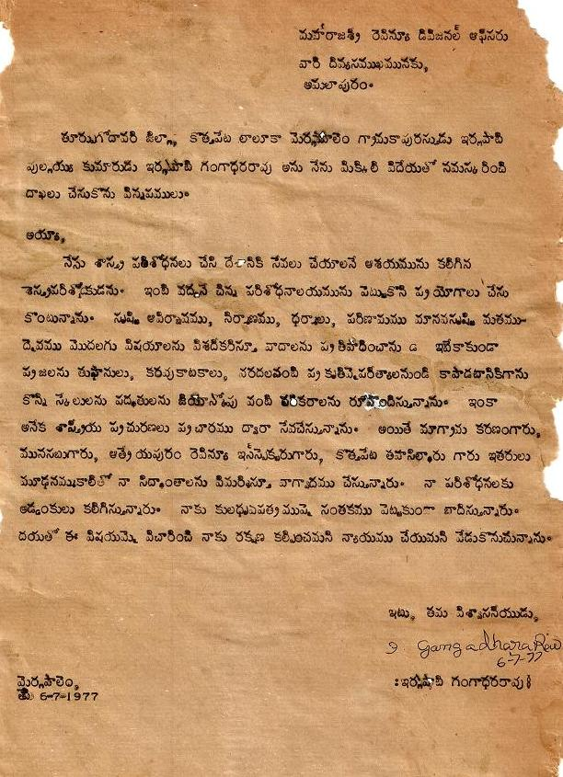
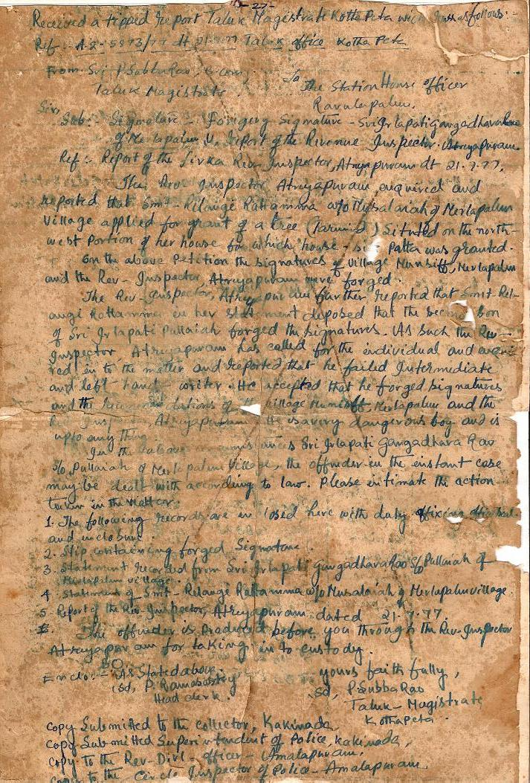
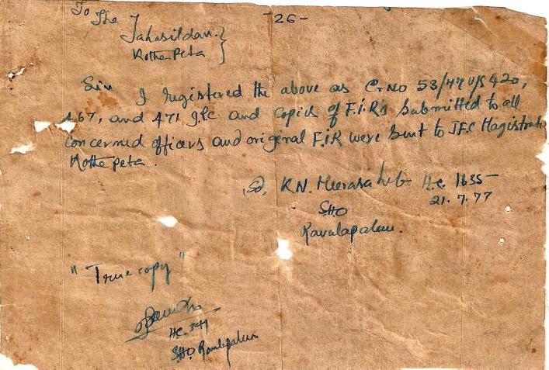
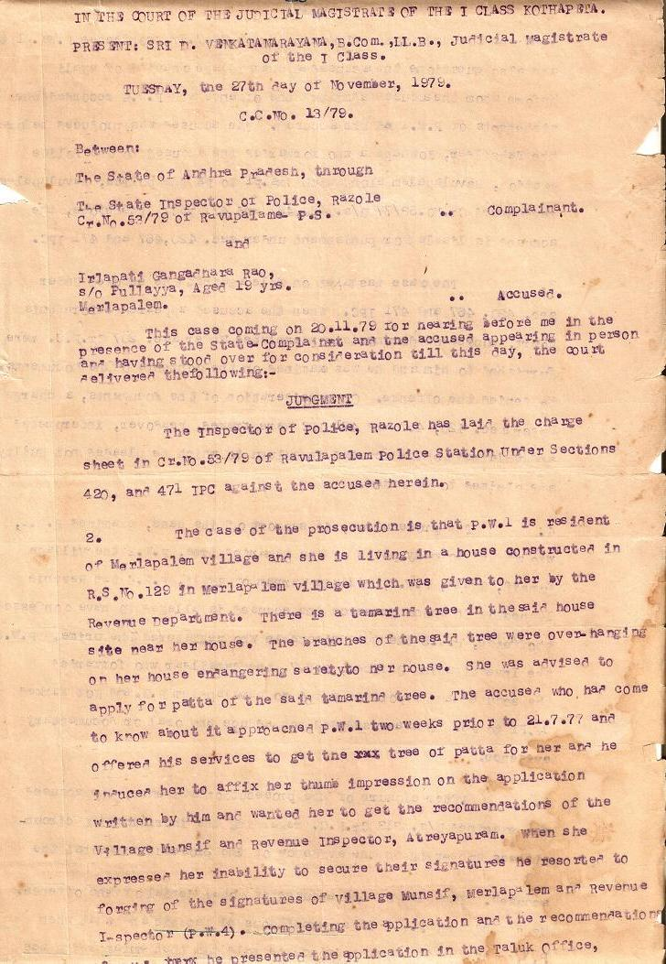
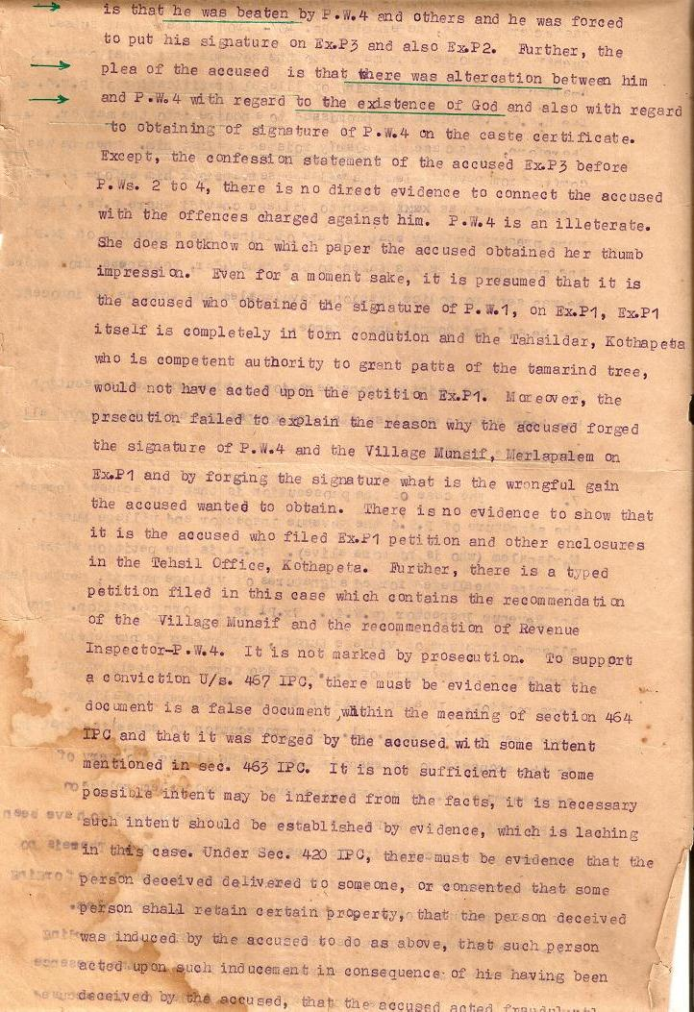
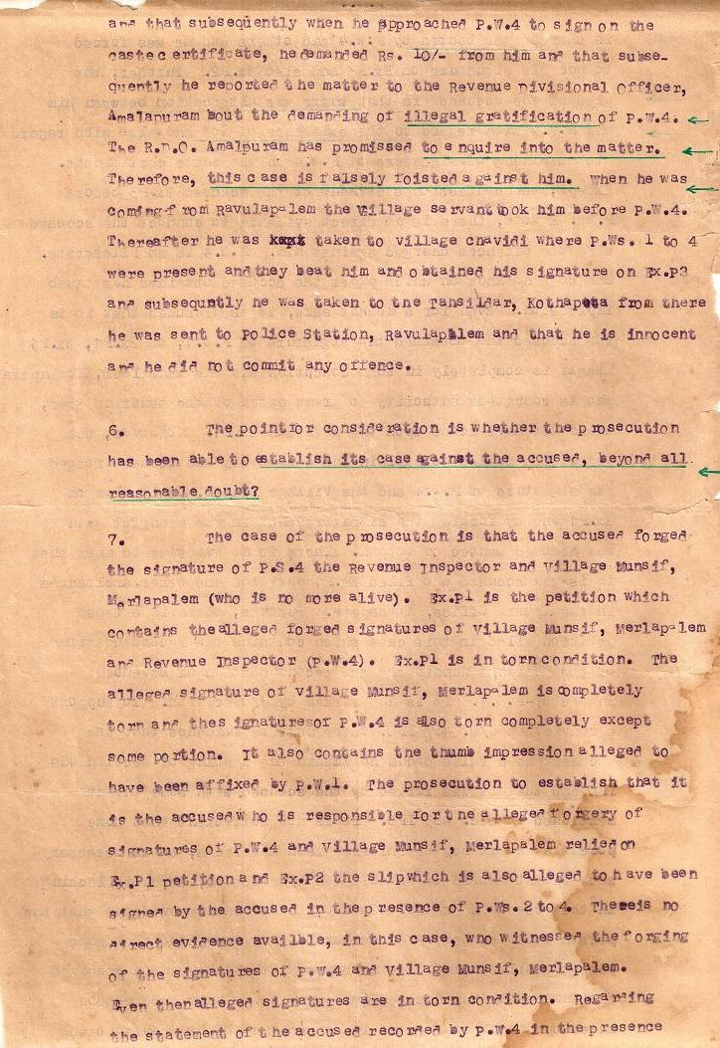
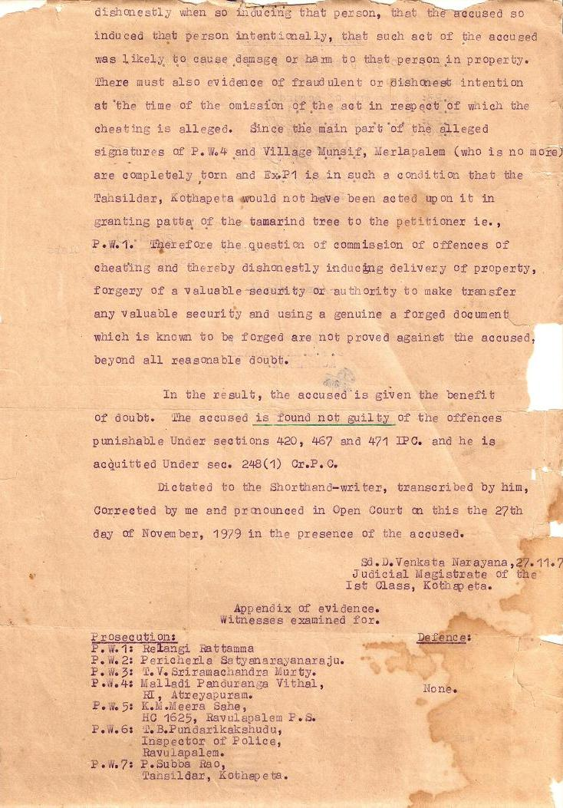
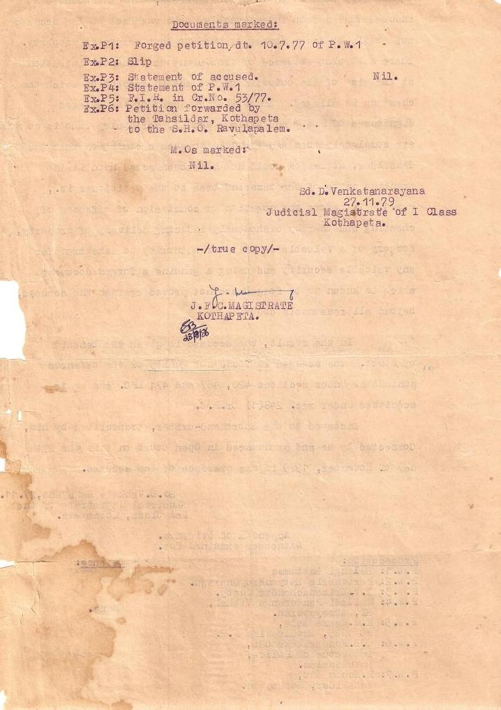
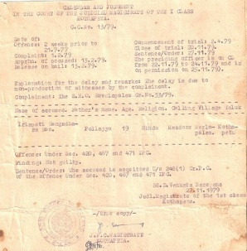
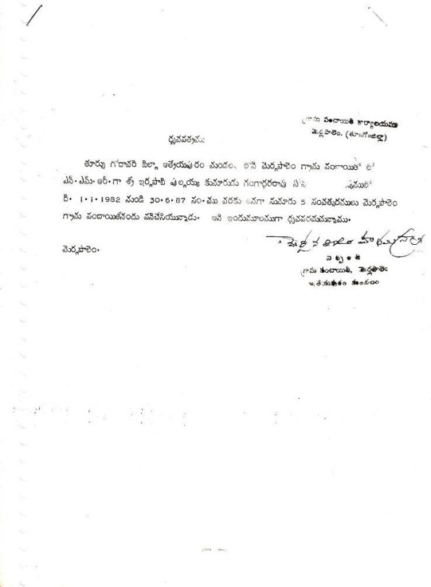
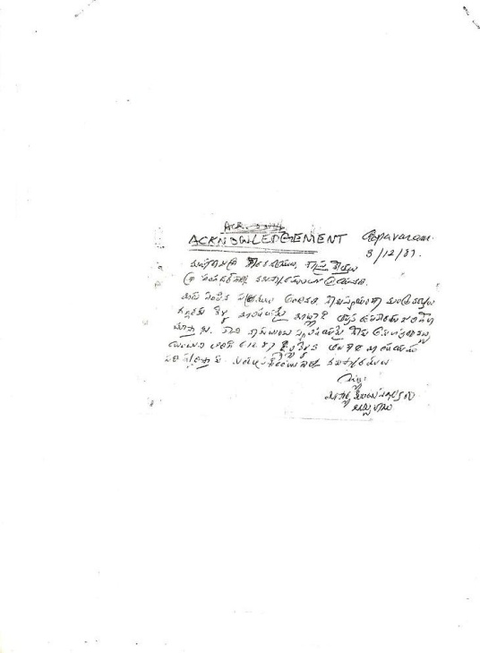
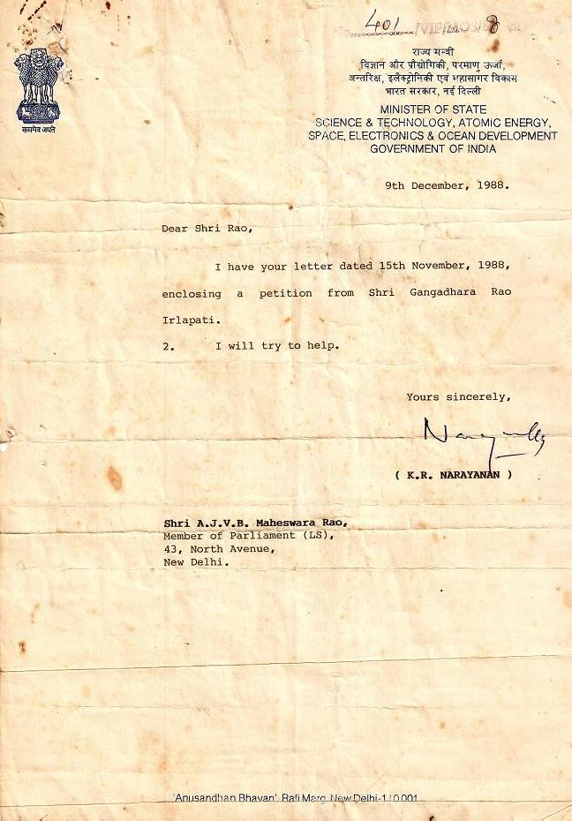
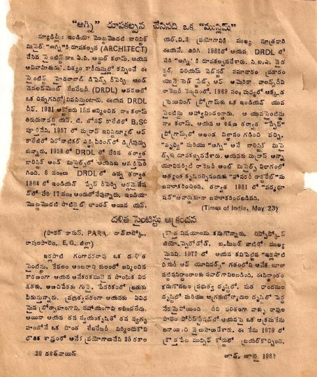
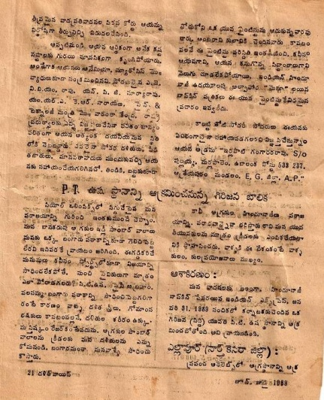

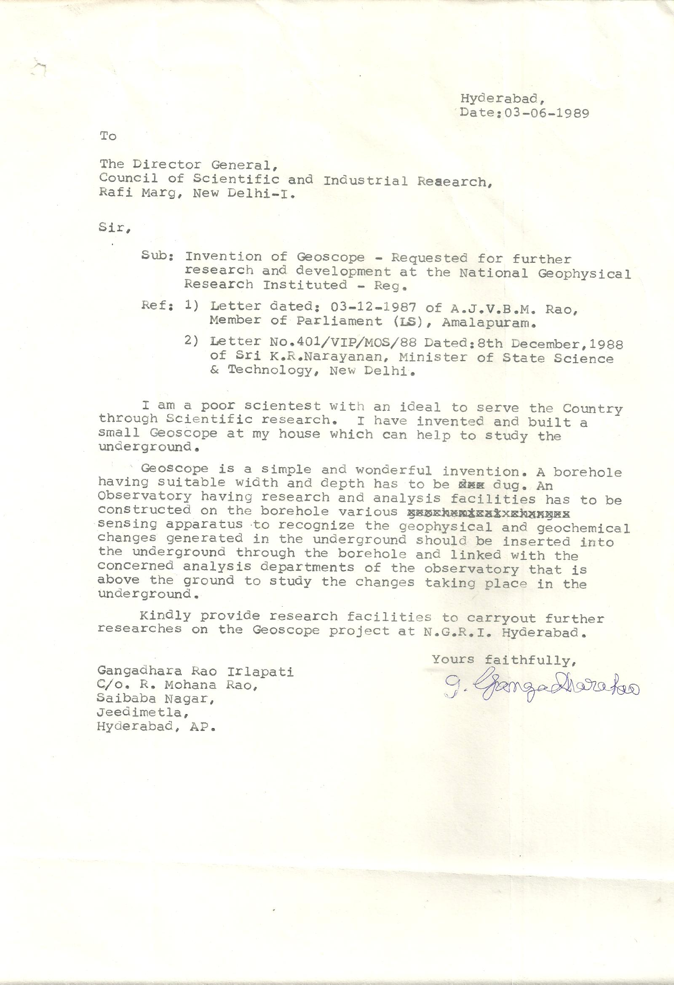
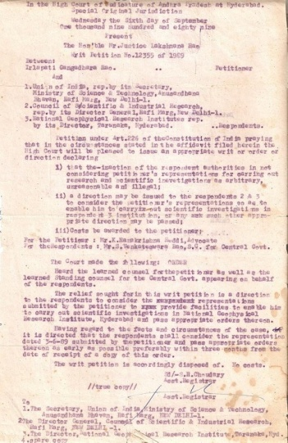
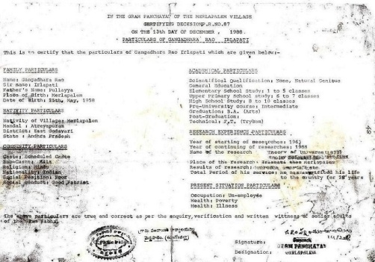
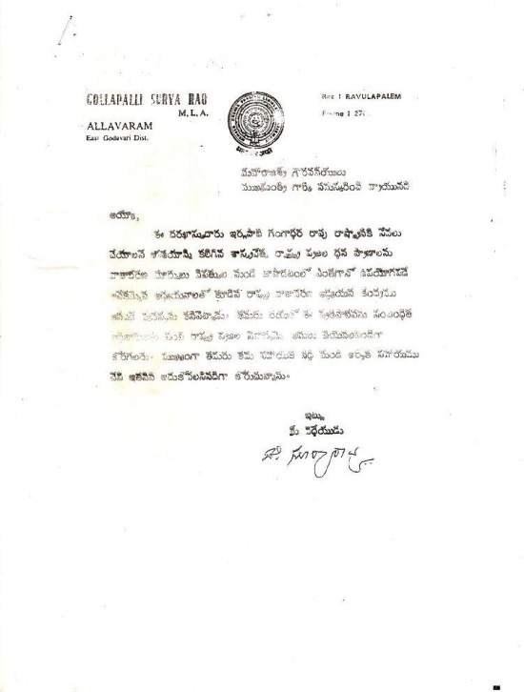
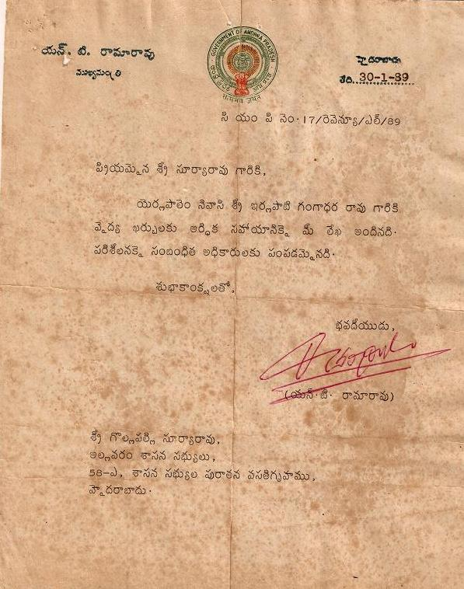

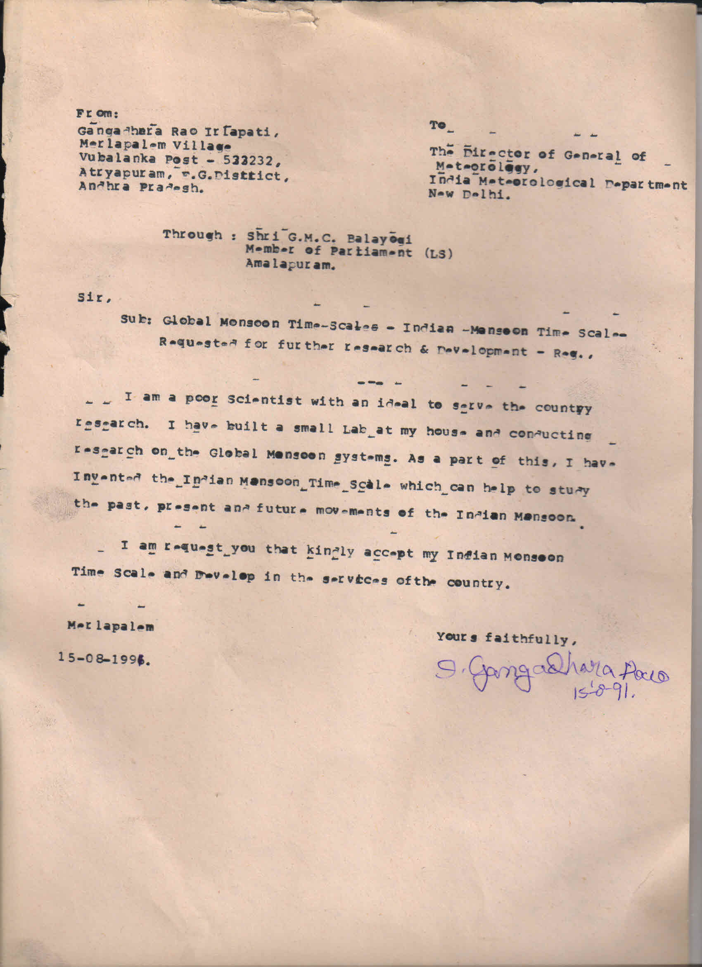
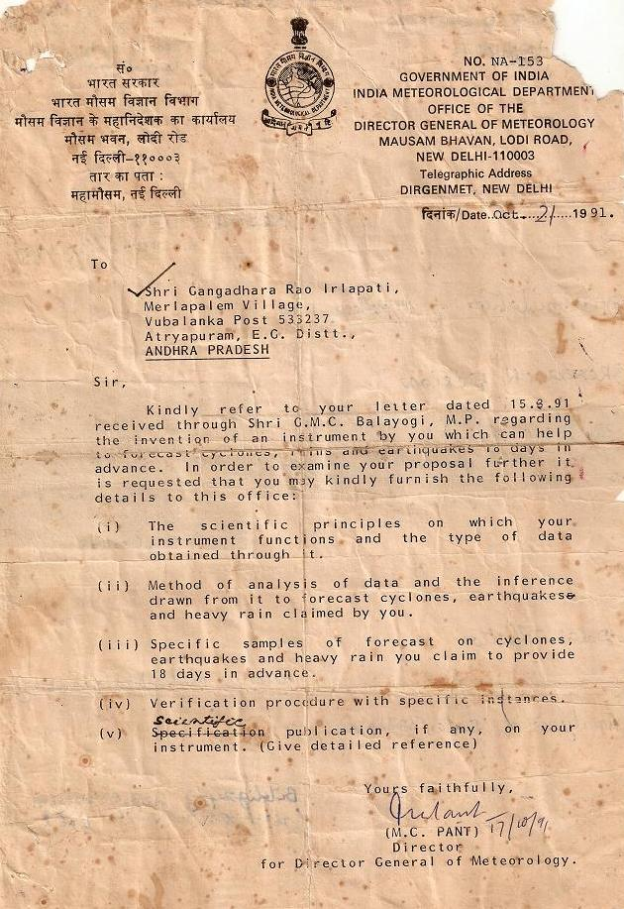
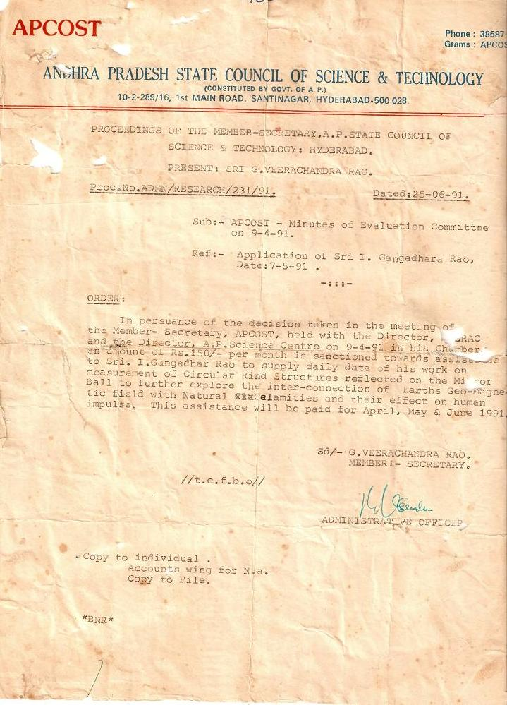
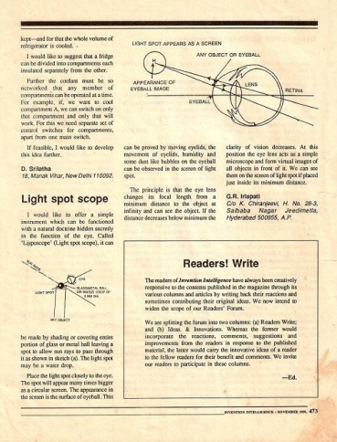
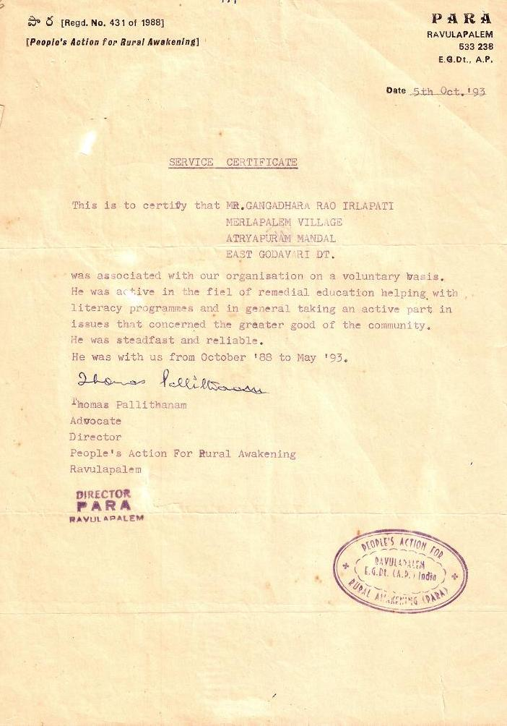
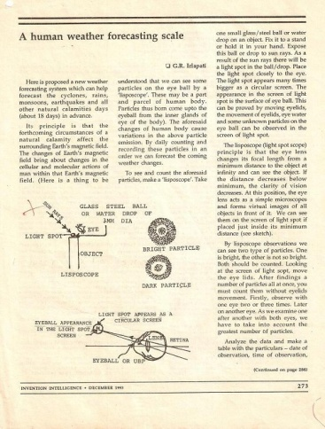
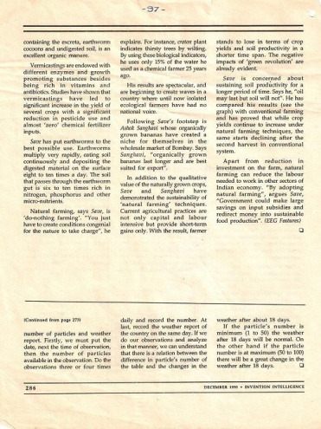
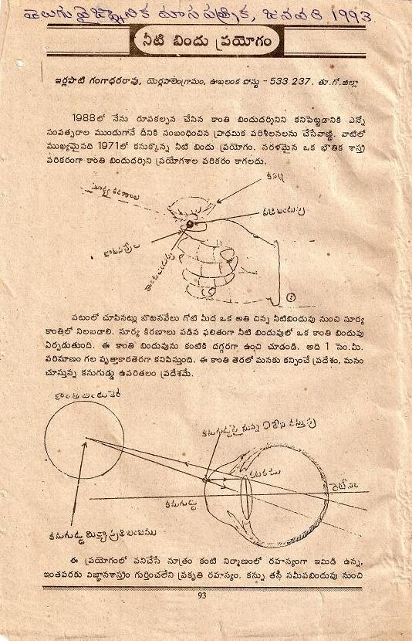
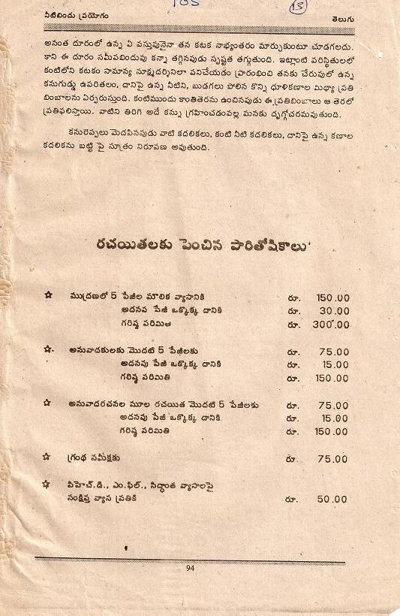
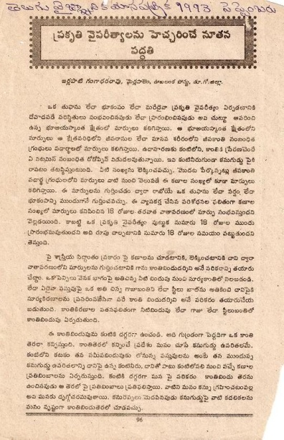
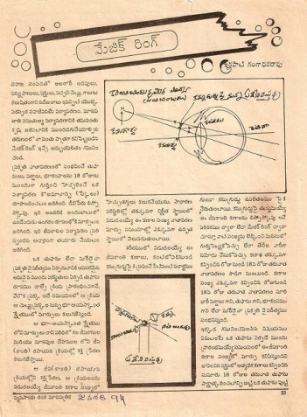
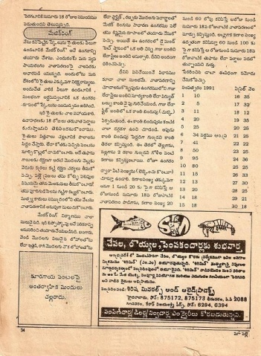
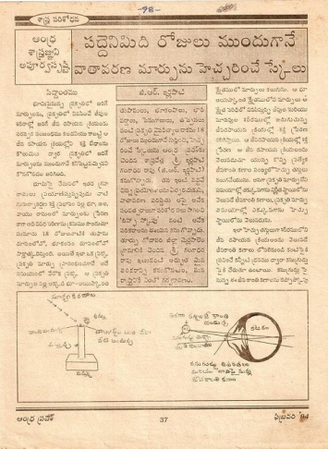
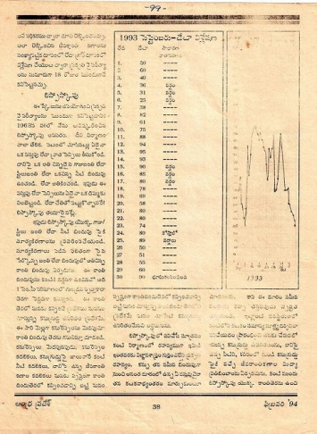
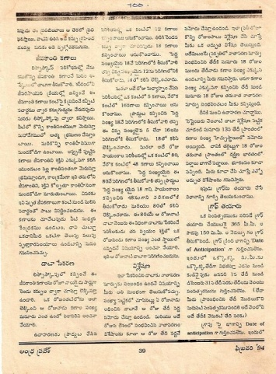
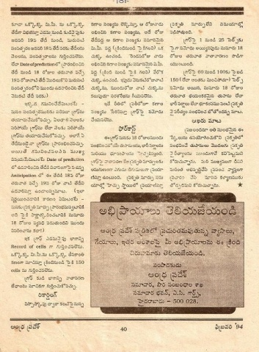
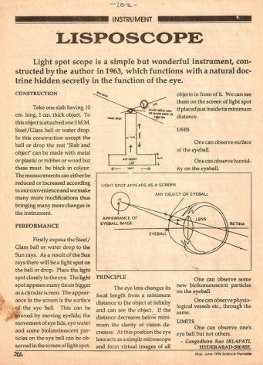
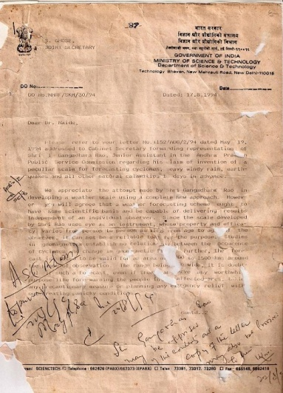
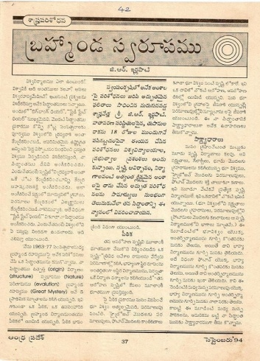
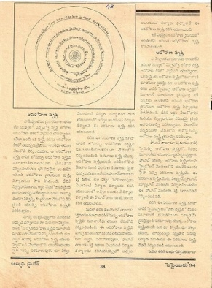
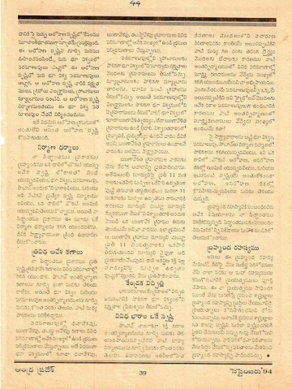
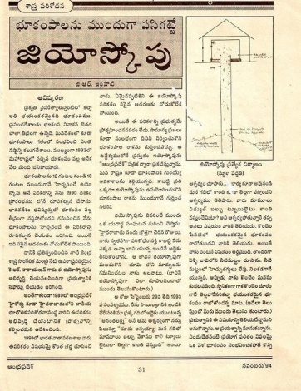
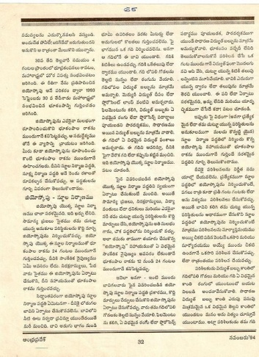
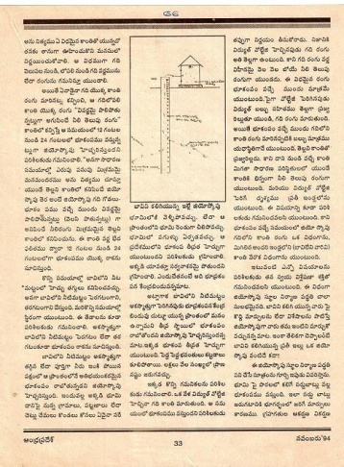
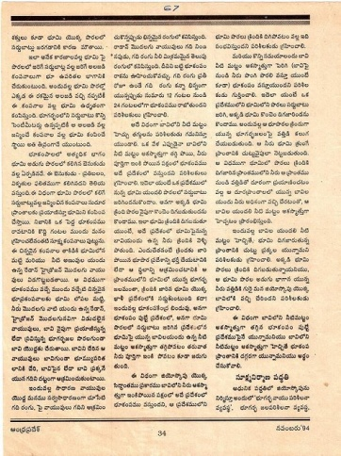
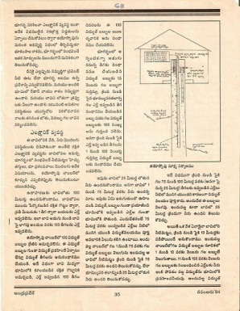
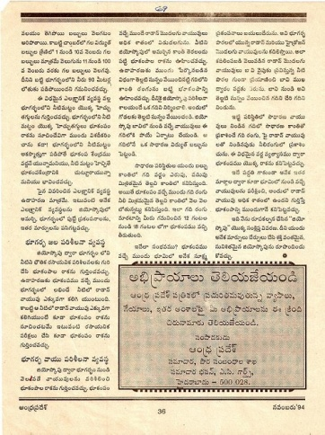
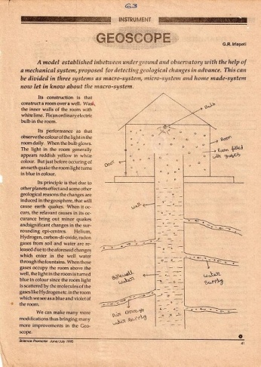
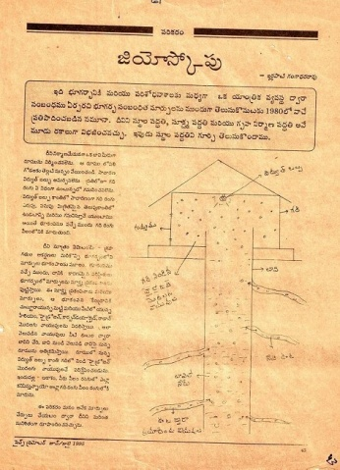
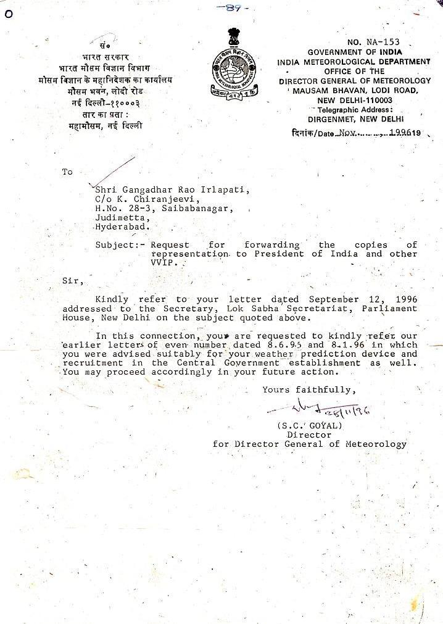
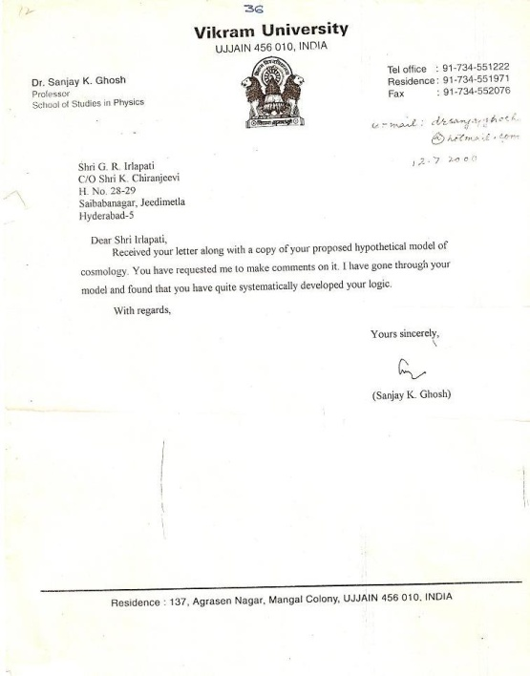
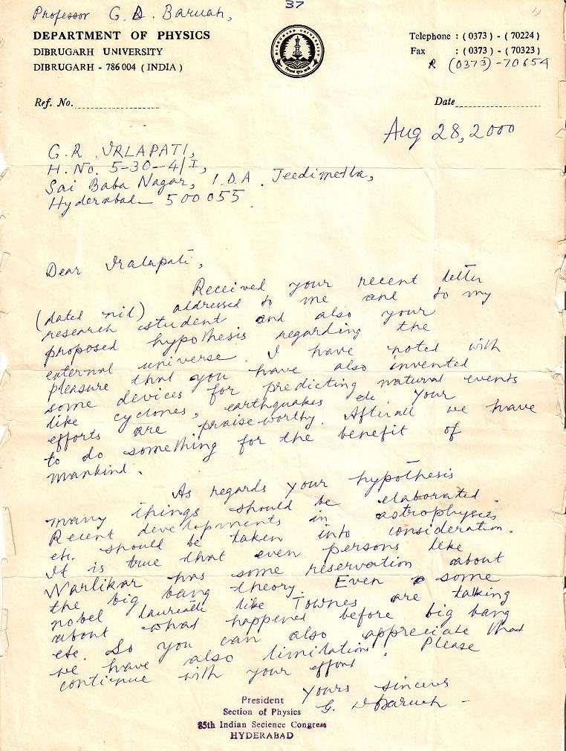
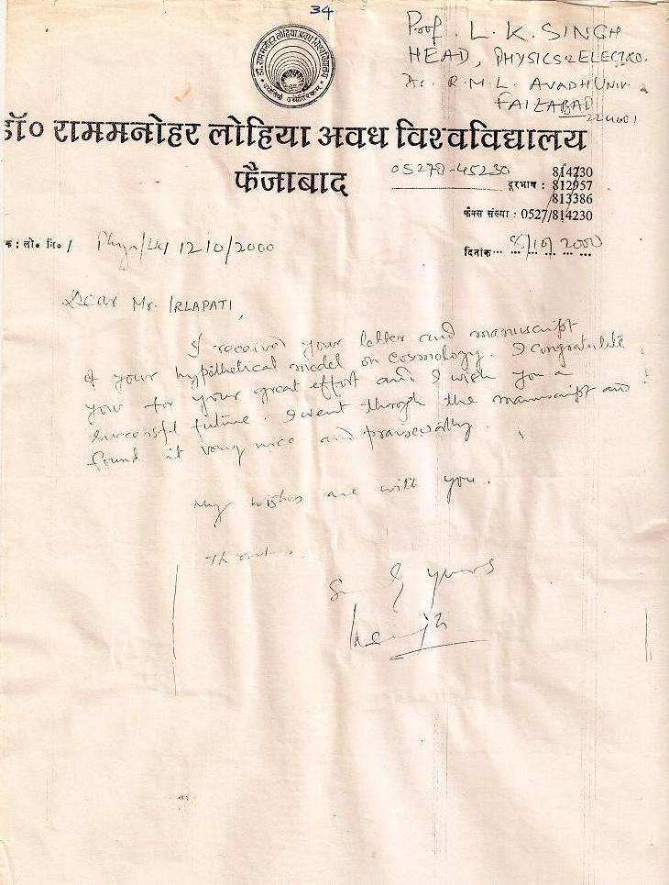
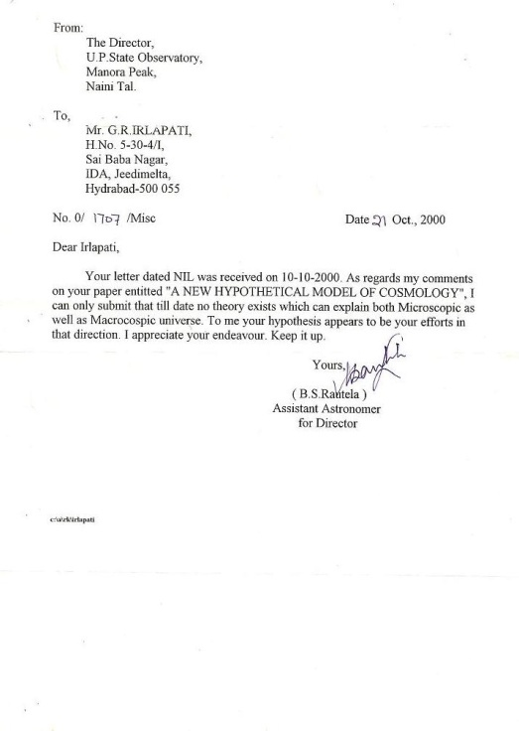
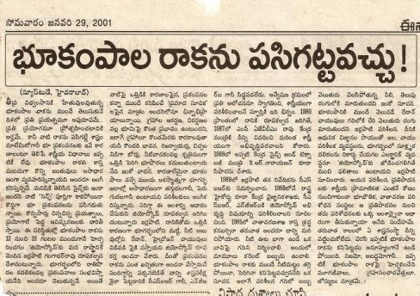
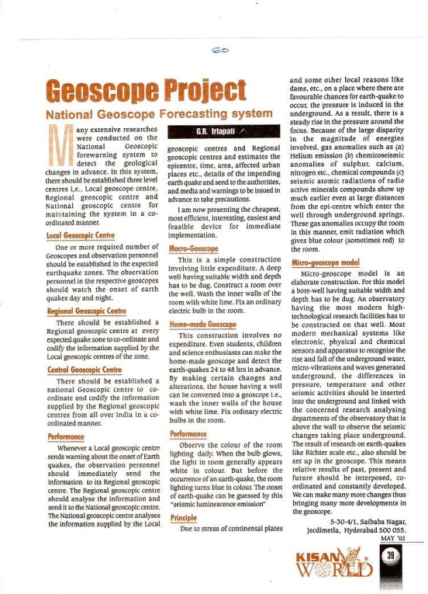
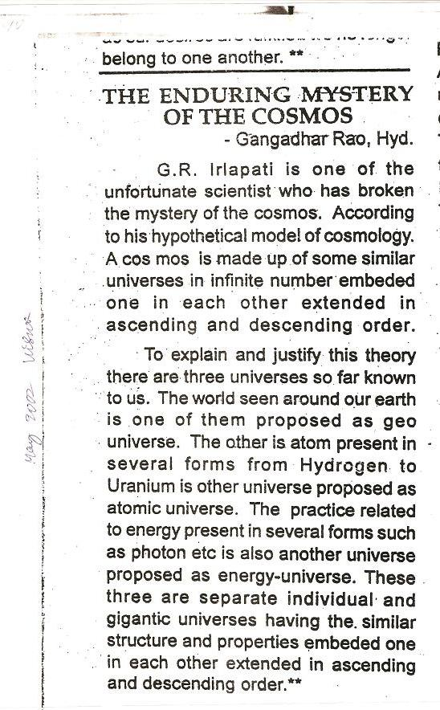
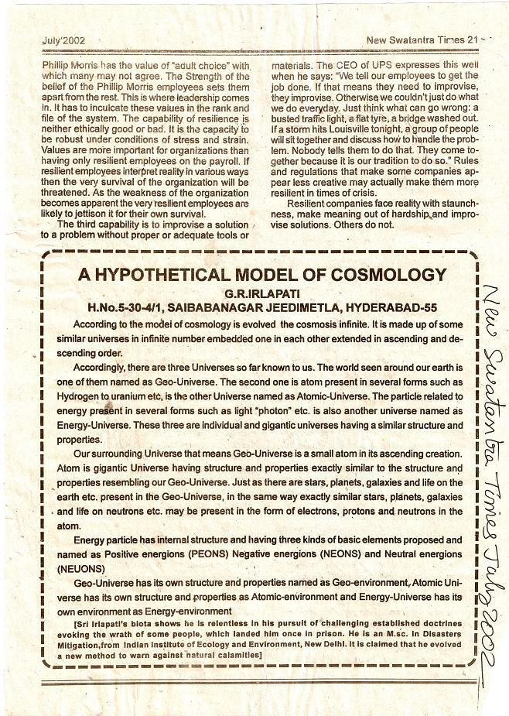
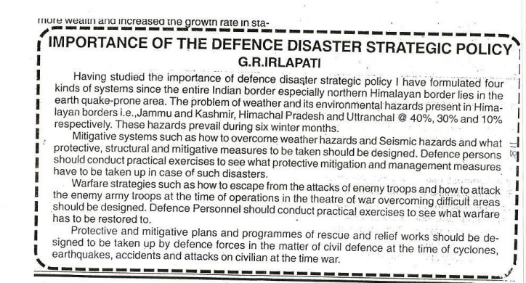
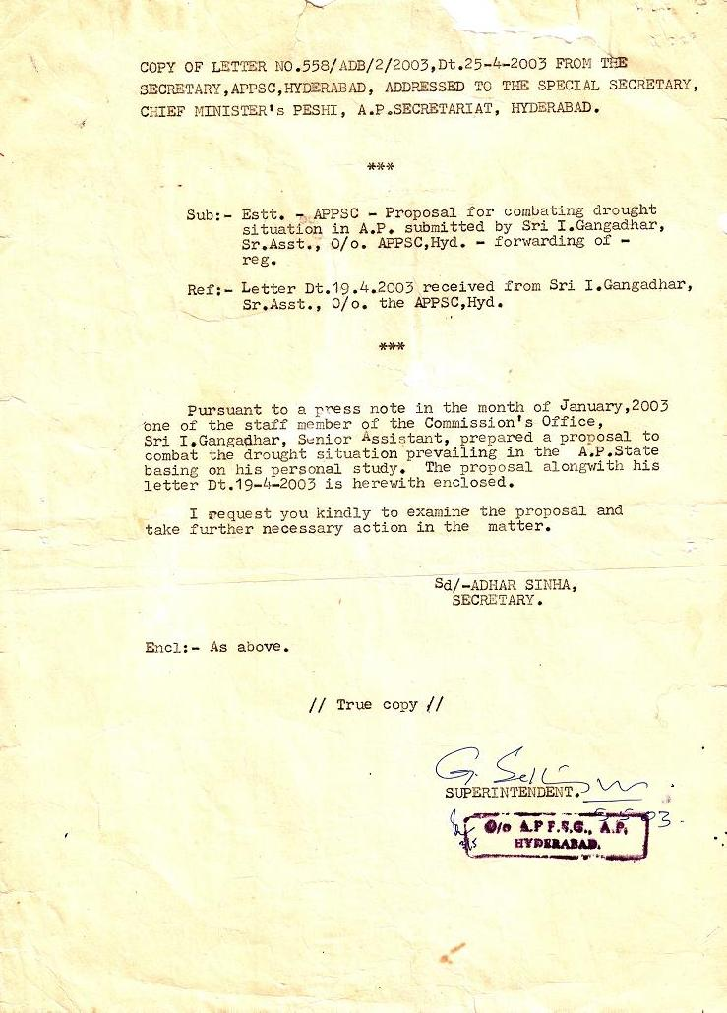
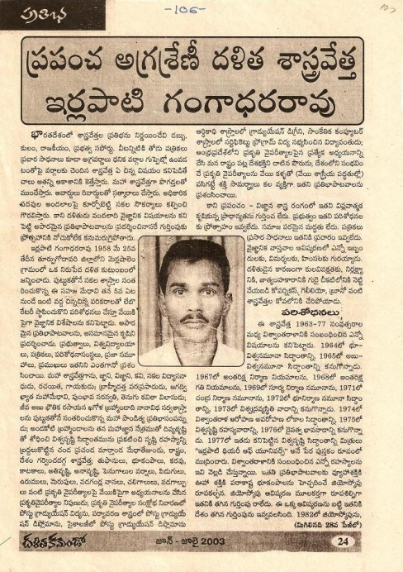
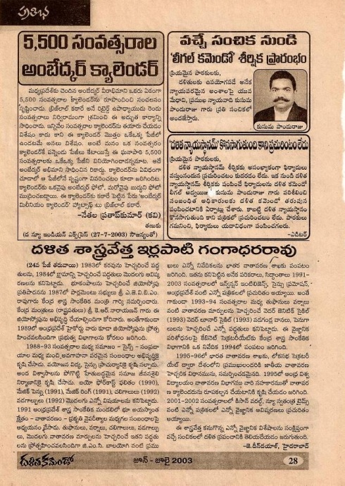
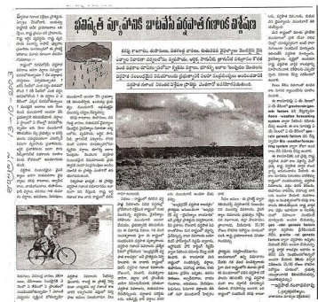
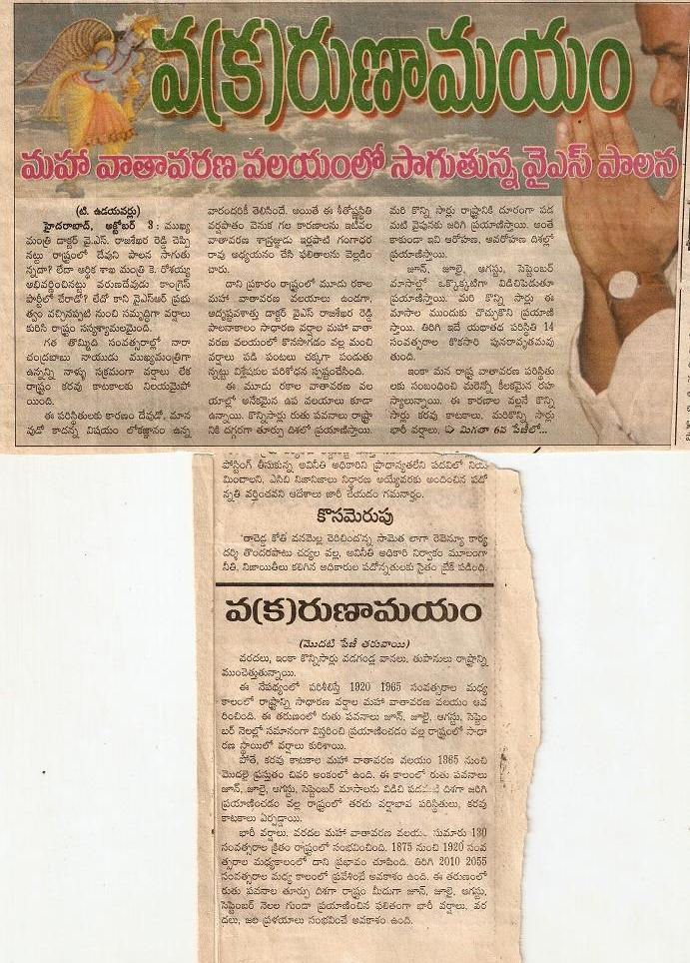
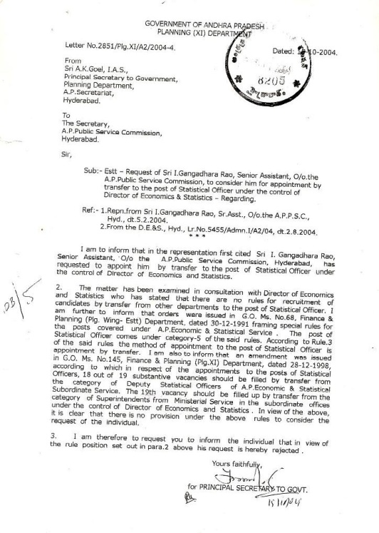
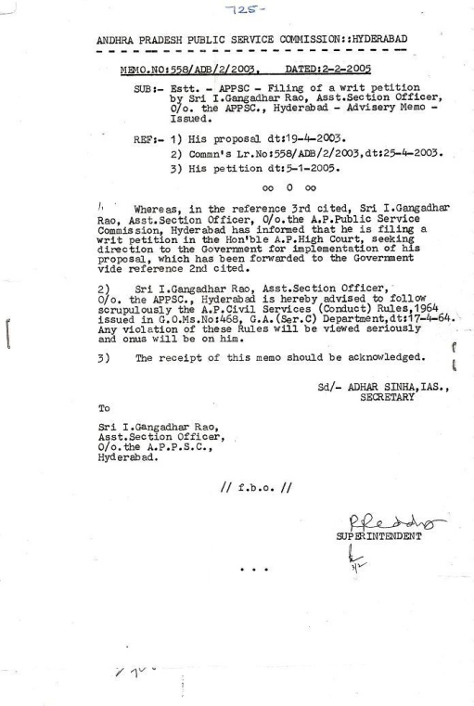
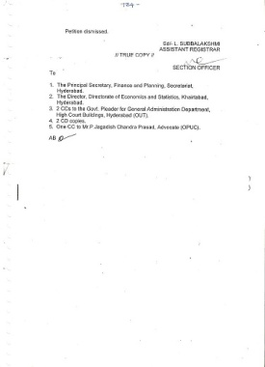
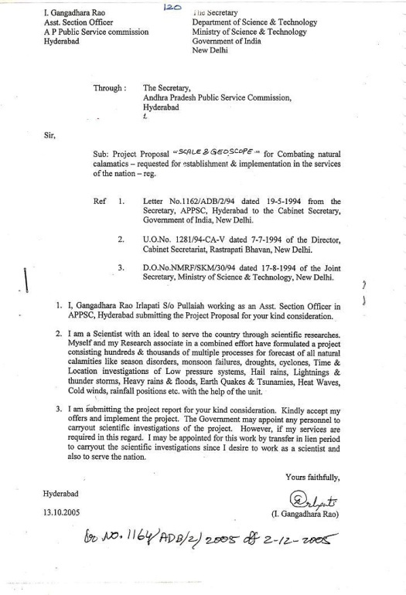
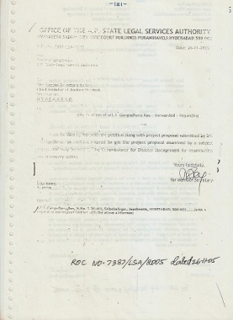
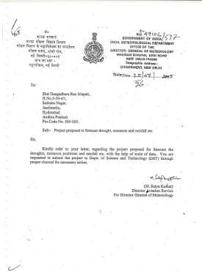
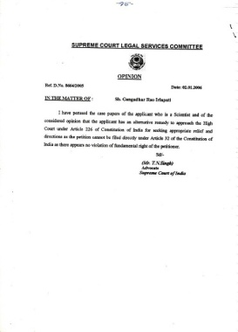
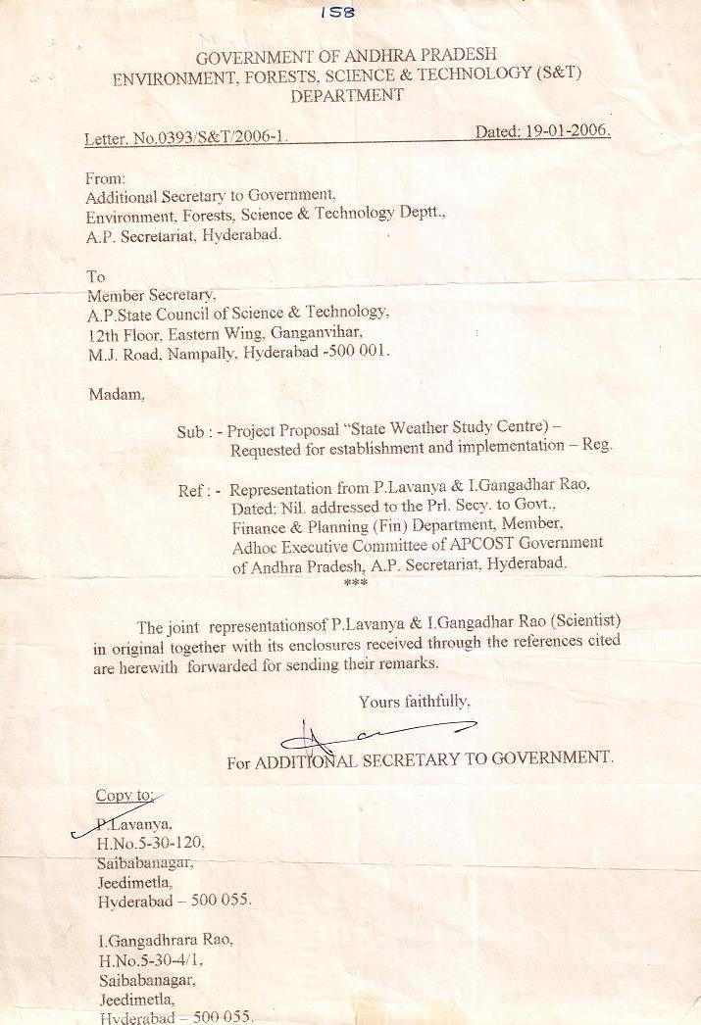
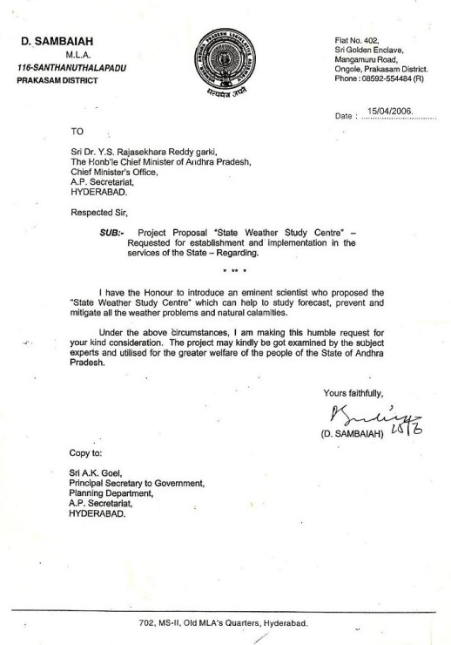
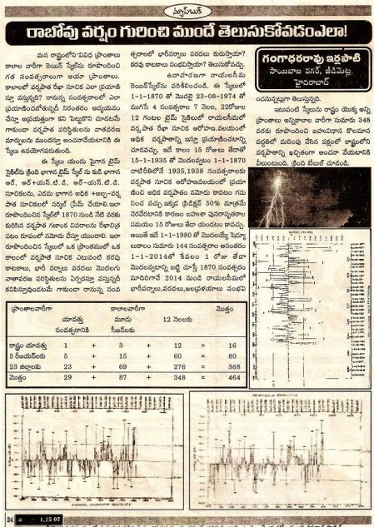
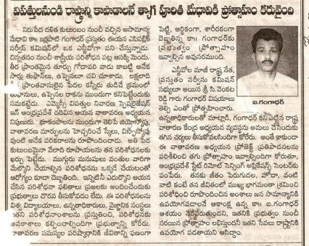
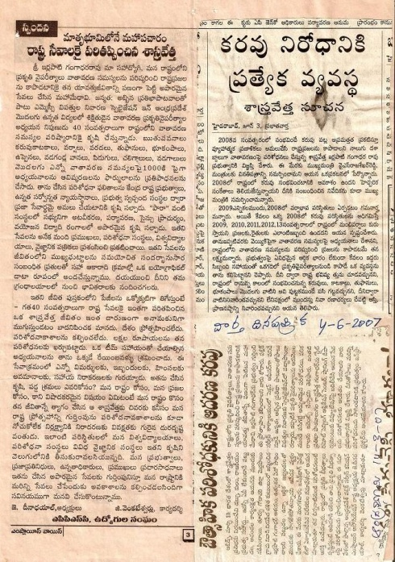
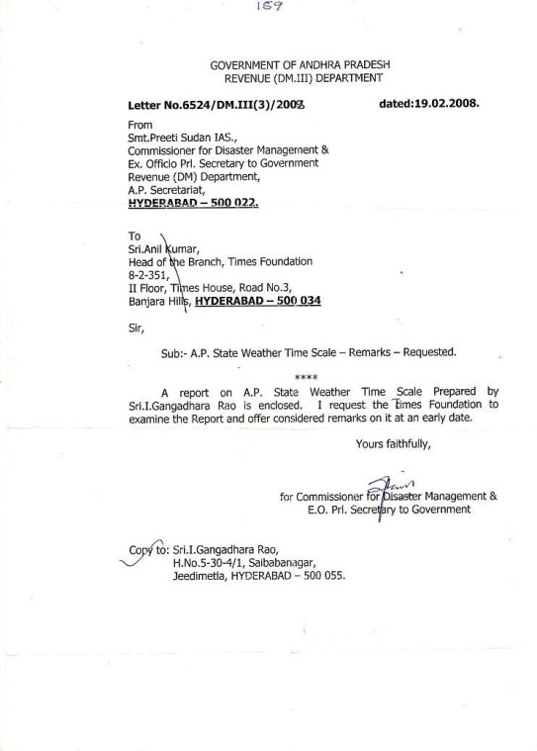
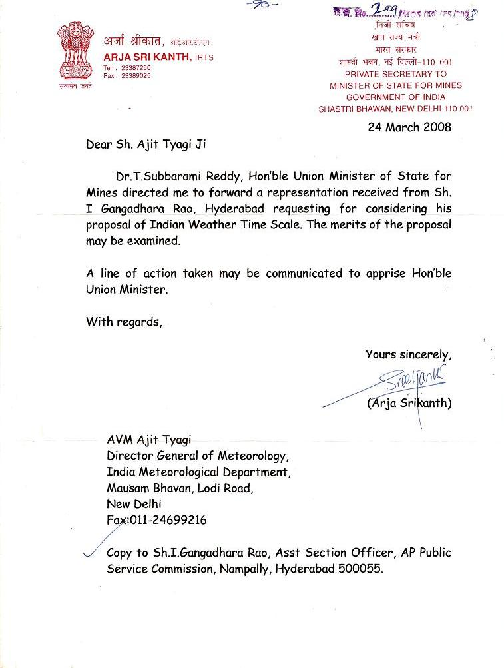
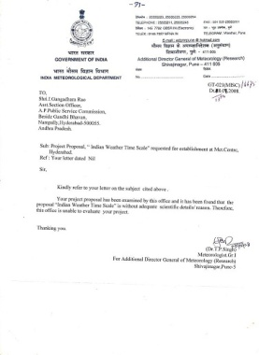
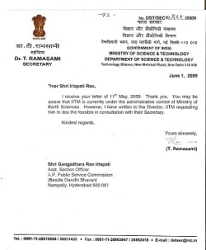
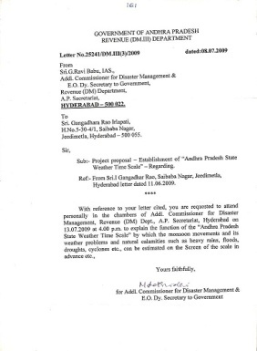
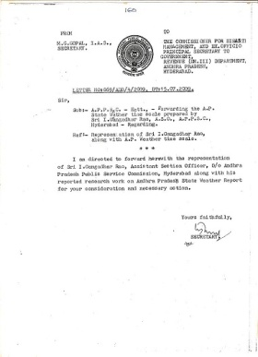
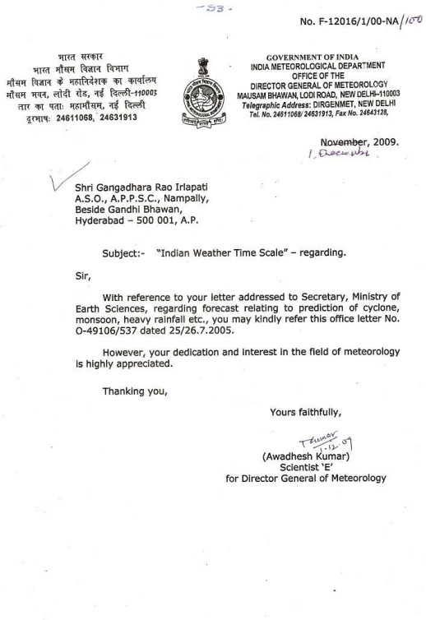
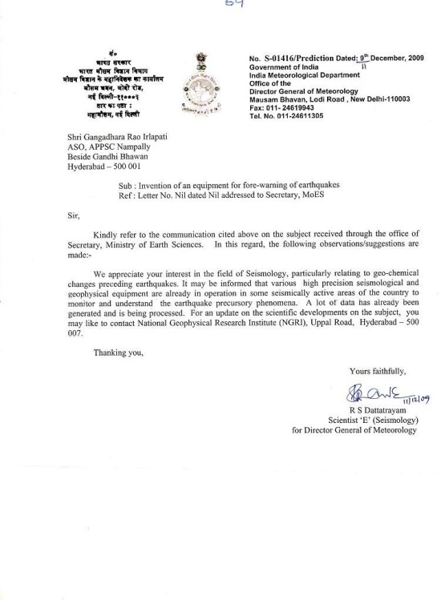
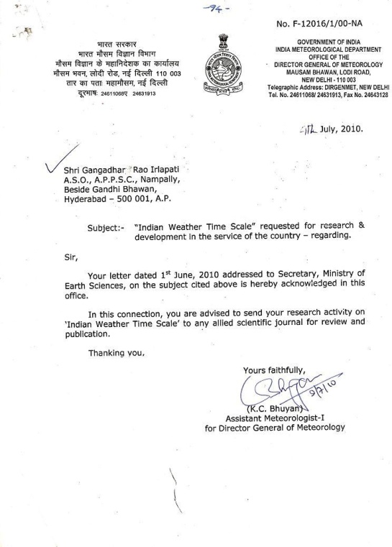

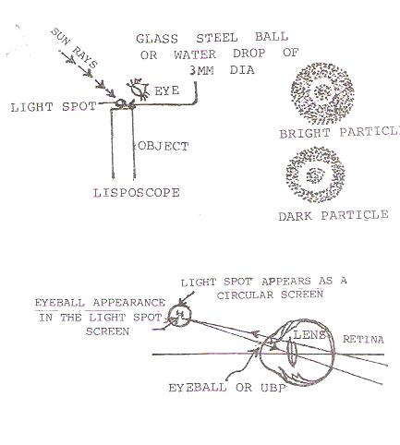
BIOFORECAST

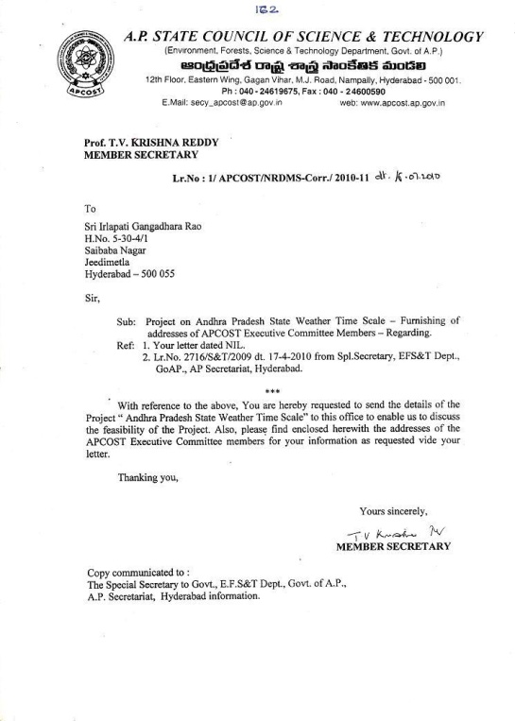
…
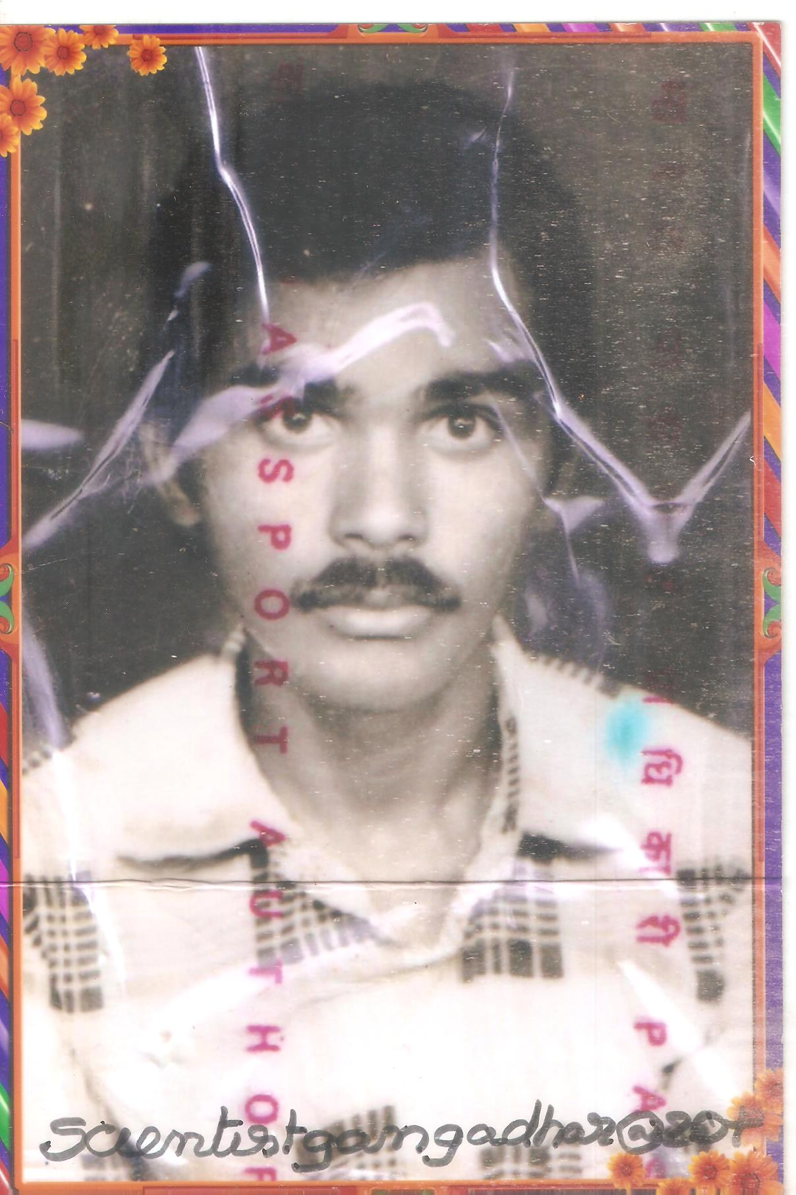

. 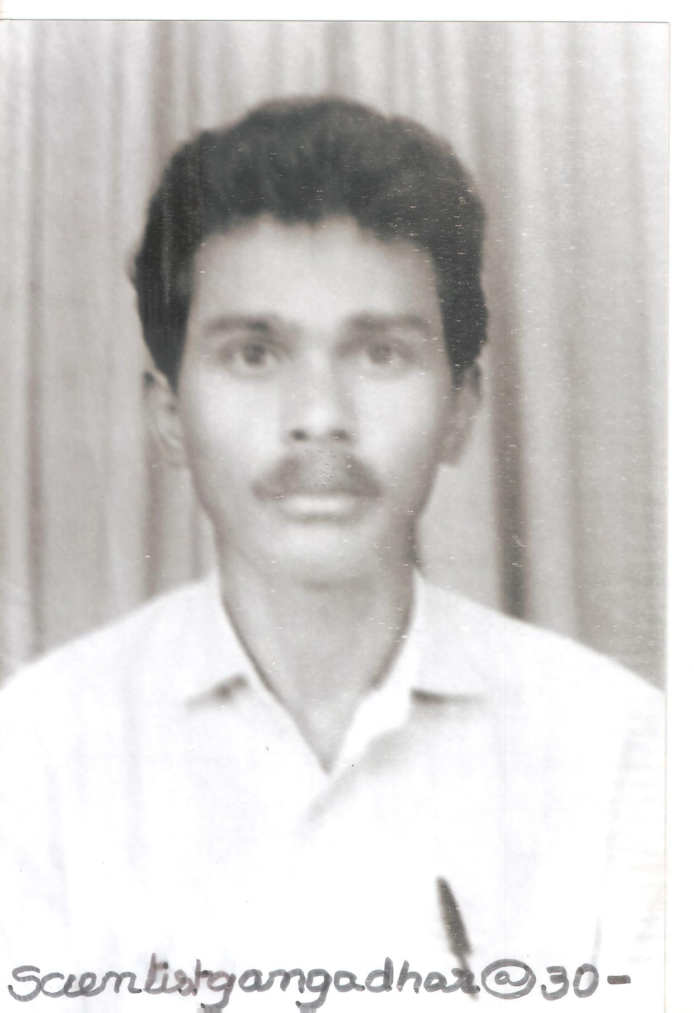

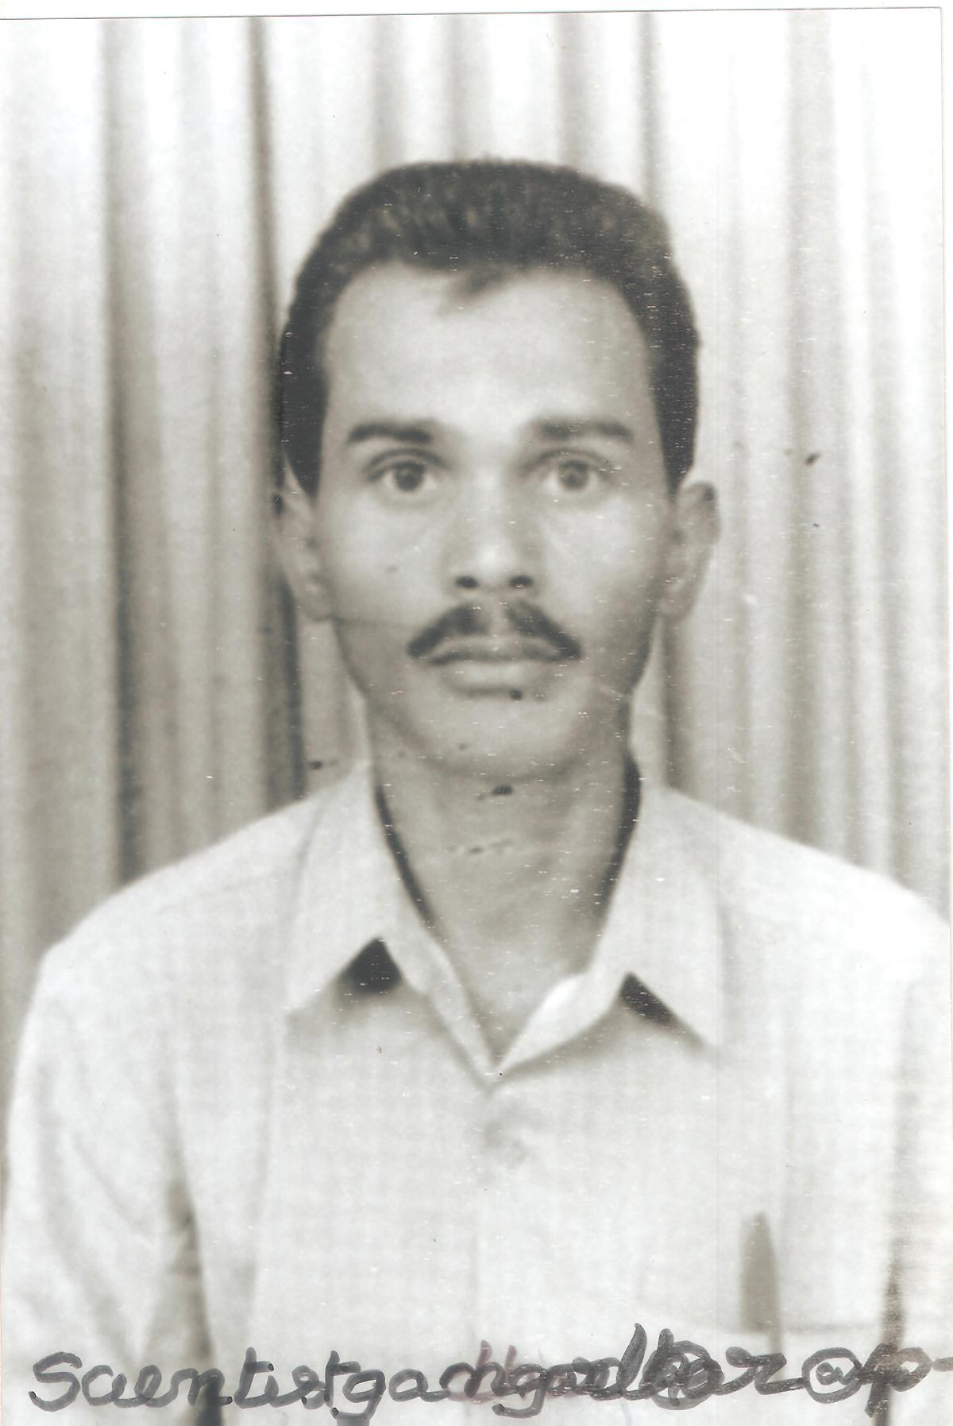

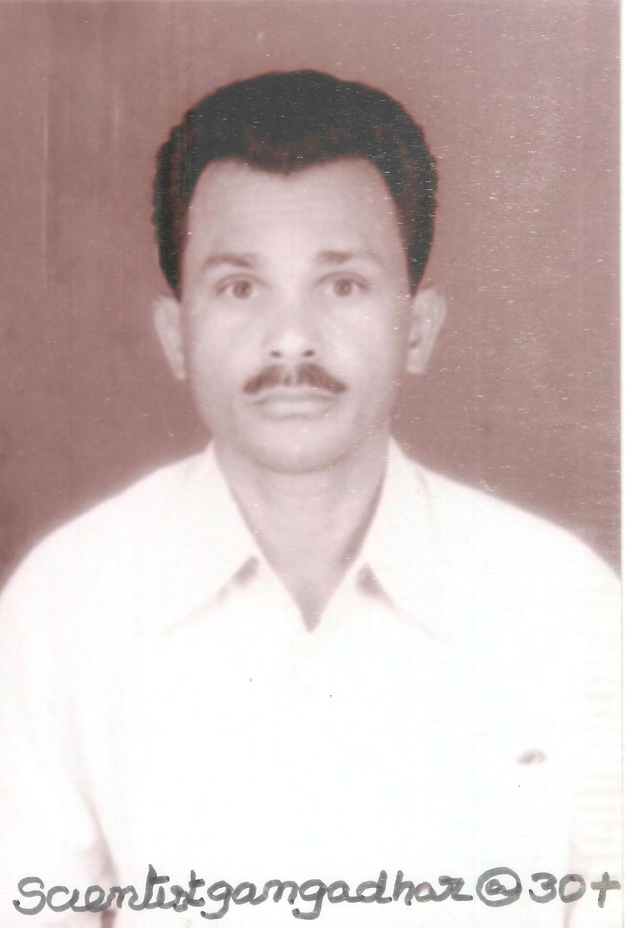

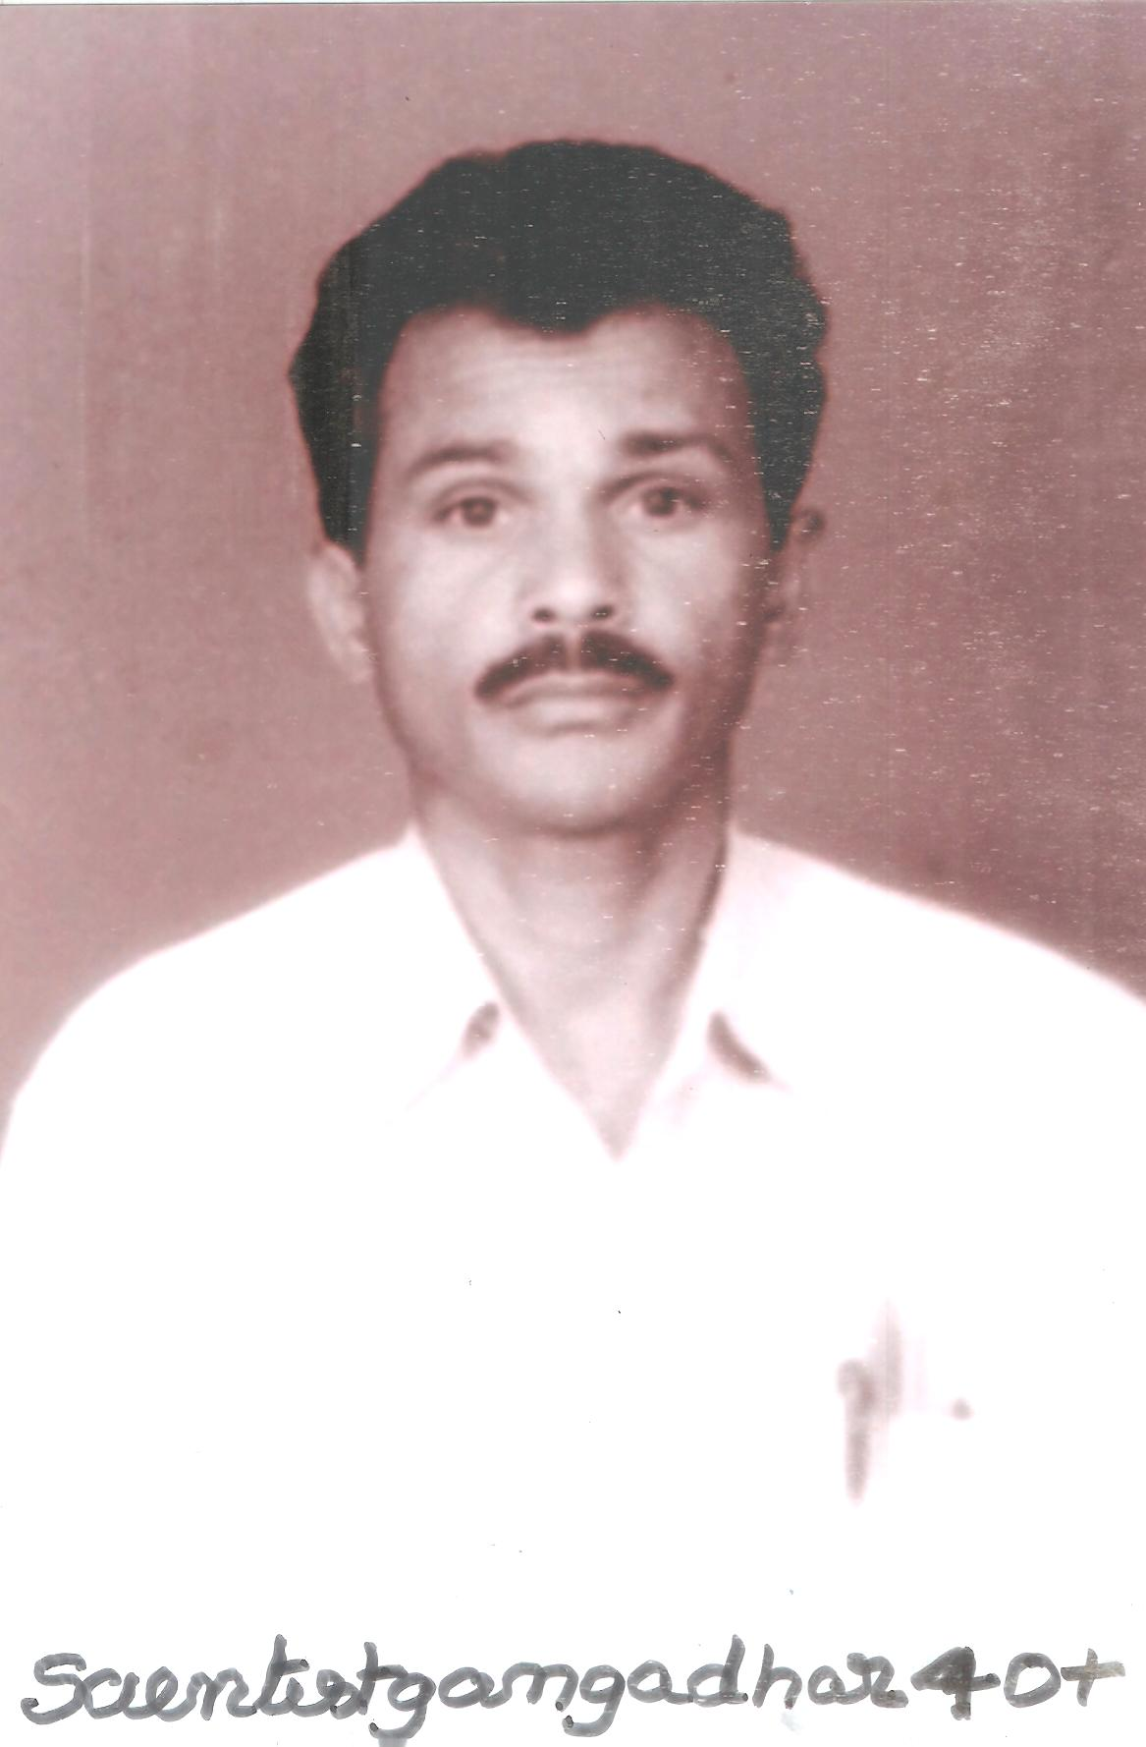

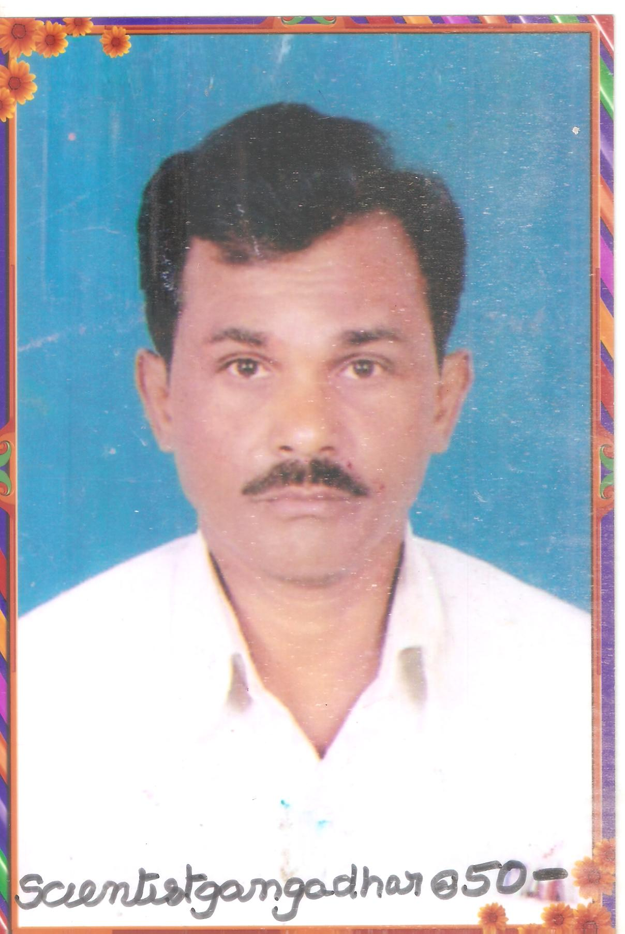

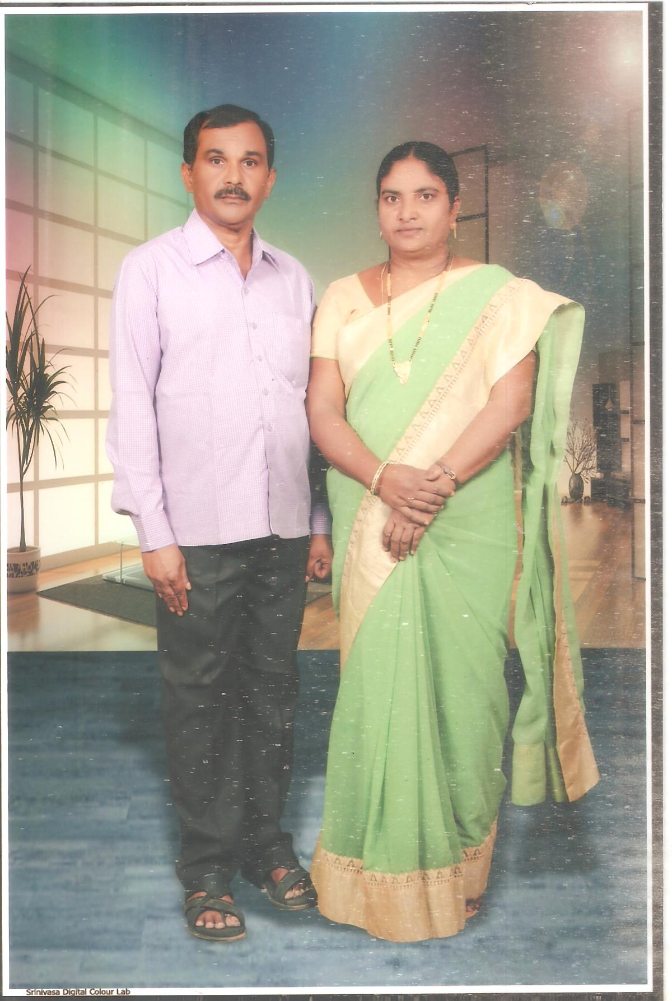

11/20/2022

