Flood Forecasting By Monitoring Rainfall Intensity And Cloud Movement (on the example of the Northern Ferghana)

Makulov Jasurbek Takhirjonovich

Teacher at Namangan State University
E-mail: jmakulov@mail.ru

Abstract: In the article Areas of flooding caused by torrential rains in the republic. Rain intensity An analysis of flood targeting technologies in the regions was carried out.
[Makulov J. Flood Forecasting By Monitoring Rainfall Intensity And Cloud Movement (on the example of the Northern Ferghana). Researcher 2022;14(8):40-44] ISSN1553-9865 (print); ISSN 2163-8950 (online) http://www.sciencepub.net/researcher. 04.doi:10.7537/marsrsj140822.04.

Keywords: emergency, danger, threat, monitoring, forecasting, targeted alerts, rain intensity, information exchange.

1. Introduction
Today, the scale of emergencies in the northern region of the Fergana Valley is not limited to a single state border, but is becoming more transboundary. The existing scientific potential of the country, information and communication technologies are not used enough to monitor and forecast the risks and threats that may arise in such situations, as well as to provide information, to solve problems in the field of flood protection. A flood is a stream of solid mixed water that flows down a mountain at great speed, capable of destroying anything in its path. Such a catastrophe not only destroys various communications equipment, buildings, facilities, waterworks and irrigation drainage systems, causing great material damage to the country’s economy, but also often kills domestic animals and sometimes even people. The material damage caused by the flood is enormous, but its damage is not limited to this.

2. Research Methods
In order to protect agricultural crops from hail in the foothills of Namangan region (Chust, Kosonsoy, northern part of Turakurgan district, Yangikurgan, Chartak and Uychi districts), convection clouds were used by MRL-5 meteorological radar station "Hail Fighting Season 31" August) to conduct daily meteorological observations and to prevent hail and stop hail when there is a risk of hail in convective clouds.
GJTK MQ B Station, using MERL-5 meteorological radar system "Merkom" automated radar system (ART), in the process of conducting meteorological observations within a radius of 100 km, in the Fergana Valley and the western mountainous regions of the Kyrgyz Republic directly, in real time, where, what cloud is developing? meteorological characteristics, type and intensity of precipitation (heavy-rain, hail, hail), location (coordinate, azimuth, distance), direction and speed of movement.
Using this information, in the process of providing comprehensive monitoring and forecasting of the occurrence and development of hydrometeorological emergencies in the MERL-5 radar station automated radar system "Merkom" (Scientific Production Center "Ecotechnology" of the Russian Federation) meteorological monitoring program, North Fergana Valley Meteorological surveys were carried out to monitor and forecast and warn of the occurrence of floods from rain clouds in developed and inactive, inactive, and stationary states in rivers and large streams, including river and large river basins (Figure 1).

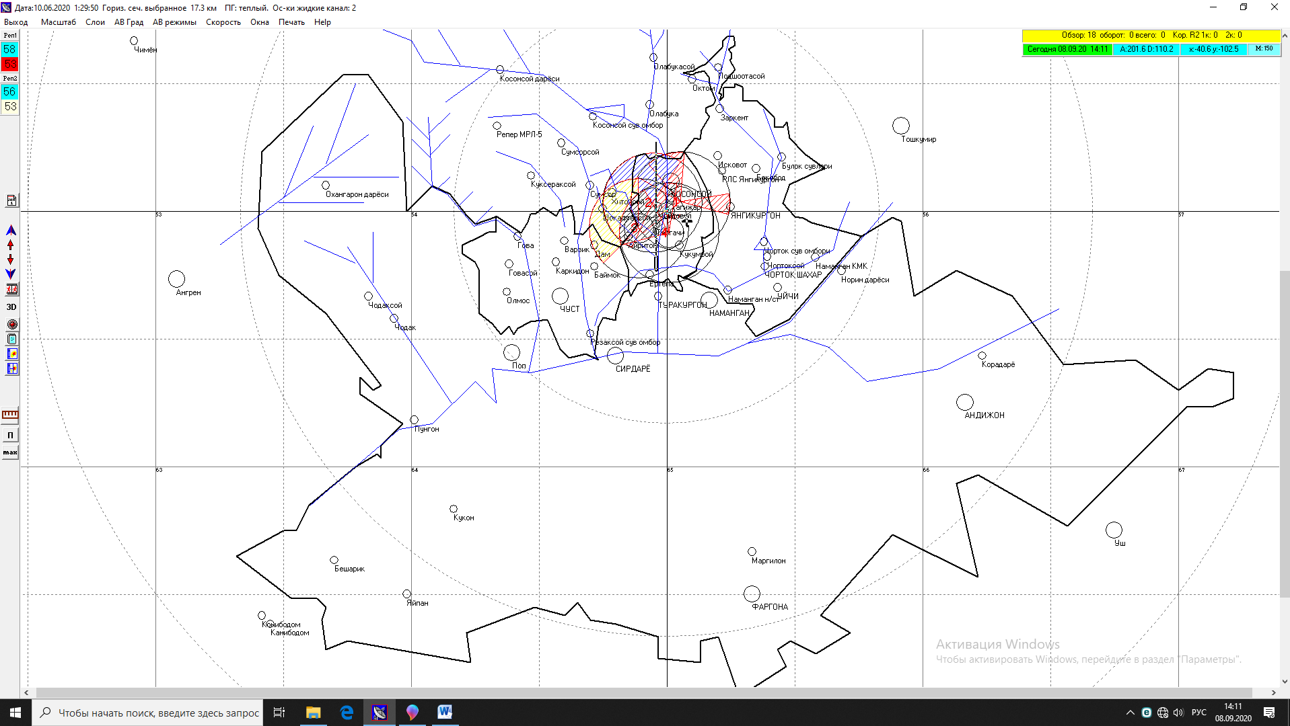
Figure 1. The river and river basin of the northern Fergana Valley, represented in the meteorological program of the automated radar system (ART) "Merkom" as part of the radar station MRL-5.

Studies (2018-2021) have shown that GJTK MQ B Stations are formed as a result of strong, intense and persistent atmospheric precipitation (rain, hail, hail) from the observed clouds moving, inactive and stationary, along the rivers and streams of the northern Fergana Valley. A few hours ago it became known that floods could be predicted and warned about, and meteorological observations proved their worth several times (with the exception of floods caused by the melting of perennial snow and glaciers in the mountains as a result of rising temperatures).
On July 13, 2020 from 14:30 to 16:30 in the Gavasay river basin of Chust district of Namangan region (Jalal-Abad region of the Kyrgyz Republic) developed stationary-inactive strong heavy rain-hail cloud (Figure 2). As a result of cloudy precipitation (according to the locator - heavy rain, small hail and hail) at 18:25 a flood of 60 m3 / sec came to the Govasay hydroelectric power station.

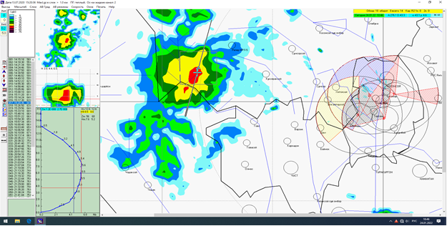
Figure 2. Stationary-inactive rain-hail cloud observed in Gavasay river basin (territory of the Kyrgyz Republic) July 13, 2020

"On the possibility of floods" issued in a timely manner to the duty unit of the FSB of Namangan region and the duty officer of Govasay hydroelectric power station (hydroelectric power station). X. Based on Meliev's warning, a 60 m3 / sec flood at the Govasay hydroelectric power station was accidentally missed by the regional FSB.
Weather forecast: July 13, 2020. By Uzhydromet - short-term rainfall in mountainous and foothill areas. Uzhydromet did not provide information about the flood. FVV - No flood warning issued. On July 13, 2021 from 11:45 to 13:35 in the Kosonsoy river basin of the Kosonsoy district of the Namangan region (Jalal-Abad region of the Kyrgyz Republic) a strong rain-hail cloud was observed (Figure 3-4).

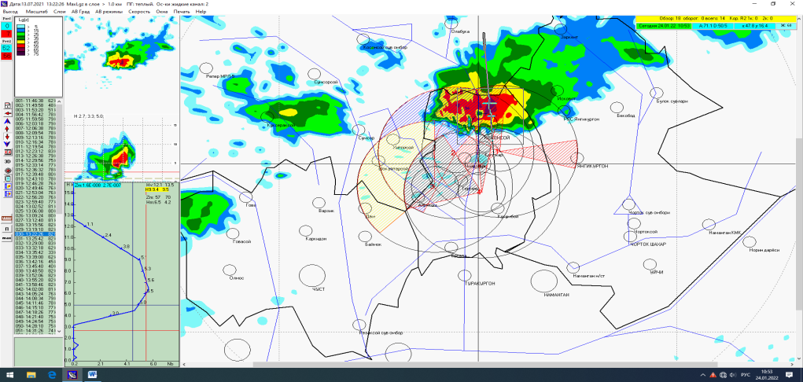

Figure 3. Rain and hail clouds observed in the Kosonsoy river basin (Jalal-Abad region of the Kyrgyz Republic) July 13, 2021

According to the data, as a result of heavy rains, hail and hail, at 13:30 the water consumption at the Teshiktash hydroelectric power station on the Kosonsoy River reached 60 m3 / sec. Due to the accumulation of precipitation (heavy rains, hail and hail) in the river basin of the Teshiktash hydroelectric power station, the flood occurred below the Teshiktash hydroelectric power station and the water consumption exceeded 60 m3 / sec.
The floods in Kosonsoy district of Namangan region on July 13, 2021 were caused by heavy rains in the southern Jalal-Abad region of Kyrgyzstan. Some local media also reported heavy hailstorms in the district before the floods. They also noted that no such hail had been observed in Kosonsoy before. They also included photos of the disaster (Figure 5). At the same time, Uzhydromet also officially confirmed the incident of hail along with short-term showers. The fact that this natural disaster is being observed in the middle of summer is also a cause for concern. Floods and heavy rains, on the other hand, followed several days of abnormal heat in Uzbekistan.
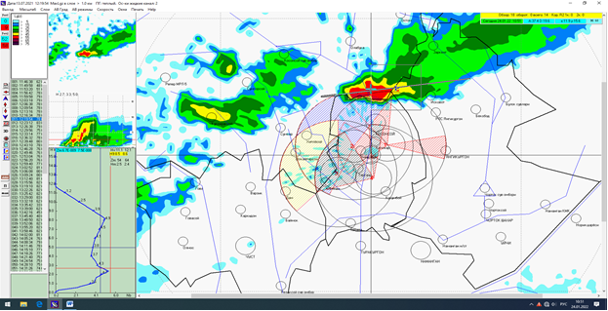

Figure 4. A rainy-hail cloud observed in the Kosonsoy river basin. (Moved from the northern part of the city of Kosonsoy) July 13, 2021

On the same day, the Ministry of Emergency Situations of Uzbekistan shared preliminary information on the situation in the district. Eight people were killed and six others were injured in the disaster, officials said.
The scale of emergencies in the Central Asian region is not limited to a single state border, but is becoming more transboundary. Monitoring and forecasting the risks and threats that may arise in such situations, as well as regulating cooperation with neighboring countries in the provision of information is one of the important issues. Today, Uzbekistan attaches great importance to the Central Asian region in its foreign policy. This is a well-thought-out path. Located in the heart of Central Asia, Uzbekistan has a direct interest in transforming the region into a region of stability, sustainable development and good neighborliness [1].
The first appendix of the Decree of the President of the Republic of Uzbekistan No. PF-60 of January 28, 2022, the Development Strategy of the new Uzbekistan for 2022-2026, states that the ninety-second goal is to create an effective system of prevention and response to emergencies. In the fourth and fifth paragraphs of this objective:
- Systematization of measures for the prevention and rapid elimination of emergencies in the tourist zones of the republic.
- Tasks have been set to modernize the emergency notification system.
Today, almost all mountainous and foothill areas of Uzbekistan are at high risk of flooding. At the same time, the Fergana Valley in particular is at risk. In addition, Namangan and Fergana regions, followed by Surkhandarya, Tashkent, Samarkand and Kashkadarya regions, were also found to have relatively high flood risk [2].
Floods caused by heavy rains are more frequent in the foothills and adjacent plains of the country. In the mountainous region, where large snow and glaciers are scattered, the snail type is more common. The torrential type of flood poses a great threat to the population and the regions, causing a great deal of economic damage. Timely identification, recording and public awareness of risk factors play an important role in the proper functioning of the population in dangerous areas, especially in areas prone to landslides and floods. The sheer number of factors involved in flood formation makes it difficult to predict in a timely manner. Nevertheless, the timing of the start of the flood season is predictable [3].
According to this estimate, special walls, swings, dams and other protection structures will be built to protect against floods in high-risk areas. Residents in flood-prone areas should be alerted within ten minutes, no more than 1-2 hours. Usually, the overflow of rivers and streams, the strong humming that occurs at the top of them, the collision of large rocks in the stream, a panic situation occurs. It is necessary to strengthen the banks of rivers, reservoirs and canals in flood-prone areas, and in the absence of such facilities, to build flood traps or networks that direct the flow to areas that do not harm the population.
Taking into account the fact that floods occur and their formation as a result of the intensity of precipitation, to take timely and systematic measures to strengthen communication with the public and prevent emergencies through close cooperation with citizens' self-government bodies. Significant improvement and quality of work on monitoring and forecasting of emergencies, systematization of work on hydrometeorological and seismic observations, implementation of tasks aimed at early detection of emergencies at large hydraulic structures and water bodies.
3. Conclusion. In accordance with the Decree of the President of the Republic of Uzbekistan "On measures to radically increase the effectiveness of the system of prevention and response to emergencies", in order to ensure comprehensive monitoring and forecasting of risks of hydrometeorological emergencies, A few hours before the flood forecasting and warning of floods that may occur in the rivers and streams of the valley With the extensive use of technology program, the "Experimental" group and the organization of research work in the field, comprehensive monitoring and forecasting of the risk of occurrence and development of hydrometeorological emergencies, possible hydrometeorological x timely targeted warning and information of the population about the dangers, ensuring the safety of the population in water bodies, protection of the population and territories from emergencies, sustainable operation of hydraulic structures, prevention and mitigation of natural and man-made emergencies.

Corresponding Author:
Dr. Jasurbek Takhirjonovich
Namangan State University,
Namangan, Uzbekistan

References
- Jumaxanov Sh 3., Makulov J.T. Sotrudnichestvo Respubliki Uzbekistan s gosudarstvami Tsentralnoy Azii po predotvrashcheniyu transgranichnyx chrezvыchaynyx situatsiy ”Institut upravleniya i sotsialno - ekonomicheskogo razvitiya. Russia. Economics and society. № 11 (66). 2019. -p. 238-243. www.iupr.ru
- www.lex.uz Decree of the President of the Republic of Uzbekistan, PF-60 dated 28.01.2022 on the development strategy of new Uzbekistan for 2022-2026
- Official website of the Ministry of Emergency Situations of the Republic of Uzbekistan» www.fvv.uz.
- Mirzahmedov I. Use And Protection Of Natural Resources Of Kokand Oasis. Nat Sci 2020;18(12): -P. 49-52.
- https://scholar.google.com/citations?view_op=view_citation&hl=ru&user=Tu57EucAAAAJ&citation_for_view=Tu57EucAAAAJ:ufrVoPGSRksC

8/22/2022

