A MINI REVIEW OF RESEARCH ON STUDY HILL TOUR OF FOREST TYPES M.Sc FORESTRY STUDENTS SESSION (2020-22) PAKISTAN FOREST INSTITUTE PESHAWAR, KPK

Ahmad Zamir, Nizar Ali, Syed Talha Kamil, Kamal Anwar, Arz Muhammad Umrani, Shabir Ahmad Jan,
1= Pakistan Forest Institute Peshawar, 25130
Correspondence author Email: arz.forest87@yahoo.com

ABSTRACT
The hill tour is the part of Forestry Course Field Work (forest types) having credit hour 2(0+2) and is quite valuable and is important aspects to provide practical knowledge to the students of Pakistan Forest Institute Peshawar. The occupying faculty study hill tour comprised Director Forest Education Division Peshawar and instructors who have contributed greatly with their capacity and expertise in their field based activities. The two instructors were assigned to supervise 43 students of M.sc forestry session (2020-22). Questionnaire were developed to collect the student’s feedback. It has improved the capacity and knowledge on various forest related practical including scope of forestry including method of managing forest i.e afforestation reforestation and sustainable forest management. This kind of hill tour is the useful for their forestry career endeavor. The tour study was taken to know forest ecosystem, forest types, natural and artificial regeneration, nursery establishment, field planting techniques etc. The students have advanced knowledge on Silviculture operations. The resource persons of the forest and wildlife department Khyber Pakhtunkhwa have delivered a series of lectures, hands –on experience on various applications and field based excursion. The overall students expressed satisfaction for availing the opportunity and they were committed to the sustainability of natural resources.
[Ahmad Zamir, Nizar Ali. A MINI REVIEW OF RESEARCH ON STUDY HILL TOUR OF FOREST TYPES M.Sc FORESTRY STUDENTS SESSION (2020-22) PAKISTAN FOREST INSTITUTE PESHAWAR, KPK..Researcher2022;14(7):41-46]ISSN1553-9865(print);ISSN2163-8950(online)http://www.sciencepub.net/researcher. 07.doi:10.7537/marsrsj140722.07.

KEY WORDS: Study tour, practical knowledge, instructors, excursion, Pakistan Forest Institute Peshawar

INTRODUCTION:
The study tour was useful to know about the Silviculture concepts, applications based on the Ralph, D.(2007). Ecology and silvicultural strategies Fujimori, (2001). The sites were ( Shogran, Balakot, Paras, Malakandi Forest, Naran, Saful Muluk National Park, Shinkiari). It was useful in order to understand advantages and disadvantages of even aged and uneven aged stands, pure and mix stand influence of density, crowns. It was comprehensive and effective in order to gain the knowledge about forest ecosystem, forest types, natural and artificial regeneration, nursery establishment field planting techniques.
The Study Hill Tour was very useful to understand the practical applications of silviculture in the subject of General Silviculture (Course Code FOR = 520) (2(2+0) credit hour).

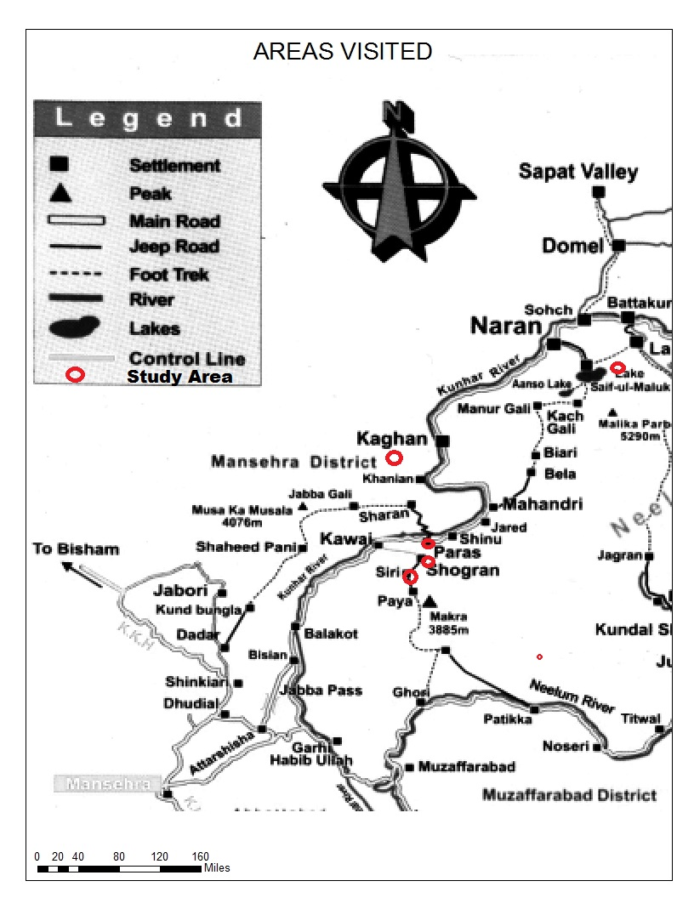
Figure 1 Map of Visited Areas.

MATERIALS AND METHODS:
It includes the secondary information that collected from instructors and students. All secondary data collected was reasonable, consistent. Feedback data was essential and obtained.

RESULTS AND DISCUSSION:
In this era of competition, the importance of students being given an opportunity to gain outdoor knowledge. The study area is blessed with natural resources that help to acquire knowledge about the forests, to know about various ecosystems, identification of various species of exotic and other threats of biodiversity. According to the developed questionnaire from the 43 students therein 81% were highly satisfied from the hill study tour, 9% were less satisfied and 10% were satisfied. The papers also discuss students learning experiences. The study tour helped students to develop project management skills of scoping, planning, learning. Director Forest Education Division briefed about the scientific and technical aspects of Silviculture, protection and forest regulations.

STUDENTS REVIEWS FROM RESPECTIVE GROUPS ABOUT LEARNING FROM THE STUDY TOUR
Table: 01
S.no | Group Name | Views/Feedback
1 | Group A | - After attending the hill tour, we have acquainted ourselves more with the objective of conservation and management of Forest ecosystem.  - The study tour has helped us in getting the knowledge about the cultural, social and biological diversity in visited areas.  - We had familiar myself with the knowledge of climatic conditions prevailing in diverse area and techniques of watershed and bad land stabilization.
2 | Group B | - Honestly we would say that the study tour was our best experience, we learned so many new things about nursery management and operations.  - Our every day was useful and superb, we just want to say thanks to Director Forest Education Division and Instructors who helped throughout Tour.  - We lived like one family and were comfortable and a significant journey of learning.
3 | Group C | - We have learnt about different forest types, associated species, and soil conservation techniques.  - We have improved our mental skills and sound knowledge about different forest ecosystem, layout of bare rooted nursery.  - The study has enhanced our knowledge about protected area particular National parks.
4 | Group D | - The study tour duration should be decreased.  - We have satisfied from stay stations, meal and other logistics  - It was great opportunity to interact with different professionals  - Instructors are briefly explained about the forest management with the overall its administrative, economic, legal, social aspects.
5 | Group E | - Excellent arrangement of logistics and infrastructure.  - We had a good communication with our class fellows and teachers.  - We really acknowledged the contributions of Orderly Officer (OO) and Mess Secretary.  - We felt owner to gain a sound knowledge professionally and technically from instructors and tour in charge.  - We are really indebted of ADG and DFE for their constant support and motivation.

FIELD LECTURES:
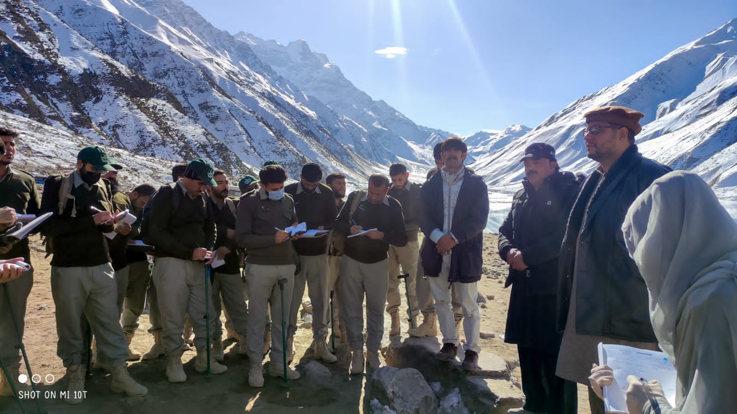
Figure 2 Field Lecture
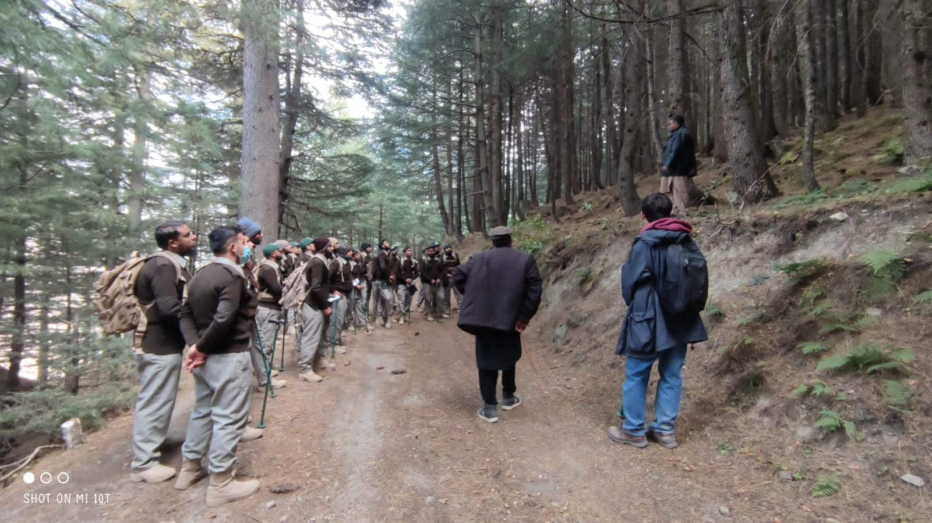
Figure 3 Field Lecture

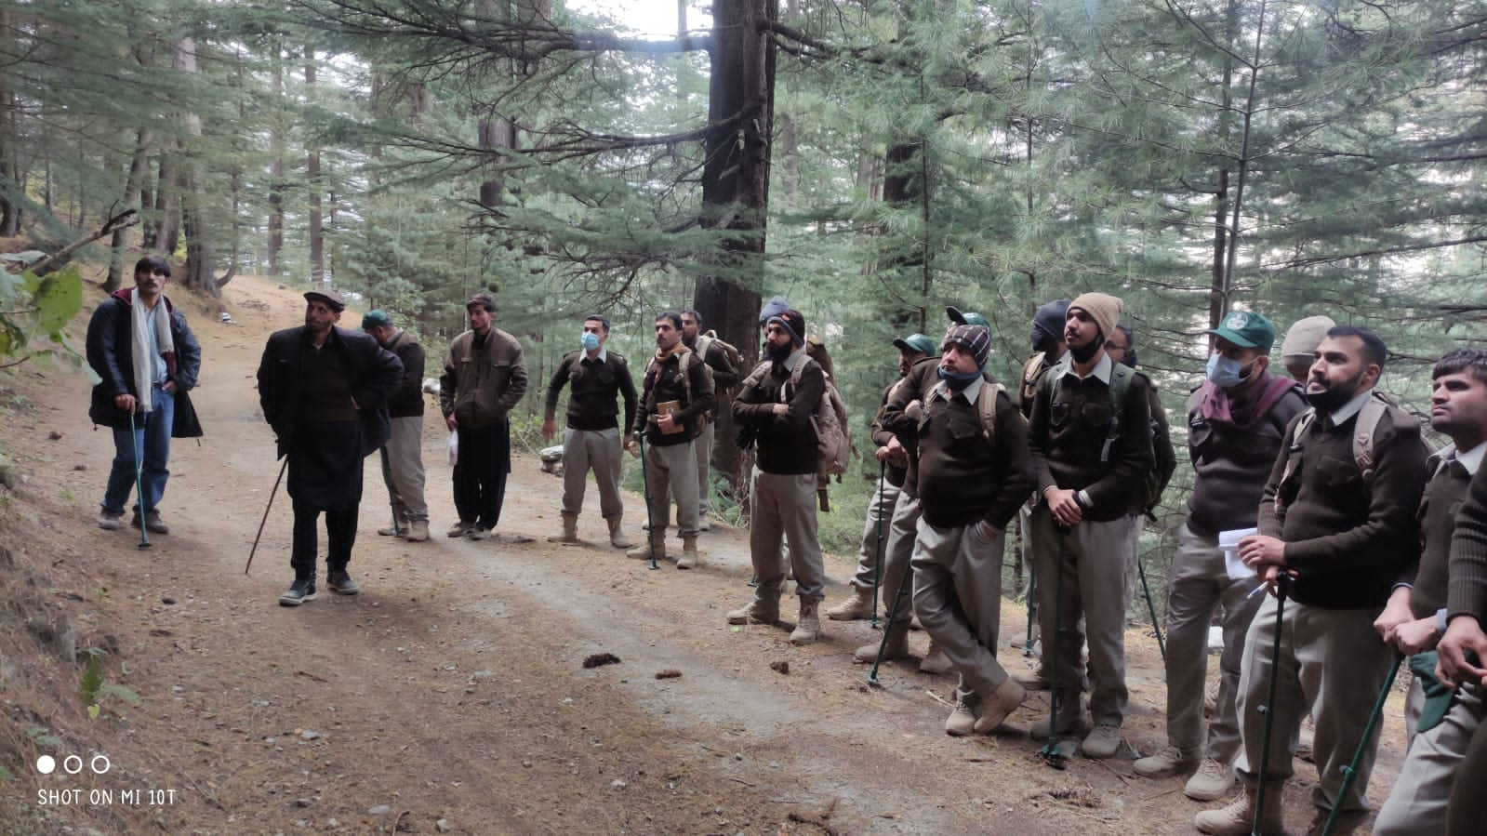
Figure 4 Field Lecture
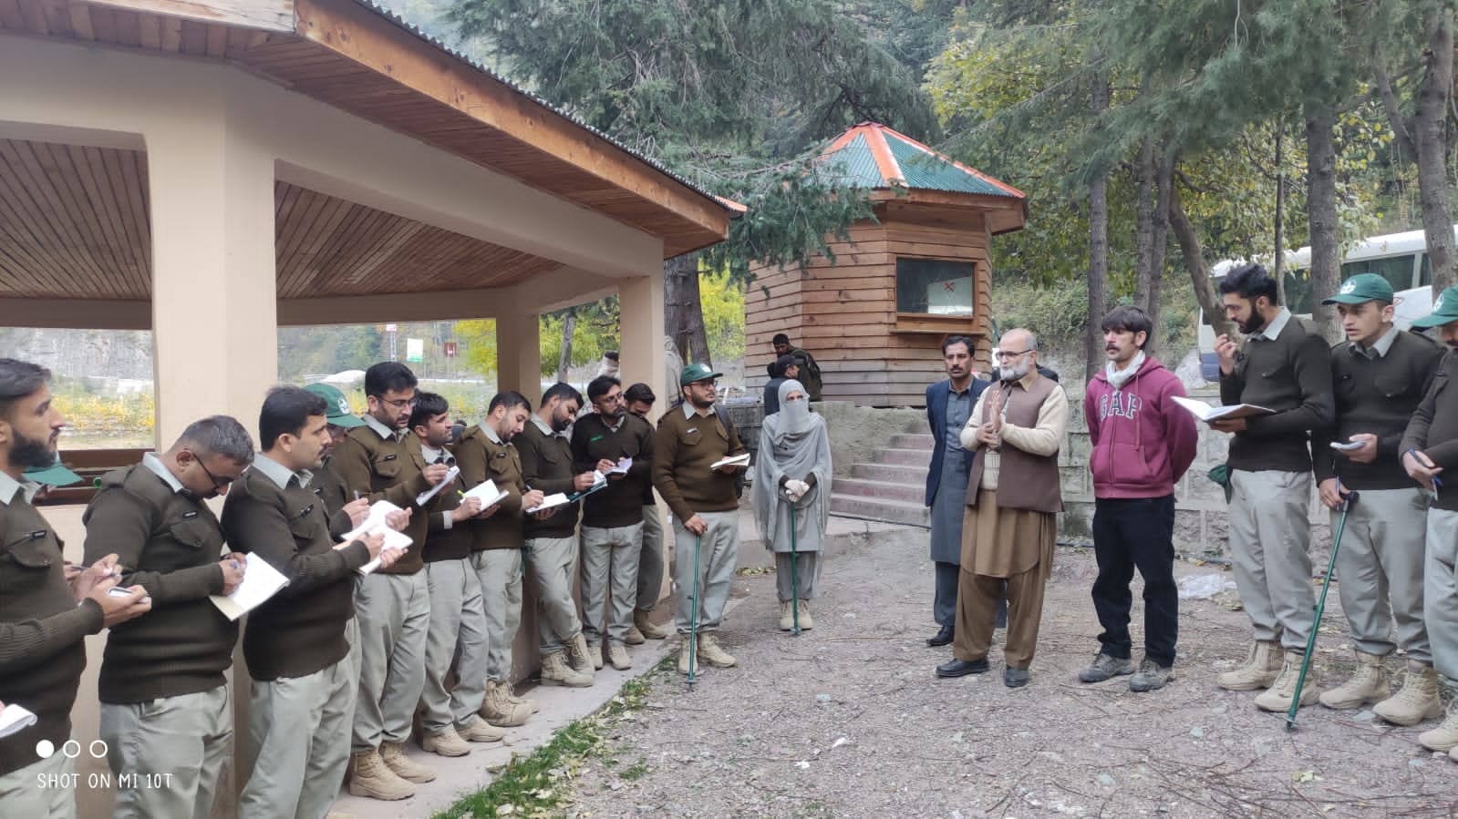

Figure 5 Field Lecture

ACKNOWLEDGEMENTS:
Authors are indebted to ADG and Director Pakistan Forest Institute Peshawar for valuable suggestions and inputs.

REFERENCES:
- Ralph, D. N. Silviculture: Concepts and Applications. Waveland Press. McGraw Hills Forestry Series.
- Champion, H. G, Seth, S> K and Khattak, G. M. (1965). Manual of Silviculture for Pakistan, Peshawar.
- Sheikh, M. I (1986). Afforestation on Arid and Semi-Arid Lands. FAO document No.13. Pakistan Forest Institute, Peshawar. Pakistan.
- Fujimori. (2001). Ecology and Silvicultural Strategies for Sustainable Forest Management. Elservier Science Publications.

7/22/2022

