Production of DNA vaccine coding for MCE4A and Esat-6 genes of Mycobacterium bovis

Michael, R.F.**; *Manal, O.Elhamshary. ;*Nasr, M.I.;**¹Soliman, Y.A.;

**Central Laboratory for Evaluation of Veterinary Biologics, Abasia, Cairo (ARC)
* GEBRI, Molecular Diagnosis and Therapeutics Dept. University of Sadat City, Sadat City, Egypt.\
Yousefadel00@hotmail.com

Abstract: One of the major aims in the tuberculosis infection is developing a vaccine that could prevent mycobacterial cells from being enter the macrophage and hence will be subjected to the immune defense mechanisms. MCE4A and Esat-6 are protein antigens of the secretory antigens that enables tuberculosis to enter macrophages thus neutralization of such antigen will aid in the restriction of disease development. In the current study the 1200bp full length mce4a gene and 300bp for esat 6 gene were amplified and cloned in gateway entry cloning vector( pEnter\SD\topo) and then homologous recombination with the destination vector( pDEST 40) was done in order to develop the DNA vaccine. Vaccination of guinea pigs with this DNA vaccine and subsequent challenging with M bovis revealed comparable results with that of the BCG revealing that the vaccine could be promising approach to be tested on the cattle.
[Michael, R.F.; Manal, O.Elhamshary. Soliman, Y.A. Production of DNA vaccine coding for MCE4A and Esat-6 genes of Mycobacterium bovis. Researcher 2022;14(6):1-12] ISSN 1553-9865 (print); ISSN 2163-8950 (online) http://www.sciencepub.net/researcher. 1. doi:10.7537/marsrsj140622.01.

Keywords: Production; DNA; vaccine; coding; MCE4A; gene; Mycobacterium bovis

Introduction:
Mycobacteria survives phagocytosis and replicates within macrophages. Following infection with M. tuberculosis, both healthy subjects and patients with active tuberculosis develop T-cell responses against mycobacterial antigens (Arruda et al., 1993). Identified a DNA fragment of 450 bp from M. tuberculosis H37Ra that conferred the ability on nonpathogenic E.coli to enter mammalian cells and survive, they designated this gene mce1. Subsequently, (Parker et al., 1995) showed the presence of a similar gene in M. avium, M. intracellulare and M. scrofulaceum by PCR approach.
Since the delineation of the complete genome sequence of M. tuberculosis H37Rv, four mce operons, designated mce1 to mce4, having similar organization and containing the 450-bp core sequence were identified (Cole et al., 1998). Subsequently, the presence of mce1 was also detected in M. leprae, while all the mce operons except mce3 were detected in M. bovis (Wiker et al., 1999 and Zuma´rraga et al., 1999). Furthermore, (Chitale et al., 2001) demonstrated that mce1encodes a surface protein and that polystyrene latex microspheres coated with purified recombinant mce1 protein can enter HeLa cells, while mce2, which has 67% similarity with mce1, does not display this property. This suggests that in addition to cell entry, mce operons perhaps have other functions. Later, the presence of mce operons in M. smegmatis, which is a saprophytic species, was also reported.
The emerging reports on the role of mce4 operon in survival of mycobacteria in host tissue indicates that Mce4 proteins may be involved in maintaining the mycobacteria in a nutrient deficient environment for long term survival , also it has been suggested that the proteins of the mce4 operon may operate as a major cholesterol import system because strains lacking mce4 operon exhibit drastically reduced ability to take up and metabolize cholesterol in vitro and hence grow poorly when cholesterol is the primary source of carbon (Pandey and Sassetti 2008). It was reported earlier that mutation in mce1 operon produces growth defect in early phase of infection in mice and mutation in mce4 operon produces growth defect after 3–4 weeks post infection, indicating thereby that mce4 operon is required in later phase of infection (Sassetti and Rubin 2003).

The esat-6 gene, which lacks a signal sequence , is present in M. tuberculosis and virulent Mycobacterium bovis but absent in the M. Bovis BCG vaccine strain. One possible avenue toward improved vaccines against tuberculosis would therefore be recombinant live vaccine carriers such as BCG or attenuated vaccinia virus expressing ESAT-6.However, such an approach will hinder the use of the tuberculin test for diagnostic purposes, thus an alternative approach is the DNA vaccine that encodes the esat-6 gene.

The 6-KDa early secretory antigenic target (ESAT-6) of M. bovis has attracted considerable interest in recent years as it is a dominant antigen during the early stages of M. bovis infection and due to its strong recognition by ThI cells in the early phase of infection in patients as well as in experimental animals. Recently, several T-cell epitopes were identified on ESAT-6 which are strongly recognized in mice and a very high percentage. Overlapping peptides spanning the sequence of ESAT-6 have been used to map two T-cell epitopes on this molecule in mice.

The current study aimed to production of the mammalian expression DNA vaccine that encode for the Mce4A & ESAT-6 protein antigens and preliminary evaluation of its protective efficacy against subsequent challenge with the M. bovis virulent strains as a control measure for the tuberculosis infection.

Material and Methods:
Mycobacterium bovis isolation:
Mycobacterium bovis. This strain was isolated from Lungs showing P/M lesions from tuberculin positive cross breed dairy cattle collected from Behaira Governorate during the year 2013. This strain used for amplification of esat-6 gene and mce4a gene and challenge of guinea pigs. ( Micheal 2017)

Identification of the isolate:
Species level identification of growth of acid fast bacilli (AFB) positive mycobacterial isolates was done by standard biochemical tests [niacin production, nitrate reduction, catalase activity at 68°C and at room temperature, tween hydrolysis, arylsulphatase and thiophen-2 carboxylic acid hydrazide (TCH) sensitivity and urease test] as per CDC Manual , a combination of positive urease and negative activity for niacin, nitrate reduction, catalase at 68°C, tween hydrolysis, arylsulphatase and TCH were considered as characteristics of M. bovis (Vestal, 1977).
DNA Extraction:
The DNA was extracted from the mycobacterial strain by Triazol method (Soliman et al., 2011) according to the manufacture instructions with some modification. Briefly, the pellets were reconstituted in 1 ml TE buffer pH 8 and incubated at 37ºC for 2 hours with 20 ul lysozymes (final concentration 100μg/ml). Proteinase-K 100μl/1ml (final concentration 100μg/ml) and SDS (final concentration 1%) were added and incubated for further 3 hours at 56ºC with shaking then 1 ml of Triazol was added. After vortexing for 30 sec, 0.5 ml of chloroform was added and centrifuged for 10 min at 14000 rpm. The DNA in the interphase was precipitated with 0.5 ml of absolute ethanol, washed twice with 0.1M sodium citrate in absolute ethanol and finally redissolved in 50ul of 8 mM NaOH. The pH was then adjusted at 8 by adding 115 µl/ml HEPES (0.1 M). Two µl of RNAase were then added and incubated at 37ºC for 1 hour. Purification of the genomic DNA was done using Wizard DNA clean up system (Promega).

PCR amplification:
The full length mce4A &ESAT-6 genes were amplified using the cloning primer that enables the gene to be cloned in pEnter SD/D topo cloning vector( invitrogene cat # K2420-20).
These primers were designed using DNASTARE version 10, mce-F (5'- CACCATGTCCGGCGGCGGATCT-3') and mce-R (5'-GAAGTCGTCCCGTTCCGCGAAC-3').
esat-6-Fb(TGGAATTTCGCGGGTATCGAG) and esat-6-R (ATGCGAACATCCCAGTGACGT)
PCR was performed in 50-µl reaction mixtures containing 50 mM KCl, 10mM Tris-HCl (pH8.8), 3 mM MgCl2, 200 mM (each) deoxynucleoside triphosphate, 10µl Q solution (Qiagene) and 2.5 U of thermostable pfu DNA polymerase and 100 pmol of each oligonucleotide primer. DNA samples (1 µg) was pipetted through into the mix true. Thermal cycling was performed using T professional thermal cycler (Biometra, Germany), the parameters for amplification were denaturation at 95 ºC for 3 min for one cycle and then 40 cycles at 95ºC for 1 min (denature), 62 ºC for 45 sec, and 72ºC for 1.5 min (extension). A final extension at 72 ºC for 10 min was also included. The amplicon was then visualized under U.V. transelumination after electrophoresis on 1% agarose. The size of the amplicons was analyzed in comparison to gene ruler 100pb plus DNA ladder (Fremantase cat # SM0323).
Cloning of mce4a & ESAT-6 gene in the entry vector:
The mce4a gene was first cloned in pENTR/SD/D-TOPO Cloning vector (Invitrogen cat # K2420-20) according to the manufacture instruction. Briefly, two µl of the purified gene were mixed with one µl of the cloning vector and 1µl of the salt solution. The volume was adjusted to 6µl using nuclease free water and the directional cloning was done by incubation of the mixture at 22°C/30min. one µl of the cloning mixture was added to a vial containing the Topo 10 chemically competent E. coli and transformation was done at 42°C/45 sec followed by rapid incubation of the cells at ice /5min then 100µl of these transformed cells were spread onto the surface of LB agar plates containing ampicillin (100µg/ml) and incubated at 37°C overnight. The growing colonies were picked up and inoculated in LB broth containing ampicillin and incubated over night at 37°C. The recombinant plasmid was then purified using plasmid miniprep kit (BioFlux #K0502).

Cloning of mce4a & Esat-6 genes in the destination vector:
One of the plasmids that gave positive results indicating the presence of the insert within the donor vector was selected and used for the homologous recombination with the Gateway pcDNA DEST40 Vector which will be used as the mammalian expression vector and used for animal vaccination.
In order to perform the homologous recombination, both donor vector containing the mce4a gene insert and the destination vector were mixed in ratio of 1:1 with 1µl of the LR clonase II enzyme mix and the reaction was incubated at 25°C for 30 min, the reaction was then kept at -20°C till used for transformation of E. coli competent cells.

Evaluation of the vaccinal potential of the pDEST 40 mammalian expression vector that express the mce4a & Esat-6 genes:
DNA vaccine (20µg/dose) was mixed in 0.2ml sterile physiological saline. BCG vaccine was given in a dose of 10³ bacilli / animal.
Health female guinea pigs were divided into 5 groups 10 animal each as shown in table (3).
The guinea pigs were challenged 5 weeks after the last dose of the vaccine with M. bovis. Each animal in each group was inoculated I/M in the inner aspect of the thigh with 1 ml of physiological saline containing 5x10⁴ CFU.
Two weeks post challenge the animals were sacrificed and aseptically, lungs, spleen, were taken from each animal and processed for bacteriological count.
The animals were sacrificed 2 weeks post challenge and organs were aseptically were removed, homogenized with PBS and serial dilution of the homogenate plated out on Middle brook 7H10 agar plates and incubated for one month at 37°C. The bacterial load was then enumerated and result values were presented as mean of Log 10 CFU per organ ± one standard deviation or as Log ₁₀ unit of resistance, corresponding to the difference between Log ₁₀ CFU in control non vaccinated animals and Log ₁₀ CFU in immunized animals.
Survival rates (alive versus total) in the immunized animals as well as control were noted for 30 days post challenge.
Three milliliter of blood was taken aseptically from each animal by heart puncture and mixed with heparin (10U/ML). It was used for measurement of the cell mediated immune response.

Table (1) shows the vaccination regimen of the guinea pigs used in this study.
Group number | Route and the type of the vaccine/ animal | boostering
G1 | DNA vaccine expressing the esat-6 gene | 2 doses 2 weeks intervals I/M injection
G2 | DNA vaccine expressing the mce4a gene | 2 doses 2 weeks intervals I/M injection
G3 | DNA vaccine expressing the mce4a gene and esat-6 gene | 2 doses 2 weeks intervals I/M injection
G4 | BCG vaccine (positive control) | Once I/D injection
G5 | Un-vaccinated negative control | -

Results:
Results of DNA isolation and purification:
The genomic DNA of M. bovis was isolated by simple mechanical disruption of the cells followed by triazole. The OD₂₆₀ was 0.196 and OD₂₈₀ was 0.326, the DNA concentration was 0.49 µg/µl and the purity was calculated as 1.66.
After purification, the OD changed markedly. In triazole extraction, the OD₂₆₀ was 0.185 and OD₂₈₀ was 0.310, the DNA concentration was 0.46 µg/µl and the purity was 1.67
Results of mce4a & Esat-6 genes amplification:
The mce4a and esat-6 genes were amplified by PCR ,a clear visible band migrate at 288bp for esat-6 gene and 1200 bp was for the mce4a gene as visualized under the UV illumination.
Fig. (1) Shows the electrophoretic mobility of esat-6 and mce4a gene on 1% agarose.

.

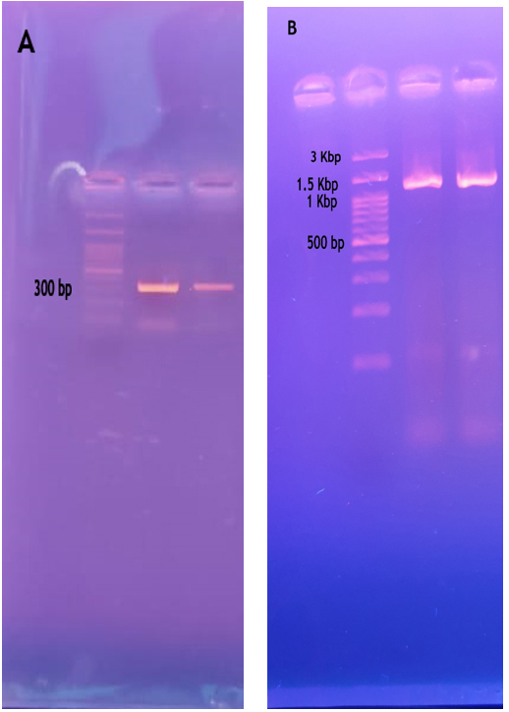

Fig (1). Agarose gel electrophoresis of the amplified esat-6 gene (A) and mce4a gene (B) from the genomic DNA of M. bovis

Results of mce4a gene cloning:
The full length mce4a gene and east 6 gene of M. bovis were cloned first in the pENTR/SD/D-TOPO entry vector. After recombination, the vectors were transformed into E.coli Topo competent cells and plated onto LB agar plates containing the selective antibiotic kanamycin. After 24h incubation at 37 °C, the developed colonies were subjected to subjected to further analysis using PCR.

Analysis of the transformants using qPCR analysis of the miniprep prepared from overnight culture:
Five colonies were collected from the overnight culture of the transformed E.coli with the donor vector containing either esat-6 or mce4a gene inserts and the inserts were analyzed using qPCR using specific primers. As seen in fig (2,3), all the colonies gave positive C_{t} ranging from 17.39 – 21.03 for esat-6 gene and 26.28- 36.41 for mce4a gene. Indicating that all the miniprep contain the respective inserts.

Results of mce4a gene and esat 6 amplification of miniprep of the donor vector:
In order to verify the positive orientation of the cloned gene within the vector, miniprep of the plasmid carrying either esat-6 or mce4a genes were done from the overnight shacked culture of the selected colonies and PCR amplification was dome to the mce4a and esat 6 gene using one primer within the gene (the reverse primer) and the other one lies within the vector itself (the M13 forward primer).
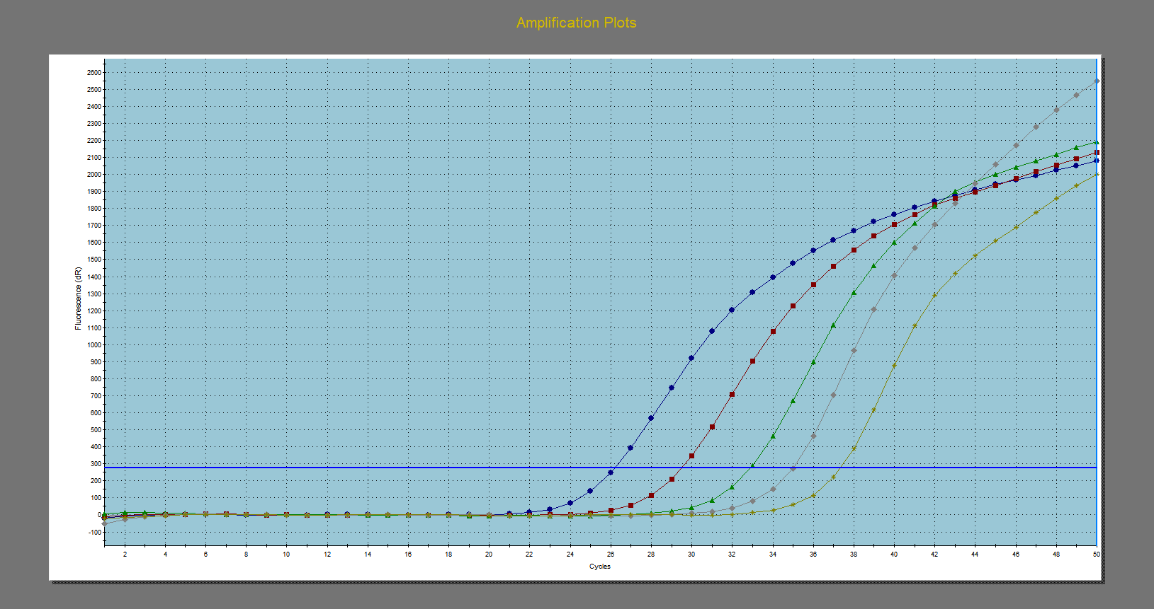
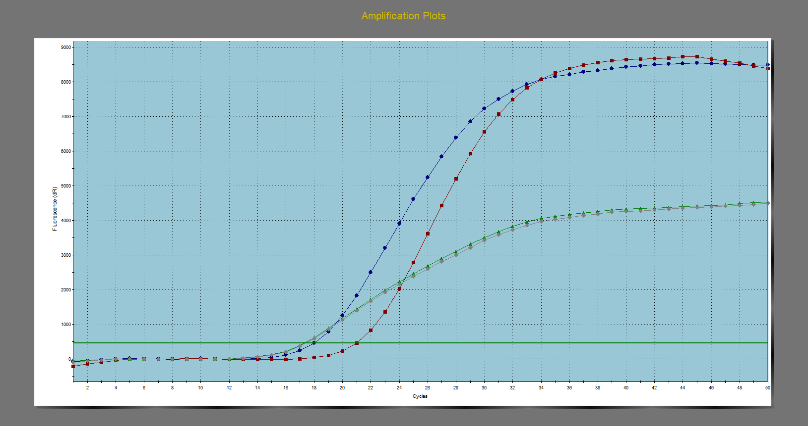
Fig (3) The amplification plot of esat-6 gene amplification from the miniprep of the recombinant donor vector.
Fig (2) the amplification plot of mce4a gene amplification from the miniprep of the recombinant donor vector.

Results of mce4a gene and esat 6 amplification of miniprep of the donor vector:
In order to verify the positive orientation of the cloned gene within the vector, miniprep of the plasmid carrying either esat-6 or mce4a genes were done from the overnight shacked culture of the selected colonies and PCR amplification was dome to the mce4a and esat 6 gene using one primer within the gene (the reverse primer) and the other one lies within the vector itself (the M13 forward primer).
As showed in fig (4) lane 2, the full length esat-6 and mce4a genes could be amplified from the recombinant donor vector indication positive orientation of the gene within the vector.

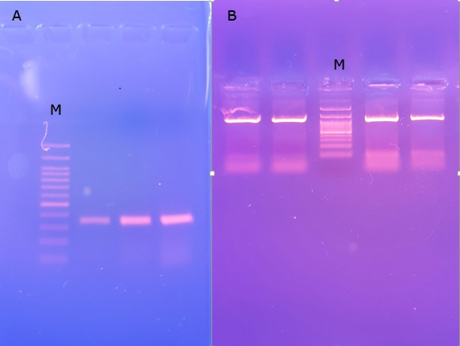
Fig(4) shows the amplification of esat6 gene (A) and mce4a gene (B) from miniprep of some selected clones. Notice the presence of a clear band migrating about at about 300bp for esat 6 gene and 1.2 kbp for mce4A gene M- 100 bp plus ladder

Results of esat 6 and mce4a gene cloning in the destination vector:
Homologues recombination between the donor vector and destination vector were done, and the resulted vectors are the final mammalian expression DNA vaccine. After homologous recombination, the reactions mix were used to transform E. coli topo 10 competent cells to propagate the plasmid. Overnight growth on LB- ampicillin agar media of the positive colonies harboring were recovered and the recombinant plasmid transfer the ampicillin resistant gene to the E. coli strain. It was noticed that the number of the transformants was much less, than in the previous step, yet all the colonies were harboring the plasmid when subjected to downstream analysis.

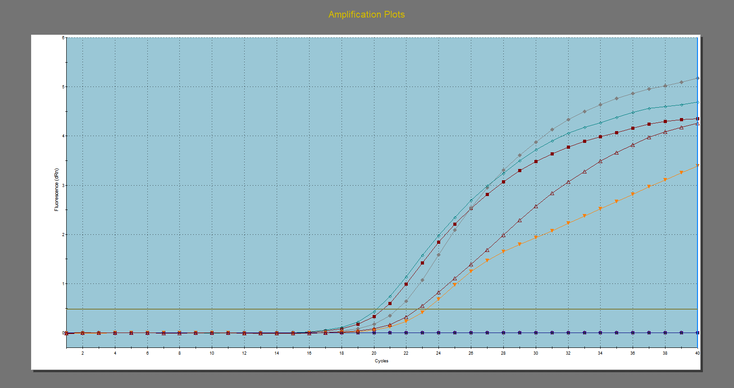
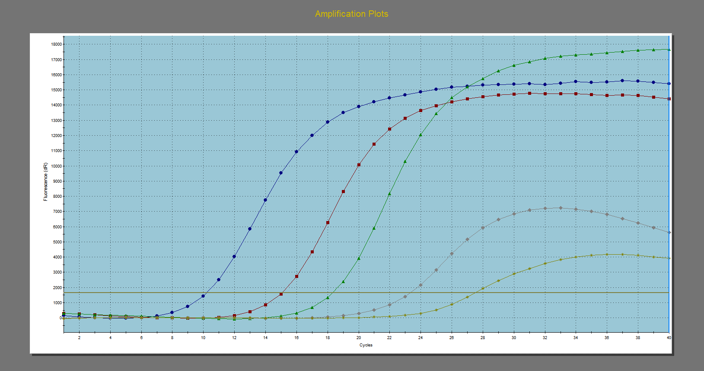
Fig (6) The amplification plot of mce4a gene amplification from the miniprep of the recombinant destination vector.
Fig (5) The amplification plot of esat-6 gene amplification from the miniprep of the recombinant destination vector.

Results of evaluation of the vaccinal potential of the esat-6 and mce4a genes expressed by the pDEST 40 mammalian expression vaccine:
Different parameters were undertaken in order to perform preliminary evaluation of the vaccinal potential of the DNA vaccine expressing wither east-6 and /or the mce4a genes of M. bovis . All the used parameters directed towards the measurements of the protective efficacy of the DNA vaccine in comparison with the slandered BCG vaccine. These parameters were root specific lung weight, lung density, root specific lung density, viable bacterial count in lung and spleen and the survival rate.

No. of alive
Survival rate =
Total No.

Table(2): The results of Vaccinations of guinea pigs with different types of vaccines
DNA Vaccine | Measured parameter
 | RSLW | Lung density | Log₁₀ mean viable bacterial count + SEM |  | survival rate in weeks
 |  |  | in lung | in spleen | 2w | 4w | 8w
Esat-6 | 13.8 | ++ | 3.18+ 0.06 | 3.75+ 0.06 | 10/10 | 8/10 | 7/10
Mce4a | 13 | ++ | 4.06 + 0.34 | 4.58 + 0.92 | 10/10 | 8/10 | 5/10
Esat-6 and mce4a | 12.8 | + | 2.85+ 0.06*♦ | 2.95+ 0.06*♦ | 10/10 | 10/10 | 8/10
BCG vaccine | 11 | - | 2.98 + 0.06*♦ | 3.36 + 0.93* | 10/10 | 10/10 | 9/10
Control unvaccinated | 20.6 | ++++ | 5.67 + 0.02 | 6.66 + 0.89 | 6/10 | 4/10 | 0/10
* There were significant different (P<0.05) when compared to the control unvaccinated group
♦ There were significant different (P<0.05) when compared to the groups received DNA vaccine coding for esat-6 or mce4a only.

Results of IFN-γ of the vaccinal potential of the esat-6 and mce4a genes expressed by the pDEST 40 mammalian expression vaccine:
Gamma interferon transcripts were quantitated using 2 steps qPCR assay, the data were statistically analyzed using ΔΔC_{t} method and the expressed in the log 10 of the fold change of expression in comparison with the negative control unvaccinated group (G5).
Data in table (2) Fig(7) and revealed that, mce4a has very limited effect on IFN-γ transcripts while most effect seen in the group vaccinated with the DNA vaccine coding for esat-6 protein antigen . The most powerful IFN-γ response was seen in the group vaccinated with the DNA vaccine coding for both esat-6 and mce4a protein antigens, especially at 7 days post challenge.

Table(3): The mean of normalized C_{t} of target gene (IFN-γ) after vaccination and post challenge as analyzed using REST 2009 software to calculate the differential expression level.
Groups | Mean of Normalized ∆∆Ct of the target IFN-γ gene |  |  | Fold change of target IFN-γ gene transcripts
 | Days post challenge (PC)
 | 3d | 5d | 7d | 3d | 5d | 7d
G1 | -10.262 | -12.308 | -17.164 | 1227 | 5070 | 146851
G2 | -2.899 | -2.719 | -3.135 | 7 | 6 | 8
G3 | -12.862 | -15.225 | -22.996 | 7444 | 38298 | 8365382
G4 | -11.287 | -12.195 | -15.073 | 2498 | 4688 | 34468
G5 | 10.287 | 8.195 | -2.073 | 0.00 | 0.00 | 4.2

Fig(7) The Log 10 fold change of interferon gamma transcripts after 3,5 and 7 days post challenge with M. bovis.

Discussion:
Deciphering the biology of M. tuberculosis from the complete genome sequence ( Cole et al., 1998 and Tekaia et al., 1999) revealed the presence of a large operon coding for a putative virulence genes called mammalian cell entry genes enable the mycobacterium to invade and/or intracellular survive within macrophages. This Mce was subsequently shown to be preceded by two integral membrane proteins (YrbE) and followed by five other Mce proteins arranged in a mce operon. The genome sequencing also revealed four copies of mce, arranged in four homologous mce Operons (mce1–4). The mce genes encode invasin/adhesin-like proteins with putative signal sequences at the N-terminal end and are most likely located at the mycobacterial cell surface (Tekaia et al., 1999 and, Chitale et al., 2001) The antipeptide antibodies corresponding to a predicted B-cell epitope in each of the Mce1A-F showed that these Mce are expressed during the in vitro growth of M. tuberculosis (Harboe et al., 1999 and Joshi et al., 2006). Mce1A and Mce1E are also expressed and elicit antibody production during natural infection with M. tuberculosis (Ahmad et al., 1999).
The first step in the current protocol is to isolate highly purified whole genomic DNA of the Mycobacterium bovis strain which will be used for the amplification of the mce4a gene that will be used for the cloning procedures. A hindrance in the development of efficient and rapid procedures for isolation of mycobacterial genomic DNA has been the mycobacterial cell wall. Mycobacterium species are endowed with a unique cell wall composed of a covalently attached complex of peptidoglycan, arabinogalatan, and mycolic acid (Brennan and Nikadio, 1995). In addition, an array of glycolipids, lipoglycan and a unique polar lipid form an outer leaflet that is closely associated with the cell-wall mycolic acid. This structure composed of tightly packed lipophilic and highly branched polysaccharides is largely responsible for the low permeability of the mycobacterial cell envelope and results in a formidable protective barrier. Owing to this unique cellular envelope the standard methods for isolating DNA from Gram -ve (Sambrook et al., 1988), and Gram +ve bacteria (Caparon and Scott, 1991 and Hoch, 1991) are not optimal for mycobacteria. Several methods, with varying approaches to achieve efficient cell lysis are reported for isolation of genomic DNA from mycobacterial species including enzymatic (Patel et al., 1986 and Shoemaker et al., 1986) mechanical (Jacobs et al., 1991, Barrera et al., 1993 and Yandell and McCarthy 1980) and/or chemical methods (Gongalez et al., 1996).
The mycobacterium cells were treated with a simple mechanical management in the form of repeated freezing and thawing followed by homogenization. After enzymatic digestion with Proteinase-K and lysozymes (Soliman et al., 2011 and Whipple et al., 1987), the organic extraction was done by triazole extraction. Despite the low yield of DNA extracted by triazole, still gave a high purity then traditional phenol extraction. DNA purification was then done to eliminate not only protein contaminant but also salts and polysaccharides that portioned with the aqueous soluble DNA and may interfere with the subsequent PCR or endonuclease digestion analysis (Brennan and Nikadio, 1995 and Hurley et al., 1988).
The recombinant donor vector, which contains the esat-6, and mce4A genes in the correct correction were subjected to homologous recombination with the destination vector pDEST40 which will be used as a DNA vaccine. This recombination is done using the LR colonizee enzyme II mix which enables the recombination between the attR sit in the donor vector and the attB sit in the destination vector resulting in the directional insertion of the esat-6 and mce4A genes in the destination vector and this recombination is done within 5 min at room temperature (Landy, 1989).
As seen in fig 8 the recombinant destination vector purified from the E.coli and electrophoresed on 1% agarose gel and the 8.3 and 7.4 Kbp fragments were seen which corresponds to the size of the destination vector plus the esat-6 and mce4A genes insert respectively.
The last step in the current study aimed to perform the preliminary study on the protective efficacy of the mammalian expression vector (destination vector) that carries the esat-6 and mce4A genes against the M. bovis infection in the experimental infection model of the guinea pigs.
First, the guinea pigs were vaccinated with the DNA vaccine coding for either esat-8 or mce4a genes or both, and the BCG vaccine was used as a positive control, the guinea pigs were later challenged with virulent M. bovis strain used originally for the amplification of the esat-6 and mce4A genes.
Three different parameters were used to assess the protective efficacy of the DNA vaccine. The first parameter is related to the density of the organs affected mainly the lung and spleen that may result in nodular formation (tubercula), where a reduction in pathological lesions in these organs will reduce the weight of the organ in comparison to the group where pathological lesions were more pronounced. The second parameter is the bacteriological count of live mycobacteria in the lung and spleen after the challenge, which gives a good indicator about the spread of infection and the ability of the immune system to restrict mycobacteria. Finally, the measurement of the IFN-γ transcript in the PMNCs in response to mycobacterial protein antigens reflects the strength of the cell-mediated immune response in the limitation of the infection and the destruction of the mycobacteria in the macrophages.
as shown in table (2) , the RSLW revealed that the BCG vaccination gave better results and it was sig different from the control unvaccinated group, while the DNA vaccine coding for the esat 6 and/or mce4a gene gave more index but still sig differ from the unvaccinated group. This index measures the degree of the development of the tubercle nodules in the lung. More nodules gave more weight, which reflects the inability of the immune system to localize and prevent the spread of the infection. These results indicated that the DNA vaccine could give many restrictions to the spread of the infection. Because BCG is an attenuated form of M. bovis, it gave better results than the mce4a DNA vaccine as it contains a complex mixture of antigens that could potentiate the immune system much more than the single antigen. The same results were obtained using different parameters such as lung density ( Parlane et al., 2015).
Bacterial count in the lung and spleen reflects the ability of the bacterial to overcome the immune system of the animals. low counts indicate high immune reaction that restricts the ability of mycobacteria to multiply, as seen in the table (4) and, bacterial count in lung and spleen in both vaccinated animals with either BCG or DNA vaccines coding for esat 6 and/or mce4a were significantly lower than the unvaccinated negative control challenged guinea pigs (p<0.05).
Elimination of M. tuberculosis infection mainly depends on the success of the interaction between infected macrophages and T lymphocytes despite the involvement of other cells. Macrophages are important effector cells in immunity against intracellular bacteria. On infection, macrophages (MO) recognize the mycobacteria by toll-like receptor (TLR) engagement (especially TLR1/2 and TLR2/6) followed by phagocytosis and control of mycobacteria growth. In addition, macrophages and dendritic cells also secrete cytokines such as IL-12 and IL23 to induce IFN-γ production by T and NK cells, which, in turn, increases the phagocytosis, phagolysosomal fusion, oxidative burst, and other not fully clear nonoxidative mechanisms [8]. For an efficient T helper 1 (Th1, IFN-γ producer cells) differentiation, costimulation (e.g., CD40L-CD40 and CD28-CD80/CD86 interactions) and NEMO/NF-κB dependent signaling [9] are required. On the other hand, the negative regulation of IFN-γ production involves different mechanism, including production of Th2 cytokines (IL-4, IL-5, and IL-13) and the participation of suppressor of cytokine signaling- (SOCS-) 1. The mechanism by which IFN-γ improves the functional defects of phagocytes occurs at both the level of a progenitor cell and mature cells. This cytokine enhances the oxidative burst response, but, on the other hand, IFN-γ has been shown to contradictorily improve neutrophil microbicidal killing through mechanisms other than enhanced oxidative activity. IFN-γ is an important cytokine which plays multifarious roles in different parts of the immune system. It is involved in the process of generating, sustaining, and regulating the cells of the innate and adaptive arms of the immune system. Macrophages activated by IFN-γ increased pinocytosis, receptor-mediated phagocytosis, and microbial killing ability against mycobacteria. As we studied a small cohort, the continuation of this research line is required to study increased number of patients with MDR-TB in order to study comprehensively MDM mechanisms of controlling M. tuberculosis growth. In addition, large randomized controlled trials have been already performed showing that adjuvant therapy using IFN-γ might be beneficial to TB patients .
In the current study, both G1 (DNA vaccine coding for esat-6 gene) and G3 (DNA vaccine coding for esat-6 and mce4a genes) gave highly significant results (upregulated) when compared to the unvaccinated group, or even with the G2 ( DNA vaccine coding for mce4a gene). These results were not surprising as the east-6 gene is targeting the T-cells and have a property of IFN-γ stimulation.
The results of high IFN-γ production along with both low bacterial count and low pathological findings in both lung and spleen in the DNA vaccinated group with DNA vaccine coding for both esat-6 and mce4a genes was reflected on the survival rate as shown in the table (3) with the highest survival rate among all tested groups.
In conclusion, the DNA vaccine coding for the esat-6 and mce4a genes gave a promising protective efficacy when combined together that could be used for the control of tuberculosis infection.

References:
- Ahmad, S.; Akbar, P.K.; Wiker, H.G.; Harboe, M.; Mustafa, A.S. 1999. Cloning, expression and immunological reactivity of two mammalian cell entry proteins encoded by the mce1 operon of Mycobacterium tuberculosis. Scand J. Immunol. 50:510–8.
- Arruda, S.; Bomfim, G.; Knights, R.; Huima-Byron, T. and Riley, L. W. 1993 Cloning of an M. tuberculosis DNA fragment associated with entry and survival inside cells. Science 261:1454–1457.
- Barrera, L.F.; Skamene, A. and Radzioch, D. (1993): Assessment of mycobacterial infection and multiplication in macrophage by polymerase chain reaction. J. Immunol. Method., 157: 91 – 99.
- Brennan, P.J. and Nikaido, H. 1995 The envelope of mycobacteria. Annu. Rev. Biochem. 64:29 – 63.
- Capron, M.G. and Scott, J.R. 1991 Genatic manipulation of pathogenic Streptococci. Method Enzymol.., 204:556 – 586.
- Chitale, S.; Ehrt, S. and Kawamura, I. 2001.
- Recombinant Mycobacterium tuberculosis protein associated with mammalian cell entry. Cell Microbiol, 3:247–254.
- Chitale, S.;Ehrt, S.;Kawamura ,S.; Fujimura, T.;Shimono, N.;Anand, N.; Lu, S.; Cohen-Gould, L.and Riley, L. W. 2001. Recombinant Mycobacterium tuberculosis protein associated with mammalian cell entry. Cell.Microbiol.3:247–254.
- Cole, S.T.; Brosch, R.; Parkhill, J.; Garnier, T.; Churcher, C.; Harris, D.; Gordon, S.V.; Eiglmeier, K.; Gas, S.; Barry III, C.E.; Tekaia, F.; Badcock, K.; Basham, D.; Brown, D.; Chillingworth, T.; Connor, R.; Davis, R.; Devlin, K.; Feltwell, T.; Gentles, S.; Hamlin, N.; Holroyd, S.; Hornsby, T.; Jagels, K.; Krogh, A.; Rogers, J.; Rutter, S.; Seeger, K.; Skelton, J.; Squares, R.; Squares, S.; Sulston, J.E.; Taylor, K.; Whitehead, S. and Barrell, B.G. 1998. Deciphering the biology of Mycobacterium tuberculosis from the complete genome sequence. Nature 393, 537-544.
- Crowle, A. J. 1958 A simplified micro double-diffusion agar precipitin technique. J. Lab. Clin. Med.52:784.
- Gongalez,J.A.; Estrada, I.; Colston, M.J. and Cox, R.A. (1996) ; A noval method for isolation of mycobacterial DNA.FEMS Microbiol.Lett. , 135 :71 – 77.
- Harboe, M.; Christensen, A.and Haile, Y. 1999. Demonstration of operon of Mycobacterium tuberculosis by anti-peptide antibodies, expression of six proteins of the mammalian cell entry (mce1) enzyme-linked immunosorbent assay and reverse transcription-polymerase chain reaction. Scand J. Immunol 50:519–27.
- Hoch, J.A. (1991): Genetic analysis in bacillus subtilis. Method Enzym., 204 : 305 – 320.
- Hurley, S.S.; Splitter, G.A. and Welch, R.A. 1988 Deoxyribonucleic acid relatedness of Mycobacterium paratuberculosis to the other member of the family Mycobacteriaceae. Intl. J. Sys. Bacteriol., 38:143 – 146.
- Jacobs, Jr.W.R.; Kalpana, G.N.; Cirillo, J.D.; Pascopella, L.; Snapper, S.B.; Udani,R.A.; Jones, W.; Barletta, R.G. and Bloom, B.R. 1991 Genetic system for Mycobacteria. Methods Enzymol. 204 : 537 – 555.
- Joshi, S. M.; Pandey, A. K.; Capite, N.; Fortune, S.M.; Rubin, E. J. and Sassetti, C. M. 2006 Characterization of mycobacterial virulence genes through genetic interaction mapping PNAS, 2006, 103, 31
- Landy, A. 1989 Dynamic, Structural, and Regulatory Aspects of Lambda Site-specific Recombination. Ann. Rev. Biochem. 58, 913-949.
- Marks, J. (1972):Ending the routine Guinea pigs test. Tubercle, 53: 31 - 34.
- Oiozco, L.C.; Quintana, F.O.; Beltran, R.M.; DeMoreno, I.; Wasser, M. and Rodringuez, G. 1986 The use of rifampicin and isoniazid entrapped in liposomes for the treatment of murine tuberculosis. Tubercul, 67: 91 – 97.
- Pandey, A.K. and Sassetti, C.M. 2008
- Mycobacterial persistence requires the utilization of host cholesterol. Proc Natl Acad Sci, 105:4376-4380.
- Patal, R.; Kvach,J.T. and Mounts, P. 1986
- Isolation and restriction endonuclease analysis of mycobacterial DNA. J.Gen.Micobiol., 132:541- 551.
- Parker, S. L.; Tsai, Y. L.and Palmer, C. J. 1995. Comparison of PCRgeneratedfragments of the mce gene from Mycobacterium tuberculosis, M.avium, M. intracellulare, and M. scrofulaceum. Clin.Diagn. Lab. Immunol.2:770–775.
- Sambrook, J.; Fritsch, E.F.and Maniatis, T. 1989 Moleculer cloning: A laboratory manual, 2nd ed. Cold Spring Harbor Lab., N.Y.
- Sassetti, C.M. and Rubin, E.J. 2003 Genetic requirements for mycobacterial survival during infection. Proc Natl Acad Sci, 100:12989-12994.
- Shoemaker, S.A.; Fisher, J.H.; Jones, Jr. W.D. and Scoggin, C.H. 1986 Restriction fragment analysis of chromosomal DNA defines different strains of Mycobacterium tuberculosis. Am. Rev. Respir. Dis., 134: 210 – 213.
- Soliman,Y.A.; Abdel-Rahman,M.; Nasr,E.A. and Ebiary, E.A. 2011 Genetic diversity of mammalian cell entry genes among different Mycobacterial species 11th sci,cong, Egyptian society for cattle disease Dec 5-8-Luxor , Egypt
- Sousa, F.; Prazeres, D.M. and Queiroz, J.A. 2009 Improvement of transfection efficiency by using supercoiled plasmid DNA purified with arginine affinity chromatography. J. Gene Med. 2009 Jan;11(1):79-88. doi: 10.1002/jgm.1272.
- Tekaia, F.; Gordon, S.V.; Garnier, T.; Brosch, R.; Barrel, B.G. and Cole,S.T. 1999. Analysis of the proteome of Mycobacterium tuberculosis in silico. Tuber Lung Dis; 79:329–42.
- Vestal, A.L. 1977: In: Procedures for isolation and identification of Mycobacteria, U.S. Department of Health, Education and Welfare, CDC Atlanta, Georgia, Publication No CDC-77 - 8230. 1977: p15-9.
- Whipple, D.L.; LeFebver, R. B.; Andrews, Jr.R.E. and Thiermann, A.B. 1987 Isolation and analysis of restriction endonuclease digestive patterns of chromosomal DNA from Mycobacterium paratuberculosis and other Mycobacterial species. J. Clin. Microbiol., 25:1511 – 1515.
- Wiker, H. G.;Spierings, E.;Kolkman ,M. A. B.;Ottenhoff, T. H. M. and Harboe, M. 1999.
- The mammalian cell entry operon 1 (mce1) of Mycobacteriumleprae and Mycobacterium tuberculosis. Microb.Pathog. 27:173–177.
- Yandell, P.M. and McCarthy, C. 1980 Isolation of deoxyribonucleic acid from Mycobacterium avium by rapid nitrogen decompression. Infect. Immunol., 27 : 368 – 375.
- Zuma´rraga, M.; Bigi, F.; Alito, A.; Romano, M. I. and Cataldi, A.1999. A 12.7kb fragment of the Mycobacterium tuberculosis genome is not present in Mycobacterium bovis. Microbiology 145:893–897.

5/31/2022

Author of correspondence Yousefadel00@hotmail.com

