Ethno botanical studies of Neelam Valley, Azad Kashmir, Pakistan

Ahmad Zamir, Saeed Imran, Arz Muhammad Umrani, Shabir Ahmad Jan, Syed Talha Kamil, Kamal Anwar

Pakistan Forest Institute Peshawar, Pakistan, 25130
zamir_usafzai@yahoo.com

Abstract: The study was carried to document of medicinally important plants with their economic importance to local community and investigation of problems regarding conservation of medicinal plants including poverty, lack of awareness of alternatives, lack of marketing opportunities, educational level , level of treatment, selling, common plants used and reasons for not collecting Neelam valley located on 73-75⁰ N and 32-35⁰E, 260 kilometer long Neelam river running along with Neelam Valley and situated to the north and north east of Muzaffarabad. The information were gathered from the local people of the area, through questionnaires and interview of local names ,parts of plants used ,ailment treated ,method of preparation. This paper was also aim to collect indigenous knowledge of local inhabitants about use of medicinal plants. Total 81 medicinal plants were recorded belonging to different families (Appendix-1) and revealed that these plants are used by for treatments of several routine diseases of wide range of ailments furthermore there is need to find ways to harvest medicinal plants sustainably from the wild .The plant parts most common used for the preparations of remedies were leaves, aerial parts and fruits. It was concluded that lack of awareness is main problem for the conservation of these medicinal plants.
[Ahmad Zamir, Saeed Imran, Arz Muhammad Umrani, Shabir Ahmad Jan, Syed Talha Kamil, Kamal Anwar. Ethno botanical studies of Neelam Valley, Azad Kashmir, Pakistan. Researcher 2022;14(2):65-73] ISSN 1553-9865 (print); ISSN 2163-8950 (online). http://www.sciencepub.net/researcher. 7. doi:10.7537/marsrsj140222.07.

[Key words: Ethno botanical Study, Neelam Valley, Indigenous, Medicinal Plants, Awareness

Introduction
Medicinal plants have biological, economic and cultural relationship with people; indigenous knowledge of medicinal plants is as old as human civilization. The term ethno botany was first time used by an American botanist John. W. Harsh Bereger in 1896. Hamayun et al (2003) Pakistan is endowed with rich and diversified vegetation by the nature. Mehmood et al., (2011) worked on medicinal plants from Neelam valley, Azad Jammu and Kashmir and reported 40 plant species were found to be valuable for medicinal, food, fodder, fuel, timber, shelter and agriculture purpose. According to WHO 80% of the population in the developing countries rely on medicinal plants healthcare. The present paper documents the ethno botanical values of most commonly used plants of Neelam valley, AJK Pakistan. Paper reports on the indigenous knowledge of different community of study area used plants for their treatments of various ailments. Population of the study area is mostly dependent on farming, rearing livestock and associated products of forests and wild plants. Authors agreed that ethno botanical research also helps in establishments of priorities of local community to ensure that the local values are translated into rational uses of resources with effective biological and cultural diversity. Indeed Pakistan owing to its diverse geo climatic conditions with many plants which are traditionally used. Furthermore efforts are required for their photochemical and pharmalogical evaluation that would be as promising precursors for developing potent medicines of plant origin. Now days ethno medicine have gained popularity in many countries and indigenous people living in different parts of the world use medicinal plants as source of medicines for the treatments of various ailments Raju GS, Moghal MMR, Dewan SMR, Amin MN, Billahm (2013) WHO ( 2013). A study by Teklehaymanot and Giday indicated that documentation of the traditional uses of the medicinal plants needs immediate attention, increasing global demands of herbal medicines and policy issues are also major issues in pertaining to medicinal plants cultivation, conservation and income generation in Pakistan. According to Chaudary and Qureshi (1991) nearly 37% (266 species) of the total of 709 endangered species are endemic to Pakistan. Alone in Lakhnow (India) medicinal plants worth Rs.90 million are grown annually .as such cultivation becomes necessary when there is demand but unfortunately in Pakistan not enough emphasis to cultivation of medicinal plants.

Materials and methods:
Area was visited and plants specimen were collected and identified with help of flora Pakistan. The informants were interview using questionnaire related with the educational level ,occupational status ,treatment level , Collection of medicinal plants, level of common use ,sell of medicinal plants, sell of medicinal plants ,plants collection source , level suggestion. Level of impact and level of problems the age of inhabitants were ranged between 27 to 80, who had knowledge about the plants.

Results and discussion
The study area is blessed with natural resources .the area is rich in medicinal plants .Total 81 medicinal plants were recorded(Appendix-1)used for various ailments including stomach, diarrhea, cough, cold, piles, asthma, diabetics, jaundice, tooth ache, gastric problems, allergies, hepatics ,liver and gastric problems. Common Plants used, reasons for not collecting and selling were studied. The various anthropogenic activities were noted, recommendations were given to protect and conserve theses medicinal plants, in addition forest department should come forward to carryout research and development studies on medicinal plants. The checklist and ethno medicinal inventory was developed. The detail of plants and their medicinal uses for different diseases are studied. It was obvious that leaves are main parts used followed by stem, fruit, seed, roots, flower. Medicinal plants are good source of income, but if not properly managed this may cause return extinction of species.

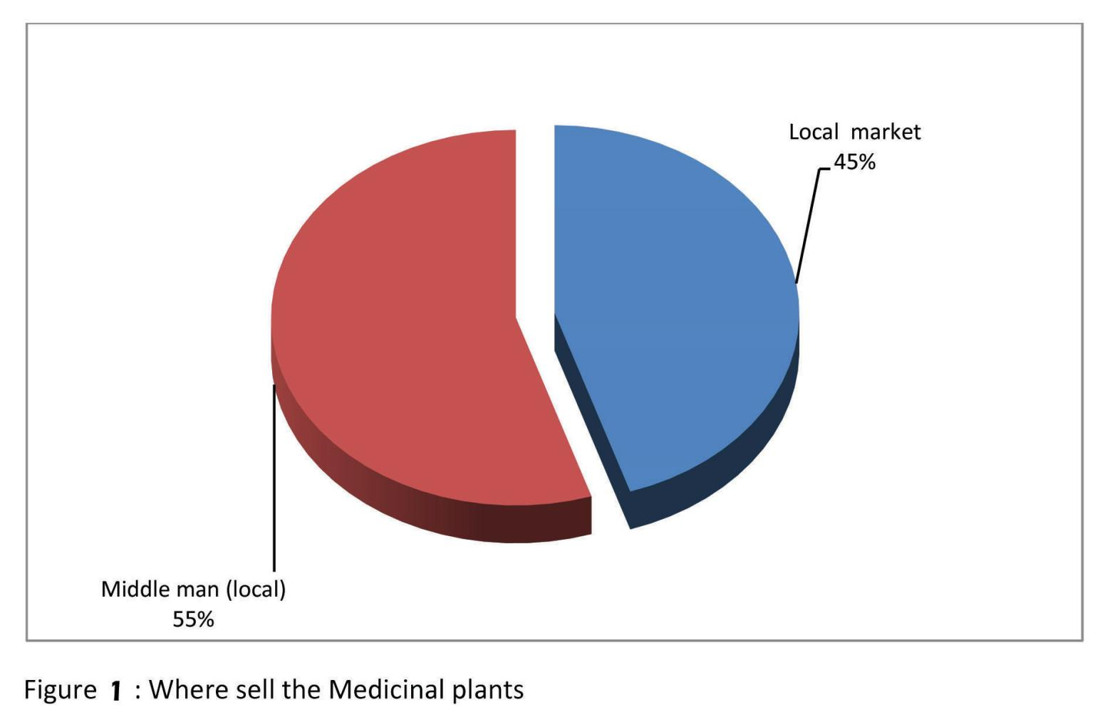

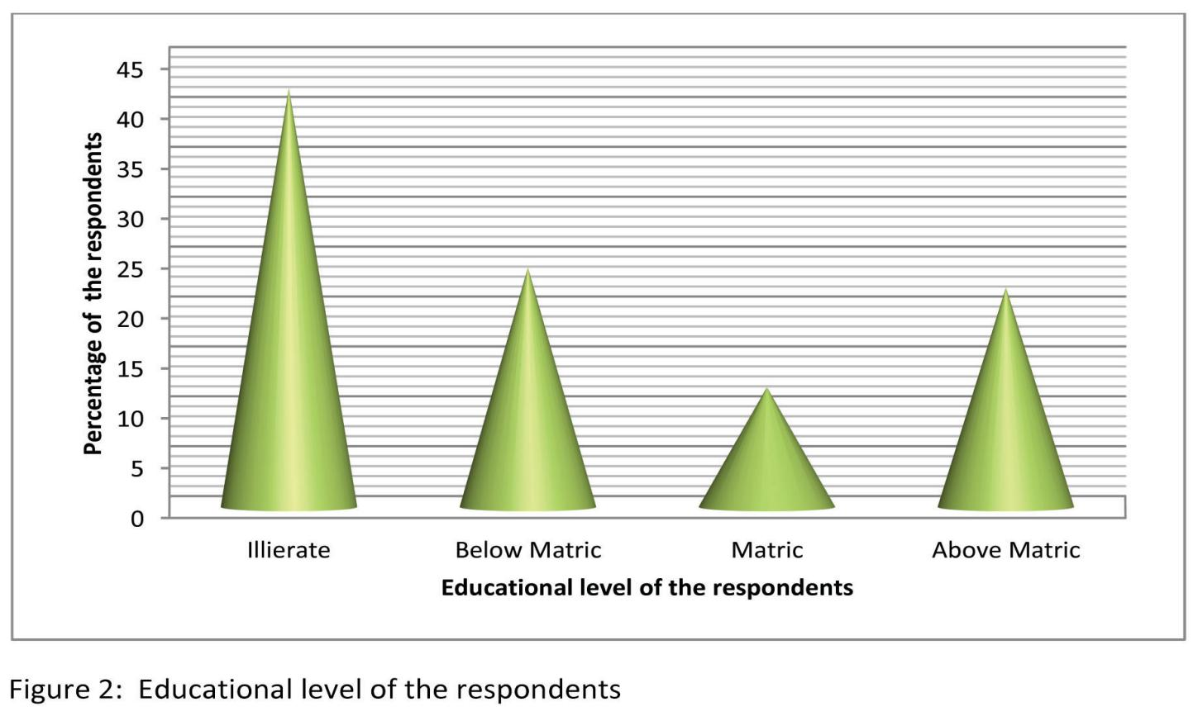

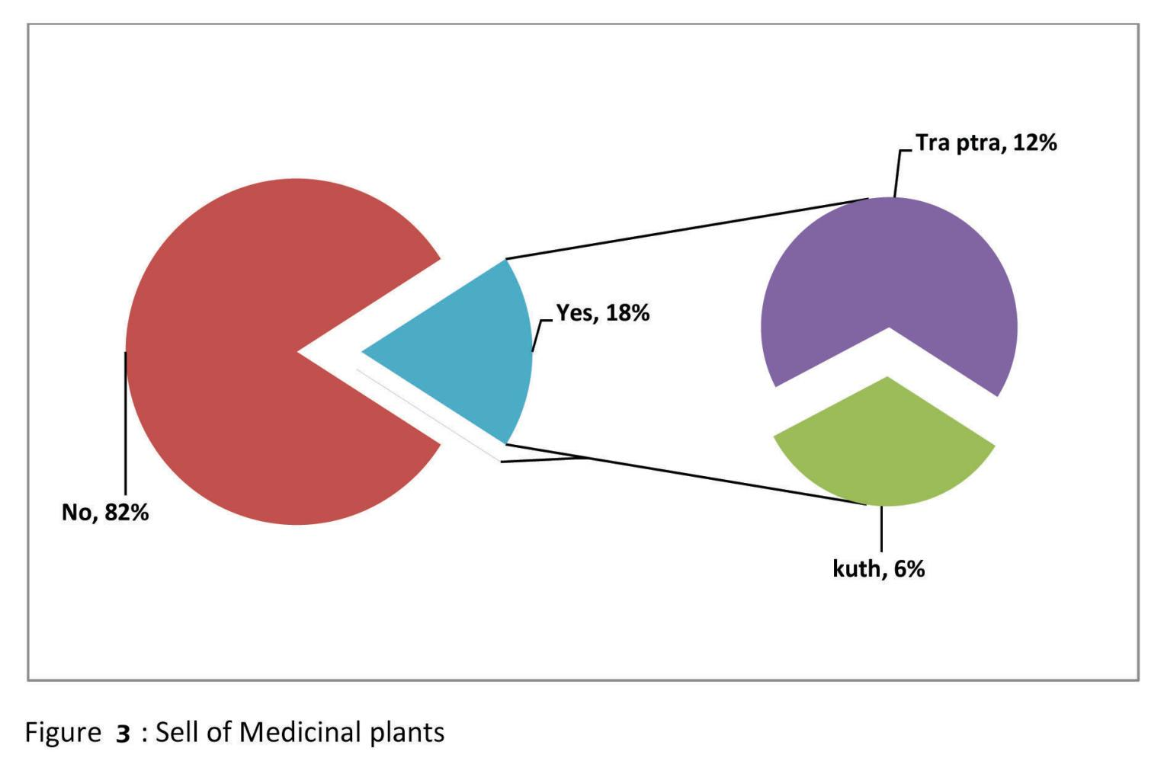

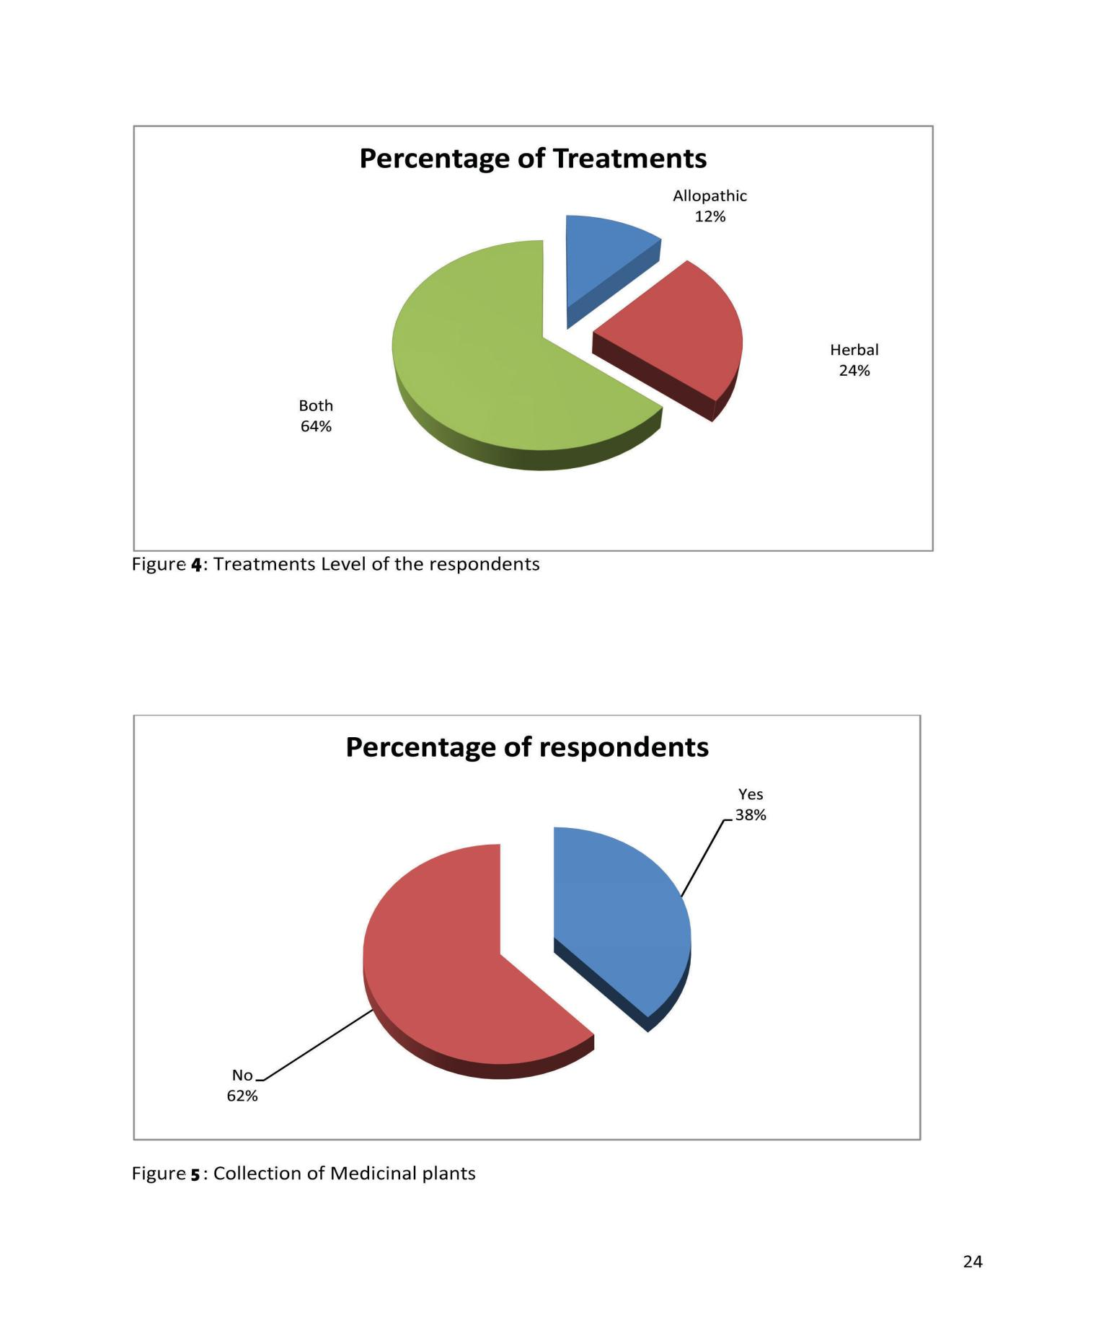

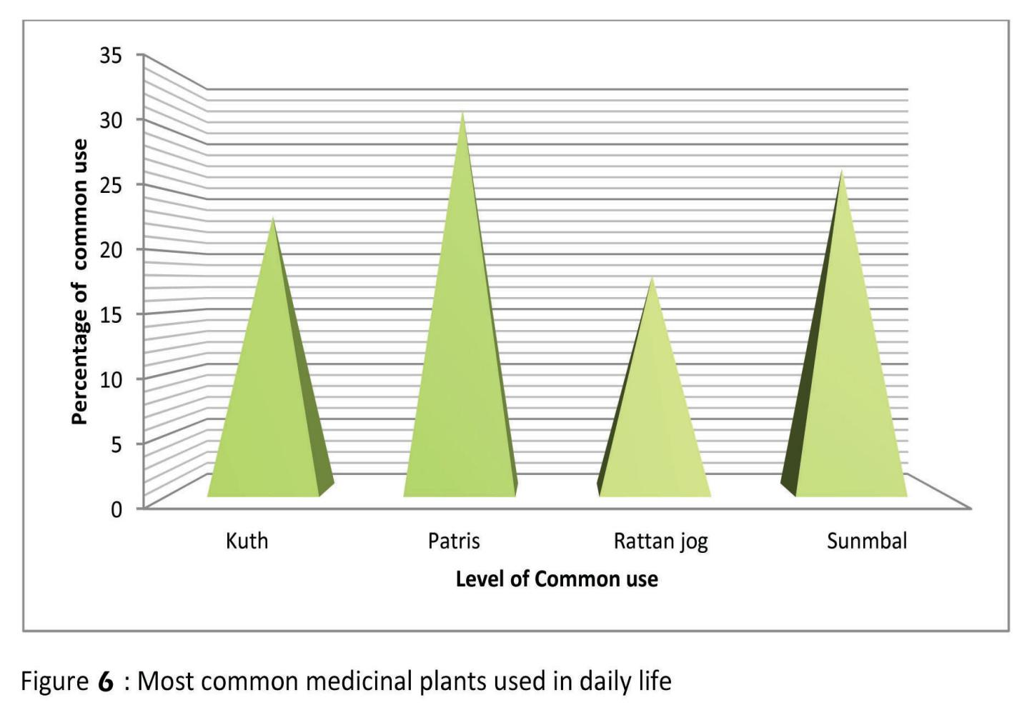

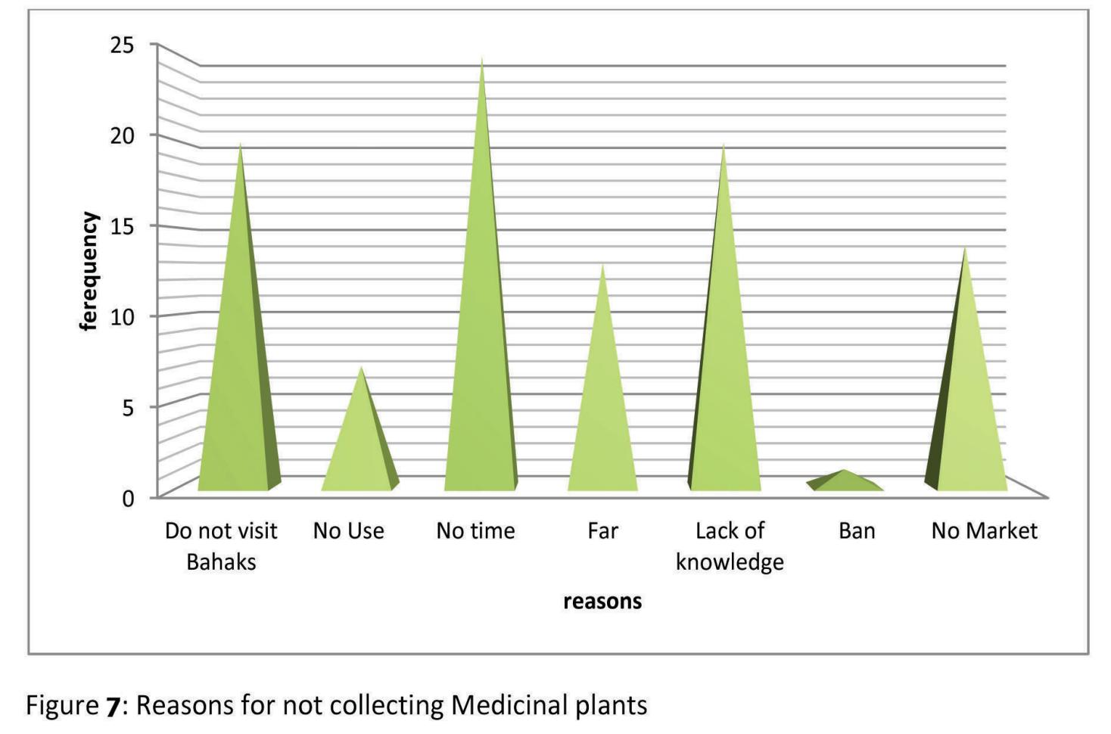

Conclusion and Recommendation:
It is concluded that the area is full of medicinal plants, deforestation and grazing are also posing threats to the conservation to the medicinal plants, there is dire need of awareness for the local people to know proper collection, uses, plantation and the said area should be further explored for the search of new medicinal Plants, in addition establishment of nursery and local market for medicinal plant may be confirmed. The availability of energy plantation and kerosene oil, LPG should be confirmed to discourage use of medicinal plants and seed of medicinal plants should be provided to the farmers.

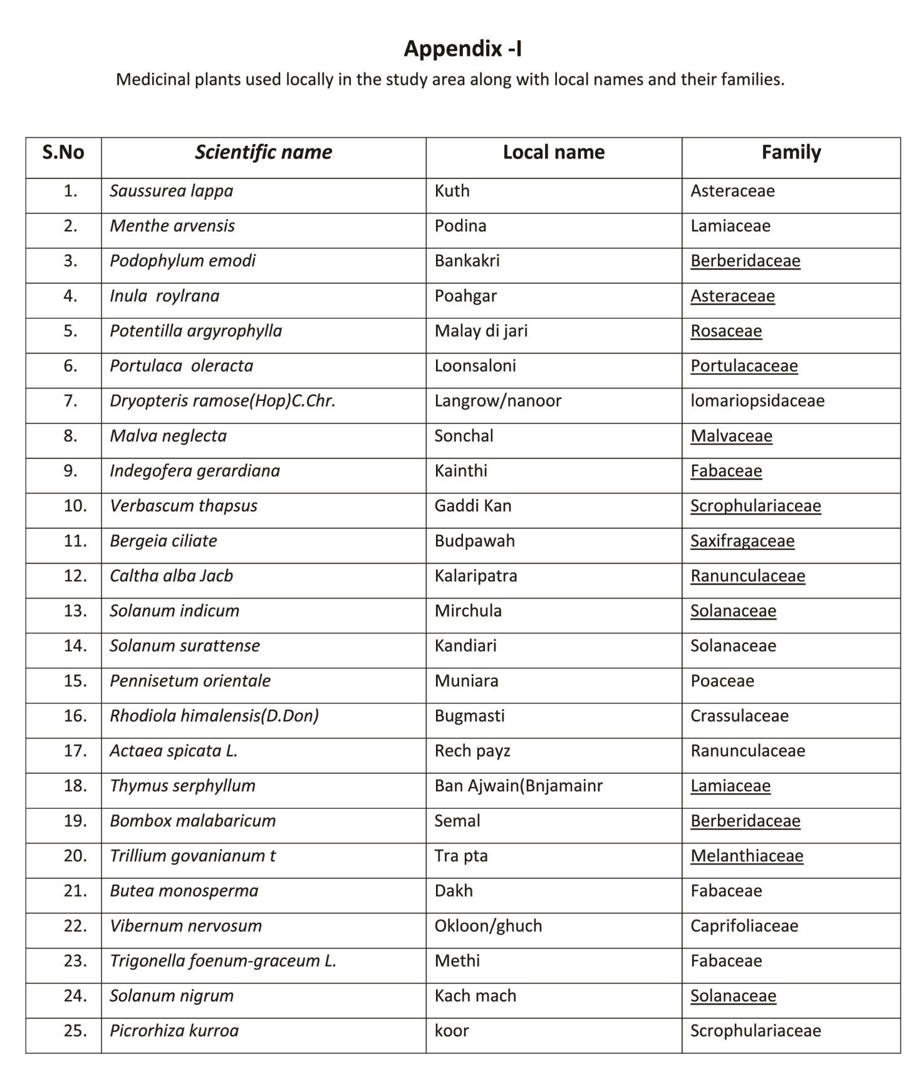

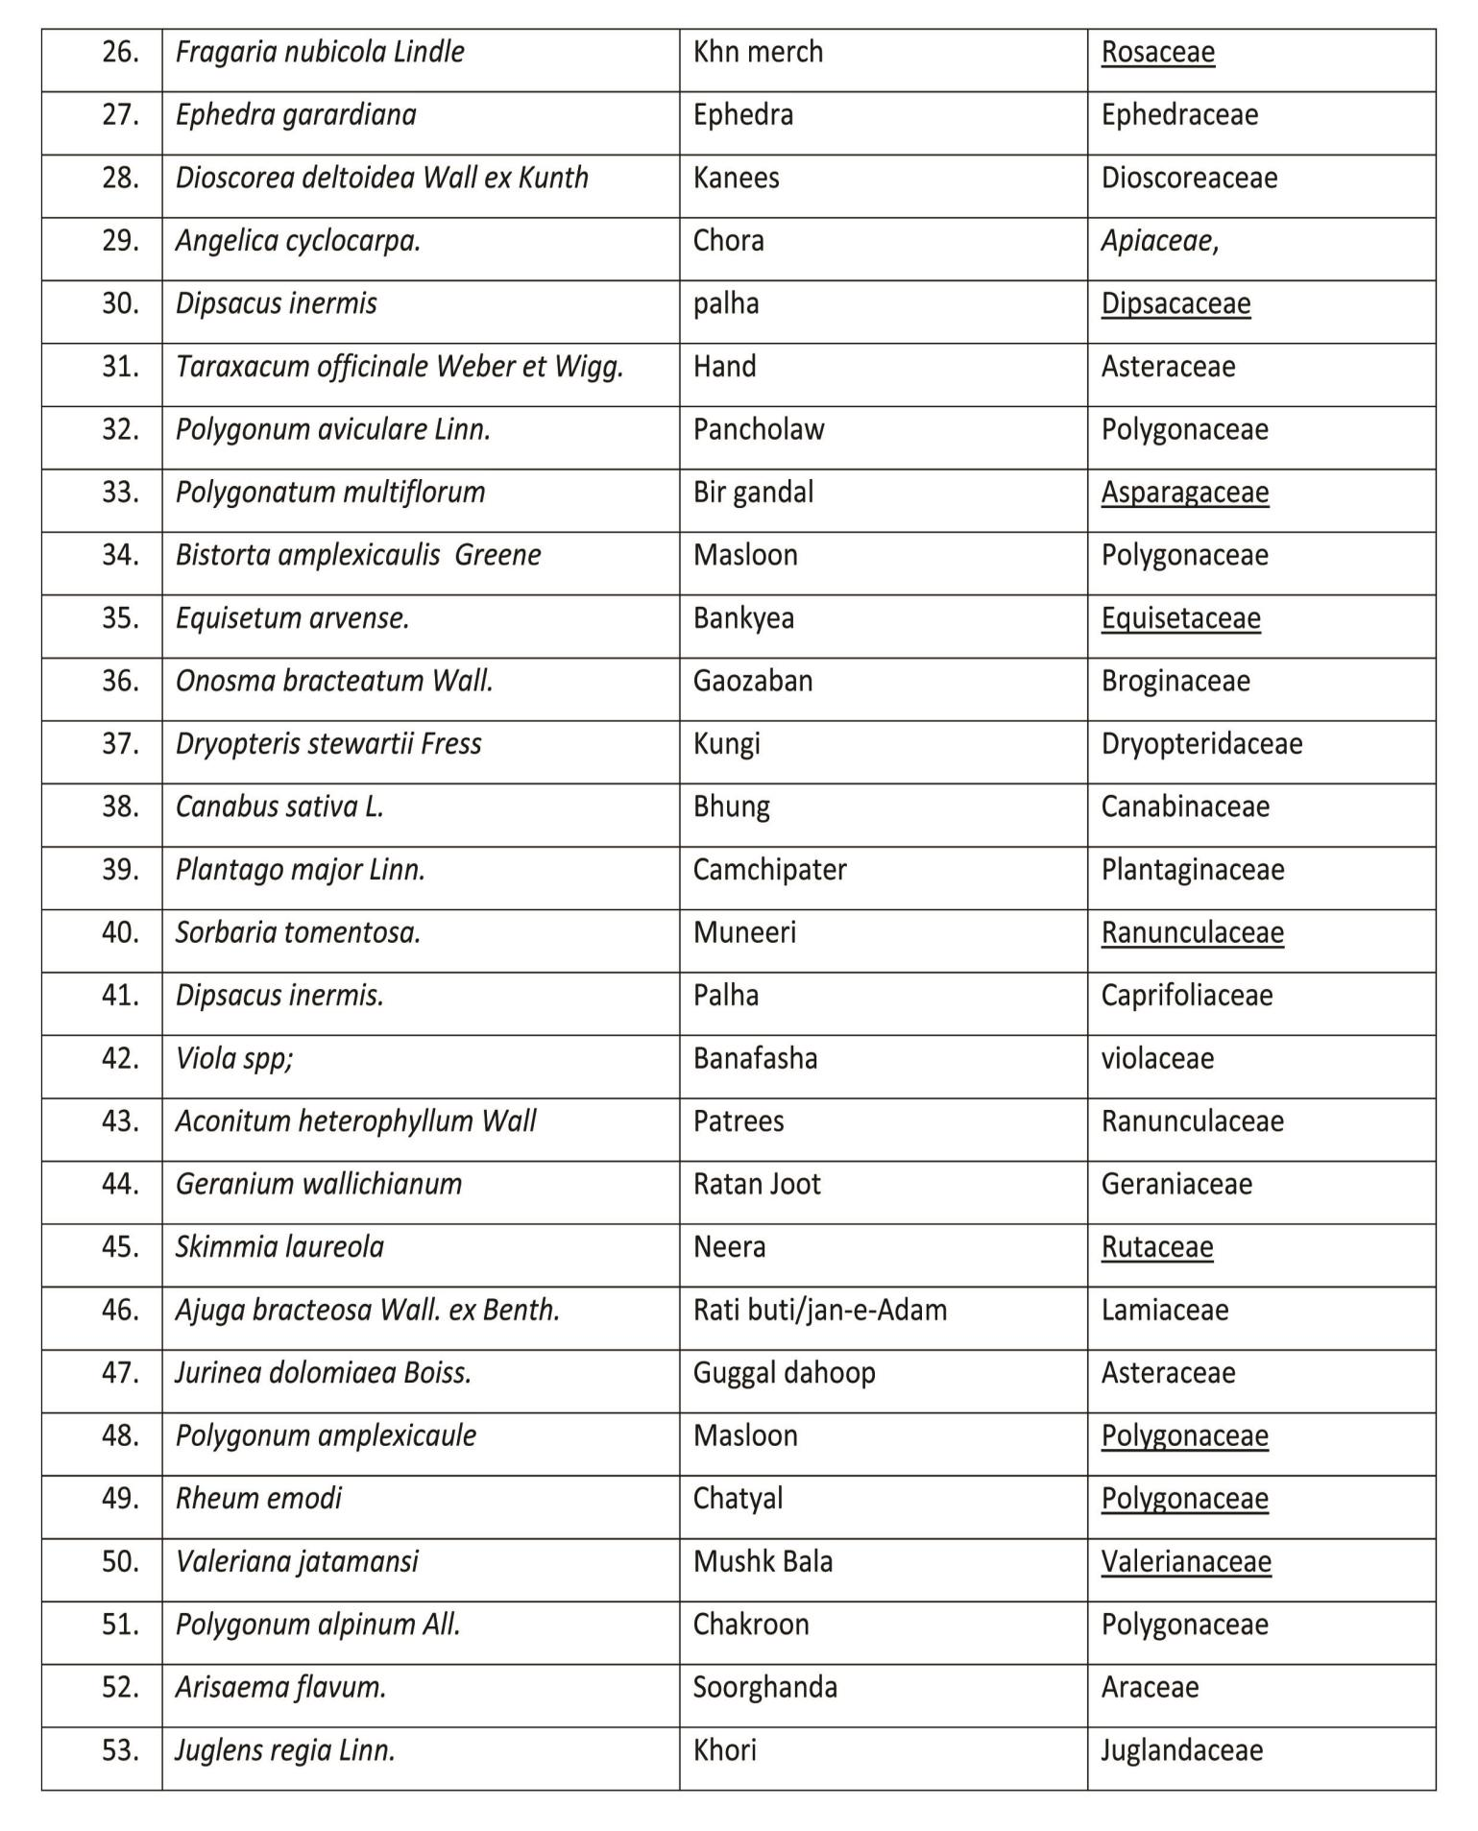

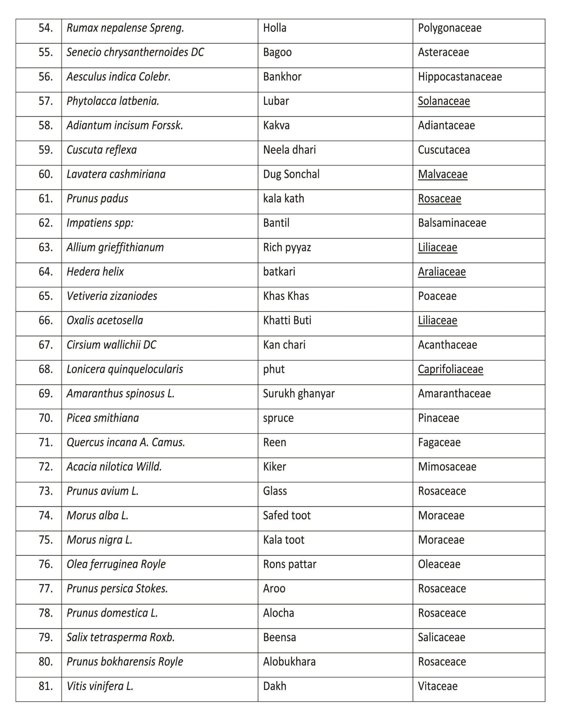

Acknowledgements
Authors are grateful to Director Forest education Pakistan forest institute Peshawar for his critical review of this article and valuable suggestion. We are also indebted to senior forest and wildlife officers from KPK, PFI and Baluchistan for their valuable information and input.

Corresponding Author:
Ahmad Zamir
Pakistan Forest Institute, Peshawar
Email: zamir_usafzai@yahoo.com

References:
- WHO (2013) WHO traditional medicine strategy
- Ali SI,Qaiser M ( 1986) A phtogeographical analysis of the phanerogames of Pakistan and kashmir.proc.r.Soc.edinburg 89-101
- Governt of Pakistan (1998) biodiversity action plan ,Pakistan ( Draft reprt) prepared from iucn/wwf and world bank / GEF
- Aaizeh funder S Khalil,said O (2003).Ethnobotanicial knowledge of local Arab practitioners in the Middle Eastern region .Fitoerapia 74:98-108.
- Elisabetsky E (1990).Plants used as analgesics by Amazonian Capbocils.Int,J,Crude Drug Res.,28:309-320.
- Martin GJ (1995).Ethnobotany:A People and plants conservation manual Clapham & Hall London ,New York ,Tokyo.
- Mirza HK ,Ihsan I , Mustajab K (1992) Preliminary report on the Subtropical vegetation of Darra Adam Khel Hills (Kohat Pass).Sarhad J.Agric .,VIII(1):71-77.

2/21/2022

