Evaluation of Nokia's Strategic Analysis in the Global Context

Eng. Hatem Mohammed Alshmrani

Projects Manager, MBA in Process - Universidad Catolica San Antonio de Murcia (UCAM)
Email: hatem_022@hotmail.com

Abstract: Nokia has suffered significant losses despite its control of the smartphone market and operating technology in previous periods. Its sales decreased due to the operating system and the neglect of the Android system; the company followed many strategies, SWOT analysis, PESTEL analysis, and other analyses and strategies to rise again. Despite the Nokia crises, Nokia management still has a solid determination to remain, develop, and improve its products and services. Up to the present time, the word Nokia still means the beautiful past, and its customers still have high loyalty to this pioneering company.
At the end, the researcher recommended a set of recommendations that would enable the company to survive in global markets.
[Hatem Mohammed Alshmrani Evaluation of Nokia's Strategic Analysis in the Global Context Researcher 2021;13(9):1-16]. ISSN 1553-9865 (print); ISSN 2163-8950 (online). http://www.sciencepub.net/researcher. 1. doi:10.7537/marsrsj130921.01.

Keywords: SWOT analysis, PESTEL analysis, Boston Consulting Group (BCG), Porter's theory, implementation plan.

- Introduction
Nokia is a Finnish partnership established in 1865 as a paper factory activity. Through the 19 Century, the organization extended, stretching into a few distinct items (NOKIA, 2011). In the late twentieth century, the organization exploited the expanding prominence of PC and phones. (Schwarz, 2019). Nonetheless, expanded rivalry and other market influences caused changes in Nokia's business plans (Nokia, 2021). In the year 2007, Nokia owned about 40% of cell phone sales in the world. After that, users' preferences shifted to touch-enabled smartphones, and in mid-2007, Apple produced an iPhone device, which led to a rapid decline in Nokia's market share. Revenues declined until the company sold the phones to Microsoft in 2014. The company began executing a program to decrease costs and lay off of workers, which led to the deterioration of its employees' enthusiasm due to the lack of incentive. Nokia has already made a production line for the production of Android phones and named it Nokia X. The phones used Microsoft's search engine and Nokia Maps only, and that was before Microsoft acquired it. And here comes the most crucial question why did it reject the Android system? Why It only owns 4% of the market? All these issues will be covered in this assignment.

- Research Problem
Many articles and published research reviewed the success story of Nokia and examined its crises. However, through the initial study, the researcher found a lack of clarity about the company's situation. Is it an internal administrative crisis? or crisis that has arisen from the competition with other giant companies, or a financial crisis? The researcher is motivated to conduct a theoretical study to know its difficulties and how they overcame them.

- Research Objectives
By reviewing studies, articles, publications, and books related to the topic of study, the researcher identified the main objectives of this research as follow:
- How Nokia conducted Stakeholders Analysis in Nokia?
- How Nokia applied Porter's theory?
- What is Organizational Performance at Nokia?
- What is the impact of external factors on strategic management in Nokia (PESTEL's analysis)?
- How Nokia applied SWOT Analysis?
- How Nokia used Boston Consulting Group (BCG)?
- How Nokia applied a business strategy that encourages and supports innovation and change?
- What is the implementation plan to fulfil significant stakeholder expectations at Nokia?

- Research Importance
This research declares the pioneering role that Nokia has played in continuing and cohesion despite external conditions and global issues such as the Corona pandemic. The study will explain all types of strategies and tactics that the company has implemented to face its internal and external crises and a set of recommendations to ensure survival and continuity in global markets again.

- Research limitation
This research has theoretically driven to examine Nokia strategies for survival by gathering and analyzing studies, reports, periodicals, and books to represent an initial picture of Nokia's performance. After that, the researcher is looking to conduct an analytic survey to assess all performance in Nokia. This research has been applied in Abril 2021.

- Theoretical frame work

How Nokia conducted Stakeholders Analysis in Nokia?
The company relied on many strategic management theories to achieve integration between all stakeholders' goals inside and outside the company using two dimensions power and interest as below: (Roseke, 2019).
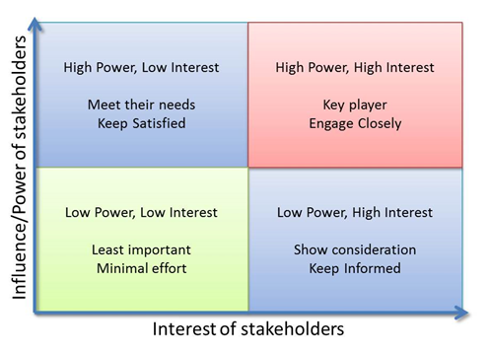

(Roseke, 2019 )

Investor
Nokia consistently attempts to improve the situation for them. Investors mastermind the significant piece of capital. Investors get a portion of the benefit, reward, and profit.
Staff
Nokia focuses on includes workers in conversations about issues like corporate qualities, profession and capability improvement, execution, variety, and balance of fun and serious activities that is live up to worker's needs and desires (NOKIA, 2011).The culture of Nokia aims to assure that operating at the company is an experience that influences its employees' lives. Nokia attempts to accomplish this goal by giving its staff enough training, coaching, and compensating outstanding performance. During 2006, Nokia executed different schemes and actions to raise its operation conditions and knowledge. It investigated its employees' opinions and established work processes and internal procedures to ensure an appropriate degree of job satisfaction. The organization gave its workers an online course for the Code of principles and Conduct to enhance their capabilities. In 2020, Nokia possessed 92.04 workers in approximately 130 places universally, with about 38,000 each in Europe and another 20,000 in the Asia-Pacific district. (Murphy, 2018).

Providers
Providers are a very important for the company. Nokia comprehends its significance and attempts to address its issues and assumptions like early instalment, settlement ahead of time, serious worth, and correspondence consistency.
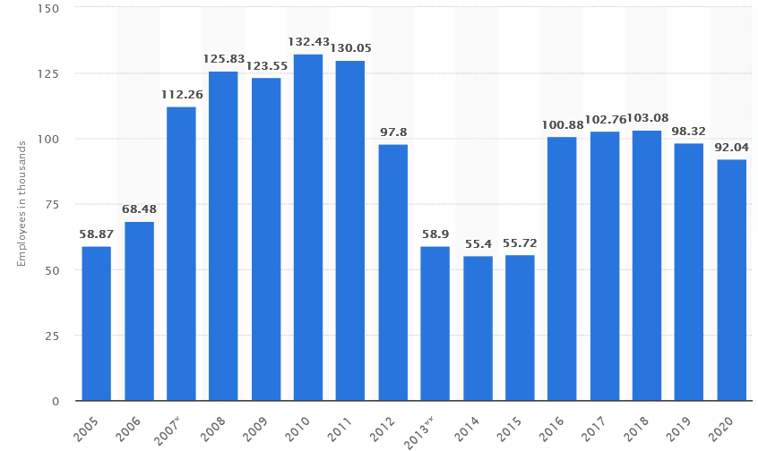

(Alsop, 2021 )

Clients
Given significant consideration to its clients' requirements, Nokia should deal with every one of its clients and different partners. This obligation incorporates the ecological and moral issues. (Nokia, 2021).
Competitors
Notable competitors were both Samsung, Apple, and HTC. The analysis below indicated that Nokia is in third place compared to our competitors. The company should have conducted a complete study of competitors and know their movements and orientations. (Chandramouli, 2018). The loss that the company achieved in 2017 and 2018 is not a crisis, but the real trouble is to continue to decrease sales and allow others to penetrate and expand. That is why the company must analyse Boston consulting group to know its current situation and determine the appropriate strategy that meets all stakeholders' aspirations and desires.
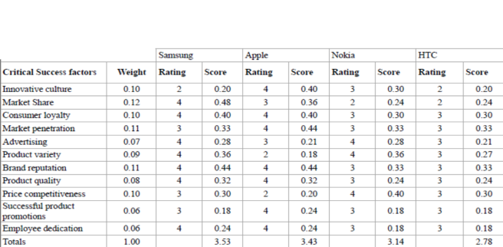

(Huyen, 2014)

Government and Local Community
The company adheres to guidelines, government rules, and taxes and is also obligated to serving populations worldwide. Nokia sponsors AIDS hospital, cancer hospital, all kinds of national games. Nokia supports various study collaborations with business and educational associates. Nokia's goal is to foster harmony between both researchers and academics. (Grünewälder, 2008).

How Nokia applied Porter's theory?
To fulfil its partners expectation, the company relied on Porter's theory, which comprises of three strategizes as below:

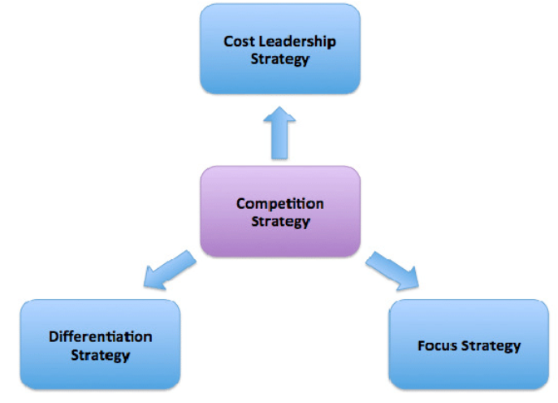

(Dininni, 2011)

Nokia's cost leadership strategy
Cost leadership strategy has laid out numerous advantages, for example, acquiring fast brand acknowledgment, extending the client base, empowering utilization, and accomplishing deals focus by underlining over item's availability and inexpensiveness compared to other companies (Nokia, 2021). This present system's essential target is to safeguard the market leadership position through efficient value chain management.
This methodology permits Arising Nokia to extend the market by focusing on the working class, making the central extent of the available consumer market blend in many nations. For the most part, working-class purchasers place a high significance on the estimating variable, and cost administration is the best procedure to oblige this buyer fragment's necessities. (Tanwar, 2013).
Nokia centres around moderateness and simple accessibility of its items worldwide, prompting high brand mindfulness and high sales development and gives a solid competitive advantage. (Kinyuira, 2014).
Arising Nokia regularly offers limits and coupons to accomplish deal targets and handle the severe pressing factor by its nearest rival other than charging low costs by bringing down creation costs and expanding inventory network effectiveness. The planned result of these rebates and special missions is to raise brand ubiquity and energize utilization. (Chandramouli, 2018).

Differentiation strategy
Indicates giving various goods or services from rivals to achieve rival advantages on a large market. The determination of differentiation as an auxiliary technique permits Nokia to extend the client base by underlining the unique item (Tanwar, 2013). Arising Nokia's essential goal of utilizing this procedure is to separate by installing the development and address the shoppers' developing wellbeing concerns. For instance, Arising Nokia has broadened its product offering in the wake of examining the shoppers' changing advantages to separate itself from contenders and extend the extent of chances inside the business. The blend of the separation and cost initiative has helped Arising Nokia assemble a solid and faithful client base. (Datta, 2010).
Using the differentiation technique, Nokia positions its items to stick out and be unique than accessible other options found in the market. Being an accomplished brand with solid traction, the organization uses this differentiation technique to decrease the competition pressure by different brands. Heavy interest in showcasing, promotion, and celebrity advertisement is made to separate Nokia from other competitive brands.
The brand logo is used to set the differentiation premise. The remarkable and particular brand logo has set up a solid brand picture in buyers' memory. Although the brand has gone through numerous modifications, the embodiment has continued as before, filling in as an essential differentiating element. (PORTER, 1991).
Also, the company extends a broad collection of characteristics to complement each consumer's taste. It utilizes development to offer separated expanded services that may please the clients and increment their preference of Nokia over different brands. (Chen, 2013).
Focus strategy
Focus strategy is concentrate on particular client bunch. Nokia embraces this strategy by offering the best worth. The Focus strategy is activated by serving a specialty market section’s necessity at the least possible cost by underscoring the effective characterizes that could best match the clients' necessities and prerequisites. The firm re-examines its marking techniques and ongoing improvements to fulfil the clients' assumptions and expectations. (PORTER, 1991).

What is Organizational Performance at Nokia?
Despite the achievements, the company achieved in the period from 1995 to 2006 and the excellent analysis of the stakeholders' wishes, Nokia's sales declined in the late 2000s. (Chen, 2013). One of the reasons for Nokia's declining market share in the mobile phone market was because it kept its Symbian mobile running method (OS) for too high and did not switch to Google's Android operating system at that time (NOKIA, 2011).In 2014, Nokia sold its hardware and services business to Microsoft for € 5.44 billion. Since then, Nokia has only sold brand permissions for smartphones. The drop-in sales volumes were evident in 2013, 2014, and 2015 (BOYCE, 2021). In 2020, Nokia's net sales reached 21.87 billion euros, slightly declining from the previous year. In the past, the firm has done numerous changes in portable devices' direction to the network foundation to keep pace with the quickly evolving electronics and information production. The organization is compelled to lay off labourers, almost 350 positions in Finland, and the organization desires to save 700 million euros in yearly expenses during 2019 and 2020 (Haseeb, 2016). In the period of 2000 up to 2006, the company attempts to satisfy all stakeholder's needs. However, the main reason for the collapse is bureaucracy. The top management at the company could not recognize the problem of external competitors (Chandramouli, 2018). Nokia completed the manufacture of its phones without any change or update; the problem was not within the sizes of phones or touch phones but in the operating system. Nokia was not ready to change its approach at this time. (rodrigo, 2021).

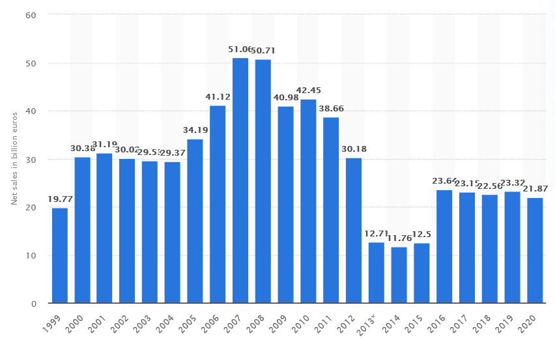

(Alsop, 2021 )

What is the impact of external factors on strategic management in Nokia (PESTEL's analysis)?
The study of external factors is the constitution for the success of current and future business enterprises, and here, PESTEL's analysis will be reviewed in Nokia:

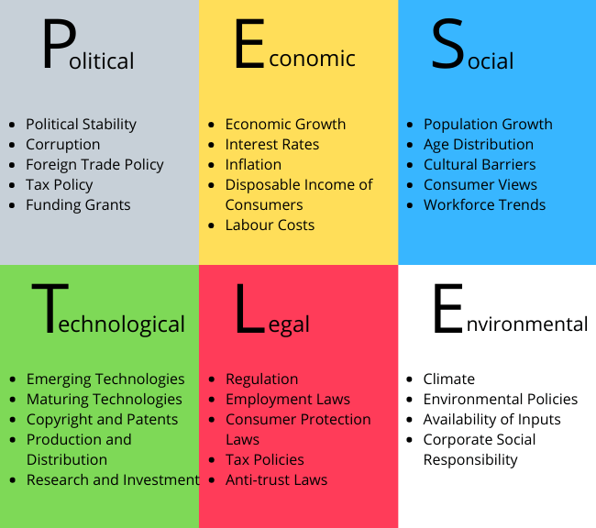

(BOYCE, 2021)

Political Factor
Political elements play a critical part in deciding the variables that can affect a Nokia firm in a specific country or market. Nokia is working in many nations and opens itself to various political risks (Baruah, 2020). Nokia sells its items in around 150 countries; every government has its principles and guidelines to manage the IT system. For example, the company has abided by the laws of minimum wages in India and has not used the labour force in an unsatisfactory manner. In any event, when the organization entered metropolitan nations, it likewise adheres to their political guidance, so the organization typically some significant political boundaries for any country like Political security, Hazard of military intrusion, and the degree of Bureaucracy. (Miller, 2017).
Economic factors
The company faced several economic variables that affected its performance as it suffered severely from the European downturn in recent years. (Murphy, 2018). The economic turmoil in Europe has affected it by limiting purchasing power in its domestic markets (BOYCE, 2021).It has faced sharp fluctuations in inflation, the saving rate, the interest rate, the foreign exchange rate, the economic cycle, aggregate demand, and total financing. So, the firm decided to focus on a financial framework in the work nations and the kind of monetary framework, unemployment rate along with the degree of government intervention in the free economy and related innovation as essential economic factors. (Baruah, 2020).
Social Factors
Society and its desires are the basic formula for success. The community's culture and beliefs affect the company's performance, so the company's marketers have designed the marketing message to consumers in light of their orientations and beliefs (Murphy, 2018).The company initially focused on elegance and fashion and satisfying customers' desires, except for new competitors such as Samsung, Apple, and others. They are more oriented with new social factors and provided types of electronic devices that are more streamlined and comfortable for customers. (BOYCE, 2021). So, the company decided to give more attention to the following points: (Murphy, 2018).
- Demographics and experience rate of the community, (Baruah, 2020).
- Society composition, hierarchy and authority arrangement in the society.
- Attitudes (well-being, natural awareness) and Entrepreneurial level.
- Learning level and training criterion in the Nokia company (Chandramouli, 2018).
The collapse of Nokia came with a scenario quite similar to Blackberry's failure. In 2007 Nokia represented more than 40% of mobile phone sales around the world (NOKIA, 2011). Still, consumer preferences were already on their way to shifting towards smartphones that touch, so as soon as it came, iPhone came to the scene until Nokia's market share shrank rapidly. Its revenue fell sharply, and by 2013 the long-standing Nokia had sold the phone industry to Microsoft. (Nokia, 2021).
Technological Factors
Technology is the blood that nourishes the heart of the organization. Technology and Innovation are disturbing different enterprises in all fields (Beattie, 2020).There are numerous rivals in the IT business market and present new cell phones with the most recent mechanical. Individuals like further improvements and Innovation, giving them more happiness and dazzle others (rodrigo, 2021). This way, Nokia ought to improve the nature of the web, internal system, touch screen, call system, web-based media playback, and video calls with others. Nokia has cooperated with Microsoft to present some innovative applications in its cell phones to overcome its obstacles. However, the other players usually update their electronic services continually, leading to more barriers to coping. Failure to take advantage of the technological aspects led to internal bleeding in the heart of Nokia. (Chen, 2013).
Environmental Factors
Crises come cumulatively, the company has struggled a lot to survive, but fluctuating environmental factors such as global warming, and climate, so Nokia must ensure that it operates appropriately. (Grünewälder, 2008). With the increasing popularity of cell phone recycling systems, the safe and rapid disposal of batteries will preserve the community's public health and the environment, requiring deep consideration to waste management in the Technology division and the maintenance of renewable energy. (rodrigo, 2021).
Legal Factors
Intellectual characteristics and rational properties are the safety valve and protective shield to any business. It should focus on securing its rights (Huyen, 2014). These industries include a massive number of competitors who work 24 hours a week; when they address a creative sense, it is crucial to defend the rights through permissions, copyright, trademark to guarantee they are not "taken" by their rivals (Murphy, 2018). The company should update its operations and features in distinctive ways over its competitors to save its rights and use all legal rights to continue worldwide. Unfortunately, Nokia considered the main corridor through which competitors have crossed. I conclude that there is almost unanimity on the impact of PESTLE methods in achieving miraculous successes for companies and the destruction of others, even gigantic ones, in case of ignoring the value of this analysis. (The Author, 2021).

How Nokia applied SWOT Analysis?
Strengths
Doubtless, Nokia was probably the most established organization. Nokia has acquired a few qualities in the field of innovation. Nokia is perhaps the most seasoned organization worldwide. As an old firm, it has driving involvement with the field of correspondence and innovation. It was established in 1865. At this period, it has the most mature and innovative staff in the field of portable. (Osita, 2014).
Nokia has an enormous and uninterrupted communication channel. It has set up client care focuses and retail shops to sell its cell phones to disseminate its items through South Asia nations (Schwarz, 2019).Yet, at the same time, the most extensive conveyance network isn't so much solid. Fifth, Nokia fabricates and appropriates challenging items by giving quality items. (Grünewälder, 2008).
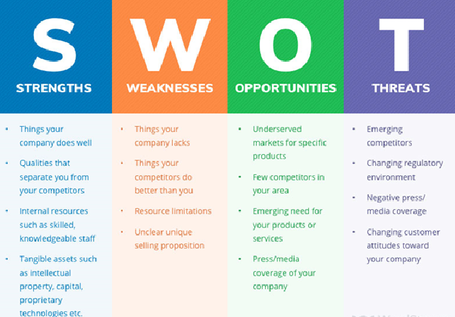

(McIntosh, 2020)

Weaknesses
Unfortunately, despite all the accomplishments. Nokia has some shortcomings for which it has been enduring in the innovation area. The primary drawback is that it is delayed to respond to the rivals and the perception of its managers that they are the best and that they never fall. The subsequent shortcoming is the low affectability to mechanical changes. They are not delicate and receptive to the new changes in the client's assumptions. Nokia sells inadequately planned cell phones. These handsets didn't permit them to draw in more new clients. The majority of them are not appealing, dissimilar to HTC, APPLE, or Samsung. (Haseeb, 2016).

Opportunities
There is still hope. The possibility of transformation is possible. As different organizations do, Nokia additionally has numerous chances to develop their business further. The company can switch to using the Android system, especially since this area's demand does not end. There is an excellent opportunity to ally with other companies and focus on the higher growth areas (Alsop, 2021 ). They can also utilize the benefits of Fifth-generation networks. The company can use the technical problems in rival phones. (Chen, 2013).
For example, Apple has issues with the operating system and processors and high maintenance costs. From here, Nokia can study these problems and develop its products, networks, and logistical operations by following the strategy of improvement and diversification. (Nokia, 2021).

Threats
The threat to Nokia has become very high and cannot be avoided, but it can be dealt with professionally through simple and easy techniques and achieving cost savings. Apple, Samsung, and others are the most important source of threat to the company and cheap and high potential Chinese mobile phones (Singh & Bansal, 2020). For this, a distinctive research and development department must be established. To study competitors, various laws and legislations, communication systems, and taxes so that the company finds a passage to cross and achieve profits and sustainability in the markets again. The company may resort to restructuring its sectors in some countries in which its profits have decreased in order to achieve a balance between revenues and expenses. (Nokia, 2021).

How Nokia used Boston Consulting Group (BCG)?
Based on SWOT analysis and PESLTE analysis. Nokia can adapt (BCG) model to evaluate its current situation and design proper strategies. BCG is a business model based on examining products and services through their life cycle analysis, which helps firms shape strategic decisions when designating their resources. (Ionescu, 2011 ).
It classifies products into four categories as follow:
Question Marks:
Products with a high growth rate but a low market share, meaning that this category must be analyzed and the appropriate decision was taken to convert them to bright products. (Keelson, 2018).
Stars:
Products with a high market growth rate and significant market share. These products generate a lot of revenue. (Mohajan, 2018).
Cash Cows:
Products that have a low growth rate but at the same time a significant market share and may be the market leader. The revenue generated by these products can be used to convert into a good area. (Chen, 2013).
Dogs:
Products with a low growth rate and minimal market share. These products consume a lot of financial resources and do not generate the desired revenue, and therefore, you must exit this market as soon as possible. (Chandramouli, 2018).
Nokia's products fell into the question mark's square, meaning that its products have a low market share, but the industry's growth rate is high, so it must intensify investments in these products. Otherwise, they will move to a worse situation. Accordingly, we can say that the question mark represents the first stage or is usually called the step of presenting the commodity in the product life cycle curve. According to studies that the company that is located in the question box, it is possible to implement more than one strategy such as (penetration, product development, market development). (NOKIA, 2011).

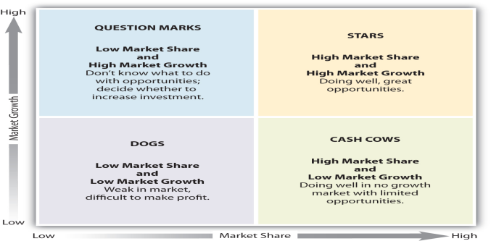

(Narole, 2013)

Having reasonable strategies and proper procedures is half of the organization's prosperity, and the leftover half is dependent upon precise execution. For this, the company should analyse the current situation carefully and reformulate its strategic plan and vision in a manner consistent with the new changes. I suggest that the company adapt to development strategy in all its operation to maintain worldwide. This development might be internally and externally. (Keelson, 2018).
The company may adapt to the joint venture strategy to achieve integration between its capabilities and resources with other distinguished companies in the communications and information technology sector (Chen, 2013).Thus, it will achieve liquidity and abundance in its resources. Also, it is possible to put the company's shares for circulation in the stock market to increase the number of shareholders. The company must focus on the appropriate marketing mix strategy through develop compelling products and services at a reasonable price. (Bhasin, 2018 ).

(Hausman, 2020)

The process of diversification and continuous improvement has a vital role in the company's sustainability by adding different technical advantages better than competitors by taking advantage of its previously mentioned strengths and studying and analyzing improvement opportunities in communications and information technology. (Miller, 2017).
Nokia can also sign agreements with public & private companies that have an influential role in stabilizing the reputation and financial returns. The company may penetrate the markets and achieve the maximum possible returns. (Singh & Bansal, 2020).
In my opinion, this is only might be achieved with the presence of rational management and effective leadership that sets a road map according to a timeframe and specific, measurable goals. The company can take advantage of countries with good infrastructure to strengthen its communication systems, adopt governance systems and study different cultures to rise and reach the top. Among the adequate tools for the company's success is establishing communication systems with all its customers and branches so that it can transfer and disseminate information quickly without delay. (NOKIA, 2011).

How Nokia applied a business strategy that encourages and supports innovation and change?
There is no better strategy than another; rather, it depends on the institution's performance and the reality of its financial and marketing results, but reform and development always come initially, and then other strategies can be adopted. (Chandramouli, 2018). A giant company like Nokia should have a specific, long-term strategic plan with an appropriate number of strategies distributed according to a timeframe. According to the mentioned above in the previous question, the starting point is a broad understanding of Nokia's current business environment, stakeholder opinions, and expectations, environmental, social, and economic factors, etc., in addition to Nokia's current situation and procedure. Based on this information, the company can build and analyse strategic options through which a strategic plan is formed based on specific objectives. The internal and external development strategy is considered ahead of strategic alternatives to improve Nokia's overall performance. (Singh & Bansal, 2020)
The internal development strategy focuses on reforming Nokia's internal problems operating systems appropriately to match customers' desires; this requires applying contemporary organizational change theories to mitigate any resistance within the company. (Pogue, 2020).
The company also must restructure jobs, distribute specializations, tasks, and create a clear job description for all its employees. There is a real need to re-engineer internal and external logistical processes to facilitate the arrival of products to customers.
Nokia managers should find radical solutions for solving financing problems using fishbone diagrams. The study of technical issues and the time of implementation of services is a crucial component of the internal development strategy. Company managers must acknowledge mistakes and not ignore them and empower workers in making decisions because Nokia employees are the masterminds for the future. To ensure development, the company must build a culture of creativity and emphasize innovation concepts, the importance of innovation for institutions, types and sources of innovation, innovation management tasks, steps in the innovation processes in enterprises, and the mechanisms for developing an innovation strategy. (Khan & Habib, 2009).
The company must also build an integrated set of Key performance indicators (KPIs) that ensure strategic alignments, such as marketing and financial productivity indicators. Nokia can adapt the project management methodology by following the Agile approach in manufacturing, modern operating systems, multimedia, and other modern production systems that improve the quality of internal processes in light of the prevailing economic and environmental legislation and regulations in each country. (Chen, 2013).
Among the internal development and improvement strategy as a proposed strategy for resolving crises within Nokia is to study the level of inner job satisfaction among its employees and seek to find fair solutions to compensate workers for the effort exerted within the company because the employees have faced multiple problems, including reducing salaries and reducing the number of employees at a time of low sales and the emergence of competitors. (Malsam, 2019).
The external development strategy is to manage customers' opinions periodically through surveys and facilitate communication. Nokia should enter new markets with unique features that are stronger than competitors and try to develop products, even initially. Hence, customers feel the company's presence in the markets again and increase their loyalty. (BOYCE, 2021).
The company must review the performance of current and new competitors based on Porter's theory and know the extent of technological progress in alternative products, all of this is the first start of real development, for knowledge of the capabilities and capabilities and fixing mistakes is the basis for development and that the company does not modernize internally, it cannot enter the market efficiently and effectively (Nokia, 2021). Like it used to be. Here, the role of benchmarking also appears in order to find out the best intricacies in the fields of communication and information technology, and the use of modern quality systems and digital technologies. Among the options that lead to creativity and development are integration strategies by improving the contractual relationship with the company's suppliers and maintaining them (backward integration). The forward integration strategy means improving relations with its distributors in different countries and maintaining a satisfactory profit margin for both parties. The company may be able to enter strategic alliances with giant companies by signing their home agreements and sharing profits and returns, but in order for Nokia managers to negotiate with others, they must have good negotiation capabilities and organizational capabilities that enable them to negotiate successfully. (Hausman, 2020 ).
The development strategy requires analyzing all sources of risk that may affect the company's performance. These risks are classified and divided according to the types of potential risks and available opportunities, as they may be internal or external risks. The development strategy also requires that the company use the Balanced Scorecard Card (BSC) to translate its vision and strategy into interconnected strategic goals and measurements through four main parameters (financial, customers, internal processes, learning, and growth) (Iyibildiren & Karasioglu, 2018). Through the performance evaluation result, it will be apparent to Nokia which areas need development and improvement. (Chandramouli, 2018).

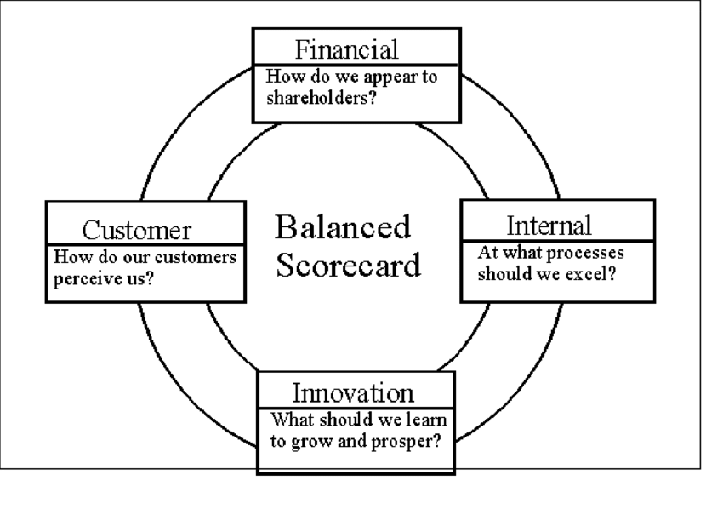

(Khan & Habib, 2009)

The strategy that I propose, which is the internal and external development strategy, differs from the strategy that prevailed in the company. The strategy of continuing on the current situation that Nokia followed without focus on customers' desires was among the most critical problems that Nokia faced. (Haseeb, 2016).
The company faced a significant challenge with relying on the ineffective operating system. Managerial decisions, complex organizational structures, bureaucracy, and internal disputes have a role in preventing the company from realizing its failures and shortcomings. (Chen, 2013).
The company’s management selected the strategy focused on staying on the current situation, which led to many problems, such as Nokia’s innovation was modest compared to Apple and the absence of vision, message, and goals. And it also led to conflicts among the employees and internal disputes between the two main stakeholders.
The most important reasons for the company's failure were producing Mass productions without analyzing its customer needs and expirations. However, the other competitors like Apple focused on technical and digital innovation in operating systems and data preservation and continuous new updates according to customer expectations.
Apple has a different philosophy. (BOYCE, 2021).The main secret of Apple's success was its vision and policy. Apple was located in the stars square in the Boston Matrix. It gained significant market share in a growing industry because it focused on research and development and provided high-quality products. Apple also possessed good communication with customers, after-sales services, and psychological stability for its employees. (Porter, 2018).
Finally, I can confirm that the collar of salvation is the company's internal and external development to recover once again in the market.

What is the implementation plan to fulfil significant stakeholder expectations at Nokia?
According to the analysis in the fourth and fifth questions, and after identifying the development strategy as a suitable strategy for Nokia, it requires exemplary implementation because the ineffective implementation of plans and policies leads to failure. The strategic implementation process affects all parts Nokia organization (NOKIA, 2011). Thus, it is not an easy process, as it requires a set of activities that must be carried out by senior management. The most critical challenges facing the strategy are to turn it into reality. In other words, how to convert strategic goals into operational goals, programs and projects, convert operational goals into activities, develop performance indicators and link activities, sub-goals, strategic plans, and indicators. (Beattie, 2020).
There are some critical dimensions to implement the proposed strategy (Development Strategy) as follow: (Waida, 2021).
First: Before the actual implementation of the development strategy in Nokia.
Realizing and understanding the determinants and requirements of performance requires answering the following questions:
- Are all the structural mechanisms available and interconnected with each other in a manner consistent with the set strategy? (Waida, 2021).
- Have all the conflicts existing between the different functional areas and activities been resolved in a manner consistent with implementing the strategy?
- Has the strategy been communicated or communicated in a sound and appropriate manner to all parties involved in it? (Pogue, 2020).
- Will the development strategy achieve a rate of return on investment (ROI)?
- Is there a commitment by the organization's leadership and endorsement of the strategy? Or does the management or leadership style fit the requirements of implementing the plan? (Lucco, 2016).
- Is there a monitoring system in place that provides appropriate and required feedback? (Eby, 2017).
- How to deal with problems or obstacles and difficulties of the different functional areas and activities? (Lucco, 2016).
- Does physical stimulation adequately support behavior and achievement? Or what is the appropriate system to implement the strategy and motivate individuals well?
- Will the development strategy achieve a rate of Net present value (NPV))?
All the previous questions are the cornerstone before starting the actual implementation, as they are a significant part of Nokia's concerned requirements.
Second: The Actual Implementation for Nokia development strategy
After answering the above questions, the top management of the company determines the following considerations:
- Financial resources needed for implementation
The company's strategy requires enough financial resources to carry out internal reforms in the phones' operating systems, update the quality of services provided to customers, and use modern digital technologies in a manner that fulfills stakeholder desires. The estimation of Nokia's financial resources should be conducted through an official meeting and approved by the higher authorities. (Huy, 2018).
- Nokia Programs Time Frame
These programs include the annual goals that the administration seeks to achieve in light of the strategic plan, its resources, and the activities to be undertaken. It also requires determining the activity's start and completed date and those responsible for their implementation. (Lucco, 2016).
- Writing policies and processes
Nokia policies should be written to receive and distribute products through distribution channels and documenting problems in Nokia's issue log. This issue should be updated regularly to ensure all issue have been registered and solved. (rodrigo, 2021).
- Distribution of tasks to employees within the company using RACI charts
A RACI chart is a straightforward model applied to allocate tasks and duties for each job or milestone. (Kantor, 2018). The company must also focus on spreading the culture of strategic planning and implementing change management. This is a particularly significant component of the process of persuading strategic planning and assuring the implementation method. (Elhady & Abushama, 2015).
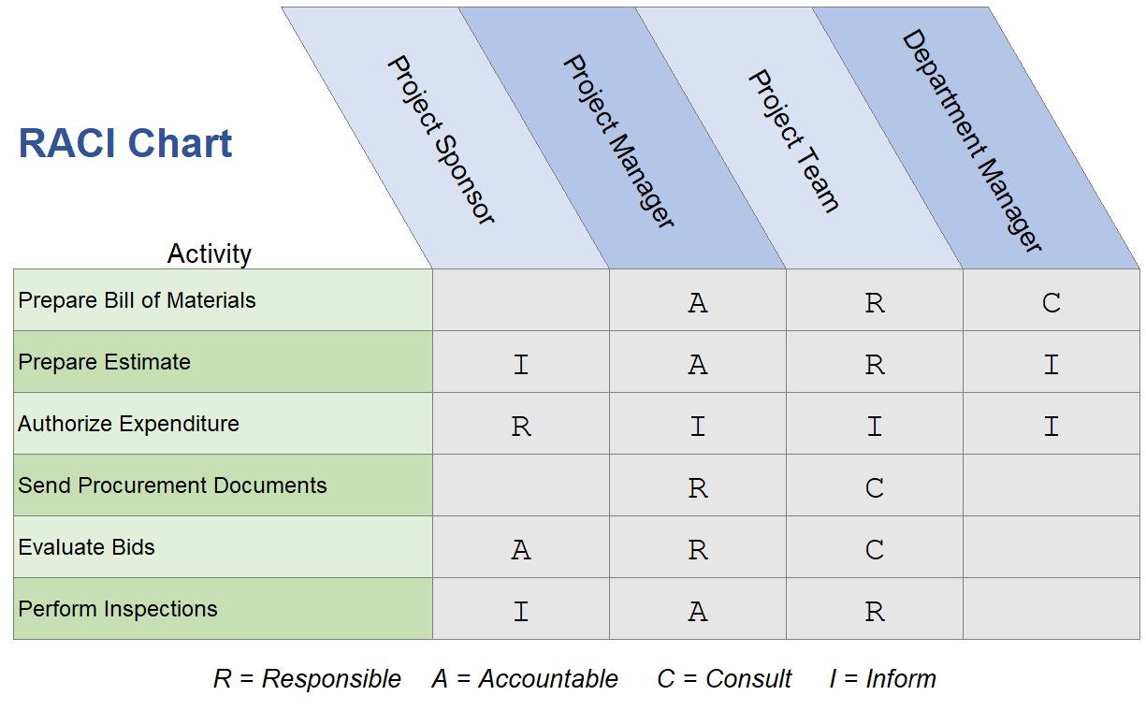

(Hartney, 2019)

- Defining the executive procedures:
Defining the executive procedures: Nokia's new guidelines are the consisting of sequential steps specifying the method of performing a specific task or job and describing in detail the various activities that must be performed to accomplish the organization's programs." (Pogue, 2020).
- Employees Empowerment
The employees inside the company need a precise mechanism that enables them to participate and interact. Empowerment is defined as the philosophy of giving more responsibility and decision-making authority. (Malsam, 2019).
According to the studies from 2017 up to 2019, a culture of fear from the leaders disperses in the company, as supervision experts interviewed 120 workers in "Nokia," including administrators, executives, and regulators, and found that employees were afraid to express opinions, and the culture of blaming others became the dominant culture. (Huy, 2018).
- Continuing to know the customers' desires and aspirations
Understanding customers' desires and aspirations on an ongoing basis by adopting the research and development budget to monitoring their attitude and purchasing behavior. The implementation also requires the emphasis on the charter of values and principles, respect for human rights, and taking into account all environmental aspects. (Hausman, 2020 ).
- Developing and implementing risk plan
Developing a risk plan and identifying the expected risks, whether internal or external. Performing a quantitative and qualitative risk analysis using simulation models and sensitivity analysis to manage any future threat. Implementation of response plans for risks during the strategy's implementation, unexpected internal or external risks may arise. Having clear response plans limits the spread of risk. For example, the emergence of the Corona pandemic as an unexpected threat made many telecommunications companies do online communication to prevent mixing and crowding, in other words, for Nokia devices to be updated and developed in light of any new developments. (Heller, 2021).

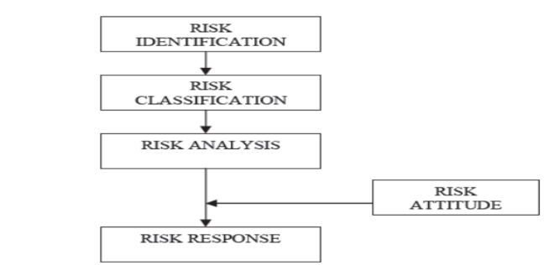

(Keci, 2014)

- Developing Structure
The organization's organizational chart represents how the organization's departments and units are organized, and responsibilities are clarified. (Pogue, 2020).
- Shared values
Shared values are the rules and standards that guide employees' behavior and the work of the organization. (Hartney, 2019).
Third: after Implementation
The development and reform strategy require a periodic monitoring system to ensure the accuracy of implementation. Here, deviations from the established process are measured. The stakeholders must also participate and communicate with them to inform them about the extent of progress and development in the markets and the expected return on investment from implementing this strategy. (Kinyuira, 2014)

Conclusion and Recommendation
Knowing your mistakes and problems is the basis of success. I have concluded that the reasons for Nokia's collapse and loss in the smartphone market, because of the operating system, neglect of the Android system, and the lack of attention to the Symbian system and its applications store enough, were among the most important factors that kept users away from Nokia. In the period that witnessed a significant decline in sales and company shares, Microsoft tried to compete in phone operating systems through Windows Phone, which had only a tiny percentage. The leadership style was narcissism and lack of involvement of others in the decision-making process and policies. Among the problems is the lack of continuous study of the market to determine customer needs and wants.
I also concluded that there is almost unanimity on the impact of PESTLE, SWOT, Boston Consulting Group (BCG) methods in achieving miraculous successes for companies and the destruction of others, even gigantic ones. For Nokia, learning from the other's success and mistakes are considered great lessons that cannot be denied. This report contains objective evidence taking preventive initiatives. We have presented the importance of administrative harmony between all levels to avoid the risks resulting from technological change and exploit the opportunities this change may provide. This is one of the essential benefits of this field. Still, harmony will be reflected in many benefits in terms of productivity and quality, and even customer satisfaction will increase if employees are empowered and shared.
I also recommend that the company review its current organizational structure and use the agile methodology in its logistical operations. The employees involve you in decision-making, updating internal communication systems, and studying competitors on an ongoing basis to find out where the defects are, and updating their technological systems periodically.

References
- Alsop, T., 2021 . Nokia number of employees worldwide from 2005 to 2020. [Online] Available at: https://www.statista.com/statistics/275358/number-of-nokia-employees-since-2005/ [Accessed 6 Abril 2021 ].
- Baruah, P., 2020. What is STEEP Analysis?. [Online] Available at: https://planningtank.com/market-research/steep-analysis [Accessed 13 Abril 2021].
- Beattie, A., 2020. How Did Apple Get So Big?. [Online] Available at: https://www.investopedia.com/articles/personal-finance/042815/story-behind-apples-success.asp [Accessed 15 Abril 2021].
- Bhasin, H., 2018 . Marketing mix of Nokia. [Online] Available at: https://www.marketing91.com/marketing-mix-nokia/[Accessed 11 Abril 2021].
- BOYCE, P., 2021. PESTLE Analysis Definition and Template. [Online] Available at: https://boycewire.com/pestle-analysis-definition-and-template/ [Accessed 15 Abril 2021].
- Chandramouli, K., 2018. Nokia & Feature phones – A match made in heaven?.[Online] Available at: https://medium.com/@iam_karthikcm/nokia-feature-phones-a-match-made-in-heaven-296e64f3fe5[Accessed 15 Abril 2021].
- Chen, C.-Y., 2013. Nokia and strategic agility. African Journal of Business Management, 7(26), p. 2599.
- Datta, 2010. A critique of Porter’s cost leadership and differentiation strategies. Chinese Business Review, 9(4), p. 39.
- Dininni, J., 2011. Management Theory of Michael Porter. [Online] Available at: https://www.business.com/articles/management-theory-of-michael-porter/ [Accessed 9 Abril 2021].
- Eby, K., 2017. From Strategy to Execution: How to Create a Sustainable, Repeatable Implementation Plan. [Online] Available at:www.smartsheet.com/implementation-plan [Accessed 13 Abril 2021].
- Elhady, A. S. & Abushama, H., 2015. RACI Scrum Model For Controlling of ChangeUser Requirement In Software Projects. International Journal of Application or Innovation in Engineering & Management, 4(1), p. 216.
- Grünewälder, A., 2008. Analysis of Nokia‘s Corporate, business, and marketing strategies. [Online] Available at: https://www.grin.com/document/112926 [Accessed 14 Abril 2021].
- Hartney, J., 2019. How to Use a RACI Chart to Simplify Responsibilities. [Online] Available at: https://www.projectengineer.net/how-to-use-a-raci-chart-to-simplify-responsibilities [Accessed 13 Abril 2021].
- Haseeb, 2016. SWOT of Nokia. [Online] Available at:www.marketingdawn.com/swot-of-nokia/ [Accessed 14 Abril 2021].
- Hausman, A., 2020 . A Marketing Mix Strategy That Delivers Guaranteed Profits. [Online] Available at: https://www.hausmanmarketingletter.com/a-marketing-mix-strategy-that-delivers-guaranteed-profits/#.YHiyUj9RU2w[Accessed 14 Abril 2021].
- Heller, A., 2021. Here’s how Covid-19 has forever changed our need for connectivity. [Online] Available at: https://www.nokia.com/blog/heres-how-covid-19-has-forever-changed-our-need-for-connectivity [Accessed 14 Abril 2021].
- Huyen, 2014. [Online] Available at: https://www.slideshare.net/HuyenVo5/samsung-electronics-41493865 [Accessed 10 Abril 2021].
- Huy, Q., 2018. How Nokia Bounced Back (With the Help of the Board). [Online] Available at: https://knowledge.insead.edu/strategy/how-nokia-bounced-back-with-the-help-of-the-board-10211 [Accessed 10 Abril 2021].
- Ionescu, F. T., 2011 . Boston Consulting Group II – A Business Portfolio Analysis Matrix. International Journal of Economic Practices and Theories, 1(2), pp. 4-6.
- Iyibildiren, M. & Karasioglu, F., 2018. Balanced Scorecard in Business Performance Measurement and Its Effect on Financial Structure. Global Journal of Management and Business Research: CFinance, 18(2), p. 7.
- Kantor, B., 2018. The RACI matrix: Your blueprint for project success. [Online] Available at: https://www.cio.com/article/2395825/project-management-how-to-design-a-successful-raci-project-plan.html [Accessed 15 Abril 2021].
- Keci, J., 2014. A User-Oriented Implementation of Risk Breakdown Structure in Construction Risk Management. Journal of Civil Engineering and Architecture, 8(5), p. 531.
- Keelson, S. A., 2018. An Examination of the Program Mix at Technical Universities of Ghana: The Application of the Boston Consulting Group Matrix. European Journal of Business and Innovation Research, 6(1), p. 42.
- Khan, H. Z. & Habib, A. K., 2009. Perceptions of Firms Learning and Growth under Knowledge Management Approach with Linkage to Balanced Scorecard (BSC): Evidence from a Multinational Corporation of Bangladesh. International Journal of Business and Management , 4(9), pp. 258-259.
- Kinyuira, D., 2014. Effects of Porter’s Generic Competitive Strategies on the Performance of Savings andCredit Cooperatives (Saccos) in Murang’a County, Kenya. IOSR Journal of Business and Management , 16(6), p. 96.
- Lucco, J., 2016. 7 Questions To Ask For Your Reporting Software Implementation Process. [Online] Available at: https://www.clearpointstrategy.com/reporting-software-implementation-process/ [Accessed 10 Abril 2021].
- Malsam, W., 2019. Implementation Plan: How to Create and Execute One. [Online] Available at: https://www.projectmanager.com/blog/implementation-plan [Accessed 14 Abril 2021].
- Miller, D., 2017. Relating Porter's Business Strategies to Environment and Structure: Analysis and Performance Implications. Academy of Management Journal, 31(2), p. 40.
- Mohajan, H. K., 2018. An Analysis on BCG Growth Sharing Matrix. Noble International Journal of Business and Management Research, 2(1), p. 3.
- Murphy, F., 2018. Nokia Corporation PESTEL & Environment Analysis. [Online] Available at: https://www.essay48.com/term-paper/5983-Nokia-Corporation-Pestel-Analysis [Accessed 13 Abril 2021].
- Narole, M., 2013. BCG matrix with example. [Online] Available at: https://www.slideshare.net/9579764806/bcg-matrix-with-example [Accessed 14 Abril 2021].
- NOKIA, 2011. Sustainability Reports, Finland: NOKIA.
- Nokia, 2021. Nokia Annual Report , Washington : Nokia Corporation.
- Osita, I. C., 2014. Organization’s stability and productivity: the role of SWOT analysis an acronym for strength, weakness, opportunities and threat. International Journal of Innovative and Applied Research , 2(9), p. 24.
- Pogue, S., 2020. 8 Questions to Ask Your Project Management Vendor About Implementation. [Online] Available at: https://www.workzone.com/blog/questions-to-ask-your-project-management-vendor-about-implementation/ [Accessed 14 Abril 2021].
- PORTER, M. E., 1991. Towards a dynamic theory of strategy. Strategic Management Journal, 1(12), pp. 95-110.
- Porter, S., 2018. Five big things that have made Apple. [Online] Available at: https://www.bbc.com/news/business-45044963 [Accessed 11 Abril 2021].
- Rodrigo, 2021. Strategic Analysis of Nokia Corporation. [Online] Available at: https://writepass.com/journal/2012/12/strategic-analysis-of-nokia corporation/ [Accessed 11 Abril 2021].
- Roseke, B., 2019 . Types of Stakeholder Matrix. [Online] Available at: https://www.projectengineer.net/3-types-of-stakeholder-matrix/ [Accessed 7 Abril 2021].
- Schwarz, S., 2019. NOKIA GO Future Success Strategy, Finland: Tampere University of Applied Sciences.
- Singh, R. & Bansal, R., 2020. Failure of Nokia – Lessons from Losers, New Delhi: National Press Associates.
- Tanwar, R., 2013. Porter’s Generic Competitive Strategies. Journal of Business and Management, 15(1), pp. 12-13.
- Waida, M., 2021. The Ultimate Guide To Implementation Plans. [Online] Available at: https://www.wrike.com/blog/implementation-plan-ultimate-guide/ [Accessed 14 Abril 2021].

9/7/2021

