**Synthesis and Charaterization of Polyaniline Nickel Oxide Nanoparticles**

Rakesh Kumar Yadav1, Pushpendra Kumar Kariyare2 & Abhishek Sharma3, S.P. Mahapatra4

**1-2**Department of Chemistry, Dr. C.V. Raman University, Kargi Road Kota, Bilaspur (C.G.) 495113 India.

**3,**4Departmentof Chemistry, National Institute of Technology (NIT), Raipur (C.G.) India

1Corresponding Author, rakeshyadav96@gmail.com, 8770993716

**ABSTRACT-** Nickel oxide (NiO) nanoparticles was prepared by the simple sol gel method using nickel chloride (NiCl2.6H2O) as a precursors. The nanocomposite was prepared in-situ polymerization method of polyaniline in the presence of NiO at room temperature using potassium persulphate (K2)2S2O8 as an oxidant in acidic medium. The synthesized PANI/NiO nanocomposites have been characterized by means of Flourier Transform Infra-red (FTIR), and NiO with FTIR and UV-VIS spectroscopy both. The results obtained confirm the formation of nickel oxide nanoparticles and its composites.

[Rakesh Kumar Yadav, Pushpendra Kumar Kariyare& Abhishek Sharma, S.P. Mahapatra. **Synthesis and Charaterization of Polyaniline Nickel Oxide Nanoparticles**. *Researcher* 2021;13(8):1-5]. ISSN 1553-9865 (print); ISSN 2163-8950 (online). <http://www.sciencepub.net/researcher>. 1. doi:[10.7537/marsrsj13082](http://www.dx.doi.org/10.7537/marsrsj130821.01)1.01.

**Keywords –** NiO nanoparticle, NiO-PANI Nanocomposites, Polyaniline

**1. Introduction**

**Nanotechnology-** Nanotechnology is the modern and latest advancement in the world of sciences. Its field of research and innovation concerned with building things generally materials and devices on the scale of atoms and molecules. The origin of nanotechnology can be traced to a quote in the speech of Richard Feynman delivered in 1959. The term nanotechnology includes a wide range of technologies across a number of disciplines and as a result can be a handicap to any discussion about social and environmental implication that specific to particular applications.

Nanotechnologies are a branch of science which deals with the synthesis, characterization, exploration and exploitation of nano-structured materials. A nanostructure constitutes a bridge between molecules and infinite bulk systems. Individual nanostructures comprise of clusters, quantum dots, Nano crystals, nanowires, and nanotubes, whereas collection of nanostructures includes arrays, assemblies, and super lattices of the individual nanostructures.

In recent years, nanotechnology has become one of the most important and exciting forefront fields in chemistry, physics, engineering and biology. It shows great promise for providing us in the near future with many breakthroughs that will change the direction of technological advances in wide range of application.

**Nanoparticles-** Nanocomposite is class of materials in which one or more phases with nanoscale dimensions (0-D, 1-D, and 2-D) are embedded in a metal, ceramic, or polymer matrix. Nanoparticles (NPs) are wide class of materials that include particulate substances, which have one dimension less than 100 nm at least . Depending on the overall shape these materials can be 0D, 1D, 2D or 3D. The importance of these materials realized when researchers found that size can influence the physio-chemical properties of a substance e.g. the optical properties.

Nanoparticles are not simple molecules itself and therefore composed of three layers i.e. the surface layer, which may be functionalized with a variety of small molecules, metal ions, surfactants and polymers. The shell layer, which is chemically different material from the core in all aspects, and the core, which is essentially the central portion of nanoparticle.

Nanoparticles research is currently an area of intense scientific interest due to a wide variety of potential applications of these materials in the fields of in optical and electronic fields, biomedical- Drug delivery systems, In MRI studies, Detection of proteins, probing of  DNA structure. Biomedicine, optics and electronics.

Nanoparticles are of great scientific concern as they are effectively a bridge between bulk materials and atomic or molecular structures. A bulk material should have constant physical properties regardless of its size, but at the nano-scale size-dependent properties are often observed. Thus, the properties of materials change as their size approaches the nanoscale and as the percentage of atoms at the surface of a material becomes significant

Polyaniline (PANI) is one of the most useful conducting polymers and it contains synthesis and environmental stability and it also has a most property in electrical field which can be easily controlled by changing its oxidation and protonation states. There are many unresolved problems concerning the structure and properties of polyaniline because of complexities in molecular structure, due to synthesis conditions.

**2. Material and Methods**

**Experimental:**

**Chemicals*-***

Aniline monomer was distilled under reduced pressure prior to use. Aniline (99.5%), potassium iodate (99.5%), sulphuric acid (98%), nickel chloride (99%), sodium hydroxide , ethanol (99.9%), and potassium persulphate (99.5%) were brought from S.D. Fine-Chem. Ltd. All chemicals were of analytical grade and solutions were prepared with double distilled water.

**Synthesis of NiO Nanoparticles**

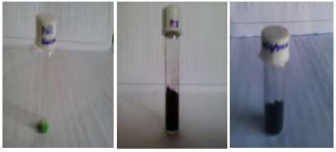NiCl2.6H2O (1.5g/0.0063mol) was taken by appropriate amount and transferred to 250 ml round bottom flask then dissolved 70 ml of absolute ethanol at the room temperature (clean green solution ). Another beaker NaOH (0.5g, 0.0125mol) was taken and dissolved in 100 ml of absolute ethanol then NaOH solution dropwise transferred to above prepared solution . then stirred these solution continue for 2 hours at room temperature (light green colour) after 2 hour gel filtrated and the precipitate of Nio was washed completely using distilled water and also washed by ethanol to remove by product .The product was dried in air drying or hot air oven at 80◦c for till the product will completely dried. The light green powder (Nio nanoparticles) obtained .

**Synthesis of PANI/NiO nanoparticles**

The as-synthesized NiO nanoparticles were incarporated in in situ chemical oxidative polymerization of PANI matrix. In a typical procedure, 0.1M of aniline was dissolved in 100 ml of 1M H2SO4 solution and stirred for 1 hour, then mixed with 10 ml of sonicated NiO nanoparticles by further sonication for 30 min. 100 ml of 1M H2SO4 solution containing 0.1M (K2) S2O8 (PPS) was then slowly added drop wise to well dispersed suspension mixture for 2 hour with a continuous stirring. After 3 hour, a good degree of polymerization was achieved as observed by the change in colour from blue to blackish green and the solution was kept overnight. The precipitate produced in the reaction was removed by filtration, washed repeatedly with 1M H2SO4 and dried under vacuum for 24 hour. The conductive emeraldine salt (ES) form of PANI/NiO nanocomposite powder was obtained.

## Chemical Reaction:

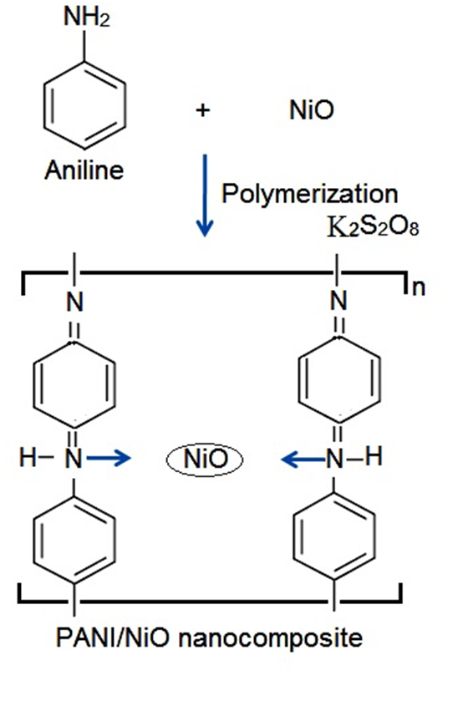

(A) NiO nanoparticle (B) PANI (C) NiO-PANI nanocomposite



FT-IR spectra of PANI/NiO Nanocomposite

**3. Results and Discussion**

There are many methods to prepare NiO nanoparticles including thermal treatment of electro deposited or sol gel prepare nickel hydroxide, liquid phase process, spray pyrolysis method, and rotating ring-disc electrode method etc. NiO thin films adopt the NaCl structure with octahedral NI(ii) and O2- sites they are recently drawing considerable attention because of there importance in several scientific and technological application, they have a lot of special optical, electrical and magnetic property , they are used as anti-ferrromagnetic materials and electrochemical display device

**Characterizations:**

**FTIR Spectroscopy**

FT-IR spectra of NiO nanoparticles

The FTIR spectrum of the precursor nickel oxide nanoparticle is shown in five. The broad absorption band centered at 3439 cm*−*1 is attributed to the band O–H stretching vibrations, and the band at 1614 cm*−*1 is attributed to bending mode (H–O–H). The strong band at 478 cm*−*1corresponds to the bending vibration of NiO nanoparticle.

The chemical structure of nickel oxide nanoparticle was determined by FTIR spectrum. The FTIR spectroscopy has provided valuable information regarding the formation of NiO. FTIR analysis has been done to identify the characteristic peaks of product FTIR spectra in the 4000-500 cm region.

The FTIR spectroscopy has provided valuable information regarding the formation of Polyaniline. FTIR analysis has been done to identify the characteristic peaks of product FTIR spectra in the 4000-500 cm region. The spectra shows the presence of characteristic absorption bands at 1560 cm 1 (C=C stretching vibration of the quinoid ring), 1486 cm 1 (stretching vibration of C=C of the benzenoid ring), 1311 cm 1 (C-N stretching vibration),1298 cm 1 (C-H in-plane deformation),827.46 cm 1 (C-H out-of-plane deformation).

**UV-Visible Spectra**

The absorbance spectra of the synthesized metal oxide Polyaniline was recorded using the double beam spectrophotometer of UV-Visible spectrophotometer. The spectra show two characteristics peaks at a wavelength of 370nm and 630nm. The first peak corresponds to the formation of nickel oxide while the latter on peaks at 630nm corresponds to the formation of Polyaniline.



The chemical structure of PANI is shown in Fig

**4. Conclusion**

The NiO nanopartical were with success made-up via sol-gel methodology exploitation nickel chloride hexahydrate and sodium hydroxide as main materials. The results indicated the formation of pure NiO NPs with none impurity. The morphological study showed nanorange of particles and Elemental analysis successfully derived Ni and O elements. Nickel chemical compound nanoparticles have promising signs within the fields of sunshine weight optics, metal ion batteries, waste material purification, and semiconductor materials.

NiO nanoparticles and PANI-NiO nanocomposites have been successfully prepared. FTIR spectra, and UV-VIS spectroscopy images shows the preparation of NiO and FTIR spectra of PANI-NiO nanocomposites indicate the interactions exist between PANI and NiO nanoparticles. The incorporation of NiO into PANI matrix affects the transport and polymeric conductivity properties of nanocomposites.

**Acknowledgement**

I am extremely grateful to my guide, Dr. Rakesh Kumar Yadav, Associate Professor, Department of Chemistry, Dr. C. V. Raman University, Kargi Road Kota Bilaspur (C.G.) for their valuable guidance, scholarly inputs and consistent encouragement despite of his busy schedules, which I received throughout the research work. I consider it as a great opportunity to do my M. Phil programme under their guidance and to learn from their research expertise. The thesis would not have come to a successful completion, without the help I received from the staff of the computer center and my research laboratory.

**Corresponding Author:**

Dr. Rakesh Kumar Yadav

Department of Chemistry

Dr.C.V. Raman University, Kargi Road Kota Bilaspur (C.G.) 495113 India

+91-8770993716

Email: [rakeshyadav96@gmail.com](mailto:rakeshyadav96@gmail.com)

**5. References**

1. Theivasanthi, T., & Alagar, M. (2012). Chemical capping synthesis of nickel oxide nanoparticles and their characterizations studies. arXiv preprint arXiv:1212.4595 .
2. Davar, F., Fereshteh, Z., & Salavati-Niasari, M. (2009). Ni and NiO nanoparticles: synthesis, houses and magnetism.Journal of Alloys and Compounds, 476 (12), 797801
3. Pooja Khandagale and Dipali Shinde. (2017); a Synthesis and characterization of nickel oxide nanoparticles with the useful resource of the use of the usage of coprecipitation approach. a International Journal of Advanced Research., A5˘a (5). 13331338
4. Zorkipli, N. N. M., Kaus, N. H. M., & amp; Muhammad, A.A. (2016). The sol-gel approach became used to synthesize NiO nanoparticles. Procedia Chemistry, 19, 626-631.
5. Salahuddin, N. A., El-Kemary, M., & Ibrahim, E. M. (2015).Synthesis and characterization of ZnO nanoparticles via way of means of deposition process: the impact of annealing temperature on particle size.˘aNanoscience and Nanotechnology,˘a5(4), 82-88 .
6. Wang, H., Kou, X., Zhang, J., & Li, J. (2008). Bulletin of Materials Science, 31(1), 97-100
7. Chaudhary, R. G., Tanna, J. A., Gandhare, N. V., Rai, A. R., & Juneja, . (2015). Synthesis of nickel nanoparticles: Microscopic investigation, an inexperienced catalyst and effective antibacterial activity. Adv. Mater. Lett, 6(11), 990-998. Open J. Chem. 2019, 2(1), 16-20 20
8. Ungula, J. (2015). Growth and characterization of ZnO nanoparticles with the useful resource of the use of sol-gel process (Doctoral dissertation, University of the Free State (Qwaqwa Campus)).
9. Bhatia, S. (2016). In Natural polymer drug delivery systems (pp. 33-93). Springer, Cham.
10. Srivastava, R. (2012). Synthesis and characterization techniques of nanomaterials. International Journal of Green Nanotechnology, 4(1), 1727.

7/22/2021