Desmoplastic Fibroma at Femoral Neck Radiologically mimicking Aneurysmal Bone Cyst: A case Report and Literature review. When sampling matter

Somaia Ahmed Saad El-Din^{1,2} and Dr. Salim Al-Busaidi³

¹Pathology Laboratory, Armed Forces Hospital, Muscat, Oman.
²Pathology Department, Faculty of Medicine, Ain Shams University, Cairo, Egypt.
³Department of Orthopaedic Surgery, Armed Forces Hospital, Muscat, Oman
Email: drsomaia2005@gmail.com

Abstract: Desmoplastic fibroma (DF) of bone is an extremely rare benign intra-osseous aggressive bone tumour with high risk of recurrence. The neck of femur is an extremely rare location of such tumour. We present a case of young Omani female patient with lytic lesion over the left neck of the femur that clinical and radiological favour diagnosis of aneurysm bone cyst with the initial histopathology examination on core biopsy was insufficient bloody material. Accordingly, extended curettage and bone graft with dynamic hip screw fixation were done. The final histopathological diagnosis on the curettage material was consistent with desmoplastic fibroma of bone. Although, desmoplastic fibroma of femoral neck is an extremely rare, it should be considered in our differential diagnosis with radiological lytic soap bubble lesion especially when the initial sample is insufficient and special attention to MRI, T2 shortening is needed.
[Somaia Ahmed Saad El-Din and Salim Al-Busaidi. Desmoplastic Fibroma at Femoral Neck Radiologically mimicking Aneurysmal Bone Cyst: A case Report and Literature review. When sampling matter. Researcher 2021;13(7):44-48]. ISSN 1553-9865 (print); ISSN 2163-8950 (online).
http://www.sciencepub.net/researcher. 9. doi:10.7537/marsrsj130721.09.

Key Words: Desmoplastic Fibroma of bone, Aneurysmal bone cyst, radiology, aggressive biological behaviour

1. Introduction:
Desmoplastic fibroma (DF) of bone was initially described in 1958 by Jaffe [1], who separated it as a distinct entity from other intraosseous fibrous tumours. It is an extremely rare benign intra-osseous aggressive non-metastatic bone tumour with high risk of recurrence with incidence rate of 0.1% to 0.3 % and most of them diagnosed histologically [2]. Numerous bones can be affected, but more than 50% of the cases reported in the long bone of the extremities, then in ilium or in the mandible [3]. The neck of femur is extremely a rare location of such tumour. The vast majority of patients affected by this tumour are in the first three decades of life. Pain or swelling is the commonest symptoms. Radiologically, it is a pure lytic lesion with soap bubble appearance and endosteal scalloping. Late diagnosis may present with cortical break with or without soft tissue expansion. In addition, it exhibits low signal intensity on T2 weighted MRI. Histologically, it is similar to soft tissue fibromatosis[4,5].

2. The Case Presentation:
We present a 27 years old healthy Omani female with one year history of left hip non-traumatic pain without any history of constitutional symptoms. Initially she was seen overseas and her initial imaging showed a lytic lesion over the left neck of femur. Her clinical examination revealed, thin girl with painful weight bearing and local tenderness over proximal left femur with no palpable mass. Moreover, hip range of movement was painful and restricted. The rest of examinations were unremarkable.
On radiographs, the lesion is large, expansible and lytic with narrow zone of transition with intact cortex, and not extending into the epiphysis.
MRI demonstrates some areas of T2 cystic changes more medially, with areas of intermediate signal intensity more laterally. Post contrast administration: there is moderate diffuse heterogeneous enhancement more in the peripheral and inferior aspects. The margins are sharp and lobulated with a sharp zone of transition. The overlying cortex is thinned out and showed possible small defects at places. There is no evidence of soft tissue masses. No pathological fracture is seen. The surrounding muscle appeared normal. The hip joint itself appeared normal. There is no evidence of greater trochanter bursitis. The remainder of the visualized bones and soft tissue structures are normal (Figure 1A, 1B, 2A, 2B).
Patient underwent CT scan guided core biopsy with pathological impression of “Bloody sample, non representative /non diagnostic, with no malignant cells appreciated.
Based on clinical and radiological findings, a diagnosis of aneurysmal bone cyst (ABC) was suggested. Accordingly, extended curettage and bone graft with dynamic hip screw (DHS) fixation was done (Figure 3A, 3B). Tumour curettage material was sent for histopathology examination.

3. Histopathology Examination:
The gross appearance of the received curettage tissue was tan whitish nodular/lobulated that does not match the clinical diagnosis of ABC that appears reddish bloody admix with bony trabeculae.
Microscopic examination reveals a benign collagenized spindle cell lesion with variable cellularity. The spindle cells show oval nuclei and eosinophilic fibrillary cytoplasm admix with abundant collagen arranged in sweeping and fascicular patterns with foci of myxoid degeneration, some scattered mast cells, and some scattered blood vessels. The lesion appears infiltrating and encasing the cortical and the medullary bone trabeculae as well as the hemopoietic bone marrow elements. There is no mitosis appreciated. There is no atypia or necrosis (Figure 4A, 4B, 4C).
Focal areas show prominent siderophages along with lymphoplasmacytic infiltrate, small blood vessel proliferation, edema, haemorrhage and fibrin deposition (site of previous biopsy).
Masson’s trichrome stain highlights the prominent collagen deposition in the lesion. Smooth muscle actin (SMA) immune stain show scattered positive cells denoting the myofibroblastic nature of the spindle cells (Figure 4D).
Other immune stains (Nuclear beta catenin, calretinin, and S100) were negative. Ki67 was very low, less than 1%. Hormonal receptors including ER, PR and AR were all negative.
Thus, the gross, microscopic and immune stain results in context of the radiological features were consistent with the diagnosis of DF of bone, which is considered the bony counter part of soft tissue aggressive fibromatosis, with similar biological behaviour with high incidence of local recurrence rate.

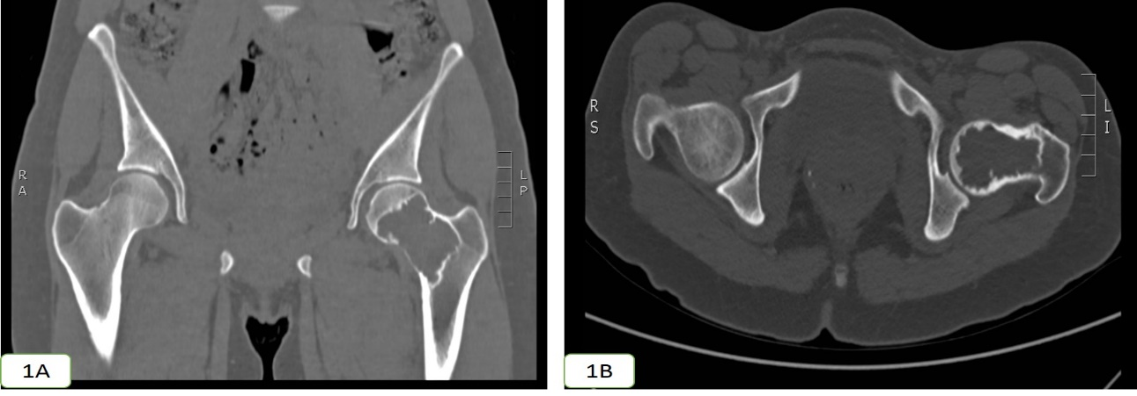
Fig. 1A, 1B: CT scan coronal (A) and axial (B) cuts showed the hypodense lesion at the left neck femur
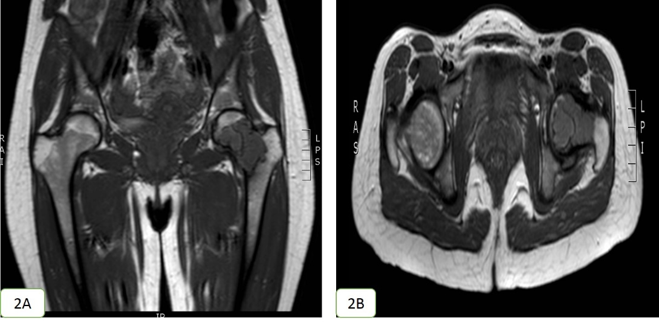
Fig. 2A, 2B: MRI coronal (A) and axial (B) cuts showed the hypodense lesion at the left neck femur

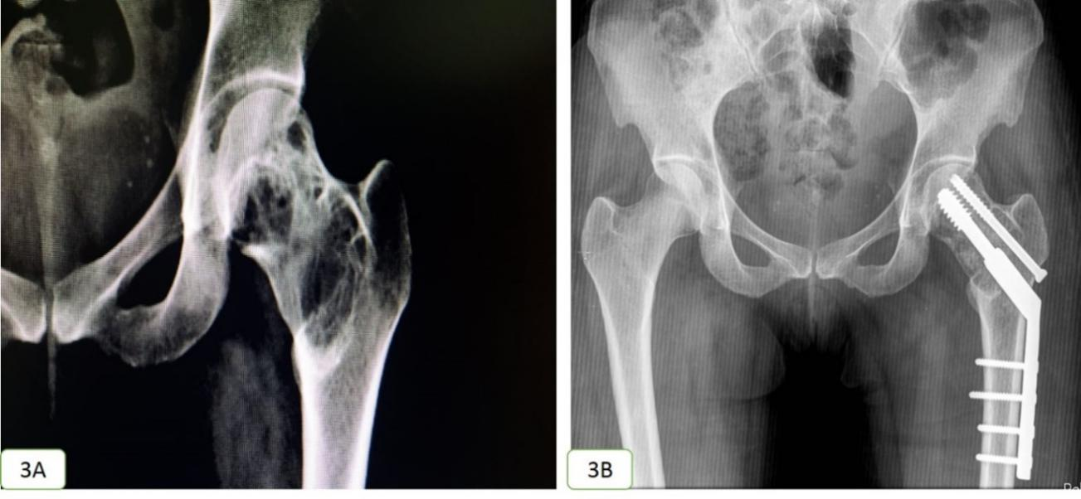
Fig. 3A, 3B: X ray AP view pelvis showed the osteolytic soap bubble lesion at left neck femur (3A) and bone graft with DHS 6 weeks post treatment (3B).

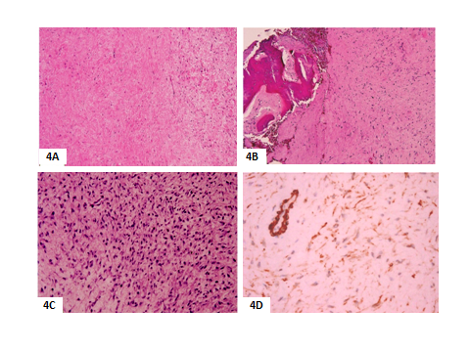
Fig. 4A,B,C,D: (A) hypo-cellular collagenized spindle cell lesion (B) the lesion infiltrating into the bone (C) areas of mild hypercellularity, (H&E, x100,x100,x200), Smooth muscle actin immune stain is positive with positive blood vessel wall internal control , x200.

4. Discussion:
DF of bone is a rare, locally aggressive and non-metastatic myofibroblastic benign tumour of bone, mostly affects the metaphysis of long bones and occurs in the first three decades of life. The symptoms are nonspecific, including pain in the region of the tumour, both at rest and on movement [1].
The present case is quite similar to other published cases where there is a concordance with the age and history of slow-growing painful lesion with non-specific radiological feature, which is misdiagnosed with ABC, especially that ABC is one of the five most common bone tumors." [6] and treated with extended curettage and bone graft. On other hand, the location of tumour of our presented case is extremely rare as only few cases in literature review can be found [5,7].
Radiographic appearance may vary from unilocular to multilocular, well defined lytic lesion in the metaphysis of long bone, with expansion of the bone contour and cortical thinning out with no reactive periosteal new bone formation. It classically shows lobulated and bubbly appearance, frequently accompanied by coarse trabeculations. Cortical breakdown occurs in minority of cases and best seen on CT scan image. MRI findings are generally non-specific but may reveal the fibrous nature of the lesion by low signal on T1 and T2 weighted images. T2 may have more heterogeneous signal depending on the relative amount of collagen. The collagen rich hypocelluar areas of the tumors showed T2-shortening while hyper-cellular parts filled with active fibroblastic proliferation are responsible for the higher intensity parts within the lesions. [8]. Frick MA, et al found that T2 shortening is important diagnostic feature of intraosseous fibrous lesions as it is one of the described features to soft tissue fibromatosis [9].
The overall appearance is suggestive of benign neoplasm with the differential diagnosis of aneurysmal bone cyst, simple bone cyst and chondromyxoid fibroma [9,10]. Accordingly, the diagnosis of DF of bone based on radiological evidence alone remains a challenge. This is in agreement with our presented case that showed well-defined lytic lobulated lesion and was suggested to be ABC with differential diagnosis of chondromyxoid fibroma.
There are two cases reported by Gong et al, 2015 [11] of DF of neck of femur and misdiagnosed as ABC and treated with extended curettage and bone graft as done in the present case. In contrast to Gong cases, our presented case fixed with DHS in order to prevent pathological fracture in the future.
The Histologic criteria for DF of bone as defined by the World Health Organization is “a rare benign bone tumor composed of spindle-shaped cells with minimal cytological atypia and abundant collagen production” [4]. In the present case, the histopathological appearance was similar to soft tissue fibromatosis with the lesion showed mature fibrous connective tissue, low to mild higher cellularity and spindle-shaped fibroblasts/ myofibroblasts with uniform long nuclei in an abundant stroma of collagenous matrix, lacking cellular pleomorphism, nuclear hyperchromasia or mitoses. The lesion was non-capsulated with poor demarcation with infiltrative margins encroaching on the trabecular bone and bone marrow.
The immunohistochemical expression of nuclear beta catenin in DF of bone is mostly negative unlike deep fibromatosis [12]. Also calretinin (somewhat newly described marker for deep fibromatosis), and the hormonal receptors (ER, PR, and AR) are mostly negative. In the present case, we assess all deep fibromatosis markers including hormonal receptors, thus patient may benefit from hormonal therapy in case they are positive as an optional line of treatment and thus decrease the recurrence. It was reported that 50% of the cases can express muscle specific markers as smooth muscle actin denoting the myofibroblastic nature of the proliferating cells [13]. This was in concordance with our case that expresses only SMA and was negative to all other markers. Other studies showed cytoplasmic expression of beta catenin with no nuclear stain in about 46% of the cases. This also was in agreement with our finding as cytoplasmic stain with no nuclear stain appreciated to nuclear beta catenin and interpreted as nonspecific stain. However, Nedopil et al, [1] found positive nuclear stain to nuclear beta catenin, and Kadowaki et al, [14] found one reported DF of the mandible with nuclear beta catenin immunohistochemical expression as well as CTNNB1 point mutation.
Histologically, it could mimic other spindle cell tumors as low-grade fibrosarcoma, benign fibrous histiocytoma, fibrous dysplasia, or a low-grade intra-osseous osteosarcoma or tumor-like lesions such as simple bone cyst [15]. Thus, incorporation of the clinical, radiological and the histopathological features with special consideration to tumor cell growth pattern, the composition of the tumor, the cellularity, mitosis and pleomorphism would help to reach a definite diagnosis.
DF of bone is locally aggressive and can recur with a subtotal resection [16]. The ideal therapy is an en bloc resection. Alternative therapy as curettage is suggested for cases in which anatomical considerations limit resection, with free survival up to 9 years [17].
We believe that in view of the high incidence of recurrence after curettage the en block resection is the best option when it is feasible with low morbidity and if not done like in our case due to misdiagnosis and its location, a long close clinically and radiologically follow up is strongly recommended to detect any recurrence early.

Conclusion:
DF of bone is an extremely rare locally aggressive bone tumour with high risk of recurrence that is commonly misinterpreted radiologically as other benign lesions especially ABC. MRI and special attention to T2 weighted image with shorting may be very helpful. The pathological examination remains the gold standard in its diagnosis and long close follow up is strongly recommended.

Conflict of interest:
The authors declare that there are no conflicts of interest.

Funding Resources: Nil

Consent: had been taken from the patient for publication.

Acknowledgment:
I would like to thanks Dr. Lakshmi Rao, the senior consultant at the Pathology Department, Armed Forces Hospital, Muscat, Oman who further confirm such rare diagnosis and Dr.Masoud Al-Kindi, the head of the pathology department, Armed Forces Hospital, Muscat, Oman who gives us the permission for publication of this case and taking photos.
Abbreviation:
ABC: (aneurysmal bone cyst), DF: (desmoplastic fibroma), DHS: (Dynamic hip screw).

References:
- Nedopil A., Raab P., Rudert M. Desmoplastic fibroma: a case report with three years of clinical and radiological observation and review of the literature. Open Orthop J. 2013;8:40–46. [PMC free article] [PubMed] [Google Scholar]
- Jaffe HL. Desmoplastic fibroma and fibrosarcoma: In Jaffe HL, ed. Tumors and Tumorous Conditions of Bones and Joints. Philadelphia; Lea and Febiger; 1958: 298-303.
- Guruprasad Y, Chauhan DS: Desmoplastic fibroma of mandible. Case report. Medical Journal of Dr.D.Y Patil Vidyapeeth: 2015, Volume 8, Issue 2, Page: 254-257.
- Hoch B and Gannon FH: Practical Orthopaedic Pathology A diagnostic Approach by Andrea T. Deyrup and Gene P.Siegal 2016, publisher ELSEVIER, chapter 12/Lesions Characterized by a Fibrous Spindle Cell Proliferation Replacing Trabecular Bone, P173-174.
- Apadydin M, Gelal F, AvicA et al. Desmoplastic fibroma in humorous. J Med Imaging RadiatOncol. 2008; 52: 489-490.
- Öztürk R, Arikan SM, Bulut EK, Kekeç AF, Çelebi F, Güngör BS. Distribution and evaluation of bone and soft tissue tumors operated in a tertiary care center. Acta Orthop Traumatol Turc. 2019; 53: 189-194).
- Vanhoenacker FM, Hauben E, De Beuckeleer LH, et al: Desmoplastic fibroma of bone:MRI features. Skeletal Radiol, 2000;29:171-175.
- Shi H, Wang P, Wang S, Yu Q. Desmoplastic fibroma of the mandible. Dentomaxillofac Radiol. 2008;37:408–11. [PubMed] [Google Scholar]
- Frick MA, Sundaram M, Unni KK, et al: Imaging Findings in Desmoplastic Fibroma of Bone. Distinict T2 Characteristics AJR Am J Roentgenol, 2005; 184:1762-1767.
- Scott N, Patel M, Newlands C. Desmoplastic fibroma of the mandible: An unusual presentation and treatment. J Surg Case Rep 2011. 2011 5. [PMC free article]
- Gong YB, Li-Mei QU, Xin QI and Liu JG: Desmoplastic fibroma in the proximal femur: A case report with long-term follow-up, Oncology letters, 2015 Oct; 10 (4) :2465-2467.
- Woods TR, Cohen DM, Islam MN, Rawal Y, and Bhattacharyya I, 2015: Desmoplastic Fibroma of the Mandible: A Series of Three Cases and Review of LiteratureHead Neck Pathol. 2015 Jun; 9(2): 196–204. doi: 10.1007/s12105-014-0561-5.
- Hauben EI, Jundt G, Cleton-Jansen AM, Yavas A, Kroon HM, Van Marck E, et al. Desmoplastic fibroma of bone: An immunohistochemical study including beta-catenin expression and mutational analysis for beta-catenin. Hum Pathol. 2005;36:1025–30. [PubMed] [Google Scholar].

Kadowaki H, Oyama Y, Nishida H, Kusaba T, Arakane M, Kawamura K, Kawano K, Daa T, 2020: A case of desmoplastic fibroma of bone with CTNNB1 point mutation, Oral Surgery, Oral Medicine, Oral Pathology and Oral Radiology, Volume 129, Issue 4, April 2020, Pages e230-e233 https://doi.org/10.1016/j.oooo.2019.09.007
- Fornasier V, Pritzker KPH, Bridge JA: Desmoplastic fibroma of bone. In: Fletcher CDM, Unni KK, Mertens F, editors. In: Pathology and Genetics of Tumours of Soft Tissue and Bone (IARC WHO Classification of Tumours), third edition. Lyon: IARC Press; 2006 [Google Scholar]
- Dalili-Kajan Z, Adham-Fumani G, Dalili-kajan H. Desmoplastic fibroma with periosteal reaction. Acta Med Iran. 2007;45:325–8. [Google Scholar]
- Nishida J, Tajima K, Abe M, et al. Desmoplastic fibroma. Aggressive curettage as a surgical alternative for treatment. ClinOrthopRelat Res. 1995;320:142–8. [PubMed]

7/22/2021

