**Monitoring and Evaluation of Trace Metal Concentrations in Tissues of *Clarias gariepinus* Caught from Orashi River, Niger Delta, Nigeria.**

1George, Ubong, 2Inyang-Etoh Aniema, 3Bate, Garba Barde

1Department of Fisheries & Aquaculture, Akwa Ibom State University, Obio Akpa Campus

2Department of Fisheries & Aquaculture, Faculty of Oceanography, University of Calabar, Calabar, Nigeria

3Department of Environmental Science, Federal University Dutse, Jigawa State, Nigeria

**Email:** [**ubonggeorge@aksu.edu.ng**](mailto:ubonggeorge@aksu.edu.ng)

**Abstract:** The levels of trace metals in the tissues of *C. gariepinus* from Orashi River, Niger Delta, Nigeria were investigated in order to ascertain the public health implication of consuming this edible species. Samples of *C. gariepinus* were collected for a period of for 12 months (between May 2016 and April 2017) from the upstream and downstream of the River and were analyzed using Atomic Absorption spectrophotometry for the determination of heavy metals. From the results it was observed that trace metals bioaccumulated in the tissues of *C. gariepinus* with high concentrations in the intestine and muscles. Significant variations for upstream and downstream were observed for Cd, Cr, Cu, Pb, Mn and Zn (p<0.05) exception for Iron (p>0.05). The high concentration of Fe and Zn recorded during the study can be attributed to its abundance in the earth crust. Transfer factor index used in this study as a tool to assess the level of bioaccumulation in the studied species showed evidence of bioaccumulation of heavy metals in the tissues which calls for public health concern. However, the level of trace metal were above recommended tolerable limits for most of the metals when compared to world standards for safety of consumption of aquatic organism exception for Pb and Cr. The result of the studies implies that *C. gariepinus* caught from Orashi River is not safer as a food source for human consumption. However, constant monitoring of the river is emphasized in order to forestall cumulative effects of contamination which may arise in future if not checked.

[George, Ubong, Inyang-Etoh Aniema, Bate, Garba Barde*.* **Monitoring and Evaluation of Trace Metal Concentrations in Tissues of *Clarias gariepinus* Caught from Orashi River, Niger Delta, Nigeria.** *Researcher* 2021;14(6):45-53]. ISSN 1553-9865 (print); ISSN 2163-8950 (online). <http://www.sciencepub.net/researcher>. 7. doi:[10.7537/marsrsj13062](http://www.dx.doi.org/10.7537/marsrsj130621.07)1.07.

**Keywords:** Monitoring, Trace Metal Concentration, Tissues*, Clarias gariepinus*, Orashi River, Public Health

1. **Introduction**

Fish are most important organisms in aquatic food chain, and they are sensitive to heavy metals contamination. Most of the species of the fresh water are confined to specific microhabitat within inter connected river / stream ecosystem. In the event of contamination of such system with heavy metals, fish species either shift to less polluted segment of river / stream or die off which ultimately disturb the food chains (Rashed, 2001). Higher levels of heavy metals in fish tissues have apparent lethal and chronic effects on fishes (Kotze, *et al.,* 1999). Various pathways of metal accumulation in fish include ingestion of food, suspended particulate matter, metal ion exchange through gills and skin (Nussey, 2000). Other routes include food, suspended particle, gills, intake of water and integuments.

Metals get into the blood and are transported to various organs for either storage or excretion through these pathways. The index of metal pollution in an ecosystem is determined by the level of trace metals in different organs of fish, which is considered as an important tool to highlight the role of elevated level of metals in aquatic organisms (Tarrio *et al.,* 1991). The rate of concentration of heavy metals in different tissues / organs of fishes is dependent on the contamination in aquatic environment, uptake, regulation and elimination inside the fish body (Nussey, 2000). Liver stores either heavy metals or excretes through the bile. It has been revealed that metal bioaccumulation by fish and subsequent distribution in organs is greatly inter-specific. In addition, many factors can influence metal uptake like sex, age, reproduction cycle, swimming patterns, feeding behavior and living environment (geographical location).

The accumulation of heavy metals in various tissues and organs depends on the exposure such as through diet or their elevated level in surrounding environment (Nussey, 2000; Alam *et al.,* 2002). Morphological and behavioral abnormalities such as alteration in sensory reception, reduced responses to normal olfactory function (feeding, mating, selection or homing), reduction in swimming performance, gills purge, ventilation, coughs, learning impairment, loss of equilibrium that lapsed into paralysis, loss of reproductive efficiency and irregular metamorphosis appeared as symptom of toxic exposure of trace metals (Mansour and Sidky, 2002). Concentration of heavy metals becomes toxic to fish when its level exceeds the permissible level; this threshold limit not only varies from metal to metal but also from one species to another.

Several studies (George, 2015; George, *et. al*. 2015; Ademoroti, 1996; Heath, 1987) have also indicated that fish are able to accumulate and retain heavy metals from their environment depending upon exposure of concentration and duration as well as salinity, temperature, hardness and metabolism of the animals. Adeyeye *et al,* (1996) also showed that the concentration of metals was a function of fish species as it accumulates more in some fish species than others. The results of many field studies of metal accumulation in fish living in polluted waters shows that considerable amounts of various metals may be deposited in fish tissues without causing mortality (Farkas, *et al*., 2002). Accumulations of various metals in fish varies, such variation is as result of different affinity of metals to fish tissues, different uptake, deposition and excretion rates. The determination of toxic heavy metals in fish can serve as bio-indicator of their impacts on these organisms as well as give an insight to the degree of pollution of the water body in particular (Farkas *et al.,* 2002).

Considering the importance of constant monitoring of aquatic ecosystem, the present study is aimed at quantifying the levels of some trace metals (Cd, Cu, Fe, Pb, Zn, Mn and Cr) in intestine, muscles, liver and gills of *Clarias gariepinus* caught from the upstream and downstream of Orashi River, Nigeria.

**2.0 Materials and Methods**

**2.1 Description of study area**

Orashi River (Figure 1) is located between latitude 050 08’ 22.7’’ and longitude 006o 29’ 57.6’’ (up-stream) and latitude 050 01’ 11.6’’ and longitude 0060 26’ 04.3’’ (down-stream), with an elevation of 270 meters above sea level. The study area is inhabited by two (2) Ethnic groups (The Engenni’s and The Ekpeye’s) both on either side of the river. Orashi River is a crucial resource for all the surrounding communities. The river system is strongly seasonal, and the main feeder river on the east flank of the lower Niger Delta when viewed through the map. In the dry season, water entering the system comes from the flood plains and drains up-stream through Onosi, Omoku, Ndoni and Oguta Lake while during the wet season, the Orashi River is swollen by the overflow of River Niger flood which enters Orashi River mainly through Ndoni creek. Human activities along the study area are mainly dredging, illegal crude oil refining, transportation, fishing, markets, disposal of domestic waste, sewage disposal, sand dredging, jetties and agricultural run-off.

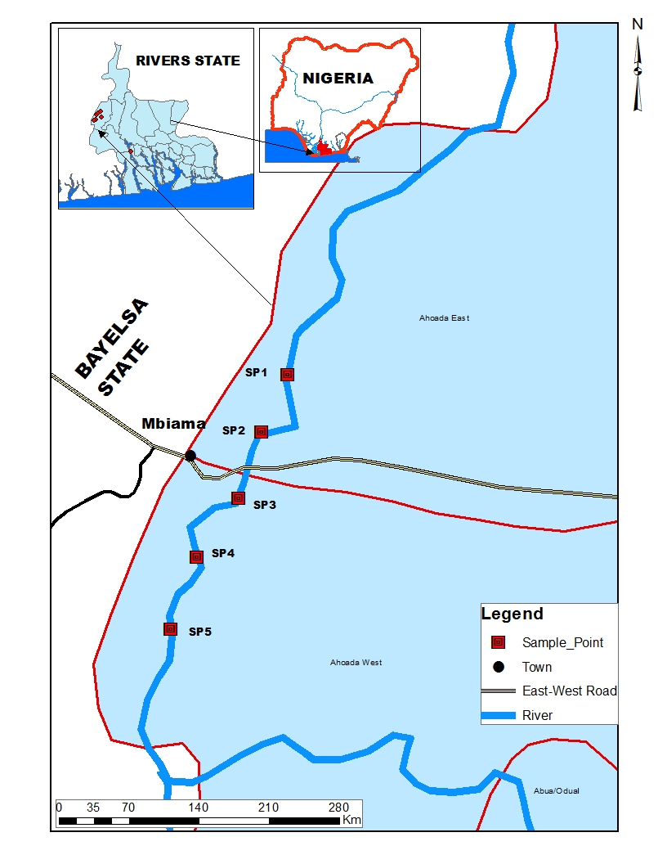

**FIG. 1: Map of Study Area Showing Sampling Locations**

**2.2 Sampling Stations**

Five (2) sampling stations from the upstream and downstream of the River were established. These stations were chosen based on the level of ecological activities that took place along the shore of the river. Geolocation of the sampling stations is presented in Table 1.

**Table 1: Geolocation of the Sampling Stations**

|  |  |  |  |
| --- | --- | --- | --- |
| Sampling Stations | **Latitude** | **Longitude** | **Altitude (m)** |
| SP1 (Oshiobele) | 5° 5'10.52"N | 6°28'19.98"E | 11 |
| SP2 (Akinima) | 5° 4'32.11"N | 6°27'55.53"E | 10 |
| SP3 (Mbiama) | 6°28'19.98"E | 6°26'50.22"E | 11 |
| SP4 (Odhiogbor) | 5° 1'36.52"N | 6°26'23.04"E | 7 |
| SP5 (Odereke) | 5° 0'42.11"N | 6°25'50.47"E | 10 |

**2.3 Collection of fish specimen’s**

Ten (10) Samples of *Clarias gariepinus* were collected on a monthly basis for 12 months (between May 2016 and April 2017) at Oshiobele, Akinima, Mbiama, Odhiogbor and Odereke along Orashi River using the services of artisanal fishermen fishing with the aid of basket trap fishing gear. Pictorial representation of *C. gariepinus* is presented in Figure 2.



**FIG 2: Pictorial Presentation of *Clarias gariepinus***

**2.4 Analysis of Samples**

In the laboratory the soft tissues (intestine, muscles, liver, gills) of *C. gariepinus* was air - dried at room temperature for two weeks. The air-dried soft tissues were grounded to powder form, sieved, weighed and ashed at 77 °C for two hours in a furnace. Ten grams (10 g) of ashed tissues were digested with 20 ml of concentrated HNO3 to bring the metal into solution and then transfer to 100 ml plastic can for Atomic Absorption Spectrophotometer (AAS) analysis. Heavy metals were determined using Atomic Absorption Spectrophotometer (model GBC scientific AASGF 3000) according to APHA, (1998).

**2.5 Transfer Factor Index**

Health risk assessment of humans consuming the studied fish species was evaluated using transfer factor index (TF). The transfer factor index is an approach based on the water - fish transfer factor that provides a straightforward, constructive method for assessing heavy metal accumulation for the purpose of health risk assessment of humans consuming the fish. The water - fish transfer factor (TF) of the biological accumulation coefficient (BAC), which expresses the ratio of contaminants concentration in fish to the concentration in water, was used to characterize quantitatively the transfer of an element from water to fish (Rodriguez, *et. al*. 2002; Tome *et.al*. 2003, Mbong *et. al.* 2014) using the formular;

TF = Mtissue/ Mwater

Where,

Mtissue is the metal concentration in fish tissue

Mwater is the metal concentration in water

**2.6 Statistical Analysis**

Mean values (±SE) of triplicate experiment were taken for each analysis. One-way analysis of variance (ANOVA) and Least Significant Difference (LSD) test were employed to separate significant differences in mean values computed for upstream and downstream.

**3.0 Results**

Table 2 to Table 5 shows the range and mean values of trace metal concentrations observed in the tissues of *C. gariepinus* for upstream and downstream along Orashi River during the study period. However, it was observed that metals were above the WHO (2011) permissible limit for seafood in the intestine exception of chromium which was below detectable limit (BDL). In the muscles most of the trace metals were within the tolerable range for seafood consumption exception for Cd, Cu, Fe and Zn which were above the threshold level as recommended by WHO, 2011. The levels of elemental concentrations of trace metals in the liver and gills recorded a similar pattern of results were all the metals were within the acceptable range exception of Fe and Cd that were above the permissible limit. Chromium was below detectable level in the intestine and muscles, while similar observation was recorded for lead which was also found to be below detectable limit in the liver and gills of *T. Zilli* during the study duration. Cr was below detectable limit in the gills of C. gariepinus throughout the study duration.

The elemental concentrations of trace metals in the liver and gills was however low when compared to the values obtained in the intestine and muscles of the same species. Significant (P<0.05) variations were observed in the concentration of trace metals (Cd, Cu, Fe, Pb, Zn and Mn) between upstream and downstream exception of chromium (Cr) (p>0.05). The transfer factor of trace metals for upstream and downstream in the tissues of *C. gariepinus* during the study duration is presented in Fig 3.

**Table 2: Results of Range Values, Mean and Standard Error of Upstream and Downstream of Heavy metals Concentration obtained in intestine of *Clarias gariepinus studied* between May, 2016 to April, 2017**

|  |  |  |  |  |  |  |
| --- | --- | --- | --- | --- | --- | --- |
| **Parameters** | **Units** | **Range**  **Upstream** | **Range**  **Downstream** | **Mean ± S.E (Upstream)** | **Mean ± S.E (Downstream)** | **WHO Permissible Limit** |
| Cadmium | mg/kg | 0.00 – 0.88 | 0.00 – 0.40 | 0.61 ± 0.81 | 0.85 ± 0.41 | 0.01 |
| Copper | mg/kg | 0.90 - 2.11 | 0.30 – 2.31 | 1.25 ± 1.06 | 1.28 ± 1.55 | 1.0 |
| Iron | mg/kg | 6.40 – 16.50 | 6.50 - 18.80 | 8.01 ± 0.81 | 12.95 ± 1.31 | 0.3 |
| Lead | mg/kg | 0.00 – 1.13 | 0.00 – 0.87 | 0.65 ± 0.83 | 0.15 ± 0.87 | 0.05 |
| Zinc | mg/kg | 1.44 – 12.90 | 1.10 – 8.80 | 8.23 ± 0.90 | 5.73 ± 0.89 | 3.0 |
| Manganese | mg/kg | 0.00 – 2.54 | 0.00 – 1.66 | 1.39 ± 0.17 | 0.41 ± 0.18 | - |
| Chromium | mg/kg | BDL | BDL | BDL | BDL | 0.05 |

**Table 3: Results of Range Values, Mean and Standard Error of Upstream and Downstream of Heavy metals Concentration obtained in muscles of *Clarias gariepinus studied* between May, 2016 to April, 2017.**

|  |  |  |  |  |  |  |
| --- | --- | --- | --- | --- | --- | --- |
| **Parameters** | **Units** | **Range**  **Upstream** | **Range**  **Downstream** | **Mean ± S.E (Upstream)** | **Mean± S.E (Downstream)** | **WHO Permissible Limit** |
| Cadmium | mg/kg | 0.00 – 0.47 | 0.00 – 0.14 | 0.19 ± 0.39 | 0.43 ± 0.01 | 0.01 |
| Copper | mg/kg | 0.04 – 0.90 | 0.01 – 2.65 | 0.23 ± 0.72 | 0.58 ± 0.23 | 1.0 |
| Iron | mg/kg | 2.11 – 9.40 | 2.40 – 13.40 | 3.30 ± 0.58 | 9.19 ± 1.25 | 0.3 |
| Lead | mg/kg | 1.10 – 5.50 | 0.00 – 0.01 | 0.00± 0.00 | 0.00 ± 0.00 | 0.05 |
| Zinc | mg/kg | 1.10 – 5.50 | 1.10 – 8.80 | 2.33 ± 0.53 | 3.43 ± 0.74 | 3.0 |
| Manganese | mg/kg | 0.00 – 1.87 | 0.00 – 0.90 | 1.89 ± 0.60 | 0.20 ± 0.09 | - |
| Chromium | mg/kg | BDL | BDL | BDL | BDL | 0.05 |

**Table 4: Results of Range Values, Mean and Standard Error of Upstream and Downstream of Heavy metals Concentration obtained in Liver of *Clarias gariepinus studied* between May, 2016 to April, 2017.**

|  |  |  |  |  |  |  |
| --- | --- | --- | --- | --- | --- | --- |
| **Parameters** | **Units** | **Range**  **Upstream** | **Range**  **Downstream** | **Mean ± S.E (Upstream)** | **Mean ± S.E (Downstream)** | WHO Permissible Limit |
| Cadmium | mg/kg | 0.00 – 0.76 | 0.03 – 0.31 | 0.25 ± 0.50 | 0.07 ± 0.31 | 0.01 |
| Copper | mg/kg | 0.30 – 0.80 | 0.00 – 0.80 | 0.42 ± 0.49 | 0.38 ± 0.06 | 1.0 |
| Iron | mg/kg | 0.61 – 3.62 | 0.10 – 11.80 | 1.27 ± 0.25 | 2.45 ± 0.97 | 0.3 |
| Lead | mg/kg | BDL | BDL | BDL | BDL | 0.05 |
| Zinc | mg/kg | 0.00 – 3.40 | 0.40 – 3.30 | 1.83 ± 0.21 | 1.65 ± 0.24 | 3.0 |
| Manganese | mg/kg | 0.00 – 0.90 | 0.00 – 0.49 | 0.25 ± 0.09 | 0.06 ± 0.04 | - |
| Chromium | mg/kg | 0.00 – 0.14 | 0.00 – 0.17 | 0.02 ± 0.15 | 0.01 ± 0.14 | 0.05 |

**Table 5: Results of Range Values, Mean and Standard Error of Upstream and Downstream of Heavy metals Concentration obtained in gills of *Clarias gariepinus studied* between May, 2016 to April, 2017.**

|  |  |  |  |  |  |  |
| --- | --- | --- | --- | --- | --- | --- |
| **Parameters** | **Units** | **Range**  **Upstream** | **Range**  **Downstream** | **Mean ± S.E (Upstream)** | **Mean ± S.E (Downstream)** | WHO Permissible Limit |
| Cadmium | mg/kg | 0.00 – 1.10 | 0.01 – 0.21 | 0.27 ± 0.11 | 0.44 ± 0.19 | 0.01 |
| Copper | mg/kg | 0.10 – 0.33 | 0.01 – 0.94 | 0.21 ± 0.02 | 0.33 ± 0.08 | 1.0 |
| Iron | mg/kg | 1.09 – 2.78 | 1.05 – 10.48 | 1.60 ± 0.17 | 2.71 ± 0.78 | 0.3 |
| Lead | mg/kg | BDL | BDL | BDL | BDL | 0.05 |
| Zinc | mg/kg | 1.30 – 2.50 | 0.40- 2.50 | 1.61 ± 0.10 | 1.42 ± 0.16 | 3.0 |
| Manganese | mg/kg | 0.00 – 0.80 | 0.00 – 0.17 | 0.27 ± 0.09 | 0.03 ± 0.01 | - |
| Chromium | mg/kg | BDL | BDL | BDL | BDL | 0.05 |

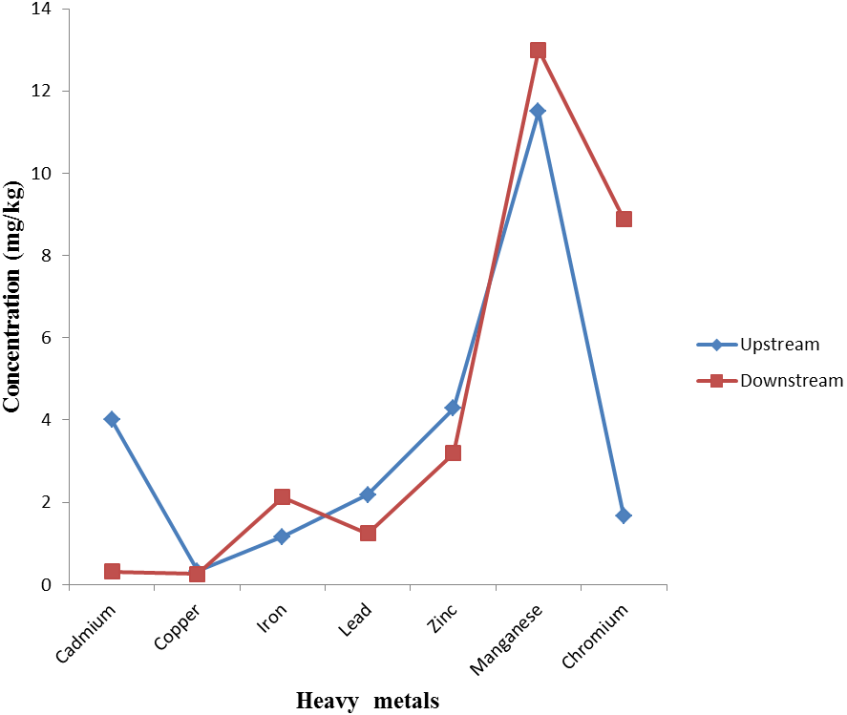

**FIG. 3. Transfer factor threshold for *Clarias gariepinus* obtained from upstream and downstream of Orashi River.**

**4.0 Discussion**

The concentration of heavy metals; (Cadmium, Copper, Iron, Lead, Zinc, Manganese and Chromium) in the tissues (intestine, muscles, liver and gills) of *Clarias gariepinus* caught from Orashi River indicates evidence of bioaccumulation. This may be attributed to the levels of human activities emanating within the study area, with regards to illegal refining of crude oil, bunkering activities, discharge of untreated sewage and uses of industrial materials that contains trace metals. The present findings agree with earlier report by George *et. al.* (2015) during their studies on levels of heavy metal concentration in the tissue of *Crassostrea gigas* Obtained from Imo River, South Eastern Nigeria.

The concentration of metals in the intestine followed the trend Fe>Zn> Cu>Mn>Cd>Pb. The trend differed with the muscles exhibiting preferential uptake for Fe >Zn>Mn>Cu>Cd>Pb. In the liver the trend for upstream and downstream were Fe>Zn>Cu>Cd>Mn>Cr. For the gills. differential uptake of trace metals was observed in the tissues which followed the trend Fe>Zn>Cd>Cu>Mn. However, it was observed that Cr was below detectable limit in the intestine, muscles and gills while similar observation was recorded for Pb in the liver and gills during the study duration. The high concentration of Fe observed in all the tissues of *C. gariepinus* may be attributed to its abundance in the earth crust. Similar observation of high concentration of Fe in the tissue of *T. fuscatus* was reported by George, (2015). WHO, 1993 postulated that Fe is one of the most abundant metals in the earth's crust, found in natural fresh waters at levels ranging from 0.5 to 50 mg/l.

The result of the present study has proven that fish accumulate toxic chemicals such as heavy metals directly from water and diet and these contaminant residues may ultimately reach concentrations of hundreds or thousands of times above those measured in the water and sediment (Ekpo *et. al*.2015; George, *et*. *al.,* 2015). Heavy metals are normal constituents of marine environment that occur as a result of pollution principally due to the discharge of untreated wastes and effluents into rivers by industries. However, the toxic effect of metals is more pronounced when various metabolic activities inside organism body fail to detoxify (Nussey, 2000).

It was observed in the study that accumulation patterns of heavy metals were organs specific which followed an interesting pattern in the order intestine> muscles> gills>liver. The result of the present study is not in agreement with the findings of Wepener *et al.,* (2001) who reported that gills, liver and kidneys accumulate higher concentration of heavy metals when compared to muscles, which exhibit lowest levels of metals accumulation.

In addition, the rate of bioaccumulation of heavy metals in tissues of fish is also dependent on the ability of fish to digest the metals and the concentration of such metal in the aquatic system. Secondly, the concentration of the heavy metal in the surrounding sediments as well as the feeding habits of the organism. Fish and other aquatic organism’s bio-accumulate trace metals in considerable amounts and stay over a long period. It has been recognized that fish are good accumulator of organic and inorganic pollutants (Ishaq *et al.,* 2011). Also, age of fish and mode of feeding are a significant factor that affects accumulation of heavy metals in fish.

These metals accumulated in the tissues of the fish and finally transferred to other animals including humans through the food chain becomes a concern for public health which necessitated the present study. The discharge of industrial waste containing toxic heavy metals into aquatic ecosystem significantly affects the rate of bioaccumulations of these heavy metals in fish and other aquatic animals, which may endanger public health through the consumption of contaminated seafood and irrigated food crops.

Evidence of trace metal contamination in Orashi River is affirmed in the present findings which suggest impacts of anthropogenic activities. Transfer factor index was used to assess the health risk associated with the consumption of *C. gariepinus* caught from the River. Evidence of bioaccumulation in the tissues of the studied species was confirmed using the transfer factor index. Transfer factor index value of above one (1) shows evidence of bioconcentration in the tissues of *C. gariepinus* which calls for concern as the species in question is contaminated and unhealthy for human consumption.

**5.0 Conclusion**

The elemental concentrations of trace metals observed during the study were higher in the intestine and muscles of *C. gariepinus* during the study duration. Lead and Chromium were below the threshold limit as recommended by WHO (2011) in the tissues of the studies species. This was attributed to minimal or absence of human mediated activities capable of increasing the concentrations of these trace metals in the study area. However, the concentrations of heavy metals observed in the liver and gills were below the WHO threshold limit exception of iron which was considerably higher than the WHO recommended threshold limit for seafood consumption. Transfer factor index for *C. gariepinus* showed evidence of bioaccumulation of heavy metals in the tissues of this organism. It was observed that most of the studied trace metals had a transfer factor index > 1 which demonstrate evidence of bioaccumulation. From the result of findings, the water quality of Orashi River is severely impacted by human activities resulting from indiscriminate discharge of domestic waste, industrial waste, agricultural run-off and sewage disposal into the river. The high concentrations of heavy metal in some of the tissues of *C. gariepinus* calls for concern as this may result in deleterious health effects to consumers of these fishes’ overtime. *C. gariepinus* is a common commercial finfish consumed in Nigeria, notably the Niger Delta Region by most rural dwellers and riverine communities owing to their protein source and as a delicacy in most of our cuisines. However, this study recommends constant monitoring of trace metal levels in tissues of edible aquatic organisms to prevent sub-lethal poisoning to man as the final consumer of this seafood’s along the food chain and also, provide remedial measures in the event of contamination of the system.

**6.0 References**

Ademorati, C. M. A (1996). Standard methods for water and effluents analysis. Foludex press ltd Ibadan, 182p

Adeyeye, E. I (1996). Determination of trace metals in *Illisha africana,* fish and water soil sediment from some fish ponds, *International journal of environmental studies,* 45 ; 231-240

Alam, M. G. M., Tanaka, A., Allinson, G., Laurenson, L. J. B., Stagnitti, F and Snow, E. T(2002). A comparison of trace element concentrations in cultured and wild carp (*Cyprinus carpio*) of lake Kasumigaura, Japan,” *Ecotoxicology and environmental safety*, 53(3); 348-354.

American Public Health Association (APHA) (1998). Standard methods for the examination of water and wastewater, 20th edition. New York: American Water Resources Association, 980 p.

Ekpo, E. A., George, U. U. and Edet, M. (2015). Impacts of Water Pollution with Heavy Metal on the Tissue of Egeria radiata (Bivalvia: Tellinacea: Donacidae) (Lammark, 1804) Obtained from Calabar River, Cross River State, Nigeria. *Nature and Science*; 13(8):36-39.

Farkas, A., Salanki, I. Specziar, A (2002). Relation between growth and the heavy metal concentration in organs of bream *Abamis ibrama* L. populating lake Balaton, *Arch, environmental contam, toxicology,* 43(2); 236-243

George, U. U. (2015). Environmental Risk Posed by Heavy Metal Concentration in the Tissue of *Tympanotonus fuscatus* from Calabar River, Nigeria. *Cancer Biology*; 5(4):76-79.

George, U. U., Ekpo, E. A. and Edet, M. (2015). Levels of Heavy Metal Concentration in the Tissue of *Crassostrea gigas* Obtained from Imo River, South Eastern Nigeria. *Academia Arena*; 7(6):34-37.

Heath, A.G. (1987). Water pollution and fish physiology. CRC press, Florida, USA, 245 Pp.

Ishaq, S. E., Rufus, S. A and Ammun, A (2011). Bioaccumulation of heavy metals in fish (*Tilapia zilli* and *Clarias gariepinus*) organs from river Benue, north- central Nigeria. *Pak journal of environmental chemistry*, 12(1); 25-31.

Kotze P., Dupreez H. H and Van Vuren J. H (1999). Bioaccumulation of Copper and Zinc in *Oreochromis mossambicus* and *Clarias gariepinus* from the Olifants Rivers, Mpumalanga, South Africa: Water SA 25 (1): 99 – 110

Mansour, S.A and Sidky, M.M (2002). Ecotoxicological studies of heavy metal contaminating water and fish from Fayoum Governorate, Egypt. *Food Chemistry* 78: 15 – 22

Mbong E.O., Akpan E.E. and Osu S.R. (2014). Soil-plant heavy metal relations and transfer factor index of habitats densely distributed with Citrus reticulata (tangerine). J. Res. Environ. Sci. Toxicol. 3(4):61-65.

Nussey, G., Van Vuren, J.H.J., Du Preez, H. H (2000). Bioaccumulation of Chromium, Manganese, Nickel and Lead in the tissues of the Moggel, *Labeoumbratus*(Cyprinidae), from Witbank Dam, Mpumalanga. *Water South Africa*, **26**:269-284.

Rashed, M. N (2001). Monitoring of environmental heavy metals in fish from Nasser Lake. *Environ. Int. 27: 27 -33*

Rodriguez, M. B., Tome, F. V. and Lozano, J. C. (2002). About the Assumption of Linearity in Soil to Plants Transfer Factors for Uranium, Thorium and 22Ra Isotopes. *Science Total Environment*, 284: 167 – 175

Tarrio, J., Jaffor, M and Ashraf, M (1991). Levels of selected heavy metals in commercial fish from five fresh water lake in Pakistan, *Toxicological & Environmental Chemistry,* 33(1-2) 133-140.

Tome, F. V., Rodriguez, M. B., and Lozano, J. C. (2003). Soil to Plant Transfer Factors for Natural Radionuclides and Stable Elements in a Meditaranean Area. *Journal of Enviornmental Radioactivity*, 65: 161 – 175.

Wepener, W., Vurenvan, J. H. J and Preezdu, H. H (2001). Uptake and distribution of a copper, iron and zinc mixture in gill, live rand plasma of a freshwater teleost, Tilapia sparrmanii,” *Water SA*, 27(1); 99-108.

World Health Organization (WHO) (1993): Guidelines for Drinking Water Quality- Second Edition- Vol.1, Recommendations. WHO, Geneva. Pp. 39.

World Health Organization (WHO) (2011). Guidelines for drinking water quality, 4th edition. Geneva, 504Pp.

6/25/2021