From Sympathize to Share & Spread: Virtual Reality News Design Based on Text-to-scence Conversion Technology and Communication Effect Evaluation Strategy

Yuehong CHEN , Xinjing GAO , Enze ZHANG

School of Architecture, Harbin Institute of Technology; Key Laboratory of Interactive Media Design and Equipment Service Innovation, Ministry of Culture and Tourism, Heilongjiang Harbin
Chengdu Eapil Technology Co., Ltd.

Abstract: This paper introduces Text-to-scence Conversion technology to the production process of virtual reality news, for rapid construction of the scene, action figures has been added manually to realize the production of the scene news "Module Hospital". Based on the investigation of the communication effect of virtual reality news, this paper studies the evaluation factors of its communication effect with the aid of SIPS news communication evaluation system model, and further puts forward the evaluation strategy of the communication effect of virtual reality news. Finally, on the basis of the proposed evaluation strategy, qualitative and quantitative experiments were carried out on this work and some conclusions are obtained: virtual reality news can stimulate the audience's empathy, but it gives the audience less sense of reality and timeliness.
[Yuehong CHEN, Xinjing GAO, Enze ZHANG. From Sympathize to Share&Spread: Virtual Reality News Design Based on Text-to-scence Conversion Technology and Communication Effect Evaluation Strategy. Researcher 2021;13(5):104-111]. ISSN 1553-9865 (print); ISSN 2163-8950 (online). 7 http://www.sciencepub.net/researcher. doi:10.7537/marsrsj130521.07.

Keywords: Virtual reality news design; Text-to-scence Conversion Technology; Communication effect; SIPS model

Project: This paper is a phased achievement of the National Social Science Foundation project "Virtual Reality News Research under the Perspective of Communication Science"(No. 18BXW102).

The iteration of scientific innovation and the continuous breakthrough of media technology have changed the cognitive category of human beings to the world. Modern creative technologies such as intelligent algorithm, naked-eye 3D, holographic projection and 5G communication network are integrated into the whole process of virtual reality news collection, production, release and presentation, and promote the development of virtual reality news in visualization, diversification and diversification. Virtual reality news break through the deficiency of transmitting information in a single form of media, and "transport" audiences in distant places to the place where the event occurred and go through the occurrence and follow-up of the event on the spot. The audience is no longer simply "reading", "listening" and "watching" news events, but also "participating" in the whole process of news occurrence, and gains not only a news story but also audio-visual experience and emotional experience in story interpretation and participation ^{[1]}. Virtual reality news is redefining the way news spreads in the media^{[2]}. In the past virtual reality news design, the process of setting up the scene was not easy, it was dominated by news producers, and the team had to complete the setting up of the scene, as well as making character models and writing action scripts. Therefore, the production of virtual reality news requires news reporters to have the ability of building models and creating animations, which not only increases the workload of news reporters, but also resulting is a long production cycle of virtual reality news. In the design of this virtual reality news work, text-to-scence Conversion technology is introduced into the production process of scene news, and the production of scene news was also delivered to the machine on the premise that the 3D model base was sufficient. So that ordinary journalists can also manually add action figures to realize the production of scene news realize the rapid construction of the scene.
It is a new form of news, virtual reality news also needs us to investigate and discuss the communication effect. Communication effect is a field with the longest research time and the richest content in communication science. To study the communication effect of virtual reality news, we ought to learn from the existing basic viewpoints and knowledge accumulation ^{[3]}. First of all, the brand-new virtual reality news is still a news category in essence, so in evaluating the news dissemination effect, it is still important to examine the impact of such news reports on the audience, such as whether the audience is really willing to participate in it, whether they can get the expected resonance in immersive news and finally choose to share and continue to disseminate. At the same time, we should also measure the efforts made by news in shaping the overall values of society and the social responsibilities of the public in responding to emergencies and spreading efficient programs. The rest of this paper is organized as follows:（一）The construction of virtual reality news scene.（二）Evaluation strategy of news communication effect under SIPS model.（三）Analysis of experimental data of communication effect evaluation. With the help of SIPS news communication evaluation system model, this paper designs an evaluation system from four dimensions: audience's emotional experience effect, interactive participation effect, reflection resonance effect and communication-sharing effect, and then carries out experimental measurement and evaluation on the immersive news communication effect of virtual reality, aiming at optimizing the current virtual reality news through the evaluation and analysis of audience feedback.

The construction of virtual reality news scene
The purpose of the text-to-scene conversion system is to write the virtual scene conceived by people with the aid of natural language text, and then convert it into visual representation with visible picture through the natural language understanding technology, so as to enable richer information communication than language description. Combined with 5W elements of news, its main flow can be divided into three parts (as shown in fig. 1-1): the first part is the processing of inputting corpus information, i.e. the process of entity recognition and naming in natural language processing. the front end of the system receives natural language as input, then analyzes the structure of each sentence, and extracts the events described by the sentences and the participants of the events (objects, background, the relationship between objects), with the aim of clarifying the visual content; The second part is the language generation of visual content, i.e. VRML language, which aims to VR mark-up to retrieve visual materials, such as scene materials, sound samples, figures or object models, etc.The third part is the visual expression of interactive information in the scene, i.e. input the VR mark-up language into the 3D scene construction system such as Unity, and then find the models for each event from the animation library and assemble them into the scene to complete the 3D scene generation.

Corpus information input
Machine instruction generation (VRML language)
Interactive scene construction
Natural Language Processing
Transfer models
when
where
what
why
who
Scene material
Sound sample
Character model
Object model
Figure 1-1 The main flow of text-to-scene conversion system

To create the news role, it is necessary to retrieve the predetermined model samples from the model base on the completion of entity naming. The model texts stored in this research are stored on the server in MySQL database. The model information is stored in the XML text and includes the following parts: the ID, name, store path of the model (Table 1-1). Both the text and the model are stored in the same directory together.

Table 1-1 Model attributes
Physical property
Meta model
Name | Dim |  | Size | Towards |  | Position |  | Function | Mod format | Store _path
 | 3D |  | Size.x=  Size.y=  Size.z= | Towards.x=  Towards.y=  Towards.z= |  | Position.x=  Position.y=  Position.z= |  | Run  Fly  Jump | obj  (obj/fbx/max/3Ds/stp/stl)
Color
Texture |  | Mate_name |  |  | Mate_format |  | Mate_store_path |  | Mate_format  (bmp/ppm/png/jpg/iff/tim)
Space area
Coordinate system
World coordinate system Local coordinate system
Spatial characteristics
Mod_form Solid Liquid Gas Mod_center Normal direction
Center.x=
Center.y= 2D(y)
Center.z=

The next step is to judge the emitter, background and spatial relationship according to the input content, and then complete the loading and placing of the scene, sky box and camera. On the basis of the last completion, a further steep is to retrieve the corresponding items in the model library, calculate their specific coordinates through the bounding box, and then put the model into the interface according to the coordinates, size and other information by collision detection, so as to complete the final Unity3D scene generation ( Figure 1-2, Figure 1-3, Figure 1-4, Figure 1-5 ). After setting up the scene, some characters and their actions are manually added to form a complete virtual reality news report of "Module Hospital" ( Figure 1-6, Figure 1-7 and Figure 1-8 ).

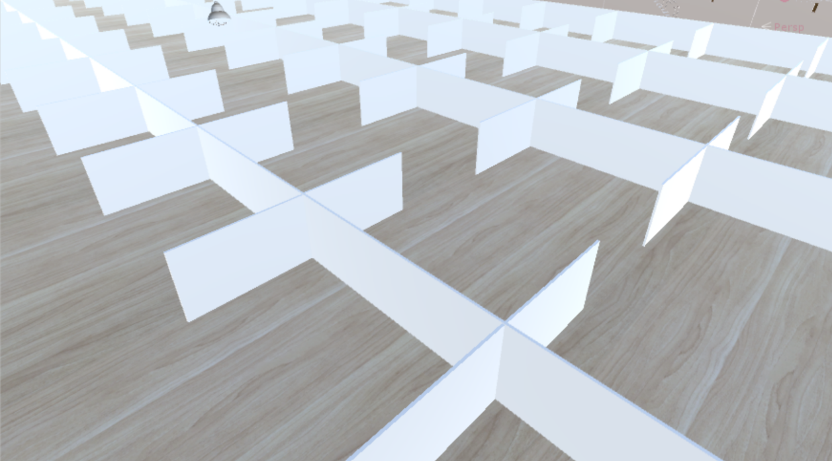
Figure 1-2 Isolation area of vertical assembly of partitions

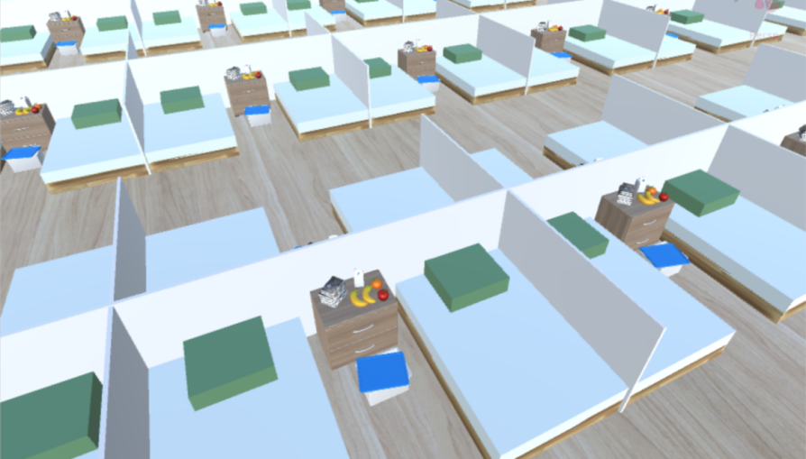
Figure 1-3 The beds lean on both sides of the partition, and the quilts are on the beds

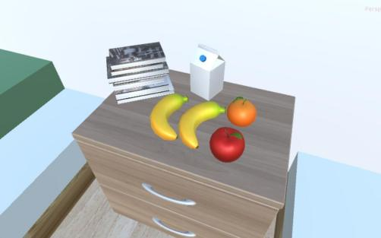
Figure 1-4 A storage box is in front of the table. bananas, apples, oranges, milk and books on the table

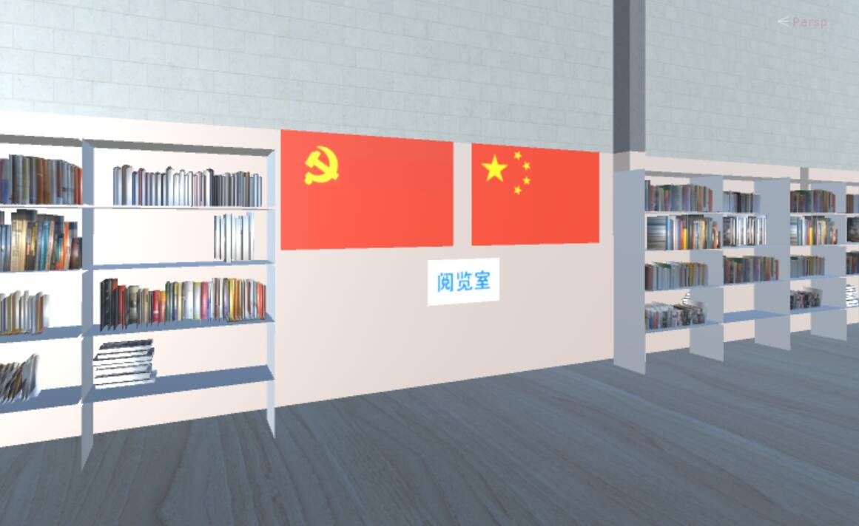
Figure 1-5 The Chinese Communist Party flag and the Chinese flag hung side by side on the wall

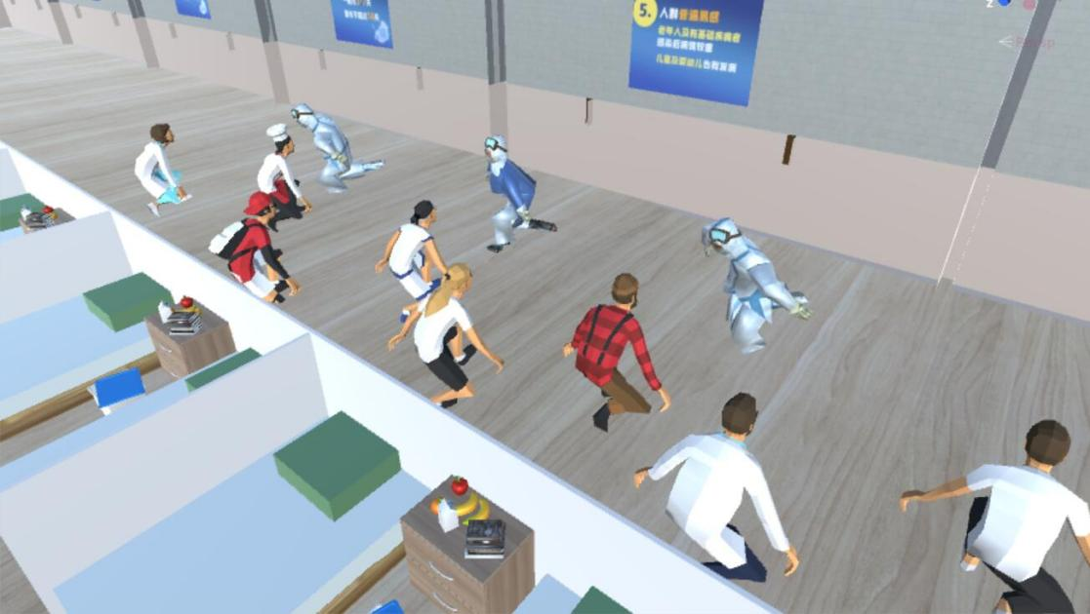
Figure 1-6 The doctors of the rescue team lead the patient to dance square dancing

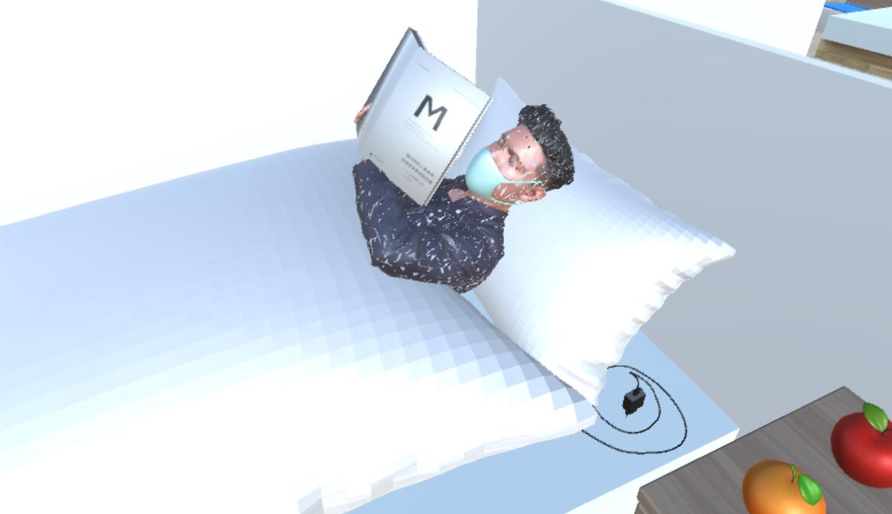
Figure 1-7 The patient reads on the hospital bed

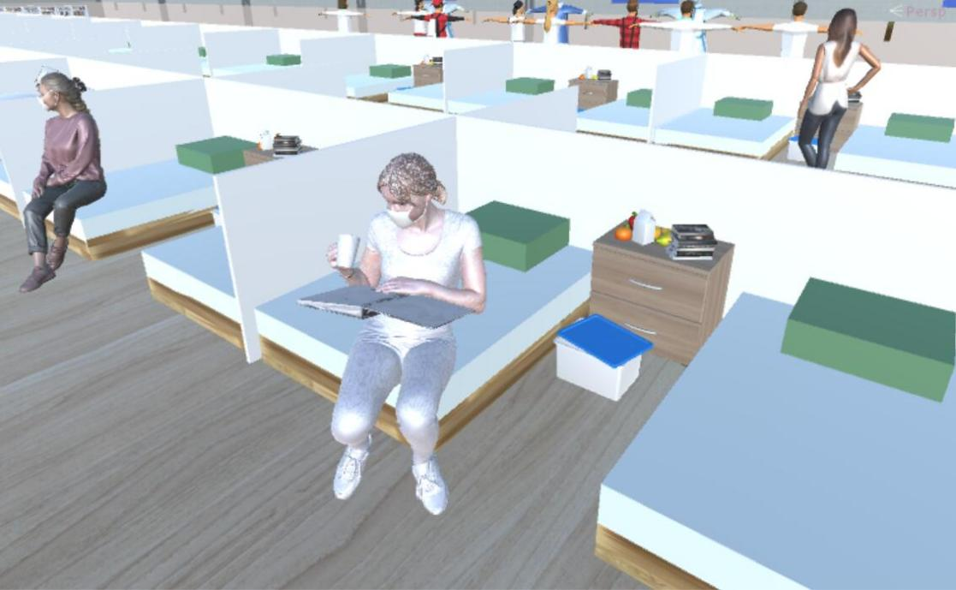
Figure 1-8 Girl is preparing for further studies

Evaluation Strategy of News Communication Effect Under SIPS Model
Just as Negroponte predicted in Being Digital, human beings have entered a society based on digital information^{[4]}. From recreation to making friends and falling in love, from work meetings to study classes, many people's food, clothing, housing and living can't be separated from the Internet. Under the social normal of "opening up the whole world with one network ^{[5]} ", "digital consumption behavior" has also become the general trend. With the emergence of new media, the audience's media usage habits are constantly changing, and the traditional measurement model is constantly evolving and developing with the changes of media forms and audience's media usage habits. Based on the analysis and research of audience's consumption behavior in the digital age, in 2011, Dentsu Co., Ltd., a Japanese advertising company, summed up a new framework for studying audience's consumption behavior pattern in the new era background-SIPS model, which alluded to the communication 4.0 era in the background of internet plus ^{[6]}. Advertising is a complete psychological process from triggering audience sympathy, confirming their emotional value, audience generating desire to participate in it, to finally completing information share&spread. Compared with the early AIDA model, AIDMA model and AISAS model, SIPS model pays more attention to the emotional experience of consumers. This model deeply analyzes the development and changes of consumer behavior in the new social media era, and provides a more suitable framework for social media marketing creativity, consumer behavior analysis and communication effect evaluation for producers and sellers ^{[7]}. Kevin Kelly, the founding editor-in-chief of Wired magazine, pointed out in his book inevitability that the future trend is the user's "filtering" of information, where the audience's attention is focused, and the world's wealth will flood into ^{[8]}. In the era of attention economy, the focus of the major media platforms has evolved into grabbing the audience's attention, which makes many video works have the property of commodity besides their artistic value. Therefore, improving the attraction of virtual reality news to its audience (such as praise, forwarding and attention, etc.) is a kind of marketing behavior to win the audience's attention. In this impact model, the audience's behavior changes from the real emotion generated by the news party's experience as an interactive experience to sharing and diffusion of this news experience on the final social media platform which corresponds to the hierarchical progressive relationship of the four stages of the SIPS model, as shown in Figure 2-1, which is the effect impact model under the SIPS model:

SIPS Model
Measurement factors
of virtual news effect
Sympathize
Identify
Participate
Share&Spread
Generate emotional resonance
Form a common value group
Create one’s own experience
Willingness to share socially

Figure 2-1 Measurement Factors of Virtual News Effect under SIPS Model

Analysis of Experimental Result of Communication Effect Evaluation
Based on the above analysis, the household experience evaluation scale is designed (Table 3-1). Through the experimental evaluation of the same news content in different media, such as text, pictures and videos, the user experience of the virtual reality news "Module Hospital" is tested, and based on these data, the advantages and disadvantages of virtual reality news compared with traditional news in the past are analyzed.

Table 3-1 User Experience Evaluation Scale under Different Media

 | Category | Text news |  |  |  |  | Photo News |  |  |  |  | Video news |  |  |  |  | VR News
Ce | Cognitive education | 1 | 2 | 3 | 4 | 5 | 1 | 2 | 3 | 4 | 5 | 1 | 2 | 3 | 4 | 5 | 1 | 2 | 3 | 4 | 5
Ce1 | Generate empathy | - | - | - | - | - | - | - | - | - | - | - | - | - | - | - | - | - | - | - | -
Ce2 | Value identity | - | - | - | - | - | - | - | - | - | - | - | - | - | - | - | - | - | - | - | -
Ce3 | Participation impulse | - | - | - | - | - | - | - | - | - | - | - | - | - | - | - | - | - | - | - | -
Ce4 | Sharing impulse | - | - | - | - | - | - | - | - | - | - | - | - | - | - | - | - | - | - | - | -
Ir | Information reception | 1 | 2 | 3 | 4 | 5 | 1 | 2 | 3 | 4 | 5 | 1 | 2 | 3 | 4 | 5 | 1 | 2 | 3 | 4 | 5
Ir1 | True feelings | - | - | - | - | - | - | - | - | - | - | - | - | - | - | - | - | - | - | - | -
Ir2 | Degree of richness | - | - | - | - | - | - | - | - | - | - | - | - | - | - | - | - | - | - | - | -
Ir3 | Content limitation | - | - | - | - | - | - | - | - | - | - | - | - | - | - | - | - | - | - | - | -
Ir4 | Ease of use | - | - | - | - | - | - | - | - | - | - | - | - | - | - | - | - | - | - | - | -
Ae | Artistic experience | 1 | 2 | 3 | 4 | 5 | 1 | 2 | 3 | 4 | 5 | 1 | 2 | 3 | 4 | 5 | 1 | 2 | 3 | 4 | 5
Ae1 | Aesthetic feeling | - | - | - | - | - | - | - | - | - | - | - | - | - | - | - | - | - | - | - | -
Ae2 | Interactive experience | - | - | - | - | - | - | - | - | - | - | - | - | - | - | - | - | - | - | - | -
Ae3 | Participation fun | - | - | - | - | - | - | - | - | - | - | - | - | - | - | - | - | - | - | - | -
Ae4 | Expression attraction | - | - | - | - | - | - | - | - | - | - | - | - | - | - | - | - | - | - | - | -

This design aims to appease the panic of the masses through the optimism conveyed by news reports, and promote the positive energy of the whole society to work together to eliminate viruses. Therefore, cognitive education (i.e., empathy) and information transmission are important considerations, while artistic aesthetic standards can be allocated less. Therefore, cognitive education(Ce), information reception (Ir) and artistic aesthetic experience (Ae) are respectively assigned to 40%, 40% and 20%. Then, after considering the subdivision ratio under each category, the four dimensions of each specific category are set to 25%. Then 15 people were invited to experience the experiment, calculate the experimental results and analyze the data.The data obtained are analyzed as follows (Figure 3-1、Figure 3-2):
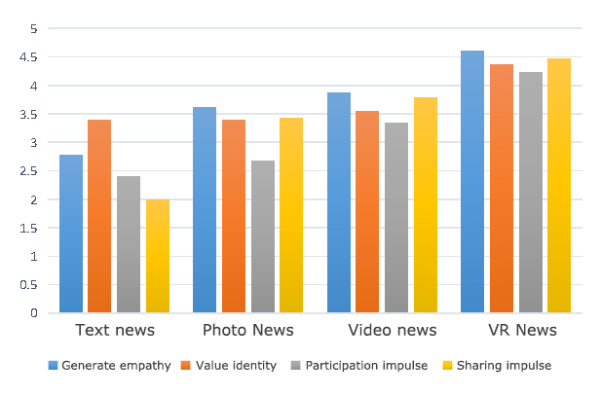
Figure 3-1 Comparison of different media news in cognitive education

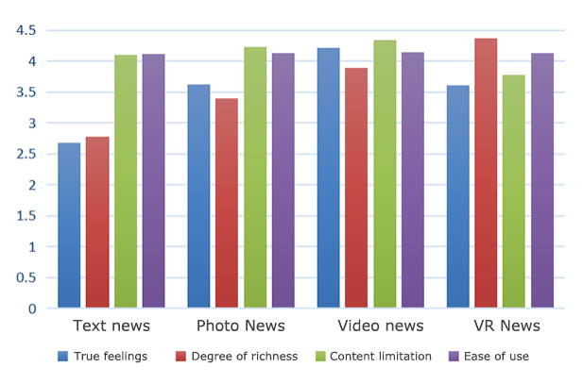
Figure 3-2 Comparison of different media news in information reception

Analysis of data：
1. Compared with other media forms, VR news can stimulate the audience's empathy experience, and the audience enters the Module Hospital to dig news stories independently, which makes the audience have a different participation experience. This kind of cognitive and psychological influence on audience stimulates their self-reflection, and then reduces their anxiety, anxiety and panic caused by the unknown trend of sudden public health events. After calming down, they can cooperate with the national policy arrangement and actively participate in other production and life, thus ensuring the stable operation of the whole society.
2. Compared with the news content produced by the traditional media production mode, VR news gives the audience a weak real feeling and content timeliness. Therefore, the creators of virtual reality news should be particularly rigorous and pragmatic in the process of content creation to ensure that the news information received by the audience is objective and true. In terms of timeliness of production, with the development of text-to-scence Conversion technology based on natural language processing, creators' ability to quickly build news scenes will be strengthened, thus enhancing the real-time nature of news.

Conclusion
In this paper, the news "Module Hospital" was produced with the help of text-to-scence Conversion technology . Based on SIPS communication evaluation system model, the evaluation strategy of news communication effect of virtual reality was put forward and experimented. The research conclusion is that the balance between artistry and authenticity of virtual scenes should be further studied in the future, the timeliness and innovation of news story content should be further improved.

References
[1] Jia Qianhui, Jerry Lee. The innovation and change of VR technology to traditional disaster news reports. Today Media, ,No.1, (2020): pp.25-27.
[2] Li Yiwen. Research on Virtual Reality News Design and Its Communication Effect. Harbin Institute of Technology, 2016.
[3] Jiang Yun. “On Measurement of Dissemination Value of Science and Technology News and Evaluation of Its Dissemination Effect, ”qiushi, No.2, (2006): pp. 285-286.
[4] Nicholas Negroponte. Being Digital.Vintage,1996.
[5] Chen Yuehong, Li Yiwen, Gao Minghui. Communication in the internet plus Era 4.0. Journalism Knowledge, No.3,( 2016): pp. 21-24.
[6] Chen Si. “On the Evolution of Communication Effect Evaluation Tools and Methods-From AIDMA to SIPS Effect Evaluation Development Stage,” Chinese Newspaper Industry, No.3, (2013): pp. 44-45.
[7] Kevin Kelly. The Inevitable. Penus, 2015.

4/22/2021

