Invent the East Asian Monsoon Time Scale & Break the mysteries of the East Asian monsoon

Gangadhara Rao Irlapati

H.No.5-30-4/1, Saibabanagar, Jeedimetla, Hyderabad, India-500055
Email: scientistgangadhar@yahoo.com

Abstract: East Asian Monsoon Time Scale is proposed and designed by me to study the East Asian monsoon. This is very useful to study the East Asian monsoon. So scientists can make this East Asian Monsoon Time Scale and make further research & develop, promote & propagate it. Find out it by searching it’s name East Asian Monsoon Time Scale in all websites or can get by sending your email to scientistgangadhar@yahoo.com I call on world scientists to invent this scale and break down the mysteries of the aforesaid monsoon. Scientists who want to invent this scale have trouble in making it, kindly contact me via my personal email id and take my assistance in making it. I will help you in making this scale. A sample scale will also be made and send to you. For this, a certain amount should be sent for expenses. For this, they must send the list of events of climate just like dust storms, monsoon low pressure systems etc. last 140 years since 1880 formed over the East Asian monsoon region in the procedure cited below reference. In addition to this, a certain amount should be sent for expenses. You need to design the computer model later.
[Gangadhara Rao Irlapati. Invent the East Asian Monsoon Time Scale & Break the mysteries of the East Asian monsoon. Researcher 2021;13(5):102-103]. ISSN 1553-9865 (print); ISSN2163-8950 (online). http://www.sciencepub.net/researcher. 6. doi:10.7537/marsrsj130521.06.

Key Words: Global Monsoon Time Scales, Indian Monsoon Time Scale, East Asian Monsoon Time Scale

Introduction:
The East Asian Monsoon effects large parts of Indo-China, Philippines, China, Korea and Japan. It is characterized by a warm, rainy summer monsoon and a cold, dry winter monsoon. The rain occurs in a concentrated belt that stretches east-west except in East China where it is tilted east-northeast over Korea and Japan.
Material and method: In order to make the East Asian Monsoon Time Scale, I prepared a model scale for the Indian monsoon named Indian Monsoon Time Scale it is a compelling scale to prepare the East Asian Monsoon Time Scale. Take Indian Monsoon Time Scale as an example to develop the North American Monsoon Time Scale.
I have prepared Indian Monsoon Time Scale having 365 horizontal days from March 21st to next year March 20th or from 1st April to next year March 31st of 139 years from 1888 to 2027 or a required period comprising of a large time and weather have been taken and framed into a square graphic scale. The monsoon pulses in the form of low pressure systems over the Indian region have been taken as the data to construct this scale. For this, a lot of enormous data of low pressure systems, depressions and cyclone have been taken.

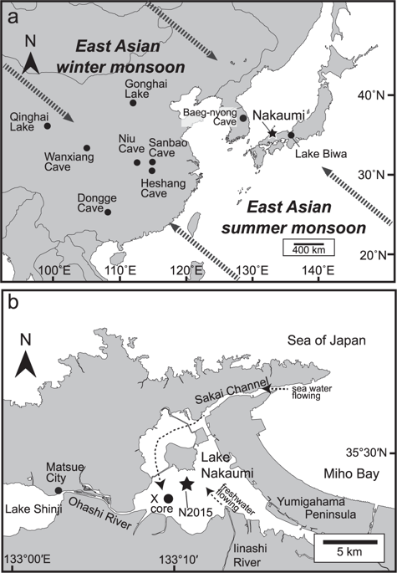

Management:
The monsoon pulses in the form of low pressure systems over the Indian region have been entering on the scale in stages by 1 for low, 2 for depression, 3 for storm, 4 for severe storm and 5 for severe storm with core of hurricane winds pertaining to the date and month of the each and every year. If we have been managing the scale in this manner continuously, we can study the past, present and future movements of monsoon of India.
Results; Keep track the Indian Monsoon Time Scale carefully. During 1871-1900’s the main path-way of the Indian Monsoon was rising over June, July, August. During 1900-1920’s it was falling over August, September. During 1920-1965’s, it was rising again over July, August, September. During 1965-2004’s it was falling over falling over September. From 2004 it is now rising upwards and estimated that it will be traveling over the months of June, July, August by the 2060.
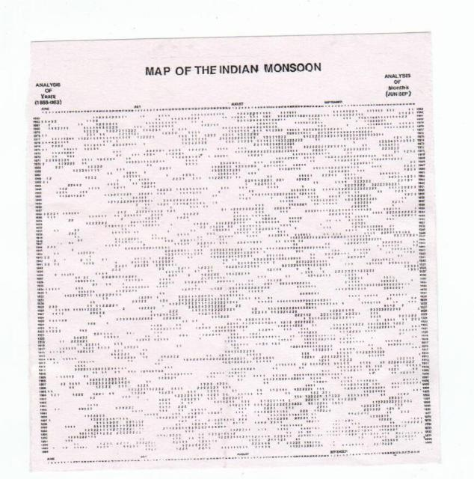
Study & discussion:
Let’s now study and analyze the information available on the Indian Monsoon Time Scale with the rainfall data available from 1871 to till date. During the period 1871-2015, there were 19 major flood years:1874, 1878, 1892, 1893, 1894, 1910, 1916, 1917, 1933, 1942, 1947, 1956, 1959, 1961, 1970, 1975, 1983, 1988, 1994. And in the same period 1871-2015, there were 26 major drought years: 1873, 1877, 1899, 1901, 1904, 1905, 1911, 1918, 1920, 1941, 1951, 1965, 1966, 1968, 1972, 1974, 1979, 1982, 1985, 1986, 1987, 2002, 2004, 2009, 2014, 2015. Depending on the data mentioned above, it is interesting to note that there have been alternating periods extending to 3-4 decades with less and more frequent weak monsoons over India.
For example, the 44-year period 1921-64 witnessed just three drought years and happened good rainfall in many years. This is the reason that when looking at the Indian Monsoon Time Scale you may note that during 1920-1965’s, the passage of the Indian monsoon had been rising over July, August, September in the shape of concave direction and resulting good rainfall in more years..
During the other period that of 1965-87 which had as many as 10 drought years out of 23, This is the reason that when looking at the Indian Monsoon Time Scale you may note that during 1965-2004’s the path of the Indian monsoon had been falling over the September in the shape of convex direction and causing low rainfall and droughts in many year.
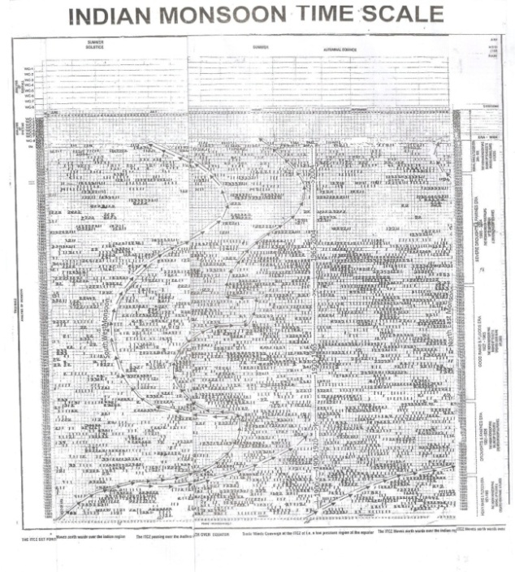
Scientific theorem:
The year to year change of movement of axis of the earth inclined at 23½ degrees from vertical to its path around the sun does play a significant role in formation of clusters, bands & paths of the Indian Monsoon and stimulates the Indian weather. The inter-tropical convergence zone at the equator follows the movement of the sun and shifts north of the equator merges with the heat low pressure zone created by the rising heat of the sub-continent due to direct and converging rays of the summer sun on the India Sub-Continent and develops into the monsoon trough and maintain monsoon circulation.

Conclusion:
The East Asian Monsoon Time Scale I invented is a preliminary invention. I have worked hard to design in manual. Researchers have to do more researches on the East Asian Monsoon Time Scale and establish a computer model.

References:
1) Mooley DA, Shukla J(1987); Characteristics of the west ward-moving summer monsoon low pressure systems over the Indian region and their relationship with the monsoon rainfall. Centre for ocean-land atmospheric interactions, university of Maryland, College, park, M.

5/2/2021

