A novel sensor for electro catalytic determination of two nitro aromatic compounds

Meisam Asghari ¹, Paria Amirian²

¹ Faculty of chemistry, University of Sistan & Baloochestan, Iran.
Email: mei_asghari_chem@yahoo.com
²Department of Environment, Payame Noor University (PNU), I.R. of IRAN
Email: paria_amirian@yahoo.com

Abstract: In this study a modified glassy carbon electrode (GCE) coated with a mixture of multi-wall carbon nanotube (MWCNT), 1, 4-dihydroxy anthra quinone (Q) and chitosan (C) has been used for electro catalytic determination of nitrobenzene (NB) and 1, 2-dinitro phenyl hydrazine (DNPH). The results obtained by using this electrode were compared with those obtained by the application of different modified GCE with MWCNT, Q, C, MWCNT-Q, MWCNT-C and Q-C under the same conditions. Also the effective parameters such as pH and scan rate of modified electrode were studied. The modified electrode showed electro catalytic activity for the reduction of DNPH and NB with the domination of overpotential of about 100 mV and 50 mV for DNPH and NB compared with that for a bare electrode in cyclic volt ammo grams and an increase in peak current. The calibration curves were linear from 5.0×10-6 to 7.9×10-5 M (r=0.992, n=12) and (5.0×10-6 to 1. 7×10-4 M (r=0.993, n=14) for DNPH and NB, respectively. The values of recovery for three samples obtained between 94.0 and 102.3. This newly modified electrode was applied to determination of NB and DNPH in spiked natural water samples.
[Meisam Asghari, Paria Amirian. A novel sensor for electro catalytic determination of two nitro aromatic compounds Researcher 2021;13(4):49-53]. ISSN 1553-9865 (print); ISSN 2163-8950 (online).
http://www.sciencepub.net/researcher 7. doi:10.7537/marsrsj130421.07.

Keywords: 1, 4-dihydroxy anthraquinone- nitrobenzene-1, 2-dinitro phenyl hydrazine - Multiwall carbon nano tube, electrocatalytic

1. Introduction
Nitro aromatic compounds have been widely used in the industries for the production of aniline, aniline dyes, explosives, pesticides and drugs, and also as a solvent in products like paints, shoes and floor metal polishes “(M. Latifoglu and et al, 2003)”. As a toxic and suspected carcinogenic nitro aromatic compounds such as nitrobenzene released to environment poses a great threat to human health. Even at low concentrations, it may present high risks to environment, “(D.S. Bhatkhande and et al, 2003)”. The strong electron affinity of nitro reduces the electron cloud density of benzene ring and thus makes nitrobenzene very stable. Therefore, nitrobenzene is listed as one of prior pollutants by many countries. Nitro aromatic compounds are often difficult to donate electron due to the low electron cloud density in their benzene ring, so the oxidation of nitro aromatic compounds is very difficult to achieve. Furthermore, the oxidation of nitrobenzene may produce some more toxic dead-end products like picolinic acid, “(S.F. Nishino, and et al 1993)”. Therefore, reductive technologies attracted more and more attention recently “(E.K. Nefso and et al, 2005)”.
In this research we are applied MWCNT for modification of electrode because obviously MWCNT as a magical material, because their uniqueness and have received excellent attention for the preparation of electrochemical sensor, as it was extensively reviewed. “(M. Trojanowicz and et al, 2005)”, “(J. Wang, 2005)”, “(N. Li, J. Wang and et al, 2003)”, “(C.E. Banks and et al, 2006)”,“(J. Wang, 2005)”, “(M. Valcarcel and et al, 2005)”.

2. Material and Methods
All the electrochemical measurements were carried out with a Electroanalyser. The three-electrode system consisted of a modified GCE, a SCE reference electrode, and a platinum auxiliary electrode. All potentials were referred to the SCE.
Two 10-2mol l-1 stock solutions of DNPH and NB were prepared by direct dissolution of DNPH and NB in acetonitril and store in the dark. The chitosan solution (8%) was prepared by dissolving 0. 8 g chitosan in 10 ml acetic acid. CNTs were functionalized by sonification treatment in a mixture of sulfuric acid and nitric acid (3:1) for 6 h at room temperature. Functionalized MCNTs (fMCNTs) were washed with dowble distilled water (DDW) and separated by centrifugation. “ (S. Hoon Baek and et al, 2008)”. 1, 4-Diydroxy anthrax quinone, 1, 2-Dinitro phenyl hydrazine, Nitrobenzene, Acetonitrile (AN), purchased. All experiments were carried out at room temperature (about 15 °C).
First make a solution of Q (0.05mg) in 2.5ml acetonitril and then added 25mg of MWCNT and agitation with ultrasonic to give a black suspension, now 0.5ml of this suspension mixed with 0.1ml of chitosan solution (0.5%). Before being modified, the GCE was polished with 0.3 and 0.05 µm aluminum slurry, rinsed thoroughly with DDW, then ultrasonically cleaned with H2SO4(1M) for 5 min, finally rinsed with DDW, and dried under an infrared lamp. After the GCE was cooled, it was smeared evenly with 6 µL of a MWCNT–chitosan-anthraquione (0.5%) solution by a micro-syringe, and then dried under an infrared lamp for 10 min. After cooling, the MCQ/GCE could be used.
A phosphate buffer solution (PB) 0.3 M (pH= 1.5) was used as the supporting electrolyte and each DNPH and NB was added to the sample cell. The solution was purged with nitrogen for 2 minutes. In the cyclic voltammetric (CV) study, the electrode was scanned between 0 and -1V.

3. Results
The CV former component of elecrode shown in fig.1 at the QMC/GCE the CV demonstrated two reversible wave with half peaks potential (E1/2) respectively at -0.032and -0.327 V. As shown in fig.1 the values of ipa, ipc for QMC/GCE is more than of this values for Q/ GCE respectively because chitosan promote electron transfer in the matrix. “(Zhang M and et al, 2005)”, “(Zhang M and et al, 2005)”, “(Zhang M and et al, 2004)”.
The behavior of DNPH at a bare GCE and QMC/GCE was studied by cyclic voltammetry. Figure 2 shows the cyclic voltammogram obtained for 1.0×10-3 mol L-1 DNPH in PB solution (PH=1.5). With the bare GCE, current peak is low with value of potential -0.458 v range studied, evidencing the high overpotential of DNPH reduction. In voltammogram obtained with modified electrode the value of current enhanced extremely and potential of peak (77 mv) shifted toward more positive values. Hence, the presence of CNTs leads to a decrease in the over potential of reduction of DNPH and effectively catalyzes its reduction. This is probably due to the combined effect of a large effective surface area of CNTs, their electronic structure, and the topological defects present on the tube surface, “(G Jurmann and et al, 2007)”. The large surface area is also responsible for the higher background current of the modified electrode as compared to that of the bare GCE. Experiments have been performed in a variety of electrolytes and PH. The results showed that the CNT catalyzed reduction of DNPH takes place only in moderately to highly acidic media (PH=1.5). Therefore, it is suspected that it is DNPH that is actually reduced on the modified electrode.

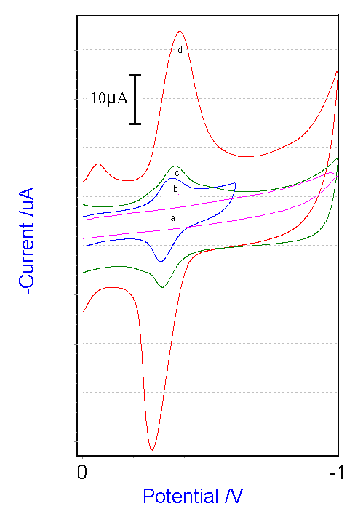

Fig 1. The CV former component of electrode in 0.3M PB (PH=1.5), Scan rate=100mv/sec

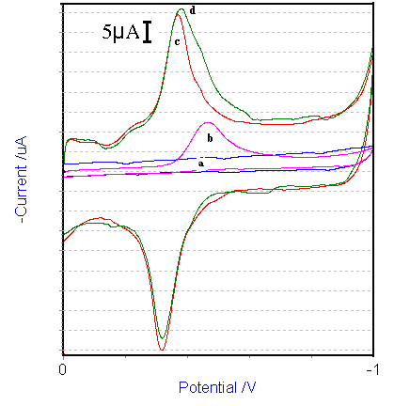
Figure 2. Cyclic voltammogram With the bare GCE and QMC/GCE in absence and presence 1.0×10-3 mol L-1 DNPH in PB solution (PH=1.5).

A series of cyclic voltammograms obtained at different scan rates for a typical DNPH concentration showed that the anodic and catodic peak current (ipa, ipc) were proportional to the square root of scan rate (v1/2) (r =0.987, 0.983 respectively). In addition, at lower concentration of DNPH, the ipc of the QMC/GCE in DNPH solution did not increase with the increase of immersed time. The results suggested that the oxidation and reduction of DNPH was undergoing a diffusion-controlled process.
The amount of modifier on the surface of electrode affected the ipa and ipc. Fig 3. showed that the ipa, ipc enhanced when the amount of MWCNT increased, which probably because of the presence of electro-reactive sites which increased with the amount of MWCNTs, “(C.E. Banks and et al, 2005)”, “(C.E. Banks and et al, 2004)”. When the concentration of MWCNTs in the modifier surpassed 0.5ml, the ipa, ipc of nitrite fell. These because the film on the electrode surface was too thick, which prevented the electron transfer between nitrite and electrode. In this paper, 0.5ml MWCNTs in the Q-chitosan–MWCNT modifier was used as optimum amount for voltammetric determination of DNPH, NB.

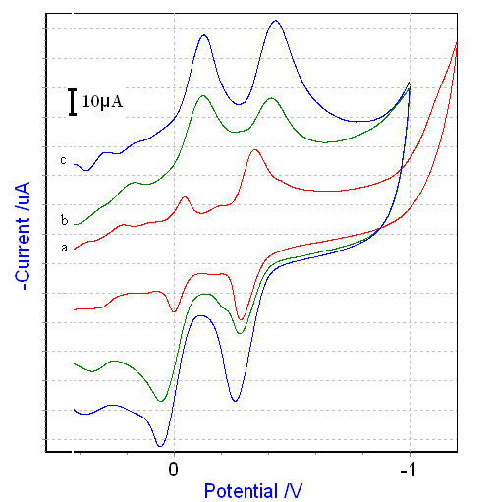
Fig. 3. The cyclic voltammogram of QMC/GCE preparated with ratios contains a) 0.1 ml of mix (MWCNT, Q) b) 0.3 ml of mix (MWCNT, Q), c)0.5 ml of mix (MWCNT, Q) with 0.1 ml chitosan in 0.3M PB (pH=1.5),Scan rate=100mv/sec

A series of standard solutions of DNPH were determined by CV (shown in fig 4.). The, ipc was linearly related to DNPH concentrations over the range of 5.00×10⁻⁶– 7.94×10⁻⁵ mol l⁻¹ with a correlation coefficient of r ²= 0.992respectively.

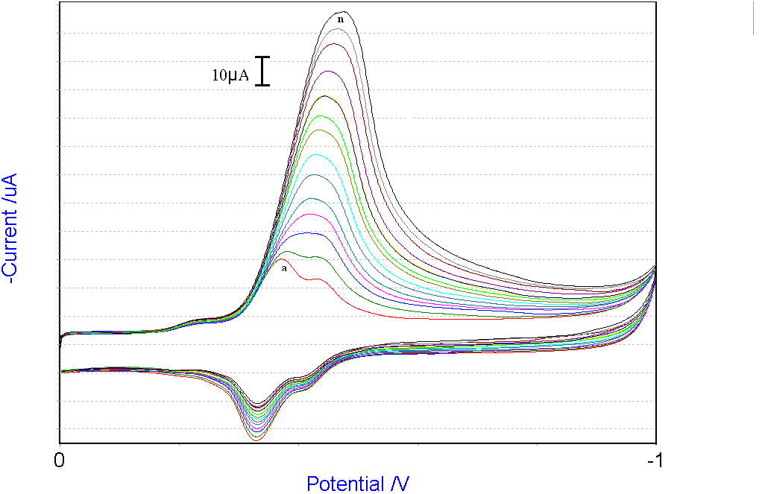.

Fig. 4. Cyclic voltammograms of QMC/GCE, at scan rate 100 mVs-1 with increasing DNPH concentration (from a to n) 0.0, 5.0, 10, 15, 20,25,30,35,40, 45, 50, 60, 70 and 80 mM of DNPH in pH 1.5 phosphate buffer solution. Inset, plot of peak current vs. DNPH concentrations.

Figure 5 shows the cyclic voltammetric responses of bare GCE and QMC/GCE in the presence of 5.0×10−6 M NB at a scan rate of 100mV s−1. At the bare GCE, a small and broad catodic peak at the potential of -0.0.51 V was observed (curve b), while at the BGCE, a significant reduction peak appeared at about -0.478 V (curve a). Though the potential is more positive than the reduction peak at the bare GCE, the peak current is of about sex fold enhancement. With an increase of NB concentration, the reduction current increased, accompanied by the evidently negative shift of the peak potential (curve b). These results suggest that QMC film has an excellent electrochemical activity toward the reduction of NB, and that the electrochemical behavior varies slightly with the substrate concentration. Fig 6. Shows cyclic voltammograms of QMC/GCE in solutions containing different concentrations of NB and the inset shows the plots of catodic current vs. NB concentration. The plot of catodic current vs. NB concentration was linear in the concentration range 5×10-6 - 1.67×10- 4 M, and R2=0.995.

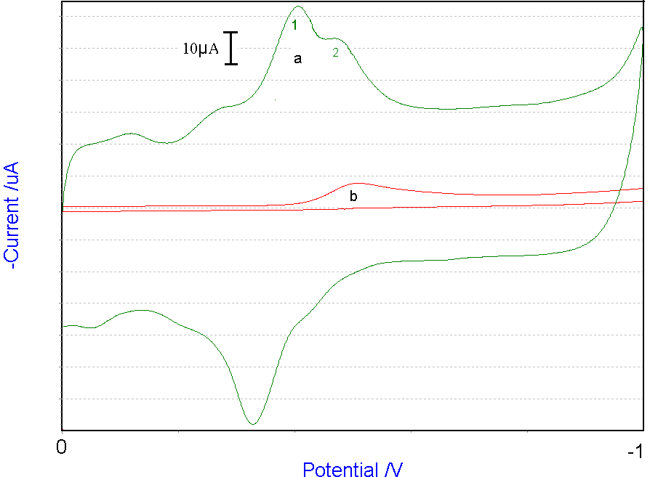

Figure 5. Cyclic voltammetric responses of a) QMC/GCE and b)bare GCE in the presence of 5.0×10−6 M NB at a scan rate of 100mV s−1 in pH 1.5 phosphate buffer solution.

The effect of the solution pH on the current response for 5.0×10−6 M NB in 0.1 M PB was examined. Acidic conditions are more favorable for a good response and the maximum current is obtained at pH 2.0. Therefore, pH 2.0 was adopted for the NB determination.

Fig 6. Cyclic voltammograms of QMC/GCE, at scan rate 100 mvs-1 with increasing NB concentration (from a to n) 0.0, 5.0, 10, 15, 20,25,30,35,40,45,50,60,70 and 80 mM of NB in pH 1.5 phosphate buffer solution. Inset, plot of a) peak current b) potential catodic vs. NB concentrations.

To check the validity of the proposed procedure for DNPH and NB in 3 samples Water, the recoveries of added DNPH and NB, were determined. All the samples were prepared by adding 2mL fresh water samples to the cell and diluted to 20mL with the supporting electrolyte solution and each recovery was calculated by comparing the results obtained before and after adding the DNPH and NB standard solutions. The amounts of DNPH and NB in the samples, and their recoveries, are shown in Tables 1and 2 this results evidenced the reliability of the method.

Table 1. Determination of DNPH in 3samples water
samples | Added(molL⁻¹) | Found(molL⁻¹) | Recovery(%)
Mineral water | 5.0×10⁻⁶ | 4.987×10⁻⁶ | 99.7
Well water | 5.0×10⁻⁶ | 5.14×10⁻⁶ | 102.8
City water | 5.0×10⁻⁶ | 4.83×10⁻⁶ | 96.9

Table 2. Determination of NB in 3samples water
samples | Added(molL⁻¹) | Found(molL⁻¹) | Recovery(%)
Mineral water | 5.0×10⁻⁶ | 4.85×10⁻⁶ | 97
Well water | 5.0×10⁻⁶ | 5.136×10⁻⁶ | 102.7
City water | 5.0×10⁻⁶ | 4.94×10⁻⁶ | 94

4. Discussions
The CNT in modified electrode acts as an efficient catalyst for electrochemical reduction of nitrobenzene and 1, 2-dinitro phenyl hydrazine. Thus this modified electrode is a highly sensitive sensor for monitoring two nitro aromatic compounds.
Obviously this result is reproducible for 3 sample waters. The responsibility of this electrode is good and needs a very short time.

Corresponding Author:
Mrs Paria Amirian
Department of Environment
Payame Noor University (PNU)
I.R. of IRAN
E-mail: paria_amirian@yahoo.com

References
- M. Latifoglu, M.D. Gurol, Water Res. 37 (2003) 1879.
- D.S. Bhatkhande, V.G. Pangarkar, A.A.C.M. Water Res. 37 (2003) 1223.
- S.F. Nishino, J.C. Spain, Appl. Environ. Microbiol. 59 (1993) 2520.
- E.K. Nefso, S.E. Burns, C.J. McGrathb, J. Hazard. Mater. B123 (2005) 79.
- M. Trojanowicz, M. Szewczynska, TrAC-Trend. Anal. Chem. 24(2005) 92.
- J. Wang, Electroanalysis 17 (2005) 7.
- N. Li, J. Wang, M. Li, Rev. Anal. Chem. 22 (2003) 19.
- C.E. Banks, R.G. Compton, Analyst 131 (2006) 15.
- J. Wang, Analyst 130 (2005) 421.
- M. Valcarcel, B.M. Simonet, S. Cardenas, E.B. Suarez, Anal. Bioanal. Chem. 382 (2005) 1783.
- S.Hoon Baek, B. Kim, K.Do Suh, Colloids and Surfaces A: Physicochem. Eng. Aspects 316 (2008) 292–296
- Zhang M, Gorski W. J Am Chem Soc( 2005)127:2058–9.
- Zhang M, Gorski W.Anal Chem (2005)77:3960–5.
- Zhang M, Smith A, Gorski W. Anal Chem (2004)76:5045–50.
- G Jurmann, D J. Schiffrin, Kaido Tammeveski Electrochim Acta 53 (2007) 390–399
- C.E. Banks, T.J. Davis, G.G. Wildgoose, R.G. Compton, Chem. Commun. 7 (2005) 829.
- C.E. Banks, R.R. Moore, T.J. Davis, R.G. Compton, Chem.Commun. 16 (2004) 1804.

2/22/2021

