**The Roots of USA 2008 Financial Crisis and its Impact on Global Financial Institutions**

Mahdiyeh Rashki Ghale noo 1, Dr. Mohammad Esmaeil Eezazi 2

1: Business Management (financial), Sistan and Baloochestan, Pardis, Chabahar, Iran

2: Business Management (financial), Sistan and Baloochestan, Iran

[rashkighalehnoomahdiyeh@yahoo.com](mailto:rashkighalehnoomahdiyeh@yahoo.com)

**Abstract**: In the global economy, there are highly dependent between developments in the housing market between America and the world financial markets and trade flow MBS in this market. This financial crisis has caused irreparable damage to America in 2008, not only the safety and health of America's economic system has arrived, but many economies may not safe in developing and developed from the harmful effects crisis in the. This paper examines the origins, effects, future results and financial crisis and its impact on developing countries.

[Mahdiyeh Rashki Ghalenoo, Mohammad Esmaeil Eezazi. **The Roots of USA 2008 Financial Crisis and its Impact on Global Financial Institutions**. *Researcher* 2021;13(3):39-47]. ISSN 1553-9865 (print); ISSN 2163-8950 (online). <http://www.sciencepub.net/researcher>. 8. doi:[10.7537/marsrsj130321.08](http://www.dx.doi.org/10.7537/marsrsj130321.08).

**Keywords:** financial crisis, housing market, financial institutions, financial systems

**1. Introduction**

Milton Friedman (1912 - 2006) and leader of the Chicago school of economics Nobel Prize Minimizing the role of government in economic affairs to minimize the amount demanded was possible only in cases where government intervention is justified, which is in crisis. He states: "The Great Depression" of the 1930s due to the government was resume they did not have enough money to banks. His ideas continue to influence America's economic system. Friedman's view after decades dominate the American economic outlook, now under evaluation and has serious criticism. One of his ideas deregulation lay hands on and opens trade and economic activities. This idea has been used in the last two decades of America's economy, but now the idea twice in irreparable damage to the safety and health of America's economic system has arrived. Beginning of the third millennium, the loss of economic growth (especially investment) that came with President Clinton had prosperity in America. In September 2001, the people of America were faced with the shock of the terrorist attacks of al-Qaeda in his country. It was the mental atmosphere in America is severely inflamed.

Bank of America's response to the hope and optimism of its people continue to grow and invest in something other than an order to reduce the interest rate to the lowest level was not possible. The fastest and most convenient option for Bank of America chose to deal with the recession. The existence of hazardous conditions and the sharp decline in interest rates, investors in the real estate market in America, and it was a flood of credit. Terms of the low-income segment of America has the opportunity to purchase residential units get better. The significant growth in demand in the housing market, America can be caused by competition between sellers and blindly mortgage and housing facilities as well. Friedman criticized the idea is same.

**2. 2008 financial crisis in America**

Until October 2008, in United States of America Federal National Mortgage Association (Fannie Mae) and Federal Home Loan Mortgage Corporation (Freddie Mac) which are considered America's biggest mortgage-backed securities sponsors, with 5000 billion dollars, were nationalized. The Indy Mac Bank, Lehman Brothers and its rival, Merrill Lynch and Bank Institute, Washington Mutual, known as WaMu With the severe economic shock bankruptcy of America's financial markets have entered. Following the failure of banks and financial institutions, insurance companies, insurance, loans and deposits, which had suffered large losses and even many companies including AIG (Largest insurer Institute of America) have also failed. In a report submitted to Congress for approval by America's economic rescue plan, which predicted the financial crisis in 1300 and 7700 billion losses in the financial markets led to losses in America's housing market.

So we discuss to the volatility of stock indices and gold from 2001 to recent months of 2008:



Figure 1: Volatility of per ounce gold prices from 2001 to 2008

Source: Gold Price, Wren Research

From parity of the prices gold and dollar, the dollar's weakness is evident as well in the years 2001 to 2008. So the oil price increasing and many other precious metals in the common market would be justifiable.



Figure 2: changes in the Dow Jones Index from 2001 to 2008

Source: Dow Jones, Wren Research

Figure 2 shows have been seen that during the 8 years of heavy losses in the Dow Jones Industrial Average in three times. In the last months of 2001 and 2002 we see stocks have been falling like a shock.

Based on Table 1, highest amount of mortgage-backed securities issued in America in 2003, after which the fever is the release of the securities declines. Months of 2008 compared with the same months in 2007 shows that 93 percent of financial tools to reduce direct emissions to drop 32 percent decline in the total amount of securities over the same period published in 2007.

Table 1: issued mortgage-backed securities market in America

|  |  |  |  |
| --- | --- | --- | --- |
| Mortgage-Related Issuance | | | |
| Year | (Law) Agency | (Direct) Non Agency | Total |
| 2001 | 1454.8 | 216.5 | 1671.3 |
| 2002 | 1985.3 | 263.9 | 2249.2 |
| 2003 | 2725.8 | 345.3 | 3071.1 |
| 2004 | 1375.2 | 403.8 | 1779.0 |
| 2005 | 1321.0 | 645.7 | 1966.7 |
| 2006 | 1214.7 | 773.1 | 1987.8 |
| 2007 | 1371.7 | 678.4 | 2050.1 |
| 2007 | | | |
| Jan | 100.1 | 53.4 | 153.5 |
| Feb | 105.5 | 82.4 | 187.9 |
| Mar | 111.9 | 87.1 | 199.0 |
| Apr | 119.4 | 64.5 | 183.9 |
| May | 123.9 | 83.8 | 207.7 |
| Jun | 138.0 | 98.6 | 236.6 |
| Jul | 127.3 | 57.9 | 185.2 |
| Aug | 108.1 | 53.0 | 161.1 |
| Sep | 108.0 | 30.5 | 138.5 |
| Oct | 105.6 | 24.1 | 129.7 |
| Nov | 110.6 | 26.8 | 137.4 |
| Dec | 113.3 | 16.0 | 129.3 |
| 2008 | | | |
| Jan | 98.7 | 3.6 | 102.3 |
| Feb | 149.7 | 8.9 | 158.6 |
| Mar | 124.4 | 6.3 | 130.7 |
| Apr | 134.4 | 6.6 | 141.0 |
| May | 143.0 | 1.9 | 144.9 |
| Jun | 140.6 | 11.3 | 151.9 |
| Jul | 103.3 | 0.2 | 103.5 |
| Aug | 100.7 | 1.2 | 101.9 |
| YTD '07 | 934.2 | 580.8 | 1515.0 |
| YTD '08 | 994.8 | 39.9 | 1034.7 |
| % Change | 6.5% | -93.1% | -31.7% |

Source: Government-Sponsored Enterprises, Thomson Financial, Bloomberg

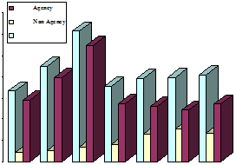

Figure 3: changes in mortgage-backed securities issued in America

**3. Results**

Undoubtedly there are rely heavily on developments in the housing market between America and the world financial markets and trade flow MBS in this market. When homeowners are unable to get out of debt, cash flow for MBS. They will not face a fall future. Investors and corporate bonds will be significantly affected by it. The effect of the level (amount) of individuals and corporate debt (financial leverage) will double up. this means that the credit market has grown.

The following table shows the decline in the securities markets in America.

Table 3: the market value of exchanges America in 2008 (amounts in millions of dollars)

|  |  |  |  |  |  |
| --- | --- | --- | --- | --- | --- |
| Exchange Market | Months | | | | |
| January | February | March | April | May |
| American SE | 247,898 | 253,599 | 242,820 | 244,890 | 238,501 |
| Nasdaq | 3703024 | 3475575 | 3470381 | 4034068 | 4205069 |
| NYSE Group | 14611421 | 14575975 | 14225517 | 14621017 | 15071483 |
| Exchange  Market | June | July | August | September | Percent change compared to September 2007 |
| American SE | 226,003 | 220,519 | 209,071 | 160,531 | -37.1% |
| Nasdaq | 3603229 | 3628687 | 3692974 | 3110698 | -26.0% |
| NYSE Group | 14413303 | 13418169 | 13567085 | 13045903 | -18.5% |

Source: http://www.world-exchanges.org

Figure 4: The gap between supply and demand in the housing market of America:

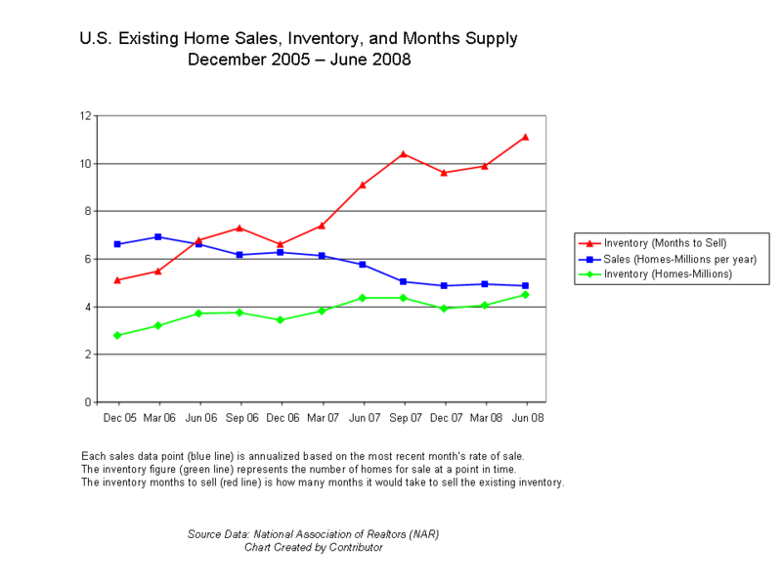

Figure 5: The bank's quarterly operating in income and realized losses incurred

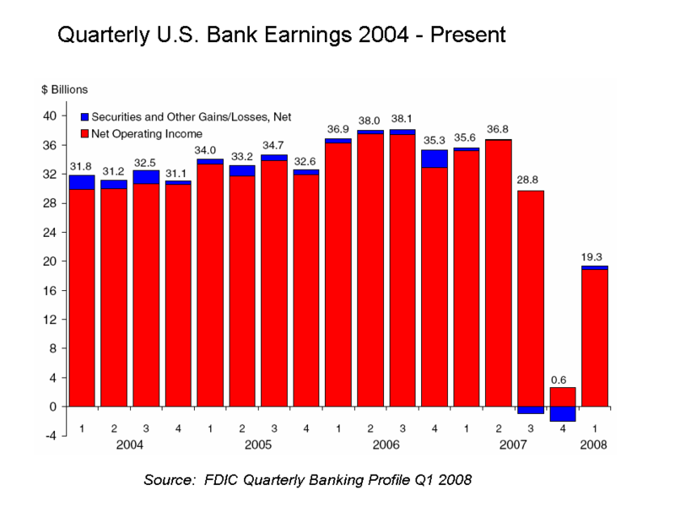

Figure 6: The seasonal low credit mortgage foreclosures holders

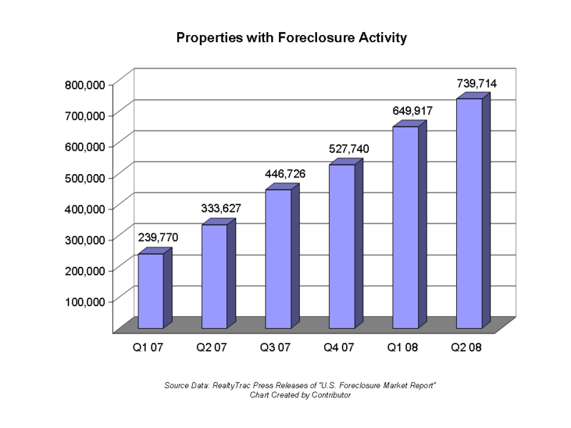

Figure 7: The amount of mortgage-backed securities whose ratings have plummeted

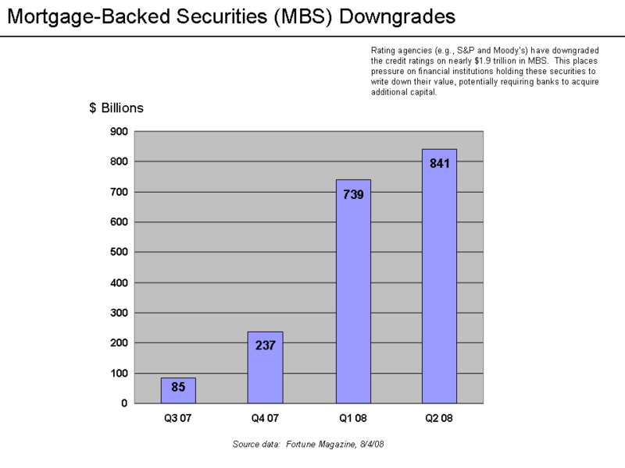

Figure 8: Changes in interest rates and credit risk indicators

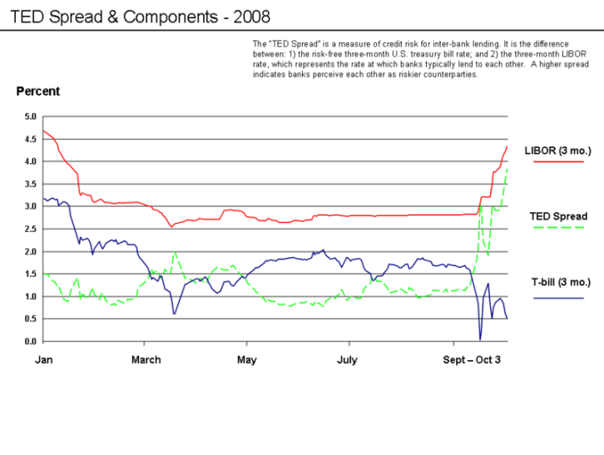

Figure 9: The trend in Corruption reporting of the mortgage

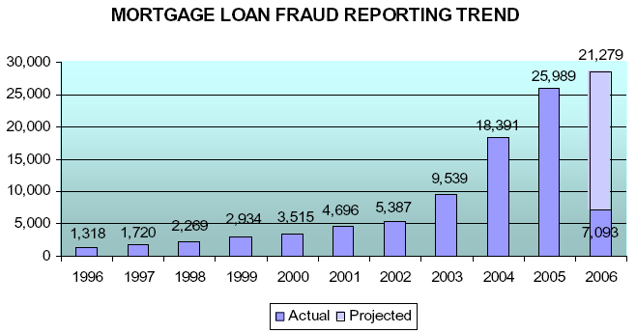

Expected economic impact of the credit crisis in America can be summed as follows:

* Due to the falling home prices, Housing wealth holders in America have fallen so far that influence the amount (Piggue Effect) has led to a sharp decline of America's economy. This in turn has created psychological inappropriate because the stock market is anticipated, reducing the amount of industrial America has stagnated and their profitability will be decreased.
* The problem of job losses and legal penalties rising because of the inability to pay the mortgage payments and lose the house will become one of America's social and economic problems.
* Industry consecutive falling due to the reducing of purchasing power of people may be dropped.
* Financial crisis (due to loss of tax revenue) for the incidence of America and increase the government deficit. While national financial institutions of America require more investment and spending by the government.

World Bank and IMF have warned of the consequences of the global financial crisis. According to these two institutions, the economic outlook, global financial crisis, the rise in food and fuel prices, poor countries can enter other fatal blows. IMF annual meeting of the "Focus on Financial Crisis America, predict consequences, and the way things" will be held on 13 October 2008. IMF's initial proposal to create a fund to provide liquidity to the global financial markets is being mental. In this context, IMF Mexico controlled liquidity crisis has experience and is able to use the same recipe for the Mexican crisis.

Critics argue that the current crisis is a clear and predictable economic policy of the Chicago school due to reduced government control over the private sector, particularly in the credit markets and the papers of Critical height of the credit crisis when it formed a plan to save America by Treasury Chief Paulson and Ben Bernanke America was presented with the support of America in Congress passed cache. This solution is the same solution to the crisis of the 1930s, Friedman had suggested.  But the critical point is that economists are strongly opposed to it. The economic doctrine tells us:

First, limit the operating then offer a way to eliminate the effects of the crisis.

The debate between policy makers identify the economic crisis in America has never been taken seriously. In other words, the origin of the crisis was that deregulation does not matter.

On the other hand there are other critics who are opposed to any government intervention in the market. They believe their way is the market and appropriate solution to be closed. Government intervention, there will be the market and teach you not to repeat mistakes of the past events.

American critics and scholars credit crisis of 2007 marks the end of America's political and economic thoughts refer to:

Francis Fukuyama argues that the invalidity of the credit crisis of 2008, America was America thinking Reganism in the financial sector. These features mentality of toughness relative to the market, small government and is low taxes or belief in scientific term "deregulation".

**4. Conclusion**

Due to the issues mentioned in the previous section, the reasons for this crisis are many and complex. But in principle it can be attributed to several factors housing and credit markets. Factors such as:

* Price bubble existence in the USA housing market
* Owner's inability to pay mortgages
* Poor judgment borrowers and lenders
* Speculation and sudden growth in housing construction
* Make risky loans and mortgage products.
* High levels of individuals and corporate debt (financial leverage above)
* New financial instruments that the default risk distribution or hide
* Bank of America's policies
* Weaknesses in monitoring and regulating the market

The above keys are as major contributors to the crisis. In addition to the aforementioned crisis has sparked another important factor, and the story of transactions on credit derivatives is using inside information. This was an issue that Congress and the President of America strongly suspect that FBI Urged to carefully consider these and other violations pay the mortgage institutions. The policies adopted by the Bank of America without regard to the specific objectives of the economy have been getting conflicting interests. In this regard, some argue that the close involvement of senior management and the possibility of two giants Fannie Mae and Freddie Mac, Bank of America's board of directors and public support from the two companies, cause "boundary capitalism" of a friend success America is in an economic system.

Many believe that the financial markets were weak in 2007 and then in 2008 it was no longer possible to resist impacts and fell down into.

**Corresponding Author:**

ahdiyeh Rashki Ghalenoo

1: Business Management (financial), Sistan and Baloochestan, Pardis, Chabahar, Iran

[rashkighalehnoomahdiyeh@yahoo.com](mailto:rashkighalehnoomahdiyeh@yahoo.com)

**References**

1. Dow Jones, Wren Research.
2. Gold Price, Wren Research.
3. Government-Sponsored Enterprises, Thomson Financial, Bloomberg.
4. <http://www.bbc.co.uk/persian/business/story>
5. <http://www.imf.org/external/index.htm>.
6. <http://www.worldbank.org/html/extdr/foodprices/>.
7. <http://www.world-exchanges.org>.
8. Hui Li a,b, Jie Sun.2011. Principal component case-based reasoning ensemble for business failure prediction. Information & Management 48 (2011) 220–227.
9. Jong Sik Yoon a, Young S. Kwonb.2010. A practical approach to bankruptcy prediction for small businesses: Substituting the unavailable financial data for credit card sales information. Expert Systems with Applications 37 (2010) 3624–3629.
10. Melek Acar Boyacioglu a, Yakup Kara b, O¨ mer Kaan Baykan.2009. Predicting bank financial failures using neural networks, support vector machines and multivariate statistical methods: A comparative analysis in the sample of savings deposit insurance fund (SDIF) transferred banks in Turkey. Expert Systems with Applications 36 (2009) 3355–3366.
11. Mu-Yen Chen.2011. A hybrid ANFIS model for business failure prediction utilizing particle swarm optimization and subtractive clustering. Inform. Sci. (2011), doi:10.1016/j.ins.2011.09.013.
12. Xiaoyan Xu, Yu Wang.2009. Financial failure prediction using efficiency as a predictor. Expert Systems with Applications 36 (2009) 366–373.

3/25/2021