**The investigation of Performance of Gas-Turbine Engine**

Seyyed Ali Mousavi Ghasemi

MA of Mechatronics Engineering, Iran

[mousavighasemiali@yahoo.com](mailto:mousavighasemiali@yahoo.com)

**Abstract**: The Massachusetts Institute of Technology Department of Mechanical Engineering teaches thermodynamics and fluid mechanics through a pair of classes, Thermal Fluids Engineering I & II. The purpose of this project was to design and fabricate a gas-turbine engine for demonstration use in these two classes. The engine was built from an automobile turbocharger with a combustion chamber connected between its compressor and turbine. Pressure and temperature sensors at different points of the engine cycle allow students to monitor the performance of the individual engine components and the complete engine cycle.

[Seyyed Ali Mousavi Ghasemi.**The investigation of Performance of Gas-Turbine Engine.** *Researcher* 2021;13(3):34-38]. ISSN 1553-9865 (print); ISSN 2163-8950 (online). <http://www.sciencepub.net/researcher>. 7. doi:[10.7537/marsrsj130321.07](http://www.dx.doi.org/10.7537/marsrsj130321.07).

**Keywords:** Engine Cycle, Gas-Turbine Engine, automobile turbocharger

**1. Introduction**

The Massachusetts Institute of Technology Department of Mechanical Engineering teaches thermodynamics and fluid mechanics through a pair of classes, Thermal Fluids Engineering I & II. The courses cover the basic principles of thermodynamics, fluid mechanics, and heat transfer. This includes the rate processes involved with heat and work transfer, steady flow components of thermodynamic plants, and energy conversion cycles. The purpose of this project was to design and fabricate a gas-turbine engine that is suitable for use as a classroom demonstration. The gas turbine designed and built for this project illustrates the operation of the Brayton cycle. The Brayton cycle is a convenient cycle to demonstrate because it involves a combination of standard components, which are used in many other energy conversion applications. The Brayton cycle consists of a compressor, a heat exchanger, a turbine, and another heat exchanger. The gas turbine engine operates on an open version of the Brayton cycle and allows students to measure the temperature and pressure changes associated with each system component. The students can then use these values to calculate the performance of the engine components as well as the overall cycle efficiency. In order to make the engine suitable for demonstration use, there were several requirements. The engine had to be portable so that it could be easily moved to the desired location. It also needed run on an easily attainable fuel and at a safe maximum temperature. The state of the air flow through the engine also needed to be measurable at each point of the engine cycle so that students could compare the predicted and measured performance of the engine.

The construction of the engine involved the design and selection of each component of the gas turbine and the engine's auxiliary systems. The engine is based around an automobile turbocharger comprised of a compressor and turbine that operate on a common shaft. Between the outlet of the compressor and the turbine inlet is a combustion chamber. The design and fabrication of the combustion chamber represents the bulk of the work for this thesis. In addition to these main system components, the cooling and lubrication system runs oil through the turbocharger, a generator creates a spark to ignite the fuel, and a series of components is used to control the flow rate of fuel to the engine. The completed engine is shown in Figure 1.

This thesis is the continuation of the project begun by Keane Nishimoto for his undergraduate thesis requirement. His thesis included the selection of the turbocharger, the purchase of the oil pump for the lubrication and cooling system, and the initial idea of a concentric shell design for the combustion chamber.

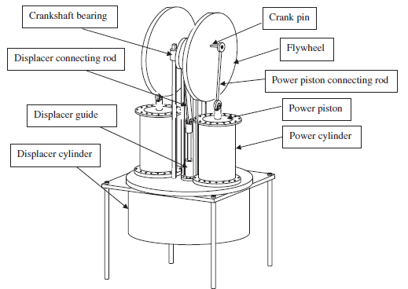

Figure 1: Schematic diagram of the twin power piston Stirling engine

**2. Methodology**

This thesis begins with a description of the basic thermodynamic theory behind gas turbine engines, examining the cycle of the energy conversion system and the individual components involved. Then, there is a brief introduction to automobile turbochargers, which is followed by a discussion of the selection and design of each component of the engine. Section 8 describes the auxiliary systems needed for the engine to run: the lubrication. and cooling system, the ignition system, and the temperature and pressure measurement devices used to monitor the engine's performance. Final conclusions and recommendations Gas turbines are thermodynamic systems that use fuel and air to produce a positive work transfer. They convert the chemical potential energy of the fuel to mechanical energy. The gas turbine operates on an open cycle consisting of a compressor, a combustor, and a turbine combined in series (Figure 2). Air from the atmosphere enters the compressor where it is compressed by a negative shaft work transfer. The compressed air is then combined and burned with fuel in the combustion chamber. The combustor increases both the temperature and the specific volume of the air. The hot air is then fed into the turbine where it is expanded. The expansion of the air creates a positive shaft work transfer. The expanded air is then exhausted to the atmosphere. A net positive shaft work transfer is produced because the negative shaft work transfer required to power the compressor is less than the positive work transfer produced by the turbine.

The gas turbine can be modeled as a closed system with air as the working fluid if the following assumptions are made:

* The combustion chamber is modeled as a constant pressure heat transfer device.
* The heat transfer rate in the combustor is determined by the product of the mass flow rate of the fuel and the heating value of the fuel.
* The increase in the mass flow rate due to the addition of fuel in the combustion chamber is neglected because it is small relative to the flow rate of the air.

In this closed cycle, the exhaust air must be cooled back to the inlet state by a constant pressure heat transfer process. This closed cycle is known as the Brayton cycle.

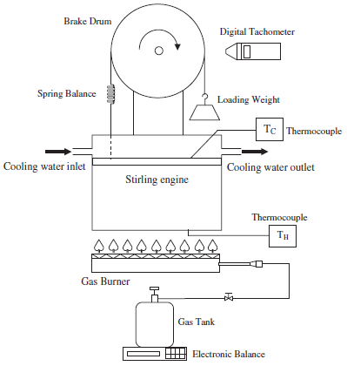

Figure 2: Schematic diagram of the Stirling engine and testing facilities

**3. Results**

The Brayton cycle consists of two adiabatic work transfers and two constant pressure heat transfer heat processes (Figure 3). From State 1 to State 2 the gas undergoes an isentropic, adiabatic compression. This process increases the temperature, pressure, and density of the gas. From State 2 to State 3, heat is added at constant pressure. For a gas-turbine, heat is added through a combustion process. From State 3 to State 4 the gas passes through an adiabatic isentropic turbine which decreases the temperature and pressure of the gas. For the closed Brayton cycle, heat is removed from the gas between State 4 and State 1 via a heat exchanger.

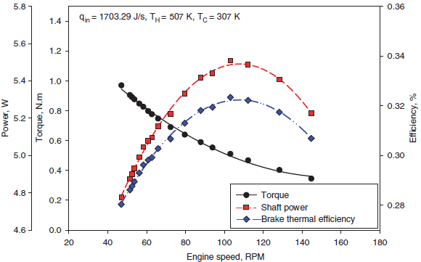

Figure 3: Twin power piston engine performance at the actual heat input of 1703.29 J/s

Compressors are an example of negative shaft work machines. They increase both the temperature and pressure of the working fluid. Increasing the pressure of the fluid requires a negative shaft work transfer. This work transfer was characterized by Equation 3. Most compressors can be considered adiabatic because the fluid is in the machine for a short time relative to the time necessary for the fluid to reach thermal equilibrium. Therefore there is virtually no heat transfer.

The combustion chamber is the component of the gas turbine in which the fuel is combined with the air from the compressor and burned. The combustion chamber functions like a heat exchanger and can be modeled as a constant pressure device. The combustion process raises the temperature of the air in the system by converting the chemical potential energy of the reactants to thermal energy. There is no work transfer involved in the reaction.

Turbochargers are devices commonly used in automobiles to increase power without a significant increase in vehicle weight. A turbocharger is comprised of a compressor and turbine operating on a common shaft. The compressor is located between the car engine's air filter and intake manifold, and it compresses the air flowing into the engine cylinders. This allows more air to be packed into the cylinder and more fuel to be burned. The exhaust air from the cylinders is fed through the turbine blades, spinning the turbine shaft. This in turn causes the compressor blades to spin and compress more air for the engine cylinders. The performance of the turbocharger is heavily dependent on the design of the compressor and turbine housings as well as their blades.

**4. Conclusion**

The selection and design of the components of the gas turbine were limited by the requirement that the completed engine be usable as a classroom demonstration, and fabricated from available materials and tools. The engine needed to be portable so that all of the components fit together on a cart. Also, the engine needed to run on a flow rate of propane that corresponded to an acceptable maximum cycle temperature. The completed engine is shown in Figure 1. The engine consists of a turbocharger (mounted to the top shelf of the cart) with a combustion chamber between its compressor outlet and its turbine inlet. The turbocharger is mounted so that air enters the compressor horizontally. The air exits the compressor vertically upwards where it is fed through piping to the combustor inlet. Fuel is fed from the propane tank up to the combustor inlet where the air is burned. The flow of propane is monitored by a valve and pressure gauges. From the combustion chamber, the exhaust passes through the turbine and then exits horizontally. Oil for the engine lubrication and cooling is pumped from the bottom of the oil reservoir up through an oil filter to the turbocharger and then back down to the reservoir.

**Corresponding Author:**

Seyyed Ali Mousavi Ghasemi

MA of Mechatronics Engineering, Iran

[mousavighasemiali@yahoo.com](mailto:mousavighasemiali@yahoo.com)

**References**

1. Haneman D. Theory and principles of low-temperature hot air engines fuelled by solar energy. Report Prepared for U.S. Atomic Energy Commission Contract W-7405-Eng-48; 1975.
2. Iwamoto I, Toda F, Hirata K, Takeuchi M, Yamamoto T. Comparison of low-and high-temperature differential Stirling engines. Proceedings of eighth International Stirling engine conference, 1997. 29–38.
3. Kongtragool B, Wongwises S. A review of solar powered Stirling engines and low temperature differential Stirling engines. Renewable Sustainable Energy Rev 2003;7:131–54.
4. Kongtragool B, Wongwises S. Investigation on power output of the gamma-configuration low temperature differential Stirling engines. Renewable Energy 2005;30:465–76.
5. Kongtragool B, Wongwises S. Optimum absorber temperature of a once-reflecting full conical concentrator of a low-temperature differential Stirling engine. Renewable Energy 2006;31:345–59.
6. Kongtragool B, Wongwises S. Theoretical investigation on Beale number for low-temperature differential Stirling engines. Proceedings of the second international conference on heat transfer, fluid mechanics, and thermodynamics 2003 (Paper no. KB2, Victoria Falls, Zambia).
7. O’Hare LR. Convection powered solar engine, U.S. Patent; 1984. p. 4, 453, 382.
8. Rizzo JG. The Stirling engine manual. Somerset: Camden miniature steam services; 1997 p. 1, 43, 153, 155.
9. Senft JR. An ultra-low temperature differential Stirling engine. Proceeding of the fifth international stirling engine conference, Paper ISEC 91032, Dubrovnik, May 1991.
10. Senft JR. Ringbom Stirling engines. New York: Oxford University Press; 1993 p. 3, 72, 88, 110, 113–37.
11. Spencer LC. A comprehensive review of small solar-powered heat engines: Part III. Research since 1950- ’’unconventional’’ engines up to 100 kW. Sol Energy 1989;43:211–25.
12. Van Arsdell BH. Stirling engines. In: Zumerchik J, editor. Macmillan encyclopedia of energy, vol. 3. Macmillan Reference USA; 2001. p. 1090–5.
13. Walpita SH. Development of the solar receiver for a small Stirling engine. Special study project report no. ET-83-1. Bangkok: Asian Institute of Technology; 1983. p. 3.
14. West CD. A historical perspective on Stirling engine performance. Proceedings of the 23rd intersociety energy conversion engineering conference, Paper 889004. Denver: American Society of Mechanical Engineers.

3/25/2021