Evaluation of bio-protective capacity of some botanicals against post harvest fruit rot microbes of pepper (Capsicum annum L)

Ijato J. Y

Department Of Plant Science and Biotechnology, Faculty of Science,
Ekiti State University, Ado-Ekiti P.M.B 5363, Ekiti State, Nigeria.
E-mail: considerureternity@gmail.com; GSM: 08067335124

Abstract: Healthy and infected samples of peppers (Capsicum annum) fruits were collected from neighborhood market, placed in sterile polyethene bag and transported to the laboratory for bioassay. The infested fruit samples were sterilized and cultured on potato dextrose agar. The cultures were incubated at room temperature and later sub cultured to obtain pure culture. Fungal isolates were sub cultured, identified through microscopic examination and characterized. Fresh and healthy pepper (C. annum L.) fruits were also inoculated with pure isolates and their pathogenicity determined. The result of bioassay showed that Rhizopus stolonifer, Aspergillus niger, Fusarium solani, Alternaria alternata, Geotrichum candidum and Mucor pussilus were found to be responsible for bio deterioration of the peppers fruits. Aspergillus niger and Rhizopus stolonifer were mostly distributed and abundant in the fruits. Mycelia growth of Aspergillus niger (86.87%) and G. candidum (75.96%) was most and least inhibited respectively by eighty percent (80%) ethanolic extracts of Azadirachta indica, Similarly, Eighty percent ethanolic extracts of Tridax procumbens exhibited 88.03% inhibition on mycelia growth of Aspergillus niger and least inhibition on G. candidum (67.22%). Mycelia growth of Aspergillus niger (87.21%) and M. pusillus (64.10%) was most and least inhibited respectively by eighty percent ethanolic extracts of Vernonia amygdalina. In the course of transit, wounds predispose peppers fruits to mycofloral contamination; hence this scenario could be minimized by proper phtyosanitary handling for elongation of fruits’ shelf life.
[Ijato J. Y. Evaluation of bio-protective capacity of some botanicals against post harvest fruit rot microbes of pepper (Capsicum annum L). Researcher 2021;13(3):14-20]. ISSN 1553-9865 (print); ISSN 2163-8950 (online). http://www.sciencepub.net/researcher. 4. doi:10.7537/marsrsj130321.04.

Keywords: pepper, plant extracts, rot fungi

Introduction
Pepper (C. annum) is a genus of flowering plants in the nightshade family Solanaceae. Norman et al (1992) reported that Capsicum frutescens is a small perennial shrub which is characterized by greenish white corolla, more than one pedicel at a node, and not so large fruits. The hot perennial pepper belongs to this species, Capsicum annum is an herb or sub-shrub which has white corolla and produces only one pedicel per node. The fruits vary in size, shape and pungency. It consists of approximately 20-27 species, out of which five are domesticated: C. annuum, C. baccatum, C. chinense, C. frutescens and C. pubescens (Bakri, 2010). Its species are native to the Americas, they are also cultivated worldwide. C. annuum is an important crop and extensively cultivated throughout the tropics and Southern countries such as Bangladesh, India, Pakistan and Sri Lanka, with the majority of species having some ranges in Brazil. Norman et al (1992) and Tindall (1983) stated that the Capsicum peppers are indigenous to Central and Tropical America. C. chinese and C. frutescens from Northern half of South America to parts of Central America and the Caribbean.
Pepper fruits are a rich source of antioxidants as they contain a high level of vitamins C and E in addition to carotenoids and xanthophylls they also contain essential minerals as human daily dietary intake for healthy living (Bosland and Votava 2000). The total of antioxidants is completed by phenolic compounds, which occur in peppers in connection with sugars, (Materska, et al., 2003;). Most pepper species are prone to attack by pest and diseases, causing micro-organisms such as fungi, bacteria and nematodes. In addition to causing rots, they may also make fruit unfit for consumption by producing mycotoxins (Salau, 2012; Bill, 2010).
Among spoilage organisms on pepper fruits, fungi are the most common with resultant economic impact (Campbell, 2008). Due to low pH, higher moisture content and nutrient composition, fruits and vegetables are very susceptible to pathogenic fungal attack causing postharvest losses due to very high moisture content Salunke et al. (1991). Moreover,
there are characteristic fungal rots pathogens such as few fungi imperfecti like Penicillium, Aspergillus, Alternaria some zygomycetes like Mucor and Rhizopus. These fungal species produce many spores, they are present almost everywhere pepper is grown and handled as they take advantage of any damage or bruising on pepper fruit at stages from harvest to consumption (Campbell, 2008). Research had shown that fungi make way into its host tissue through natural openings such as lenticels, stomata and through the unbroken epidermis by means of appresorium or germ tube It is necessary to isolate and identify fungi that are associated with postharvest rot of pepper (Capsicum annuum) for easy disease control and preservation with a view to mitigate deleterious effects of these rot pathogens on pepper fruits.

Materials And Methods
Collection of Pepper Fruits
Twenty-four samples of infected pepper (C. annum) fruits were collected from market and kept in sterile polythene bags and these were brought to the laboratory. The collected samples were sterilized. Direct plating method was used for the culturing; a sterile needle was used to cut a piece from each of the pepper fruits from areas of advancement of the rot and placed on the media in separate Petri dishes for each samples and the needle was sterilized using spirit lamp after each use. The cultures were incubated at room temperature.
Media Preparation
Thirty nine (39g) of potato dextrose agar (PDA) was measured using a weighing balance and diluted with 1000ml of distilled water in a conical flask and heated in an autoclave for 60 minutes at 110°C. After heating, the media was allowed to cool for 15 minutes, 8g of streptomycin was added to prevent bacterial growth and the media was poured into sterilized Petri dishes and left to solidify under aseptic conditions.
Isolation of Fungal Isolates
The isolation technique used was the same as that used by Chiejina (2008). Thin sections (2mm diameter) were cut from the periphery of diseased pepper fruits and sterilized in 0.1% ethanol for two (2) minutes. These sections were rinsed in three (3) changes of sterile distilled water and plated in Potato Dextrose Agar (PDA) plates. The plates were incubated at room temperature (25°C ± 2°C) for three 3 days (72 hours). Pure cultures were obtained by several transfers of the colony growth from PDA plates to clean PDA plates aseptically.
Determination of Percentage of Fungal Occurrence
This was done to determine the frequency of occurrence of the different fungal isolates. Isolations were made from different diseased pepper fruits and were cultured differently. The number of occurrence for each of the isolates in the eight different fruits were recorded, calculated and expressed in percentage.
Percentage of occurrence = X/N x 100/1
X = Total number of each organism in all the fruits
N = Total number of the entire organism in all the fruits screened.
Pathogenicity Tests
Pathogenicity tests were carried out using techniques of (Okigbo, et al., 2009). Healthy pepper fruits were washed in sterile distilled water and surface sterilized with 0.1% ethanolic solution. A sterilized cork borer was used to cut the fruits and then culture of the isolates were introduced into the open cut and replaced with the core. Petroleum jelly was smeared to completely seal the hole. These were incubated for seven (7) days. Upon observation of disease symptoms, inoculums from the infected fruits were taken and cultured. The symptoms were identical to those of naturally infected peppers.
Organisms Identification
Pure fungal isolates obtained from the diseased pepper fruits were identified having subjected the isolates to identification purposes. Each isolate was subjected to colony and microscopic examinations during which their structural features were observed. Identification of fungi was based on the growth patterns, colour of mycelia and microscopic examinations of vegetative and reproductive structures.
Preparation of plant extracts
Thirty grams of the dried powdered plant were soaked separately in 150ml of ethanol. These mixtures were refluxed followed by agitation at 200 revolutions per minute (rpm) for one hour. The ethanol extracts were squeezed and then filtered by muslin cloth. The extracts were placed in a wide tray to evaporate ethanol and water added to make plant extracts (Ijato, et al., 2011).
Evaluation of plant extracts against fungal growth
The approach of Ijato et al (2011) was used to evaluate the effect of the extract on fungal growth. This was done by creating four equal sections on each plate by drawing two perpendicular lines at the bottom of the plate. The centre of the plates indicated the point of intersection of the inoculum. This was done before dispensing the PDA into the plates. The extracts were poured into the flask plugged with cotton wool and heated for about 10 minutes to avoid contamination. Two (2ml) of the extract of various concentrates were separately introduced into the Petri dish containing equal amount (10mls) of the PDA media (poisoned food method). Each plate was inoculated with 5mm plug of pure isolate taken from margins of actively growing culture of pathogen. The plates were incubated at 25° ± 2°C. The control plates were only added with equal quantity of ethanol and distilled water. Mycelial growth diameter of each isolates was measured and recorded and compared with the growth in the control treatment. Each treatment was repeated three times. The set up was a completely randomized design. Mean radial mycelial growth of each isolate was recorded and data were transformed into inhibition percentage by using the following formula
Inhibition percentage (%) = $\frac{DC- DT}{DC}×100$
Where DC - Average Diameter of fungal spore in control
DT - Average diameter of fungal spore with treatment.
Statistical Analysis
Data were analyzed using the SAS computer program. Differences between means of inhibition of radial mycelial growth were determined using analysis of variance (ANOVA) and means that were significant were separated using Fisher’s protected LSD test (P<0.05).

Results
Fungi Isolated from Pepper
A total of six fungal species comprising of R. stolonifer, A. niger, A. alternate, G. candidum, Mucor species and F. solani were identified from the samples collected from the market at three various market. Table 1shows the various colonial characteristics observed in the six fungi isolated during the study.
4.2. Percentage of Fungi Identified from Pepper During Collection
The result showed that A. niger (3.67≈4.0) was the most distributed fungal isolates while F. solani and G. candidum were the least (1.33≈1) Table 2 in descending order. With respect to percentage frequency of fungi, A. niger was the highest (29.73%) while F. solani and G. candidum were the least (10.81%) Table 2. The fungal isolated from the post harvested C. annuum were in the decreasing order of A. niger (29.73%) > R. stolonifer (21.62%) > A. alternate 13.51%) M. Pusillus (13.51%) >F. solani (10.81) = G. candidum (10.81) Table 2.

Table 1. Fungal isolates and their colonial characteristics.
S/N | Fungal Species | Morphological Characteristic
1 | - alternate | Both transverse and longitudinal septate hyphae. Conidia borne in a chain at the top of conidiophores
2 | - niger | Simple conidiophores that terminate in the globose swelling. Hyphae is septate
3 | F. solani | Sickle shaped macroconidia, it is intracellular and intercellular hyaline branched geniculate and septate
4 | M. pusillus | Thick hyphae and non-septate. Reproductive structure is round bear sporangia
5 | G. candidum | Septate branching hyphae and dissociated anthrospores are present
6 | R. stolonifer | Non-septate hyphae and cotton mycelium. Produce clusters of root-like structure rhizoid and stolon

Table 2. Frequency of fungi associated with peppers fruit rot
Fungi Isolates | Number of Isolates (%) |  |  | Total (%) | Mean±SE
 | 1st Sample | 2nd Sample | 3rd Sample
A. alternata | 2 (14.29) | 1 (8.33) | 2 (18.18) | 5 (13.51) | 1.67
A. niger | 4 (28.57) | 4 (33.33) | 3 (27.27) | 11 (29.73) | 3.67
F. solani | 1 (7.14) | 2 (16.67) | 1 (9.09) | 4 (10.81) | 1.33
G. candidum | 2 (14.29) | 1 (8.33) | 1 (9.09) | 5 (13.51) | 1.33
M. pusillus | 2 (14.29) | 2 (16.67) | 1 (9.09) | 5 (13.51) | 1.67
R. stolonifer | 3 (21.43) | 2 (16.67) | 3 (27.27) | 8 (21.62) | 2.67
TOTAL | 14 | 12 | 11 | 37 | 2.06
Means along the same column are significantly different (p<0.05).

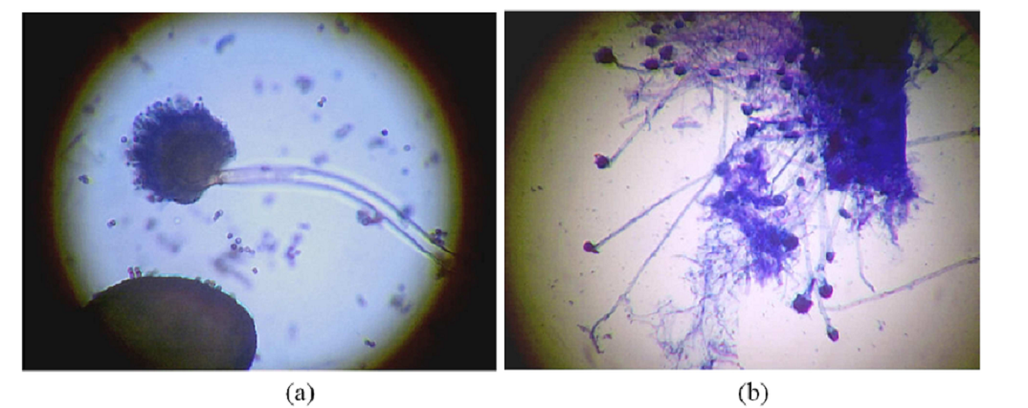
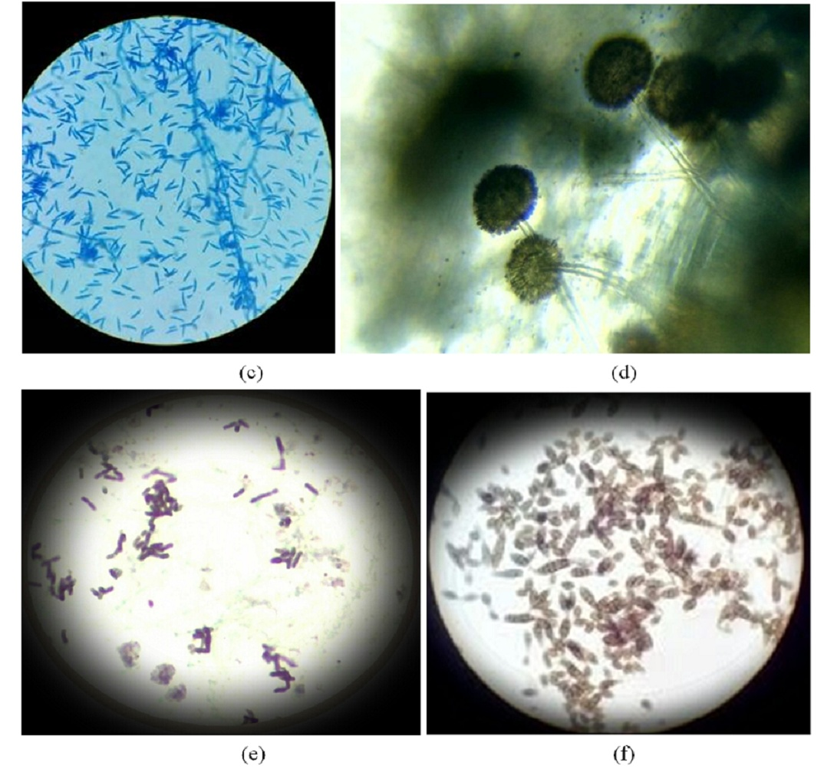
Figure1. Photomicrograph of fungal isolates (a) A. niger (x40) (b) M. pusillus (x40) (c) Fusarium solani (x40) (d) R. stolonifer (x40) (e) G. candidum (x40) (f) A. alternata (x40).

Table 3 shows the effect of ethanol extract of A. indica on the mycelial growth of fungal isolates
All concentrations of ethanolic A. indica leaf extracts suppressed the mycelial growth of the six tested pathogens. Statistically, there was significant difference in inhibition of radial mycelial growth in all the fungal isolates at all concentrations (P=0.05) except in A. alternata where there was no significant difference in inhibition of radial mycelial growth observed between the concentrations of 20% and 40%. The effect was proportional to concentration and inhibition value at 80% concentration (highest concentration), and was higher for A. niger (86.87%), followed by R. stolonifer (85.27%) while the lowest inhibition value was observed for G. candidum (75.96%). There was no inhibition in radial mycelial growth exhibited in the control in all cases (Table 3).

Table 3: Percentage inhibition of mycelia growth of fungal isolates incorporated with ethanol plant extracts of A. indica.
Fungal isolates | Concentrations%
 | 20 | 40 | 60 | 80 | Control | Mean | LSD (P<0.05)
A. niger | 68.83 | 80.71 | 84.56 | 86.87 | 0.00 | 64.19 | 1.44
R. stolonifer | 45.78 | 53.17 | 64.22 | 85.27 | 0.00 | 49.69 | 3.85
A. alternata | 47.57 | 48.20 | 61.00 | 81.72 | 0.00 | 47.70 | 4.04
M. pusillus | 27.10 | 46.54 | 57.65 | 80.56 | 0.00 | 42.37 | 6.64
F. solani | 37.92 | 53.26 | 63.91 | 77.51 | 0.00 | 46.52 | 4.33
G. candidum | 35.52 | 50.00 | 60.02 | 75.96 | 0.00 | 37.20 | 4.23

Table 4: shows the effect of ethanol extract of Tridax procumbens on the mycelial growth of fungal isolates
All concentrations of ethanolic T. procumbens leaf extracts suppressed the mycelial growth of the six tested pathogens. Statistically, there was significant difference in inhibition of radial mycelial growth for all the fungi isolates at all tested concentrations (P=0.05). The effect was proportional to concentration and inhibition value at 80% concentration (highest concentration), was higher for Aspergillus niger (88.03%), followed by Alternaria alternata (80.53%) while the lowest inhibition value was observed for Geotrichum candidum (67.22%). There was no inhibition in radial mycelial growth exhibited in the control (Table 4).

Table 4: Percentage inhibition of mycelia growth of fungal isolates incorporated with ethanolic plant extracts of T. procumbens.
Fungal isolates | Concentrations%
 | 20 | 40 | 60 | 80 | Control | Mean | LSD (P<0.05)
A. niger | 70.35 | 81.87 | 84.20 | 88.03 | 0.00 | 64.89 | 0.73
R. stolonifer | 33.93 | 46.01 | 56.26 | 73.74 | 0.00 | 41.99 | 3.22
A. alternata | 46.98 | 57.37 | 67.07 | 80.53 | 0.00 | 50.40 | 4.23
M. pusillus | 35.81 | 49.33 | 62.16 | 80.40 | 0.00 | 45.54 | 5.85
F. solani | 42.86 | 50.32 | 58.39 | 69.57 | 0.00 | 44.23 | 2.56
G. candidum | 40.26 | 49.44 | 52.63 | 67.22 | 0.00 | 41.91 | 1.98

Table 5: shows the effect of ethanol extract of V. amygdalina on the mycelial growth of fungal isolates.
All concentrations of ethanolic V. amygdalina leaf extracts suppressed the mycelial growth of the six tested pathogens. Statistically, there was significant difference in inhibition of radial mycelial growth in all the fungal isolates at all concentrations (P=0.05) except in A. niger, where no significant difference in inhibition of radial mycelial growth was observed between 40% and 60% concentration and between 60% and 80% concentration of the extract. The effect was proportional to concentration and inhibition value at 80% concentration (highest concentration), was higher for Aspergillus niger (87.21%), followed by Rhizopus stolonifer (83.95%) while the lowest inhibition value was observed for Mucor pusillus (64.10%). There no inhibition in radial mycelial growth exhibited in the control in all cases (Table 5).

Table 5: Percentage inhibition of mycelia growth of fungal isolates incorporated with ethanolic plant extracts of Vernonia amygdalina.
Fungal isolates | Concentrations%
 | 20 | 40 | 60 | 80 | Control | Mean | LSD (P<0.05)
A. niger | 69.80 | 80.00 | 82.56 | 87.21 | 0.00 | 63.91 | 4.86
R. stolonifer | 30.57 | 57.52 | 69.43 | 83.95 | 0.00 | 48.29 | 3.75
A. alternata | 47.23 | 56.44 | 61.96 | 71.16 | 0.00 | 47.36 | 4.05
M. pusillus | 24.36 | 32.69 | 60.90 | 64.10 | 0.00 | 36.41 | 2.24
F. solani | 39.50 | 50.62 | 62.37 | 68.52 | 0.00 | 44.20 | 41.52
G. candidum | 35.80 | 47.46 | 59.36 | 65.02 | 0.00 | 41.52 | 4.30

Discussion
Losses caused by post-harvest diseases are greater than generally realized because the value of fresh fruits and vegetables increases several-fold while passing from the field to the consumer. Good storage limits losses of good products over relatively long period of time. In the market, the traders store the vegetables in bags and baskets and the fruits probably get contaminated during transportation and packaging in bags and baskets that are unsterilized. Aspergillus niger, Rhizopus stolonifer and Alternaria alternata identified in this study agrees with fungal species identified in the study of fungi associated with post-harvest rot of common fruits pepper inclusive in Sokoto metropolis, Nigeria by Salau (2012) who identify the same fungal species. The Aspergillus niger, Fusarium species and Mucor species identified in this study agrees with the work of Mensah and Owusu (2011) who identified Aspergillus niger, Fusarium species and Mucor species in the study of fruit borne mycoflora of Capsicum annum, Abelmoscus esculentus, and Lycopersicon esculentum from Accra metropolis. Aspergillus niger found to be the most abundant fungi of pepper fruit is similar to the report of Mensah and Owusu (2011) who listed Aspergillus niger as one of the most common fungal species found on the fruits in their study in Accra metropolis. It also agrees with (Chiejina 2008) who indicated that Aspergillus was isolated from 79.5% of the samples. Aspergillus niger and Rhizopus stolonifer were found to be the most abundant fungi causing spoilage of pepper, this work agrees with that of Essien et al (2009), who reported that Aspergillus species and Rhizopus stolonifer are the most common post-harvest fungi associated with tomato and pepper. This also agrees with the work of Droby, (2006) on the study of the predominant fungi in Irish potatoes. This is due to the abundance of their spores in the air and also the temperature and humidity favors their proliferation. Because moisture and temperature influence the growth of fungi, characterizing weather conditions favorable for fungi may be used to predict the abundance and richness of fungi in habitats with different climate conditions Atmospheric moisture is generally the single most important environmental factor influencing the incidence and severity of fungal diseases on plants. High relative humidity and several hours of free surface water are critical for both spore germination and successful infection.
Field studies on plant pathogens have demonstrated that the growth of fungi is favored by high moisture and moderate temperatures (Rowan, 2009) and that low relative humidity and extreme temperatures inhibit growth and spore germination. The relative abundance of Aspergillus niger (29.73%) observed in this study is lower than value (75% ) reported by Mensah and Owusu (2011). Alternaria species (13.51%), Geothricum candidum (10.81%), Fusarium solani (10.81%), Rhizopus species (21.27%) and Mucor species (13.51%). This result slightly agrees with (Essien, et al 2009) who isolated Rhizopus solani (20.4%), Fusarium solani (19.5%).
The changes in these value isolate might be as a result of disparity in the climatic variables (Rainfall, temperature e.t.c). Ijato et al (2011) reported that ethanol extracts of 30% of both Vernonia amygdalina and Tridax procumbens had high inhibitory effect of 46.00% and 68.20% respectively against A. niger. At 20% concentration of Vernonia amygdalina and Tridax procumbens in this study an inhibitory effect of 70.35% and 69.80% respectively was recorded on Aspergillus niger. These differences could be due to the dilution method or difference in the medium used as reported by Ijato et al. (2011) and Salau (2012). The changes in these value isolate might be as a result of disparity in the climatic variables (Rainfall, temperature etc.).

Conclusion
This study reveals different fungi rot species associated with Capsicum annum. This indicates that fresh fruit of Capsicum annum should be handled with care during harvesting, transportation, storage and marketing to reduce fungal contamination, since it has been known that Aspergillus and Fusarium have strains that produce toxic metabolites. At the post-harvest, biological control, natural products such as chitosan, essential oils and plant extracts, resistant cultivars and some salts have been used for control.

References
- Bakri, Y, Masson, M and Thonart, P (2010). Isolation and identification of two new fungal strains for xylanase production. Applied Biochemistry and Biotechnology. 162: 1626- 1634.
- Bill, D. D (1981). Mycotoxin production in whole tomatoes, apples, oranges and lemons. Journal of Agricultural Food Chemistry, 29: 790-792.
- Bosland, P. W and Votava, E. J (2000). Pepper Vegetable and Spice Capsicums. CABI Publishing, New York pp. 3 – 4. Hardenburg, R. (1986) The Commercial Storage of Fruits, Vegetables and Florist and Nursery Stocks. USDA Handbook No. 66 United States Department of Agriculture, Agricultural Research Service, Pp 17.
- Campbell, R (1985). Plant microbial ELBS Edition. London Publishers, London, pp. 38: 42.
- Chiejina, N. V (2008). Mycoflora of some salad vegetables. Biological Research. 6(2): 392-39.
- Droby, S (2006). Improving quality and safety of fresh fruits and vegetables after harvest by the use of bio control agents and natural materials. Accra Horticulture. 709: 45-51.
- Essien, J. P, Odoema, C. S and Essien, E. P (2009). Effect of traditional preservation on seed borne pathogens and seed viability on okro (capsicum) and tomato (Lycopersicum solanum). Journal of Tropical Science, 39: 238-234. 29.
- Ijato, J.Y, Adebiyi, A.O and Ijadunola, J.A ( 2011). Antifungal effects of four tropical plant aqueous and ethanol extracts on post harvest rot of tomato (Lycopersicumesculentum) in Ado–Ekiti, Nigeria. New York Science Journal. 4(1): 64- 68.
- Materska, M, Perucka, I, Stochmal, A, Piacente, S and Oleszek, W (2003a). Quantitative and qualitative determination of flavonoids and phenolic acid derivatives from pericarp of hot pepper fruit cv. Bronowicka Ostra. Pol. J. Food Nutr. Sci., 12 (53): 72-76.
- Mensah, K, Owusu, E (2011). Fruit-borne microflora of Capsicum annum L. (pepper) Abelmoschus esculentus L. Moench (Okra), and Lycopersicon esculentum Mill. (Tomato) from Accra metropolis. African Journal of food Sciences (1): 1-7.
- Norman, J. C and Abotsi, E. K (1992). Pungency in fruits of some West African Cultivars of hot pepper (Capsicum frutescence) Gartenbauwissenschaft. 53(6) –249.
- Okigbo, R. N, Ramesh, P and Achusi C. T (2009). Postharvest Deterioration of Cassava and its Control Using Extracts of Azadirachta indica and Aframomum melegueta. Electronic Journal of Chemistry, 6 (4), 1274-1280.
- Rowan, A, Bataille, V, Mackie, R, Healy, E, Bicknell, D, Bodmer, W and Tomlinson I. (1999). Somatic mutationsin the Peutz-Jeghers gene in sporadic malignant melanomas. Journal of Investmen Dermatol. 12 (4), 509-511.
- Salau, I. A (2012) Studies of fungi associated with human skin and vegetable disease in Fadama land of Sokoto metropolis, Sokoto State, Nigeria. M.Sc Thesis, Usman Dan Fodio University Sokoto, Nigeria.
- Salunke, D. K, Bolin, H. R and Reddy, N. R. (1991). Storage, Processing and Nutritional Quality of Fruits and Vegetables. Vol. 1, CRC Press, Boca Raton. F1 (2 edn.).
- Tindall, H. D (1983). Vegetables in the Tropics, ELBS, Macmillan Ed. Ltd. Hampshire. pp 347 – 354.

3/16/2021

