Control of Bacterial Food Poisoning in between Nanotechnology and Future Insights Approaches

Azza S. M. Abuelnaga¹, Nagwa S. Atta¹, Mona S. Zaki², Mona A. Elshabrawy¹, Effat M.M., Magdy A. Kamel¹, Sohier M Syame¹ and Hakim A.S.¹

¹Microbiolog and Immunology Department, National Research Centre, Cairo, Egypt
² Hydrobiology Department, National Reseach Centre, Cairo, Egypt
drmonazaki@yahoo.com

Abstract: Nanotechnology proffers the food industry a volume of novel accesses for getting the quality, shelf life, integrity, safety, and healthiness of foods better. In response to the probable hazards linked with the globalization of the food industry, research has been converge on the emergence of new sensing techniques to supply the means of contamination recognition at any stage in the food supply chain. Nanotechnology has been reported as the new industrial revolution, both developed, and developing countries are investing in this technology to secure a market share. Nanoscience and nanotechnology exhibit enormous interest in different areas of research and applications, including biomedical sciences, food industry and combating food pathogens. Nanoparticle strictly refers to 1–100 nm in size. Also the direction will pointed to blue technology; application of metabolites and compounds derived from marine primitive creatures. This review article summarizes the application of both inorganic (silver, iron oxide, titanium dioxide, silicon dioxide, and zinc oxide) and organic (lipid, protein, and carbohydrate) nanoparticles in foods. In addition to, highlights on the future approaches in relation to blue nature deraviteves in food preservation.
[Azza S. M. Abuelnaga, Nagwa S. Atta, Mona S. Zaki, Mona A. Elshabrawy, Effat M.M., Magdy A. Kamel, Sohier M Syame and Hakim A.S. Control of Bacterial Food Poisoning in between Nanotechnology and Future Insights Approaches. Researcher 2020;12(12):32-35]. ISSN 1553-9865 (print); ISSN 2163-8950 (online). http://www.sciencepub.net/researcher. 5. doi:10.7537/marsrsj121220.05.

Key words: blue technology- food poisoning – microcapsulation- nanoemulsion- nanoparticles

- Nanotechnology Role
Nowadays, nanotechnology displays remarkable contribution to clinical aspects using biocompatible nanoscale natural antibacterial carriers, as liposomes, polymeric nanoparticles and metal nanoparticles for more efficient and safer delivery of various antibacterial agents. Polymeric nanoparticles are vastly demonstrated significant inhibitory on food borne microorganisms, particularly on fruits and vegetables, further elevate the efficiency and stability of the antimicrobial agent (Rozman et al., 2019). Nano-emulsions show plentiful advantages over traditional emulsions due to the minute droplets size they contain: high optical visibility, excellent physical stability and droplet accumulation, and polish bioavailability of encapsulated materials, which make them compatible for food applications. Nano-encapsulation, nanocomposites and food packaging is the most worthy favorable developing technologies having the possibility to trap bioactive antibacterials (Thiruvengadam et al., 2018).
Nano-encapsulation operation represents the design nano-coating to be utilized as carrier of various functional components. All the encapsulation technologies, in the long run, rely on proper drying strategies to get nanoencapsulates in powder form. Lee et al. (2017) performed a study to enhance the water solubility and antimicrobial activity of food-packaging agent. Nano-encapsulation of worthy microorganisms; probiotics, is advantageous because targeted and site-specific allocation to the wanted region of the gastrointestinal tract can be fulfilled. The encapsulation of bacteriocins from lactic acid bacteria has involved numerous methods to protect them from undesirable environmental conditions and incompatibilities (Chandrakasan et al., 2019). Polymer nanocomposites from carbon black and polyaniline designated to detect and identify foodborne pathogens (B. cereus, Vibrio parahaemolyticus, and Salmonella spp.) relied on the specific response criteria for each microorganism, as excited by different vapors produced during their metabolism (Angiolillo et al., 2017)
Jebel and Almasi (2016) mentioned the antibacterial efficiency of Zinc oxide nanoparticles embedded in cellulose films on E. coli and S. aureus. Martínez-Bueno et al. (2017) mentioned the applications of gold nanoparticles in food contamination detection. Nanosensors used to control foodborne bacteria during storage and transit
processes, Moreover, nanosensors could check foodborne bacterial toxins in the food, even during food packaging stage (Pathakoti et al., 2017).

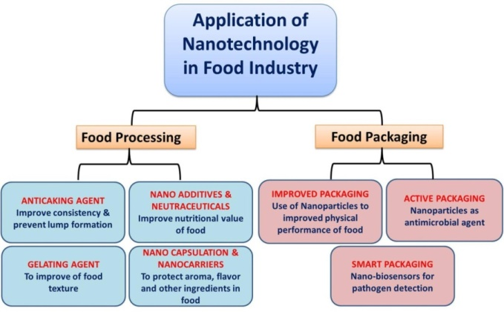
Figure (1): nanotechnology applications in food industry
https://www.frontiersin.org/articles/10.3389/fmicb.2017.01501/full

Furthermore the term green nanotechnology is used widely to express the environmental friendly preparations; Jeyaraj Pandian et al. (2017) developed green synthesized nickel nanoparticles, coated by citric acid and conjugated with specific antibody for efficient recognition and removal of S. typhimurium.
Patra and Baek (2017) studied a simple, fast, and eco-friendly green method to synthesize magnetite iron oxide nanoparticles (Fe₃O₄ NPs) using the aqueous extracts of two food processing wastes, namely silky hairs of corn and outer leaves of Chinese cabbage and mentioned their antibacterial activity.
Another novel approach is the utilization of eco-friendly nanotechnology in chitosan processing; Al-Sherbini et al. (2019) studied fabricated chitosan/silver (CS/Ag) bio-nano-composites thin films and mentioned their inhibitory effect on Gram-negative bacteria like E. coli, and Gram-positive bacteria like Bacillus spp.
The easy leakage of silver nanoparticle in food package was overcome through administration of oxygen plasma-treated foil polyethylene or Polypropylene (Glaser et al., 2019) or liposomes encapsulated (Wu et al., 2019) and the preparations exhibited over 90% reduction of S. aureus and over 77% reduction of E. coli .
Nowadays, there are advancing in utilization of chitosan in food safety through novel approaches; Kumar et al. (2018) mentioned that the microwaved copolymerized grafted chitosan film has efficient antimicrobial activity versus the tested strains; E. coli and S. aureus for apple and guava packaging. Also, the biodegradability study results of the grafted chitosan film were positive.
Nevertheless, there is concern from consumers, regulatory agencies, and the food industry about potential adverse effects (toxicity) associated with the application of nanotechnology in foods. In particular, there is concern about the direct incorporation of engineered nanoparticles into foods, such as those used as delivery systems for colors, flavors, preservatives, nutrients, and nutraceuticals, or those used to modify the optical, rheological, or flow properties of foods or food packaging.

II. Future aspirant insight
Nature is a precious source of compounds, with the ability to cure diseases, involving infectious food born illnesses. Future studies will target the novel pathless natural resources, their mechanism of action and the structure-activity sides. Consequently, this may provide both additional antimicrobial progress, and also worthy insight into prospect possibilities to overcome the antimicrobial resistance (Gouda et al., 2016).

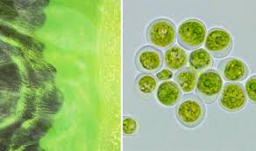
Figure (2): blue green algae
https://www.express.co.uk/life-style/health/993227/blue-green-algae-dogs-warning-toxic-algae-alton-water-aqua-park

Endophytes are an endosymbiotic set of microorganisms that colonize in plants and can be readily recovered from any plant growth medium. They do as source of novel bioactive secondary metabolites that serve as a potential nominee for antimicrobial. Antimicrobial operators from endophytes are considered a substantial arsenal to override the emerging drug resistance by pathogens. Numerous bioactive antimicrobial agents have been obtained from endophytic fungi showed promising antimicrobial performance versus broad scope of food born bacteria including S. aureus sp., aureus, Salmonella enterica sp., enterica and Escherichia coli (Joshi, 2017).
Coral-derived and marine microorganisms are known for their innate capability to produce novel products; this new pathway is termed ‘Blue technology’. The chemical structures obtained from marine organisms are diverse, reflecting biodiversity of genes, species and ecosystems. Chemical compositions of marine outputs often have unique metabolic pathways ‘biodiversity’ and vary from terrestrial secondary metabolites in being halogenated with bromine and/or chlorine. Biodiversity is an unusual face of life and supplies benefits to humanity as promising the new patterns for combating pathogens (Jin et al., 2016).
A respectable number of novel metabolites with pharmacological potential have been isolated from marine organisms, which revealed enormous biological activities involving antibiotic properties (Hou et al., 2019). Some of the halogenated compounds have exhibited antibiotic properties; laurinterol, obtained from a red alga, show activity versus gram-positive bacteria analogous to that of streptomycin (Lauritano et al., 2019).

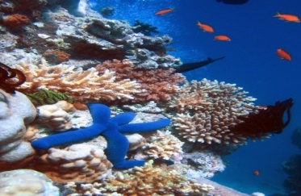
Figure (3): coral reef
https://en.wikipedia.org/wiki/Coral_reef

References
- Al-Sherbini AA, Ghannam HEA, El-Ghanam GMA, El-Ella AA and Youssef AM. (2019): Utilization of chitosan/Ag bionanocomposites as eco-friendly photocatalytic reactor for Bactericidal effect and heavy metals removal. Heliyon. 5(6):e01980.
- Angiolillo L, Spinelli S, Conte A and Del Nobile MA. (2017): Recent advances in food packaging with a focus on nanotechnology. Recent Patents on Engineering, 11: (3)174 – 187.
- Chandrakasan G, Rodríguez-Hernández AI, Del Rocío López-Cuellar M, Palma-Rodríguez HM and Chavarría-Hernández N. (2019): Bacteriocin encapsulation for food and pharmaceutical applications: advances in the past 20 years. Biotechnol Lett., 41(4-5):453-469.
- Glaser TK, Plohl O, Vesel A, Ajdnik U, Ulrih NP, Hrnčič MK, Bren U and Fras Zemljič L. (2019): Functionalization of Polyethylene (PE) and Polypropylene (PP) Material Using Chitosan Nanoparticles with Incorporated Resveratrol as Potential Active Packaging. Materials (Basel), 12(13). pii: E2118.
- Gouda S, Das G, Sen SK, Shin HS and Patra JK. (2016): Endophytes: A treasure house of bioactive compounds of medicinal importance. Front Microbiol., 7:1538.
- Hou XM, Hai Y, Gu YC, Wang CY and Shao CL. (2019): Chemical and Bioactive Marine Natural Products of Coral-Derived Microorganisms (2015‒2017). Curr Med Chem., 5: 26.
- Jebel FS and Almasi H. (2016): Morphological, physical, antimicrobial and release properties of ZnO nanoparticles-loaded bacterial cellulose films. Carbohydr Polym., 149:8–19.
- Jeyaraj Pandian C, Palanivel R and Balasundaram U. (2017): Green synthesized nickel nanoparticles for targeted detection and killing of S. typhimurium. J Photochem Photobiol B., 174:58-69.
- Jin L, Quan C, Hou X and Fan S. (2016): Potential Pharmacological Resources: Natural Bioactive Compounds from Marine-Derived Fungi. Mar Drugs, 14(4):76.
- Kumar D, Kumar P and Pandey J. (2018): Binary grafted chitosan film: Synthesis, characterization, antibacterial activity and prospects for food packaging. Int J Biol Macromol., 115:341-348.
- Lauritano C, Ferrante MI, Rogato A. (2019): Marine Natural Products from Microalgae: An -Omics Overview. Mar Drugs, 17(5): pii: E269.
- Lee JS, Hong DY, Kim ES and Lee HG. (2017): Improving the water solubility and antimicrobial activity of silymarin by nanoencapsulation. Colloids Surf B. Biointerfaces., 154:171–177.
- Martínez-Bueno MJ, Hernando MD and Uclés S. (2017): Identification of non-intentionally added substances in food packaging nano films by gas and liquid chromatography coupled to orbitrap mass spectrometry. Talanta., 172:68–77.
- Pathakoti K, Manubolu M, and Hwang H. (2017): Nanostructures: Current uses and future applications in food science. Journal of food and drug analysis, 25: 245 -253.
- Patra JK and Baek KH. (2017): Green biosynthesis of magnetic iron oxide (Fe3O4) nanoparticles using the aqueous extracts of food processing wastes under photo-catalyzed condition and investigation of their antimicrobial and antioxidant activity. J Photochem Photobiol B.,173:291-300.
- Rozman NAS, Tong WY, Leong CR, Tan WN, Hasanolbasori MA and Abdullah SZ. (2019): Potential Antimicrobial Applications of Chitosan Nanoparticles (ChNP). J Microbiol Biotechnol., 7: 1904.
- Thiruvengadam M, Rajakumar G and Chung IM. (2018): Nanotechnology: current uses and future applications in the food industry. Biotech., 8(1):74.
- Wu Z, Zhou W, Pang C, Deng W, Xu C, Wang X. (2019): Multifunctional chitosan-based coating with liposomes containing laurel essential oils and nanosilver for pork preservation. Food Chem., 15; 295:16-25.

12/8/2020

