On the historical evolution of panoramic technology and the analysis of the concept of panoramic industry standards

Enze Zhang

Chengdu Yitong Technology Company Limited

Abstract: This article elaborates on the history of panoramic technology and the concept of panoramic industry standards. In the existing literature, it is difficult to find very authoritative panoramic technology and industry articles. Entering the 21st century, "Panorama" has quickly entered the public's field of vision since 2010. An endless stream of technology companies have invested a lot of capital, manpower and material resources to promote panoramic technology and panoramic products, including success and failure cases. Panorama technology is moving from unpopular technology to mass technology. In this process, it will encounter drastic changes in user perception, technological innovation, and industrial evolution. This requires us to objectively sort out the development process of panorama technology, and then understand the panorama from a global perspective. The effect of technology.
[Enze Zhang. On the historical evolution of panoramic technology and the analysis of the concept of panoramic industry standards. Researcher 2020;12(11):53-57]. ISSN 1553-9865 (print); ISSN 2163-8950 (online). http://www.sciencepub.net/researcher. 11. doi:10.7537/marsrsj121120.11.

Keywords: panoramic technology, development process, general video technology, conflict collision.

- The history of panoramic technology
As a potential "universal video technology", the emergence of panoramic video capture technology is more to solve the problem of blind corners of other "universal video technologies", so as to facilitate content viewing/users to obtain more comprehensive information. By consulting the literature, we can directly trace back to the display form of the early panoramic technology.
Humans’ pursuit of comprehensive information is inherent and growing. Before the invention of photography, as early as 20 AD, people living in Pompeii began to create on the walls in order to show an immersive scene. Long painting; A century before the emergence of photography technology, it is recorded that in 1787, panorama painting technology reached a peak, the Irish painter Robert Barker also used the word “panorama” to describe his work for the first time, and realized it by working inside the cylindrical building. The complete 360° panorama painting is very rich in detail, which perfectly restores the city scenery of Edinburgh at that time (Figure 1). Since the 19th century, panoramic painting has become a very popular method, usually showing some grand and spectacular scenery or important historical events. The viewer can experience the beauty in 360-degree panoramic works.
By the middle of the 19th century, with the invention of Daguerreotype, humans entered the era of photography. Photographers pursuing panoramic views can capture a wider field of view by stitching a series of photos taken by multiple silver plates side by side, as shown in Figure 2.
Immediately after the second half of the 19th century, the wet-plate collodion (wet-plate collodion) imaging process revolutionized the photography industry. Compared with silver plate shooting, this technology greatly improved the equipment size and imaging time, allowing photography It’s easier and cheaper to take pictures. There were also many famous panoramic photography works during this period, as shown in Figure 3.
At the end of the 19th century, the emergence of flexible film technology first transitioned from glass material to paper material and then to plastic material. The surface material was also an explosive and highly toxic compound. It was not until the beginning of the
20th century that the Eastman Kodak Company in the United States invented it. Chemically stable and cheap "safety film" is the film technology we usually mean now. In 1904, William J. Johnston applied for a very famous patent, PANORAMIC CAMERA, as shown in Figure 4. This is also the industry's earliest patent for panoramic technology. It uses a large 5"x6" film format, and rotates the camera around the axis through a mechanical structure, which can directly produce 360°×360° panoramic photos. This camera was manufactured by the Rochester Panoramic Camera Company in 1905 and named Cirkut. Later, the Rochester Panoramic Camera Company was acquired by Kodak.

Figure 1. Panorama of Edinburgh painted by Irish painter Robert Barker in 1787

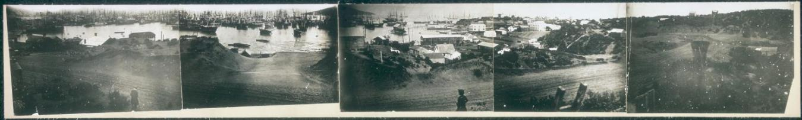
Figure 2. In 1851, American photographer Martin Behrmanx used silver plate photos to take pictures of early San Francisco scenes. It is rumored that there were 11 silver plates at first, but some were lost due to unknown reasons.

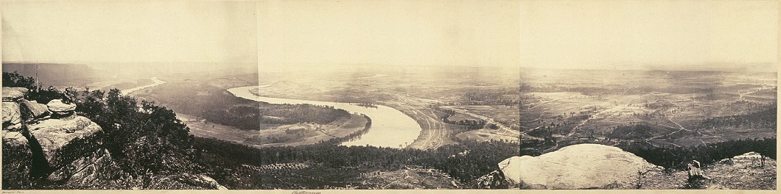
Figure 3. A panoramic photo of Tennessee, USA, taken by photographer George N. Barnard in 1864 using wet collodion imaging stitching

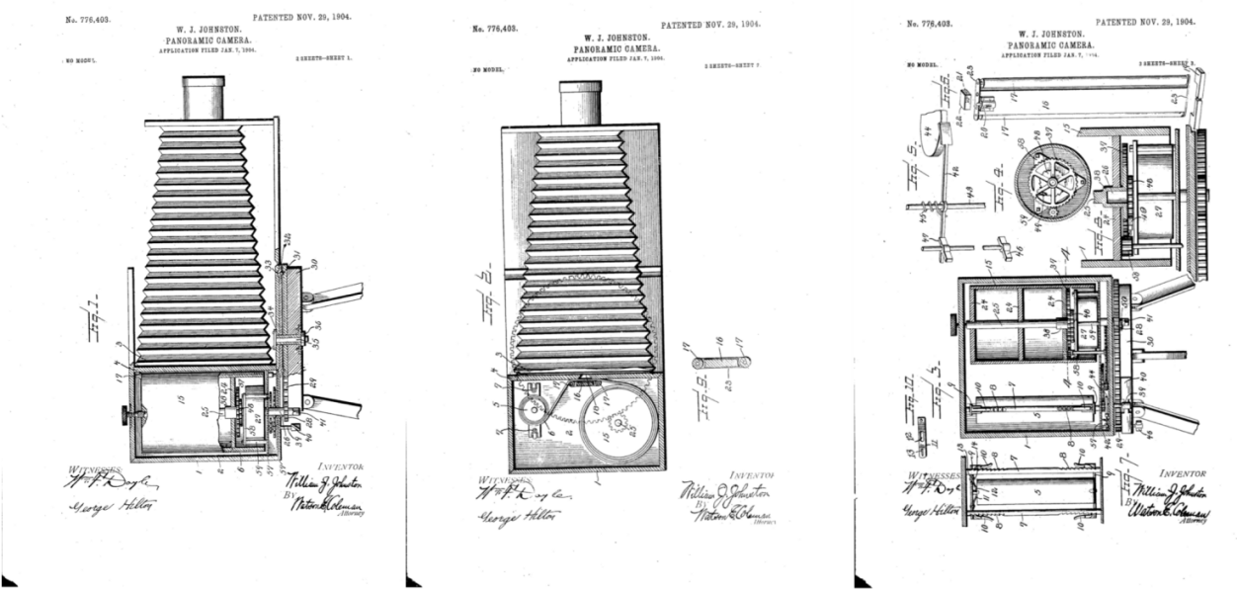
Figure 4. Patent US776403A, panoramic camera, inventor William J. Johnston, on January 7, 1904

In order to make the picture capture a larger angle of view and capture more comprehensive picture information, in addition to imaging technology, the optical technology industry has derived wide-angle and fish-eye technology to obtain a larger horizontal and vertical viewing angle of the image. The term "fisheye" was coined in 1906 by the physicist inventor Robert W. Wood. He is based on the phenomenon that fish can see an ultra-wide hemispherical field of vision underwater (also known as " "Snell's window", "Snell's window", describes the phenomenon that underwater observers can see all fields of vision above the horizontal plane through a light cone with a width of about 96 degrees), the principle is shown in Figure 5. Through continuous experimentation, in 1920, the first fisheye lens developed by Robert W. Wood was used for the first time in meteorological research. It was not until 1960 that the mass production process of fisheye lens was polished and matured and it became available on the market. The general promotion is shown in Figure 6.

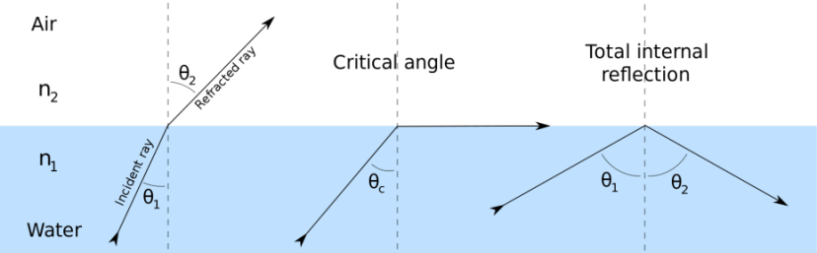
Figure 5. Fisheye lens physics, "Snell window" principle

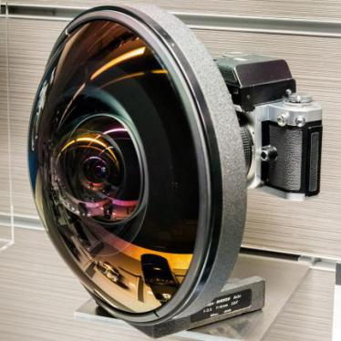
Figure 6. Nikkor fisheye 6mm f/2.8 camera lens produced in 1972, horizontal angle 220°

The machinery industry derives PTZ technology, which uses motors to drive the camera to rotate to capture images. Regardless of whether it is fisheye technology or mechanical pan-tilt technology, both have now become the standard "universal video technology", but they have not fully fulfilled consumer needs in solving the problem of picture angles and solving blind spots. Mechanical pan/tilt camera technology is essentially "time-sharing" in video calling, so there are many inconveniences in screen rotation, synchronization, and stitching, and it cannot effectively travel continuous and smooth videos; and because of the current largest optical fisheye technology Although it can be designed to a horizontal viewing angle close to 280 degrees, on the one hand, there is a certain distance from the horizontal 360 degrees without dead angle, and the dead angle problem is still not solved. On the one hand, huge edge distortion and picture loss make the super large fisheye optics still need to be developed.
Since then, with the continuous improvement of technology, image technology has transitioned from the film age to the digital age, and light and shadow imaging no longer only depends on the optical lens and imaging device itself, but is also closely integrated with electronic image enhancement technology. Especially in the 21st century, image distortion correction and feature point splicing technology has been greatly improved and popularized. Therefore, the industry has begun to use multiple camera modules to combine splicing to achieve panoramic image capture. From 2000 to 2010, the intelligent hardware industry produced many panoramic cameras, most of which were stitching of 3 to 30 cameras. At this stage, panoramic equipment output more pictures than videos, and the quality of picture stitching is also uneven. From 2010 to 2014, with the breakthrough of fish-eye technology, people gradually began to reduce the number of optical lenses and increase the horizontal field of view of the lens. 4-camera, 3-camera and even dual-camera appeared one after another. At this stage, Ricoh RICOH company gave priority to using two The fisheye lens with a horizontal angle of view greater than 180° is placed back to back and stitched to achieve a panoramic 360°×360° image and video capture, as shown in Figure 7.

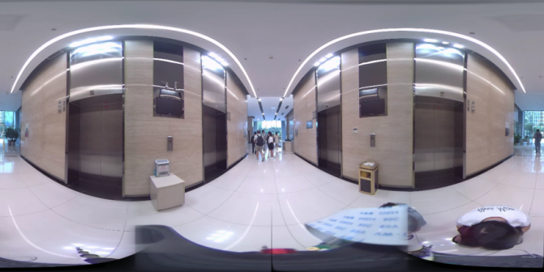
Figure 7. 360°×360° full celestial sphere screen

Since the number of panoramic stitching lenses is directly related to the amount of calculation of the electronic platform, the picture parameters, and the terminal price, with the continuous optimization of stitching and stitching technology and fisheye technology, double fisheye back-to-back technology has gradually become the mainstream solution in the industry. Until 2015, the fragmented video sharing, live broadcast and VR industries began to take off. Panorama appeared as a "more convenient way to take pictures" in the eyes of consumers. The panorama industry ushered in an explosion of market awareness, and the industry also took the year 2015 As the "first year" of the panoramic industry.
Originally, panoramic technology was only exchanged in the unpopular circle of some geeks and enthusiasts. Everyone shared huge and complex equipment and panoramic pictures with poor quality and huge distortion. It was a well-deserved niche product and niche technology. However, with the continuous maturation of technology and products, the effects of panoramic products have gradually been recognized by consumers. Driven by the demands of new economic industries such as VR, live broadcasting, and drones, all walks of life are paying more and more attention to panoramic technology. Panoramic technology, especially panoramic camera technology that can form consumer-level applications and large-scale market promotion, was selected as one of the top ten breakthrough technologies in the world in 2017 by the famous technology review magazine MIT Technology Review.
The appearance of multiple cameras, the original picture with distortion, the interactive 2.5D image, the shooting method without considering the blind angle and direction, the immersive VA/AR experience. These feature points always make the panoramic products highly recognizable, but from In terms of the purer panorama technology itself, panorama can be used as a universal way of image capture. As the technology continues to mature, it will change our lifestyle step by step.

2. Panorama (Panorama) industry standard concept
Panorama (from the Modern Chinese Dictionary):
1 - All scenery
2 - A movie camera captures a picture of the whole body of a person or the whole scene, allowing the audience to see the whole body movement of the person and part of the surrounding environment.
Panorama (from Merriam-Webster):
1 - a: cyclorama
b: a picture exhibited a part at a time by being unrolled before the spectator
2 - a: an unobstructed or complete view of an area in every direction
b: a comprehensive presentation of a subject
c: range
3- a mental picture of a series of images or events
From wall paintings thousands of years ago, to silver plate photo stitching in the 19th century, to mechanical rotating panoramic photography in the early 20th century, to 360-degree surrounding images, multi-camera one-time imaging stitching, single fisheye hemisphere, double fisheye back-to-back global… With the continuous pursuit of panoramic technology and the continuous upgrading of imaging optical and mechanical technology, the application of panoramic products has changed from unpopular to popular, and its effects and content performance have also been recognized by more and more people. It can be seen from the above that the general "panorama" and "Panorama" dictionary notes are not strictly defined at the technical level and the effect level. Therefore, the industry is also full of mechanical pan-tilt panoramic views, 360-degree panoramic views, 180-degree panoramic views, and 360-degree panoramic views. The complicated vocabulary such as degree panorama and 720 degree panorama is dazzling and brings more confusion to consumers. This shows that the panoramic industry is an industry that has not yet been regulated.
In the view of this article, this lack of specification is more a result of the conflict between the expected demand and the level of technological realization. In different periods, the concept of "panorama" is also changing. With the development of technology, image technology is also maturing, and the current concept of panoramic view that is close to consumer needs can also be fully realized. In terms of technical requirements, this article is more inclined to the 2a explanation of the Webster’s dictionary: "an unobstructed or complete view of an area in every direction", that is, "full view of all angles in a range". That is to say, on a picture, it is necessary to show the entire field of view of the front, back, left, right, up, and down, to achieve a true picture without blind spots. The definition of 720-degree panorama in the industry is closer to the concept of "horizontal 360-degree × vertical 360-degree full celestial field of view without dead angle." With the development of technology, this concept can now be realized.
Therefore, the "panorama" and "panoramic technology" mentioned in this article are all based on a 720-degree panoramic view with no dead ends.

References
- Grau, Oliver; Custance, Gloria (2003). Virtual art: from illusion to immersion ([Rev. and expanded ed.] ed.). MIT Press. ISBN 978-0-262-07241-0.
- Oettermann, Stephan; Bell, Rob; Flannel (Firm); Zondervan Corporation (1997). The panorama: history of a mass medium Zone Books. ISBN 978-0-942299-83-0.
- Comment, Bernard. XIXe siècle des panoramas (1999). The panorama (Rev. and expanded ed. Reaktion. ISBN 978-1-86189-042-9.
- Hannavy, John (2008). Encyclopedia of nineteenth-century photography. Taylor & Francis Group. ISBN 978-0-203-94178-2.
- https://www.technologyreview.com/video/604500/the-360-degree-selfie-10-breakthrough-technologies-2017/ original foreign website, https://36kr.com/p/5064615.html domestic report

11/25/2020

Grau, Oliver; Custance, Gloria (2003). Virtual art: from illusion to immersion ([Rev. and expanded ed.] ed.). MIT Press. ISBN 978-0-262-07241-0;
Oettermann, Stephan; Bell, Rob; Flannel (Firm); Zondervan Corporation(1997). The panorama: history of a mass medium Zone Books. ISBN 978-0-942299-83-0
Comment, Bernard. XIXe siècle des panoramas (1999). The panorama (Rev. and expanded ed. Reaktion. ISBN 978-1-86189-042-9.
Hannavy, John (2008). Encyclopedia of nineteenth-century photography. Taylor & Francis Group. ISBN 978-0-203-94178-2.
https://www.technologyreview.com/video/604500/the-360-degree-selfie-10-breakthrough-technologies-2017/ original foreign website,https://36kr.com/p/5064615.html domestic report

