**Speed Control of Ward Leonard Layout System using H Optimal Control**



Mustefa Jibril 1, Messay Tadese 2, Eliyas Alemayehu Tadese 3

1. School of Electrical & Computer Engineering, Dire Dawa Institute of Technology, Dire Dawa, Ethiopia

2. School of Electrical & Computer Engineering, Dire Dawa Institute of Technology, Dire Dawa, Ethiopia

3. Faculty of Electrical & Computer Engineering, Jimma Institute of Technology, Jimma, Ethiopia

[mustefazinet1981@gmail.com](mailto:mustefazinet1981@gmail.com)

**Abstract:** In this paper, modelling designing and simulation of a Ward Leonard layout system is done using robust control theory. In order to increase the performance of the Ward Leonard layout system with H  optimal control synthesis and H  optimal control synthesis via -iteration controllers are used. The open loop response of the Ward Leonard layout system shows that the system needs to be improved. Comparison of the Ward Leonard layout system with H  optimal control synthesis and H  optimal control synthesis via -iteration controllers to track a desired step speed input have been done. Finally, the comparative simulation results prove the effectiveness of the proposed Ward Leonard layout system with H  optimal control synthesis controller in improving the percentage overshoot and the settling time.

[Mustefa Jibril, Messay Tadese, Eliyas Alemayehu Tadese. **Speed Control of Ward Leonard Layout System using H Optimal Control.** *Researcher* 2020;12(11):35-39]. ISSN 1553-9865 (print); ISSN 2163-8950 (online). <http://www.sciencepub.net/researcher>. 8. doi:[10.7537/marsrsj121120.08](http://www.dx.doi.org/10.7537/marsrsj121120.08).



**Keywords:** Ward Leonard layout, H  optimal control synthesis controller, H  optimal control synthesis via -iteration controller

1. **Introduction**

Ward Leonard layout, additionally referred to as the Ward Leonard Drive system, become a widely used DC motor speed manipulate system added by way of Harry Ward Leonard in 1891. It was applied to railway locomotives utilized in World War I, and become utilized in anti- aircraft radars in World War II. Connected to automated anti-aircraft gun administrators, the monitoring motion in two dimensions needed to be extraordinarily smooth and particular. The MIT Radiation Laboratory decided on Ward-Leonard to equip the well-known radar SCR-584 in 1942. The Ward Leonard layout become widely used for elevators till thyristor drives have become available inside the Nineteen Eighties, because it supplied easy velocity control and steady torque. Many Ward Leonard control structures and versions on them stay in use.

1. **Mathematical Modelling of the Ward Leonard layout**

The Ward Leonard layout system is shown in Figure 1 below.

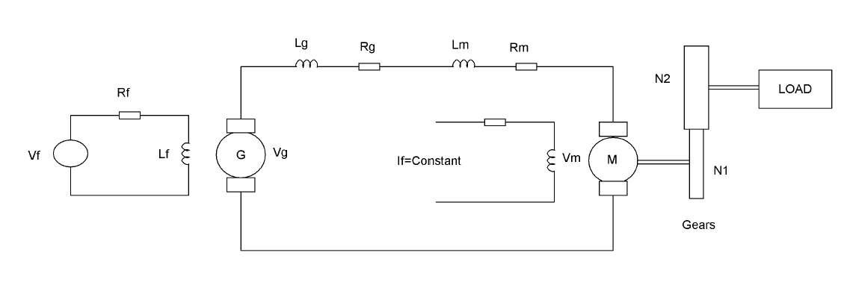

Figure 1 Ward Leonard layout

The equations of the Ward–Leonard layout are as follows. The Kirchhoff’s law of voltages of the excitation field of the generator G is



The voltage vg of the generator G is proportional to the current if, i.e.,



The voltage vm of the motor M is proportional to the angular velocity, i.e.,



The differential equation for the current ia is



The torque Tm of the motor is proportional to the current ia, i.e.,



The rotational motion of the rotor is described by



Here, Jm is the moment of inertia and Bm the viscosity coefficient of the motor: likewise, for JL and BL of the load. From the above relations, we can determine the transfer function of the Ward–Leonard (WL) layout (including the load):



Where



The parameters of the system is shown in Table 1 below.

Table 1 System parameter

|  |  |  |  |
| --- | --- | --- | --- |
| No | Parameter | Symbol | Value |
| 1 | Motor coil inductance |  | 18 H |
| 2 | Motor coil resistance |  | 20 ohm |
| 3 | Moment of inertia of the motor |  | 66 |
| 4 | Damping coefficient of the motor |  | 28 |
| 3 | Moment of inertia of the Load |  | 23 |
| 4 | Damping coefficient of the Load |  | 18 |
| 5 | Generator Coil inductance |  | 16 H |
| 6 | Generator coil resistance |  | 28 ohm |
| 5 | Generator field inductance |  | 10 H |
| 6 | Generator field resistance |  | 18 ohm |
| 7 | Generator voltage constant |  | 8 |
| 8 | Motor voltage constant |  | 16 |
| 9 | Motor torque constant |  | 18 |
| 10 | Gear one |  | 64 |
| 11 | Gear two |  | 32 |

The transfer function of the system becomes



And the state space representation becomes



**3. The Proposed Controllers Design2**

* 1. **H  Optimal Control Synthesis Controller Design**

**H**  optimal control synthesis solve the small-gain infinity-norm robust control problem; i.e., find a stabilizing controller F (s) for a system P (s) such that the closed-loop transfer function satisfies the infinity-norm inequality



The block diagram of the system with **H**  optimal control synthesis controller is shown in Figure 2 below

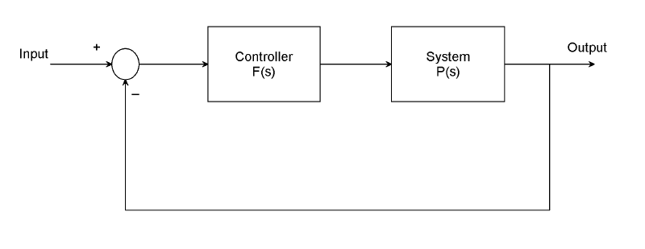

Figure 2 Block diagram of the system with **H**  optimal control synthesis controller

An important use of the infinity-norm control theory is for direct shaping of closed-loop singular value Bode plots of control systems. In such cases, the system P (s) will typically be the plant augmented with suitable loop-shaping filters

The **H**  optimal control synthesis controller transfer function is



* 1. **H fOptimal Control Synthesis via -iteration Controller Design**

**H**  optimal control synthesis via -iteration compute the optimal **H** controller using the loop-shifting two-Riccati formulae. The output is the optimal “” for which the cost function can achieve under a preset tolerance.



The search of optimal stops whenever the relative error between two adjacent stable solutions is less than the tolerance specified. For most practical purposes, the tolerance can be set at 0.01 or 0.001. The block diagram of the system with **H**  optimal control synthesis via -iteration controller is shown in Figure 3 below

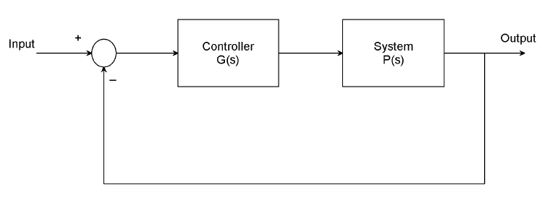

Figure 3 Block diagram of the system with **H**  optimal control synthesis via -iteration controller

The **H**  optimal control synthesis via -iteration controller transfer function is



1. **Result and Discussion**
   1. **Ward Leonard layout System Open Loop Response**

The Simulink model of the open loop Ward Leonard layout system and the simulation result of the system for a constant field voltage input of 100 volt is shown in Figure 4 and Figure 5 respectively.

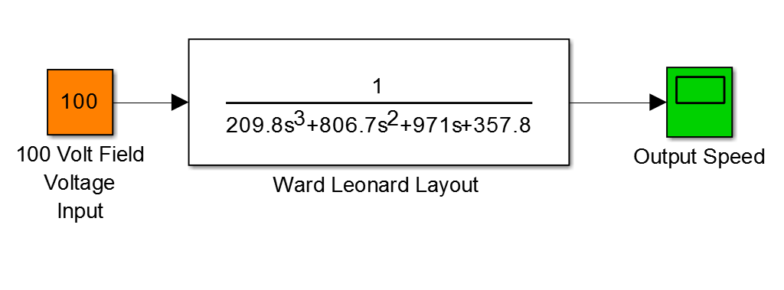

Figure 4 Simulink model of the open loop of Ward Leonard layoutsystem

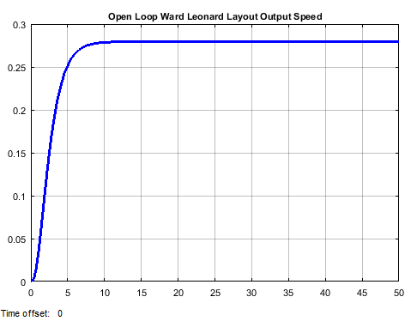

Figure 5 Simulation result

The simulation result shows that the Ward Leonard layout output speed is 0.75 rad/sec which needs a performance improvement.

* 1. **Comparison of the Proposed Controllers for Tracking a Desired Step Speed**

The Simulink model of the Ward Leonard layoutsystem with **H**  optimal control synthesis and **H**  optimal control synthesis via -iteration controllers are shown in Figure 6 below

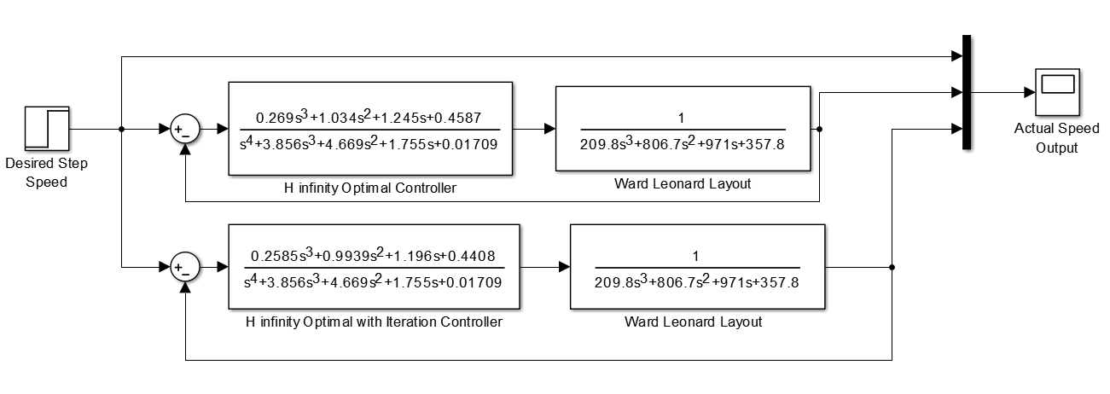

Figure 6 Simulink model of the Ward Leonard layoutsystem with **H**  optimal control synthesis and **H**  optimal control synthesis via -iteration controllers

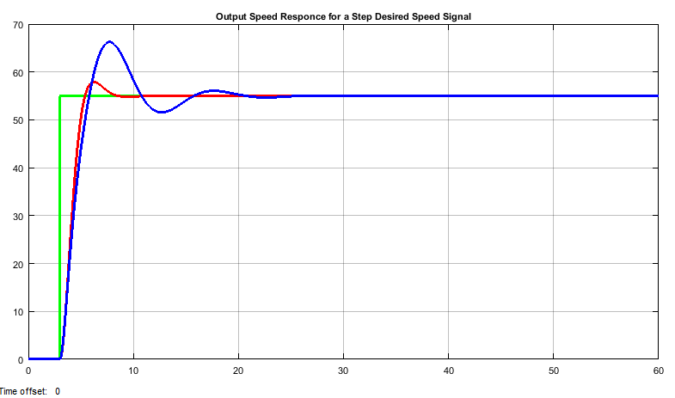

Figure 7 Simulation result

The simulation result of the Ward Leonard layoutsystem with **H**  optimal control synthesis and **H**  optimal control synthesis via -iteration controllers for tracking a desired step speed (from 0 to 55 rad/sec) input is shown in Figure 7.

The performance data of the rise time, percentage overshoot, settling time and peak value is shown in Table 2.

Table 2． Step response data

|  |  |  |  |
| --- | --- | --- | --- |
| No | Performance Data | **H**  optimal | **H**  optimal via -iteration |
| 1 | Rise time | 3.8 sec | 3.8 sec |
| 2 | Per. overshoot | 3.63 % | 21.8 % |
| 3 | Settling time | 8 sec | 26 sec |
| 4 | Peak value | 57 rad/sec | 67rad/sec |

1. **Conclusion**

In this paper, a Ward Leonard layoutsystem is designed using a DC motor generator combination. In order to improve the performance of the system, a robust control technique with **H** optimal control synthesis and **H** optimal control synthesis via -iteration controllers are used. The open loop response of the system shows that the system needs improvement. The comparison of the proposed controllers is done to track a desired step speed and the results proves that the system with **H** optimal control synthesis controller improves the settling time and the percentage overshoot than the system with **H** optimal control synthesis via -iteration controller.

**Reference**

1. Messay T et al. “Performance Investigation of DC Motor Angular Velocity using Optimal and Robust Control Method” International Journal of Advance Research and Innovative Ideas in Education, Volume-6, Issue-2, 2020.
2. Mustefa J. et al. “DC Motor Speed Control with the Presence of Input Disturbance using Neural Network Based Model Reference and Predictive Controllers” International Research Journal of Modernization in Engineering Technology and Science, Vol. 2, Issue 4, 2020.
3. Panagiotis K. et al. “Fuzzy Q-Learning Agent for Online Tuning of PID Controller for DC Motor Speed Control” Algorithms for PID Controller (Special Issue), Vol. 11, Issue. 10, 2018.
4. N.L Ismail et al. “DC Motor Speed Control using Fuzzy Logic Controller” AIP Conference Proceedings, Vol. 1930, Issue. 1, 2018.
5. K. Priyanka et al. “DC Motor Control using PWM” International Journal of Innovative Science and Research Technology, Vol. 3, Issue. 2, 2018.
6. Ali A. Hassan et al. “Comparative Study for DC Motor Speed Control using PID Controller” International Journal of Engineering and Technology, Vol. 9, No. 6, pp 4181-4192, 2017.
7. Lubica M et al. “Speed Control of DC Motor” American Journal of Mechanical Engineering, Vol. 4, No. 7, pp 380-384, 2016.
8. Cody L. et al. “An Investigation of the Ward Leonard System for use in a Hybrid or Electric Passenger Vehicle” ASME International Design Engineering Technical Conferences and Computers and Information in Engineering Conference, 2013.

11/19/2020