**Design & Control of Vehicle Boom Barrier Gate System using Augmented  Optimal &  Synthesis Controllers**

Mustefa Jibril1, Messay Tadese2, Tesfabirhan Shoga3

1 Msc, School of Electrical & Computer Engineering, Dire Dawa Institute of Technology, Dire Dawa, Ethiopia

2 Msc, School of Electrical & Computer Engineering, Dire Dawa Institute of Technology, Dire Dawa, Ethiopia

3 Msc, Faculty of Electrical & Computer Engineering, Jimma Institute of Technology, Jimma, Ethiopia

[mustefa.jibril@ddu.edu.et](mailto:mustefa.jibril@ddu.edu.et)

**Abstract:** A vehicle boom barrier gate system is one of the recently developed technologies operating at the entrances to the restricted areas. This paper aims to design and control of vehicle’s boom barrier gate system using robust augmentation technique.  optimal and  synthesis controllers are used to improve the performance of the system. The open loop response analysis of the vehicle boom barrier gate system shows that the input of the system need to be improved. Comparison of the vehicle boom barrier gate system with  optimal and  synthesis controllers have been done to track a set point desired angular position using a step and operational open and close input signals and a promising results have been observed.

[Mustefa Jibril, Messay Tadese, Tesfabirhan Shoga. **Design & Control of Vehicle Boom Barrier Gate System using Augmented  Optimal &  Synthesis Controllers.** *Researcher* 2020;12(11):16-23]. ISSN 1553-9865 (print); ISSN 2163-8950 (online). <http://www.sciencepub.net/researcher>. 5. doi:[10.7537/marsrsj121120.05](http://www.dx.doi.org/10.7537/marsrsj121120.05).

**Keywords:** Boom barrier gate, optimal, synthesis

1. **Introduction**

A vehicle boom barrier gate system, is a bar, or beam pivoted to allow the boom to block vehicular or passer-by entrees through a controlled point. Typically, the tip of a boom entrance rises in a normal arc to a near regular position. Boom barrier gates are often counter weighted, so the pole is easily tipped. Boom barrier gates are often paired either conclusion to end, or offset appropriately to block entrance in both directions. Some boom gates also have a helper arm which hangs 300 to 400 mm below the upper tongs when lowered, to supplement approach visibility, and which hangs on links so it lies flat with the main boom as the limit is raised. Some limit also features a pivot roughly half way, whereas the limit is raised, the outermost half remains horizontal, with the limit resembling an upside-down L when raised. Boom barrier gates are typically found at tier crossings, drawbridges, parking facilities, checkpoints and doorway to restricted areas. They are also the usual bureau for controlling ducts through toll booths, and tins also be found on some freeway entryways levee which are automatically controlled to drop to restrict traffic in the demand of incident washing or progress closures without the poverty to dispatch lane laborer or direction enforcement to use a means to block the way. Some boom barrier gates are automatic and powered, others are manually operated. Manual gates are sometimes hung in the manner of a usual gate (i.e. hinged horizontally). In some places, boom barrier gates are installed across suburban streets as a traffic calming measure, obstacle through traffic, while allowing authorized vehicles such as emergency services and buses to take advantage of the shorter and more direct route.

1. **Mathematical Modeling of Vehicle Boom Barrier Gate System**

The vehicle boom barrier gate system design is shown in Figure 1 below.

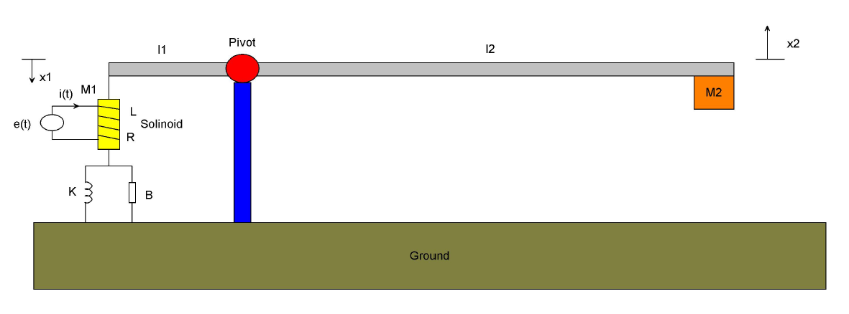

Figure 1 Vehicle boom barrier gate system design

For the solenoid system we have



We assume that the solenoid produces a magnetic force proportional to the current in the coil,



The equilibrium equation of the arm is given as



The force equation at point 2 is



The force equation at point 1 is



Substituting Equation (2) for f and Equation (3) for f1 to Equation (5) yields



Again substituting Equation (3) for x1 and Equation (4) for f2 to Equation (6) yields



Taking the Laplace transform of Equation (7) yields



Taking the Laplace transform of Equation (1) and substituting it into Equation (8) for i (t) yields



The transfer function between the input voltage and the output displacement becomes



The angular position at point 2 is simply



Substituting Equation (11) in to Equation (10) yields to the transfer function between the input voltage and the output angular displacement as



The system parameters are given in Table 1 below.

Table 1 System parameters

|  |  |  |  |
| --- | --- | --- | --- |
| No | Parameter | Symbol | Value |
| 1 | Side 1 rod length |  | 1 m |
| 2 | Side 2 rod length |  | 3.75 m |
| 3 | Mass of solenoid |  | 2 Kg |
| 4 | Mass at the rod side 2 |  | 3.5 Kg |
| 5 | Spring stiffness |  | 38 N/m |
| 6 | Damping coefficient |  | 18 N-s/m |
| 7 | Resistance |  | 75 ohm |
| 8 | Inductance |  | 15 H |
| 9 | Magnetic force constant |  | 0.014 |

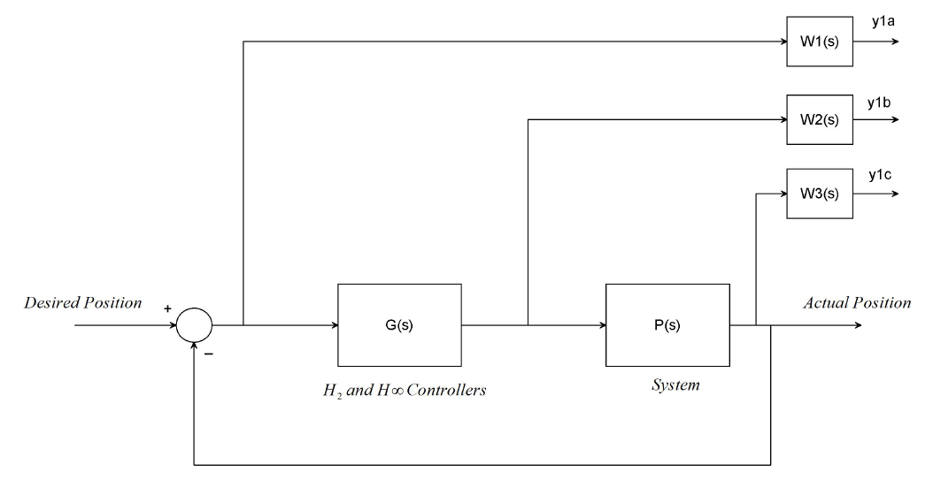

Figure 2 weighted control structure with the proposed controllers

Numerically the transfer function becomes



1. **Proposed Controllers Design**
   1. **Augmentations of the Model with Weighting Functions**

In this section, we will focus on the weighted control structure shown in Figure 2, where *W*1*(s)*, *W*2*(s)*, and *W*3*(s)* are weighting functions or weighting filters. We assume that *G (s)*, *W*1*(s)*, and *W*3*(s) G (s)* are all proper; i.e., they are bounded when *s* →∞. It can be seen that the weighting function *W*3*(s)* is not required to be proper. One may wonder why we need to use three weighting functions in Figure 7.13. First, we note that the weighting functions are, respectively, for the three signals, namely, the error, the input, and the output. In the two-port state space structure, the output vector y1 = [y1a, y1b, y1c] T is not used directly to construct the control signal vector u2. We should understand that y1 is actually for the control system performance measurement. So, it is not strange to include the filtered “input signal” u (t) in the “output signal” y1 because one may need to measure the control energy to assess whether the designed controller is good or not. Clearly, Figure 2 represents a more general picture of optimal and robust control systems. We can design an H 2 synthesis and synthesis controllers by using the idea of the augmented state space model.

The weighting function ***W***1*(s)*, ***W***2*(s)*, and ***W***3*(s)* are chosen as



The H 2 optimal controller become



The synthesis controller become:



1. **Result and Discussion**
   1. **Open Loop Response of the Vehicle Boom Barrier Gate System**

The Simulink model of the open loop system is shown in Figure 3 below. For the System output angular position to make a vehicle to pass through, it must be opened at least 65 degrees. So the voltage input becomes 2800 volt which is a high voltage and the system needs to improve the input voltage as shown in the simulation result in Figure 4 below.

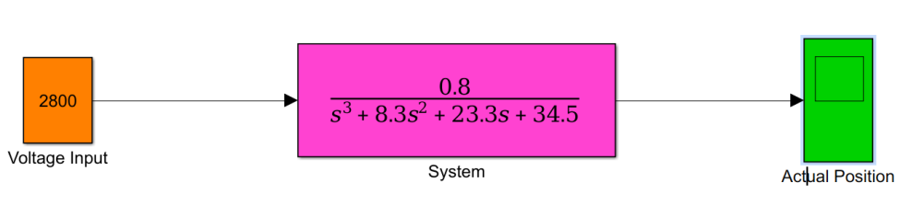

Figure 3 Simulink model of the open loop system

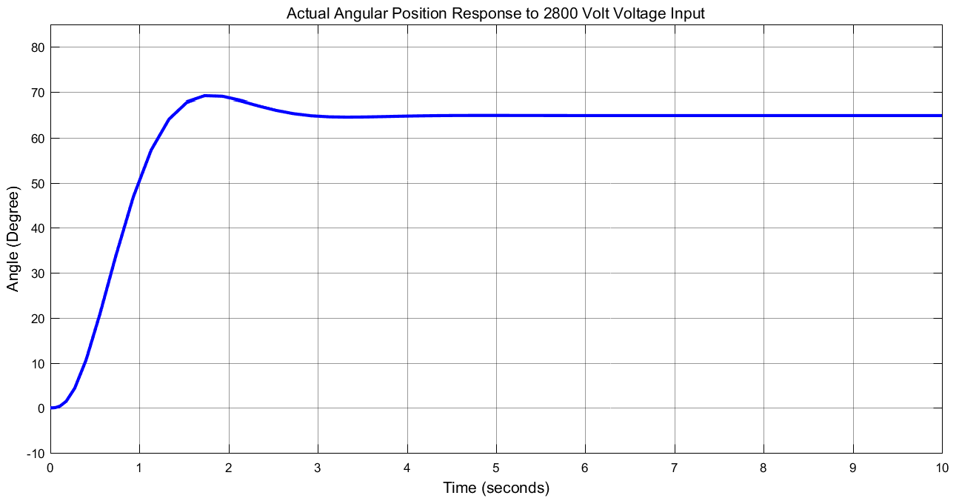

Figure 4 Open loop simulation result

* 1. **Comparison of the Vehicle Boom Barrier Gate System with H 2 optimal and** **synthesis controllers using Step Input Desired Position Signal**

The Simulink model of the vehicle boom barrier gate system with H 2 optimal and synthesis controllers using step input desired position signal is shown in Figure 5 below.

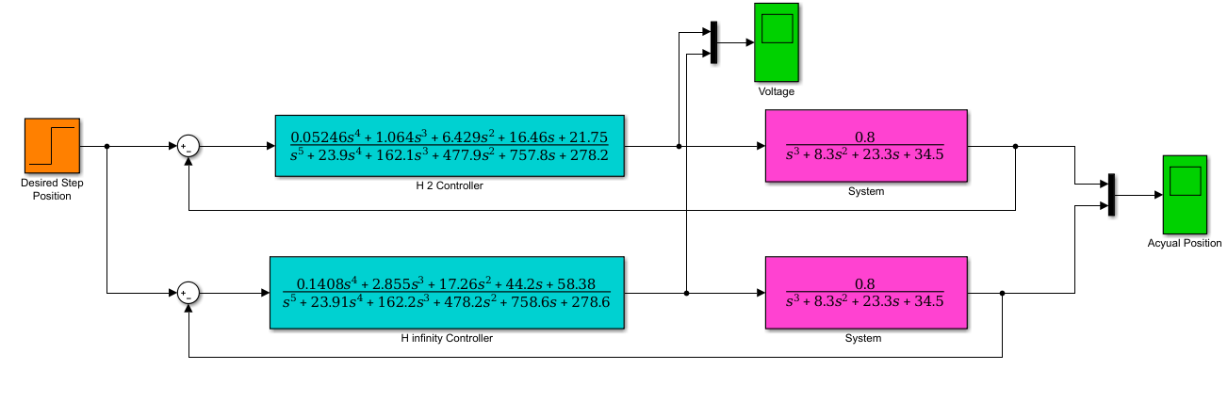

Figure 5 Simulink model of the vehicle boom barrier gate system with H 2 optimal and synthesis controllers using step input desired position signal

The simulation result of the comparison with the input voltage to the system with H 2 optimal and synthesis controllers are shown in Figure 6, Figure 7 and Figure 8 respectively.

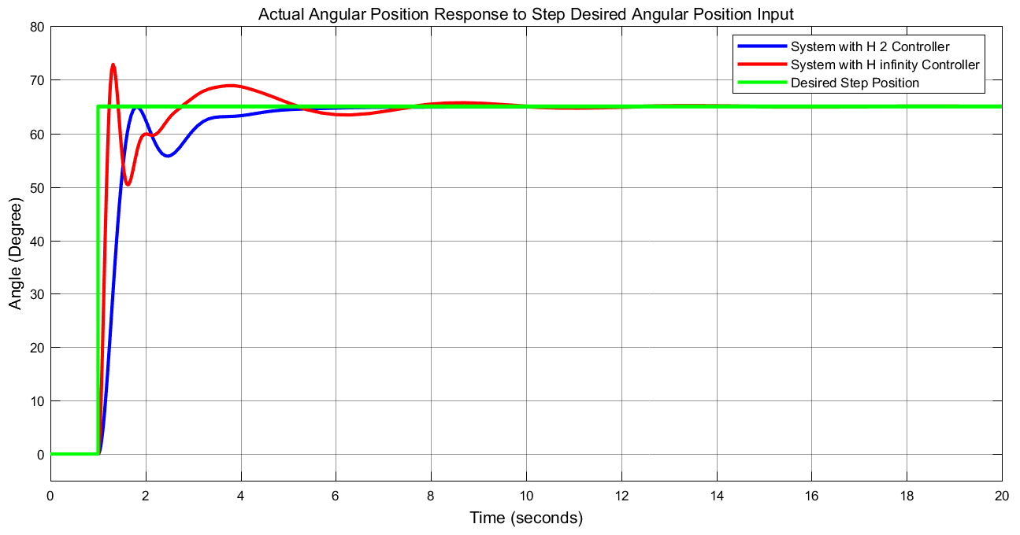

Figure 6 Step response of the comparison

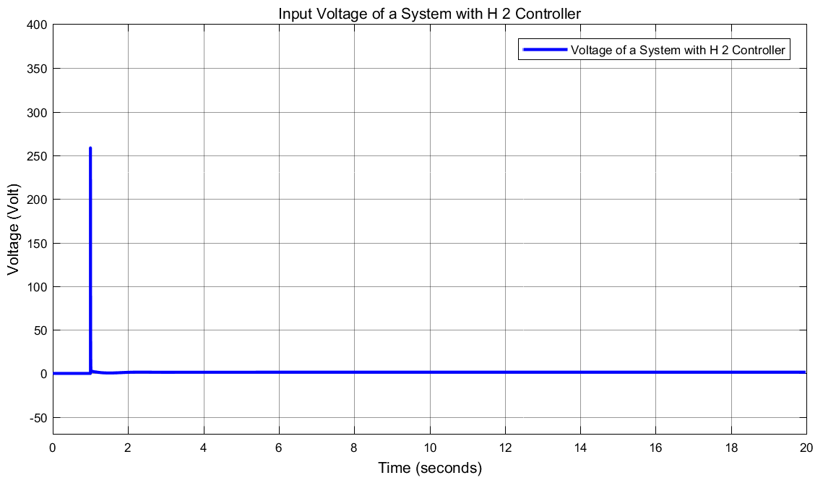

Figure 7 Input voltage to the system with H 2 optimal controller

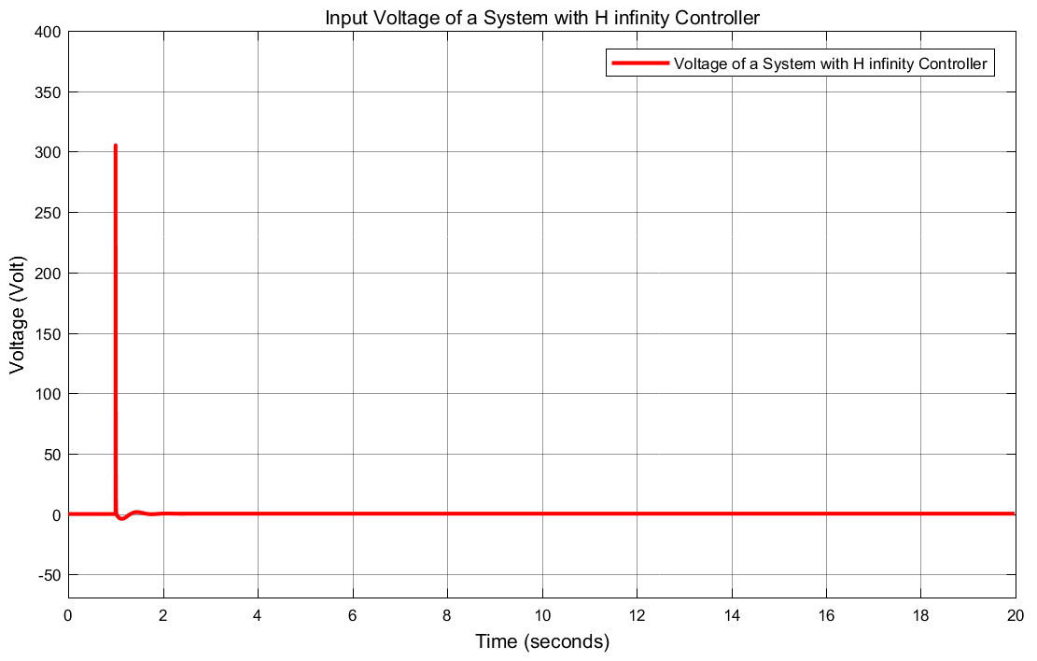

Figure 8 Input voltage to the system with H infinity synthesis controller

The input voltages of the vehicle boom barrier gate system with the proposed controllers shows improvement in reducing the voltage amplitude but the system with H 2 optimal controller shows better improvement. The data of the rise time, percentage overshoot, settling time and peak value is shown in Table 2.

Table 2 Step response data

|  |  |  |  |
| --- | --- | --- | --- |
| No | Performance Data | H 2 optimal | synthesis controller |
| 1 | Rise time | 1.4 sec | 1.2 sec |
| 2 | Per. overshoot | 3 % | 13.8 % |
| 3 | Settling time | 7 sec | 12 sec |
| 4 | Peak value | 65 Degree | 74 Degree |

As Table 2 shows that the vehicle boom barrier gate system with H 2 optimal controller improves the performance of the system by minimizing the percentage overshoot and settling time.

* 1. **Comparison of the Vehicle Boom Barrier Gate System with H 2 optimal and** **synthesis controllers using Operational Open and Close Input Desired Position Signal**

The Simulink model of the vehicle boom barrier gate system with H 2 optimal and synthesis controllers using operational open and close input desired position signal is shown in Figure 9 below.

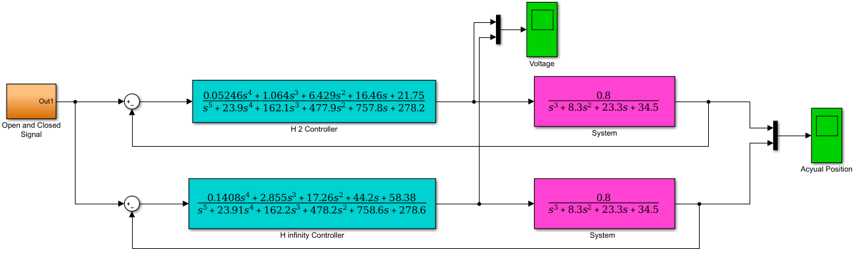

Figure 9 Simulink model of the proposed system with H 2 optimal and synthesis controllers using operational open and close input desired position signal

The simulation result of the comparison with the input voltage to the system with H 2 optimal and synthesis controllers are shown in Figure 10, Figure 11 and Figure 12 respectively.

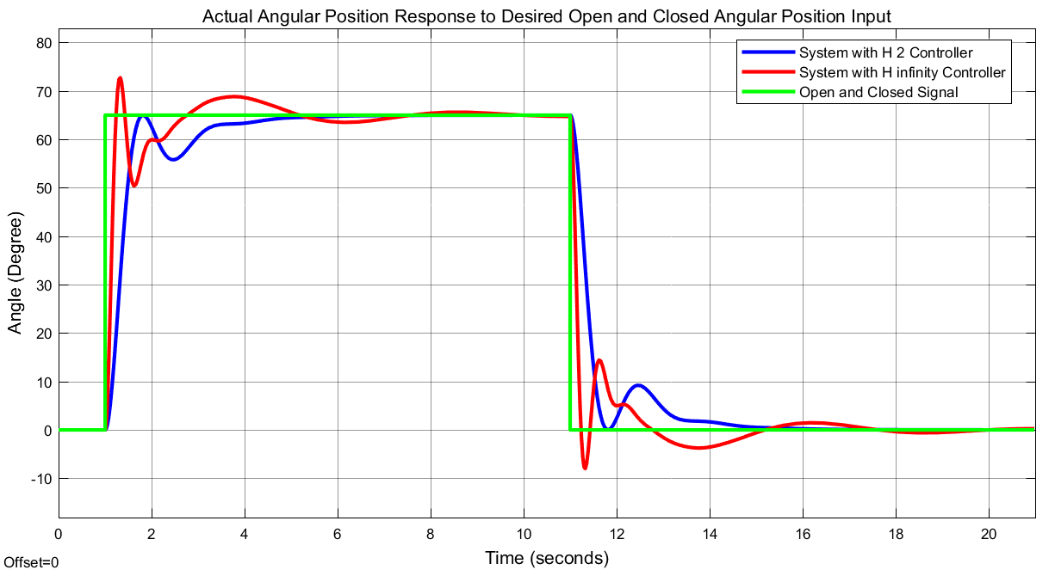

Figure 10 Operational open and close response of the comparison

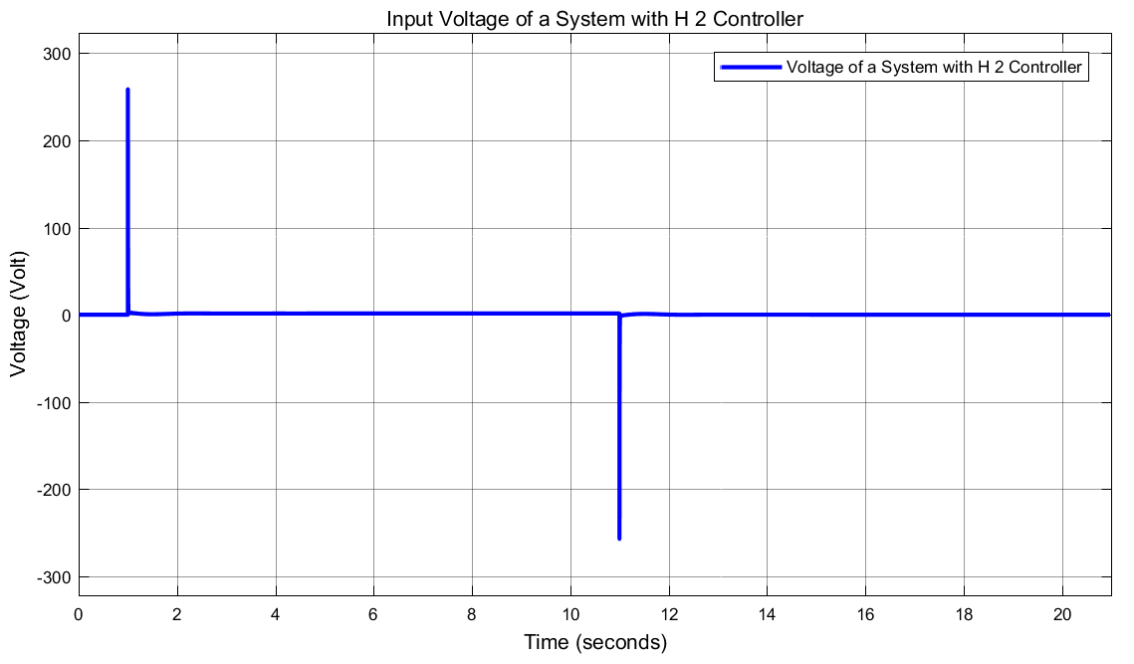

Figure 11 Input voltage to the system with H 2 optimal controller

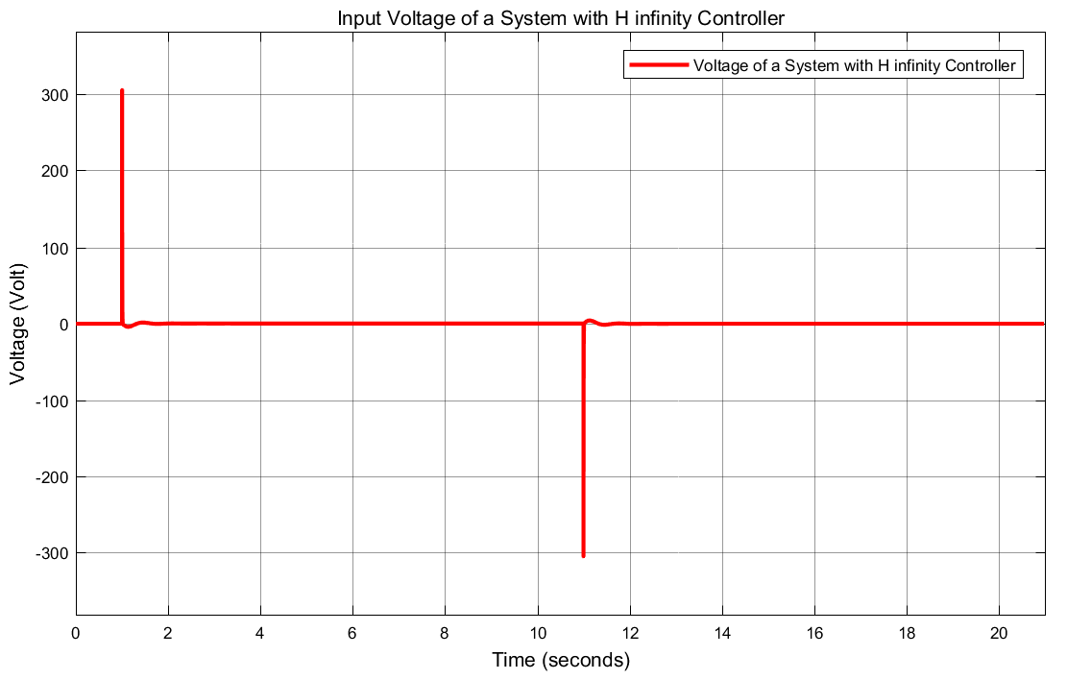

Figure 12 Input voltage to the system with H infinity synthesis controller

For the vehicle boom barrier gate system with synthesis controllers, The system opens and closed with high oscillation and even not reaching the steady state value as compared to the system with H 2 optimal controller while the input voltages of the system with the proposed controllers shows improvement in reducing the voltage amplitude but the system with H 2 optimal controller shows better improvement.

1. **Conclusion**

In this paper, the design and control of a vehicle boom barrier gate system is done using Matlab/Simulink Toolbox using robust augmentation technique with optimal and synthesis controllers successfully. The open loop response analysis of the system shows that the system must be opened at least 65 degrees to pass a vehicle and the input voltage becomes 2800 volt which is a high voltage and the system needs to improve the input voltage. Comparison of the vehicle boom barrier gate system with optimal and synthesis controllers have been done to track a set point using a step and operational open and close input signals. The step response shows that the system with H 2 optimal controller improves the performance of the system by minimizing the percentage overshoot and settling time while the response to the operational open and close input signal shows that the vehicle boom barrier gate system with synthesis controller opened and closed with high oscillation and even not reaching the steady state value as compared to the system with H 2 optimal controller. Finally the comparison simulation results proves the system with H 2 optimal controller improves the performance of the system.

**Reference**

1. Kazybek Kasym et al. “Parking Gate Control Based on Mobile Application” 2018 Joint 7th International Conference on Informatics, Electronics & Vision (ICIEV) and 2018 2nd International Conference on Imaging, Vision & Pattern Recognition (icIVPR), 2018.
2. Abu kebiru et al. “Design and Development of an Automatic Vehicle Gate Opener” IOSR Journal of Engineering (IOSRJEN), Vol. 7, Issue 11, pp.12-17, 2017.
3. Karlos et al. “Review on vehicle barrier protection guidance” EUR, Publications Office of the European Union, doi 10.2760/845599
4. B Huang et al. “The application of the digital barrier gate in the parking management system” Journal of Chinese security. 2014.
5. Jonathan A. et al. “An electronically controlled automatic security access gate” Leonardo Journal of Sciences, Vol. 1, Issue 25, pp. 85-96, 2014.
6. C Li et al. “Introduction to the design of the control system of the automobile in and out” Journal of Wuxi Nanyang Vocational College, Vol. 6, Issue 1, pp. 51-53, 2013.
7. Adewuyi P.A et al. “An intelligent gate controller using a personal computer and pattern recognition protocols” International Journal of Computational Intelligence and Information Security, Vol. 4, Issue 2, pp. 13-20, 2013.
8. Adewuyi P.A et al. “PIC based model of an intelligent gate controller” International Journal of Engineering and Advanced Technology, Vol. 2, Issue 3, pp. 601-605, 2013.

11/19/2020