# Fruit Shapes Of Pycnanthus Angolensis

Bello, O. A1. and Adesakin T.J2

1,2 Department of Biology, Osun State College of Education, Ila-Orangun, Osun State, Nigeria

[nikebello73@gmail.com](mailto:nikebello73@gmail.com)

**Abstract:** Fruit shapes of *Pycnanthus angolensis* were carried outto determine roundness and ellipsoid ratios. Matured trees of *Pycnanthus angolensis* (20.0±5.0years) were purposively selected from Osun (Gbongan, Ajaba), Ekiti (Otun, Ayetoro) and Oyo (Idito, Adewumi) States, based on availability. Fruit morphology was determined by measuring weight (g), width (cm) and length (cm) of 100 samples per location and was used to determine, roundness ratio and ellipsoid ratio. Roundness ratio was derived using formular. The largest diameter ranged from 3.6 to 5.0 and smallest diameter ranged from 2.1 to 3.4, rounded fruits ranged between 116.0 to139.7 and ellipsoid fruits ranged from 1.5 to 2.0. Idito had the highest rounded ratio (139.7) followed by Adewumi, (134.8) and Otun (130.4). Others were Gbongan (126.6), Ajaba (126.2) and last were Ayetoro (116.0). With regards to their ellipsoid ratio, the result showed that Ajaba had the highest (2.0) level of ellipsoid followed by Gbongan 1.5 and Otun 1.6. Adewumi, Ayetoro and Gbongan had similar ellipsoid ratio (1.5). The fruits are rounded to ellipsoids, 3.6 - 5.0 cm x 2.1 - 3.4cm. The *Pycnanthus angolensis* from Ajaba had the highest ellipsoid fruits and Idito had the highest rounded fruits.

[Bello, O. A. and Adesakin T.J. **Fruit Shapes Of Pycnanthus Angolensis.** *Researcher* 2020;12(11):12-15]. ISSN 1553-9865 (print); ISSN 2163-8950 (online). <http://www.sciencepub.net/researcher>. 4. doi:[10.7537/marsrsj121120.04](http://www.dx.doi.org/10.7537/marsrsj121120.04).

# Keywords: Roundness, Ratio, Ellipsoid, *Pycnanthus angolensis*, Fruit Shape

**1. Introduction**

*Pycnanthus angolensis* Welw. (Myristicaceae False African nutmeg) is facing risk of disappearance due to harsh human activities. The generic name, Pycnanthus is derived from the Greek word, the literal meaning is ‘dense flowers’ and it refers to the numerous flowers crowded together. *Pycnanthus angolensis* is known for its analgesic, stomachic,carminative, anti-inflammatory, haemostatic and antimicrobial actions belong to a family known for its numerous fruit trees, fragrant spicy plants whose dried fruits are used as condiment. Fruit shape is one of the most important physical properties and quality parameters of all agricultural produce (Kavdir and Guyer 2004). Consumers prefer fruits of identical heaviness and homogeneous form. Malformed fruits are generally discarded according to categorization principles of fruit. Fruit shape is exaggerated by inheritance adding up to ecological growing circumstances. Due to its uses, there is need to study the Fruit shape of *Pycnanthus angolensis* in evaluating agricultural produce, meeting quality values and increasing market value. The diversity of *Pycnanthus angolensis* fruit shape through different locations give vital information on the possible production.

**2. Material and Methods**

Matured trees of *Pycnanthus angolensis* (20.0±5.0years) were purposively selected from Osun (Gbongan, Ajaba), Ekiti (Otun, Ayetoro) and Oyo (Idito, Adewumi) States, based on availability. Fruit morphology was determined by measuring weight (g), width (cm) and length (cm) of 100 samples per location and was used to determine, roundness ratio and ellipsoid ratio. Roundness ratio was derived using the formular: (Rashidi and Seyif 2007):

: $RR=\frac{TL}{\sqrt{Ld×Sd}}$

Ellipsoid ratio was derived using the formula: $ER=Ld÷Sd$

Where:

RR = Roundness Ratio

ER = Ellipsoid Ratio

TL = Total Length

Ld = Largest diameter (diameter of the largest fruit)

Sd = Smallest Diameter (Diameter of the smallest fruit)

**3. Results**

Table 1 showed the TL of the fruit, largest diameter, smallest diameter, RR and ER of the various study locations. The largest diameter ranged from 3.6

to 5.0 and smallest diameter ranged from 2.1 to 3.4. The results from rounded fruits ranged from 116.0 to139.7 and ellipsoid fruits ranged from 1.5 to 2.0. The result in figure1 showed that Idito had the highest rounded ratio (139.7) followed by Adewumi, (134.8) and Otun (130.4). Others were Gbongan (126.6), Ajaba (126.2) and last were Ayetoro (116.0) (Figure 1 and Plate 1). With regards to their ellipsoid ratio, the result showed that Ajaba had the highest (2.0) level of ellipsoid followed by Gbongan 1.5 and Otun 1.6. Adewumi, Ayetoro and Gbongan had similar ellipsoid ratio (1.5) (Figure 2 and Plate 1)

# Table1: Roundness Ratio and Ellipsoid Ratio of *P. angolensis*

|  |  |  |  |  |  |
| --- | --- | --- | --- | --- | --- |
| **Location** | **Largest Diameter (Ld)** | **Smallest Diameter (Sd)** | **Total Length (Tl)** | **Roundness Ratio (Rr)** | **Ellipsoid Ratio (Er)** |
| Adewumi | 4.6 | 3.1 | 504.9 | 134.8 | 1.5 |
| Ajaba | 4.7 | 2.3 | 415.0 | 126.2 | 2.0 |
| Ayetoro | 5.0 | 3.3 | 471.2 | 116.0 | 1.5 |
| Gbongan | 5.0 | 3.4 | 522.6 | 126.6 | 1.5 |
| Idito | 3.6 | 2.1 | 384.1 | 139.7 | 1.7 |
| Otun | 5.1 | 3.2 | 524.4 | 130.4 | 1.6 |

**Figure 1: Roundness Ratio at various locations**

**Figure 2: Ellipsoid Ratio at various locations**

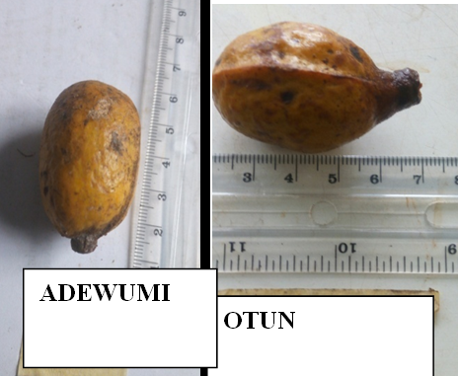

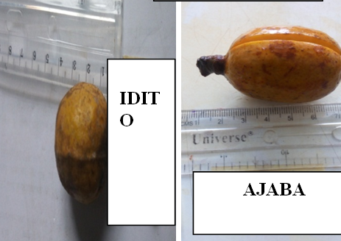

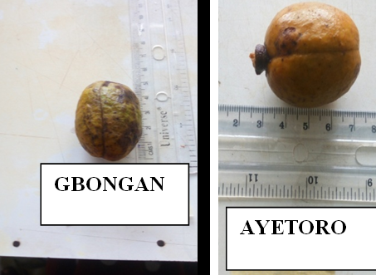

**Plate 1: Fruit shape Variation of *Pycnanthus angolensis***

**4. Discussions**

The diversity of *Pycnanthus angolensis* fruit shape through six different locations provide important data on the potential production of the most important The result showed that Ajaba had the highest ellipsoid fruits and this is similar to the report of some researchers and Idito had the highest rounded fruits. The fruits are rounded to ellipsoids, 3.6 - 5.0 cm x 2.1 - 3.4cm and these are in contrary to Mapongmetsem, (2007) and this might be due to environmental conditions.

**Conclusion**

The diversity of *Pycnanthus angolensis* fruit shape through six different locations gave vital information on the possible production. The fruits are rounded to ellipsoids, 3.6 - 5.0 cm x 2.1 - 3.4cm. The *Pycnanthus angolensis* from Ajaba had the highest ellipsoid fruits and Idito had the highest rounded fruits.

**References**

1. Kavdir, I. and D.E. Guyer, (2004). Comparison of artificial neural networks and statistical classifiers in apple sorting using textural features. Biosystems uniformity in size and shape. Engineering, 89(3): 331-344.
2. Mapongmetsem, P.M. (2007). *Pycnanthus angolensis* Welw. Warb. In: van der Vossen, H.A.M. & Mkamilo, G.S. (Editors). PROTA 14: Vegetable oils/Oleagineux. [CD-Rom]. PROTA, Wageningen, Netherlands.
3. Rashidi M, Seyif K (2007). Classification of fruit shape in Cantaloupe using analysis of geometrical attributes. World J Agric Sci 3(6):735–740.

11/19/2020