Application tensor algebra to cosmic triangles

S. Kalimuthu

2/394, Kanjampatti P.O, Pollachi Via, Tamil Nadu n642003, India
Email: owlskalimuthu@gmail.com, Mobile +91 850-8991577

Researcher ID: AAP-4476-2020
Scopus Author ID: 25723330600
ORCID ID: 0000-0001-7978-9013
MR ID 1048338

Abstract: According to Einstein's theory of General Relativity, space itself can be curved by mass. As a result, the density of the universe — how much mass it has spread over its volume — determines its shape, as well as its future. To put it in other words, if the cosmic triangle is spherical, then the universe is closed; if it is hyperbolic then the universe is open. In case the cosmic triangle is Euclidean, then the universe is flat. In this brief work, by applying.
[S. Kalimuthu. Application tensor algebra to cosmic triangles. Researcher 2020;12(11):4-5]. ISSN 1553-9865 (print); ISSN 2163-8950 (online). http://www.sciencepub.net/researcher. 2. doi:10.7537/marsrsj121120.02.

Keywords: Fate of the universe, cosmic triangles, freedman equations.
MSC: 51M04,08C99

Given: Cosmic Triangle ABC.
Construction: Make AD = AE; AF = AG and AH = AJ. Join D and E; F and G and H and J.
Let e, g, s and w denote the sum of the interior angles of cosmic triangles ADE, AFG, AHJ and ABC respectively. In another words,
ADE = e [I]
AFG = g [II]
AHJ = s [III]
ABC = w [IV]
Results
Applying the laws of tensor algebra, we can formulate the following tensors:
A^{eg} (1)
B_{ws} (2)
C_{se} (3)
D^{ws} (4)
E_{eg} (5)
F_{gw} (6)
(1). (2). (4). (5).= A^{eg} B_{ws}D^{ws} E_{eg} = Unity
(1). (3). (4). (6).= A^{eg}C_{se} D^{ws} F_{gw} = Unity
Equating the above two relations, (1). (2). (4). (5).= (1). (3). (4). (6).
i.e. B_{ws}E_{eg} = C_{se}F_{gw}
Mwseg = Nsegw (7)
According to the law of equality of tensors, if two tensors of same rank and same type are equal, then their components are one to one equal, using this law in (9) we get the following relations:
w = s; s = e; e = g; g = w`
From the above relations we obtain that e = g = s = w
From the above relation we obtain, e = g = w=s. (8)

Discussion
From (8) and from we get that the cosmic triangles ADE, AFG, AHJ and ABC are similar. Consequently this establishes that the shape of our universe is flat.

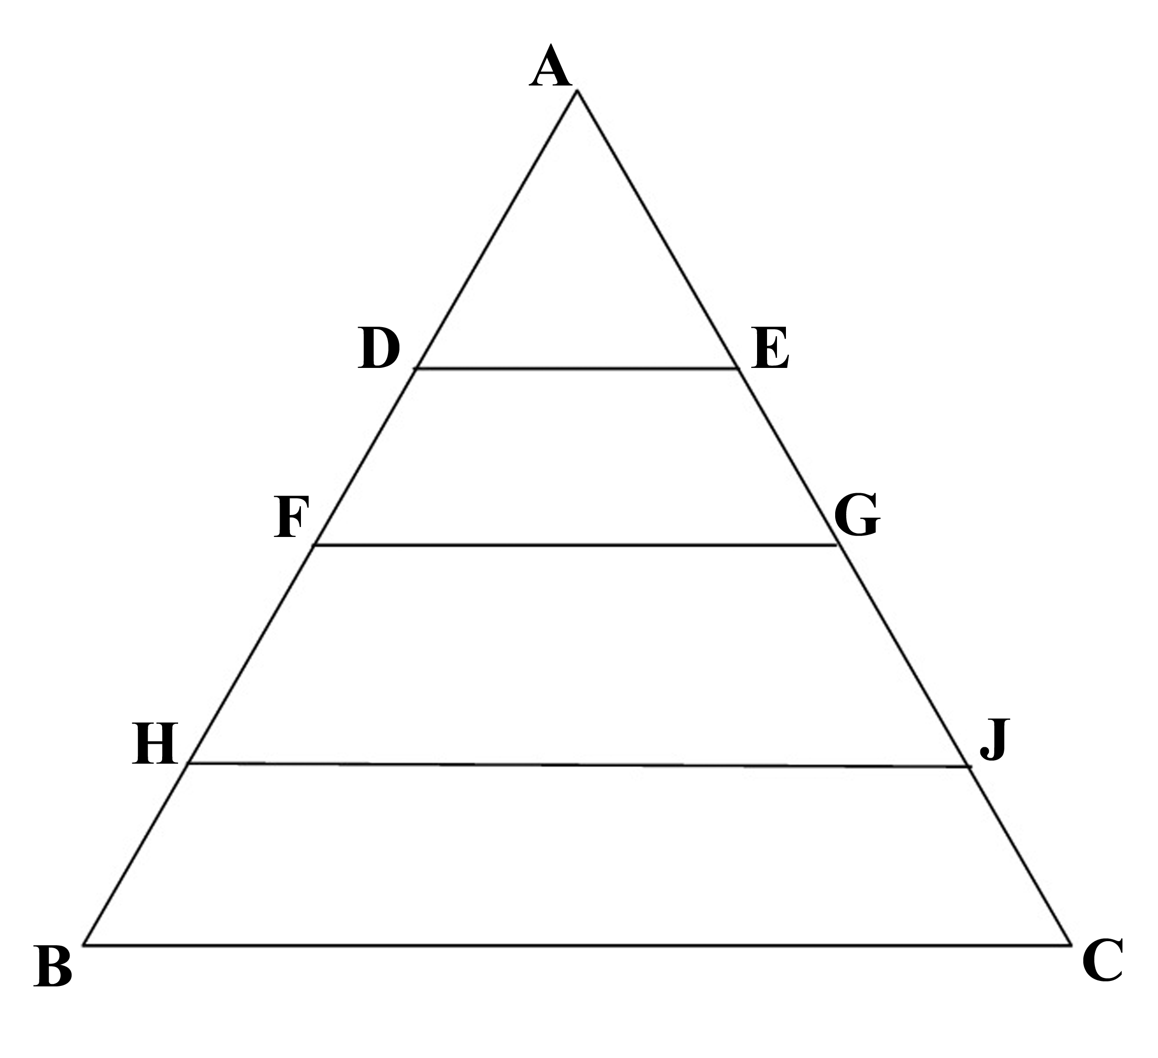
Figure 1

References
[1] https://map.gsfc.nasa.gov/universe/uni_shape.html
[2] https://map.gsfc.nasa.gov/mission/sgoals_parameters.html
[3] http://www.maths.adelaide.edu.au/thomas.leistner/talks/ugsem20100908.pdf
[4] http://www.maths.adelaide.edu.au/thomas.leistner/talks/ugsem20100908.pdf
[5] https://www.nasa.gov/mission_pages/station/research/experiments/results_name.html
- Google. http://www.google.com. 2020.
- http://www.sciencepub.net/nature/0501/10-0247-mahongbao-eternal-ns.pdf.
- Journal of American Science. http://www.jofamericanscience.org. 2020.
- Life Science Journal. http://www.lifesciencesite.com. 2020.
- Ma H. The Nature of Time and Space. Nature and science 2003;1(1):1-11. doi:10.7537/marsnsj010103.01. http://www.sciencepub.net/nature/0101/01-ma.pdf.
- Marsland Press. http://www.sciencepub.net. 2020.
- Marsland Press. http://www.sciencepub.org. 2020.
- National Center for Biotechnology Information, U.S. National Library of Medicine. http://www.ncbi.nlm.nih.gov/pubmed. 2020.
- Nature and Science. http://www.sciencepub.net/nature. 2020.
- Wikipedia. The free encyclopedia. http://en.wikipedia.org. 2020.

11/5/2020

